**Test Bank**

*For*

**Wordsmith: A Guide to Paragraphs and Short Essays**

Seventh Edition

**Pamela Arlov**, *Middle Georgia State College*

***Prepared by***

Darcie Kinsella *Portland Community College*

Susan Booth Larson

*Portland Community College*

Pamela Arlov

*Middle Georgia State College*

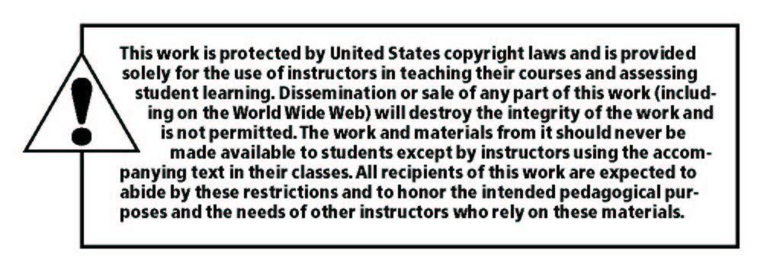

Copyright © 2019, 2016, 2012 by Pearson Education, Inc. or its affiliates.  All Rights Reserved.  Printed in the United States of America. This publication is protected by copyright, and permission should be obtained from the publisher prior to any prohibited reproduction, storage in a retrieval system, or transmission in any form or by any means, electronic, mechanical, photocopying, recording, or otherwise. For information regarding permissions, request forms and the appropriate contacts within the Pearson Education Global Rights & Permissions Department, please visit [www.pearsoned.com/permissions/](http://www.pearsoned.com/permissions/).

ISBN-10: 013477230X

ISBN-13: 9780134772301



# TABLE OF CONTENTS

**Chapter Tests**

Chapter 1 1

Chapter 2 4

Chapter 3 7

Chapter 4 10

Chapter 5 13

Chapter 6 16

Chapter 7 20

Chapter 8 24

Chapter 9 27

Chapter 10 30

Chapter 11 34

Chapter 12 37

Chapter 13 39

Chapter 14 41

Chapter 15 43

Chapter 16 47

Chapter 17 51

Chapter 18 54

Chapter 19 56

Chapter 20 58

Chapter 21 60

Chapter 22 64

Chapter 23 67

Chapter 24 70

Chapter 25 72

Chapter 26 75

Chapter 27 78

Chapter 28 80

**Grammar Pretest** 83

**Grammar Posttest** 90

**Chapter Test Answer Key** 98

**Pretest Answer Key** 118

**Posttest Answer Key** 119

## Chapter 1, Test 1 The Writing Process

1. Put the following steps in the writing process in order: drafting, planning, proofreading, revising, prewriting
2. Which step is the “thinking” step?
3. Which step involves making major changes in content and organization?
4. Which step involves writing a topic sentence?
5. What is the meaning of the Latin root of the word “revise”?
6. Which step of the writing process involves correcting grammar and spelling?
7. Is the writing process sequential or repetitive? Explain.
8. What kind of help might you expect to get from a writing group?
9. What does it mean to have a “right-brained” or “holistic” thinking style?
10. Name one specific tip for “right-brained” writers.

**Chapter 1, Test 2 The Writing Process**

1. Which step in the writing process is the “thinking” step?
   * 1. planning
     2. proofreading
     3. prewriting
     4. revising

1. Which step in the writing process involves correcting grammar, spelling, and punctuation?

a) planning

* + 1. drafting
    2. proofreading
    3. revising

1. Which step in the writing process involves making major changes in content and organization?
   * 1. planning
     2. drafting
     3. proofreading
     4. revising

1. Which step in the writing process involves writing a topic sentence?
   * 1. planning
     2. drafting
     3. proofreading
     4. revising

1. The steps in the writing process go in the following order:
   * 1. prewriting, drafting, revising, planning, proofreading
     2. prewriting, planning, drafting, revising, proofreading
     3. planning, prewriting, drafting, proofreading, revising
     4. planning, prewriting, revising, drafting, proofreading

1. A writing group can help a writer with
   * 1. grammar and punctuation.
     2. development of ideas.
     3. focusing on the requirements of the assignment.
     4. all of the above.

1. A writing group should be consulted
   * 1. before prewriting.
     2. immediately after prewriting.
     3. when the writer has completed a rough draft.
     4. when the final paper is complete.

1. “Revising” literally means
   * 1. repeating.
     2. writing again.
     3. writing correctly.
     4. seeing again.

1. “Right-brained” thinkers
   * 1. can’t use the writing process.
     2. focus on details.
     3. are poor writers.
     4. see the “big picture.”

1. Right-brained writers should
   1. follow the writing process exactly in order.
   2. write during their most creative times of day.
   3. write in a silent atmosphere.
   4. write by hand rather than on a computer.

## Chapter 2, Test 1 Preparing to Write

1. What causes writer’s block?

1. How does prewriting protect a writer against writer’s block?

1. What is the main goal of prewriting?

1. What is brainstorming?

1. What is freewriting?

1. What is “invisible writing”?

1. What is clustering?

1. Which technique is designed to use both the right and left sides of the brain?

1. What is outlining?

1. What is the benefit of keeping a journal?

**Chapter 2, Test 2 Preparing to Write**

1. A writer should use prewriting to
   1. generate ideas.
   2. prevent writer’s block.
   3. sort out some thoughts on the topic.
   4. all of the above.

1. The goal of prewriting is to
   1. get as many ideas as possible on paper.
   2. select which ideas are good or useful.
   3. complete a solid rough draft.
   4. think about a topic before writing anything down.

1. Brainstorming involves
2. making a list.
3. drawing.
4. using a computer.
5. meeting with a group.

1. Freewriting involves writing
2. with no punctuation.
3. in a smooth, logical sequence.
4. a numbered list of ideas.
5. nonstop for a short period of time.

1. Invisible writing involves
2. thinking or talking about your topic without writing.
3. writing on a computer with the monitor turned off.
4. talking rather than writing.
5. writing in a journal.

1. Clustering involves
2. putting ideas in circles connected by lines.
3. making two lists: pros and cons.
4. creating lists of subtopics.
5. sketching pictures of your ideas.

1. The prewriting method that involves both the right and left hemispheres of the brain is
2. brainstorming.
3. freewriting.
4. invisible writing.
5. clustering.

1. When prewriting, you should be most concerned with
2. the quality of ideas.
3. the quantity of ideas.
4. organization.
5. grammar and punctuation.

1. Outlining is helpful to
2. practice Roman numerals.
3. think of new ideas.
4. organize your thoughts.
5. describe your specific details.

1. Outlining is usually done
2. before prewriting.
3. during brainstorming, freewriting, or clustering.
4. as the last step in prewriting.
5. after the first draft.