***University Physics* (Pearson)**

**Topic 2 Vectors**

2.1 Conceptual Questions

**2.1.1 Addition and Subtraction**

1) Addition and subtraction: If  - = 0, then the vectors  and  have equal magnitudes and are directed in the opposite directions from each other.

A) True

B) False

Answer: B

Var: 1

Topic: Addition and subtraction

2) Addition and subtraction: Under what condition is | - | = *A + B*?

A) The magnitude of vector  is zero.

B) Vectors  and  are in opposite directions.

C) Vectors  and  are in the same direction.

D) Vectors  and  are in perpendicular directions.

E) The statement is never true.

Answer: B

Var: 1

Topic: Addition and subtraction

3) Addition and subtraction: If *A > B*, under what condition is | -  | = *A - B*?

A) The statement is never true.

B) Vectors  and  are in opposite directions.

C) Vectors  and  are in the same direction.

D) Vectors  and  are in perpendicular directions.

E) The statement is always true.

Answer: C

Var: 1

Topic: Addition and subtraction

4) Addition and subtraction: For the vectors shown in the figure, express vector  in terms of vectors  and .

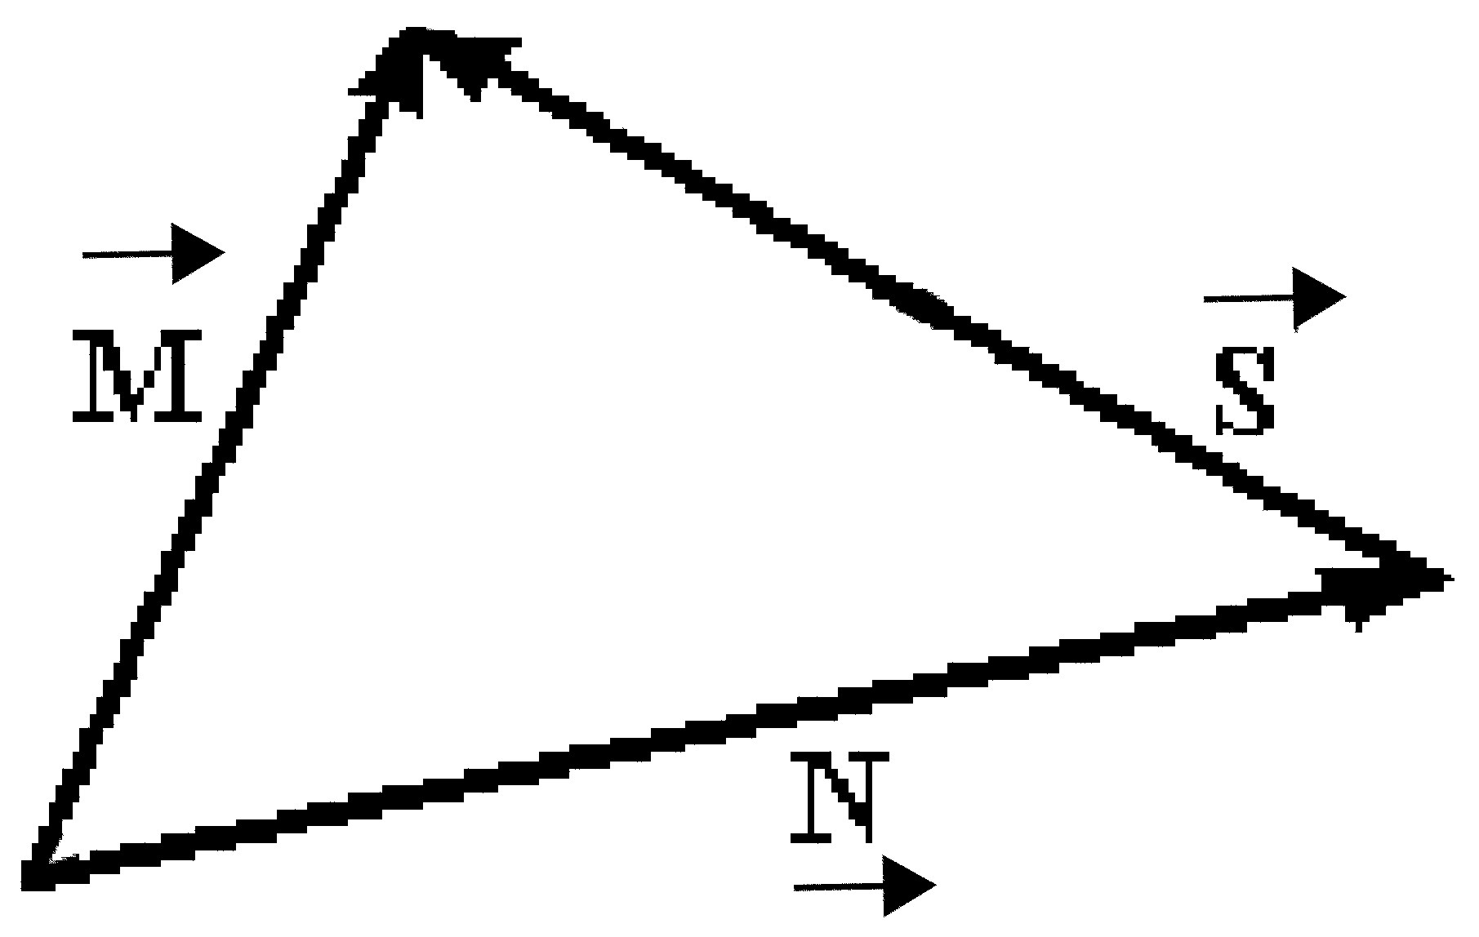

Answer:  =  - 

Var: 1

Topic: Addition and subtraction

**2.1.2 Components**

1) Components: Which of the following is an accurate statement?

A) The magnitude of a vector can be zero even though one of its components is not zero.

B) It is possible to add a scalar quantity to a vector.

C) Even though two vectors have unequal magnitudes, it is possible that their vector sum is zero.

D) Rotating a vector about an axis passing through the tip of the vector does not change the vector.

E) The magnitude of a vector is independent of the coordinate system used.

Answer: E

Var: 1

Topic: Components

2) Components: The magnitude of a vector can never be less than the magnitude of one of its components.

A) True

B) False

Answer: A

Var: 1

Topic: Components

3) Components: If the magnitude of vector  is less than the magnitude of vector , then the x component of  is always less than the x component of .

A) True

B) False

Answer: B

Var: 1

Topic: Components

4) Components: If the eastward component of vector  is equal to the westward component of vector  and their northward components are equal. Which one of the following statements about these two vectors is correct?

A) Vector  is parallel to vector .

B) Vectors  and  point in opposite directions.

C) Vector is perpendicular to vector .

D) The magnitude of vector  is equal to the magnitude of vector .

E) The magnitude of vector  is twice the magnitude of vector .

Answer: D

Var: 1

Topic: Components

**2.1.3 Unit Vectors**

1) Unit vectors: If all the components of a vector are equal to 1, then that vector is a unit vector.

A) True

B) False

Answer: B

Var: 1

Topic: Unit vectors

**2.1.4 Scalar (dot) Product**

1) Scalar (dot) product: If the dot product of two nonzero vectors is zero, the vectors must be perpendicular to each other.

A) True

B) False

Answer: A

Var: 1

Topic: Scalar (dot) product

2) Scalar (dot) product: If two nonzero vectors point in the same direction, their dot product must be zero.

A) True

B) False

Answer: B

Var: 1

Topic: Scalar (dot) product

3) Scalar (dot) product: The value of the dot product of two vectors depends on the particular coordinate system being used.

A) True

B) False

Answer: B

Var: 1

Topic: Scalar (dot) product

**2.1.5 Vector (cross) Product**

1) Vector (cross) product: If two vectors are perpendicular to each other, their cross product must be zero.

A) True

B) False

Answer: B

Var: 1

Topic: Vector (cross) product

2) Vector (cross) product: If two vectors point in opposite directions, their cross product must be zero.

A) True

B) False

Answer: A

Var: 1

Topic: Vector (cross) product

3) Vector (cross) product: If  and are nonzero vectors for which ∙  = 0, it must follow that

A)  ×  = 0.

B)  is parallel to .

C) |× | = AB.

D) | × | = 1.

Answer: C

Var: 1

Topic: Vector (cross) product

2.2 Problems

**2.2.1 Addition and Subtraction**

1) Addition and subtraction: You walk 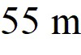 to the north, then turn 60° to your right and walk another 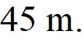 How far are you from where you originally started?

A) 87 m

B) 50 m

C) 94 m

D) 46 m

Answer: A

Var: 31

Topic: Addition and subtraction

2) Addition and subtraction: Vectors  and  are shown in the figure. Vector  is given by  =  -  . The magnitude of vector  is 16.0 units, and the magnitude of vector  is 7.00 units. What is the magnitude of vector ?

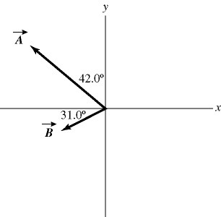

A) 9.00

B) 9.53

C) 15.5

D) 16.2

E) 17.5

Answer: D

Var: 1

Topic: Addition and subtraction

3) Addition and subtraction: Vectors  and  are shown in the figure. Vector  is given by  =  - . The magnitude of vector  is 16.0 units, and the magnitude of vector  is 7.00 units. What is the angle of vector , measured counterclockwise from the +*x*-axis?



A) 16.9°

B) 22.4°

C) 73.1°

D) 287°

E) 292°

Answer: D

Var: 1

Topic: Addition and subtraction

4) Addition and subtraction: A rabbit trying to escape a fox runs north for 8.0 m, darts northwest for 1.0 m, then drops 1.0 m down a hole into its burrow. What is the magnitude of the net displacement of the rabbit?

A) 8.8 m

B) 8.1 m

C) 66 m

D) 10 m

Answer: A

Var: 50+

Topic: Addition and subtraction

5) Addition and subtraction: You walk 53 m to the north, then turn 60° to your right and walk another  Determine the direction of your displacement vector. Express your answer as an angle relative to east.

A) 63° N of E

B) 50° N of E

C) 57° N of E

D) 69° N of E

Answer: A

Var: 50+

Topic: Addition and subtraction

**2.2.2 Components**

1) Components: Vector  has a magnitude 5.00 and points in a direction 40.0° clockwise from the negative *y* axis. What are the *x* and *y* components of vector .

A) *A*x = 3.83 and *A*y = 3.21

B) *A*x = 3.83 and *A*y = -3.21

C) *A*x = -3.21 and *A*y = -3.83

D) *A*x = -3.21 and *A*y = 3.83

E) *A*x = 4.29 and *A*y = 2.16

Answer: C

Var: 5

Topic: Components

2) Components: The components of vector  are *Ax* = + 3.90 and *Ay* = -4.00. What is the angle measured counterclockwise from the +x-axis to vector ?

A) 314°

B) 134°

C) 224°

D) 136°

E) 46.0°

Answer: A

Var: 1

Topic: Components

3) Components: Vector  has a magnitude of 5.5 cm and points along the *x*-axis. Vector  has a magnitude of 7.5 cm and points at +30° above the negative *x*-axis.

(a) Determine the *x* and *y* components of Vector .

(b) Determine the *x* and *y* components of Vector .

(c) Determine *x* and *y* components of the sum of these two vectors.

(d) Determine the magnitude and direction of the sum of these two vectors.

Answer: (a) *Ax* = 5.5 cm, *Ay* = 0

(b) *Bx* = -6.5 cm, *By* = 3.8 cm

(c) *Rx* = -1.0 cm, *Ry* = 3.8 cm

(d) 3.9 cm at 75° above -*x*-axis

Var: 1

Topic: Components

4) Components: Vector  has a magnitude of 75.0 cm and points at 30° above the positive *x*-axis. Vector  has a magnitude of 25.0 cm and points along the negative *x*-axis. Vector  has a magnitude of 40.0 cm and points at 45° below the negative *x*-axis.

(a) Determine the *x* and *y* components of Vector .

(b) Determine the *x* and *y* components of Vector .

(c) Determine the *x* and *y* components of Vector .

(d) Determine *x* and *y* components of the sum of these three vectors.

(e) Determine the magnitude and direction of the sum of these three vectors.

Answer: (a) *Ax* = 65 cm, *Ay* = 38 cm

(b) *Bx* = -25 cm, *By* = 0

(c) *Cx* = -28 cm, *Cy* = -28 cm

(d) *Rx* = 12 cm, *Ry* = 9.2 cm

(e) 15 cm at 38° above +*x*-axis

Var: 1

Topic: Components

5) Components: A helicopter is flying horizontally with a speed of 444 m/s over a hill that slopes upward with a 2% grade (that is, the "rise" is 2% of the "run"). What is the component of the helicopter's velocity perpendicular to the sloping surface of the hill?

A) 8.9 m/s

B) 220 m/s

C) 435 m/s

D) 444 m/s

Answer: A

Var: 50+

Topic: Components

6) Components: An apple falls from an apple tree growing on a 20° slope. The apple hits the ground with an impact velocity of 16.2 m/s straight downward. What is the component of the apple's impact velocity parallel to the surface of the slope?

A) 5.5 m/s

B) 8.7 m/s

C) 12 m/s

D) 15 m/s

Answer: A

Var: 50+

Topic: Components

7) Components: The components of vector  are ** = + 2.2 and ** = -6.9 , and the components of vector  are given are ** = -6.1 and ** = -2.2. What is the magnitude of the vector  - ******?

A) 9.5

B) 6.1

C) 9.9

D) 91

E) 0.76

Answer: A

Var: 50+

Topic: Components

8) Components: The components of vector  are ** = -3.5 and ** = -9.7, and the components of vector  are ** = -6 and ** = + 8.1. What is the angle (less than 180 degrees) between vectors  and ******?

A) 124°

B) 56°

C) 17°

D) 163°

E) 106°

Answer: A

Var: 50+

Topic: Components

9) Components: An airplane undergoes the following displacements: First, it flies 66 km in a direction 30° east of north. Next, it flies 49 km due south. Finally, it flies 100 km 30° north of west. Using vector components, determine how far the airplane ends up from its starting point.

A) 79 km

B) 81 km

C) 82 km

D) 78 km

E) 76 km

Answer: A

Var: 1

Topic: Components

10) Components: In the figure, the magnitude of vector  is 18.0 units, and the magnitude of vector is 12.0 units. What vector  must be added to the vectors  andso that the resultant of these three vectors points in the -*x* direction and has a magnitude of 7.50 units? Use vector components to find your answer, and express vector  by giving its magnitude and the angle it makes with the +*x*-axis taking counterclockwise to be positive.

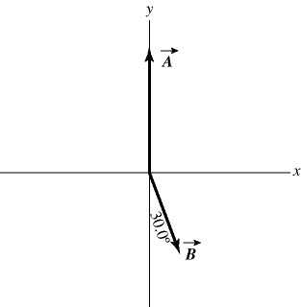

Answer: 15.5, 209°

Var: 1

Topic: Components

11) Components: Three forces are exerted on an object placed on a tilted floor. Forces are vectors. The three forces are directed as shown in the figure. If the forces have magnitudes * =* 1.0 N,  * =* 8.0 N and * =* 7.0 N, where N is the standard unit of force, what is the component of the *net force* net = 1 + 2 + 3 parallel to the floor?

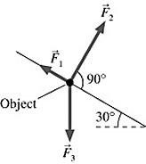

A) 2.5 N

B) 5.1 N

C) 6.0 N

D) 7.8 N

Answer: A

Var: 29

Topic: Components

12) Components: As shown in the figure, three force vectors act on an object. The magnitudes of the forces as shown in the figure are *F*1 = 80.0 N, *F*2= 60.0 N, and *F*3 = 40.0 N, where N is the standard SI unit of force. The resultant force acting on the object is given by

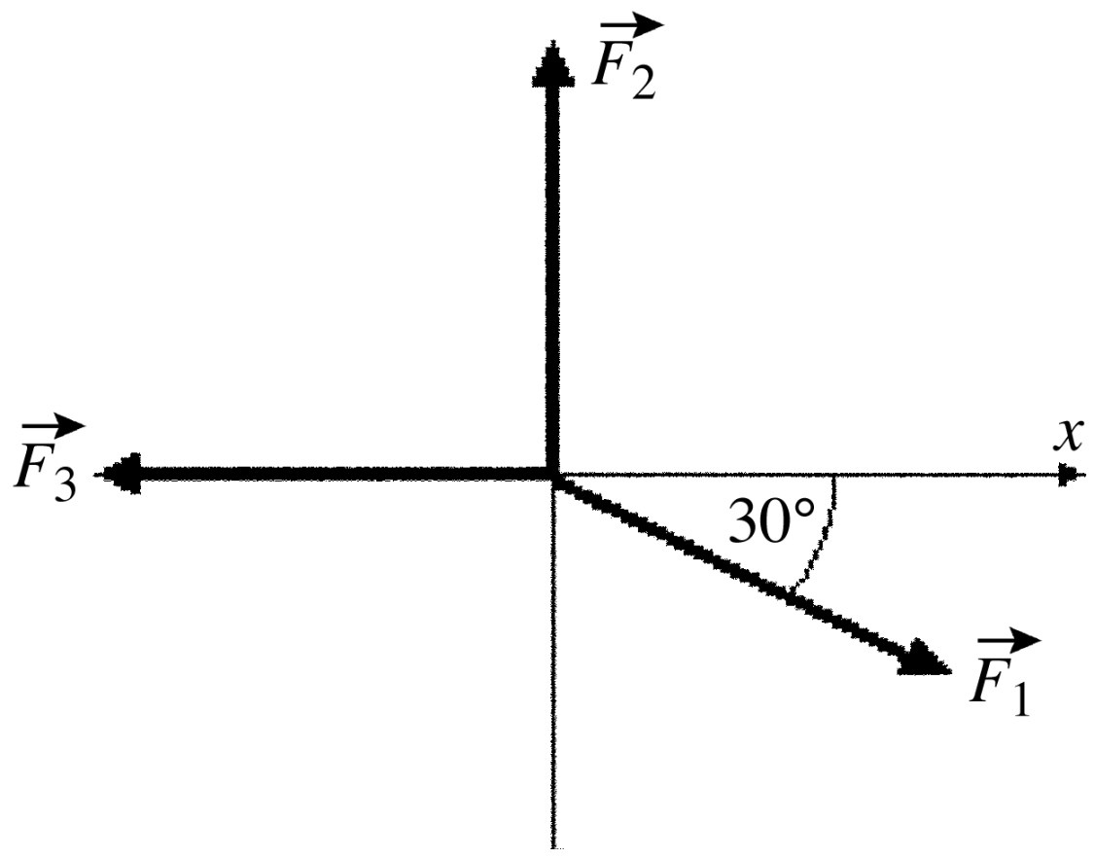

A) 180 N at an angle 60.0° with respect to +*x*-axis.

B) 60.0 N at an angle 90.0° with respect to +*x*-axis.

C) 20.0 N at an angle 34.3° with respect to +*x*-axis.

D) 35.5 N at an angle 34.3° with respect to +*x*-axis.

E) 40.0 N at an angle 60.0° with respect to *+x*-axis.

Answer: D

Var: 1

Topic: Components

13) Components: A teacher sends her students on a treasure hunt. She gives the following instructions:

1. Walk 300 m north

2. Walk 400 m northwest

3. Walk 700 m east-southeast and the treasure is buried there.

As all the other students walk off following the instructions, Jane physics student quickly adds the displacements and walks in a straight line to find the treasure. How far and in what direction does Jane need to walk?

A) 187 m in a direction 67.3° north of east

B) 481 m in a direction 40.9° north of east

C) 399 m in a direction 52.5° north of east

D) 284 m in a direction 28.2° west of north

E) The treasure position cannot be reached in one straight walk.

Answer: B

Var: 1

Topic: Components

**2.2.3 Unit Vectors**

1) Unit vectors:Vector  = -3.00  + 3.00  and vector  = 3.00  + 4.00 . What is vector  =  + ?

A) 0.00  + 3.00 

B) 7.00  + 7.00 

C) -3.00  + 7.00 

D) 0.00  + 7.00 

E) -3.00  -3.00 

Answer: D

Var: 1

Topic: Unit vectors

2) Unit vectors: Vector  = 1.00  + -2.00  and vector = 3.00  + 4.00  What are the magnitude and direction of vector  =  + ?

A) 7.21 in a direction 33.7° counterclockwise from the positive *x* axis

B) 6.00 in a direction 63.4° counterclockwise from the positive *x* axis

C) 4.47 in a direction 6.34° counterclockwise from the positive *x* axis

D) 4.47 in a direction 26.6° counterclockwise from the positive *x* axis

E) 7.21 in a direction 56.3° counterclockwise from the positive *x* axis

Answer: D

Var: 1

Topic: Unit vectors

3) Unit vectors: What is the magnitude of *** +  + ***, where ******= 1.00  + 4.00  - 1.00 ***, *** = 3.00  - 1.00  - 4.00 and  = -1.00 + 1.00  ?

A) 7.07

B) 2.00

C) 10.76

D) 6.78

E) 8.12

Answer: A

Var: 9

Topic: Unit vectors

4) Unit vectors: If  = + 4  - 2  - 3  and  = - 4  -2  - 3 , which of the following numbers is closest to the magnitude of  - ******?

A) 8

B) 7

C) 9

D) 10

E) 11

Answer: A

Var: 50+

Topic: Unit vectors

5) Unit vectors: Vector  = -1.00  + -2.00  and vector  = 3.00  + 4.00  What are the magnitude and direction of vector  = 3.00 + 2.00 ?

A) 3.61 in a direction -56.3° counterclockwise from the positive *x*-axis

B) 3.61 in a direction 56.3° counterclockwise from the positive *x*-axis

C) 3.61 in a direction 33.7° counterclockwise from the positive *x*-axis

D) 5.00 in a direction 56.3° counterclockwise from the positive *x* axis

E) 6.72 in a direction 34.4° counterclockwise from the positive *x*-axis

Answer: C

Var: 1

Topic: Unit vectors

6) Unit vectors: Vectors  and  are shown in the figure. What is |-5.00  + 4.00 |

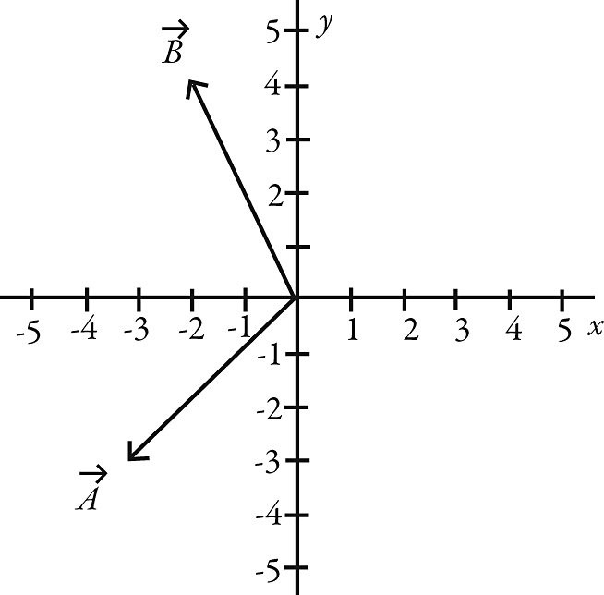

A) 31.8

B) -32.0  - 2.00 

C) 1028

D) 34.0

E) -2.00  - 32.0 

Answer: A

Var: 1

Topic: Unit vectors

**2.2.4 Scalar (dot) Product**

1) Scalar (dot) product: Determine the scalar product of  = 6.0 + 4.0**** - 2.0 and  = 5.0**** - 6.0**** - 3.0****.

A) 30 + 24**** + 6****

B) 30  - 24**** + 6****

C) 12

D) 60

E) undefined

Answer: C

Var: 5

Topic: Scalar (dot) product

2) Scalar (dot) product: Determine the angle between the directions of vector  = 3.00**** + 1.00****** and vector  = -3.00 + 3.00****.

A) 26.6°

B) 30.0°

C) 88.1°

D) 117°

E) 45.2°

Answer: D

Var: 5

Topic: Scalar (dot) product

3) Scalar (dot) product: The scalar product of vector  = 3.00**** + 2.00****** and vector  is 10.0. Which of the following vectors could be vector **?

A) 2.00**** + 4.00******

B) 4.00 + 6.00******

C) 5.00**** + 4.00******

D) 12.0

E) 2.00**** + 2.00**

Answer: E

Var: 5

Topic: Scalar (dot) product

4) Scalar (dot) product: The angle between vector  = 2.00**** + 3.00** a**nd vector  is 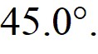 The scalar product of vectors  and  is 3.00. If the *x* component of vector ** is positive, what is vector ****.

A) 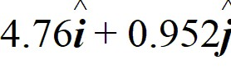

B) 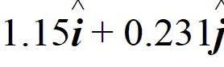

C) 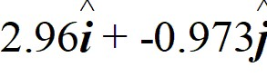

D) 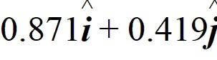

E) 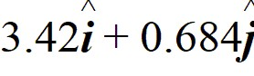

Answer: B

Var: 5

Topic: Scalar (dot) product

5) Scalar (dot) product: What is the angle between the vector  = + 3**** - 2**** - 3**** and the +*y*-axis?

A) 115°

B) 65°

C) 25°

D) 155°

E) 90°

Answer: A

Var: 16

Topic: Scalar (dot) product

6) Scalar (dot) product: If  = 3  -  + 4 and  = *x*  +  - 5, find *x* so  will be perpendicular to .

Answer: 7

Var: 1

Topic: Scalar (dot) product

7) Scalar (dot) product: Two boys searching for buried treasure are standing underneath the same tree. One boy walks 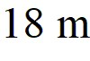 east and then  north. The other boy walks 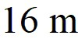 west and then 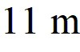 north. Find the scalar product of their net displacements from the tree.

Answer: -90 

Var: 50+

Topic: Scalar (dot) product

8) Scalar (dot) product: A rectangular box is positioned with its vertices at the following points:

*A* = (0,0,0) *C* = (2,4,0) *E* = (0,0,3) *G* = (2,4,3)

*B* = (2,0,0) *D* = (0,4,0) *F* = (2,0,3) *H* = (0,4,3)

If the coordinates all have three significant figures, the angle between the line segments *AG* and *AH* is closest to:

A) 21.8°.

B) 22.5°.

C) 26.6°.

D) 36.9°.

E) 45.0°.

Answer: A

Var: 1

Topic: Scalar (dot) product

9) Scalar (dot) product: For the vectors shown in the figure, assume numbers are accurate to two significant figures. The scalar product  ×  is closest to

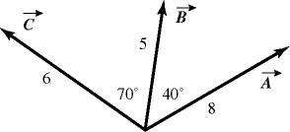

A) zero.

B) 16.

C) 45.

D) -16.

E) -45.

Answer: D

Var: 1

Topic: Scalar (dot) product

**2.2.5 Vector (cross) Product**

1) Vector (cross) product: What is the vector product of  = 2.00  + 3.00  + 1.00 and  = 1.00  - 3.00  - 2.00?

A) -3.00  + 5.00  - 9.00

B) -5.00  + 2.00  - 6.00

C) -9.00  - 3.00  - 3.00

D) -4.00  + 3.00  - 1.00

E) 2.00  - 9.00  - 2.00

Answer: A

Var: 1

Topic: Vector (cross) product

2) Vector (cross) product: What is the magnitude of the cross product of a vector of magnitude 2.00 m pointing east and a vector of magnitude 4.00 m pointing 30.0° west of north?

A) 6.93

B) -6.93

C) 4.00

D) -4.00

E) 8.00

Answer: A

Var: 1

Topic: Vector (cross) product

3) Vector (cross) product: If the magnitude of the cross product of two vectors is one-half the dot product of the same vectors, what is the angle between the two vectors?

Answer: 26.6°

Var: 1

Topic: Vector (cross) product

4) Vector (cross) product: If  = - 4****** - 2 - 3, what is  ×  ***?***

A) +3****** - 4

B) +3****** + 4

C) -3****** + 4

D) +3****** + 2- 4

E) -3****** - 2 + 4

Answer: A

Var: 50+

Topic: Vector (cross) product

5) Vector (cross) product: If  = -2****** - 6 + 2 and  = - 2****** -2 - 3, which of the following numbers is closest to the magnitude of  × ******?

A) 25

B) 21

C) 17

D) 13

E) 9

Answer: A

Var: 50+

Topic: Vector (cross) product

6) Vector (cross) product: For the vectors shown in the figure, find the magnitude and direction of  × , assuming that the quantities shown are accurate to two significant figures.



A) 26, directed into the plane

B) 26, directed out of the plane

C) 31, directed on the plane

D) 31, directed into the plane

E) 31, directed out of the plane

Answer: A

Var: 1

Topic: Vector (cross) product

7) Vector (cross) product: For the vectors shown in the figure, find the magnitude and direction of the vector product  ×  that the quantities shown are accurate to two significant figures.



A) 16, directed into the plane

B) 16, directed out of the plane

C) 45, directed on the plane

D) 45, directed into the plane

E) 45, directed out of the plane

Answer: E

Var: 1

Topic: Vector (cross) product