1. Which of the following was not obtained by people of ancient civilizations from observations of the night sky?
 | a. | the relative distances of the Sun, the Moon, and stars from Earth
 | b. | timing information, both daily and yearly
 | c. | patterns of stars in the sky about which stories and myths were devised
 | d. | directions for navigation

ANSWER: | a

2. Two opposite sides of the Egyptian pyramids are aligned with which direction(s) on the horizon?
 | a. | northeast to southwest
 | b. | midsummer sunrise
 | c. | north–south
 | d. | rising of the star Sirius

ANSWER: | c

3. Meaningful observations of the sky by ancient peoples:
 | a. | were, of necessity, restricted to the western hemisphere.
 | b. | were, of necessity, restricted to the regions north of the equator.
 | c. | were, of necessity, restricted to the regions south of the equator.
 | d. | were made in regions throughout the world.

ANSWER: | d

4. Which ancient culture discovered a 584-day pattern in the motions of Venus?
 | a. | Native Americans in the southwestern United States
 | b. | Mayan civilization in Central America
 | c. | Stonehenge builders in England
 | d. | Observers in ancient Egypt

ANSWER: | b

5. In modern astronomy, the constellations are:
 | a. | clusters of stars that are held together by the mutual gravitational attractions of the individual stars in the cluster.
 | b. | nearby galaxies to which astronomers have given specific names.
 | c. | 12 regions of sky through which the Sun, the Moon, and planets move as seen from Earth.
 | d. | 88 regions of sky, covering the entire sky.

ANSWER: | d

6. Constellations are generally made up of stars that are:
 | a. | moving through space together.
 | b. | about the same age.
 | c. | separated by relatively small distances (compared to their distances from us).
 | d. | merely located along more or less the same line of sight as viewed from Earth.

ANSWER: | d

7. The constellations:
 | a. | are 88 in number and cover the entire sky.
 | b. | that the ancients imagined are constantly being augmented by newly invented constellations as new stars are being discovered.
 | c. | are of historical interest only and play no role at all in modern astronomy.
 | d. | consist of groups of stars that are all about the same distance from us.

ANSWER: | a

8. Describing a star as being in the constellation Cygnus (the Swan) tells a modern astronomer that the star is:
 | a. | in a distant galaxy located in a particular direction from Earth.
 | b. | inside our solar system.
 | c. | somewhere in a particular region of sky having definite boundaries.
 | d. | one of a set of bright stars that make up a particular "picture" in the sky.

ANSWER: | c

9. If a star is described as being in the constellation Leo, a modern astronomer knows that it is:
 | a. | somewhere in a particular region of sky having definite boundaries.
 | b. | in a distant galaxy located in a particular direction from Earth.
 | c. | inside a region of the sky bounded by two lines of right ascension in the sky.
 | d. | one of a few individual bright stars that make a picture (of a lion) in the sky.

ANSWER: | a

10. Which of the following statements correctly describes the relationship between stars and constellations?
 | a. | Only those stars that were visible to the ancient Greeks are located in constellations.
 | b. | Only the brighter stars are in constellations.
 | c. | Only stars within the zodiac close to the ecliptic, Earth's orbital plane, are located in constellations.
 | d. | Every star is located in a constellation.

ANSWER: | d

11. If the unaided human eye is sensitive enough to see about 6000 of the stars in the entire sky, about how many stars would be seen at one time on a given night from a single location from which the horizon is completely visible around the observer?
 | a. | about 3000
 | b. | only 1000 because the rest are hidden by Earth
 | c. | depends on the observer's latitude; observers at the poles will see 6000, while equatorial observers will see only one-half of this number, or 3000
 | d. | about 6000

ANSWER: | a

12. Which one of the following statements about constellations is correct?
 | a. | If you point randomly to some direction in the sky, you are pointing at some constellation.
 | b. | Only if you point in the vicinity of one of the brighter stars are you pointing at a constellation.
 | c. | Astronomers are seeking to discover new constellations.
 | d. | Astronomers are constantly inventing new constellations.

ANSWER: | a

13. The constellation whose stars are used as pointers to the north celestial pole in the northern hemisphere is:
 | a. | Leo, the lion, containing the bright star Regulus.
 | b. | Ursa Major, the Great Bear.
 | c. | Ursa Minor, the Little Bear, containing the bright star Polaris.
 | d. | Bootes, the shepherd, containing the bright star Arcturus.

ANSWER: | b

14. The Winter Triangle, a group of three bright stars in the winter sky, consists of Sirius, Procyon, and:
 | a. | Betelgeuse.
 | b. | Vega.
 | c. | Castor.
 | d. | Polaris.

ANSWER: | a

15. The Summer Triangle, a group of three bright stars in the summer sky, consists of Deneb, Altair, and:
 | a. | Betelgeuse.
 | b. | Vega.
 | c. | Pollux.
 | d. | Polaris.

ANSWER: | b

16. Diurnal motion of objects in the sky is caused by the:
 | a. | precession of Earth's axis.
 | b. | revolution of Earth around the Sun.
 | c. | motion of the Moon across the sky.
 | d. | rotation of Earth on its axis.

ANSWER: | d

17. The nightly motion of objects across the sky is caused by the:
 | a. | revolution of Earth around the Sun.
 | b. | rotation of the whole celestial sphere of stars around the fixed Earth.
 | c. | rotation of Earth on its axis.
 | d. | motion of the solar system around the galaxy.

ANSWER: | c

18. A star rises at 8 P.M., moves across the sky (crossing high overhead), and then sets at:
 | a. | midnight.
 | b. | 2 A.M.
 | c. | 8 A.M.
 | d. | noon.

ANSWER: | c

19. You are observing from the east coast of the United States as a star rises above the horizon. At this same instant your friend on the west coast will find that this star:
 | a. | is just rising.
 | b. | is just setting.
 | c. | rose a few hours earlier.
 | d. | has not yet risen.

ANSWER: | d

20. The most readily observed east-to-west motion of objects in the night sky is caused by the:
 | a. | motion of the Moon and planets across the sky.
 | b. | rotation of Earth on its axis.
 | c. | relative motions of stars with respect to each other in the sky.
 | d. | revolution of Earth around the Sun.

ANSWER: | b

21. The pattern of stars that is visible from one position on Earth gradually shifts from east to west across the sky over 1 night. This is caused by the:
 | a. | atmospheric motions and winds.
 | b. | rotation of Earth about its own north–south axis.
 | c. | motion of the Moon and planets across the sky.
 | d. | motion of Earth around the Sun.

ANSWER: | b

22. The most easily observed motion in the night sky is produced by the:
 | a. | revolution of Earth around the Sun.
 | b. | motion of stars with respect to each other in the sky.
 | c. | motion of the planets along their orbits around the Sun.
 | d. | rotation of Earth on its axis.

ANSWER: | d

23. The phrase "diurnal motion" refers to the:
 | a. | slow change in position of the constellations from east to west from night to night, resulting in different constellations being visible at 11 P.M. in May than at 11 P.M. in December.
 | b. | apparent motion of the Sun along the ecliptic over the course of a year.
 | c. | change in position of the Moon in the sky as it runs through its phases over the course of a month.
 | d. | gradual motion of the constellations from east to west across the sky each night, resulting in different constellations being visible at 4 A.M. than at 10 P.M. on any given night.

ANSWER: | d

24. Over the course of 1 night, an observer at a middle latitude location on Earth sees most of the constellations gradually move from east to west across the sky. This is caused primarily by the:
 | a. | inherent rotation of the universe.
 | b. | wind.
 | c. | motion of Earth around the Sun.
 | d. | rotation of Earth around its own axis.

ANSWER: | d

25. What basic pattern do stars seem to trace out in our sky if you watch (or photograph) stars near the north celestial pole for a period of several hours?
 | a. | circles, with the north celestial pole at the center
 | b. | spirals, as the stars move while Earth rotates
 | c. | almost straight lines, rising from the horizon towards the zenith
 | d. | ellipses, with the north pole at one focus

ANSWER: | a

26. When we watch the nighttime sky, we find that:
 | a. | the stars and constellations remain fixed in our sky, not rising or setting in a time as short as 1 night because they are so far away.
 | b. | most stars and constellations slowly rise in the west, pass overhead, and set in the east.
 | c. | all stars and constellations reach their highest point in the sky at midnight.
 | d. | most stars and constellations slowly rise in the east, pass overhead, and set in the west.

ANSWER: | d

27. Which way are you moving with respect to the stars during the rotation of Earth?
 | a. | eastward
 | b. | southward
 | c. | westward
 | d. | northward

ANSWER: | a

28. With respect to the stars, the rotation of Earth carries you toward the:
 | a. | south.
 | b. | east.
 | c. | west.
 | d. | north.

ANSWER: | b

29. If the stars Polaris and Arcturus (as shown in Figure 2-6 of Universe, 11th ed.), are known to be 71° apart, how far away from Polaris is the closest star in Ursa Major?
​
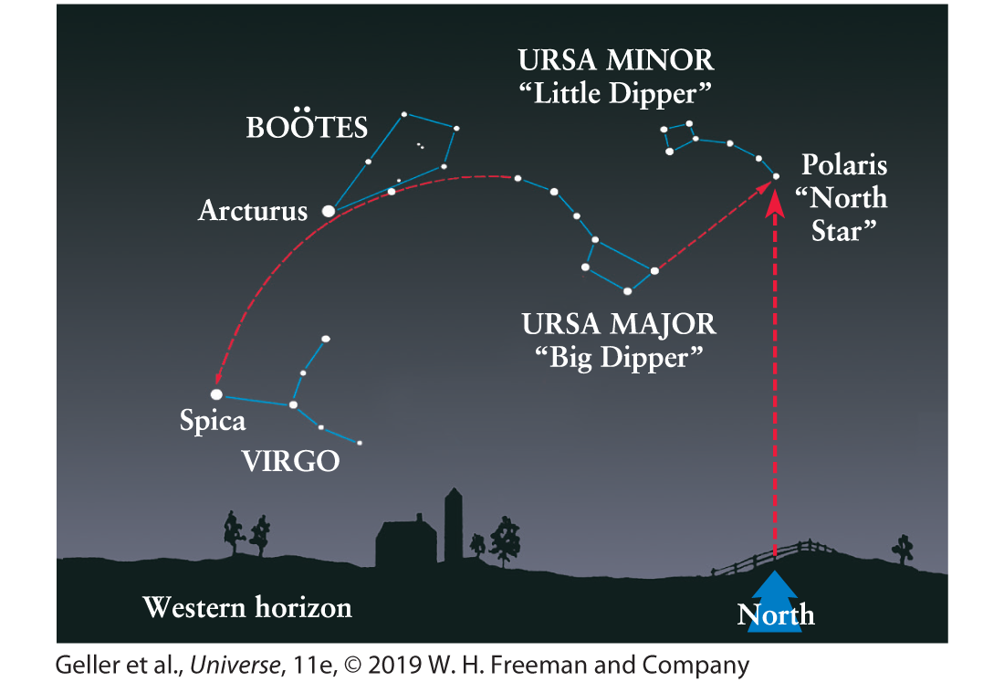
​
 | a. | about 25°
 | b. | about 2.5°
 | c. | about 250°
 | d. | about 7.1°

ANSWER: | a

30. If the stars Polaris and Spica are 101° apart (as shown in Figure 2-6 of Universe, 11th ed.), how far away from Polaris is the closest star in Ursa Major, from our view?
​
​
 | a. | about 2.5°
 | b. | about 260°
 | c. | about 77°
 | d. | about 25°

ANSWER: | d

31. In late September, Andromeda appears high in the sky at midnight. Six months later Virgo appears high in the sky at midnight. Where is Andromeda at this time?
 | a. | It is still high in the sky at midnight.
 | b. | It has moved to the western horizon.
 | c. | It has moved to the eastern horizon.
 | d. | It is high in the sky at noon and is thus not visible.

ANSWER: | d

32. Perseus appears high in the sky at midnight in November. Andromeda appears high in the sky at midnight in September. (See Figure 2-5 of Universe, 11th ed.) Where is Andromeda at midnight in November?
​
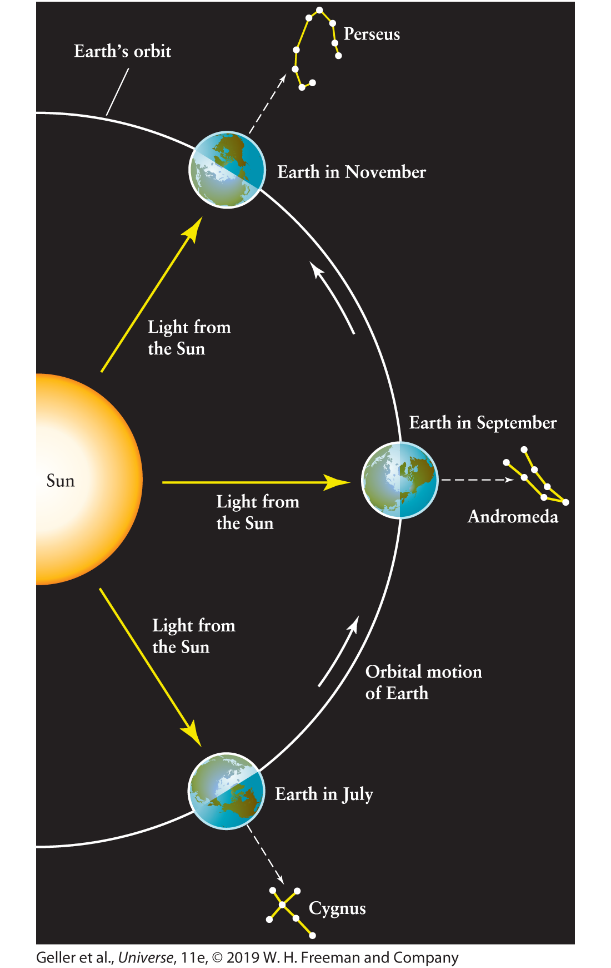
​
 | a. | It remains high in the center of the sky.
 | b. | It will be near the eastern horizon.
 | c. | It will be near the western horizon.
 | d. | It will be high in the sky at noon and thus will not be visible.

ANSWER: | c

33. Cygnus appears high in the sky at midnight in July. Andromeda appears high in the sky at midnight in September. (See Figure 2-5 of Universe, 11th ed.) Where is Andromeda at midnight in July?
​
​
 | a. | It is still high in the sky at midnight.
 | b. | It has moved to the western horizon.
 | c. | It has moved to the eastern horizon.
 | d. | It is high in the sky at noon and is thus not visible.

ANSWER: | c

34. Sirius is the brightest star in the night sky. You watch it set behind the western horizon about 2 A.M. in the middle of February. About what time will it set in the middle of March?
 | a. | 10 P.M.
 | b. | midnight
 | c. | 2 A.M.
 | d. | 4 A.M.

ANSWER: | b

35. People in which one of the following cities experience sunrise first?
 | a. | New York
 | b. | San Francisco
 | c. | Chicago
 | d. | Denver

ANSWER: | a

36. Which of the following directions does not always remain fixed in place relative to an observer's horizon?
 | a. | summer solstice
 | b. | north celestial pole
 | c. | points where the celestial equator contacts the horizon
 | d. | zenith

ANSWER: | a

37. Which of the following points remains fixed in the sky relative to an observer's horizon?
 | a. | north celestial pole
 | b. | direction to a distant star (e.g., Betelgeuse, in Orion)
 | c. | vernal equinox
 | d. | winter solstice

ANSWER: | a

38. Which of the following directions remains fixed in the sky relative to an observer's horizon?
 | a. | zenith
 | b. | direction to the Moon at noon, over 1 month
 | c. | direction to the Sun at noon, over 1 year
 | d. | autumnal equinox

ANSWER: | a

39. During a given night, some stars will be observed to pass through the:
 | a. | vernal equinox.
 | b. | zodiac.
 | c. | celestial equator.
 | d. | zenith.

ANSWER: | d

40. If you were standing on the equator, which one of the following positions in the sky would pass through your zenith at some time in one 24-hour period?
 | a. | the position of the Sun at summer solstice
 | b. | the position of the north celestial pole, or perpendicular to the celestial equator
 | c. | the position of the ecliptic pole, or perpendicular to the ecliptic plane
 | d. | the position of the vernal equinox, or 0 hours right ascension, 0° declination

ANSWER: | d

41. How much of the overall sky is north of the celestial equator, that is, in the northern hemisphere?
 | a. | all of it, by definition
 | b. | exactly one-half
 | c. | less than one-half, because of the tilt of the equator to the ecliptic plane
 | d. | more than one-half, because of the precession of the poles

ANSWER: | b

42. Compared with its appearance to a person in mid-latitude northern latitudes, how will the constellation Orion appear to an observer in Australia?
 | a. | exactly the same since the stars of Orion are very far away from Earth
 | b. | upside down but with the same orientation of stars
 | c. | upside down and inverted left to right, a mirror image of that seen in the northern hemisphere
 | d. | same way up but inverted left to right

ANSWER: | b

43. The celestial equator is defined as the:
 | a. | extension into space of Earth's equator.
 | b. | line traced in our sky by the Moon each month against the background stars.
 | c. | line traced in our sky by the Sun over 1 year against the background stars.
 | d. | band of constellations through which the Sun and Moon move in our sky.

ANSWER: | a

44. Which of the following lines or points is always directly over your head, no matter where on Earth you go?
 | a. | zenith
 | b. | celestial equator
 | c. | ecliptic
 | d. | 90° north declination

ANSWER: | a

45. If you point toward the zenith today and point there again 45 days later, you will have pointed twice in the same direction relative to the:
 | a. | Moon.
 | b. | Sun.
 | c. | fixed stars.
 | d. | horizon.

ANSWER: | d

46. The zenith defines a direction:
 | a. | vertically above a point on the equator.
 | b. | vertically above an observer.
 | c. | toward the Sun at noon.
 | d. | vertically above the North Pole.

ANSWER: | b

47. If you are standing on Earth's equator, your zenith (the vertical direction above your head) over a period of 1 year will maintain which of the following alignments?
 | a. | a fixed angle of 23.5° to the spin axis of Earth
 | b. | an angle to Earth's spin axis that will vary between 0° and 23.5° over a period of 6 months
 | c. | parallel to Earth's spin axis
 | d. | perpendicular to Earth's spin axis

ANSWER: | d

48. The celestial coordinate system of declination and right ascension:
 | a. | can be used to assign coordinates to any direction in the sky.
 | b. | is an extension of the latitude-longitude system used on Earth. The celestial equator is an extension of Earth's equator, and the location for the zero of right ascension is an extension of the prime meridian through Greenwich, England.
 | c. | rotates along with Earth.
 | d. | is centered at the Sun rather than at Earth.

ANSWER: | a

49. If you view the sky from 20° north of the equator, the north circumpolar stars (which do not rise and set) would be:
 | a. | the stars within 20° of the horizon.
 | b. | the stars within 20° of Polaris, the North Star.
 | c. | the stars within 20° of the zenith (the point directly overhead).
 | d. | nonexistent, since all the stars rise and set when viewed from 20° north of the equator.

ANSWER: | b

50. As Earth rotates, the zenith of a person standing on the equator sweeps out:
 | a. | a path between north and south poles, along the observer's celestial meridian.
 | b. | the celestial equator.
 | c. | a variable path across the sky within the zodiac but not always on the celestial equator.
 | d. | the ecliptic plane.

ANSWER: | b

51. A given star in the sky will reach its highest point to a particular observer in the northern hemisphere when it passes through the:
 | a. | celestial equator.
 | b. | zodiac.
 | c. | ecliptic plane.
 | d. | region of the sky due south.

ANSWER: | d

52. Polaris, the "pole star," is at present:
 | a. | within 1° of the north celestial pole.
 | b. | exactly perpendicular to the ecliptic plane (ecliptic pole).
 | c. | above Earth's magnetic pole.
 | d. | precisely at the north celestial pole.

ANSWER: | a

53. As Earth rotates, the apparent motion of the pole star, Polaris, in a period of a day is:
 | a. | a slow drift across the sky.
 | b. | a wobble back and forth in a straight line.
 | c. | a small circle with a radius of less than 1° in about 24 hours.
 | d. | zero; there is no motion of the pole star by definition.

ANSWER: | c

54. For an observer at a fixed location on Earth, the angle between the north celestial pole and an observer's horizon depends on the:
 | a. | time of year.
 | b. | time of day.
 | c. | observer's latitude (north or south of the equator).
 | d. | observer's longitude (east or west of Greenwich).

ANSWER: | c

55. To navigators in the northern hemisphere, their latitude in degrees is equal to:
 | a. | 15 times the number of hours since the sun set.
 | b. | the angle between their meridian and the north celestial pole.
 | c. | the angle between the north celestial pole and their zenith.
 | d. | the angle between the north celestial pole and their northern horizon.

ANSWER: | d

56. The angle between an observer's horizon and the north celestial pole is governed by:
 | a. | latitude.
 | b. | local time.
 | c. | sidereal time.
 | d. | longitude.

ANSWER: | a

57. The elevation angle between the northern horizon of a fixed observer and the north celestial pole is equal to:
 | a. | the observer's longitude.
 | b. | the observer's latitude.
 | c. | the right ascension of the vernal equinox.
 | d. | a variable value, depending on the time of year.

ANSWER: | b

58. At a certain time the star straight overhead has a right ascension of 2 hours and 30 minutes. One hour later this same star will have a right ascension of:
 | a. | 1 hour and 30 minutes.
 | b. | 2 hours and 30 minutes.
 | c. | 3 hours and 30 minutes.
 | d. | 4 hours and 30 minutes.

ANSWER: | b

59. Over what range of declination will stars be circumpolar (i.e., be visible at any time of the night on any night of the year) for an observer at 30° north latitude?
 | a. | 60° to 90°N and 60° to 90°S
 | b. | 60° to 90°N
 | c. | 30° to 90°N
 | d. | 0° to 30°N

ANSWER: | b

60. Over what range of declination will stars be circumpolar (i.e., be visible at any time of the night on any night of the year) for an observer at the South Pole?
 | a. | 0° to 90°N
 | b. | only stars at the south celestial pole
 | c. | 90°S to 90°N (the whole sky)
 | d. | 0° to 90°S

ANSWER: | d

61. The two angles used by astronomers to define the position of a star in the sky and define a coordinate system applicable anywhere on Earth are:
 | a. | azimuth and elevation.
 | b. | latitude and longitude.
 | c. | horizontal and vertical angles.
 | d. | right ascension and declination.

ANSWER: | d

62. The celestial coordinates that together describe a star's position precisely and unambiguously are:
 | a. | right ascension and declination.
 | b. | right ascension and sidereal time.
 | c. | sidereal time and latitude.
 | d. | longitude and latitude.

ANSWER: | a

63. The declination angle between the north celestial pole and the celestial equator is:
 | a. | 360°.
 | b. | 89° because of the displacement of the Pole Star.
 | c. | 180°.
 | d. | 90°.

ANSWER: | d

64. The declination of a star is a measure of its:
 | a. | position above the observer's horizon along a great circle passing through the observer's zenith.
 | b. | time of rising above the horizon.
 | c. | position along the celestial equator.
 | d. | position north or south of the celestial equator along a great circle passing through the north and south celestial poles.

ANSWER: | d

65. The declination of a star in the sky is defined as the angle between the:
 | a. | Sun and the star, measured along the ecliptic.
 | b. | celestial equator and the star, measured along a great circle passing through both celestial poles.
 | c. | center of the galaxy and the star, measured along the galactic equator.
 | d. | vernal equinox and the star, measured along the celestial equator.

ANSWER: | b

66. The right ascension of a star is one coordinate of its position, measured along the:
 | a. | observer's meridian.
 | b. | celestial equator.
 | c. | observer's horizon.
 | d. | ecliptic.

ANSWER: | b

67. In the right ascension coordinate direction, 1 hour corresponds to what equivalent angle?
 | a. | 15°
 | b. | 360°
 | c. | 1°
 | d. | variable depending on the time of year

ANSWER: | a

68. A comet moving northward from the equator across the sky can be described as having its:
 | a. | declination increase with time.
 | b. | right ascension decrease with time.
 | c. | declination decrease with time.
 | d. | right ascension increase with time.

ANSWER: | a

69. What is the angle, measured in degrees between two stars of RA = 4^{h}, declination = 0°, and RA = 8^{h}, declination = 0°?
 | a. | 4°
 | b. | 0°, since declinations are equal
 | c. | 120°
 | d. | 60°

ANSWER: | d

70. The summer solstice position coordinates are RA = 6^{h} 0^{m} 0^{s}, declination = +23° 27´. What are the coordinates of the winter solstice?
 | a. | RA = 18^{h} 0^{m} 0^{s}, declination = +23° 27´
 | b. | RA = 0^{h} 0^{m} 0^{s}, declination = 0° 0', by definition
 | c. | RA = 12^{h} 0^{m} 0^{s}, declination = –23° 27´
 | d. | RA = 18^{h} 0^{m} 0^{s}, declination = –23° 27´

ANSWER: | d

71. A star with RA = 4^{h} is in your meridian at a certain time. Which of the following stars will be on your meridian 2.5 hours from now?
 | a. | RA = 6^{h} 30^{m}
 | b. | RA = 4^{h} 2^{m} 30^{s}
 | c. | RA = 1^{h} 30^{m}
 | d. | RA = 4^{h}, since RA of a star does not change with time

ANSWER: | a

72. At what approximate value of declination was the Sun on March 21 this year?
 | a. | 0°
 | b. | 23.5°
 | c. | 180°
 | d. | no unique value

ANSWER: | a

73. At what approximate value of declination was the Sun on June 21 this year?
 | a. | –23.5°
 | b. | 90°
 | c. | 0°
 | d. | 23.5°

ANSWER: | d

74. At what approximate value of declination was the Sun on September 21 this year?
 | a. | 23.5°
 | b. | 90°
 | c. | 180°
 | d. | 0°

ANSWER: | d

75. At what approximate value of declination was the Sun on December 21 this year?
 | a. | 23.5°
 | b. | 90°
 | c. | 0°
 | d. | –23.5°

ANSWER: | d

76. At what approximate value of right ascension was the Sun this year on March 21?
 | a. | 1 hour
 | b. | no particular value
 | c. | 12 hours
 | d. | 0 hours

ANSWER: | d

77. At what approximate value of right ascension was the Sun this year on June 21?
 | a. | 18 hours
 | b. | 0 hours
 | c. | 12 hours
 | d. | 6 hours

ANSWER: | d

78. At what approximate value of right ascension was the Sun this year on September 21?
 | a. | 18 hours
 | b. | 0 hours
 | c. | 6 hours
 | d. | 12 hours

ANSWER: | d

79. At what approximate value of right ascension was the Sun this year on December 21?
 | a. | 0 hours
 | b. | 12 hours
 | c. | 18 hours
 | d. | 6 hours

ANSWER: | c

80. The change in the right ascension of the Sun between June 21 and September 21 is approximately:
 | a. | 0 hours.
 | b. | 18 hours.
 | c. | 6 hours.
 | d. | 12 hours.

ANSWER: | c

81. The change in the right ascension of the Sun between June 21 and December 21 is approximately:
 | a. | 0 hours 0 minutes.
 | b. | 12 hours.
 | c. | 18 hours.
 | d. | 6 hours.

ANSWER: | b

82. The change in the declination of the Sun between December 21 and June 21 is approximately:
 | a. | 90°.
 | b. | 180°.
 | c. | 47°.
 | d. | 23.5°.

ANSWER: | c

83. The change in the declination of the Sun between March 21 and June 21 is approximately:
 | a. | 23.5°.
 | b. | 90°.
 | c. | 180°.
 | d. | 47°.

ANSWER: | a

84. The difference in declination angles between the north and south celestial poles is:
 | a. | variable, depending on the season.
 | b. | 23.5°.
 | c. | 180°.
 | d. | 90°.

ANSWER: | c

85. The celestial coordinates of the star ß Tauri are right ascension 5^{h} 25^{m}, declination +28°, and those of the star ß Geminorum are right ascension 7^{h} 44^{m}, declination +28°. Measured along the shortest angle in the sky between the two stars, ß Tauri is:
 | a. | west of ß Geminorum.
 | b. | south of ß Geminorum.
 | c. | north of ß Geminorum.
 | d. | east of ß Geminorum.

ANSWER: | a

86. The celestial coordinates of the star γ Geminorum are right ascension 6^{h} 37^{m}, declination +16°; the coordinates of the star α Tauri are right ascension 4^{h} 35^{m}, declination +16°. Measured along the shortest angle in the sky between the two stars, γ Geminorum is:
 | a. | north of α Tauri.
 | b. | east of α Tauri.
 | c. | south of α Tauri.
 | d. | west of α Tauri.

ANSWER: | b

87. The celestial coordinates of the star γ Persei are right ascension 3^{h} 03^{m}, declination +53°; the coordinates of the star ρ Persei are right ascension 3^{h} 03^{m}, declination +39°. Measured along the shortest angle in the sky between the two stars, γ Persei is:
 | a. | west of ρ Persei.
 | b. | north of ρ Persei.
 | c. | south of ρ Persei.
 | d. | east of ρ Persei.

ANSWER: | b

88. The celestial coordinates of the star ζ Leonis are right ascension 10^{h} 16^{m}, declination +24°; the coordinates of the star λ Ursae Majoris are right ascension 10^{h} 16^{m}, declination +43°. Measured along the shortest angle in the sky between the two stars, ζ Leonis is:
 | a. | west of λ Ursae Majoris.
 | b. | north of λ Ursae Majoris.
 | c. | east of λ Ursae Majoris.
 | d. | south of λ Ursae Majoris.

ANSWER: | d

89. The two bright stars in the constellation Gemini, the Twins are Castor (right ascension 7^{h} 33^{m}, declination +31° 56N) and Pollux (right ascension 7^{h} 44^{m}, declination +28° 5N). From these coordinates you can see that:
 | a. | Pollux is slightly southeast of Castor.
 | b. | Pollux is slightly northwest of Castor.
 | c. | Pollux is slightly northeast of Castor.
 | d. | Pollux is slightly southwest of Castor.

ANSWER: | a

90. You are looking at the star Aldebaran (right ascension 4^{h} 34^{m}, declination +16° 28N) from a location in the northern hemisphere. Where is the star Betelgeuse (right ascension 5^{h} 54^{m}, declination +7° 24N)?
 | a. | below Aldebaran and to the left
 | b. | above Aldebaran and to the left
 | c. | below Aldebaran and to the right
 | d. | above Aldebaran and to the right

ANSWER: | a

91. The declination of Polaris, the North Star, when viewed from a location 35° north of the equator, is:
 | a. | 0°.
 | b. | 35°.
 | c. | 55°.
 | d. | 90°.

ANSWER: | d

92. Where must you stand on Earth to have the celestial equator along your horizon?
 | a. | the North Pole
 | b. | the South Pole
 | c. | either pole
 | d. | the equator

ANSWER: | c

93. Where must you stand on Earth to have the celestial equator pass through your zenith?
 | a. | the North Pole
 | b. | the South Pole
 | c. | either pole
 | d. | the equator

ANSWER: | d

94. The apparent path of the Sun across the sky, day by day, throughout the year, is known as the:
 | a. | celestial meridian.
 | b. | zenith.
 | c. | ecliptic.
 | d. | celestial equator.

ANSWER: | c

95. The ecliptic is defined as the:
 | a. | band of constellations through which the Sun and the Moon move in the sky.
 | b. | line in the sky that is perpendicular to Earth's spin axis.
 | c. | line traced in the sky by the Moon each month against the background stars.
 | d. | line traced in the sky by the Sun over 1 year against the background stars.

ANSWER: | d

96. The ecliptic crosses the celestial equator at:
 | a. | two points, known as solstices.
 | b. | one point only, known as the vernal equinox.
 | c. | the meridian.
 | d. | two points, known as equinoxes.

ANSWER: | d

97. If we could observe background stars in daylight, how would the Sun appear to move against this background because of our motion on an orbiting Earth?
 | a. | 1° per day, from west to east
 | b. | 15° per hour, from east to west
 | c. | 1° per day, from east to west
 | d. | 15° per hour, from west to east

ANSWER: | a

98. If the daytime sky were not bright, in which direction would we see the Sun move along the ecliptic over the course of 1 year, relative to the background stars?
 | a. | toward the east
 | b. | toward the southwest
 | c. | toward the west
 | d. | toward the northwest

ANSWER: | a

99. Which way are you moving with respect to the background stars because of the revolution of Earth in its orbit around the Sun?
 | a. | westward
 | b. | northeastward
 | c. | northwestward
 | d. | eastward

ANSWER: | d

100. At what average speed does the Sun appear to move across the sky with respect to the stars in order to move through one full circle in 1 year?
 | a. | 15° per hour
 | b. | about 1° per day
 | c. | The Sun never appears to move with respect to the stars in the sky.
 | d. | about 13° per day

ANSWER: | b

101. What is the primary cause of Earth's seasons?
 | a. | The orbit of Earth is an ellipse, so Earth is not always the same distance from the Sun.
 | b. | Earth's rotation axis tilts with respect to the plane of its orbit around the Sun.
 | c. | Earth's precession axis precesses (wobbles).
 | d. | In accord with Kepler's second law, Earth moves faster during parts of its orbit around the Sun and more slowly during other parts.

ANSWER: | b

102. The reason Earth experiences seasons is that:
 | a. | Earth's rotation axis is not perpendicular to the ecliptic.
 | b. | Earth's rotation axis is not perpendicular to the ecliptic, and the direction in which this axis points changes with time.
 | c. | Earth is closer to the Sun during part of the year.
 | d. | the Moon pulls on Earth from a distance that varies over the year.

ANSWER: | a

103. If Earth's spin axis were perpendicular to Earth's orbital plane (the ecliptic plane), then the seasons and seasonal variation would be:
 | a. | very little different from the present seasons.
 | b. | much faster (shorter seasons), but less severe.
 | c. | much more severe.
 | d. | nonexistent.

ANSWER: | d

104. The tilt of Earth's spin axis to the direction perpendicular to the ecliptic plane (known as the ecliptic pole) is:
 | a. | variable between 0° and 23.5° over each 3-month season.
 | b. | 0°.
 | c. | 23.5°.
 | d. | 90°.

ANSWER: | c

105. Earth would not have seasons if:
 | a. | its axis of rotation were perpendicular to its equatorial plane.
 | b. | its equatorial plane were perpendicular to its orbital plane.
 | c. | its axis of rotation were perpendicular to its orbital plane.
 | d. | the observer's zenith were perpendicular to Earth's orbital plane.

ANSWER: | c

106. Over a period of 6 months, the tilt of Earth's spin axis with respect to the background stars changes by an angle of:
 | a. | 47°.
 | b. | 23.5°.
 | c. | 180°.
 | d. | 0°.

ANSWER: | d

107. In the northern hemisphere, summertime occurs when:
 | a. | Earth is closest to the Sun in its elliptical orbit.
 | b. | sunlight falls more directly on this hemisphere, heating it more than at other times of the year.
 | c. | Earth's equator is parallel to the plane of its orbit.
 | d. | sunlight falls less directly on this hemisphere, spreading the heat out over a greater area.

ANSWER: | b

108. Summertime in the northern hemisphere is when:
 | a. | the Sun is closest to Earth.
 | b. | the Sun is closest to the ecliptic.
 | c. | the Moon is closest to Earth.
 | d. | more direct sunlight shines on this hemisphere.

ANSWER: | d

109. Winter in the northern hemisphere occurs when:
 | a. | Earth is farthest from the Sun in the elliptical orbit.
 | b. | sunlight falls most obliquely on this region of Earth.
 | c. | Earth's axis is at its largest angle with respect to the ecliptic plane because of precession.
 | d. | Earth is farthest from the ecliptic plane.

ANSWER: | b

110. The lowest amount of solar energy per square meter is incident on the surface of Earth in the northern hemisphere on or about:
 | a. | March 21, the end of winter.
 | b. | February 5, midwinter.
 | c. | September 21, the beginning of autumn.
 | d. | December 21, the beginning of winter.

ANSWER: | d

111. At what time of the year will the shadow of a vertical pole (a sundial) at any site in the northern hemisphere be the shortest?
 | a. | noon, August 5, midsummer
 | b. | noon, December 21, at the beginning of winter
 | c. | dawn, June 21, at the beginning of summer
 | d. | noon, June 21, at the beginning of summer

ANSWER: | d

112. At which time of the year will your shadow in sunlight at midday be shortest?
 | a. | midwinter, or early January
 | b. | midsummer, about August 5
 | c. | the first day of summer, about June 21
 | d. | the first day of spring, about March 21

ANSWER: | c

113. It is warmer in summer than winter because:
 | a. | the Sun is higher in the sky and the days are shorter.
 | b. | the Sun is lower in the sky and sunlight passes through more atmosphere, thereby warming it more during summer.
 | c. | Earth is closer to the Sun in summer.
 | d. | the Sun is higher in the sky and the days are longer.

ANSWER: | d

114. Seasonal variations on a planet's surface occur because:
 | a. | the planet's distance from the Sun varies periodically over the orbital path.
 | b. | clouds alternately form and decay away in a periodic way.
 | c. | the planet's axis of spin is tilted with respect to the perpendicular to the orbital plane.
 | d. | volcanoes periodically cloud out the atmospheres of planets because of tidal interactions and distortions.

ANSWER: | c

115. When the northern hemisphere is experiencing winter:
 | a. | Earth is closer to the Sun than it is during northern summer.
 | b. | Earth is farther from the Sun than it is during the northern summer.
 | c. | Earth is the same distance from the Sun as it is the rest of the year because Earth's orbit is circular with the Sun in the center.
 | d. | the southern hemisphere is experiencing winter also.

ANSWER: | a

116. What does it mean to be "in the tropics," that is, between the Tropic of Cancer and the Tropic of Capricorn?
 | a. | The Sun is directly overhead at noon every day.
 | b. | The Sun is directly overhead on at least 1 day of the year.
 | c. | The stars do not appear to rise and set.
 | d. | Days and nights are of equal length all year long.

ANSWER: | b

117. One required condition for seasons to occur is that a planet's:
 | a. | spin axis be tilted with respect to the perpendicular to its orbital plane.
 | b. | axis be perpendicular to its orbital plane.
 | c. | atmosphere be thick.
 | d. | distance from the Sun vary.

ANSWER: | a

118. The vernal equinox is one time of the year when the Sun:
 | a. | crosses the Moon's orbital path in the sky.
 | b. | crosses the celestial equator.
 | c. | crosses the ecliptic plane.
 | d. | is at its lowest point in the sky at midday.

ANSWER: | b

119. The vernal equinox is that time of the year when:
 | a. | the Sun crosses the equatorial plane, or celestial equator, moving north.
 | b. | the Sun crosses the equatorial plane, or celestial equator, moving south.
 | c. | the Sun crosses the ecliptic plane.
 | d. | Earth is at the closest point to the Sun in its elliptical orbit.

ANSWER: | a

120. The equinoxes are located at the intersections of the:
 | a. | ecliptic and the horizon.
 | b. | ecliptic and the celestial equator.
 | c. | ecliptic and the Moon's orbit.
 | d. | horizon and the celestial equator.

ANSWER: | b

121. When the Sun is at one of the equinoxes:
 | a. | day and night are of equal length only for people on the equator.
 | b. | the day is longer than the night in one hemisphere of Earth and shorter in the other hemisphere.
 | c. | people on the equator have perpetual daylight.
 | d. | day and night are of equal length everywhere on Earth.

ANSWER: | d

122. If you observe from a location north of the equator the Sun's position on the horizon as it rises each morning throughout the year you will find that:
 | a. | the Sun always rises in the same place.
 | b. | the Sun rises due east only at summer solstice.
 | c. | the rising position moves progressively northward from December through June.
 | d. | the rising position moves progressively southward from December through June.

ANSWER: | c

123. The Sun rises due east in the sky when viewed from any site:
 | a. | on Earth only on the first day of spring and the first day of fall.
 | b. | on the equator on every day of the year.
 | c. | along Earth's equator at midsummer and midwinter.
 | d. | on Earth on the first day of summer and the first day of winter.

ANSWER: | a

124. Twice per year, when day and night are equal in length, the Sun is at one of two positions in the sky known as equinoxes. These points are the intersections of which two planes in the sky?
 | a. | ecliptic and celestial meridian
 | b. | ecliptic and arctic circle
 | c. | celestial meridian and celestial equator
 | d. | celestial equator and ecliptic

ANSWER: | d

125. The autumnal equinox is that time of the year when:
 | a. | the Sun crosses the ecliptic plane, moving north.
 | b. | Earth is at the closest point to the Sun in its elliptical orbit.
 | c. | the Sun crosses the equatorial plane, moving south.
 | d. | the Sun passes through the galactic plane.

ANSWER: | c

126. On the day of the vernal equinox (approximately March 21 each year), which of the following conditions holds?
 | a. | The Sun rises at its most northerly point on the horizon on this day.
 | b. | Both day and night are almost exactly 12 hours long at all locations on Earth.
 | c. | Daylight is longest on this day.
 | d. | The Sun passes through an observer's zenith only on this day each year.

ANSWER: | b

127. The approximate date March 21 represents the beginning of which season to people living in New Zealand?
 | a. | winter
 | b. | summer
 | c. | autumn
 | d. | spring

ANSWER: | c

128. The time of autumnal equinox, about September 21, is what season for Australians in the southern hemisphere?
 | a. | beginning of spring
 | b. | middle of winter
 | c. | middle of summer
 | d. | beginning of autumn or fall

ANSWER: | a

129. At the summer solstice in the northern hemisphere, the Sun:
 | a. | is nearest to Earth.
 | b. | reaches its highest angle above the southern horizon for the whole year.
 | c. | is on the celestial equator.
 | d. | is at its lowest angle above the southern horizon at midday for the whole year.

ANSWER: | b

130. As a result of the tilt of the spin axis of Earth to the plane of Earth's orbit (the ecliptic plane), sunrise in the winter months in the mid-latitude northern hemisphere occurs in which direction in the observer's sky?
 | a. | The Sun always rises due west.
 | b. | southwest
 | c. | northeast
 | d. | southeast

ANSWER: | d

131. If the horizon is considered to be split into northern and southern parts by the east–west line, can the Sun ever rise in the southern part of the sky when viewed from a mid-latitude site in the northern hemisphere?
 | a. | Yes, for exactly half a year.
 | b. | No, since the site is in the northern hemisphere.
 | c. | Yes, but only for a few days around midsummer.
 | d. | Yes, for most of the year, since the observing site is in the northern hemisphere.

ANSWER: | a

132. If the horizon is considered to be split into northern and southern parts by the east–west line, can the Sun ever rise in the northern part of the sky when viewed from a mid-latitude site in the southern hemisphere?
 | a. | Yes, for exactly half a year.
 | b. | No, since the site is in the southern hemisphere.
 | c. | Yes, but only for a few days around midsummer.
 | d. | Yes, for most of the year, since the observing site is in the southern hemisphere.

ANSWER: | a

133. If the horizon is considered to be split into northern and southern parts by the east–west line, can the Sun ever rise in the southern part of the sky when viewed from a mid-latitude site in the southern hemisphere?
 | a. | Yes, for exactly half a year.
 | b. | No, since the site is in the southern hemisphere.
 | c. | Yes, but only for a few days around midsummer.
 | d. | Yes, for most of the year, since the observing site is in the southern hemisphere.

ANSWER: | a

134. In winter in the southern hemisphere, the Sun will rise on the:
 | a. | northwestern horizon.
 | b. | northeastern horizon.
 | c. | southwestern horizon.
 | d. | southeastern horizon.

ANSWER: | b

135. The lowest latitude above which, for at least 1 day per year, one can see the Sun for a full 24 hours is approximately:
 | a. | 23.5°.
 | b. | 52°.
 | c. | 66.5°.
 | d. | 90°.

ANSWER: | c

136. Astronomers living north of the Arctic Circle around the time of summer solstice will enjoy which of the following?
 | a. | 24 hours of sunlight
 | b. | continuous observation of the full moon for several weeks
 | c. | a period of several weeks during which the Moon does not appear, allowing uninterrupted views of faint objects in the background sky
 | d. | 24 hours of continuous darkness

ANSWER: | a

137. Where would you have to be in the northern or southern hemispheres for the Sun to remain below the horizon for a 24-hour period for at least a part of the year?
 | a. | above about 23.5° latitude
 | b. | nowhere, since the Sun is always visible at some time of the day anywhere on Earth
 | c. | only at 90°, or at the poles
 | d. | above about 66.5° latitude

ANSWER: | d

138. Approximately how long will the Sun remain above the horizon once it first appears at the beginning of spring at the North Pole?
 | a. | 18 hours
 | b. | 6 months
 | c. | about 1 hour
 | d. | 12 hours

ANSWER: | b

139. The Arctic Circle is at a latitude of:
 | a. | 66.5°N.
 | b. | 66.5°S.
 | c. | 23.5°N.
 | d. | a variable average of 66.5°.

ANSWER: | a

140. The Arctic Circle is defined as a line on Earth marking the southern boundary of the region where the Sun:
 | a. | is always 23.5° or more above or below the horizon.
 | b. | never shines at any time of the year.
 | c. | always shines, winter and summer.
 | d. | can be seen for 24 hours on at least 1 day of the year.

ANSWER: | d

141. The "Land of the Midnight Sun" is so named because:
 | a. | the Sun is above the horizon for a full 24 hours at a certain time of the year.
 | b. | the Sun passes overhead in this region at least once during the year.
 | c. | twilight is bright and lasts all night through the summer months since the Sun never gets far below the horizon from these locations.
 | d. | the full moon is always up whenever the Sun sets, maintaining light skies throughout the summer months.

ANSWER: | a

142. If you were standing on the equator, which of the following positions in the sky would pass directly over your head (i.e., through your zenith) at some time in one 24-hour period? (See Figure 2-15 of Universe, 11th ed.)
​
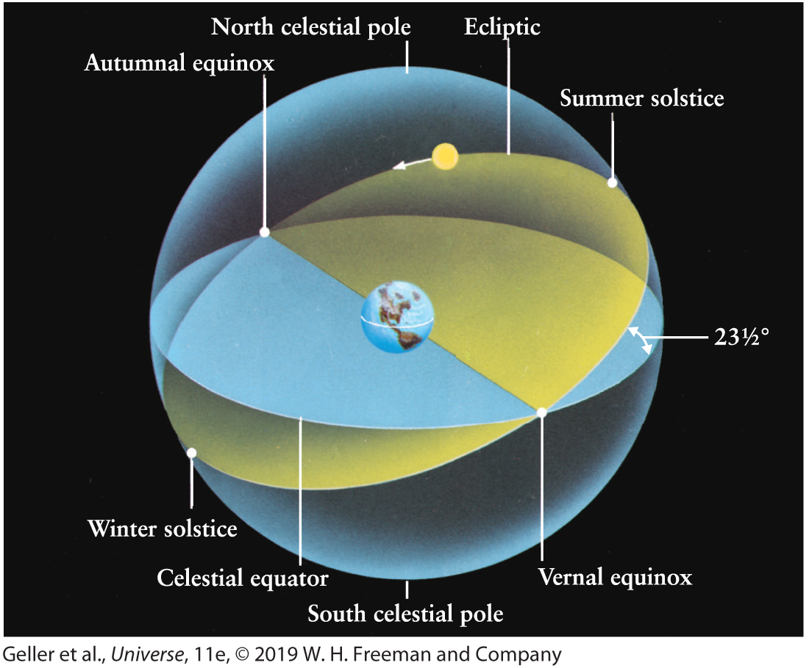
​
 | a. | the position of the Sun at summer solstice
 | b. | the ecliptic pole, or perpendicular to the direction of the ecliptic plane
 | c. | the vernal equinox, or the zero point of the right ascension on the celestial equator
 | d. | the north celestial pole, or perpendicular to the direction of the celestial equator

ANSWER: | c

143. In what region of Earth would you have to be to have the Sun pass through your zenith at some time during the year?
 | a. | within the Arctic Circle
 | b. | at any latitude
 | c. | within +/– 23.5° of the equator—the tropics
 | d. | only on the equator, nowhere else

ANSWER: | c

144. If the Sun passes through your zenith sometime during the year, then you must be:
 | a. | anywhere within 23.5° of the equator.
 | b. | anywhere within 66.5° of the equator.
 | c. | exactly on the equator.
 | d. | anywhere on Earth (no limitation).

ANSWER: | a

145. If you stand at latitude 10°N, how many times during the year will the Sun pass precisely through your zenith?
 | a. | twice
 | b. | once
 | c. | never
 | d. | every day for a half a year

ANSWER: | a

146. Where would you have to be to see the south celestial pole on your horizon?
 | a. | at the North Pole
 | b. | about 1° away from the South Pole, to allow for precession
 | c. | at the South Pole
 | d. | on the equator

ANSWER: | d

147. During one complete year, an observer on the equator would be able to see what fraction of the overall sky?
 | a. | 50%
 | b. | a variable amount, depending on the person's longitude
 | c. | a variable amount, depending on which year
 | d. | 100%

ANSWER: | d

148. During one complete year, an observer at the South Pole would be able to see what fraction of the overall sky?
 | a. | 50%
 | b. | a variable amount, depending on which year
 | c. | 100%
 | d. | a variable amount, depending on the person's longitude

ANSWER: | a

149. From the North Pole:
 | a. | only stars within 66.5° of the north celestial pole can be seen.
 | b. | only half the celestial sphere can be seen on every clear night.
 | c. | only stars 23.5° above the celestial equator can be seen.
 | d. | the whole celestial sphere is visible at some time during the year.

ANSWER: | b

150. Where would you have to be in order to see the north celestial pole in your zenith?
 | a. | about 1° away from the South Pole, to account for precession
 | b. | North Pole
 | c. | South Pole
 | d. | equator

ANSWER: | b

151. If you were standing on the South Pole with the south celestial pole in your zenith at the time of the vernal equinox, where would you see the Sun all day?
 | a. | on your horizon
 | b. | 23.5° above the horizon
 | c. | well below your horizon
 | d. | at your zenith

ANSWER: | a

152. If you were at the South Pole for a full year, what would be the highest angle the Sun would reach above your horizon (at midday, of course)?
 | a. | 90°
 | b. | 0°; it would reach only the horizon.
 | c. | It would never reach above the horizon, since the South Pole is always in darkness.
 | d. | 23.5°

ANSWER: | d

153. If you were standing on the South Pole at the time of the autumnal equinox, where would you expect the Sun to be at midday?
 | a. | on your horizon
 | b. | well below your horizon
 | c. | at your zenith
 | d. | 23.5° above your horizon

ANSWER: | a

154. Where would you expect to see the Sun in your sky if you were at the North Pole at the beginning of fall (about September 21)?
 | a. | at your zenith
 | b. | about 23.5° above your horizon all day
 | c. | on the horizon
 | d. | below your horizon all day

ANSWER: | c

155. What would be the position and motion of the Sun on December 21 from the South Pole on Antarctica?
 | a. | It would rise in the east at 6 A.M. and set in the west at 6 P.M., reaching 47° above the horizon at midday.
 | b. | It would pass across the sky from the horizon at midnight to reach an angle of 23.5° above the horizon at midday and then return to the horizon.
 | c. | It would remain below the horizon for the whole 24 hours.
 | d. | It would move completely around the sky in 24 hours while maintaining an angle of 23.5° above the horizon.

ANSWER: | d

156. You view the night sky for a period of 1 hour. What changes during this hour?
 | a. | the right ascension of a particular star, like Castor in Gemini
 | b. | the declination of a particular star, like Pollux in Gemini
 | c. | the right ascension of the star at your zenith
 | d. | the position of Polaris

ANSWER: | c

157. Suppose Earth's rotation axis were straight up and down with respect to the plane of the ecliptic and not tilted. How would a person exactly at the north pole view the Sun?
 | a. | The Sun would always be below the horizon and never visible.
 | b. | The Sun would always be visible on the horizon.
 | c. | The Sun would be visible for half the year, as is the case now.
 | d. | The Sun would be visible for more than half the year, but not for the whole year.

ANSWER: | b

158. Suppose Earth's rotation axis were straight up and down with respect to the plane of the ecliptic and not tilted. Each of the following statements would be true except one. Which one would not be true?
 | a. | The stars would rise along paths perpendicular to the horizon (rather than slanted) when viewed from middle latitudes.
 | b. | Seasons, as we presently experience them, would not exist.
 | c. | Every point on Earth would experience 12 hours of sunlight and 12 hours of darkness each day.
 | d. | In general, the declinations of stars would be different from their present values.

ANSWER: | c

159. What is the definition of the vernal equinox?
 | a. | March 21
 | b. | the point on the celestial equator crossed by the local meridian at Greenwich Observatory
 | c. | the date when the Sun first enters the constellation Aries
 | d. | the point on the ecliptic where the Sun crosses the celestial equator from south to north

ANSWER: | d

160. What is the right ascension of the Sun?
 | a. | 0 hours
 | b. | 12 hours
 | c. | a number that changes only very slowly because of precession
 | d. | a number that changes significantly over a day

ANSWER: | d

161. What is the declination of the Sun?
 | a. | 0°
 | b. | 90°
 | c. | a number that changes only very slowly because of precession
 | d. | a number that changes significantly over a day

ANSWER: | d

162. What is the declination of Polaris?
 | a. | 0°
 | b. | 90°
 | c. | a number that depends on the latitude from which you are observing
 | d. | a number that changes significantly over a day

ANSWER: | b

163. In its motion across the sky against the background stars in the course of a month, the Moon appears to move about:
 | a. | 0.5° per day, its own diameter, from west to east.
 | b. | 1.0° per day, twice its diameter, from west to east.
 | c. | 0.5° per hour, its own diameter, from east to west.
 | d. | 0.5° per hour, its own diameter, from west to east.

ANSWER: | d

164. The zodiac is a:
 | a. | band of sky extending 8° on each side of the celestial equator.
 | b. | constellation representing a boat in the sky.
 | c. | band of sky extending 8° on either side of the ecliptic.
 | d. | band of sky 8° wide centered on the ecliptic.

ANSWER: | c

165. The total width of the zodiac surrounding the ecliptic plane in the sky is approximately:
 | a. | 8°.
 | b. | 16°.
 | c. | 23.5°.
 | d. | 1°.

ANSWER: | b

166. Precession is:
 | a. | the motion of Earth along its orbital path.
 | b. | a very slow conical motion of Earth's axis of rotation.
 | c. | the occasional reversal of the direction of spin of Earth.
 | d. | the daily spinning motion of Earth.

ANSWER: | b

167. Precession is:
 | a. | the slow coning motion of the spin axis of Earth, similar to that of a spinning top.
 | b. | the daily spinning motion of Earth, producing the apparent motion of the Sun and the stars.
 | c. | another name for a parade.
 | d. | the motion of Earth along its orbital path during a year.

ANSWER: | a

168. What is the significance of Polaris, the North Star?
 | a. | It has been chosen as the zero point for declination measurements because it will always be at the pole of Earth's axis, i.e., due north.
 | b. | The direction from Earth to Polaris is used as the zero line of prime meridian for measurements of right ascension.
 | c. | Polaris is near the center of the curve traced out by the rotation axis as a result of the precession of the rotation direction.
 | d. | Polaris is almost on the curve traced out by the rotation axis as a result of the precession of the rotation direction.

ANSWER: | d

169. The direction of the axis around which Earth rotates:
 | a. | always points toward Polaris, the North Star.
 | b. | precesses (wobbles) and takes about a century to go around once.
 | c. | precesses and takes many thousands of years to go around once.
 | d. | always tilts slightly toward the direction of the Sun.

ANSWER: | c

170. Precession of Earth's spin axis results in a:
 | a. | cyclic variation over a period of 1 year of the constellations visible at night from Earth.
 | b. | daily shift in the position of the observer's zenith relative to the celestial equator (for an observer at a fixed location on Earth).
 | c. | gradual shift in the angle between the ecliptic and the celestial equator.
 | d. | gradual shift of the vernal equinox along the ecliptic.

ANSWER: | d

171. A science fiction writer, writing a story about inhabitants on Earth in 14,000 C.E. who have survived a disaster that included the loss of modern navigational aids, describes them traveling due north across barren wastes by walking toward Polaris, the Pole Star. What is wrong with this situation?
 | a. | Polaris will have moved away from due north since it is moving rapidly with respect to surrounding stars.
 | b. | Polaris will no longer be due north, because of Earth's precession.
 | c. | By that time, Polaris will be due south, not due north, because of the reversal of Earth's spin axis.
 | d. | Polaris will no longer be visible since its lifetime is only a few thousand years.

ANSWER: | b

172. Polaris is our "pole star" at the present time. At approximately what time in history or in the future would the star Thuban be our "pole star?" (See Figure 2-20 of Universe, 11th ed.)
​
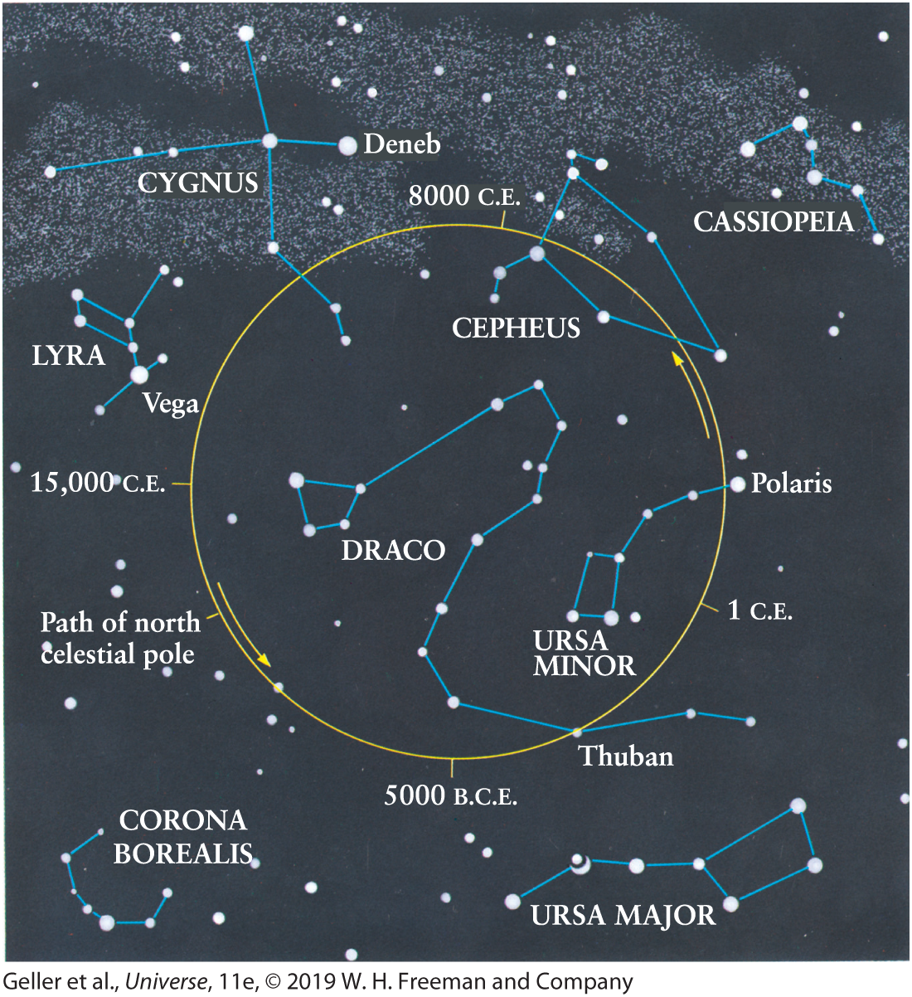
​
 | a. | never, since Polaris will always be our "pole star" when viewed from Earth
 | b. | 1 C.E.
 | c. | 3000 C.E.
 | d. | 3000 B.C.E.

ANSWER: | d

173. The position in Earth's orbit around the Sun, which presently corresponds to winter solstice, will instead correspond to summer solstice in about:
 | a. | 6500 years.
 | b. | 13,000 years.
 | c. | 19,500 years.
 | d. | 26,000 years.

ANSWER: | b

174. Precession of Earth's axis of rotation is caused by:
 | a. | changes in the rate of rotation (length of the day) of Earth caused primarily by the gravitational pull of the Moon.
 | b. | changes in the shape of Earth's orbit due to the gravitational pull of the Moon.
 | c. | the gravitational pull of the Moon and the Sun on the equatorial bulge of Earth.
 | d. | changes in the shape of Earth's orbit due to the gravitational pull of the Sun.

ANSWER: | c

175. The reason for the slow movement of the vernal equinox through the sky against the background stars over long periods of time is the:
 | a. | precession of the spin axis of Earth.
 | b. | overall movement of local stars in the sky.
 | c. | movement of the Sun in the Milky Way Galaxy.
 | d. | motion of Earth in its orbit.

ANSWER: | a

176. The phenomenon of precession of Earth's spin axis is caused by the:
 | a. | varying intensity of sunlight on Earth throughout the year.
 | b. | tidal ebb and flow of ocean waters on Earth.
 | c. | variation of the spin rate of Earth.
 | d. | gravitational pull of the Moon and the Sun on Earth's equatorial bulge.

ANSWER: | d

177. If the polar axis of Earth precesses through a full circle (See Figure 2-20 of Universe, 11th ed.) in 26,000 years, how many years will it take for the line between the axis and the center of the circle to move through 1°?
​
​
 | a. | 720
 | b. | 0.014
 | c. | 7.2
 | d. | 72

ANSWER: | d

178. To what constellation will the north celestial pole be closest in the year 14,000 C.E.? (See Figure 2-20 of Universe, 11th ed.)
​
​
 | a. | Draco
 | b. | Lyra
 | c. | Cepheus
 | d. | Ursa Major, since the north celestial pole never moves

ANSWER: | b

179. The precessional motion of the north celestial pole of Earth over a period of 26,000 years is a circle of 47° diameter in the northern sky. The equivalent motion of the south celestial pole is:
 | a. | a circle of 47° diameter, covered in 26,000 years.
 | b. | a much smaller circle, covered in 26,000 years.
 | c. | a circle of 47° diameter, covered in a much shorter time, about 1000 years.
 | d. | the south celestial pole does not move at all during this precession.

ANSWER: | a

180. The time that will elapse before the spin axis of Earth points toward the present pole star again as a result of precession is:
 | a. | 9 years.
 | b. | at least 1 million years.
 | c. | 13,000 years.
 | d. | 26,000 years.

ANSWER: | d

181. The slow coning pattern of the spin axis of Earth's precession will move the end of this axis in a complete circle in a period of:
 | a. | 26 million years.
 | b. | 26,000 years.
 | c. | 2600 years.
 | d. | 1 year.

ANSWER: | b

182. The position of the vernal equinox in the sky is at present in the constellation:
 | a. | Ursa Major.
 | b. | Pisces.
 | c. | Aquarius.
 | d. | Aries.

ANSWER: | b

183. Do the astronomical coordinates of right ascension and declination of a star change systematically night by night?
 | a. | They do not change, since they are positions on a fixed star chart.
 | b. | Yes, because of the motion of Earth in its orbit around the Sun.
 | c. | Yes, because of the bending of light by Earth's atmosphere.
 | d. | Yes, because of the precession of Earth's spin axis.

ANSWER: | d

184. Earlier in this chapter we discussed some ancient buildings that were constructed so that they were aligned to the rising of the Sun at vernal equinox or some other important astronomical date. How does the precession of the equinoxes affect these alignments in a building, say, 2000 years old?
 | a. | The alignments of such a building should still be perfect.
 | b. | The alignments will vary slightly, but after a mere 2000 years the discrepancy in alignment will be almost too small to measure.
 | c. | The alignments will vary significantly after 2000 years, but only for buildings within 23.5° of the equator.
 | d. | The alignments will vary significantly after 2000 years for buildings anywhere on Earth.

ANSWER: | d

185. The Moon's equatorial plane is nearly the same as:
 | a. | Earth's equatorial plane.
 | b. | the ecliptic.
 | c. | the plane passing through both poles and the zenith (for an observer on Earth).
 | d. | the plane passing through both poles and the vernal equinox (for an observer on Earth).

ANSWER: | b

186. In 1 year the apparent path of the Sun through the background of the stars passes through:
 | a. | only the 12 zodiac constellations defined by the ancients.
 | b. | the 12 zodiac constellations plus the constellation Ophiuchus.
 | c. | only 11 of the original 12 zodiac constellations: The path no longer passes through Aries.
 | d. | only the north circumpolar constellations.

ANSWER: | b

187. Which one of the following does not change due to the precession of Earth's spin axis?
 | a. | the right ascension of a typical star
 | b. | the declination of a typical star
 | c. | the date of the vernal equinox
 | d. | the definition of the zero of the system of right ascension

ANSWER: | d

188. Which direction in an observer's sky is not always on his or her meridian?
 | a. | the zenith
 | b. | the north celestial pole
 | c. | due south on the horizon
 | d. | the vernal equinox

ANSWER: | d

189. An observer's meridian passes through:
 | a. | his or her zenith and the north and south celestial poles.
 | b. | his or her zenith and the east and west positions on his or her horizon.
 | c. | the north and south celestial poles and the vernal equinox position.
 | d. | his or her zenith and the vernal and autumnal equinoxes.

ANSWER: | a

190. A given star in the sky will reach its highest point for a particular observer when it passes through the:
 | a. | zodiac.
 | b. | ecliptic plane.
 | c. | meridian.
 | d. | celestial equator.

ANSWER: | c

191. An observer's celestial meridian is the:
 | a. | arc joining the north and south celestial poles through the observer's zenith.
 | b. | extension of the horizon onto the sky.
 | c. | plane of Earth's orbit extended onto the sky.
 | d. | extension of Earth's equator onto the sky.

ANSWER: | a

192. The line on the sky joining the north and south celestial poles through a person's zenith is known as the
 | a. | meridian.
 | b. | celestial equator.
 | c. | zodiac.
 | d. | horizon.

ANSWER: | a

193. The star grouping Leo (the lion) extends for about 30° along and close to the celestial equator. At low to mid-latitudes, roughly how long does it take Leo to rise above the horizon?
 | a. | 5 hours
 | b. | 30 seconds
 | c. | 30 minutes
 | d. | 2 hours

ANSWER: | d

194. By observing the sky closely night by night, you would note that a particular star rises:
 | a. | at a varying time every night, sometimes earlier, sometimes later than a specified time.
 | b. | about 4 minutes later every night.
 | c. | about 4 minutes earlier every night.
 | d. | at the same time every night.

ANSWER: | c

195. Any star (except the Sun), when viewed from low and mid-latitudes, rises in the east:
 | a. | about 1 hour later each evening.
 | b. | about 4 minutes later each evening.
 | c. | about 4 minutes earlier each evening.
 | d. | at the same time each evening.

ANSWER: | c

196. The Big Dipper, or Ursa Major, will return to the same position in an observer's sky in what time period in solar time?
 | a. | 24 hours 4 minutes
 | b. | 365.25 days
 | c. | 23 hours 56 minutes
 | d. | 24 hours exactly

ANSWER: | c

197. The Sun appears to be about 0.5° in diameter. On the equator, approximately how long does it take for the Sun to set, from first contact with the horizon to the Sun completely below that horizon?
 | a. | 2 seconds
 | b. | 4 minutes
 | c. | 2 minutes
 | d. | about 1 hour

ANSWER: | c

198. When viewed from Earth, Venus subtends an angle of about 1 arcmin (1/60°) when it is at the closest point to Earth in its orbit. If you were watching Venus set in the west over a clear horizon (e.g., ocean), how long would it take from Venus first reaching the horizon to Venus completely setting below the horizon?
 | a. | 0.25 seconds
 | b. | about 4 seconds
 | c. | about 4 minutes
 | d. | almost instantaneous (much less than 1 second)

ANSWER: | b

199. If a person on the equator sees a particular star cross the horizon at 10 P.M. (2200 hours) on a particular night, what time would the same person (at the same location) see that star cross the horizon on the next night?
 | a. | 10:04 P.M.
 | b. | This star will not rise the next night and will be seen again only after 1 year.
 | c. | 10:00 P.M.
 | d. | 9:56 P.M.

ANSWER: | d

200. On December 1 at 10 P.M., the bright star Procyon will just be rising on the eastern horizon. At approximately what time would you see this star rising on Christmas Day (24 days later)?
 | a. | 9:36 P.M.
 | b. | 11:36 P.M.
 | c. | 10:00 P.M.
 | d. | 8:24 P.M.

ANSWER: | d

201. At 10 P.M. on December 1, the bright star Procyon is seen to rise on the eastern horizon. At approximately what time will this star rise 7 days later, on December 8?
 | a. | 10:28 P.M.
 | b. | 9:53 P.M.
 | c. | 9:32 P.M.
 | d. | 10:00 P.M.

ANSWER: | c

202. A sundial is not considered to be a good timekeeper because:
 | a. | the sky is often cloudy.
 | b. | Earth's rotation rate changes throughout the year.
 | c. | the Sun's large angular diameter produces a fuzzy shadow.
 | d. | Earth's orbital speed around the ecliptic is variable.

ANSWER: | d

203. Time, as indicated by an uncorrected sundial, can differ from true time by as much as 15 minutes at certain times of the year. This is because:
 | a. | Earth moves non-uniformly along an orbit inclined to the celestial equator.
 | b. | the Sun moves with respect to the background stars because of our motion on an orbiting Earth.
 | c. | the time zones are poorly defined on Earth's surface, leading to time errors that vary through the year.
 | d. | Earth's rotation rate varies throughout the year.

ANSWER: | a

204. Sidereal time is the more fundamental time, since it is a measure of the true rotation rate of Earth. Why then do we govern our lives by solar time rather than sidereal time?
 | a. | We cannot divide the day into 24 equal hours of sidereal time.
 | b. | In sidereal time, the Sun would reach the meridian early or late, sometimes by as much as 17 minutes at certain times of the year.
 | c. | Different clocks tick at different rates depending on latitude in sidereal time.
 | d. | We wish to remain in time with the Sun's illumination on Earth, with high Sun angle at about midday every day.

ANSWER: | d

205. The difference between 1 second of sidereal time and 1 second of solar time is:
 | a. | very small but variable because of the variable motion of Earth in its orbit.
 | b. | 0, since they are defined to be equal.
 | c. | a very small but finite and fixed interval of time.
 | d. | very large, because 1 sidereal second measures a fraction of 1 year while 1 solar second measures the same fraction of 1 solar day.

ANSWER: | c

206. At a particular time, the vernal equinox passes through the celestial meridian of an observer. What is the sidereal time at that site?
 | a. | 12 hours (noon) exactly
 | b. | 0 hours (midnight) exactly
 | c. | variable, depending on the observer's latitude
 | d. | variable, depending on the time of year

ANSWER: | b

207. The beginning of a sidereal day (at midnight, sidereal time) at any location on Earth is defined by the passage of the:
 | a. | pole star through the lower meridian at that site.
 | b. | Sun through the position of the vernal equinox.
 | c. | vernal equinox through the upper meridian at that site.
 | d. | pole star through the upper meridian at that site.

ANSWER: | c

208. I record the time in New York and know that it is the same time in California. This scenario can be true if the time I am measuring is:
 | a. | solar time only.
 | b. | sidereal time only.
 | c. | UTC only.
 | d. | any of these.

ANSWER: | c

209. The distorting effects of Earth's atmosphere are minimized when you observe in the direction of:
 | a. | the pole star.
 | b. | the eastern horizon.
 | c. | the upper meridian.
 | d. | the lower meridian.

ANSWER: | c

210. Sidereal clocks are based on the position of:
 | a. | the Sun.
 | b. | the vernal equinox.
 | c. | Polaris.
 | d. | the summer solstice.

ANSWER: | b

211. A calendar year, from vernal equinox to vernal equinox, is called a:
 | a. | tropical year.
 | b. | sidereal year.
 | c. | solar year.
 | d. | vernal year.

ANSWER: | a

212. Which of the following were leap years according to the calendar then in use: 1000, 1492, 1600, 1776?
 | a. | just 1600
 | b. | just 1492 and 1776
 | c. | all except 1600
 | d. | all of these years

ANSWER: | d

213. The direction of Earth's rotation about its axis is the same as the direction of its revolution about the Sun. How does a solar day compare to a sidereal day on Earth?
 | a. | A solar day is always longer.
 | b. | A sidereal day is always longer.
 | c. | They are always the same length.
 | d. | A sidereal day is longer when Earth is farther from the Sun (northern summer), but a solar day is longer when Earth is closer to the Sun (northern winter).

ANSWER: | a

214. A solar day is the time it takes Earth to rotate around its axis between two consecutive solar positions (i.e., high noon to high noon or sunset to sunset). A sidereal day is the time it takes Earth to rotate around its axis between two consecutive positions of a distant star (i.e., Vega on the eastern horizon to Vega again on the eastern horizon). Which is longer?
 | a. | A solar day is always longer.
 | b. | A sidereal day is always longer.
 | c. | They are always the same length.
 | d. | A sidereal day is longer when Earth is farther from the Sun (northern summer), but a solar day is longer when Earth is closer to the Sun (northern winter).

ANSWER: | a

215. The tropical year is about 20 minutes shorter than the sidereal year. What does this tell you about precession?
 | a. | The vernal equinox moves eastward along the ecliptic.
 | b. | The vernal equinox moves westward along the ecliptic.
 | c. | The vernal equinox remains fixed on the ecliptic, but the Sun progressively changes its apparent position against the background stars from one sidereal year to the next.
 | d. | This time difference has nothing to do with the precession of the equinoxes.

ANSWER: | b

