**Chapter 2**

**Test Bank**

**Type: multiple choice question**

**Title:** Chapter 02 Question 01

**1)** Why is the New Testament a problematic source for understanding the historical Jesus?

**Feedback:** Rise of Christianity

**Page reference:** 28

\***a.** It is more concerned with the meaning of his ministry than fact

**b.** It is an objective biography of Jesus that omits important symbolism

**c.** The Gospels were not written until several centuries after Jesus’ death

**d.** The Gospels are aimed exclusively at a Roman audience

**Type: multiple choice question**

**Title:** Chapter 02 Question 02

**2)** Which of the following best describes the growth of Christianity in the West?

**Feedback:** Rise of Christianity

**Page reference:** 30

**a.** Immediately popular among Jews only

**b.** State-supported from the start

\***c.** Slow, uncertain, and subject to persecution

**d.** Driven by violence

**Type: fill-in-blank**

**Title:** Chapter 02 Question 03

**3)** _________ is the term for a divinely appointed savior in the Jewish tradition.

**Feedback:** Rise of Christianity

**Section reference:** p. 30

**a.** Messiah

**Type: multiple choice question**

**Title:** Chapter 02 Question 04

**4)** Which of the following Jewish sects refers to spiritual reformers who sought mystical union with the divine?

**Feedback:** Before Christ

**Page reference:** 31

**a.** Pharisees

**b.** Sadducees

**c.** Zealots

\***d.** Essenes

**Type: multiple choice question**

**Title:** Chapter 02 Question 05

**5)** How did the Roman religion typically treat other polytheisms?

**Feedback:** Growth of the New Religion

**Page reference:** 33

**a.** It rejected them as enemy religions

\***b.** It accommodated and incorporated them

**c.** It replaced its own deities with new ones

**d.** It paid no attention to them

**Type: multiple response question**

**Title:** Chapter 02 Question 06

**6)** Which of the following are properties of mystery religions? (Select all that apply)

**Feedback:** Growth of the New Religion

**Page reference:** 31

\***a.** A priesthood that held spiritual power

**b.** Veneration of the *Lares*

**c.** State-based rituals

\***d.** Belief in sacred and eternal mysteries

**Type: fill-in-blank**

**Title:** Chapter 02 Question 07

**7)** __________ was the individual primarily responsible for spreading Christianity widely and highlighting its distinction from Judaism.

**Feedback:** Growth of the New Religion

**Section reference:** 29

**a.** Paul

**Type: multiple response question**

**Title:** Chapter 02 Question 08

**8)** Which of the following contributed to Roman persecution of Christians? (Select all that apply)

**Feedback:** The Problem of Persecution

**Page reference:** 40

**a.** Christian belief in a god other than those the Romans worshipped

\***b.** Christian tendencies to worship privately

\***c.** Christian refusal to serve in the Roman army

\***d.** Christian denunciation of state gods

**Type: fill-in-blank**

**Title:** Chapter 02 Question 09

**9)** __________ was the emperor who inflicted the worst persecution on Christians.

**Feedback:** The Problem of Persecution

**Section reference:** p. 41

**a.** Diocletian

**Type: fill-in-blank**

**Title:** Chapter 02 Question 10

**10)** __________ means a system of rational thought that elucidates divine mysteries, serving as the cornerstone of religion.

**Feedback:** The Problem of Heresy

**Section reference:** p. 43

**a.** Theology

**Type: multiple choice question**

**Title:** Chapter 02 Question 11

**11)** Which of the following best describes the state of early Christianity around the age of persecutions?

**Feedback:** The Problem of Heresy

**Page reference:** 43

**a.** A clear, central authority that dictated doctrine

**b.** A series of authorities that all agreed on doctrine

**c.** A single community that misinterpreted Jesus’ teachings

\***d.** A fractured series of communities that struggled to define doctrine

**Type: multiple response question**

**Title:** Chapter 02 Question 12

**12)** Which heresies threatened the doctrinal unity of early Christianity? (Select all that apply)

**Feedback:** The Problem of Heresy

**Page reference:** 44

**a.** Catharism

\***b.** Donatism

**c.** Gnosticism

\***d.** Arianism

**Type: multiple choice question**

**Title:** Chapter 02 Question 13

**13)** Which of the following is NOT a contribution Constantine made to the growth of Christianity in the fourth century?

**Feedback:** Constantine and Theodosius

**Page reference:** 46-47

\***a.** Requiring all Roman citizens to convert to Christianity

**b.** Building basilicas like St Peter’s

**c.** Legally ending imperial persecution

**d.** Educating and providing resources for priests

**Type: multiple choice question**

**Title:** Chapter 02 Question 14

**14)** What purpose did the Nicene Creed serve?

**Feedback:** Constantine and Theodosius

**Page reference:** 47

**a.** It placed the emperor in charge of the Christian Church

**b.** It established a precedent of flexibility regarding Christian doctrine

\***c.** It laid out a formal declaration of orthodox Christian beliefs

**d.** It reconciled Arian and orthodox Christian beliefs

**Type: multiple choice question**

**Title:** Chapter 02 Question 15

**15)** What event of 391 CE decisively cleared a path for Christianity’s growth?

**Feedback:** Constantine and Theodosius

**Page reference:** 49

\***a.** Theodosius declared Christianity the official religion of the empire

**b.** Theodosius declared Christianity one of the official religions of the empire

**c.** Constantine converted to Christianity

**d.** Constantine passed the Edict of Milan

**Type: multiple choice question**

**Title:** Chapter 02 Question 16

**16)**

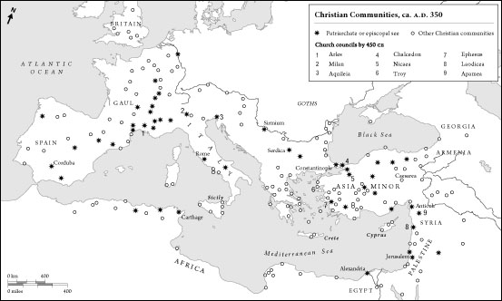

What is true about the church councils called before 450 CE?

**Feedback:** Constantine and Theodosius

**Page reference:** 51

**a.** They are geographically centered around Rome

\***b.** They are geographically diverse, from Western Europe to the Near East

**c.** They all occur in Western Europe

**d.** They all occur in the Near East

**Type: multiple choice question**

**Title:** Chapter 02 Question 17

**17)**

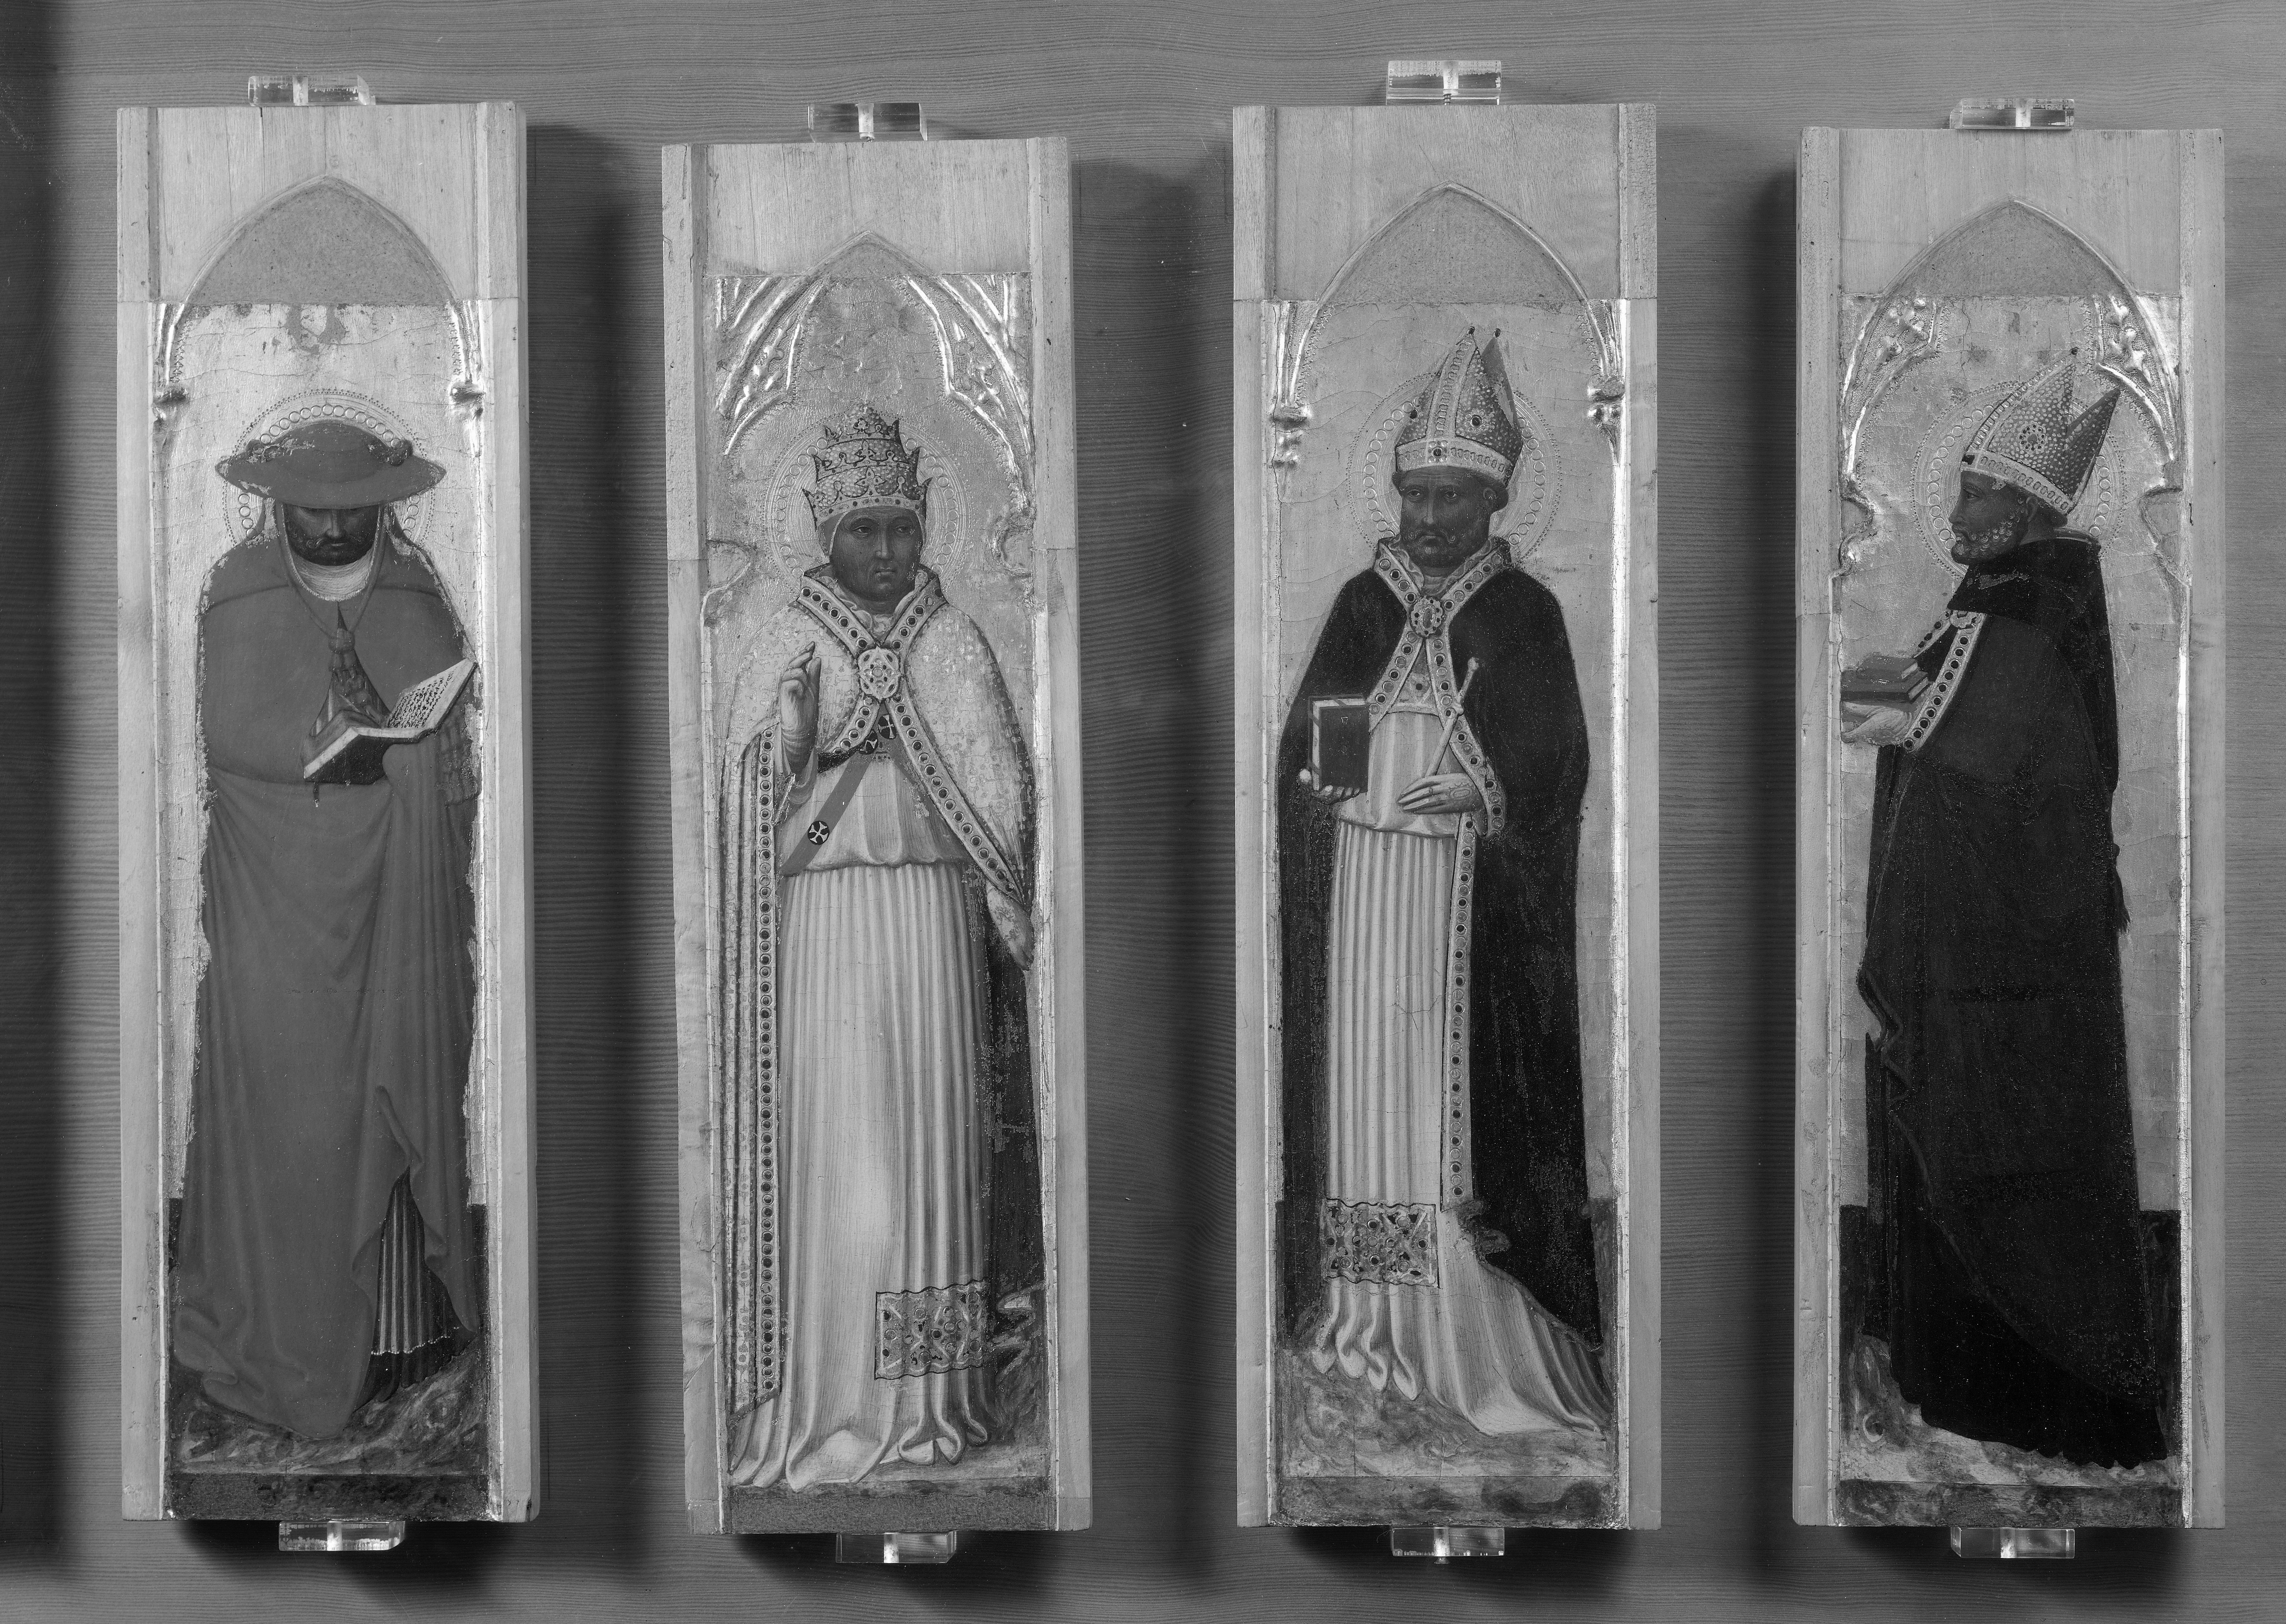

What figures does this painting depict?

**Feedback:** Responses to Imperialization

**Page reference:** 53

**a.** Saints martyred by Diocletian

**b.** Emperors who supported Christianity

**c.** The leaders of heresies

\***d.** The Latin Doctors

**Type: fill-in-blank**

**Title:** Chapter 02 Question 18

**18)** ___________ refers to St Jerome’s translation of the Bible into Latin.

**Feedback:** Responses to Imperialization

**Section reference:** p. 55

**a.** Vulgate

**Type: multiple choice question**

**Title:** Chapter 02 Question 19

**19)** What philosophy inspired St Augustine to focus on the difference between the material and spiritual worlds?

**Feedback:** Responses to Imperialization

**Page reference:** 57

**a.** Manichaeism

\***b.** Neo-Platonism

**c.** Donatism

**d.** Aristotelianism

**Type: fill-in-blank**

**Title:** Chapter 02 Question 20

**20)** The sack of __________ heralded the end of the world for many fifth-century people.

**Feedback:** Responses to Imperialization

**Section reference:** p. 56

**a.** Rome