Package Title: Testbank

# Course Title: The World Today 8e

## Chapter Number: Chapter 02

Question type: Multiple-Choice

1) The two leading languages spoken in Canada are:

a) English and Spanish

b) English and French

c) English and Canadian

d) Canadian and French

e) French and Spanish

Answer: b

Difficulty: Easy

Learning Objective: Delineate the realm and identify the main geographic features.

Standard 1: Bloom's || Knowledge

Section Reference: Defining the Realm

2) More than 2/3rds of Canada's exports go to:

a) The United States

b) The United Kingdom

c) China

d) Japan

e) Mexico

Answer: a

Difficulty: Easy

Learning Objective: Delineate the realm and identify the main geographic features.

Standard 1: Bloom's || Knowledge

Section Reference: Defining the Realm

3) The physiographic region called the Canadian Shield:

a) contains enormous mineral resources

b) is an intermontane zone

c) consists of extensive mountainous terrain

d) is bordered on the west by the Appalachian Mountains

e) is also known as the Arctic Coastal Plain

Answer: a

Difficulty: Medium

Learning Objective: Identify the main landforms, climate, and impacts of climate change.

Standard 1: Bloom's || Knowledge

Section Reference: North America’s Physiography

4) Which of the following States contains territory located in the Intermontane Basins and Plateaus physiographic province?

a) Wisconsin

b) Texas

c) Pennsylvania

d) Nevada

e) New York

Answer: d

Difficulty: Hard

Learning Objective: Identify the main landforms, climate, and impacts of climate change.

Standard 1: Bloom's || Knowledge

Section Reference: North America’s Physiography

5) The Great Lakes' main outlet to the sea is the:

a) Mississippi River

b) St. Lawrence Seaway

c) Erie Canal

d) Columbia River

e) There is no outlet to the sea.

Answer: b

Difficulty: Medium

Learning Objective: Identify the main landforms, climate, and impacts of climate change.

Standard 1: Bloom's || Knowledge

Section Reference: North America’s Physiography

6) A continental climate is most likely to be found in the State of:

a) Maine

b) Oregon

c) Florida

d) Hawai'i

e) Kansas

Answer: e

Difficulty: Medium

Learning Objective: Identify the main landforms, climate, and impacts of climate change.

Standard 1: Bloom's || Application

Section Reference: North America’s Physiography

7) The rain-shadow effect is felt most strongly in which physiographic province of North America?

a) The Rocky Mountains

b) The Gulf-Atlantic Plain

c) The Interior Lowlands

d) The Great Plains

e) The Canadian Shield

Answer: d

Difficulty: Hard

Learning Objective: Identify the main landforms, climate, and impacts of climate change.

Standard 1: Bloom's || Application

Section Reference: North America’s Physiography

8) According to Figure 2-4, the highest elevation in North America lies within this physiographic province:

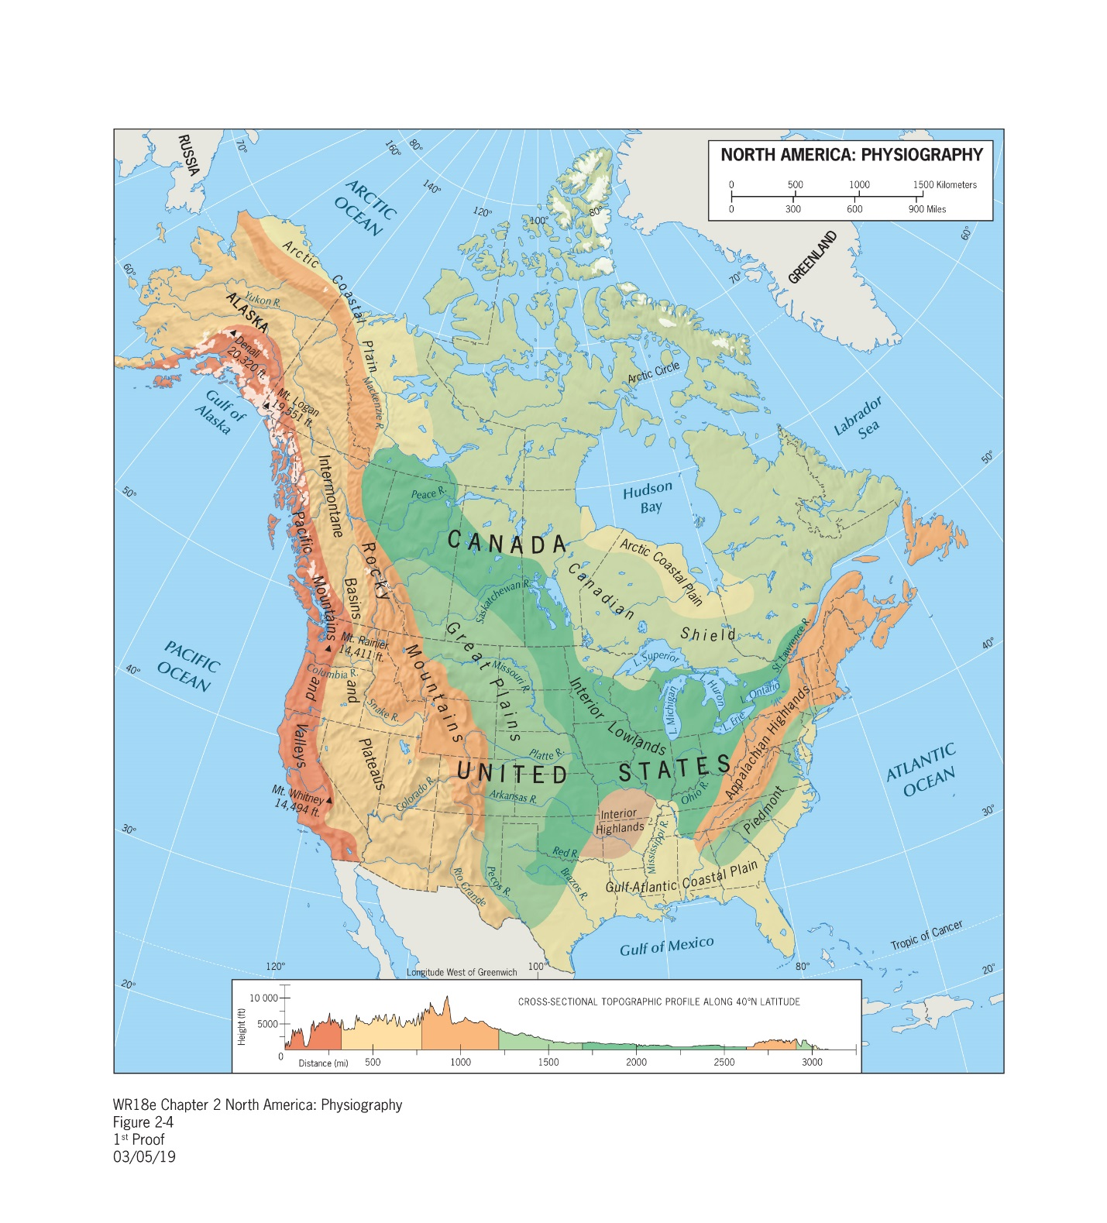

a) Pacific Mountains and Valleys

b) Intermontane Valleys and Plateaus

c) Rocky Mountains

d) Canadian Shield

e) Appalachian Mountains

Answer: c

Difficulty: Medium

Learning Objective: Identify the main landforms, climate, and impacts of climate change.

Standard 1: Bloom's || Application

Section Reference: North America’s Physiography

9) The rain-shadow effect would be most evident in which direction relative to the Rocky Mountains?

1. east
2. south
3. southwest
4. west
5. northwest

Answer: a

Difficulty: Medium

Learning Objective: Identify the main landforms, climate, and impacts of climate change.

Standard 1: Bloom's || Application

Section Reference: North America’s Physiography

10) The indigenous peoples called Native Americans in the U.S. are known as __________ in Canada.

a) Native Canadians

b) Indians

c) Aboriginals

d) Saskatchewans

e) First Nations

Answer: e

Difficulty: Medium

Learning Objective: Appreciate the historical context of Native Americans and European settlers.

Standard 1: Bloom's || Knowledge

Section Reference: Native Americans and European Settlement

11) The two European powers that most influenced the territory that became Canada were the:

a) French and Russians

b) British and Russians

c) French and British

d) Dutch and Spanish

e) Spanish and Portuguese

Answer: c

Difficulty: Easy

Learning Objective: Appreciate the historical context of Native Americans and European settlers.

Standard 1: Bloom's || Knowledge

Section Reference: Native Americans and European Settlement

12) Mormonism is most widespread in which of the following regions:

a) Northern Frontier

b) Continental Interior

c) Maritime Northeast

d) Southwest

e) The Rocky Mountains Region

Answer: e

Difficulty: Easy

Learning Objective: Appreciate the historical context of Native Americans and European settlers.

Standard 1: Bloom's || Knowledge

Section Reference: Native Americans and European Settlement

13) Washington D.C. is to the United States as _________ is to Canada.

a) Winnipeg

b) Ottawa

c) Toronto

d) Vancouver

e) Montreal

Answer: b

Difficulty: Easy

Learning Objective: Understand the federal structure of government and distribution of natural resources across administrative boundaries.

Standard 1: Bloom's || Application

Section Reference: The Federal Map of North America

14) According to Figure 2-7, which of the following is a major natural gas producing State?

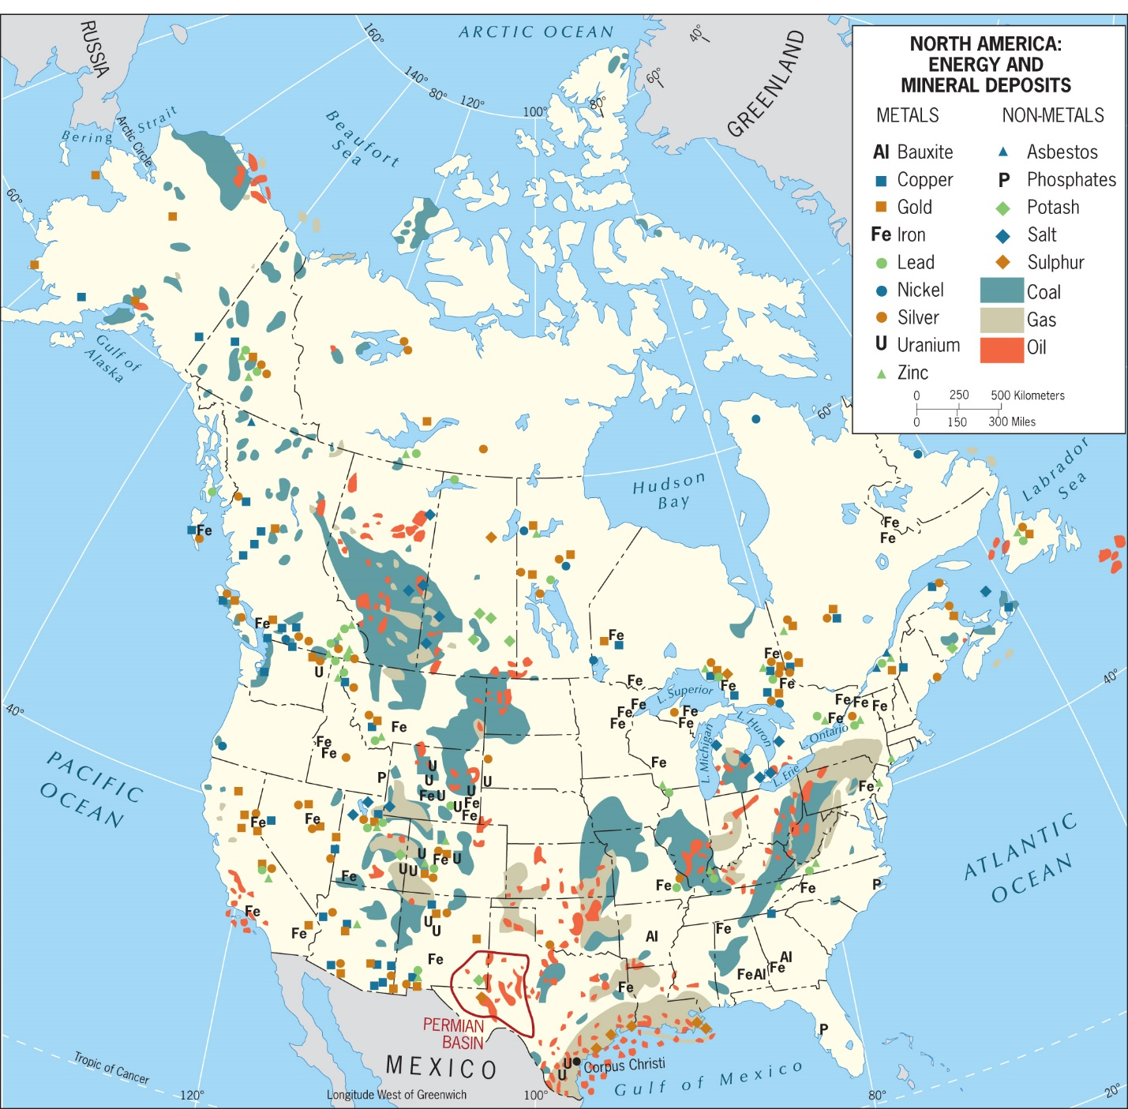

a) Wisconsin

b) New York

c) Florida

d) Texas

e) Arizona

Answer: d

Difficulty: Medium

Learning Objective: Understand the federal structure of government and distribution of natural resources across administrative boundaries.

Standard 1: Bloom's || Application

Section Reference: The Federal Map of North America

15) According to Figure 2-7, which province in Canada has significant coal deposits?



a) Ontario

b) Yukon Territory

c) Manitoba

d) Alberta

e) Quebec

Answer: d

Difficulty: Medium

Learning Objective: Understand the federal structure of government and distribution of natural resources across administrative boundaries.

Standard 1: Bloom's || Application

Section Reference: The Federal Map of North America

16) According to Figure 2-7, the North Slope of Alaska contains large quantities of:



a) tar sands

b) diamonds

c) gas

d) coal and oil

e) marine life

Answer: d

Difficulty: Medium

Learning Objective: Understand the federal structure of government and distribution of natural resources across administrative boundaries.

Standard 1: Bloom's || Application

Section Reference: The Federal Map of North America

17) According to Figure 2-7, what mineral deposit in addition to oil and gas is located along the coastline of the Gulf of Mexico?



a) Lead

b) Nickel

c) Silver

d) Sulphur

e) Gold

Answer: d

Difficulty: Medium

Learning Objective: Understand the federal structure of government and distribution of natural resources across administrative boundaries.

Standard 1: Bloom's || Application

Section Reference: The Federal Map of North America

18) According to Figure 2-7, which of the following states or provinces does not contain coal or oil reserves?



a) Alberta

b) Wyoming

c) Oklahoma

d) Illinois

e) Florida

Answer: e

Difficulty: Medium

Learning Objective: Understand the federal structure of government and distribution of natural resources across administrative boundaries.

Standard 1: Bloom's || Application

Section Reference: The Federal Map of North America

19) Which is the only one of the Great Lakes situated entirely within the borders of the United States?

1. Superior
2. Michigan
3. Huron
4. Erie
5. Ontario

Answer: b

Difficulty: Medium

Learning Objective: Understand the federal structure of government and distribution of natural resources across administrative boundaries.

Standard 1: Bloom's || Knowledge

Section Reference: The Federal Map of North America

20) Which city is not located in the American Manufacturing Belt?

a) Chicago

b) Pittsburgh

c) Kansas City

d) Toronto

e) New York

Answer: c

Difficulty: Medium

Learning Objective: Understand the interrelated development of urbanization and industrialization, and subsequent deindustrialization and suburbanization.

Standard 1: Bloom's || Knowledge

Section Reference: Urbanization and The Spatial Economy

21) The development of America’s multinodal pattern of urban development began ________.

a) early in the 21stcentury

b) during the Industrial Revolution

c) in the post-World War II era

d) around 1900

e) during the 1980s

Answer: c

Difficulty: Hard

Learning Objective: Understand the interrelated development of urbanization and industrialization, and subsequent deindustrialization and suburbanization.

Standard 1: Bloom's || Knowledge

Section Reference: Urbanization and The Spatial Economy

22) The logging industry embodies the ____________ sector of a nation’s economy.

a) primary

b) secondary

c) tertiary

d) quaternary

e) quinary

Answer: a

Difficulty: Easy

Learning Objective: Understand the interrelated development of urbanization and industrialization, and subsequent deindustrialization and suburbanization.

Standard 1: Bloom's || Knowledge

Section Reference: Urbanization and The Spatial Economy

23) Gentrification would likely occur in this urban realm of the typical American city.

a) West

b) Northwest

c) East

d) Southeast

e) Central or Downtown

Answer: e

Difficulty: Hard

Learning Objective: Understand the interrelated development of urbanization and industrialization, and subsequent deindustrialization and suburbanization.

Standard 1: Bloom's || Knowledge

Section Reference: Urbanization and The Spatial Economy

24) Which of the following political units was created in the late 1990s in response to a major aboriginal land claim?

a) Newfoundland and Labrador

b) the Northeast Territory

c) Alaska

d) Nunavut

e) Quebec

Answer: d

Difficulty: Medium

Learning Objective: Discuss Canada’s spatial and social divisions involving First Nations and the divisions among English and French speakers.

Standard 1: Bloom's || Knowledge

Section Reference: Regionalism in Canada: Divisive Forces

25) Montreal and the lower course of the St. Lawrence Seaway are located in the Canadian province of ________.

a) British Columbia

b) Alberta

c) Nova Scotia

d) Quebec

e) Ontario

Answer: d

Difficulty: Easy

Learning Objective: Discuss Canada’s spatial and social divisions involving First Nations and the divisions among English and French speakers.

Standard 1: Bloom's || Knowledge

Section Reference: Regionalism in Canada: Divisive Forces

26) Canada’s largest city on its Pacific coast is:

a) Montreal

b) Toronto

c) Anchorage

d) Vancouver

e) Calgary

Answer: d

Difficulty: Easy

Learning Objective: Discuss Canada’s spatial and social divisions involving First Nations and the divisions among English and French speakers.

Standard 1: Bloom's || Knowledge

Section Reference: Regionalism in Canada: Divisive Forces

27) Which of the following is one of Canada's Atlantic Provinces?

a) New Brunswick

b) British Columbia

c) Nunavut

d) Quebec

e) Alberta

Answer: a

Difficulty: Medium

Learning Objective: Discuss Canada’s spatial and social divisions involving First Nations and the divisions among English and French speakers.

Standard 1: Bloom's || Knowledge

Section Reference: Regionalism in Canada: Divisive Forces

28) Which of the following is one of Canada's Prairie Provinces?

a) Nova Scotia

b) British Columbia

c) Manitoba

d) Newfoundland and Labrador

e) Prince Edward Island

Answer: c

Difficulty: Easy

Learning Objective: Discuss Canada’s spatial and social divisions involving First Nations and the divisions among English and French speakers.

Standard 1: Bloom's || Knowledge

Section Reference: Regionalism in Canada: Divisive Forces

29) The majority of Canadians live ____________________.

a) close to the U.S. border

b) in the western provinces

c) in the Atlantic provinces

d) in rural area

e) on the shores of Lake Michigan and Superior

Answer: a

Difficulty: Easy

Learning Objective: Discuss Canada’s spatial and social divisions involving First Nations and the divisions among English and French speakers.

Standard 1: Bloom's || Knowledge

Section Reference: Regionalism in Canada: Divisive Forces

30) Over the past half-century, divisive or devolutionary forces in Canada have been strongest in _______.

a) Nunavut

b) Nova Scotia

c) Newfoundland and Labrador

d) British Columbia

e) Quebec

Answer: e

Difficulty: Medium

Learning Objective: Discuss Canada’s spatial and social divisions involving First Nations and the divisions among English and French speakers.

Standard 1: Bloom's || Knowledge

Section Reference: Regionalism in Canada: Divisive Forces

31) Quebec's cross-border linkages to the U.S. are most strongly developed with the State of:

a) Ohio

b) Maine

c) New York

d) Michigan

e) Massachusetts

Answer: c

Difficulty: Medium

Learning Objective: Discuss Canada’s spatial and social divisions involving First Nations and the divisions among English and French speakers.

Standard 1: Bloom's || Knowledge

Section Reference: Regionalism in Canada: Divisive Forces

32) The Southwest Region of North America has the largest cluster of _________ in the United States.

a) Hispanic Americans

b) African Americans

c) Asian Americans

d) Native Americans

e) European Americans

Answer: a

Difficulty: Medium

Learning Objective: Discuss the position of large ethnic and racial minorities and their spatial distribution.

Standard 1: Bloom's || Knowledge

Section Reference: Regionalism and Ethnicity in the United States

33) Which U.S. State contains the largest number of Asian Americans?

a) Texas

b) New York

c) Illinois

d) Alaska

e) California

Answer: e

Difficulty: Medium

Learning Objective: Discuss the position of large ethnic and racial minorities and their spatial distribution.

Standard 1: Bloom's || Knowledge

Section Reference: Regionalism and Ethnicity in the United States

34) The most numerous among Americans who would identify themselves as Asian are:

a) Japanese

b) Filipino

c) Korean

d) Chinese

e) Vietnamese

Answer: d

Difficulty: Medium

Learning Objective: Discuss the position of large ethnic and racial minorities and their spatial distribution.

Standard 1: Bloom's || Knowledge

Section Reference: Regionalism and Ethnicity in the United States

35) According to Figure 2-17, which of the following North American regions is located only in the United States?

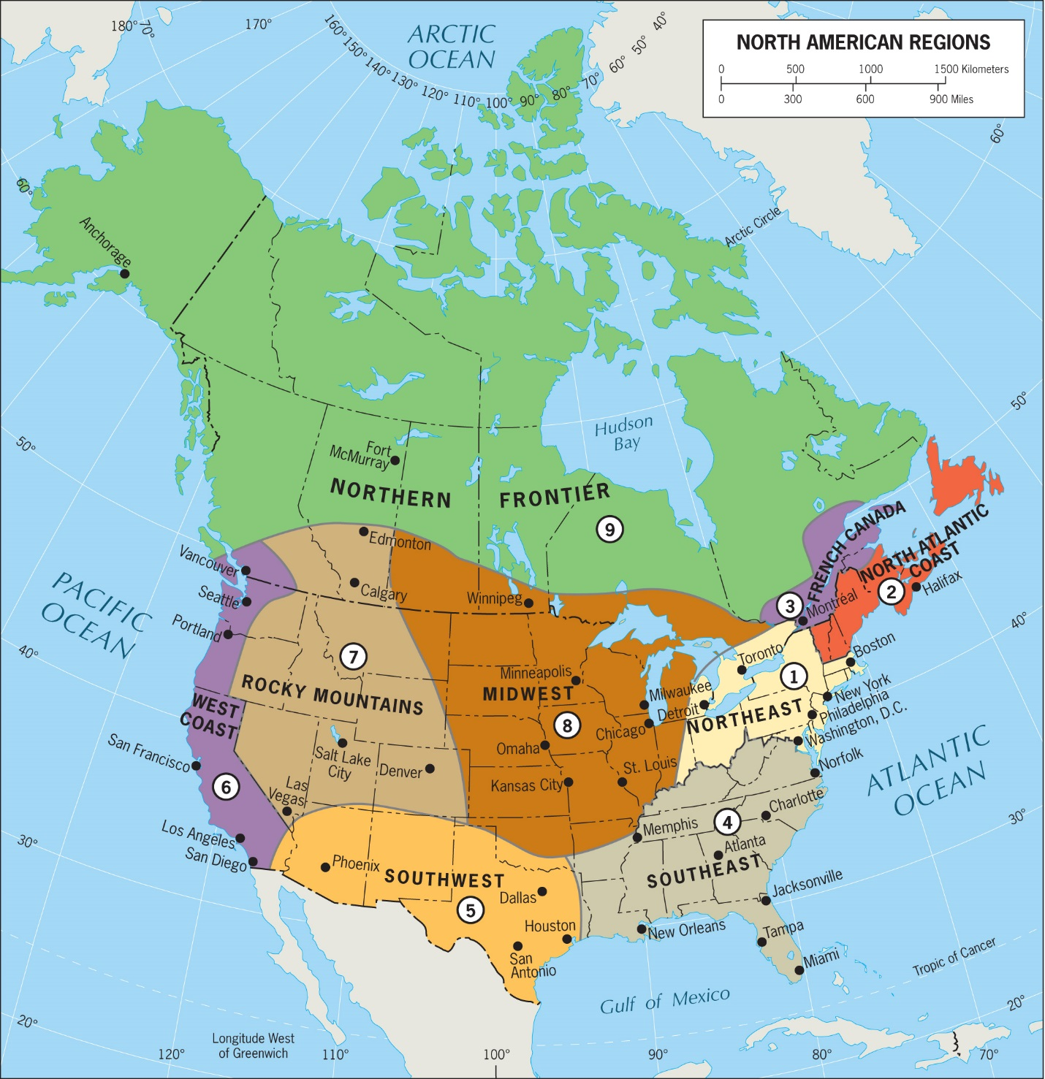

a) The Continental Interior

b) The Maritime Northeast

c) The Southeast

d) The Pacific Hinge

e) The Northern Frontier

Answer: c

Difficulty: Easy

Learning Objective: Discuss the main 9 regions of the realm.

Standard 1: Bloom's || Application

Section Reference: Regions of North America

36) Which region of North America contains the most important agricultural area of this realm?

a) The Midwest

b) The Western Frontier

c) The Southwest

d) The Northern Frontier

e) North American’s Historic Core

Answer: a

Difficulty: Easy

Learning Objective: Discuss the main 9 regions of the realm.

Standard 1: Bloom's || Knowledge

Section Reference: Regions of North America

37) Northern New England's strongest cultural and economic links to Canada are with:

a) Quebec

b) the Atlantic provinces

c) British Columbia

d) the St. Lawrence Valley

e) metropolitan Montreal

Answer: b

Difficulty: Easy

Learning Objective: Discuss the main 9 regions of the realm.

Standard 1: Bloom's || Knowledge

Section Reference: Regions of North America

38) Which of the following is not part of North America's primary Francophone area?

a) southern Quebec

b) northern New Brunswick

c) northernmost New Hampshire

d) southern Louisiana

e) metropolitan Montreal

Answer: d

Difficulty: Hard

Learning Objective: Discuss the main 9 regions of the realm.

Standard 1: Bloom's || Knowledge

Section Reference: Regions of North America

39) Canada's Francophone population in New Brunswick are known as the:

a) Cajuns

b) First Nations

c) Acadians

d) Old Brunswickers

e) Prince Edward Islanders

Answer: c

Difficulty: Hard

Learning Objective: Discuss the main 9 regions of the realm.

Standard 1: Bloom's || Knowledge

Section Reference: Regions of North America

40) The North American region that has undergone the most change over the past 50 years is:

a) the Southeast

b) North America’s Historic Core

c) the Pacific Hinge

d) The Western Frontier

e) French Canada

Answer: a

Difficulty: Medium

Learning Objective: Discuss the main 9 regions of the realm.

Standard 1: Bloom's || Knowledge

Section Reference: Regions of North America

41) The North American region with the greatest disparity in income between rich and poor is:

a) the Southeast

b) the Maritime Northeast

c) the Southwest

d) New England/Atlantic Provinces

e) the Western Frontier

Answer: a

Difficulty: Medium

Learning Objective: Discuss the main 9 regions of the realm.

Standard 1: Bloom's || Knowledge

Section Reference: Regions of North America

42) The Southwest is a region comprised of majority:

a) blacks

b) Alaskans

c) Hispanics

d) First Nations

e) None of the answer choices are correct

Answer: c

Difficulty: Easy

Learning Objective: Discuss the main 9 regions of the realm.

Standard 1: Bloom's || Knowledge

Section Reference: Regions of North America

43) Which of the following cities is not a component of the Southwest's productive technopoles?

a) Dallas

b) San Antonio

c) Fort Worth

d) Phoenix

e) Houston

Answer: d

Difficulty: Medium

Learning Objective: Discuss the main 9 regions of the realm.

Standard 1: Bloom's || Knowledge

Section Reference: Regions of North America

44) This subregion is a hub of international trade and the northern anchor of a North American Free Trade Agreement general transnational growth corridor that extends into Mexico as far south as Monterrey.

1. The West Coast
2. The Southwest
3. The Southeast
4. French Canada
5. The Midwest

Answer: b

Difficulty: Medium

Learning Objective: Discuss the main 9 regions of the realm.

Standard 1: Bloom's || Knowledge

Section Reference: Regions of North America

45) The U.S. city that is associated with the Mortgage Meltdown preceding the Great Recession of 2008-2010 is:

a) Detroit

b) Las Vegas

c) Atlanta

d) Boston

e) St. Louis

Answer: b

Difficulty: Medium

Learning Objective: Discuss the main 9 regions of the realm.

Standard 1: Bloom's || Knowledge

Section Reference: Regions of North America

46) Utah, Nevada, Idaho, and western Colorado are all located in the:

a) Rocky Mountains Region

b) Continental Interior

c) Northern Frontier

d) Southwest

e) Pacific Hinge

Answer: a

Difficulty: Easy

Learning Objective: Discuss the main 9 regions of the realm.

Standard 1: Bloom's || Knowledge

Section Reference: Regions of North America

47) Which of the following cities is not located in the Rocky Mountain region?

a) Las Vegas, Nevada

b) Phoenix, Arizona

c) Denver, Colorado

d) Salt Lake City, Utah

e) Boise, Idaho

Answer: b

Difficulty: Medium

Learning Objective: Discuss the main 9 regions of the realm.

Standard 1: Bloom's || Knowledge

Section Reference: Regions of North America

48) The North American region that is the largest but the least densely settled is the:

a) Northern Frontier

b) Continental Interior

c) Maritime Northeast

d) Southwest

e) Western Frontier

Answer: a

Difficulty: Easy

Learning Objective: Discuss the main 9 regions of the realm.

Standard 1: Bloom's || Knowledge

Section Reference: Regions of North America

49) The North American region in which First Nations are a leading cultural force is:

a) Northern Frontier

b) Continental Interior

c) Maritime Northeast

d) Southwest

e) Western Interior

Answer: a

Difficulty: Easy

Learning Objective: Discuss the main 9 regions of the realm.

Standard 1: Bloom's || Knowledge

Section Reference: Regions of North America

50) The major mountain range of the West Coast region is the:

a) Rockies

b) Sierra Nevada

c) Black Hills

d) Cascades

e) Wasatch

Answer: d

Difficulty: Easy

Learning Objective: Discuss the main 9 regions of the realm.

Standard 1: Bloom's || Knowledge

Section Reference: Regions of North America

51) _________ is the most influenced by Asians of any metropolis in North America.

a) Denver

b) Vancouver

c) Seattle

d) New York

e) Chicago

Answer: b

Difficulty: Hard

Learning Objective: Discuss the main 9 regions of the realm.

Standard 1: Bloom's || Knowledge

Section Reference: Regions of North America

52) According to Figure 2-20, Canada's Boreal forest lies in all of the following provinces or territories except:

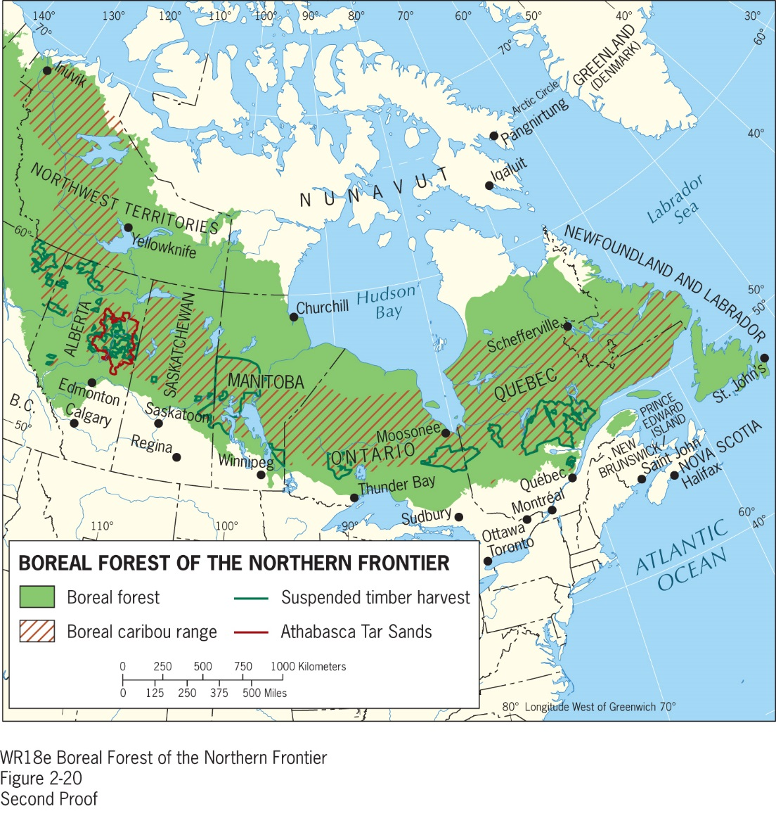

a) Nunavut

b) Manitoba

c) Quebec

d) Ontario

e) Newfoundland and Labrador

Answer: a

Difficulty: Easy

Learning Objective: Discuss the main 9 regions of the realm.

Standard 1: Bloom's || Application

Section Reference: Regions of North America

Question Type: True/False

53) Canada’s population is growing as rapidly as that in the US.

Answer: False

Difficulty: Easy

Learning Objective: Delineate the realm and identify the main geographic features.

Standard 1: Bloom's || Knowledge

Section Reference: Defining the Realm

54) Both Canada and the U.S. exhibit a high degree of cultural pluralism.

Answer: True

Difficulty: Easy

Learning Objective: Delineate the realm and identify the main geographic features.

Standard 1: Bloom's || Knowledge

Section Reference: Defining the Realm

55) African Americans constitute about 25 percent of the U.S. population.

Answer: False

Difficulty: Easy

Learning Objective: Delineate the realm and identify the main geographic features.

Standard 1: Bloom's || Knowledge

Section Reference: Defining the Realm

56) The Rocky Mountains and Great Plains are examples of physiographic regions.

Answer: True

Difficulty: Easy

Learning Objective: Identify the main landforms, climate, and impacts of climate change.

Standard 1: Bloom's || Knowledge

Section Reference: North America’s Physiography

57) The intermontane region of North America is found in eastern Canada.

Answer: False

Difficulty: Medium

Learning Objective: Identify the main landforms, climate, and impacts of climate change.

Standard 1: Bloom's || Knowledge

Section Reference: North America’s Physiography

58) Yearly temperature ranges are much larger in the interior of continents.

Answer: True

Difficulty: Easy

Learning Objective: Identify the main landforms, climate, and impacts of climate change.

Standard 1: Bloom's || Knowledge

Section Reference: North America’s Physiography

59) The rain shadow effect has its greatest influence on the climate of Los Angeles and other Pacific-bordering cities.

Answer: False

Difficulty: Medium

Learning Objective: Identify the main landforms, climate, and impacts of climate change.

Standard 1: Bloom's || Application

Section Reference: North America’s Physiography

60) The predominant religion in the South is Roman Catholicism.

Answer: False

Difficulty: Easy

Learning Objective: Appreciate the historical context of Native Americans and European settlers.

Standard 1: Bloom's || Knowledge

Section Reference: Native Americans and European Settlement

61) Americans are more religious than the rest of the Western world.

Answer: True

Difficulty: Easy

Learning Objective: Appreciate the historical context of Native Americans and European settlers.

Standard 1: Bloom's || Knowledge

Section Reference: Native Americans and European Settlement

62) Like the U.S., Canada is a federal state.

Answer: True

Difficulty: Easy

Learning Objective: Understand the federal structure of government and distribution of natural resources across administrative boundaries.

Standard 1: Bloom's || Knowledge

Section Reference: The Federal Map of North America

63) The Canadian Shield is a high-elevation geological feature that has almost no natural resources.

Answer: False

Difficulty: Easy

Learning Objective: Understand the federal structure of government and distribution of natural resources across administrative boundaries.

Standard 1: Bloom's || Knowledge

Section Reference: The Federal Map of North America

64) California is the most populous State in the U.S.

Answer: True

Difficulty: Easy

Learning Objective: Understand the federal structure of government and distribution of natural resources across administrative boundaries.

Standard 1: Bloom's || Knowledge

Section Reference: The Federal Map of North America

65) Most Americans today are employed in the primary sector of the economy.

Answer: False

Difficulty: Medium

Learning Objective: Understand the interrelated development of urbanization and industrialization, and subsequent deindustrialization and suburbanization.

Standard 1: Bloom's || Knowledge

Section Reference: Urbanization and The Spatial Economy

66) The Great Recession has had a more negative impact in Canada than in the United States.

Answer: False

Difficulty: Easy

Learning Objective: Understand the interrelated development of urbanization and industrialization, and subsequent deindustrialization and suburbanization.

Standard 1: Bloom's || Knowledge

Section Reference: Urbanization and The Spatial Economy

68) Since the 1960s the population center of gravity in the United States has not changed.

Answer: False

Difficulty: Easy

Learning Objective: Discuss the historical patterns of mobility and immigration, and current debates about immigration in relation to multiculturalism and demography.

Standard 1: Bloom's || Knowledge

Section Reference: The Making of a Multicultural Realm

69) Nunavut is a new aboriginal province in northern Quebec.

Answer: False

Difficulty: Medium

Learning Objective: Discuss Canada’s spatial and social divisions involving First Nations and the divisions among English and French speakers.

Standard 1: Bloom's || Knowledge

Section Reference: Regionalism in Canada: Divisive Forces

70) Quebec successfully seceded from Canada in 2007.

Answer: False

Difficulty: Easy

Learning Objective: Discuss Canada’s spatial and social divisions involving First Nations and the divisions among English and French speakers.

Standard 1: Bloom's || Knowledge

Section Reference: Regionalism in Canada: Divisive Forces

71) New England has a strong cultural and economic affinity with the Atlantic provinces of Canada.

Answer: True

Difficulty: Easy

Learning Objective: Discuss the main 9 regions of the realm.

Standard 1: Bloom's || Knowledge

Section Reference: Regions of North America

72) Newfoundland and Labrador are Canada's easternmost province.

Answer: True

Difficulty: Easy

Learning Objective: Discuss the main 9 regions of the realm.

Standard 1: Bloom's || Knowledge

Section Reference: Regions of North America

73) Wheat farming is, in general, located to the west of corn farming in the U.S.

Answer: True

Difficulty: Medium

Learning Objective: Discuss the main 9 regions of the realm.

Standard 1: Bloom's || Application

Section Reference: Regions of North America

74) The population of The Midwest region is in decline.

Answer: True

Difficulty: Easy

Learning Objective: Discuss the main 9 regions of the realm.

Standard 1: Bloom's || Knowledge

Section Reference: Regions of North America

75) The growth of the Hispanic population is occurring throughout the Southeast and Southwest Regions.

Answer: True

Difficulty: Medium

Learning Objective: Discuss the main 9 regions of the realm.

Standard 1: Bloom's || Knowledge

Section Reference: Regions of North America

76) In the Southeastern United States _____ has evolved in a world-city, a globally linked, southward-orientated conduit between North America and the rest of the hemisphere.

1. Miami, FL
2. Phoenix, AZ
3. Detroit, MI
4. Austin, TX
5. Charlotte, NC

Answer: e

Difficulty: Easy

Learning Objective: Discuss the main 9 regions of the realm.

Standard 1: Bloom's || Knowledge

Section Reference: Regions of North America

77) Alaska is located in the Rocky Mountain region.

Answer: False

Difficulty: Easy

Learning Objective: Discuss the main 9 regions of the realm.

Standard 1: Bloom's || Knowledge

Section Reference: Regions of North America

78) The Rocky Mountain region includes the States of Utah, Nevada, New Mexico, and western Colorado.

Answer: False

Difficulty: Easy

Learning Objective: Discuss the main 9 regions of the realm.

Standard 1: Bloom's || Knowledge

Section Reference: Regions of North America

79) The Las Vegas area is the fastest growing part of the Northern Frontier.

Answer: False

Difficulty: Easy

Learning Objective: Discuss the main 9 regions of the realm.

Standard 1: Bloom's || Knowledge

Section Reference: Regions of North America

80) The Northern Frontier is the largest region in North America.

Answer: True

Difficulty: Easy

Learning Objective: Discuss the main 9 regions of the realm.

Standard 1: Bloom's || Knowledge

Section Reference: Regions of North America

81) The Canadian Shield is mostly located in the Northern Frontier region.

Answer: True

Difficulty: Easy

Learning Objective: Discuss the main 9 regions of the realm.

Standard 1: Bloom's || Knowledge

Section Reference: Regions of North America

82) The Northern Frontier has significant quantities of raw materials, including oil.

Answer: True

Difficulty: Easy

Learning Objective: Discuss the main 9 regions of the realm.

Standard 1: Bloom's || Knowledge

Section Reference: Regions of North America

83) Unlike most of the rest of the western half of the U.S., most of the Pacific coast has adequate rainfall.

Answer: True

Difficulty: Easy

Learning Objective: Discuss the main 9 regions of the realm.

Standard 1: Bloom's || Knowledge

Section Reference: Regions of North America

84) Vancouver has the largest Asian influence of any large metropolis in North America.

Answer: True

Difficulty: Easy

Learning Objective: Discuss the main 9 regions of the realm.

Standard 1: Bloom's || Knowledge

Section Reference: Regions of North America

Question type: Text-entry

85) The westernmost and largest of the five Great Lakes is Lake___.

Answer: Superior

Difficulty: Easy

Learning Objective: Identify the main landforms, climate, and impacts of climate change.

Standard 1: Bloom's || Knowledge

Section Reference: North America’s Physiography

86) The northward extension of the Sierra Nevada Mountains through the states of Oregon and Washington is called the __________ Mountains.

Answer: Cascade

Difficulty: Easy

Learning Objective: Identify the main landforms, climate, and impacts of climate change.

Standard 1: Bloom's || Knowledge

Section Reference: North America’s Physiography

87) The outlet to the sea for the Great Lakes is the __________ Seaway.

Answer: St. Lawrence

Difficulty: Easy

Learning Objective: Identify the main landforms, climate, and impacts of climate change.

Standard 1: Bloom's || Knowledge

Section Reference: North America’s Physiography

88) The three leading fossil fuels are petroleum (oil), natural gas, and___.

Answer: coal

Difficulty: Easy

Learning Objective: Understand the federal structure of government and distribution of natural resources across administrative boundaries.

Standard 1: Bloom's || Knowledge

Section Reference: The Federal Map of North America

89) Secondary economic activities involve jobs in the __________ sector, which is engaged in the transformation of raw materials into finished products.

Answer: manufacturing; industrial

Difficulty: Easy

Learning Objective: Understand the interrelated development of urbanization and industrialization, and subsequent deindustrialization and suburbanization.

Standard 1: Bloom's || Knowledge

Section Reference: Urbanization and The Spatial Economy

90) Since the 1960s, the advent of widespread ___ __________ helped speed the population boom of the Sunbelt States of the U.S. southern tier.

Answer: air-conditioning

Difficulty: Medium

Learning Objective: Understand the interrelated development of urbanization and industrialization, and subsequent deindustrialization and suburbanization.

Standard 1: Bloom's || Knowledge

Section Reference: Urbanization and the Spatial Economy

91) Montreal and the lower course of the St. Lawrence River are located in the Canadian province of___.

Answer: Quebec

Difficulty: Easy

Learning Objective: Discuss the main 9 regions of the realm.

Standard 1: Bloom's || Knowledge

Section Reference: Regions of North America

92) In recent decades, _____ have boosted the regional economy of the North Atlantic Coast.

1. Fishing and logging
2. Logging and manufacturing
3. Recreation and tourism
4. Tourism and energy resources
5. Oil and natural gas resources

Answer: c

Difficulty: Medium

Learning Objective: Discuss the main 9 regions of the realm.

Standard 1: Bloom's || Knowledge

Section Reference: Regions of North America

93) The only U.S. State that lies within the Northern Frontier region is __________.

Answer: Alaska

Difficulty: Easy

Learning Objective: Discuss the main 9 regions of the realm.

Standard 1: Bloom's || Knowledge

Section Reference: Regions of North America

Learning Objective: Understand the interrelated development of urbanization and industrialization, and subsequent deindustrialization and suburbanization.

Standard 1: Bloom's || Application

Section Reference: Urbanization and The Spatial Economy

94) View Figure 2-10 and apply your knowledge of the North American Freight Market. Which of the following is NOT a major contributor as to why Savannah has been expanding its port?

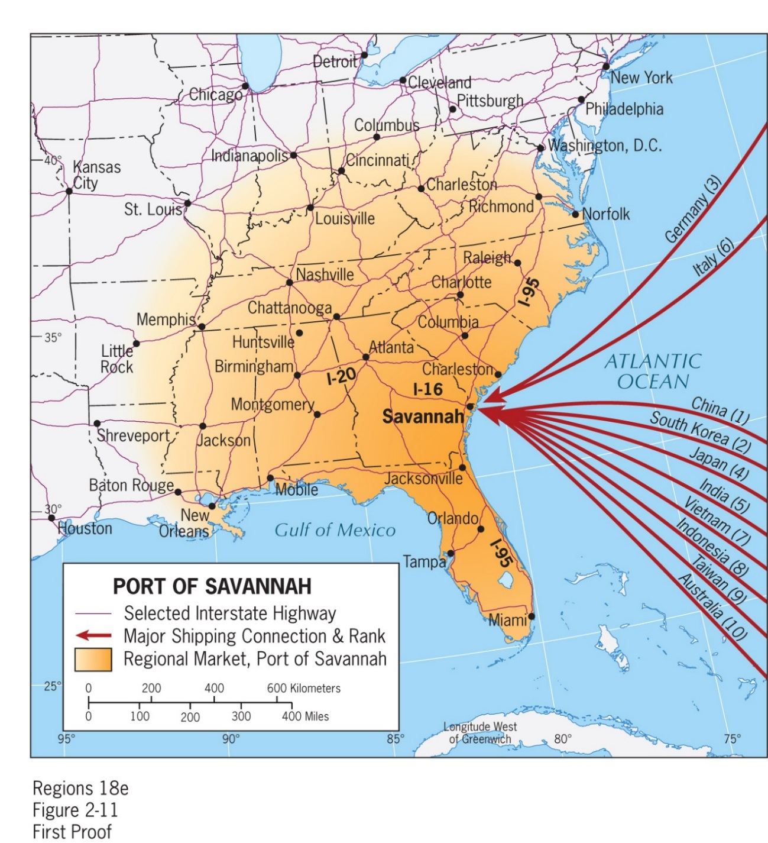

a) It is in an area prone to hurricanes.

b) It has interstates running in the directions of north, south, and west.

c) Its port is ice free year-round.

d) It is relatively close to the Panama Canal.

e) None of the answer choices are correct

Answer: a

Difficulty: Medium

Learning Objective: Understand the interrelated development of urbanization and industrialization, and subsequent deindustrialization and suburbanization.

Standard 1: Bloom's || Application

Section Reference: Urbanization and The Spatial Economy

95) Think of the information economy that is emerging in places like Silicon Valley, Washington State, and Research Triangle Park in North Carolina. Which of the following are major contributors to growth?

a) high speed internet

b) excellent airports

c) research universities

d) good weather

e) All of the answer choices are correct

Answer: e

Difficulty: Medium

Learning Objective: Describe the emergence of the information economy and influence on cities, along with the emergency of polycentric urban centers.

Standard 1: Bloom's || Application

Section Reference: The Information Economy and City Regions

96) According to the text, which factor contributes most to homelessness in places like Los Angeles, San Francisco, and New York?

a) The local climate is mild enough for the homeless to survive outdoors.

b) Rising incomes for some lead to higher housing costs for all.

c) There are more drug addicts in California and New York.

d) California and New York do not allocate resources to combating the homeless situation.

e) There are not enough homeless shelters.

Answer: b

Difficulty: Medium

Learning Objective: Describe the spatial dimensions of inequality in the realm, especially the urban-rural divide and intra-urban disparities.

Standard 1: Bloom's || Application

Section Reference: Geographies of Inequality

97) The strongest stance, in North America, and elsewhere, tends to be in geographic areas where cultural diversity is less pronounced.

Answer: True

Difficulty: Medium

Learning Objective: Discuss the historical patterns of mobility and immigration, and current debates about immigration in relation to multiculturalism and demography.

Standard 1: Bloom's || Application

Section Reference: The Making of a Multicultural Realm

98) Use your knowledge of the U.S. population. If Hispanics number around 57 million, about what percentage of the U.S. population is of Hispanic origin?

a) 1/2

b) 1/4

c) 1/8

d) 1/3

e) 1/6

Answer: e

Difficulty: Medium

Learning Objective: Discuss the historical patterns of mobility and immigration, and current debates about immigration in relation to multiculturalism and demography.

Standard 1: Bloom's || Application

Section Reference: The Making of a Multicultural Realm

99) Choose the best definition of gentrification.

a) An area with increasing numbers of gentlemen’s clubs.

b) An area with an aging population.

c) An area where the revitalization and upgrading of crumbling downtown neighborhoods are made over for more upscale housing and shops.

d) An area with a crumbling and declining downtown.

e) None of the answer choices are correct.

Answer: c

Difficulty: Medium

Learning Objective: Describe the emergence of the information economy and influence on cities, along with the emergency of polycentric urban centers.

Standard 1: Bloom's || Knowledge

Section Reference: The Information Economy and City Regions

100) What is a gig economy?

a) A primitive economy where a community supports itself from gig fishing.

b) A downtown concentration of musical hotspots, where musicians gig, play instruments or sing, for a living.

c) An urban economy where proximity is as fundamental as advanced technology to working professionals.

d) An urban poor economy, where day laborers work gig or day jobs, by standing on a street corner waiting for homeowners or contractors to hire them.

e) None of the answer choices are correct.

Answer: c

Difficulty: Medium

Learning Objective: Describe the emergence of the information economy and influence on cities, along with the emergency of polycentric urban centers.

Standard 1: Bloom's || Knowledge

Section Reference: The Information Economy and City Regions

101) Choose a great example of an east coast polycentric urban area.

a) Richmond, VA-Washington, D.C.

b) Fort Lauderdale-Miami.

c) New York-Philadelphia.

d) Raleigh-Charlotte.

e) All of the answer choices are correct.

Answer: b

Difficulty: Medium

Learning Objective: Describe the emergence of the information economy and influence on cities, along with the emergency of polycentric urban centers.

Standard 1: Bloom's || Knowledge

Section Reference: The Information Economy and City Regions

102) GPS was invented by _____.

a) the Department of Defense

b) manufacturers of smartphones

c) developers of self-driving vehicles

d) by urban planners

e) NASA

Answer: a

Difficulty: Medium

Learning Objective: Describe the emergence of the information economy and influence on cities, along with the emergency of polycentric urban centers.

Standard 1: Bloom's || Knowledge

Section Reference: The Information Economy and City Regions

103) Since the 1970s, the number of families living in middle-income neighborhoods has fallen by approximately_____.

a) 3/4

b) 1/2

c) 1/3

d) 1/4

e) 1/10

Answer: c

Difficulty: Medium

Learning Objective: Describe the spatial dimensions of inequality in the realm, especially the urban-rural divide and intra-urban disparities.

Standard 1: Bloom's || Knowledge

Section Reference: Geographies of Inequality

104) This city has the most unequal income distribution in the United States.

a) Miami

b) Atlanta

c) York

d) San Francisco

e) Los Angeles

Answer: b

Difficulty: Medium

Learning Objective: Describe the spatial dimensions of inequality in the realm, especially the urban-rural divide and intra-urban disparities.

Standard 1: Bloom's || Knowledge

Section Reference: Geographies of Inequality

105) What is the leading factor in housing segregation in the United States?

a) income

b) race

c) class

d) ethnicity

e) religion

Answer: a

Difficulty: Medium

Learning Objective: Describe the spatial dimensions of inequality in the realm, especially the urban-rural divide and intra-urban disparities.

Standard 1: Bloom's || Knowledge

Section Reference: Geographies of Inequality

106) The neighborhood effect describes that your neighborhood primarily impacts your_____.

a) exposure to toxins

b) access to jobs

c) mindset and outlook on life

d) religion

e) None of the above are correct.

Answer: c

Difficulty: Medium

Learning Objective: Describe the spatial dimensions of inequality in the realm, especially the urban-rural divide and intra-urban disparities.

Standard 1: Bloom's || Comprehension

Section Reference: Geographies of Inequality

107) Approximately what percentage of the United States’ population is foreign born?

a) 50%

b) just under 25%

c) about 15%

d) about 33%

e) 1/6

Answer: c

Difficulty: Medium

Learning Objective: Discuss the historical patterns of mobility and immigration, and current debates about immigration in relation to multiculturalism and demography.

Standard 1: Bloom's || Application

Section Reference: The Making of a Multicultural Realm

108) Approximately what percentage of the Canadian population is foreign born?

a) 50%

b) 33%

c) 13%

d) 77%

e) 22%

Answer: e

Difficulty: Medium

Learning Objective: Discuss the historical patterns of mobility and immigration, and current debates about immigration in relation to multiculturalism and demography.

Standard 1: Bloom's || Application

Section Reference: The Making of a Multicultural Realm

109) American has long been known as a melting pot. What best describes a mosaic culture?

a) Communities where many different cultural groups live side by side.

b) Communities where people of similar cultural backgrounds live near each other and primarily socialize among their group.

c) Communities that are segregated by class.

d) Communities that are segregated by race.

e) None of the answer choices are correct.

Answer: b

Difficulty: Medium

Learning Objective: Discuss the historical patterns of mobility and immigration, and current debates about immigration in relation to multiculturalism and demography.

Standard 1: Bloom's || Comprehension

Section Reference: The Making of a Multicultural Realm

110) This group is primarily settled in the western United States.

a) aboriginal inhabitants

b) blacks

c) Asians

d) whites

e) Hispanics

Answer: a

Difficulty: Medium

Learning Objective: Discuss the position of large ethnic and racial minorities and their spatial distribution.

Standard 1: Bloom's || Knowledge

Section Reference: Regionalism and Ethnicity in the United States

111) This group relocated to the industrial heartland in great numbers during the 20th century.

a) aboriginal inhabitants

b) blacks

c) Asians

d) whites

e) Hispanics

Answer: b

Difficulty: Medium

Learning Objective: Discuss the position of large ethnic and racial minorities and their spatial distribution.

Standard 1: Bloom's || Knowledge

Section Reference: Regionalism and Ethnicity in the United States

© John Wiley & Sons, Inc. or the author, All rights reserved. Instructors who are authorized users of this course are permitted to download these materials and use them in connection with the course. Except as permitted herein or by law, no part of these materials should be reproduced, stored in a retrieval system, or transmitted, in any form or by any means, electronic, mechanical, photocopying, recording or otherwise.