**Chapter 02 - Origins of the Cold War**

**Test Bank**

**Type: multiple choice question**

**Title:** Chapter 2 Question 1

**1)** Soviet suspicion of the United States went back to

**Feedback:** Soviet suspicion of the United States went back to America’s hostile reaction to the Bolshevik revolution itself.

**Section reference:** The Historical Context

**a.** World War I

\***b.** The hostile US reaction to the Bolshevik revolution

**c.** Disagreements between Roosevelt and Stalin during World War II

**d.** The Berlin Blockade

**Type: multiple choice question**

**Title:** Chapter 2 Question 2

**2)** Unlike the Soviets, the US presented its foreign policy as based in

**Feedback:**  America’s historic reluctance to use arguments of self-interest as a basis for foreign policy undoubtedly reflected a belief that, in a democracy, people would not support foreign ventures inconsistent with their own sense of themselves as a noble and just country. This forced national leaders to invoke moral, even religious, idealism as a basis for actions that might well fall short of moral expectations.

**Section reference:** The Historical Context

**a.** Isolationism

**b.** National self-interest

\***c.** Morals and idealism

**d.** Reluctant leadership

**Type: multiple choice question**

**Title:** Chapter 2 Question 3

**3)** The Soviet Union’s priority during World War II was to gain

**Feedback:** The Soviet Union’s priorities during World War II were much more directly expressed than their Allies—they wanted security. The Soviets sought a sphere of influence over which they could have unrestricted control.

**Section reference:** The Historical Context

\***a.** Security

**b.** Free trade

**c.** The free exchange of ideas

**d.** The victory of the working class

**Type: multiple choice question**

**Title:** Chapter 2 Question 4

**4)** Soviet deaths during World War II totaled

**Feedback:** Soviet deaths totaled more than 18 million during the war, 60 times the 300,000 lives lost by the United States.

**Section reference:** The War Years

**a.** About 300,000

**b.** Over 1 million

**c.** Around 10 million

\***d.** Over 18 million

**Type: multiple choice question**

**Title:** Chapter 2 Question 5

**5)** Roosevelt focused on the lend-lease program early in the war and personally intervened to rush shipments of supplies to the Soviet Union

**Feedback:** All of the above were reasons behind Roosevelt’s focus on lend-lease aid to the USSR.

**Section reference:** The War Years

**a.** In order to build trust between the two countries

**b.** Because he understood how much the USSR was suffering from the Nazi invasion

**c.** Because American lives were being saved by the damage the Soviets were inflicting on the Nazi armies

\***d.** All of the above

**Type: multiple choice question**

**Title:** Chapter 2 Question 6

**6)** One of the primary problems with the lend-lease program was

**Feedback:** The damage done by German submarine attacks sank thousands of tons of supplies and slowed the flow of war materiel to Europe.

**Section reference:** The War Years

\***a.** German submarine assaults that sunk thousands of tons of supplies

**b.** The slowness of American industrial retooling

**c.** American reluctance to share resources

**d.** Lack of raw materials

**Type: multiple choice question**

**Title:** Chapter 2 Question 7

**7)** The Soviets pushed for the establishment of a second, western front in Europe because

**Feedback:** In 1942, Soviet foreign minister Molotov agreed to withdraw Soviet territorial demands in return for US and British forces opening a second, western front that would draw off 40 German divisions from the eastern front.

**Section reference:** The War Years

**a.** They wanted sole credit for defeating the Nazis

\***b.** A second front would draw German divisions into France and out of Russia

**c.** Stalin thought it would give his allies an idea of what the Soviets had been facing since 1939

**d.** They hoped it would aid the Soviet goals of territorial acquisition in Europe

**Type: multiple choice question**

**Title:** Chapter 2 Question 8

**8)** The Americans and British wanted a peace guided by universalism, meaning

**Feedback:** The principles of universalism would allow each liberated country to determine its own political structure through democratic means that would ensure representation of all factions in the body politic.

**Section reference:** Negotiating Peace

\***a.** Each country liberated from Germany would have the opportunity to determine its own political structure

**b.** Europe would be split into two spheres of influence: American and Soviet

**c.** One, united European government

**d.** A requirement for democratic governments throughout Europe

**Type: multiple choice question**

**Title:** Chapter 2 Question 9

**9)** Instead of supporting self-determination by the people, the Allies negotiated with Fascist governments in

**Feedback:** Concern with expediting military victory and securing political stability caused Britain and the United States to negotiate with the fascist Badoglio regime in Italy.

**Section reference:** Negotiating Peace

**a.** Germany

**b.** France

**c.** The USSR

\***d.** Italy

**Type: multiple choice question**

**Title:** Chapter 2 Question 10

**10)** The US and British legitimized the Soviet desire to unilaterally create governments in eastern Europe by

**Feedback:** By not giving Russia an opportunity to participate in the Italian surrender, the West helped legitimize Russia’s desire to proceed unilaterally in Eastern Europe.

**Section reference:** Negotiating Peace

**a.** Refusing to go to war over them

**b.** Signing a treaty that allocated this sphere of influence to the Soviets

\***c.** Doing the same thing in Italy and North Africa

**d.** All of the above

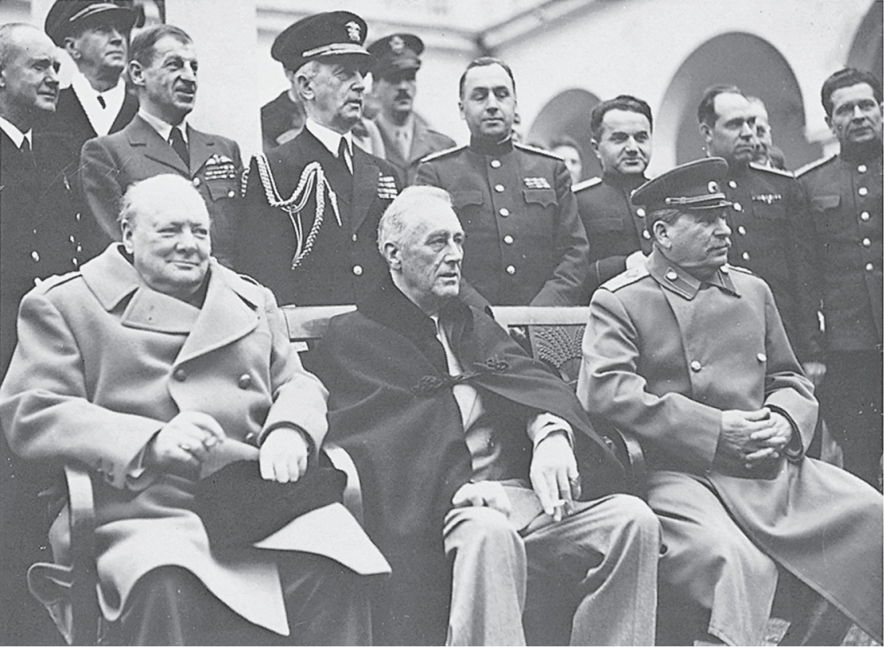

**Type: multiple choice question**

**Title:** Chapter 2 Question 11

**11)** This image of Churchill, Roosevelt, and Stalin at Yalta represents

**Feedback:** Churchill, Roosevelt, and Stalin met at Yalta, on the Black Sea, in 1943 to shape postwar plans for the world.

**Section reference:** Negotiating Peace

\***a.** One of the face-to-face meetings of the three leaders during the war

**b.** A pre-war negotiation of the alliance between the US, USSR, and UK.

**c.** A celebration of the end of World War II

**d.** An attempt at appeasing Hitler’s desire for territory through a mutual conference

**Type: multiple choice question**

**Title:** Chapter 2 Question 12

**12)** By the end of the war, most well-informed Americans believed

**Feedback:** Despite disagreement from some experts and members of government, by the end of the war the majority of well-informed Americans thought that Stalin was homicidal, bent on world domination, of the same breed as Hitler.

**Section reference:** Finding a Path of Mutual Accommodation

**a.** That Soviet suspicion of Western Europe was rational, given repeated invasions of Russian territory

**b.** That Soviet representatives tended to mean what they said

\***c.** That Stalin was a homicidal maniac bent on world domination

**d.** That Stalin was far less of a threat than Hitler.

**Type: multiple choice question**

**Title:** Chapter 2 Question 13

**13)** Roosevelt felt that the best way to deal with the Soviets was to

**Feedback:** Roosevelt felt that a path of mutual accommodation would sustain and nourish the prospects of postwar partnership between the US and USSR without ignoring the realities of geopolitics.

**Section reference: Finding a Path of Mutual Accommodation**

**a.** Assume they shared the same ideals and goals as Americans

**b.** Dictate terms to them in order to prevent them from running rampant throughout Europe

\***c.** Forge a path of mutual accommodation that would sustain a mutual partnership through disagreements

**d.** Convince the Soviets that American ways were better than theirs

**Type: multiple choice question**

**Title:** Chapter 2 Question 14

**14)** Roosevelt’s belief that he could build trust with the Soviet government and with Stalin rested on

**Feedback:**  President Roosevelt possessed an almost mystical confidence in his own capacity to break through policy differences based on economic structures and political systems, and to develop a personal relationship of trust that would transcend impersonal forces of division.

**Section reference:** Finding a Path of Mutual Accommodation

**a.** His belief in their inherent goodness

**b.** His belief in their basic pragmatism

**c.** His belief in the skill and professionalism of US diplomats

\***d.** His belief in his own ability to develop a personal relationship of trust

**Type: multiple choice question**

**Title:** Chapter 2 Question 15

**15)** President Roosevelt died in

**Feedback:** Roosevelt suffered a massive cerebral hemorrhage and died on April 12, 1945.

**Section reference:** Finding a Path of Mutual Accommodation

**a.** June of 1944

\***b.** April of 1945

**c.** August of 1945

**d.** December of 1946

**Type: multiple choice question**

**Title:** Chapter 2 Question 16

**16)** Which of the following is not one of the major causes of the Cold War?

**Feedback:** Historians tend to agree that the five major issues that caused the Cold War were: Poland, the structure of governments in Eastern European countries, the future of Germany, economic reconstruction of Europe, and international policies about the atomic bomb.

**Section reference:** Cold War Issues

**a.** The future of Germany

\***b.** Colonialism in Africa

**c.** The economic reconstruction of Europe

**d.** Poland

**Type: multiple choice question**

**Title:** Chapter 2 Question 17

**17)** The Soviets demanded a postwar Polish government friendly to themselves in order to

**Feedback:** On three occasions, Poland had served as the avenue for devastating invasions of Russian territory. It was imperative to the USSR that Poland be governed by a supportive regime.

**Section reference:** Cold War Issues

\***a.** Ensure their border security

**b.** Serve as a base for invasion of Europe should it ever be necessary

**c.** Advance communism in Europe

**d.** Exploit Poland’s natural resources

**Type: multiple choice question**

**Title:** Chapter 2 Question 18

**18)** Many Western diplomats suspected that the Soviet army allowed the Nazis to crush resistance in Warsaw in 1944 because

**Feedback:** In the summer of 1944 the Red Army was within six miles of Warsaw and the city’s resistance rose in rebellion against the Nazis. The Soviets rejected all pleas for help, and many suspected it was because the majority of Warsaw Poles supported democratic government,

**Section reference:** Cold War Issues

**a.** The Warsaw Poles supported a pro-Soviet government

**b.** Of logistical difficulties

\***c.** The Warsaw Poles wanted a democratically elected government

**d.** They were predominately Jewish

**Type: multiple choice question**

**Title:** Chapter 2 Question 19

**19)** At Yalta, Roosevelt hoped to convince Stalin to

**Feedback:** Roosevelt accepted Soviet postwar control of the Baltic states and Poland, and only requested that Stalin commit to future elections in order to satisfy American ideals.

**Section reference:** Cold War Issues

**a.** Allow immediate free and fair elections throughout eastern Europe

\***b.** Publicly commit to future elections to satisfy American scruples

**c.** Allow open economies and free trade throughout Europe

**d.** End colonialism

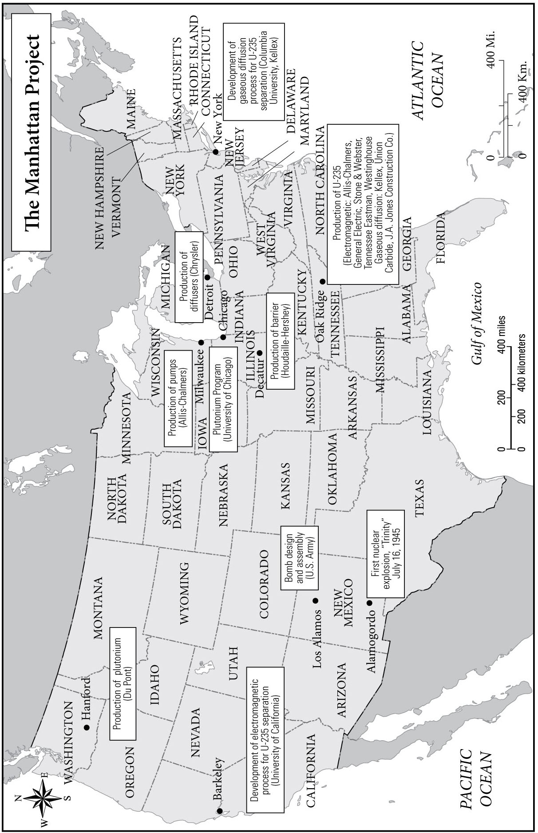

**Type: multiple choice question**

**Title:** Chapter 2 Question 20

**20)** How does this map reflect a new kind of collaboration between industry and government on the Manhattan Project?

**Feedback:** The map shows the various companies who produced components for the atomic bomb all over the country. The bomb was then assembled and tested by the military.

**Section reference:** Type relevant section heading and/or page number here

**a.** It shows that the majority of the atomic bomb was built on military bases

**b.** It shows industry using government facilities to produce the atomic bomb

**c.** It shows that military schools played a pivotal role in developing bomb technology

\***d.** It shows the various companies across the country who produced components for the atomic bomb, which was assembled and tested by the military