1. A study is conducted to determine if one can predict the price of a stock based on the price-to-earnings ratio. The response variable in this study is:
 | a. | the price of the stock.
 | b. | the price-to-earnings ratio.
 | c. | the type of study conducted.
 | d. | either the NASDAQ or the Dow Jones Industrial Average.

ANSWER: | a

2. A study is conducted to determine if one can predict the price of a stock based on the price-to-earnings ratio. The explanatory variable in this study is:
 | a. | the price of the stock.
 | b. | the price-to-earnings ratio.
 | c. | the type of study conducted.
 | d. | either the NASDAQ or the Dow Jones Industrial Average.

ANSWER: | b

3. A researcher is interested in determining if one could predict the score on a Statistics exam from the amount of time spent studying for the exam. In this study, the explanatory variable is:
 | a. | the researcher.
 | b. | the amount of time spent studying for the exam.
 | c. | the score on the exam.
 | d. | the type of questions on the Statistics exam.

ANSWER: | b

4. A researcher is interested in determining if one could predict the score on a Statistics exam from the amount of time spent studying for the exam. In this study, the response variable is:
 | a. | the researcher.
 | b. | the amount of time spent studying for the exam.
 | c. | the score on the exam.
 | d. | the type of questions on the Statistics exam.

ANSWER: | c

5. An experiment is undertaken in a printing operation to determine if the roughness of the paper influences the quality of print obtained. In this experiment, the explanatory variable is:
 | a. | the printing operation.
 | b. | the roughness of the paper.
 | c. | the quality of print.
 | d. | the experiment.

ANSWER: | b

6. An experiment is undertaken in a printing operation to determine if the roughness of the paper influences the quality of print obtained. In this experiment, quality of print variable might be called the:
 | a. | the dependent variable.
 | b. | the independent variable.
 | c. | the explanatory variable.
 | d. | the influenced variable.

ANSWER: | a

7. A real estate company wishes to do analysis in an attempt to show that the prime lending rate can be used to predict the number of houses that its agents sell. In this analysis, the response variable is:
 | a. | the number of houses sold.
 | b. | the real estate company.
 | c. | the agents.
 | d. | the prime lending rate.

ANSWER: | a

8. A real estate company wishes to do analysis in an attempt to show that the prime lending rate can be used to predict the number of houses its agents sell. In this analysis, the explanatory variable is:
 | a. | the number of houses sold.
 | b. | the real estate company.
 | c. | the agents.
 | d. | the prime lending rate.

ANSWER: | d

9. Explanatory variables are sometimes referred to as:
 | a. | dependent variables.
 | b. | independent variables.
 | c. | association variables.
 | d. | correlation variables.

ANSWER: | b

An investigation of the determinants of salary paid to managers at a large corporation was done. A sample of the managers was selected from company records, with a small number of the cases displayed in the table below.
​
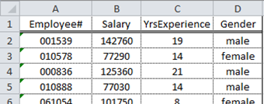

10. Which of the variables is a label variable?
 | a. | Gender
 | b. | Employee#
 | c. | YrsExperience
 | d. | All of the above

ANSWER: | b

11. The variable Gender is:
 | a. | qualitative.
 | b. | a label variable.
 | c. | quantitative.
 | d. | both qualitative and a label variable.

ANSWER: | a

12. Which of the variables is quantitative?
 | a. | Employee#
 | b. | Gender
 | c. | Salary
 | d. | Both Employee# and Salary

ANSWER: | c

13. The most common way to display the relationship between two quantitative variables is with:
 | a. | a contingency table.
 | b. | a side-by-side bar chart.
 | c. | a scatterplot.
 | d. | side-by-side boxplots.

ANSWER: | c

14. When creating a scatterplot, one should:
 | a. | use the vertical axis for the response variable.
 | b. | use the vertical axis for the explanatory variable.
 | c. | use a different plotting symbol if the explanatory variable is categorical than if the response variable is categorical.
 | d. | use a plotting scale that makes the overall trend roughly linear.

ANSWER: | a

The height (in feet) and volume of usable lumber (in cubic feet) of 32 cherry trees are measured by a researcher. The goal is to determine if volume of usable lumber can be estimated from the height of a tree. The results are plotted below.
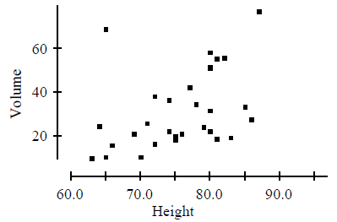

15. In this study, the response variable is:
 | a. | height.
 | b. | volume.
 | c. | height or volume. It doesn't matter which is considered the response.
 | d. | neither height nor volume. The measuring instrument used to measure height is the response variable.

ANSWER: | b

16. The scatterplot suggests:
 | a. | there is a positive association between height and volume.
 | b. | there is an outlier in the plot.
 | c. | both A and B.
 | d. | neither A nor B.

ANSWER: | c

17. At a large university, the office responsible for scheduling classes notices that demand is low for classes meeting before 10:00 A.M. or after 3:00 P.M. and is high for classes meeting between 10:00 A.M. and 3:00 P.M. We may conclude which of the following?
 | a. | There is an association between demand for classes and the time the classes meet.
 | b. | There is a positive association between demand for classes and the time the classes meet.
 | c. | There is a negative association between demand for classes and the time the classes meet.
 | d. | The time of the class meeting must cause changes in the demand for the classes.

ANSWER: | a

18. An advertising agency is interested in determining if the length of the television commercial promoting a product improves people's memory of the product and its features. Data are collected from an experiment in which the length of the commercial is varied and the participants' memory of the product is measured with a memory test score. Which variable should be plotted on the y axis in the scatterplot of the data?
 | a. | Length of the commercial since it is the explanatory variable.
 | b. | Test score since it is the explanatory variable.
 | c. | Length of the commercial since it is the response variable.
 | d. | Test score since it is the response variable.

ANSWER: | d

19. The description of the overall pattern of a scatterplot should include:
 | a. | the form of the relationship.
 | b. | the direction of the relationship.
 | c. | the strength of the relationship.
 | d. | all of the above.

ANSWER: | d

20. When creating a scatterplot, one can make the slope of the relationship appear steeper by:
 | a. | stretching the y axis.
 | b. | stretching the x axis.
 | c. | shrinking the y axis.
 | d. | none of the above.

ANSWER: | a

21. When creating a scatterplot, one can make the slope of the relationship appear steeper by:
 | a. | shrinking the y axis.
 | b. | stretching the x axis.
 | c. | shrinking the x axis.
 | d. | none of the above.

ANSWER: | c

22. The graph below shows the relationship between the quality of print achieved (higher numbers indicate better print quality) and the roughness (higher values indicate more roughness) of the paper in a printing operation. Two brands of paper have been used, with Brand 1 denoted by the black circles and Brand 2 denoted by the gray triangles.
​
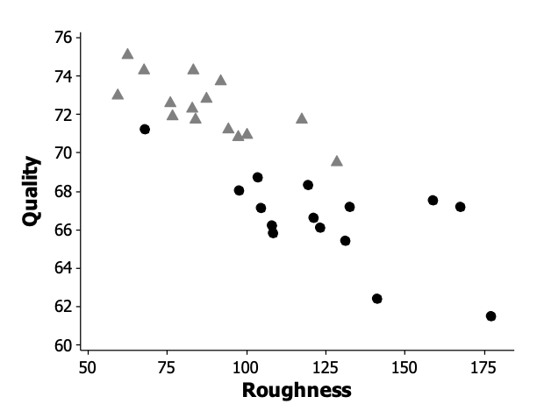
From this plot, we may conclude that:
 | a. | there is a strong positive linear relationship between the roughness of the paper and the quality of print achieved.
 | b. | the relationship between roughness of the paper and the quality of print achieved is linear for Brand 2 paper, but it is curved for Brand 1 paper.
 | c. | Brand 1 paper tends to be rougher than Brand 2 paper.
 | d. | Brand 1 paper tends to be associated with higher quality of print achieved.

ANSWER: | c

23. The graph below plots the gas mileage (miles per gallon, or mpg) of various 1978 model cars versus the weight of these cars in thousands of pounds.
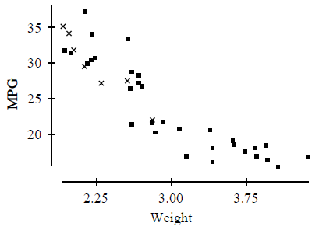
The points denoted by the plotting symbol × correspond to cars made in Japan. From this plot, we may conclude that:
 | a. | there is little difference between Japanese cars and cars made in other countries.
 | b. | Japanese cars tend to be lighter in weight than other cars.
 | c. | Japanese cars tend to get poorer gas mileage than other cars.
 | d. | the plot is invalid. A scatterplot is used to represent quantitative variables, and the country that makes a car is a qualitative variable.

ANSWER: | b

24. Which of the following is true regarding a transformation?
 | a. | A transformation uses a formula to replace the original values of a variable with other values.
 | b. | An example of a transformation is
 | c. | The log transformation tends to make skewed distributions appear more symmetric.
 | d. | All of the above are true.

ANSWER: | d

25. The graph below plots the combined city/highway gas mileage (miles per gallon, or mpg) of various 2015 model vehicles versus the curb weight of these cars in thousands of pounds.
​
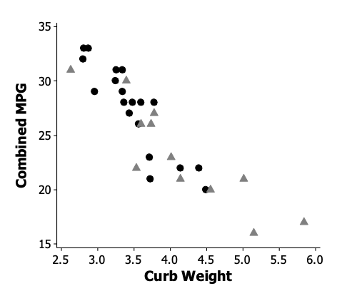
The points denoted by the black circles correspond to Japanese-brand vehicles, while the gray triangles correspond to U.S.-brand vehicles. From this plot, we may conclude that:
 | a. | there is little difference between Japanese and U.S. vehicles.
 | b. | Japanese vehicles tend to be lighter in weight than U.S. vehicles.
 | c. | There is a weak relationship between curb weight and combined gas mileage.
 | d. | the plot is invalid. A scatterplot is used to represent quantitative variables, and the country that makes a car is a qualitative variable.

ANSWER: | b

26. When investigating the relationship between two quantitative variables, we sometimes transform one of the variables in order to:
 | a. | change a linear relationship into a nonlinear one.
 | b. | conserve space.
 | c. | more accurately portray the variable.
 | d. | make the data look more Normal.

ANSWER: | d

27. The graph below plots the combined city/highway gas mileage (miles per gallon, or mpg) of various 2015 model vehicles versus the curb weight of these cars in thousands of pounds.
​
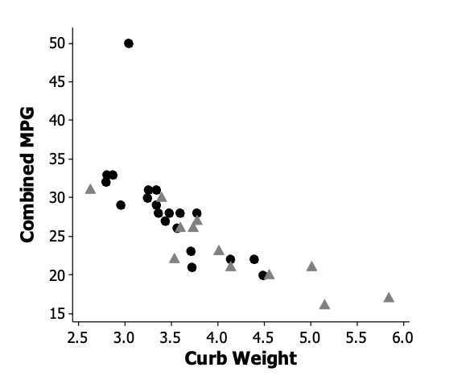
The points denoted by the black circles correspond to Japanese-brand vehicles, while the gray triangles correspond to U.S.-brand vehicles. From this plot, we may conclude that:
 | a. | there is an outlier in the data.
 | b. | Japanese vehicles tend to weigh less than U.S. vehicles.
 | c. | there is a strong negative relationship between curb weight and combined gas mileage.
 | d. | All of the above.

ANSWER: | d

28. The stores of a large retail chain were divided into three groups. While customers were shopping, the stores in Group 1 played light rock music, Group 2 played classical music, and Group 3 played show tunes. The daily sales for each day in a 30-day period were recorded. Suppose that, on average, sales were highest in those stores that played light rock music, second highest for those stores playing show tunes, and lowest for those stores playing classical music. We conclude that:
 | a. | there is a positive association between sales and type of music played.
 | b. | there is a negative association between sales and type of music played.
 | c. | there is both positive and negative association present.
 | d. | none of the above.

ANSWER: | d

29. A college newspaper interviews a psychologist about a proposed system for rating the teaching ability of faculty members. The psychologist says, "The evidence indicates that the correlation between a faculty member's research productivity and teaching rating is close to zero." A correct interpretation of this statement would be that:
 | a. | good researchers tend to be poor teachers and vice versa.
 | b. | good teachers tend to be poor researchers and vice versa.
 | c. | good researchers are just as likely to be good teachers as they are bad teachers. The same is true for poor researchers.
 | d. | good research and good teaching go hand in hand.

ANSWER: | c

30. A student wonders if people of similar heights tend to date each other. She measures herself, her dormitory roommate, and the women in the adjoining rooms. She then measures the next man each woman dates. Here are the data (heights are in inches):
​
Women | 66 | 64 | 66 | 65 | 70 | 65
Men | 72 | 68 | 70 | 68 | 74 | 69
Which of the following statements is true?
 | a. | The variables measured are all categorical.
 | b. | There is a strong negative association between the heights of these men and women because the women are always smaller than the men they date.
 | c. | There is a positive association between the heights of these men and women.
 | d. | Any height above 70 inches must be considered an outlier.

ANSWER: | c

31. Which of the following statements is true?
 | a. | The correlation coefficient equals the proportion of times two variables lie on a straight line.
 | b. | The correlation coefficient will be +1.0 only if all the data lie on a perfectly horizontal straight line.
 | c. | The correlation coefficient measures the fraction of outliers that appear in a scatterplot.
 | d. | The correlation coefficient is a unitless number and must always lie between –1.0 and +1.0, inclusive.

ANSWER: | d

32. A study found a correlation of r = –0.61 between the gender of a worker and his or her income. You may correctly conclude:
 | a. | that women earn more than men on the average.
 | b. | that women earn less than men on the average.
 | c. | that an arithmetic mistake was made. Correlation must be positive.
 | d. | nothing because r makes no sense here.

ANSWER: | d

33. Which of these will correlation explicitly provide information about?
I. Direction of relationship
II. Form of relationship
III. Strength of relationship
 | a. | II only
 | b. | III only
 | c. | I and III
 | d. | I, II, and III

ANSWER: | c

34. In an experiment to learn about consumer preferences for a new snack bar, the recipe for the snack bar was varied with respect to sugar and moisture content. Participants were randomly assigned to taste a version of the snack bar, after which they rated it on a scale of 0 to 100. The data are shown below.
​
Rating | 48 | 60 | 75 | 64 | 81 | 90 | 68 | 82 | 93
Sugar | 2 | 4 | 6 | 2 | 4 | 6 | 2 | 4 | 6
Moisture | 2 | 2 | 2 | 4 | 4 | 4 | 6 | 6 | 6
Which of the following statements is true?
 | a. | There is a no association between sugar content and rating.
 | b. | There is a no association between moisture and rating.
 | c. | There is no association between sugar content and moisture content.
 | d. | All pairs of variables are highly correlated.

ANSWER: | c

35. Which of the following statements is true regarding the correlation between two variables?
 | a. | The correlation coefficient equals the proportion of times two variables lie on a straight line.
 | b. | The correlation coefficient will be +1.0 only if all the data points lie on a perfectly straight upward sloping line.
 | c. | The correlation coefficient measures the slope of the form displayed in the scatter plot.
 | d. | The correlation coefficient is a unitless number and must always lie between 0 and +1.0, inclusive.

ANSWER: | b

36. The correlation coefficient is always:
 | a. | between –1 and 0.
 | b. | between 0 and +1.
 | c. | between –1 and +1.
 | d. | between 0% and 100%.

ANSWER: | c

37. Which of the following statements is true regarding the correlation between two variables?
 | a. | The correlation coefficient equals the proportion of times two variables lie on a straight line.
 | b. | The correlation coefficient will be 0 only if all the data points lie on a perfectly straight horizontal line.
 | c. | The correlation coefficient measures the slope of the form displayed in the scatter plot.
 | d. | None of the above.

ANSWER: | d

38. Two variables, labeled X-1 and X-2 in the plots below, are explanatory variables for the response variable, Y.
​
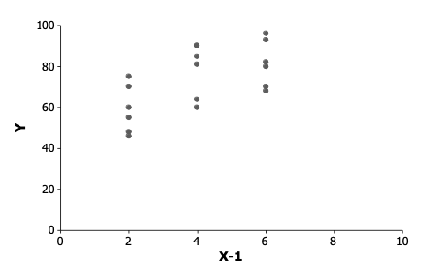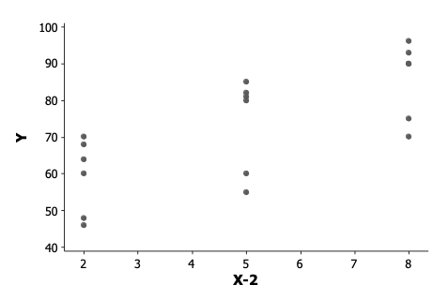
​
From the scatterplots above we know that:
 | a. | Y is more highly correlated with X-1 since there is less vertical scatter in the (X-1, Y) plot than in the (X-2, Y) plot.
 | b. | Y is more highly correlated with X-2 than with X-1 since X-2 spans a larger range.
 | c. | No comparison of correlation of Y with X-1 and X-2 can be made because of scale differences.
 | d. | None of the above.

ANSWER: | c

39. A study of the percent of a structure destroyed by fire and the distance in miles that the structure is from a fire station resulted in correlation between the two to be 0.6181. Which of the following is true about the correlation if we convert the distance to kilometers? Note that there is 0.6214 mile per kilometer.
 | a. | The correlation would be smaller since a mile is shorter than a kilometer.
 | b. | The correlation would be the same since correlation is not affected by units of measure.
 | c. | The correlation would be larger since there are more kilometers in each distance measure.
 | d. | The correlation would become negative.

ANSWER: | b

40. The following scatterplot displays the 2009 per capita income versus number of deaths due to traffic accidents per 100,000 people for each of the 50 states plus the District of Columbia.
​
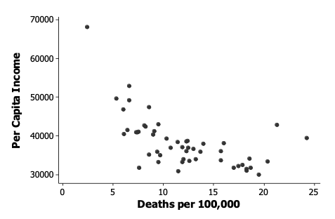
Which of the following is a plausible value for the correlation coefficient between income and deaths?
 | a. | +0.2
 | b. | –0.6
 | c. | +0.7
 | d. | –1.0

ANSWER: | b

41. A corporation administers an aptitude test to all new sales representatives. Management is interested in the extent to which this test is able to predict their eventual success. A sample of past results for Y = average weekly sales and X = the aptitude test scores of its sales representatives resulted in = $50,000, = 5, and r = 0.90. New hire, Sandra D., scored 7 on the aptitude test. From this, we can predict that Sandra's average weekly sales are likely to be:
 | a. | <$50,000.
 | b. | >$50,000.
 | c. | 90% of average.
 | d. | 7/5 of average.

ANSWER: | b

42. Consider the following scatterplot.
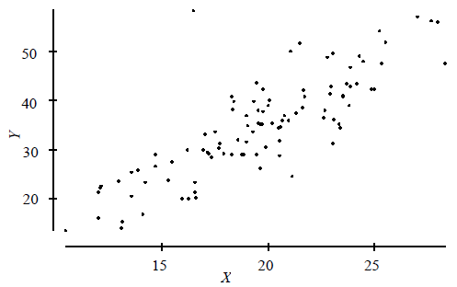
The correlation between X and Y is approximately:
 | a. | 0.999.
 | b. | 0.8.
 | c. | 0.0.
 | d. | –0.7.

ANSWER: | b

43. Consider the following scatterplot of two variables X and Y.
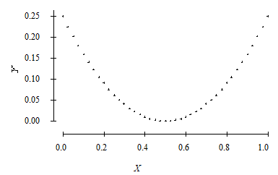
We may conclude that:
 | a. | the correlation between X and Y must be close to 1 because there is nearly a perfect relationship between them.
 | b. | the correlation between X and Y must be close to –1 because there is nearly a perfect relationship between them, but it is not a straight line relationship.
 | c. | the correlation between X and Y is close to 0.
 | d. | the correlation between X and Y could be any number between –1 and +1. Without knowing the actual values, we can say nothing more.

ANSWER: | c

A researcher wants to determine if a man's height and his foot length (measured from the heel to the big toe) are associated. Two men were measured, and the results are below. Both height and foot length are measured in inches.
​
​ | Male 1 | Male 2
Height | 70 | 75
Foot length | 10 | 12

44. The correlation r computed from the measurements on these males is:
 | a. | 1.0.
 | b. | positive and between 0.25 and 0.75.
 | c. | near 0 but could be either positive or negative.
 | d. | exactly 0.

ANSWER: | a

45. The correlation r would have units measured in:
 | a. | inches.
 | b. | square inches.
 | c. | feet and inches.
 | d. | no units.

ANSWER: | d

46. Which of the following is true of the correlation coefficient r?
 | a. | It is a resistant measure of association.
 | b. | –1 ≤ r ≤ 1.
 | c. | If r is the correlation between X and Y, then –r is the correlation between Y and X.
 | d. | The sign of the correlation tells us about the strength of the relationship between X and Y.

ANSWER: | b

47. A corporation administers an aptitude test to all new sales representatives. Management is interested in the extent to which this test is able to predict their eventual success. The accompanying table records average weekly sales (in tens of thousands of dollars) and aptitude test scores for a random sample of five representatives.
​
Test Score | 4 | 4 | 5 | 6 | 6
Weekly Sales | 3 | 1 | 4 | 7 | 5
What is the correlation between Test Score and Weekly Sales?
 | a. | 0.8944
 | b. | 8944.00
 | c. | 0.4000
 | d. | –0.4000

ANSWER: | a

48. The scatterplot below is from a small data set.
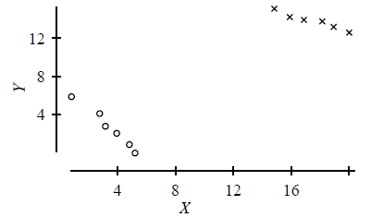
The data were classified as either of type 1 or type 2. Those of type 1 are indicated by o's and those of type 2 by x's. The overall correlation of the data in this scatterplot is:
 | a. | positive.
 | b. | negative because the o's display a negative trend and the x's display a negative trend.
 | c. | near 0 because the o's display a negative trend and the x's display a negative trend, but the trend from the o's to the x's is positive. The different trends cancel.
 | d. | impossible to compute for such a data set.

ANSWER: | a

49. A scatterplot of a variable Y versus a variable X produced the scatterplot below. The value of Y for all values of X is exactly 1.0. The correlation between Y and X is:
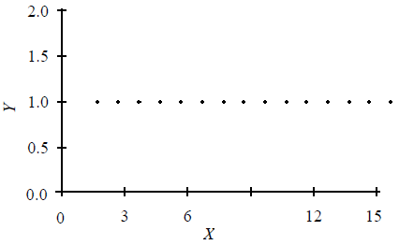
 | a. | +1.0 because the points lie perfectly on a line.
 | b. | either +1.0 or –1.0, because the points lie perfectly on a line.
 | c. | 0 because Y does not change as X increases.
 | d. | none of the above.

ANSWER: | c

The profits (in multiples of $100,000) versus the sales (in multiples of $100,000) for a number of companies are plotted below.
​
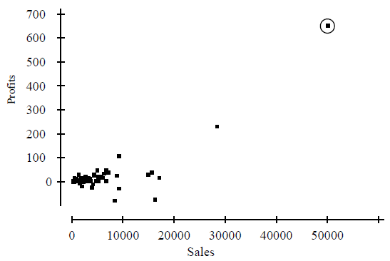

50. The correlation between profits and sales is 0.814. Suppose we removed the point that is circled from the data represented in the plot. The correlation between profits and sales would then be:
 | a. | 0.814.
 | b. | larger than 0.814.
 | c. | smaller than 0.814.
 | d. | either larger or smaller than 0.814. It is impossible to say which.

ANSWER: | c

51. In the plot, profits is treated as the response variable and sales as the explanatory variable. The correlation between profits and sales is 0.814. Suppose we had taken sales to be the response variable and profits to be the explanatory variable. In this case, the correlation between sales and profits would be:
 | a. | 0.814.
 | b. | –0.814.
 | c. | 0.000
 | d. | Any number between –0.814 and 0.814, but one cannot state the exact value.

ANSWER: | a

52. A large mutual fund company offers sector funds. These sector funds concentrate their investments in narrow segments of the stock market. In this case, the sectors are financial services, technology, and utilities. The company offers a number of portfolios in each of these sectors. In the plot below, the percent return for these portfolios is plotted against the sector each represents.
​
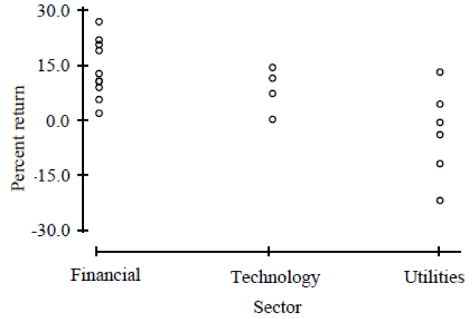
​
The correlation between percent return and sector is:
 | a. | negative.
 | b. | positive.
 | c. | essentially zero because the columns of points overlap in their values of percent return.
 | d. | a meaningless measure in this case.

ANSWER: | d

53. Inspection of the scatterplot below reveals an outlier at X = 20.
​
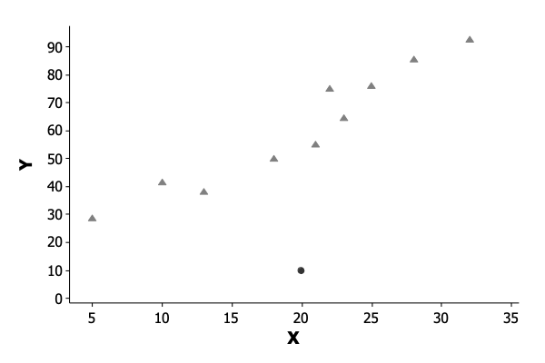
If the outlier is removed from the data set, what will happen to the correlation between X and Y?
 | a. | The correlation will increase.
 | b. | The correlation will decrease since there will be fewer data points.
 | c. | The correlation will remain the same.
 | d. | We cannot identify what will happen to correlation since the outlier appears to occur at the average value for X.

ANSWER: | a

54. The method of determining an equation that summarizes the relationship between a response variable and an explanatory variable is:
 | a. | correlation analysis.
 | b. | exploratory analysis.
 | c. | residual analysis.
 | d. | regression analysis.

ANSWER: | d

55. The difference between correlation analysis and regression is that:
 | a. | regression requires that one variable be explained or predicted by the other, whereas correlation analysis makes no distinction between the response and explanatory variables.
 | b. | regression provides a description of how one variable causes the other to change, while correlation analysis only describes the strength of the relationship between two variables.
 | c. | there is no difference between the two since they both provide information about the strength of relationship between two variables.
 | d. | none of the above.

ANSWER: | a

56. In a regression problem, the following pairs of (x, y) are given:
​
(3, 1), (3, –1), (3, 0), (3, –2), and (3, 2).
From this we can determine that:
 | a. | the value of r² is –1.
 | b. | the correlation between x and y is 0.
 | c. | the correlation between x and y is 1.
 | d. | the slope of the least-squares regression line is 1.

ANSWER: | b

57. A regression line is calculated to be . One of the (x, y) data points used to calculate this line is (5, 18). The prediction error calculated for this point is:
 | a. | 20.
 | b. | 2.
 | c. | –2.
 | d. | 18.

ANSWER: | c

58. A regression line has a slope of 3 and a y intercept of 5. If x = 2, the actual value of y is:
 | a. | 13.
 | b. | 11.
 | c. | –1.
 | d. | unknown.

ANSWER: | d

59. The following is a scatterplot of the calories and sodium content (in mg) of several brands of meat hot dogs. The least-squares regression line has been drawn in on the plot.
​
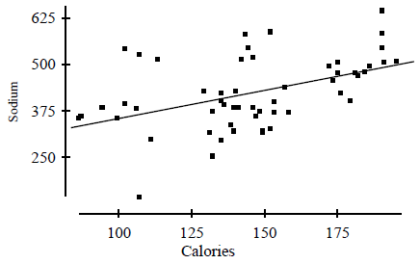
Referring to the scatterplot above, based on the least-squares regression line, one would predict that a hot dog containing 100 calories would have a sodium content of about:
 | a. | 70 mg.
 | b. | 350 mg.
 | c. | 400 mg.
 | d. | 600 mg.

ANSWER: | b

60. The British government conducts regular surveys of household spending. The average weekly household spending on tobacco products and alcoholic beverages for each of 11 regions in Great Britain was recorded. A scatterplot of spending on tobacco versus spending on alcohol is given below.
​
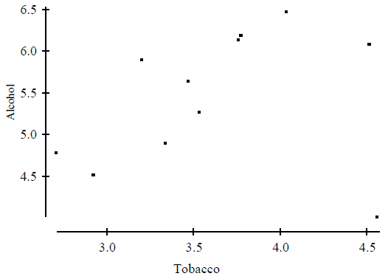
Which of the following statements holds?
 | a. | The observation in the lower right corner of the plot is influential.
 | b. | There is clear evidence of negative association between spending on alcohol and tobacco.
 | c. | The equation of the least-squares line for this plot would be approximately y = 10 – 2x.
 | d. | The correlation coefficient for this data is 0.99.

ANSWER: | a

61. The fraction of the variation in the values of y that is explained by the least-squares regression of y on x is:
 | a. | the correlation coefficient.
 | b. | the slope of the least-squares regression line.
 | c. | the square of the correlation coefficient.
 | d. | the intercept of the least-squares regression line.

ANSWER: | c

62. In least-squares regression, is:
 | a. | a residual.
 | b. | always negative since always provides a better prediction than .
 | c. | the difference in prediction errors obtained when using the regression line to predict y and when using only the sample of y-values alone to predict y.
 | d. | all of the above.

ANSWER: | c

63. In regression, r² is:
a.
b.
c.
d.

ANSWER: | a

​
The following shows the relationship between selling price (in $) of properties zoned as residential and the size of the residences (in square feet) on those properties.
​
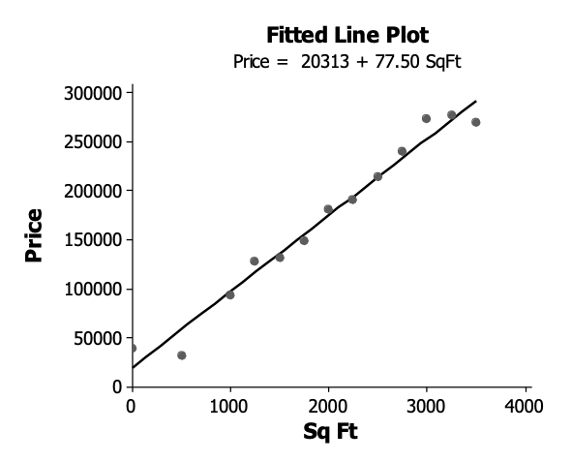
​

64. The y intercept of the regression line to predict selling price has the value:
 | a. | 0.
 | b. | 77.50.
 | c. | 20313.
 | d. | 20313 + 77.50x.

ANSWER: | c

65. The slope of the regression line to predict selling price has the value:
 | a. | 0.
 | b. | 77.50.
 | c. | 20313.
 | d. | 1/77.50.

ANSWER: | b

66. The y intercept of the regression line to predict selling price can be interpreted to mean that:
 | a. | for each additional square foot in size of the residence, the selling price is predicted to increase by $77.50.
 | b. | the predicted selling price of the land on which the residence is built is $20,313.
 | c. | the intercept is meaningless since a residence with 0 square feet of space would have no value.
 | d. | for each additional dollar of selling price, the equation predicts that an increase in size of the residence is equal to 77.50 square feet.

ANSWER: | b

67. The slope of the regression line to predict selling price can be interpreted to mean that:
 | a. | for each additional square foot in size of the residence, the selling price is predicted to increase by $77.50.
 | b. | the predicted selling price of the property on which the residence is built is $20,313.
 | c. | the intercept is meaningless since a residence with 0 square feet of space would have no value.
 | d. | for each additional dollar of selling price, the equation predicts that an increase in size of the residence is equal to 77.50 square feet.

ANSWER: | a

68. A regression of Sales (in $1000) on Advertising Budget (in $100) resulted in the least squares equation: Sales = 100 + 10Ad. From this, we can predict that:
 | a. | an increase of $1 in advertising will result in $110 of additional sales.
 | b. | an increase of $100 of advertising is associated with an additional $1000 of sales.
 | c. | an increase of $1 in advertising will cause sales to increase $10.
 | d. | an increase of $100 of advertising is associated with an additional $10,000 of sales.

ANSWER: | d

69. A regression of Sales (in $1000) on Advertising Budget (in $100) resulted in the least squares equation: Sales = 100 + 10Ad. From this, we can predict that if the advertising budget is $500, sales will be:
 | a. | $5100.
 | b. | $510,000.
 | c. | $15,000.
 | d. | $150,000.

ANSWER: | d

70. In a Statistics course, a linear regression equation was computed to predict the final exam score from the score on the first test. The equation of the least-squares regression line was:
​
​
where y represents the final exam score and x is the score on the first exam. Suppose Joe scores a 90 on the first exam. What would be the predicted value of his score on the final exam?
 | a. | 90
 | b. | 85
 | c. | 80
 | d. | The value cannot be determined from the information given. We also need to know the correlation.

ANSWER: | b

John's parents recorded his height at various ages up to 66 months. Below is a record of the results.
​
Age (months) | 36 | 48 | 54 | 60 | 66
Height (inches) | 35 | 38 | 41 | 43 | 45

71. Which of the following is the equation of the least-squares regression line of John's height on age? (Note: You do not need to directly calculate the least-squares regression line to answer this question.)
 | a. | height = 12 × (age)
 | b. | height = age/12
 | c. | height = 60 – 0.22 × (age)
 | d. | height = 22.3 + 0.34 × (age)

ANSWER: | d

72. John's parents decide to use the least-squares regression line of John's height on age to predict his height at age 21 years (252 months). We conclude that:
 | a. | John's height in inches should be about half his age in months.
 | b. | the parents will get a fairly accurate estimate of his height at age 21 years because the data are clearly correlated.
 | c. | such a prediction could be misleading because it involves extrapolation.
 | d. | all of the above.

ANSWER: | c

73. A researcher wished to determine whether a company's profits can be used to predict the market value of the company. Based on data from a sample of more than 80 companies from the Fortune 500 list, the researcher calculated the equation of the least-squares line for predicting market value from profits to be:
​
MarketValue = 388.2 + 13.7(Profits)
​
The correlation between market value and profits would be:
 | a. | 1/13.7.
 | b. | 13.7/388.2.
 | c. | positive, but we cannot say what the exact value is.
 | d. | either positive or negative. It is impossible to say anything about the correlation from the information given.

ANSWER: | c

74. The least-squares regression line is:
 | a. | the line that makes the square of the correlation in the data as large as possible.
 | b. | the line that makes the sum of the squares of the vertical distances of the data points from the line as small as possible.
 | c. | the line that best splits the data in half, with half of the points above the line and half below the line.
 | d. | all of the above.

ANSWER: | b

75. Which of the following is true of the least-squares regression line?
 | a. | The slope is the change in the response variable that would be predicted by a unit change in the explanatory variable.
 | b. | It always passes through the point (,), the means of the explanatory and response variables, respectively.
 | c. | It will pass through all the data points only if r = ±1.
 | d. | All of the above.

ANSWER: | d

76. A residual is equal to:
 | a. | observed y – average y.
 | b. | observed y – predicted y.
 | c. | predicted y – observed y.
 | d. | predicted y – average y.

ANSWER: | b

77. A pediatrician wishes to study how the average weight Y (in kilograms) of children changes during the first year of life. He plots these averages versus the age X (in months) and decides to fit a least-squares regression line to the data with X as the explanatory variable and Y as the response variable. He computes the following quantities:
​
r = correlation between X and Y = 0.84
= mean of the values of X = 5.69
ȳ = mean of the values of Y = 6.26
s_{x} = standard deviation of the values of X = 3.23
s_{y} = standard deviation of the values of Y = 2.04
​
The slope of the least-squares line is:
 | a. | 0.53.
 | b. | 0.64.
 | c. | 0.84.
 | d. | 2.04.

ANSWER: | a

78. Recall that when we standardize the values of a variable, the standardized value has mean 0 and standard deviation 1. Suppose we measure two variables, X and Y, on each of several subjects. We standardize both variables and then compute the least-squares regression line of Y on X for these standardized values. Suppose the slope of this least-squares regression line is –0.44. We may conclude that:
 | a. | the intercept will be 1.0.
 | b. | the intercept will also be –0.44.
 | c. | the correlation will be 1.0.
 | d. | the correlation will be –0.44.

ANSWER: | d

79. A least squares regression of Y on X resulted in the equation . Which of the following graphs depicts that relationship?
a.
b.
c.
d.

ANSWER: | b

80. In a study of 2005 model cars, a researcher found that the fraction of the variation in the car's miles per gallon (mpg) that was explained by the least-squares regression on weight was about 0.64. For the cars in this study, the correlation between the car's mpg and its weight was found to be negative. The actual value of the correlation is:
 | a. | –0.08.
 | b. | –0.41.
 | c. | –0.80.
 | d. | –0.64.

ANSWER: | c

81. In a study of 2005 model cars, a researcher computed the least-squares regression line of miles per gallon (mpg) on weight (in pounds). He obtained the following equation for this line:
mpg = 34.941 – 0.004 × weight
Based on the least-squares regression line, we would predict that a 2005 model car with weight equal to 3000 pounds would have an mpg of:
 | a. | 34.941.
 | b. | 30.931.
 | c. | 22.941.
 | d. | 26.921.

ANSWER: | c

82. A researcher wished to determine whether a company's profits (in millions of dollars) can be used to predict the market value (in millions of dollars) of the company. Based on data from a sample of 80 companies from the Fortune 500 list, the researcher calculated the equation of the least-squares regression line for predicting market value from profits to be:
Market value = 388.2 + 13.7(Profits)
One company used by the researcher had profits of $36 million dollars, and the market value of this company was $885 million. These values were used in the calculation of the least-squares regression line. The residual corresponding to these values is:
 | a. | $3.6 million.
 | b. | –$3.6 million.
 | c. | $13.7 million.
 | d. | –$849 million.

ANSWER: | a

83. The least-squares regression line is fit to a set of data. If one of the data points has a negative residual, then:
 | a. | the correlation between the values of the response and explanatory variables must be positive.
 | b. | the point must lie below the least-squares regression line.
 | c. | the point must lie near the left edge of the scatterplot.
 | d. | the point must lie above the least-squares regression line.

ANSWER: | b

84. Which of the following statements concerning residuals is true?
 | a. | The sum of the residuals is always 0.
 | b. | A plot of the residuals is useful for assessing the fit of the least-squares regression line.
 | c. | The value of a residual is the observed value of the response minus the value of the response that one would predict from the least-squares regression line.
 | d. | All of the above.

ANSWER: | d

85. Which of the following statements concerning the least squares regression of Y on X depicted in the graph below is true?
​
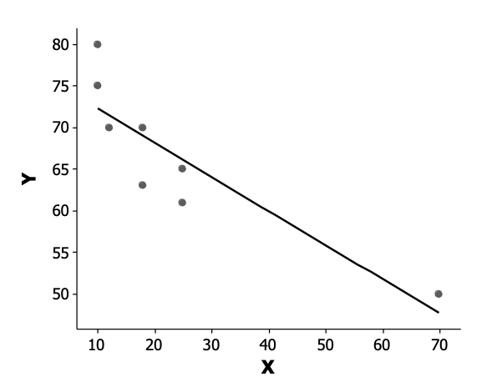
​
 | a. | The point (70, 50) is very influential and has a large residual.
 | b. | The point (70, 50) is very influential but has a small residual.
 | c. | The point (70, 50) is not influential but has a large residual.
 | d. | The point (70, 50) is not influential and has a small residual.

ANSWER: | b

86. Below is a scatterplot of the world record time for women in the 10,000-meter run versus the year in which the record was set. Note that time is in seconds and the data are for the period 1965–1995.
​
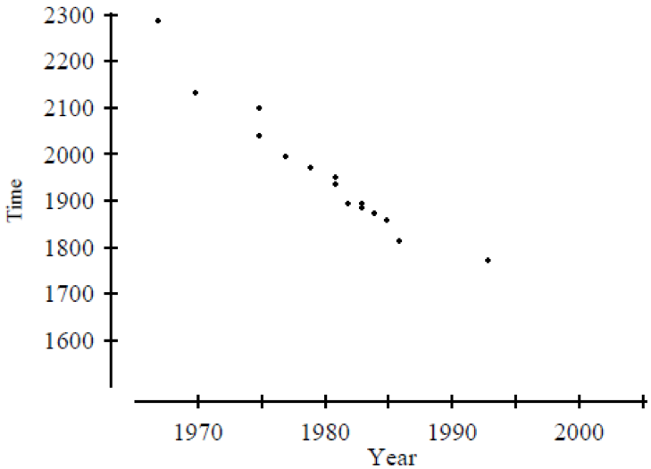
Based on this plot, one would expect:
 | a. | by 2005, the world record time for women will be well below 1500 seconds.
 | b. | that about every decade, the world record time will decrease by at least 100 seconds.
 | c. | that about every decade, the world record time will decrease by about 50 seconds.
 | d. | none of the above.

ANSWER: | d

87. The following is a scatterplot of the calories and sodium content of several brands of meat hot dogs. The least-squares regression line has been drawn in on the plot.
​
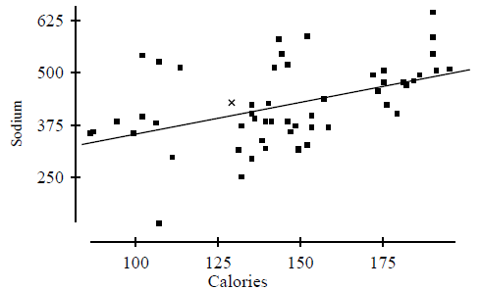
​
Referring to the scatterplot above, the value of the residual for the point labeled x:
 | a. | is about 40.
 | b. | is about 1300.
 | c. | is about 425.
 | d. | cannot be determined from the information given.

ANSWER: | a

88. Researchers studied a sample of 100 adults between the ages of 25 and 35 and found a strong negative correlation between the annual salary and the number of pounds the individual was overweight. We may conclude which of the following?
 | a. | This is strong but not conclusive evidence that being overweight results in lower salaries.
 | b. | If the annual salary and the number of pounds overweight for each individual in this study were plotted on a scatterplot, the points would lie close to a negatively sloping straight line.
 | c. | If a larger sample of adults between the ages of 25 and 35 had been studied, the correlation would have been even stronger.
 | d. | All of the above.

ANSWER: | b

89. A response Y and explanatory variable X were measured on each of several subjects. A scatterplot of the measurements is given below. The least-squares regression line is shown in the plot.
​
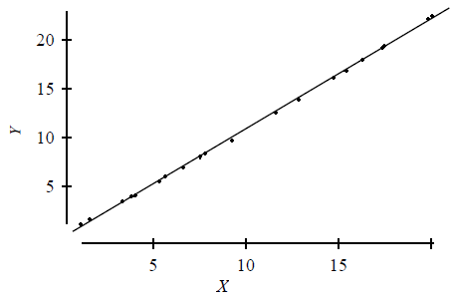
Which of the following is a plot of the residuals for the above data versus X?
a.
b.
c.
d.

ANSWER: | c

90. The owner of a chain of supermarkets notices that there is a positive correlation between the sales of beer and the sales of ice cream over the course of the previous year. Seasons when sales of beer were above average, sales of ice cream also tended to be above average. Likewise, during seasons when sales of beer were below average, sales of ice cream also tended to be below average. Which of the following would be a valid conclusion from these facts?
 | a. | There must be an error. There should be no association between beer and ice cream sales.
 | b. | Evidently, for a significant proportion of customers of these supermarkets, drinking beer causes a desire for ice cream or eating ice cream causes a thirst for beer.
 | c. | A scatterplot of monthly ice cream sales versus monthly beer sales would show that a straight line describes the pattern in the plot, but it would have to be a horizontal line.
 | d. | None of the above.

ANSWER: | d

91. A researcher studies the relationship between the total SAT score (Math SAT score plus Critical Reading SAT score plus Writing SAT score) and the grade point average (GPA) of college students at the end of their freshman year. In order to use a relatively homogeneous group of students, the researcher examines only data of high school valedictorians (students who graduated at the top of their high school class) who have completed their first year of college. The researcher finds the correlation between total SAT score and GPA at the end of the freshman year to be very close to 0. Which of the following would be a valid conclusion from these facts?
 | a. | Because the group of students studied is a very homogeneous group of students, the results should give a very accurate estimate of the correlation the researcher would find if all college students who have completed their freshman year were studied.
 | b. | The correlation we would find if all college students who have completed their freshman year were studied would be even smaller than that found by the researcher. By restricting to valedictorians, the researcher is examining a group that will be more informative than those students who have only completed their freshman year.
 | c. | The researcher made a mistake. Correlation cannot be calculated (the formula for correlation is invalid) unless all students who completed their freshman year are included.
 | d. | None of the above.

ANSWER: | d

92. When exploring very large sets of data involving many variables, which of the following is true?
 | a. | Extrapolation is safe because it is based on a greater quantity of evidence.
 | b. | Associations will be stronger than would be seen in a much smaller subset of the data.
 | c. | A strong association is good evidence for causation because it is based on a large quantity of information.
 | d. | None of the above.

ANSWER: | d

93. Consider the scatterplot below:
​
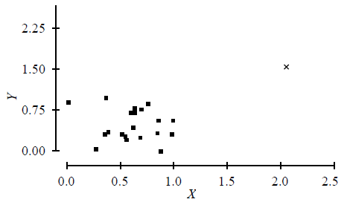
The point indicated by the plotting symbol x would be:
 | a. | a residual.
 | b. | influential.
 | c. | a z-score.
 | d. | a least-squares point.

ANSWER: | b

The following scatterplot displays the 1990 per capita income versus number of deaths due to traffic accidents per 100,000 people for each of the 50 states, plus the District of Columbia.
​
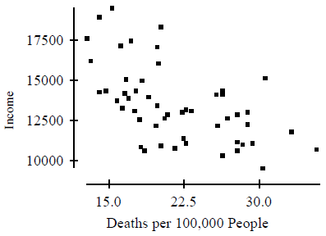
​
The correlation between income and deaths per 100,000 people is r = –0.57.
​

94. If instead of plotting these variables for each of the 50 states and the District of Columbia we plotted the values of these variables for each county in the United States, we would expect the value of the correlation r to be:
 | a. | exactly the same.
 | b. | smaller in magnitude.
 | c. | +0.57 (the magnitude is the same, but the sign should change).
 | d. | much higher and probably near 1 because there are many more counties than states.

ANSWER: | b

95. The least-squares regression line was fit to the data in the scatterplot and the residuals computed. A plot of the residuals versus the percent of miles traveled on urban roads in the state is given below.
​
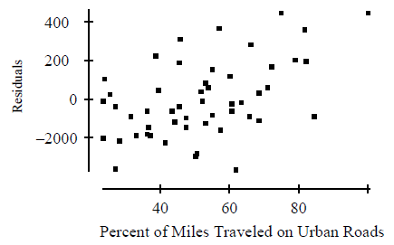
This plot suggests that:
 | a. | a high number of deaths per 100,000 people implies low per capita income, but only for states with a high percentage of miles traveled on urban roads.
 | b. | a high number of deaths per 100,000 people implies low per capita income, but only for states with a low percentage of miles traveled on urban roads.
 | c. | percentage of miles traveled on urban roads may be a lurking variable in understanding the association between income and deaths per 100,000 people.
 | d. | none of the above.

ANSWER: | c

96. Two variables, x and y, are measured on each of several individuals. The correlation between these variables is found to be 0.88. To interpret this correlation, we should do which of the following?
 | a. | compute the least-squares regression line of y on x and consider whether the slope is positive or negative
 | b. | interchange the roles of x and y (i.e., treat x as the response and y as the predictor variable) and recompute the correlation
 | c. | plot the data
 | d. | all of the above

ANSWER: | c

97. A sample of 79 companies was taken and the annual profits (y) were plotted against annual sales (x). The plot is given below. All values in the plots are in units of $100,000.
​
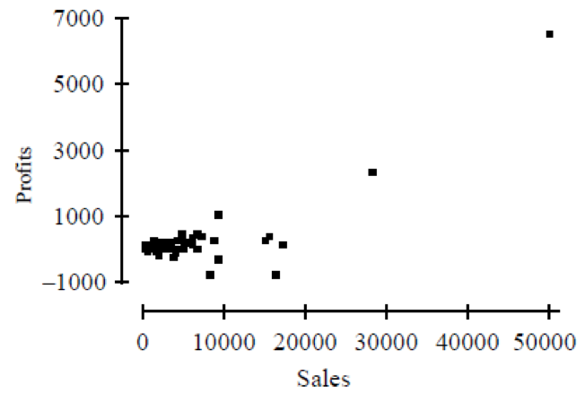
The correlation between sales and profits is found to be 0.814. Based on this information, we may conclude which of the following?
 | a. | Not surprisingly, increasing sales causes an increase in profits. This is confirmed by the large positive correlation.
 | b. | There are clearly influential observations present.
 | c. | If we group the companies in the plot into those that are small in size, those that are medium in size, and those that are large in size and compute the correlation between sales and profits for each group of companies separately, the correlation in each group will be about 0.8.
 | d. | All of the above.

ANSWER: | b

98. A researcher computed the average Math SAT score of all high school seniors who took the SAT exam for each of the 50 states. The researcher also computed the average salary of high school teachers in each of these states and plotted these average salaries against the average Math SAT scores. The plot showed a distinct negative association between average Math SAT scores and teacher salaries. A second researcher conducted a similar study but computed the average Math SAT score for each school district in the nation and plotted these against the average salary of high school teachers in the district. The association between average Math SAT score and average teacher salaries in the plot of the second researcher will most likely be:
 | a. | about the same as the association seen by the first researcher.
 | b. | much stronger than that seen by the first researcher.
 | c. | much stronger than that seen by the first researcher, but with the opposite sign.
 | d. | weaker than that seen by the first researcher.

ANSWER: | d

99. Consider the following scatterplot.
​
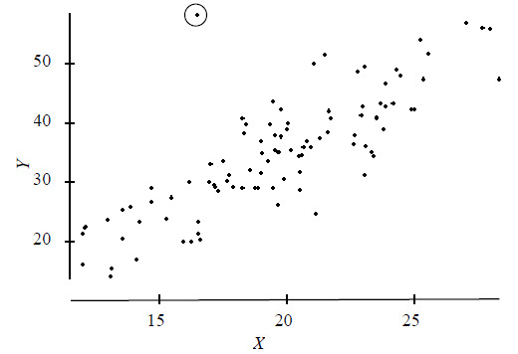
​
From this plot, we can conclude that:
 | a. | there is evidence of a modest cause-and-effect relation between X and Y with increases in X causing increases in Y.
 | b. | there is an outlier in the plot.
 | c. | there is a strongly influential point in the plot.
 | d. | all of the above.

ANSWER: | b

100. When possible, the best way to establish that an observed association is the result of a cause-and-effect relation is by means of:
 | a. | the least-squares regression line.
 | b. | the correlation coefficient.
 | c. | examining z-scores rather than the original variables.
 | d. | a well-designed experiment.

ANSWER: | d

101. Which of the following would be necessary to establish a cause-and-effect relation between two variables?
 | a. | strong association between the variables
 | b. | an association between the variables being observed in many different settings
 | c. | the alleged cause being plausible
 | d. | all of the above

ANSWER: | d

102. Recent data show that states that spend an above-average amount of money X per pupil in high school tend to have below-average mean Critical Reading SAT scores Y of all students taking the SAT in the state. In other words, there is a negative association between X and Y. This is particularly true in states that have a large percentage of all high school students taking the exam. Such states also tend to have larger populations. The most plausible explanation for this association is that:
 | a. | X causes Y. Overspending generally leads to extra, unnecessary programs, diverting attention from basic subjects. Inadequate training in these basic subjects generally leads to lower SAT scores.
 | b. | Y causes X. Low SAT scores create concerns about the quality of education. This inevitably leads to additional spending to help solve the problem.
 | c. | changes in X and Y are due to changes in other lurking variables. If a higher percentage of students take the exam, the average score will be lower. Also, states with larger populations have large urban areas where the cost of living is higher and more money is needed for expenses.
 | d. | the association between X and Y is purely coincidental. It is implausible to believe the observed association could be anything other than accidental.

ANSWER: | c

103. A researcher observes that, on average, the number of businesses in cities with Major League Baseball teams is larger than in cities without Major League Baseball teams. The most plausible explanation for this observed association is that:
 | a. | the presence of a Major League Baseball team causes the number of divorces to rise because the city becomes an attractive location for businesses.
 | b. | the high number of businesses is responsible for the presence of a Major League Baseball team because cities with a healthy business environment are attractive to major league teams.
 | c. | the association is due to a lurking variable (major league teams tend to be in large cities with more people, hence a greater number of businesses).
 | d. | the observed association is purely coincidental. It is implausible to believe the observed association could be anything other than accidental.

ANSWER: | c

An article in the student newspaper of a large university had the headline "A's swapped for evaluations?" The article included the following:
​
According to a new study, teachers may be more inclined to give higher grades to students, hoping to gain favor with the university administrators who grant tenure. The study examined the average grade and teaching evaluation in a large number of courses given in 1997 in order to investigate the effects of grade inflation on evaluations. "I am concerned with student evaluations because instruction has become a popularity contest for some teachers," said Professor Smith, who recently completed the study. Results showed higher grades directly corresponded to a more positive evaluation.
​

104. The underlined statement indicates the study found that:
 | a. | course grade is positively associated with teaching evaluation.
 | b. | teaching evaluation is negatively associated with course grade.
 | c. | there was a perfect positive correlation between course grade and teaching evaluation.
 | d. | all of the above.

ANSWER: | a

105. Which of the following would be a valid conclusion to draw from the study?
 | a. | A teacher can improve his or her teaching evaluations by giving good grades.
 | b. | A good teacher, as measured by teaching evaluations, helps students learn better, resulting in higher grades.
 | c. | Teachers of courses in which the mean grade is above average apparently tend to have above-average teaching evaluations.
 | d. | All of the above.

ANSWER: | c

106. A researcher computed the average Math SAT score of all high school seniors who took the SAT exam for each of the 50 states. The researcher also computed the average salary of high school teachers in each of these states and plotted these average salaries against the average Math SAT scores for each state. The plot showed a distinct negative association between average Math SAT scores and teacher salaries. The researcher may legitimately conclude which of the following?
 | a. | Increasing the average salary of teachers will cause the average of Math SAT scores to decrease, but it is not correct to conclude that increasing the salaries of individual teachers causes the Math SAT scores of individual students to increase.
 | b. | States that pay teachers highly tend to do a poor job of teaching mathematics, on average.
 | c. | States whose students tend to perform poorly in mathematics probably have a higher proportion of problem students and thus need to pay teachers higher salaries in order to attract them to teach in those states.
 | d. | The data used by the researcher do not provide evidence that increasing the salary of teachers will cause the performance of students on the Math SAT to get worse.

ANSWER: | d

107. The average number of home runs hit by Major League Baseball players is greater now than it was three decades ago. A researcher suspects that the reason may be that baseballs are livelier now than 30 years ago. To check this, he tested two baseballs, one that was manufactured 30 years ago (but never used) and one that was new. He noticed that the new baseball bounced higher than the older ball when both were dropped from the same height; that is, the new baseball was livelier than the old one. The researcher can legitimately conclude that:
 | a. | there is a positive association between the liveliness of the balls tested and the average number of home runs hit in the year that the ball was used.
 | b. | baseballs have been gradually getting livelier over the last three decades.
 | c. | there is good evidence that the increase in the liveliness of baseballs has caused the increase in home run. This is because there is a positive association between liveliness of baseballs and average number of home runs hit and because there is a plausible theory for the observed association.
 | d. | all of the above.

ANSWER: | a

108. A researcher notices that in a sample of adults, those who take larger amounts of vitamin C have fewer illnesses. From this, the researcher can conclude that:
 | a. | larger intake of vitamin C causes one to have fewer illnesses.
 | b. | the association between vitamin C intake and number of illnesses could be explained by of a lurking variable, such as exercise.
 | c. | there is a positive correlation between vitamin C intake and the number of illnesses in adults.
 | d. | increased number of illnesses causes increased vitamin C intake.

ANSWER: | b

109. In 1982, Kennesaw, Georgia, passed a law requiring all citizens to own at least one gun. Although the law was never enforced, six months after the law was passed, the number of burglaries in that month was less than in the month prior to passage of the law. We may conclude which of the following?
 | a. | Gun ownership and burglary rates are negatively associated.
 | b. | Gun ownership causes a reduction in crime. This is because there is a negative association between gun ownership and burglary rates and because there is a plausible explanation for this association (gun ownership acts as a deterrent to crime).
 | c. | Both A and B.
 | d. | Neither A nor B.

ANSWER: | d

110. A study of the salaries of full professors at Upper Wabash Tech shows that the median salary for female professors is considerably less than the median male salary. Further investigation shows that the median salaries for male and female full professors are about the same in every department (English, Physics, etc.) of the university. This apparent contradiction is an example of:
 | a. | extrapolation.
 | b. | Simpson's paradox.
 | c. | causation.
 | d. | correlation.

ANSWER: | b

111. The reversal of the direction of an association when lurking variables are taken into account is called:
 | a. | Simpson's paradox.
 | b. | least-squares regression.
 | c. | negative association.
 | d. | Benford's law.

ANSWER: | a

112. Which of the following could be used to summarize the relationship between two categorical variables?
 | a. | pie chart
 | b. | side-by-side boxplots
 | c. | two-way table
 | d. | back-to-back stem-and-leaf diagrams

ANSWER: | c

113. A survey of registered voters in a state was taken to gauge sentiment regarding proposed legislation. The results are summarized below.
​
 | Democrat | Republican | Independent
Favor | 95 | 50 | 25
Oppose | 45 | 85 | 70
Undecided | 10 | 5 | 30
This type of display is called:
 | a. | a conditional distribution.
 | b. | a Pareto chart.
 | c. | a two-way table.
 | d. | a simultaneous distribution.

ANSWER: | c

114. A survey asked each individual to choose their favorite sport from the list of baseball, football, basketball, hockey, or another sport. The following two-way table categorizes a person's favorite sport by the gender.
​
 | Male | Female
Baseball | 13,959 | 2641
Football | 3148 | 2469
Basketball | 3222 | 709
Hockey | 1457 | 690
Other | 2039 | 1783
Which of the following statements is consistent with the table?
 | a. | There is absolutely no evidence of a relationship between the gender of the person and their favorite sport.
 | b. | More women were surveyed than men.
 | c. | Men display a greater tendency to enjoy baseball than do women.
 | d. | The correlation between these two variables is clearly positive.

ANSWER: | c

115. In a study of the link between high blood pressure and cardiovascular disease, a group of white male businessmen aged 35 to 64 was followed for five years. At the beginning of the study, each man had his blood pressure measured, and it was classified as either low systolic blood pressure (less than 140 mm Hg) or high blood pressure (140 mm Hg or higher). The following table gives the number of men in each blood pressure category and the number of deaths from cardiovascular disease during the five-year period.
​
Blood pressure | Deaths | Total
Low | 10 | 2000
High | 50 | 3500
Based on these data, which of the following statements is correct?
 | a. | These data are consistent with the idea that there is a link between high blood pressure and death from cardiovascular disease.
 | b. | The mortality rate (proportion of deaths) for men with high blood pressure is five times that of men with low blood pressure.
 | c. | These data probably understate the link between high blood pressure and death from cardiovascular disease because men will tend to understate their true blood pressure.
 | d. | All of the above.

ANSWER: | a

116. X and Y are two categorical variables. The best way to determine if there is a relationship between them is to:
 | a. | calculate the correlation between X and Y.
 | b. | draw a scatterplot of the X and Y values.
 | c. | make a two-way table of the X and Y values.
 | d. | do all of the above.

ANSWER: | c

A business has two types of employees: managers and workers. Managers earn either $100,000 or $200,000 per year. Workers earn either $30,000 or $50,000 per year. The number of male and female managers at each salary level and the number of male and female workers at each salary level are given in the two tables below:
​
​ | Managers |  | ​ |  | Workers
​ | Male | Female | ​ | ​ | Male | Female
$100,000 | 80 | 20 | ​ | $30,000 | 30 | 20
$200,000 | 20 | 30 | ​ | $50,000 | 20 | 80

117. The proportion of male workers who make $50,000 per year is:
 | a. | 0.067.
 | b. | 0.133.
 | c. | 0.200.
 | d. | 0.400.

ANSWER: | d

118. The proportion of female managers who make $200,000 per year is:
 | a. | 0.100.
 | b. | 0.200.
 | c. | 0.400.
 | d. | 0.600.

ANSWER: | d

119. We may conclude that:
 | a. | the mean salary of female managers is greater than that of male managers.
 | b. | the mean salary of males in this business is greater than the mean salary of females.
 | c. | the mean salary of female workers is greater than that of male workers.
 | d. | all of the above.

ANSWER: | d

A review of voter registration records in a small town yielded the following table of the number of males and females registered as Democrat, Republican, or some other affiliation.
​
 | Male | Female
Democrat | 325 | 436
Republican | 456 | 285
Other | 94 | 79

120. The proportion of males that are registered as Democrat is:
 | a. | 0.19.
 | b. | 0.37.
 | c. | 0.43.
 | d. | 0.71.

ANSWER: | b

121. The proportion of registered as Democrat who are male is:
 | a. | 0.19.
 | b. | 0.37.
 | c. | 0.43.
 | d. | 0.71.

ANSWER: | c

122. The proportion of all voters who are male and registered as Democrat is:
 | a. | 0.19.
 | b. | 0.37.
 | c. | 0.43.
 | d. | 0.71.

ANSWER: | a

123. The proportion of females that are registered as Republican is:
 | a. | 0.36.
 | b. | 0.38.
 | c. | 0.65.
 | d. | 0.71.

ANSWER: | a

124. The proportion of registered voters in the "Other" category who are female is:
 | a. | 0.54.
 | b. | 0.46.
 | c. | 0.10.
 | d. | 0.79.

ANSWER: | b

125. The proportion of all voters who are registered as Democrat is:
 | a. | 0.47.
 | b. | 0.37.
 | c. | 0.45.
 | d. | 0.54.

ANSWER: | c

126. The total number of all voters who are male is:
 | a. | 800.
 | b. | 761.
 | c. | 875.
 | d. | 1675.

ANSWER: | c

127. Which of the following could be used to summarize the relationship between two categorical variables?
 | a. | pie chart
 | b. | side-by-side boxplots
 | c. | mosaic plot
 | d. | back-to-back stem-and-leaf diagrams

ANSWER: | c

128. A sample of the parts is taken from each shift (1, 2, or 3) in a manufacturing operation to investigate the relationship between the shift and the quality of parts (conforming or nonconforming) being produced. The number of conforming and nonconforming parts per shift is summarized in the table below:
​
 | Shift 1 | Shift 2 | Shift 3 | Total
Conforming | 370 | 285 | 175 | 830
Nonconforming | 30 | 15 | 25 | 70
Total | 400 | 300 | 200 | 900

Which of the following is the conditional distribution for part quality?
 | a. | ​  Shift 1 Shift 2 Shift 3 Total  Conforming 0.4458 0.3434 0.2108 1  Nonconforming 0.4286 0.2143 0.3571 1  ​
 | b. | ​  Shift 1 Shift 2 Shift 3  Conforming 0.9250 0.9500 0.8750  Nonconforming 0.0750 0.0500 0.1250  Total 1 1 1  ​
 | c. | ​  Shift 1 Shift 2 Shift 3 Total  Conforming 0.4111 0.3167 0.1944 0.9222  Nonconforming 0.0333 0.0167 0.0278 0.0778  Total 0.4444 0.3334 0.2222 1  ​
 | d. | none of the above

ANSWER: | a

129. A survey of 400 registered voters in a state was taken to gauge sentiment regarding proposed legislation. Of the 400 voters surveyed, 140 were registered Republicans. Thirty percent of the registered Democrats surveyed oppose the proposed legislation. The complete results are summarized graphically below.
​
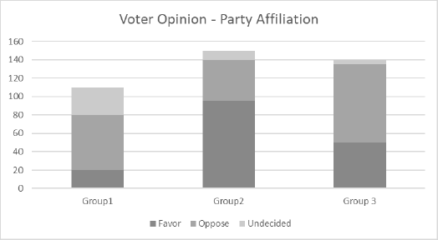
Which of the following statements is true?
 | a. | Group1 is Democrat, Group 2 is Republican, and Group 3 is Independent.
 | b. | Group 1 is Independent, Group 2 is Republican, and Group 3 is Democrat.
 | c. | Group 1 is Republican, Group 2 is Independent, and Group 3 is Democrat.
 | d. | Group 1 is Independent, Group 2 is Democrat, and Group 3 is Republican.

ANSWER: | d

130. The "Medal Tracker" posted on ESPN's website reported the overall medal count for the 2014 Winter Olympics in Sochi. The results are summarized in the two-way table below.
​
 | Gold | Silver | Bronze | Total
Russia | 13 | 11 | 9 | 33
United States | 9 | 7 | 12 | 28
Norway | 11 | 5 | 10 | 26
Canada | 10 | 10 | 5 | 25
Other | 56 | 64 | 63 | 183
Total | 99 | 97 | 99 | 295
Which of the following correctly identifies the size of the table?
 | a. | 3 × 5
 | b. | 4 × 6
 | c. | 6 × 4
 | d. | 5 × 3

ANSWER: | d

