Chapter 2—The Rise of the Atlantic World, 1400-1625

SHORT ANSWER

Instructions: Identify the following. Be as specific as possible, and include names, dates, and relevant facts as appropriate. Be sure to explain the significance of the person or term.

1. Christopher Columbus

ANS:

REF: p. 16 | p. 26 | p. 28

2. Mali

ANS:

REF: p. 17

3. Islam

ANS:

REF: p. 18-19

4. Renaissance

ANS:

REF: p. 19 | p. 21

5. Peasants

ANS:

REF: p. 21

6. Enclosure

ANS:

REF: p. 21-22

7. European reciprocity

ANS:

REF: p. 22

8. Joint-stock company

ANS:

REF: p. 22

9. Roman Catholic Church

ANS:

REF: p. 23-24

10. Martin Luther, John Calvin

ANS:

REF: p. 23

11. Counter-Reformation

ANS:

REF: p. 24

12. Henry VIII, Church of England (Anglican Church)

ANS:

REF: p. 24

13. Puritans

ANS:

REF: p. 24

14. Maritime Revolution

ANS:

REF: p. 25

15. Prince Henry "the Navigator", Bartolomeu Días, and Vasco da Gama

ANS:

REF: p. 25

16. "New slavery"

ANS:

REF: p. 25

17. John Cabot, Amerigo Vespucci

ANS:

REF: p. 27-28

18. Vasco Núñez de Balboa, Ferdinand Magellan

ANS:

REF: p. 28

19. conquistador

ANS:

REF: p. 28

20. Hernán Cortés

ANS:

REF: p. 29

21. Smallpox

ANS:

REF: p. 29-30

22. Columbian Exchange

ANS:

REF: p. 29-30

23. St. Augustine, Florida

ANS:

REF: p. 30

24. Cabeza de Vaca, Juan Ponce de Léon, Hernando de Soto

ANS:

REF: p. 31

25. Encomiendas

ANS:

REF: p. 28

26. Jacques Cartier, Samuel de Champlain

ANS:

REF: p. 31-32

27. Grand Banks

ANS:

REF: p. 32

28. Battle at Lake Champlain

ANS:

REF: p. 33-34

29. Francis Drake

ANS:

REF: p. 34

30. Roanoke Island

ANS:

REF: p. 34

31. Armada

ANS:

REF: p. 34

32. Virginia Company of London

ANS:

REF: p. 35

33. Jamestown, Captain John Smith, Pocahontas

ANS:

REF: p. 35

34. "Headright", indentured servants

ANS:

REF: p. 36

35. John Rolfe, tobacco

ANS:

REF: p. 36

36. Opechancanough and Anglo-Powhatan Wars

ANS:

REF: p. 36

37. Mayflower Compact, Plymouth Colony, Squanto

ANS:

REF: p. 37

38. New Netherland, Henry Hudson, New Amsterdam

ANS:

REF: p. 37

39. Sugar

ANS:

REF: p. 30

40. Kongo

ANS:

REF: p. 17

41. New Mexico

ANS:

REF: p. 31

42. Protestant Reformation

ANS:

REF: p. 23

43. New France

ANS:

REF: p. 32-34

44. predestination

ANS:

REF: p. 23

45. Church of England

ANS:

REF: p. 24

46. Conversion experience

ANS:

REF: p. 23

47. Little Commonwealth

ANS:

REF: p. 22

MULTIPLE CHOICE

48. When Columbus first encountered the Tainos, how did he react?
a. | He assumed they were bloodthirsty killers.
b. | He said that they reminded him of residents of England.
c. | He concluded that they were simplistic innocents who could be Christianized.
d. | He wanted to sell them as slaves in earn gold.
e. | He assumed that they were stupid savages who were good for nothing.

ANS: C REF: p. 16 KEY: Christopher Columbus

49. What was the general social structure in European society in the sixteenth century?
a. | Egalitarian
b. | Hierarchical
c. | Communistic
d. | Matriarchal
e. | Socialistic

ANS: B REF: p. 21 KEY: European society

50. In the early 1500s what percentage of Europe's population consisted of peasants?
a. | Less than 10 percent
b. | Between 40 percent and 50 percent
c. | About 75 percent
d. | Less than one percent
e. | Over 90 percent

ANS: C REF: p. 21 KEY: European society

51. How did the Puritans want to reform the Church of England?
a. | They wanted to revert to purer Roman Catholic rituals.
b. | They wanted to purify it of Roman Catholic rituals.
c. | They wanted to purge the church of Quaker influences.
d. | They wanted to distinguish between the clergy and the congregation.
e. | They wanted to discourage laypersons from interfering in church affairs.

ANS: B REF: p. 24 KEY: Puritans

52. Which of the following was not one of the Puritan beliefs?
a. | Salvation was predetermined.
b. | Christ was not present in the Eucharist.
c. | A learned sermon was the heart of worship.
d. | Membership in the church should be extended to anyone who had been baptized.
e. | It was necessary to live lives of severe self-discipline.

ANS: D REF: p. 24 KEY: Puritans

53. Which of the following statements accurately describe Prince Henry the Navigator's role in encouraging Portuguese exploration?
a. | Most of his financial support came from the Pope.
b. | He discouraged Portuguese seamen from using caravels because he thought they were unreliable.
c. | He looked for alternative routes to Asia.
d. | He wrote a popular book about the value of Benin.
e. | He led a Portuguese fleet around Cape Horn.

ANS: C REF: p. 25 KEY: Prince Henry the Navigator

54. Which statement concerning the West African empires prior to 1600 is true?
a. | They engaged in vigorous trade, were Islamic, and were known for their wealth.
b. | They had no written language and no transportation infrastructure.
c. | They were infested with tsetse flies and therefore unable to develop a state bureaucracy.
d. | They were generally warrior states with little inclination to develop agriculture.
e. | They were ruled over by kings whose absolute political power was based on ruthless use of force.

ANS: A REF: p. 17 KEY: Africa

55. Which of the following is true of both African and Indian religion?
a. | Both believed the practice of magic was wrong.
b. | Both believed that another world lay beyond the one the people perceived with their five senses.
c. | Both believed in a devil.
d. | Both believed that human beings ultimately could become gods.
e. | All of these are true.

ANS: B REF: p. 18 KEY: Religion

56. Which of the following is not a legacy of the Reformation?
a. | The development of various denominations in Europe
b. | A belief in the importance of reading
c. | The idea that clergy have no special powers
d. | A counter-reformation by the Catholic Church
e. | Cooperation between Protestant denominations and the Catholic Church

ANS: E REF: p. 23-24 KEY: Reformation

57. Why was John Rolfe important to the eventual success of the Jamestown settlement?
a. | He adapted a salable variety of tobacco to conditions in Virginia.
b. | He negotiated agreements with the Indians that provided essential food between 1607 and 1610.
c. | He resolved the problem of an inadequate labor supply by importing slaves from Africa.
d. | He introduced the policy that if you did not work you would not eat.
e. | He persuaded Powhatan to teach the settlers how to grow food.

ANS: A REF: p. 36 KEY: John Rolfe

58. Which of the following was not one of the problems in English society in the fifteenth and sixteenth centuries?
a. | High unemployment
b. | A declining population
c. | Falling wages
d. | Class differences
e. | Widening gap between rich and poor

ANS: B REF: p. 21-22 KEY: England

59. Which of the following was not a development of the "maritime revolution" of the fifteenth century?
a. | New materials for constructing ships
b. | A more maneuverable ship
c. | A new type of sail
d. | Mastering the compass
e. | Better use of the astrolabe

ANS: A REF: p. 25
KEY: Maritime revolution | Technology

60. Which of the following nations led the way in exploration in the fifteenth century?
a. | England
b. | Portugal
c. | The Netherlands
d. | Spain
e. | France

ANS: B REF: p. 25 KEY: Portugal

61. Which of the following statements about the fifteenth century slave trade is correct?
a. | Slavery already existed in West African societies and was a much harsher, less humane form of slavery than that practiced by the Europeans.
b. | The only motivation was economic, and race had no role.
c. | Slave traders often traded gold for the African slaves.
d. | The trade began accidentally because of a linguistic misunderstanding between Portuguese seamen and African tribes.
e. | Those sold into slavery by African kings were primarily undesirables such as lawbreakers or persons accused of witchcraft.

ANS: C REF: p. 25 KEY: Slavery | Slave trade

62. How did the European slavery that arose in the fifteenth century differ from other forms of European slavery?
a. | The "new slavery" was a high-volume business.
b. | Slaves taken under the "new slavery" were treated harshly and were destined for exhausting, mindless labor rather than domestic service.
c. | Slaves were regarded ad property rather than merely as persons of low status.
d. | The "new slavery" was based explicitly on the blackness and cultural differences of Africans.
e. | All of these choices

ANS: E REF: p. 26 KEY: Slavery

63. Which of the following statements about Christopher Columbus is correct?
a. | He believed by sailing west he could reach Asia.
b. | He had been recruited by the King and Queen of Spain to be the agent of Spanish territorial expansion.
c. | He embarked on his expedition with limited navigating experience.
d. | His sole goal was to glorify his god, and he thought nothing of personal gain or even the finances of his expedition.
e. | He was simply one of about a dozen would-be explorers who roamed Europe endlessly hawking their enterprises.

ANS: A REF: p. 26 KEY: Christopher Columbus

64. Which of the following statements does not correctly portray an aspect of the "Columbian exchange"?
a. | Europe carried deadly germs to the Americas.
b. | The Americas sent corn and potatoes to Europe.
c. | The Americas sent horses and sheep to Europe.
d. | Europeans transported silver to the Americas to finance new settlements.
e. | Europe sent coffee and sugar to the Americas.

ANS: C REF: p. 29-30 KEY: Columbian exchange

65. What was the primary object of Spanish explorers in the New World?
a. | Agricultural land
b. | Gold
c. | Land
d. | A fountain of youth
e. | Furs

ANS: B REF: p. 29 KEY: Spanish exploration

66. Where was the first permanent European settlement on future United States soil?
a. | Jamestown, Virginia
b. | Quebec, Canada
c. | St. Augustine, Florida
d. | Plymouth, Massachusetts
e. | Santa Fe, New Mexico

ANS: C REF: p. 30 KEY: St. Augustine

67. Where did the French attempt to make their first settlement in North America?
a. | Along the St. Lawrence Valley
b. | South Carolina
c. | Jacksonville, Florida
d. | Fort Nassau
e. | None of these choices

ANS: A REF: p. 31 KEY: French exploration

68. In the 1570s, what were England's objectives in the Western Hemisphere?
a. | It wanted to find the Northwest Passage and to harass the Spanish.
b. | It wanted to find a steady source of furs for aristocratic English women.
c. | It wanted to convert the Native Americans to Protestantism and to establish colonies.
d. | It wanted to discover new sources of gold and to develop new markets for English goods.
e. | It wanted to lay claim to new fishing beds and to find an outpost to which they could exile Irish rebels.

ANS: A REF: p. 34
KEY: English exploration | Northwest Passage

69. What was the leading empire in West Africa in the 14th and early 15th centuries?
a. | Ashanti
b. | Zulu
c. | Sambura
d. | Mali
e. | Yoruba

ANS: D REF: p. 17 KEY: Mali

70. How did the Renaissance encourage exploration?
a. | It led Italian monarchs to support explorers in search of a return to Rome's greatness.
b. | It encouraged individuals to search for new knowledge and information.
c. | It destroyed the connections between Christianity and science.
d. | It ended the disputes between Protestantism and Catholicism
e. | It motivated many to look for lost treasures.

ANS: B REF: p. 21 KEY: Renaissance

71. What was the main problem that crippled the Roanoke colony and hurt Jamestown in its early years?
a. | The English settlers refused to work.
b. | The nearby French settlement monopolized the Native American labor supply.
c. | The Native Americans refused to trade with the English settlers.
d. | The British refused to send more supplies.
e. | The blacks brought by the English refused to live in harmony with the Native Americans.

ANS: A REF: p. 34 KEY: Roanoke colony

72. What was European reciprocity?
a. | It was when European monarchs funded explorers in return for any riches found during the explorations.
b. | It was when Europeans paid for exploration with gold and silver.
c. | It was when the upper classes acted with dignity and the lower classes showed deference to their superiors.
d. | It was the agreement between the Pope and Protestant monarchs to collaborate on colonizing the New World.
e. | None of these choices

ANS: C REF: p. 22 KEY: European reciprocity

73. According to Martin Luther, what is the basis of a person's salvation?
a. | People can buy their salvation by giving money to the church.
b. | People can earn their salvation by doing good works.
c. | People can only gain their salvation through faith in God.
d. | People can gain their salvation after seeing Jesus Christ.
e. | None of these choices

ANS: C REF: p. 23 KEY: Martin Luther

74. How were the early English efforts at settlement paid for?
a. | Through the issuance of company stock
b. | Through the sale of slaves
c. | Through the floating of government bonds
d. | Through the raising of income taxes
e. | Through deficit spending by the government

ANS: A REF: p. 35 KEY: Joint-stock companies

75. Who broke with the Catholic Church and persuaded Parliament to create the Church of England?
a. | Richard I
b. | Henry VIII
c. | Mary I
d. | Elizabeth I
e. | James I

ANS: B REF: p. 24 KEY: Henry VIII

76. What was one of the purposes of the settlement at Plymouth Plantation?
a. | The settlers wanted to form a religious outpost to convert the Native Americans to Christianity.
b. | The settlers wanted to establish a community in which all members could freely practice the religion of their choice.
c. | The settlers wanted to compete with the Virginia colony for furs.
d. | The settlers wanted to identify a source of gold to finance future religious wars.
e. | The settlers wanted to send back lumber, furs, and fish.

ANS: E REF: p. 36 KEY: Plymouth Plantation

77. What was the Mayflower Compact?
a. | It was an agreement reached by the first Pilgrims to constitute themselves a civil body politic.
b. | It was an agreement reached by the first Pilgrims to live in harmony with the local Indians.
c. | It was an agreement reached by the first Pilgrims to be governed directly by England.
d. | It was an agreement reached by the first Pilgrims to establish a colony open to all newcomers.
e. | None of these choices

ANS: A REF: p. 37 KEY: Mayflower Compact

78. Where was the first permanent English settlement in the New World?
a. | Plymouth
b. | Newport
c. | St. Augustine
d. | Jamestown
e. | Charles Town

ANS: D REF: p. 35 KEY: Jamestown

79. Who did Virginia rely on for most of its labor in its initial years as a colony?
a. | Indentured servants
b. | Hessians
c. | Irish laborers
d. | Slaves
e. | Indians

ANS: A REF: p. 36 KEY: Indentured servants

80. How did Governor Francis Wyatt wage the Second Anglo-Powhatan War?
a. | He ordered all captured Indians enslaved.
b. | He made an alliance with Chippewa Indians to overwhelm the Powhatan Indians.
c. | He used ruthless tactics like destroying food supplies and driving Indians from their homes during winter.
d. | He attempted to minimize bloodshed by offering generous concession to the Indians if they stopped fighting.
e. | He laid siege to the Indians' villages and then negotiated.

ANS: C REF: p. 36
KEY: Second Anglo-Powhatan War

81. Where was New Netherland established?
a. | On the Hudson River
b. | On the St. Lawrence River
c. | On the Potomac River
d. | On the Delaware River
e. | On the Savannah River

ANS: A REF: p. 37 KEY: New Netherland

82. What was a result of the battle of Lake Champlain in 1609?
a. | The French gained control of Atlantic Canada.
b. | Indian-European relations entered a deadly era of trade, diplomacy, and warfare.
c. | The lake's value as a highway for Indian traders, diplomats, and warriors ended.
d. | The English controlled all of North America except for Florida.
e. | The fish and waterfowl populations virtually died out.

ANS: B REF: p. 34 KEY: Battle of Lake Champlain

83. To Europeans, what was the "little commonwealth"?
a. | It was the individual.
b. | It was the nuclear family.
c. | It was the extended family.
d. | It was the local village.
e. | It was the entire colony.

ANS: B REF: p. 22 KEY: Little commonwealth

ESSAY

84. What was the Columbian Exchange? What did the Old World send to the New World and vice versa? How did this exchange influence cultures on both sides of the Atlantic Ocean? Explain.

ANS:

85. Compare and contrast black African and Native American societies before European contacts.

ANS:

86. European society in the sixteenth and seventeenth centuries was characterized by hierarchy, economic change, and religious upheaval. Explain how these three factors affected European exploration and settlement of the Western Hemisphere.

ANS:

87. What did the French and Dutch colonies have in common? How were they different? Why were those colonies significant? What impact did they have on the Indian populations of North America?

ANS:

88. Examine the motives behind Portuguese and Spanish exploration in the 15th century. Why did these countries decide to explore? How were their motives similar and different? What leaders provided support for exploration? Why? Did the countries achieve their goals? Explain.

ANS:

89. Discuss the "new slavery" that emerged in the fifteenth and sixteenth centuries. What nations were involved? What were the reasons for the slave trade? How did it affect African societies and politics? How did the "new slavery" differ from previous slavery?

ANS:

90. What were the goals of the Spanish empire in the Western Hemisphere? What were their methods? To what extent were they successful?

ANS:

91. Compare the experiences of the first English settlements: Roanoke, Jamestown, and Plymouth. What were their motivations for settlement? What problems did the settlers face, and how, if at all, did they overcome them? What lessons did the English learn from their experiences in each colony?

ANS:

92. Why were the English late in joining the European expansion that began in the sixteenth century? What factors eventually stimulated English expansion? How did the goals and techniques of the English differ from those of other European nations? To what extent were they similar?

ANS:

93. Explore the Reformation in England. What were the main issues that led to England's split from the Catholic Church and the establishment of the Church of England? How did the Reformation influence England's development in the late 16th and early 17th centuries?

ANS:

94. What forces were transforming West Africa before the advent of the Atlantic slave trade?

ANS:

95. How did European monarchs use commerce and religion to advance their nations' fortunes?

ANS:

96. What role did the Columbian exchange play in the formation of an Atlantic world?

ANS:

97. How did European relations with Native Americans affect the success of early European colonizing efforts?

ANS:

MAP QUESTIONS

Instructions: Choose the letter on the accompanying map of Africa that correctly identifies each of the following:

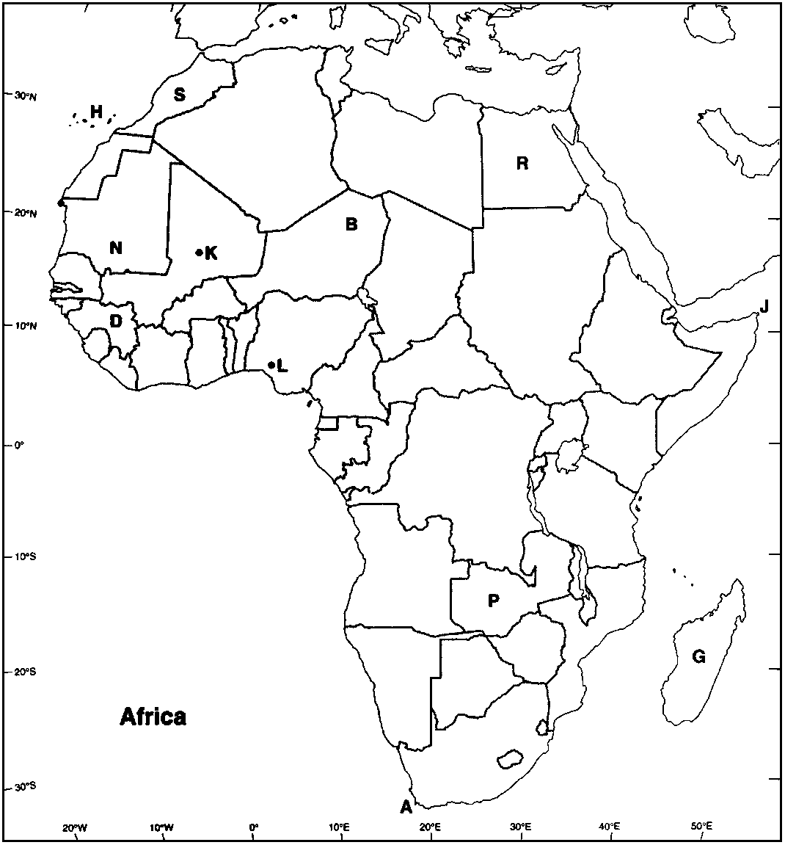

98. Sahara Desert

ANS:
[B]

99. Timbuktu, Mali

ANS:
[K]

100. Benin

ANS:
[L]

101. Cape of Good Hope

ANS:
[A]

102. Canary Islands

ANS:
[H]

Instructions: Choose the letter on the accompanying map of the United States that correctly identifies each of the following:

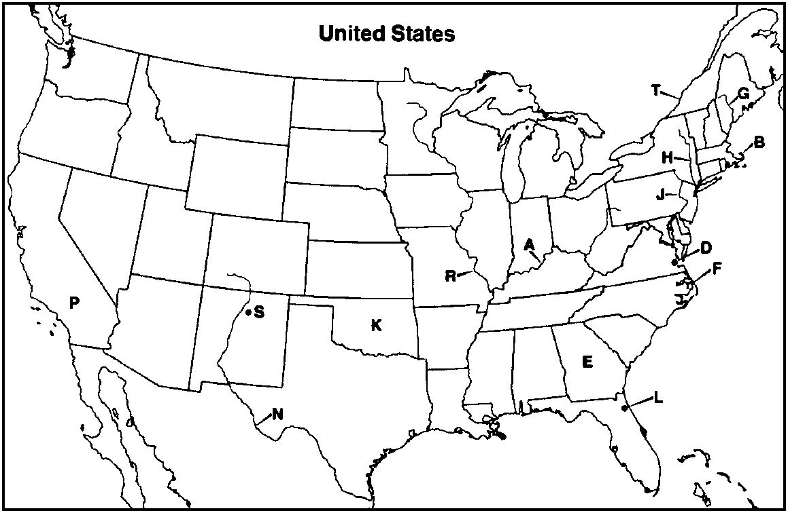

103. Roanoke Island, North Carolina

ANS:
[F]

104. Kennebec River, Maine

ANS:
[G]

105. Jamestown, Virginia

ANS:
[D]

106. St. Augustine, Florida

ANS:
[L]

107. St. Lawrence River

ANS:
[T]

108. Hudson River

ANS:
[H]

Instructions: Choose the letter on the accompanying map of Europe that correctly identifies each of the following:

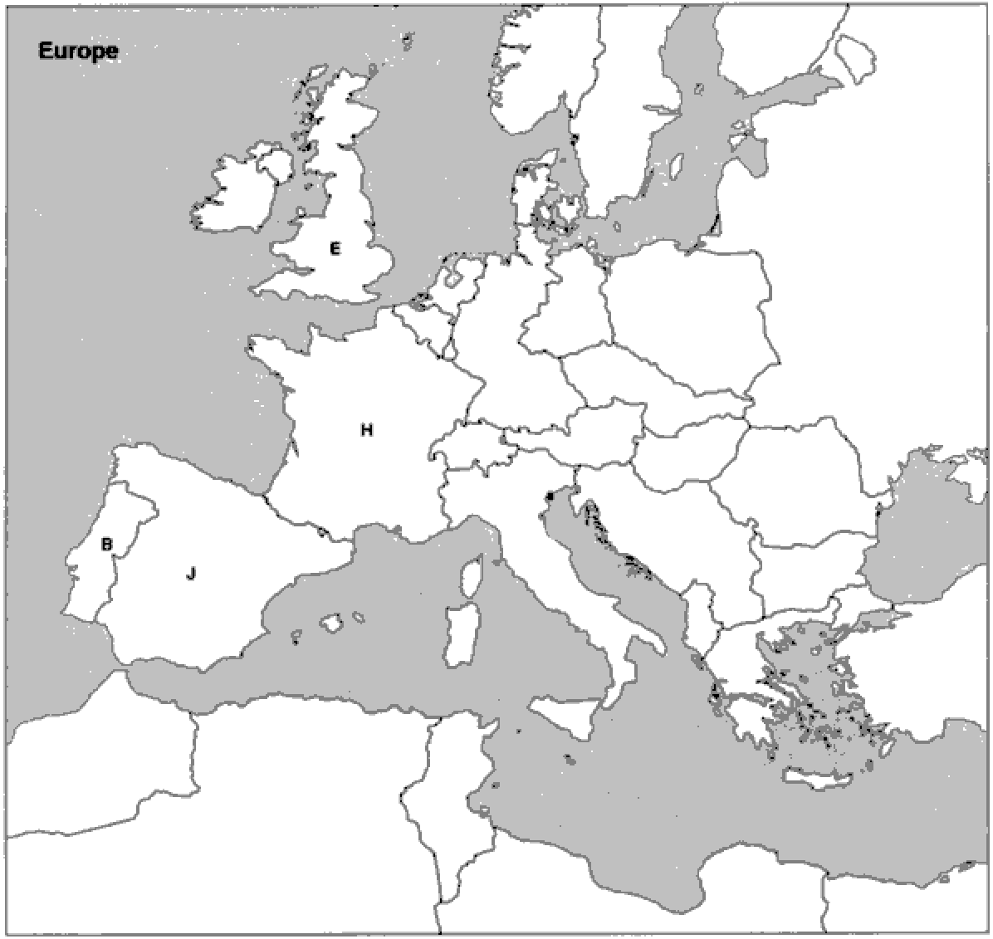

109. Portugal

ANS:
[B]

110. England

ANS:
[E]

111. France

ANS:
[H]

112. Spain

ANS:
[J]

Instructions: Choose the letter on the accompanying map of the North Atlantic region that correctly identifies each of the following:

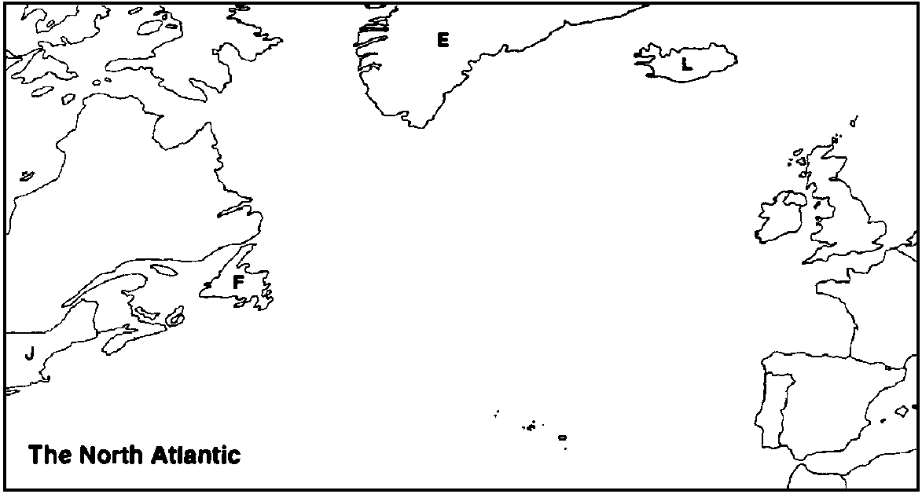

113. Iceland

ANS:
[L]

114. Greenland

ANS:
[E]

115. Newfoundland

ANS:
[F]

116. New England

ANS:
[J]

