# Instructor’s Manual and Test Bank

## *For*

**Teaching Children to Read**

**The Teacher Makes the Difference**

# Eighth Edition

## D. Ray Reutzel, Ph.D., *[University of Wyoming]*

## Robert B. Cooter Jr., Ed.D., *[Bellarmine University]*

***Prepared by***

**Cindy Jones,** *[Utah State University]*

Boston Columbus Indianapolis New York San Francisco Hoboken

Amsterdam Cape Town Dubai London Madrid Milan Munich Paris Montreal Toronto

Delhi Mexico City Sao Paolo Sydney Hong Kong Seoul Singapore Taipei Tokyo

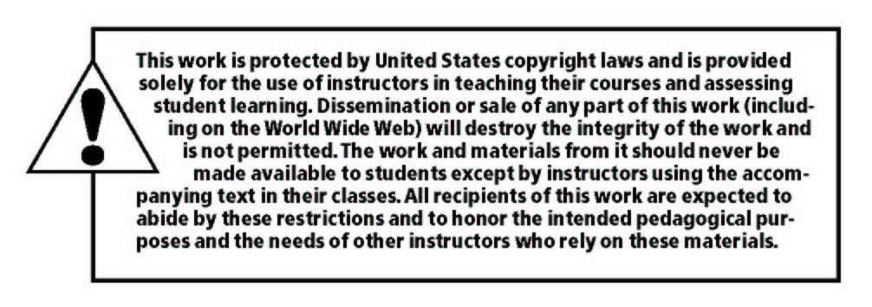

___________________________________________________________________________________

Copyright © 2019, 2015, 2012 by Pearson Education, Inc. or its affiliates.  All Rights Reserved.  Printed in the United States of America. This publication is protected by copyright, and permission should be obtained from the publisher prior to any prohibited reproduction, storage in a retrieval system, or transmission in any form or by any means, electronic, mechanical, photocopying, recording, or otherwise. For information regarding permissions, request forms and the appropriate contacts within the Pearson Education Global Rights & Permissions Department, please visit [www.pearsoned.com/permissions/](http://www.pearsoned.com/permissions/).

Instructors of classes using *Teaching Children to Read: The Teacher Makes the Difference, Seventh Edition, by D. Ray Reutzel and Robert B, Cooter, Jr.,* may reproduce material from the Instructor’s Resource Manual and Test Bank for classroom use.

10 9 8 7 6 5 4 3 2 1 ISBN-10: 0134742419 ISBN-13: 9780134742410

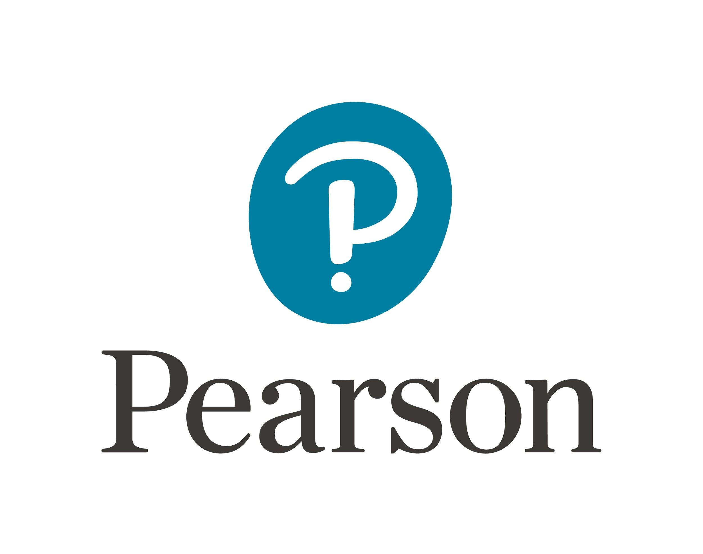

www.pearsonhighered.com

### Table of Contents

|  |  |
| --- | --- |
| **CHAPTER RESOURCES** | **Page** |
| Chapter One: *Effective Reading Instruction* | 1 |
| Chapter Two:*Developing Children’s Oral Language to Support Literacy Instruction* | 9 |
| Chapter Three:*Early Reading Instruction: Getting Started with the Foundations* | 19 |
| Chapter Four: *Phonics and Word Recognition* | 28 |
| Chapter Five: *Reading Fluency* | 38 |
| Chapter Six: *Increasing Reading Vocabulary* | 46 |
| Chapter Seven: *Teaching Reading Comprehension* | 55 |
| Chapter Eight: *Writing* | 64 |
| Chapter Nine: *Evidence-Based Reading Programs and Tools* | 71 |
| Chapter Ten: *Assessment* | 81 |
| Chapter Eleven: *Effective Reading Instruction and Organization in Grades K-3* | 88 |
| Chapter Twelve: *Effective Disciplinary Literacy Instruction in Grades 4-8* | 97 |
| Answer Key | 105 |

**CHAPTER ONE RESOURCES**

***Effective Reading Instruction***

**Learning Outcomes**

* Explain why investing in teacher knowledge and skill development is important to student outcomes in P-12 schools.
* Create a timeline of historical events that have shaped current trends and practices in teaching reading.
* Analyze the rationale behind the major anchor standards for the English Language Arts in the Common Core State Standards (CCSS).
* Discuss how the definition of traditional print literacy has been broadened in the past decade.
* Explain why teachers make such a difference in helping a child to read.
* Describe the seven pillars of effective reading instruction used throughout this book.

**Chapter Outline with Lecture Points (LP) and Focus Questions (FQ)**

Becoming a Master Teacher of Reading

* FQ: Discuss early reading experiences (How did you learn to read? Who helped you? What do you remember about learning to read?). Discuss how positive or negative experiences affect motivation to learn to read (Are there lasting impacts from those experiences? As a result of these learning experiences, do you enjoy reading now?)
* LP: Explain how fiction and nonfiction reading sources can be incorporated into the class curriculum.
* LP: Discuss what it means to be a master teacher.

A Brief History of Current Trends in Reading Instruction

* Inability to Read: “A National Health Risk”
* LP: Discuss the effects of illiteracy and aliteracy on an individual and societal

level.

* Political Responses to the Literacy Crisis:
* FQ: What have been the political responses leading to reading reform and have

they been effective?

* LP: Discuss the findings of the National Reading Panel and subsequent panels.

Common Core State Standards

* FQ: Why were the Common Core State Standards developed?
* LP: Explain the goal of the Common Core State Standards (CCSS) and how they

have shaped current educational thinking and practice.

* LP: Discuss how the Common Core State Standards were reverse-engineered

and set higher standards for students.

What is Reading?

* LP: Compare and contrast the definitions of reading. Discuss how the definitions

of reading have changed over time

* Reading Instruction in the Twenty-First Century
* LP: Discuss how the broadening use of media and technology is influencing the definition and goal of reading instruction.
* The Skills, Concepts, and Strategies of Successful Reading
* LP: Present early reading skills, concepts and strategies
* LP: Discuss the relationship between reading and writing
* LP: Present early writing skills, concepts and strategies

Teachers Make the Difference

* FQ: How did your teachers make a difference in your success and motivation to

learn to read?

* LP: Discuss the relationship between knowledgeable, skilled, and competent

teachers and strong readers.

* LP: Explain why teachers make such a difference in helping a child to read.
* The Need for Quality Classroom Teachers
* LP: Discuss the research pertaining to the quality of a teacher and the success of the student.
* Support from Literacy Coaches
  + FQ: What is the purpose of literacy coaches? Have you been involved with a literacy coach and if so, what benefits have you experienced?

What Reading Teachers Need to Know and Do: The Seven Pillars of Effective Reading Instruction

* Pillar One: Teacher Knowledge
  + FQ: What can you do to continually improve your ability to teach reading?
  + LP: Discuss the importance of continuing education.
* Pillar Two: Classroom Assessment
  + LP: Explain the importance of classroom assessment, the definition, the goals, and the most effective methods of classroom assessment (i.e., when to assess, purpose for assessment, analysis).
* Pillar Three: Evidence-Based Teaching Practices
* LP: Discuss the research on evidence-based practices.
* FQ: Why is classroom management important?
* LP: Discuss strategies for excellent classroom management.
* LP: Present essentials needed to become a successful reader.
* FQ: What is the difference between strategies and skills? How do they relate?
* FQ: What are ways you can make your classroom “print-rich?”
* LP: Discuss evidence-based practices that support high-quality reading

instruction.

* Pillar Four: Response to Intervention (RTI)
  + LP: Discuss the three tiers of Response to Intervention.
  + FQ: What is the goal of differentiated instruction?
  + LP: Present and discuss tools and abilities needed to provide effective

differentiated instruction.

* + LP: Discuss ways to be culturally sensitive in reading instruction.
* Pillar Five: Motivation and Engagement
* FQ: What motivates you to read?
* LP: Explain and discuss the social and emotional factors that influence a child’s choice to read.
  + LP: Discuss ways to engage the child in reading.
* Pillar Six: Technology and New Literacies
  + FQ: What are New Literacies and why is it becoming increasingly important to

include these sources in daily curriculum?

* FQ: How can computer-assisted instruction be used to enhance literacy instruction?
* Pillar Seven: Family and Community Connections
  + FQ: How can teachers involve and enhance the family and community learning

experience?

**Learning Outcome Applications**

1. Working with other members of a small group, discuss how your early reading experiences have influenced how you would like to teach children to read in your own classroom. Discuss tasks you might create in order to promote a positive early reading experience for your students. What tasks have worked for you in the past?
2. Create a timeline of historical events that have shaped current trends and practices in teaching reading.
3. Write a brief essay on how the definition of reading has changed over time. Include information on the causes of the changes.
4. The child, parent, and teacher must work together to create the ideal learning environment. Think about the Seven Pillars of Effective Reading Instruction and using a spider graph, relate each pillar to each participant in this powerful support group.
5. Working with other members of a small group, share and discuss two classroom management techniques that have been successful in your classroom or that you have observed to be successful.
6. Prepare a PowerPoint presentation and present three tasks to the class that will engage a child in reading using three of Gambrell’s seven rules of motivation and engagement and addressing two dimensions of motivation. Include at least two vignettes.
7. Research an evidence-based classroom practice. Write a three-page paper discussing this practice. Include the steps of how you would incorporate the practice in the classroom.
8. Using technology and New Literacies, engage your students in a reading/writing task over the next five days. Following the task, write a three-page paper discussing the specifics of the task, how well the students responded (i.e., was it engaging), and what you would change about this specific task to make it more effective.
9. Watch the National Reading Panel Video Example 1.1. Discuss why the panel was formed and its major findings. How does the NRP’s report continue to influence the way we think about literacy education today?

**Field and Classroom Applications from the Textbook**

1. Read *Using Research and Reason in Education: How Teachers Can Use Scientifically Based Research to Make Curricular and Instructional Decisions* (Stanovich & Stanovich, 2003)*.* Working with other members of a small group, list ten reasons why teachers should rely on the results of research evidence to inform their instructional and curricular choices. Share your group’s list with the rest of the class. Collapse all of the small-group charts into a single class chart.
2. Read the *Report of the National Reading Panel: Teaching Children to Read* (National Reading Panel, 2000) found online. Make a list of the five essentials of effective reading instruction. Next, read more closely to determine three instructional practices, skills, strategies, or concepts associated with each of the five essentials of reading for providing evidence-based reading instruction.
3. Read the Executive Summary of the *Developing Early Literacy* report from the National Early Literacy Panel (2008) available online. In small groups, prepare a brochure or pamphlet that explains to parents, teachers, and school administrators the best early predictors for success in learning to read. Share your pamphlet with your class or with parents at your first open house.
4. Read the Executive Summary of the report from the Annie E. Casey Foundation (2010) - *Early warning!* Available at The Children’s Reading Foundationwebsite under the Research banner link*.* Make a list with a partner of at least two reasons why learning to read successfully when children are young is so critical.

**Related Readings**

Armbruster, B. B., Lehr, F., & Osborn, J. (2001). Put reading first: The research building blocks for teaching children to read. Washington, DC: U.S. Department of Education.

August, D., & Shanahan, T. (2006). Developing literacy in second-language learners: Report of the National Literacy Panel on language-minority children and youth. Mahwah, NJ: Lawrence Erlbaum Associates.

Brooks, D. (2014). When the circus descends (April 17). New York, NY: New York Times. Retrieved from <http://www.nytimes.com/2014/04/18/opinion/brookswhen-the-circus-descends.html>

Cervetti, G. N., & Hiebert, E. H. (2015). The sixth pillar of reading instruction: Knowledge development. The Reading Teacher, 68(7): 548–551.

Konza, D. (2014). Teaching reading: Why the “Fab Five” should be the “Big Six.” Australian Journal of Teacher Education, 39(12): 153–169.

Leu, D. J., Forzani, E., Timbrell, N., & Maykel, C. (2015). Seeing the forest forest, not the trees. The Reading Teacher 69(2), 139–145.

National Early Literacy Panel (NELP). (2008). Developing early literacy: Report of the National Early Literacy Panel. Jessup, MD: National Institute for Literacy.

National Institute of Child Health and Human Development (NICHD). (2000). Report of the National Reading Panel: Teaching children to read. Washington, DC: Author.

Roskos, K., & Neuman, S. B. (2011). The classroom environment. The Reading Teacher, 64(2), 110–114.

Shanahan, T. (2003). Research-based reading instruction: Myths about the National Reading Panel Report. The Reading Teacher, 56(7), 646–654.

Snow, C. E., Burns, M. S., & Griffin, P. (1998). Preventing reading difficulties in young children. Washington, DC: National Academy Press.

Snow, C. E., Griffin, P., & Burns, M. S. (2005). Knowledge to support the teaching of reading: Preparing teachers for a changing world. San Francisco, CA: Jossey-Bass.

Stanovich, P. J., & Stanovich, K. E. (2003). Using research and reason in education: How teachers can use scientifically based research to make curricular and instructional decisions. Washington, DC: National Institute for Literacy.

U.S. Department of Education. (2003). Identifying and implementing educational practices supported by rigorous evidence: A user-friendly guide. Washington, DC: Coalition for Evidence-Based Policy

**Test Bank**

**Multiple Choice Questions**

1. Investing in teacher knowledge and skill development is
2. unimportant since children learn to read first from peers.
3. important since beginning readers learn first from their teacher.
4. not necessary to create master teachers of reading.
5. necessary to receive federal funding.
6. What term refers to the ability to read well?
7. phonemic awareness
8. literacy
9. orthographic awareness
10. aliteracy
11. What term describes the ability to hear individual sounds in spoken words?
12. print concepts
13. alphabetic principle
14. phonemic awareness
15. orthographic awareness
16. Recent social, political, and economic actions in the United States have been aimed at preparing students to
17. become more competitive in the world of work and in university studies.
18. advance in technology.
19. become more independent learners.
20. work in a collaborative environment.
21. The Common Core State Standards for English Language Arts
22. are adopted by all 50 states.
23. place fewer demands on teachers and students.
24. are reverse-engineered.
25. are most appropriate for the primary grades.
26. Reading involves cognitive and _________________ activities.
27. thinking
28. schemata
29. semantic
30. social
31. All of the following are important early reading skills, concepts, and strategies ***except***
32. hearing and manipulating individual sounds in spoken words.
33. decoding words with accuracy, speed, and expression.
34. grasping concepts about how printed language looks and works.
35. efficiently summarizing large sections of text.
36. The relationship between reading and writings is
37. nonexistent.
38. complementary.
39. opposite.
40. pragmatic.
41. Traditional literacy has broadened in the past decade to include more of what type of media?
42. digital
43. magazines
44. books
45. newspapers
46. What does research tell us about a teacher’s instructional abilities and students’ learning?
47. These factors are unrelated.
48. These factors are marginally related.
49. These factors are strongly related.
50. These factors are occasionally related.
51. What do researchers and policymakers agree is the best hope for closing the achievement gap?
52. decreasing class size
53. increasing teacher knowledge and skill
54. incorporating more independent reading
55. implementing research-based curriculum
56. When should reading assessments be conducted to be the most effective?
57. the end of each reading unit
58. the end of each school year
59. periodic intervals throughout the year
60. before, during and after reading instruction
61. Students’ literacy processes are best examined by which activity?
62. classroom assessments
63. teacher informal observation
64. daily assignments
65. portfolios
66. Which practice refers to responding to the specific needs of every child?
67. reading reform
68. evidence-based instruction
69. differentiated instruction
70. classroom management
71. To achieve the ideal teaching/learning environment, children should be grouped according to
72. interests.
73. level of attention span.
74. learning rates.
75. similar abilities and needs.
76. What is the optimum number of children for small group instruction?
77. 1-5
78. 2-6
79. 4-8
80. 6-10
81. What percentage of reading material is incomprehensible to students in 4th grade who read below grade level?
    * 1. 30%
      2. 40%
      3. 50%
      4. 60%
82. Which act by the U.S. Department of Education initiated reading reform and contained funding specifically targeted to underachieving and high-poverty school populations?
83. Reading Excellence Act
84. National Literacy Act for Language Minority Children and Youth
85. Reading Reform Act
86. Literacy Reform Act

19. Which of the following was an organization created in the late 1900s to examine research on best teaching practices and to share their findings with the public?

1. National Assessment of Education Progress
2. U.S. Department of Education
3. American Federation of Teachers
4. National Reading Panel
5. Which of the following is NOT a motivational factor according to Wigfield?
6. challenge
7. fear
8. recognition
9. curiosity

**Short Answer/Essay Questions**

1. Describe the political history and reform of literacy education and discuss the effectiveness of those responses.

1. Describe the unique skill set of master teachers and how you plan to implement these skills in your own teaching.
2. Explain the relationship that exists between acquiring reading and writing skills.
3. Name and describe the four components of a highly effective reading instruction program and describe ways you can incorporate these components in the classroom.