# Test Bank

## *For*

# Strategies for Technical Communication in the Workplace

# Fourth Edition

## Laura J. Gurak, *University of Minnesota*

## John M. Lannon, *University of Massachusetts-Dartmouth*

***Prepared by***

**Lee Scholder,** *Capella University*

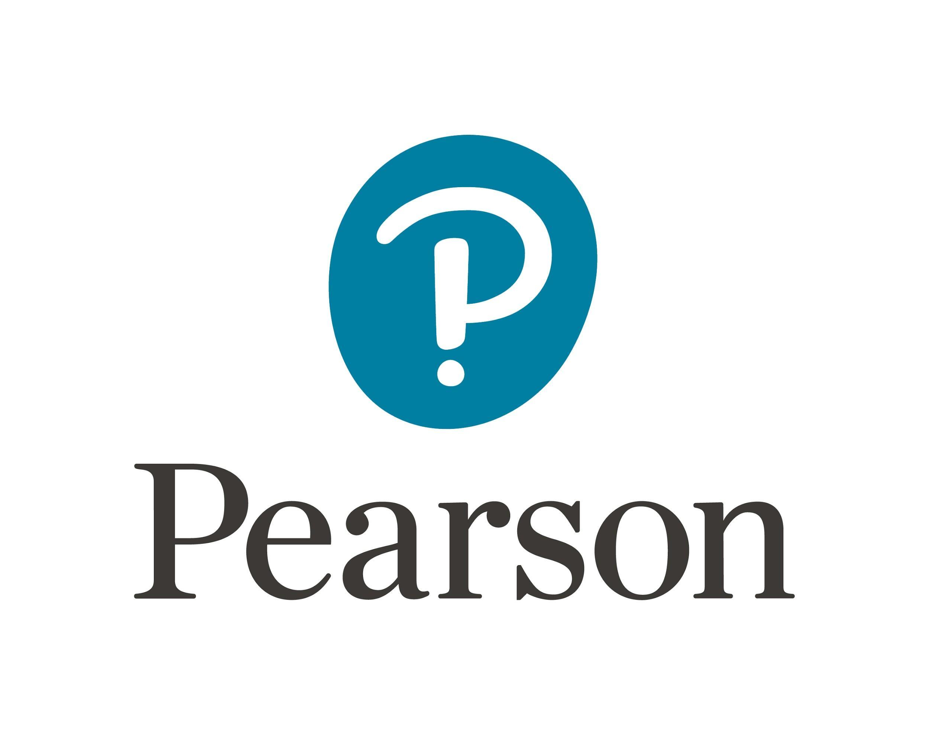

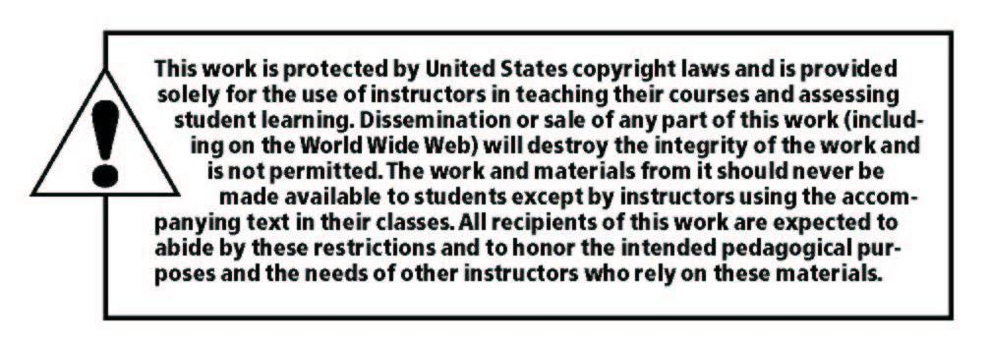

______________________________________________________________________________

Copyright © 2019, 2016, 2013 by Pearson Education, Inc. or its affiliates.  All Rights Reserved.  Printed in the United States of America. This publication is protected by copyright, and permission should be obtained from the publisher prior to any prohibited reproduction, storage in a retrieval system, or transmission in any form or by any means, electronic, mechanical, photocopying, recording, or otherwise. For information regarding permissions, request forms and the appropriate contacts within the Pearson Education Global Rights & Permissions Department, please visit [www.pearsoned.com/permissions/](http://www.pearsoned.com/permissions/).

ISBN-10: 0134680111  
ISBN-13: 9780134680118

**Table of Contents**

CHAPTER 1. Technical Communication: Global, Collaborative, and Digital 1

CHAPTER 2. The Research Process in Technical Communication 5

CHAPTER 3. Providing Audiences with Usable Information 9

CHAPTER 4. Recognizing Ethical Issues in Technical Communication 13

CHAPTER 5. Structuring Information for Your Readers 16

CHAPTER 6. Writing with a Readable Style 20

CHAPTER 7. Using Audience-Centered Visuals 24

CHAPTER 8. Designing User-Friendly Documents 27

CHAPTER 9. Résumés and Other Employment Materials 31

CHAPTER 10. Memos and Letters 35

CHAPTER 11. Definitions 39

CHAPTER 12. Descriptions 43

CHAPTER 13. Instructions and Procedures 47

CHAPTER 14. Summaries 51

CHAPTER 15. Informal Reports 55

CHAPTER 16. Formal Reports 59

CHAPTER 17. Proposals 63

CHAPTER 18. Email 67

CHAPTER 19. Blogs, Wikis, and Web Pages 71

CHAPTER 20. Social Media 75

CHAPTER 21. Oral Presentations and Video Conferencing 79

**CHAPTER 1. Technical Communication: Global, Collaborative, and Digital**

**True/False Questions**

1. Technical communication helps us interact with technology in our daily lives.

2. An effective way to manage team conflicts is to listen passively.

3. Technical documents are typically written by teams.

4. All documents are at least partly persuasive.

5. Technical communication does not include digital media such as blogs, apps, and wikis.

6. A collaborative document should be written in a style that emphasizes the different voices of the individual writers.

7. The definition of technical communication is any communication that provides complex information for technical experts; it is not intended for broader audiences.

8. Paying attention to “face saving” is key to working across cultures.

**Fill-in-the-blank Questions**

9. The oldest form of virtual collaboration, multiple callers meet by telephone.

takes place when

10.

involves making a document more precise and readable at the word and sentence level.

11. To outline a work schedule, team member responsibilities, and other components of a project, fill out a .

12. The three purposes of technical documents are to ,

, and .

**Multiple-Choice Questions**

13. Technical communication seeks to

(a) anticipate and answer questions. (b) help people perform a task.

(c) persuade people to do something. (d) b and c.

(e) All of these answers are correct.

14. Effective technical documents

(a) use obfuscation.

(b) avoid combining text, visuals, and sound.

(c) are easy to navigate. (d) a and c.

(e) None of these answers are correct.

15. Which of the following statements is *most* accurate?

(a) Technical communication helps us interact with technology in our daily lives. (b) Technical communication helps advance workplace goals.

(c) Technical communication helps specialists solve complex problems. (d) b and c

(e) All of these answers are correct.

16. Sources of conflict in collaborative groups include

(a) interpersonal differences. (b) cultural differences.

(c) gender differences.

(d) All of these answers are correct.

(e) b and c.

17. Choose which strategy below helps support running successful meetings.

(a) Allow the conversation to stray as the group desires.

(b) Set an agenda with specific time limits for items of discussion. (c) Don’t waste the group’s time by summarizing minutes from the last meeting.

(d) Highlight points of disagreement.

(e) Avoid appointing roles; instead, let the roles spontaneously evolve.

18. Which statement below is *most* accurate?

(a) Blogs are not a useful medium for collaboration. (b) An intranet is an external company Web site.

(c) Instant messaging is an easy means of holding real-time team meetings. (d) E-mail is the preferred way to address conflict.

(e) None of these answers are correct.

19. When communicating with someone from another culture, (a) use humor on first contact to break the ice.

(b) use humor only in email correspondence.

(c) use humor only in face-to-face contact.

(d) always use humor to facilitate strong interpersonal connections.

(e) avoid humor.

20. Which of the following statements about organizing a team project is *least* accurate?

(a) Work without a manager; allow all team members to take charge. (b) Compose a purpose statement.

(c) Develop a file-naming system for documents.

(d) Decide on a specific meeting schedule. (e) All of these answers are correct.

**ANSWER KEY True/False**

1. T

2. F

3. T

4. T

5. F

6. F

7. F

8. T

**Fill-in-the-blank**

9. teleconferencing

10. editing

11. project planning form

12. inform, instruct, persuade

**Multiple-Choice**

13. e

14. c

15. e

16. d

17. b

18. c

19. e

20. a