Statistics: Data and Models, Cdn. Ed., 3e (De Veaux)
Chapter 2 Displaying and Describing Categorical Data

2.1 Summarizing and Displaying a Single Categorical Variable

1) Of the 1470 applicants to a college program, 760 were accepted, 269 were wait-listed, and 441 were turned away for lack of space. Find the relative frequency distribution of the decisions made, and write a sentence describing it.
A) 1470 students applied for admission to the college program. 52% were accepted, 18% were wait-listed, and 30% were turned away.
B) 1470 students applied for admission to the college program. 52% were accepted, and 48% were turned away.
C) 1470 students applied for admission to the college program. 52% were accepted, 35% were wait-listed, and 30% were turned away.
D) 1470 students applied for admission to the college program. 52% were accepted, 35% were wait-listed, and 58% were turned away.
E) 1470 students applied for admission to the college program. 70% were accepted, and 30% were turned away.
Answer: A
Diff: 1 Type: BI
Objective: (2.1) Find Relative Frequency Distribution

2) Of the 1606 applicants to a college program, 456 were Black or Hispanic, 300 were Asian, and 850 were White. Summarize the relative frequency distribution of ethnicity with a sentence or two in the proper context.
A) Of the 1606 students who applied for admission to the college program, 3% were Black or Hispanic, 2% were Asian, and 5% were White.
B) Of the 1606 students who applied for admission to the college program, 54% were Black or Hispanic, 35% were Asian, and 53% were White.
C) Of the 1606 students who applied for admission to the college program, 14% were Black, 14% were Hispanic, 19% were Asian, and 53% were White.
D) Of the 1606 students accepted in the college program, 28% were Black or Hispanic, 19% were Asian, and 53% were White.
E) Of the 1606 students who applied for admission to the college program, 28% were Black or Hispanic, 19% were Asian, and 53% were White.
Answer: E
Diff: 1 Type: BI
Objective: (2.1) Find Relative Frequency Distribution
3) Statistics Canada gives the following mortality data for Canada in 2013.

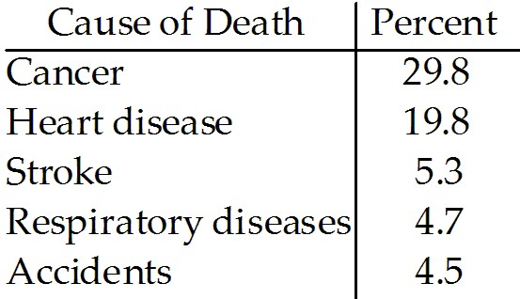

Is it reasonable to conclude that cancer or accidents were the cause of approximately 34.3% of deaths in 2013?
A) No, because the percentages do not add up to 100%.
B) Yes, because these categories do not overlap.
C) Yes, because the percentages can always be added in relative frequency tables.
D) No, because the percentages in relative frequencies tables can never be added.
E) No, because these categories overlap.
Answer: B
Diff: 1 Type: BI
Objective: (2.1) Interpret Relative Frequency Table

4) Statistics Canada gives the following mortality data for Canada in 2013.

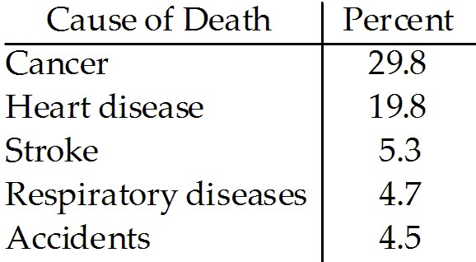

What percent of deaths were from causes not listed here?
A) 58.5%
B) 35.9%
C) 36%
D) 64.1%
E) The percent cannot be determined from the given percentages because the categories overlap.
Answer: B
Diff: 1 Type: BI
Objective: (2.1) Interpret Relative Frequency Table
5) The City of Windsor Department of Parks and Recreation is planning to build a recreation centre in one of the city's parks. They conducted a poll to find out the types of physical activities the local population would be interested in. The poll was based on telephone responses from 1013 randomly selected adults. The table shows the percentages of people who expressed interest in various activities.

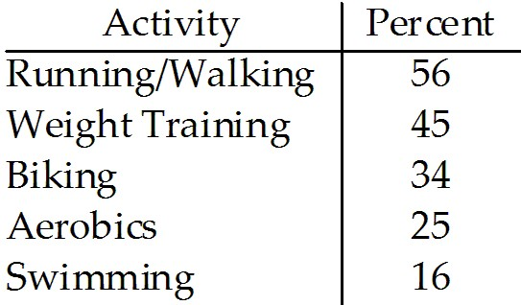

Is it reasonable to conclude that 59% expressed interest in either biking or aerobics?
A) Yes, because these categories do not overlap.
B) No, because the poll is not based on a large-enough number of individuals.
C) No, because these categories overlap.
D) No, because the percentages in relative frequencies tables can never be added.
E) Yes, because the percentages can always be added in relative frequency tables.
Answer: C
Diff: 1 Type: BI
Objective: (2.1) Interpret Relative Frequency Table

6) The City of Windsor Department of Parks and Recreation is planning to build a recreation centre in one of the city's parks. They conducted a poll to find out the types of physical activities the local population would be interested in. The poll was based on telephone responses from 1013 randomly selected adults. The table shows the percentages of people who expressed interest in various activities.

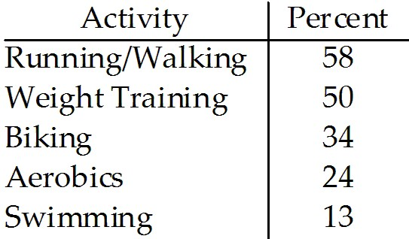

What percent of adults polled did not express interest in any of these activities?
A) 21%
B) 179%
C) 79%
D) 90%
E) The percent cannot be determined from the given percentages because the categories overlap.
Answer: E
Diff: 1 Type: BI
Objective: (2.1) Interpret Relative Frequency Table
7) A newspaper surveyed its subscribers as to which section of the paper they read first. The results are listed below.

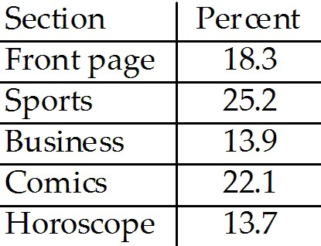

Is it reasonable to conclude that 39.1% of the paper's subscribers read the business or sports sections first?
A) Yes, because the percentages can always be added in relative frequency tables.
B) No, because the percentages in relative frequencies tables can never be added.
C) No, because the percentages do not add up to 100%.
D) No, because these categories overlap.
E) Yes, because these categories do not overlap.
Answer: E
Diff: 1 Type: BI
Objective: (2.1) Interpret Relative Frequency Table

8) A newspaper surveyed its subscribers as to which section of the paper they read first. The results are listed below.

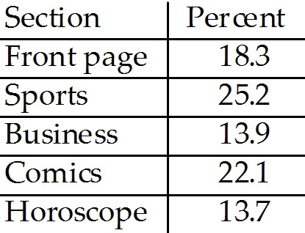

What percent of subscribers read a section of the paper not listed above first?
A) 6.8%
B) 4.7%
C) 7.2%
D) 8.3%
E) The percent cannot be determined from the given percentages because the categories overlap.
Answer: A
Diff: 1 Type: BI
Objective: (2.1) Interpret Relative Frequency Table
9) A poll asked adults which activities they had engaged in during the past month. The results are listed below.

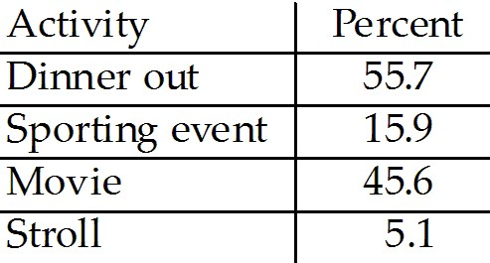

Is it reasonable to conclude that 61.5% of those polled had seen a movie or gone to a sporting event during the past month?
A) Yes, because these categories do not overlap.
B) No, because the percentages in relative frequencies tables can never be added.
C) Yes, because the percentages can always be added in relative frequency tables.
D) No, because these categories overlap.
E) No, because the poll is not based on a large enough number of individuals.
Answer: D
Diff: 1 Type: BI
Objective: (2.1) Interpret Relative Frequency Table

10) A real estate company kept a database on the apartments in a certain city. The percentages of various types of apartments are listed below.

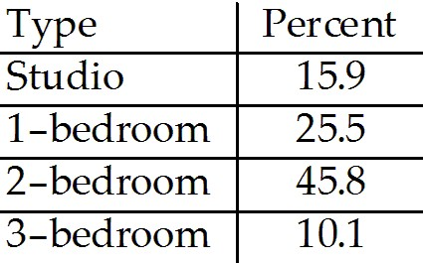

What percentage of the apartments in the city are 1-bedroom or 2-bedroom apartments?
A) 69.9%
B) 69.4%
C) 71.3%
D) 73.3%
E) The percent cannot be determined from the given percentages because the categories overlap.
Answer: C
Diff: 1 Type: BI
Objective: (2.1) Interpret Relative Frequency Table

11) The Centers for Disease Control in the U.S.A. lists causes of death for individual states in 2002. The mortality data for the five leading causes of death for one state is given.

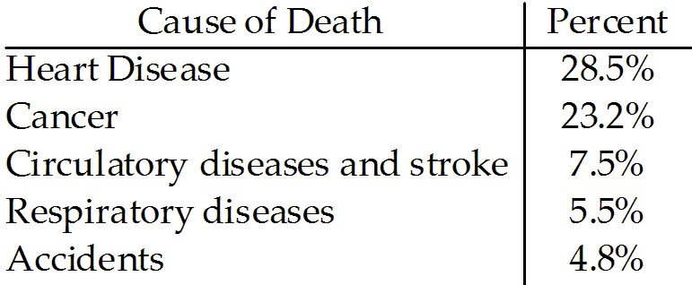

Which of the following displays is/are appropriate to describe the data for all causes of death? (More than one display may be appropriate.)

I II
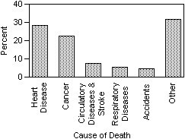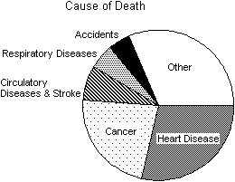

III
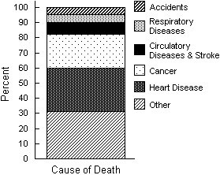
A) II, III
B) I, II, III
C) I
D) I, II
E) None of these displays are appropriate.
Answer: B
Diff: 2 Type: BI
Objective: (2.1) Determine Appropriate Display for Data
12) The Centers for Disease Control in the U.S.A. lists causes of death for individual states in 2002. The mortality data for the five leading causes of death for one state is given.

Which of the following displays is/are appropriate to describe the data for all causes of death? (More than one display may be appropriate.)

I II
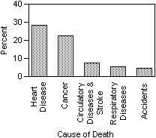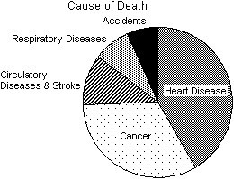

III
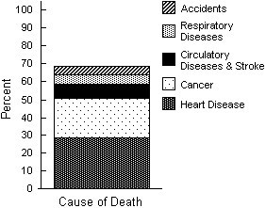
A) I, II
B) I
C) I, III
D) I, II, III
E) None of these displays are appropriate.
Answer: E
Diff: 2 Type: BI
Objective: (2.1) Determine Appropriate Display for Data

13) The Centers for Disease Control in the U.S.A. lists causes of death for individual states in 2002. The mortality data for the five leading causes of death for one state is given.

Which of the following displays is/are appropriate to describe the data for all causes of death? (More than one display may be appropriate.)

I II

III
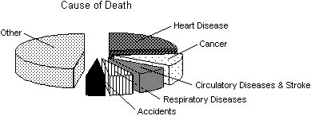
A) I, II
B) I, II, III
C) I
D) II
E) None of these displays are appropriate.
Answer: C
Diff: 2 Type: BI
Objective: (2.1) Determine Appropriate Display for Data

14) The Centers for Disease Control in the U.S.A. lists causes of death for individual states in 2002. The mortality data for the five leading causes of death for one state is given.

Which of the following displays is/are appropriate to describe the data for all causes of death? (More than one display may be appropriate.)

I II
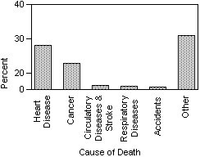

III
A) I, II
B) I, II, III
C) II, III
D) II
E) None of these displays are appropriate.
Answer: C
Diff: 2 Type: BI
Objective: (2.1) Determine Appropriate Display for Data

15) The City of Windsor Department of Parks and Recreation is planning to build a recreation centre in one of the city's parks. They conducted a poll to find out which of five types of physical activities the local population would be interested in. The poll was based on telephone responses from 1013 randomly selected adults. The table shows the percentages of people who expressed interest in various activities.

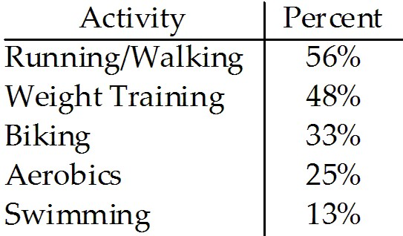

Which of the following displays is/are appropriate to describe the data for these five activities? (More than one display may be appropriate.)
I II
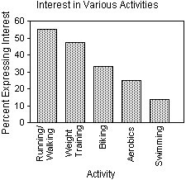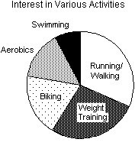
III
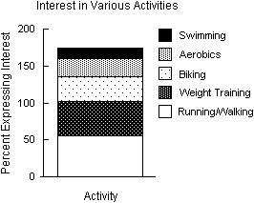
A) I
B) I, II
C) I, II, III
D) II
E) None of these displays are appropriate.
Answer: A
Diff: 2 Type: BI
Objective: (2.1) Determine Appropriate Display for Data
16) The City of Windsor Department of Parks and Recreation is planning to build a recreation centre in one of the city's parks. They conducted a poll to find out which of five types of physical activities the local population would be interested in. The poll was based on telephone responses from 1013 randomly selected adults. The table shows the percentages of people who expressed interest in various activities.

Which of the following displays is/are appropriate to describe the data for these five activities? (More than one display may be appropriate.)
I II
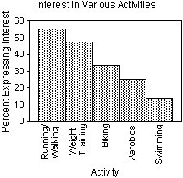
III
A) II
B) I, II, III
C) I, II
D) I
E) None of these displays are appropriate.
Answer: E
Diff: 2 Type: BI
Objective: (2.1) Determine Appropriate Display for Data

17) The City of Windsor Department of Parks and Recreation is planning to build a recreation centre in one of the city's parks. They conducted a poll to find out which of five types of physical activities the local population would be interested in. The poll was based on telephone responses from 1013 randomly selected adults. The table shows the percentages of people who expressed interest in various activities.

Which of the following displays is/are appropriate to describe the data for these five activities? (More than one display may be appropriate.)

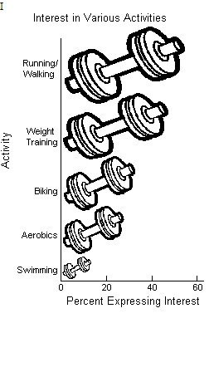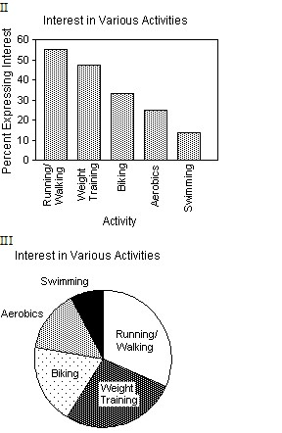
A) I, II, III
B) II, III
C) II
D) III
E) None of these displays are appropriate.
Answer: C
Diff: 2 Type: BI
Objective: (2.1) Determine Appropriate Display for Data

18) A prediction of the number of medals to be won by various countries in the 2014 Winter Olympics was made using past Olympics data. The predicted values are listed in the table below.

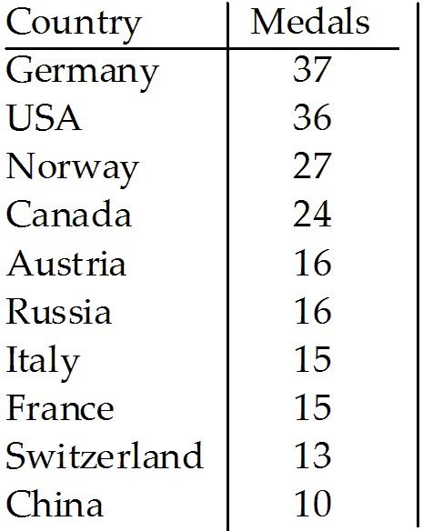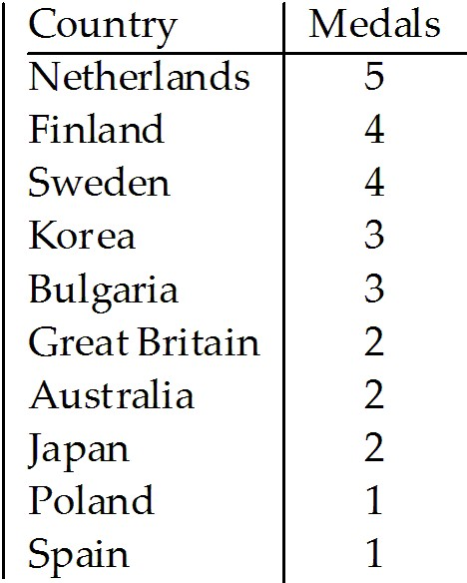

Which of the following displays is the most appropriate for these data?

I
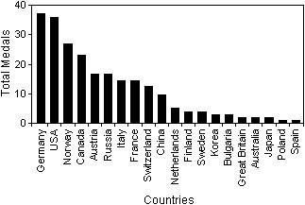

II III
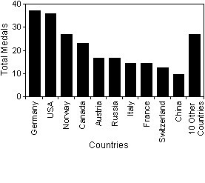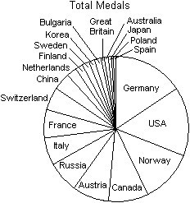
A) I
B) III
C) II
D) All of these displays are equally appropriate.
E) None of these displays are appropriate.
Answer: C
Diff: 2 Type: BI
Objective: (2.1) Determine Appropriate Display for Data
19) The focus of a recent survey was on teenagers' familiarity with and use of modern technology. The teenagers were asked if they used each of the following technologies on a daily basis and if the technology was critically important to own. For each question, the percentage of those responding "Yes" is given. Subtracting the "Use daily" percentage from the "Critically important to own" percentage gives the "Importance Gap". Here are the results:
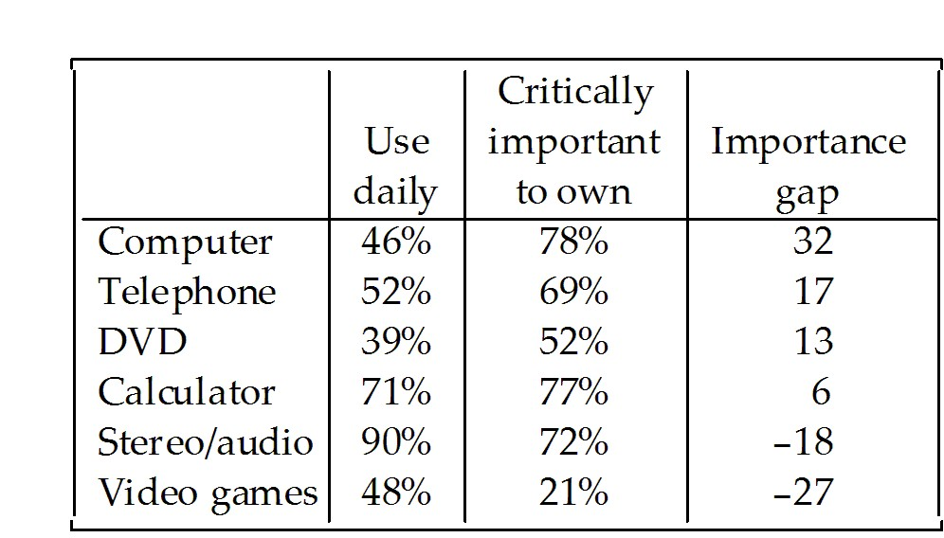

Which of the following displays is the most appropriate for these data?

I II
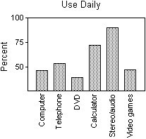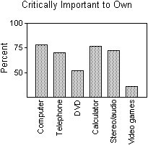

III
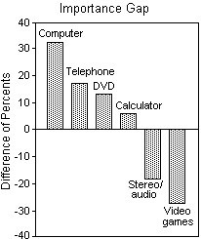

A) III
B) I
C) II
D) All of these displays are equally appropriate.
E) None of these displays are appropriate.
Answer: A
Diff: 2 Type: BI
Objective: (2.1) Determine Appropriate Display for Data

20) Students in a Political Science course were asked to describe their politics as "Liberal", "Moderate", or "Conservative." Here are the results:

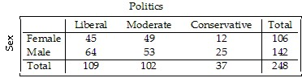

Which graphical display shows the marginal distribution of politics in the class?

I II
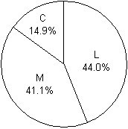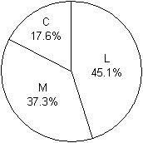

III
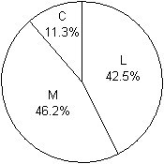
A) III
B) II
C) I
D) I, II, III
E) None of these displays show the marginal distribution of politics in the class.
Answer: C
Diff: 2 Type: BI
Objective: (2.1) Determine Appropriate Display for Data
21) Statistics Canada gives the following mortality data for Canada in 2007.

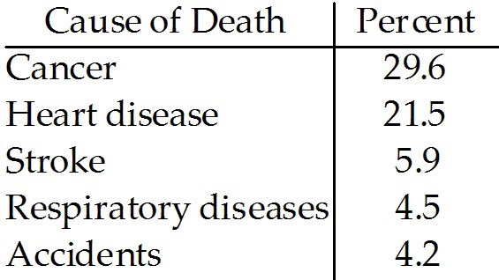

Create a bar chart to display the mortality percentages for all causes in Canada in 2007.
Answer:
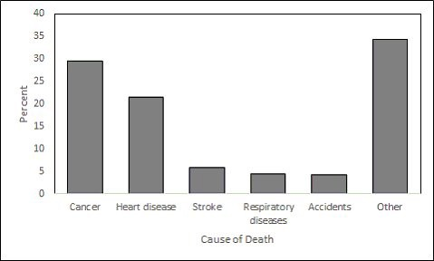
Diff: 1 Type: SA
Objective: (2.1) Create Graphical Display for Data I
22) Statistics Canada gives the following mortality data for Canada in 2011.

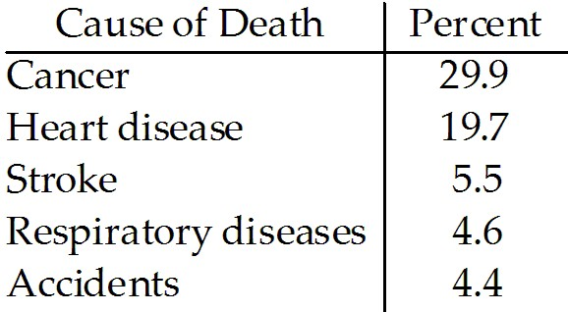

Create a bar chart to display the mortality percentages for all causes in Canada in 2011.
Answer:
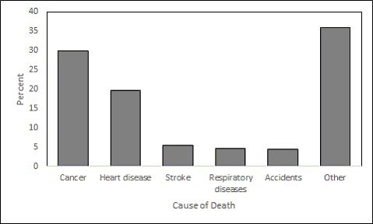
Diff: 1 Type: SA
Objective: (2.1) Create Graphical Display for Data I
23) The City of Windsor Department of Parks and Recreation is planning to build a recreation centre in one of the city's parks. They conducted a poll to find out the types of physical activities the local population would be interested in. The poll was based on telephone responses from 1013 randomly selected adults. The table shows the percentages of people who expressed interest in various activities.

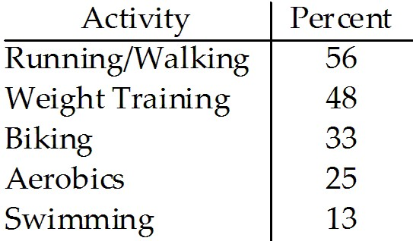

Create a bar chart for these data.
Answer:
Diff: 1 Type: SA
Objective: (2.1) Create Graphical Display for Data I
24) The focus of a recent survey was on teenagers' familiarity with and use of modern technology. The teenagers were asked if they used each of the following technologies on a daily basis and if the technology was critically important to own. For each question, the percentage of those responding "Yes" is given. Subtracting the "Use daily" percentage from the "Critically important to own" percentage gives the "Importance Gap." Here are the results:
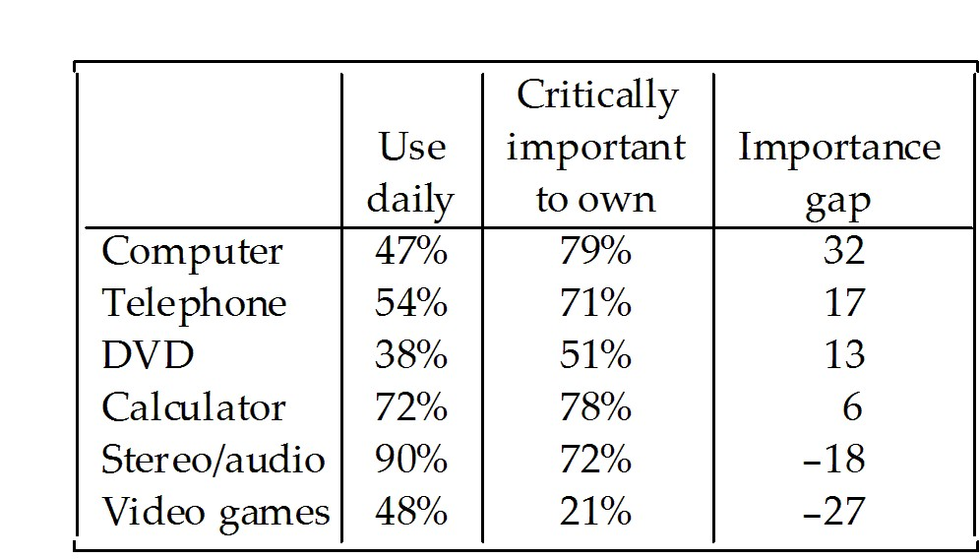

Create a bar chart for the "Importance Gap".
Answer:
Diff: 1 Type: SA
Objective: (2.1) Create Graphical Display for Data I
25) Students in a Political Science course were asked to describe their politics as "Liberal", "Moderate", or "Conservative." Here are the results:

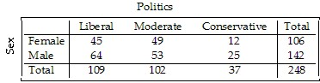

Produce a pie chart that shows the conditional distribution of politics among the males.
Answer:
Diff: 1 Type: SA
Objective: (2.1) Create Graphical Display for Data I

2.2 Exploring the Relationship Between Two Categorical Variables

1) A survey of automobiles parked in student and staff lots at a large university classified the brands by region of origin, as seen in the table.

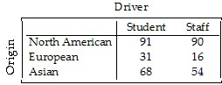

What is the marginal distribution of origin?
A) 52% North American, 13% European, 35% Asian
B) 56% North American, 10% European, 34% Asian
C) 54% Students, 46% Staff
D) 107% North American, 16% European, 54% Asian
E) 48% North American, 16% European, 36% Asian
Answer: A
Diff: 2 Type: BI
Objective: (2.2) Find Marginal or Conditional Distribution
2) A survey of automobiles parked in student and staff lots at a large university classified the brands by country of origin, as seen in the table.

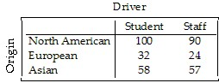

What is the conditional distribution of origin for students?
A) 53% North American, 16% European, 32% Asian
B) 25% North American, 7% European, 16% Asian
C) 53% North American, 14% European, 33% Asian
D) 53% North American, 17% European, 31% Asian
E) 28% North American, 9% European, 16% Asian
Answer: D
Diff: 2 Type: BI
Objective: (2.2) Find Marginal or Conditional Distribution

3) A survey of automobiles parked in student and staff lots at a large university classified the brands by country of origin, as seen in the table.

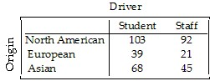

What is the conditional distribution of origin for staff?
A) 25% North American, 6% European, 12% Asian
B) 49% North American, 19% European, 32% Asian
C) 28% North American, 11% European, 18% Asian
D) 53% North American, 16% European, 31% Asian
E) 58% North American, 13% European, 28% Asian
Answer: E
Diff: 2 Type: BI
Objective: (2.2) Find Marginal or Conditional Distribution
4) A company held a blood pressure screening clinic for its employees. The results are summarized in the table below by age group and blood pressure level.

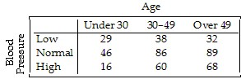

Find the marginal distribution of blood pressure level.
A) 20% low, 40% normal, 41% high
B) 20% under 30, 40% between 30-49, 41% over 50
C) 21% low, 48% normal, 31% high
D) 32% low, 51% normal, 18% high
E) 27% low, 91% normal, 45% high
Answer: C
Diff: 2 Type: BI
Objective: (2.2) Find Marginal or Conditional Distribution

5) A company held a blood pressure screening clinic for its employees. The results are summarized in the table below by age group and blood pressure level.

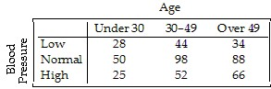

Find the conditional distribution of blood pressure level for employees under 30.
A) 18% low, 47% normal, 35% high
B) 23% low, 51% normal, 27% high
C) 22% low, 49% normal, 29% high
D) 27% low, 49% normal, 24% high
E) 6% low, 10% normal, 5% high
Answer: D
Diff: 2 Type: BI
Objective: (2.2) Find Marginal or Conditional Distribution
6) A company held a blood pressure screening clinic for its employees. The results are summarized in the table below by age group and blood pressure level.

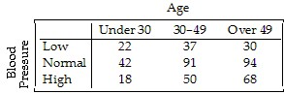

Find the conditional distribution of blood pressure level for employees in the 30-49 age group.
A) 27% low, 51% normal, 22% high
B) 8% low, 20% normal, 11% high
C) 20% low, 50% normal, 30% high
D) 21% low, 51% normal, 28% high
E) 16% low, 49% normal, 35% high
Answer: D
Diff: 2 Type: BI
Objective: (2.2) Find Marginal or Conditional Distribution

7) A company held a blood pressure screening clinic for its employees. The results are summarized in the table below by age group and blood pressure level.

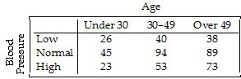

Find the conditional distribution of blood pressure level for employees over 49.
A) 8% low, 19% normal, 15% high
B) 21% low, 50% normal, 28% high
C) 28% low, 48% normal, 24% high
D) 19% low, 45% normal, 37% high
E) 22% low, 47% normal, 31% high
Answer: D
Diff: 2 Type: BI
Objective: (2.2) Find Marginal or Conditional Distribution
8) A survey of university students in Canada reported the following percentages.

 | Cat lover | Dog lover | Other | Total
Brand 1 Cola | 22.5% | 28.0% | 16.5% | 67.0%
Brand 2 Cola | 7.5% | 12.0% | 13.5% | 33.0%
Total | 30.0% | 40.0% | 30.0% | 100%

Find the marginal distribution of pet preference.
A) 30.0% cat, 40.0% dog, 30.0% other
B) 22.5% cat, 28.0% dog, 16.5% other
C) 7.5% cat, 12.0% dog, 13.5% other
D) 15.0% cat, 16.0% dog, 3.0% other
E) 19.0% cat, 24.0% dog, 57.0% other
Answer: A
Diff: 2 Type: BI
Objective: (2.2) Find Marginal or Conditional Distribution

9) A survey of university students in Canada reported the following percentages.

 | Cat lover | Dog lover | Other | Total
Brand 1 Cola | 22.5% | 28.0% | 16.5% | 67.0%
Brand 2 Cola | 7.5% | 12.0% | 13.5% | 33.0%
Total | 30.0% | 40.0% | 30.0% | 100%

Find the conditional distribution of pet preference for students that prefer Brand 1 Cola.
A) 30.0% cat, 40.0% dog, 30.0% other
B) 22.5% cat, 28.0% dog, 16.5% other
C) 33.6% cat, 41.8% dog, 24.6% other
D) 22.7% cat, 36.4% dog, 40.9% other
E) 19.0% cat, 24.0% dog, 57.0% other
Answer: C
Diff: 2 Type: BI
Objective: (2.2) Find Marginal or Conditional Distribution
10) Students in a political science course were asked to describe their politics as "Liberal", "Moderate", or "Conservative." Here are the results:

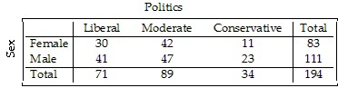

What percent of the class considers themselves to be "Liberal"?
A) 36.1%
B) 57.7%
C) 21.1%
D) 36.6%
E) 15.5%
Answer: D
Diff: 2 Type: BI
Objective: (2.2) Interpret Contingency Table I

11) Students in a political science course were asked to describe their politics as "Liberal", "Moderate", or "Conservative." Here are the results:

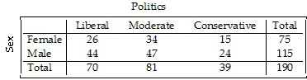

What percent of the females in the class consider themselves to be "Liberal"?
A) 38.3%
B) 45.3%
C) 34.7%
D) 37.1%
E) 36.8%
Answer: C
Diff: 3 Type: BI
Objective: (2.2) Interpret Contingency Table I
12) Students in a political science course were asked to describe their politics as "Liberal", "Moderate", or "Conservative." Here are the results:

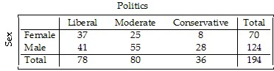

What percent of all males in the class are "Liberals"?
A) 21.1%
B) 33.1%
C) 40.2%
D) 52.9%
E) 52.6%
Answer: B
Diff: 3 Type: BI
Objective: (2.2) Interpret Contingency Table I

13) Students in a political science course were asked to describe their politics as "Liberal", "Moderate", or "Conservative." Here are the results:

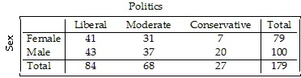

What percent of all students in the class are males who consider themselves to be "Liberal"?
A) 51.2%
B) 43%
C) 24%
D) 46.9%
E) 22.9%
Answer: C
Diff: 2 Type: BI
Objective: (2.2) Interpret Contingency Table I
14) Students in a political science course were asked to describe their politics as "Liberal", "Moderate", or "Conservative." Here are the results:

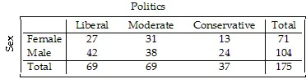

What percent of all "Moderates" in the class are male?
A) 44.9%
B) 55.1%
C) 21.7%
D) 36.5%
E) 39.4%
Answer: B
Diff: 3 Type: BI
Objective: (2.2) Interpret Contingency Table I

15) A college examined the impact of an applicant's ethnicity on the likelihood of admission to a particular program. The data are summarized in the table below.

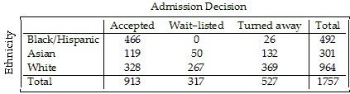

What percent of all applicants were Black or Hispanic?
A) 28%
B) 26.5%
C) 53.9%
D) 48%
E) 17.1%
Answer: A
Diff: 2 Type: BI
Objective: (2.2) Interpret Contingency Table I
16) A college examined the impact of an applicant's ethnicity on the likelihood of admission to a particular program. The data are summarized in the table below.

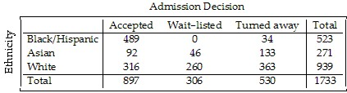

What percent of all applicants were turned away?
A) 51.8%
B) 17.7%
C) 30.2%
D) 30.6%
E) 44.1%
Answer: D
Diff: 2 Type: BI
Objective: (2.2) Interpret Contingency Table I

17) A college examined the impact of an applicant's ethnicity on the likelihood of admission to a particular program. The data are summarized in the table below.

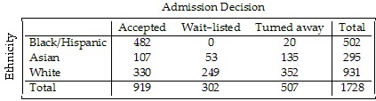

What percent of White applicants were accepted?
A) 26.7%
B) 35.4%
C) 37.8%
D) 35.9%
E) 19.1%
Answer: B
Diff: 3 Type: BI
Objective: (2.2) Interpret Contingency Table I
18) A college examined the impact of an applicant's ethnicity on the likelihood of admission to a particular program. The data are summarized in the table below.

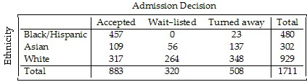

What percent of Asian applicants were wait-listed?
A) 17.5%
B) 3.3%
C) 18.5%
D) 36.1%
E) 45.4%
Answer: C
Diff: 3 Type: BI
Objective: (2.2) Interpret Contingency Table I

19) A college examined the impact of an applicant's ethnicity on the likelihood of admission to a particular program. The data are summarized in the table below.

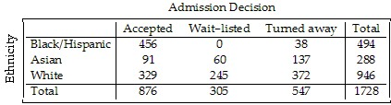

What percent of accepted applicants were Black or Hispanic?
A) 108.6%
B) 6.9%
C) 92.3%
D) 52.1%
E) 26.4%
Answer: D
Diff: 3 Type: BI
Objective: (2.2) Interpret Contingency Table I
20) Just how accurate are the weather forecasts we hear every day? The table below compares the daily forecast with a city's actual weather for a year.

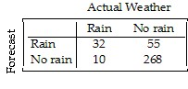
On what percent of days did it actually rain?
A) 2.7%
B) 11.5%
C) 76.2%
D) 8.8%
E) 23.8%
Answer: B
Diff: 3 Type: BI
Objective: (2.2) Interpret Contingency Table II

21) Just how accurate are the weather forecasts we hear every day? The table below compares the daily forecast with a city's actual weather for a year.

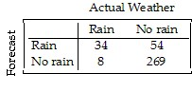
On what percent of days was rain predicted?
A) 14.8%
B) 24.1%
C) 38.6%
D) 9.3%
E) 11.5%
Answer: B
Diff: 3 Type: BI
Objective: (2.2) Interpret Contingency Table II
22) Just how accurate are the weather forecasts we hear every day? The table below compares the daily forecast with a city's actual weather for a year.

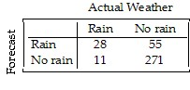
What percent of the time was the forecast correct?
A) 74.2%
B) 7.7%
C) 81.9%
D) 77.3%
E) 18.1%
Answer: C
Diff: 3 Type: BI
Objective: (2.2) Interpret Contingency Table II

23) A survey of automobiles parked in student and staff lots at a large university classified the brands by region of origin, as seen in the table.

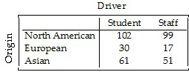

What percent of all the cars surveyed were foreign (not North American)?
A) 44.2%
B) 18.9%
C) 13.1%
D) 25.3%
E) 31.1%
Answer: A
Diff: 3 Type: BI
Objective: (2.2) Interpret Contingency Table II
24) A survey of automobiles parked in student and staff lots at a large university classified the brands by region of origin, as seen in the table.

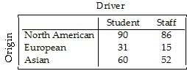

What percent of the North American cars were owned by staff?
A) 48.9%
B) 51.1%
C) 56.2%
D) 25.7%
E) 128.4%
Answer: A
Diff: 3 Type: BI
Objective: (2.2) Interpret Contingency Table II

25) A survey of automobiles parked in student and staff lots at a large university classified the brands by region of origin, as seen in the table.

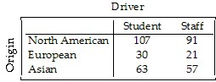

What percent of the staff owned North American cars?
A) 24.7%
B) 116.7%
C) 53.8%
D) 53.5%
E) 46%
Answer: C
Diff: 3 Type: BI
Objective: (2.2) Interpret Contingency Table II
26) A survey of automobiles parked in student and staff lots at a large university classified the brands by region of origin, as seen in the table.

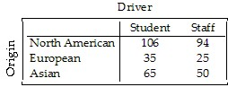

What percent of the foreign cars were owned by students?
A) 42.9%
B) 57.1%
C) 37.1%
D) 20%
E) 26.7%
Answer: B
Diff: 3 Type: BI
Objective: (2.2) Interpret Contingency Table II

27) Most patients who undergo surgery make routine recoveries and are discharged as planned, but some patients experience complications and their discharge is delayed. A small city has a large hospital and a small hospital, each performing major and minor surgeries. Data is collected at each hospital to see how many surgical patients have their discharges delayed by postsurgical complications. The results are shown in the following table.

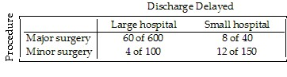
Overall, for what percent of surgical patients was discharge delayed?
A) 1.8%
B) 9.4%
C) 42%
D) 9.1%
E) 7.6%
Answer: B
Diff: 3 Type: BI
Objective: (2.2) Interpret Contingency Table II
28) Most patients who undergo surgery make routine recoveries and are discharged as planned, but some patients experience complications and their discharge is delayed. A small city has a large hospital and a small hospital, each performing major and minor surgeries. Data is collected at each hospital to see how many surgical patients have their discharges delayed by postsurgical complications. The results are shown in the following table.

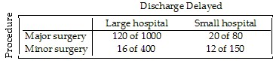
What were the discharge delay rates for each kind of surgery?
A) Major surgery: 13%
Minor surgery: 5.1%
B) Major surgery: 10.3%
Minor surgery: 10.3%
C) Major surgery: 9.7%
Minor surgery: 13.9%
D) Major surgery: 8.6%
Minor surgery: 1.7%
E) Major surgery: 37%
Minor surgery: 12%
Answer: A
Diff: 3 Type: BI
Objective: (2.2) Interpret Contingency Table II
29) Most patients who undergo surgery make routine recoveries and are discharged as planned, but some patients experience complications and their discharge is delayed. A small city has a large hospital and a small hospital, each performing major and minor surgeries. Data is collected at each hospital to see how many surgical patients have their discharges delayed by postsurgical complications. The results are shown in the following table.

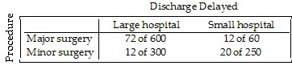
What were the discharge delay rates at each hospital?
A) Large hospital: 12.7%
Small hospital: 8.9%
B) Large hospital: 9.6%
Small hospital: 9.6%
C) Large hospital: 16%
Small hospital: 28%
D) Large hospital: 9.6%
Small hospital: 2.6%
E) Large hospital: 9.3%
Small hospital: 10.3%
Answer: E
Diff: 3 Type: BI
Objective: (2.2) Interpret Contingency Table II

30) A survey of university students in Canada reported the following percentages.

 | Cat lover | Dog lover | Other | Total
Brand 1 Cola | 22.5% | 28.0% | 16.5% | 67.0%
Brand 2 Cola | 7.5% | 12.0% | 13.5% | 33.0%
Total | 30.0% | 40.0% | 30.0%

What percentage of cat and/or dog lovers prefers Brand 2 Cola?
A) 25.0%
B) 30.0%
C) 27.5%
D) 33.8%
E) 27.9%
Answer: E
Diff: 3 Type: BI
Objective: (2.2) Interpret Contingency Table II
31) Students in a political science course were asked to describe their politics as "Liberal", "Moderate", or "Conservative." The results are listed in the table below, and a graphical display of the conditional distributions of sex among the three categories of politics is given.

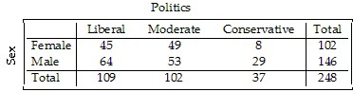

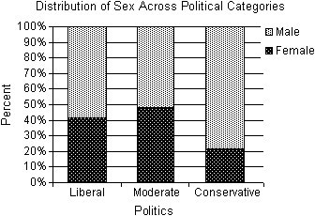

The political science instructor states that sex and politics are independent. Is this an accurate statement? Explain.
A) No. The percentage of males and females varies across political categories. The percentage of Liberals and Moderates who are female is approximately twice that of Conservatives who are female. This would suggest that sex and politics are not independent.
B) No. The percentage of males and females varies across political categories. The percentage of Liberals and Moderates who are male is approximately twice that of Conservatives who are male. This would suggest that sex and politics are not independent.
C) Yes. The percentage of males and females varies across political categories; however, there are more males in the class than females. There is not enough evidence to make an association between sex and politics. Sex and politics are independent.
D) No. The percentage of males and females is similar across political categories. This would suggest that sex and politics are not independent.
E) Yes. The percentage of males and females is similar across political categories. This would suggest that sex and politics are independent.
Answer: A
Diff: 2 Type: BI
Objective: (2.2) Interpret Conditional Distributions Display
32) A survey of automobiles parked in student and staff lots at a large university classified the brands by country of origin. The results are listed in the table below, and a graphical display of the conditional distributions of origin by driver is given.

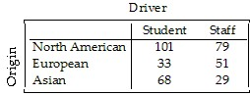

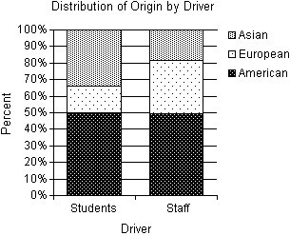
Do you think that origin of the car is independent of the type of driver? Explain.
A) Yes. The conditional distributions of origin by driver have similarities and differences. The two groups own nearly the same percentage of American cars. Therefore, because of this one similarity, driver and origin must be independent.
B) No. The conditional distributions of origin by driver have similarities and differences. Although students appear to own a higher percentage of Asian cars and a smaller percentage of European cars than the staff, the two groups own nearly the same percentage of American cars. However, because of the differences, there is evidence of an association between driver and origin.
C) No. The conditional distributions of origin by driver have similarities and differences. Students own a higher percentage of Asian and European cars than the staff. Therefore, because of this difference, there must be an association between driver and origin.
D) No. The conditional distributions of origin by driver have similarities and differences. Although staff appear to own a higher percentage of Asian cars and a smaller percentage of European cars than the students, the two groups own nearly the same percentage of American cars. However, because of the differences, there is evidence of an association between driver and origin.
E) Yes. The conditional distributions of origin by driver have similarities and differences. Although students appear to own a higher percentage of Asian cars and a smaller percentage of European cars than the staff, the two groups own nearly the same percentage of American cars. However, because there are more students than staff, an association between driver and origin cannot be claimed.
Answer: B
Diff: 2 Type: BI
Objective: (2.2) Interpret Conditional Distributions Display
33) At a university in the U.S.A., the incoming freshmen were surveyed about their chosen majors. The university organized the data by placing the majors into the appropriate colleges. The table displays the results for males and females by colleges. A graphical display of the conditional distributions of colleges by gender is given.

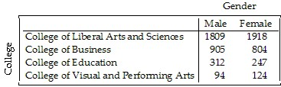

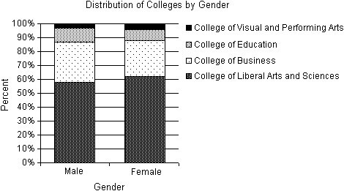
Do you think that the college the freshmen will be entering is independent of the gender of the student? Explain.
A) Yes. The conditional distributions of colleges by gender are similar. Since the distributions of colleges is essentially the same for males and females, there is evidence of an association between gender and colleges.
B) Yes. The conditional distributions of colleges by gender are similar. Since the distributions of colleges is essentially the same for males and females, there is no evidence of an association between gender and colleges.
C) No. The conditional distributions of colleges by gender vary. More male students will be entering the College of Business and the College of Education than female students. This is sufficient evidence of an association between gender and colleges.
D) No. The conditional distributions of colleges by gender are similar. Since the distributions of colleges is essentially the same for males and females, there is no evidence of an association between gender and colleges.
E) No. The conditional distributions of colleges by gender are similar. Since the distributions of colleges is essentially the same for males and females, there is evidence of an association between gender and colleges.
Answer: B
Diff: 2 Type: BI
Objective: (2.2) Interpret Conditional Distributions Display
34) The table below compares what students at a small Canadian university did after graduating with a bachelor's degree in 1992, 1998, and 2003. A graphical display of the conditional distributions of what students did after graduation by year is given.

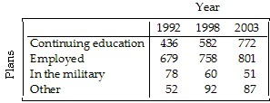

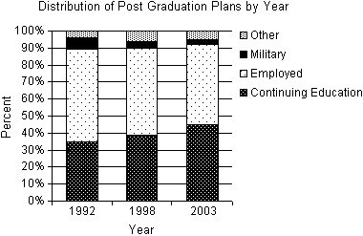
Does this study present any evidence that postgraduation plans have changed over this 11-year period? Explain.
A) Yes. There is evidence that the percentage of graduates entering the work force after graduation has increased from 1992 to 2003. Likewise, the percentage of graduates continuing their education appears to have decreased from 1992 to 2003.
B) Yes. There is evidence that the percentage of graduates continuing their education has increased from 1992 to 2003. Likewise, the percentage of graduates entering the work force after graduation appears to have decreased from 1992 to 2003.
C) No. The percentage of graduates continuing their education has increased from 1992 to 2003. Likewise, the percentage of graduates entering the work force after graduation appears to have decreased from 1992 to 2003. However, this is not sufficient evidence to show any change due to the fact that those entering the military or seeking other options remained relatively constant.
D) No. The percentage of graduates continuing their education has increased from 1992 to 2003. Likewise, the percentage of graduates entering the work force after graduation appears to have decreased from 1992 to 2003. However, this is not sufficient evidence to show any change due to the fact that the number of students graduating has increased over this same time period.
E) Yes. There is evidence that the percentage of graduates continuing their education and entering the work force after graduation has increased from 1992 to 2003.
Answer: B
Diff: 2 Type: BI
Objective: (2.2) Interpret Conditional Distributions Display
35) A company held a cholesterol screening clinic for its employees. The results are summarized in the table below by age group and cholesterol level. A graphical display of the conditional distributions of cholesterol levels by age is given.

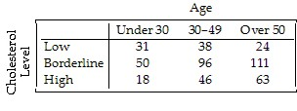
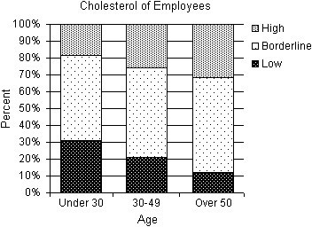
Does this prove that aging causes increased cholesterol levels? Explain.
A) No. There is sufficient evidence of an association between age and cholesterol level. However, the percentage of employees with low cholesterol increased with age. Likewise, the percentage of employees with high cholesterol decreased with age.
B) No. Generally, an association between two variables does not imply a cause-and-effect relationship. Specifically, these data come from only one company and cannot be applied to all people. Only a controlled experiment can isolate the relationship between age and cholesterol level.
C) No. Generally, an association between two variables does imply a cause-and-effect relationship. Specifically, these data come from only one company and cannot be applied to all people. However, if more companies provided cholesterol screenings and these data were compiled, then the claim could be proven.
D) Yes. Generally, an association between two variables does imply a cause-and-effect relationship. However, these data come from only one company and cannot necessarily be applied to all people. A controlled experiment that can isolate the relationship between age and cholesterol level would make this a stronger claim.
E) Yes. There is evidence of an association between age and cholesterol level. The percentage of employees with high cholesterol increased with age. Likewise, the percentage of employees with low cholesterol decreased with age.
Answer: B
Diff: 2 Type: BI
Objective: (2.2) Interpret Conditional Distributions Display
36) A survey of salesmen was conducted to examine the possibility of a relationship between men's height and annual income. The company interested in the results of the survey believes that taller men are more successful at getting sales, resulting in a higher annual income. The table shows the percentages of income levels for each height category. A graphical display of the conditional distributions of income levels by height is given.

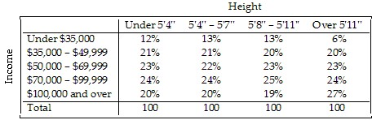
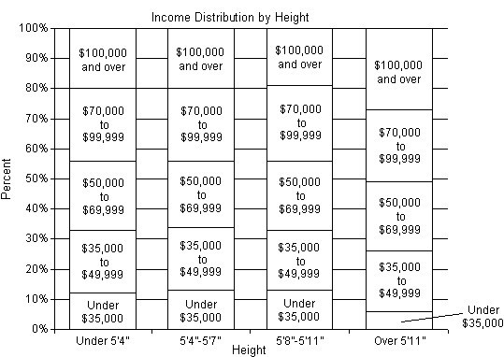

Do these data support the company's belief: taller men are more successful salesmen? Explain.
A) Yes. The percentages in all income levels for salesmen over 5'11'' are higher than the percentages in the same income levels for men 5'11'' or shorter.
B) Yes, to a certain extent. The percent of salesmen over 5'11'' that make $100,000 or more is 27%, compared to the 19% or 20% for men 5'11'' or shorter. Similarly, the percent of salesmen over 5'11'' that make under $35,000 is 6%, compared to the 12% or 13% for men 5'11'' or shorter. However, with these two exceptions, the percentages in the remaining income levels did not vary by more than 1%.
C) No. The percentages in the income levels for the different height categories did not vary by more than 1%, with the exception of salesmen over 5'11' in the under $35,000 category and the $100,000 or over category. These data should be ignored.
D) No. The percentages in all income levels for all height categories of salesmen are too similar to make this claim.
E) Yes. The percent of salesmen over 5'11'' that make $100,000 or more is 27%, compared to the 19% or 20% for men 5'11'' or shorter. Similarly, the percent of salesmen over 5'11'' that make under $35,000 is 6%, compared to the 12% or 13% for men 5'11'' or shorter.
Answer: B
Diff: 2 Type: BI
Objective: (2.2) Interpret Conditional Distributions Display

37) Most women who have had a mastectomy can have breast reconstruction surgery. The reconstruction surgery can be performed at the same time as the mastectomy, an immediate reconstruction, or after the patient has healed from the mastectomy, second surgery reconstruction. Some women opt not to have reconstruction surgery. The table shows the percentages of women's choices regarding reconstruction for three age categories. A graphical display of the conditional distributions of reconstruction choice by age is given.
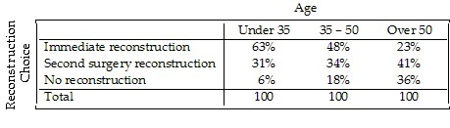
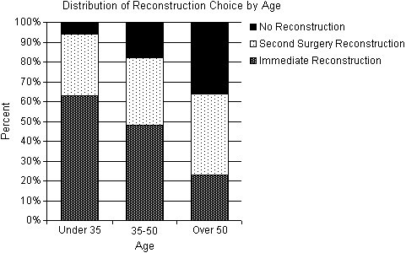
Does there appear to be an association between reconstruction choice and age? Explain.
A) No. The number of women over 50 who were included in these data was probably higher than the number who were under 35. Using this assumption, there is not enough evidence to show an association between reconstruction choice and age.
B) Yes. A higher percentage of older women, especially over 50, who have had mastectomies choose not to have reconstruction surgery. Likewise, a higher percentage of younger patients choose to have immediate reconstruction. It appears that as the age of women having mastectomies increases, the importance of having reconstructive breast surgery decreases.
C) No. The percentages of women who have had mastectomies who choose to have second surgery reconstruction do not vary significantly. There is not enough evidence to show an association between reconstruction choice and age.
D) No. In all age groups, most women want reconstruction surgery.
E) Yes. A higher percentage of older women, especially over 50, who have had mastectomies choose to have second surgery reconstruction. It appears that as the age of women having mastectomies increases, the importance of having reconstructive breast surgery increases.
Answer: B
Diff: 2 Type: BI
Objective: (2.2) Interpret Conditional Distributions Display

38) A company must decide which of two delivery services they will contract with. During a recent trial period they shipped numerous packages with each service, and have kept track of how often deliveries did not arrive on time. Here are the data:

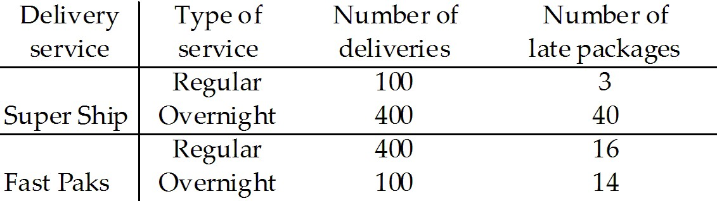

Based on the results, the company decided to hire Fast Paks. Do you agree they deliver on time more often? Explain.
A) Yes. Fast Paks only delivers 3% of its regular packages late, compared to Super Ship, who deliver 4% of its regular packages late. Additionally, Fast Paks only delivers 10% of its overnight packages late, compared to Super Ship, who delivers 14% of its overnight packages late. Fast Paks is better at delivering regular and overnight packages.
B) No. Super Ship only delivers 3% of its regular packages late, compared to Fast Paks, who deliver 4% of its regular packages late. Additionally, Super Ship only delivers 10% of its overnight packages late, compared to Fast Paks, who delivers 14% of its overnight packages late. Super Ship is better at delivering regular and overnight packages.
C) No. Fast Paks only delivers 0.09% of its packages late, compared to Super Ship, who delivers 0.06% of its packages late. Super Ship is better at delivering regular and overnight packages.
D) Yes. Fast Paks only delivers 0.06% of its packages late, compared to Super Ship, who delivers 0.09% of its packages late. Fast Paks is better at delivering regular and overnight packages.
E) No. This is an example of Simpson's paradox and unfair averaging. Since the overall percentages and the individual percentages disagree on which delivery service is better, both services can be considered equal. It cannot be determined whether Super Ship or Fast Paks deliver packages on time more often.
Answer: B
Diff: 2 Type: BI
Objective: (2.2) Interpret Case Involving Simpson's Paradox
39) An article in a magazine examined the graduate admissions process at a university for evidence of gender bias. The table below shows the number of applicants accepted to each of four graduate programs.

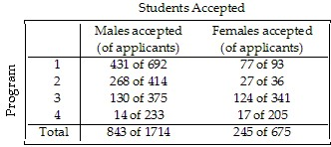

After reading this article, a classmate claims that there is gender bias because the university clearly accepted more males than females. Do you agree with your classmate? Explain.
A) Yes. Overall, 49.2% of males were accepted, compared to 36.3% of females were accepted. The overall percentages are always the most valid comparison.
B) No. Overall, 49.2% of males were accepted, compared to 36.3% of females were accepted. However, the comparison of the acceptance rate within each program shows that females had a higher acceptance rate for all four programs.
C) Yes. Overall, 49.2% of males were accepted, compared to 36.3% of females were accepted. Additionally, the comparison of the acceptance rate within each program shows that males had a higher acceptance rate for all four programs.
D) No. Overall, 49.2% of females were accepted, compared to 36.3% of males were accepted. Additionally, the comparison of the acceptance rate within each program shows that females had a higher acceptance rate for all four programs.
E) No. This is an example of Simpson's paradox and unfair averaging. Since the overall percentages and the individual percentages disagree on which gender was favored, the study is useless. Nothing can be determined from these data.
Answer: B
Diff: 2 Type: BI
Objective: (2.2) Interpret Case Involving Simpson's Paradox
40) Students in a Political Science course were asked to describe their politics as "Liberal", "Moderate", or "Conservative." The results are listed in the table below.

Create a segmented bar graph which shows the conditional distributions by gender for each political category.
Answer:
Diff: 2 Type: SA
Objective: (2.2) Create a Graphical Display for Data II
41) A company held a cholesterol screening clinic for its employees. The results are summarized in the table below by age group and cholesterol level.

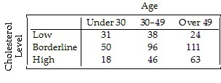
Create a segmented bar graph which shows the conditional distributions of cholesterol levels for each age group.
Answer:
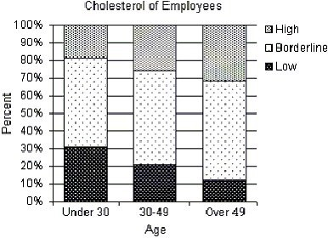
Diff: 2 Type: SA
Objective: (2.2) Create a Graphical Display for Data II
42) A survey of automobiles parked in student and staff lots at a large university classified the brands by country of origin. The results are listed in the table below.

Create a segmented bar graph which shows the conditional distributions of origin for both students and staff.
Answer:
Diff: 2 Type: SA
Objective: (2.2) Create a Graphical Display for Data II
43) The table compares what students at a Canadian college did after graduating in 1992, 1998, and 2003.

Create a segmented bar graph which shows the conditional distributions of plans for each of the three years.
Answer:
Diff: 2 Type: SA
Objective: (2.2) Create a Graphical Display for Data II

44) From a sample of individuals the following percentages are reported:
- 22% of the individuals said they drink beer and wine.
- 12% of the individuals said they drink neither beer nor wine.
- 35% of the individuals said they drink beer.
Create a contingency table with percentages describing the relationship between beer and wine drinkers.
Answer:
 | Drink Wine | Don't Drink Wine | Total
Drink Beer | 22% | 13% | 35%
Don't Drink Beer | 53% | 12% | 65%
Total | 75% | 25% | 100%
Diff: 3 Type: SA
Objective: (2.2) Create a Contingency Table
45) From a sample of individuals the following percentages are reported:
- 75% of cat lovers prefer Brand 1 cola.
- 70% of dog lovers prefer Brand 1 cola.
- 55% of individuals that don't like cats or dogs prefer Brand 1 cola.
- 30% are cat lovers and 40% are dog lovers.
Create a contingency table with percentages describing the relationship between pet preference and cola preference.
Answer:
 | Cat lover | Dog lover | Other | Total
Brand 1 Cola | 22.5% | 28.0% | 16.5% | 67.0%
Brand 2 Cola | 7.5% | 12.0% | 13.5% | 33.0%
Total | 30.0% | 40.0% | 30.0% | 100%
Diff: 3 Type: SA
Objective: (2.2) Create a Contingency Table

