**Chapter 2: *The First Steps in Vision:***

***From Light to Neural Signals***

**Test Bank**

**Type: multiple choice question**

**Title:** Chapter 02 Question 01

1. Light can be described as a stream of photons or a(n)

**Feedback:** *Textbook Reference:* 2.1 A Little Light Physics

*Learning Objective:* 2.1.1 Summarize the relationship between visible light and the rest of the electromagnetic spectrum.

*Bloom’s Level:* 1. Remembering

a. signal.

*b. wave.

c. source.

d. outlet of energy.

e. illuminant.

**Type: multiple choice question**

**Title:** Chapter 02 Question 02

2. Refer to the figure.

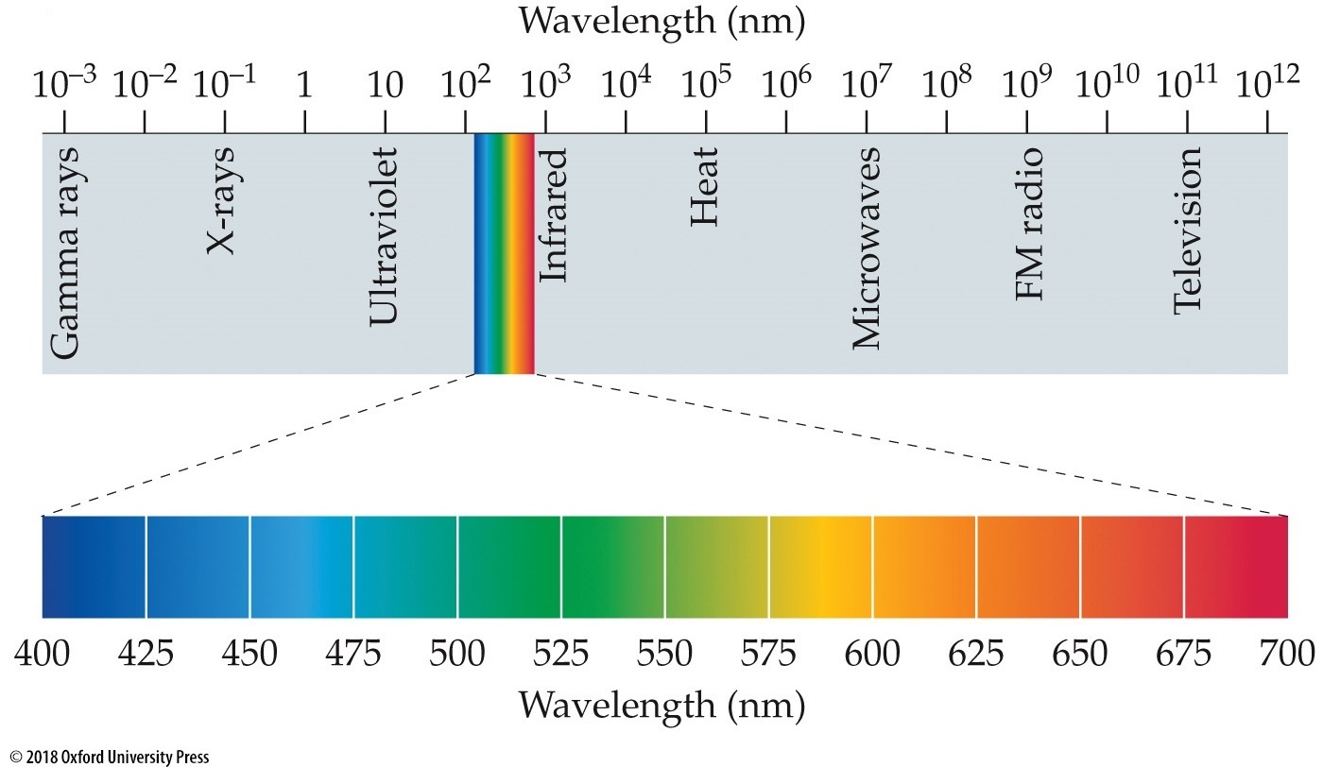

The top part of the figure shows the

**Feedback:** *Textbook Reference:* 2.1 A Little Light Physics

*Learning Objective:* 2.1.1 Summarize the relationship between visible light and the rest of the electromagnetic spectrum.

*Bloom’s Level:* 2. Understanding

a. spectrum of visible light.

b. different kinds of light.

c. amount of heat emitted by a light source.

d. number of photons emitted by a light source.

*e. spectrum of electromagnetic energy.

**Type: multiple choice question**

**Title:** Chapter 02 Question 03

3. Refer to the figure.



The bottom part of the figure shows the

**Feedback:** *Textbook Reference:* 2.1 A Little Light Physics

*Learning Objective:* 2.1.1 Summarize the relationship between visible light and the rest of the electromagnetic spectrum.

*Bloom’s Level:* 2. Understanding

*a. spectrum of visible light.

b. different kinds of light.

c. spectrum of electromagnetic energy.

d. number of photons emitted by a light source.

e. amount of heat emitted by a light source.

**Type: multiple choice question**

**Title:** Chapter 02 Question 04

4. Light *cannot* be

**Feedback:** *Textbook Reference:* 2.1 A Little Light Physics

*Learning Objective:* 2.1.2 Describe the various ways that light can be affected as it journeys from the sun to the eye.

*Bloom’s Level:* 2. Understanding

a. absorbed.

b. refracted.

*c. dissolved.

d. transmitted.

e. scattered.

**Type: multiple choice question**

**Title:** Chapter 02 Question 05

5. Refraction of a wave of energy means

**Feedback:** *Textbook Reference:* 2.1 A Little Light Physics

*Learning Objective:* 2.1.2 Describe the various ways that light can be affected as it journeys from the sun to the eye.

*Bloom’s Level:* 1. Remembering

a. oscillation that travels through a medium.

*b. bending or spreading out of waves as they pass through a medium.

c. bending or spreading out of waves as they pass the edge of an obstacle.

d. passing of waves with no interruption.

e. redirection of light back toward its source.

**Type: multiple choice question**

**Title:** Chapter 02 Question 06

6. When something strikes a surface, especially light, sound, or heat, and is redirected (usually back toward its point of origin), it is being

**Feedback:** *Textbook Reference:* 2.1 A Little Light Physics

*Learning Objective:* 2.1.2 Describe the various ways that light can be affected as it journeys from the sun to the eye.

*Bloom’s Level:* 2. Understanding

a. refracted.

b. transmitted.

c. scattered.

*d. reflected.

e. absorbed.

**Type: multiple choice question**

**Title:** Chapter 02 Question 07

7. The transparent “window” on the outer part of the eye that allows light into the eyeball is called the

**Feedback:** *Textbook Reference:* 2.2 Eyes That Capture Light

*Learning Objective:* 2.2.1 Identify the parts of the eye and their function in vision.

*Bloom’s Level:* 1. Remembering

a. pupil.

b. iris.

c. lens.

d. retina.

*e. cornea.

**Type: multiple choice question**

**Title:** Chapter 02 Question 08

8. The aqueous humor is a(n)

**Feedback:** *Textbook Reference:* 2.2 Eyes That Capture Light

*Learning Objective:* 2.2.1 Identify the parts of the eye and their function in vision.

*Bloom’s Level:* 1. Remembering

a. funny substance.

*b. watery fluid between the cornea and iris.

c. gel-like fluid between the lens and retina.

d. circular opening at the center of the iris.

e. opaque fluid.

**Type: multiple choice question**

**Title:** Chapter 02 Question 09

9. The vitreous humor is a(n)

**Feedback:** *Textbook Reference:* 2.2 Eyes That Capture Light

*Learning Objective:* 2.2.1 Identify the parts of the eye and their function in vision.

*Bloom’s Level:* 1. Remembering

a. funny substance.

b. watery fluid between the cornea and iris.

*c. gel-like fluid between the lens and retina.

d. circular opening at the center of the iris.

e. opaque fluid.

**Type: multiple choice question**

**Title:** Chapter 02 Question 10

10. The dark, circular opening at the center of the eye, where light enters the eye, is called the

**Feedback:** *Textbook Reference:* 2.2 Eyes That Capture Light

*Learning Objective:* 2.2.1 Identify the parts of the eye and their function in vision.

*Bloom’s Level:* 1. Remembering

*a. pupil.

b. iris.

c. lens.

d. retina.

e. cornea.

**Type: multiple choice question**

**Title:** Chapter 02 Question 11

11. The colored part of the eye, consisting of a muscular diaphragm, is called the

**Feedback:** *Textbook Reference:* 2.2 Eyes That Capture Light

*Learning Objective:* 2.2.1 Identify the parts of the eye and their function in vision.

*Bloom’s Level:* 1. Remembering

a. pupil.

*b. iris.

c. lens.

d. retina.

e. cornea.

**Type: multiple choice question**

**Title:** Chapter 02 Question 12

12. The structure that becomes thicker or thinner to allow images to be focused onto the back of the eye is called the

**Feedback:** *Textbook Reference:* 2.2 Eyes That Capture Light

*Learning Objective:* 2.2.1 Identify the parts of the eye and their function in vision.

*Bloom’s Level:* 1. Remembering

a. pupil.

b. iris.

*c. lens.

d. retina.

e. cornea.

**Type: multiple choice question**

**Title:** Chapter 02 Question 13

13. This term refers to the process by which the eye changes focus.

**Feedback:** *Textbook Reference:* 2.2 Eyes That Capture Light

*Learning Objective:* 2.2.1 Identify the parts of the eye and their function in vision.

*Bloom’s Level:* 1. Remembering

*a. Accommodation

b. Adaptation

c. Presbyopia

d. Convergence

e. Emmetropia

**Type: multiple choice question**

**Title:** Chapter 02 Question 14

14. The light-sensitive membrane at the back of the eye that contains rods and cones is called the

**Feedback:** *Textbook Reference:* 2.2 Eyes That Capture Light

*Learning Objective:* 2.2.1 Identify the parts of the eye and their function in vision.

*Bloom’s Level:* 1. Remembering

a. pupil.

b. iris.

c. lens.

*d. retina.

e. cornea.

**Type: multiple choice question**

**Title:** Chapter 02 Question 15

15. The retina

**Feedback:** *Textbook Reference:* 2.2 Eyes That Capture Light

*Learning Objective:* 2.2.1 Identify the parts of the eye and their function in vision.

*Bloom’s Level:* 1. Remembering

a. is the tough outer covering that protects the eye.

b. contains watery fluid.

*c. focuses the image.

d. diffracts light.

e. contains rods and cones.

**Type: multiple choice question**

**Title:** Chapter 02 Question 16

16. The retina is analogous to the _______ in a camera.

**Feedback:** *Textbook Reference:* 2.2 Eyes That Capture Light

*Learning Objective:* 2.2.1 Identify the parts of the eye and their function in vision.

*Bloom’s Level:* 2. Understanding

a. lens

b. stop

c. flash

*d. film

e. shutter

**Type: multiple choice question**

**Title:** Chapter 02 Question 17

17. Which of the following sense light?

**Feedback:** *Textbook Reference:* 2.2 Eyes That Capture Light

*Learning Objective:* 2.2.1 Identify the parts of the eye and their function in vision.

*Bloom’s Level:* 2. Understanding

a. Ganglion cells

*b. Rods and cones

c. Horizontal cells

d. Amacrine cells

e. Bipolar cells

**Type: multiple choice question**

**Title:** Chapter 02 Question 18

18. Rods are photoreceptors that are specialized for

**Feedback:** *Textbook Reference:* 2.2 Eyes That Capture Light

*Learning Objective:* 2.2.1 Identify the parts of the eye and their function in vision.

*Bloom’s Level:* 1. Remembering

a. daylight vision.

b. sensing narrow objects.

c. transmitting light.

*d. night vision.

e. processing color.

**Type: multiple choice question**

**Title:** Chapter 02 Question 19

19. Photoreceptors that are specialized for daylight vision, fine acuity, and color are called

**Feedback:** *Textbook Reference:* 2.2 Eyes That Capture Light

*Learning Objective:* 2.2.1 Identify the parts of the eye and their function in vision.

*Bloom’s Level:* 1. Remembering

a. duplexes.

b. ganglion cells.

*c. rods.

d. bipolar cells.

e. cones.

**Type: multiple choice question**

**Title:** Chapter 02 Question 20

20. The iris is analogous to the _______ in a camera.

**Feedback:** *Textbook Reference:* 2.2 Eyes That Capture Light

*Learning Objective:* 2.2.1 Identify the parts of the eye and their function in vision.

*Bloom’s Level:* 2. Understanding

a. lens

*b. aperture

c. flash

d. film

e. shutter

**Type: multiple choice question**

**Title:** Chapter 02 Question 21

21. Refer to the figure.

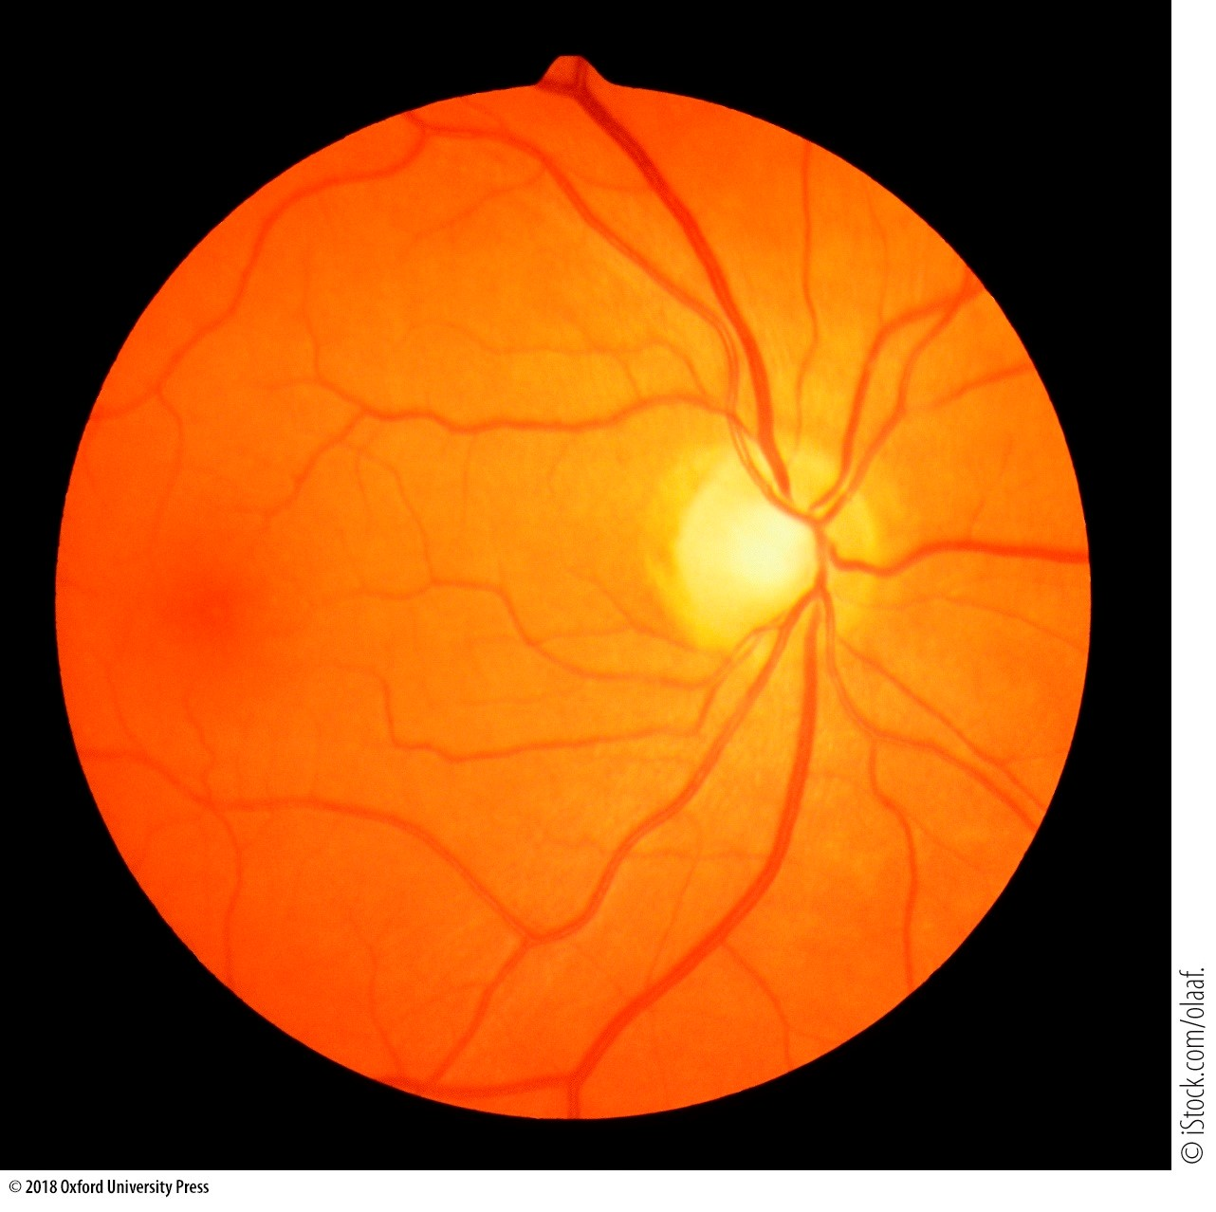

Eye doctors use an instrument called an ophthalmoscope to look at the _______ of their patients’ eyes, as seen in the image.

**Feedback:** *Textbook Reference:* 2.2 Eyes That Capture Light

*Learning Objective:* 2.2.1 Identify the parts of the eye and their function in vision.

*Bloom’s Level:* 2. Understanding

a. cornea

b. iris

c. lens

d. focal point

*e. fundus

**Type: multiple choice question**

**Title:** Chapter 02 Question 22

22. People with _______ do *not* require an optical correction to see normally.

**Feedback:** *Textbook Reference:* 2.2 Eyes That Capture Light

*Learning Objective:* 2.2.2 Describe the various defects in the eye that can cause impaired vision.

*Bloom’s Level:* 2. Understanding

a. myopia

b. hyperopia

c. astigmatism

*d. emmetropia

e. All the above require optical correction.

**Type: multiple choice question**

**Title:** Chapter 02 Question 23

23. Which of the following is a unit of measurement of the optic power of a lens?

**Feedback:** *Textbook Reference:* 2.2 Eyes That Capture Light

*Learning Objective:* 2.2.2 Describe the various defects in the eye that can cause impaired vision.

*Bloom’s Level:* 1. Remembering

*a. Diopter

b. Visual angle

c. Accommodation

d. Hertz

e. Wavelength

**Type: multiple choice question**

**Title:** Chapter 02 Question 24

24. Which of the following refers to nearsightedness?

**Feedback:** *Textbook Reference:* 2.2 Eyes That Capture Light

*Learning Objective:* 2.2.2 Describe the various defects in the eye that can cause impaired vision.

*Bloom’s Level:* 1. Remembering

*a. Myopia

b. Hyperopia

c. Astigmatism

d. Emmetropia

e. Strabismus

**Type: multiple choice question**

**Title:** Chapter 02 Question 25

25. Refer to the figure.

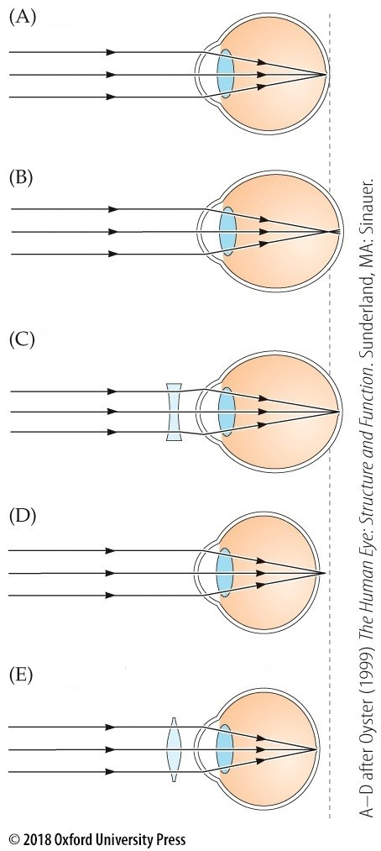

Which part of the figure depicts hyperopia without correction?

**Feedback:** *Textbook Reference:* 2.2 Eyes That Capture Light

*Learning Objective:* 2.2.2 Describe the various defects in the eye that can cause impaired vision.

*Bloom’s Level:* 2. Understanding

a. A

b. B

c. C

*d. D

e. E

**Type: multiple choice question**

**Title:** Chapter 02 Question 26

26. Accommodation is the process during which the _______ of the eye changes its shape.

**Feedback:** *Textbook Reference:* 2.2 Eyes That Capture Light

*Learning Objective:* 2.2.2 Describe the various defects in the eye that can cause impaired vision.

*Bloom’s Level:* 1. Remembering

a. retina

*b. lens

c. pupil

d. iris

e. cornea

**Type: multiple choice question**

**Title:** Chapter 02 Question 27

27. Refer to the figure.

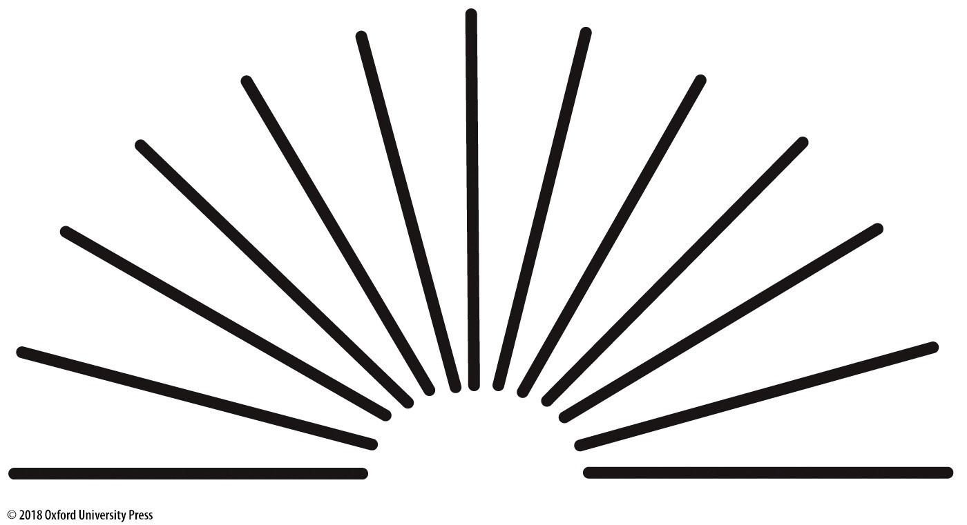

This chart is used to test for

**Feedback:** *Textbook Reference:* 2.2 Eyes That Capture Light

*Learning Objective:* 2.2.2 Describe the various defects in the eye that can cause impaired vision.

*Bloom’s Level:* 2. Understanding

a. myopia.

b. hyperopia.

*c. astigmatism.

d. macular degeneration.

e. retinitis pigmentosa.

**Type: multiple choice question**

**Title:** Chapter 02 Question 28

28. Literally meaning “old sight,” this term refers to age-related loss of accommodation, which makes it difficult to focus on near objects.

**Feedback:** *Textbook Reference:* 2.2 Eyes That Capture Light

*Learning Objective:* 2.2.2 Describe the various defects in the eye that can cause impaired vision.

*Bloom’s Level:* 1. Remembering

a. Emmetropia

b. Hyperopia

c. Macular degeneration

d. Retinitis pigmentosa

*e. Presbyopia

**Type: multiple choice question**

**Title:** Chapter 02 Question 29

29. In presbyopia, the lens becomes stiff with age and cannot change its shape. What is the perceptual consequence of this change?

**Feedback:** *Textbook Reference:* 2.2 Eyes That Capture Light

*Learning Objective:* 2.2.2 Describe the various defects in the eye that can cause impaired vision.

*Bloom’s Level:* 3. Applying

a. Too much light gets into the eye, causing difficulties with daytime vision.

b. Not enough light gets into the eye, causing difficulties with nighttime vision.

*c. It may become difficult to focus on objects at certain depths.

d. Light becomes so scattered in the eye that perception is impossible.

e. Peripheral vision is lost gradually over time.

**Type: multiple choice question**

**Title:** Chapter 02 Question 30

30. The light energy from an object is _______ into neural energy that can be interpreted by the brain.

**Feedback:** *Textbook Reference:* 2.2 Eyes That Capture Light

*Learning Objective:* 2.2.3 Describe the anatomical geography of the retina, including the distribution of cones and rods in the central and peripheral regions.

*Bloom’s Level:* 1. Remembering

a. transferred

b. transformed

*c. transduced

d. absorbed

e. translated

**Type: multiple choice question**

**Title:** Chapter 02 Question 31

31. Rods are most highly concentrated in which area of the retina?

**Feedback:** *Textbook Reference:* 2.2 Eyes That Capture Light

*Learning Objective:* 2.2.3 Describe the anatomical geography of the retina, including the distribution of cones and rods in the central and peripheral regions.

*Bloom’s Level:* 2. Understanding

a. Blind Spot

b. Cornea

c. Fovea

d. Lens

*e. Periphery

**Type: multiple choice question**

**Title:** Chapter 02 Question 32

32. Cones are most highly concentrated in which area of the retina?

**Feedback:** *Textbook Reference:* 2.2 Eyes That Capture Light

*Learning Objective:* 2.2.3 Describe the anatomical geography of the retina, including the distribution of cones and rods in the central and peripheral regions.

*Bloom’s Level:* 2. Understanding

a. Blind Spot

b. Cornea

*c. Fovea

d. Lens

e. Periphery

**Type: multiple choice question**

**Title:** Chapter 02 Question 33

33. The retina can be referred to as _______ because it contains rods and cones, which operate under different conditions.

**Feedback:** *Textbook Reference:* 2.2 Eyes That Capture Light

*Learning Objective:* 2.2.3 Describe the anatomical geography of the retina, including the distribution of cones and rods in the central and peripheral regions.

*Bloom’s Level:* 2. Understanding

a. a focal point

b. a shutter

*c. duplex

d. a light-passing membrane

e. bipartisan

**Type: multiple choice question**

**Title:** Chapter 02 Question 34

34. The high-resolution part of the eye that is used for detailed vision is called the

**Feedback:** *Textbook Reference:* 2.2 Eyes That Capture Light

*Learning Objective:* 2.2.3 Describe the anatomical geography of the retina, including the distribution of cones and rods in the central and peripheral regions.

*Bloom’s Level:* 1. Remembering

a. cornea.

b. lens.

*c. iris.

d. sclera.

e. fovea.

**Type: multiple choice question**

**Title:** Chapter 02 Question 35

35. _______ refers to the distance between the location of a retinal image and the fovea.

**Feedback:** *Textbook Reference:* 2.2 Eyes That Capture Light

*Learning Objective:* 2.2.3 Describe the anatomical geography of the retina, including the distribution of cones and rods in the central and peripheral regions.

*Bloom’s Level:* 1. Remembering

a. Degradation

b. Density

c. Circularity

*d. Eccentricity

e. Signal strength

**Type: multiple choice question**

**Title:** Chapter 02 Question 36

36. Light and dark adaptation can occur by pupil constriction or dilation and

**Feedback:** *Textbook Reference:* 2.3 Dark and Light Adaptation

*Learning Objective:* 2.3.1 Explain the two major strategies the eye uses to adapt to dark and light environments.

*Bloom’s Level:* 2. Understanding

a. lateral inhibition.

*b. changes in photoreceptor concentration.

c. photoactivation.

d. bipolar cell activation and deactivation.

e. ganglion cell activation and deactivation.

**Type: multiple choice question**

**Title:** Chapter 02 Question 37

37. Suppose your pupils are dilated after visiting the eye doctor. What is the effect on the amount of photopigment in your photoreceptors, and why?

**Feedback:** *Textbook Reference:* 2.3 Dark and Light Adaptation

*Learning Objective:* 2.3.1 Explain the two major strategies the eye uses to adapt to dark and light environments.

*Bloom’s Level:* 3. Applying

a. You have more photopigment than normal because your photoreceptors are trying to adapt to the decreased amount of light striking the retina.

b. You have more photopigment than normal because your photoreceptors are trying to adapt to the increased amount of light striking the retina.

c. You have less photopigment than normal because your photoreceptors are trying to adapt to the decreased amount of light striking the retina.

*d. You have less photopigment than normal because your photoreceptors are trying to adapt to the increased amount of light striking the retina.

e. You have the same amount of photopigment as normal because photoreceptors do not adapt to changes in the amount of light entering the eyes.

**Type: multiple choice question**

**Title:** Chapter 02 Question 38

38. A neuron will not fire if a stimulus does not activate its

**Feedback:** *Textbook Reference:* 2.3 Dark and Light Adaptation

*Learning Objective:* 2.3.2 Explain the concept of a receptive field.

*Bloom’s Level:* 2. Understanding

a. axon.

b. action potential.

*c. central region.

d. photoreceptor.

e. receptive field.

**Type: multiple choice question**

**Title:** Chapter 02 Question 39

39. In retinitis pigmentosa, there is

**Feedback:** *Textbook Reference:* 2.3 Dark and Light Adaptation

*Learning Objective:* 2.3.3 Describe age-related macular degeneration and retinitis pigmentosa.

*Bloom’s Level:* 2. Understanding

a. regeneration of too many photoreceptors.

b. loss of color in the iris of the eye.

*c. loss of macular opacity.

d. loss of the ability to use the lens in order to focus.

e. degeneration of the pigment epithelium.

**Type: multiple choice question**

**Title:** Chapter 02 Question 40

40. In aging-related macular degeneration (AMD) there is a _______ loss of _______ vision.

**Feedback:** *Textbook Reference:* 2.3 Dark and Light Adaptation

*Learning Objective:* 2.3.3 Describe age-related macular degeneration and retinitis pigmentosa.

*Bloom’s Level:* 2. Understanding

a. sudden; peripheral

b. gradual; peripheral

c. sudden; central

*d. gradual; central

e. complete; all

**Type: multiple choice question**

**Title:** Chapter 02 Question 41

41. With regard to retinitis pigmentosa (RP) and age-related macular degeneration (AMD), which would have the greatest impact on scotopic (nighttime) vision, and why?

**Feedback:** *Textbook Reference:* 2.3 Dark and Light Adaptation

*Learning Objective:* 2.3.3 Describe age-related macular degeneration and retinitis pigmentosa.

*Bloom’s Level:* 3. Applying

*a. RP, because it damages peripheral vision, which is most important for scotopic vision.

b. RP, because it damages central vision, which is most important for scotopic vision.

c. AMD, because it damages peripheral vision, which is most important for scotopic vision.

d. AMD, because it damages central vision, which is most important for scotopic vision.

e. Neither of these diseases affects scotopic vision.

**Type: multiple choice question**

**Title:** Chapter 02 Question 42

42. With regard to retinitis pigmentosa (RP) and age-related macular degeneration (AMD), which would have the greatest impact on photopic (daytime) vision, and why?

**Feedback:** *Textbook Reference:* 2.3 Dark and Light Adaptation

*Learning Objective:* 2.3.3 Describe age-related macular degeneration and retinitis pigmentosa.

*Bloom’s Level:* 3. Applying

a. RP, because it damages peripheral vision, which is most important for photopic vision.

b. RP, because it damages central vision, which is most important for photopic vision.

c. AMD, because it damages peripheral vision, which is most important for photopic vision.

*d. AMD, because it damages central vision, which is most important for photopic vision.

e. Neither of these diseases affects photopic vision.

**Type: multiple choice question**

**Title:** Chapter 02 Question 43

43. The part of the photoreceptor that contains photopigment molecules is called the

**Feedback:** *Textbook Reference:* 2.4 Retinal Information Processing

*Learning Objective:* 2.4.1 Describe how photoreceptors capture light and transduce it into neural firing.

*Bloom’s Level:* 1. Remembering

a. retina.

*b. outer segment.

c. inner segment.

d. synaptic terminal.

e. vitreous humor.

**Type: multiple choice question**

**Title:** Chapter 02 Question 44

44. _______ is the visual pigment found in rods.

**Feedback:** *Textbook Reference:* 2.4 Retinal Information Processing

*Learning Objective:* 2.4.1 Describe how photoreceptors capture light and transduce it into neural firing.

*Bloom’s Level:* 1. Remembering

a. Macular pigment

b. Melanopsin

*c. Rhodopsin

d. Chromopsin

e. Vitreous humor

**Type: multiple choice question**

**Title:** Chapter 02 Question 45

45. There may be a third type of photoreceptor in the retina that helps regulate our sleep and wake cycles. What type of photopigment do these cells contain?

**Feedback:** *Textbook Reference:* 2.4 Retinal Information Processing

*Learning Objective:* 2.4.1 Describe how photoreceptors capture light and transduce it into neural firing.

*Bloom’s Level:* 1. Remembering

a. Macular pigment

*b. Melanopsin

c. Rhodopsin

d. Chromopsin

e. Vitreous humor

**Type: multiple choice question**

**Title:** Chapter 02 Question 46

46. When light strikes a photoreceptor, what happens to its electrical potential?

**Feedback:** *Textbook Reference:* 2.4 Retinal Information Processing

*Learning Objective* 2.4.1 Describe how photoreceptors capture light and transduce it into neural firing.

*Bloom’s Level:* 2. Understanding

*a. It decreases and becomes more negative.

b. It decreases but stays positive.

c. It increases but stays negative.

d. It increases and becomes more positive.

e. Its electrical potential stays the same.

**Type: multiple choice question**

**Title:** Chapter 02 Question 47

47. Lateral inhibition is the

**Feedback:** *Textbook Reference:* 2.4 Retinal Information Processing

*Learning Objective:* 2.4.2 Name the different cells in the retina and describe their functioning.

*Bloom’s Level:* 1. Remembering

a. increase in activation caused by nearby regions of the retina.

b. measure of the finest detail that one can resolve.

c. process of inhibiting light from moving.

d. processing of inhibitory cells.

*e. antagonistic neural interaction between adjacent regions of the retina.

**Type: multiple choice question**

**Title:** Chapter 02 Question 48

48. Why is lateral inhibition important for retinal ganglion cell receptive fields?

**Feedback:** *Textbook Reference:* 2.4 Retinal Information Processing

*Learning Objective:* 2.4.2 Name the different cells in the retina and describe their functioning.

*Bloom’s Level:* 4. Analyzing

a. It opposes and counteracts the lateral excitation also happening in the retina.

b. It inhibits perception of the sides of objects, causing the eyes to focus on the center.

*c. It creates the center-surround receptive field structure, which acts like a filter for perception.

d. It stops the receptive fields from responding to contrast in the retinal image.

e. Lateral inhibition is not important in the retina.

**Type: multiple choice question**

**Title:** Chapter 02 Question 49

49. Which of the following is a specialized retinal cell responsible for lateral inhibition?

**Feedback:** *Textbook Reference:* 2.4 Retinal Information Processing

*Learning Objective:* 2.4.2 Name the different cells in the retina and describe their functioning.

*Bloom’s Level:* 1. Remembering

a. Amacrine cell

b. Bipolar cell

c. Ganglion cell

*d. Horizontal cell

e. Photoreceptor

**Type: multiple choice question**

**Title:** Chapter 02 Question 50

50. Retinal cells that make connections with bipolar cells, ganglion cells, and other cells like themselves are called

**Feedback:** *Textbook Reference:* 2.4 Retinal Information Processing

*Learning Objective:* 2.4.2 Name the different cells in the retina and describe their functioning.

*Bloom’s Level:* 3. Applying

*a. amacrine cells.

b. cones.

c. horizontal cells.

d. chromophores.

e. rods.

**Type: multiple choice question**

**Title:** Chapter 02 Question 51

51. Which of the following are retinal cells that synapse with photoreceptors, horizontal cells, and ganglion cells?

**Feedback:** *Textbook Reference:* 2.4 Retinal Information Processing

*Learning Objective:* 2.4.2 Name the different cells in the retina and describe their functioning.

*Bloom’s Level:* 3. Applying

a. Amacrine cells

*b. Bipolar cells

c. Chromophores

d. Cones

e. Rods

**Type: multiple choice question**

**Title:** Chapter 02 Question 52

52. In the fovea, single cones pass information to single ganglion cells via _______ cells.

**Feedback:** *Textbook Reference:* 2.4 Retinal Information Processing

*Learning Objective:* 2.4.2 Name the different cells in the retina and describe their functioning.

*Bloom’s Level:* 3. Applying

a. horizontal

b. amacrine

*c. midget bipolar

d. diffuse bipolar

e. rod

**Type: multiple choice question**

**Title:** Chapter 02 Question 53

53. In which area of the eye would you find midget bipolar cells?

**Feedback:** *Textbook Reference:* 2.4 Retinal Information Processing

*Learning Objective:* 2.4.2 Name the different cells in the retina and describe their functioning.

*Bloom’s Level:* 2. Understanding

a. Blind spot

*b. Fovea

c. Lens

d. Periphery

e. Pupil

**Type: multiple choice question**

**Title:** Chapter 02 Question 54

54. In which area of the eye would you find diffuse bipolar cells?

**Feedback:** *Textbook Reference:* 2.4 Retinal Information Processing

*Learning Objective:* 2.4.2 Name the different cells in the retina and describe their functioning.

*Bloom’s Level:* 2. Understanding

a. Blind spot

b. Fovea

c. Lens

*d. Periphery

e. Pupil

**Type: multiple choice question**

**Title:** Chapter 02 Question 55

55. Retinal cells called _______ leave the eye via the optic nerve and transmit information to the brain and midbrain.

**Feedback:** *Textbook Reference:* 2.4 Retinal Information Processing

*Learning Objective:* 2.4.2 Name the different cells in the retina and describe their functioning.

*Bloom’s Level:* 1. Remembering

*a. Ganglion cells

b. Bipolar cells

c. Amacrine cells

d. Horizontal cells

e. Photoreceptors

**Type: multiple choice question**

**Title:** Chapter 02 Question 56

56. If the optic nerve is severed, which retinal cells are damaged?

**Feedback:** *Textbook Reference:* 2.4 Retinal Information Processing

*Learning Objective:* 2.4.2 Name the different cells in the retina and describe their functioning.

*Bloom’s Level:* 3. Applying

a. Amacrine cells

b. Bipolar cells

*c. Ganglion cells

d. Horizontal cells

e. Photoreceptors

**Type: multiple choice question**

**Title:** Chapter 02 Question 57

57. The vertical pathway in the retina consists of all the following *except*

**Feedback:** *Textbook Reference:* 2.4 Retinal Information Processing

*Learning Objective:* 2.4.2 Name the different cells in the retina and describe their functioning.

*Bloom’s Level:* 4. Analyzing

a. cones.

b. rods.

c. bipolar cells.

d. ganglion cells.

*e. amacrine cells.

**Type: multiple choice question**

**Title:** Chapter 02 Question 58

58. The lateral pathway in the retina consists of horizontal cells and

**Feedback:** *Textbook Reference:* 2.4 Retinal Information Processing

*Learning Objective:* 2.4.2 Name the different cells in the retina and describe their functioning.

*Bloom’s Level:* 2. Understanding

a. photoreceptors.

*b. amacrine cells.

c. midget bipolar cells.

d. diffuse bipolar cells.

e. ganglion cells.

**Type: multiple choice question**

**Title:** Chapter 02 Question 59

59. P ganglion cells are different than M ganglion cells in that P ganglion cells

**Feedback:** *Textbook Reference:* 2.4 Retinal Information Processing

*Learning Objective:* 2.4.2 Name the different cells in the retina and describe their functioning.

*Bloom’s Level:* 3. Applying

a. have larger receptive fields than M ganglion cells do.

b. are more sensitive to motion than M ganglion cells are.

c. synapse with more photoreceptors than M ganglion cells do.

d. operate better in low-light conditions than M ganglion cells do.

*e. are more sensitive to color than M ganglion cells are.

**Type: multiple choice question**

**Title:** Chapter 02 Question 60

60. If the P ganglion cells in the retina suddenly disappeared, what would be the consequences for perception?

**Feedback:** *Textbook Reference:* 2.4 Retinal Information Processing

*Learning Objective:* 2.4.2 Name the different cells in the retina and describe their functioning.

*Bloom’s Level:* 4. Analyzing

a. Motion perception would be severely impaired.

b. Peripheral vision would be severely impaired.

*c. Color and form perception would be severely impaired.

d. Color and form perception would be improved.

e. Scotopic vision would be severely impaired.

**Type: multiple choice question**

**Title:** Chapter 02 Question 61

61. If the M ganglion cells in the retina suddenly disappeared, what would be the consequences for perception?

**Feedback:** *Textbook Reference:* 2.4 Retinal Information Processing

*Learning Objective:* 2.4.2 Name the different cells in the retina and describe their functioning.

*Bloom’s Level:* 4. Analyzing

*a. Motion perception would be severely impaired.

b. Peripheral vision would be greatly improved.

c. Foveal vision would be greatly improved.

d. Foveal vision would be severely impaired.

e. Color and form perception would be severely impaired.

**Type: multiple choice question**

**Title:** Chapter 02 Question 62

62. A neuron will *not* fire if a stimulus does not activate its

**Feedback:** *Textbook Reference:* 2.4 Retinal Information Processing

*Learning Objective:* 2.4.3 Describe the receptive field characteristics of retinal ganglion cells.

*Bloom’s Level:* 2. Understanding

a. axon.

b. action potential.

c. central region.

d. photoreceptor.

*e. receptive field.

**Type: multiple choice question**

**Title:** Chapter 02 Question 63

63. Which stimulus would optimally activate an ON-center ganglion cell?

**Feedback:** *Textbook Reference:* 2.4 Retinal Information Processing

*Learning Objective:* 2.4.3 Describe the receptive field characteristics of retinal ganglion cells.

*Bloom’s Level:* 3. Applying

*a. A spot of light in the center of the receptive field

b. A shadow in the center of the receptive field

c. A ring of light covering the surround of the receptive field

d. A large spot of light covering both the center and surround portions of the receptive field

e. A large shadow covering both the center and surround portions of the receptive field

**Type: multiple choice question**

**Title:** Chapter 02 Question 64

64. Which stimulus would optimally activate an OFF-center ganglion cell?

**Feedback:** *Textbook Reference:* 2.4 Retinal Information Processing

*Learning Objective:* 2.4.3 Describe the receptive field characteristics of retinal ganglion cells.

*Bloom’s Level:* 3. Applying

a. A spot of light in the center of the receptive field

*b. A shadow in the center of the receptive field

c. A ring of shadow covering the surround of the receptive field

d. A large spot of light covering both the center and surround portions of the receptive field

e. A large shadow covering both the center and surround portions of the receptive field

**Type: essay/short answer question**

**Title:** Chapter 02 Question 65

65. Describe the journey of light from the time it is emitted by the sun to the time it is registered by our eyes. In what ways is light reflected, refracted, transmitted, and absorbed?

**Feedback:** Light is emitted by the sun, enters the atmosphere where some of it is absorbed and scattered, and the rest of it is transmitted through the air until it hits an object. When light hits an object, some of it is absorbed and the rest of it is reflected. Reflected light may strike the eye, where it is transmitted and slightly refracted by the cornea and aqueous humor. It then passes through the pupil, is refracted and focused by the lens, transmitted through the vitreous humor and finally is absorbed by photoreceptors in the back of the eye.

*Textbook Reference:* 2.2 Eyes That Capture Light

*Learning Objective:* 2.1.2 Describe the various ways that light can be affected as it journeys from the sun to the eye.

*Bloom’s Level:* 3. Applying

**Type: essay/short answer question**

**Title:** Chapter 02 Question 66

66. Describe how the shape of the human lens and eyeball can cause blurry vision that requires correction. What are the differences between emmetropia, myopia, hyperopia, and astigmatism?

**Feedback:** The eyeball may be too long or too short for light that is refracted by the cornea and lens to be properly focused on the back of the eye. An eye that is too long, such that the focus point is in front of the retina, results in myopia, or nearsightedness. An eye that is too short, such that the focus point is behind the retina, results in hyperopia, or farsightedness. An eye that has unequal curving results in an astigmatism, which will cause an image to be blurry along a particular angle. A corrective lens in front of the eye (either in the form of a contact lens or glasses) bends the light in such a way that it properly focuses on the back of the eye. When the eyeball is perfectly round and the image is focused properly on the back of the eye, one is said to have the happy condition of emmetropia, which does not require any correction.

*Textbook Reference:* 2.2 Eyes That Capture Light

*Learning Objective:* 2.2.2 Describe the various defects in the eye that can cause impaired vision.

*Bloom’s Level:* 4. Analyzing

**Type: essay/short answer question**

**Title:** Chapter 02 Question 67

67. We all have a blind spot in each eye. In normal circumstances, why is it that we do not experience large black empty regions in our visual field?

**Feedback:** There are several reasons. First, we typically look at the world with two eyes, so the blind spot in each eye is covered by the other eye. Second, even when we look at the world with one eye, the brain “fills in” missing information in the blind spot to create a complete image. Finally, we don’t have receptors for the blind spot in our eye or brain, so we don’t have any cells to encode the lack of information in the first place!

*Textbook Reference:* 2.2 Eyes That Capture Light

*Learning Objective:* 2.2.3 Describe the anatomical geography of the retina, including the distribution of cones and rods in the central and peripheral regions.

*Bloom’s Level:* 4. Analyzing

**Type: essay/short answer question**

**Title:** Chapter 02 Question 68

68. What are age-related macular degeneration (AMD) and retinitis pigmentosa (RP)? How are they similar and how are they different?

**Feedback:** Age-related macular degeneration and retinitis pigmentosa are progressive eye diseases that result in blindness in part of the visual field. AMD leads to central field loss, such that the center of one’s vision disappears. RP leads to peripheral field loss such that the edges of one’s vision disappears.

*Textbook Reference:* 2.3 Dark and Light Adaptation

*Learning Objective:* 2.3.3 Describe age-related macular degeneration and retinitis pigmentosa.

*Bloom’s Level:* 2. Understanding

**Type: essay/short answer question**

**Title:** Chapter 02 Question 69

69. Describe the various ways that our visual system adapts to darkness and allows us to see in low lighting conditions. Why are we said to have a “duplex retina”?

**Feedback:** Our visual system adapts to dark situations using two strategies. First, the pupil (iris) expands to let more light into the eye than it would under higher lighting conditions. This response is rather quick and is responsible for short-term dark adaptation. Second, and more importantly, the number of photopigment molecules present in photoreceptors is increased such that the retina becomes more sensitive to what little light is actually present in the environment. In high illumination situations, our eyes detect light using mostly cones, while in low illumination, our eyes detect light using mostly rods. The presence of both rods and cones in the retina is what makes it “duplex.” Together, rods and cones can support visual perception under a huge number of lighting conditions.

*Textbook Reference:* 2.3 Dark and Light Adaptation

*Learning Objective:* 2.3.1 Explain the two major strategies the eye uses to adapt to dark and light environments.

*Bloom’s Level:* 4. Analyzing

**Type: essay/short answer question**

**Title:** Chapter 02 Question 70

70. In what ways is the human eye similar to a camera? In what ways does it differ from a camera? Compare and contrast camera functions to the physiology of the human eye.

**Feedback:** The eye is analogous to a camera in the sense that both have an aperture for allowing light in (the pupil/iris of the eye and the aperture of a camera), a lens for adjusting focal length, and a medium for recording images (the retina in the eye and film or digital chip in a camera). An eye is unlike a camera in the sense that while a camera passively records images, an eye actively interprets images using the wiring of the retina, particularly horizontal and amacrine cells. Horizontal cells help to create the center-surround receptive fields through lateral inhibition, which emphasize edges in an image. Amacrine cells aid in contrast enhancement and temporal sensitivity. After the retina, image information is sent on to the LGN (lateral geniculate nucleus) and primary visual cortex for further analysis, interpretation, and enhancement. While film in a camera processes and represents all parts of an image equally, the retina processes the center of an image (the portion that falls on the fovea) in much more detail than the periphery.

*Textbook Reference:* 2.4 Retinal Information Processing

*Learning Objective:* 2.4.2 Name the different cells in the retina and describe their functioning.

*Bloom’s Level:* 5. Evaluating

**Type: essay/short answer question**

**Title:** Chapter 02 Question 71

71. Describe the transmission of information in the retina from photoreceptors to the optic nerve. What cells are functioning in what order, and how do they transform visual information on the way to the brain?

**Feedback:** Once light strikes the outer segment of photoreceptors in the retina, a chromophore captures the light molecule which begins the process of photoactivation, causing the photoreceptor to become hyperpolarized. The graded potentials of the photoreceptor that result from photoactivation are sent on to the bipolar cells, which may be either diffuse bipolar cells or midget bipolar cells. Diffuse bipolar cells connect to multiple cones while midget bipolar cells connect to only a single cone. Horizontal cells connect to the synapse of photoreceptors and bipolar cells and help to create the center-surround receptive field organization through lateral inhibition. ON bipolar cells respond to increases in light and OFF bipolar cells respond to decreases in light. Bipolar cells connect to P and M ganglion cells as well as amacrine cells. Amacrine cells modulate the signals coming from bipolar cells to emphasize contrast and improve temporal processing. P ganglion cells receive excitatory input from midget bipolar cells and feed the parvocellular layer of the lateral geniculate nucleus (LGN). M ganglion cells receive excitatory input from diffuse bipolar cells and feed the magnocellular layer of the LGN Ganglion cells converge at the optic disk where they leave the eye and form the optic nerve. The optic nerve transmits signals from the retina to the LGN.

*Textbook Reference:* 2.4 Retinal Information Processing

*Learning Objective:* 2.4.2 Name the different cells in the retina and describe their functioning.

*Bloom’s Level:* 4. Analyzing