1. A roof has a rise of 5 feet for every horizontal change of 7 feet (see figure). Find the inclination of the roof. Round your answers to one decimal place.
​
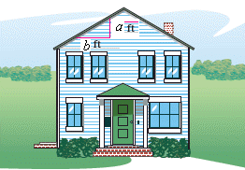
​
​

2. Graphically estimate the x- and y-intercepts of the graph.
​
​
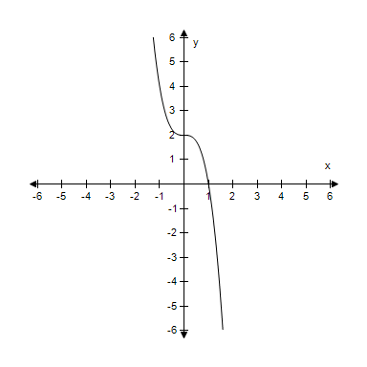
​

3. The parent function is related to g. Describe the sequence of transformations from f to g.
​
​

4. From the graph of the quadratic function , determine the equation of the axis of symmetry.

5. Find the distance between the point and the line. Round your answer to four decimal places.
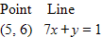
​

6. Write an equation for the function that is described by the following characteristics.

The shape of , but moved eight units down, two units to the left, and then reflected in the x-axis.

7. Find the inclination Θ (in degrees) of the line with a slope of m. Round your answer to one decimal places.
​
​

8. Find all real value of x such that .
​
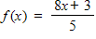
​

9. Evaluate if .
​

10. Use algebraic tests to check the following for symmetry with respect to the axes and the origin.
​
​

11. Select the graph of g.
​
​

12. Find the value(s) of x for which .
​
​

13. A rectangle is bounded by the x-axis and the semicircle 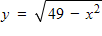 (see figure). Select the area A of the rectangle as a function of x, and determine the domain of the function.
​
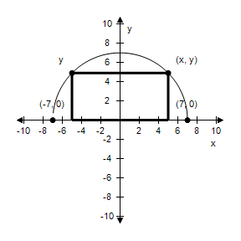
​

14. Determine the quadrant(s) in which (x, y) is located so that the condition(s) is (are) satisfied.
​
x > 3 and y < 0
​

15. Find the angle (in radians and degrees) between the lines. Round your answer to four decimal places for radians and round your answer to one decimal places for degree.
​
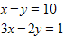
​

Answer Key
1.

2. x-intercept: (1, 0)
y-intercept: (0, 2)

3. Horizontal shift three units to the right.

4.

5.

6.

7.

8. x =

9.

10. Symmetric with respect to the x-axis.

11. ​
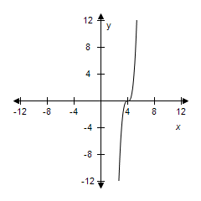

12. x= –3, 6

13. 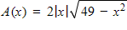,

14. Quadrant IV

15.

