1. A sample of 20 endangered species was obtained and the length of time (in months) since being placed on the list was recorded for each species. The ordered data follow:
52, 54, 58, 59, 59, 60, 60, 63, 65, 66, 67, 68, 69, 73, 74, 77, 78, 79, 79, 98
What is the median length of time (in months) since being placed on the list for these 20 species?
 | a. | 66.0
 | b. | 66.5
 | c. | 67.0
 | d. | 67.5

ANSWER: | b

2. A sample of 20 endangered species was obtained and the length of time (in months) since being placed on the list was recorded for each species. The ordered data follow:
52, 54, 58, 59, 59, 60, 60, 63, 65, 66, 67, 68, 69, 73, 74, 77, 78, 79, 79, 98
What is the mean length of time (in months) since being placed on the list for these 20 species?
 | a. | 66.32
 | b. | 66.50
 | c. | 67.90
 | d. | 68.25

ANSWER: | c

3. A sample of 20 endangered species was obtained and the length of time (in months) since being placed on the list was recorded for each species. The ordered data follow:
52, 54, 58, 59, 59, 60, 60, 63, 65, 66, 67, 68, 69, 73, 74, 77, 78, 79, 79, 98
What is the first quartile of the length of time (in months) since being placed on the list for these 20 species?
 | a. | 5
 | b. | 59.5
 | c. | 74
 | d. | 75.5

ANSWER: | b

4. A sample of 20 endangered species was obtained and the length of time (in months) since being placed on the list was recorded for each species. The ordered data follow:
52, 54, 58, 59, 59, 60, 60, 63, 65, 66, 67, 68, 69, 73, 74, 77, 78, 79, 79, 98
Which value would need to be exceeded for a data point to be considered an outlier when using the 1.5 × IQR rule?
 | a. | 75.5
 | b. | 83.5
 | c. | 91.5
 | d. | 99.5

ANSWER: | d

5. The following dotplot shows the migraine intensity (on a scale of 1 to 10) for 29 adults suffering from recurring migraines.
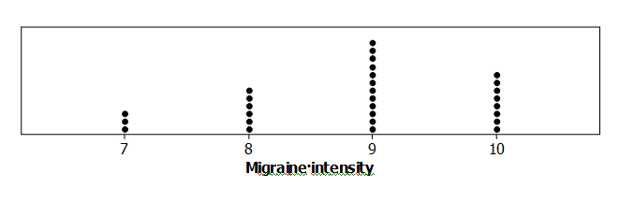
What is the median migraine intensity in this sample?
 | a. | 8
 | b. | 8.5
 | c. | 9
 | d. | Impossible to determine

ANSWER: | c

6. The following dotplot shows the migraine intensity (on a scale of 1 to 10) for 29 adults suffering from recurring migraines.
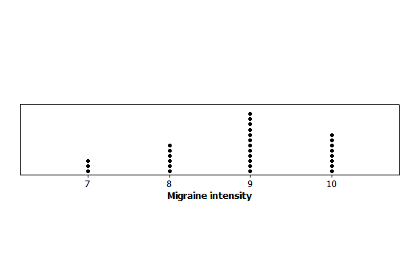
What is the first quartile for this data set?
 | a. | 7.25
 | b. | 7.5
 | c. | 7.75
 | d. | 8

ANSWER: | d

7. The following dotplot shows the migraine intensity (on a scale of 1 to 10) for 29 adults suffering from recurring migraines.
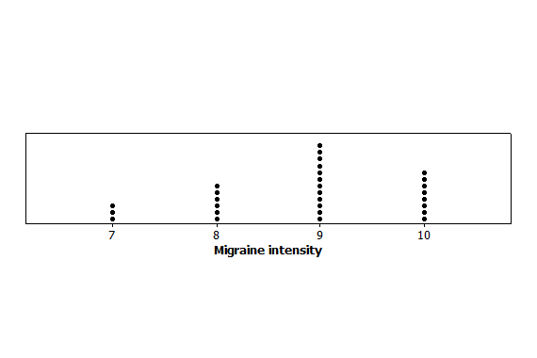
What is the third quartile for this data set?
 | a. | 9
 | b. | 9.25
 | c. | 9.5
 | d. | 10

ANSWER: | d

8. The following dotplot shows the migraine intensity (on a scale of 1 to 10) for 29 adults suffering from recurring migraines.

What is the five-number summary for this data set?
 | a. | 7, 8, 9, 10, 10
 | b. | 7, 8, 8.5, 9, 10
 | c. | 7, 7.5, 8.5, 9.5, 10
 | d. | 7, 7.5, 8.5, 9, 10

ANSWER: | a

9. A sample was taken of the metabolic rates of men participating in a study regarding diets. The following boxplot depicts these rates (measured in kilocalories per 24 hours).
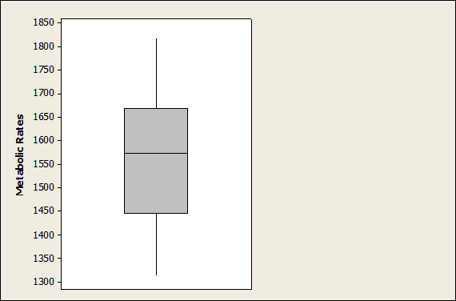
Based on this boxplot, to which value is the interquartile range closest?
 | a. | 75
 | b. | 175
 | c. | 200
 | d. | 500

ANSWER: | c

10. A sample was taken of the metabolic rates of men participating in a study regarding diets. The following boxplot depicts these rates (measured in kilocalories per 24 hours).
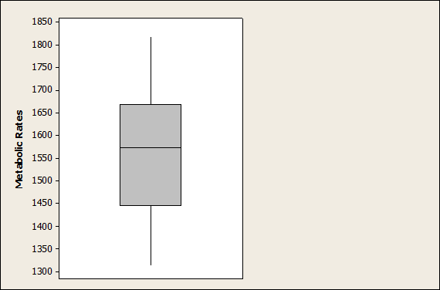
Based on this boxplot, which of the following statements is TRUE?
 | a. | The distribution of metabolic rates is fairly symmetric.
 | b. | Approximately half the rates were greater than 1550.
 | c. | None of the men had a rate less than 1200.
 | d. | All of these choices are correct.

ANSWER: | d

11. A sample was taken of the metabolic rates of men participating in a study regarding diets. The following boxplot depicts these rates (measured in kilocalories per 24 hours).
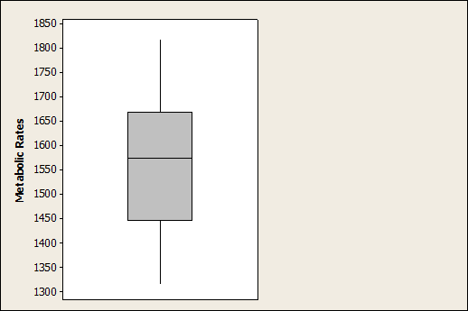
Which of the following statements would be true if each person in this data set increased his rate by 120 kilocalories per 24 hours?
 | a. | The median would increase by 120.
 | b. | The first quartile would decrease by 60.
 | c. | The third quartile would increase by 60.
 | d. | The interquartile range would increase by 120.

ANSWER: | a

12. A sample was taken of the metabolic rates of men participating in a study regarding diets. The following boxplot depicts these rates (measured in kilocalories per 24 hours).
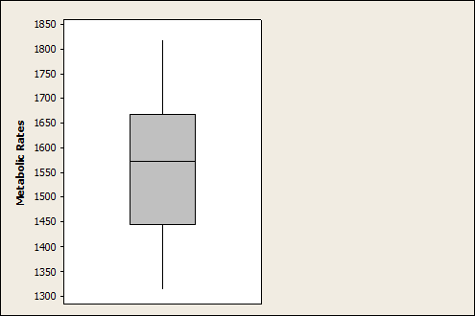
Which metabolic rate do approximately 75% of the men exceed?
 | a. | 1325
 | b. | 1450
 | c. | 1575
 | d. | 1650

ANSWER: | b

13. A sample was taken of the metabolic rates of men participating in a study regarding diets. The following boxplot depicts these rates (measured in kilocalories per 24 hours).
If 25 points were added to each rate, how would the standard deviation of the new distribution of rates change?
 | a. | The standard deviation would increase by 5.
 | b. | The standard deviation would increase by 25.
 | c. | The standard deviation would increase by 625.
 | d. | The standard deviation would remain unchanged.

ANSWER: | d

14. Here is the ordered data of body temperatures (in degrees Fahrenheit) for 65 healthy adult women:
96.4, 96.7, 96.8, 97.2, 97.2, 97.4, 97.6, 97.7, 97.7, 97.8, 97.8, 97.8, 97.9, 97.9, 97.9,
98.0, 98.0, 98.0, 98.0, 98.0, 98.1, 98.2, 98.2, 98.2, 98.2, 98.2, 98.2, 98.3, 98.3, 98.3,
98.4, 98.4, 98.4, 98.4, 98.4, 98.5, 98.6, 98.6, 98.6, 98.6, 98.7, 98.7, 98.7, 98.7, 98.7,
98.7, 98.8, 98.8, 98.8, 98.8, 98.8, 98.8, 98.8, 98.9, 99.0, 99.0, 99.1, 99.1, 99.2, 99.2,
99.3, 99.4, 99.9, 100.0, 100.8

What is the median body temperature according to these data?
 | a. | 98.0
 | b. | 98.35
 | c. | 98.4
 | d. | 98.5

ANSWER: | c

15. Here is the ordered data of body temperatures (in degrees Fahrenheit) for 65 healthy adult women:
96.4, 96.7, 96.8, 97.2, 97.2, 97.4, 97.6, 97.7, 97.7, 97.8, 97.8, 97.8, 97.9, 97.9, 97.9,
98.0, 98.0, 98.0, 98.0, 98.0, 98.1, 98.2, 98.2, 98.2, 98.2, 98.2, 98.2, 98.3, 98.3, 98.3,
98.4, 98.4, 98.4, 98.4, 98.4, 98.5, 98.6, 98.6, 98.6, 98.6, 98.7, 98.7, 98.7, 98.7, 98.7,
98.7, 98.8, 98.8, 98.8, 98.8, 98.8, 98.8, 98.8, 98.9, 99.0, 99.0, 99.1, 99.1, 99.2, 99.2,
99.3, 99.4, 99.9, 100.0, 100.8

What is the first quartile of body temperatures for this data set?
 | a. | 97.5
 | b. | 97.6
 | c. | 97.9
 | d. | 98.0

ANSWER: | d

16. Here is the ordered data of body temperatures (in degrees Fahrenheit) for 65 healthy adult women:
96.4, 96.7, 96.8, 97.2, 97.2, 97.4, 97.6, 97.7, 97.7, 97.8, 97.8, 97.8, 97.9, 97.9, 97.9,
98.0, 98.0, 98.0, 98.0, 98.0, 98.1, 98.2, 98.2, 98.2, 98.2, 98.2, 98.2, 98.3, 98.3, 98.3,
98.4, 98.4, 98.4, 98.4, 98.4, 98.5, 98.6, 98.6, 98.6, 98.6, 98.7, 98.7, 98.7, 98.7, 98.7,
98.7, 98.8, 98.8, 98.8, 98.8, 98.8, 98.8, 98.8, 98.9, 99.0, 99.0, 99.1, 99.1, 99.2, 99.2,
99.3, 99.4, 99.9, 100.0, 100.8
What is the third quartile of body temperatures for this data set?
 | a. | 98.8
 | b. | 99.0
 | c. | 99.5
 | d. | 99.9

ANSWER: | a

17. Here is the ordered data of body temperatures (in degrees Fahrenheit) for 65 healthy adult women:
96.4, 96.7, 96.8, 97.2, 97.2, 97.4, 97.6, 97.7, 97.7, 97.8, 97.8, 97.8, 97.9, 97.9, 97.9,
98.0, 98.0, 98.0, 98.0, 98.0, 98.1, 98.2, 98.2, 98.2, 98.2, 98.2, 98.2, 98.3, 98.3, 98.3,
98.4, 98.4, 98.4, 98.4, 98.4, 98.5, 98.6, 98.6, 98.6, 98.6, 98.7, 98.7, 98.7, 98.7, 98.7,
98.7, 98.8, 98.8, 98.8, 98.8, 98.8, 98.8, 98.8, 98.9, 99.0, 99.0, 99.1, 99.1, 99.2, 99.2,
99.3, 99.4, 99.9, 100.0, 100.8

Which value would need to be exceeded for a data point to be considered an outlier when using the 1.5 × IQR rule?
 | a. | 99.6
 | b. | 99.8
 | c. | 100.0
 | d. | 100.8

ANSWER: | c

18. Stream ecologists are interested in the number of distinct organisms found in streams, and whether differences exist based on geography. Separate random samples are obtained from sites in northeastern and southeastern streams, and the number of distinct organisms is recorded for each site. The data are given as separate boxplots for northeastern and southeastern streams.
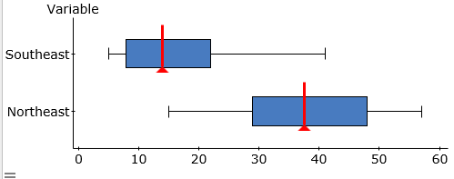
What is the approximate value of the median number of distinct organisms found in the sample of northeastern stream?
 | a. | The median is approximately the same as for southeastern streams.
 | b. | The median is approximately 14.
 | c. | The median is approximately 33.
 | d. | The median is approximately 37.

ANSWER: | d

19. Stream ecologists are interested in the number of distinct organisms found in streams, and whether differences exist based on geography. Separate random samples are obtained from sites in northeastern and southeastern streams, and the number of distinct organisms is recorded for each site. The data are given as separate stemplots for northeastern and southeastern streams.
Northeastern Southeastern
0 0 5 5 7 8
1 5 1 1 2 3 5 9 9
2 0 3 9 2 2 7
3 1 4 7 8 8 3 3
4 4 8 8 4 1
5 5 7 5
What is the mean number of distinct organisms recorded for northeastern streams?
 | a. | 16.93
 | b. | 36.93
 | c. | 37.50
 | d. | Cannot be determined from the information given

ANSWER: | b

20. Stream ecologists are interested in the number of distinct organisms found in streams, and whether differences exist based on geography. Separate random samples are obtained from sites in northeastern and southeastern streams, and the number of distinct organisms is recorded for each site. The data are given as separate boxplots for northeastern and southeastern streams.
Which of the following statements about these data is correct?
 | a. | The southeastern plot is skewed to the right.
 | b. | The northeastern plot is nearly symmetric.
 | c. | The median number of organisms found in northeastern streams is larger than the median for southeastern streams.
 | d. | All of these answers are correct.

ANSWER: | d

21. Which of the following statements correctly describes the five-number summary of a set of data?
 | a. | It includes the mean, standard deviation, first quartile, median, and third quartile.
 | b. | It includes the mean, median, interquartile range, variance, and standard deviation.
 | c. | It can be computed from the information in a stemplot.
 | d. | It includes the minimum, interquartile range, mean, median, and maximum.

ANSWER: | c

22. A study of freely forming groups in bars throughout Europe examined the number of individuals found in groups that were laughing together. A summary of the 501 groups examined is shown here:
Group size | Number of groups
2 | 254
3 | 168
4 | 52
5 | 21
6 | 6
What is the median group size?

ANSWER: | 2

23. A maze experiment uses 24 lab rats of various ages, as summarized here:
Age (in months) | Number of rats
2 | 4
3 | 6
4 | 6
5 | 4
7 | 3
9 | 1
What is the median rat age (in months) for this maze experiment?
 | a. | 3.5
 | b. | 4
 | c. | 4.5
 | d. | 5

ANSWER: | b

24. Researchers measured the length of the central retrix (R1), a flight-involved tail feather, in 21 female long-tailed finches. A boxplot of the length, in millimeters (mm), is given here:
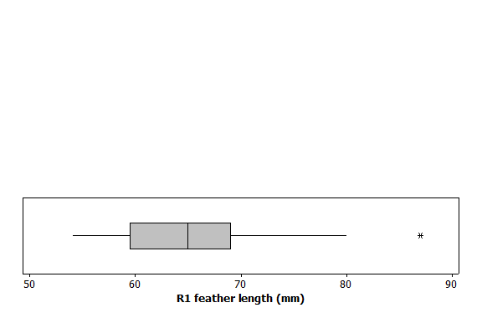
Based on this boxplot, to which value is the interquartile range closest?
 | a. | 10 mm
 | b. | 25 mm
 | c. | 60 mm
 | d. | 70 mm

ANSWER: | a

25. Researchers measured the length of the central retrix (R1), a flight-involved tail feather, in 21 female long-tailed finches. A boxplot of the length, in millimeters (mm), is given here:
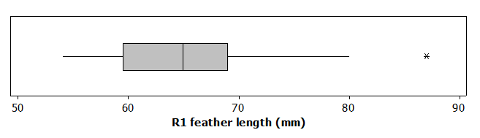
Based on this boxplot, which of the following statements is TRUE?
 | a. | The distribution of R1 lengths is bimodal.
 | b. | The distribution of R1 lengths has a high outlier.
 | c. | In this study, 75% of the birds had an R1 length above 70 mm.
 | d. | The mean R1 length is approximately 66.

ANSWER: | b

26. Suppose the graph of a distribution of data shows that the graph is skewed to the right. Which comparison should we make for the measures of center?
 | a. | Mean > median
 | b. | Median > mean
 | c. | Mean = median
 | d. | No conclusion about the relative position of the mean and the median can be made.

ANSWER: | a

27. If the graph of a distribution of data is skewed, which measure of central tendency is most appropriate?
 | a. | Midrange
 | b. | Median
 | c. | Mode
 | d. | Mean

ANSWER: | b

28. A researcher reports that, on average, participants in a study lost 10.4 pounds after two months on a new diet. A friend of yours comments that she tried the diet for two months and lost no weight. Which of the following statements is correct?
 | a. | Your friend must not have followed the diet correctly since she did not lose weight.
 | b. | Because your friend did not lose weight, the research report must not be correct.
 | c. | The report gives only the average. It is possible that some of the study participants lost no weight at all, like your friend.
 | d. | For the study to be correct, we must now add your friend’s results to those of the study and recompute the new average.

ANSWER: | c

29. Geckos are lizards with specialized toe pads that enable them to easily climb all sorts of surfaces. A research team examined the adhesive properties of 7 Tokay geckos. Following are the toe-pad areas (in square centimeters, cm²) for this sample:
5.6 4.9 6.0 5.1 5.5 5.1 7.5
Rounded to two decimal places, what is the mean toe-pad area in this sample of geckos?
ANSWER: | 5.67

30. Geckos are lizards with specialized toe pads that enable them to easily climb all sorts of surfaces. A research team examined the adhesive properties of 7 Tokay geckos. Following are the toe-pad areas (in square centimeters, cm²) for this sample:
5.6 4.9 6.0 5.1 5.5 5.1 7.5
Using the correct units, what is the value of the sample variance of toe-pad areas?
 | a. | 0.89 cm²
 | b. | 0.89 cm⁴
 | c. | 0.79 cm²
 | d. | 0.79 cm⁴

ANSWER: | d

31. Geckos are lizards with specialized toe pads that enable them to easily climb all sorts of surfaces. A research team examined the adhesive properties of 7 Tokay geckos. Following are the toe-pad areas (in square centimeters, cm²) of this sample:
5.6 4.9 6.0 5.1 5.5 5.1 7.5
What is the first quartile for these data?
ANSWER: | 5.1

32. Geckos are lizards with specialized toe pads that enable them to easily climb all sorts of surfaces. A research team examined the adhesive properties of 7 Tokay geckos. Following are the toe-pad areas (in square centimeters, cm²) for this sample:
5.6 4.9 6.0 5.1 5.5 5.1 7.5
What is the value of the interquartile range for these data?
ANSWER: | 0.9

33. Geckos are lizards with specialized toe pads that enable them to easily climb all sorts of surfaces. A research team examined the adhesive properties of 7 Tokay geckos. Following are the toe-pad areas (in square centimeters, cm²) for this sample:
5.6 4.9 6.0 5.1 5.5 5.1 7.5
Which of the following ranges must a value fall outside of to be considered an outlier according to the 1.5 × IQR rule?
 | a. | 5.10 to 6.00
 | b. | 4.90 to 7.50
 | c. | 4.20 to 6.90
 | d. | 3.75 to 7.35

ANSWER: | d

34. The distribution of ages of people in a class (to the nearest year) is as follows:
Age | 18 | 19 | 20 | 21 | 22 | 23 | 24 | 25 | 32
Number of students | 14 | 120 | 200 | 200 | 90 | 30 | 10 | 2 | 1
What is TRUE about the median age (to the nearest year) of this distribution?
 | a. | It must be 20.
 | b. | It could be any number between 19 and 21.
 | c. | It must be 21.
 | d. | It could be any number between 20 and 21.

ANSWER: | a

35. The median age of five people on a committee is 30 years. One of the members, whose age is 50 years, resigns. What is the median age of the remaining four people in the committee?
 | a. | 40 years
 | b. | 30 years
 | c. | 25 years
 | d. | Cannot be determined from the information given

ANSWER: | d

36. Which of the following data are likely to have a mean that is smaller than the median?
 | a. | Right-skewed data
 | b. | Left-skewed data
 | c. | Bimodal data
 | d. | Cyclical data

ANSWER: | b

37. By inspection, which of the following sets of numbers has the smallest standard deviation?
 | a. | 7, 8, 9, 10
 | b. | 5, 5, 5, 5
 | c. | 0, 0, 10, 10
 | d. | 0, 1, 2, 3

ANSWER: | b

38. There are three children in a room, age 3, 4, and 5. What will happen to the mean and variance of the ages if a 4-year-old child enters the room?
 | a. | The mean age will stay the same, but the variance will increase.
 | b. | The mean age will stay the same, but the variance will decrease.
 | c. | The mean age and variance will stay the same.
 | d. | The mean age and variance will increase.

ANSWER: | b

39. Brown tree snakes are an invasive species causing huge environmental and financial damage in Guam. In June 2000, researchers captured 504 brown tree snakes on Guam’s Andersen Air Force Base. On average, the snakes weighed 121 g, and their weights ranged from 23 to 663 g at capture. From this information, what can we conclude about the shape of the distribution of brown tree snake masses?
 | a. | It must be roughly symmetric.
 | b. | It must be left-skewed, have a low outlier, or both.
 | c. | It must be right-skewed, have a high outlier, or both.
 | d. | It must be multimodal (multiple-peaked).

ANSWER: | c

40. The following histogram shows the yearly number of unprovoked attacks by alligators on people in Florida over a 33-year period.
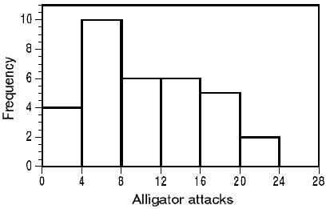
What must be the median yearly counts of alligator attacks?
 | a. | A value in class 4 to 8
 | b. | A value in class 8 to 12
 | c. | Exactly 12
 | d. | A value in class 12 to 16

ANSWER: | b

41. The following histogram shows the yearly number of unprovoked attacks by alligators on people in Florida over a 33-year period.
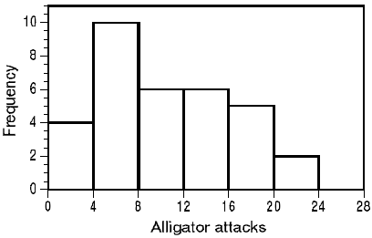
What must be the third quartile of yearly counts of alligator attacks?
 | a. | A value in class 12 to 16
 | b. | A value in class 16 to 20
 | c. | Exactly 18
 | d. | A value greater than 14

ANSWER: | a

42. In a study of the function of pectoral fins in fish, a graduate student examined 7 fish with the following lengths (in centimeters, cm):
30 28 29 27 31 25 29
What is the mean length of these 7 fish?
 | a. | 28.4 cm
 | b. | 28.6 cm
 | c. | 29.0 cm
 | d. | 29.4 cm

ANSWER: | a

43. In a study of the function of pectoral fins in fish, a graduate student examined 7 fish with the following lengths (in centimeters, cm):
30 28 29 27 31 25 29
What is the variance of these 7 fish lengths?
 | a. | 1.41 cm
 | b. | 1.99 cm²
 | c. | 3.39 cm²
 | d. | 3.95 cm²

ANSWER: | d

44. In a study of the function of pectoral fins in fish, a graduate student examined 7 fish with the following lengths (in centimeters, cm):
30 28 29 27 31 25 29
What is the first quartile for these data?
 | a. | 27 cm
 | b. | 27.5 cm
 | c. | 28 cm
 | d. | 28.5 cm

ANSWER: | a

45. In a study of the function of pectoral fins in fish, a graduate student examined 7 fish with the following lengths (in centimeters, cm):
30 28 29 27 31 25 29
What is median fish length?
 | a. | 27 cm
 | b. | 28 cm
 | c. | 28.5 cm
 | d. | 29 cm

ANSWER: | d

46. Which of the following numerical summaries is least affected by the addition of an extreme outlier?
 | a. | Mean
 | b. | Median
 | c. | Standard deviation
 | d. | Interquartile range

ANSWER: | b

