Weeks_CoverDesign_R2

**Instructor's Manual and Test Bank—V.12.1/Nov. 2014**

© 2016 by Cengage Learning, Inc. All rights reserved. Instructors of classes adopting POPULATION: AN INTRODUCTION TO CONCEPTS AND ISSUES, TWELFTH EDITION by John R. Weeks as a required text may reproduce materials for classroom use. Otherwise, no part of this book may be reproduced, stored in a retrieval system, or transcribed, in any form or by any means, without the prior written permission of the publisher, Cengage Learning, 20 Channel Center Street, Boston, MA 02210 USA.

Printed in the United States of America

1 2 3 4 5 6 7 8 9 10---20 19 18 17 16

**CONTENTS**

[PREFACE…3](#preface)

[ERRATA…5](#ERRATA)

PART ONE—A DEMOGRAPHIC PERSPECTIVE

1 [Introduction to Demography…6](#chap1)

2 [Global Population Trends...10](#Chap2)

3 [Demographic Perspectives...15](#chap3)

4 [Demographic Data…20](#chap4)

PART TWO—POPULATION PROCESSES

5 [The Health and Mortality Transition...25](#chap5)

6 [The Fertility Transition...30](#chap6)

7 [The Migration Transition...35](#chap7)

PART THREE—POPULATION STRUCTURE AND

CHARACTERISTICS

8 [The Age Transition...40](#chap8)

9 [The Urban Transition...44](#chap9)

10 [The Family and Household Transition...48](#chap10)

PART FOUR—USING THE DEMOGRAPHIC

PERSPECTIVE

11 [Population and Sustainability...53](#chap11)

12 [What Lies Ahead?...58](#chap12)

[TERM PROJECT TEMPLATES…63](#term_projects)

**PREFACE**

This Instructor's Manual and Test Bank is a companion to my book, **POPULATION: AN INTRODUCTION TO CONCEPTS AND ISSUES, TWELFTH EDITION** (Boston, MA: Cengage Learning 2016). Most of the material presented here has been used successfully in my own classes, but I would appreciate feedback from users with respect to suggested revised wording of questions and answers, as well as student responses to term projects and supplemental material. I should note that over the years I have gradually withdrawn from reliance on the multiple-choice and true-false questions in my own classes, so I will especially appreciate feedback on the quality of these questions. I am currently using these questions in Blackboard, requiring that students keep answering questions until they get them right, rather than using them directly as a grading device. If you have ideas and suggestions please email me at [john.weeks@sdsu.edu](file:///C:\Users\Owner\Desktop\Carlisle%20Projects\Weeks\Weeks\IM-TB\john.weeks@sdsu.edu), and I will try to incorporate them into subsequent updates of this manual.

***Please visit, comment on, and make use of my blog:*** <http://weekspopulation.blogspot.com/>

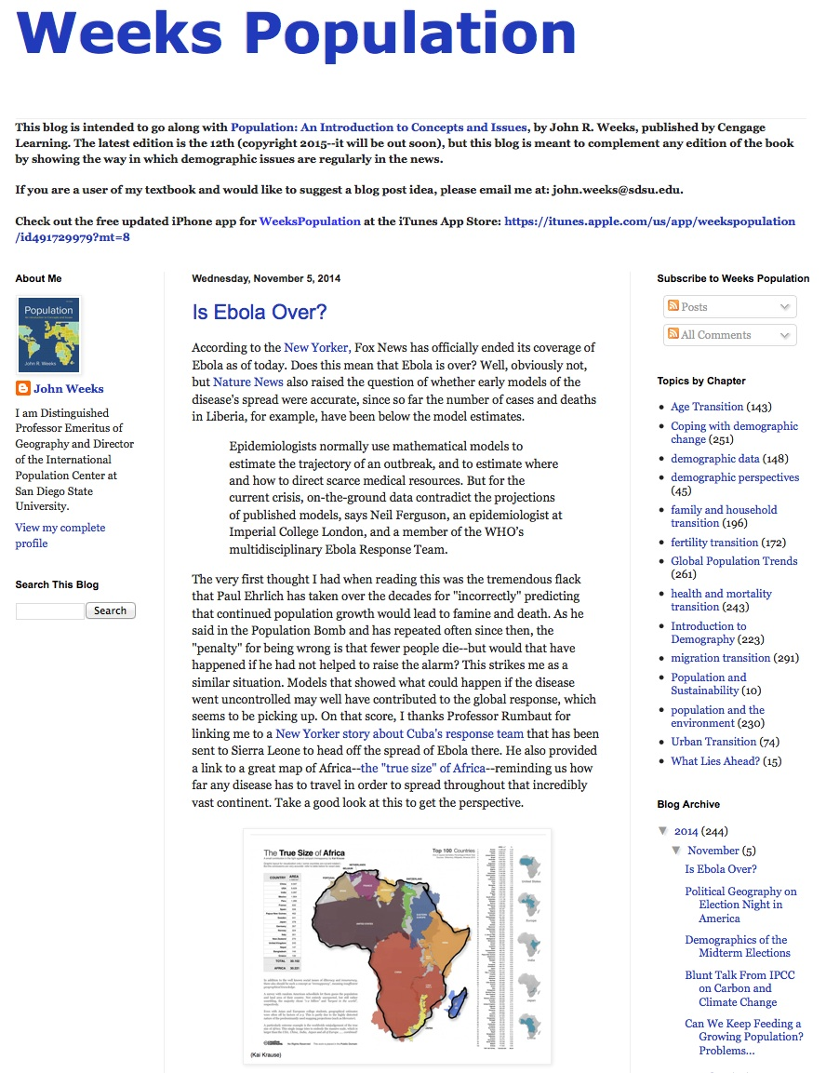Each item posted to the blog is identified according to the chapter(s) to which it most closely relates. By clicking on the labels listed on the right-hand side of the page, you will bring up related posts, which can then be the basis of class discussion and/or essay assignments. You can also search for key words.

The blog can be accessed directly through ***my iPhone app***: [WeeksPopulation](http://itunes.apple.com/app/weekspopulation/id491729979?mt=8) (available on the iTunes store).

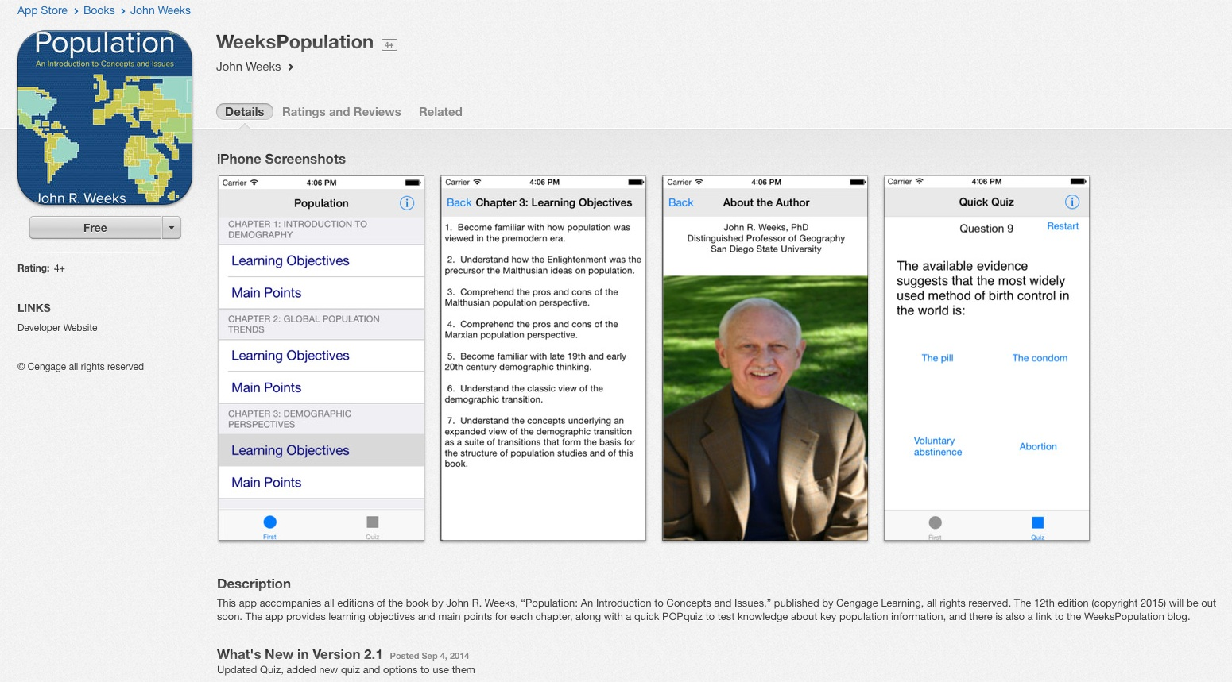

**FEATURES OF THIS MANUAL**

For each of the 12 chapters in the text, I have provided the following:

* ***Learning Objectives*** for the chapter;
* ***Main Points*** from each chapter, as a summary of the chapter contents;
* ***Examination questions***, including 20 multiple-choice and 10 true-false questions per chapter;
* ***Five essay/class discussion questions***, which are drawn from the discussion questions at the end of each chapter; and
* ***A list of the websites*** suggested at the end of each chapter of the text.

In addition, I have provided at the end of the manual a set of two ***term project templates.***

There is also a set of ***PowerPoint slides*** that I have prepared for each chapter that may be downloaded from the publisher’s website, at the same location where you found this Instructor’s Manual. You may also contact me directly at [john.weeks@sdsu.edu](mailto:john.weeks@sdsu.edu) for a copy of the slides.

**ERRATA**

Page 222—Figure 6.5. The correlation coefficient (r) should be a negative value: –.76.**PA R T O N E**

**A D E M O G R A P H I C P E R S P E C T I V E**

**CHAPTER ONE**

**INTRODUCTION TO DEMOGRAPHY**

**LEARNING OBJECTIVES**

1. Understand what the field of demography is all about.
2. Understand why demography is important to study—how it connects the dots.
3. Heighten the awareness of the relationships between population and resources.
4. Comprehend the relationships between population and global events.
5. Understand how demographic information can be used.

**MAIN POINTS**

1. Demography is concerned with everything that influences or can be influenced by population size, growth or decline, processes, spatial distribution, structure, and characteristics.
2. Almost everything in your life has demographic underpinnings that you should understand.
3. Demography is a force in the world that influences every improvement in human well-being that the world has witnessed over the past few hundred years.
4. The past was very different from the present in large part because of demographic changes taking place all over the globe; and the future will be different for the same reasons.
5. The cornerstones of population studies are the processes of mortality (a deadly subject), fertility (a well-conceived topic), and migration (a moving experience).
6. Demographic change demands that societies adjust, thus forcing social change, but different societies will respond differently to these challenges, sometimes for the better, sometimes for the worse.
7. Examples of global issues that have deep and important demographic components include the relationship of population to food, water, and energy resources, as well as housing and infrastructure, and environmental degradation.
8. Population is also connected to social and political dynamics such as regional conflict, often exacerbated by youth bulges, as well as globalization, the need for immigrants created by the phenomenon of “demographic fit” and then the backlash against those immigrants.
9. Changes in the age structure are the most obvious ways in which demography forces societal change and, at the same time, creates business opportunities—exemplified by the idea of “riding the age wave.”
10. A key to all demographic trends in the world is the status of women.

**EXAMINATION QUESTIONS**

**Multiple-Choice** (Choose the single best answer—the page where the answer is found is indicated in parentheses)

1. The modern concept of demography emphasizes the \_\_\_\_\_\_ and \_\_\_\_\_\_ of population change.
   1. causes; consequences (3)
   2. spatial distribution; population structure
   3. processes; characteristics
   4. size; growth
2. “Hatching, matching, and dispatching” is shorthand for the description of
   1. population processes. (3)
   2. population distribution.
   3. population characteristics.
   4. none of the above.
3. Population structure is defined as
   1. how many people there are in a given place.
   2. where people are located and why.
   3. how many males and females there are of each age. (3)
   4. what people are like in a given place.
4. The concept of the past as a foreign country is based on the idea that
   1. there used to be fewer foreigners in the United States than there are now.
   2. the boundaries of the country have changed over the past two hundred years.
   3. the population structure and characteristics have changed over time. (3)
   4. immigrants have dramatically changed the demographics of the United States.
5. Between 1910 and 2010, life expectancy in the United States increased from about \_\_\_\_ to more than 80.
   1. 40
   2. 50 (4)
   3. 60
   4. 70
6. Between 1910 and 2010, the average number of children born to women in the United States declined from\_\_\_\_ to 1.9.
   1. 5.0
   2. 4.5
   3. 4.0
   4. 3.5 (4)
7. Population growth is closely associated with water availability because
   1. people prefer to live near water.
   2. water is required to grow more food .(6)
   3. waterways provide a key source of transportation for people.
   4. a warming planet will reduce the amount of ground water available per person.
8. Population growth alone would not have had such a huge impact on the environment were it not for the accompanying fact that
   1. people have been living longer.
   2. there has been an intensive increase in the use of resources. (7)
   3. the atmospheric conditions have been shifting.
   4. humans have settled in increasingly vulnerable parts of the planet.
9. One of the major demographic forces that is incendiary in the Middle East is
   1. the high maternal mortality rate.
   2. high mortality from violent causes.
   3. refugees leaving the area.
   4. the impact of the youth bulge. (8)
10. The demographic roots of violence in sub-Saharan Africa are related especially to
    1. the high maternal mortality rate.
    2. high mortality from violent causes.
    3. refugees leaving the area.
    4. the impact of the youth bulge. (9)
11. The predominant underlying demographic roots of social unrest in the Middle East and North Africa (MENA) region of the world are especially related to
    1. religious differences within the region that force women to have children.
    2. the debilitating impact of dictatorships that raise the death rate.
    3. population stress on the environment. (10)
    4. increasing numbers of internally displaced persons.
12. As a region, the population of MENA was approximately \_\_\_\_ times greater in 2015 than in 1950.
    1. two
    2. three
    3. four
    4. five (11)
13. Globalization is rooted in demography most clearly as a result of
    1. migration from developing to richer nations.
    2. low-wage labor in rapidly growing developing nations. (6)
    3. the spread of transportation and communication technology.
    4. the global increase in educational levels.
14. The United States accepts more immigrants than any other country in the world, but the country with the highest number of immigrants per person is
    1. Canada. (10)
    2. Australia.
    3. the United Kingdom.
    4. France.
15. Besides Mexico’s proximity to the United States, the migration from Mexico to the United States can be explained best by
    1. the “demographic fit” between the two countries. (14)
    2. the deep poverty in Mexico.
    3. the pervasiveness of drug use in the United States.
    4. insufficient border control.
16. With reference to Europe, the “demographic time bomb” usually refers to
    1. the rapid growth of the Muslim population.
    2. the impact of undocumented immigrants from sub-Saharan Africa.
    3. low fertility leading to the demise of the nuclear family.
    4. the rapid aging of the population. (15)
17. Unlike in the United States, the aging of the population in Japan is not accompanied by a(n)
    1. rise in life expectancy.
    2. drop in fertility.
    3. emptying out of rural villages.
    4. increase in immigration. (15)
18. Population growth and change is most immediately experienced as changes in the ratio of
    1. successive age groups to each other. (16)
    2. immigrants to the native-born.
    3. births to deaths.
    4. women to men.
19. The rise and fall of consumer product sales is closely associated with the ratio of
    1. successive age groups to each other. (18)
    2. immigrants to the native-born.
    3. births to deaths.
    4. women to men.
20. Economic data suggest that a \_\_\_\_\_\_ is good for economic growth.
    1. very youthful population
    2. rapidly aging population
    3. population with a disproportionate share of people of working age (20)
    4. population with a disproportionate share of immigrants

**True-False**

1. The term *demography* has Greek linguistic roots meaning “people” and “study of.” T (3)
2. Between 1910 and 2010 the world’s population increased from 2 to 7 billion. T (3).
3. At the beginning of the twentieth century, the percent of the U.S. population that was foreign born was considerably less than it was at the beginning of the twenty-first century. F (4)
4. The fact that demography is connected to nearly everything means that demography determines nearly everything. F (5)
5. All of the future growth in the world is expected to show up in cities. T (7)
6. A youth bulge inevitably leads to conflict in human populations. F (9)
7. Globalization has been spurred on by the global decline in death rates after World War II. T (9)
8. The crime rate is associated with the age structure because young men are most apt to commit crimes. T (18)
9. Life insurance companies and pension funds both make more money the longer that their customers live. F (19)
10. The oppression of women in a society will likely be associated with an unfavorable demographic profile for that country. T (21)

**ESSAY/CLASS DISCUSSION QUESTIONS**

1. When did you first become aware of demography or population issues more broadly, and what were the things that initially seemed to be important to you?
2. Why is the idea that nearly everything is connected to demography, or the companion idea that demography is destiny, not the same as demographic ­determinism?
3. How do you think the politics of the Middle East and North Africa (MENA) will be influenced in the long term by the changing demographics of the region?
4. Discuss the relative advantages and disadvantages of a youth bulge for a society to deal with.
5. Because globalization has an underlying demographic component, how might that ­affect the investing patterns of someone who uses demography as one of their investment criteria?

**WEBSITES SUGGESTED FOR THIS CHAPTER**

<http://www.census.gov> The website of the U.S. Census Bureau has many useful features, including U.S. and world population information and U.S. and world population clocks (where you can check the latest estimate of the total U.S. and world populations).

<http://www.prb.org> The Population Reference Bureau (PRB) in Washington, D.C., is a world leader in developing and distributing population information. The site includes regularly updated information about PRB’s own activities, as well as links to a wide range of other population-related websites all over the world.

<http://www.un.org/en/development/desa/population/> The Population Division of the United Nations is the single most important producer of global demographic information, which can be accessed at this site. Closely related United Nations data can be accessed through http://data.un.org.

<http://www.poodwaddle.com/clocks/worldclock/> This website keeps track of a wide range of demographic data from various official sources and then produces estimates that are constantly being updated (thus, they are called “clocks”) by extrapolation models.

And, of course, check for the latest items related to this chapter on my blog:

[http://weekspopulation.blogspot.com/search/label/Introduction to Demography](http://weekspopulation.blogspot.com/search/label/Introduction%20to%20Demography)

**OTHER RESOURCES**

To follow up on the theme of “the past is a foreign country,” you might assign some or all of Claude S. Fischer and Michael Hout, ***Century of Difference: How America Changed in the Last One Hundred Years*** (New York: Russell Sage Foundation), 2006.

**CHAPTER TWO**

**GLOBAL POPULATION TRENDS**

**LEARNING OBJECTIVES**

1. Become familiar with the basic historical facts of world population growth.
2. Understand how and why the world’s population is distributed as it is around the globe.
3. Understand the current regional patterns of population size and growth in all parts of the world.
4. Comprehend the major regional demographic contrasts that exist today.

**MAIN POINTS**

1. During the first 90 percent of human existence, the population of the world had grown only to the size of today’s New York City.
2. Between 1750 and 1950, the world’s population mushroomed from 800 million to 2.5 billion, and since 1950 it has expanded to more than 7 billion.
3. Despite the fact that humans have been around for tens of thousands of years, more than 1 in 10 people ever born is currently alive.
4. Early population growth was slow not because birth rates were low but because death rates were high; on the other hand, continuing population increases are due to dramatic declines in mortality without a matching decline in fertility.
5. World population growth has been accompanied by migration from rapidly growing areas into less rapidly growing regions. Initially, that meant an outward expansion of the European population, but more recently it has meant migration from less developed to more developed nations.
6. Migration has also involved the shift of people from rural to urban areas, and urban regions on average are currently growing more rapidly than ever before in history.
7. Although migration is crucial to the demographic history of the United States and Canada, both countries have grown largely as a result of natural increase—the excess of births over deaths—after the migrants arrived.
8. At the time of the American Revolution, fertility levels in North America were among the highest in the world. Now they are low, although not as low as in Europe.
9. The world’s 10 most populous countries are the People’s Republic of China, India, the United States, Indonesia, Brazil, Pakistan, Nigeria, Bangladesh, Russia, and Japan. Together they account for 59 percent of the world’s population.
10. Almost all of the population growth in the world today is occurring in the less developed nations, leading to an increase in the global demographic contrasts among countries.

**EXAMINATION QUESTIONS**

**Multiple-Choice** (Choose the single best answer—the page where the answer is found is indicated in parentheses)

1. The world’s population at the time of the Agricultural (Neolithic) Revolution was approximately
   1. 4 million. (26)
   2. 40 million.
   3. 400 million.
   4. 4 billion.
2. Carrying capacity is lower for hunter-gatherers than for agriculturists because
   1. their death rates are higher.
   2. they use the land extensively rather than intensively. (26)
   3. they have fewer technological skills.
   4. birth rates regularly exceeded death rates.
3. Between the third and fifth centuries A.D. the world’s population declined somewhat, probably due to
   1. the impact of Indonesian volcanic eruptions.
   2. higher mortality brought on by the early days of the Little Ice Age.
   3. the collapse of the Roman Empire and famine and floods in China. (27)
   4. the Irish Potato Famine.
4. Europe’s population began to grow between 1650 and 1850 because of all of the following *except*
   1. the disappearance of the plague.
   2. an increase in the birth rate. (27)
   3. the introduction of the potato from the Americas.
   4. changes in agricultural practices.
5. Two hundred years ago, the world’s population was approximately
   1. 100 million.
   2. 200 million.
   3. 1 billion. (28)
   4. 2 billion.
6. Current projections from the United Nations suggest that we could reach a population of 10 billion by approximately
   1. 2020.
   2. 2040.
   3. 2060. (28)
   4. 2080.
7. The total population of the world is currently increasing by about \_\_\_\_\_ million people per year.
   1. 20
   2. 40
   3. 60
   4. 80 (29)
8. The Persian chess board story illustrates the concept of
   1. the Queen as embodiment of female empowerment.
   2. the power of doubling. (31)
   3. logarithm growth.
   4. carrying capacity.
9. Population growth was slow for most of human history because
   1. death rates were very high. (32)
   2. abortion rates were very high.
   3. people preferred small families.
   4. low levels of technology always lead to low rates of growth.
10. The most important reason for the massive increase in the human population over the past 200 years is
    1. the Green Revolution that increased agricultural productivity.
    2. the increase in the birth rate.
    3. technology that has made it possible for humans to live in more places.
    4. the decline in the death rate. (33)
11. If a country is thought to be on the verge of depopulation, it is probably located in
    1. North America.
    2. Sub-Saharan Africa.
    3. South Asia.
    4. Europe. (34)
12. The total number of people who have ever lived throughout human history is probably about
    1. 10 billion.
    2. 30 billion.
    3. 60 billion. (34)
    4. 90 billion.
13. At the peak of European migratory expansion in approximately 1930, people of European origin accounted for almost \_\_\_ of the world’s population, but it has since dropped to about \_\_\_\_ percent.
    1. 35; 16 (35)
    2. 35; 26
    3. 20; 10
    4. 20; 5
14. The five most populous countries in the world account for about \_\_\_\_ percent of the world’s total population.
    1. 10
    2. 25
    3. 50 (37)
    4. 70
15. The United States is currently the third most populous nation, but UN projections suggest that by 2050 it will be overtaken by
    1. Nigeria. (38)
    2. Indonesia.
    3. Pakistan.
    4. Bangladesh.
16. At about the time of the American Revolution, the United States had a birth rate that was
    1. very similar to the birth rate in England at the time.
    2. already lower than that of any currently developing nation.
    3. higher than birth rates even in Sub-Saharan Africa at that time.
    4. comparable to the highest national birth rates in the world today. (41)
17. Population growth in Mexico was very rapid until recently because of a substantial delay in
    1. its fertility decline. (43)
    2. its mortality decline.
    3. migration out of the country to the United States.
    4. improving agricultural productivity.
18. An important demographic consequence of below-replacement-level fertility in Europe is that
    1. European countries have all been actively recruiting immigrants to fill in the younger ages.
    2. European countries are aging. (44, 46–48)
    3. the status of women has risen dramatically.
    4. taxes have risen sharply in order to pay benefits to the elderly.
19. The most populous predominantly Muslim country in the world is
    1. Egypt.
    2. Saudi Arabia.
    3. Pakistan.
    4. Indonesia. (51)
20. Although Europe is most often pointed to when the discussion turns to low fertility, the other major region of the world with very low fertility is
    1. Latin America.
    2. East Asia. (53)
    3. North America.
    4. South Asia.

**True-False**

1. The Agricultural Revolution beginning 10,000 years ago led to a growth in population. T (26)
2. The United Nations projects that the population of the world will double again over the next 40 years. F (29)
3. Declining mortality, not rising fertility, is the cause of the “population explosion.” T (33)
4. The least developed countries in the world are growing faster than the less developed or more developed nations. T (33)
5. The majority of people ever born are alive at this moment. F (34)
6. Nearly 4 in 10 humans live either in China or on the Indian subcontinent. T (37)
7. India’s demography is so diverse that some of its southern states actually have fertility levels that are below replacement. T (50)
8. The drop in fertility in China is largely a result of its one-child policy. F (53)
9. China may be the first country in demographic history to grow old before it grows rich. T (54)
10. Fertility is so low in Japan that it seems to have its own “one-child policy.” T (62)

**ESSAY/CLASS DISCUSSION QUESTIONS**

1. Describe what you think might be the typical day in the life of a person living in a world where death rates and birth rates are both very high. How might those demographic imperatives influence everyday life? How would “culture” be different from today as a result?
2. The media in the United States and Europe regularly have stories about the impact of low fertility slowing down population growth in these countries. If you were asked to be on a TV talk show commenting on such a story, how would you respond?
3. Migration of people into other countries is a major part of the demography of the modern world. How do you think the world of 2050 will look demographically as a consequence of the trends currently in place?
4. Even without migration, the world will look very different in 2050 than it did in 1950. Analyze Table 2.2 in terms of the idea that “the past is a foreign country.”
5. How would you explain the regional patterns that are very observable with respect to global demography? Are European countries more like each other than they are like Asian countries? Is Africa unique demographically? Are national boundaries therefore meaningless when it comes to population trends?

**WEBSITES SUGGESTED FOR THIS CHAPTER**

<http://www.gapminder.org/videos/dont-panic-the-facts-about-population/> Hans Rosling is a Swedish academic—Professor of International Health at Karolinska Institute in Sweden and co-founder and chairman of the Gapminder Foundation (gapminder.org). In this program prepared for BBC in 2013 he talks about the current world population situation. Check out his other population-related talks because he does a nice job of explaining things visually.

<http://chinadatacenter.org> Although not an official government website, there is a great deal of useful demographic information about China available at the University of Michigan’s China Data Center.

<http://censusindia.gov.in> You don’t have to take anybody else’s word for what’s happening demographically in India. This Indian census website is in English and has lots of data for the country and its regions.

<http://sedac.ciesin.columbia.edu/data/collection/gpw-v3> The Gridded Population of the World is a database created from censuses, surveys, satellite imagery, and other sources, producing a very realistic picture of population density and other characteristics at the global level. Regional maps and data are also available at this website.

<http://www.ornl.gov/sci/landscan/>LandScan is another globally gridded set of population data, designed at the Oak Ridge National Laboratory for the U.S. government as a way of evaluating the population anywhere in the world at risk of potential disasters.

<http://www.worldpop.org.uk> The WorldPop project was initiated in October 2013 to combine the AfriPop, AsiaPop, and AmeriPop population mapping projects. It aims to provide an open-access archive of spatial demographic datasets for Central and South America, Africa, and Asia to support development and health applications. The methods used are designed with full open access and operational application in mind, using transparent, fully documented and shareable methods to produce easily updatable maps with accompanying metadata.

And, of course, look for the latest items related to this chapter posted on my blog:

[http://weekspopulation.blogspot.com/search/label/Global Population Trends](http://weekspopulation.blogspot.com/search/label/Global%20Population%20Trends)

**OTHER RESOURCES**

For the past few years, I have routinely shown the video “World in the Balance—The Population Paradox” during the first or second week of class. It was produced in 2004 as part of the NOVA series on Public Television. Global demographics change slowly enough that the basic ideas are still very current, and students appreciate the visuals. It is available at <http://www.pbs.org/wgbh/nova/worldbalance/>.