***Organic Chemistry, 4e* (Klein)**

**Chapter 2 Molecular Representations**

1) What is the molecular formula for the following compound?

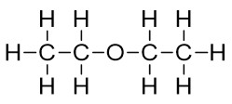

A) C2H6O

B) C4H6O

C) C4H10O

D) C2H4O

E) None of these

Answer: C

Diff: 1

Learning Objective: 2.1 Convert molecular representations from one drawing style to another, including Lewis structures, partially condensed structures, condensed structures, and molecular formulas

2) Which of the following compounds have a molecular formula of C2H6O?

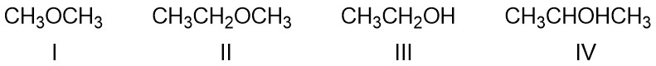

A) I

B) II

C) III

D) IV

E) Both I and III

Answer: E

Diff: 1

Learning Objective: 2.1 Convert molecular representations from one drawing style to another, including Lewis structures, partially condensed structures, condensed structures, and molecular formulas

3) Which of the following is the correct condensed structure for the following compound?

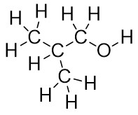

A) CH3CHCH3CH2OH

B) CH3CH2CH2OH

C) (CH3)2CHCH2OH

D) CH3CH2CH2OCH3

E) CH3CH3CHCH2OH

Answer: C

Diff: 1

Learning Objective: 2.1 Convert molecular representations from one drawing style to another, including Lewis structures, partially condensed structures, condensed structures, and molecular formulas

4) Which of the following is the correct condensed structure for the following compound?

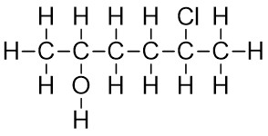

A) CH3CHOHCH2CHClCH3

B) CH3CH(OH)CH2CH2CHClCH3

C) (CH3)2CHOHCH2CH2Cl

D) HOCH3CHCH2CH2CH3CHCl

E) CH3C2H4CH3OHCl

Answer: B

Diff: 1

Learning Objective: 2.1 Convert molecular representations from one drawing style to another, including Lewis structures, partially condensed structures, condensed structures, and molecular formulas

5) Which of the following is the correct condensed structure for the following compound?

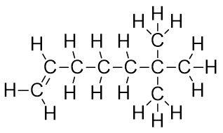

A) CH2=CH(CH2)3C(CH3)3

B) CH2=(CH2)4C(CH3)3

C) (CH3)2CH(CH2)4CH3

D) CH2=C(CH2)3(CCH3)3

E) (CH)3(CH2)3C(CH3)3

Answer: A

Diff: 2

Learning Objective: 2.1 Convert molecular representations from one drawing style to another, including Lewis structures, partially condensed structures, condensed structures, and molecular formulas

6) Which of the following is the correct condensed structure for the following compound?

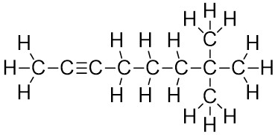

A) HC≡C(CH2)3C(CH3)3

B) HC≡C(CH2)3C(CH3CH3CH3)

C) (CH3)3C2(CH2)3CH3

D) CH3C≡C(CH2)3C(CH3)3

E) CH3C≡C((CH2)C(CH3))3

Answer: D

Diff: 2

Learning Objective: 2.1 Convert molecular representations from one drawing style to another, including Lewis structures, partially condensed structures, condensed structures, and molecular formulas

7) Which of the following is the correct condensed structure for the following compound?

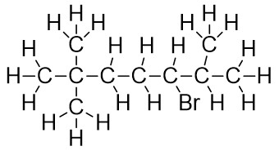

A) CH3C(CH3)2(CH2)2(CH)BrC(CH3)2

B) CH3CH3CH3C(CH2)2C(CH3)2CHBr

C) (CH3)3C(CH2)3BrCHCH3CH3

D) CH3CH3CH3C(CH2)2CHBrCHCH3CH3

E) (CH3)3C(CH2)2CHBrCH(CH3)2

Answer: E

Diff: 2

Learning Objective: 2.1 Convert molecular representations from one drawing style to another, including Lewis structures, partially condensed structures, condensed structures, and molecular formulas

8) What is the molecular formula for the following compound?

The bond-line structure of a compound has a SMILES string of 
CCOCC. 

A) C2H6O

B) C4H6O

C) C4H10O

D) C2H4O

E) C2H5O

Answer: C

Diff: 1

Learning Objective: 2.1 Convert molecular representations from one drawing style to another, including Lewis structures, partially condensed structures, condensed structures, and molecular formulas

9) Which of the following compounds have a molecular formula of C2H6O?

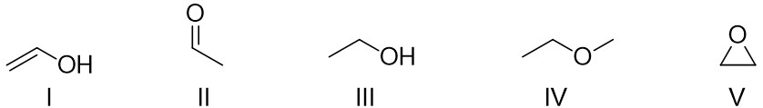

A) I

B) II

C) III

D) IV

E) V

Answer: C

Diff: 1

Learning Objective: 2.1 Convert molecular representations from one drawing style to another, including Lewis structures, partially condensed structures, condensed structures, and molecular formulas

10) Which of the following is the correct molecular formula for (CH3CH2)4C?

A) C8H20

B) C5H20

C) C9H20

D) C6H5

E) C3H20

Answer: C

Diff: 1

Learning Objective: 2.1 Convert molecular representations from one drawing style to another, including Lewis structures, partially condensed structures, condensed structures, and molecular formulas

11) Which of the following is the correct Lewis structure for CH3(CH2)2NH2?

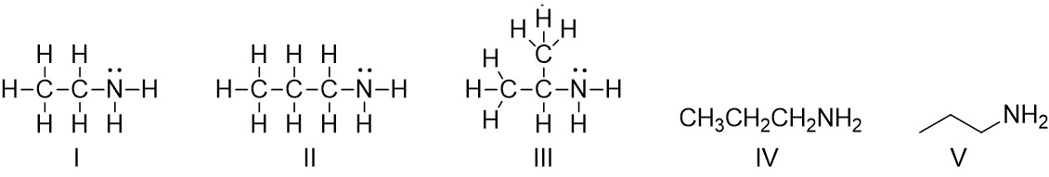

A) I

B) II

C) III

D) IV

E) V

Answer: B

Diff: 1

Learning Objective: 2.1 Convert molecular representations from one drawing style to another, including Lewis structures, partially condensed structures, condensed structures, and molecular formulas

12) Which of the following is the correct Lewis structure for CH3(CH2)2OH?

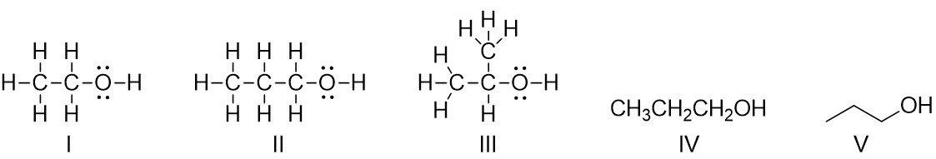

A) I

B) II

C) III

D) IV

E) V

Answer: B

Diff: 1

Learning Objective: 2.1 Convert molecular representations from one drawing style to another, including Lewis structures, partially condensed structures, condensed structures, and molecular formulas

13) Which of the following is the correct Lewis structure for (CH3)2CHCH2OH?

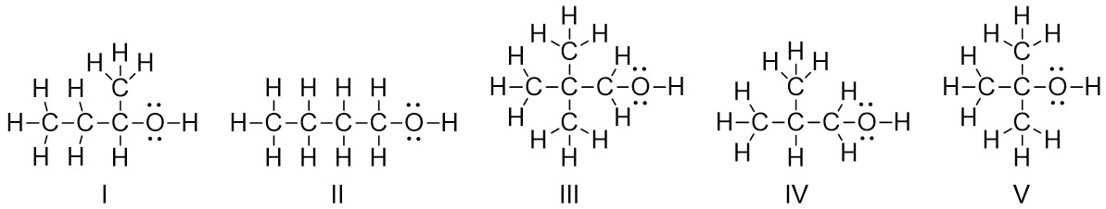

A) I

B) II

C) III

D) IV

E) V

Answer: D

Diff: 1

Learning Objective: 2.1 Convert molecular representations from one drawing style to another, including Lewis structures, partially condensed structures, condensed structures, and molecular formulas

14) Which of the following is the correct Lewis structure for (CH3)3C(CH2)2NHCH3?

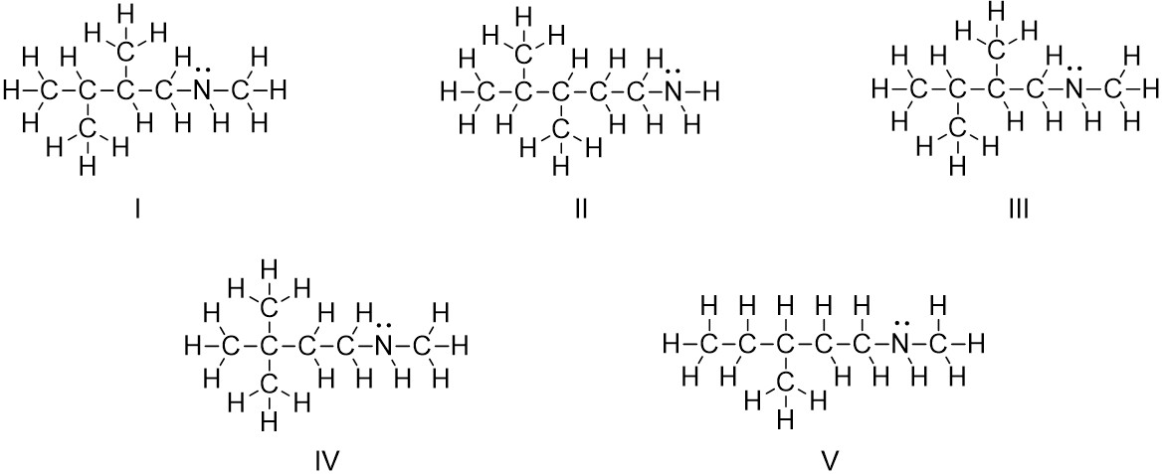

A) I

B) II

C) III

D) IV

E) V

Answer: D

Diff: 2

Learning Objective: 2.1 Convert molecular representations from one drawing style to another, including Lewis structures, partially condensed structures, condensed structures, and molecular formulas

15) Which of the following is the correct Lewis structure for CH3C≡C(CH2)3C(CH3)3?

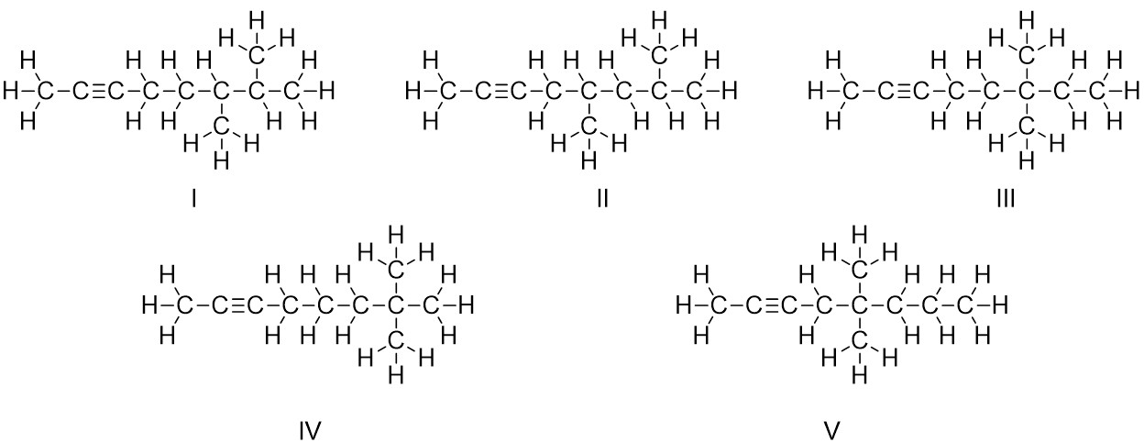

A) I

B) II

C) III

D) IV

E) V

Answer: D

Diff: 2

Learning Objective: 2.1 Convert molecular representations from one drawing style to another, including Lewis structures, partially condensed structures, condensed structures, and molecular formulas

16) Which of the following is the correct Lewis structure for (CH3)3C(CH2)2OCH(CH2CH3)2?

The Lewis structure of the first molecule has a four-carbon chain, in which C 1 is bonded to an oxygen atom and two hydrogen atoms, C 2 is bonded to two hydrogen atoms, C 3 is bonded to two methyl groups, and C 4 is bonded to three hydrogen atoms. The oxygen atom is further bonded to C 2 carbon atom of a four-carbon chain. In the four-carbon chain, C 1 and C 4 carbon atoms are each bonded to three hydrogen atoms, C 2 is bonded to a methyl group, and C 3 is bonded to two hydrogen atoms. The Lewis structure of the second molecule has a four-carbon chain, in which C 1 is bonded to an oxygen atom and two hydrogen atoms, C 2 and C 3 carbon atoms are each bonded to a hydrogen atom and a methyl group, and C 4 is bonded to three hydrogen atoms. The oxygen atom is further bonded to C 3 carbon atom of a five-carbon chain. In the five-carbon chain, C 1 and C 5 carbon atoms are each bonded to three hydrogen atoms, C 2 and C 4 is bonded to two hydrogen atoms, and C 3 is also bonded to a hydrogen atom. The Lewis structure of the third molecule has a four-carbon chain, in which C 1 is bonded to an oxygen atom and two hydrogen atoms, C 2 is bonded to a hydrogen atom and C 1 carbon atom of an ethyl group, C 3 is bonded to a hydrogen atom and a methyl group, and C 4 is bonded to three hydrogen atoms. The oxygen atom is further bonded to C 2 carbon atom of a four-carbon chain. In the four-carbon chain, C 1 and C 4 carbon atoms are each bonded to three hydrogen atoms, C 2 is bonded to a hydrogen atom, and C 3 is bonded to two hydrogen atoms. The Lewis structure of the fourth molecule has a four-carbon chain, in which C 1 is bonded to an oxygen atom and two hydrogen atoms, C 2 is bonded to two hydrogen atoms, C 3 carbon atoms is bonded to two methyl groups, and C 4 is bonded to three hydrogen atoms. The oxygen atom is further bonded to C 3 carbon atom of a five-carbon chain. In the five-carbon chain, C 1 and C 5 carbon atoms are each bonded to three hydrogen atoms, C 2 and C 4 is bonded to two hydrogen atoms, and C 3 is also bonded to a hydrogen atom. The Lewis structure of the fifth molecule has a three-carbon chain, in which C 2 is bonded to an oxygen atom and a methyl group and C 1 and C 3 carbon atoms are each bonded to three hydrogen atoms. The oxygen atom is further bonded to C 3 carbon atom of a five-carbon chain. In the five-carbon chain, C 1 and C 5 carbon atoms are each bonded to three hydrogen atoms, C 2, and C 4 is bonded to two hydrogen atoms, and C 3 is also bonded to a hydrogen atom.

A) I

B) II

C) III

D) IV

E) V

Answer: D

Diff: 2

Learning Objective: 2.1 Convert molecular representations from one drawing style to another, including Lewis structures, partially condensed structures, condensed structures, and molecular formulas

17) Identify the partially condensed structure for the molecule shown in the box below.

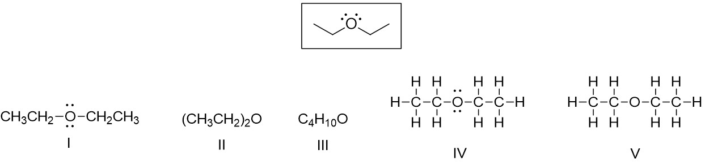

A) I

B) II

C) III

D) IV

E) V

Answer: A

Diff: 1

Learning Objective: 2.1 Convert molecular representations from one drawing style to another, including Lewis structures, partially condensed structures, condensed structures, and molecular formulas

18) Which of the following is the correct condensed structure for the following compound?

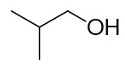

A) CH3CHCH3CH2OH

B) CH3CH2CH2OH

C) (CH3)2CHCH2OH

D) CH3CH2CH2OCH3

E) CH3CH3CHCH2OH

Answer: C

Diff: 1

Learning Objective: 2.1 Convert molecular representations from one drawing style to another, including Lewis structures, partially condensed structures, condensed structures, and molecular formulas

19) Which of the following is the correct condensed structure for the following compound?

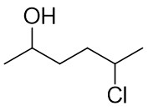

A) CH3CHOHCH2CHClCH3

B) CH3CHOH(CH2)2CHClCH3

C) (CH3)2CHOHCH2CH2Cl

D) HOCH3CHCH2CH2CH3CHCl

E) CH3C2H4CH3OHCl

Answer: B

Diff: 1

Learning Objective: 2.1 Convert molecular representations from one drawing style to another, including Lewis structures, partially condensed structures, condensed structures, and molecular formulas

20) Which of the following is the correct condensed structure for the following compound?

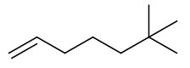

A) CH2=CH(CH2)3C(CH3)3

B) CH=(CH2)4C(CH3)3

C) (CH3)2CH(CH2)4CH3

D) CH2=C(CH2)3(CCH3)3

E) (CH)3(CH2)3C(CH3)3

Answer: A

Diff: 2

Learning Objective: 2.1 Convert molecular representations from one drawing style to another, including Lewis structures, partially condensed structures, condensed structures, and molecular formulas

21) Which of the following is the correct condensed structure for the following compound?

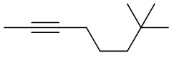

A) HC≡C(CH2)3C(CH3)3

B) HCC(CH2)3C(CH3CH3CH3)

C) (CH3)3C2(CH2)3CH3

D) CH3C≡C(CH2)3C(CH3)3

E) CH3CC(CH2)C(CH3)3

Answer: D

Diff: 2

Learning Objective: 2.1 Convert molecular representations from one drawing style to another, including Lewis structures, partially condensed structures, condensed structures, and molecular formulas

22) Which of the following is the correct condensed structure for the following compound?

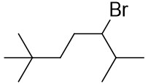

A) CH3C(CH3)2(CH2)2(CH)BrC(CH3)2

B) CH3CH3CH3C(CH2)2C(CH3)2CHBr

C) (CH3)3C(CH2)3BrCHCH3CH3

D) CH3CH3CH3C(CH2)2CHBrCHCH3CH3

E) (CH3)3C(CH2)2CHBrCH(CH3)2

Answer: E

Diff: 2

Learning Objective: 2.1 Convert molecular representations from one drawing style to another, including Lewis structures, partially condensed structures, condensed structures, and molecular formulas

23) Which of the following is the correct condensed structure for the following compound?

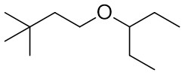

A) CH3CH3CH3CCH2CH2OCHCH2CH3CH2CH3

B) (CH3)3(CH2)2OC(CH2CH3)2

C) (CH3)3CCH2OCHCH2CH3

D) (CH3)3C(CH2)2OCH(CH2CH3)2

E) (CH3)3(CCH2)2O(CHCH2CH3)2

Answer: D

Diff: 2

Learning Objective: 2.1 Convert molecular representations from one drawing style to another, including Lewis structures, partially condensed structures, condensed structures, and molecular formulas

24) Which of the following is the correct condensed structure for the following compound?

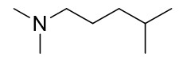

A) (CH3)2N(CH2)3CH(CH3)2

B) CH3CH2NCH2CH(CH3)2

C) N(CH3)2CH(CH2)3(CH3)2

D) CH3CH3NCH23CHCH3CH3

E) (CH3)2(NCH2)3(CHCH3)2

Answer: A

Diff: 2

Learning Objective: 2.1 Convert molecular representations from one drawing style to another, including Lewis structures, partially condensed structures, condensed structures, and molecular formulas

25) Tamiflu®, the most effective antiviral drug used to treat avian influenza, has the following structure. Identify the functional groups in Tamiflu®.

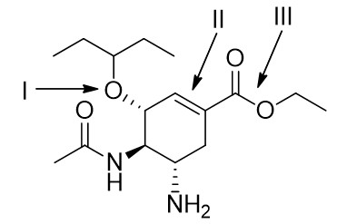

A) I = ester; II = aromatic; III = carboxylic acid

B) I = ether; II = aromatic; III = anhydride

C) I = ether; II = alkene; III = ether

D) I = alcohol; II = alkyne; III = carboxylic acid

E) I = ether; II = alkene; III = ester

Answer: E

Diff: 2

Learning Objective: 2.3 Identify and draw the functional groups

26) Aspartame, an artificial sweetener used in Equal® and diet beverages, has the following structure. Identify the functional groups in Aspartame.

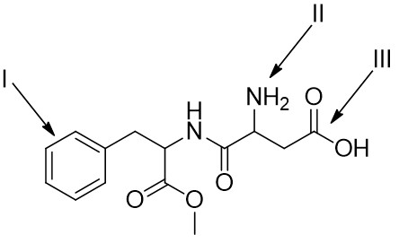

A) I = aromatic; II = amine; III = carboxylic acid

B) I = alkene; II = amide; III = alcohol

C) I = aromatic; II = amine; III = ester

D) I = alkene; II = amine; III = anhydride

E) I = aromatic; II = amide; III = carboxylic acid

Answer: A

Diff: 2

Learning Objective: 2.3 Identify and draw the functional groups

27) How many hydrogen atoms are connected to the indicated carbon atom?

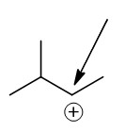

A) one

B) two

C) three

D) four

E) none

Answer: A

Diff: 1

Learning Objective: 2.4 Identify formal charges on carbon

28) How many hydrogen atoms are connected to the indicated carbon atom?

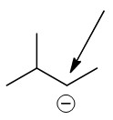

A) one

B) two

C) three

D) four

E) none

Answer: A

Diff: 1

Learning Objective: 2.4 Identify formal charges on carbon

29) Which of the following structures have -1 as a formal charge on an oxygen atom?

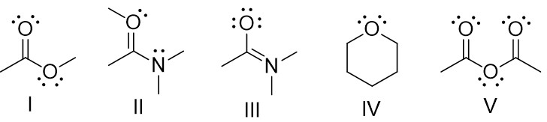

A) I

B) II

C) III

D) IV

E) V

Answer: C

Diff: 2

Learning Objective: 2.5 Describe the relationship between the number of bonds, the number of lone pairs, and formal charge for oxygen and nitrogen atoms

30) Which of the following structures have -1 as a formal charge on the nitrogen atom?

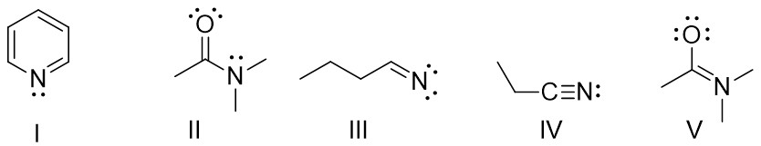

A) I

B) II

C) III

D) IV

E) V

Answer: C

Diff: 2

Learning Objective: 2.5 Describe the relationship between the number of bonds, the number of lone pairs, and formal charge for oxygen and nitrogen atoms

31) How many lone pairs of electrons are found on the indicated atom?

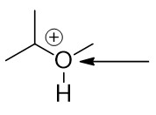

A) one

B) two

C) three

D) four

E) none

Answer: A

Diff: 1

Learning Objective: 2.5 Describe the relationship between the number of bonds, the number of lone pairs, and formal charge for oxygen and nitrogen atoms

32) Which of the following is the correct bond-line structure for (CH3)4C?

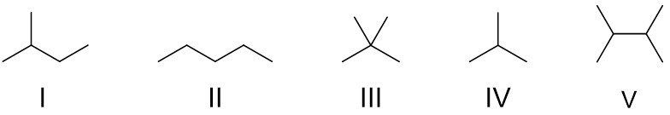

A) I

B) II

C) III

D) IV

E) V

Answer: C

Diff: 1

Learning Objective: 2.2 Demonstrate how to read and draw bond-line structures through converting other styles of molecular representation into bond-line structures and vice versa

33) Which of the following is the correct bond-line structure for (CH3)2CHCH2CH3?

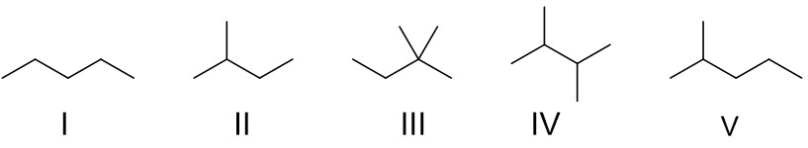

A) I

B) II

C) III

D) IV

E) V

Answer: B

Diff: 1

Learning Objective: 2.2 Demonstrate how to read and draw bond-line structures through converting other styles of molecular representation into bond-line structures and vice versa

34) Which of the following is the correct bond-line structure for (CH3)2CHCH2C(CH3)3?

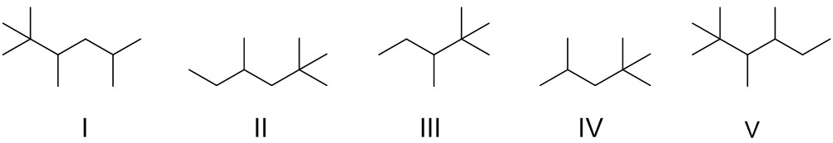

A) I

B) II

C) III

D) IV

E) V

Answer: D

Diff: 2

Learning Objective: 2.2 Demonstrate how to read and draw bond-line structures through converting other styles of molecular representation into bond-line structures and vice versa

35) Which of the following is the correct bond-line structure for CH3C≡C(CH2)2CH(CH3)2?

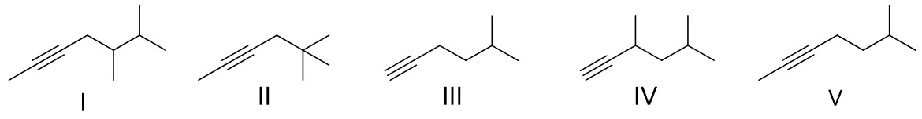

A) I

B) II

C) III

D) IV

E) V

Answer: E

Diff: 2

Learning Objective: 2.2 Demonstrate how to read and draw bond-line structures through converting other styles of molecular representation into bond-line structures and vice versa

36) Which of the following is the correct bond-line structure for CH3CHOH(CH2)2CH(CH2CH3)2?

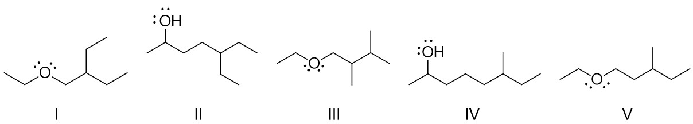

A) I

B) II

C) III

D) IV

E) V

Answer: B

Diff: 2

Learning Objective: 2.2 Demonstrate how to read and draw bond-line structures through converting other styles of molecular representation into bond-line structures and vice versa

37) Which of the following is the correct bond-line structure for CH3CH2O(CH2)2CH(CH3)2?

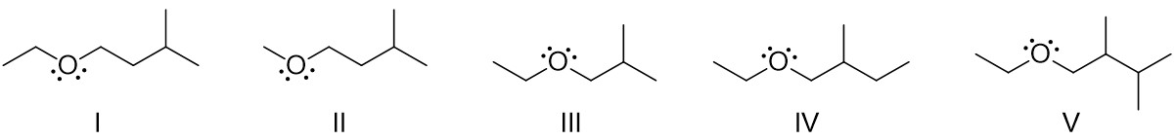

A) I

B) II

C) III

D) IV

E) V

Answer: A

Diff: 2

Learning Objective: 2.2 Demonstrate how to read and draw bond-line structures through converting other styles of molecular representation into bond-line structures and vice versa

38) Which of the following is the correct bond-line structure for (CH3)2N(CH2)3CH(CH3)2?

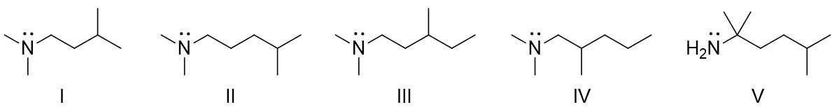

A) I

B) II

C) III

D) IV

E) V

Answer: B

Diff: 2

Learning Objective: 2.2 Demonstrate how to read and draw bond-line structures through converting other styles of molecular representation into bond-line structures and vice versa

39) Which of the following is the correct bond-line structure for CH3C≡C(CH2)3C(CH3)2CH2OCH3?

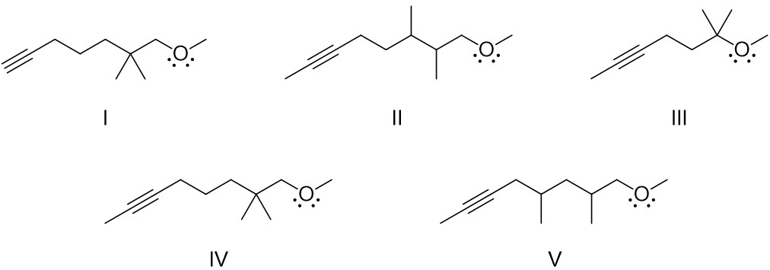

A) I

B) II

C) III

D) IV

E) V

Answer: D

Diff: 2

Learning Objective: 2.2 Demonstrate how to read and draw bond-line structures through converting other styles of molecular representation into bond-line structures and vice versa

40) Identify bond-line structures for constitutional isomers with a molecular formula of C2H4O.

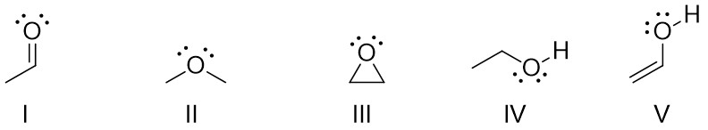

A) I and V

B) II and IV

C) I, III, and V

D) II, III, and IV

E) IV and V

Answer: C

Diff: 2

Learning Objective: 2.2 Demonstrate how to read and draw bond-line structures through converting other styles of molecular representation into bond-line structures and vice versa

41) Identify bond-line structures for constitutional isomers with a molecular formula of C3H8O.

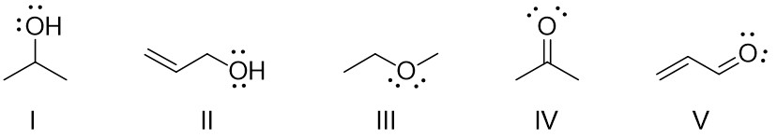

A) I and II

B) I and III

C) II, IV, and V

D) II and IV

E) I and IV

Answer: B

Diff: 2

Learning Objective: 2.2 Demonstrate how to read and draw bond-line structures through converting other styles of molecular representation into bond-line structures and vice versa

42) Which of the following is the correct condensed structure for the following compound?

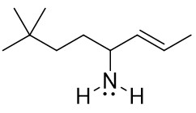

A) CH3CH3CH3C(CH2)2CH(NH2)CH=CHCH3

B) (CH3)3C(CH2)2CH(NH2)CH=CHCH3

C) (CH3)3CCH2CH(NH2)CH=CHCH3

D) (CH3)3CCH2CHN(H)2(CH)2CH3

E) (CH3C)3(CH2)2CHNH2(CH)2CH3

Answer: B

Diff: 2

Learning Objective: 2.2 Demonstrate how to read and draw bond-line structures through converting other styles of molecular representation into bond-line structures and vice versa

43) Identify bond-line structures for constitutional isomers with a molecular formula of C4H10O.

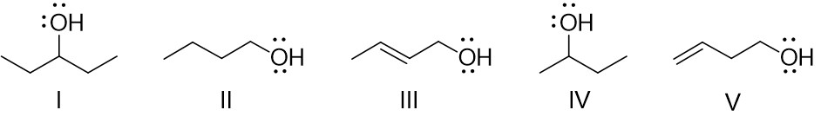

A) I and II

B) II and III

C) III and IV

D) IV and V

E) II and IV

Answer: E

Diff: 2

Learning Objective: 2.2 Demonstrate how to read and draw bond-line structures through converting other styles of molecular representation into bond-line structures and vice versa

44) Identify bond-line structures for constitutional isomers with a molecular formula of C4H11N.

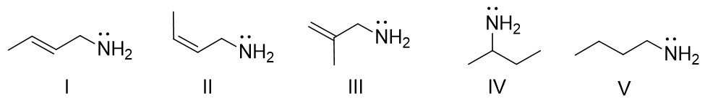

A) I and II

B) II and III

C) III and IV

D) IV and V

E) II and IV

Answer: D

Diff: 2

Learning Objective: 2.2 Demonstrate how to read and draw bond-line structures through converting other styles of molecular representation into bond-line structures and vice versa

45) For the following compound identify the indicated lone pairs as localized or delocalized.

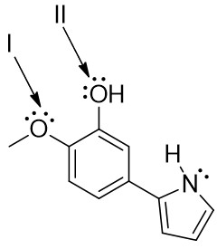

A) I = both localized; II = both localized

B) I = both localized; II = one localized and one delocalized

C) I = one localized and one delocalized; II = both localized

D) I = one localized and one delocalized; II = one localized and one delocalized

E) I = both delocalized; II = both delocalized

Answer: D

Diff: 2

Learning Objective: 2.13 Distinguish between delocalized and localized lone pairs and describe how delocalized lone pairs participate in resonance and why localized lone pairs do not participate in resonance

46) For the following compound identify the indicated lone pairs as localized or delocalized.

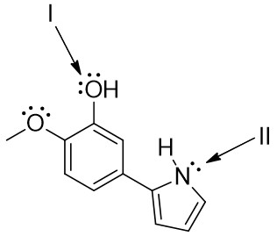

A) I = both delocalized; II = localized

B) I = both localized; II = localized

C) I = both delocalized; II = delocalized

D) I = one localized and one delocalized; II = localized

E) I = one localized and one delocalized; II = delocalized

Answer: E

Diff: 2

Learning Objective: 2.13 Distinguish between delocalized and localized lone pairs and describe how delocalized lone pairs participate in resonance and why localized lone pairs do not participate in resonance

47) For the following compound, what is the hybridization and molecular geometry at the indicated atoms.

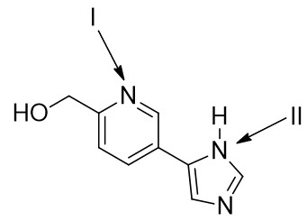

A) I = *sp*2, bent; II = *sp*2, trigonal pyramidal

B) I = *sp*2, bent; II = *sp*2, trigonal planar

C) I = *sp*2, linear; II = *sp*2, trigonal pyramidal

D) I = *sp*, linear; II = *sp*2, trigonal planar

E) I = *sp*2, trigonal planar; II = *sp*2, trigonal planar

Answer: B

Diff: 3

Learning Objective: 2.13 Distinguish between delocalized and localized lone pairs and describe how delocalized lone pairs participate in resonance and why localized lone pairs do not participate in resonance

48) Which of the following compounds contain an alcohol functional group?

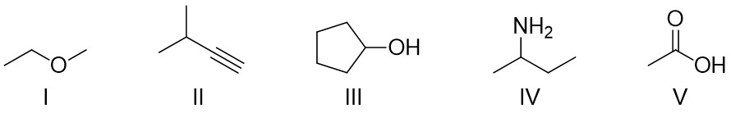

A) I

B) II

C) III

D) IV

E) V

Answer: C

Diff: 1

Learning Objective: 2.3 Identify and draw the functional groups

49) Which of the following compounds contain an alkene functional group?

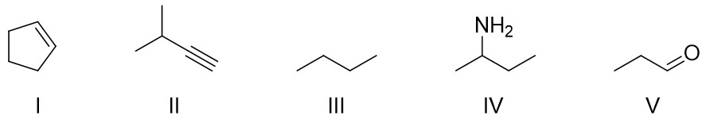

A) I

B) II

C) III

D) IV

E) V

Answer: A

Diff: 1

Learning Objective: 2.3 Identify and draw the functional groups

50) Which of the following compounds contain an amine functional group?

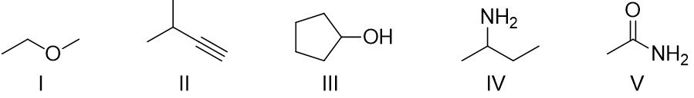

A) I

B) II

C) III

D) IV

E) V

Answer: D

Diff: 1

Learning Objective: 2.3 Identify and draw the functional groups

51) Which of the following compounds contain a ketone functional group?

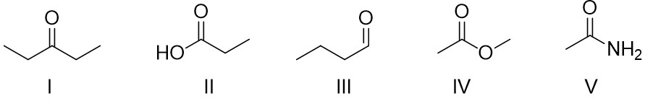

A) I

B) II

C) III

D) IV

E) V

Answer: A

Diff: 1

Learning Objective: 2.3 Identify and draw the functional groups

52) Which of the following compounds contain an aromatic ring?

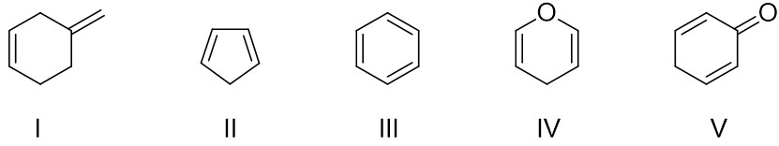

A) I

B) II

C) III

D) IV

E) V

Answer: C

Diff: 1

Learning Objective: 2.3 Identify and draw the functional groups

53) Which of the following compounds contain an ester functional group?

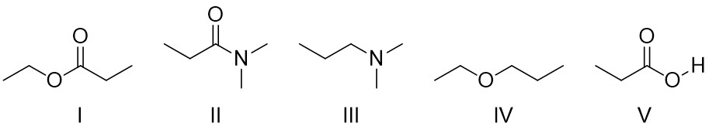

A) I

B) II

C) III

D) IV

E) V

Answer: A

Diff: 1

Learning Objective: 2.3 Identify and draw the functional groups

54) Which of the following compounds contain an amide functional group?

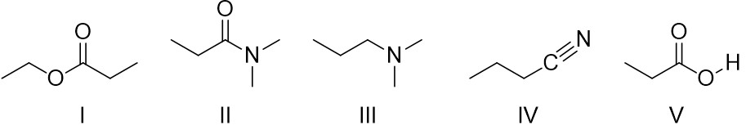

A) I

B) II

C) III

D) IV

E) V

Answer: B

Diff: 1

Learning Objective: 2.3 Identify and draw the functional groups

55) Which of the following compounds contain an anhydride functional group?

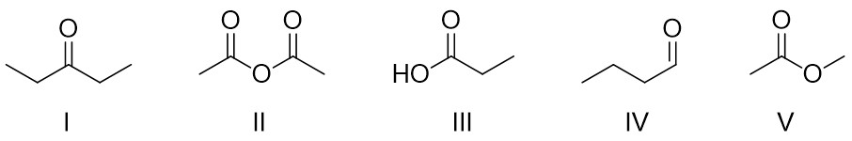

A) I

B) II

C) III

D) IV

E) V

Answer: B

Diff: 1

Learning Objective: 2.3 Identify and draw the functional groups

56) Which of the following compounds contain an alkyne functional group?

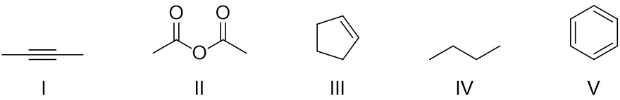

A) I

B) II

C) III

D) IV

E) V

Answer: A

Diff: 1

Learning Objective: 2.3 Identify and draw the functional groups

57) Which of the following compounds contain a thiol functional group?

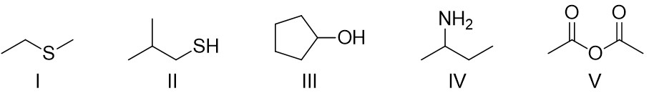

A) I

B) II

C) III

D) IV

E) V

Answer: B

Diff: 1

Learning Objective: 2.3 Identify and draw the functional groups

58) Which of the following compounds contain an alkyl halide functional group?

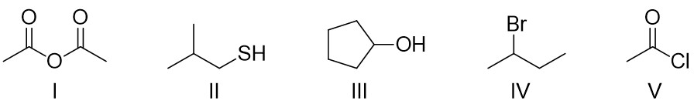

A) I

B) II

C) III

D) IV

E) V

Answer: D

Diff: 1

Learning Objective: 2.3 Identify and draw the functional groups

59) What functional groups are present in the following compound?

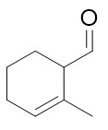

A) ketone and alkene

B) ketone and alkyne

C) aldehyde and alkene

D) aldehyde and alkyne

E) ester and alkene

Answer: C

Diff: 2

Learning Objective: 2.3 Identify and draw the functional groups

60) Which of the following compounds have both ketone and ester functional groups?

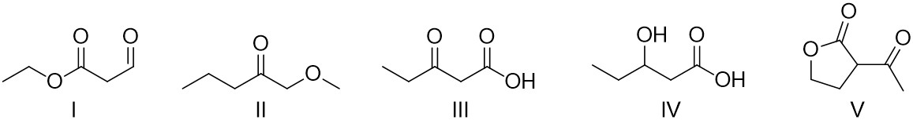

A) I

B) II

C) III

D) IV

E) V

Answer: E

Diff: 2

Learning Objective: 2.3 Identify and draw the functional groups

61) Norethynodrel, a component of the first combined oral contraceptive, has the following structure. Identify the indicated functional groups in Norethynodrel.

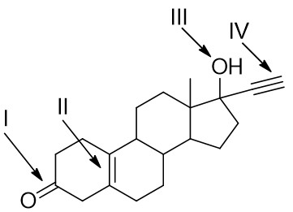

A) I = aldehyde; II = alkyne; III = alcohol; IV = alkene

B) I = ketone; II = alkene; III = alcohol; IV = alkyne

C) I = ketone; II = aromatic; III = alcohol; IV = alkyne

D) I = anhydride; II = alkene;III = carboxylic acid; IV = alkene

E) I = ester; II = alkene; III = alcohol; IV = alkyne

Answer: B

Diff: 2

Learning Objective: 2.3 Identify and draw the functional groups

62) Identify the indicated functional groups in the following compound.

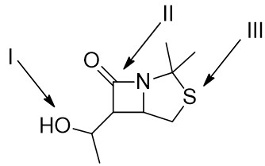

A) I = alcohol; II = amine; III = thiol

B) I = ester; II = ketone; III = thiol

C) I = alcohol; II = amide; III = sulfide

D) I = ether; II = amide; III = thiol

E) I = alcohol; II = aldehyde; III = sulfide

Answer: C

Diff: 2

Learning Objective: 2.3 Identify and draw the functional groups

63) Tamiflu®, the most effective antiviral drug used to treat avian influenza, has the following structure. Identify the indicated functional groups in Tamiflu®.

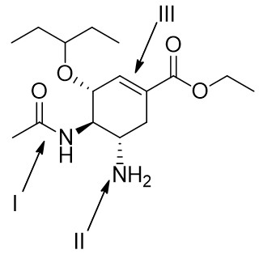

A) I = ketone; II = amine; III = alkene

B) I = ester; II = amide; III = alkyne

C) I = amine; II = amide; III = alkene

D) I = amide; II = amine; III = alkene

E) I = amine; II = amine; III = aromatic

Answer: D

Diff: 2

Learning Objective: 2.3 Identify and draw the functional groups

64) Aspartame, an artificial sweetener used in Equal® and diet beverages, has the following structure. Identify the indicated functional groups in Aspartame.

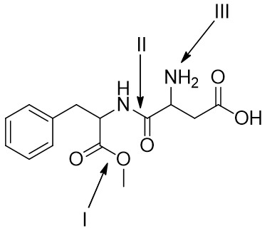

A) I = ester; II = amide; III = amine

B) I = ester; II = amine; III = amide

C) I = ether; II = amide; III = amine

D) I = ether; II = amine; III = amide

E) I = anhydride; II = ketone; III = amine

Answer: A

Diff: 2

Learning Objective: 2.3 Identify and draw the functional groups

65) For the following compound, identify the hybridization and molecular geometry at the indicated atoms.

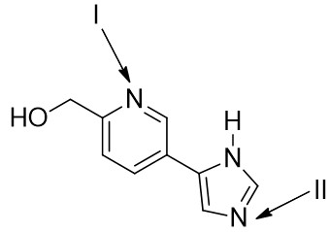

A) I = *sp*2, bent; II = *sp*2, trigonal pyramidal

B) I = *sp*2, linear; II = *sp*2, bent

C) I = *sp*2, bent; II = *sp*2, bent

D) I = *sp*, trigonal planar; II = *sp*, trigonal planar

E) I = *sp*, linear; II = *sp*, linear

Answer: C

Diff: 3

Learning Objective: 2.13 Distinguish between delocalized and localized lone pairs and describe how delocalized lone pairs participate in resonance and why localized lone pairs do not participate in resonance

66) Caffeine has the following structure. Identify the hybridization and molecular geometry at the indicated atoms.

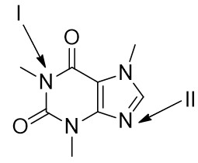

A) I = *sp*3, trigonal pyramidal; II = *sp*2, trigonal planar

B) I = *sp*3, trigonal planar; II = *sp*2, bent

C) I = *sp*2, trigonal pyramidal; II = *sp*, linear

D) I = *sp*2, trigonal planar; II = *sp*2, bent

E) I = *sp*3, trigonal pyramidal; II = *sp*2, bent

Answer: D

Diff: 3

Learning Objective: 2.13 Distinguish between delocalized and localized lone pairs and describe how delocalized lone pairs participate in resonance and why localized lone pairs do not participate in resonance

67) How many hydrogen atoms are connected to the indicated carbon atom?

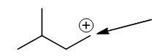

A) one

B) two

C) three

D) four

E) none

Answer: B

Diff: 1

Learning Objective: 2.4 Identify formal charges on carbon

68) How many hydrogen atoms are connected to the indicated carbon atom?

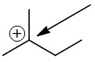

A) one

B) two

C) three

D) four

E) none

Answer: E

Diff: 1

Learning Objective: 2.4 Identify formal charges on carbon

69) How many hydrogen atoms are connected to the indicated carbon atom?

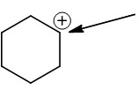

A) one

B) two

C) three

D) four

E) none

Answer: A

Diff: 1

Learning Objective: 2.4 Identify formal charges on carbon

70) How many hydrogen atoms are connected to the indicated carbon atom?

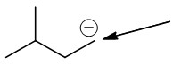

A) one

B) two

C) three

D) four

E) none

Answer: B

Diff: 1

Learning Objective: 2.4 Identify formal charges on carbon

71) How many hydrogen atoms are connected to the indicated carbon atom?

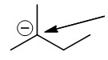

A) one

B) two

C) three

D) four

E) none

Answer: E

Diff: 1

Learning Objective: 2.4 Identify formal charges on carbon

72) How many hydrogen atoms are connected to the indicated carbon atom?

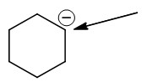

A) one

B) two

C) three

D) four

E) none

Answer: A

Diff: 1

Learning Objective: 2.4 Identify formal charges on carbon

73) How many lone pairs of electrons are found on the indicated atom?

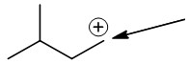

A) one

B) two

C) three

D) four

E) none

Answer: E

Diff: 1

Learning Objective: 2.4 Identify formal charges on carbon

74) What is the formal charge on a carbon atom with singles bonds to three other carbon atoms and no lone pairs?

A) -2

B) -1

C) 0

D) +1

E) +2

Answer: D

Diff: 1

Learning Objective: 2.4 Identify formal charges on carbon

75) What is the formal charge on a carbon atom with single bonds to three other carbon atoms and one lone pair?

A) -2

B) -1

C) 0

D) +1

E) +2

Answer: B

Diff: 1

Learning Objective: 2.4 Identify formal charges on carbon

76) How many lone pairs of electrons are found on the indicated carbon atom?

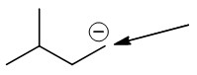

A) one

B) two

C) three

D) four

E) none

Answer: A

Diff: 1

Learning Objective: 2.4 Identify formal charges on carbon

77) How many lone pairs of electrons are found on the indicated carbon atom?

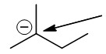

A) one

B) two

C) three

D) four

E) none

Answer: A

Diff: 1

Learning Objective: 2.4 Identify formal charges on carbon

78) How many lone pairs of electrons are found on the indicated carbon atom?

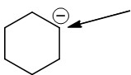

A) one

B) two

C) three

D) four

E) none

Answer: A

Diff: 1

Learning Objective: 2.4 Identify formal charges on carbon

79) What is the formal charge on the oxygen atom in the following compound?

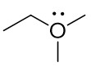

A) +1

B) +2

C) -1

D) -2

E) 0

Answer: A

Diff: 1

Learning Objective: 2.5 Describe the relationship between the number of bonds, the number of lone pairs, and formal charge for oxygen and nitrogen atoms

80) What is the formal charge on the nitrogen atom in the following compound?

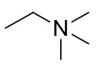

A) -1

B) -2

C) +1

D) +2

E) 0

Answer: C

Diff: 1

Learning Objective: 2.5 Describe the relationship between the number of bonds, the number of lone pairs, and formal charge for oxygen and nitrogen atoms

81) What is the formal charge on the nitrogen atom in the following compound?

The bond-line structure of a molecule has a three-carbon chain, in which C 1 is triple bonded to a nitrogen atom that is further bonded to a methyl group. 

A) +1

B) +2

C) -1

D) -2

E) 0

Answer: A

Diff: 1

Learning Objective: 2.5 Describe the relationship between the number of bonds, the number of lone pairs, and formal charge for oxygen and nitrogen atoms

82) What is the formal charge on the indicated oxygen atom in the following compound?

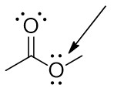

A) +1

B) +2

C) -1

D) -2

E) 0

Answer: E

Diff: 1

Learning Objective: 2.5 Describe the relationship between the number of bonds, the number of lone pairs, and formal charge for oxygen and nitrogen atoms

83) What is the formal charge on the nitrogen atom in the following compound?

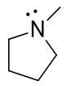

A) +1

B) +2

C) -1

D) -2

E) 0

Answer: E

Diff: 1

Learning Objective: 2.5 Describe the relationship between the number of bonds, the number of lone pairs, and formal charge for oxygen and nitrogen atoms

84) Which of the following structures have +1 as a formal charge on an oxygen atom?

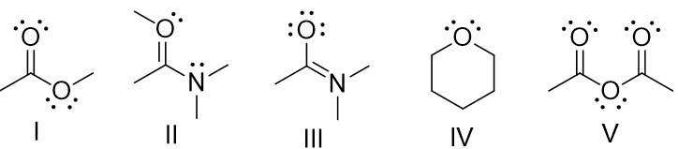

A) I

B) II

C) III

D) IV

E) V

Answer: B

Diff: 2

Learning Objective: 2.5 Describe the relationship between the number of bonds, the number of lone pairs, and formal charge for oxygen and nitrogen atoms

85) Which of the following structures have +1 as a formal charge on the nitrogen atom?

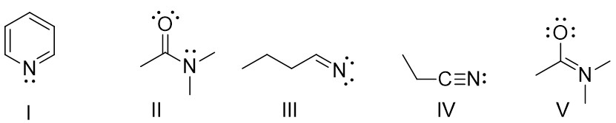

A) I

B) II

C) III

D) IV

E) V

Answer: E

Diff: 2

Learning Objective: 2.5 Describe the relationship between the number of bonds, the number of lone pairs, and formal charge for oxygen and nitrogen atoms

86) Determine the formal charge on each atom as indicated for the structure below.

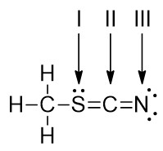

A) I = +1; II = 0; III = -1

B) I = -1; II = +1; III = 0

C) I = 0; II = -1; III = +1

D) I = -1; II = 0; III = +1

E) I = +1; II = 0; III = +1

Answer: A

Diff: 2

Learning Objective: 2.5 Describe the relationship between the number of bonds, the number of lone pairs, and formal charge for oxygen and nitrogen atoms

87) Diazomethane has the molecular formula CH2N2. Determine the formal charge on each atom as indicated for the structure below.

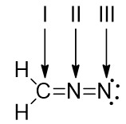

A) I = -1; II = +1; III = 0

B) I = +1; II = 0; III = -1

C) I = 0; II = -1; III = +1

D) I = 0; II = +1; III = -1

E) I = 0; II = +1; III = 0

Answer: D

Diff: 2

Learning Objective: 2.5 Describe the relationship between the number of bonds, the number of lone pairs, and formal charge for oxygen and nitrogen atoms

88) Consider the structure in the box, and then identify the bond-line representation, with appropriate formal charges if needed, from the options provided.

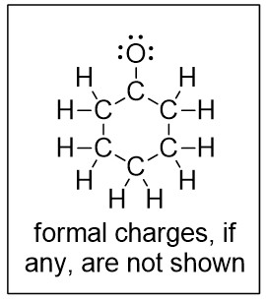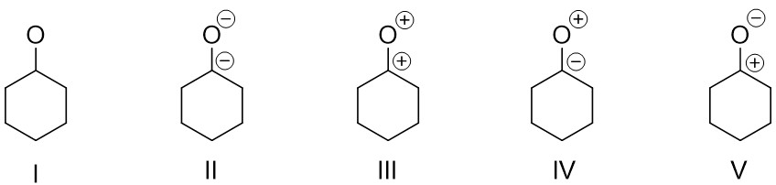

A) I

B) II

C) III

D) IV

E) V

Answer: E

Diff: 2

Learning Objective: 2.5 Describe the relationship between the number of bonds, the number of lone pairs, and formal charge for oxygen and nitrogen atoms

89) How many lone pairs of electrons are on the oxygen atom?

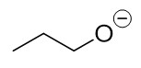

A) one

B) two

C) three

D) four

E) none

Answer: C

Diff: 1

Learning Objective: 2.5 Describe the relationship between the number of bonds, the number of lone pairs, and formal charge for oxygen and nitrogen atoms

90) How many lone pairs of electrons are on the nitrogen atom?

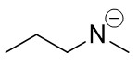

A) one

B) two

C) three

D) four

E) none

Answer: B

Diff: 1

Learning Objective: 2.5 Describe the relationship between the number of bonds, the number of lone pairs, and formal charge for oxygen and nitrogen atoms

91) How many lone pairs of electrons are on the oxygen atom?

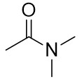

A) one

B) two

C) three

D) four

E) none

Answer: B

Diff: 1

Learning Objective: 2.5 Describe the relationship between the number of bonds, the number of lone pairs, and formal charge for oxygen and nitrogen atoms

92) How many lone pairs of electrons are on the nitrogen atom?



A) one

B) two

C) three

D) four

E) none

Answer: A

Diff: 1

Learning Objective: 2.5 Describe the relationship between the number of bonds, the number of lone pairs, and formal charge for oxygen and nitrogen atoms

93) How many lone pairs of electrons are on the nitrogen atom?

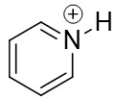

A) one

B) two

C) three

D) four

E) none

Answer: E

Diff: 1

Learning Objective: 2.5 Describe the relationship between the number of bonds, the number of lone pairs, and formal charge for oxygen and nitrogen atoms

94) How many lone pairs of electrons are on the indicated oxygen atom?

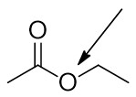

A) one

B) two

C) three

D) four

E) none

Answer: B

Diff: 1

Learning Objective: 2.5 Describe the relationship between the number of bonds, the number of lone pairs, and formal charge for oxygen and nitrogen atoms

95) How many lone pairs of electrons are on the indicated oxygen atom?

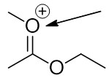

A) one

B) two

C) three

D) four

E) none

Answer: A

Diff: 1

Learning Objective: 2.5 Describe the relationship between the number of bonds, the number of lone pairs, and formal charge for oxygen and nitrogen atoms

96) How many total lone pairs of electrons are in the following compound?

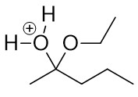

A) one

B) two

C) three

D) four

E) none

Answer: C

Diff: 1

Learning Objective: 2.5 Describe the relationship between the number of bonds, the number of lone pairs, and formal charge for oxygen and nitrogen atoms

97) Identify the structure that shows the correct placement of all lone pairs for the compound illustrated in the box below.

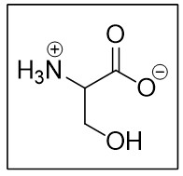

The first bond-line structure of the molecule has a three-carbon chain, in which C 1 is a carboxylate anion group, C 2 is bonded to ammonia cation, and C 3 is bonded to a hydroxyl group. The double bonded oxygen atom in carboxylate anion has two lone pairs of electrons and the single bonded oxygen anion has three lone pairs of electrons. The oxygen atom in hydroxyl group has two lone pairs of electrons. The second bond-line structure of the molecule has a three-carbon chain, in which C 1 is a carboxylate anion group, C 2 is bonded to ammonia cation, and C 3 is bonded to a hydroxyl group. The double bonded oxygen atom in carboxylate anion has two lone pairs of electrons and the single bonded oxygen anion has three lone pairs of electrons. The nitrogen atom in the ammonia cation has a lone pair of electrons. The oxygen atom in hydroxyl group has two lone pairs of electrons. The third bond-line structure of the molecule has a three-carbon chain, in which C 1 is a carboxylate anion group, C 2 is bonded to ammonia cation, and C 3 is bonded to a hydroxyl group. The double bonded oxygen atom in carboxylate anion has two lone pairs of electrons and the single bonded oxygen anion has three lone pairs of electrons. The oxygen atom in hydroxyl group has a lone pair of electrons. The fourth bond-line structure of the molecule has a three-carbon chain, in which C 1 is a carboxylate anion group, C 2 is bonded to ammonia cation, and C 3 is bonded to a hydroxyl group. The double bonded oxygen atom in carboxylate anion has two lone pairs of electrons and the single bonded oxygen anion has two lone pairs of electrons. The oxygen atom in hydroxyl group has two lone pairs of electrons. The fifth bond-line structure of the molecule has a three-carbon chain, in which C 1 is a carboxylate anion group, C 2 is bonded to ammonia cation, and C 3 is bonded to a hydroxyl group. The double bonded oxygen atom in carboxylate anion has two lone pairs of electrons and the single bonded oxygen anion has two lone pairs of electrons. The oxygen atom in hydroxyl group has two lone pairs of electrons.

A) I

B) II

C) III

D) IV

E) V

Answer: A

Diff: 2

Learning Objective: 2.5 Describe the relationship between the number of bonds, the number of lone pairs, and formal charge for oxygen and nitrogen atoms

98) Identify the structure that shows the correct placement of all lone pairs for the compound illustrated in the box below.

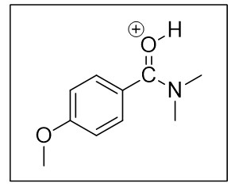

The first bond-line structure of a molecule has a benzene ring, in which C 1 is bonded to a carbon atom that is double bonded to an oxygen cation which is bonded to a hydrogen atom and the carbon atom is bonded to a nitrogen atom that is further bonded to two methyl groups. C 4 carbon atom of benzene ring is bonded to an oxygen atom that is further bonded to a methyl group. The double bonded oxygen cation has a lone pair of electrons. The nitrogen atom has two lone pairs of electrons. The oxygen atom bonded to C 4 has two lone pairs of electrons. The second bond-line structure of a molecule has a benzene ring, in which C 1 is bonded to a carbon atom that is double bonded to an oxygen cation which is bonded to a hydrogen atom and the carbon atom is bonded to a nitrogen atom that is further bonded to two methyl groups. C 4 carbon atom of benzene ring is bonded to an oxygen atom that is further bonded to a methyl group. The double bonded oxygen cation has a lone pair of electrons. The nitrogen atom has a lone pair of electrons. The oxygen atom bonded to C 4 has two lone pairs of electrons. The third bond-line structure of a molecule has a benzene ring, in which C 1 is bonded to a carbon atom that is double bonded to an oxygen cation which is bonded to a hydrogen atom and the carbon atom is bonded to a nitrogen atom that is further bonded to two methyl groups. C 4 carbon atom of benzene ring is bonded to an oxygen atom that is further bonded to a methyl group. The double bonded oxygen cation has a lone pair of electrons. The nitrogen atom has a lone pair of electrons. The oxygen atom bonded to C 4 has a lone pair of electrons. The fourth bond-line structure of a molecule has a benzene ring, in which C 1 is bonded to a carbon atom that is double bonded to an oxygen cation which is bonded to a hydrogen atom and the carbon atom is bonded to a nitrogen atom that is further bonded to two methyl groups. C 4 carbon atom of benzene ring is bonded to an oxygen atom that is further bonded to a methyl group. The double bonded oxygen cation has a lone pair of electrons. The oxygen atom bonded to C 4 has two lone pairs of electrons. The fifth bond-line structure of a molecule has a benzene ring, in which C 1 is bonded to a carbon atom that is double bonded to an oxygen cation which is bonded to a hydrogen atom and the carbon atom is bonded to a nitrogen atom that is further bonded to two methyl groups. C 4 carbon atom of benzene ring is bonded to an oxygen atom that is further bonded to a methyl group. The double bonded oxygen cation has two lone pairs of electrons. The nitrogen atom has a lone pair of electrons. The oxygen atom bonded to C 4 has two lone pairs of electrons.

A) I

B) II

C) III

D) IV

E) V

Answer: B

Diff: 2

Learning Objective: 2.5 Describe the relationship between the number of bonds, the number of lone pairs, and formal charge for oxygen and nitrogen atoms

99) The representation of the indicated bond in the following compound is ________ of the paper.

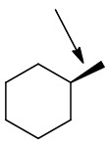

A) in the plane

B) out of the plane

C) behind the plane

D) None of these

Answer: B

Diff: 1

Learning Objective: 2.6 Describe how wedges and dashes are used to indicate three-dimensional molecular structure

100) The representation of the indicated bond in the following compound is ________ of the paper.

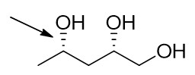

A) in the plane

B) out of the plane

C) behind the plane

D) None of these

Answer: C

Diff: 1

Learning Objective: 2.6 Describe how wedges and dashes are used to indicate three-dimensional molecular structure

101) The representation of the indicated bond in the following compound is ________ of the paper.

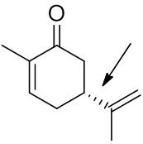

A) in the plane

B) out of the plane

C) behind the plane

D) None of these

Answer: C

Diff: 1

Learning Objective: 2.6 Describe how wedges and dashes are used to indicate three-dimensional molecular structure

102) Which of the following pairs are resonance structures of each other?

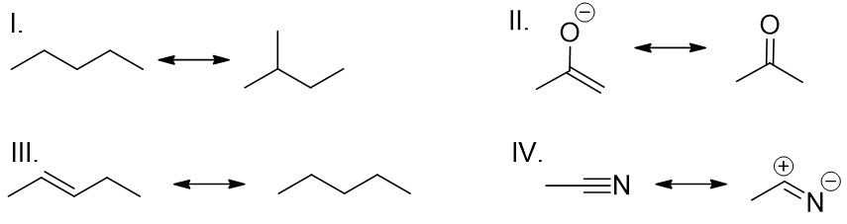

A) I

B) II

C) III

D) IV

E) II and IV

Answer: D

Diff: 1

Learning Objective: 2.7 Define "resonance", describing the relationship between resonance and molecular orbital theory

103) Which of the following pairs are resonance structures of each other?

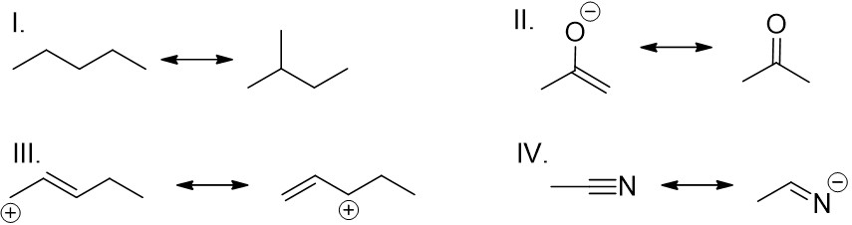

A) I

B) II

C) III

D) IV

E) II and IV

Answer: C

Diff: 1

Learning Objective: 2.7 Define "resonance", describing the relationship between resonance and molecular orbital theory

104) The spreading of electrons over two or more atoms in a compound is called ________.

A) isomerism

B) delocalization

C) stereoisomerism

D) localization

E) None of these

Answer: B

Diff: 1

Learning Objective: 2.7 Define "resonance", describing the relationship between resonance and molecular orbital theory

105) Delocalization of electrons over two or more atoms ________ a molecule.

A) destabilizes

B) delocalizes

C) localizes

D) stabilizes

E) None of these

Answer: D

Diff: 1

Learning Objective: 2.7 Define "resonance", describing the relationship between resonance and molecular orbital theory

106) Resonance structures have ________ connectivity of atoms and ________ distribution of electrons.

A) different, the same

B) the same, the same

C) different, different

D) the same, different

E) None of these

Answer: A

Diff: 2

Learning Objective: 2.7 Define "resonance", describing the relationship between resonance and molecular orbital theory

107) Which statement best describes a resonance hybrid?

A) The process of dealing with the inadequacy of bond-line structures.

B) A structure showing an allyl carbocation.

C) A representation of a molecule showing all the bonds and lone pairs.

D) Molecules with the same molecular formula, but different atom connectivity.

E) A representation of a molecule that can alternatively be represented by drawing two or more resonance structures.

Answer: E

Diff: 2

Learning Objective: 2.7 Define "resonance", describing the relationship between resonance and molecular orbital theory

108) Which of the following violates the rules for curved arrows?

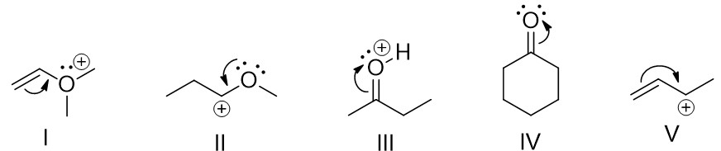

A) I

B) II

C) III

D) IV

E) V

Answer: A

Diff: 1

Learning Objective: 2.8 Demonstrate the used of curved arrows in drawing resonance structures, stating the two rules to be applied when drawing curved arrows

109) Which of the following violates the rules for curved arrows?

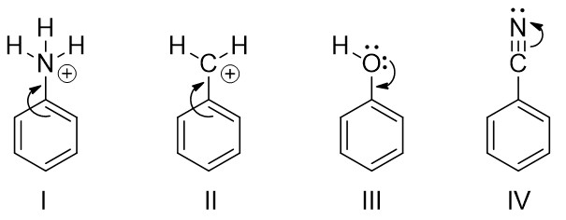

A) I

B) I and II

C) I and III

D) II and III

E) III and IV

Answer: C

Diff: 1

Learning Objective: 2.8 Demonstrate the used of curved arrows in drawing resonance structures, stating the two rules to be applied when drawing curved arrows

110) Why is the single curved arrow shown insufficient to draw a resonance structure?

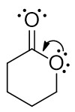

A) The resulting structure would have a positive on the most electronegative atom.

B) The resulting structure would have an octet rule violation.

C) The resulting structure would have a negative on the most electronegative atom.

D) The resulting structure would have a negative on the least electronegative atom.

E) The resulting structure would have an atom with less than an octet.

Answer: B

Diff: 2

Learning Objective: 2.8 Demonstrate the used of curved arrows in drawing resonance structures, stating the two rules to be applied when drawing curved arrows

111) Identify the resulting resonance structure(s) indicated by the curved arrow.

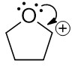

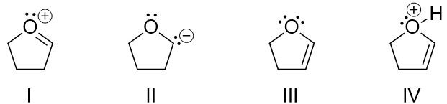

A) I

B) II

C) III

D) IV

E) I and III

Answer: A

Diff: 2

Learning Objective: 2.9 Describe the use of arrow pushing and formal charges in resonance structures

112) Identify the resulting resonance structure indicated by the curved arrows.

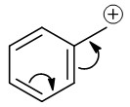

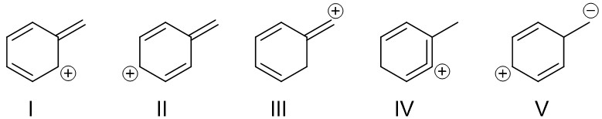

A) I

B) II

C) III

D) IV

E) V

Answer: B

Diff: 2

Learning Objective: 2.9 Describe the use of arrow pushing and formal charges in resonance structures

113) Identify the resulting resonance structure indicated by the curved arrows.

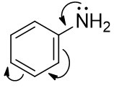

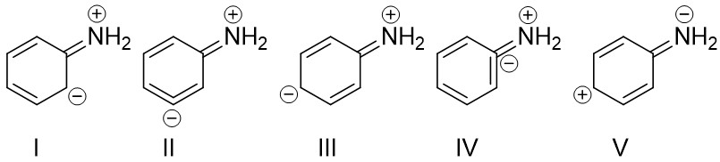

A) I

B) II

C) III

D) IV

E) V

Answer: C

Diff: 2

Learning Objective: 2.9 Describe the use of arrow pushing and formal charges in resonance structures

114) Identify the resulting resonance structure indicated by the curved arrows.

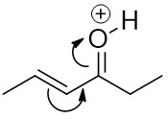

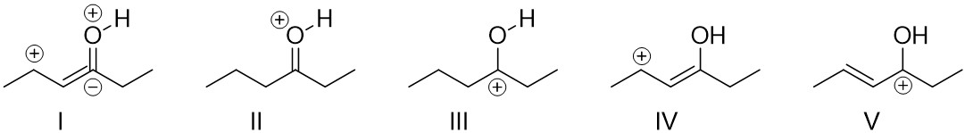

A) I

B) II

C) III

D) IV

E) V

Answer: D

Diff: 2

Learning Objective: 2.9 Describe the use of arrow pushing and formal charges in resonance structures

115) Identify the proper curved arrow to convert the first resonance structure into the second resonance structure.

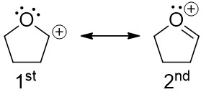

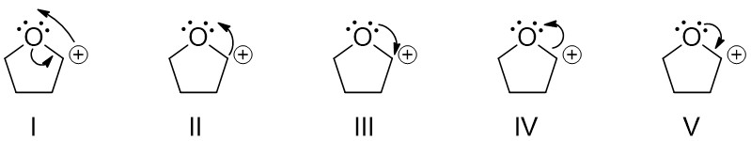

A) I

B) II

C) III

D) IV

E) V

Answer: E

Diff: 2

Learning Objective: 2.9 Describe the use of arrow pushing and formal charges in resonance structures

116) Identify from the options given the proper curved arrow to convert the first resonance structure into the second resonance structure.

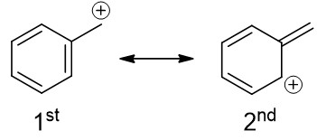

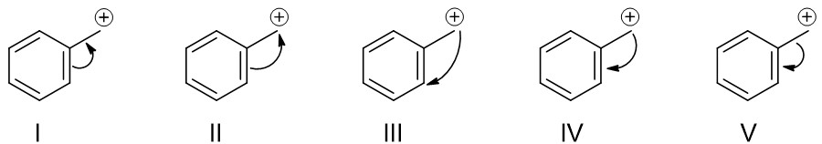

A) I

B) II

C) III

D) IV

E) V

Answer: A

Diff: 2

Learning Objective: 2.9 Describe the use of arrow pushing and formal charges in resonance structures

117) Identify from the options given the proper curved arrows to convert the first resonance structure into the second resonance structure.

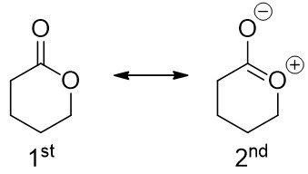

The first bond-line resonance structure of a molecule has a cyclohexane ring, in which C 1 is replaced by an oxygen atom that has two lone pairs of electrons and C 2 is double bonded to an oxygen atom that has two lone pairs of electrons. First curved arrow points from the single bond between C 2 and O 1 to the O 1. Second curved arrow points from the double bond between C 2 and oxygen atom to the double bonded oxygen atom. The second bond-line resonance structure of a molecule has a cyclohexane ring, in which C 1 is replaced by an oxygen atom that has two lone pairs of electrons and C 2 is double bonded to an oxygen atom that has two lone pairs of electrons. First curved arrow points from one of the lone pairs of electrons of O 1 oxygen atom to the single bond between O 1 and C 2. Second curved arrow points from the double bond between C 2 and oxygen atom to the double bonded oxygen atom. The third bond-line resonance structure of a molecule has a cyclohexane ring, in which C 1 is replaced by an oxygen atom that has two lone pairs of electrons and C 2 is double bonded to an oxygen atom that has two lone pairs of electrons. First curved arrow points from the double bonded oxygen atom to double bond between oxygen atom and C 2. Second curved arrow points from the single bond between C 2 and O 1 to the O 1 atom. The fourth bond-line resonance structure of a molecule has a cyclohexane ring, in which C 1 is replaced by an oxygen atom that has two lone pairs of electrons and C 2 is double bonded to an oxygen atom that has two lone pairs of electrons. First curved arrow points from the double bonded oxygen atom to O 1. Second curved arrow points from O 1 to the double bonded oxygen atom. The fifth bond-line resonance structure of a molecule has a cyclohexane ring, in which C 1 is replaced by an oxygen atom that has two lone pairs of electrons and C 2 is double bonded to an oxygen atom that has two lone pairs of electrons. First curved arrow points from one of the lone pairs of electrons of O 1 oxygen atom to the single bond between O 1 and C 2. Second curved arrow points from the double bonded oxygen atom to double bond between oxygen atom and C 2.

A) I

B) II

C) III

D) IV

E) V

Answer: B

Diff: 2

Learning Objective: 2.9 Describe the use of arrow pushing and formal charges in resonance structures

118) For the structure shown in the box below identify a corresponding correct resonance structure.

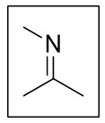

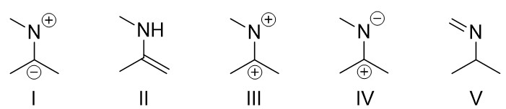

A) I

B) II

C) III

D) IV

E) V

Answer: D

Diff: 2

Learning Objective: 2.10 Identify resonance structures by naming the five different structural patterns in molecules

119) For the structure shown in the box below identify a corresponding correct resonance structure.

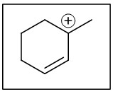

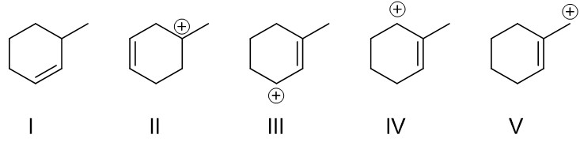

A) I

B) II

C) III

D) IV

E) V

Answer: C

Diff: 1

Learning Objective: 2.10 Identify resonance structures by naming the five different structural patterns in molecules

120) For the structure shown in the box below identify corresponding correct resonance structures.

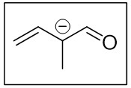

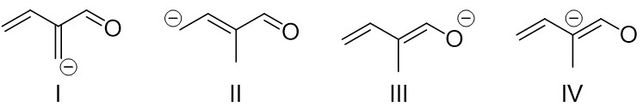

A) I and II

B) II and III

C) III and IV

D) I and III

E) II and IV

Answer: B

Diff: 2

Learning Objective: 2.10 Identify resonance structures by naming the five different structural patterns in molecules

121) For the structure shown in the box below identify corresponding correct resonance structures.

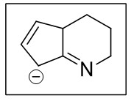

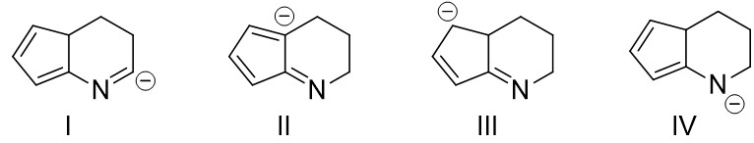

A) I and II

B) II and III

C) III and IV

D) I and III

E) II and IV

Answer: C

Diff: 2

Learning Objective: 2.10 Identify resonance structures by naming the five different structural patterns in molecules

122) For the structure shown in the box below identify a corresponding correct resonance structure.

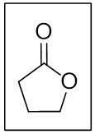

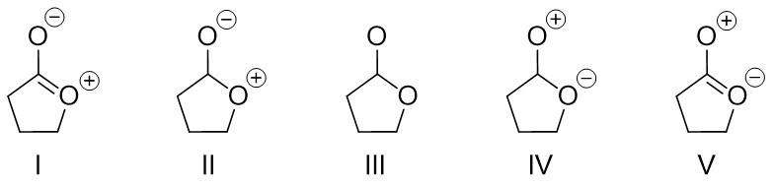

A) I

B) II

C) III

D) IV

E) V

Answer: A

Diff: 2

Learning Objective: 2.10 Identify resonance structures by naming the five different structural patterns in molecules

123) For the structure shown in the box below identify corresponding correct resonance structures.

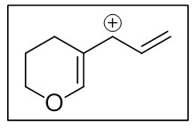

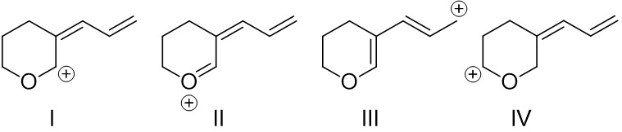

A) I and II

B) II and III

C) III and IV

D) I, II and III

E) II, III and IV

Answer: D

Diff: 3

Learning Objective: 2.10 Identify resonance structures by naming the five different structural patterns in molecules

124) For the structure shown in the box below identify a corresponding correct resonance structure.

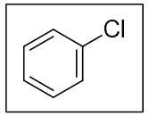

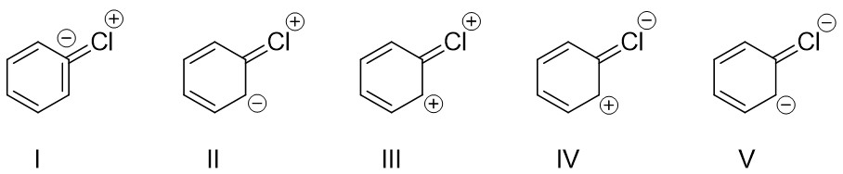

A) I

B) II

C) III

D) IV

E) V

Answer: B

Diff: 1

Learning Objective: 2.10 Identify resonance structures by naming the five different structural patterns in molecules

125) For the structure shown in the box below identify a corresponding correct resonance structure.

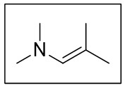

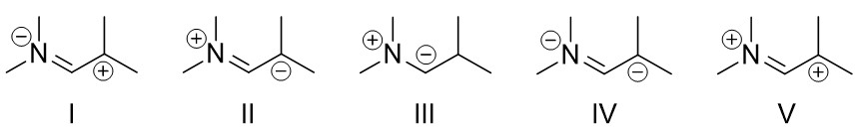

A) I

B) II

C) III

D) IV

E) V

Answer: B

Diff: 1

Learning Objective: 2.10 Identify resonance structures by naming the five different structural patterns in molecules

126) For the structure shown in the box below identify a corresponding correct resonance structure.

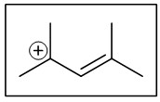

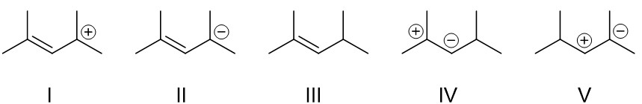

A) I

B) II

C) III

D) IV

E) V

Answer: A

Diff: 1

Learning Objective: 2.10 Identify resonance structures by naming the five different structural patterns in molecules

127) For the compound shown in the box below identify two corresponding correct resonance structures.

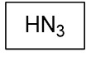

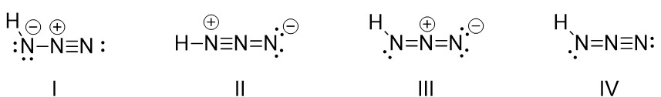

A) I and II

B) II and III

C) III and IV

D) I and III

E) II and IV

Answer: D

Diff: 3

Learning Objective: 2.10 Identify resonance structures by naming the five different structural patterns in molecules

128) For the structure shown in the box below identify two corresponding correct resonance structures.

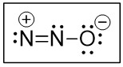

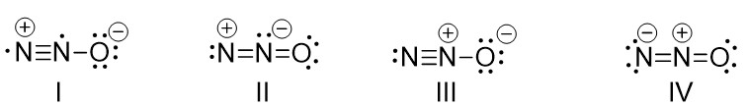

A) I and II

B) II and III

C) III and IV

D) I and III

E) II and IV

Answer: C

Diff: 3

Learning Objective: 2.10 Identify resonance structures by naming the five different structural patterns in molecules

129) For the structure shown in the box below identify two corresponding correct resonance structures.

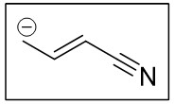

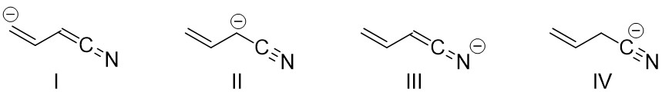

A) I and II

B) II and III

C) III and IV

D) I and III

E) II and IV

Answer: B

Diff: 3

Learning Objective: 2.10 Identify resonance structures by naming the five different structural patterns in molecules

130) Identify the most significant resonance structure(s).

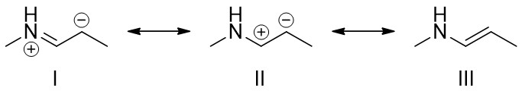

A) I

B) II

C) III

D) I and III

E) II and III

Answer: C

Diff: 1

Learning Objective: 2.11 Distinguish between significant and insignificant resonance structures, describing how the significance of resonance is determined

131) Identify the most significant resonance structure(s).

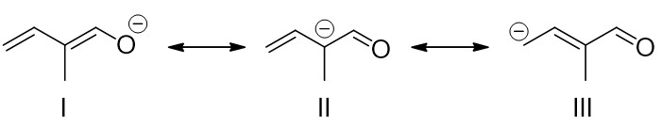

A) I

B) II

C) III

D) I and II

E) II and III

Answer: A

Diff: 1

Learning Objective: 2.11 Distinguish between significant and insignificant resonance structures, describing how the significance of resonance is determined

132) Identify the most significant resonance structure(s).

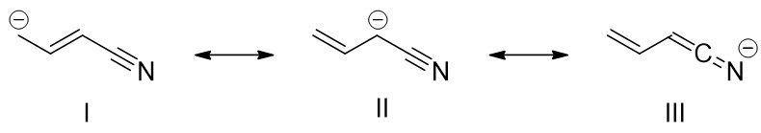

A) I

B) II

C) III

D) I and II

E) II and III

Answer: C

Diff: 2

Learning Objective: 2.11 Distinguish between significant and insignificant resonance structures, describing how the significance of resonance is determined

133) Identify the most significant resonance structure(s).

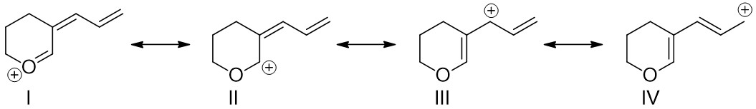

A) I

B) II

C) III

D) I and II

E) III and IV

Answer: A

Diff: 3

Learning Objective: 2.11 Distinguish between significant and insignificant resonance structures, describing how the significance of resonance is determined

134) Identify the most significant resonance structure(s).



A) I

B) II

C) III

D) IV

E) All structures are of equal significance

Answer: C

Diff: 2

Learning Objective: 2.11 Distinguish between significant and insignificant resonance structures, describing how the significance of resonance is determined

135) Identify the most significant resonance structure(s).

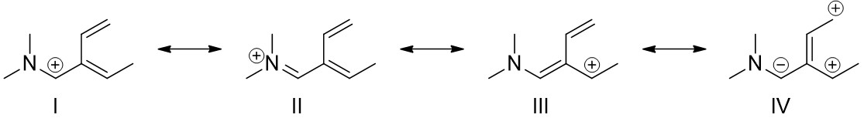

A) I

B) II

C) III

D) IV

E) All structures are of equal significance

Answer: B

Diff: 2

Learning Objective: 2.11 Distinguish between significant and insignificant resonance structures, describing how the significance of resonance is determined

136) Identify the most significant resonance structure(s).



A) I

B) II

C) III

D) IV

E) II and IV

Answer: D

Diff: 3

Learning Objective: 2.11 Distinguish between significant and insignificant resonance structures, describing how the significance of resonance is determined

137) Identify the most significant resonance structure.



A) I

B) II

C) III

D) IV

E) V

Answer: E

Diff: 2

Learning Objective: 2.11 Distinguish between significant and insignificant resonance structures, describing how the significance of resonance is determined

138) What is the relationship between the following structures?

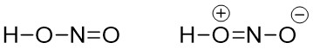

A) constitutional isomers

B) resonance structures

C) conformers

D) identical compounds

E) conjugate acid and conjugate base

Answer: B

Diff: 1

Learning Objective: 2.11 Distinguish between significant and insignificant resonance structures, describing how the significance of resonance is determined

139) What is the relationship between the following structures?

The bond-line structure of a molecule has a five-carbon zigzag chain, in which C 1 is double bonded to an oxygen and C 3 is double bonded to C 4. The second bond-line structure has a five-carbon zigzag chain, in which C 1 is double bonded to an oxygen and C 4 is double bonded to C 5. 

A) constitutional isomers

B) resonance structures

C) conformers

D) identical compounds

E) stereoisomers

Answer: A

Diff: 1

Learning Objective: 2.11 Distinguish between significant and insignificant resonance structures, describing how the significance of resonance is determined

140) What is the relationship between the following structures?

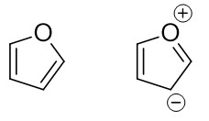

A) constitutional isomers

B) resonance structures

C) conformers

D) identical compounds

E) different compounds

Answer: B

Diff: 1

Learning Objective: 2.11 Distinguish between significant and insignificant resonance structures, describing how the significance of resonance is determined

141) What is the relationship between the following structures?

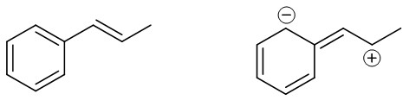

A) constitutional isomers

B) resonance structures

C) conformers

D) identical compounds

E) different compounds

Answer: B

Diff: 1

Learning Objective: 2.11 Distinguish between significant and insignificant resonance structures, describing how the significance of resonance is determined

142) Identify the resonance hybrid for the following compound.

The bond-line structure of a molecule has a four-carbon zigzag chain, in which C 1 is double bonded to an oxygen atom, C 2 is double bonded to C 3, and C 4 has a negative charge. 

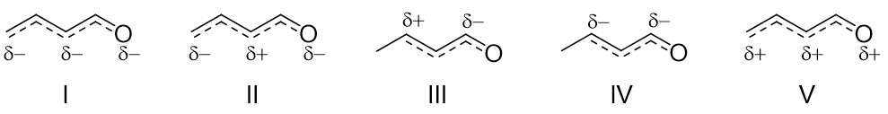

A) I

B) II

C) III

D) IV

E) V

Answer: A

Diff: 2

Learning Objective: 2.12 Draw a resonance hybrid using partial bonds and partial charges, reflecting the combination of individual resonance structures

143) Identify the resonance hybrid for CH2=CHCH=CHCH2+.

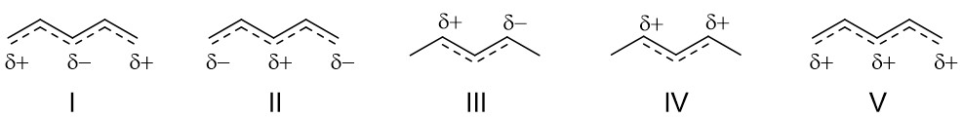

A) I

B) II

C) III

D) IV

E) V

Answer: E

Diff: 2

Learning Objective: 2.12 Draw a resonance hybrid using partial bonds and partial charges, reflecting the combination of individual resonance structures

144) Identify the resonance hybrid for the following compound.

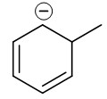

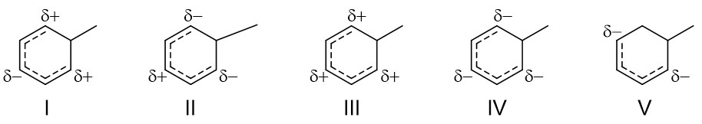

A) I

B) II

C) III

D) IV

E) V

Answer: D

Diff: 2

Learning Objective: 2.12 Draw a resonance hybrid using partial bonds and partial charges, reflecting the combination of individual resonance structures

145) The lone pair on the nitrogen atom in the following compound is ________.

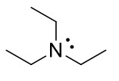

A) localized

B) delocalized

C) conjugated

D) resonance stabilized

E) unhybridized

Answer: A

Diff: 1

Learning Objective: 2.13 Distinguish between delocalized and localized lone pairs and describe how delocalized lone pairs participate in resonance and why localized lone pairs do not participate in resonance

146) The lone pairs on the oxygen in the following compound are best described ________.

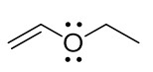

A) both localized

B) both delocalized

C) one localized and one delocalized

D) unhybridized

E) allylic to each other

Answer: C

Diff: 1

Learning Objective: 2.13 Distinguish between delocalized and localized lone pairs and describe how delocalized lone pairs participate in resonance and why localized lone pairs do not participate in resonance

147) The lone pair on the nitrogen atom in the following compound is ________.

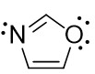

A) localized

B) delocalized

C) conjugated

D) resonance stabilized

E) unhybridized

Answer: A

Diff: 1

Learning Objective: 2.13 Distinguish between delocalized and localized lone pairs and describe how delocalized lone pairs participate in resonance and why localized lone pairs do not participate in resonance

148) The lone pairs on the oxygen atom in the following compound are best described as ________.

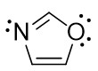

A) both localized

B) both delocalized

C) one localized and one delocalized

D) unhybridized

E) allylic to each other

Answer: C

Diff: 1

Learning Objective: 2.13 Distinguish between delocalized and localized lone pairs and describe how delocalized lone pairs participate in resonance and why localized lone pairs do not participate in resonance

149) The lone pairs on the nitrogen atoms in the following compound are best described as ________.

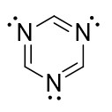

A) all three pairs localized

B) all three pairs delocalized

C) two localized pairs and one delocalized pair

D) one localized pair and two delocalized pairs

E) unhybridized

Answer: A

Diff: 1

Learning Objective: 2.13 Distinguish between delocalized and localized lone pairs and describe how delocalized lone pairs participate in resonance and why localized lone pairs do not participate in resonance

150) For the following compound, identify the indicated lone pairs as localized or delocalized.

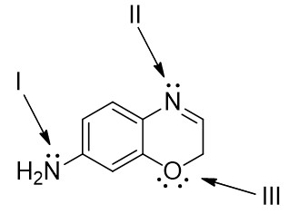

A) I = localized; II = delocalized; III = one localized and one delocalized

B) I = delocalized; II = localized; III = one localized and one delocalized

C) I = localized; II = delocalized; III = both delocalized

D) I = delocalized; II = localized; III = both localized

E) I = delocalized; II = delocalized; III = one localized and one delocalized

Answer: B

Diff: 2

Learning Objective: 2.13 Distinguish between delocalized and localized lone pairs and describe how delocalized lone pairs participate in resonance and why localized lone pairs do not participate in resonance

151) For the following compound, identify the indicated lone pairs as localized or delocalized.

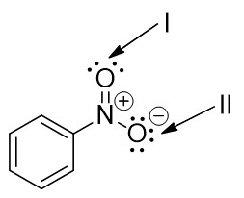

A) I = both delocalized; II = two localized and one delocalized

B) I = both localized; II = two localized and one delocalized

C) I = both localized; II = one localized and two delocalized

D) I = one localized and one delocalized; II = one localized and two delocalized

E) I = one localized and one delocalized; II = two localized and one delocalized

Answer: B

Diff: 2

Learning Objective: 2.13 Distinguish between delocalized and localized lone pairs and describe how delocalized lone pairs participate in resonance and why localized lone pairs do not participate in resonance

152) For the following compound, identify the indicated lone pairs as localized or delocalized.

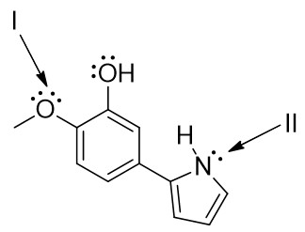

A) I = both delocalized; II = localized

B) I = both localized; II = localized

C) I = both delocalized; II = delocalized

D) I = one localized and one delocalized; II = localized

E) I = one localized and one delocalized; II = delocalized

Answer: E

Diff: 2

Learning Objective: 2.13 Distinguish between delocalized and localized lone pairs and describe how delocalized lone pairs participate in resonance and why localized lone pairs do not participate in resonance

153) For the following compound what is the hybridization state and molecular geometry at the indicated atoms?

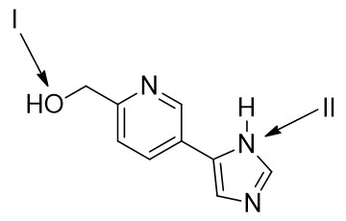

A) I = *sp*3, tetrahedral; II = *sp*2, trigonal pyramidal

B) I = *sp*3, bent; II = *sp*2, trigonal planar

C) I = *sp*3, bent; II = *sp*2, trigonal pyramidal

D) I = *sp*3, tetrahedral; II = *sp*2, trigonal planar

E) I = *sp*2, trigonal pyramidal; II = *sp*, trigonal planar

Answer: B

Diff: 3

Learning Objective: 2.13 Distinguish between delocalized and localized lone pairs and describe how delocalized lone pairs participate in resonance and why localized lone pairs do not participate in resonance

154) Caffeine has the following structure. Identify the hybridization state and molecular geometry at the indicated atoms.

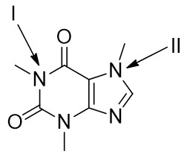

A) I = *sp*3, trigonal pyramidal; II = *sp*3, trigonal pyramidal

B) I = *sp*3, trigonal planar; II = *sp*3, trigonal planar

C) I = *sp*2, trigonal pyramidal; II = *sp*2, trigonal pyramidal

D) I = *sp*2, trigonal planar; II = *sp*2, trigonal planar

E) I = *sp*3, trigonal pyramidal; II = *sp*2, trigonal planar

Answer: D

Diff: 3

Learning Objective: 2.13 Distinguish between delocalized and localized lone pairs and describe how delocalized lone pairs participate in resonance and why localized lone pairs do not participate in resonance

155) Enalapril, is a drug used in the treatment of heart disease. What is the hybridization state at the indicated atoms in Enalapril?

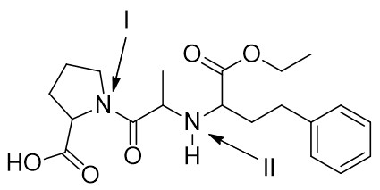

A) I = *sp*2, trigonal planar; II = *sp*3, trigonal pyramidal

B) I = *sp*3, trigonal pyramidal; II = *sp*3, trigonal pyramidal

C) I = *sp*2, trigonal pyramidal; II = *sp*2, trigonal pyramidal

D) I = *sp*2, trigonal planar; II = *sp*2, trigonal planar

E) I = *sp*3, trigonal pyramidal; II = *sp*2, trigonal planar

Answer: A

Diff: 3

Learning Objective: 2.13 Distinguish between delocalized and localized lone pairs and describe how delocalized lone pairs participate in resonance and why localized lone pairs do not participate in resonance

© (2021) John Wiley & Sons, Inc. All rights reserved. Instructors who are authorized users of this course are permitted to download these materials and use them in connection with the course. Except as permitted herein or by law, no part of these materials should be reproduced, stored in a retrieval system, or transmitted, in any form or by any means, electronic, mechanical, photocopying, recording or otherwise.