1. Trade creates value because:
 | a. | people get what they want.
 | b. | raw materials are transformed into finished products.
 | c. | people exchange things they do not want for things they do.
 | d. | idle resources are put to use.

ANSWER: | c

2. eBay creates value by:
 | a. | helping sellers trick buyers into purchasing broken items.
 | b. | moving goods like broken laser pointers from people who don't want them to people who do.
 | c. | helping people with the same preferences find each other.
 | d. | moving toys from children who want them to children who don't.

ANSWER: | b

3. David sells his car, which he considers worthless, to Cameron for $200. Which of the following statements is TRUE?
 | a. | David and Cameron must have different preferences for the car.
 | b. | This trade did not create value because Cameron is buying a car that David considers worthless.
 | c. | Cameron is the only one made better off by the trade.
 | d. | David is made better off by the trade, but Cameron is made worse off.

ANSWER: | a

4. Matilda sells her iPhone, which she considers worthless, to Gabriel for $200. Which of the following statements is TRUE?
 | a. | Matilda and Gabriel must have the same preferences for the iPhone.
 | b. | This trade created value because Gabriel is buying the iPhone for more than Matilda thinks it is worth.
 | c. | Matilda is the only one made better off by the trade.
 | d. | Matilda is made better off by the trade, but Gabriel is made worse off by the trade.

ANSWER: | b

5. Jose sells his economics textbook from last semester, which he could sell back to the bookstore for $40, to Adolfo for $150. Adolfo had planned to pay $240 for the textbook at the bookstore. Which of the following statements is TRUE?
 | a. | Jose and Adolfo must have the same preferences for the textbook.
 | b. | This trade did not create value because Adolfo is buying the textbook for more than Jose could get from the bookstore.
 | c. | Both Jose and Adolfo are made better off by the trade.
 | d. | Adolfo is made better off by the trade, but Jose is made worse off by the trade.

ANSWER: | c

6. Mark values his drum set at $800, and Ella values her guitar at $1,000. Suppose that Mark trades his drum set for Ella's guitar.
 | a. | This trade makes Ella worse off by $200.
 | b. | This trade makes Mark better off by $200.
 | c. | Mark must value Ella's guitar for at least $800, and Ella must value Mark's drum set for at least $1,000.
 | d. | This trade decreases total value by moving the guitar and drum away from people who placed a high value on them.

ANSWER: | c

7. Facilitators of trade (such as Pierre Omidyar, the developer of eBay):
 | a. | may become very rich since they are creating value for many individuals.
 | b. | find it very hard to profit from their services since they are not directly involved in the trades.
 | c. | typically profit from their services only if they are able to obtain government patent rights.
 | d. | are usually seen as taking advantage of consumers.

ANSWER: | a

8. Trade makes people better off when:
 | a. | everyone wants the same things as other people.
 | b. | some people are less productive than others.
 | c. | people cannot specialize in certain activities.
 | d. | people have different preferences.

ANSWER: | d

9. Each of 100 people receives a random item from a grocery store and assigns it a value between 1 (low) and 10 (high). They trade those items among themselves for items they prefer rather than those they randomly received and then assign a second value (again, 1 to 10) to the item that they end up with after the trading concludes. How would the sum of those values before trading compare with the sum after trading?
 | a. | The value would stay the same because no new goods were introduced.
 | b. | The value would stay the same because no one has a comparative advantage.
 | c. | After trading, value would be lower because no one can specialize.
 | d. | After trading, value would be higher because preferences are diverse.

ANSWER: | d

10. Which of the following is least likely to be a consequence of the division of knowledge?
 | a. | the development of the computer tablet
 | b. | a totally self-sufficient family farm
 | c. | a new delivery method for cancer-fighting drugs
 | d. | the provision of a new bike path in your community

ANSWER: | b

11. Only a very small portion of people who use microwaves know how they work. This is an example of:
 | a. | a production possibility frontier.
 | b. | the division of knowledge.
 | c. | absolute advantage.
 | d. | opportunity cost.

ANSWER: | b

12. Jennifer buys a computer based on the recommendation of her brother, who is an information technology professional. This is an example of:
 | a. | a production possibility frontier.
 | b. | the division of knowledge.
 | c. | gains from trade.
 | d. | opportunity cost.

ANSWER: | b

13. Division of knowledge refers to:
 | a. | dividing tasks into different subtasks and having one person perform all these subtasks.
 | b. | people learning different tasks in which they specialize.
 | c. | assigning one person to learn all the different ways to perform the same task.
 | d. | limiting what each person knows about another person.

ANSWER: | b

14. Which of the following situations would lead to more starvation?
 | a. | a world where everyone grows his or her own food and there is no trade
 | b. | a world with trade and lots of specialization
 | c. | a world with immense division of knowledge
 | d. | a world where only some people specialize in food and everyone else produces something else

ANSWER: | a

15. The main reason specialization can raise productivity is that:
 | a. | knowledge in human brains is limited.
 | b. | some persons have more knowledge than others.
 | c. | it is always good to know less than more.
 | d. | it is impossible to learn anything well.

ANSWER: | a

16. There are many specialties in the practice of medicine. For example, there are surgeons, cardiologists, neurologists, obstetricians, and ophthalmologists. This is an example of:
 | a. | a production possibility frontier.
 | b. | the division of knowledge.
 | c. | gains from trade.
 | d. | opportunity cost.

ANSWER: | b

17. Knowledge increases _____ and specialization _____ total output.
 | a. | education; decreases
 | b. | productivity; increases
 | c. | perception; increases
 | d. | economies of scale; decreases

ANSWER: | b

18. Economic growth in the modern era is primarily due to the:
 | a. | increases in the number of people.
 | b. | increases in money.
 | c. | defining of national borders.
 | d. | creation of new knowledge.

ANSWER: | d

19. Specialization and trade can _____ the per unit cost of production because _____ .
 | a. | decrease; they allow for more small-scale production
 | b. | decrease; they create economies of scale associated with large-scale production
 | c. | increase; they require more expensive, specialized equipment
 | d. | increase; more expensive labor is needed

ANSWER: | b

20. The United States and the European Union are groups of semi-independent states that have come together under an agreement whereby resources can travel freely across borders and a common currency is in use. Which of the following statements best explains how this allows for the achievement of economies of scale?
 | a. | Each state or country can now target larger markets and can thus earn more export revenue.
 | b. | States and countries no longer have to worry about borders impeding trade.
 | c. | Each state or country can adopt large-scale production techniques that allow lower per unit costs of production.
 | d. | The removal of trade borders and a common currency enhance trade between member states.

ANSWER: | c

21. One of the outcomes of specialization is that it leads to _____, which _____ the average cost of production.
 | a. | smaller-scale production; lowers
 | b. | smaller-scale production; raises
 | c. | larger-scale production; raises
 | d. | larger-scale production; lowers

ANSWER: | d

22. Without _____, specialization is impossible.
 | a. | different preferences
 | b. | productivity
 | c. | opportunity costs
 | d. | trade

ANSWER: | d

23. If each of us had to grow all of our own food:
 | a. | civilization would collapse, and billions of people would starve.
 | b. | we would have more time for other pursuits.
 | c. | people would be richer since they would no longer have to spend money on groceries.
 | d. | the total amount of knowledge in society would increase since everyone would have to learn about farming.

ANSWER: | a

24. If instead of specialized doctors (neurologists, cardiologists, gastroenterologists, etc.) we had doctors who each knew the same things about all aspects of medicine, it would be:
 | a. | better because then we could just go to one doctor with no loss of quality in medical care.
 | b. | better because total medical knowledge in society would increase.
 | c. | worse because the human brain is limited.
 | d. | worse because total medical knowledge in society would decrease.

ANSWER: | d

25. Roses grown in Kenya travel to Amsterdam and ultimately to your local flower shop because:
 | a. | the World Rose Commission coordinates the different elements of the rose industry.
 | b. | markets coordinate the specialization and trade necessary for the flower industry to function.
 | c. | of the trade agreement between the governments of Kenya and Amsterdam.
 | d. | customers are willing to pay more for roses that pass through Amsterdam.

ANSWER: | b

26. Trade barriers like the Berlin Wall:
 | a. | increased the number of scientists and engineers.
 | b. | added billions of minds to the global division of knowledge.
 | c. | decreased innovation and global cooperation.
 | d. | prevented restrictive monopolistic practices.

ANSWER: | c

27. A rock carving from ancient Norway depicts two identical people doing different jobs in the same boat: one uses a bow to hunt while the other paddles. How does this early example illustrate the benefits of trade?
 | a. | One prefers to hunt, while the other prefers to paddle the boat; this is an example of diverse preferences.
 | b. | One learns to be very good at paddling, and one learns to be very good at hunting; this is an example of specialization and division of knowledge.
 | c. | The paddler is stronger than the hunter, so the paddler sacrifices a lot by hunting; this is an example of comparative advantage.
 | d. | There is no trade in this example, since no goods are being exchanged.

ANSWER: | b

28. Fourteenth-century potters in the Chinese city of Jingdezhen developed the technology to heat a kiln at 1,300 degrees Celsius and produce porcelain, or “china,” which was particularly popular in Persia, where the Koran forbade serving food on gold or silver and wealthy families were anxious for a legal way to impress their dinner guests. The potters also imported Persian cobalt to create the blue dye for the porcelain (local cobalt was not as bold in color). Which advantage(s) from trade is (are) illustrated in this passage?
 | a. | differences in preferences
 | b. | specialization
 | c. | comparative advantage
 | d. | all of these advantages

ANSWER: | d

29. As trade becomes more widespread, specialization _____, which in turn _____ productivity.
 | a. | decreases; decreases
 | b. | increases; increases
 | c. | decreases; increases
 | d. | increases; decreases

ANSWER: | b

30. Which of the following statements is TRUE?
I. Compared with a modern economy, the division of knowledge is greater in a primitive economy because every family is self-sufficient: growing its own food, making its own clothes, and constructing its own shelter.
II. Nobody understands the entire process of producing even the simplest products, like a lead pencil, in a modern economy.
III. The collapse of communism and the opening of the Chinese economy to the rest of the world have increased the division of knowledge, leading to increased world output.
 | a. | I only
 | b. | III only
 | c. | II and III only
 | d. | I, II, and III

ANSWER: | c

31. Why do people specialize?
 | a. | Specialization increases productivity.
 | b. | Specialization decreases people's dependence on one another.
 | c. | People become self-sufficient when they specialize.
 | d. | Most people know how to do only a few tasks.

ANSWER: | a

32. Without trade, the knowledge used by an entire economy would be about the same as the knowledge had by:
 | a. | all intelligent people combined.
 | b. | a large number of people.
 | c. | one person.
 | d. | no one.

ANSWER: | c

33. With trade, the knowledge used by an entire economy would be about the same as the knowledge had by:
 | a. | all intelligent people combined.
 | b. | a large number of people.
 | c. | one person.
 | d. | no one.

ANSWER: | a

34. Which of the following is typically a result of the division of knowledge?
 | a. | The society runs with the knowledge of a few persons.
 | b. | Each person has the same knowledge as everyone else.
 | c. | Labor productivity is higher.
 | d. | No one specializes in any activity.

ANSWER: | c

35. As _____ develops, so does _____.
 | a. | specialization; trade
 | b. | trade; specialization
 | c. | productivity; trade
 | d. | productivity; specialization

ANSWER: | c

36. As _____ develops, so does _____.
 | a. | trade; the division of knowledge
 | b. | trade; specialization
 | c. | productivity; trade
 | d. | productivity; specialization

ANSWER: | c

37. Economies can grow due to:
 | a. | the extent to which all individuals are educated in all areas of production.
 | b. | government policies.
 | c. | the extent to which markets facilitate specialization through trade.
 | d. | barriers to trade that promote the growth of domestic markets.

ANSWER: | c

38. The enormous variety of goods and services that we consume each day can be attributed mainly to:
 | a. | government regulations.
 | b. | home production.
 | c. | specialization and trade.
 | d. | early craftsmen handing down their knowledge.

ANSWER: | c

39. If the goal of education were solely to support economic growth, the ideal graduate would be a:
 | a. | jack-of-all-trades but master of none (where a “jack” is a serviceable tradesperson).
 | b. | jack-of-one-trade and master of one.
 | c. | jack-of-no-trades and master of none.
 | d. | jack-of-some-trades but master of none.

ANSWER: | b

40. The relationship between trade and specialization is best characterized as follows:
 | a. | trade decreases specialization, which in turn increases the demand for trade.
 | b. | trade decreases specialization, which in turn decreases the demand for trade.
 | c. | trade increases specialization, which in turn increases the demand for trade.
 | d. | trade increases specialization, which in turn decreases the demand for trade.

ANSWER: | c

41. Absolute advantage derives from which of the following?
 | a. | the lowest cost of production
 | b. | the most suitable climate
 | c. | the least expensive labor force
 | d. | the best educated labor force

ANSWER: | a

42. Utilizing comparative advantage can best be exemplified as:
 | a. | your lawyer word-processing her own legal briefs.
 | b. | the CEO of Microsoft programming his own computer.
 | c. | the president of your university teaching a class again.
 | d. | a world-renowned chef hiring someone to cook meals for his family.

ANSWER: | d

43. Utilizing comparative advantage can best be exemplified as:
 | a. | your plumber fixing his own faucet.
 | b. | your professor writing an economics textbook.
 | c. | a seamstress making her daughter’s prom dress.
 | d. | an auto mechanic having his oil changed on the way home from work.

ANSWER: | d

44. Which of the following best describes the principle of comparative advantage?
 | a. | Some people can produce the same good better than other producers can.
 | b. | Someone has the ability to produce the same good using fewer inputs than another producer.
 | c. | Someone has the ability to produce the same good for the lowest opportunity cost.
 | d. | To produce more of one good, people have to produce less of another good.

ANSWER: | c

45. Jesse is good at math and excellent at making friends, and Addae is equally good at both. Mathematically and socially challenged Jordan wants to hire tutors to help in each area. Who should tutor Jordan in which area to maximize Jordan's college experience?
 | a. | Jesse and Addae should tutor Jordan in both math and social skills.
 | b. | Jesse should teach math, and Addae should teach how to make friends.
 | c. | Jesse and Addae should both teach how to make friends.
 | d. | Jesse should teach how to make friends, and Addae should teach math.

ANSWER: | d

46. Which of the following best explains the term “specialization” with respect to trade?
 | a. | Specialization occurs when people concentrate their productive resources on the goods and services they can produce most efficiently.
 | b. | Specialization occurs when one person can produce more of a particular good than another person can.
 | c. | Specialization refers to the absolute advantage that a person enjoys in the production of goods and services.
 | d. | Specialization refers to the ability of a person to produce more of a good than his or her trading partners can.

ANSWER: | a

47. Owen Wilson is an actor who has acted in many action comedy films. In contrast, Tom Cruise has acted in many serious action films. How might the theory of specialization be applied to them?
 | a. | Owen Wilson has fully specialized in action comedy movies, while Tom Cruise has fully specialized in serious action movies.
 | b. | Due to filmography protectionism, Owen Wilson is unable to secure serious action roles, and Tom Cruise is unable to secure action comedy roles.
 | c. | Casting directors see Owen Wilson as relatively better at action comedy roles and Tom Cruise as relatively better at serious action roles and cast them accordingly.
 | d. | Owen Wilson does not have the talent necessary to act in more serious films.

ANSWER: | c

48. Absolute advantage refers to:
 | a. | the ability to make a good with fewer inputs than another producer.
 | b. | the ability to produce a good with a lower opportunity cost than another producer.
 | c. | specializing in the production of one good.
 | d. | the amount of output produced by an input.

ANSWER: | a

49. Comparative advantage refers to:
 | a. | the ability to make a good with fewer inputs than another producer.
 | b. | the ability to produce a good with a lower opportunity cost than another producer.
 | c. | specializing in the production of one good.
 | d. | the amount of output produced by an input.

ANSWER: | b

50. The ability of one producer to produce one good or service using fewer inputs than another producer is:
 | a. | comparative advantage.
 | b. | absolute advantage.
 | c. | opportunity cost.
 | d. | competition.

ANSWER: | b

51. Suppose a famous baseball player, Jacob deGrom, hires a high-school student to paint his house. Which of the following is most likely TRUE?
 | a. | The opportunity cost of painting a house is higher for Jacob deGrom than for the high-school student.
 | b. | The opportunity cost of painting a house is lower for Jacob deGrom than for the high-school student.
 | c. | The opportunity cost of painting a house is the same for Jacob deGrom as for the high-school student.
 | d. | The opportunity cost of painting a house is zero for Jacob deGrom and is negative for the high-school student.

ANSWER: | a

52. A producer has a comparative advantage over other producers if his production of the good involves:
 | a. | more inputs.
 | b. | fewer inputs.
 | c. | a higher opportunity cost.
 | d. | a lower opportunity cost.

ANSWER: | d

53. A producer has an absolute advantage over other producers if his production of the good involves:
 | a. | more inputs.
 | b. | fewer inputs.
 | c. | a higher opportunity cost.
 | d. | a lower opportunity cost.

ANSWER: | b

54. Table: iPhone and Apple Watch Production

 | 1 iPhone | 1 Apple Watch
Chinese labor units | 3 | 3
German labor units | 5 | 4

According to the table on iPhone and Apple Watch production, which of the following is TRUE?
 | a. | China has an absolute advantage in producing both iPhones and Apple Watches.
 | b. | Germany has an absolute advantage in producing both iPhones and Apple Watches.
 | c. | China has an absolute advantage in producing iPhones, and Germany has an absolute advantage in producing Apple Watches.
 | d. | Germany has an absolute advantage in producing iPhones, and China has an absolute advantage in producing Apple Watches.

ANSWER: | a

55. Table: iPhone and Apple Watch Production

 | 1 iPhone | 1 Apple Watch
Chinese labor units | 3 | 3
German labor units | 5 | 4

According to the table on iPhone and Apple Watch production, the opportunity cost of producing one iPhone is:
 | a. | 5/4 Apple Watches for Germany, and 1 Apple Watch for China.
 | b. | 3 Apple Watches for China, and 4 Apple Watches for Germany.
 | c. | 4/5 of one Apple Watch for China, and 1 Apple Watch for Germany.
 | d. | 2 Apple Watches for China, and 5/4 Apple Watches for Germany.

ANSWER: | a

56. Table: iPhone and Apple Watch Production

 | 1 iPhone | 1 Apple Watch
Chinese labor units | 3 | 3
German labor units | 5 | 4

According to the table on iPhone and Apple Watch production, which of the following is TRUE about German and Chinese comparative advantages?
 | a. | China has a comparative advantage in producing both iPhones and Apple Watches.
 | b. | Germany has a comparative advantage in producing both iPhones and Apple Watches.
 | c. | China has a comparative advantage in producing iPhones, and Germany has a comparative advantage in producing Apple Watches.
 | d. | Germany has a comparative advantage in producing iPhones, and China has a comparative advantage in producing Apple Watches.

ANSWER: | c

57. Table: Automobile and Light SUV Production

 | 1 Automobile | 1 Light SUV
South Korean labor units | 15 | 18
U.S. labor units | 24 | 20

According to the table on automobile and light SUV production, which of the following is TRUE?
 | a. | South Korea has an absolute advantage in producing both automobiles and light SUVs.
 | b. | The United States has an absolute advantage in producing both automobiles and light SUVs.
 | c. | South Korea has an absolute advantage in producing automobiles, and the United States has an absolute advantage in producing light SUVs.
 | d. | The United States has an absolute advantage in producing automobiles, and South Korea has an absolute advantage in producing light SUVs.

ANSWER: | a

58. Table: Automobile and Light SUV Production

 | 1 Automobile | 1 Light SUV
South Korean labor units | 15 | 18
U.S. labor units | 24 | 20

According to the table on automobile and light SUV production, the opportunity cost of producing one automobile is:
 | a. | 6/5 light SUVs for the United States, and 5/6 of one light SUV for South Korea.
 | b. | 6 light SUVs for the United States, and 5 light SUVs for South Korea.
 | c. | 5/6 of one light SUV for the United States, and 1 light SUV for South Korea.
 | d. | 4 light SUVs for the United States, and 5/4 light SUVs for South Korea.

ANSWER: | a

59. Table: Automobile and Light SUV Production

 | 1 Automobile | 1 Light SUV
South Korean labor units | 15 | 18
U.S. labor units | 24 | 20

According to the table on automobile and light SUV production, which of the following is TRUE about U.S. and South Korean comparative advantages?
 | a. | South Korea has a comparative advantage in producing both automobiles and light SUVs.
 | b. | The United States has a comparative advantage in producing both automobiles and light SUVs.
 | c. | South Korea has a comparative advantage in producing automobiles, and the United States has a comparative advantage in producing light SUVs.
 | d. | The United States has a comparative advantage in producing automobiles, and South Korea has a comparative advantage in producing light SUVs.

ANSWER: | c

60. According to the theory of comparative advantage, a country should specialize in producing a good that involves:
 | a. | more inputs than those in other countries.
 | b. | fewer inputs than those in other countries.
 | c. | a higher opportunity cost than that of other countries.
 | d. | a lower opportunity cost than that of other countries.

ANSWER: | d

61. Suppose France can produce 4 phones or 3 computers with 1 unit of labor, and Sweden can produce 1 phone or 2 computers with 1 unit of labor. If France can trade only with Sweden, then the theory of comparative advantage suggests that:
 | a. | France should specialize in producing phones and import computers from Sweden.
 | b. | France should specialize in producing computers and import phones from Sweden.
 | c. | France should produce both phones and computers, and import nothing from Sweden.
 | d. | France should import both phones and computers from Sweden.

ANSWER: | a

62. Suppose South Africa can produce 6 phones or 3 computers with 1 unit of labor, and Australia can produce 7 phones or 2 computers with 1 unit of labor. If South Africa can trade only with Australia, then the theory of comparative advantage suggests that:
 | a. | South Africa should specialize in producing phones and import computers from Australia.
 | b. | South Africa should specialize in producing computers and import phones from Australia.
 | c. | South Africa should produce both phones and computers, and import nothing from Australia.
 | d. | South Africa should import both phones and computers from Australia.

ANSWER: | b

63. Suppose Italy can produce 6 bottles of olive oil or 3 bottles of wine with 1 unit of labor, and France can produce 2 bottles of olive oil or 4 bottles of wine with 1 unit of labor. If Italy can trade only with France, then the theory of comparative advantage suggests that:
 | a. | France should specialize in producing olive oil and import wine from Italy.
 | b. | France should specialize in producing wine and import olive oil from Italy.
 | c. | France should produce both olive oil and wine, and import nothing from Italy.
 | d. | France should import both olive oil and wine from Italy.

ANSWER: | b

64. According to the theory of comparative advantage:
 | a. | every country can produce some good with a lower opportunity cost.
 | b. | every country should produce goods that involve high opportunity costs.
 | c. | some countries have a comparative advantage in producing every good.
 | d. | some countries should import every good from other countries.

ANSWER: | a

65. Which of the following statements shows how absolute advantage can be distinguished from comparative advantage?
 | a. | Absolute advantage refers to the ability to produce a good using fewer inputs, while comparative advantage is based on the monthly amount.
 | b. | Absolute advantage is based on the yearly production amount that a country can produce, while comparative advantage is based on the monthly production amount.
 | c. | Absolute advantage refers to the ability to produce a larger amount of goods with the same number of inputs, whereas comparative advantage refers to the ability to have the lowest opportunity cost of production.
 | d. | Absolute advantage is based on the amount of land a country has to use, while comparative advantage is based on the cost of the labor.

ANSWER: | c

66. The real cost of producing a good is:
 | a. | the dollar cost of inputs used to make the item.
 | b. | the opportunity cost of producing the good.
 | c. | the resources that were used to make the good.
 | d. | the dollar amount it costs to sell the good.

ANSWER: | b

67. Comparative advantage is determined by which of the following?
 | a. | efficiency
 | b. | bargaining power
 | c. | opportunity cost
 | d. | productivity

ANSWER: | c

68. The theory of comparative advantage is:
 | a. | rarely relevant for identifying whether gains from trade can be obtained.
 | b. | always relevant for identifying whether gains from trade can be obtained.
 | c. | not TRUE for nations, though it may be TRUE for individuals.
 | d. | TRUE for nations, but it is not TRUE for business or individuals.

ANSWER: | b

69. Figure: PPF Goods X and Y
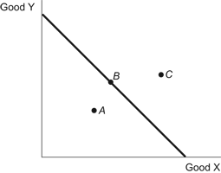

Which of the points representing various consumption possibilities for the country portrayed in the figure is only attainable through foreign trade?
 | a. | point A
 | b. | point B
 | c. | point C
 | d. | both points C and B

ANSWER: | c

70. Figure: PPF Goods X and Y
Point A represents an allocation of resources that is:
 | a. | efficient.
 | b. | inefficient.
 | c. | impossible.
 | d. | the result of trade.

ANSWER: | b

71. Suppose a country without any international trade opens its borders to international trade. After specialization, how will its location on its production possibility frontier change?
 | a. | The country moves from inside the PPF to on the PPF.
 | b. | The country moves from on the PPF to beyond the PPF.
 | c. | The country moves along the PPF toward its comparative advantage.
 | d. | The country moves along the PPF away from its comparative advantage.

ANSWER: | b

72. Figure: PPF Nickel and Textiles

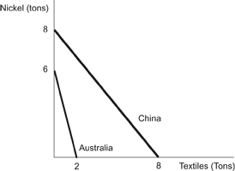
​
What is the maximum amount of nickel China can produce?
 | a. | 10 tons
 | b. | 8 tons
 | c. | 6 tons
 | d. | 4 tons  ​

ANSWER: | b

73. Figure: PPF Nickel and Textiles
​

What is the maximum amount of textiles China can produce?
 | a. | 10 tons
 | b. | 8 tons
 | c. | 6 tons
 | d. | 4 tons  ​

ANSWER: | b

74. Figure: PPF Nickel and Textiles
​
How many tons of textiles does Australia give up to produce 1 ton of nickel?
 | a. | 1/3
 | b. | 1/2
 | c. | 2
 | d. | 3  ​

ANSWER: | a

75. On a production possibilities frontier, a trade-off can be illustrated as:
 | a. | an outward shift.
 | b. | an inward shift.
 | c. | a movement from a point inside the frontier to one on the frontier.
 | d. | a movement along the frontier itself.

ANSWER: | d

76. The production possibilities frontier shows:
 | a. | the combinations of outputs a country can produce given its resources and productivity.
 | b. | the combinations of inputs that a country has given its outputs and productivity.
 | c. | the combinations of outputs and resources that a country possesses given its productivity.
 | d. | the maximum level of a country's productivity given its resources and outputs.

ANSWER: | a

77. Anita is a wonderful baker and can bake 10 cakes in a day, but then she has no time left to make cookies. If she bakes only cookies, she can make 200 cookies in a day. John can make equally delicious cakes and cookies but can make only 7 cakes or 100 cookies in a day. Based on this information, which of the following statements is TRUE?
 | a. | Anita has the comparative advantage in the production of cakes.
 | b. | John has the comparative advantage in the production of cakes.
 | c. | John has the absolute advantage in the production of cookies.
 | d. | Anita has the comparative advantage in the production of both cakes and cookies.

ANSWER: | b

78. Anita is a wonderful baker and can bake 10 cakes in a day, but then she has no time left to make cookies. If she bakes only cookies, she can make 200 cookies in a day. John can make equally delicious cakes and cookies but can make only 7 cakes or 100 cookies in a day. Based on this information, which of the following statements is TRUE?
 | a. | Anita should split her time between cakes and cookies. John should bake cakes.
 | b. | Anita should bake cakes, and John should bake cookies.
 | c. | Anita and John should split their time equally between cakes and cookies.
 | d. | Anita should bake cookies, and John should bake cakes.

ANSWER: | d

79. Figure: PPF Mexico and United States
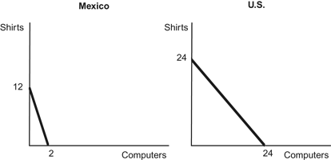

The production possibility frontiers above show what Mexico and the U.S. can produce using 24 units of labor. The opportunity costs of producing 1 computer are:
 | a. | 6 shirts for Mexico and 1 shirt for the United States.
 | b. | 1/6 of a shirt for both Mexico and the United States.
 | c. | 1 shirt for Mexico and 1/6 of a shirt for the United States.
 | d. | 6 shirts for both Mexico and the United States.

ANSWER: | a

80. Figure: PPF Mexico and United States

The production possibility frontiers above show what Mexico and the U.S. can produce using 24 units of labor. The opportunity costs of producing 1 shirt are:
 | a. | 1 computer for Mexico and 1/6 of a computer for the United States.
 | b. | 1/6 of a computer for Mexico and 1 computer for United States.
 | c. | 1 computer for both Mexico and the United States.
 | d. | 1/6 of a computer for both Mexico and the United States.

ANSWER: | b

81. Figure: PPF Mexico and United States

The production possibility frontiers above show what Mexico and the U.S. can produce using 24 units of labor. Mexico has a comparative advantage in _____, and the United States has a comparative advantage in _____.
 | a. | computers; shirts
 | b. | shirts; computers
 | c. | computers; computers
 | d. | shirts; shirts

ANSWER: | b

82. Figure: PPF Australia and United States
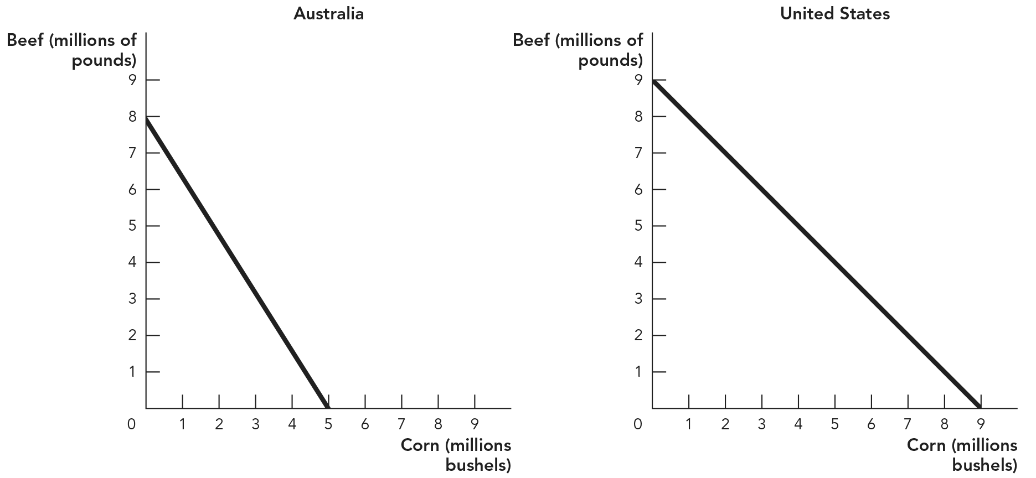
​
The figures above show what Australia and the U.S. can produce using the same quantity of labor. The opportunity costs of producing 1 pound of beef are:
 | a. | 5/8 of a bushel of corn for Australia and 1 bushel of corn for the United States.
 | b. | 8/5 bushels of corn for the United States and 1 bushel of corn for Australia.
 | c. | 1 bushel of corn for Australia and 5/8 of a bushel of corn for the United States.
 | d. | 8/5 bushels of corn for the United States and 1 bushel of corn for Australia.

ANSWER: | a

83. Figure: PPF Australia and United States
​
The figures above show what Australia and the U.S. can produce using the same quantity of labor. The opportunity costs of producing 1 bushel of corn are:
 | a. | 8/5 pounds of beef for Australia and 1 pound of beef for the United States.
 | b. | 5/8 of a pound of beef for the United States and 1 pound of beef for Australia.
 | c. | 8/5 pounds of beef for Australia and 5/8 of a pound of beef for the United States.
 | d. | 1 pound of beef for the United States and 5/8 of a pound of beef for Australia.  ​

ANSWER: | a

84. Figure: PPF Australia and United States
​
The figures above show what Australia and the U.S. can produce using the same quantity of labor. Australia and the United States would be willing to trade 1 pound of beef for:
 | a. | between 1 and 8/5 pounds of corn.
 | b. | between 5/8 and 1 pound of corn.
 | c. | between 2/3 and 5/8 of a pound of corn.
 | d. | 5/8 of a pound of beef for the United States and 8/5 pounds of beef for Australia.  ​

ANSWER: | b

85. Figure: PPF Australia and United States
​
The figures above show what Australia and the U.S. can produce using the same quantity of labor. Australia has a comparative advantage in _____, and the United States has a comparative advantage in _____.
 | a. | corn; beef
 | b. | beef; beef
 | c. | beef; corn
 | d. | corn; corn  ​

ANSWER: | c

86. Figure: PPF Australia and United States
​
The figures above show what Australia and the U.S. can produce using the same quantity of labor. Australia has an absolute advantage in _____, and the United States has an absolute advantage in _____.
 | a. | neither corn nor beef; both corn and beef
 | b. | both corn and beef; neither corn nor beef
 | c. | beef; corn
 | d. | corn; beef  ​

ANSWER: | b

87. Figure: PPF Australia and United States
​
The figures above show what Australia and the U.S. can produce using the same quantity of labor. If Australia and the United States trade to have higher consumption, the United States should specialize in the production of _____, and Australia should specialize in the production of _____.
 | a. | neither corn nor beef; both corn and beef
 | b. | both corn and beef; neither corn nor beef
 | c. | beef; corn
 | d. | corn; beef  ​

ANSWER: | d

88. Table: Production Possibilities for the United States and Mexico
 | Corn (millions of tons) | Potatoes (millions of tons)
United States | 50 | 10
Mexico | 40 | 5

According to the table on production possibilities for the United States and Mexico, Mexico has an absolute advantage in _____ and a comparative advantage in _____.
 | a. | neither good; corn
 | b. | corn; potatoes
 | c. | potatoes; corn
 | d. | neither good; potatoes

ANSWER: | a

89. Table: Production Possibilities for the United States and Mexico
 | Corn (millions of tons) | Potatoes (millions of tons)
United States | 50 | 10
Mexico | 40 | 5

According to the table on production possibilities for the United States and Mexico, the United States has an absolute advantage in _____ and a comparative advantage in _____.
 | a. | both goods; corn
 | b. | both goods; potatoes
 | c. | potatoes; corn
 | d. | nothing; potatoes

ANSWER: | b

90. Table: Production Possibilities for the United States and Mexico
 | Corn (millions of tons) | Potatoes (millions of tons)
United States | 50 | 10
Mexico | 40 | 5

According to the table on production possibilities for the United States and Mexico, Mexico's opportunity cost of producing each ton of potatoes is _____, while the United States's opportunity cost of producing each ton of potatoes is _____.
 | a. | 0.125 ton of potatoes; 0.2 ton of potatoes
 | b. | 8 tons of corn; 0.2 ton of potatoes
 | c. | 8 tons of corn; 5 tons of corn
 | d. | 5 tons of corn; 0.2 ton of corn

ANSWER: | c

91. Table: Production Possibilities for the United States and Mexico
 | Corn (millions of tons) | Potatoes (millions of tons)
United States | 50 | 10
Mexico | 40 | 5

Using the table on production possibilities for the United States and Mexico, assume each country specializes in the good for which it has a comparative advantage. Which of the following answers identifies a trade price that both countries would find acceptable?
 | a. | A price between 0.2 potato for 1 corn and 5 corns for 1 potato
 | b. | A price between 0.125 potato for 1 corn and 8 potatoes for 1 corn
 | c. | A price between 5 corns for 1 potato and 8 corns for 1 potato
 | d. | A price between 0.125 potato for 1 corn and 5 potatoes for 1 corn

ANSWER: | c

92. Table: Production Possibilities for Dante and Helena
 | Greeting Cards | Artistic Posters
Dante | 4 | 2
Helena | 6 | 1

Dante is an artist who produces custom-made greeting cards and artistic posters. Helena is an equally talented artist who can produce these items as well. According to the table on production possibilities, Dante's opportunity cost of producing artistic posters is _____, and Helena's opportunity cost of producing artistic posters is _____.
 | a. | ½ greeting card; 1/6 greeting card
 | b. | 4 greeting cards; 6 greeting cards
 | c. | 2 greeting cards; 6 greeting cards
 | d. | 4 greeting cards; 1 greeting card

ANSWER: | c

93. Table: Production Possibilities for Dante and Helena
 | Greeting Cards | Artistic Posters
Dante | 4 | 2
Helena | 6 | 1

Dante is an artist who produces custom-made greeting cards and artistic posters. Helena is an equally talented artist who can produce these items as well. According to the table on production possibilities, Dante's opportunity cost of producing greeting cards is _____, and Helena's opportunity cost of producing greeting cards is _____.
 | a. | ½ artistic poster; 1/6 artistic poster
 | b. | 2/3 artistic poster; ½ artistic poster
 | c. | 2 artistic posters; 6 artistic posters
 | d. | 4 artistic posters; 1 artistic poster

ANSWER: | a

94. Table: Production Possibilities for Dante and Helena
 | Greeting Cards | Artistic Posters
Dante | 4 | 2
Helena | 6 | 1

Dante is an artist who produces custom-made greeting cards and artistic posters. Helena is an equally talented artist who can produce these items as well. According to the table on production possibilities, Dante should specialize in producing _____, and Helena should specialize in producing _____.
 | a. | greeting cards; greeting cards
 | b. | artistic posters; artistic posters
 | c. | artistic posters; greeting cards
 | d. | greeting cards; artistic posters

ANSWER: | c

95. Table: Production Possibilities for Kenya and Sri Lanka
 | Beans (millions of tons) | Tea (millions of tons)
Kenya | 100 | 200
Sri Lanka | 150 | 450

According to the table on production possibilities for Kenya and Sri Lanka, Kenya's opportunity cost of producing beans is _____, while Sri Lanka's opportunity cost of producing beans is _____.
 | a. | 0.5 tea; 0.33 tea
 | b. | 2 teas; 0.33 tea
 | c. | 200 teas; 450 teas
 | d. | 2 teas; 3 teas

ANSWER: | d

96. Table: Production Possibilities for Kenya and Sri Lanka
 | Beans (millions of tons) | Tea (millions of tons)
Kenya | 100 | 200
Sri Lanka | 150 | 450

According to the table on production possibilities for Kenya and Sri Lanka, Kenya should produce _____, and Sri Lanka should produce _____.
 | a. | beans; tea
 | b. | tea; beans
 | c. | both goods; neither good
 | d. | neither good; both goods

ANSWER: | a

97. Table: Production Possibilities for Kenya and Sri Lanka
 | Beans (millions of tons) | Tea (millions of tons)
Kenya | 100 | 200
Sri Lanka | 150 | 450

According to the table on production possibilities for Kenya and Sri Lanka, which of the following answers identifies a trade price that both countries would find acceptable?
 | a. | A price between 0.5 bean for 1 tea and 2 teas for 1 bean
 | b. | A price between 0.5 and 3 beans for 1 tea
 | c. | A price between 2 and 3 teas for 1 bean
 | d. | A price between 0.3 and 2 beans for 1 tea

ANSWER: | c

98. Table: Production Possibilities for Italy and Belgium
 | Labor Hours Needed to Make 1 Pound of: |  |  | Pounds Produced in 40 Hours
 | Linen | Pasta | Linen |  | Pasta
Italy | 10 | 4 | 4 |  | 10
Belgium | 2 | 8 | 20 |  | 5

According to the table on production possibilities for Italy and Belgium, the opportunity cost of 1 pound of linen for Italy is:
 | a. | 10 pounds of pasta.
 | b. | 1/4 pound of pasta.
 | c. | 4 pounds of pasta.
 | d. | 2 1/2 pounds of pasta.

ANSWER: | d

99. Table: Production Possibilities for Italy and Belgium
 | Labor Hours Needed to Make 1 Pound of: |  |  | Pounds Produced in 40 Hours
 | Linen | Pasta | Linen |  | Pasta
Italy | 10 | 4 | 4 |  | 10
Belgium | 2 | 8 | 20 |  | 5

According to the table on production possibilities for Italy and Belgium, the opportunity cost of 1 pound of linen for Belgium is:
 | a. | 5 pounds of pasta.
 | b. | 4 pounds of pasta.
 | c. | 1/4 pound of pasta.
 | d. | 20 pounds of pasta.

ANSWER: | c

100. Table: Production Possibilities for Italy and Belgium
 | Labor Hours Needed to Make 1 Pound of: |  |  | Pounds Produced in 40 Hours
 | Linen | Pasta | Linen |  | Pasta
Italy | 10 | 4 | 4 |  | 10
Belgium | 2 | 8 | 20 |  | 5

According to the table on production possibilities for Italy and Belgium, the opportunity cost of 1 pound of pasta for Italy is:
 | a. | 2/5 pound of linen.
 | b. | 4 pounds of linen.
 | c. | 1/4 pound of linen.
 | d. | 2 hours of labor.

ANSWER: | a

101. Table: Production Possibilities for Italy and Belgium
 | Labor Hours Needed to Make 1 Pound of: |  |  | Pounds Produced in 40 Hours
 | Linen | Pasta | Linen |  | Pasta
Italy | 10 | 4 | 4 |  | 10
Belgium | 2 | 8 | 20 |  | 5

According to the table on production possibilities for Italy and Belgium, the opportunity cost of 1 pound of pasta for Belgium is:
 | a. | 5 pounds of linen.
 | b. | 20 pounds of linen.
 | c. | 1/4 pound of linen.
 | d. | 4 pounds of linen.

ANSWER: | d

102. Table: Production Possibilities for Italy and Belgium
 | Labor Hours Needed to Make 1 Pound of: |  |  | Pounds Produced in 40 Hours
 | Linen | Pasta | Linen |  | Pasta
Italy | 10 | 4 | 4 |  | 10
Belgium | 2 | 8 | 20 |  | 5

According to the table on production possibilities for Italy and Belgium, Italy has a comparative advantage in:
 | a. | both goods, while Belgium has a comparative advantage in neither good.
 | b. | linen, while Belgium has a comparative advantage in pasta.
 | c. | pasta, while Belgium has a comparative advantage in linen.
 | d. | neither good, while Belgium has a comparative advantage in both goods.

ANSWER: | c

103. Table: Production Possibilities for Italy and Belgium
 | Labor Hours Needed to Make 1 Pound of: |  |  | Pounds Produced in 40 Hours
 | Linen | Pasta | Linen |  | Pasta
Italy | 10 | 4 | 4 |  | 10
Belgium | 2 | 8 | 20 |  | 5

According to the table on production possibilities for Italy and Belgium, Italy and Belgium both could benefit if Italy were to specialize in:
 | a. | neither good and Belgium were to specialize in both goods.
 | b. | both goods and Belgium were to specialize in neither good.
 | c. | pasta and Belgium were to specialize in linen.
 | d. | linen and Belgium were to specialize in pasta.

ANSWER: | c

104. Table: Production Possibilities for Italy and Belgium
 | Labor Hours Needed to Make 1 Pound of: |  |  | Pounds Produced in 40 Hours
 | Linen | Pasta | Linen |  | Pasta
Italy | 10 | 4 | 4 |  | 10
Belgium | 2 | 8 | 20 |  | 5

According to the table on production possibilities for Italy and Belgium, Belgium should specialize in linen production because it:
 | a. | has an absolute advantage in producing linen and pasta.
 | b. | can do so at a greater opportunity cost.
 | c. | has a comparative advantage in producing linen.
 | d. | already can produce enough pasta to meet demand.

ANSWER: | c

105. Table: Production in the United States and Germany
 | Labor Units Required to Produce:
 | 1 Clock | 1 Sofa
United States | 2 | 5
Germany | 3 | 9

According to the table, the opportunity cost of producing 1 sofa in the United States is _____, and the opportunity cost of producing 1 sofa in Germany is _____.
 | a. | 2 clocks; 3 clocks
 | b. | 10 clocks; 27 clocks
 | c. | 0.4 clock; 0.33 clock
 | d. | 2.5 clocks; 3 clocks

ANSWER: | d

106. Table: Production in the United States and Germany
 | Labor Units Required to Produce:
 | 1 Clock | 1 Sofa
United States | 2 | 5
Germany | 3 | 9

According to the table, the opportunity cost of producing 1 clock in the United States is _____, and the opportunity cost of producing 1 clock in Germany is _____.
 | a. | 5 sofas; 9 sofas
 | b. | 0.4 sofa; 0.33 sofa
 | c. | 5 clocks; 9 clocks
 | d. | 2.5 clocks; 3 clocks

ANSWER: | b

107. Table: Production in the United States and Germany
 | Labor Units Required to Produce:
 | 1 Clock | 1 Sofa
United States | 2 | 5
Germany | 3 | 9

According to the table, which of the following statements is TRUE?
 | a. | The United States has a comparative advantage in clocks.
 | b. | Germany has an absolute advantage in clocks and sofas.
 | c. | The United States has a comparative advantage in sofas.
 | d. | The United States has a comparative advantage in clocks and sofas.

ANSWER: | c

108. Table: Production in France and Italy
 | Labor Units Required to Produce:
 | 1 Bag of Truffles | 1 Pair of Wool Socks
France | 1 | 1
Italy | 2 | 4

According to the table, France should specialize in producing _____, and Italy should specialize in producing _____.
 | a. | truffles; wool socks
 | b. | wool socks; truffles
 | c. | truffles; truffles
 | d. | wool socks; wool socks

ANSWER: | b

109. In Colombia, it takes 3 workers to produce 2 pounds of coffee. In Mexico, it takes 4 workers to produce 1 pound of coffee. Therefore:
 | a. | Colombia has a comparative advantage in the production of coffee.
 | b. | Mexico has a comparative advantage in the production of coffee.
 | c. | in Colombia, the opportunity cost of producing 1 pound of coffee is 2/3.
 | d. | Colombia has an absolute advantage in the production of coffee.

ANSWER: | d

110. In Spain, it takes 4 workers to produce 4 bottles of wine. In France, it takes 3 workers to produce 4 bottles of wine. Therefore:
 | a. | Spain has a comparative advantage in the production of wine.
 | b. | France has an absolute advantage in the production of wine.
 | c. | In Spain, the opportunity cost of producing 1 bottle of wine is 3/4.
 | d. | Spain has an absolute advantage in the production of wine.

ANSWER: | b

111. In Spain, it takes 3 workers to produce 4 pounds of cheese. In France, it takes 6 workers to produce 4 pounds of cheese. Therefore:
 | a. | Spain has a comparative advantage in the production of cheese.
 | b. | France has an absolute advantage in the production of cheese.
 | c. | In Spain, the opportunity cost of producing 1 pound of cheese is 1/2.
 | d. | Spain has an absolute advantage in the production of cheese.

ANSWER: | d

112. Which statement is TRUE?
 | a. | It is virtually impossible for a country to be the low-cost producer of all goods and services.
 | b. | The benefits of trade depend on absolute advantage, not comparative advantage.
 | c. | A country could have a comparative advantage in producing everything.
 | d. | A country that has the absolute advantage in production will also have the comparative advantage.

ANSWER: | a

113. Figure: Countries A and B
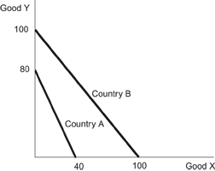
​
According to the diagram about countries A and B, which of the following statement(s) is correct?
I. Country A has a comparative advantage in good Y.
II. Country B has an absolute advantage in both goods.
III. Country B has a comparative advantage in good X.
 | a. | I and II only
 | b. | I and III only
 | c. | II and III only
 | d. | I, II, and III  ​

ANSWER: | d

114. Figure: Countries A and B
​
The opportunity cost of producing good X in country A is _____, and in country B, it is _____, meaning that country _____ should specialize in producing good X and country _____ in good Y.
 | a. | 2Y; 1Y; B; A
 | b. | 1/2Y; 1Y; B; A
 | c. | 1/2Y; 1Y; A; B
 | d. | 2Y; 1Y; A; B  ​

ANSWER: | a

115. Figure: Countries A and B
​
If both countries fully allocated all of their labor toward the good in which they have a comparative advantage, the combined production for the two countries would be _____ units of good X and _____ units of good Y.
 | a. | 100; 80
 | b. | 70; 90
 | c. | 40; 100
 | d. | 100; 100  ​

ANSWER: | a

116. Figure: Countries A and B
​
Assume that each country begins by allocating half its labor force to the production of each good. Through trade with each other, each country could increase its consumption of both goods if country A moved part of its labor force to the production of good _____ and country B moved part of its labor force to the production of good _____.
 | a. | X; X
 | b. | X; Y
 | c. | Y; Y
 | d. | Y; X  ​

ANSWER: | d

117. Figure: Countries A and B
​
If each country allocated half of its labor force to the production of each good before trade and then each specialized in its comparative advantage and allocated 75 percent of its labor force to the production of that good, world production of good X would change by _____ and the production of good Y by _____.
 | a. | 40; 50
 | b. | 25; –5
 | c. | 15; –5
 | d. | 50; 40  ​

ANSWER: | c

118. Figure: Countries M and N
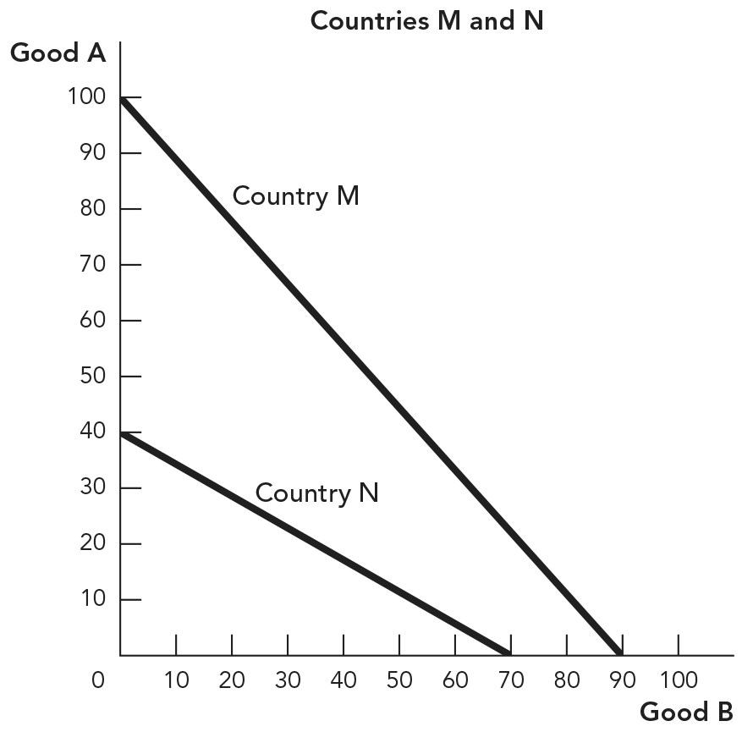

If both countries fully allocated all of their labor toward the good in which they have a comparative advantage, the combined production for the two countries would be _____ units of good A and _____ units of good B.
 | a. | 100; 70
 | b. | 40; 90
 | c. | 90; 70
 | d. | 100; 40

ANSWER: | a

119. Figure: Countries M and N

Assume that each country begins by allocating half of its labor force to the production of each good. Through trade, each country could increase its consumption of both goods if country M moved part of its labor force to the production of good _____ and country N moved part of its labor force to the production of good _____.
 | a. | A; B
 | b. | B; A
 | c. | A; A
 | d. | B; B

ANSWER: | a

120. Which of the following best characterizes the relationship between the parties to a trade and the gains from trade?
 | a. | Gains from trade are fueled by differences in preferences and differences in opportunity costs of production.
 | b. | Gains from trade are fueled by differences in preferences only.
 | c. | Gains from trade are fueled by differences in opportunity costs of production only.
 | d. | Gains from trade are greatest when there are no differences between the two parties to a trade.

ANSWER: | a

121. Two countries that specialize in something where they have a comparative advantage and then trade with each other will experience increases in:
I. wages.
II. total output.
III. living standards.
 | a. | I and II only
 | b. | II and III only
 | c. | II only
 | d. | I, II, and III

ANSWER: | d

122. Which of the following statements is TRUE?
 | a. | Two countries that specialize in something in which they have a comparative advantage and then trade with each other will experience an increase in wages, but not total output.
 | b. | Two countries that specialize in something in which they have a comparative advantage and then trade with each other will experience an increase in total output, but not wages.
 | c. | Two countries that specialize in something in which they have a comparative advantage and then trade with each other will experience a decrease in living standards.
 | d. | Two countries that specialize in something in which they have a comparative advantage and then trade with each other will experience an increase in wages, total output, and living standards.

ANSWER: | d

123. Which of the following statements is TRUE?
 | a. | Trade makes workers in high-productivity countries less productive.
 | b. | Trade causes workers in low-wage countries to receive an even lower wage.
 | c. | Specialization and trade raise wages in both countries that are party to the trade.
 | d. | Specialization and trade raise productivity but not wages.

ANSWER: | c

124. If labor in China is less productive than labor in the United States in all areas of production, then:
 | a. | both the United States and China can benefit from trade.
 | b. | neither nation can benefit from trade.
 | c. | China can benefit from trade, but the United States cannot.
 | d. | the United States can benefit from trade, but China cannot.

ANSWER: | a

125. According to the theory of comparative advantage, the reason wages are lower in China than in the United States is:
 | a. | the higher cost of living in the United States.
 | b. | lower productivity in China.
 | c. | the lower opportunity cost to work in China.
 | d. | more trade restrictions in the United States.

ANSWER: | b

126. Which of the following statements is TRUE?
 | a. | Only a high-wage country can benefit by trading with a low-wage country.
 | b. | A high-wage country cannot benefit by trading with a low-wage country.
 | c. | Trade raises the wages of workers in low- and high-wage countries.
 | d. | There is an inverse relationship between productivity and wages.

ANSWER: | c

127. Sophia and Manuel are married. Sophia can do $15 worth of household chores per hour, and Manuel can do $30 worth of household chores per hour. In the labor market, Manuel can earn $30 per hour and Sophia can earn $45 per hour. The theory of comparative advantage suggests that:
 | a. | Manuel should specialize in household chores and Sophia should specialize in the labor market.
 | b. | Sophia should specialize in household chores and Manuel should specialize in the labor market.
 | c. | Sophia should specialize in both household chores and the labor market.
 | d. | Manuel should specialize in both household chores and the labor market.

ANSWER: | a

128. The principles of comparative advantage, specialization, and trade apply to:
I. individuals.
II. communities.
III. regions.
IV. nations.
 | a. | I and II only
 | b. | I, II, and III only
 | c. | II, III, and IV only
 | d. | I, II, III, and IV

ANSWER: | d

129. Adam Smith advocated the benefits of:
 | a. | protectionism.
 | b. | trade tariffs over trade quotas.
 | c. | international trade.
 | d. | absolute advantage.

ANSWER: | c

130. Absolute advantage is the ability to produce a:
 | a. | good at a lower opportunity cost than others.
 | b. | good with fewer inputs than others.
 | c. | good when demand is high.
 | d. | variety of goods.

ANSWER: | b

131. A country has a comparative advantage in producing a good when it produces that good:
 | a. | at a lower opportunity cost than another country.
 | b. | at a higher opportunity cost than another country.
 | c. | in greater quantity than another country.
 | d. | with fewer inputs than another country.

ANSWER: | a

132. Two persons each produce two identical goods. Which of the following is TRUE about their absolute and comparative advantages in the production of these two goods?
 | a. | One person can have an absolute advantage in both goods but not a comparative advantage in both goods.
 | b. | One person can have a comparative advantage in both goods but not an absolute advantage in both goods.
 | c. | One person can have neither an absolute nor a comparative advantage in either good.
 | d. | Both persons can always have both an absolute and comparative advantage in both goods.

ANSWER: | a

133. To benefit the most from trade, a person should:
 | a. | specialize in an activity for which she has an absolute advantage.
 | b. | specialize in an activity for which she has a comparative advantage.
 | c. | do everything she possibly can.
 | d. | do as little as possible.

ANSWER: | b

134. The concept of comparative advantage implies that:
 | a. | there are winners and losers when people trade without specializing.
 | b. | people have to be self-sufficient.
 | c. | people benefit from specializing and trading with one another.
 | d. | only those people who are productive benefit from trade.

ANSWER: | c

135. The reason Martha Stewart does not iron her own clothes is that:
 | a. | she has never learned how to iron.
 | b. | she has a comparative advantage in ironing.
 | c. | she does not have an absolute advantage in ironing.
 | d. | her opportunity cost of ironing exceeds the person's wages providing the ironing service.

ANSWER: | d

136. Both Maria and Jorge bake cookies and bread, but Maria spends less time baking each batch of cookies and each loaf of bread than Jorge does. Which of the following is TRUE?
 | a. | Maria has an absolute advantage in baking both cookies and bread.
 | b. | Maria has a comparative advantage in baking both cookies and bread.
 | c. | Jorge has an absolute advantage in baking both cookies and bread.
 | d. | Jorge has a comparative advantage in baking both cookies and bread.

ANSWER: | a

137. Both Maria and Jorge bake cookies and bread, but Maria spends less time baking each batch of cookies and each loaf of bread than Jorge does. Specialization and trade between them can benefit:
 | a. | both Maria and Jorge.
 | b. | Maria, but not Jorge.
 | c. | Jorge, but not Maria.
 | d. | neither Maria nor Jorge.

ANSWER: | a

138. Both Bohai and Guiren build fine wood dining tables and desks. Bohai spends less time building each desk than Guiren does. Guiren spends less time building each dining table than Bohai does. Which of the following is TRUE?
 | a. | Bohai has an absolute advantage in building both dining tables and desks.
 | b. | Bohai has a comparative advantage in building desks.
 | c. | Guiren has an absolute advantage in building both dining tables and desks.
 | d. | Guiren has a comparative advantage in building desks.

ANSWER: | b

139. Both Bohai and Guiren build fine wood dining tables and desks. Bohai spends less time building each desk than Guiren does. Guiren spends less time building each dining table than Bohai does. Specialization and trade between them can benefit:
 | a. | both Bohai and Guiren.
 | b. | Bohai, but not Guiren.
 | c. | Guiren, but not Bohai.
 | d. | neither Bohai nor Guiren.

ANSWER: | a

140. Which of the following explains why someone with an absolute advantage in painting houses may NOT spend their time painting houses?
 | a. | They may also have a comparative advantage in painting houses.
 | b. | Even though they have an absolute advantage in painting houses, they still may not be very good at it.
 | c. | In an efficient market, someone with an absolute advantage in painting houses will always spend their time painting houses.
 | d. | They may be relatively better at something else than painting houses.

ANSWER: | d

141. In his prime, Michael Jordan played both professional basketball and professional baseball. Compared with most people, Jordan would have an absolute advantage in:
 | a. | playing both basketball and baseball, since he was better at both than the average person.
 | b. | playing basketball only because he was relatively better at basketball.
 | c. | playing baseball only, since he ultimately gave up baseball to concentrate on basketball.
 | d. | neither basketball or baseball, since he cannot hold the relative advantage in both sports.

ANSWER: | a

142. A country has an absolute advantage in production if:
 | a. | it can produce the same good using fewer inputs than another country.
 | b. | it can produce a good using fewer inputs than it takes another country to produce a different good.
 | c. | other countries can produce the same good using fewer inputs.
 | d. | it has the lowest opportunity cost of producing a good.

ANSWER: | a

143. A country has a comparative advantage in production if:
 | a. | it can produce the same good using fewer inputs than another country.
 | b. | it can produce a good using fewer inputs than it takes another country to produce a different good.
 | c. | other countries can produce the same good using fewer inputs.
 | d. | it has the lowest opportunity cost of producing a good.

ANSWER: | d

144. Martha Stewart does not do her own ironing because she:
 | a. | is not very good at ironing.
 | b. | has an absolute advantage in ironing.
 | c. | has a comparative advantage in something else.
 | d. | has a comparative advantage in ironing.

ANSWER: | c

145. A country has a comparative advantage in a good if:
 | a. | it can produce more of that good than any other country can.
 | b. | it does not have an absolute advantage in that good.
 | c. | it has the lowest opportunity cost of producing that good.
 | d. | no other country is willing to buy that good from it.

ANSWER: | c

146. Traders should specialize in the good:
 | a. | that they can produce with the lowest opportunity cost.
 | b. | in which they have an absolute advantage.
 | c. | in which their trading partner has a comparative advantage.
 | d. | in which they do not have an absolute advantage.

ANSWER: | a

147. Brazil can produce 1 unit of sugarcane with 1 unit of labor and 1 iPod with 8 units of labor, and China can produce 1 unit of sugarcane with 2 units of labor and 1 iPod with 4 units of labor. Which of the following is TRUE?
 | a. | Brazil has a comparative advantage in sugarcane production and an absolute advantage in iPod production.
 | b. | Both countries have a comparative advantage in sugarcane production.
 | c. | China has an absolute advantage in production of both goods.
 | d. | Brazil has both a comparative advantage and an absolute advantage in sugarcane production.

ANSWER: | d

148. Brazil can produce 1 unit of sugarcane with 1 unit of labor and 1 iPod with 8 units of labor, and China can produce 1 unit of sugarcane with 2 units of labor and 1 iPod with 4 units of labor. What are each country's opportunity costs of producing iPods?
 | a. | Brazil: 4 units of sugarcane; China: 2 units of sugarcane
 | b. | Brazil: 8 units of sugarcane; China: 2 units of sugarcane
 | c. | Brazil: 1/8 unit of sugarcane; China: 1/2 unit of sugarcane
 | d. | Brazil: 1/2 unit of sugarcane; China: 1/2 unit of sugarcane

ANSWER: | b

149. Brazil can produce 1 unit of sugarcane with 1 unit of labor and 1 iPod with 8 units of labor, and China can produce 1 unit of sugarcane with 2 units of labor and 1 iPod with 4 units of labor. Which of the following is TRUE?
 | a. | Before trade, China's opportunity cost of 1 unit of sugarcane is 2 iPods.
 | b. | China has an absolute advantage in sugarcane production.
 | c. | Both parties benefit if they specialize and trade at terms of 1 unit of sugarcane for 2 iPods.
 | d. | With trade, Brazil should specialize in sugarcane and China in iPods.

ANSWER: | d

150. The better a person is at producing one good:
 | a. | the worse he is at producing other goods.
 | b. | the higher the opportunity cost to him of producing other goods.
 | c. | the lower the incentive he has to trade with other people.
 | d. | the better he is at producing other goods.

ANSWER: | b

151. Producers who have absolute advantages in all goods:
 | a. | cannot exist.
 | b. | have no use for trade.
 | c. | are better off specializing in their comparative advantages and trading for other goods.
 | d. | should avoid the global division of labor because it is counterproductive for them.

ANSWER: | c

152. In 2010, Switzerland-based Nestlé began sailing supermarket barges up and down parts of the Amazon River. The barges carry approximately 300 different goods and cater to about a dozen local communities that fish the Amazon's bountiful rivers and whose members lack the time and money to visit a conventional store. Which advantage from trade is illustrated in this passage?
 | a. | differences in preferences
 | b. | specialization
 | c. | comparative advantage
 | d. | Each of these advantages is illustrated in the passage.

ANSWER: | c

153. When determining what a country should specialize in producing, economists chiefly consider:
 | a. | absolute advantage.
 | b. | comparative advantage.
 | c. | incentives.
 | d. | the dispersion of knowledge.

ANSWER: | b

154. A country has an absolute advantage if it can produce _____ good using _____ inputs than another country.
 | a. | the same; fewer
 | b. | a different; more
 | c. | the same; more
 | d. | a different; fewer

ANSWER: | a

155. The production possibility frontier shows:
 | a. | how society can produce more of one good without giving up the production of another good.
 | b. | what people can consume given different combinations of goods produced.
 | c. | the combinations of output that an economy can produce given its productivity and supply of inputs.
 | d. | the types of goods and services that society should produce to satisfy social interest.

ANSWER: | c

156. When using a production possibilities frontier (PPF), a trade-off is demonstrated by:
 | a. | an outward shift of the PPF.
 | b. | an inward shift of the PPF.
 | c. | a movement from a point inside the PPF to a point on the frontier.
 | d. | a movement along the PPF.

ANSWER: | d

157. Figure: Production Possibilities A and B
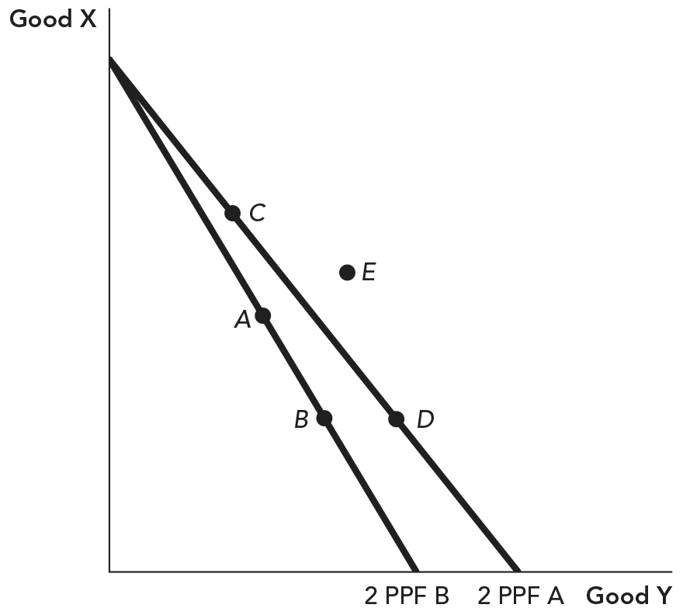

In the graph, a trade-off is shown in the movement from:
 | a. | point A to point B.
 | b. | point A to point C.
 | c. | point B to point E.
 | d. | PPF A to PPF B.

ANSWER: | a

158. Figure: Production Possibilities A and B

If this economy is currently functioning at point D on PPF A without international trade, which point best represents consumption with trade?
 | a. | point A
 | b. | point C
 | c. | point E
 | d. | point B

ANSWER: | c

159. The fundamental idea behind the production possibilities frontier is:
 | a. | the idea of absolute advantage.
 | b. | the trade-offs that exist in production.
 | c. | that economic growth is unlimited.
 | d. | that incentives matter.

ANSWER: | b

160. The slope of the production possibilities frontier at a given point indicates _____.
 | a. | the preferences of a country
 | b. | a country's total gains from trade
 | c. | a country's opportunity cost of production
 | d. | a country's trade balance

ANSWER: | c

161. Which of the following is FALSE regarding the production possibilities frontier (PPF)?
 | a. | The PPF shows the combination of goods that a country can produce given its current productivity and supply of resources.
 | b. | The PPF illustrates the trade-offs that exist in the production of goods.
 | c. | The PPF shows us that gains from trade are maximized when countries produce goods for which they have an absolute advantage in production.
 | d. | The PPF illustrates the fundamental ideas of scarcity and opportunity cost.

ANSWER: | c

162. Figure: U.S. Production Possibility Frontier
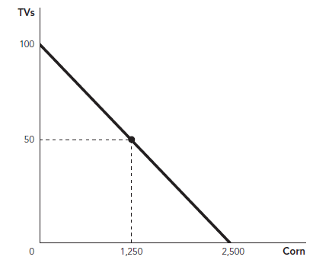

Suppose the figure illustrates the U.S. PPF for the production of corn and TVs. Which of the following statements is TRUE?
 | a. | The United States should specialize in the production of corn, since it can produce more corn than TVs.
 | b. | For each TV that the United States produces, it gives up 25 units of corn.
 | c. | The United States should produce 50 TVs and 1,250 units of corn to maximize value to society.
 | d. | The United States has a comparative advantage in the production of TVs.

ANSWER: | b

163. A production possibilities frontier shows:
 | a. | the supply and demand for a good in a country.
 | b. | all combinations of goods that a country can produce given its productivity and supply of inputs.
 | c. | the uninhabited territory of a country that is full of new possibilities.
 | d. | the goods that a country will be able to produce in the future if it continues to grow.

ANSWER: | b

164. Figure: Coffee and Tea
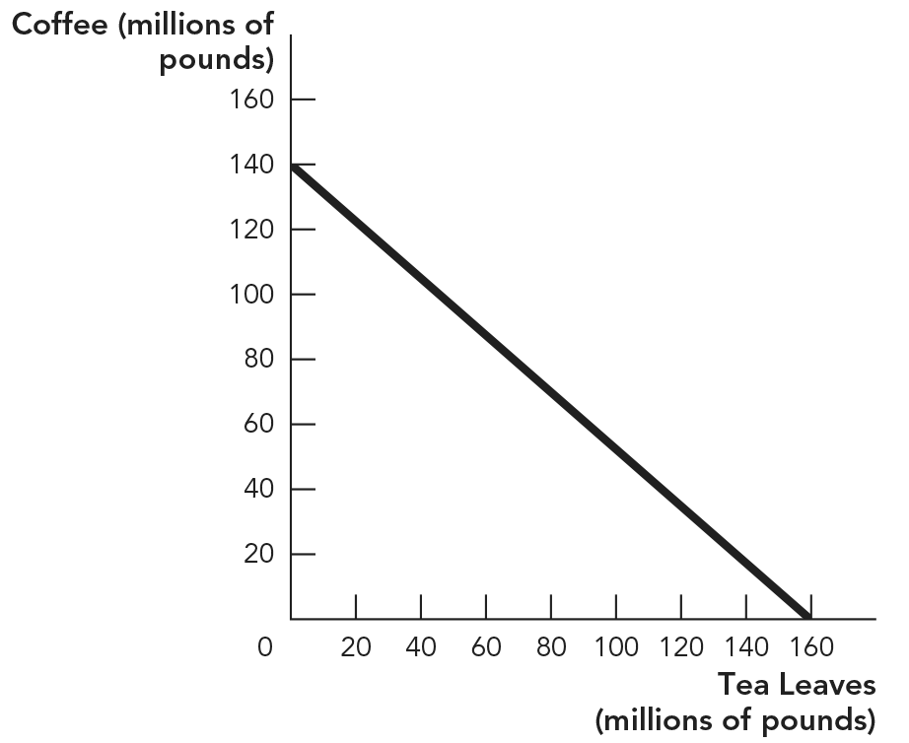

Despite its widespread popularity today, coffee wasn't consumed as a beverage until the mid-1400s. Tea was the beverage of choice, particularly in Southeast Asia. Before coffee, what was the total tea production? (Assume the only reason to grow coffee was for beverage purposes.)
 | a. | 80,000,000
 | b. | 130,000,000
 | c. | 140,000,000
 | d. | 160,000,000

ANSWER: | d

165. Figure: Coffee and Tea

Which of the following is NOT a possible production level?
 | a. | 20 million pounds of tea, 100 million pounds of coffee
 | b. | 120 million pounds of tea, 80 million pounds of coffee
 | c. | 100 million pounds of tea, 40 million pounds of coffee
 | d. | 0 million pounds of tea, 120 million pounds of coffee

ANSWER: | b

166. Figure: Drums and Shoes
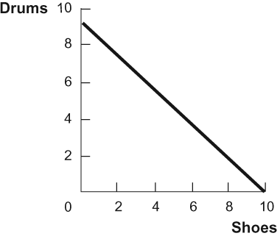

Given the graph of the production possibilities frontier in the figure, which of the following statements is TRUE?
 | a. | The country has 2 units of labor, and it takes 0.5 unit of labor to produce 1 unit of either good.
 | b. | The country has 3 units of labor, and it takes 1 unit of labor to produce 3 drums and 1 unit of labor to produce 3 1/3 pairs of shoes.
 | c. | The country has 4 units of labor, and it takes 2 units of labor to produce 8 drums and 3 units of labor to produce 3 shoes.
 | d. | The country has 5 units of labor, and it takes 1 unit of labor to produce 1.8 drums and 1 unit of labor to produce 2.5 shoes.

ANSWER: | b

167. The _____ shows all combinations of goods that a country can produce given its productivity and _____.
 | a. | comparative advantage frontier; market prices
 | b. | absolute advantage frontier; supply of inputs
 | c. | production possibilities frontier; supply of inputs
 | d. | production possibilities frontier; market prices

ANSWER: | c

168. Figure: Cars and Boats
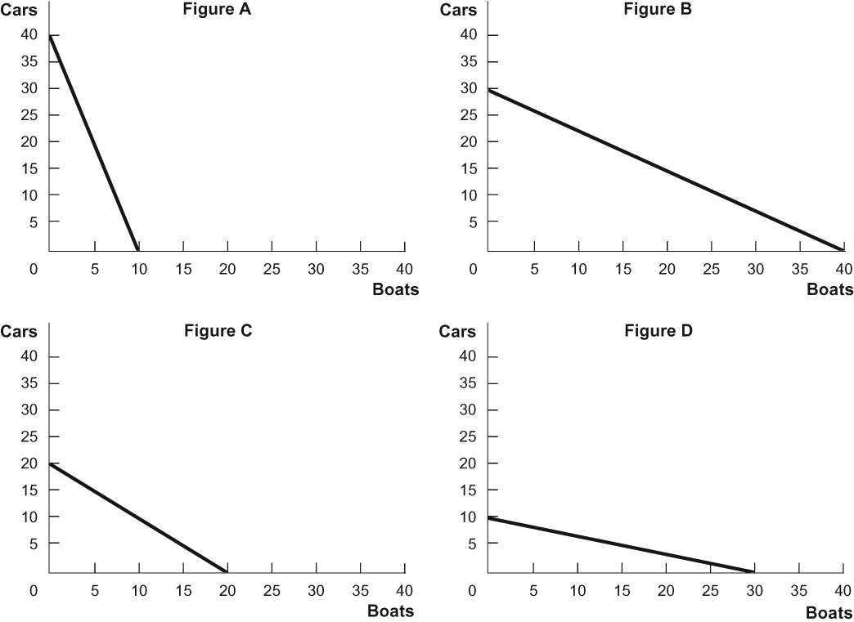

A country needs 4 units of labor to produce 1 car and 3 units of labor to produce 1 boat, and the country has 120 units of labor. Which of the figures represents this country's PPF?
 | a. | Figure A
 | b. | Figure B
 | c. | Figure C
 | d. | Figure D

ANSWER: | b

169. Iceland produces two goods: Viking hats (Y) and fish (X). Its production possibilities frontier is characterized as Y = 50 – 2X and tells us that the opportunity cost of catching (producing) an additional unit of fish in Iceland is:
 | a. | increasing in fish production.
 | b. | constant in fish production.
 | c. | decreasing in fish production.
 | d. | unable to be determined from the information given.

ANSWER: | b

170. Iceland produces two goods: Viking hats (Y) and fish (X). Its production possibilities frontier is characterized as Y = 50 – 2X. What is the opportunity cost of producing a tenth unit of fish (i.e., going from 9 units of fish production to 10)?
 | a. | 0.5 unit of fish
 | b. | 2 units of fish
 | c. | 0.5 Viking hat
 | d. | 2 Viking hats

ANSWER: | d

171. Iceland produces two goods: Viking hats (Y) and fish (X). Its production possibilities frontier is characterized as Y = 50 – 2X. What is the opportunity cost of producing a tenth Viking hat (i.e., going from a production level of 9 Viking hats to a production level of 10 Viking hats)?
 | a. | 0.5 unit of fish
 | b. | 2 units of fish
 | c. | 0.5 Viking hat
 | d. | 2 Viking hats

ANSWER: | a

172. Table: Movies and Oil
 | Hypothetical Maximum Production per Year
State | Movies | Barrels of Oil (millions)
Texas | 75 | 50
California | 60 | 30
New York | 20 | 5

According to the table, which state has a comparative advantage in oil?
 | a. | Texas, because it can produce more oil than anyone else
 | b. | New York, because its opportunity cost for a barrel of oil is 4 movies per year
 | c. | Texas, because its opportunity cost for a barrel of oil is 1.5 movies per year
 | d. | California, because its opportunity cost for a barrel of oil is 2 movies per year

ANSWER: | c

173. Table: Movies and Oil
 | Hypothetical Maximum Production per Year
State | Movies | Barrels of Oil (millions)
Texas | 75 | 50
California | 60 | 30
New York | 20 | 5

According to the table, which state has a comparative advantage in movies?
 | a. | Texas, because it can produce more movies than anyone else
 | b. | New York
 | c. | California
 | d. | impossible to tell from the information in the table

ANSWER: | b

174. Brazil and Canada trade two goods: bananas and ice pops. Brazil has a comparative advantage in banana production. This means that:
 | a. | Brazil also has a comparative advantage in ice pop production.
 | b. | Canada has a comparative advantage in ice pop production.
 | c. | neither country has a comparative advantage in ice pop production.
 | d. | both countries have a comparative advantage in ice pop production.

ANSWER: | b

175. Brazil and Canada trade two goods: bananas and ice pops. Brazil has a comparative advantage in banana production. From this, we know that:
 | a. | Brazil produces bananas at a lower explicit cost than does Canada.
 | b. | Brazil produces ice pops at a lower explicit cost than does Canada.
 | c. | Brazil produces bananas at a lower opportunity cost than does Canada.
 | d. | Brazil produces ice pops at a lower opportunity cost than does Canada.

ANSWER: | c

176. Jimmy Kimmel hosts the Jimmy Kimmel Live! show, and Molly McNearney helps write for it. Jimmy needs 4 hours to rehearse, while Molly would need 10 hours of rehearsal if she were to host. Jimmy writes one usable joke in 1 hour, but Molly needs 2 hours to do the same. From these numbers, we infer that Jimmy has an absolute advantage in the production of:
 | a. | show hosting.
 | b. | joke writing.
 | c. | neither show hosting nor joke writing.
 | d. | both show hosting and joke writing.

ANSWER: | d

177. Jimmy Kimmel hosts the Jimmy Kimmel Live! show, and Molly McNearney writes for it. Jimmy needs 4 hours to rehearse, while Molly would need 10 hours of rehearsal if she were to host. Jimmy writes one usable joke in 1 hour, but Molly needs 2 hours to do the same. From these numbers, we infer that Jimmy has a comparative advantage in the production of:
 | a. | show hosting.
 | b. | joke writing.
 | c. | neither show hosting nor joke writing.
 | d. | both show hosting and joke writing.

ANSWER: | a

178. Jimmy Kimmel hosts the Jimmy Kimmel Live! show, and Molly McNearney writes for it. Jimmy needs 4 hours to rehearse, while Molly would need 10 hours of rehearsal if she were to host. Jimmy writes one usable joke in 1 hour, but Molly needs 2 hours to do the same. If each party produces according to their comparative advantage:
 | a. | Molly will host and Jimmy will write.
 | b. | Molly will host and Molly will write.
 | c. | Jimmy will host and Jimmy will write.
 | d. | Jimmy will host and Molly will write.

ANSWER: | d

179. Martha Stewart can iron 20 shirts per hour. Her housekeeper can iron 12 shirts per hour. From this information alone, we can infer that:
 | a. | Martha has a comparative advantage in ironing.
 | b. | the housekeeper has a comparative advantage in ironing.
 | c. | Martha has an absolute advantage in ironing.
 | d. | the housekeeper has an absolute advantage in ironing.

ANSWER: | c

180. Jack and Jill work at a bakery. In 1 hour, Jack can decorate either 5 ice-cream cakes or 2 wedding cakes. In 1 hour, Jill can decorate either 4 ice-cream cakes or 1 wedding cake. Thus the opportunity cost of decorating an ice-cream cake is _____ for Jack and _____ for Jill.
 | a. | 4 wedding cakes; 2.5 wedding cakes
 | b. | 1/4 wedding cake; 2/5 wedding cake
 | c. | 2.5 wedding cakes; 4 wedding cakes
 | d. | 2/5 wedding cake; 1/4 wedding cake

ANSWER: | d

181. Jack and Jill work at a bakery. In 1 hour, Jack can decorate either 5 ice-cream cakes or 2 wedding cakes. In 1 hour, Jill can decorate either 4 ice-cream cakes or 1 wedding cake. According to this scenario, _____ has a comparative advantage in decorating ice-cream cakes and _____ has a comparative advantage in decorating wedding cakes.
 | a. | Jack; Jack
 | b. | Jill; Jill
 | c. | Jack; Jill
 | d. | Jill; Jack

ANSWER: | d

182. Jack and Jill work at a bakery. In 1 hour, Jack can decorate either 5 ice-cream cakes or 2 wedding cakes. In 1 hour, Jill can decorate either 4 ice-cream cakes or 1 wedding cake. According to this scenario, which of the following outcomes will benefit both Jack and Jill the most?
 | a. | Both Jack and Jill specialize in decorating ice-cream cakes.
 | b. | Both Jack and Jill specialize in decorating wedding cakes.
 | c. | Jill specializes in decorating ice-cream cakes, and Jack specializes in decorating wedding cakes.
 | d. | Jill specializes in decorating wedding cakes, and Jack specializes in decorating ice-cream cakes.

ANSWER: | c

183. Suppose the United States is more productive than China at making both T-shirts and cell phones. The theory of comparative advantage suggests that consumption in both countries will:
 | a. | increase if the United States produces both goods.
 | b. | increase if each country specializes in producing the good with a lower opportunity cost.
 | c. | not change if China produces either T-shirts or cell phones.
 | d. | remain unchanged.

ANSWER: | b

184. Figure: Computers and Books
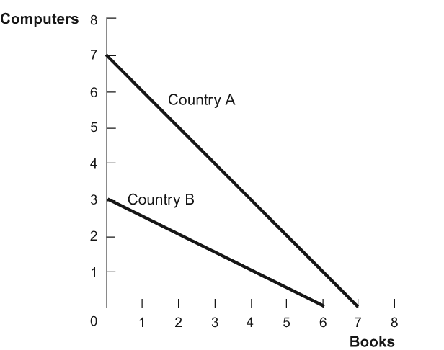

According to the figure, the opportunity cost of producing books:
 | a. | is higher for country A than for country B.
 | b. | is higher for country B than for country A.
 | c. | is the same for countries A and B.
 | d. | cannot be determined.

ANSWER: | a

185. Figure: Computers and Books

According to the figure, both countries can increase consumption if:
 | a. | both countries buy computers and books from each other.
 | b. | both countries produce both computers and books.
 | c. | country A produces only computers and buys books from country B.
 | d. | country A produces only books and buys computers from country B.

ANSWER: | c

186. Figure: Computers and Books

According to the figure, if country A produces only the good for which it has a comparative advantage and then consumes the other good by exchanging computers for books, then:
 | a. | country A will consume outside its PPF, but country B will consume inside its PPF.
 | b. | country A will consume inside its PPF, but country B will consume outside its PPF.
 | c. | both countries will consume inside their own PPFs.
 | d. | both countries will consume outside their own PPFs.

ANSWER: | d

187. When economists say that an individual or country has a comparative advantage in the production of a good, it means that they:
 | a. | can produce more of the good than anyone else.
 | b. | are the lowest-opportunity-cost producer of the good.
 | c. | are the highest-opportunity-cost producer of the good.
 | d. | are operating on their production possibilities frontier.

ANSWER: | b

188. The opportunity cost of producing a particular good refers to:
 | a. | how much of something else must be given up to produce 1 additional unit of the good.
 | b. | how much of a good can be produced with the existing technology and resources.
 | c. | the total cost of production, including wages.
 | d. | the marginal cost of production.

ANSWER: | a

189. Anita can bake 10 cakes in a day but has no time left to make cookies. If she bakes only cookies, she can make 200 cookies in a day. John makes equally delicious cakes and cookies but can make only 7 cakes or 100 cookies in a day. Based on this information, which of the following statements is TRUE?
 | a. | Anita has a comparative advantage in the production of cakes.
 | b. | John has a comparative advantage in the production of cakes.
 | c. | John has an absolute advantage in the production of cookies.
 | d. | Anita has a comparative advantage in the production of both cakes and cookies.

ANSWER: | b

190. Figure: Comparative Advantage
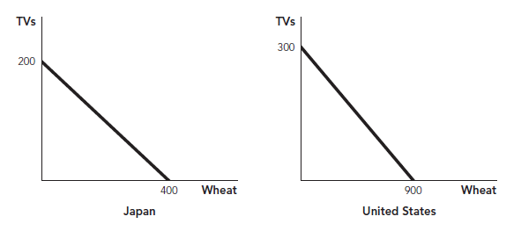

The figure illustrates both the U.S. and Japanese production possibilities frontiers for TVs and wheat. Based on this information, which of the following is TRUE?
 | a. | The United States has a comparative advantage in the production of TVs.
 | b. | The United States has a comparative advantage in the production of wheat.
 | c. | Japan has a comparative advantage in the production of wheat.
 | d. | Japan has an absolute advantage in the production of TVs.

ANSWER: | b

191. Figure: Comparative Advantage

The figure illustrates both the U.S. and Japanese production possibilities frontiers for TVs and wheat. Based on this information, which of the following is TRUE?
 | a. | The opportunity cost of producing a TV in the United States is 1/3 of a bushel of wheat.
 | b. | The opportunity cost of producing a TV in the United States is 900 bushels of wheat.
 | c. | The opportunity cost of producing a TV in Japan is 2 bushels of wheat.
 | d. | The opportunity cost of producing a bushel of wheat in Japan is 2 TVs.

ANSWER: | c

192. When countries produce those goods for which they have a comparative advantage:
 | a. | total production and consumption will increase in all countries.
 | b. | trade will increase, but production will decrease.
 | c. | at least one country will be worse off; maximizing production comes from producing those goods for which they have the absolute advantage.
 | d. | they are maximizing their opportunity costs.

ANSWER: | a

193. Figure: Sofas and Windows
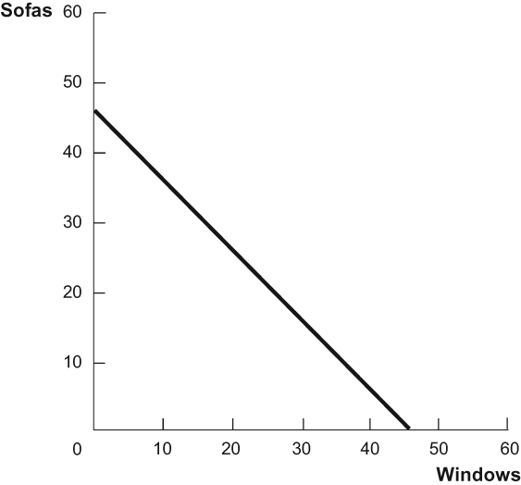

In the PPF diagram, what is the opportunity cost of producing an additional window?
 | a. | 1 1/4 sofas
 | b. | 4/5 of a window
 | c. | 1 window
 | d. | 4/5 of a sofa

ANSWER: | c

194. Figure: Sofas and Windows

In the PPF diagram, what is the opportunity cost of producing an additional sofa?
 | a. | 1 1/4 sofas
 | b. | 4/5 of a window
 | c. | 1 window
 | d. | 4/5 of a sofa

ANSWER: | c

195. How is slope, measured as rise over run, related to the production possibilities frontier?
 | a. | Slope measures the fixed costs of producing good X and good Y. For a slope of –3, the fixed cost of producing either good X or good Y is $3 multiplied by the number of units produced.
 | b. | Slope gives the opportunity cost of producing an additional unit of the good on the x-axis. So if the slope is –3, the country must give up producing one-third of a unit of good Y for every additional unit of good X it produces.
 | c. | Slope gives the fixed cost of producing an additional unit of the good on the x-axis. So if the slope is –3, the country must give up producing one-third of a unit of good Y for every additional unit of good X it produces.
 | d. | Slope gives the opportunity cost of producing an additional unit of the good on the x-axis. So if the slope is –3, the country must give up producing 3 units of good Y for every additional unit of good X it produces.

ANSWER: | d

196. Figure: Steel and Lumber
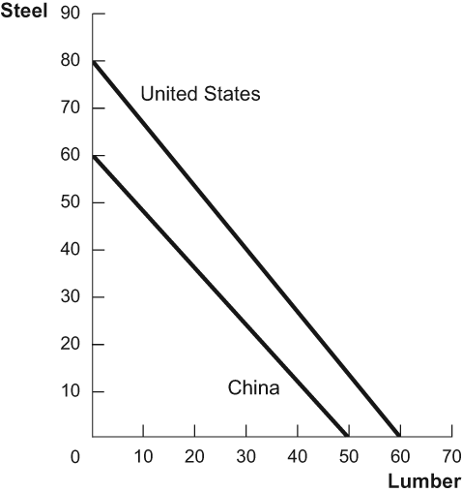

In the PPF diagram, the United States has a comparative advantage in _____ and an absolute advantage in _____.
 | a. | both goods; both goods
 | b. | steel; lumber
 | c. | steel; both goods
 | d. | lumber; steel

ANSWER: | c

197. Figure: Steel and Lumber

In the PPF diagram, China has a comparative advantage in _____ and an absolute advantage in _____.
 | a. | lumber; neither of the goods
 | b. | steel; lumber
 | c. | steel; neither of the goods
 | d. | lumber; steel

ANSWER: | a

198. Figure: Rice and Shirts
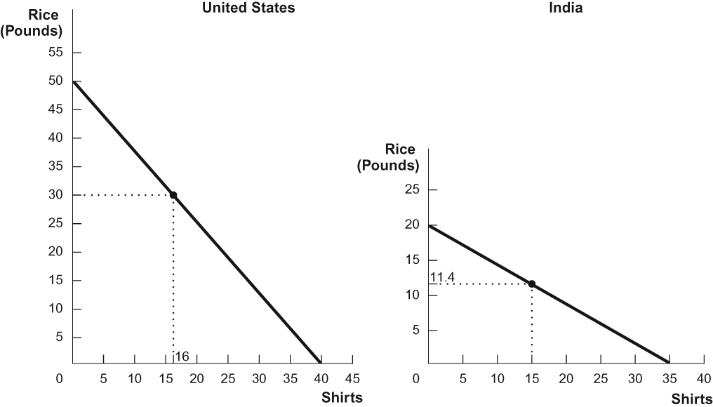

Use the PPFs shown for the United States and India. With specialization and trade, the United States would produce _____, and India would produce _____.
 | a. | 50 pounds of rice and 0 shirts; 0 pounds of rice and 35 shirts
 | b. | 30 pounds of rice and 16 shirts; 11.4 pounds of rice and 15 shirts
 | c. | 0 pounds of rice and 40 shirts; 20 pounds of rice and 0 shirts
 | d. | 50 pounds of rice and 40 shirts; 20 pounds of rice and 35 shirts

ANSWER: | a

199. Figure: Rice and Shirts

Use the PPFs shown for the United States and India. If the United States and India specialize and trade, one country will trade away 20 pounds of rice in exchange for 20 shirts from the other. Compared with no trade, _____ will be able to consume _____ additional shirts, and _____ will be able to consume an additional _____ pounds of rice.
 | a. | the United States; 0; India; 8.6
 | b. | India; 5; the United States; 0
 | c. | the United States; 4; India; 8.6
 | d. | India; 8.6; the United States; 4

ANSWER: | c

200. New Zealand is more productive than Madagascar at producing all goods and services. In this situation:
 | a. | New Zealand might benefit by trading with Madagascar.
 | b. | Madagascar would be harmed if it traded with New Zealand.
 | c. | both countries would benefit from trading with each other.
 | d. | New Zealand would see its standard of living decline if it traded with Madagascar.

ANSWER: | c

201. Trade tends to:
 | a. | decrease the wages of high-productivity countries.
 | b. | decrease the wages of low-productivity countries.
 | c. | decrease the wages of both high- and low-productivity countries.
 | d. | increase the wages of both high- and low-productivity countries.

ANSWER: | d

202. Figure: Benin
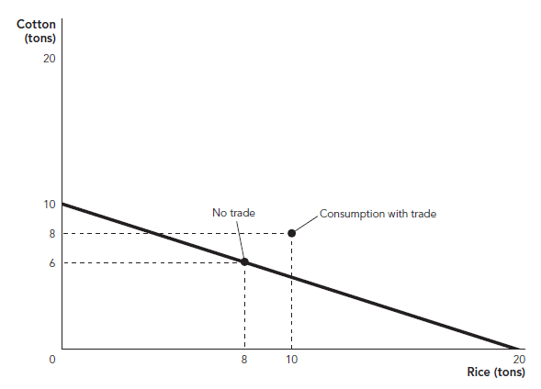
​
In the figure, Benin has 32 workers, and the price per ton of cotton and ton of rice is $2,500 and $1,200, respectively. The average wage with no trade is _____, and the average wage with trade is _____.
 | a. | $850; $1,081.25
 | b. | $768.75; $1,000
 | c. | $1,000; $850
 | d. | $1,000; $1,081.25  ​

ANSWER: | b

203. Babe Ruth could produce 2 home runs in a week of play as a fielder or 1 win in a week of play as a pitcher. What was his opportunity cost for a week of pitching?
 | a. | 1 win
 | b. | 2 wins
 | c. | 1 home run
 | d. | 2 home runs

ANSWER: | d

204. Babe Ruth could produce 2 home runs in a week of play as a fielder or 1 win in a week of play as a pitcher. What was his opportunity cost of a week of fielding?
 | a. | 1 win
 | b. | 2 wins
 | c. | 1 home run
 | d. | 2 home runs

ANSWER: | a

205. Conan O'Brien hosts the Conan show, and Andy Richter, his sidekick, writes for it. Conan needs 4 hours to rehearse and host a good show. It takes Andy 10 hours to do the same. Conan writes one usable joke in an hour, but Andy needs 2 hours to do the same. Conan's opportunity cost of writing a single usable joke is:
 | a. | 0.2 unit of hosting.
 | b. | 0.25 unit of hosting.
 | c. | 0.5 unit of hosting.
 | d. | 1 unit of hosting.

ANSWER: | b

206. Conan O'Brien hosts the Conan show, and Andy Richter, his sidekick, writes for it. Conan needs 4 hours to rehearse and host a good show. It takes Andy 10 hours to do the same. Conan writes one usable joke in an hour, but Andy needs 2 hours to do the same. Andy's opportunity cost of writing a single usable joke is:
 | a. | 0.2 unit of hosting.
 | b. | 0.25 unit of hosting.
 | c. | 0.5 unit of hosting.
 | d. | 1 unit of hosting.

ANSWER: | a

207. Conan O'Brien hosts the Conan show, and Andy Richter, his sidekick, writes for it. Conan needs 4 hours to rehearse and host a good show. It takes Andy 10 hours to do the same. Conan writes one usable joke in an hour, but Andy needs 2 hours to do the same. Conan's opportunity cost of rehearsing and hosting a show is:
 | a. | 0.2 usable joke.
 | b. | 0.5 usable joke.
 | c. | 4 usable jokes.
 | d. | 5 usable jokes.

ANSWER: | c

208. Conan O'Brien hosts the Conan show, and Andy Richter, his sidekick, writes for it. Conan needs 4 hours to rehearse and host a good show. It takes Andy 10 hours to do the same. Conan writes one usable joke in an hour, but Andy needs 2 hours to do the same. Andy's opportunity cost of rehearsing and hosting a show is:
 | a. | 0.2 usable joke.
 | b. | 0.5 usable joke.
 | c. | 4 usable jokes.
 | d. | 5 usable jokes.

ANSWER: | d

209. According to the theory of trade, if two countries trade with each other:
 | a. | consumption in one country will fall and wages in that country will also fall.
 | b. | wage costs will remain low if both countries specialize in producing the goods for which they have a comparative advantage.
 | c. | trade will raise the labor productivity and wages of both countries.
 | d. | wages in the country with a comparative advantage will rise, and wages in the country without a comparative advantage will fall.

ANSWER: | c

210. Trade tends to:
 | a. | increase wages in developed countries but decrease wages in lesser-developed countries.
 | b. | decrease wages in developed countries but increase wages in lesser-developed countries.
 | c. | decrease wages in all countries.
 | d. | increase wages in all countries.

ANSWER: | d

211. Wage rates are primarily based on the:
 | a. | level of comparative advantage.
 | b. | extent to which the country is involved in trade with other countries.
 | c. | productivity of labor.
 | d. | institutional factors present.

ANSWER: | c

212. Which of the following is TRUE regarding trade and wages?
 | a. | Trade can increase wages by increasing the productivity of labor.
 | b. | Trade helps to equalize wages between high- and low-productivity countries.
 | c. | Countries with low productivity levels will always have lower wages than high-productivity nations whether they trade or not.
 | d. | Trade directly increases productivity, which in turn increases wages.

ANSWER: | c

213. A country produces and consumes 8 units of sugarcane that cost $50 per unit and 2 Apple Watches that cost $200 each. After specialization and trade, the country consumes 8 units of sugarcane and 4 Apple Watches. With 24 units of labor, what are wages in this country?
 | a. | $33.33 without trade and $50 with trade
 | b. | $50 without trade and $75 with trade
 | c. | $50 without trade and $33.33 with trade
 | d. | $33.33 without trade and $75 with trade

ANSWER: | a

214. When a rich country that has absolute advantages in all products begins trading with a poor country:
 | a. | the wages in the rich country will go down, and the wages in the poor country will go up.
 | b. | the wages in both countries will go up.
 | c. | the wages in both countries will go down.
 | d. | the wages in the rich country will go up, and the wages in the poor country will go down.

ANSWER: | b

215. High-productivity workers fear trade because they think they cannot compete with workers in low-productivity countries. Low-productivity workers fear trade because they think they cannot compete with workers in high-productivity countries. Which of these fears is justified?
 | a. | The fears of workers in high-productivity countries are justified; the fears of workers in low-productivity countries are not.
 | b. | The fears of workers in low-productivity countries are justified; the fears of workers in high-productivity countries are not.
 | c. | Both sets of fears are justified.
 | d. | Neither set of fears is justified.

ANSWER: | d

216. According to Adam Smith:
 | a. | trade is a way for rich people to exploit poor people.
 | b. | trade within a nation benefits people, but international trade does not.
 | c. | trade does not benefit anyone.
 | d. | people buy goods for which they have higher opportunity costs than others.

ANSWER: | d

217. Adam Smith said, “It is the maxim of every prudent master of a family never to attempt to make at home what it will cost him more to make than to buy. The tailor does not attempt to make his own shoes, but buys them of the shoemaker. The shoemaker does not attempt to make his own clothes, but employs a tailor.” Which of the following concepts best illustrates Smith's intent with this statement?
 | a. | comparative advantage
 | b. | incentives matter
 | c. | scarcity
 | d. | production possibilities frontier

ANSWER: | a

218. What is the difference between trade among individuals and trade among nations?
 | a. | The logic of trade and specialization is stronger for individuals than it is for nations.
 | b. | The logic of trade and specialization is stronger for nations than it is for individuals.
 | c. | The logic of trade and specialization applies equally well among individuals and nations.
 | d. | Without looking at specific cases, we can't say much about the logic of trade and specialization for individuals and nations.

ANSWER: | c

219. Adam Smith:
 | a. | believed that trade in local communities is good for the economy, but trading with people located in foreign countries is bad for the economy.
 | b. | did not discuss or have an opinion about international trade.
 | c. | argued that it is beneficial to buy a product if the seller can sell it to us cheaper than we can make it for ourselves, regardless of the product's country of origin.
 | d. | believed that trade in local communities is bad for the economy, but trading with people located in foreign countries is good for the economy.

ANSWER: | c

220. In many universities, graduate students are employed to teach introductory undergraduate courses, even though the full professors at these universities have more experience and could potentially teach these courses better. Which of the following best explains why universities choose to hire graduate students instead of full professors to teach their introductory courses?
 | a. | Graduate students are cheaper.
 | b. | The opportunity cost of teaching an introductory course is higher for full professors than for graduate students.
 | c. | The opportunity cost of teaching an introductory course is higher for graduate students than for full professors.
 | d. | Introductory classes are the best place for graduate students to build their teaching skills.

ANSWER: | b

221. Gains from international trade are best characterized as potential gains from:
 | a. | importation.
 | b. | exportation.
 | c. | neither importation nor exportation.
 | d. | both importation and exportation.

ANSWER: | d

222. The development of shipping containers enabled companies to move freight quickly between ships, trucks, and trains by loading a single large container with many different goods and then moving the container. Before the container, freight had to be loaded and unloaded one palette, barrel, or box at a time. What impact did the shipping container have on globalization? Why?
 | a. | an increase because it allowed the faster spread of communication
 | b. | an increase because it decreased transportation costs
 | c. | a decrease because it caused many dock workers to lose their job
 | d. | a decrease because it caused the amount of human cooperation to fall

ANSWER: | b

223. According to the textbook, globalization:
 | a. | never took place.
 | b. | began as far back as the Roman Empire.
 | c. | began in the twenty-first century.
 | d. | occurred only during the Dark Ages.

ANSWER: | b

224. Increased trade has also led to:
 | a. | increased globalization of economies.
 | b. | a more equal distribution of wealth across countries.
 | c. | a decline in human cooperation.
 | d. | more specialization and thus less globalization.

ANSWER: | a

225. The trade networks of the Roman Empire:
 | a. | fell apart in the medieval era, leading to the Dark Ages.
 | b. | were not of great importance.
 | c. | show that globalization is a new phenomenon.
 | d. | did not facilitate the transport of goods from different parts of the world.

ANSWER: | a

226. Globalization is:
 | a. | pushed through by politicians while citizens are reacting to disasters and upheavals.
 | b. | the advance of human cooperation across national boundaries.
 | c. | the advance of human conflict across national boundaries.
 | d. | supported only by greedy corporations.

ANSWER: | b

227. The Dark Ages was a period in which trade:
 | a. | expanded because of rising transportation and communication costs.
 | b. | expanded because of falling transportation and communication costs.
 | c. | decreased because world markets became more isolated.
 | d. | decreased because world markets became less isolated.

ANSWER: | c

228. Globalization is best described as:
 | a. | a new process.
 | b. | an old process that has consistently grown.
 | c. | an old process that has grown intermittently.
 | d. | an old process that has declined over time.

ANSWER: | c

229. The recent pace of globalization has been increased through:
 | a. | declining transportation costs.
 | b. | increased speed of communication.
 | c. | the integration of world markets.
 | d. | each of these developments.

ANSWER: | d

230. Gains from trade are largest when two parties are similar in terms of preferences.
 | a. | True
 | b. | False

ANSWER: | b

231. Gains from trade are largest when two parties are similar in terms of opportunity costs of production.
 | a. | True
 | b. | False

ANSWER: | b

232. Trade refers to the exchange of goods or services between two parties.
 | a. | True
 | b. | False

ANSWER: | a

233. Trade refers to the exchange of goods and services between at least two different nations.
 | a. | True
 | b. | False

ANSWER: | b

234. Trade makes people better off only when they all have the same preferences.
 | a. | True
 | b. | False

ANSWER: | b

235. Trades are considered zero-sum transactions because when one person gains, the other loses an equal amount.
 | a. | True
 | b. | False

ANSWER: | b

236. Trade works best between people who share similar preferences.
 | a. | True
 | b. | False

ANSWER: | b

237. Trade creates value by moving goods from people that value them less to people that value them more.
 | a. | True
 | b. | False

ANSWER: | a

238. Jerome has an old (working) television that he would like to get rid of now that he has purchased a new television. The old television is no longer worth anything to him now. Shanique, on the other hand, has an even older television that has just broken down. She would pay up to $50 for any working TV. If Jerome trades Shanique his old television for $50, both are better off but the total value in society does not increase.
 | a. | True
 | b. | False

ANSWER: | b

239. Involuntary trades increase value in the same way voluntary trades do.
 | a. | True
 | b. | False

ANSWER: | b

240. One of the ways trade increases wealth is by taking advantage of differences in preferences.
 | a. | True
 | b. | False

ANSWER: | a

241. Large cities should have more professional closet organizers than small cities.
 | a. | True
 | b. | False

ANSWER: | a

242. In a world with trade, no one can afford to specialize.
 | a. | True
 | b. | False

ANSWER: | b

243. Trade leads to increased productivity because trade allows people to specialize.
 | a. | True
 | b. | False

ANSWER: | a

244. Although trade increases productivity, it decreases society's collective knowledge because people specialize in a very limited number of things.
 | a. | True
 | b. | False

ANSWER: | b

245. The human brain has no limits, so the division of knowledge decreases the total knowledge in society.
 | a. | True
 | b. | False

ANSWER: | b

246. Without trade, specialization is impractical.
 | a. | True
 | b. | False

ANSWER: | a

247. The U.S. interstate highway system probably allowed more people in small communities to become full-time interior decorators.
 | a. | True
 | b. | False

ANSWER: | a

248. Specialization is an example of self-interest aligning with the social interest because it increases the amount you can consume as well as the amount society can consume.
 | a. | True
 | b. | False

ANSWER: | a

249. An advantage to specialization is that it can decrease the average cost of production by concentrating on smaller-scale production.
 | a. | True
 | b. | False

ANSWER: | b

250. Specialization and the division of knowledge decreased with the fall of the Berlin Wall and the opening of China's economy to the world.
 | a. | True
 | b. | False

ANSWER: | b

251. The benefits of economies of scale and increased competition to an economy include lower unit costs.
 | a. | True
 | b. | False

ANSWER: | a

252. As trade becomes more extensive, it slows down the creation of new ideas because fewer people can specialize in areas like science and engineering.
 | a. | True
 | b. | False

ANSWER: | b

253. If it were impossible to have a comparative advantage, there would be no gains from trade.
 | a. | True
 | b. | False

ANSWER: | b

254. If you have a comparative advantage in washing dishes, then you also have an absolute advantage in washing dishes.
 | a. | True
 | b. | False

ANSWER: | b

255. When comparing two countries with two goods each, if one country has a comparative advantage in one good, the other country will have a comparative advantage in the other good.
 | a. | True
 | b. | False

ANSWER: | a

256. Comparative advantage occurs when an individual's opportunity cost for producing the same good or service is lower than that of another individual.
 | a. | True
 | b. | False

ANSWER: | a

257. Countries can benefit from trading with one another because trade allows each country to specialize in doing what it does best.
 | a. | True
 | b. | False

ANSWER: | a

258. Trading increases the amount a single country can produce.
 | a. | True
 | b. | False

ANSWER: | b

259. The production possibilities frontier shows all the combinations of goods that a country can produce given its productivity and supply of inputs.
 | a. | True
 | b. | False

ANSWER: | a

260. The points on the production possibilities frontier show the cost of the different goods that a country can produce.
 | a. | True
 | b. | False

ANSWER: | b

261. Everyone, from the most to the least skilled to the most and least educated, can benefit from trade.
 | a. | True
 | b. | False

ANSWER: | a

262. A country has a comparative advantage in producing one good if its labor cost is lower than that for other countries.
 | a. | True
 | b. | False

ANSWER: | b

263. If a country has an absolute advantage in both items produced when compared to another country, there can never be any benefit for them to trade.
 | a. | True
 | b. | False

ANSWER: | b

264. U.S. pharmaceutical companies sell drugs to Kenya, and Kenyan farmers sell flowers to the United States. This pattern of trade suggests that the United States is the low-opportunity-cost producer of drugs, and Kenya is the low-opportunity-cost producer of flowers.
 | a. | True
 | b. | False

ANSWER: | a

265. In Spain, it takes 10 workers to produce 1 barrel of wine and 4 workers to produce 1 yard of cloth. Thus, the opportunity cost of producing 1 barrel of wine is 2.5 yards of cloth.
 | a. | True
 | b. | False

ANSWER: | a

266. Trade causes wages in countries with high productivity to increase and wages in countries with low productivity to decrease.
 | a. | True
 | b. | False

ANSWER: | b

267. Specializing in its comparative advantage and trading with other nations benefit a country in terms of its total output but not individuals when it comes to their wages.
 | a. | True
 | b. | False

ANSWER: | b

268. Specializing in one's comparative advantage and trading with others will make individuals better off but may not make countries better off.
 | a. | True
 | b. | False

ANSWER: | b

269. Conan O'Brien hosts the Conan show, and Andy Richter, his sidekick, writes for it. Conan needs 4 hours to rehearse and host a good show. It takes Andy 10 hours to do the same. Conan writes one usable joke in an hour, but Andy needs 2 hours to do the same. Gains from trade are largest when Conan hosts the show and Andy writes for the show.
 | a. | True
 | b. | False

ANSWER: | a

270. International trade is based on the theory of absolute advantage.
 | a. | True
 | b. | False

ANSWER: | b

271. To benefit from trade, a country must have an absolute advantage in producing its traded good.
 | a. | True
 | b. | False

ANSWER: | b

272. A country or individual that is best at doing something should always undertake that activity to maximize gains from trade.
 | a. | True
 | b. | False

ANSWER: | b

273. Trade allows countries to consume more than their ability to produce.
 | a. | True
 | b. | False

ANSWER: | a

274. Employing comparative advantage increases the total satisfaction with what's produced but not the total amount of what's produced.
 | a. | True
 | b. | False

ANSWER: | b

275. If Kino can gather 15 logs a day or catch 10 fish a day and Jian can gather 5 logs a day or catch 5 fish a day, then Jian has a comparative advantage in catching fish.
 | a. | True
 | b. | False

ANSWER: | a

276. The production possibilities frontier's negative slope illustrates the notion of trade-offs—producing more units of one good reduces the amount of another good's production.
 | a. | True
 | b. | False

ANSWER: | a

277. According to the theory of comparative advantage, a country specializes in producing goods with lower opportunity costs than in another country.
 | a. | True
 | b. | False

ANSWER: | a

278. Poor countries are at a distinct disadvantage when it comes to economic production; they get outcompeted in everything, since they do not have a comparative advantage in anything.
 | a. | True
 | b. | False

ANSWER: | b

279. In a certain country, it takes 5 of its 10 workers to produce 1 barrel of wine but only 1 worker to produce 1 yard of cloth. If we graphed this country's PPF (placing wine on the vertical axis and cloth on the horizontal axis), the slope of the PPF would equal –1/5.
 | a. | True
 | b. | False

ANSWER: | a

280. Mila can clean and polish silverware in 2 hours and change spark plugs in a car in 4 hours. Nadia can clean and polish the same silverware in 1 hour and change spark plugs in a car in 1 hour. Mila does not have a comparative advantage in either activity.
 | a. | True
 | b. | False

ANSWER: | b

281. In the time it takes Stanley to clean the bathroom, he can make 3 cheesecakes. In the time it takes Fran to clean the bathroom, she can make 2 cheesecakes. Fran has a comparative advantage in cleaning the bathroom.
 | a. | True
 | b. | False

ANSWER: | a

282. The wage rate in India is lower than the wage rate in the United States because Indian workers are more productive than U.S. workers.
 | a. | True
 | b. | False

ANSWER: | b

283. Some countries have comparative advantages in everything.
 | a. | True
 | b. | False

ANSWER: | b

284. Trade increases productivity when production is carried out by the person/group with the comparative advantage.
 | a. | True
 | b. | False

ANSWER: | a

285. The basic idea of trade is to buy the things you could make only at a high opportunity cost and sell the things you can make at a low opportunity cost.
 | a. | True
 | b. | False

ANSWER: | a

286. The economist credited with saying, “It is the maxim of every prudent master of a family never to attempt to make at home what it will cost him more to make than to buy,” is Adam Smith.
 | a. | True
 | b. | False

ANSWER: | a

287. Because Chinese wages are much lower than wages in the United States, the Chinese can outcompete the United States in everything.
 | a. | True
 | b. | False

ANSWER: | b

288. Globalization is the advance of human cooperation across national boundaries.
 | a. | True
 | b. | False

ANSWER: | a

289. Evidence from history shows that when the extent of trade expands, the result is prosperity.
 | a. | True
 | b. | False

ANSWER: | a

290. Trade makes rich people richer and poor people poorer.
 | a. | True
 | b. | False

ANSWER: | b

291. Increased communication speed played a significant role in recent developments that led to increased trade and globalization.
 | a. | True
 | b. | False

ANSWER: | a

292. In the Star Trek: Deep Space Nine episode “Treachery, Faith and the Great River,” one of the characters is attempting to repair a spaceship. This is a critical job because there's a war going on, but the war is making it difficult to get the needed parts. An alien named Nog explains how he could obtain them by navigating the Great Material Continuum. He explains:
It binds the universe together . . . there are millions upon millions of worlds in the universe, each one filled with too much of one thing and not enough of another. And the Great Continuum flows through them all, like a mighty river, from “have” to “want” and back again. And if we navigate the Continuum with skill and grace, our ship will be filled with everything our hearts desire.
Identify which of the major themes of trade this passage about the Great Material Continuum highlights, and explain how it works.
ANSWER: | Trade makes people better off when preferences differ and cooperation is encouraged through self-interest.

293. What are the three major benefits of trade? Explain briefly.
ANSWER: | Trade requires people or countries to specialize. The first benefit of trade comes when people with differing preferences are made better off from their voluntary trades. The second benefit of trade comes from increased productivity as a result of specialization and the division of knowledge. Specialization followed by trade greatly increases productivity. The third benefit of trade comes from taking advantage of differences in opportunity costs. According to the theory of comparative advantage, people or countries can specialize in producing goods that involve the lowest opportunity costs. As a result, everyone can benefit from trade.

294. Your professor hires a teaching assistant to grade student assignments even though your professor may do the task faster and perhaps more accurately. How can you explain this behavior using the theory of comparative advantage?
ANSWER: | According to the theory of comparative advantage, people specialize in what involves the lowest opportunity cost. The professor can grade student assignments faster, so he has an absolute advantage. However, the opportunity cost of grading student assignments may be higher for the professor than for the teaching assistant, so the teaching assistant has a comparative advantage in grading assignments. On the other hand, the professor might have comparative advantages in other teaching activities, such as lecturing. So the reason for the professor to hire a teaching assistant to grade assignments is consistent with the theory of comparative advantage.

295. In a two-country world of Japan and South Korea, suppose Japan can produce 600 radios or 300 TV sets in 1 day with all its available resources, while South Korea can produce 100 radios or 200 TV sets in 1 day with all its available resources. According to the theory of comparative advantage, what would be the possible gain in this world if the two countries specialized and traded with each other?
ANSWER: | For Japan, the opportunity cost of producing 1 radio is half of 1 TV set, and the opportunity cost of producing 1 TV set is 2 radios. For South Korea, the opportunity cost of producing 1 radio is 2 TV sets, and the opportunity cost of producing 1 TV set is half of 1 radio. Suppose each of the two countries produces 100 TV sets and uses other available resources to produce radios: Japan can produce 400 radios, and South Korea can produce 50 radios. In this case, without trade the total world production is 450 radios and 200 TV sets. However, because the opportunity cost of producing radios is lower for Japan than for South Korea, Japan has a comparative advantage in producing radios. Because the opportunity cost of producing TV sets is lower for South Korea than for Japan, South Korea has a comparative advantage in producing TV sets. According to the theory of comparative advantage, Japan should specialize in producing radios and import TV sets from South Korea, while South Korea should specialize in producing TV sets and import radios from Japan. As a result of specialization and trade, the total consumption in this two-country world is 600 radios and 200 TV sets. Compared to the case without trade, there is a gain of 150 radios.

296. Cameron and Jacquie must prepare a presentation for their marketing class. As part of their presentation, they must create a marketing plan and prepare 40 PowerPoint slides. It would take Cameron 5 hours to do the required plan and 5 hours to prepare the PowerPoint slides. It would take Jacquie 6 hours to do the plan and 10 hours to prepare the PowerPoint slides.
a. How much time would it take the two to complete the project if they divided the creation of the marketing plan equally and the preparation of the PowerPoint slides equally?
b. How much time would it take the two to complete the project if they used comparative advantage and specialized in creating the marketing plan or preparing the PowerPoint slides?
c. If Cameron and Jacquie have the same opportunity cost of $5 per hour, is there a better solution than for each to specialize?
ANSWER: | a. If both tasks are divided equally, it will take 5.5 hours to create the marketing plan and 7.5 hours to prepare the PowerPoint slides. This is a total of 13 hours of work.  b. If Jacquie specializes in creating the marketing plan and Cameron specializes in preparing the PowerPoint slides, it will take 11 hours to complete the project.  c. If Jacquie specializes in creating the marketing plan, her opportunity cost will be $30; hence, Jacquie would be better off if she paid Cameron any amount less than $30 to create the marketing plan. Since Cameron's opportunity cost of creating the marketing plan is only $25, he would be better off if Jacquie paid him between $25 and $30 to create the marketing plan. In this case, the total time spent on the project would be 10 hours.

297. In Narnia, 1 binky can be produced with 2 workers and 1 sippy cup can be produced with 0.25 worker. In Bedrock, 1 binky can be produced with 1 worker and 1 sippy cup can be produced with 0.50 worker.
a. What is the opportunity cost of producing 1 sippy cup in Narnia and 1 sippy cup in Bedrock?
b. Which country has the comparative advantage in sippy cups?
c. Suppose that each country has 100 workers and completely specializes in its comparative advantage. How many units of sippy cups and binkies will each country produce?
d. Before trade, Narnia produces 25 binkies and 200 sippy cups, and Bedrock produces 50 binkies and 100 sippy cups. Show how specialization and free trade can make each country better off than it was before trade.
ANSWER: | a. The opportunity cost in Narnia is 0.125 binky, and the opportunity cost in Bedrock is 0.5 binky.  b. Narnia has the comparative advantage in sippy cups.  c. Narnia will produce 400 sippy cups and no binkies, and Bedrock will produce 100 binkies and no sippy cups.  d. If the countries agree to trade 150 sippy cups for 30 binkies, each country will be better off than when they didn't trade. Narnia will consume 250 (400 – 150) sippy cups and 30 binkies, and Bedrock will consume 70 binkies (100 – 30) and 150 sippy cups.

298. Briefly describe a few activities that a typical student might do on any given day that reflect the effects of globalization.
ANSWER: | Globalization allows us to enjoy goods from around the world and expand the variety of goods we consume as well as interact more with people from other countries and regions. A student wakes up in the morning to the ring of an alarm clock made in China. That student may then have breakfast that includes Colombian coffee, cereal that uses corn made in the United States, and bananas grown in Honduras. The student wears a shirt that has a “Made in Bangladesh” label. The student then picks up his or her textbooks made with paper that came from trees grown in Canada and goes to class where the teacher is a visiting instructor from Turkey. In class, the student sits between two other students, one from Iraq and one from Kenya. Later in the evening, the student unwinds by playing games on a Nintendo Wii made in Japan. Dinner might consist of Indian cuisine, and dessert might be Italian tiramisu. Finally the student goes back to bed and sleeps under a blanket made in South Korea.

