Microeconomics, 8e, Global Edition (Perloff)
Chapter 2 Supply and Demand

2.1 Demand

1) According to the Law of Demand, the demand curve for a good will
A) shift leftward when the price of the good increases.
B) shift rightward when the price of the good increases.
C) slope downward.
D) slope upward.
Answer: C
Section: Demand
Question Status: Old
AACSB: Analytic thinking

2) Assuming plasma TVs are a normal good, an increase in consumer incomes will lead to
A) a rightward shift of the demand curve for plasma TVs.
B) a movement upward along the demand curve for plasma TVs.
C) a rightward shift of the supply curve for plasma TVs.
D) no change of the demand curve for plasma TVs.
Answer: A
Section: Demand
Question Status: Old
AACSB: Analytic thinking

3) Consider the demand function Qd = 150 - 2P. The effects of other determinants of Qd is reflected in
A) the intercept of the function.
B) the slope of the function.
C) neither the slope nor the intercept of the function.
D) in both the slope and the intercept of the function.
Answer: A
Section: Demand
Question Status: Old
AACSB: Analytic thinking

4) Consider the demand functions: A) Qd = 250 - 2P B) Qd = 300 - 3P.
Which of the demand functions reflects a higher level of consumer incomes?
A) A
B) B
C) A and B reflect the same consumer incomes.
D) More information is needed.
Answer: D
Section: Demand
Question Status: Old
AACSB: Analytic thinking

5) Holding all other factors constant, consumers demand more of a good the
A) higher its price.
B) lower its price.
C) steeper the downward slope of the demand curve.
D) steeper the upward slope of the demand curve.
Answer: B
Section: Demand
Question Status: Old
AACSB: Analytic thinking

6) As the price of a good increases, the change in the quantity demanded can be shown by
A) shifting the demand curve leftward.
B) shifting the demand curve rightward.
C) moving down along the same demand curve.
D) moving up along the same demand curve.
Answer: D
Section: Demand
Question Status: Old
AACSB: Analytic thinking

7) If the price of automobiles were to increase substantially, the demand curve for gasoline would most likely
A) shift leftward.
B) shift rightward.
C) remain unchanged.
D) become steeper.
Answer: A
Section: Demand
Question Status: Old
AACSB: Analytic thinking

8) If the price of automobiles were to decrease substantially, the demand curve for automobiles would most likely
A) shift rightward.
B) shift leftward.
C) remain unchanged.
D) become steeper.
Answer: C
Section: Demand
Question Status: Old
AACSB: Analytic thinking

9) If the price of automobiles were to decrease substantially, the demand curve for public transportation would most likely
A) shift right.
B) shift left.
C) remain unchanged.
D) remain unchanged while quantity demanded would change.
Answer: B
Section: Demand
Question Status: Old
AACSB: Analytic thinking
10) An increase in the demand curve for orange juice would be illustrated as a
A) leftward shift of the demand curve.
B) rightward shift of the demand curve.
C) movement up along the demand curve.
D) movement down along the demand curve.
Answer: B
Section: Demand
Question Status: Old
AACSB: Analytic thinking

11) The term "inverse demand curve" refers to
A) a demand curve that slopes upward.
B) expressing the demand curve in terms of price as a function of quantity.
C) the demand for "inverses."
D) the difference between quantity demanded and supplied at each price.
Answer: B
Section: Demand
Question Status: Old
AACSB: Analytic thinking

12) If the demand for oranges is written as Q = 100 - 5p, then the inverse demand function is
A) Q = 5p - 100.
B) Q = 20 - .2p.
C) p = 20 - 5Q.
D) p = 20 - .2Q.
Answer: D
Section: Demand
Question Status: Old
AACSB: Analytic thinking

13) To determine the total demand for all consumers, sum the quantity each consumer demands
A) at a given price.
B) at all prices and then sum this amount across all consumers.
C) Both A and B will generate the same total demand.
D) None of the above.
Answer: A
Section: Demand
Question Status: Old
AACSB: Analytic thinking
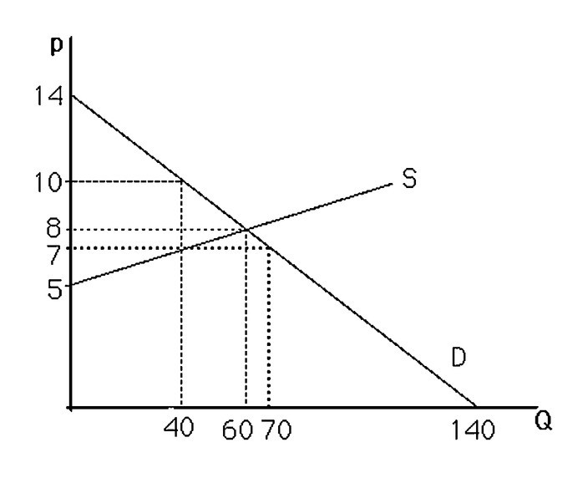
14) The above figure shows a graph of the market for pizzas in a large town. No pizzas will be demanded unless price is less than
A) $0.
B) $5.
C) $12.
D) $14.
Answer: D
Section: Demand
Question Status: Old
AACSB: Analytic thinking

15) The above figure shows a graph of the market for pizzas in a large town. If the price falls from $10 to $7 per pizza, the quantity of pizzas demanded will
A) increase by 20.
B) decrease by 30.
C) increase by 30.
D) decrease by 10.
Answer: C
Section: Demand
Question Status: Old
AACSB: Analytic thinking

16) If a yet-to-be released video game receives a positive review in a popular gaming magazine,
A) the demand curve is expected to shift to the right.
B) the demand curve is expected to shift to the left.
C) the demand curve is not expected to change.
D) for those who read the review, demand shifts to the left. For those who don't read the review, demand shifts to the right.
Answer: A
Section: Demand
Question Status: Old
AACSB: Analytic thinking
17) Which of the following cultural events likely increased the demand for the associated product?
A) the banning of cigarette advertising on television
B) the inclusion of Reese's Pieces in the movie E.T.
C) increased environmental awareness about the impacts of sport utility vehicles (SUVs)
D) concerns over "Mad Cow" disease in beef
Answer: B
Section: Demand
Question Status: Old
AACSB: Analytic thinking

18) The law of demand
A) was passed by the 102nd U.S. Congress.
B) is a natural law, much like the law of gravity.
C) is considered a "law" in economics because of the overwhelming empirical evidence that supports its logic.
D) is considered a "law" in economics in order to force economic models to operate fully.
Answer: C
Section: Demand
Question Status: Old
AACSB: Analytic thinking

19) If on Tuesday the perceived price of studying for an exam is $4 per hour but on Saturday the perceived price of studying for an exam is $10, the law of demand predicts
A) more studying on Saturday and less on Tuesday.
B) more studying on Tuesday and less on Saturday.
C) the same amount of studying on Tuesday and Saturday.
D) no studying on Tuesday or Saturday.
Answer: B
Section: Demand
Question Status: Old
AACSB: Analytic thinking

20) Which of the following would NOT change demand?
A) the price of the product
B) information about the product's health effects
C) the income of the consumers
D) the price of related products
Answer: A
Section: Demand
Question Status: Old
AACSB: Analytic thinking

21) If a demand curve shifts left, it implies
A) as a group, consumers are willing and able to pay less for the product.
B) as a group, consumers are willing and able to pay more for the product.
C) government has regulated how many people can purchase the product.
D) the profit motive of the firms is making the price too high.
Answer: A
Section: Demand
Question Status: Old
AACSB: Analytic thinking
22) If the price of gasoline were $5, many people would stop buying gasoline while others would continue to do so. This would indicate
A) those who are buying gasoline value it at least $5 per gallon.
B) those who are not buying gasoline value it more than $5 per gallon.
C) only those who are extremely wealthy are buying gasoline.
D) the price of gasoline needs to be regulated by the Federal Government.
Answer: A
Section: Demand
Question Status: Old
AACSB: Analytic thinking

23) Suppose the market demand curve for pizza can be expressed as QD = 100 - 2P + 3Pb, where QD is the quantity of pizza demanded, P is the price of pizza, and Pb is the price of a burrito. What is the relationship between burritos and pizza, from the point of view of consumers?
A) They are independent.
B) They are complements.
C) They are substitutes.
D) Not enough information to answer the question.
Answer: C
Section: Demand
Question Status: Old
AACSB: Analytic thinking

24) If the price is $5 and the quantity demanded is 100 units, then at a price of $10, the quantity demanded will be
A) less than or equal to 100 units.
B) greater than or equal to 100 units.
C) less than or equal to 1000 units.
D) equal to 100 units.
Answer: A
Section: Demand
Question Status: Old
AACSB: Analytic thinking

25) Assume the price of a movie is $10. Jenna demands 2 movies per week, Sam demands 3 movies per week, and Jordan demands 8 movies per week. From this information we can conclude that
A) the market quantity demanded at a price of $10 is at least 13 movies per week.
B) Jordan is obviously more wealthy than either Sam or Jenna.
C) Sam is irrational compared to Jenna or Jordan.
D) the movie industry is unprofitable.
Answer: A
Section: Demand
Question Status: Old
AACSB: Analytic thinking
26) Assume Joe is only willing to pay $5 for a Ferrari sports car.
A) Joe is not considered part of the demand for Ferraris.
B) Joe most likely will not be sold a Ferrari.
C) Joe is not considered rational.
D) Joe's willingness to pay is not indicative of how much he values the Ferrari.
Answer: B
Section: Demand
Question Status: Old
AACSB: Analytic thinking

27) A downward sloping demand curve indicates that
A) individuals all have the same valuation of the same product.
B) individuals have different valuations of the same product.
C) individuals have no valuations of a particular product.
D) certain individuals are uninformed about certain aspects of the product.
Answer: B
Section: Demand
Question Status: Old
AACSB: Analytic thinking

28) The demand function for tickets to Ireland is expressed as Qd = 1600 - 0.005P + 2PEngland + 3rain + 2Y, where P is the price for tickets to Ireland, PEngland is the price of tickets to England, rain is the inches of rain Ireland receives annually, and Y is annual household income. Assuming PEngland is $1000, rain is 30 inches per year, and income is 40,000, how much would the price of tickets to Ireland have to fall for consumers to be willing to buy one more trip per year?
A) $15
B) $20
C) $50
D) $200
Answer: D
Section: Demand
Question Status: Old
AACSB: Analytic thinking
29) The above figure shows a graph of the market for pizzas in a large town. If the price increases from $7 to $8 per pizza, the quantity of pizzas demanded will
A) increase by 20.
B) decrease by 30.
C) increase by 30.
D) decrease by 10.
Answer: D
Section: Demand
Question Status: New
AACSB: Analytic thinking

30) Suppose the market demand curve for tacos can be expressed as QD = 120 - 3P - Pb, where QD is the quantity of tacos demanded, P is the price of a taco, and Pb is the price of a burrito. What is the relationship between burritos and tacos, from the point of view of consumers?
A) They are independent.
B) They are complements.
C) They are substitutes.
D) Not enough information to answer the question.
Answer: B
Section: Demand
Question Status: New
AACSB: Analytic thinking
31) Suppose the market demand curve for apples can be expressed as QD = 220 - 2P - Pb + 0.2Y, where QD is the quantity of apples demanded, P is the price of an apple, Pb is the price of a banana, and Y is the average annual household income in thousands of dollars. What is the change in the quantity demanded of apples if the income increases by $10,000?
A) 220 apples
B) 2 apples
C) 40 apples
D) Not enough information to answer the question.
Answer: B
Section: Demand
Question Status: New
AACSB: Analytic thinking

For the following, please answer "True" or "False" and explain why.

32) If a good is not produced, then there is no demand for it.
Answer: False. The demand for a product is independent of its supply. It is possible that people want to buy some of the product but at prices that are below what sellers would require to begin production.
Section: Demand
Question Status: Old
AACSB: Analytic thinking

33) Because people prefer name-brand pain-relieving drugs over store-brand pain-relieving drugs, demand curves do not slope downward for pain-relieving drugs.
Answer: False. Demand curves slope downward assuming all other factors do not change. Consumers may view brand-name drugs to be of higher quality than store-brand drugs, and therefore the demand curve for brand-name drugs lies to the right of the demand curve for store-brand drugs.
Section: Demand
Question Status: Old
AACSB: Analytic thinking

34) The quantity of a good that consumers demand depends only on the price of the good.
Answer: False. The quantity of a good demanded depends on many factors including: its own price, consumers' incomes, and the price of related goods.
Section: Demand
Question Status: Old
AACSB: Analytic thinking

35) During the winter of 1997-1998, the northeastern United States experienced warmer than usual conditions. The price of home heating oil was less than it was during the previous winter, but people bought less home heating oil. This contradicts the Law of Demand.
Answer: False. The statement claiming a contradiction confuses a change in quantity demanded with a change in the demand curve. The law of demand refers to movements along a given demand curve. The mild weather caused a leftward shift of the demand curve.
Section: Demand
Question Status: Old
AACSB: Analytic thinking
36) Suppose an individual inverse demand curve is given as P = 2 – 1/2 qi, where qi is the quantity demanded by individual i. There are 50 individual consumers with this identical, individual inverse demand curve. Solve for the market demand curve.
Answer: Solve for the individual, regular demand curve, qi = 4 - 2P. Multiply the individual demand curve by 50 to yield QD = 200 - 100P.
Section: Demand
Question Status: Old
AACSB: Analytic thinking

37) Suppose the market demand curve for pizza can be expressed as QD = 100 - 2P + 3Pb, where QD is the quantity of pizza demanded, P is the price of a pizza, and Pb is the price of a burrito. What is the slope of this demand function, and what information does the slope provide?
Answer: The slope is -2. The slope tells us how a change in the price of pizzas affects the quantity of pizzas demanded. An increase in the price of pizzas by $1 will result in a decrease of the quantity demanded by 2 pizzas.
Section: Demand
Question Status: Old
AACSB: Analytic thinking

38) Suppose the demand for a particular product can be expressed as Q = 100/p. Calculate the total amount spent on this good when p = 10, 20, and 50. Can you make a generalization about the mathematical form of this demand curve and consumer behavior in this market?
Answer: In all cases, total expenditure equals 100 (since p * Q = 100). In general, a nonlinear demand curve of the form Q = A/p means that consumers wish to spend a total of A on this good regardless of its price.
Section: Demand
Question Status: Old
AACSB: Analytic thinking

2.2 Supply

1) Suppose the demand curve for a good shifts rightward, causing the equilibrium price to increase. This increase in the price of the good results in
A) a rightward shift of the supply curve.
B) an increase in quantity supplied.
C) a leftward shift of the supply curve.
D) a downward movement along the supply curve.
Answer: B
Section: Supply
Question Status: Old
AACSB: Analytic thinking

2) An increase in the price of oil will
A) shift the supply curve of oil to the left.
B) shift the supply curve of oil to the right.
C) leave the supply curve of oil unchanged.
D) Not enough information to answer the question.
Answer: C
Section: Supply
Question Status: Old
AACSB: Analytic thinking
3) The above figure shows a graph of the market for pizzas in a large town. No pizzas will be supplied unless the price is above
A) $0.
B) $5.
C) $12.
D) $14.
Answer: B
Section: Supply
Question Status: Old
AACSB: Analytic thinking

4) Supply curves
A) slope upward.
B) slope downward.
C) are horizontal.
D) can have many shapes.
Answer: D
Section: Supply
Question Status: Old
AACSB: Analytic thinking

5) Suppose there are 100 identical firms in the rag industry, and each firm is willing to supply 10 rags at any price. The market supply curve will be a
A) vertical line where Q = 10.
B) vertical line where Q = 100.
C) vertical line where Q = 1000.
D) horizontal line where Q = 1000.
Answer: C
Section: Supply
Question Status: Old
AACSB: Analytic thinking

6) The expression "increase in quantity supplied" is illustrated graphically as a
A) leftward shift in the supply curve.
B) rightward shift in the supply curve.
C) movement up along the supply curve.
D) movement down along the supply curve.
Answer: C
Section: Supply
Question Status: Old
AACSB: Analytic thinking

7) If the supply curve of a product changes so that sellers are now willing to sell 2 additional units at any given price, the supply curve will
A) shift leftward by 2 units.
B) shift rightward by 2 units.
C) shift vertically up by 2 units.
D) shift vertically down by 2 units.
Answer: B
Section: Supply
Question Status: Old
AACSB: Analytic thinking

8) The market supply curve is found by
A) horizontally summing all individual supply curves.
B) vertically summing all individual supply curves.
C) Either A or B above since they both give the same answer.
D) None of the above.
Answer: A
Section: Supply
Question Status: Old
AACSB: Analytic thinking

9) Technological innovation in the production of computers has led to
A) a decrease in the quantity demanded for computers.
B) a rightward shift of the supply curve for computers.
C) a decrease in the quantity supplied of computers.
D) None of the above.
Answer: B
Section: Supply
Question Status: Old
AACSB: Analytic thinking

10) Horizontally summing different supply curves assumes
A) that individual firms cannot influence the good's price.
B) that all firms operate in collusion.
C) that only firms who volunteer are included in the summation.
D) all firms produce the same amount of output.
Answer: A
Section: Supply
Question Status: Old
AACSB: Analytic thinking
11) If two firms produce the same product but have different supply curves,
A) this would indicate that some other variable differs across the two firms.
B) this would indicate that all variables are the same across the two firms.
C) this would indicate that one or both of the firm's managers are misinformed.
D) this would indicate a need for government regulation.
Answer: A
Section: Supply
Question Status: Old
AACSB: Analytic thinking

12) The supply curve is influenced by
A) the income of consumers.
B) the number of customers in the market.
C) the prices of the inputs required to produce the product.
D) the expectations of future profit.
Answer: C
Section: Supply
Question Status: Old
AACSB: Analytic thinking

13) The price of crude oil increased to $100 per barrel in early 2008. What would we expect to see happen to the supply of gasoline, which is produced using crude oil?
A) The supply of gasoline will increase.
B) The supply of gasoline will decrease.
C) The supply of gasoline will stay the same because the government requires gasoline producers to meet statutory minimum production levels.
D) The supply of gasoline will stay the same because of the profit motives of gasoline producers.
Answer: B
Section: Supply
Question Status: Old
AACSB: Analytic thinking

14) If ethanol production is expected to increase the price of corn, U.S. farmers will likely
A) shift the supply of corn to the left.
B) shift the supply of corn to the right.
C) reduce the production of corn by sliding down the corn supply curve, all else equal.
D) increase the production of corn by sliding up the corn supply curve, all else equal.
Answer: D
Section: Supply
Question Status: Old
AACSB: Analytic thinking
15) Suppose society wants to increase the number of teachers in society but doesn't want to pay teachers any more in salary and benefits. This could only occur by
A) making it more expensive to become a teacher, perhaps by raising college tuition rates.
B) making it less expensive to become a teacher, perhaps by offering subsidies to college tuition.
C) making computers more powerful.
D) increasing the income of student parents.
Answer: B
Section: Supply
Question Status: Old
AACSB: Analytic thinking

16) What is the total market supply, Qs, for luxury sports cars in the United States if the only three suppliers inverse supply functions are P = -10 + 5Qs1, P = 20 + 5Qs2, P = 5Qs3?
A) P = 10 + 21Qs
B) Qs = -2 + 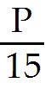
C) Qs = 6 +
D) Qs = -2 + 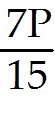
Answer: B
Section: Supply
Question Status: Old
AACSB: Analytic thinking

17) The inverse supply curve of coffee beans equals P = -5 - 2rain + Qs, where rain equals the number of inches of rain per year. How much does quantity supplied change when rain increases from 30 inches to 40 inches per year?
A) Qs decreases by 40.
B) Qs increases by 40.
C) Qs increases by 30.
D) Qs decreases by 30.
Answer: B
Section: Supply
Question Status: Old
AACSB: Analytic thinking
18) The above figure shows a graph of the market for pizzas in a large town. If the price increases from $7 to $8 per pizza, the quantity of pizzas supplied will
A) increase by 30.
B) increase by 20.
C) decrease by 10.
D) decrease by 20.
Answer: B
Section: Supply
Question Status: New
AACSB: Analytic thinking

For the following, please answer "True" or "False" and explain why.

19) The Law of Supply ensures that supply curves slope upward.
Answer: False. There is no "Law of Supply" that requires the market supply curve to have a particular slope.
Section: Supply
Question Status: Old
AACSB: Analytic thinking

20) Suppose the following information is known about a market:

1. Sellers will not sell at all below a price of $2.
2. At a price of $10, any given seller will sell 10 units.
3. There are 100 identical sellers in the market.

Assuming a linear supply curve, use this information to derive the market supply curve.
Answer: First, Q = 100q since all firms are identical. This gives two points: (p = 2, Q = 0) and (p = 10, Q = 1000). From the first point, it is known that p = 2 + bQ. When Q = 1000, 10 = 2 + b(1000). Solving for b yields b = .008. Rearranging to solve for Q yields: Q = -250 + 125p or P = 2 + .008Q.
Section: Supply
Question Status: Old
AACSB: Analytic thinking
2.3 Market Equilibrium

1) Equilibrium is defined as a situation in which
A) neither buyers nor sellers want to change their behavior.
B) no government regulations exist.
C) demand curves are perfectly horizontal.
D) suppliers will supply any amount that buyers wish to buy.
Answer: A
Section: Market Equilibrium
Question Status: Old
AACSB: Analytic thinking

2) Once an equilibrium is achieved, it can persist indefinitely because
A) shocks that shift the demand curve or the supply curve cannot occur.
B) shocks to the demand curve are always exactly offset by shocks to the supply curve.
C) the government never intervenes in markets at equilibrium.
D) in the absence of supply/demand shocks no one applies pressure to change the price.
Answer: D
Section: Market Equilibrium
Question Status: Old
AACSB: Analytic thinking

3) If price is initially above the equilibrium level,
A) the supply curve will shift rightward.
B) the supply curve will shift leftward.
C) excess supply exists.
D) all firms can sell as much as they want.
Answer: C
Section: Market Equilibrium
Question Status: Old
AACSB: Analytic thinking

4) A competitive equilibrium is described by
A) a price only.
B) a quantity only.
C) the excess supply minus the excess demand.
D) a constant price and a quantity.
Answer: D
Section: Market Equilibrium
Question Status: Old
AACSB: Analytic thinking
5) The above figure shows a graph of the market for pizzas in a large town. At a price of $14, there will be
A) no pizzas supplied.
B) equilibrium.
C) excess supply.
D) excess demand.
Answer: C
Section: Market Equilibrium
Question Status: Old
AACSB: Analytic thinking

6) The above figure shows a graph of the market for pizzas in a large town. At a price of $5, there will be
A) excess demand.
B) excess supply.
C) equilibrium.
D) zero demand.
Answer: A
Section: Market Equilibrium
Question Status: Old
AACSB: Analytic thinking

7) The above figure shows a graph of the market for pizzas in a large town. What are the equilibrium price and quantity?
A) p = 8, Q = 60
B) p = 7, Q = 40
C) p = 7, Q = 70
D) p = 10, Q = 40
Answer: A
Section: Market Equilibrium
Question Status: Old
AACSB: Analytic thinking
8) The figure above shows a graph of the market for pizzas in a large town. What characterizes the equilibrium in this market?
A) There is excess supply at the equilibrium price of $7.
B) The government has selected the appropriate price for pizzas.
C) The quantity supplied equals the quantity demanded.
D) Supply equals demand.
Answer: C
Section: Market Equilibrium
Question Status: Old
AACSB: Analytic thinking

9) The above figure shows a graph of a market for pizzas in a large town. At a price of $7, what is the amount of excess demand?
A) 0; there is excess supply at $7.
B) 20 units
C) 30 units
D) 10 units
Answer: C
Section: Market Equilibrium
Question Status: Old
AACSB: Analytic thinking

10) The above figure shows a graph of a market for pizzas in a large town. At a price of $10, the market
A) is not in equilibrium.
B) has excess supply.
C) does not have excess demand.
D) All of the above.
Answer: D
Section: Market Equilibrium
Question Status: Old
AACSB: Analytic thinking
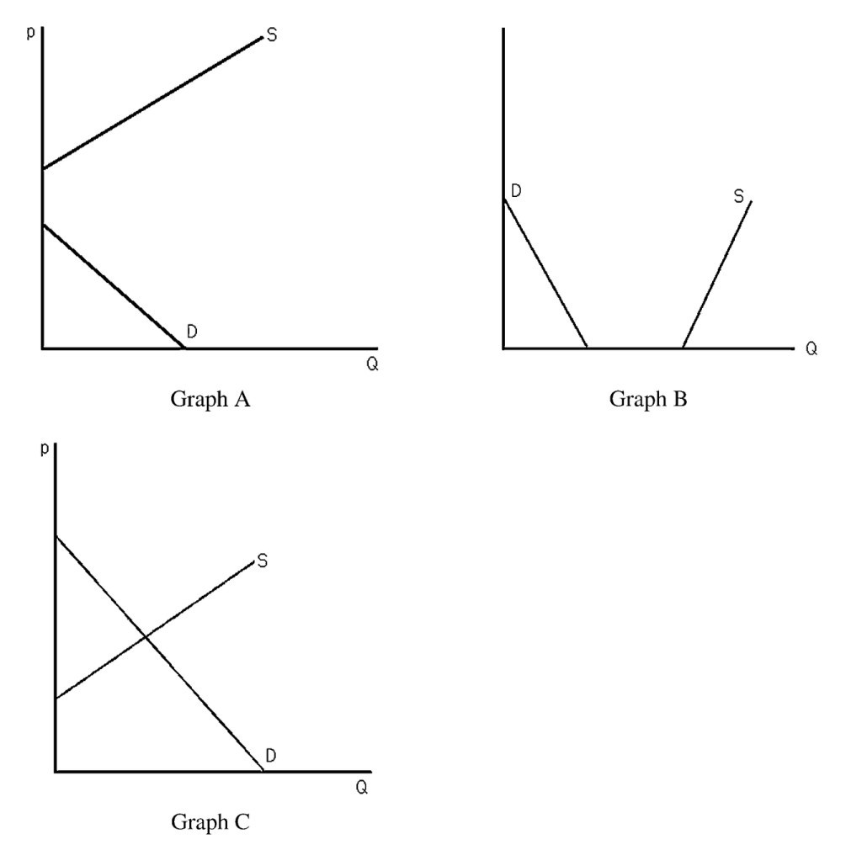
11) The above figure shows three different supply-and-demand graphs. Which graph best represents the market for vacations on Mars?
A) Graph A
B) Graph B
C) Graph C
D) None of the above.
Answer: A
Section: Market Equilibrium
Question Status: Old
AACSB: Analytic thinking
12) The above figure shows three different supply-and-demand graphs. Which graph best represents the market for workers at your nearest fast-food restaurant?
A) Graph A
B) Graph B
C) Graph C
D) None of the above.
Answer: C
Section: Market Equilibrium
Question Status: Old
AACSB: Analytic thinking

13) The above figure shows three different supply-and-demand graphs. Which graph best represents the market for the air we are currently breathing?
A) Graph A
B) Graph B
C) Graph C
D) None of the above.
Answer: B
Section: Market Equilibrium
Question Status: Old
AACSB: Analytic thinking

14) After tickets for a major sporting event are purchased at the official box office price, a market often develops whereby these tickets sell at prices well above the official box office price. Which of the following scenarios would NOT be able to explain this result?
A) The official price was below equilibrium from the moment the tickets were available.
B) Increased publicity causes the demand curve for the event to shift rightward.
C) The event was not a sellout.
D) Not everyone who wanted a ticket was able to buy one at the box office.
Answer: C
Section: Market Equilibrium
Question Status: Old
AACSB: Analytic thinking

15) At equilibrium, quantity sold equals the quantity bought. This implies that
A) to sell more, producers require more in payment than consumers are willing to pay.
B) government regulation is necessary.
C) to sell less would require a lower price but would yield greater profit.
D) those who don't buy have been treated unfairly.
Answer: A
Section: Market Equilibrium
Question Status: Old
AACSB: Analytic thinking

16) The supply and demand model assumes
A) no buyer or seller can unilaterally influence the price of the product.
B) each unit sold is sold at the same price.
C) suppliers and demanders know the price of the product.
D) All of the above.
Answer: D
Section: Market Equilibrium
Question Status: Old
AACSB: Analytic thinking
17) A market equilibrium occurs
A) only with government regulation.
B) only because of the profit motive of firms.
C) only because of the complacency of consumers.
D) through the interaction of self-interested consumers and producers.
Answer: D
Section: Market Equilibrium
Question Status: Old
AACSB: Analytic thinking

18) Lionfish is an aquatic invasive species in the southeastern U.S. and the Caribbean. Current removal policies focus on harvesting the lionfish for human consumption. However, a fishing license is required to fish in most southern states. Assume the supply of fishing licenses is Qs = 50 + 0.05L + 40P, where L = lionfish population and P = price of a fishing license, and the demand for fishing licenses is Qd = 1400 – 60P. What is the equilibrium price and quantity of fishing licenses when L = 1,000?
A) P = $8.5, Q = 890
B) P = $13, Q = 620
C) P = $13.5, Q = 590
D) P = $13.5, Q = 591
Answer: B
Section: Market Equilibrium
Question Status: Old
AACSB: Analytic thinking

19) Lionfish is an aquatic invasive species in the southeastern U.S. and the Caribbean. Current removal policies focus on harvesting the lionfish for human consumption. However, a fishing license is required to fish in most southern states. Assume that the supply of fishing licenses is Qs = 50 + 0.05L + 40P, where 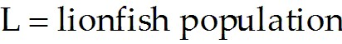 and P = price of a fishing license, and the demand for fishing licenses is Qd = 1400 – 60P. What is the equilibrium price and quantity of fishing licenses when L = 10,000?
A) P = $8.5, Q = 890
B) P = $13, Q = 620
C) P = $13.5, Q = 590
D) P = $13.5, Q = 591
Answer: A
Section: Market Equilibrium
Question Status: Old
AACSB: Analytic thinking

For the following, please answer "True" or "False" and explain why.

20) When a market is in disequilibrium consumers and producers change their behavior. As a result the market reaches equilibrium.
Answer: True. For example, when a shortage exists at a given price consumers bid up the price and firms increase production until the equilibrium is reached.
Section: Market Equilibrium
Question Status: Old
AACSB: Analytic thinking
21) Suppose the market for potatoes can be expressed as follows:

Supply: QS = -20 + 10p
Demand: QD = 400 - 20p

Solve for the equilibrium price and quantity.
Answer: Equate the RHS of the supply equation to the RHS of the demand equation: -20 + 10p = 400 - 20p.
Rearrange: 30p = 420 or p = 14. Plug this into either S or D to get Q: Q = 400 - 20(14) = 120.
Section: Market Equilibrium
Question Status: Old
AACSB: Analytic thinking

22) Use supply-and-demand graphs to explain why parking is free at the suburban shopping mall but one typically must pay to park when shopping downtown.
Answer:
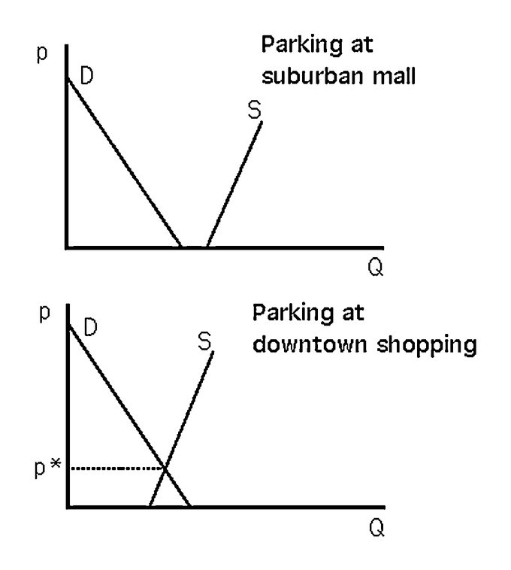
See the above figure. At the suburban shopping mall, the only cars typically on the lot belong to shoppers and employees. Mall lots are usually built to be large enough to handle peak crowds. For the relevant quantities, the supply curve is horizontal at a price of zero. As a result, the quantity demanded never exceeds the amount that is provided freely. Downtown, shoppers compete with a larger quantity and greater variety of drivers for parking spaces. The quantity that is available freely is not enough to accommodate all of those who wish to park downtown.
Section: Market Equilibrium
Question Status: Old
AACSB: Analytic thinking
23) Explain why the equilibrium price is called the market clearing price.
Answer: At the equilibrium price, sellers want to sell the exact amount consumers want to buy. There is no excess demand or excess supply. The market is exactly cleared of all goods.
Section: Market Equilibrium
Question Status: Old
AACSB: Analytic thinking

2.4 Shocking the Equilibrium

1) From the 1970s through the 1990s, the relative price of a college education has increased greatly. During the same time period, college enrollment has also increased. This evidence suggests that during this time period
A) the demand curve for a college education has shifted leftward.
B) the demand curve for a college education has shifted rightward.
C) the supply curve for a college education has shifted leftward.
D) the supply curve for a college education has shifted rightward.
Answer: B
Section: Shocking the Equilibrium
Question Status: Old
AACSB: Analytic thinking
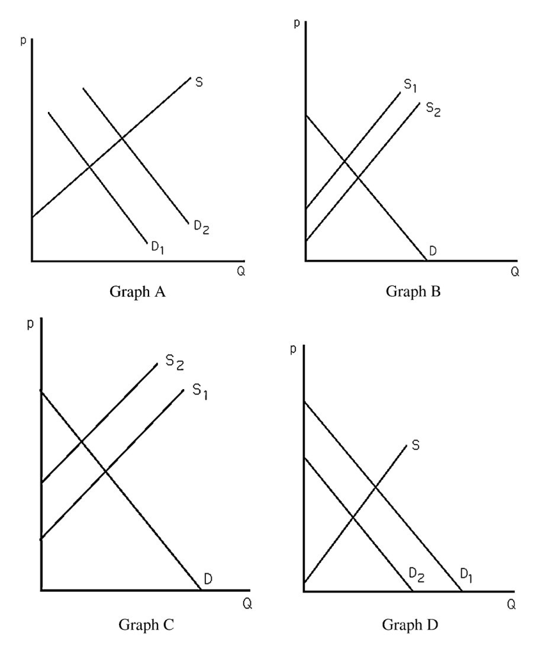
2) The above figure shows four different markets with changes in either the supply curve or the demand curve. Which graph best illustrates the market for coffee after severe weather destroys a large portion of the coffee crop?
A) Graph A
B) Graph B
C) Graph C
D) Graph D
Answer: C
Section: Shocking the Equilibrium
Question Status: Old
AACSB: Analytic thinking
3) The above figure shows four different markets with changes in either the supply curve or the demand curve. Assuming coffee and tea are substitutes, which graph best illustrates the market for tea after severe weather destroys a large portion of the coffee crop?
A) Graph A
B) Graph B
C) Graph C
D) Graph D
Answer: A
Section: Shocking the Equilibrium
Question Status: Old
AACSB: Analytic thinking

4) The above figure shows four different markets with changes in either the supply curve or the demand curve. Which graph best illustrates the market for non-dairy coffee creamer after severe weather destroys a large portion of the coffee crop?
A) Graph A
B) Graph B
C) Graph C
D) Graph D
Answer: D
Section: Shocking the Equilibrium
Question Status: Old
AACSB: Analytic thinking

5) The above figure shows four different markets with changes in either the supply curve or the demand curve. Which graph best illustrates the market for computers after technological advances in making computers occur?
A) Graph A
B) Graph B
C) Graph C
D) Graph D
Answer: B
Section: Shocking the Equilibrium
Question Status: Old
AACSB: Analytic thinking

6) The above figure shows four different markets with changes in either the supply curve or the demand curve. Which graph best illustrates the market for computer manuals after technological advances in making computers occur?
A) Graph A
B) Graph B
C) Graph C
D) Graph D
Answer: A
Section: Shocking the Equilibrium
Question Status: Old
AACSB: Analytic thinking

7) The above figure shows four different markets with changes in either the supply curve or the demand curve. Which graph best illustrates the market for typewriters after technological advances in computerized word-processing software occur?
A) Graph A
B) Graph B
C) Graph C
D) Graph D
Answer: D
Section: Shocking the Equilibrium
Question Status: Old
AACSB: Analytic thinking

8) Suppose a market were currently at equilibrium. A rightward shift of the demand curve would cause
A) an increase in price but a decrease in quantity.
B) a decrease in price but an increase in quantity.
C) an increase in both price and quantity.
D) a decrease in both price and quantity.
Answer: C
Section: Shocking the Equilibrium
Question Status: Old
AACSB: Analytic thinking

9) Suppose a market were currently at equilibrium. A rightward shift of the supply curve would cause a(n)
A) increase in price but a decrease in quantity.
B) decrease in price but an increase in quantity.
C) increase in both price and quantity.
D) decrease in both price and quantity.
Answer: B
Section: Shocking the Equilibrium
Question Status: Old
AACSB: Analytic thinking

10) A rightward shift of the demand curve will lead to an
A) increase in equilibrium price.
B) excess demand at the old equilibrium price.
C) increase in quantity supplied.
D) All of the above.
Answer: D
Section: Shocking the Equilibrium
Question Status: Old
AACSB: Analytic thinking

11) A rightward shift of the supply curve will lead to a(n)
A) decrease in equilibrium price.
B) excess supply at the old equilibrium price.
C) increase in quantity demanded.
D) All of the above.
Answer: D
Section: Shocking the Equilibrium
Question Status: Old
AACSB: Analytic thinking
12) If the demand curve is vertical a rightward shift of the supply curve will lead to
A) an increase in quantity supplied.
B) an increase in quantity demanded.
C) a decrease in quantity demanded.
D) a decrease in price.
Answer: D
Section: Shocking the Equilibrium
Question Status: Old
AACSB: Analytic thinking

13) When two goods are substitutes, a shock that raises the price of one good causes the price of the other good to
A) remain unchanged.
B) decrease.
C) increase.
D) change in an unpredictable manner.
Answer: C
Section: Shocking the Equilibrium
Question Status: Old
AACSB: Analytic thinking

14) A drought in the Midwest will raise the price of wheat because of a
A) leftward shift in the supply curve.
B) rightward shift in the supply curve.
C) leftward shift in the demand curve.
D) rightward shift in the demand curve.
Answer: A
Section: Shocking the Equilibrium
Question Status: Old
AACSB: Analytic thinking

15) If pizza and tacos are substitutes, a decrease in the price of tacos would lead to a
A) decrease in the demand curve for pizza.
B) decrease in the quantity demanded of pizza.
C) decrease in the price of pizza.
D) All of the above.
Answer: D
Section: Shocking the Equilibrium
Question Status: Old
AACSB: Analytic thinking

16) If oranges were found to cure cancer,
A) the equilibrium price of apples would likely fall.
B) the equilibrium price of oranges would likely increase in the near term.
C) the equilibrium quantity of oranges would likely increase.
D) All of the above.
Answer: D
Section: Shocking the Equilibrium
Question Status: Old
AACSB: Analytic thinking
17) What can explain the fact that DVD players decreased in price during the 1990s even as more DVD players were being sold?
A) The demand for DVDs was declining.
B) The supply of DVD players was decreasing.
C) The supply of DVD players was increasing more than the demand for DVD players.
D) The demand for DVD players was increasing more than the supply of DVD players.
Answer: C
Section: Shocking the Equilibrium
Question Status: Old
AACSB: Analytic thinking

18) If government regulations increase the cost of producing gasoline while at the same time government regulations reduce the cost of driving a relatively inefficient sport utility vehicle (SUV),
A) the supply of gasoline is expected to increase.
B) the demand for gasoline is expected to decrease.
C) the price of gasoline is expected to increase, whereas the total consumption of gasoline can increase, decrease, or stay the same.
D) the supply of gasoline is expected to decrease.
Answer: C
Section: Shocking the Equilibrium
Question Status: Old
AACSB: Analytic thinking

19) If the demand for high definition televisions increases and the supply of high definition televisions increases, then
A) it is clear that prices will increase; the change in the quantity of televisions sold is ambiguous.
B) it is clear that prices will decrease; the change in the quantity of televisions sold is ambiguous.
C) it is clear that quantity sold will increase; the change in the price of televisions is ambiguous.
D) it is clear that quantity sold will decrease; the change in the price of televisions is ambiguous.
Answer: C
Section: Shocking the Equilibrium
Question Status: Old
AACSB: Analytic thinking

20) Lionfish is an aquatic invasive species in the southeastern U.S. and the Caribbean. Current removal policies focus on harvesting the lionfish for human consumption. Assuming that lionfish is a substitute for snapper, what will likely happen to fishing efforts for lionfish if the price of snapper increases?
A) Fishing efforts will increase.
B) Fishing efforts will decrease.
C) Fishing efforts will remain the same if supply is perfectly inelastic.
D) A and C
Answer: D
Section: Shocking the Equilibrium
Question Status: Old
AACSB: Analytic thinking
21) Lionfish is an aquatic invasive species in the southeastern U.S. and the Caribbean. Current removal policies focus on harvesting the lionfish for human consumption. Assuming that lionfish is an inferior good, what will likely happen to fishing efforts if income increases?
A) Fishing efforts will increase.
B) Fishing efforts will decrease, especially when supply is relatively inelastic.
C) Fishing efforts will decrease, especially when supply is relatively elastic.
D) None of the above.
Answer: C
Section: Shocking the Equilibrium
Question Status: Old
AACSB: Analytic thinking

22) Tastes are starting to change for hybrid vehicles such that consumers are purchasing more hybrid vehicles and suppliers are choosing to produce more hybrid vehicles than they were five years ago. Due to the change in tastes, equilibrium price has fallen and equilibrium quantity has increased relative to the hybrid market from five years ago. What is the likely cause of this result?
A) Supply increased by more than demand.
B) Demand increased by more than supply.
C) Demand and supply increased by the same amount.
D) Only supply increased.
Answer: A
Section: Shocking the Equilibrium
Question Status: Old
AACSB: Application of knowledge

23) If the demand curve is horizontal and the supply curve is vertical, shifts of the supply curve will lead to
A) changes in the equilibrium quantity only.
B) changes in the equilibrium price only.
C) changes in both the equilibrium price and quantity.
D) changes in the quantity demanded only.
Answer: A
Section: Shocking the Equilibrium
Question Status: New
AACSB: Analytic thinking

24) Suppose a market is currently at equilibrium. A leftward shift of the demand curve would cause
A) an increase in price but a decrease in quantity.
B) a decrease in price but an increase in quantity.
C) an increase in both price and quantity.
D) a decrease in both price and quantity.
Answer: D
Section: Shocking the Equilibrium
Question Status: New
AACSB: Analytic thinking
25) When two goods are complements, a shock that lowers the price of one good causes the price of the other good to
A) remain unchanged.
B) decrease.
C) increase.
D) change in an unpredictable manner.
Answer: C
Section: Shocking the Equilibrium
Question Status: New
AACSB: Analytic thinking

26) A leftward shift of the supply curve will lead to an
A) increase in equilibrium price.
B) excess supply at the old equilibrium price.
C) increase in quantity supplied.
D) All of the above.
Answer: A
Section: Shocking the Equilibrium
Question Status: New
AACSB: Analytic thinking

For the following, please answer "True" or "False" and explain why.

27) During a mild winter, the price of home heating oil is expected to be less than it would be during a normal winter.
Answer: True. During a mild winter, people do not need to operate their furnace as often as in a normal winter. The demand for home heating oil lies to the left of where it would be under normal weather conditions. As a result, the price of oil falls.
Section: Shocking the Equilibrium
Question Status: Old
AACSB: Analytic thinking
28) What happens to the equilibrium price and quantity of coffee when there is a leftward shift of the supply curve for tea? Explain.
Answer:
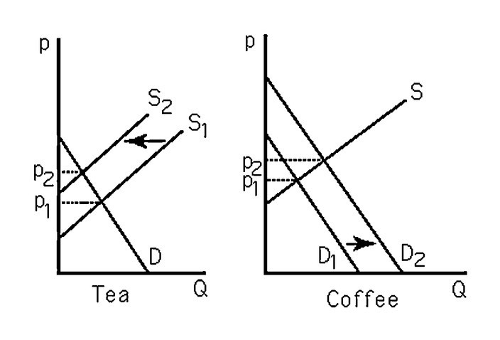
See the above figure. The leftward shift in the supply of tea causes tea prices to increase. Since coffee and tea are substitutes, the demand for coffee increases, resulting in higher coffee prices.
Section: Shocking the Equilibrium
Question Status: Old
AACSB: Analytic thinking
29) Suppose there is a linear downward-sloping demand curve and a linear upward-sloping supply curve for a good. The price of a substitute good increases and the price of an input to production also increases. Graph the original demand and supply curves, and the curves after the substitute good and input prices increase. How will the equilibrium price change after the substitute and input prices increase?
Answer:
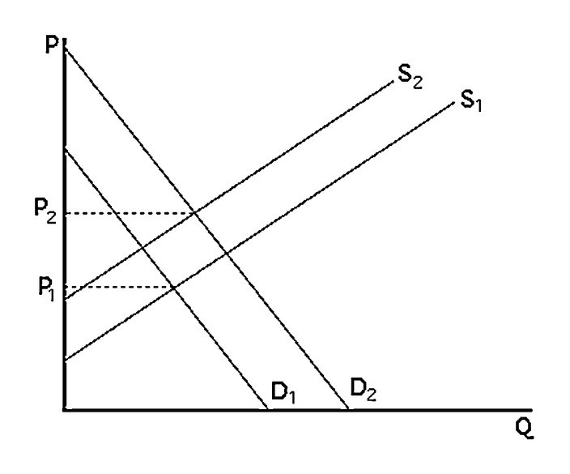
See the above figure. The new demand curve will be to the right of the original demand curve and the new supply curve will be to the left of the original supply curve. The equilibrium price will increase. The change in equilibrium quantity cannot be determined and will depend on the relative magnitude of the supply and demand shifts.
Section: Shocking the Equilibrium
Question Status: Old
AACSB: Analytic thinking

2.5 Equilibrium Effects of Government Interventions

1) Government actions can cause a
A) shift in the supply curve.
B) shift in the demand curve.
C) reaction from firms in other countries.
D) All of the above.
Answer: D
Section: Effects of Government Intervention
Question Status: Old
AACSB: Analytic thinking
2) Municipalities that have adopted the policy of "rent control" typically set the rentals on certain apartments well below equilibrium. As a result,
A) landlords have a difficult time finding tenants.
B) prospective tenants have a difficult time finding available apartments.
C) there is a surplus of apartments.
D) All of the above.
Answer: B
Section: Effects of Government Intervention
Question Status: Old
AACSB: Analytic thinking

3) When "rent controls" result in a shortage of housing, landlords
A) use criteria other than price to allocate housing.
B) lower the price to allocate the housing.
C) attempt to attract renters.
D) None of the above.
Answer: A
Section: Effects of Government Intervention
Question Status: Old
AACSB: Analytic thinking

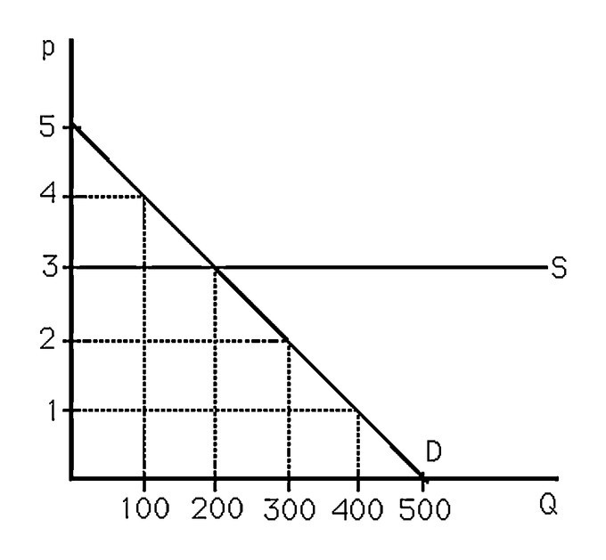
4) The above figure shows the market for apples. If a consumer group convinces the government to set a maximum price of $2 per pound, then
A) 300 pounds of apples will be sold at $2.
B) no apples will be supplied.
C) no apples will be demanded.
D) None of the above.
Answer: B
Section: Effects of Government Intervention
Question Status: Old
AACSB: Analytic thinking
5) The above figure shows the market for apples. If apple farmers convince the government to set a minimum price of $4 per pound, then
A) 100 pounds of apples will be sold at $4.
B) no apples will be supplied.
C) no apples will be demanded.
D) None of the above.
Answer: A
Section: Effects of Government Intervention
Question Status: Old
AACSB: Analytic thinking

6) The above figure shows the market for apples. If the government restricts output to no more than 300 pounds, then
A) 300 pounds of apples will be sold at $3.
B) 200 pounds of apples will be sold at $3.
C) no apples will be sold.
D) None of the above.
Answer: B
Section: Effects of Government Intervention
Question Status: Old
AACSB: Analytic thinking

7) If a government-imposed price ceiling causes the observed price in a market to be below the equilibrium price,
A) there will be excess demand.
B) there will be excess supply.
C) the curves will shift to make a new equilibrium at the regulated price.
D) None of the above.
Answer: A
Section: Effects of Government Intervention
Question Status: Old
AACSB: Analytic thinking

8) In the labor market, if the government imposes a minimum wage that is below the equilibrium wage, then
A) workers who wish to work at the minimum wage will have a difficult time finding jobs.
B) firms will hire fewer workers than without the minimum wage law.
C) some workers may lose their jobs as a result.
D) nothing will happen to the wage rate or employment.
Answer: D
Section: Effects of Government Intervention
Question Status: Old
AACSB: Analytic thinking

9) Government prohibition of advertising cigarettes on television would most likely result in
A) a rightward shift in the demand curve for cigarettes.
B) a leftward shift in the demand curve for cigarettes.
C) a rightward shift in the demand curve for television advertising time.
D) no change in the market for either cigarette or television advertising.
Answer: B
Section: Effects of Government Intervention
Question Status: Old
AACSB: Analytic thinking

10) The above figure shows a graph of the market for pizzas in a large town. Suppose that concern over dietary habits has led the government to impose a restriction that limits suppliers to produce no more than 40 pizzas. What will the price of pizza be as a result of this quota?
A) $2
B) $7
C) $8
D) $10
Answer: D
Section: Effects of Government Intervention
Question Status: Old
AACSB: Analytic thinking

11) The above figure shows a graph of the market for pizzas in a large town. Suppose that concern over dietary habits has led the government to impose a restriction that limits suppliers to produce only 40 pizzas. As a result, for prices greater than $7, the
A) supply curve is unchanged.
B) supply curve is vertical.
C) demand curve becomes vertical.
D) demand curve becomes horizontal.
Answer: B
Section: Effects of Government Intervention
Question Status: Old
AACSB: Analytic thinking

12) The above figure shows a graph of the market for pizzas in a large town. As a result of concern over the affordability of pizza, the government restricts sellers from charging a price over $7. As a result, the quantity of pizzas consumed will
A) increase.
B) decrease.
C) remain unchanged.
D) be indeterminable.
Answer: B
Section: Effects of Government Intervention
Question Status: Old
AACSB: Analytic thinking
13) Agricultural price supports are
A) floors.
B) ceilings.
C) quantity quotas.
D) taxes.
Answer: A
Section: Effects of Government Intervention
Question Status: Old
AACSB: Analytic thinking

14) Consumer groups tend to lobby for
A) price floors.
B) price ceilings.
C) quantity quotas.
D) taxes.
Answer: B
Section: Effects of Government Intervention
Question Status: Old
AACSB: Analytic thinking

15) Producer groups tend to lobby for
A) price floors.
B) price ceilings.
C) quantity quotas.
D) taxes.
Answer: A
Section: Effects of Government Intervention
Question Status: Old
AACSB: Analytic thinking

16) Quotas are most often supported by
A) foreign producers.
B) foreign consumers.
C) domestic consumers.
D) domestic producers.
Answer: D
Section: Effects of Government Intervention
Question Status: Old
AACSB: Analytic thinking

17) Considering that the U.S. places a quota on imports of steel from South Korea, which of the following would NOT likely occur?
A) The price of steel in the United States would increase.
B) The quantity of steel produced in the United States would increase or stay the same.
C) The demand for steel in the United States will increase.
D) The quantity demanded for steel in the United States will decrease.
Answer: C
Section: Effects of Government Intervention
Question Status: Old
AACSB: Analytic thinking
18) Repealing a tariff will likely
A) increase the quantity produced domestically, increase the quantity purchased domestically, and reduce the price charged domestically.
B) reduce the quantity produced domestically, increase the quantity purchased domestically, and reduce the price charged domestically.
C) reduce the amount produced abroad, reduce the price domestically, and reduce the quantity purchased domestically.
D) increase the amount produced abroad, increase the price domestically, and reduce the quantity purchased domestically.
Answer: B
Section: Effects of Government Intervention
Question Status: Old
AACSB: Analytic thinking

19) The fact that many people drive faster than the posted speed limit suggests that
A) not all price floors are enforceable.
B) not all price and quantity regulations are enforceable.
C) individual drivers act irrationally.
D) government regulation is utterly useless.
Answer: B
Section: Effects of Government Intervention
Question Status: Old
AACSB: Analytic thinking

20) A price restriction that tells suppliers the minimum price they can sell their goods for is also known as
A) a price ceiling.
B) a quota.
C) a price floor.
D) deadweight loss.
Answer: A
Section: Effects of Government Intervention
Question Status: Old
AACSB: Analytic thinking

21) Suppose that government decides to create a license for widget makers. Only licensed widget makers are allowed to produce widgets. Moreover, only half of the current widget producers are eligible to obtain the license. What will happen with the supply curve of widgets?
A) It will not change.
B) It will shift to the left.
C) It will shift to the right.
D) It will slope downwards.
Answer: B
Section: Effects of Government Intervention
Question Status: New
AACSB: Analytic thinking
For the following, please answer "True" or "False" and explain why.

22) Import quotas on steel tend to result in higher quantities of steel being sold at lower prices than would be observed in the absence of a quota.
Answer: False. The opposite is true. Quotas restrict the supply curve. This reduces quantity and raises price.
Section: Effects of Government Intervention
Question Status: Old
AACSB: Analytic thinking

23) Suppose the market for potatoes can be expressed as follows:

Supply: QS = -20 + 10p
Demand: QD = 400 - 20p

If the government sets a maximum price of $10 per unit, what will be the quantity demanded and quantity supplied?
Answer: With a maximum price of $10, suppliers will sell only 80 units. (Q = -20 + 10(10) = 80). But at a price of $10, buyers wish to purchase 200 units: Q = 400 - 20(10) = 200. Thus, there will be excess demand of 120 units.
Section: Effects of Government Intervention
Question Status: Old
AACSB: Analytic thinking

24) Usury laws place a ceiling on interest rates that lenders such as banks can charge borrowers. The interest rate is the price of a loan. Graph a binding usury law on the market for loans, and describe the effects of the law on the quantity of loans supplied and the quantity of loans demanded.
Answer:
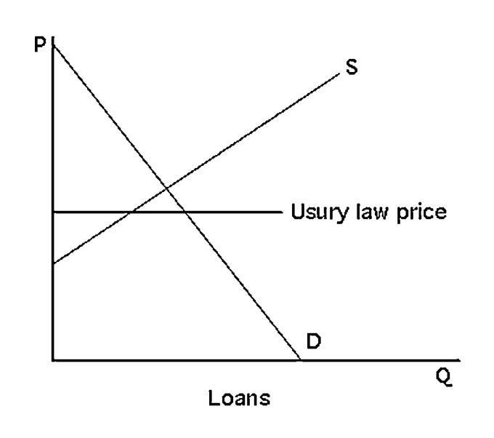
See the above figure. The usury law will result in more loans being demanded and fewer loans being supplied.
Section: Effects of Government Intervention
Question Status: Old
AACSB: Analytic thinking
25) Suppose the market for potatoes can be expressed as follows:

Supply: QS = -20 + 10p
Demand: QD = 400 - 20p

Suppose the government restricts the quantity to 100 units. What will be the price of potatoes?
Answer: (1) Find the inverse supply curve: p = 2 + .1Q. If quantity were restricted to 100 units, sellers would require only $12 per unit. (2) Find the inverse demand curve: p = 20 - .05Q. Buyers would be willing to pay $15 per unit and would bid the price up to that amount.
Section: Effects of Government Intervention
Question Status: Old
AACSB: Analytic thinking

26) Use a supply-and-demand graph to predict what happens to sheet steel prices in the United States after quotas on Japanese and European sheet steel expire.
Answer:
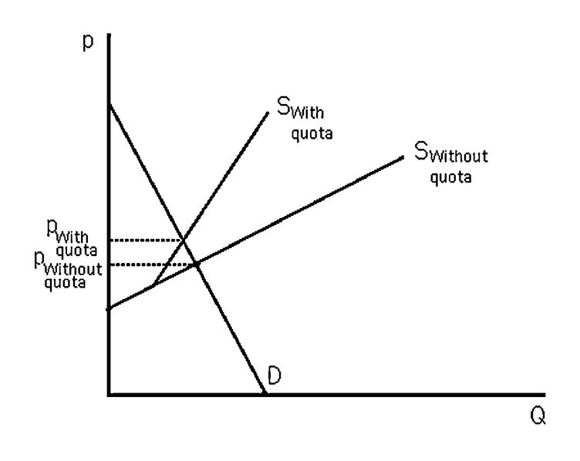
See the above figure. The quota-restricted supply results in a higher price than the market equilibrium. When the quotas expire, the Japanese and European steel firms export into the United States based upon their own supply curves. The new equilibrium will be at a lower price.
Section: Effects of Government Intervention
Question Status: Old
AACSB: Analytic thinking
27) Assume that the market for annual physical checkups is in equilibrium, and not everyone gets an annual physical checkup. What is the effect on price and quantity if a government regulation fixes price at the current level and requires everyone to get an annual physical checkup?
Answer:
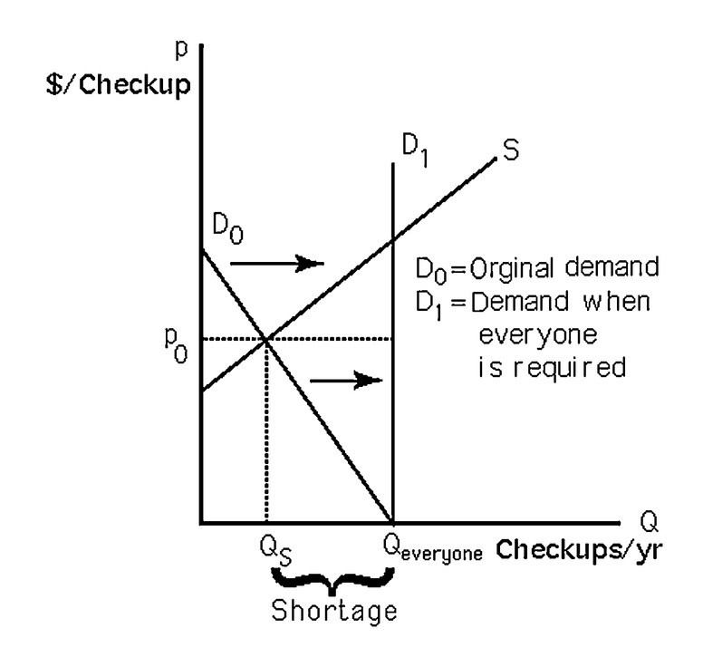
See the above figure. Requiring everyone to get a physical would shift the demand curve rightward. With price remaining fixed, a shortage will result.
Section: Effects of Government Intervention
Question Status: Old
AACSB: Analytic thinking

28) Suppose the market for a good is expressed as follows:

Inverse demand: P = 200 - 2Q
Inverse supply: P = 2Q

What is the equilibrium if the government imposes a supply quota of 75 units?
What is the equilibrium if the government imposes a supply quota of 25 units?
Answer: The market equilibrium with no quota is P = $100 and Q = 50 units. A supply quota of 75 units is not binding so the equilibrium is unchanged. A supply quota of 25 units will change the supply curve. The new supply curve will be the same as the no quota supply curve until 25 units and then it will be vertical. The new equilibrium is P = $150 and Q = 25 units.
Section: Effects of Government Intervention
Question Status: Old
AACSB: Analytic thinking
2.6 When to Use the Supply-and-Demand Model

1) It is appropriate to use the supply-and demand-model if, in a market,
A) everyone is a price taker with full information about the price and quality of the good.
B) firms sell identical products.
C) costs of trading are low.
D) All of the above.
Answer: D
Section: When to Use the Supply-and-Demand Model
Question Status: Old
AACSB: Analytic thinking

2) Consumers and firms are known as price takers only if
A) no market exists to determine the equilibrium price.
B) they can set the market price.
C) they cannot unilaterally affect the market price.
D) excess demand exists.
Answer: C
Section: When to Use the Supply-and-Demand Model
Question Status: Old
AACSB: Analytic thinking

3) Costs that pertain to finding a trading partner and making a trade are called
A) transaction costs.
B) transgression costs.
C) consumption costs.
D) transaction taxes.
Answer: A
Section: When to Use the Supply-and-Demand Model
Question Status: Old
AACSB: Analytic thinking

4) It is appropriate to use the supply-and-demand model in which of the following markets?
A) beer market
B) car market
C) wheat market
D) market for breakfast cereal
Answer: C
Section: When to Use the Supply-and-Demand Model
Question Status: Old
AACSB: Analytic thinking

5) One of the biggest benefits of the Internet auction site eBay
A) is its control over prices.
B) is that it increases the supply of products.
C) is that it increases the demand for products.
D) is that it reduces transaction costs for both sellers and buyers.
Answer: D
Section: When to Use the Supply-and-Demand Model
Question Status: Old
AACSB: Analytic thinking
6) What is one reason the supply and demand model might NOT be appropriate to the health-care industry?
A) Consumers do not have full information.
B) Providers do not know the demand for health-care services.
C) Consumers do not know how to value their own health.
D) The costs of finding a doctor are too low.
Answer: A
Section: When to Use the Supply-and-Demand Model
Question Status: Old
AACSB: Analytic thinking

7) The power of the supply and demand model lies in its ability
A) to generally predict how price and quantity will change with supply and demand shocks.
B) to precisely predict the impact of government regulations on quantity and price.
C) to precisely determine the difference between price ceilings and price floors.
D) to generally predict how profit motive impacts the distribution of goods and services.
Answer: A
Section: When to Use the Supply-and-Demand Model
Question Status: Old
AACSB: Analytic thinking

8) Understanding the supply and demand model facilitates
A) greed.
B) charity.
C) happiness.
D) prediction.
Answer: D
Section: When to Use the Supply-and-Demand Model
Question Status: Old
AACSB: Analytic thinking

9) The military is NOT a perfectly competitive market because
A) there is only one buyer, i.e., the government, for military goods/services.
B) there is imperfect information, i.e., intelligence branches.
C) there are heterogeneous goods/services because each military branch provides different goods/services.
D) All of the above.
Answer: D
Section: When to Use the Supply-and-Demand Model
Question Status: Old
AACSB: Analytic thinking

10) Suppose that firm A obtained a patent for a new medication that cures certain types of cancer. Which assumption of the supply-and-demand model does not hold in this example?
A) Everyone is a price taker.
B) Products are homogeneous.
C) Trading costs are low.
D) Everyone has full information about the price and quality of goods.
Answer: A
Section: When to Use the Supply-and-Demand Model
Question Status: New
AACSB: Analytic thinking
For the following, please answer "True" or "False" and explain why.

11) The supply-and-demand model may not be appropriate in markets with large transaction costs.
Answer: True. If the costs of finding a trading partner are high, no trades may occur, or trades may occur at a variety of prices.
Section: When to Use the Supply-and-Demand Model
Question Status: Old
AACSB: Analytic thinking

12) If a large number of people decide to major in economics, the supply and demand model has little to say about the future wages of economists.
Answer: False. If more people major in economics, and the demand for economists does not change, the wages of economists will be expected to decline in the future as the supply of economists increases.
Section: When to Use the Supply-and-Demand Model
Question Status: Old
AACSB: Analytic thinking

13) Explain why the supply-and-demand model should not be used to analyze the market for jeans.
Answer: Products in the jeans market are not identical (at least not in the consumers' eyes). The fact that there is only one manufacturer per brand gives that particular firm (limited) power over the price of its product. Thus, two conditions for the use of the model are not fulfilled.
Section: When to Use the Supply-and-Demand Model
Question Status: Old
AACSB: Analytic thinking

