Student name:__________

**MULTIPLE CHOICE - Choose the one alternative that best completes the statement or answers the question.  
1)** The invisible hand refers to the coordination that occurs from:

A) everyone working in his or her own self-interest.   
 B) a government agency finding efficiencies.  
 C) everyone working for the overall good of society.  
 D) a government coordinating economic activity.

**2)** When an economist says that a country can experience gains from trade, this means it can:

A) consume at a point outside its production possibilities frontier.   
 B) increase its exports.  
 C) increase the efficiency of its production.  
 D) experience a bowed-out production possibilities frontier.

**3)** The concept of the invisible hand was first introduced to economics by:

A) David Ricardo.   
 B) Adam Smith.  
 C) Thomas Malthus.  
 D) Milton Friedman.

**4)** A production possibilities frontier is a line or curve that:

A) shows all the possible combinations of outputs that can be produced using all available resources.   
 B) shows what should be produced when all available resources are efficiently used.  
 C) shows the best combinations of outputs that can be produced using all available resources.  
 D) explains why societies make the choices they do.

**5)** 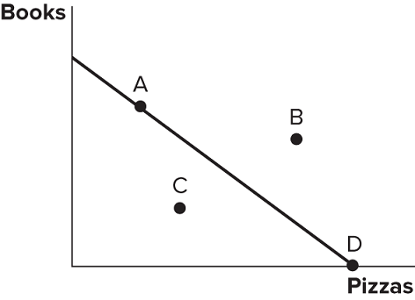Consider the production possibilities frontier displayed in the figure shown. The fact that the line slopes downward displays which economic concept?

A) Production possibilities   
 B) Trade-offs  
 C) Specialization  
 D) Efficiency

**6)** 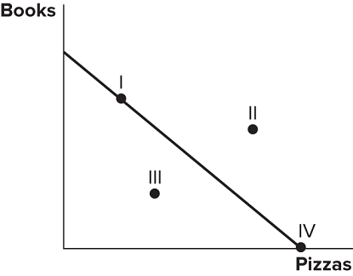Consider the production possibilities frontier displayed in the figure shown. A society faced with this curve could choose to produce:

A) I, II, or IV.   
 B) I, II, or III.  
 C) I, IV, or III.  
 D) II, III, or IV.

**7)** Consider the production possibilities frontier displayed in the figure shown. Which points are efficient and attainable with existing resources?

A) Only point II   
 B) Only point I  
 C) Points I and IV  
 D) Points I, III, and IV

**8)** Consider the production possibilities frontier displayed in the figure shown. A society faced with this curve currently:

A) cannot obtain point II.   
 B) can only obtain point III.  
 C) can only obtain point IV or point I.  
 D) cannot obtain point III.

**9)** Considering the production possibilities frontier displayed in the figure shown, producing at point ______ would be inefficient.

A) IV   
 B) III  
 C) II  
 D) I

**10)** Consider the production possibilities frontier displayed in the figure shown. Which of the following statements is currently true?

A) Producing at point I is the best choice because both books and pizzas are made.   
 B) Producing at point IV would be inefficient because no books would be produced.  
 C) Producing at point III is the best choice because it's closest to the middle of the line.  
 D) Producing at point II is impossible.

**11)** The slope of a production possibilities frontier measures:

A) the opportunity cost of producing one good in terms of the other.   
 B) the trade-off in the consumption of one good versus the other.  
 C) how much of the resources must be used in order to produce one the goods.  
 D) the inefficient production of a good.

**12)** 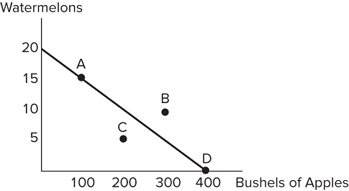Consider the production possibilities frontier displayed in the figure shown. A society with this frontier should choose to produce:

A) at point C, because it is the safest.   
 B) at point B, because this is the most the society can produce.  
 C) at any point that produces some of each good.  
 D) at any point on the frontier rather than inside it.

**13)** Consider the production possibilities frontier displayed in the figure shown. The opportunity cost of a bushel of apples is:

A) 3/20 watermelons.   
 B) 1/20 watermelons.  
 C) 1/40 watermelons.  
 D) 1/30 watermelons.

**14)** Consider the production possibilities frontier displayed in the figure shown. The opportunity cost of one watermelon is:

A) 10 bushels of apples.   
 B) 20 bushels of apples.  
 C) 30 bushels of apples.  
 D) 40 bushels of apples.

**15)** 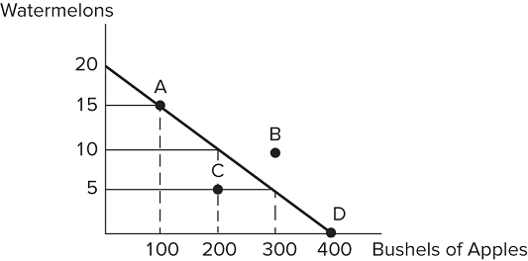Consider the production possibilities frontier displayed in the figure shown. If a society with this frontier chooses to produce 200 bushels of apples, it can produce no more than:

A) 20 watermelons.   
 B) 15 watermelons.  
 C) 10 watermelons.  
 D) 5 watermelons.

**16)** Consider the production possibilities frontier displayed in the figure shown. Which of the following combinations could be produced?

A) 400 bushels of apples, 20 watermelons   
 B) 100 bushels of apples, 15 watermelons  
 C) 300 bushels of apples, 10 watermelons  
 D) 400 bushels of apples, 10 watermelons

**17)**   
   
Consider the production possibilities frontier displayed in the figure shown. Which of the following combinations could *not* be produced?

A) 400 bushels of apples, 20 watermelons   
 B) 100 bushels of apples, 15 watermelons  
 C) 150 bushels of apples, 10 watermelons  
 D) 400 bushels of apples, 0 watermelons

**18)** Consider the production possibilities frontier displayed in the figure shown. If this society chooses to produce 15 watermelons, it can produce no more than:

A) 400 bushels of apples.   
 B) 300 bushels of apples.  
 C) 200 bushels of apples.  
 D) 100 bushels of apples.

**19)** Consider the production possibilities frontier displayed in the figure shown. The opportunity cost of one watermelon:

A) will decrease as more watermelons are produced.   
 B) is constant.  
 C) will increase as more watermelons are produced.  
 D) is zero at point C.

**20)** If we consider the reality that each worker has different skills, then the production possibilities frontier should:

A) be bowed inward.   
 B) be bowed outward.  
 C) be a straight line.  
 D) shift outward.

**21)** If we consider the reality that each worker has different skills, then the production possibilities frontier:

A) should display a constant opportunity cost of a good, as more of that good is produced.   
 B) should display a decreasing opportunity cost of a good, as more of that good is produced.  
 C) should display an increasing opportunity cost of a good as more of that good is produced.  
 D) cannot be drawn, as too many variables would need to be taken into consideration.

**22)** A realistic production possibilities curve is _____, while a simple production possibilities curve _____.

A) bowed outward; has constant opportunity costs.   
 B) straight; has constant opportunity costs.  
 C) straight; bows outward.  
 D) bowed outward has increasing opportunity costs.

**23)** 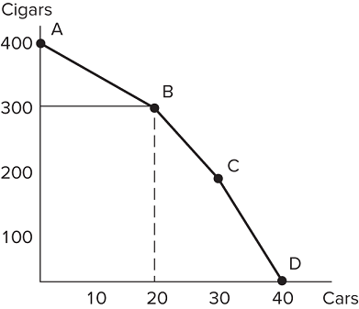Consider the production possibilities frontier in the figure shown. As more and more cars are produced, the opportunity cost of producing more cars:

A) decreases.   
 B) stays the same.  
 C) increases.  
 D) decreases then increases.

**24)** Consider the production possibilities frontier in the figure shown. As more and more cigars are produced, the opportunity cost of producing more cigars:

A) decreases.   
 B) stays the same.  
 C) increases.  
 D) decreases then increases.

**25)** Consider the production possibilities frontier in the figure shown. The opportunity cost of one cigar between points A and B is:

A) 1/5 car.   
 B) 20 cars.  
 C) 5 cars.  
 D) 10 cars.

**26)** Consider the production possibilities frontier in the figure shown. The opportunity cost of cars between points B and C is:

A) greater than the opportunity cost of cars between points A and B.   
 B) less than the opportunity cost of cars between points A and B.  
 C) greater than the opportunity cost of cars between any other two points.  
 D) There is no opportunity cost between points B and C.

**27)** Choosing to produce at any point within (inside, not on) a production possibilities frontier is:

A) inefficient, meaning the society would not be using all its available resources in their best possible uses.   
 B) efficient, meaning the society would be using all its available resources in their best possible uses.  
 C) unobtainable, meaning the society cannot produce that combination of goods.  
 D) efficient, but not attainable.

**28)** The production possibilities frontier:

A) shows all possible combinations of goods but does not tell us which combination a society should choose.   
 B) shows the best combination of goods that a society should choose.  
 C) cannot show all possible combinations of goods because society is typically inefficient.  
 D) shows us the possible combinations of goods a society should choose, but cannot tell us which points will be inefficient.

**29)** If society were to experience an increase in its available resources, its production possibilities frontier would:

A) shift outward.   
 B) shift inward.  
 C) not move.  
 D) become convex.

**30)** 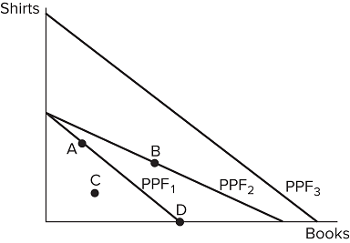Consider a society facing the production possibilities frontiers in the figure shown. Out of the options provided, which is the most likely cause of a society moving from PPF1 to PPF2?

A) More workers   
 B) Better printing press technology  
 C) A desire to read more books  
 D) Better sewing technology

**31)** Consider a society facing the production possibilities frontiers in the figure shown. Out of the options provided, which is the most likely cause of a society moving from PPF 1 to PPF 3?

A) More workers   
 B) Better printing press technology  
 C) A desire to read more books  
 D) Better sewing technology

**32)** Consider a society facing the production possibilities frontiers in the figure shown. Out of the options provided, which is the most likely cause of a society moving from PPF3 to PPF1?

A) A tornado   
 B) More workers  
 C) A desire to read less books  
 D) Better sewing technology

**33)** An increase in productivity as a result of a new technology would cause the production possibilities frontier to:

A) shift inward.   
 B) shift outward.  
 C) remain the same.  
 D) shift inward, then shift outward.

**34)** Hurricane Katrina destroyed much of New Orleans and other parts of the South. Which of the following statements is true? The hurricane:

A) caused the U.S. production possibilities frontier to shift inward.   
 B) caused production possibilities to increase, since much work was needed to rebuild the city.  
 C) caused the U.S. production possibilities frontier to bow inward.  
 D) moved production from a point on the frontier to a point inside the frontier.

**35)** When nations trade, the result would most likely be a(n):

A) increase in total production, which would benefit every nation involved.   
 B) increase in total production, which would benefit only the wealthiest nations.  
 C) decrease in total production, which would benefit only the wealthiest nations.  
 D) decrease in total production, which would benefit countries that do not have an absolute advantage.

**36)** When nations trade:

A) only the strongest nation benefits.   
 B) only the weakest nation benefits.  
 C) all nations involved can benefit.  
 D) only one nation benefits, but we cannot identify which without more information.

**37)** Which of the following statements about trade is true?

A) Trade involves a winner and a loser.   
 B) Trade often hurts both parties in the long run.  
 C) Trade is a zero-sum proposition.  
 D) Trade can benefit both parties.

**38)** If the United States, a wealthy nation, trades with Cambodia, a poorer, less developed nation, which of the following statements is likely true?

A) The United States is taking advantage of Cambodia and is the only beneficiary to the trade.   
 B) Cambodia has been pressured to enter trade and is not benefiting at all.  
 C) Both the United States and Cambodia can benefit from trading.  
 D) The United States is being charitable and not benefiting from the trade at all.

**39)** Suppose that a worker in Country A can make either 10 iPhones or 5 iPads each year. Country A has 100 workers. Suppose a worker in Country B can make either 2 iPhones or 10 iPads each year. Country B has 200 workers. A bundle of goods that Country A could potentially make would be:

A) (1,000 iPhones, 500 iPads).   
 B) (500 iPhones, 500 iPads).  
 C) (500 iPhones, 250 iPads).  
 D) (750 iPhones, 150 iPads).

**40)** Suppose that a worker in Country A can make either 10 iPhones or 5 iPads each year. Country A has 100 workers. Suppose a worker in Country B can make either 2 iPhones or 10 iPads each year. Country B has 200 workers. Suppose Country B's population of workers increased to 600. Which of the following statements is now true?

A) Country B's production possibilities frontier has rotated outward for only the production of iPhones.   
 B) Country B's production possibilities frontier has shifted straight outward.  
 C) Country B's production possibilities frontier has shifted straight inward.  
 D) Country B's production possibilities are now more limited due to overcrowding from the extra workers.

**41)** When a producer is operating efficiently, it is producing:

A) at a point on its production possibilities frontier.   
 B) at a point on or below its production possibilities frontier.  
 C) only one good.  
 D) the good in which it has an absolute advantage.

**42)** When a country is producing goods and services efficiently it:

A) is producing at a point on or below its production possibilities frontier.   
 B) is getting the most output by using all its available resources.  
 C) is trading with other countries.  
 D) is able to reach a point beyond its production possibilities frontier.

**43)** 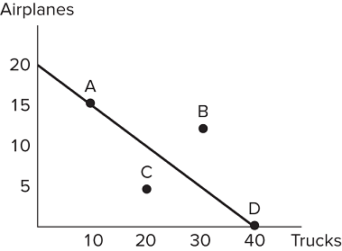Suppose the figure shown represents the production possibilities frontier for Country A. Which of the following combinations of goods could Country A consume in the absence of trade?

A) (15 airplanes, 15 trucks)   
 B) (20 airplanes, 40 trucks)  
 C) (10 airplanes, 30 trucks)  
 D) (5 airplanes, 30 trucks)

**44)** Suppose that a worker in Country A can make either 10 iPhones or 5 iPads each year. Country A has 100 workers. Suppose a worker in Country B can make either 2 iPhones or 10 iPads each year. Country B has 200 workers. A bundle of goods that Country A could potentially make would be:

A) (500 iPhones, 500 iPads).   
 B) (500 iPhones, 400 iPads).  
 C) (500 iPhones, 300 iPads).  
 D) (500 iPhones, 200 iPads).

**45)** Suppose that a worker in Country A can make either 10 iPhones or 5 iPads each year. Country A has 100 workers. Suppose a worker in Country B can make either 2 iPhones or 10 iPads each year. Country B has 200 workers. Which of the following is a bundle of goods that Country A could ***not*** make?

A) (250 iPhones, 250 iPads)   
 B) (400 iPhones, 250 iPads)  
 C) (500 iPhones, 250 iPads)  
 D) (500 iPhones, 300 iPads)

**46)** Suppose that a worker in Country A can make either 10 iPhones or 5 iPads each year. Country A has 100 workers. Suppose a worker in Country B can make either 2 iPhones or 10 iPads each year. Country B has 200 workers. Country A would be using resources efficiently if it was producing:

A) (500 iPhones, 100 iPads).   
 B) (500 iPhones, 150 iPads).  
 C) (500 iPhones, 200 iPads).  
 D) (500 iPhones, 250 iPads).

**47)** Suppose that a worker in Country A can make either 10 iPhones or 5 iPads each year. Country A has 100 workers. Suppose a worker in Country B can make either 2 iPhones or 10 iPads each year. Country B has 200 workers. Which of the following is a bundle of goods that Country B could potentially make?

A) (400 iPhones, 2,000 iPads)   
 B) (300 iPhones, 500 iPads)  
 C) (200 iPhones, 1,500 iPads)  
 D) (100 iPhones, 2,000 iPads)

**48)** Suppose that a worker in Country A can make either 10 iPhones or 5 iPads each year. Country A has 100 workers. Suppose a worker in Country B can make either 2 iPhones or 10 iPads each year. Country B has 200 workers. Which of the following is a bundle of goods that Country B could potentially make?

A) (400 iPhones, 2,000 iPads)   
 B) (200 iPhones, 1,500 iPads)  
 C) (300 iPhones, 450 iPads)  
 D) (400 iPhones, 1 iPad)

**49)** Suppose that a worker in Country A can make either 10 iPhones or 5 iPads each year. Country A has 100 workers. Suppose a worker in Country B can make either 2 iPhones or 10 iPads each year. Country B has 200 workers. Which of the following is a bundle of goods that Country B could *not* make?

A) (400 iPhones, 250 iPads)   
 B) (300 iPhones, 500 iPads)  
 C) (200 iPhones, 750 iPads)  
 D) (100 iPhones, 1,000 iPads)

**50)** Suppose that a worker in Country A can make either 10 iPhones or 5 iPads each year. Country A has 100 workers. Suppose a worker in Country B can make either 2 iPhones or 10 iPads each year. Country B has 200 workers. Country B would be using resources efficiently if it was producing:

A) (200 iPhones, 1,750 iPads).   
 B) (200 iPhones, 1,500 iPads).  
 C) (200 iPhones, 1,000 iPads).  
 D) (200 iPhones, 750 iPads).

**51)** Suppose that a worker in Country A can make either 25 bananas or 5 tomatoes each year. Country A has 200 workers. Suppose a worker in Country B can make either 18 bananas or 6 tomatoes each year. Country B has 400 workers. What are two possible consumption bundles that Country A could produce?

A) (5,000 bananas, 1,000 tomatoes) and (1,000 bananas, 5,000 tomatoes)   
 B) (5,000 bananas, 0 tomatoes) and (2,500 bananas, 500 tomatoes)  
 C) (2,500 bananas, 500 tomatoes) and (1,250 bananas, 800 tomatoes)  
 D) (2,500 bananas, 750 tomatoes) and (1,250 bananas, 750 tomatoes)

**52)** Suppose that a worker in Country A can make either 25 bananas or 5 tomatoes each year. Country A has 200 workers. Suppose a worker in Country B can make either 18 bananas or 6 tomatoes each year. Country B has 400 workers. What are two possible consumption bundles that Country B could produce?

A) (7,200 bananas, 2,400 tomatoes) and (3,600 bananas, 1,200 tomatoes)   
 B) (7,200 bananas, 0 tomatoes) and (4,000 bananas, 1,200 tomatoes)  
 C) (3,600 bananas, 1,200 tomatoes) and (1,800 bananas, 1,600 tomatoes)  
 D) (1,800 bananas, 1,800 tomatoes) and (900 bananas, 2,200 tomatoes)

**53)** Assume that the opportunity cost for Germany to produce a jet is 50 cars. If Germany is producing on its production possibilities frontier, which of the following describes possible combinations of output?

A) (1,000 jets, 5,000 cars) and (900 jets, 10,000 cars)   
 B) (1,000 jets, 5,000 cars) and (900 jets, 15,000 cars)  
 C) (2,500 jets, 2,000 cars) and (2,300 jets, 20,000 cars)  
 D) (2,500 jets, 2,000 cars) and (2,300 jets, 3,000 cars)

**54)** 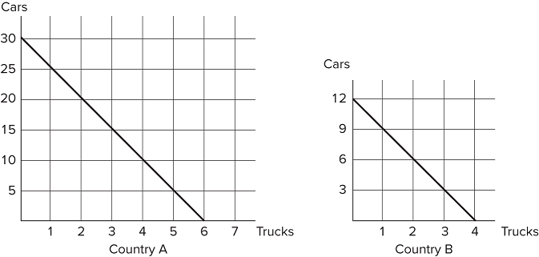Refer to the figure shown, which represents the production possibilities frontiers for Countries A and B. If Country A were to divide its resources equally, it could produce:

A) 30 cars and 6 trucks.   
 B) 25 cars and 5 trucks.  
 C) 15 cars and 3 trucks.  
 D) 10 cars and 4 trucks.

**55)** Refer to the figure shown, which represents the production possibilities frontiers for Countries A and B. The slope of Country A's production possibilities frontier:

A) measures the opportunity cost of trucks in terms of cars.   
 B) measures the trade-off that Country A faces when deciding how to allocate resources.  
 C) is constant, because the opportunity cost remains constant.  
 D) All of these statements are true.

**56)** Refer to the figure shown, which represents the production possibilities frontiers (PPFs) for Countries A and B. The slope of Country A's PPF is _____ and the slope of Country B's PPF is _____.

A) −5; −3   
 B) −30; −3  
 C) −1/5; −1/3  
 D) 1/5; 1/3

**57)** Tom and Jerry have one day to work, but two tasks to focus on: building chairs and tables. If Tom spends all day building chairs, he will make 16 chairs. If he instead devotes his day to building tables, Tom will make 4 tables. If Jerry spends his day building chairs, he will make 14 chairs; if he spends the day building tables, he will make 7 tables. If Tom divides his time evenly between activities and acts efficiently, he will produce:

A) 16 chairs and 4 tables.   
 B) 12 chairs and 3 tables.  
 C) 8 chairs and 2 tables.  
 D) 4 chairs and 3 tables.

**58)** Tom and Jerry have one day to work, but two tasks to focus on: building chairs and tables. If Tom spends all day building chairs, he will make 16 chairs. If he instead devotes his day to building tables, Tom will make 4 tables. If Jerry spends his day building chairs, he will make 14 chairs; if he spends the day building tables, he will make 7 tables. In one day, Tom can produce either:

A) (16 chairs, 4 tables) or (8 chairs, 2 tables).   
 B) (8 chairs, 2 tables) or (4 chairs, 6 tables).  
 C) (8 chairs, 2 tables) or (4 chairs, 3 tables).  
 D) (12 chairs, 3 tables) or (8 chairs, 3 tables).

**59)** Tom and Jerry have one day to work, but two tasks to focus on: building chairs and tables. If Tom spends all day building chairs, he will make 16 chairs. If he instead devotes his day to building tables, Tom will make 4 tables. If Jerry spends his day building chairs, he will make 14 chairs; if he spends the day building tables, he will make 7 tables. In one day, Jerry can produce:

A) 14 chairs and 7 tables.   
 B) 12 chairs and 6 tables.  
 C) 10 chairs and 5 tables.  
 D) 6 chairs and 4 tables.

**60)** Tom and Jerry have one day to work, but two tasks to focus on: building chairs and tables. If Tom spends all day building chairs, he will make 16 chairs. If he instead devotes his day to building tables, Tom will make 4 tables. If Jerry spends his day building chairs, he will make 14 chairs; if he spends the day building tables, he will make 7 tables. At the end of the day, if Jerry was efficient with his resources, he will have produced:

A) 12 chairs and 0 tables.   
 B) 10 chairs and 2 tables.  
 C) 8 chairs and 2 tables.  
 D) 6 chairs and 2 tables.

**61)** Tom and Jerry have one day to work, but two tasks to focus on: building chairs and tables. If Tom spends all day building chairs, he will make 16 chairs. If he instead devotes his day to building tables, Tom will make 4 tables. If Jerry spends his day building chairs, he will make 14 chairs; if he spends the day building tables, he will make 7 tables. For Tom, the opportunity cost of building a table is _______ chairs made.

A) 16   
 B) 12  
 C) 8  
 D) 4

**62)** Tom and Jerry have one day to work, but two tasks to focus on: building chairs and tables. If Tom spends all day building chairs, he will make 16 chairs. If he instead devotes his day to building tables, Tom will make 4 tables. If Jerry spends his day building chairs, he will make 14 chairs; if he spends the day building tables, he will make 7 tables. For Jerry, the opportunity cost of building a table is _____ chairs made.

A) 14   
 B) 7  
 C) 4  
 D) 2

**63)** Refer to the figure shown, which represents the production possibilities frontiers for Countries A and B. The opportunity cost of a truck in Country A is:

A) 30 cars.   
 B) 6 trucks.  
 C) 5 cars.  
 D) 3 cars.

**64)** 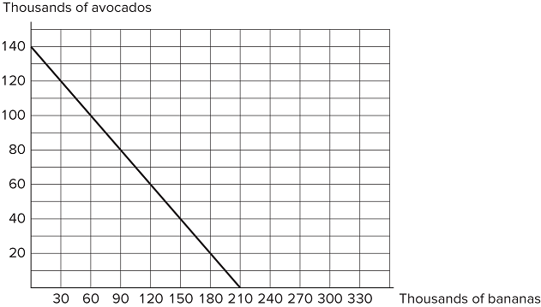Consider the production possibilities frontier displayed in the figure shown. The opportunity cost of one avocado is:

A) 2/3 bananas.   
 B) 2 bananas.  
 C) 1.5 bananas.  
 D) 210 bananas.

**65)** Refer to the figure shown, which represents the production possibilities frontiers for Countries A and B. The opportunity cost of a truck in Country B is:

A) 12 cars.   
 B) 4 trucks.  
 C) 1.5 cars  
 D) 3 cars.

**66)** Refer to the figure shown, which represents the production possibilities frontiers for Countries A and B. Why are these graphs ***not*** realistic representations of actual countries?

A) The production possibilities frontiers are straight lines rather than bowed out.   
 B) They only represent the production of two goods.  
 C) They only represent two countries.  
 D) All of these statements are reasons why these graphs are not realistic representations.

**67)** 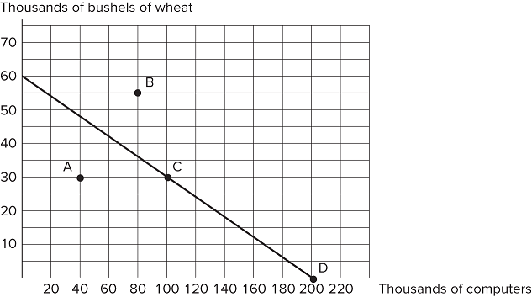Consider the production possibilities frontier displayed in the figure shown. Which of the following statements is true?Point A is unattainable.Point B is inefficient.Points A and D are inefficient.Points C and D are attainable.

A) I and II only   
 B) III only  
 C) II and IV only  
 D) IV only

**68)** Consider the production possibilities frontier displayed in the figure shown. The opportunity cost of one bushel of wheat is:

A) 30 computers.   
 B) 5 computers.  
 C) 6 computers.  
 D) 1/5 computers.

**69)** 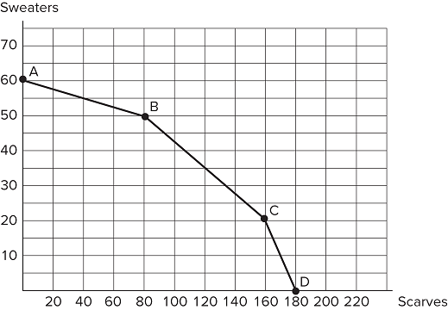Consider the production possibilities frontier displayed in the figure shown. The opportunity cost of one scarf between points C and D is:

A) 1 sweater.   
 B) 20 sweaters.  
 C) 10 sweaters  
 D) 2 sweaters.

**70)** Consider the production possibilities frontier displayed in the figure shown. The opportunity cost of one scarf is largest between:

A) points A and B.   
 B) points B and C.  
 C) points C and D.  
 D) points A and D.

**71)** Suppose that a worker in Country A can make either 15 cars or 5 computers each year. Country A has 1,000 workers. Suppose a worker in Country B can make either 4 cars or 20 computers each year. Country B has 600 workers. A bundle of goods that Country B could potentially make would be:

A) (2,400 cars, 12,000 computers).   
 B) (2,400 cars, 4,000 computers).  
 C) (1,400 cars, 6,000 computers).  
 D) (1,200 cars, 6,000 computers).

**72)** Suppose that a worker in Country A can make either 10 iPhones or 5 iPads each year. Country A has 100 workers. Suppose a worker in Country B can make either 2 iPhones or 10 iPads each year. Country B has 200 workers. Which of the following is true?

A) In Country A, the opportunity cost of one iPhone is two iPads.   
 B) In Country A, the opportunity cost of one iPad is two iPhones.  
 C) The opportunity cost of iPads is lower in Country A than in Country B.  
 D) In Country B, the opportunity cost of one iPhone is two iPads.

**73)** If the opportunity cost of producing corn is lower for Ohio than for Iowa, then:

A) Iowa should specialize in corn production.   
 B) Iowa has a comparative advantage at producing corn.  
 C) Iowa should export corn to Ohio.  
 D) Ohio has a comparative advantage at producing corn.

**74)** Refer to the figure shown, which represents the production possibilities frontiers for Countries A and B. Which of the following statements is true?

A) Country A has a comparative advantage at producing cars.   
 B) Country A has a comparative advantage at producing trucks.  
 C) Country A has a comparative advantage at producing both cars and trucks.  
 D) Country B has a comparative advantage at producing both cars and trucks.

**75)** Refer to the figure shown, which represents the production possibilities frontiers for Countries A and B. Assuming both countries have the same amount of resources available to them, which of the following statements is true?

A) Country A has an absolute advantage at producing cars, and Country B has an absolute advantage at producing trucks.   
 B) Country A has an absolute advantage at producing trucks and Country B has an absolute advantage at producing cars.  
 C) Country A hasan absolute advantage at producing both cars and trucks.  
 D) Country B has an absolute advantage at producing both cars and trucks.

**76)** Refer to the figure shown, which represents the production possibilities frontiers for Countries A and B. Which of the following statements is true?

A) Country A has a comparative advantage at producing cars and Country B has a comparative advantage at producing trucks.   
 B) Country A has a comparative advantage at producing trucks and Country B has a comparative advantage at producing cars.  
 C) Country A has a comparative advantage at producing both cars and trucks.  
 D) Country B has a comparative advantage at producing both cars and trucks.

**77)** Suppose that a worker in Country A can produce either 25 bananas or 5 tomatoes each year. Country A has 200 workers. Suppose a worker in Country B can produce either 18 bananas or 6 tomatoes each year. Country B has 400 workers. For a worker in Country B, the trade-off to producing one tomato is:

A) 2 bananas.   
 B) 3 bananas.  
 C) 4 bananas.  
 D) 5 bananas.

**78)** Suppose that a worker in Country A can make either 25 bananas or 5 tomatoes each year. Country A has 200 workers. Suppose a worker in Country B can make either 18 bananas or 6 tomatoes each year. Country B has 400 workers. For a worker in Country A, the trade-off of making one tomato is:

A) 2 bananas.   
 B) 3 bananas.  
 C) 4 bananas.  
 D) 5 bananas.

**79)** Suppose that a worker in Country A can make either 10 iPhones or 5 iPads each year. Country A has 100 workers. Suppose a worker in Country B can make either 2 iPhones or 10 iPads each year. Country B has 200 workers. Country B has a comparative advantage at producing:

A) iPhones.   
 B) iPads.  
 C) both iPhones and iPads.  
 D) neither iPhones nor iPads.

**80)** Suppose that a worker in Country A can make either 10 iPhones or 5 iPads each year. Country A has 100 workers. Suppose a worker in Country B can make either 2 iPhones or 10 iPads each year. Country B has 200 workers. Country A has an absolute advantage at producing:

A) iPhones.   
 B) iPads.  
 C) both iPhones and iPads.  
 D) neither iPhones nor iPads.

**81)** Suppose that a worker in Country A can make either 10 iPhones or 5 iPads each year. Country A has 100 workers. Suppose a worker in Country B can make either 2 iPhones or 10 iPads each year. Country B has 200 workers. Suppose Country B's population of workers increases to 600. Country B now has:

A) an absolute advantage at producing both goods.   
 B) an absolute advantage at producing tablets only.  
 C) a comparative advantage at producing iPhones only.  
 D) no need to trade.

**82)** Suppose that, given the same number of workers, the United States can produce five times as many computers or ten times as many airplanes as Mexico. Which of the following statements is true?

A) The United States has an absolute advantage at producing computers and Mexico has an absolute advantage at producing airplanes.   
 B) The United States has an absolute advantage at producing airplanes and Mexico has an absolute advantage at producing computers.  
 C) The United States has an absolute advantage at producing both airplanes and computers.  
 D) Mexico has an absolute advantage at producing both airplanes and computers.

**83)** Suppose that, given the same number of workers, the United States can produce twice as many televisions or 20 times as many potatoes as Chile. Which of the following statements is true?

A) Chile should make televisions and trade them to the United States in exchange for potatoes, because the United States has an absolute advantage in the production of potatoes.   
 B) Chile should make potatoes and trade them to the United States in exchange for televisions, because the United States has an absolute advantage in the production of potatoes.  
 C) The United States can benefit from trading with Chile, but Chile will receive no benefit.  
 D) The United States has an absolute advantage at producing both televisions and potatoes.

**84)** If a country has an absolute advantage at producing one good, which of the following is true?

A) It cannot have an absolute advantage at producing the other good.   
 B) It must also have a comparative advantage at producing both goods.  
 C) It can produce more of that good than the other good.  
 D) It can produce more of that good given the same resources.

**85)** Suppose that only two goods are produced in an economy. If a country possesses a comparative advantage at producing one good, then it:

A) must also possess a comparative advantage at producing the other good.   
 B) must also possess an absolute advantage at producing that good.  
 C) cannot also possess a comparative advantage at producing the other good.  
 D) cannot also possess an absolute advantage at producing that good.

**86)** Suppose an American worker can make 20 pairs of shoes or grow 100 apples per day. On the other hand, a Canadian worker can produce 10 pairs of shoes or grow 20 apples per day. Which of the following statements is true?

A) The United States has an absolute advantage at producing both shoes and apples.   
 B) Canada has an absolute advantage at producing both shoes and apples.  
 C) The United States has an absolute advantage at producing shoes and Canada has an absolute advantage at producing apples.  
 D) Canada has an absolute advantage at producing shoes and the United States has an absolute advantage at producing apples.

**87)** Suppose an American worker can make 20 pairs of shoes or grow 100 apples per day. On the other hand, a Canadian worker can produce 10 pairs of shoes or grow 20 apples per day. Which of the following statements is true?

A) The U.S. has both an absolute advantage and a comparative advantage at producing shoes.   
 B) The U.S. has both an absolute advantage and a comparative advantage at producing apples.  
 C) The U.S. has an absolute advantage at producing both goods, but no comparative advantage  
 D) The U.S. has both an absolute advantage and a comparative advantage at producing both goods.

**88)** Suppose an American worker can make 20 pairs of shoes or grow 100 apples per day. On the other hand, a Canadian worker can produce 10 pairs of shoes or grow 20 apples per day. Which of the following statements is true?

A) The United States has a comparative advantage at producing shoes.   
 B) Canada has a comparative advantage at producing shoes.  
 C) Neither country has a comparative advantage at producing shoes.  
 D) Both countries have a comparative advantage at producing shoes.

**89)** Suppose an American worker can make 20 pairs of shoes or grow 100 apples per day. On the other hand, a Canadian worker can produce 10 pairs of shoes or grow 20 apples per day. When trade opens up, the United States should produce _____ because it has a(n) _____ and should _____.

A) both goods; absolute advantage in both goods; not trade   
 B) only shoes; comparative advantage at producing shoes; trade for apples.  
 C) only apples; comparative advantage at producing apples; not trade  
 D) only apples; comparative advantage at producing apples; trade for shoes.

**90)** Suppose an American worker can make 20 pairs of shoes or grow 100 apples per day. On the other hand, a Canadian worker can produce 10 pairs of shoes or grow 20 apples per day. The opportunity cost of one pair of shoes for the United States is _____, while the opportunity cost of one pair of shoes for Canada is ______.

A) 5 apples; 2 apples   
 B) 1/5 apple; 1/2 apple  
 C) 2,000 apples; 200 apples  
 D) 100 apples; 20 apples

**91)** Suppose an American worker can make 20 pairs of shoes or grow 100 apples per day. On the other hand, a Canadian worker can produce 10 pairs of shoes or grow 20 apples per day. The opportunity cost for the United States is:

A) 5 apples for each pair of shoes.   
 B) 5 pairs of shoes for each apple.  
 C) 1/55 apple for each pair of shoes.  
 D) 1 pair of shoes for every 2 apples.

**92)** Suppose an American worker can make 20 pairs of shoes or grow 100 apples per day. On the other hand, a Canadian worker can produce 10 pairs of shoes or grow 20 apples per day. The opportunity cost for Canada is:

A) 2 apples for each pair of shoes.   
 B) 2 pairs of shoes for each apple.  
 C) ½ apple for each pair of shoes.  
 D) ½ pair of shoes for every 2 apples.

**93)** Suppose an American worker can make 20 pairs of shoes or grow 100 apples per day. On the other hand, a Canadian worker can produce 10 pairs of shoes or grow 20 apples per day. The opportunity cost of a pair of shoes is _____ for the United States than Canada, so Canada has a(n) _____ advantage at producing shoes.

A) higher; comparative   
 B) lower; comparative  
 C) higher; absolute  
 D) lower; absolute

**94)** Suppose an American worker can make 20 pairs of shoes or grow 100 apples per day. On the other hand, a Canadian worker can produce 10 pairs of shoes or grow 20 apples per day. Canada's opportunity cost of producing a pair of shoes is _____ than the United States, so Canada should specialize in _____ production.

A) higher; shoe   
 B) lower; apple  
 C) higher; apple  
 D) lower; shoe

**95)** Suppose an American worker can make 50 pairs of gloves or grow 300 radishes per day. On the other hand, a Bangladeshi worker can produce 100 pairs of gloves or grow 200 radishes per day. What are their respective opportunity costs of one pair of gloves?

A) 6 radishes for the United States and 2 radishes for Bangladesh   
 B) 60 radishes for the United States and 20 radishes for Bangladesh  
 C) 1/6 radishes for the United States and ½ radishes for Bangladesh  
 D) 6,000 radishes for the United States and 2,000 radishes for Bangladesh

**96)** Suppose an American worker can make 50 pairs of gloves or grow 300 radishes per day. On the other hand, a Bangladeshi worker can produce 100 pairs of gloves or grow 200 radishes per day. Which of the following statements is true?

A) The U.S. has an absolute advantage at producing both gloves and radishes.   
 B) The U.S. does not have an absolute advantage at producing either gloves or radishes.  
 C) The U.S. has an absolute advantage at producing gloves, but not radishes.  
 D) The U.S.has an absolute advantage at producing radishes, but not gloves.

**97)** Suppose an American worker can make 50 pairs of gloves or grow 300 radishes per day. On the other hand, a Bangladeshi worker can produce 100 pairs of gloves or grow 200 radishes per day. Which of the following statements is true?

A) The U.S. has a comparative advantage at producing both gloves and radishes.   
 B) The U.S. does not have a comparative advantage at producing either gloves or radishes.  
 C) The U.S. has a comparative advantage at producing gloves only.  
 D) The U.S. has a comparative advantage at producing radishes only.

**98)** Suppose an American worker can make 50 pairs of gloves or grow 300 radishes per day. On the other hand, a Bangladeshi worker can produce 100 pairs of gloves or grow 200 radishes per day. The opportunity cost of one pair of gloves is:

A) lower for the United States than Bangladesh, therefore the United States has a comparative advantage at producing gloves.   
 B) higher for the United States than Bangladesh, therefore the United States has a comparative advantage at producing radishes.  
 C) the same for both the United States and Bangladesh, therefore neither country has a comparative advantage at producing gloves.  
 D) the same for both the United States and Bangladesh, therefore both countries have a comparative advantage at producing gloves.

**99)** Suppose an American worker can make 50 pairs of gloves or grow 300 radishes per day. On the other hand, a Bangladeshi worker can produce 100 pairs of gloves or grow 200 radishes per day. Which of the following statements is true?

A) Bangladesh shouldspecialize in glove production because it has a comparative advantage at producing gloves.   
 B) Bangladesh should specialize in radish production because it has a comparative advantage at producing radishes.  
 C) Bangladesh shouldproduce both gloves and radishes because it has an absolute advantage at producing both goods.  
 D) Bangladesh shouldproduce only radishes because it has an absolute advantage at producing radishes.

**100)** Suppose an American worker can make 100 nets or catch 1,000 fish per day. A Chilean worker, on the other hand, can produce 40 nets or catch 400 fish per day. Which of the following statements is true?

A) The United States has a comparative advantage at producing nets.   
 B) Chile has a comparative advantage at producing nets.  
 C) Both the United States and Chile have a comparative advantage at producing nets.  
 D) Neither the United States nor Chile has a comparative advantage at producing nets.

**101)** Suppose an American worker can make 100 nets or catch 1000 fish per day. On the other hand, a Chilean worker can produce 40 nets or catch 400 fish per day. The United States has a(n) _____ advantage at producing nets, but does ***not*** have a(n) _____ advantage at producing fish.

A) absolute; comparative   
 B) comparative; absolute  
 C) absolute; absolute  
 D) comparative; comparative

**102)** Suppose an American worker can make 100 nets or catch 900 fish per day. On the other hand, a Chilean worker, can make 40 nets or catch 400 fish per day. The United States has an absolute advantage at producing both fish and nets. This means that the United States:

A) should produce only nets and trade with Chile to get fish.   
 B) should produce only fish and trade with Chile to get nets.  
 C) should take advantage of Chile by trading with them.  
 D) same amount of workers" to read "same number of workers.

**103)** When a producer has the ability to produce a good or service at a lower opportunity cost than others, economists say the producer:

A) has an absolute advantage at producing that good.   
 B) has a comparative advantage at producing that good.  
 C) has no reason to trade with others.  
 D) is efficient in production.

**104)** When a producer has a comparative advantage at producing a good, it means the producer:

A) can produce more of that good than others with the same number of workers.   
 B) has the ability to produce the good at a lower opportunity cost than others.  
 C) has no reason to trade with others.  
 D) is efficient in production.

**105)** When a producer has an absolute advantage at producing a good, it means the producer:

A) can produce more of that good than others with the same amount of resources.   
 B) has the ability to produce a good or service at a lower opportunity cost than others.  
 C) has no reason to trade with others.  
 D) is less efficient than other producers.

**106)** The United States and Canada trade hockey skates and apple pie. If the United States has an absolute and a comparative advantage at producing apple pie, then:

A) Canada must have a comparative advantage at producing skates.   
 B) Canada must have an absolute advantage at producing skates.  
 C) Canada must have an absolute and a comparative advantage at producing skates.  
 D) the United States must also have a comparative advantage at producing skates.

**107)** Which of the following statements about absolute and comparative advantage is ***not*** true?

A) If a country has a comparative advantage at producing a good, it can have an absolute advantage at producing another good.   
 B) If a country has an absolute advantage at producing a good, it can also have a comparative advantage at producing that good.  
 C) A country may have an absolute advantage at producing all goods.  
 D) A country may have a comparative advantage at producing all goods.

**108)** Suppose England has a comparative advantage over the United States at producing tea. If this is true, then:

A) England should produce more tea than it wants and sell the rest to the United States.   
 B) England should produce a small amount of tea and buy the rest of the tea it wants from the United States.  
 C) England should buy all of the tea it wants from the United States.  
 D) the United States has nothing to gain from buying tea produced by England.

**109)** Suppose that a worker in Country A can produce either 25 bananas or 5 tomatoes each year. Country A has 200 workers. Suppose a worker in Country B can produce either 18 bananas or 6 tomatoes each year. Country B has 400 workers. The opportunity cost of one tomato is:

A) lower in Country A than Country B.   
 B) higher in Country A than Country B.  
 C) the same in both countries.  
 D) impossible to calculate without more information.

**110)** Suppose that a worker in Country A can produce either 25 bananas or 5 tomatoes each year. Suppose that a worker in Country B can produce either 18 bananas or 6 tomatoes each year. Country B has an absolute advantage at:

A) producing bananas, but not tomatoes.   
 B) producing bananas and tomatoes.  
 C) producing tomatoes, but not bananas.  
 D) producing neither good.

**111)** Tom and Jerry have one day to work, but two tasks to focus on: building chairs and tables. If Tom spends all day building chairs, he will make 16 chairs. If he instead devotes his day to building tables, Tom will make 4 tables. If Jerry spends his day building chairs, he will make 14 chairs; if he spends the day building tables, he will make 7 tables. Because Tom has a _____ opportunity cost for one table compared to Jerry, we know Tom has _____.

A) higher; a comparative advantage at producing tables   
 B) lower; a comparative advantage at producing tables  
 C) similar; no advantage at producing either good  
 D) higher; a comparative advantage at producing chairs

**112)** Tom and Jerry have one day to work, but two tasks to focus on: building chairs and tables. If Tom spends all day building chairs, he will make 16 chairs. If he instead devotes his day to building tables, Tom will make 4 tables. If Jerry spends his day building chairs, he will make 14 chairs; if he spends the day building tables, he will make 7 tables. Jerry has a comparative advantage at producing _____ because he has a _____ opportunity cost of making that good.

A) chairs; lower   
 B) chairs; higher  
 C) tables; lower  
 D) tables; higher

**113)** Tom and Jerry have one day to work, but two tasks to focus on: building chairs and tables. If Tom spends all day building chairs, he will make 16 chairs. If he instead devotes his day to building tables, Tom will make 4 tables. If Jerry spends his day building chairs, he will make 14 chairs; if he spends the day building tables, he will make 7 tables. After looking at the production possibilities for both Tom and Jerry, what can we surmise?

A) Tom has an absolute advantage at producing both chairs and tables.   
 B) Jerry has an absolute advantage at producing both chairs and tables.  
 C) Tom has an absolute advantage at producing chairs and Jerry has an absolute advantage at producing tables.  
 D) Tom has an absolute advantage at producing tables and Jerry has an absolute advantage at producing chairs.

**114)** Tom and Jerry have one day to work, but two tasks to focus on: building chairs and tables. If Tom spends all day building chairs, he will make 16 chairs. If he instead devotes his day to building tables, Tom will make 4 tables. If Jerry spends his day building chairs, he will make 14 chairs; if he spends the day building tables, he will make 7 tables. After looking at the production possibilities for both Tom and Jerry, what can we conclude?

A) Tom has a comparative advantage at producing chairs.   
 B) Jerry has a comparative advantage at producing chairs.  
 C) Tom has a comparative advantage at producing tables.  
 D) Neither Tom nor Jerry has a comparative advantage at producing either good.

**115)** Suppose that a worker in Country A can make either 15 cars or 5 computers each year. Country A has 1,000 workers. Suppose a worker in Country B can make either 4 cars or 20 computers each year. Country B has 600 workers. _____ has a comparative advantage at producing cars, and _____ has a comparative advantage at producing computers.

A) Country A; Country B   
 B) Country B; Country A  
 C) Country A; Country A  
 D) Country B; Country B

**116)** Suppose that a worker in Country A can make either 30 cars or 15 computers each year. Country A has 1,000 workers. Suppose a worker in Country B can make either 60 cars or 20 computers each year. Country B has 600 workers. _____ has the comparative advantage at producing cars, and _____ has a comparative advantage at producing computers.

A) Country A; Country B   
 B) Country B; Country A  
 C) Country A; Country A  
 D) Country B; Country B

**117)** A country completely specializes in production when it spends all of its resources producing

A) a particular good.   
 B) the goods it has an absolute advantage at producing.  
 C) only what other countries need.  
 D) the goods it can make more of.

**118)** When two countries specialize and trade with one another, total production:

A) remains unchanged, but consumption rises.   
 B) increases, but only if a comparative advantage exists.  
 C) may increase, depending on trade relations.  
 D) remains unchanged, as does consumption.

**119)** Which of the following is a reason people might choose *not* to specialize?

A) Specialization can lead people to consume more than if they would if they were self-sufficient.   
 B) Specialization can lead people to consume beyond the production possibilities frontier.  
 C) Specialization allows people to acquire goods at a lower opportunity cost.  
 D) Production standards are harder to control if goods are imported from other countries.

**120)** The improvement in outcomes that occurs when specialized producers exchange goods and services is called:

A) gains from trade.   
 B) absolute advantage.  
 C) comparative advantage.  
 D) specialization.

**121)** People will choose to specialize and trade if they can acquire the goods they want:

A) at a lower cost than making the goods themselves.   
 B) at a higher cost than making the goods themselves.  
 C) from someone who is willing to trade with them.  
 D) from a capitalistic system of exchange.

**122)** Why do people often choose to specialize and trade?

A) It allows them to enjoy more goods than they can create on their own.   
 B) They can consume a bundle of goods on their production possibilities frontier.  
 C) It allows them to always produce at a point beyond their own production possibilities frontier.  
 D) They can take advantage of another nation’s poor choices.

**123)** Two countries will choose to specialize and trade *only* if:

A) the terms of trade fall between the two nations' opportunity costs for producing the goods on their own.   
 B) the opportunity costs are the same for the two nations.  
 C) the opportunity costs for producing the goods on their own are astronomically high.  
 D) one country has an absolute advantage at producing both goods, but a comparative advantage at producing only one good.

**124)** When a country loses its comparative advantage at producing a good it will:

A) stop trading and become self-sufficient.   
 B) gain a comparative advantage at producing another good.  
 C) become a loser in trade in the long run.  
 D) still have an absolute advantage at producing the good.

**125)** If France is capable of producing cheese, wine, or some combination of those two, it should:

A) produce the good it is more efficient at producing.   
 B) produce the good for which it has a comparative advantage.  
 C) produce the good for which it has a higher opportunity cost.  
 D) remain self-sufficient, as long as it has an absolute advantage at producing both goods.

**126)** If Spain is capable of producing tapas, soccer balls, or some combination of those two, then it should:

A) produce the good it has an absolute advantage at producing.   
 B) produce the good it has a comparative advantage at producing.  
 C) remain self-sufficient, as long as it can produce both efficiently.  
 D) trade only if it has an absolute advantage at producing both goods.

**127)** Suppose that a worker in Country A can produce either 25 bananas or 5 tomatoes each year. Country A has 200 workers. Suppose a worker in Country B can produce either 18 bananas or 6 tomatoes each year. Country B has 400 workers. The workers in Country A should specialize in producing _____ because it has a(n) _____ at producing that good.

A) bananas; comparative advantage   
 B) tomatoes; comparative advantage  
 C) bananas; absolute advantage  
 D) tomatoes; absolute advantage

**128)** Suppose that a worker in Country A can produce either 25 bananas or 5 tomatoes each year. Country A has 200 workers. Suppose a worker in Country B can produce either 18 bananas or 6 tomatoes each year. Country B has 400 workers. Country B will benefit from trade if the country specializes in _____ because _____

A) bananas; it has a comparative advantage at producing bananas.   
 B) tomatoes; its opportunity cost of tomatoes is higher than that of Country A.  
 C) tomatoes; its opportunity cost of tomatoes is lower than that of Country A.  
 D) bananas; it has an absolute advantage at producing bananas.

**129)** Suppose that a worker in Country A can make either 10 iPhones or 5 iPads each year. Country A has 100 workers. Suppose a worker in Country B can make either 2 iPhones or 10 iPads each year. Country B has 200 workers. Country B has a(n) _____ advantage at producing iPads, which means it should specialize in _____.

A) comparative; iPads   
 B) absolute; iPads  
 C) comparative; iPhones  
 D) absolute; iPhones

**130)** Tom and Jerry have one day to work, but two tasks to focus on: building chairs and tables. If Tom spends all day building chairs, he will make 16 chairs. If he instead devotes his day to building tables, Tom will make 4 tables. If Jerry spends his day building chairs, he will make 14 chairs; if he spends the day building tables, he will make 7 tables. The opportunity cost of building one table is _____ for Tom and _____ for Jerry. Therefore, Tom should specialize in _____.

A) 4 chairs; 2 chairs; chairs   
 B) 16 chairs; 14 chairs; chairs  
 C) 4 chairs; 2 chairs; tables  
 D) 16 chairs; 14 chairs; tables

**131)** 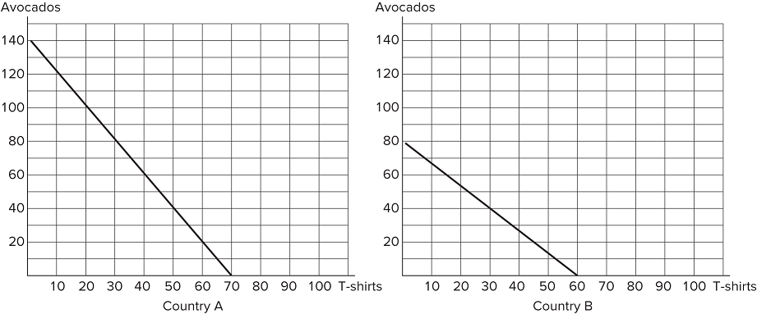Refer to the figure shown, which represents the production possibilities frontiers for Countries A and B. Which of the following statements is true regarding Country A’s opportunity cost of a t-shirt?

A) It is lower than that of Country B, so Country A should specialize in t-shirts and trade for avocados.   
 B) It is higher than that of Country B, so Country A should specialize in avocados and trade for t-shirts.  
 C) It is higher than that of Country B for both goods, so Country A will not benefit from trade.  
 D) It is lower than that of Country B for both goods, so Country A will not benefit from trade.

**132)** Refer to the figure shown, which represents the production possibilities frontiers for Countries A and B. After comparing each country's production possibilities frontier, it is clear that:

A) Country A should specialize in cars, Country B should specialize in trucks, and both could benefit from trade.   
 B) Country A should specialize in trucks, Country B should specialize in cars, and both will benefit from trade.  
 C) Country A will not benefit from trade.  
 D) Country B will lose by trading with Country A.

**133)** Refer to the figure shown, which represents the production possibilities frontiers for Countries A and B. After examining the production possibilities of each country, what can we surmise about the opportunity cost of a car for Country A?

A) It is lower than that of Country B; Country A should specialize in cars and trade with Country B for trucks.   
 B) It is higher than that of Country B; Country A should specialize in cars and trade with Country B for trucks.  
 C) It is the same as that of Country B; Country A will not benefit from trade and should refrain.  
 D) It should have no effect on Country A's decision to trade; absolute advantage drives that decision.

**134)** Refer to the figure shown, which represents the production possibilities frontiers for Countries A and B. After examining each country's production possibilities frontier, it is clear that:

A) neither country will benefit from trade.   
 B) both countries can benefit from trade because an absolute advantage exists.  
 C) both countries could benefit from trade because a comparative advantage exists.  
 D) only Country A will benefit from trade.

**135)** Refer to the figure shown, which represents the production possibilities frontiers for Countries A and B. Considering the production possibilities frontiers of both countries, we know that both would be willing to agree to which terms of trade?

A) One truck for two cars   
 B) One truck forfour cars  
 C) One truck for six cars  
 D) One truck for eight cars

**136)** Refer to the figure shown, which represents the production possibilities frontiers for Countries A and B. Considering the production possibilities frontiers of both countries, we can infer that Country A should specialize in producing _____ and be willing to _____ five cars for each truck.

A) trucks; accept no less than   
 B) cars; give no more than  
 C) trucks; accept no more than  
 D) cars; give no less than

**137)** Refer to the figure shown, which represents the production possibilities frontiers for Countries A and B. Considering the production possibilities frontiers of both countries, we can conclude that Country B will specialize in _____ and be willing to _____ three cars for each truck.

A) trucks; accept no fewer than   
 B) cars; give no more than  
 C) trucks; accept no more than  
 D) cars; give no fewer than

**138)** Suppose the figure shown represents the production possibilities frontier for Country A. Country B offers to trade four trucks for every airplane. Assuming Country A specializes in airplane production, which of the following combinations of goods could Country A consume?

A) (15 airplanes, 20 trucks)   
 B) (10 airplanes, 20 trucks)  
 C) (10 airplanes, 30 trucks)  
 D) (5 airplanes, 20 trucks)

**139)** A country's newest ruler has decided the country will become self-sufficient and ceases trade with the rest of the world. How will this most likely affect the country's citizens?

A) They will beforced to consume less of the goods the country had a comparative advantage at producing.   
 B) They will be better off than before as long as the country has an absolute advantage at producing any good.  
 C) They will be better off than before only if the country has an absolute advantage at producing most of the goods they consume.  
 D) They will be better off than before only if they have a comparative advantage at producing all goods.

**140)** Economic theory states that losing a comparative advantage at producing one good means creating a comparative advantage at producing another. As an economy transitions from producing one good to producing another good:

A) those who must transition from the production of one good to the production of another good may find the transition difficult in the short run.   
 B) the transition can be seen as a success in the short run.  
 C) outsourcing will always be good for every member of a society.  
 D) no one will complain in the short run, but in the long run people may not like the transition.

**141)** Suppose that a worker in Country A can make either 10 iPhones or 5 iPads each year. Country A has 100 workers. Suppose a worker in Country B can make either 2 iPhones or 10 iPads each year. Country B has 200 workers. Which of the following is true?

A) Country B should produce iPads and Country A should produce iPhones, and they could both benefit from trade.   
 B) Country B should produce iPhones and Country A should produce iPads, and they could both benefit from trade.  
 C) Neither country would benefit from trade because there is no comparative advantage at producing these goods.  
 D) Because Country B has an absolute advantage at producing iPads, it should specialize in their production.

**142)** Suppose that a worker in Country A can produce either 25 bananas or 5 tomatoes each year. Country A has 200 workers. Suppose a worker in Country B can produce either 18 bananas or 6 tomatoes each year. Country B has 400 workers. Country B specializes in producing tomatoes and Country A specializes in producing bananas. What terms of trade would both countries be willing to agree to?

A) One tomato for one banana   
 B) One tomato for two bananas  
 C) One tomato for four bananas  
 D) One tomato for six bananas

**143)** Suppose that a worker in Country A can produce either 25 bananas or 5 tomatoes each year. Country A has 200 workers. Suppose a worker in Country B can produce either 18 bananas or 6 tomatoes each year. Country B has 400 workers. Country A specializes in producing bananas and Country B specializes in producing tomatoes. Regarding the terms of trade, Country A will give no _____ than _____ for every _____.

A) more; 5 bananas; one tomato   
 B) less; 5 bananas; one tomato  
 C) more; 1 tomato; 5 bananas  
 D) less; 1 tomato; 5 bananas

**144)** Suppose that a worker in Country A can produce either 25 bananas or 5 tomatoes each year. Country A has 200 workers. Suppose a worker in Country B can produce either 18 bananas or 6 tomatoes each year. Country B has 400 workers. Country A specializes in bananas and Country B specializes in tomatoes. Regarding the terms of trade, Country B will accept no _____ than _____ for every _____.

A) more; 3 bananas; one tomato   
 B) less; 3 bananas; one tomato  
 C) more; 1 tomato; 3 bananas  
 D) less; 1 tomato; 3 bananas

**145)** What limits the terms of trade that a country would find acceptable?

A) The country's opportunity costs of production.   
 B) Whether the country has an absolute advantage at producing a good.  
 C) How much the country values the good for which it is trading.  
 D) When the country has a comparative advantage at producing both goods.

**146)** Tom and Jerry have one day to work, but two tasks to focus on: building chairs and tables. If Tom spends all day building chairs, he will make 16 chairs. If he instead devotes his day to building tables, Tom will make 4 tables. If Jerry spends his day building chairs, he will make 14 chairs; if he spends the day building tables, he will make 7 tables. Based on their production possibilities frontiers, Tom and Jerry:

A) can both benefit from trade because absolute advantage exists.   
 B) can both benefit from trade because comparative advantage exists.  
 C) cannot benefit from trade because Tom has an absolute advantage at producing both goods.  
 D) will decide not to trade because no comparative advantage exists.

**147)** Tom and Jerry have one day to work, but two tasks to focus on: building chairs and tables. If Tom spends all day building chairs, he will make 16 chairs. If he instead devotes his day to building tables, Tom will make 4 tables. If Jerry spends his day building chairs, he will make 14 chairs; if he spends the day building tables, he will make 7 tables. If Jerry decides to specialize in building tables, what are the limits to his terms of trade?

A) Jerry will accept no less than 7 chairs for each table.   
 B) Jerry will accept no less than 2 chairs for each table.  
 C) Jerry will accept no less than 7 tables for each chair.  
 D) Jerry will accept no less than 2 tables for each chair.

**148)** The concepts of comparative advantage, specialization, and trade form a compelling argument in favor of:

A) free trade.   
 B) protectionism.  
 C) self-sufficiency.  
 D) only exporting goods and not importing goods.

**149)** The concepts of comparative advantage, specialization, and trade can be useful in explaining why:

A) countries import and export certain goods.   
 B) individuals typically work at one job, and buy the other goods and services they need.  
 C) we allow ourselves to be interdependent on others.  
 D) All of these statements are true.

**150)** 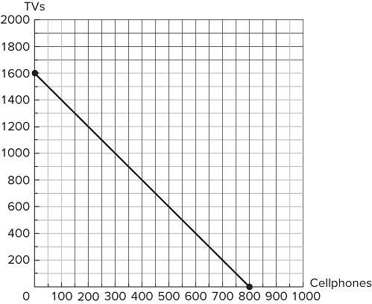Suppose the figure shown represents the production possibilities frontier for Country A. Country B offers to give 3 TVs to Country A for every cellphone it receives. Assuming Country A fully specializes in cellphone production, which of the following combinations of goods could Country A now consume that it could not achieve before trade?

A) (300 cellphones, 1,000 TVs)   
 B) (800 cellphones, 1,600 TVs)  
 C) (600 cellphones, 800 TVs)  
 D) (400 cellphones, 1,200 TVs)

**151)** 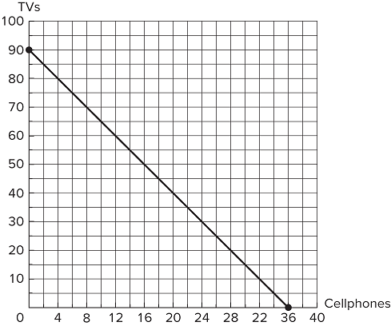Suppose the figure shown represents the production possibilities frontier for Country A. Country B offers to give 4 TVs to Country A for every cellphone it receives. Assuming Country A fully specializes in cellphone production and that it wishes to consume 24 cellphones total, how many TVs can Country A consume after trade?

A) 30 TVs   
 B) 48 TVs  
 C) 96 TVs  
 D) 28 TVs

**152)** Refer to the figure shown, which represents the production possibilities frontiers for Countries A and B. Which of the following statements is true?Country A has an absolute advantage at producing both avocados and t-shirts.Country B has a comparative advantage at producing t-shirts.Country B would benefit from trade, but Country A would not.

A) I only   
 B) III only  
 C) I and II only  
 D) II and III only

**153)** Refer to the figure shown, which represents the production possibilities frontiers for Countries A and B. What terms of trade would both countries be willing to agree to?

A) One t-shirt for one avocado   
 B) One t-shirt for 1.5 avocados  
 C) One t-shirt for 2.5 avocados  
 D) One t-shirt for 3 avocados

**154)** 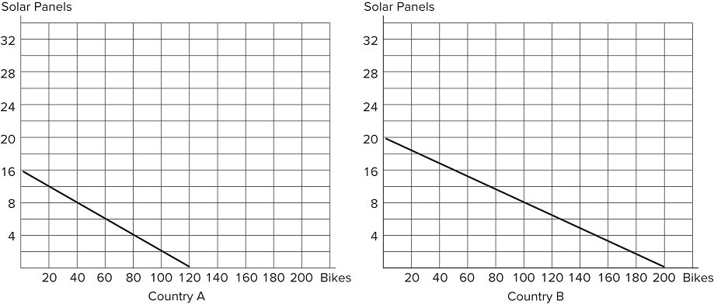Refer to the figure shown, which represents the production possibilities frontiers for Countries A and B. What terms of trade would both countries be willing to agree to?

A) One solar panel for 2 bikes   
 B) One solar panel for 7 bikes  
 C) One solar panel for 8 bikes  
 D) One solar panel for 12 bikes

**Answer Key**Test name: chapter 2

1) A

2) A

3) B

4) A

5) B

6) C

7) C

8) A

9) B

10) D

11) A

12) D

13) B

14) B

15) C

16) B

17) A

18) D

19) B

20) B

21) C

22) A

23) C

24) C

25) C

26) A

27) A

28) A

29) A

30) B

31) A

32) A

33) B

34) A

35) A

36) C

37) D

38) C

39) C

40) B

41) A

42) B

43) D

44) D

45) D

46) D

47) B

48) C

49) A

50) C

51) B

52) C

53) A

54) C

55) D

56) A

57) C

58) C

59) D

60) B

61) D

62) D

63) C

64) C

65) D

66) D

67) D

68) B

69) A

70) C

71) D

72) B

73) D

74) A

75) C

76) A

77) B

78) D

79) B

80) A

81) A

82) C

83) D

84) D

85) C

86) A

87) B

88) B

89) D

90) A

91) A

92) A

93) A

94) D

95) A

96) D

97) D

98) B

99) A

100) D

101) A

102) D

103) B

104) B

105) A

106) A

107) D

108) A

109) B

110) C

111) D

112) C

113) C

114) A

115) A

116) B

117) A

118) B

119) D

120) A

121) A

122) A

123) A

124) B

125) B

126) B

127) A

128) C

129) A

130) C

131) B

132) A

133) A

134) C

135) B

136) B

137) A

138) A

139) A

140) A

141) A

142) C

143) A

144) B

145) A

146) B

147) B

148) A

149) D

150) D

151) B

152) C

153) B

154) C