McKnight's Physical Geography, 12e (Hess)
Chapter 2 Portraying Earth

1) A disadvantage of globes compared to maps is that globes are NOT ________.
A) conformal
B) accurate
C) suitable for use in class
D) equivalent
E) able to show as much detail
Answer: E
Diff: 1
Topic/Section: 2.1 Maps and Globes
Learning Outcome: 2.1 Explain why no map of the world can be as accurate as a globe.
Natl. Geog Stds: GS3
Global Sci Stds: G3
Bloom's Taxonomy: Remembering/Understanding

2) A map made to show the distribution of one or more phenomenon is a(n) ________ map.
A) conic
B) isoline
C) equivalent
D) compromise
E) thematic
Answer: E
Diff: 1
Topic/Section: 2.1 Maps and Globes
Learning Outcome: 2.1 Explain why no map of the world can be as accurate as a globe.
Natl. Geog Stds: GS3
Global Sci Stds: G3
Bloom's Taxonomy: Remembering/Understanding

3) Compared to the number of globes in use, the number of maps is ________.
A) much less
B) about the same
C) a little more
D) twice as many
E) millions of times more
Answer: E
Diff: 1
Topic/Section: 2.1 Maps and Globes
Learning Outcome: 2.1 Explain why no map of the world can be as accurate as a globe.
Natl. Geog Stds: GS3
Global Sci Stds: G3
Bloom's Taxonomy: Remembering/Understanding
4) The scale of "an inch on the map represents two miles on the surface of the Earth" would be CLOSEST to which representative fraction?
A) 1:120,000
B) 1:200,000
C) 1:1,000,000
D) 1:60,000
E) 1:12
Answer: A
Diff: 1
Topic/Section: 2.2 Map Scale
Learning Outcome: 2.7 Define verbal scale of a map.
Natl. Geog Stds: GS3
Global Sci Stds: G3
Bloom's Taxonomy: Applying/Analyzing

5) The smallest scale of the following is ________.
A) 1:100,000
B) 1:200,000
C) 1:500,000
D) 1:750,000
E) 1:900,000
Answer: E
Diff: 1
Topic/Section: 2.2 Map Scale
Learning Outcome: 2.1 Explain why no map of the world can be as accurate as a globe.
Natl. Geog Stds: GS3
Global Sci Stds: G3
Bloom's Taxonomy: Applying/Analyzing

6) The relationship between the map distance and the corresponding distance on the ground is known as the ________.
A) vector
B) azimuth
C) map quotient
D) loxodrome
E) scale
Answer: E
Diff: 1
Topic/Section: 2.2 Map Scale
Learning Outcome: 2.1 Explain why no map of the world can be as accurate as a globe.
Natl. Geog Stds: GS3
Global Sci Stds: G3
Bloom's Taxonomy: Remembering/Understanding
7) The scale of 1:63,360 is the same as one inch equals ________.
A) one foot
B) one mile
C) one furlong
D) one meter
E) one yard
Answer: B
Diff: 2
Topic/Section: 2.2 Map Scale
Learning Outcome: 2.6 Identify examples of fractional scales from a map; 2.7 Define verbal scale of a map.
Natl. Geog Stds: GS3
Global Sci Stds: G3
Bloom's Taxonomy: Applying/Analyzing

8) "Scale" relates ________ to ________.
A) Earth distance, Earth distance
B) map distance, map distance
C) map distance, Earth distance
D) Earth distance, map distortion
E) map distortion, map distance
Answer: C
Diff: 1
Topic/Section: 2.2 Map Scale
Learning Outcome: 2.2 Define map scale.
Natl. Geog Stds: GS3
Global Sci Stds: G3
Bloom's Taxonomy: Remembering/Understanding

9) The largest scale among the following representative fractions is ________.
A) 1:100,000
B) 1:1,000,000
C) 1:24,000
D) 1:10,000
E) 1:50,000
Answer: D
Diff: 2
Topic/Section: 2.2 Map Scale
Learning Outcome: 2.5 Define fractional scale of a map.
Natl. Geog Stds: GS3
Global Sci Stds: G4
Bloom's Taxonomy: Evaluating/Creating
10) A scale of one inch equals one mile is ________ in a representative fraction.
A) 1:10,000
B) 1:63,360
C) 1:100,000
D) 1:1,000,000
E) 1:250,000
Answer: B
Diff: 2
Topic/Section: 2.2 Map Scale
Learning Outcome: 2.5 Define fractional scale of a map.
Natl. Geog Stds: GS1
Global Sci Stds: G4
Bloom's Taxonomy: Evaluating/Creating

11) A(n) ________ scale remains correct even if the map is enlarged or reduced when reproduced.
A) isogonic
B) large
C) graphic
D) representative fraction
E) color
Answer: C
Diff: 1
Topic/Section: 2.2 Map Scale
Learning Outcome: 2.3 Define graphic scale of a map.
Natl. Geog Stds: GS3
Global Sci Stds: G3
Bloom's Taxonomy: Remembering/Understanding

12) The characteristic of projections that portray accurate sizes but distort the shapes of landmasses is called ________.
A) conformality
B) sinusoidal
C) equivalence
D) azimuthality
E) polyconic
Answer: C
Diff: 1
Topic/Section: 2.3 Map Projections and Properties
Learning Outcome: 2.11 Explain when an equivalent map projection is most suited for use in geographic studies.
Natl. Geog Stds: GS3
Global Sci Stds: G3
Bloom's Taxonomy: Remembering/Understanding
13) On large-scale maps, equivalence and conformity can be ________.
A) simultaneously present
B) simultaneously approximated for small areas
C) disregarded if the map is of high latitudes
D) considered to be the same map property
Answer: B
Diff: 1
Topic/Section: 2.3 Map Projections and Properties
Learning Outcome: 2.11 Explain when an equivalent map projection is most suited for use in geographic studies.
Natl. Geog Stds: GS3
Global Sci Stds: G3
Bloom's Taxonomy: Remembering/Understanding

14) The property of equivalence portrays accurate size although it ________.
A) bends parallels
B) renders the poles as lines
C) stretches the circle of tangency
D) distorts shapes
Answer: D
Diff: 1
Topic/Section: 2.3 Map Projections and Properties
Learning Outcome: 2.10 Describe equivalent map projection.
Natl. Geog Stds: GS1
Global Sci Stds: G3
Bloom's Taxonomy: Remembering/Understanding

15) One difference between any two different map projections must always be ________.
A) scale
B) how the geographic grid is arranged
C) the number of degrees from the equator to the North Pole
D) how accurately shapes are portrayed
E) how accurately relative sizes are portrayed
Answer: B
Diff: 1
Topic/Section: 2.1 Maps and Globes
Learning Outcome: 2.9 Define map projection.
Natl. Geog Stds: GS1
Global Sci Stds: G3
Bloom's Taxonomy: Remembering/Understanding

16) Planar projections ________.
A) all have their meridians at right angles to each other
B) are projected from the globe to a plane
C) usually show both hemispheres
D) is tangent to the globe at one point
E) do not have any distortions
Answer: B
Diff: 2
Topic/Section: 2.3 Map Projections and Properties
Learning Outcome: 2.1 Explain why no map of the world can be as accurate as a globe.
Natl. Geog Stds: GS1
Global Sci Stds: G3
Bloom's Taxonomy: Remembering/Understanding
17) Conformal maps greatly distort ________ of continents in higher latitudes.
A) shapes
B) sizes
C) the number
D) the latitude
E) the longitude
Answer: B
Diff: 1
Topic/Section: 2.3 Map Projections and Properties
Learning Outcome: 2.12 Describe conformal map projection.
Natl. Geog Stds: GS1
Global Sci Stds: G3
Bloom's Taxonomy: Remembering/Understanding

18) Central meridians are essential features on a(n) ________ projection.
A) perfectly conformal
B) large-scale
C) small-scale
D) interrupted
E) Mercator
Answer: D
Diff: 1
Topic/Section: 2.3 Map Projections and Properties
Learning Outcome: 2.14 Describe compromise map projection.
Natl. Geog Stds: GS1
Global Sci Stds: G3
Bloom's Taxonomy: Remembering/Understanding

19) Misuse of the Mercator projection is a result of ________.
A) an inaccurate projection of latitude and longitude
B) the Cold War
C) the fact that it is so old
D) the curved loxodromes
E) latitudinal differences in scale
Answer: E
Diff: 2
Topic/Section: 2.3 Map Projections and Properties
Learning Outcome: 2.13 Explain when a conformal map is most suited for use in geographic studies.
Natl. Geog Stds: GS1
Global Sci Stds: G3
Bloom's Taxonomy: Applying/Analyzing
20) ________ is the major dilemma of mapmaking.
A) Conformality versus scale
B) Scale versus equivalence
C) Equivalence versus conformality
D) Conic versus azimuthal projections
E) The inclusion of too much information on a map
Answer: C
Diff: 2
Topic/Section: 2.3 Map Projections and Properties
Learning Outcome: 2.13 Explain when a conformal map is most suited for use in geographic studies.
Natl. Geog Stds: GS1
Global Sci Stds: G3
Bloom's Taxonomy: Applying/Analyzing

21) Which map-making method would be used to minimize distortion of continents on a world map?
A) A perfectly equivalent projection
B) A large scale
C) A conic projection
D) An interrupted projection
E) A Mercator projection
Answer: D
Diff: 1
Topic/Section: 2.3 Map Projections and Properties
Learning Outcome: 2.9 Define map projection.
Natl. Geog Stds: GS1
Global Sci Stds: G3
Bloom's Taxonomy: Remembering/Understanding

22) All map projections have this in common.
A) Small scale
B) Some distortion
C) Equivalence
D) Conformality
E) Perfect portrayal of the globe
Answer: B
Diff: 1
Topic/Section: 2.3 Map Projections and Properties
Learning Outcome: 2.9 Define map projection.
Natl. Geog Stds: GS1
Global Sci Stds: G3
Bloom's Taxonomy: Remembering/Understanding
23) You wish to navigate your yacht from Europe to the United States. Which type of map projection would be most useful?
A) Informal
B) Mercator
C) Interrupted
D) Equivalent
E) Topographic
Answer: B
Diff: 2
Topic/Section: 2.3 Map Projections and Properties
Learning Outcome: 2.11 Explain when an equivalent map projection is most suited for use in geographic studies.
Natl. Geog Stds: GS1
Global Sci Stds: G3
Bloom's Taxonomy: Applying/Analyzing

24) Most worldwide maps are ________ projections and are an optimal portrayal of worldwide distributions.
A) equivalent
B) conformal
C) conic
D) azimuthal
E) gnomonic
Answer: B
Diff: 2
Topic/Section: 2.3 Map Projections and Properties
Learning Outcome: 2.11 Explain when an equivalent map projection is most suited for use in geographic studies.
Natl. Geog Stds: GS1
Global Sci Stds: G3
Bloom's Taxonomy: Applying/Analyzing

25) If one wished to produce a map that focused on the continents and showed little of the world's oceans, then she/he should use a(n) ________ projection.
A) large-scale
B) equal-area
C) interrupted
D) conical
E) azimuthal
Answer: C
Diff: 2
Topic/Section: 2.3 Map Projections and Properties
Learning Outcome: 2.11 Explain when an equivalent map projection is most suited for use in geographic studies.
Natl. Geog Stds: GS1
Global Sci Stds: G3
Bloom's Taxonomy: Applying/Analyzing
26)
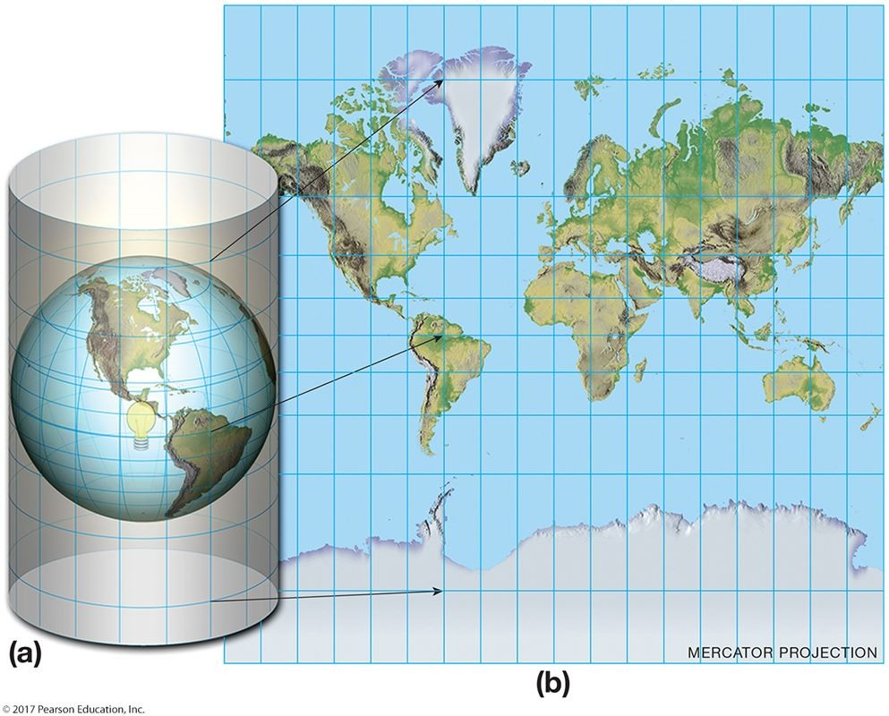

This is a Mercator projection but not a(n) ________ projection.
A) equivalent
B) optical
C) small-scale
D) conformal
E) useful
Answer: A
Diff: 2
Topic/Section: 2.1 Maps and Globes
Learning Outcome: 2.13 Explain when a conformal map is most suited for use in geographic studies.
Natl. Geog Stds: GS3
Global Sci Stds: G3
Bloom's Taxonomy: Applying/Analyzing

27) On small-scale maps, it is difficult to achieve ________.
A) a circle of tangency
B) proper scale
C) equivalency
D) pole-centered perspective
E) conformality
Answer: C
Diff: 1
Topic/Section: 2.3 Map Projections and Properties
Learning Outcome: 2.10 Describe equivalent map projection.
Natl. Geog Stds: GS3
Global Sci Stds: G3
Bloom's Taxonomy: Remembering/Understanding
28)
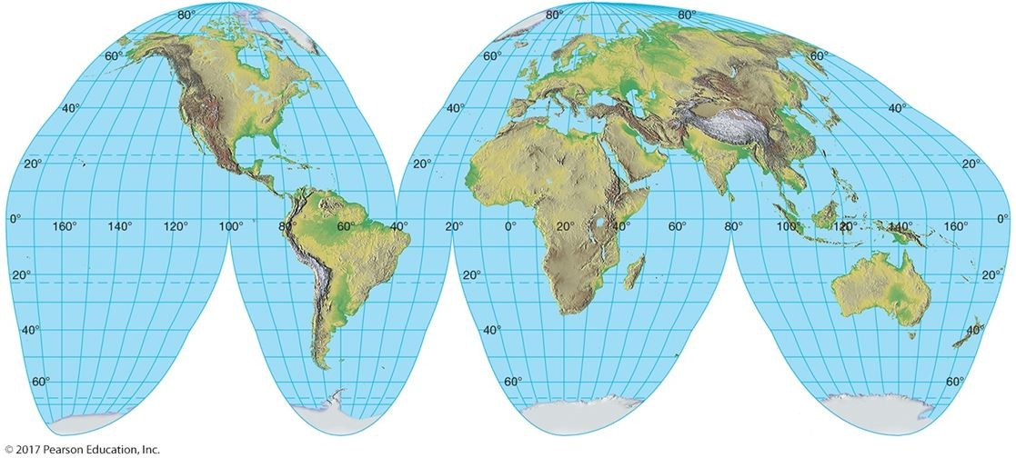

This figure is an example of a(n) ________ projection.
A) interrupted
B) distorted
C) cylindrical
D) maximal
E) useless
Answer: A
Diff: 1
Topic/Section: 2.3 Map Projections and Properties
Learning Outcome: 2.14 Describe compromise map projection.
Natl. Geog Stds: GS3
Global Sci Stds: G3
Bloom's Taxonomy: Remembering/Understanding

29) Which of the following map projections is impossible to construct?
A) Mercator
B) Conic
C) Cylindrical
D) Equivalent
E) A projection without distortion
Answer: E
Diff: 1
Topic/Section: 2.3 Map Projections and Properties
Learning Outcome: 2.14 Describe compromise map projection.
Natl. Geog Stds: GS1
Global Sci Stds: G3
Bloom's Taxonomy: Remembering/Understanding
30) Map projections are mainly derived ________.
A) mathematically
B) from interpolation
C) from aerial reconnaissance
D) by analogy
E) by osmosis
Answer: A
Diff: 1
Topic/Section: 2.3 Map Projections and Properties
Learning Outcome: 2.19 Describe planar projection.
Natl. Geog Stds: GS1
Global Sci Stds: G3
Bloom's Taxonomy: Remembering/Understanding

31) A line of constant compass direction is a ________.
A) rhumb line
B) x-ray
C) gnomon
D) thermal scanner
E) meridian
Answer: A
Diff: 1
Topic/Section: 2.3 Map Projections and Properties
Learning Outcome: 2.17 Describe some of the best uses for maps with a cylindrical projection.
Natl. Geog Stds: GS1
Global Sci Stds: G3
Bloom's Taxonomy: Remembering/Understanding

32) ________ projection is the most famous map projection.
A) The Mercator
B) Goode's
C) 3D
D) Laser
E) The Stadler
Answer: A
Diff: 1
Topic/Section: 2.3 Map Projections and Properties
Learning Outcome: 2.12 Describe conformal map projection.
Natl. Geog Stds: GS1
Global Sci Stds: G3
Bloom's Taxonomy: Remembering/Understanding
33)
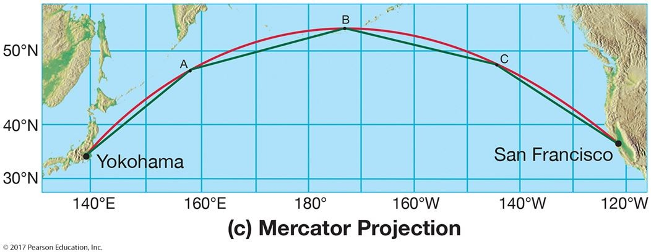

This map shows a series of ________, which serve as approximations of the great-circle route.
A) meridians
B) parallels
C) loxodromes
D) gnomons
E) axes
Answer: C
Diff: 2
Topic/Section: 2.4 Families of Map Projections
Learning Outcome: 2.13 Explain when a conformal map is most suited for use in geographic studies.
Natl. Geog Stds: GS3
Global Sci Stds: G3
Bloom's Taxonomy: Remembering/Understanding

34) A Mercator map is constructed by projecting the grid of the globe onto a(n) ________.
A) flat surface
B) cone
C) cylinder
D) interrupted surface
E) circle
Answer: C
Diff: 1
Topic/Section: 2.4 Families of Map Projections
Learning Outcome: 2.16 Describe cylindrical projection.
Natl. Geog Stds: GS1
Global Sci Stds: G3
Bloom's Taxonomy: Remembering/Understanding
35) A psuedocylindrical projection ________.
A) is an oval projection
B) cannot be used with interrupted projections
C) is the kind of projection used in most of your textbook's maps
D) does not have central meridians and parallels
E) is not a type of projection explained in your textbook
Answer: A
Diff: 2
Topic/Section: 2.4 Families of Map Projections
Learning Outcome: 2.17 Describe some of the best uses for maps with a cylindrical projection.
Natl. Geog Stds: GS1
Global Sci Stds: G3
Bloom's Taxonomy: Remembering/Understanding

36) Which of the following should contain a brief summary of the map's content or purpose?
A) The title
B) The legend
C) The scale
D) The area within the map's boundaries
E) The data source
Answer: A
Diff: 1
Topic/Section: 2.5 Conveying Information on Maps
Learning Outcome: 2.26 Explain how isolines are used to convey information on a map.
Natl. Geog Stds: GS1
Global Sci Stds: G3
Bloom's Taxonomy: Remembering/Understanding

37) A(n) ________ is a line joining the points of equal magnetic declination.
A) contour line
B) isohyet
C) isotherm
D) isomag
E) isogonic line
Answer: E
Diff: 2
Topic/Section: 2.5 Conveying Information on Maps
Learning Outcome: 2.26 Explain how isolines are used to convey information on a map.
Natl. Geog Stds: GS1
Global Sci Stds: G2
Bloom's Taxonomy: Remembering/Understanding
38) Title, date, and legend are three ________.
A) suggested map components
B) map essentials
C) components that are never all together on a map
D) informative features usually appearing on the back of a map
E) things that can be left off of a map
Answer: B
Diff: 1
Topic/Section: 2.5 Conveying Information on Maps
Learning Outcome: 2.25 Identify the basic components of a map.
Natl. Geog Stds: GS1
Global Sci Stds: G3
Bloom's Taxonomy: Remembering/Understanding

39)
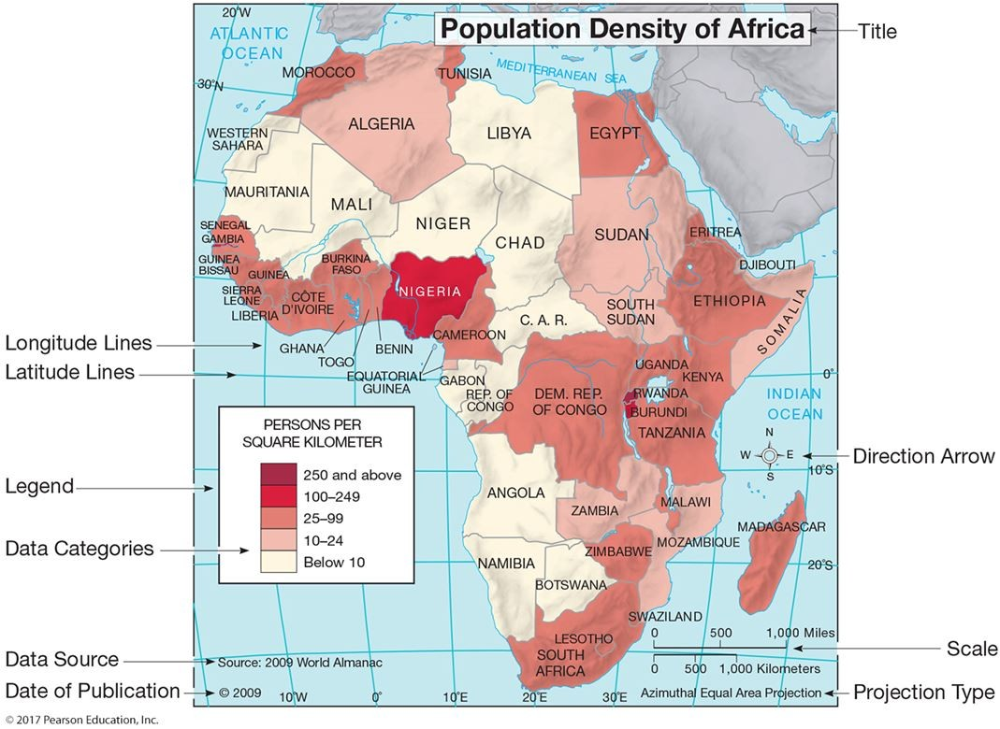

This figure is an example of a(n) ________.
A) map projection that can be used for all purposes
B) isogonic map
C) contour map
D) thematic map
E) large-scale map
Answer: D
Diff: 2
Topic/Section: 2.5 Conveying Information on Maps
Learning Outcome: 2.25 Identify the basic components of a map.
Natl. Geog Stds: GS1
Global Sci Stds: G3
Bloom's Taxonomy: Applying/Analyzing
40)
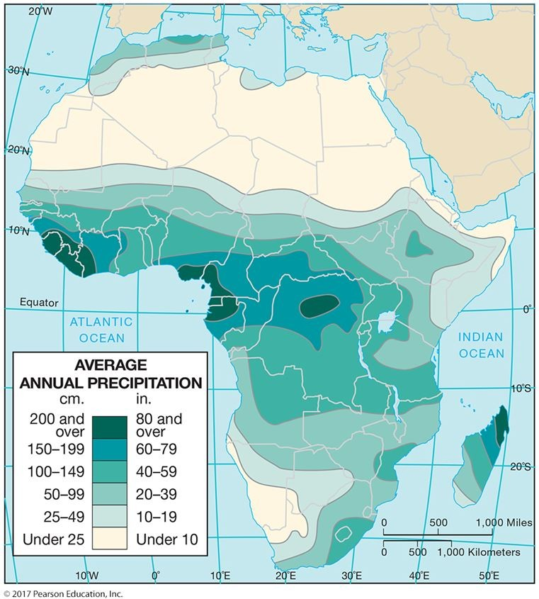

This figure is an isoline map of yearly rainfall over Africa. These specific type of isolines are ________.
A) elevation contours
B) isotherms
C) isohyets
D) isogonic lines
E) intervals
Answer: C
Diff: 1
Topic/Section: 2.5 Conveying Information on Maps
Learning Outcome: 2.26 Explain how isolines are used to convey information on a map.
Natl. Geog Stds: GS1
Global Sci Stds: G3
Bloom's Taxonomy: Remembering/Understanding
41)
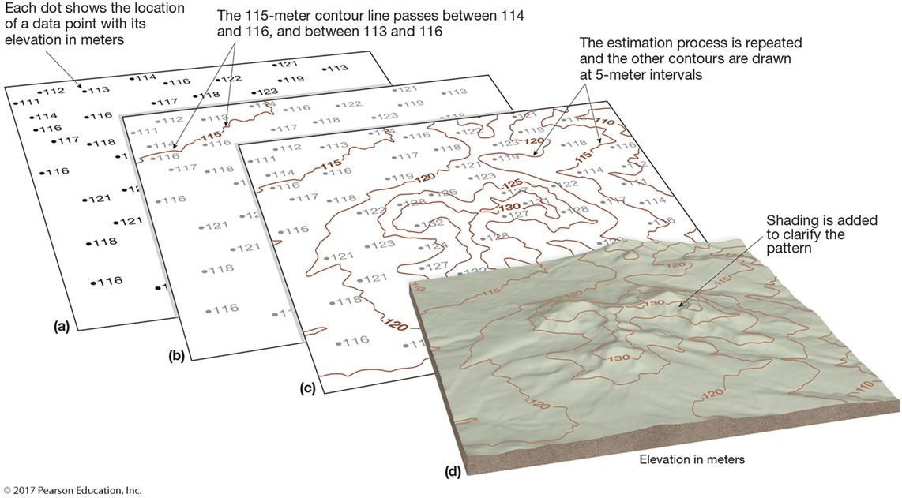

This figure shows height contours that ________.
A) usually confuse map readers
B) are useful in conveying the shape of the landscape
C) incorrectly represent the point data from which they are drawn
D) are probably suspect because we only see five contour elevations
E) would be better if they were shown in feet
Answer: B
Diff: 2
Topic/Section: 2.5 Conveying Information on Maps
Learning Outcome: 2.26 Explain how isolines are used to convey information on a map.
Natl. Geog Stds: GS1
Global Sci Stds: G3
Bloom's Taxonomy: Applying/Analyzing

42) Of the following, which is NOT considered a map essential?
A) Title
B) Date
C) Color
D) Legend
E) Scale
Answer: C
Diff: 2
Topic/Section: 2.5 Conveying Information on Maps
Learning Outcome: 2.25 Identify the basic components of a map.
Natl. Geog Stds: GS1
Global Sci Stds: G3
Bloom's Taxonomy: Remembering/Understanding
43) Geopositioning technology ________.
A) typically uses receivers larger than filing cabinets
B) is widely used for making maps
C) has never been commercially successful
D) began in the 1920s
E) is another term for the drawing of isolines
Answer: B
Diff: 1
Topic/Section: 2.6 Global Navigational Satellite System
Learning Outcome: 2.28 Define GNSS.
Natl. Geog Stds: GS3
Global Sci Stds: G3
Bloom's Taxonomy: Remembering/Understanding

44) For the geographer, new mapping tools like remote sensing, GPS, and GIS are best viewed as ________.
A) replacements for traditional geographic description
B) in the test mode and too expensive for most geographers to use
C) adjuncts to field study
D) aids in the study of small areas
E) too difficult for geographers to use
Answer: C
Diff: 1
Topic/Section: 2.6 Global Navigational Satellite System
Learning Outcome: 2.28 Define GNSS.
Natl. Geog Stds: GS3
Global Sci Stds: G3
Bloom's Taxonomy: Remembering/Understanding

45) Which of the following is TRUE concerning GPS technology?
A) It appears useful but receivers are very expensive.
B) It usually cannot pinpoint locations with an accuracy greater than 1 km.
C) The GPS satellites are owned by a private corporation.
D) The technology is freely available to the public.
E) The GPS technology allows "perfect" maps to be drawn.
Answer: D
Diff: 1
Topic/Section: 2.6 Global Navigational Satellite System
Learning Outcome: 2.30 Describe some common uses of GPS.
Natl. Geog Stds: GS1
Global Sci Stds: G3
Bloom's Taxonomy: Remembering/Understanding
46) Which of the following is essential in order for GPS to function?
A) Highly accurate clocks
B) A nearby base station on Earth's surface
C) A small, radar unit
D) A GIS unit in a receiver
E) Locations on land instead of the ocean
Answer: A
Diff: 1
Topic/Section: 2.6 Global Navigational Satellite System
Learning Outcome: 2.29 Describe how a GPS unit determines its location.
Natl. Geog Stds: GS1
Global Sci Stds: G3
Bloom's Taxonomy: Remembering/Understanding

47) Which of the following is the acronym for the system of U.S. Department of Defense satellites, which are used to establish exact locations on Earth?
A) GIS
B) Landsat
C) GPS
D) EOS
E) Color infrared
Answer: C
Diff: 1
Topic/Section: 2.6 Global Navigational Satellite System
Learning Outcome: 2.30 Describe some common uses of GPS.
Natl. Geog Stds: GS1
Global Sci Stds: G3
Bloom's Taxonomy: Remembering/Understanding
48)
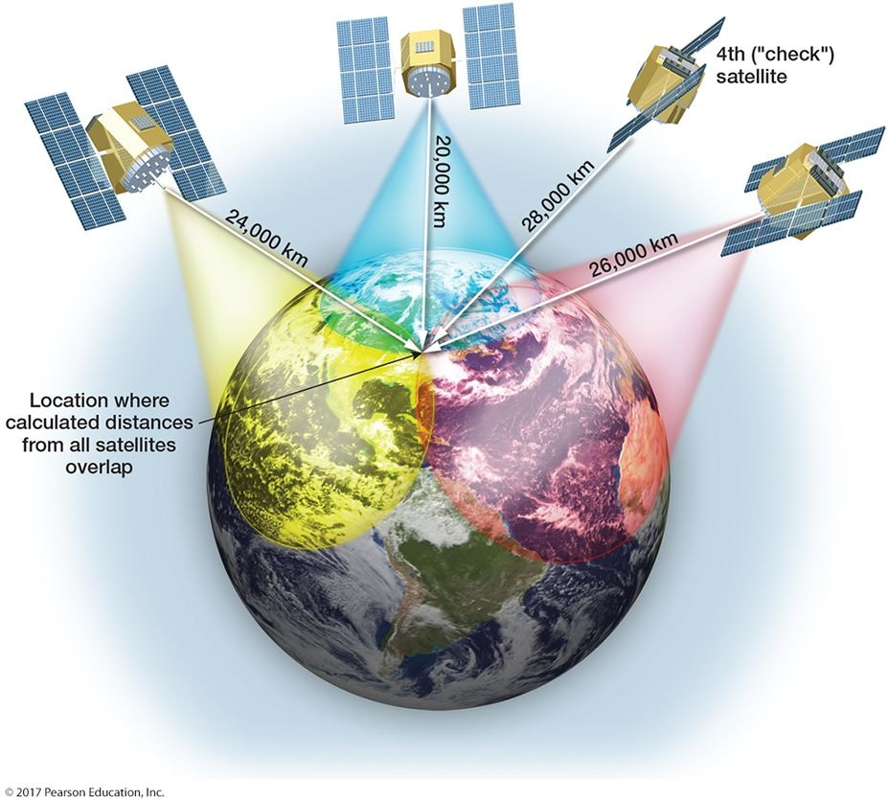

The world system of locational satellites, orbited by several countries, is most properly called ________.
A) CORS
B) NAVSTAR
C) WAAS
D) NEXRAD
E) GNSS
Answer: E
Diff: 1
Topic/Section: 2.6 Global Navigational Satellite System
Learning Outcome: 2.28 Define GNSS.
Natl. Geog Stds: GS1
Global Sci Stds: G3
Bloom's Taxonomy: Remembering/Understanding
49) The U.S. version of GNSS is dependent on a network of ________ satellites
A) 2
B) 3
C) 5
D) 24
E) 108
Answer: D
Diff: 1
Topic/Section: 2.6 Global Navigational Satellite System
Learning Outcome: 2.29 Describe how a GPS unit determines its location.
Natl. Geog Stds: GS1
Global Sci Stds: G3
Bloom's Taxonomy: Remembering/Understanding

50) The global positioning system (GPS) is based on ________.
A) aerial photography
B) infrared light sources
C) data from satellites
D) large, expensive receivers
E) gravity waves from the Sun and Moon
Answer: C
Diff: 1
Topic/Section: 2.6 Global Navigational Satellite System
Learning Outcome: 2.29 Describe how a GPS unit determines its location.
Natl. Geog Stds: GS1
Global Sci Stds: G3
Bloom's Taxonomy: Remembering/Understanding

51) Which of the following would you not expect to be accomplished using geopositioning technology?
A) Ocean floor mapping
B) Earthquake prediction
C) Natural disaster damage assessment
D) Volcano monitoring
E) Counting a city's population
Answer: E
Diff: 2
Topic/Section: 2.6 Global Navigational Satellite System
Learning Outcome: 2.29 Describe how a GPS unit determines its location.
Natl. Geog Stds: GS1
Global Sci Stds: G3
Bloom's Taxonomy: Applying/Analyzing
52)
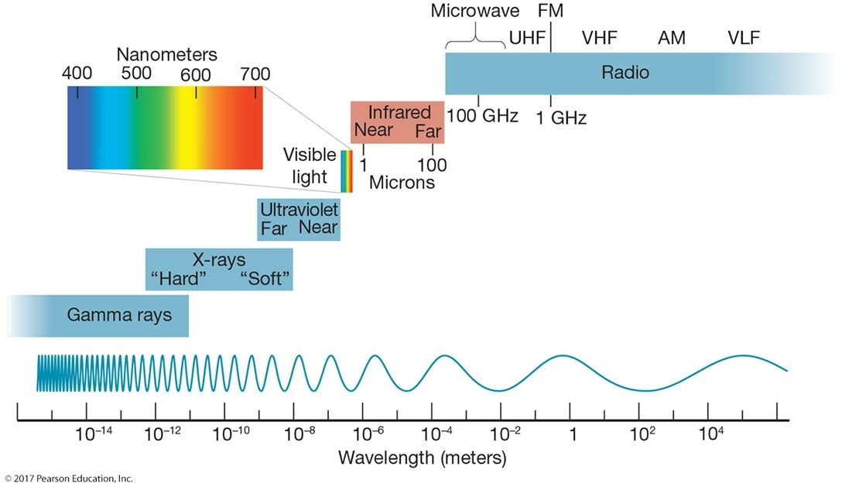

This figure shows the various wavelengths of electromagnetic energy used in remote sensing. False color imagery uses wavelengths on the order of ________ meter(s)
A) 1
B) 10-2
C) 10-4
D) 10-6
E) 10
Answer: D
Diff: 2
Topic/Section: 2.7 Remote Sensing
Learning Outcome: 2.32 Discuss the kinds of information that can be gathered by remote sensing.
Natl. Geog Stds: GS1
Global Sci Stds: G3
Bloom's Taxonomy: Applying/Analyzing

53) Lidar is based on actively sending ________ from a device in order to precisely measure the Earth's surface.
A) radar
B) ultrasound
C) infrared energy
D) ultraviolet energy
E) light
Answer: E
Diff: 1
Topic/Section: 2.7 Remote Sensing
Learning Outcome: 2.32 Discuss the kinds of information that can be gathered by remote sensing.
Natl. Geog Stds: GS3
Global Sci Stds: G3
Bloom's Taxonomy: Remembering/Understanding
54) Which of the following is NOT a commercial satellite system?
A) SPOT
B) GeoEye-1
C) QuickBird
D) Worldview
E) Landsat
Answer: E
Diff: 2
Topic/Section: 2.7 Remote Sensing
Learning Outcome: 2.32 Discuss the kinds of information that can be gathered by remote sensing.
Natl. Geog Stds: GS3
Global Sci Stds: G3
Bloom's Taxonomy: Applying/Analyzing

55)
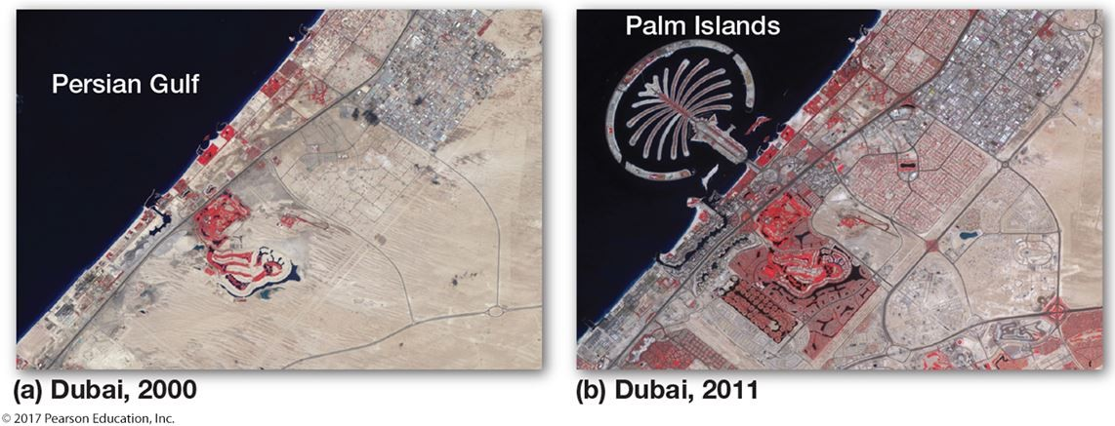

This figure shows Dubai before and after the appearance of the Palm Islands. Satellite imagery is quite useful here because it can monitor ________.
A) ship positions
B) environmental change
C) large farms
D) mountain runoff
E) the emergence of the volcano
Answer: B
Diff: 2
Topic/Section: 2.7 Remote Sensing
Learning Outcome: 2.32 Discuss the kinds of information that can be gathered by remote sensing.
Natl. Geog Stds: GS3
Global Sci Stds: G3
Bloom's Taxonomy: Applying/Analyzing
56)
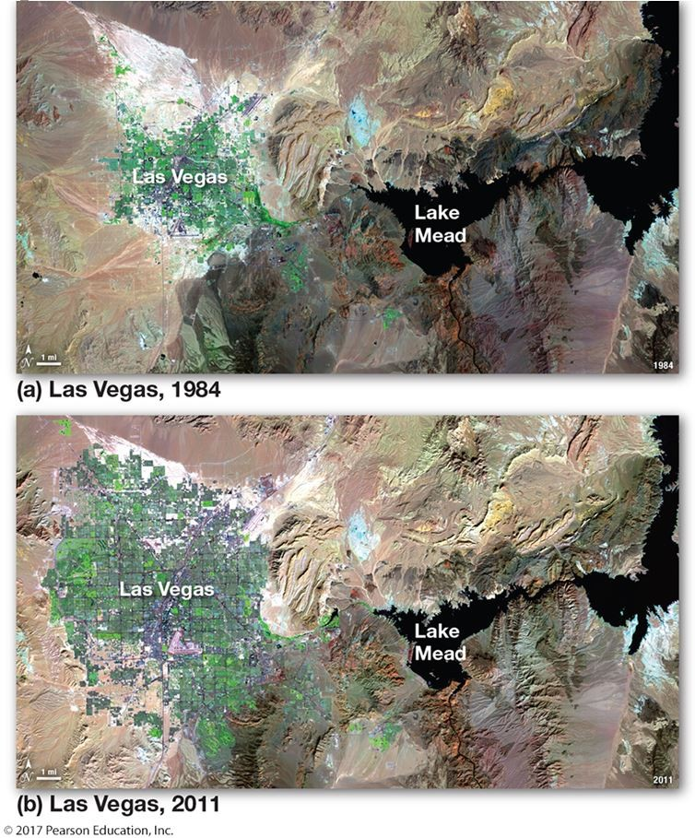

This figure gives the big picture of the dramatic growth of Las Vegas. To which of the following is this type of satellite imagery NOT well suited?
A) Forecasting thunderstorms
B) Monitoring environmental change
C) Tracking the size of the urban area
D) Placing it in a GIS for urban planning
E) Studying the amount of concrete surfaces generating high runoff
Answer: A
Diff: 2
Topic/Section: 2.7 Remote Sensing
Learning Outcome: 2.32 Discuss the kinds of information that can be gathered by remote sensing.
Natl. Geog Stds: GS3
Global Sci Stds: G3
Bloom's Taxonomy: Applying/Analyzing
57) Which of the following is most closely identified with multispectral remote sensing?
A) Radar imaging
B) Color infrared photography
C) Landsat
D) Microwave imaging
E) Thermal infrared scanning
Answer: C
Diff: 3
Topic/Section: 2.7 Remote Sensing
Learning Outcome: 2.32 Discuss the kinds of information that can be gathered by remote sensing.
Natl. Geog Stds: GS3
Global Sci Stds: G3
Bloom's Taxonomy: Remembering/Understanding

58) Landsat has a resolution of ________ meters in the visible portion of the electromagnetic spectrum.
A) 0.3
B) 3
C) 30
D) 300
E) 3,000
Answer: C
Diff: 1
Topic/Section: 2.7 Remote Sensing
Learning Outcome: 2.32 Discuss the kinds of information that can be gathered by remote sensing.
Natl. Geog Stds: GS3
Global Sci Stds: G3
Bloom's Taxonomy: Remembering/Understanding

59) Which of the following is NOT associated with Landsat images?
A) Thematic mapper
B) Multispectral scanning system
C) A series of several satellites over many years
D) The ultraviolet portion of the spectrum
E) Millions of pieces of data (pixels) per image
Answer: D
Diff: 1
Topic/Section: 2.7 Remote Sensing
Learning Outcome: 2.32 Discuss the kinds of information that can be gathered by remote sensing.
Natl. Geog Stds: GS3
Global Sci Stds: G3
Bloom's Taxonomy: Remembering/Understanding
60) ________ is the science of obtaining reliable measurements from photographs.
A) Sonar
B) Orthophoto mapping
C) Remote sensing
D) Photogrammetry
E) Satellite imaging
Answer: D
Diff: 1
Topic/Section: 2.7 Remote Sensing
Learning Outcome: 2.31 Define remote sensing.
Natl. Geog Stds: GS4
Global Sci Stds: G3
Bloom's Taxonomy: Remembering/Understanding

61) The first airborne platform for aerial photography was a(n)________.
A) balloon
B) airplane
C) satellite
D) bird
E) kite
Answer: A
Diff: 1
Topic/Section: 2.7 Remote Sensing
Learning Outcome: 2.31 Define remote sensing.
Natl. Geog Stds: GS4
Global Sci Stds: G3
Bloom's Taxonomy: Remembering/Understanding

62) ________ is the science of taking reliable measurements from aerial photographs.
A) Cartography
B) Photogrammetry
C) Map projection
D) Multispectral scanning
E) Symap
Answer: B
Diff: 1
Topic/Section: 2.7 Remote Sensing
Learning Outcome: 2.31 Define remote sensing.
Natl. Geog Stds: GS3
Global Sci Stds: G3
Bloom's Taxonomy: Applying/Analyzing
63) In ________ film photography, the photographic film is sensitive to wavelengths longer than visible light.
A) color infrared
B) passive microwave
C) true color
D) thermal infrared
E) Landsat
Answer: A
Diff: 1
Topic/Section: 2.7 Remote Sensing
Learning Outcome: 2.31 Define remote sensing.
Natl. Geog Stds: GS3
Global Sci Stds: G3
Bloom's Taxonomy: Remembering/Understanding

64) The type of remote sensing that penetrates clouds at night for accurate terrain representation is ________.
A) radar
B) sonar
C) passive microwave
D) thermal infrared
E) Landsat
Answer: A
Diff: 1
Topic/Section: 2.7 Remote Sensing
Learning Outcome: 2.32 Discuss the kinds of information that can be gathered by remote sensing.
Natl. Geog Stds: GS3
Global Sci Stds: G3
Bloom's Taxonomy: Remembering/Understanding

65) Which of the following is NOT a form of remote sensing?
A) Aerial photography
B) Color infrared photography
C) Radar
D) Thermal infrared imaging
E) Measurement by thermometer
Answer: E
Diff: 1
Topic/Section: 2.7 Remote Sensing
Learning Outcome: 2.31 Define remote sensing.
Natl. Geog Stds: GS3
Global Sci Stds: G3
Bloom's Taxonomy: Remembering/Understanding
66) On an orthophoto map, one might expect to find ________.
A) distortion-free photographs
B) many problems with map distortion
C) sketches rather than true projections
D) cultural but not physical features
E) symbols that are difficult to read
Answer: A
Diff: 1
Topic/Section: 2.7 Remote Sensing
Learning Outcome: 2.32 Discuss the kinds of information that can be gathered by remote sensing.
Natl. Geog Stds: GS3
Global Sci Stds: G3
Bloom's Taxonomy: Remembering/Understanding

67) Which of the below is an active remote sensing system?
A) Color infrared photography
B) Landsat
C) Radar
D) Thermal infrared imagery
E) Black and white aerial photography
Answer: C
Diff: 1
Topic/Section: 2.7 Remote Sensing
Learning Outcome: 2.32 Discuss the kinds of information that can be gathered by remote sensing.
Natl. Geog Stds: GS3
Global Sci Stds: G3
Bloom's Taxonomy: Applying/Analyzing

68) Aside from normal photographic film, ________ film has proven very valuable for interpretation of Earth's resources from airborne cameras.
A) color infrared
B) ultraviolet
C) thermal infrared
D) x-ray
E) gamma ray
Answer: A
Diff: 1
Topic/Section: 2.7 Remote Sensing
Learning Outcome: 2.32 Discuss the kinds of information that can be gathered by remote sensing.
Natl. Geog Stds: GS3
Global Sci Stds: G3
Bloom's Taxonomy: Remembering/Understanding
69) On which type of aerial imagery would a football field of artificial grass be discernible from natural grass?
A) Color photography
B) Black and white photography
C) Color infrared photography
D) Radar imagery
E) Microwave imagery
Answer: C
Diff: 1
Topic/Section: 2.7 Remote Sensing
Learning Outcome: 2.32 Discuss the kinds of information that can be gathered by remote sensing.
Natl. Geog Stds: GS3
Global Sci Stds: G3
Bloom's Taxonomy: Applying/Analyzing

70) Which of the following refers to an active remote sensing system?
A) Radar
B) Color infrared photography
C) GPS
D) Thermal infrared imagery
E) Black and white photography
Answer: A
Diff: 1
Topic/Section: 2.7 Remote Sensing
Learning Outcome: 2.32 Discuss the kinds of information that can be gathered by remote sensing.
Natl. Geog Stds: GS3
Global Sci Stds: G3
Bloom's Taxonomy: Remembering/Understanding

71) Unlike aerial photography, Landsat imagery is interpreted through ________.
A) remote sensing
B) numerical processing
C) stereoscopic
D) film
E) visual analysis
Answer: B
Diff: 1
Topic/Section: 2.7 Remote Sensing
Learning Outcome: 2.33 Describe the remote sensing method that most satellites use today.
Natl. Geog Stds: GS3
Global Sci Stds: G3
Bloom's Taxonomy: Remembering/Understanding
72) Which of the following bands are NOT used by the Earth-sensing satellites mentioned in the text?
A) X-rays
B) Color infrared
C) Panchromatic
D) Thermal infrared
E) Visible red
Answer: A
Diff: 2
Topic/Section: 2.7 Remote Sensing
Learning Outcome: 2.33 Describe the remote sensing method that most satellites use today.
Natl. Geog Stds: GS3
Global Sci Stds: G3
Bloom's Taxonomy: Applying/Analyzing

73) A satellite that remains over the same spot over all the time is ________.
A) geosynchronous
B) photogrammetric
C) a "low orbiter"
D) a Landsat mission
E) an impossibility
Answer: A
Diff: 1
Topic/Section: 2.7 Remote Sensing
Learning Outcome: 2.33 Describe the remote sensing method that most satellites use today.
Natl. Geog Stds: GS3
Global Sci Stds: G3
Bloom's Taxonomy: Remembering/Understanding

74) Which of the below wavelengths have been most useful in sensing the health and amount of vegetation in the landscape?
A) Ultraviolet
B) X-rays
C) Near infrared
D) Radio wavelengths
E) Gamma wavelengths
Answer: C
Diff: 1
Topic/Section: 2.7 Remote Sensing
Learning Outcome: 2.32 Discuss the kinds of information that can be gathered by remote sensing.
Natl. Geog Stds: GS3
Global Sci Stds: G3
Bloom's Taxonomy: Remembering/Understanding
75) Which remote sensing systems sense the longest wavelengths?
A) Landsat
B) Color photography
C) Thermal infrared imaging
D) Radar
E) Black and white photography
Answer: D
Diff: 2
Topic/Section: 2.7 Remote Sensing
Learning Outcome: 2.34 Distinguish passive remote sensing systems from active remote sensing systems.
Natl. Geog Stds: GS1
Global Sci Stds: G3
Bloom's Taxonomy: Applying/Analyzing

76) The multispectral MODIS instrument is associated with which satellite series?
A) Landsat
B) GOES
C) Space Shuttle
D) NIMBUS
E) EOS
Answer: E
Diff: 2
Topic/Section: 2.7 Remote Sensing
Learning Outcome: 2.33 Describe the remote sensing method that most satellites use today.
Natl. Geog Stds: GS3
Global Sci Stds: G3
Bloom's Taxonomy: Applying/Analyzing

77) Which of the following is an advantage of radar over all other remote sensing techniques?
A) It can operate at high altitude.
B) It can operate at night.
C) It can operate in clear weather.
D) It can operate at wavelengths shorter than 1 micrometer.
E) It can operate without using an electrical source.
Answer: B
Diff: 2
Topic/Section: 2.7 Remote Sensing
Learning Outcome: 2.34 Distinguish passive remote sensing systems from active remote sensing systems.
Natl. Geog Stds: GS3
Global Sci Stds: G3
Bloom's Taxonomy: Applying/Analyzing
78) In terms of remote sensing, geographers ________.
A) should not stop using maps and field study
B) have shown very little interest
C) will someday identify one remote sensing type that is best for all purposes
D) have never used remote sensing
E) should never use remote sensing
Answer: A
Diff: 1
Topic/Section: 2.7 Remote Sensing
Learning Outcome: 2.32 Discuss the kinds of information that can be gathered by remote sensing.
Natl. Geog Stds: GS3
Global Sci Stds: G3
Bloom's Taxonomy: Remembering/Understanding

79) The first aerial photographs were taken ________.
A) in the middle 1800s
B) during World War II
C) during the Vietnam War
D) during the Korean War
E) in the middle 1600s
Answer: A
Diff: 1
Topic/Section: 2.7 Remote Sensing
Learning Outcome: 2.32 Discuss the kinds of information that can be gathered by remote sensing.
Natl. Geog Stds: GS3
Global Sci Stds: G3
Bloom's Taxonomy: Remembering/Understanding

80) A geometrically corrected map consisting of aerial photographs is known as a(n) ________ map.
A) projected
B) Mercator
C) orthophoto
D) color infrared
E) large-scale
Answer: C
Diff: 1
Topic/Section: 2.7 Remote Sensing
Learning Outcome: 2.32 Discuss the kinds of information that can be gathered by remote sensing.
Natl. Geog Stds: GS3
Global Sci Stds: G3
Bloom's Taxonomy: Remembering/Understanding
81) The false color imagery of some aerial photographs uses ________ wavelengths.
A) x-ray
B) microwave
C) near infrared
D) sonar
E) radar
Answer: C
Diff: 1
Topic/Section: 2.7 Remote Sensing
Learning Outcome: 2.32 Discuss the kinds of information that can be gathered by remote sensing.
Natl. Geog Stds: GS3
Global Sci Stds: G3
Bloom's Taxonomy: Remembering/Understanding

82) By far, the greatest use of IR scanning systems has been ________.
A) to penetrate clouds
B) onboard meteorological satellites
C) in surface weather thermometer shelters
D) in making orthophoto quadrangles
E) to sense underwater features
Answer: B
Diff: 1
Topic/Section: 2.7 Remote Sensing
Learning Outcome: 2.32 Discuss the kinds of information that can be gathered by remote sensing.
Natl. Geog Stds: GS3
Global Sci Stds: G3
Bloom's Taxonomy: Remembering/Understanding

83) The most important Earth resources satellite series was started in the 1970s and is known as ________.
A) Landsat
B) Sputnik
C) TIROS
D) Seasat
E) GOES
Answer: A
Diff: 1
Topic/Section: 2.7 Remote Sensing
Learning Outcome: 2.32 Discuss the kinds of information that can be gathered by remote sensing.
Natl. Geog Stds: GS3
Global Sci Stds: G3
Bloom's Taxonomy: Remembering/Understanding
84) Satellite data are analyzed in individual pieces representing several to many meters on the Earth's surface. These pieces are known as ________.
A) pixels
B) RBVs
C) false color images
D) scan lines
E) computer maps
Answer: A
Diff: 1
Topic/Section: 2.7 Remote Sensing
Learning Outcome: 2.33 Describe the remote sensing method that most satellites use today.
Natl. Geog Stds: GS3
Global Sci Stds: G3
Bloom's Taxonomy: Remembering/Understanding

85) Radar senses energy in wavelengths longer than 1 ________.
A) angstrom
B) micrometer
C) millimeter
D) meter
E) kilometer
Answer: C
Diff: 1
Topic/Section: 2.7 Remote Sensing
Learning Outcome: 2.32 Discuss the kinds of information that can be gathered by remote sensing.
Natl. Geog Stds: GS3
Global Sci Stds: G3
Bloom's Taxonomy: Remembering/Understanding

86) Which of the following forms of remote sensing is based on sound?
A) Sonar
B) Microwave sensing
C) Radar
D) Thermal infrared imaging
E) Color infrared photography
Answer: A
Diff: 1
Topic/Section: 2.7 Remote Sensing
Learning Outcome: 2.33 Describe the remote sensing method that most satellites use today.
Natl. Geog Stds: GS3
Global Sci Stds: G3
Bloom's Taxonomy: Remembering/Understanding
87)
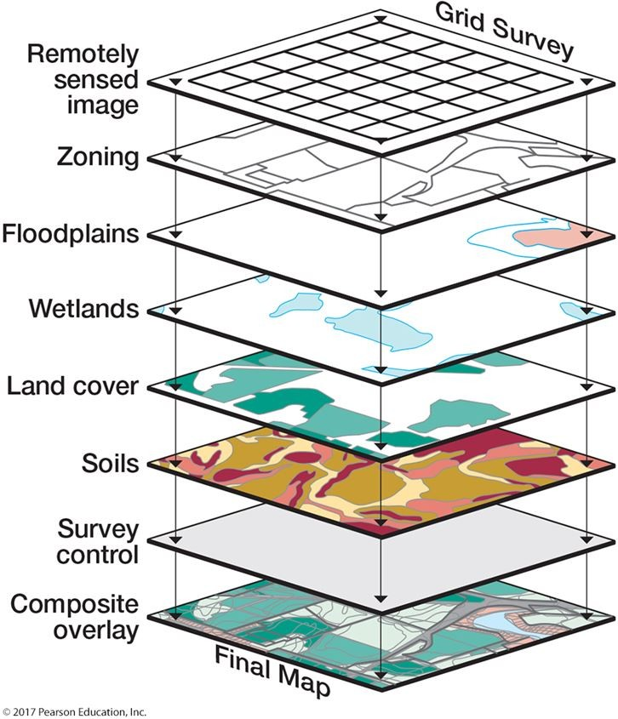

This figure shows an overlay electronic analysis frequently employed by geographers. This type of analysis is known as ________.
A) cartography
B) Landsat
C) color infrared analysis
D) GPS
E) GIS
Answer: E
Diff: 2
Topic/Section: 2.8 Geographic Information Systems
Learning Outcome: 2.35 Describe overlay analysis.
Natl. Geog Stds: GS3
Global Sci Stds: G3
Bloom's Taxonomy: Remembering/Understanding
88) Probably the largest concern with the geographer's use of maps and imagery is ________.
A) choosing the most effective maps and imagery
B) making sure it is available on the Internet
C) to always use GIS
D) to make sure the property of equivalence is always preserved
E) to use images instead of maps when possible
Answer: A
Diff: 1
Topic/Section: 2.8 Geographic Information Systems
Learning Outcome: 2.36 Explain how GIS helps in the analysis of geographic data.
Natl. Geog Stds: GS3
Global Sci Stds: G3
Bloom's Taxonomy: Remembering/Understanding

89) ________ analysis takes place when two or more layers of spatial data are superimposed or integrated.
A) GPS
B) Overlay
C) Stochastic
D) Remote sensing
E) Cloud
Answer: B
Diff: 1
Topic/Section: 2.8 Geographic Information Systems
Learning Outcome: 2.35 Describe overlay analysis.
Natl. Geog Stds: GS1
Global Sci Stds: G3
Bloom's Taxonomy: Remembering/Understanding

90) A GIS is a library of information based on ________.
A) satellites
B) stereoscopic image viewing
C) many land survey records stored on microfilm
D) manual cartography
E) maps
Answer: E
Diff: 1
Topic/Section: 2.8 Geographic Information Systems
Learning Outcome: 2.35 Describe overlay analysis.
Natl. Geog Stds: GS1
Global Sci Stds: G3
Bloom's Taxonomy: Remembering/Understanding
91) A geographic information system allows a link between data and ________.
A) scientific theory
B) a map
C) a computer
D) a color
E) orthophoto mapping
Answer: B
Diff: 1
Topic/Section: 2.8 Geographic Information Systems
Learning Outcome: 2.35 Describe overlay analysis.
Natl. Geog Stds: GS1
Global Sci Stds: G3
Bloom's Taxonomy: Remembering/Understanding

92) Which of the following would be used for an overlay map analysis, where two or more map layers are superimposed or integrated?
A) GIS
B) Landsat
C) GPS
D) EOS
E) Color infrared
Answer: A
Diff: 1
Topic/Section: 2.8 Geographic Information Systems
Learning Outcome: 2.35 Describe overlay analysis.
Natl. Geog Stds: GS1
Global Sci Stds: G3
Bloom's Taxonomy: Remembering/Understanding

93) Geographic information system technology is a direct result of advances in all EXCEPT ________.
A) surveying
B) computer cartography
C) spatial statistics
D) remote sensing
E) cartographic theory
Answer: E
Diff: 1
Topic/Section: 2.8 Geographic Information Systems
Learning Outcome: 2.35 Describe overlay analysis.
Natl. Geog Stds: GS1
Global Sci Stds: G3
Bloom's Taxonomy: Remembering/Understanding
94) Which of the following would be a type of application in which a geographic information system would NOT be used?
A) Integrating topographic information with vegetation information
B) Environment site assessment
C) Resource management
D) Environmental monitoring
E) Monitoring of weather data at a single weather station
Answer: E
Diff: 2
Topic/Section: 2.8 Geographic Information Systems
Learning Outcome: 2.36 Explain how GIS helps in the analysis of geographic data.
Natl. Geog Stds: GS1
Global Sci Stds: G3
Bloom's Taxonomy: Applying/Analyzing

95) Which of the following choices represents a technology into which the other choices can be used as inputs?
A) GPS
B) GIS
C) Landsat imagery
D) Field data
E) Aerial photography
Answer: B
Diff: 1
Topic/Section: 2.8 Geographic Information Systems
Learning Outcome: 2.35 Describe overlay analysis.
Natl. Geog Stds: GS1
Global Sci Stds: G3
Bloom's Taxonomy: Remembering/Understanding

96) Explain how the properties of conformality and equivalence always pose a dilemma to the mapmaker.
Answer: This is the classic problem for the mapmaker. A map cannot preserve both shape and relative size. A cartographer must choose one or the other, or neither. Many times there must be a compromise between the two properties.
Diff: 2
Topic/Section: 2.3 Map Projections and Properties
Learning Outcome: 2.11 Explain when an equivalent map projection is most suited for use in geographic studies; 2.13 Explain when a conformal map is most suited for use in geographic studies; 2.14 Describe compromise map projection.
Natl. Geog Stds: GS1
Global Sci Stds: G3
Bloom's Taxonomy: Applying/Analyzing

97) Name four of the map essentials and the purpose of each one.
Answer: Title, date, legend, scale, direction, and location. Include a definition of each.
Diff: 1
Topic/Section: 2.5 Conveying Information on Maps
Learning Outcome: 2.29 Describe how a GPS unit determines its location.
Natl. Geog Stds: GS1
Global Sci Stds: G3
Bloom's Taxonomy: Remembering/Understanding
98) Explain how the global positioning system operates to locate your position within a few meters.
Answer: GPS trilaterates your position by using the distance and direction to several polar orbiting satellites. The orbits are well known and a satellite is located via radio transmissions from the satellite.
Diff: 1
Topic/Section: 2.7 Remote Sensing
Learning Outcome: 2.29 Describe how a GPS unit determines its location.
Natl. Geog Stds: GS1
Global Sci Stds: G3
Bloom's Taxonomy: Remembering/Understanding

99) Compare and contrast the purposes of Landsat and commercial high-resolution satellites.
Answer: Landsat is in the public domain for studying Earth's resources. Commercial satellites also study Earth's resources but at a higher resolution, and the user is charged considerable money to do so.
Diff: 3
Topic/Section: 2.7 Remote Sensing
Learning Outcome: 2.32 Discuss the kinds of information that can be gathered by remote sensing.
Natl. Geog Stds: GS1
Global Sci Stds: G3
Bloom's Taxonomy: Evaluating/Creating

100) Suppose a geographer was hired to help assess the health/vigor of a winter wheat crop (to be harvested in the late spring) in an agricultural county of a Great Plains state; the object would be to predict the winter wheat yield two months in advance. What sort of remote sensing techniques might be used and why?
Answer: Answers will vary. The student should mention some form of remote sensing (photography or satellite imaging) that uses the near infrared portion of the spectrum sensitive to plant greenness.
Diff: 3
Topic/Section: 2.7 Remote Sensing
Learning Outcome: 2.32 Discuss the kinds of information that can be gathered by remote sensing.
Natl. Geog Stds: GS1
Global Sci Stds: G3
Bloom's Taxonomy: Evaluating/Creating

101) Explain how the use of multispectral scanning is an advantage over the use of a single band when identifying Earth's features via remote sensing.
Answer: Various bands are best for various features—give example(s). The point is that a combination of bands should be superior.
Diff: 2
Topic/Section: 2.7 Remote Sensing
Learning Outcome: 2.32 Discuss the kinds of information that can be gathered by remote sensing.
Natl. Geog Stds: GS1
Global Sci Stds: G3
Bloom's Taxonomy: Applying/Analyzing
102) Describe the features of a type of conic versus a type of planar projection and identify a proper use for each.
Answer: A conic projection is a transfer from a globe tangent to Earth; the cone is then "unrolled" to make a map. A planar projection is a transfer from a globe to a plane. A conic projection is proper for a map that emphasizes middle latitude areas with great east-west extents (e.g. North America), while a planar projection can be used to view one side of Earth at once, centered on an area of interest (e.g., the North Pole).
Diff: 3
Topic/Section: 2.4 Families of Map Projections
Learning Outcome: 2.20 Describe some of the best uses for maps with a planar projection; 2.22 Describe some of the best uses for maps with a conic projection.
Natl. Geog Stds: GS1
Global Sci Stds: G3
Bloom's Taxonomy: Evaluating/Creating

103) The near infrared is the Landsat spectral band used for identification of ________.
Answer: wetlands, organic soils, water bodies, or crop health
Diff: 2
Topic/Section: 2.7 Remote Sensing
Learning Outcome: 2.32 Discuss the kinds of information that can be gathered by remote sensing.
Natl. Geog Stds: GS1
Global Sci Stds: G2
Bloom's Taxonomy: Applying/Analyzing

104) Define remote sensing.
Answer: The measurement or acquisition of information by a recording device that is not in physical contact with the object under study.
Diff: 1
Topic/Section: 2.7 Remote Sensing
Learning Outcome: 2.31 Define remote sensing.
Natl. Geog Stds: GS1
Global Sci Stds: G2
Bloom's Taxonomy: Remembering/Understanding

105) GIS is, perhaps, the most important tool for the modern geographer. Explain why it is so important and why this has only been true in the recent past.
Answer: GIS can integrate many forms of measurement (satellite imagery, surveys, censuses, etc.) to provide a research tool in which the user can assess the spatial impact of many factors separately or jointly in social or environmental analysis. It is only important now because electronic data sets and powerful computing have become available to virtually everyone.
Diff: 3
Topic/Section: 2.8 Geographic Information Systems
Learning Outcome: 2.36 Explain how GIS helps in the analysis of geographic data.
Natl. Geog Stds: GS1
Global Sci Stds: G3
Bloom's Taxonomy: Evaluating/Creating
106) Remotely sensed ________ images are the most useful way of detecting the health of vegetation.
Answer: Near infrared or color infrared
Diff: 2
Topic/Section: 2.7 Remote Sensing
Learning Outcome: 2.32 Discuss the kinds of information that can be gathered by remote sensing.
Natl. Geog Stds: GS1
Global Sci Stds: G4
Bloom's Taxonomy: Applying/Analyzing

107) A map with a ________ scale generally shows a large portion of a continent.
Answer: small
Diff: 2
Topic/Section: 2.2 Map Scale
Learning Outcome: 2.4 Identify examples of graphic scales from a map.
Natl. Geog Stds: GS1
Global Sci Stds: G3
Bloom's Taxonomy: Applying/Analyzing

108) Maps are inherently inaccurate because ________.
Answer: they must depict the curved Earth on a flat surface
Diff: 2
Topic/Section: 2.1 Maps and Globes
Learning Outcome: 2.4 Identify examples of graphic scales from a map.
Natl. Geog Stds: GS1
Global Sci Stds: G3
Bloom's Taxonomy: Applying/Analyzing

109) ________ micrometers is a wavelength of visible light. (ANY of the wavelengths will do.)
Answer: Any wavelength between 0.36 and 0.72 micrometers is acceptable.
Diff: 2
Topic/Section: 2.7 Remote Sensing
Learning Outcome: 2.31 Define remote sensing.
Natl. Geog Stds: GS1
Global Sci Stds: G2
Bloom's Taxonomy: Applying/Analyzing

