***Exploring Geology, 5e* (Reynolds)**

**Chapter 2 Investigating Geologic Questions**

1) What was the main mystery described for the Mediterranean Sea?

A) A volcanic eruption destroyed the ancient city of Alexandria.

B) A meteorite formed the western Mediterranean Sea.

C) The Mediterranean dried up and deposited layers of salt.

D) A large landmass collapsed downward, forming the sea.

Answer: C

Section: 02.00

Topic: Study of Geology

Bloom's: 2. Understand

Gradable: automatic

Accessibility: Keyboard Navigation

2)  The Mediterranean Sea is connected with the Atlantic Ocean through the

A) Strait of Gibraltar.

B) Red Sea.

C) Nile River.

D) Black Sea.

Answer: A

Section: 02.00

Topic: Study of Geology

Bloom's: 1. Remember

Gradable: automatic

Accessibility: Keyboard Navigation

3) Beneath the Mediterranean Sea, large deposits of salt and layers of wind-deposited sand dating from around 6 million years ago are present. Which of the following would you conclude based upon this information?

A) The Mediterranean Sea once evaporated, leaving behind large salt deposits and creating a desert-like environment of wind-blown sands.

B) The Mediterranean Sea was once deeper than at present, depositing large amounts of salt and layered sand.

C) The environment within the Mediterranean Sea has not changed from 6 million years ago to today.

D) Sand and salt have blown into the Mediterranean Sea from the surrounding desert areas.

Answer: A

Section: 02.00

Topic: Study of Geology

Bloom's: 2. Understand

Gradable: automatic

Accessibility: Keyboard Navigation

4) Which locations are composed of loose materials (not bedrock)?

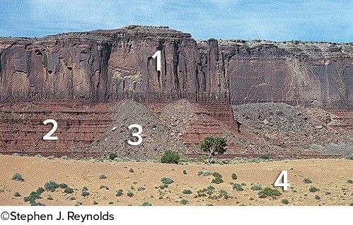

A) 1 and 2

B) 2 and 3

C) 3 and 4

D) 1 and 3

E) 2 and 4

Answer: C

Section: 02.01

Topic: Geologic Structures

Bloom's: 3. Apply

Gradable: automatic

Accessibility: Keyboard Navigation

5) Which location(s) has/have loose, angular rocks?

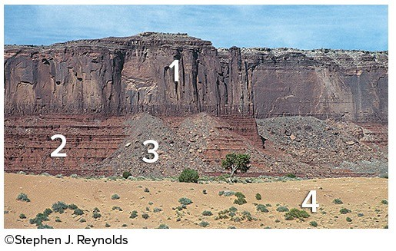

A) 1

B) 2

C) 3

D) 4

E) 1 and 2

Answer: C

Section: 02.01

Topic: Geologic Structures

Bloom's: 3. Apply

Gradable: automatic

Accessibility: Keyboard Navigation

6) Which locations contain rocks that are in place (part of the bedrock)?

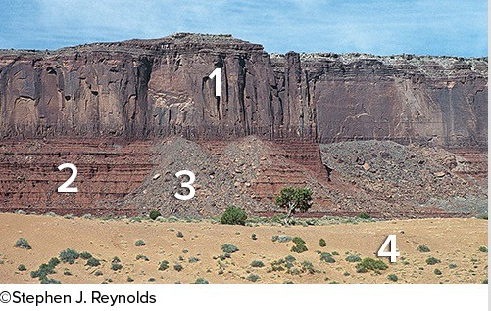

A) 1 and 2

B) 2 and 3

C) 3 and 4

D) 1 and 3

E) 2 and 4

Answer: A

Section: 02.01

Topic: Geologic Structures

Bloom's: 3. Apply

Gradable: automatic

Accessibility: Keyboard Navigation

7) Which locations consist of sediment rather than sedimentary rocks?

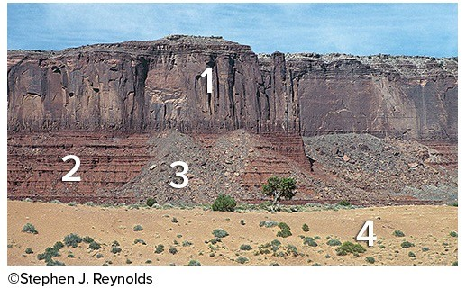

A) 1 and 2

B) 2 and 3

C) 3 and 4

D) 1 and 3

E) 2, 3, and 4

Answer: C

Section: 02.01

Topic: Geologic Structures

Bloom's: 3. Apply

Gradable: automatic

Accessibility: Keyboard Navigation

8) What are some components of the landscape shown in this photograph?

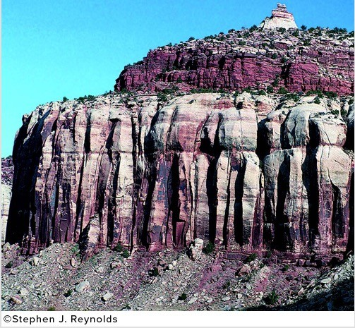

A) A natural stain on the outside of the rocks

B) Fractures and layers

C) Loose rocks covering a slope-forming unit

D) Rounding of the upper parts of the cliff

E) All of these choices are correct.

Answer: E

Section: 02.01

Topic: Geologic Structures

Bloom's: 1. Remember

Gradable: automatic

Accessibility: Keyboard Navigation

9) Which of the following is NOT a recommended strategy for observing a landscape?

A) Observe the entire landscape first and then focus on smaller parts, one part at a time.

B) Examine complexities of each feature rather than grouping features into types.

C) Focus on one type of feature at a time, noting where this type of feature is present.

D) Examine relationships between different features.

Answer: B

Section: 02.01

Topic: Study of Geology

Bloom's: 2. Understand

Gradable: automatic

Accessibility: Keyboard Navigation

10) The vertical black lines indicated in rock units 3 and 4 indicate what type of feature?

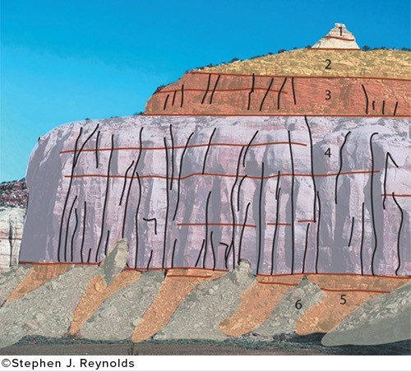

A) Fractures

B) Beddings

C) Slopes

D) Loose rock

Answer: A

Section: 02.01

Topic: Geologic Structures

Bloom's: 3. Apply

Gradable: automatic

Accessibility: Keyboard Navigation

11) What shape are the pebble-sized particles that make up the rock?

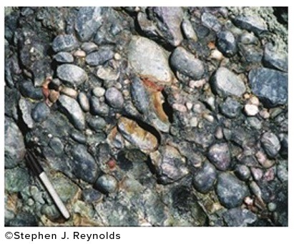

A) Rounded

B) Angular

Answer: A

Section: 02.01

Topic: Rocks

Bloom's: 3. Apply

Gradable: automatic

Accessibility: Keyboard Navigation

12) This indicates to us that the environment in which this rock formed was likely

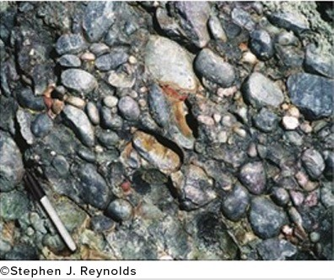

A) a river channel.

B) a steep mountain front.

Answer: A

Section: 02.01

Topic: Rocks

Bloom's: 3. Apply

Gradable: automatic

Accessibility: Keyboard Navigation

13) Rocks that are more resistant to erosion are more likely to create

A) cliffs.

B) slopes.

C) ledges.

Answer: A

Section: 02.01

Topic: Rocks

Bloom's: 2. Understand

Gradable: automatic

Accessibility: Keyboard Navigation

14) Rocks that are easy to erode often create

A) slopes.

B) ledges.

C) cliffs.

Answer: A

Section: 02.01

Topic: Rocks

Bloom's: 2. Understand

Gradable: automatic

Accessibility: Keyboard Navigation

15) The sediment in this photograph most likely formed in

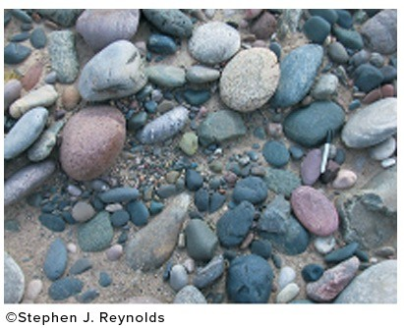

A) a steep mountain front.

B) a river.

C) a sand dune.

D) deep water conditions on the sea floor.

Answer: B

Section: 02.02

Topic: Rocks

Bloom's: 4. Analyze

Gradable: automatic

Accessibility: Keyboard Navigation

16) The sediment in this photograph mostly likely formed in

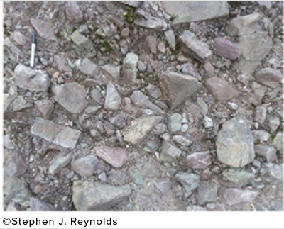

A) a steep mountain front.

B) a river.

C) a sand dune.

D) deep water conditions on the sea floor.

Answer: A

Section: 02.02

Topic: Rocks

Bloom's: 4. Analyze

Gradable: automatic

Accessibility: Keyboard Navigation

17) The rock in this photograph mostly likely formed in

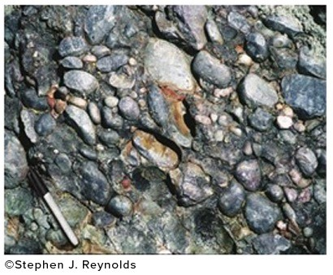

A) a steep mountain front.

B) a river.

C) a sand dune.

D) deep water conditions on the sea floor.

Answer: B

Section: 02.02

Topic: Rocks

Bloom's: 4. Analyze

Gradable: automatic

Accessibility: Keyboard Navigation

18) What is the youngest unit or feature in this figure?

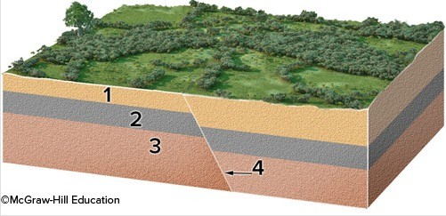

A) 1

B) 2

C) 3

D) 4

E) There is no way to tell.

Answer: D

Section: 02.02

Topic: Geologic Time

Bloom's: 4. Analyze

Gradable: automatic

Accessibility: Keyboard Navigation

19) What is the oldest unit or feature in this figure?

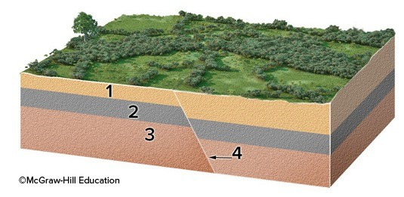

A) 1

B) 2

C) 3

D) 4

E) There is no way to tell.

Answer: C

Section: 02.02

Topic: Geologic Time

Bloom's: 4. Analyze

Gradable: automatic

Accessibility: Keyboard Navigation

20) What is the oldest unit or feature in this figure?

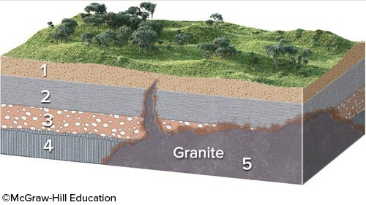

A) 1

B) 2

C) 3

D) 4

E) 5

Answer: D

Section: 02.02

Topic: Geologic Time

Bloom's: 4. Analyze

Gradable: automatic

Accessibility: Keyboard Navigation

21) What is the youngest unit or feature in this figure?

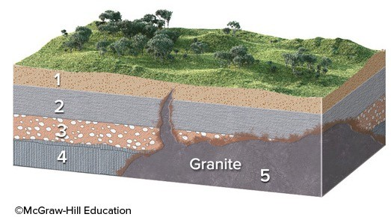

A) 1

B) 2

C) 3

D) 4

E) 5

Answer: E

Section: 02.02

Topic: Geologic Time

Bloom's: 4. Analyze

Gradable: automatic

Accessibility: Keyboard Navigation

22) The youngest unit or feature in this photograph is

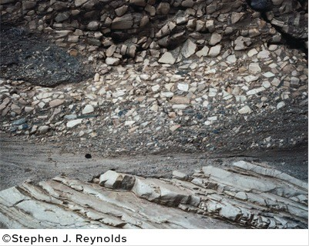

A) the rock at the top that contains angular fragments.

B) the gray layer in the middle of the photograph.

C) the tilted rocks at the bottom.

D) There is no way to tell.

Answer: A

Section: 02.02

Topic: Geologic Time

Bloom's: 4. Analyze

Gradable: automatic

Accessibility: Keyboard Navigation

23) The oldest unit or feature in this photograph is

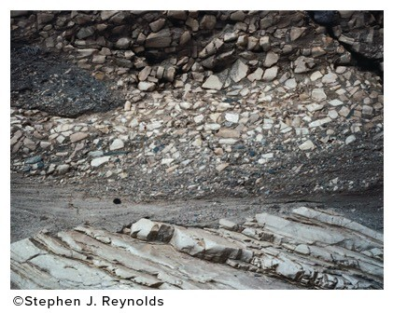

A) the rock at the top that contains angular fragments.

B) the gray layer in the middle of the photograph.

C) the tilted rocks at the bottom.

D) There is no way to tell.

Answer: C

Section: 02.02

Topic: Geologic Time

Bloom's: 4. Analyze

Gradable: automatic

Accessibility: Keyboard Navigation

24) What strategy was described for inferring the environment in which a rock formed?

A) Smashing the rock into pieces to see whether it breaks into square or rounded pieces

B) Comparing the characteristics of the rock to deposits from modern environments

C) Imagining what would happen if the rock were metamorphosed

D) All of these choices are correct.

Answer: B

Section: 02.02

Topic: Study of Geology

Bloom's: 2. Understand

Gradable: automatic

Accessibility: Keyboard Navigation

25) The phrase trading location for time signifies that

A) it takes more time to observe a landscape than is available.

B) expensive homes are built in locations that cost people time.

C) different parts of a landscape can be used to infer how the landscape changes over time.

D) some rocks are harder than others to erode and so last a longer time.

Answer: C

Section: 02.02

Topic: Study of Geology

Bloom's: 2. Understand

Gradable: automatic

Accessibility: Keyboard Navigation

26) Which of the following is a principle to interpret relative ages?

A) The youngest rock is on the bottom.

B) A geologic feature is older than any rock or feature it crosscuts.

C) A younger rock can include pieces of an older rock.

D) An older magma can bake or metamorphose younger rocks.

Answer: C

Section: 02.02

Topic: Geologic Time

Bloom's: 1. Remember

Gradable: automatic

Accessibility: Keyboard Navigation

27) In what order did the rock layers and features form in this photograph (listed from oldest to youngest)?

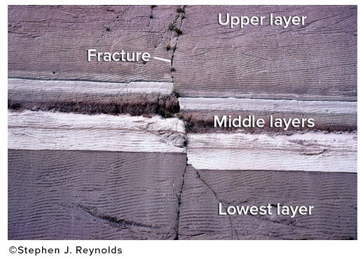

A) Upper layer, fracture, middle layers, lowest layer

B) Lowest layer, middle layers, fracture, upper layer

C) Lower layer, middle layers, upper layer, fracture

D) None of these choices are correct.

Answer: C

Section: 02.02

Topic: Geologic Time

Bloom's: 4. Analyze

Gradable: automatic

Accessibility: Keyboard Navigation

28) What can you interpret about the relative age of the rocks and features in this photograph?

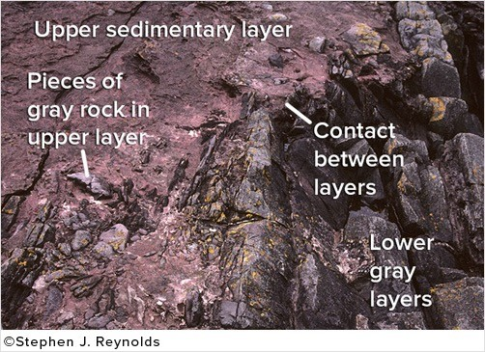

A) The upper sedimentary layer is younger.

B) The lower gray layers are younger.

C) The layers are the same age because the boundary is so irregular.

D) It is not possible to tell the relative ages of the layers.

Answer: A

Section: 02.02

Topic: Geologic Time

Bloom's: 4. Analyze

Gradable: automatic

Accessibility: Keyboard Navigation

29) What is the best criterion for the relative ages of the rocks in this photograph?

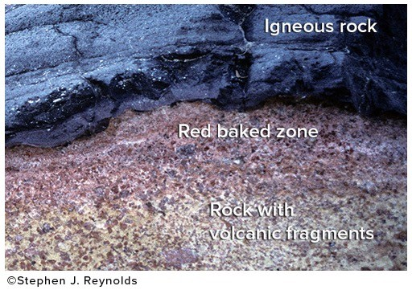

A) The igneous rock is younger because it is on top.

B) The igneous rock is younger because it has baked the adjacent rock.

C) The lower rock is younger because it contains pieces of volcanic rock.

D) The igneous rock is older because it formed at depth.

Answer: B

Section: 02.02

Topic: Geologic Time

Bloom's: 4. Analyze

Gradable: automatic

Accessibility: Keyboard Navigation

30) Which of the following is valid criteria for inferring the relative ages of the two rock types in this photograph?

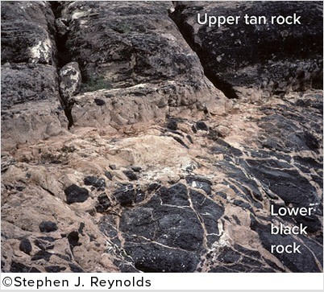

A) The black rock is younger because it is on the bottom.

B) The tan rock is younger because it contains pieces of the black rock.

C) The black rock is younger because it is crosscut by the tan rock.

D) The evidence is contradictory about the relative ages of these two rocks.

Answer: B

Section: 02.02

Topic: Geologic Time

Bloom's: 4. Analyze

Gradable: automatic

Accessibility: Keyboard Navigation

31) What can you interpret about the relative ages of the rocks and features in this photograph?

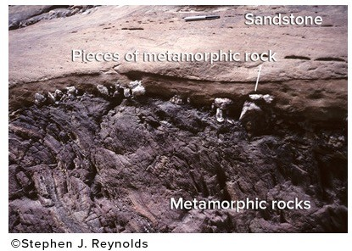

A) The sandstone is older because it is lighter in color.

B) The metamorphic rock is older because it is rougher from longer weathering.

C) The metamorphic rock is older because pieces of it are in the sandstone.

D) The sandstone is older because it is on top.

Answer: C

Section: 02.02

Topic: Geologic Time

Bloom's: 4. Analyze

Gradable: automatic

Accessibility: Keyboard Navigation

32) What sort of environment would possibly deposit sediment like that seen in the image?

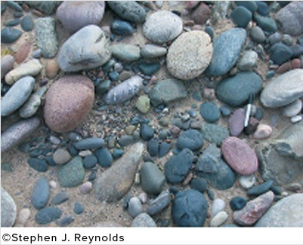

A) River channels

B) Floodplain

C) Steep mountain slope

D) Cliff face

Answer: A

Section: 02.02

Topic: Rocks

Bloom's: 4. Analyze

Gradable: automatic

Accessibility: Keyboard Navigation

33) The feature shown is a smaller, steep-sided mountain and has had its edges eroded away. This feature would commonly be called a

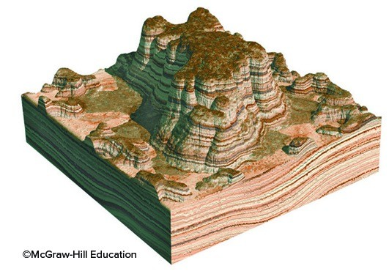

A) butte.

B) mesa.

C) knob.

Answer: A

Section: 02.02

Topic: Geologic Structures

Bloom's: 1. Remember

Gradable: automatic

Accessibility: Keyboard Navigation

34) The image represents a broad, flat-topped mountain with steep sides. This feature is called a

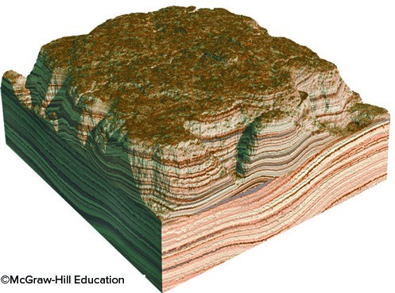

A) mesa.

B) butte.

C) knob.

Answer: A

Section: 02.02

Topic: Geologic Structures

Bloom's: 1. Remember

Gradable: automatic

Accessibility: Keyboard Navigation

35) Over time, when a mesa becomes a butte and a butte eventually becomes hills and knobs, we can infer what physical process has taken place?

A) Erosion

B) Glaciations

C) River transportation

D) Deposition

Answer: A

Section: 02.02

Topic: Geologic Structures

Bloom's: 1. Remember

Gradable: automatic

Accessibility: Keyboard Navigation

36) The age of a fossil, organism, rock, geologic feature, or event as defined relative to other geologic features or events is the

A) relative age.

B) absolute age.

C) numerical age.

D) radiometric age.

Answer: A

Section: 02.02

Topic: Geologic Time

Bloom's: 2. Understand

Gradable: automatic

Accessibility: Keyboard Navigation

37) When a fracture cuts across several rock layers, we can interpret that

A) the fracture is younger than the layers it crosscuts.

B) the fracture is older than the layers it crosscuts.

C) the layers of rock are younger than the fracture.

D) the fracture formed at some time prior to the rock layers.

Answer: A

Section: 02.02

Topic: Geologic Time

Bloom's: 2. Understand

Gradable: automatic

Accessibility: Keyboard Navigation

38) What interpretation can be made from an igneous rock body (such as granite) that has baked or metamorphosed the adjacent rocks?

A) When the granite was molten, the heat from the magma altered the preexisting rocks around it.

B) The adjacent rocks reacted with the solid granite to create a zone of metamorphism.

Answer: A

Section: 02.02

Topic: Rocks

Bloom's: 2. Understand

Gradable: automatic

Accessibility: Keyboard Navigation

39) What kind of map gives detailed information regarding the elevation of the land's surface?

A) Topographic

B) Shaded relief

C) Geologic

D) Satellite image

Answer: A

Section: 02.02

Topic: Study of Geology

Bloom's: 1. Remember

Gradable: automatic

Accessibility: Keyboard Navigation

40) What map is best for showing detailed geologic information about an area?

A) Topographic

B) Shaded relief

C) Geologic

D) Satellite image

Answer: C

Section: 02.02

Topic: Study of Geology

Bloom's: 2. Understand

Gradable: automatic

Accessibility: Keyboard Navigation

41) What type of map is shown here?

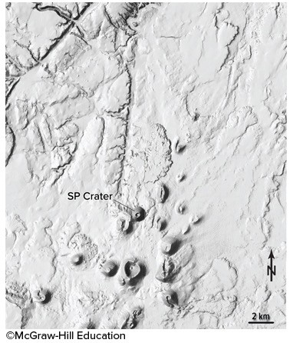

A) Shaded-relief map

B) Topographic map with contours

C) Satellite image

D) Geologic map

Answer: A

Section: 02.03; 02.04

Topic: Study of Geology

Bloom's: 1. Remember

Gradable: automatic

Accessibility: Keyboard Navigation

42) What type of map is shown here?

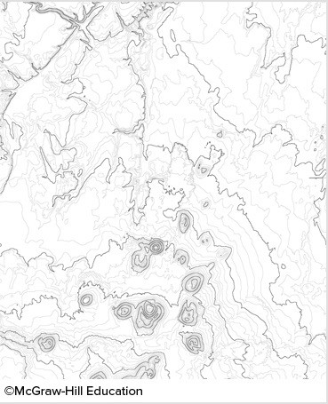

A) Shaded-relief map

B) Topographic map with contours

C) Satellite image

D) Geologic map

Answer: B

Section: 02.03; 02.04

Topic: Study of Geology

Bloom's: 1. Remember

Gradable: automatic

Accessibility: Keyboard Navigation

43) Which type of map or diagram would best show you the shape of the land surface?

A) Shaded-relief map

B) Satellite image

C) Geologic map

D) Stratigraphic section

Answer: A

Section: 02.03; 02.04

Topic: Study of Geology

Bloom's: 3. Apply

Gradable: automatic

Accessibility: Keyboard Navigation

44) Which type of map or diagram would best indicate elevation of the land surface?

A) Shaded-relief map

B) Satellite image

C) Topographic map

D) Stratigraphic section

Answer: C

Section: 02.03; 02.04

Topic: Study of Geology

Bloom's: 3. Apply

Gradable: automatic

Accessibility: Keyboard Navigation

45) What type of figure would you use to portray the relative thicknesses of rock units stacked on top of one another?

A) Shaded relief map

B) Topographic map

C) Satellite image

D) Stratigraphic section

E) Evolutionary diagram

Answer: D

Section: 02.03; 02.04

Topic: Study of Geology

Bloom's: 2. Understand

Gradable: automatic

Accessibility: Keyboard Navigation

46) What does the type of evolutionary diagrams discussed in the textbook show?

A) How one creature evolved into another creature

B) Changing of fossils up through a stratigraphic section

C) Evolution of the ways topographic maps have been drawn during history

D) The sequence of events that deposited the rocks and formed the landscape

Answer: D

Section: 02.03; 02.04

Topic: Geologic Time

Bloom's: 2. Understand

Gradable: automatic

Accessibility: Keyboard Navigation

47) If you wanted to determine how deep a rock layer was below a particular point on the surface, what type of figure would be most useful?

A) Shaded relief map

B) Topographic map

C) Satellite image

D) Evolutionary diagram

E) Geologic cross section

Answer: E

Section: 02.03; 02.04

Topic: Study of Geology

Bloom's: 2. Understand

Gradable: automatic

Accessibility: Keyboard Navigation

48) What type of map is used primarily to show the shape of the land by simulating light and dark shading on the hills and valleys?

A) Shaded relief map

B) Satellite image

C) Geologic map

D) Topographic map

Answer: A

Section: 02.03; 02.04

Topic: Study of Geology

Bloom's: 1. Remember

Gradable: automatic

Accessibility: Keyboard Navigation

49) What specific type of map represents the distribution of rock units and geologic features exposed on the surface?

A) Geologic map

B) Topographic map

C) Contour map

D) Shaded relief map

Answer: A

Section: 02.03; 02.04

Topic: Study of Geology

Bloom's: 1. Remember

Gradable: automatic

Accessibility: Keyboard Navigation

50) What specific type of image uses measurements of different wavelengths of light reflecting from a land surface to create a computer-processed image to show the distribution of different types of plants, rocks, and other features?

A) Satellite images

B) Geologic map

C) Topographic map

D) Shaded relief map

Answer: A

Section: 02.03; 02.04

Topic: Study of Geology

Bloom's: 2. Understand

Gradable: automatic

Accessibility: Keyboard Navigation

51) What type of map depicts the shape of the land surface by showing the elevation of the land surface with a series of lines called contours?

A) Topographic map

B) Satellite image

C) Shaded relief map

D) Geologic map

Answer: A

Section: 02.03; 02.04

Topic: Study of Geology

Bloom's: 1. Remember

Gradable: automatic

Accessibility: Keyboard Navigation

52) Topographic maps often have some contour lines that are darker than other contour lines. These darker lines are called

A) index contours.

B) contour intervals.

Answer: A

Section: 02.03; 02.04

Topic: Study of Geology

Bloom's: 1. Remember

Gradable: automatic

Accessibility: Keyboard Navigation

53) Which letter on the accompanying figure indicates the elevation?

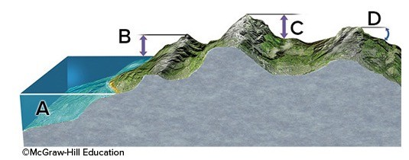

A) A

B) B

C) C

D) D

Answer: B

Section: 02.04

Topic: Study of Geology

Bloom's: 1. Remember

Gradable: automatic

Accessibility: Keyboard Navigation

54) Which letter on the accompanying figure indicates the amount of topographic relief?

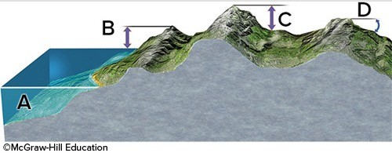

A) A

B) B

C) C

D) D

Answer: C

Section: 02.04

Topic: Study of Geology

Bloom's: 1. Remember

Gradable: automatic

Accessibility: Keyboard Navigation

55) Which letter on the accompanying figure indicates depth?

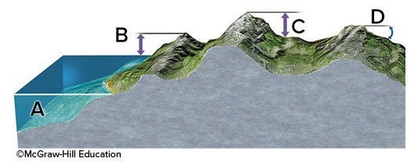

A) A

B) B

C) C

D) D

Answer: A

Section: 02.04

Topic: Study of Geology

Bloom's: 1. Remember

Gradable: automatic

Accessibility: Keyboard Navigation

56) Slopes that drop or rise sharply in elevation are

A) steep.

B) plains.

C) contours.

Answer: A

Section: 02.04

Topic: Study of Geology

Bloom's: 1. Remember

Gradable: automatic

Accessibility: Keyboard Navigation

57) Slopes in flatter areas are

A) gentle.

B) elevated.

C) cliffs.

D) indexes.

Answer: A

Section: 02.04

Topic: Study of Geology

Bloom's: 1. Remember

Gradable: automatic

Accessibility: Keyboard Navigation

58) Which of the following could be associated with a steep slope?

A) A mountain side

B) A cliff

C) Closely spaced contour lines

D) All of these choices are correct.

Answer: D

Section: 02.04

Topic: Study of Geology

Bloom's: 2. Understand

Gradable: automatic

Accessibility: Keyboard Navigation

59) Elevation variations in the land's surface might best be represented by a(n)

A) topographic profile.

B) geologic map.

C) outcrop.

Answer: A

Section: 02.04

Topic: Study of Geology

Bloom's: 2. Understand

Gradable: automatic

Accessibility: Keyboard Navigation

60) This image would be best used in what situation?

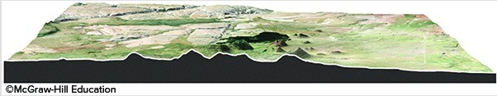

A) A petroleum company wants to know if any geologic structures in the area could contain oil pools.

B) The thickness of the surface layer of rock needs to be determined for a construction site.

C) The average gradient for a particular area needs to be known to study surface runoff.

Answer: C

Section: 02.04

Topic: Study of Geology

Bloom's: 4. Analyze

Gradable: automatic

Accessibility: Keyboard Navigation

61) Which of the following is true for an evolutionary diagram?

A) Uses a sequence of geologic diagrams to depict the geologic history of an area

B) May use block diagrams, cross sections, or maps

C) Shows the progression of changes an area undergoes through time

D) All of these choices are correct.

Answer: D

Section: 02.04

Topic: Study of Geology

Bloom's: 1. Remember

Gradable: automatic

Accessibility: Keyboard Navigation

62) Which of the following may be interpreted from the sketch?

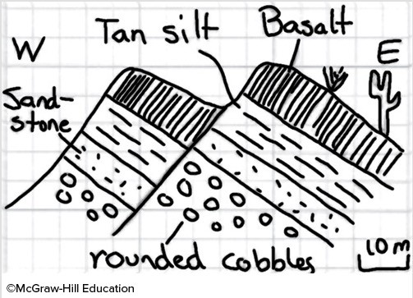

A) A fault has cut through the rock layers.

B) The fault is younger than all the rock layers present.

C) The oldest environment represented may have been a river channel, based upon the shape of the clasts.

D) All of these choices are correct.

Answer: D

Section: 02.04

Topic: Study of Geology

Bloom's: 4. Analyze

Gradable: automatic

Accessibility: Keyboard Navigation

63) What may be interpreted from this sketch?

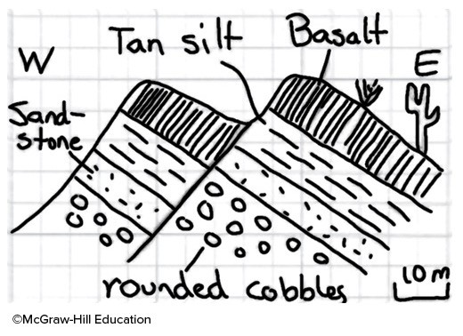

A) The basalt is younger than the fault.

B) The tan silt layer is likely the oldest layer present.

C) None of these choices are correct.

Answer: C

Section: 02.04

Topic: Study of Geology

Bloom's: 4. Analyze

Gradable: automatic

Accessibility: Keyboard Navigation

64) This figure shows three blocks in water. Which of these materials is the densest?

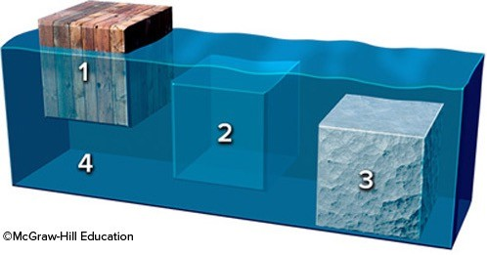

A) Block 1

B) Block 2

C) Block 3

D) The water

Answer: C

Section: 02.05

Topic: Study of Geology

Bloom's: 2. Understand

Gradable: automatic

Accessibility: Keyboard Navigation

65) This figure shows three blocks in water. Which of these materials is the least dense?

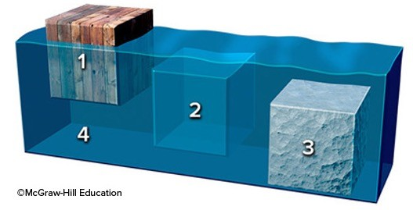

A) Block 1

B) Block 2

C) Block 3

D) The water

Answer: A

Section: 02.05

Topic: Study of Geology

Bloom's: 2. Understand

Gradable: automatic

Accessibility: Keyboard Navigation

66) This figure shows three blocks in water. Which two materials have the same density?

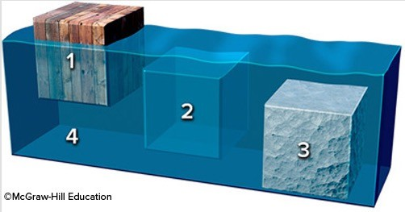

A) Blocks 1 and 2

B) Blocks 2 and 3

C) Blocks 1 and 3

D) Block 2 and the water

E) Block 3 and the water

Answer: D

Section: 02.05

Topic: Study of Geology

Bloom's: 2. Understand

Gradable: automatic

Accessibility: Keyboard Navigation

67) Which of the following is an example of quantitative data?

A) Augustine volcano represents a dangerous situation

B) The rocks were dark gray and angular

C) The steam coming from the mountain was dark gray in color

D) The rocks were too hot to touch

E) None of these choices are correct.

Answer: E

Section: 02.05

Topic: Study of Geology

Bloom's: 3. Apply; 4. Analyze

Gradable: automatic

Accessibility: Keyboard Navigation

68) Which of the following is an example of quantitative data?

A) North America is moving across Earth's surface several centimeters per year.

B) The river has flooded a low-lying area.

C) The volcano is releasing much steam.

D) Volcanoes are dangerous.

E) When held, one rock feels heavier than another rock.

Answer: A

Section: 02.05

Topic: Study of Geology

Bloom's: 4. Analyze

Gradable: automatic

Accessibility: Keyboard Navigation

69) Which of the following is true about density and weight?

A) Density is higher if you have a larger volume of the same material.

B) Density is lower if you have a larger volume of the same material.

C) A substance is more dense at night than during the day.

D) Weight depends on the mass of the object and the pull of gravity.

E) None of these choices are correct.

Answer: D

Section: 02.05

Topic: Study of Geology

Bloom's: 2. Understand

Gradable: automatic

Accessibility: Keyboard Navigation

70) Qualitative data may involve which of the following?

A) Labels

B) Sketches

C) Descriptive words

D) Images

E) All of these choices are correct.

Answer: E

Section: 02.05

Topic: Study of Geology

Bloom's: 2. Understand

Gradable: automatic

Accessibility: Keyboard Navigation

71) If a description of sediment states that it contains large, angular fragments that are mostly red in color, what type of data would this represent?

A) Qualitative

B) Quantitative

C) Numerical

D) Measurement

E) None of these choices are correct.

Answer: A

Section: 02.05

Topic: Study of Geology

Bloom's: 2. Understand

Gradable: automatic

Accessibility: Keyboard Navigation

72) Quantitative data may include

A) specific temperature data.

B) size measurements of sediments.

C) chemistry of water in a stream.

D) age of a rock.

E) All of these choices are correct.

Answer: E

Section: 02.05

Topic: Study of Geology

Bloom's: 2. Understand

Gradable: automatic

Accessibility: Keyboard Navigation

73) A geologist performs analyses on a rock to gather data recording its specific chemical composition. This type of data is

A) quantitative.

B) qualitative.

C) a survey.

Answer: A

Section: 02.05

Topic: Study of Geology

Bloom's: 2. Understand

Gradable: automatic

Accessibility: Keyboard Navigation

74) Which of the following are ways in which a geologist may determine the density of earth materials?

A) Through direct measurement in the laboratory

B) By measuring the different velocities of seismic waves

C) Using instruments to measure the pull of gravity

D) All of these choices are correct.

Answer: D

Section: 02.05

Topic: Study of Geology

Bloom's: 2. Understand

Gradable: automatic

Accessibility: Keyboard Navigation

75) Which of the following are ways in which a geologist may determine the density of earth materials?

A) Determining the weight of the object, but not its volume

B) Calculating the volume of the object, but not its mass

C) None of these choices are correct.

Answer: C

Section: 02.05

Topic: Study of Geology

Bloom's: 2. Understand

Gradable: automatic

Accessibility: Keyboard Navigation

76) The formula to determine density is

A) mass/volume.

B) mass/weight.

C) volume/mass.

D) gravity/mass.

E) weight/gravity.

Answer: A

Section: 02.05

Topic: Study of Geology

Bloom's: 1. Remember

Gradable: automatic

Accessibility: Keyboard Navigation

77) If a runner races 50 meters in 5 seconds, how fast is she going?

A) 1 meter per second

B) 5 meters per second

C) 10 meters per second

D) 50 meters per second

E) None of these choices are correct.

Answer: C

Section: 02.06

Topic: Study of Geology

Bloom's: 3. Apply

Gradable: automatic

Accessibility: Keyboard Navigation

78) This figure shows the main subdivisions of the geologic timescale. Which of these is the Cenozoic?

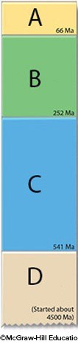

A) A

B) B

C) C

D) D

Answer: A

Section: 02.06

Topic: Geologic Time

Bloom's: 1. Remember

Gradable: automatic

Accessibility: Keyboard Navigation

79) This figure shows the main subdivisions of the geologic timescale. Which of these is the Mesozoic?

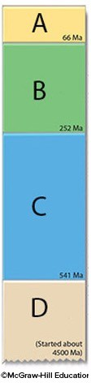

A) A

B) B

C) C

D) D

Answer: B

Section: 02.06

Topic: Geologic Time

Bloom's: 1. Remember

Gradable: automatic

Accessibility: Keyboard Navigation

80) This figure shows the main subdivisions of the geologic timescale. Which of these is the Paleozoic?

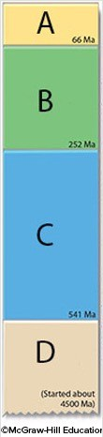

A) A

B) B

C) C

D) D

Answer: C

Section: 02.06

Topic: Geologic Time

Bloom's: 1. Remember

Gradable: automatic

Accessibility: Keyboard Navigation

81) This figure shows the main subdivisions of the geologic timescale. Which of these is the Precambrian?

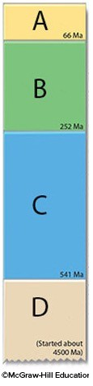

A) A

B) B

C) C

D) D

Answer: D

Section: 02.06

Topic: Geologic Time

Bloom's: 1. Remember

Gradable: automatic

Accessibility: Keyboard Navigation

82) Which of the following correctly lists the four main chapters of Earth's history, from oldest to youngest?

A) Paleozoic, Mesozoic, Cenozoic, Precambrian

B) Cenozoic, Mesozoic, Paleozoic, Precambrian

C) Paleozoic, Precambrian, Mesozoic, Cenozoic

D) Precambrian, Cenozoic, Mesozoic, Paleozoic

E) Precambrian, Paleozoic, Mesozoic, Cenozoic

Answer: E

Section: 02.06

Topic: Geologic Time

Bloom's: 1. Remember

Gradable: automatic

Accessibility: Keyboard Navigation

83) Which of the following represents the longest duration of geologic time?

A) Jurassic

B) Precambrian

C) Paleozoic

D) Mesozoic

E) Cenozoic

Answer: B

Section: 02.06

Topic: Geologic Time

Bloom's: 1. Remember

Gradable: automatic

Accessibility: Keyboard Navigation

84) Which of the following parts of geologic time is the shortest?

A) Precambrian

B) Paleozoic

C) Mesozoic

D) Cenozoic

Answer: D

Section: 02.06

Topic: Geologic Time

Bloom's: 1. Remember

Gradable: automatic

Accessibility: Keyboard Navigation

85) If all of geologic time is represented as a single year, and the Jurassic Period is in the middle of the Mesozoic era, what month were dinosaurs most abundant on the planet?

A) January

B) April

C) June

D) July

E) December

Answer: E

Section: 02.06

Topic: Geologic Time

Bloom's: 2. Understand

Gradable: automatic

Accessibility: Keyboard Navigation

86) If a stream flow measures 12 meters in 60 seconds, what is the stream's average rate of flow?

A) 0.2 m/s

B) 2 m/s

C) 0.5 m/s

D) 5 m/s

Answer: A

Section: 02.06

Topic: Study of Geology

Bloom's: 4. Analyze

Gradable: automatic

Accessibility: Keyboard Navigation

87) The formula to determine an object's average rate of movement is

A) distance/time.

B) time/distance.

C) time/speed.

D) speed/time.

Answer: A

Section: 02.06

Topic: Study of Geology

Bloom's: 1. Remember

Gradable: automatic

Accessibility: Keyboard Navigation

88) How much something changed, divided by the time required for the change to occur, is

A) rate.

B) mass.

C) volume.

D) density.

Answer: A

Section: 02.06

Topic: Study of Geology

Bloom's: 1. Remember

Gradable: automatic

Accessibility: Keyboard Navigation

89) The periods and subdivisions of Earth history, arranged in proper order, are called the

A) geologic timescale.

B) calendar year.

C) geologic flowchart.

D) stratigraphic timeline.

Answer: A

Section: 02.06

Topic: Geologic Time

Bloom's: 1. Remember

Gradable: automatic

Accessibility: Keyboard Navigation

90) The actual age of a rock or event is its

A) numeric age.

B) relative age.

C) relational age.

D) fossil age.

Answer: A

Section: 02.06

Topic: Geologic Time

Bloom's: 2. Understand

Gradable: automatic

Accessibility: Keyboard Navigation

91) Which of the following is data rather than an interpretation?

A) Recent volcanism at Yellowstone is related to the process that caused the low topography.

B) There is an area of low topography southwest of Yellowstone National Park.

C) Volcanism in Yellowstone overlies an area of hotter-than-average mantle.

D) The low topography southwest of Yellowstone formed when North America moved over a hot spot.

Answer: B

Section: 02.07

Topic: Study of Geology

Bloom's: 5. Evaluate

Gradable: automatic

Accessibility: Keyboard Navigation

92) Which of the following is data rather than an interpretation?

A) Some trees along Yellowstone Lake were flooded when the land north of the lake rose because of magma at depth.

B) Rising and sinking of the land around Yellowstone are related to underlying magma.

C) The ages of volcanic centers near Yellowstone indicate that North America is moving southwest over the mantle.

D) All of these choices are data rather than interpretations.

E) All of these choices are interpretations rather than data.

Answer: E

Section: 02.07

Topic: Study of Geology

Bloom's: 5. Evaluate

Gradable: automatic

Accessibility: Keyboard Navigation

93) How does an observation become valid?

A) A series of specific measurements is made, repeated, and recorded.

B) A guess is made to approximate a measurement and the guess is recorded.

C) An uncalibrated instrument is used to make a measurement and the measurements recorded.

Answer: A

Section: 02.07

Topic: Study of Geology

Bloom's: 2. Understand

Gradable: automatic

Accessibility: Keyboard Navigation

94) A key step in developing a new explanation is

A) making observations about a place or process.

B) asking questions about the observations.

C) proposing an interpretation that can be tested.

D) collecting new observations to test predictions.

E) All of these choices are correct.

Answer: E

Section: 02.08

Topic: Study of Geology

Bloom's: 2. Understand

Gradable: automatic

Accessibility: Keyboard Navigation

95) What steps are involved in having a hypothesis become an established theory?

A) A United Nations scientific panel votes on whether the hypothesis is accepted.

B) A U.S. government agency votes on whether the hypothesis is accepted.

C) The hypothesis is consistent with new data and investigations used to test its predictions.

D) The hypothesis makes sense when explained by politicians.

Answer: C

Section: 02.08

Topic: Study of Geology

Bloom's: 2. Understand

Gradable: automatic

Accessibility: Keyboard Navigation

96) Which of the following shows the correct order for a scientific explanation?

A) Observation - question - hypotheses - predictions - results of investigation - conclusions

B) Hypotheses - question - observation - predictions - results of investigation - conclusions

C) Predictions - hypotheses - results of investigation - question - observation - conclusion

Answer: A

Section: 02.08

Topic: Study of Geology

Bloom's: 1. Remember

Gradable: automatic

Accessibility: Keyboard Navigation

97) Which are true of a hypothesis?

A) It may be tentatively assumed.

B) It can be tested for validity.

C) It may be scrapped or amended after testing.

D) All of these choices are correct.

Answer: D

Section: 02.08

Topic: Study of Geology

Bloom's: 2. Understand

Gradable: automatic

Accessibility: Keyboard Navigation

98) Which are true of a hypothesis?

A) It is the same thing as a theory.

B) It is assumed to be true and requires no further examination.

C) None of these choices are correct.

Answer: C

Section: 02.08

Topic: Study of Geology

Bloom's: 2. Understand

Gradable: automatic

Accessibility: Keyboard Navigation

99) Which of the following is NOT a problem addressed by geologists?

A) Energy and mineral resources

B) Volcanoes and other natural hazards

C) Geometry of rock layers in the subsurface

D) Flow of groundwater

E) All of these choices are addressed by geologists.

Answer: E

Section: 02.09

Topic: Study of Geology

Bloom's: 2. Understand

Gradable: automatic

Accessibility: Keyboard Navigation

100) What is probably the most important factor in the health of most ecosystems?

A) The amount of calcium in the soil

B) The amount of potassium in the soil

C) Availability of clean water

D) The length of daylight hours

E) How often hurricanes strike

Answer: C

Section: 02.09

Topic: Water Resources

Bloom's: 2. Understand

Gradable: automatic

Accessibility: Keyboard Navigation

101) Which of the following was NOT a possible explanation for the origin of the crater in Arizona?

A) Meteoroid impact

B) Volcanic explosion

C) Warping by a rising mass of salt

D) Collapse of large, crystal-filled cave

Answer: D

Section: 02.10

Topic: Study of Geology

Bloom's: 1. Remember

Gradable: automatic

Accessibility: Keyboard Navigation

102) Which of the following would be most consistent with a volcanic origin for the Arizona crater discussed in the textbook?

A) A mass of salt should exist beneath the crater

B) Meteorite fragments would be scattered across the area

C) Solidified magma might underlie the crater floor

D) There will be no volcanic rocks because of the explosion

Answer: C

Section: 02.10

Topic: Volcanoes

Bloom's: 4. Analyze

Gradable: automatic

Accessibility: Keyboard Navigation

103) What explanation did the textbook favor for the origin of the crater in Arizona?

A) An explosion when rising magma encountered groundwater

B) Warping by a rising mass of salt that was later dissolved away to form the crater

C) Collapse of a large cave that contained large crystals of gypsum

D) Impact by a large meteoroid that hit the surface at a very high speed

Answer: D

Section: 02.10

Topic: Earth and Space

Bloom's: 1. Remember

Gradable: automatic

Accessibility: Keyboard Navigation

104) Which of the following would be most consistent with an origin of Upheaval Dome by a meteoroid impact?

A) A mass of salt should exist beneath the crater

B) Solidified magma might underlie the crater floor

C) Presence of volcanic layers much older than the crater

D) Presence of volcanic fragments scattered around the crater

E) None of these choices are correct.

Answer: E

Section: 02.11

Topic: Earth and Space

Bloom's: 4. Analyze

Gradable: automatic

Accessibility: Keyboard Navigation

105) Which of the following would be consistent with an origin of Upheaval Dome by a rising salt mass?

A) The presence of a thick salt layer beneath the region

B) Structures that are similar to those formed around rising salt

C) A lower density for salt than typical rocks

D) All of these choices are correct.

E) None of these choices are correct.

Answer: D

Section: 02.11

Topic: Geologic Structures

Bloom's: 4. Analyze

Gradable: automatic

Accessibility: Keyboard Navigation

106) Which of the following would be most consistent with an origin of Upheaval Dome by rising magma?

A) An igneous body should exist beneath the crater

B) Baking of the layers closest to the magma

C) An age determination on igneous rocks that is younger than the age of the rock layers

D) All of these choices are correct.

Answer: D

Section: 02.11

Topic: Rocks

Bloom's: 4. Analyze

Gradable: automatic

Accessibility: Keyboard Navigation