1. How did religious upheavals in Europe shape the expansion of empires in North America?
ANSWER: | Answer would ideally include the following: Role of Religion in North American Colonization: Both Protestant and Catholic leaders urged their followers to spread the faith to North America, while those who found themselves to be religious minorities went to the colonies for safety and freedom. Political struggles between Protestant and Catholic rulers in Europe inspired others to leave the area, as the politicization of religious divisions resulted in peasant unrest, economic crises, and military conflicts.

2. How did the Franciscan missionaries treat the Pueblo people of North America?
ANSWER: | Answer would ideally include the following: Abuse of Pueblo People: Franciscans converted twenty thousand Pueblos to Catholicism, destroyed Pueblo sacred shrines, and flogged Pueblo ceremonial leaders. They forced the Indians to adopt European ways, forbidding the women from farming the land and making the Indians speak, cook, and dress like Spaniards. They forced the Pueblos to work for them, building churches and supporting the mission, in violation of their own Spanish labor laws. Later, Juan de Onate established a trading post and with his 500 soldiers seized corn and clothing from Pueblo villages, murdering or raping those who resisted.

3. Describe the role of French fur traders and Native American women in creating a "middle ground" between the two communities.
ANSWER: | Answer would ideally include the following: French and Indian "Exchange": Fur traders were critical to sustaining the French presence and warding off encroachment by the English. They journeyed throughout eastern Canada, some taking Indian wives who provided them with both domestic labor and kinship ties to powerful trading partners. These marriages helped forge a middle ground in the Great Lakes region as French traders pushed westward and gained new Indian allies among other tribes. Shared economic interest motivated a remarkable degree of cultural exchange and mutual adaptation.

4. Why were the conflicts between commerce and conversion less evident in New France than in Spanish America?
ANSWER: | Answer would ideally include the following: Cultural Exchanges: French missionaries sought to build on native beliefs rather than destroy them and to learn native languages and customs and engage Indians on their own terms. French traders relied on Indian allies for help establishing trading partnerships and routes. Spanish explorers had no respect for Native American culture, rituals, or language. The Spanish sought to destroy indigenous Indian beliefs and mocked them at all opportunities. They felt less indebted to or dependent on positive relationships with Indians and were more likely to meet them with violence to get what they wanted.

5. New Amsterdam was the centerpiece of the New Netherland colony in North America. What made it successful, and why was it established?
ANSWER: | Answer would ideally include the following: Early Center of Commerce: New Amsterdam attracted traders, fishermen, and farmers. It was known for its religious toleration. Religious differences did not get in the way of making money. New Amsterdam was built to fend off French and English raids on ships by establishing a powerful Dutch presence in the middle of the North American colonies. The settlement was established by the Dutch West Indies Company, which was chartered only three years earlier, while the Dutch East India Company controlled trade routes to much of Asia and parts of Africa. These developments demonstrate the strength and ambitions of the Dutch empire.

6. John Smith was the leader of the English settlement at Jamestown, in territory belonging to the Powhatan Confederacy. Describe John Smith and Powhatan's relationship.
ANSWER: | Answer would ideally include the following: Smith and Powhatan: Smith was dependent on Powhatan's tribe for survival for years. Powhatan was far more powerful than his English neighbors and kept them alive, hoping they would provide him with European cloth, iron hatchets, and even guns. Still, English settlers raided Indian villages for corn and other food and built a fort, alarming Powhatan and causing him to lose patience.

7. What factors in the Chesapeake region in the seventeenth century led to a decrease in indentured servants from Europe and an increase in enslaved people from Africa?
ANSWER: | Answer would ideally include the following: Shift from Servitude to Slavery: Several factors contributed to a shifting workforce during the seventeenth century. Tobacco reigned supreme as the most lucrative cash crop, and its expansion was inevitable. The demand for workers outpaced their availability. From 1650 onward, improved economic conditions in England meant fewer English men and women wanted to travel to North America. Unable to recruit volunteers, the legal system was changed to support slavery. Colonial leaders in the House of Burgesses in 1660 and in Maryland in 1664 passed acts that established greater control over African inhabitants and allowed for their enslavement. The groundwork was thereby laid for establishing the full-blown racial slavery that soon followed.

8. Why did Puritans leave England and settle in North America?
ANSWER: | Answer would ideally include the following: Puritans' Safe Haven in New England: As religious dissenters, the Puritans faced persecution in England. They believed their country's church and government were corrupt. They interpreted failed harvests, financial collapse, and the resultant poverty, famine, and homelessness as a sign of God's punishment for England's sins. They saw New England as a safe haven from God's wrath. They aimed to establish a prosperous, moral, and model "City upon a Hill" that would inspire reform among those still in England.

9. How did Native Americans help the Pilgrims survive during their first year at Plymouth?
ANSWER: | Answer would ideally include the following: Native Americans Helped in Multiple Ways: Samoset (Abenaki) and Squanto (Patuxet), both of whom had been captured as young boys by European explorers, came to Plymouth in March 1621. They helped the Pilgrims by showing them how to plant corn and where to fish. They also acted as interpreters and intermediaries between the Pilgrims and the Wampanoag enabling them to negotiate a fragile peace between their respective peoples.

10. What advantages did the Puritans who migrated to North America in 1630 enjoy over their counterparts at Plymouth and Jamestown?
ANSWER: | Answer would ideally include the following: The Puritans of 1630 enjoyed multiple advantages over their counterparts. Those Puritans who sailed to North America in 1630 enjoyed many advantages over their counterparts in Plymouth and Jamestown, including the fact that they were better supplied, more prosperous, and more numerous. In addition, they came from a wide variety of backgrounds including ministers, merchants, craftsmen, and farmers. It was not uncommon for them to arrive as entire families. Their population had many women who provided important domestic and farm labor and helped ensure a high birthrate.

11. Explain the various issues that formed the critiques of Catholicism in the sixteenth century and the great expansion of Protestantism that followed.
ANSWER: | Answer would ideally include the following: Corruption: People were angry with the Roman Catholic Church for many reasons, including papal involvement in conflicts among monarchs, corruption among church officials, and widespread immorality, ignorance, and absenteeism among the clergy. Martin Luther: Critics such as Martin Luther believed that faith alone led to salvation and that indulgences were unnecessary. In 1517, Luther drafted an extended argument against indulgences, which were a source of profit for the Roman Catholic Church. Luther's teachings circulated widely, and his belief that people themselves should study Scripture and reflect on its significance was attractive to the literate middle class. John Calvin: John Calvin emerged as another leader in this movement. He developed a form of Protestantism in which civil magistrates and reformed ministers ruled over a Christian society. According to Calvin, God was all-knowing and sovereign while man was weak and sinful. He advocated "predestination," the idea that God decided at the beginning of time who was saved and who was damned. Human prayer, faith, or effort played no part in salvation. Reformation: The Protestant Reformation spread throughout Central and Northern Europe. In countries like Spain and France—whose strong central governments had powerful ties to the Roman Catholic Church—a Catholic Counter-Reformation largely quashed Protestantism.

12. Barbados was an important cog in the British economy during the eighteenth century, particularly with regard to the island's sugar production. Explain the impact of increased demand for sugar on the growth of slavery in Barbados.
ANSWER: | Answer would ideally include the following: Sugar had a major impact on the growth of slavery in Barbados. The march toward full-blown racial slavery started in Barbados. It was here that the model that Chesapeake authorities followed was established. The booming sugar industry on the island spurred the development of plantation slavery, and both proved critical to the Atlantic economy. Population Explosion: In 1660 blacks in Barbados formed a majority of the population. Twenty years later, there were 17 enslaved Africans for every white indentured servant on Barbados. The growth of slavery on the island depended almost wholly on imports from Africa since enslaved persons there died faster than they could reproduce themselves. Slave Code: In the context of high death rates, brutal working conditions, and massive imports, Barbados systematized its slave code, defining enslaved Africans as chattel—that is, as mere property more akin to livestock than to human beings.

13. What inspired Bacon's Rebellion, and why was it an important turning point in late-seventeenth-century Virginia?
ANSWER: | Answer would ideally include the following: Class Tensions: By the 1660s and 1670s, men and women who had begun as indentured servants and had earned their freedom found themselves an increasingly poor and unhappy group. Their dreams of riches were unrealized. Those who ventured west and claimed land were at constant war with the Indians. Virginia's governor neglected their complaints, instead prioritizing labor demands of wealthy planters and the economic ties of English merchants who traded with Indians. The governor established a fort system for some protection but charged taxes for it, further enraging the poor. Conflict with Indians: A conflict erupted in 1675 between frontier settlers and Indian tribes long aligned with England. Violence was widespread. Retaliation followed, but the governor refused to send in troops. Nathaniel Bacon was a young Virginia newcomer who defied the governor's order and built an army to attack the region's Indians and defend English settlers. Other elites in conflict with the governor joined Bacon's rebellion along with laborers, black and white. Virginia's Government Quells Class Conflict: The stand-down continued between Berkeley and Bacon. Bacon attacked Jamestown, and Berkeley charged Bacon with treason and working to undermine the governor. Berkeley fled as Bacon seized the governor's estate. Shortly thereafter, however, Bacon died, and the movement came undone. The governor reclaimed his authority and hanged 23 rebel leaders. The new elites realized the power and potential of an alliance between the aggrieved laborers, black and white, and sought to destroy any future solidarity between the groups. Virginia legislators began to improve the conditions of poor whites and place new restrictions on poor blacks.

14. The Puritan settlement thrived in seventeenth-century New England. Explain the Puritans' worldview and how they dealt with those who disagreed with them.
ANSWER: | Answer would ideally include the following: Puritan Beliefs: Puritans set out to establish a simpler form of worship from that practiced in the Anglican Church. They focused on their inner lives and the purity of their church and community. They believed in an all-knowing God whose true word was presented in the Bible. Only a few people received God's grace; they hoped their churches were filled with saints. Salvation was predetermined and known only by God. A godly life was a sign that one was chosen. Like most Christians at the time, they believed signs of God's hand in the world were everywhere, including in natural phenomena like comets and eclipses. Religion in the Community: Religious beliefs inspired a strong community, as faith guided civil and spiritual decisions. The church was the state. Puritan leadership and authority was generally accepted, but dissenters made themselves heard as well. Puritan leaders admonished dissenters such as Roger Williams and Anne Hutchinson, who were forced out of the colony and settled in Rhode Island, a place increasingly known for its tolerance and diversity.

15. What inspired King Philip's War? Who was involved with it? What was the outcome?
ANSWER: | Answer would ideally include the following: Causes of War: By 1670, Native American tribes in New England were decimated, with only 15,000 or so people surviving. Meanwhile, English settlements grew dramatically, soaring to over 50,000 and expanding regularly, encroaching on native hunting grounds. The English initiated conflicts with the Wampanoags, their longtime allies, insisting they surrender their guns and succumb to English law. Resisting, the Indians fought back, raided farms, and killed settlers. Who Was Involved: By 1675, Wampanoag chief Metacom, called King Philip by the English, decided the only chance of survival for the Indians was to force the English out of New England. He rallied support from neighboring Narragansett and Nipmuck Indians and attacked white settlements throughout the area. Outcome: The battles dragged on into 1676. Metacom's forces went on to attack Plymouth and Providence. The English, meanwhile, forged an alliance with Mohawks, Pequots, Mohegans, and praying Indians and ambushed Narragansett forces. Indian losses were catastrophic on both sides, as the English killed many of them and sold many more into slavery in the West Indies. Known as King Philip's War, it ended sometime after the English killed Metacom, when the Wampanoag, Narragansett, and Nipmuck forces ran out of men, guns, and food.

16. Which of the following represents one of the ways in which the Catholic Church sought to counter the effects of the Protestant Reformation?
 | a. | They rescinded the practice of selling indulgences.
 | b. | They began teaching the doctrine of predestination.
 | c. | They sought the religious conversion of North American Indians.
 | d. | They founded the Church of England.

ANSWER: | c

17. According to the map, the Seri and Yaqui lived within the boundaries of which modern-day country?
​
​
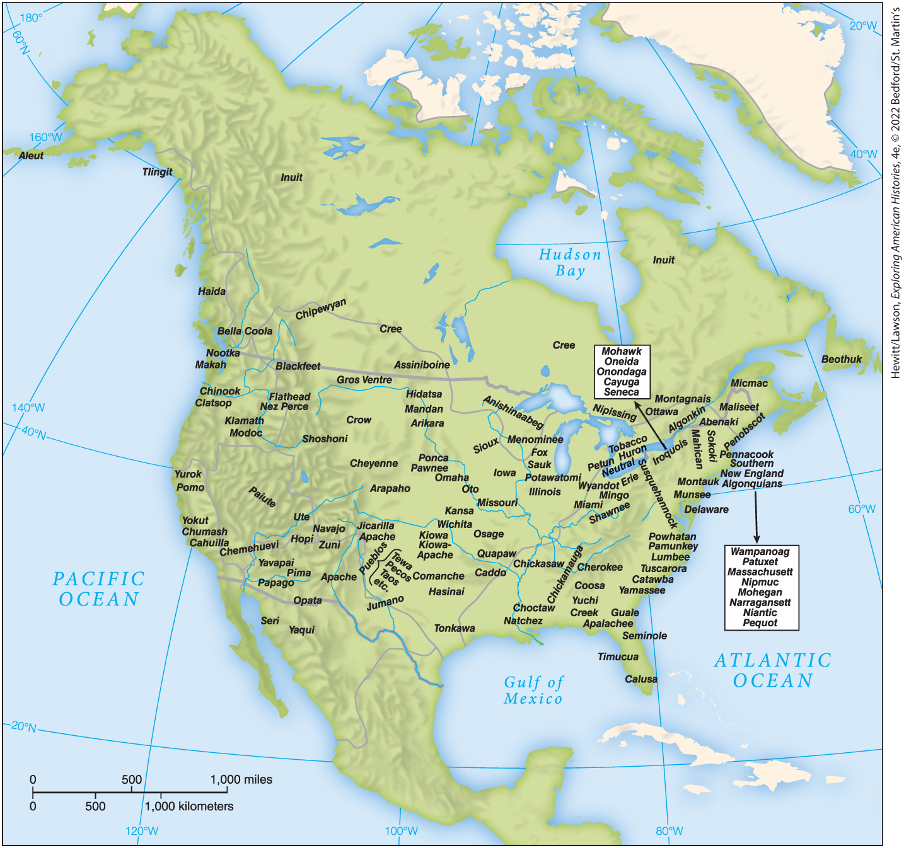
​
 | a. | Mexico
 | b. | The United States
 | c. | Canada
 | d. | Guatemala  ​

ANSWER: | a

18. According to the map, which Native American groups would the early British colonists have been most likely to encounter?
​
​
​
 | a. | Crow
 | b. | Jumano
 | c. | Wampanoag
 | d. | Sioux  ​

ANSWER: | c

19. Martin Luther and John Calvin were leaders of distinct denominations of what religious movement in the sixteenth century?
 | a. | Roman Catholicism
 | b. | Protestantism
 | c. | Eastern Orthodox Christianity
 | d. | Islam

ANSWER: | b

20. What inspired King Henry VIII's conversion to Protestantism and his establishment of the Church of England?
 | a. | He was moved by Luther's writings.
 | b. | He was tired of paying Catholic indulgences.
 | c. | The pope refused to annul his marriage.
 | d. | The pope refused to hear his penance for his wrongdoings.

ANSWER: | c

21. In 1545, Pope Paul II convened the Council of Trent to
 | a. | end services in Latin.
 | b. | demand more training for priests.
 | c. | establish a peace treaty with Protestants.
 | d. | start a campaign against witchcraft.

ANSWER: | b

22. In 1573, why did Spain decide that missionaries rather than soldiers should direct all new imperial settlements?
 | a. | The Council of Trent pushed Catholic governments to emphasize religious commitments.
 | b. | Soldiers were losing to Indians.
 | c. | Indians were more responsive to missionaries.
 | d. | The Protestant Reformation was weakening Spain's grip on its settlements.

ANSWER: | a

23. What missionaries founded missions on the margins of Pueblo villages north of Mexico and named the area New Mexico?
 | a. | Huguenots
 | b. | Jesuits
 | c. | Franciscans
 | d. | Anglicans

ANSWER: | c

24. The Spanish returned to the area of New Mexico in 1610 and established a network of missions and estates known as encomenderos, a system under which Spanish
 | a. | elites were granted rights to land and labor.
 | b. | soldiers were charged with protecting their land.
 | c. | navigators who previously claimed the land could take possession of it.
 | d. | priests would convert local Indians.

ANSWER: | a

25. How did the Protestant Reformation affect the competition among European powers in the colonization of the Americas?
 | a. | It strengthened Spanish domination.
 | b. | It allowed Portugal to begin colonizing portions of Brazil.
 | c. | It broke the Spanish monopoly on American colonization.
 | d. | Spanish colonies were forced to allow Protestant missionaries.

ANSWER: | c

26. What enabled the English to defeat the Spanish attack ordered in 1588 by King Philip II?
 | a. | Spanish weaponry lagged behind that of English.
 | b. | England had amassed the largest, most skilled navy at the time.
 | c. | France provided the English with larger, more powerful bombs.
 | d. | England was aided by Dutch ships.

ANSWER: | d

27. The French policy of developing trade in North America stood in stark contrast to the policy of conquest employed by
 | a. | Puritans.
 | b. | the Virginia Company.
 | c. | Spain.
 | d. | the Netherlands.

ANSWER: | c

28. Samuel de Champlain founded the first permanent French settlement in North America in 1608 in the area now known as
 | a. | Quebec.
 | b. | New York.
 | c. | Michigan.
 | d. | North Carolina.

ANSWER: | a

29. The Dutch were primarily motivated by which of the following as they looked to establish colonies in North America?
 | a. | Religion
 | b. | Politics
 | c. | Slavery
 | d. | Economics

ANSWER: | d

30. What European power supplied guns to the Iroquois to fend off economic competition from the Hurons?
 | a. | Spanish
 | b. | English
 | c. | Dutch
 | d. | French

ANSWER: | c

31. Why did the French establish a fortified settlement at Montreal in 1643?
 | a. | To enable hunting and gathering without disruption by Indians
 | b. | To extend their fur trade to the west
 | c. | To defend their land from the English
 | d. | To support missionary efforts to convert nearby Hurons

ANSWER: | b

32. Dutch explorers in the Americas were primarily motivated by
 | a. | economic profit.
 | b. | religious obligation.
 | c. | new territory to settle.
 | d. | revenge against Spain.

ANSWER: | a

33. When the Dutch established their trading center on the Hudson River in present-day New York, who did they want to trade with?
 | a. | Iroquois to the west
 | b. | French to the north
 | c. | English to the south
 | d. | Algonquians to the east

ANSWER: | a

34. As the Dutch established farms along the Hudson River and Long Island, tensions began to escalate with which Native American group?
 | a. | The Powhatan
 | b. | The Mohawk
 | c. | The Munsee
 | d. | The Algonquian

ANSWER: | d

35. Where did the Dutch trade furs with the Mohawk tribe?
 | a. | Port Huron
 | b. | Fort Orange
 | c. | Susquehanna
 | d. | New Amsterdam

ANSWER: | b

36. As newly elected governor of the Jamestown colony, John Smith ordered the English settlers to
 | a. | work with Indians and force them to do the farming.
 | b. | consider the Indians a threat.
 | c. | kill the Indians, take their valuables, and go back to England.
 | d. | avoid the Indians at all cost and try to survive by hunting and gathering.

ANSWER: | b

37. What caused the survivors of the "starving time" at Jamestown to abandon their plans to return to England?
 | a. | Supply ships arrived as they were departing.
 | b. | John Rolfe discovered tobacco cultivation.
 | c. | The Virginia Company threatened to punish them.
 | d. | John Smith befriended Pocahontas.

ANSWER: | a

38. How does this map reflect the influence of tobacco upon the growth of the Virginia colony?
​
​
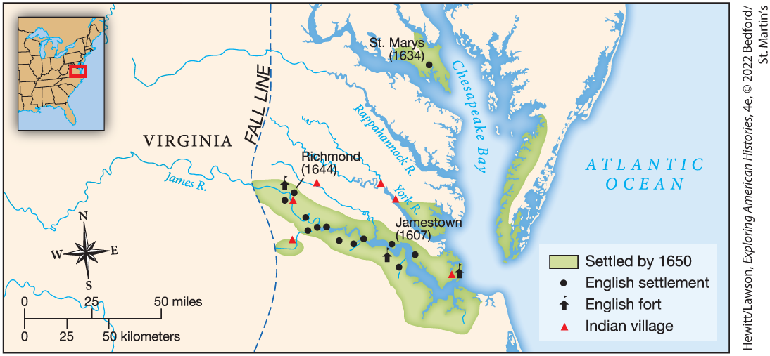
​
 | a. | The settlements are nearby Indian villages to facilitate trade in tobacco.
 | b. | A fall line was established beyond which it was illegal to cultivate tobacco.
 | c. | The construction of forts indicates a desire to protect English investment in tobacco.
 | d. | The successful cultivation of tobacco led to the spread of English settlements.  ​

ANSWER: | d

39. What do the English settlements and Indian villages pictured in this map have in common?
​
​
​
 | a. | As they multiplied, they tended to do so in a northerly direction.
 | b. | Both were growing in number during the early seventeenth century.
 | c. | Their locations reflect the importance of easy access to major waterways.
 | d. | Both groups likely lived in relative isolation from one another.  ​

ANSWER: | c

40. Which English settlement became the largest economic engine of English colonization in the early seventeenth century?
 | a. | Virginia
 | b. | West Indies
 | c. | Roanoke
 | d. | New England

ANSWER: | b

41. The Virginia Company in the early seventeenth century covered what present-day region?
 | a. | New York to North Carolina
 | b. | Massachusetts to Virginia
 | c. | Maine to Virginia
 | d. | Virginia to North Carolina

ANSWER: | a

42. The large number of British possessions in the West Indies, pictured in this map, indicate which of the following?
​
​
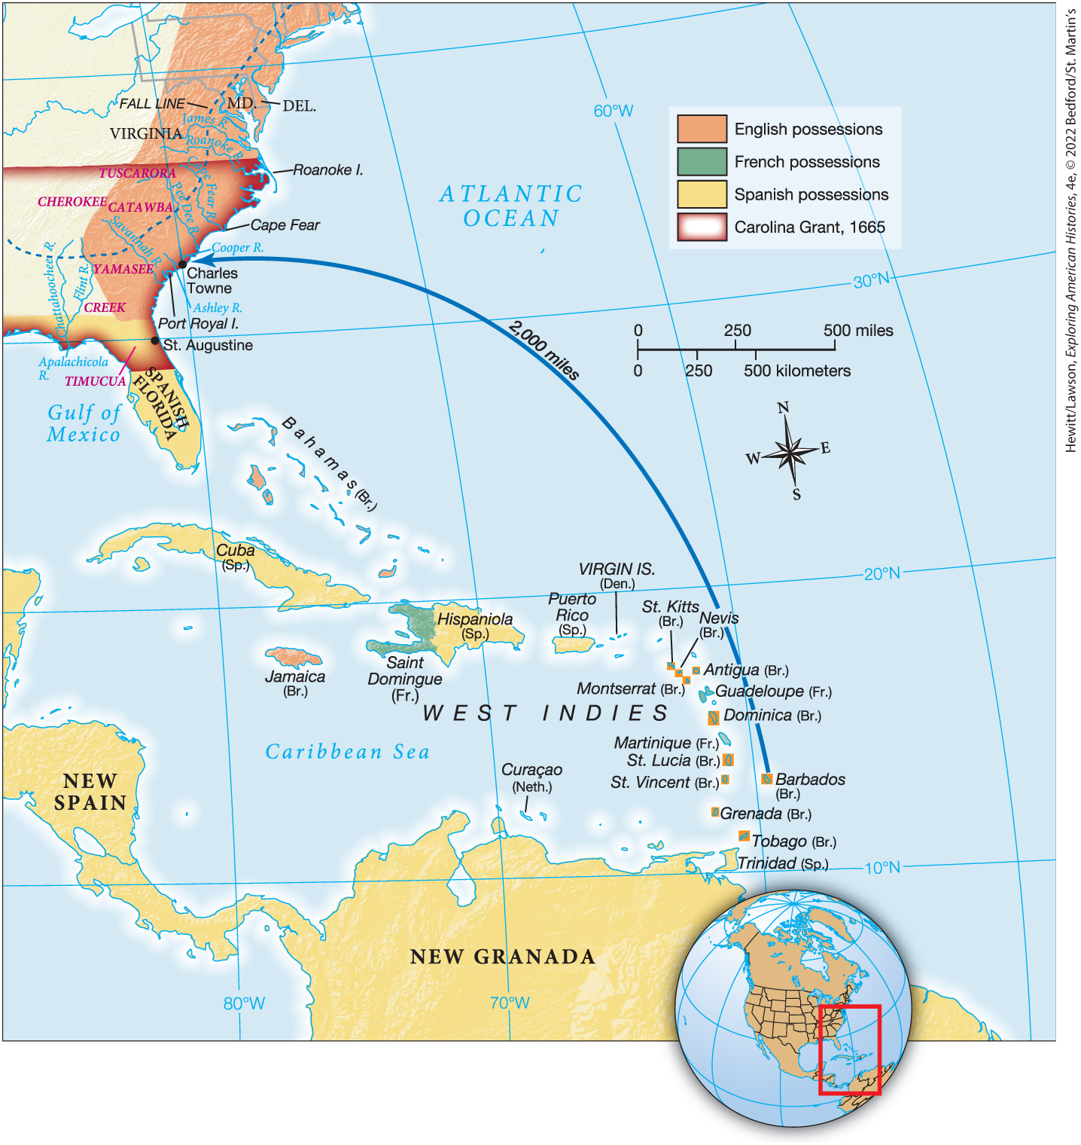
​
 | a. | Britain believed they must fortify this region to protect their colonies further to the north.
 | b. | The British hoped to one day challenge Spanish supremacy in South America.
 | c. | These possessions were of great economic importance to the British.
 | d. | Most British immigrants migrated to North America via the West Indies.  ​

ANSWER: | c

43. How did English settlers in Jamestown, Virginia survive in the early years?
 | a. | They learned to farm the land and grow corn and other vegetables.
 | b. | They received a considerable amount of food from Indians.
 | c. | They fished the oceans and hunted large and small game.
 | d. | They subsisted primarily on berries, roots, and small game.

ANSWER: | b

44. What strategy did Smith and the Virginia Company develop to save the colony and recruit new settlers that resulted in 600 new inhabitants arriving at the colony in June 1609?
 | a. | They imported massive numbers of enslaved Africans.
 | b. | They hired people from England for minimum-wage plus free shelter.
 | c. | They recruited indentured servants from across Europe.
 | d. | They forced Indians from local tribes to work the fields.

ANSWER: | c

45. The harsh winter of 1609–1610 killed what fraction of the English settlers in Jamestown?
 | a. | 7 out of 10
 | b. | 3 out of 8
 | c. | 5 out of 8
 | d. | 7 out of 8

ANSWER: | d

46. What ultimately convinced the English to keep supporting their colony in Virginia?
 | a. | Labor from Europe
 | b. | Decimation of the Indians
 | c. | Development of a cash crop
 | d. | Invention of the flintlock musket

ANSWER: | c

47. What early colony was headed by a Catholic proprietor, populated by Catholics and Protestants, and passed the Act of Religious Toleration in 1649, guaranteeing religious freedom to all Christians who settled there?
 | a. | Maryland
 | b. | Virginia
 | c. | Massachusetts
 | d. | North Carolina

ANSWER: | a

48. Why did the growth of slavery in Barbados come primarily from importation during the seventeenth century?
 | a. | Enslaved people died faster than they could reproduce.
 | b. | Most enslaved people lived there only for a short time before being sent elsewhere.
 | c. | Enslaved people ran away at an increasingly higher rate throughout the century.
 | d. | High demand for sugar meant an ever-increasing demand for slave labor.

ANSWER: | a

49. In the seventeenth century, what crop became the most lucrative for West Indies planters?
 | a. | Tobacco
 | b. | Sugarcane
 | c. | Indigo
 | d. | Rice

ANSWER: | b

50. Successful long-term colonization in North America required
 | a. | a strong military presence.
 | b. | peaceful relations with the Indians.
 | c. | fertile land.
 | d. | permanent settlement.

ANSWER: | d

51. What critical resource fueled most conflicts between Native Americans and Europeans?
 | a. | Land
 | b. | Food
 | c. | Wampum
 | d. | Furs

ANSWER: | a

52. The Virginia Company enticed men to try their luck at traveling to North America with
 | a. | the possibility of a Native American wife.
 | b. | the prospect of owning land of their own.
 | c. | fresh air and a new start in the country.
 | d. | deceit and trickery.

ANSWER: | b

53. Which group of English immigrants first settled in Plymouth in 1620?
 | a. | Puritans
 | b. | Anglicans
 | c. | Catholics
 | d. | Pilgrims

ANSWER: | d

54. What was the first written constitution adopted in North America?
 | a. | The Mayflower Compact
 | b. | The U.S. Constitution
 | c. | The Declaration of Independence
 | d. | The Articles of Confederation

ANSWER: | a

55. The English immigrants who set sail on the Mayflower in September 1620 originally intended to settle in which region?
 | a. | Massachusetts
 | b. | Pennsylvania
 | c. | Virginia
 | d. | West Indies

ANSWER: | c

56. Why did Massasoit, leader of the Wampanoag people, want to form an alliance with English settlers in Plymouth, Massachusetts?
 | a. | He feared the English settlers would kill him otherwise.
 | b. | He wanted the English to help him fight other Indians.
 | c. | He was a pacifist and didn't believe in fighting.
 | d. | He had first tried to kill the English and failed, so an alliance was a natural recourse.

ANSWER: | b

57. In establishing the Plymouth colony, the Pilgrims sought to do which of the following?
 | a. | establish a haven for Catholics
 | b. | separate themselves entirely from the Anglican Church
 | c. | purify the Church of England
 | d. | build a colony for Quakers

ANSWER: | b

58. Which group of English immigrants to North America were the most prosperous when they left for the colonies?
 | a. | Pilgrims
 | b. | Jamestownians
 | c. | Puritans
 | d. | Roanokeans

ANSWER: | c

59. In establishing the Massachusetts Bay, the Puritans sought to do which of the following?
 | a. | purify the Church of England
 | b. | separate themselves entirely from the Church of England
 | c. | build a colony for Quakers
 | d. | establish a haven for Catholics

ANSWER: | a

60. Who joined the English in a bloody attack on the Pequots that resulted in over 400 dead men, women, and children?
 | a. | The Narragansetts
 | b. | The Iroquois
 | c. | The Dutch
 | d. | The Wampanoags

ANSWER: | a

61. When England erupted in civil war in 1642 over issues of religion, taxation, and royal authority, who emerged as leader and ruled until his death in 1658?
 | a. | James I
 | b. | Oliver Cromwell
 | c. | Charles I
 | d. | Charles II

ANSWER: | b

62. In 1664, the English wrested control of what region and renamed it New York?
 | a. | New Amsterdam
 | b. | New Jersey
 | c. | New France
 | d. | New England

ANSWER: | a

63. During the 1637 conflict known as the Pequot War, allied Puritan and Narragansett forces launched a decisive attack in which
 | a. | they captured the Pequot leader and forced him to surrender.
 | b. | they attacked a Pequot village, leaving 400 people dead.
 | c. | they set fires in the forest to destroy Pequot hiding places.
 | d. | they used superior technology to defeat the Pequots in open warfare.

ANSWER: | b

64. Puritans viewed the enclosure movement as divine punishment for
 | a. | the sins of Britain's church and government.
 | b. | British colonization in North America.
 | c. | British atrocities against Native Americans.
 | d. | the growing number of enslaved people in the New World.

ANSWER: | a

65. Puritans believed that their "City upon a Hill" would
 | a. | permanently sever their ties with the Anglican Church.
 | b. | lead to the founding of similar colonies through Massachusetts.
 | c. | inspire reform in Great Britain.
 | d. | bring an end to the practice of indentured servitude.

ANSWER: | c

