***Essentials of Anatomy and Physiology for Nursing Practice* – Testbank**

**Using This Testbank**

This testbank has been designed to be used in conjunction with *Essentials of Anatomy and Physiology for Nursing Practice* by Jennifer Boore, Neal Cook and Andrea Shepherd.

**Correct answers for multiple choice questions are indicated with asterisks.**

1. Match the following

1. Substances entering the cell

2. Waste products leaving the cell

3. Conditions which allow life to continue

a. Steady temperature; pH between 7.35 and 7.45; electrolyte balance

b. Oxygen; substances for building complex molecules; substances which act as energy sources

c. Ammonia; carbon dioxide

Answers:

[b] 1.

[c] 2.

[a] 3.

2. Which of the following terms is used to describe the breakdown of complex molecules into simpler ones?

a. Anabolism

b. Synthesis

c. Homeostasis

*d. Catabolism

3. Is the following statement true or false? ‘The basic building blocks of proteins are phospholipids’

a. True

*b. False

4. What term is used to describe the metabolic mechanism whereby complex molecules are manufactured from simpler molecules?

Answers:

a. anabolism

b. anabolic

5. Which of the following applies to a compound that is a sugar?

*a. Because it is a sugar it can also be called a carbohydrate

b. It contains peptide bonds

c. It is a major component of the structural units of cells

d. All of the above are true

6. Which of the following molecules is the primary energy store in living cells?

a. DNA

b. RNA

c. Cyclic AMP

*d. ATP

7. What term is used to describe the maintenance of a constant internal environment in the cell or body?

*a. Homeostasis

b. Equilibrium

c. pH balance

d. Oxidative phosphorylation

8. Which of the following pH ranges best matches the pH range found in the majority of body fluids?

a. 7.8–8.0

b. 7.15–7.65

c. 7.2–7.5

*d. 7.35–7.45

9. Which of the following lists the correct sequence of levels forming the structural hierarchy of the body?

a. Organ, organ system, cellular, tissue, organism

b. Chemical, cellular, tissue, organism, organ, organ system

*c. Chemical, cellular, tissue, organ, organ system, organism

d. Organism, organ system, organ, tissue, cellular, chemical

10. Which of the following groups of organs are found in the abdominopelvic cavity?

a. Spinal cord, lungs, liver

b. Liver, stomach, heart

c. Brain, spinal cord, liver

*d. Gallbladder, stomach, small intestine

11. What does the term proximal mean when applied to an organ?

a. The organ is nearer the front of the body

*b. The organ is nearer to the point of attachment of a limb, or origin of a body part

c. The organ is further from the point of attachment of a limb, or origin of a body part

d. The organ is nearer to the mid-line

12. Match the numbers on the diagram of the female pelvic region to the correct organs and structures

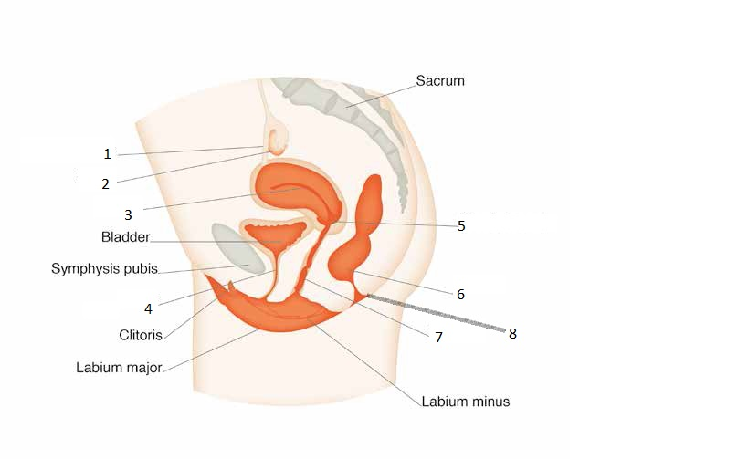

Answers:

1. Fallopian tube

2. Ovary

3. Uterus

4. Urethra

5. Cervix

6. Rectum

7. Vagina

8. Anal canal

13. Match the numbers on the diagram of the male pelvic region to the correct organs and structures  
 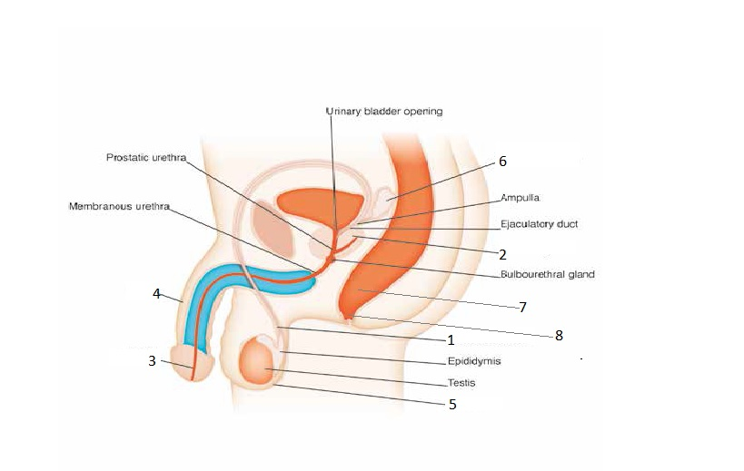

Answers:

1. Deferent duct

2. Prostate gland

3. Urethra

4. Penis

5. Scrotum

6. Seminal vesicles

7. Rectum

8. Anal canal

14. Match the numbers on the diagram of the respiratory system to the correct organs and structures  
 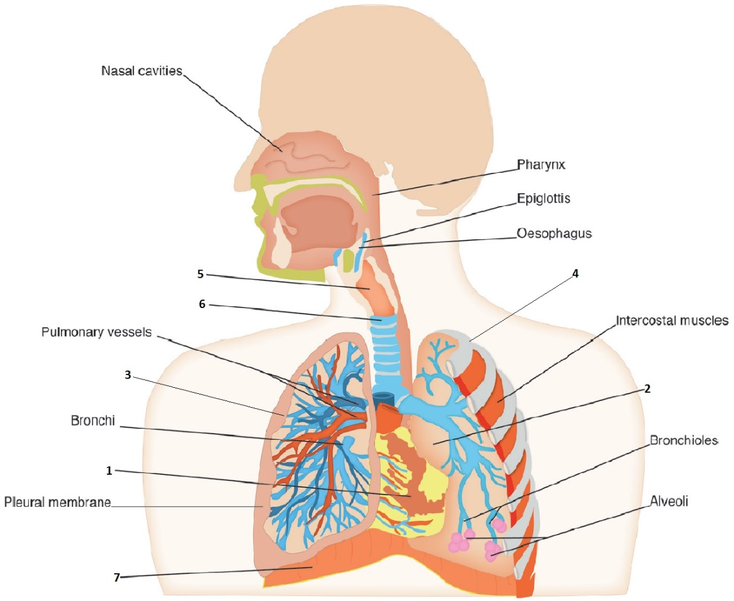

Answers:

1. Heart

2. Left lung

3. Right lung

4. Ribs

5. Larynx

6. Trachea

7. Diaphragm

15. Which of the following organelles of a cell increase the surface area to facilitate absorption of extracellular materials?

a. Endoplasmic reticulum

b. Cilia

*c. Microvilli

d. Lysosomes