Essentials of Anatomy & Physiology, 7e, Global Edition (Martini/Bartholomew)
Chapter 1 An Introduction to Anatomy and Physiology

1.1 Multiple-Choice Questions

1) Characteristics of living organisms include the ability to
A) repair and completely restore itself during any type of injury.
B) respond and adapt to their environment.
C) control the external environment.
D) form positive feedback loops.
E) create a protective covering over themselves.
Answer: B
Learning Outcome: 1-1
Bloom's Taxonomy: Remembering

2) The waste products of metabolism are eliminated through the process of
A) assimilation.
B) absorption.
C) excretion.
D) digestion.
E) resorption.
Answer: C
Learning Outcome: 1-1
Bloom's Taxonomy: Remembering

3) Humans have specialized organ systems compared to smaller organisms because
A) we have to interact with our environment and smaller organisms do not.
B) smaller organisms do not need as many nutrients.
C) our cells are larger.
D) small organisms do not do the same processes than humans do.
E) there is multicellularity and increased size in larger organisms.
Answer: E
Learning Outcome: 1-1
Bloom's Taxonomy: Understanding

4) Think about the definitions of anatomy and of physiology. The relationship between these two fields is best described by the following statement:
A) Anatomy is the study of function.
B) All structures are derived from an ancestral structure.
C) Physiology becomes more complex over time.
D) Structure follows function.
E) Organs that have similar function also have similar structure.
Answer: D
Learning Outcome: 1-2
Bloom's Taxonomy: Understanding
5) Diseases such as diabetes and cardiovascular disease would be covered in the specialty area of physiology called
A) hyperbaric physiology.
B) pathophysiology.
C) gross anatomy.
D) regional anatomy.
E) systemic anatomy.
Answer: B
Learning Outcome: 1-2
Bloom's Taxonomy: Understanding

6) Studying all the superficial and internal features in one specific area of the body is called
A) gross anatomy.
B) surface anatomy.
C) systemic anatomy.
D) regional anatomy.
E) surgical anatomy.
Answer: D
Learning Outcome: 1-2
Bloom's Taxonomy: Remembering

7) One difference between a gross anatomist and a histologist would be
A) the use of a microscope.
B) the need to use sophisticated diagnostic imaging methods.
C) one studies physiology and the other studies anatomy.
D) which organ systems one studies.
E) which diseases are seen.
Answer: A
Learning Outcome: 1-2
Bloom's Taxonomy: Understanding

8) The study of cells and cellular structures is called
A) gross anatomy.
B) cytology.
C) histology.
D) organology.
E) microbiology.
Answer: B
Learning Outcome: 1-2
Bloom's Taxonomy: Remembering

9) Biopsy samples from organs are sent to your lab for staining and then viewing in a microscope. Your area of expertise would be
A) regional physiology.
B) gross anatomy.
C) regional anatomy.
D) systemic anatomy.
E) histology.
Answer: E
Learning Outcome: 1-2
Bloom's Taxonomy: Understanding
10) The study of body structure is called
A) physiology.
B) homeostasis.
C) anatomy.
D) positive feedback.
E) negative feedback.
Answer: C
Learning Outcome: 1-2
Bloom's Taxonomy: Remembering

11) The branch of biological science that deals with how the kidney functions is called
A) endocrine physiology.
B) histology.
C) adrenal anatomy.
D) cytology.
E) renal physiology.
Answer: E
Learning Outcome: 1-2
Bloom's Taxonomy: Remembering

12) Which division of anatomy focuses on the form and structure of the heart, blood, and blood vessels?
A) regional anatomy
B) surface anatomy
C) cytology
D) histology
E) systemic anatomy
Answer: E
Learning Outcome: 1-2
Bloom's Taxonomy: Understanding

13) Which statement about anatomy and physiology is true?
A) Physiology is the study of structure.
B) Anatomy is the study of structure and function.
C) Both anatomy and physiology are needed to understand organ systems and organisms.
D) There is only one area of anatomy, whereas there are many subdivisions of physiology.
E) Special physiology focuses on a particular organ system.
Answer: C
Learning Outcome: 1-2
Bloom's Taxonomy: Understanding

14) A cardiologist studies the human body mainly with an approach resembling
A) gross anatomy.
B) surface anatomy.
C) microscopic anatomy.
D) systemic anatomy.
E) regional anatomy.
Answer: D
Learning Outcome: 1-2
Bloom's Taxonomy: Understanding
15) Which of the following is an organ?
A) blood
B) heart
C) peritoneum
D) connective tissue
E) mitochondrion
Answer: B
Learning Outcome: 1-3
Bloom's Taxonomy: Remembering

16) A collection of cells that work together designates a(n)
A) chemical.
B) organ.
C) tissue.
D) organ system.
E) molecule.
Answer: C
Learning Outcome: 1-3
Bloom's Taxonomy: Remembering

17) Which of the following is the simplest level of organization?
A) cellular
B) chemical
C) organ
D) system
E) tissue
Answer: B
Learning Outcome: 1-3
Bloom's Taxonomy: Remembering

18) The heart, blood, and blood vessels combine to form which of the following?
A) a group of cells
B) an organ system
C) the smallest level of organization
D) an organ
E) an individual living entity
Answer: B
Learning Outcome: 1-3
Bloom's Taxonomy: Remembering

19) Which statement is true?
A) An organ will likely be composed of different tissues.
B) Organs are composed of organ systems.
C) Many molecules come together to form atoms.
D) All organs in an organ system have the same function.
E) The smallest living unit in the body is an atom.
Answer: A
Learning Outcome: 1-3
Bloom's Taxonomy: Understanding
20) Which of the following is an accurate description of the cellular level of organization?
A) Cells consist of two or more different tissues working together to perform specific functions.
B) Cells are considered to be the largest living units in the body.
C) Cells are comprised of different molecules that interact to form larger structures, each type of which has a specific function.
D) Cells combine to form molecules with complex shapes, which determine their function(s).
E) Cardiac muscle is an example of the cellular level of organization.
Answer: C
Learning Outcome: 1-3
Bloom's Taxonomy: Understanding

21) The fact that a single defective protein causes cystic fibrosis, a multisystemic illness, proves that
A) all organisms are composed of cells.
B) all levels of organization within an organism are interdependent.
C) chemical molecules make up cells.
D) all cells are independent of each other.
E) congenital defects can be life threatening.
Answer: B
Learning Outcome: 1-3
Bloom's Taxonomy: Applying

22) The production of another human organism is the function of which of the following systems?
A) skeletal
B) reproductive
C) respiratory
D) lymphoid
E) cardiovascular
Answer: B
Learning Outcome: 1-4
Bloom's Taxonomy: Understanding

23) How are the endocrine organ system and nervous organ system alike?
A) They both send nerve impulses.
B) Each of the systems regulates different activities.
C) Together, they both regulate most of the activities of the body.
D) They both have many disorders associated with them.
E) One system is more involved with young life, whereas the other becomes more important later in life.
Answer: C
Learning Outcome: 1-4
Bloom's Taxonomy: Understanding
24) The trachea and lungs are components of the
A) endocrine system.
B) digestive system.
C) respiratory system.
D) urinary system.
E) lymphoid system.
Answer: C
Learning Outcome: 1-4
Bloom's Taxonomy: Remembering

25) The pituitary and thyroid glands are components of the
A) endocrine system.
B) cardiovascular system.
C) respiratory system.
D) lymphoid system.
E) digestive system.
Answer: A
Learning Outcome: 1-4
Bloom's Taxonomy: Remembering

26) Gas exchange is a function of the
A) cardiovascular system.
B) lymphoid system.
C) respiratory system.
D) urinary system.
E) endocrine system.
Answer: C
Learning Outcome: 1-4
Bloom's Taxonomy: Remembering

27) Which structure(s) is/are a component of the digestive system?
A) pituitary gland
B) ligaments
C) urethra
D) arteries
E) liver
Answer: E
Learning Outcome: 1-4
Bloom's Taxonomy: Remembering

28) Covering, protection, and control of body temperature are functions of which organ system of the human body?
A) integumentary
B) muscular
C) skeletal
D) nervous
E) endocrine
Answer: A
Learning Outcome: 1-4
Bloom's Taxonomy: Understanding
29) The thymus is associated with which organ system?
A) nervous
B) respiratory
C) digestive
D) urinary
E) endocrine
Answer: E
Learning Outcome: 1-4
Bloom's Taxonomy: Understanding

30) All of these organ systems have exchange of materials as a main function.
A) urinary and digestive
B) respiratory and cardiovascular
C) cardiovascular and endocrine
D) digestive and respiratory
E) lymphatic and bone
Answer: B
Learning Outcome: 1-4
Bloom's Taxonomy: Understanding

31) What is/are the primary function(s) of the skeletal system?
A) protection from environment
B) internal transport of materials
C) support, protection, and mineral storage
D) delivery of air for gas exchange
E) locomotion and heat production
Answer: C
Learning Outcome: 1-4
Bloom's Taxonomy: Understanding
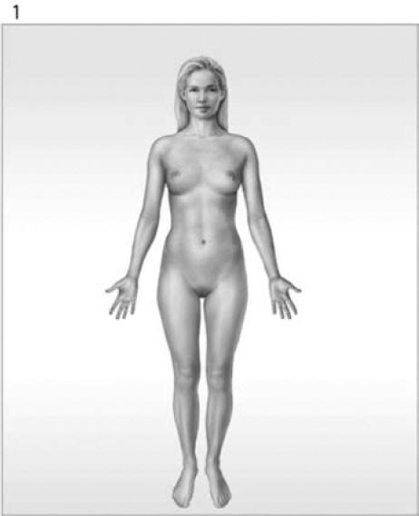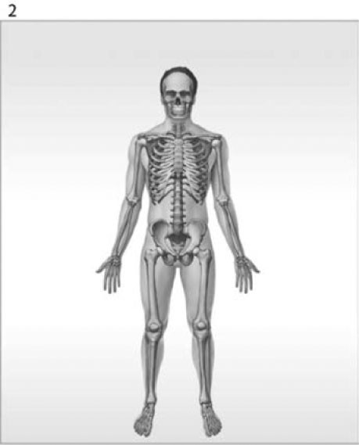

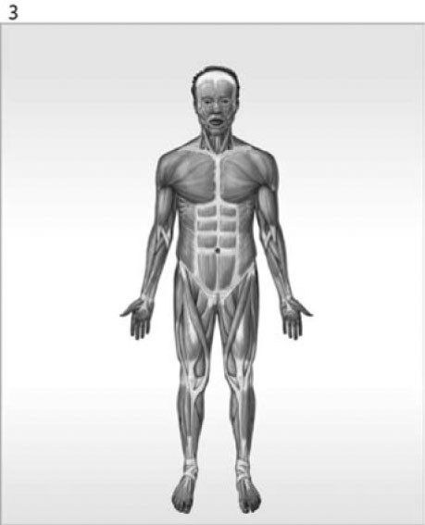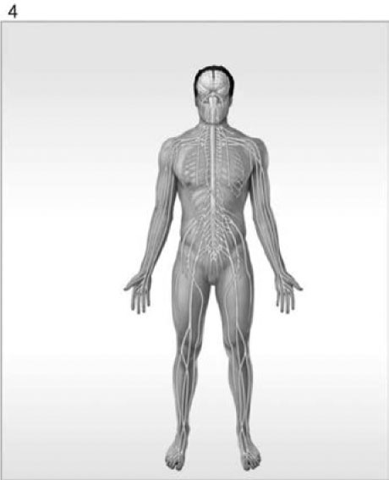
Figure 1-1 The Organ Systems of the Human Body

Use Figure 1-1 to answer the following questions:

32) Which organ system is labeled #1?
A) nervous system
B) reproductive system
C) integumentary system
D) lymphatic system
E) muscular system
Answer: C
Learning Outcome: 1-4
Bloom's Taxonomy: Remembering
33) What is/are the function(s) of the organ system labeled #3?
A) help control body temperature
B) provides support; produces heat
C) provides support; protects tissues; stores minerals
D) directs immediate responses to stimuli
E) defends against infection and disease
Answer: B
Learning Outcome: 1-4
Bloom's Taxonomy: Understanding

34) Lungs are to the respiratory system as the spleen is to the
A) lymphatic system.
B) urinary system.
C) digestive system.
D) cardiovascular system.
E) muscular system.
Answer: A
Learning Outcome: 1-4
Bloom's Taxonomy: Applying

35) Your blood glucose level has dropped perilously low because you have been starving yourself for a couple of days to lose weight. Your liver, directed by the hormone insulin, converts its last stored glycogen into glucose to get it out into your bloodstream. In this scenario, the liver is the
A) receptor.
B) effector.
C) control center.
D) feedback.
E) balance.
Answer: B
Learning Outcome: 1-5
Bloom's Taxonomy: Applying

36) The tendency for physiological systems to stabilize internal conditions with respect to the external environment is called
A) integration.
B) internal regulation.
C) responsiveness.
D) homeostasis.
E) external regulation.
Answer: D
Learning Outcome: 1-5
Bloom's Taxonomy: Remembering
37) Which component of a homeostatic regulation is characterized as having an activity that opposes or enhances the stimulus?
A) balance
B) control center
C) integration center
D) positive feedback loop
E) effector
Answer: E
Learning Outcome: 1-5
Bloom's Taxonomy: Understanding

38) As a result of playing tennis in the summer heat without proper hydration, you have become very dehydrated. You are now in hypernatremia, a condition where your blood sodium levels are too high. Your brain tells you to drink water and, as a result, your blood sodium and hydration levels go back to normal. This illustrates
A) positive feedback.
B) stimulus reinforcement.
C) negative feedback.
D) diagnostic regulation.
E) both positive and negative feedback loops.
Answer: C
Learning Outcome: 1-6
Bloom's Taxonomy: Applying

39) The prevention of change, by ignoring minor variations and maintaining a normal range rather than a fixed value, is characteristic of
A) positive feedback.
B) stimulus reinforcement.
C) negative feedback.
D) effector control.
E) both positive and negative feedback loops.
Answer: C
Learning Outcome: 1-6
Bloom's Taxonomy: Understanding

40) The increasingly forceful labor contractions that lead to childbirth are an example of which type of mechanism?
A) receptor activation
B) effector shutdown
C) negative feedback
D) positive feedback
E) thermoregulation
Answer: D
Learning Outcome: 1-6
Bloom's Taxonomy: Understanding
41) An initial stimulus produces a response that reinforces the stimulus in
A) positive feedback.
B) homeostasis.
C) negative feedback.
D) regulation.
E) integration.
Answer: A
Learning Outcome: 1-6
Bloom's Taxonomy: Remembering

42) Which of the following describes a mechanism that brings the internal environment back to normal?
A) integration
B) regulation
C) positive feedback
D) negative feedback
E) homeostasis
Answer: D
Learning Outcome: 1-6
Bloom's Taxonomy: Remembering

43) Which of the following is an example of negative feedback?
A) An increase in normal body temperature triggers heat loss through enhanced blood flow to the skin and increased sweating.
B) An increase in ambient room temperature triggers the thermostat to turn on the heater.
C) A severe cut triggers accelerated blood clotting until the bleeding stops.
D) Increased blood sugar stimulates the release of a hormone from the pancreas that stimulates the liver to release blood sugar.
E) An increase in body temperature triggers a neural response that initiates physiological changes to increase body temperature.
Answer: A
Learning Outcome: 1-6
Bloom's Taxonomy: Applying

44) Regarding components of negative feedback in thermoregulation, what is the corresponding term for the skeletal muscles?
A) effector
B) control center
C) receptor
D) integrator
E) stimulus
Answer: A
Learning Outcome: 1-6
Bloom's Taxonomy: Understanding
45) A person who is lying on his or her stomach is said to be in the
A) supine position.
B) prone position.
C) transverse position.
D) frontal position.
E) sagittal position.
Answer: B
Learning Outcome: 1-7
Bloom's Taxonomy: Remembering

46) Which directional term indicates the back of the body?
A) lateral
B) proximal
C) dorsal
D) ventral
E) medial
Answer: C
Learning Outcome: 1-7
Bloom's Taxonomy: Remembering

47) Which of the following anatomical landmarks corresponds to the groin?
A) inguinal
B) cephalon
C) gluteus
D) lumbus
E) thoracis
Answer: A
Learning Outcome: 1-7
Bloom's Taxonomy: Remembering

48) The sternum is ________ to the heart.
A) lateral
B) proximal
C) dorsal
D) ventral
E) medial
Answer: D
Learning Outcome: 1-7
Bloom's Taxonomy: Remembering

49) A person lying face up in the anatomical position is said to be in the ________ position.
A) coronal
B) supine
C) prone
D) sagittal
E) lateral
Answer: B
Learning Outcome: 1-7
Bloom's Taxonomy: Remembering
50) The forearm is called the
A) acromial.
B) olecranon.
C) antebrachium.
D) lumbus.
E) brachium.
Answer: C
Learning Outcome: 1-7
Bloom's Taxonomy: Remembering

51) ________ are terms used when comparing body areas on appendages.
A) Lateral and medial
B) Proximal and distal
C) Superior and inferior
D) Supine and prone
E) Superficial and deep
Answer: B
Learning Outcome: 1-7
Bloom's Taxonomy: Understanding

52) The term ________ refers to the wrist.
A) pes
B) tarsus
C) manus
D) palmar
E) carpus
Answer: E
Learning Outcome: 1-7
Bloom's Taxonomy: Remembering

53) Describe the regional term "antecubitis."
A) back of knee
B) midline of back
C) eye
D) front of elbow
E) forearm
Answer: D
Learning Outcome: 1-7
Bloom's Taxonomy: Remembering

54) Using anatomical terms of direction, supply the word that would make the sentence correct.
The stomach is ________ to the lungs.
A) ventral
B) dorsal
C) superior
D) inferior
E) deep
Answer: D
Learning Outcome: 1-7
Bloom's Taxonomy: Understanding
55) Which statement is true regarding the abdominopelvic regions?
A) The bulk of the liver is found within the left hypochondriac region.
B) Directly inferior to the umbilical region is the inguinal region.
C) The small intestine is located in the bottom three regions only.
D) The hypogastric region is where the stomach is located.
E) The hypochondriac regions are superior to the lumbar regions.
Answer: E
Learning Outcome: 1-7
Bloom's Taxonomy: Understanding

56) The wrist is ________ to the elbow.
A) proximal
B) distal
C) lateral
D) medial
E) deep
Answer: B
Learning Outcome: 1-7
Bloom's Taxonomy: Understanding

57) Open-heart bypass surgery, to replace obstructed vessels that feed the heart with oxygenated blood, requires a long incision cut down the breastbone. The ribs are then spread to work on the heart. This incision is along the ________ plane.
A) frontal
B) coronal
C) transverse
D) sagittal
E) oblique
Answer: D
Learning Outcome: 1-7
Bloom's Taxonomy: Understanding

58) In the terminology of planes and sections, which example includes two terms with identical meanings?
A) frontal/coronal
B) coronal/horizontal
C) equatorial/coronal
D) sagittal/midsagittal
E) caudal/cranial
Answer: A
Learning Outcome: 1-7
Bloom's Taxonomy: Understanding

59) Anterior is to ________ as posterior is to dorsal.
A) cranial
B) ventral
C) caudal
D) inferior
E) medial
Answer: B
Learning Outcome: 1-7
Bloom's Taxonomy: Understanding
60) A cut passing parallel to the long axis of the body that divides it into unequal left and right halves is known as which type of sectional plane?
A) frontal
B) coronal
C) transverse
D) sagittal
E) horizontal
Answer: D
Learning Outcome: 1-7
Bloom's Taxonomy: Understanding

61) A diagnostic technique that employs a radiopaque dye injected into blood vessels is called a(n)
A) digital subtractive angiography (DSA).
B) radiograph.
C) CT scan.
D) MRI.
E) ultrasound.
Answer: A
Learning Outcome: 1-7
Bloom's Taxonomy: Understanding
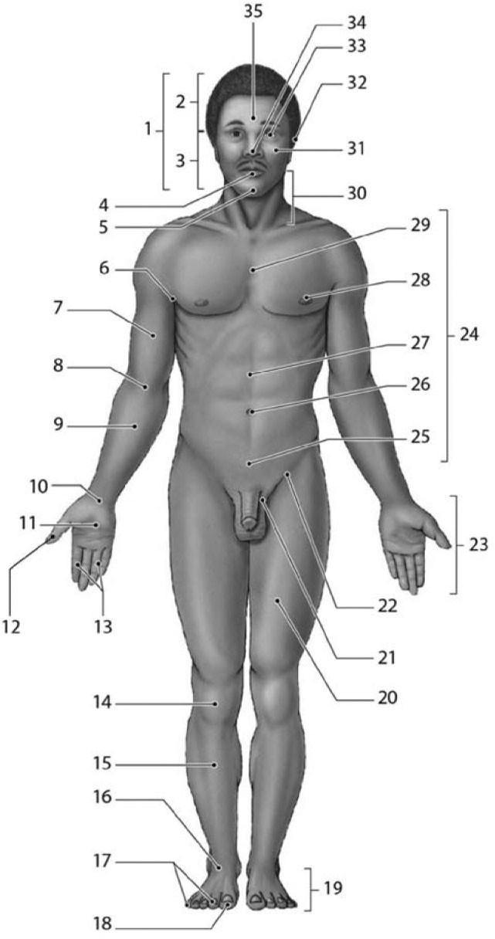

Figure 1-2 Anatomical Landmarks

Use Figure 1-2 to answer the following questions:

62) Which number identifies the cephalon?
A) 24
B) 30
C) 23
D) 10
E) 1
Answer: E
Learning Outcome: 1-7
Bloom's Taxonomy: Remembering

63) Which of the following structures is located superior to the nasus?
A) 35
B) 4
C) 32
D) 5
E) 30
Answer: A
Learning Outcome: 1-7
Bloom's Taxonomy: Remembering

64) Which number identifies the tarsal region?
A) 16
B) 29
C) 10
D) 20
E) 9
Answer: A
Learning Outcome: 1-7
Bloom's Taxonomy: Remembering

65) The leg region (#15) is also known by its anatomical term,
A) tarsal.
B) pedal.
C) patellar.
D) crural.
E) carpal.
Answer: D
Learning Outcome: 1-7
Bloom's Taxonomy: Understanding

66) The pollex is located in which region?
A) 18
B) 23
C) 12
D) 14
E) 16
Answer: C
Learning Outcome: 1-7
Bloom's Taxonomy: Understanding
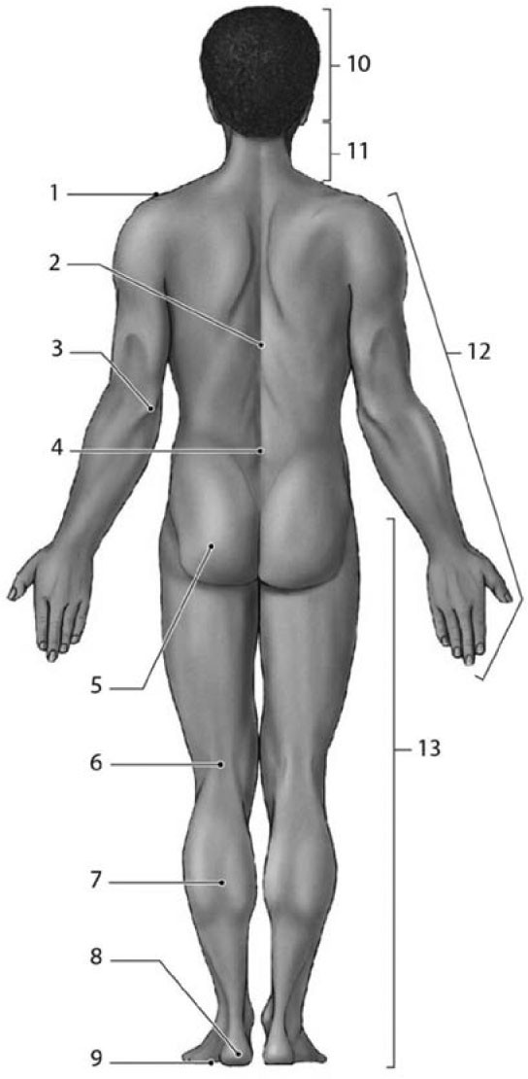

Figure 1-3 Anatomical Landmarks

Use Figure 1-3 to answer the following questions:

67) Which number identifies the olecranal region of the body?
A) 2
B) 3
C) 4
D) 12
E) 13
Answer: B
Learning Outcome: 1-7
Bloom's Taxonomy: Remembering
68) Which number identifies the acromial region?
A) 3
B) 13
C) 2
D) 12
E) 1
Answer: E
Learning Outcome: 1-7
Bloom's Taxonomy: Remembering

69) The kneecap is patellar, whereas the back of the knee is
A) crural.
B) pedal.
C) manual.
D) popliteal.
E) pubic.
Answer: D
Learning Outcome: 1-7
Bloom's Taxonomy: Remembering

70) What is the anatomical term for the calf?
A) crural
B) plantar
C) calcaneal
D) sural
E) tarsal
Answer: D
Learning Outcome: 1-7
Bloom's Taxonomy: Understanding
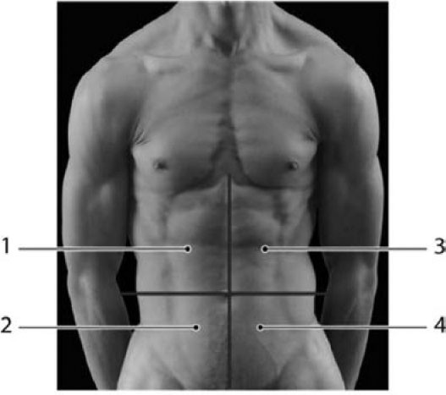
Photo Credit: Custom Medical Stock Photo, Inc.

Figure 1-4 Abdominopelvic Quadrants

Use Figure 1-4 to answer the following questions:

71) Tenderness in which region(s) may be an indication of gallbladder or liver problems?
A) 2
B) 4
C) 1
D) 3 & 4
E) 3
Answer: C
Learning Outcome: 1-7
Bloom's Taxonomy: Understanding

72) The appendix is typically located in which region(s)?
A) 2
B) 4
C) 1
D) 3
E) 1 & 3
Answer: A
Learning Outcome: 1-7
Bloom's Taxonomy: Understanding
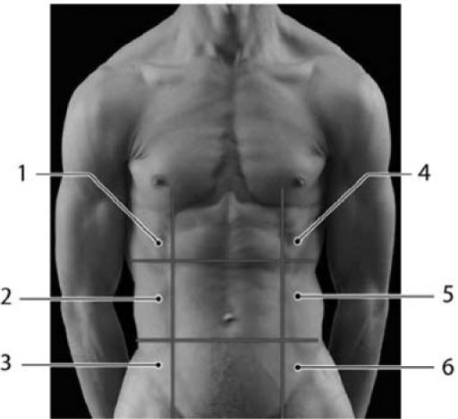
Photo Credit: Custom Medical Stock Photo, Inc.

Figure 1-5 Abdominopelvic Regions

Use Figure 1-5 to answer the following questions:

73) Which of the following is the left inguinal region?
A) 3
B) 6
C) 9
D) 4
E) 8
Answer: B
Learning Outcome: 1-7
Bloom's Taxonomy: Remembering

74) The stomach, spleen, and some of the large intestine together are located in which region?
A) 5
B) 4
C) 1
D) 7
E) 6
Answer: B
Learning Outcome: 1-7
Bloom's Taxonomy: Analyzing

75) The spleen is normally found in which abdominopelvic region?
A) hypogastric
B) left inguinal region
C) right hypochondriac
D) right lumbar region
E) left hypochondriac
Answer: E
Learning Outcome: 1-7
Bloom's Taxonomy: Understanding

76) Choose the directional term to make the following sentence correct.
The knee is ________ to the foot.
A) lateral
B) medial
C) superficial
D) distal
E) proximal
Answer: E
Learning Outcome: 1-7
Bloom's Taxonomy: Understanding

77) The two lines, one vertical and one horizontal, that divide the abdominopelvic area into quadrants cross at the
A) umbilicus/navel.
B) urinary bladder.
C) junction of the small and large intestines.
D) diaphragm.
E) sternum.
Answer: A
Learning Outcome: 1-7
Bloom's Taxonomy: Understanding

78) Mary, who is six months pregnant, goes to her obstetrician for a test to check the development of her fetus. She uses a device that employs sound waves to produce an image of the fetus. This technique is known as
A) an X-ray.
B) a CT scan.
C) an MRI.
D) an ultrasound.
E) radiography.
Answer: D
Learning Outcome: 1-7
Bloom's Taxonomy: Understanding

79) The heart is surrounded by the ________ membrane.
A) pericardial
B) peritoneal
C) visceral
D) serous
E) pleural
Answer: A
Learning Outcome: 1-8
Bloom's Taxonomy: Remembering
80) How is the MRI imaging technique different from a CT imaging technique?
A) One is used for transverse images whereas the other can be used for any orientation of the image.
B) One procedure is cheap and the other is very expensive.
C) One requires the injection of radioactive dyes and the other does not.
D) One uses X-ray technology and the other does not.
E) One is used on superficial problems and the other is used to see inside of the body.
Answer: D
Learning Outcome: 1-8
Bloom's Taxonomy: Understanding

81) The membrane covering the surface of the stomach is named the
A) parietal pleura.
B) visceral pleura.
C) pericardial sac.
D) visceral peritoneum.
E) serous membrane.
Answer: D
Learning Outcome: 1-8
Bloom's Taxonomy: Remembering

82) The membrane covering the surface of the lung is referred to as the
A) visceral pericardium.
B) parietal peritoneum.
C) visceral pleura.
D) serous membrane.
E) mediastinum.
Answer: C
Learning Outcome: 1-8
Bloom's Taxonomy: Remembering

83) The heart, lungs, and small intestine are in body cavities located on the ________ side of the body.
A) dorsal
B) proximal
C) sagittal
D) ventral
E) superficial
Answer: D
Learning Outcome: 1-8
Bloom's Taxonomy: Understanding

84) The diaphragm separates the ________ cavity from the ________ cavity.
A) pleural; mediastinum
B) thoracic; abdominopelvic
C) pericardial; pleural
D) abdominal; pelvic
E) pericardial sac; pericardial
Answer: B
Learning Outcome: 1-8
Bloom's Taxonomy: Understanding
85) The main function of a serous membrane is to
A) reduce friction.
B) protect organs.
C) allow blood to pass.
D) hold organs together.
E) fill empty spaces.
Answer: A
Learning Outcome: 1-8
Bloom's Taxonomy: Understanding

86) The peritoneal cavity contains the
A) heart.
B) small intestine.
C) lungs.
D) diaphragm.
E) thymus.
Answer: B
Learning Outcome: 1-8
Bloom's Taxonomy: Understanding

87) The inner surface of the abdominal body wall is lined by which serous membrane?
A) visceral pleura
B) visceral pericardium
C) visceral peritoneum
D) parietal pleura
E) parietal peritoneum
Answer: E
Learning Outcome: 1-8
Bloom's Taxonomy: Understanding

88) The mediastinum separates ________ from the ________.
A) the pleural cavity; coelom
B) the thoracic cavity; peritoneal cavity
C) one pleural cavity; other pleural cavity
D) the abdominal cavity; pelvic cavity
E) the pericardial sac; pericardial cavity
Answer: C
Learning Outcome: 1-8
Bloom's Taxonomy: Understanding

89) A small, low-caliber bullet has entered your chest at an angle, through the right lung and then the heart. It is now lodged in heart muscle. The surgeon will have to open some closed cavities of the body and enter those spaces to remove the bullet. What is the order of the cavities and the correct cavities that the surgeon will have to open (starting from the outside)?
A) the pleural cavity, the thoracic cavity, the pericardial cavity
B) the thoracic cavity, the pleural cavity, the mediastinum, the pericardial cavity
C) the thoracic cavity, one pleural cavity, other pleural cavity, pericardial cavity
D) the abdominal cavity, the pleural cavity, the pericardial cavity
E) the thoracic cavity, the pleural cavity, the pericardial cavity, the mediastinum
Answer: B
Learning Outcome: 1-8
Bloom's Taxonomy: Analyzing
1.2 Essay Questions

1) It is a warm day and you feel a little chilled. On checking your temperature, you find that your body temperature is 1.5 degrees below normal. Suggest some possible reasons for this situation.
Answer: There are several reasons why your body temperature may have dropped. Your body may be losing heat faster than it is being produced. This, however, is more likely to occur on a cool day. Various chemical factors, such as hormones, may have caused a decrease in your metabolic rate, and thus your body is not producing as much heat as it normally would. Alternatively, you may be suffering from an infection that has temporarily changed the set point of the body's "thermostat." This would seem to be the most likely explanation considering the circumstances given in the question.
Learning Outcome: 1-5
Bloom's Taxonomy: Analyzing

