**Test Bank**

by Natalie Zayas

to accompany

***Environmental Science: Science-Based Problem Solving in Today’s World***

Karen V. Root and RAMAS®

**Chapter 2: Risk and Uncertainty**

**Multiple Choice**

1. _______ choices about environmental problems involve _______.

a. Most; clear and present dangers

b. Few; clear and present dangers

c. Most; low risk so decisions are easy to make

d. Few; any risk and decisions are easy to make

e. All; high risk and require fast decisions and actions

Answer: b

Textbook Reference: Introduction to Risk and Uncertainty

Bloom’s Category: 2. Understanding

2. Which term best defines the following statement: “The chance of a disaster is low and the timing is unpredictable.”

a. Risk

b. Actual risk

c. Stochastic

d. Subjective decisions

e. Typicality

Answer: c

Textbook Reference: Introduction to Risk and Uncertainty

Bloom’s Category: 1. Remembering

3. Which academic discipline has shown that people are subject to biases in their decision-making?

a. Environmental science

b. Physics

c. Sociology

d. Economics

e. Psychology

Answer: e

Textbook Reference: Introduction to Risk and Uncertainty

Bloom’s Category: 1. Remembering

4. The statement “I am not concerned about food shortages occurring because scientists and technology will find solutions to the problem.” is an example of

a. discounting.

b. risk-sensitivity.

c. evolutionary response.

d. typicality.

e. availability effect.

Answer: a

Textbook Reference: Introduction to Risk and Uncertainty

Bloom’s Category: 2. Understanding

5. Current energy resources from fossil fuels have finite limits. Humans continue to consume energy at high levels. With growing populations more energy will be needed.

Which of the following is the best solution?

a. We can continue current consumption levels because technologic advances will solve the problem.

b. Conservation is necessary now and should be mandated by governments.

c. Education and conservation can solve the entire energy resource problem now, but we can wait.

d. We should conserve energy resources until we discover more fossil fuels.

e. A mix of alternative sources is needed now as we continue to use the fossil fuel sources we have.

Answer: e

Textbook Reference: Introduction to Risk and Uncertainty

Bloom’s Category: 5. Evaluating

6. You are hired to implement a plan to increase food production. Which plan would you implement when you consider risk?

a. Encourage agricultural farmers to increase production by using more pesticides so they can grow more food without the pests affecting the crops.

b. Hire biotechnology scientists to find ways to grow crops in ways that will increase food production even if we are uncertain about the effects of the crops grown in this way.

c. Hire sociologists to study populations and then get medical professionals to educate the populations on limiting the number of children they have.

d. Gather medical, agricultural, and biotech professionals and environmental scientists to devise a plan to grow more food crops.

e. All of the above

Answer: d

Textbook Reference: Decisions in the Face of Uncertainty

Bloom’s Category: 3. Applying

7. Scientists have studied the impact of clear cutting forests on erosion and waterways. They know that clear cutting will cause erosion and waterways will suffer the impact of sediment loading. Evaluate the situation and choose the statement that best explains how humans may perceive the risks involved.

a. Since the chance of disaster is low humans will not have biases about this situation.

b. Although the seriousness of the impact is well known people’s judgment may still vary dramatically.

c. All people understand this situation and will work together on a solution.

d. Both a and c

e. None of the above

Answer: b

Textbook Reference: Decisions in the Face of Uncertainty

Bloom’s Category: 5. Evaluating

8. Which of the following statements about risk-sensitivity is true?

a. Humans are usually risk-prone but never risk-averse or risk-sensitive.

b. Humans are usually risk-averse but always risk-prone and risk-sensitive.

c. Humans are never risk-sensitive but always risk-averse and risk-prone.

d. Humans are usually risk-sensitive, but not always consistently risk-prone or risk-averse.

e. Humans are never risk-averse, but always consistently risk-prone and risk-sensitive.

Answer: d

Textbook Reference: Decisions in the Face of Uncertainty

Bloom’s Category: 2. Understanding

9. On March 11, 2011, an earthquake and resulting tsunami caused the Fukushima Daiichi Nuclear Power Station to be shut down. There were fears of a major nuclear meltdown. This event was in the media all over the world. As with most situations like this there were reports of serious problems and conflicting reports that the problems would be controlled and were not serious. If the general opinion of nuclear energy had taken a positive turn in the world, a situation like this may influence opinions of the risk involved in nuclear energy. This is an example of what category of error?

a. Risk-sensitivity

b. Typicality

c. Excessive discounting

d. Risk-prone

e. Risk-averse

Answer: b

Textbook Reference: Decisions in the Face of Uncertainty

Bloom’s Category: 3. Applying

10. People tend to be risk-averse when

a. paying taxes is a loss.

b. there is a 50% chance of gaining nothing.

c. given two choices and the gains for either choice would be the same.

d. the preference is for the uncertain with the thought that it will bring the most gains.

e. the options given all result in a positive outcome for all involved.

Answer: c

Textbook Reference: Decisions in the Face of Uncertainty

Bloom’s Category: 2. Understanding

11. An investor is faced with the option of putting money into a savings account with a 2% interest rate that is guaranteed or a stock account that has a higher expected return rate of 6% but is not guaranteed. The investor chooses the stock account because they enjoy the excitement of the possibility of a higher payoff. This is an example of

a. risk-aversion and discounting.

b. neutrality only.

c. risk-sensitivity.

d. discounting only.

e. risk-sensitivity and being risk-prone.

Answer: e

Textbook Reference: Decisions in the Face of Uncertainty

Bloom’s Category: 2. Understanding

12. A community is faced with making a decision about a development project that will bring much-needed housing and jobs. Unfortunately the development project has not factored in erosion that may affect the river that runs through town. The town is split on the decision. The certain payoff is jobs and housing. The uncertain payoff is how this development project will affect the river. Those who prefer to move ahead with the development project are considered to be

a. risk-averse.

b. risk-sensitive.

c. risk-prone.

d. Both a and c

e. Both b and c

Answer: d

Textbook Reference: Decisions in the Face of Uncertainty

Bloom’s Category: 3. Applying

13. Choose the correct interpretation of the charts below. (Note: The *x*-axes represent the benefit; the *y*-axes represent the utility.)

Chart A Chart B

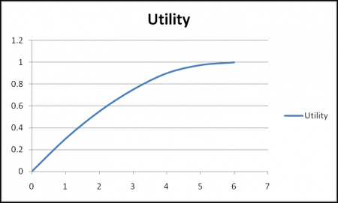 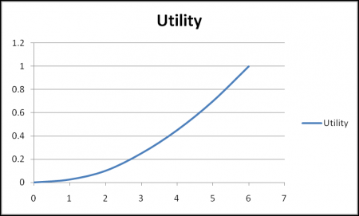

a. Chart A represents risk-aversion and chart B represents risk-neutral.

b. Chart A represents risk-prone and chart B represents risk-aversion.

c. Chart A represents risk-prone and chart B represents risk-sensitive.

d. Chart A represent risk- aversion and chart B represents risk-prone.

e. Both chart A and chart B show risk-aversion.

Answer: d

Textbook Reference: Decisions in the Face of Uncertainty

Bloom’s Category: 4. Analyzing

14. Some environmental scientists have interviewed residents in a community where there are many fuel processing plants. It seems that there is a high cancer rate in the area. Which of the following will provide the scientists with the data they need for 100% certain results that the cancer rates are directly correlated to the fuel processing plants?

a. Surveys of residents affected by cancer and how close they live to the processing plants

b. Blood tests of those with cancer who live near the processing plants

c. Blood tests of people before they move near the plants and then a few years later after living near the plants

d. All of the above

e. None of the above

Answer: e

Textbook Reference: Decisions in the Face of Uncertainty

Bloom’s Category: 4. Analyzing

15. Referring to the graph below, which of the following equations is true?

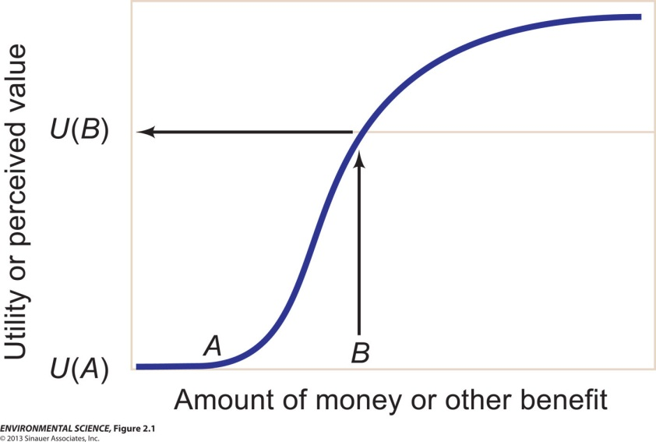

a. *U*(*B*) = *U*(*A*)

b. *U*(*B*) < *U*(*A*)

c. *U*(*B*) > *U*(*A*)

d. Both a and c are possible

e. None of the above

Answer: c

Textbook Reference: Risk and Uncertainty

Bloom’s Category: 1. Remembering

16. Community activists want to get residents of a town to support legislation that bans a pesticide that the activists feel is harmful to human health. The town depends on agriculture for jobs. The education level of the town is low and the poverty level is high. The pesticide in question has shown to increase crop production and more farmers are using it because it allows them to grow more and hire more people. There are scientific studies that show that the pesticide is harmful if those working in the fields do not take certain precautions such as protective clothing. The best way for the activists to persuade the residents to support the legislation would be to

a. tell them what they think are the harmful effects of the pesticide.

b. understand human decision-making so they can change how the people perceive the problem.

c. invite farmers to the meeting to explain the chemicals in the pesticide.

d. have the residents read all of the scientific studies.

e. have the residents brainstorm on ways to create jobs that do not involve agriculture.

Answer: b

Textbook Reference: Decision-Making and Environmental Science

Bloom’s Category: 5. Evaluating

17. When a situation is presented in such a way that some of the options are seen as gains and others are seen as losses but the outcome is the same, it is called

a. discounting.

b. risk-adverse.

c. risk-prone.

d. framing.

e. typicality.

Answer: d

Textbook Reference: Decision-Making and Environmental Science

Bloom’s Category: 1. Remembering

18. When decision-making is influenced by a recent environmental disaster or lack of one, it is called

a. typicality.

b. framing.

c. excessive discounting.

d. stochasticity.

e. risk-adversion.

Answer: a

Textbook Reference: Decision-Making and Environmental Science

Bloom’s Category: 1. Remembering

19. Which of the following statements about excessive discounting is *false*?

a. Discounting future outcomes relative to present ones makes good sense if someone is young, as they may not live to see the benefits of a decision.

b. The money value of a benefit will change with inflation, so a given future benefit is worth less in present-day currency, which gives discounting validity.

c. The future is unpredictable; policies and governments change, thus making a future agreement regarding the environment also change.

d. Individuals and institutions making decisions about environmental problems may not make sound analyses of the future value of such decisions.

e. When an environmental disaster occurs during a decision-making process, the current event will have an effect on the decision made.

Answer: e

Textbook Reference: Decision-Making and Environmental Science

Bloom’s Category: 4. Analyzing

20. _______ is a state of uncertainty where some of the possibilities involve a loss, catastrophe, or other undesirable outcome.

a. Risk

b. Typicality

c. Risk aversion

d. Availability effect

e. Excessive discounting

Answer: a

Textbook Reference: Decision-Making and Environmental Science

Bloom’s Category: 1. Remembering

21. Recent news about fires due to droughts and excessively high temperatures in parts of the United States and flash floods in Eastern Europe are events that might cause people to _______ when making environmental decisions regarding climate change.

a. use discounting

b. use risk-prone behaviors

c. use typicality

d. be neutral

e. consider delayed rewards

Answer: c

Textbook Reference: Decision-Making and Environmental Science

Bloom’s Category: 2. Understanding

22. Which of the following is an example of the typicality effect?

a. You notice that for the past few years the winters are colder than they used to be and you decide this is evidence of climate change.

b. You notice that winters have had about the same temperatures as you normally experience and climate change must be a hoax.

c. You learn that your town is deciding to build wind turbines to create a sustainable energy source to promote jobs and slow climate change.

d. You feel that the government should not make decisions to end coal production to slow the effects of climate change since it will take a long time and be very expensive.

e. You want policy-makers to establish policies based on economics and not on science so the economy is in good condition.

Answer: a

Textbook Reference: Decision-Making and Environmental Science

Bloom’s Category: 3. Applying

23. Which of the following is an example of discounting?

a. A recent environmental disaster at a nuclear power company causes concern about the safety of nuclear energy.

b. The demographics of a town show that 90% of the residents are over the age of 60. The town wants to implement a plan to reduce greenhouse emissions that will incur high financial costs and will take at least 25 years to show results.

c. A town has the choice of spending $3,000 with the possibility of earning over $10,000 if they decide to build a large solar farm in the next month.

d. All of the above

e. None of the above

Answer: b

Textbook Reference: Decision-Making and Environmental Science

Bloom’s Category: 2. Understanding

24. Which of the following statements is true?

a. There is too much uncertainty in science to help measure the probability of outcomes of decisions made regarding environmental issues.

b. Making decisions regarding environmental issues based on science has a high level of risk due to the uncertainty of measurements in science.

c. Science can help measure the probability of any particular outcome and help humans make better decisions based on the risks involved.

d. Policy-makers are in the best position to be the most helpful in making environmental decisions since they will look at risk based on human emotions and science.

e. Environmental problems have consistently predictable outcomes that allow for policy-makers, scientists, and the general public to make sound decisions for positive outcomes.

Answer: c

Textbook Reference: Decision-Making and Environmental Science

Bloom’s Category: 2. Understanding

25. An investor is faced with a decision of investing $5,000. The investor is in no hurry to cash in on their gains and is considered risk-averse. Which option should they choose?

|  |  |  |
| --- | --- | --- |
| **Rate** | **Guaranteed or not?** | **Payout in # of years** |
| 2% | Yes | 4 |
| 3% | Yes | 2 |
| 6% | Yes | 1 |
| 10% | No | 1 |

a. The 2% rate, because it is the longest payout

b. The 3% rate

c. The 6% rate, because it is the highest guaranteed return

d. The 10% rate, because the risk is worth the higher return

e. Either the 2% rate or the 6% rate, as they both offer the same total return

Answer: a

Textbook Reference: Decision-Making and Environmental Science

Bloom’s Category: 2. Understanding

**Short Answer**

1. Discuss three reasons why people tend to ignore or discount future outcomes of environmental decisions.

Answer: 1) Someone may not live long enough to see the outcomes of a decision made today which may make them decide that the environmental problem is not worth their time in solving. 2) Inflation. 3) Advances in technology may solve the environmental problem without people needing to change their behavior.

Textbook Reference: Introduction to Risk and Uncertainty

Bloom’s Category: 2. Understanding

2. Compare and contrast the following scenario in relation to risk-sensitivity, being risk-prone or risk-averse: Two people are searching for jobs. Person A has been out of work for 8 months and is on unemployment, but it’s about to expire. She is offered a job that pays slightly higher than her unemployment. Person B has a current job that pays a good wage but she is looking for a new job because she is ready for a career change. She also applied for the same job as Person A and is also offered a position. The job pays less than her current salary. Based on what you have learned in this chapter, what decision will each person make, and why?

Answer: Humans tend to be risk-sensitive since they judge the value of a benefit relative to the benefit they already possess. In this example, the person without a job for a long time sees a benefit from obtaining a job that pays, whereas someone who has a job and wants to make a career change does not benefit at all from a job that pays a lower wage. Person A will take the job and person B will most likely not accept the position.

Textbook Reference: Decisions in the Face of Uncertainty

Bloom’s Category: 4. Analyzing

3. Describe perceived risk and give an example.

Answer: Perceived risk is when someone subjectively decides that there is too much risk involved in a decision. For example, there is a small but contained leak at a nuclear power plant and people decide that all nuclear power plants are dangerous.

Textbook Reference: Decisions in the Face of Uncertainty

Bloom’s Category: 2. Understanding

4. According to psychologists, people tend to be risk-sensitive. What does this mean?

Answer: When people are risk-sensitive they prefer a certain or uncertain outcome much more than the other.

Textbook Reference: Decisions in the Face of Uncertainty

Bloom’s Category: 2. Understanding

5. Categorize the following people in relation to risk:

Person 1: Given two investments with different levels of riskiness, considers only the expected return from each investment

Person 2: Given two investments with the same return and different levels of risk, chooses the less risky investment

Person 3: Given two investments, more likely to invest in a new, unknown company over investing in a well-known and trusted company

Answer: Person 1 is considered to be risk-neutral; Person 2 is risk-adverse; Person 3 is risk-prone.

Textbook Reference: Decisions in the Face of Uncertainty

Bloom’s Category: 3. Applying

6. Defend the following statement: “Using excessive discounting based on adult mortality rates is not feasible in making environmental decisions.”

Answer: Basing environmental decisions on someone’s life span (as in them not being around to see benefits of changes enacted while they are still alive) is a selfish way of dealing with environmental concerns. Until humans can see the long-term effects of what we do (positive and negative), environmental change will continue to be difficult.

Textbook Reference: Decision-Making and Environmental Science

Bloom’s Category: 5. Evaluating

7. When people sit down to discuss an environmental concern, such as air pollution, what are some possible points of disagreement?

Answer: The decision will largely depend on how those involved in the decision discount future benefits relative to current ones. Their biases will play a part in disagreement. For example, an industry might foresee spending more money to clean up the air, whereas an environmental scientist looks at the effect on ecosystems, and a medical doctor looks at the health of people.

Textbook Reference: Decision-Making and Environmental Science

Bloom’s Category: 5. Evaluating

8. Suppose you are in charge of holding a series of meetings with various groups, businesses, and government officials to devise a plan to deal with high levels of arsenic in the water supply. Your town has not had to use this water supply yet but estimates indicate that since the town population is growing, the water will be needed within the next 15 years. What guidelines could you establish to avoid some of the disagreements that may occur in decision-making?

Answer: Have the various stake-holders prepare statements with the requirement that all statements have factual references and examples of current policies successfully enacted in other places that relate to their positions. This might avoid bias and subjective statements.

Textbook Reference: Decision-Making and Environmental Science

Bloom’s Category: 3. Applying

9. How can bias affect the decision-making process in relation to environmental issues? Give an example to help explain your answer.

Answer: Since people are prone to bias, biases can be such that decisions can seem irrational. For example, a farmer may be against water quality regulations that will cost the farmer money in monitoring and staff. This bias will seem irrational to an environmentalist who wants to keep the water supply safe and the aquatic ecosystem in good health.

Textbook Reference: Decision-Making and Environmental Science

Bloom’s Category: 2. Understanding

10. Do you feel framing is beneficial or can it be used negatively? Compare and contrast the use of framing.

Answer: Framing is useful when getting people to make decisions since choices about the environment involve uncertain results and people tend to make subjective decisions. Framing can be used to put situations into terms so subjective decision-makers can make better choices. Framing can also be used to get people to make a decision that goes the way those in charge want it to go since it involves putting a situation into terms that can seem favorable or not.

Textbook Reference: Decision-Making and Environmental Science

Bloom’s Category: 5. Evaluating