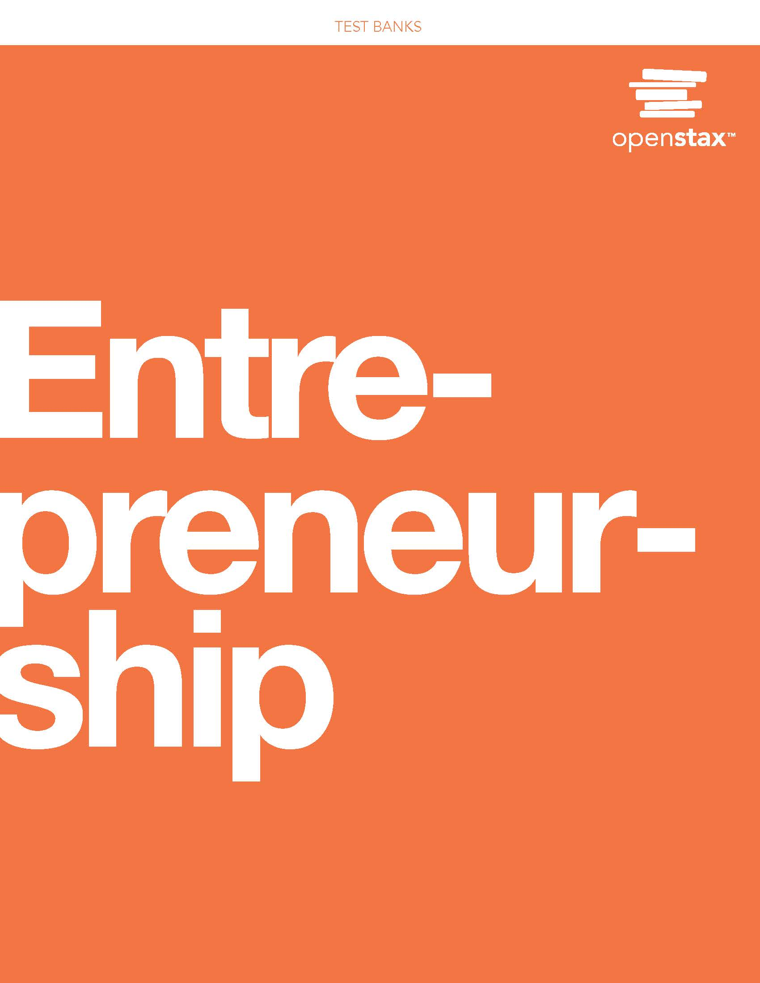

## Chapter 1: The Entrepreneurial Perspective

**\* = Correct answer**

**Multiple Choice/Fill in the Blank**

1. Which of the following is an example of an entrepreneur?

A. innovator*

B. market leader

C. nonprofit

D. strategist

Difficulty: Moderate

1. Which of the following *best* describes expanders and scalers’ approach to venturing?

A. innovating or reinventing markets from a future perspective

B. making something new or seeing a new problem

C. seeking out opportunities to expand processes, products, or creating methods*

D. finding new approaches and outlooks to venturing

Difficulty: Moderate

1. All of the following *except* ________ describe entrepreneurs.

A. activists

B. corporate rebels

C. corporate sponsors*

D. non conformists

Difficulty: Easy

1. Which of the following is an example of a lifestyle venture?

A. McDonald’s

B. Sharkits

C. Wander Girls*

D. Warby Parker

Difficulty: Easy

1. Which of the following is *not* an example of a lifestyle venture?

A. organizing trips and events for women traveling to India

B. making candles to earn money to support her family

C. starting a fashioned focused eyeglass company*

D. creating a pasta company to increase jobs in Maine

Difficulty: Easy

1. Which of the following is a way that you can put your strengths to work?

A. thinking about achievements you have accomplished*

B. identifying paths to entrepreneurship

C. making a decision to become an entrepreneur

D. giving greater freedom for opportunities

Difficulty: Moderate

1. Which is *not* a contributing factor to the desire to become an entrepreneur?

A. certainty of employment and income*

B. combination of retirement and longer life expectancy

C. excitement and fun of creating something new

D. moving a concept to materialization of an idea

Difficulty: Moderate

1. What element(s) of potential success are crucial beyond simply having an entrepreneurial mindset?

A. access to a larger pool of money

B. funding and education*

C. having an angel investor and a team

D. the number of businesses in your country

Difficulty: Moderate

1. What is institutional venture capital?

A. entrepreneurs who fund their own startup ventures

B. group of people pooling money to invest in ventures*

C. money from family and friends

D. those who provide funding early in a venture

Difficulty: Easy

1. Which factor does not influence entrepreneurial activity?

A. bank funding*

B. employment rates

D. government policies

C. trade issues

Difficulty: Easy

1. What systems discourage people from coming forward with entrepreneurial ideas? (Select all that apply.)

A. bureaucratic prevention of access to information*

B. corruption within an economy*

C. sustainable production within an economy

D. valuing self-reliance and ingenuity

Difficulty: Moderate

1. Which of the following is a key characteristic that encourages entrepreneurship?

A. access to funding through bank channels

B. geopolitical mindset

C. group-prescribed conformity

D. support for freedom to innovate*

Difficulty: Moderate

1. What are examples of entrepreneurship education that are driving growth? (Select all that apply.)

A. More colleges are teaching entrepreneurship through classes and clinics.*

B. Most universities are offering funding to young entrepreneurs.

C. Students are connecting with business ideas.*

D. Students receive scholarships for studying entrepreneurship.

Difficulty: Moderate

1. Which answer *least* describes the entrepreneurial aspect of Starbucks?

A. Its founder wanted to establish an American coffee empire.*

B. There were few coffee shops in the US with a European flair.

C. They wanted to compete with McDonalds and Dunkin Donuts which serve coffee.

D. They wanted to focus on producing high-quality coffee.

Difficulty: Moderate

1. Which of the following is *not* an example of a social-environmental entrepreneurial problem?

A. concern for quality of life

B. concern about pollution

C. concern for government funding*

D. concern for air quality

Difficulty: Moderate

1. How is a serial entrepreneur different than a social entrepreneur?

A. A serial entrepreneur is someone who starts multiple nonprofit ventures, while a social entrepreneur is someone who starts only one nonprofit venture.

B. A serial entrepreneur is someone who someone who focuses on solving a problem, while a social entrepreneur is someone who starts multiple entrepreneurial ventures.

C. A serial entrepreneur is someone who starts multiple entrepreneurial ventures, while a social entrepreneur is someone who focuses on solving a problem.*

D. A serial entrepreneur is someone who starts multiple for-profit ventures, while a social entrepreneur is someone who starts only one for-profit venture.

Difficulty: Difficult

1. Why is the United States a country that “grows” successful entrepreneurs?

A. because there are many immigrants

B. because there are few prescribed conformity traditions*

C. because of affinity marketing supporting immigrants

D. because there are a lot of retirees with pensions

Difficulty: Moderate

1. Which country is *most* attractive for entrepreneurial ventures?

A. Australia*

B. Mexico

C. Netherlands

D. Scotland

Difficulty: Moderate

1. Which of the following *best* describes an entrepreneurial mindset?

A. desiring to take business risk for growth*

B. having an entrepreneurial education

C. having sufficient venture capital funding

D. knowing what business will be successful

Difficulty: Moderate

1. What are the commonalities between an angel investor and a venture capitalist? (Select all that apply.)

A. They both have funding and a focus on lending money.*

B. They both have an interest in helping other entrepreneurs in their startups.*

C. They both provide funding at all stages of an investment.

D. They both are former entrepreneurs who have launched and harvested their own ventures.

Difficulty: Difficult

**True/False**

1. True or false? Evernote cofounder, Phil Libin, said that changing the world is the only legitimate reason to start a company.

Answer: True

Difficulty: Easy

1. True or false? Part of the entrepreneurial perspective is solving problems to make lives easier.

Answer: True

Difficulty: Easy

1. True or false? There is only one type of entrepreneur.

Answer: False

Difficulty: Easy

1. True or false? Innovators make something new or see a problem that other people have not noticed.

Answer: False

Difficulty: Moderate

1. True or false? Because of the stress of starting a business, entrepreneurs tend to have shorter life expectancies.

Answer: False

Difficulty: Moderate

1. True or false? Entrepreneurs launch only for-profit ventures.

Answer: False

Difficulty: Easy

1. True or false? Most theorists believe there is only one definition of entrepreneurial success, which is to make money.

Answer: False

Difficulty: Moderate

1. True or false? The Burt’s Bees product line grew from an idea for a lifestyle entrepreneurial venture into a major company.

Answer: True

Difficulty: Easy

1. True or false? Social entrepreneurs only start nonprofits.

Answer: False

Difficulty: Difficult

1. True or false? An opportunity-identifying perspective determines how a problem can be translated into a new opportunity to create a new venture.

Answer: True

Difficulty: Easy

1. True or false? Outside of the United States, there are few entrepreneurial ventures.

Answer: False

Difficulty: Easy

1. True or false? When a venture grows, less money is typically needed as early funding will yield greater profitability returns.

Answer: False

Difficulty: Moderate

35. True or false? United States venture capitalists have contributed more money than European and Chinese deals combined.

Answer: True

Difficulty: Moderate

36. True or false? Serial entrepreneurs focus on passion projects.

Answer: False

Difficulty: Difficult

**Short Answer**

1. What is an entrepreneur and what is an entrepreneurial venture?

Sample Answer: An entrepreneur recognizes and acts on an idea or problem that no one else has recognized or acted on. Entrepreneurial new creations can include a new process or product, a business that identifies a new or unique target market, or a combination of ideas that creates a new approach or method. The creation of any business, organization, project, or operation of interest is categorized as an entrepreneurial venture if it includes a level of risk in acting on an opportunity that has not previously been established. This can be a for-profit venture or a nonprofit venture that focuses on social needs.

Difficulty: Easy

1. What is the difference between a small business owner and an entrepreneur?

Sample Answer: The difference between a small business owner and an entrepreneur is centered on working within an established model versus creating something new. A small business owner owns or starts a business that already has an established, existing model, such as a restaurant. An entrepreneur recognizes and acts on the opportunity to bring something new to the world. Some academics argue that there is no difference, while others consider entrepreneurs and small business owners to be interchangeable.

Difficulty: Easy

1. Are there situations where a small business owner is not an entrepreneur or vice versa?

Sample Answer: A small business owner may also be an entrepreneur, but they are not mutually exclusive. Someone may start a venture that is not a completely new idea but one that introduces a product or service to a new region or market. That person can launch a small business or just be entrepreneurial. There is also the example of a franchisee, who may not be a small business owner. Franchisees are usually considered less inspired to design their own venture and want to contract with an existing business to utilize their infrastructure, product or service, and business model. This entails purchasing the rights to launch a franchise or of an existing business. Oftentimes these individuals become small business owners. Entrepreneurs instead are known for their own creative ideas and inspiration which may involve activities that are not limited by size.

Difficulty: Moderate

1. What are the lessons learned about approaching investors from the startup story of Warby Parker?

Sample Answer: When the founders of Warby Parker approached an angel investor, they were still working their normal jobs. The angel investor took that to mean that Gilboa and Blumenthal were not fully committed to the venture. Despite the investor’s advice, Gilboa and Blumenthal continued working their day jobs while building their venture, and eventually Warby Parker became highly successful. The lesson learned is that a venture needs dedication and investors want that to be demonstrated by founders.

Difficulty: Moderate

1. What happens in a funding round?

Sample Answer: In a funding round, investors give funds in exchange for an equity stake in the venture. Investors expect that they will eventually receive a return on their investment when the venture is sold or harvested. VCs usually have access to larger amounts of money and resources than individual angel investors since they work together in larger groups.

Difficulty: Easy

1. What about Angad Daryani’s inventions defines him as an entrepreneur, and how has he exemplified serial and social entrepreneurship?

Sample Answer: Angad Daryani has launched multiple products, including Sharkits and the SharkBot printer. Because he repetitively starts and harvests ventures, he is a serial entrepreneur. He also focuses on solving human problems such as air pollution and blindness. Since he attempts to solve social, environmental, and economic problems, he is also considered a social entrepreneur.

Difficulty: Moderate

1. What is Saudi Arabia’s history of entrepreneurship, and what has it done to increase its support of venturing?

Sample Answer: Historically, Saudi Arabia has not been a leader in entrepreneurship because employment was relatively stable, depending on state support from oil revenue. Recently, though, the unemployment rate has increased, and a large percentage of the population is in their prime earning years. The population has also recently wanted to be more productive and have more control over their resources, especially since leaders realize that oil production is not a sustainable industry. Saudi Arabia has more future-oriented leaders and can use bank funding, lending programs, or tax incentives to encourage their citizens to start their own businesses.

Difficulty: Moderate

1. Explain how a serial entrepreneur would define success and provide examples.

Sample Answer: Success for a serial entrepreneur means launching and harvesting multiple businesses.

Sir Richard Branson is a well-known serial entrepreneur who began with a mail-order record business that became the Virgin Group with over 200 diversified companies. This includes an airline, music, companies, beverages and clothing. He also has expanded to the travel industry with hotels and vacation packages. Another example is the late Wayne Huizenga who became a business tycoon with diverse business interests including garbage pickup, automotive sales, and video rental. He also founded six public companies and owned several sports team. Like other serial entrepreneurs, he did not stop with his first success but kept investing time, money, and effort into diversified business development.

Difficulty: Difficult

1. How do a country’s culture and traditions influence entrepreneurship?

Sample Answer: A country’s culture and traditions can either encourage or discourage entrepreneurship. For example, since America has a tradition of individualism, ingenuity, and self-reliance, entrepreneurship is reinforced. On the other hand, some countries have governments that discourage independent or innovative thinking, which impedes entrepreneurship. If a culture prioritizes unity, not being noticed, blending in, and following prescribed habits and traditions, like in Japan, France, Russia, and China, entrepreneurship is deterred.

Some countries are not able to quickly respond within their complex bureaucracies, which discourages entrepreneurship. Some nations, especially the poor, are often excluded from parts of worldwide economic structures (banking, investments, and technology) that are necessary for entrepreneurship. If people don’t have access to information that is necessary for the successful advancement of an idea, entrepreneurship is hindered.

Difficulty: Difficult

1. What causes a passion project to become an entrepreneurial venture? Give examples from outside the text.

Sample Answer: It appears that ventures start off as passion projects, and if successful, they are viewed as entrepreneurial. The link to business legitimacy seems to be funding and commercial success. There is the reality that many entrepreneurs are not serial or successful. One example is the Cinnamon Snail which is a New York-based food truck offering vegan treats. It relied on a storefront at the Pennsy, a food court. When Pennsy announced its closure, Cinnamon Snail realized that it had no central location, and it made sense to close shop as well. Some projects are just for social or community purposes and may only last a few years. They are not funded by angel investors or major research universities like MIT and rarely, if ever, are bought out by a conglomerate like Clorox. Then there are ideas of established businesspersons like Oprah Winfrey, who launched a very successful cable station (Oxygen) and network (OWN).

Difficulty: Difficult

1. Based on Johann Hari’s Ted Talk, what social ventures could be created to combat addiction?

Sample Answer: Johann Hari explained the psychology behind addiction and how to rethink how to help addicts. Individuals like him with personal backgrounds and histories that inform recovery could become social entrepreneurs that find solutions to supporting addiction recovery. A business model could include leveraging recovery solutions and perhaps launching recovery clinics or halfway housing and providing grants or support to those in recovery. The initiative could also include further community education and publicity about helping others. This would combine a social need with a business operation and success would be measured by those persons that overcome their addictions and achieve a better quality of life.

Difficulty: Difficult

1. Explain why retirees are ripe for entrepreneurial ventures.

Sample Answer: For many people, the ample time that comes with retirement is unfulfilling compared to working. Depending on an individual’s planning and savings, retirement can also bring new financial considerations. Some retirees have accumulated money but need or want to still work, with the awareness that they do not have to earn a full salary. Some older adults want to continue earning, and retirement gives them the time to do so.

Difficulty: Moderate

1. Discuss the factors that inhibit the growth of entrepreneurship.

Sample Answer: If a country has a higher employment rate, indicating the availability of many jobs and higher wages, then that would yield fewer persons seeking entrepreneurial opportunities. Another factor is retirement savings and governmental support of pensioners, which may inhibit older persons from working past retirement age. Additionally, if companies focus on internal venture development, that may decrease the amount of angel investors and venture capitalists, which limits the amount of funding available to entrepreneurs. Furthermore, if a bank or lending policy becomes more restrictive for small business development, entrepreneurial growth is inhibited.

Difficulty: Difficult

1. Evaluate and explain whether you think that entrepreneurship is a viable career choice.

Sample Answer: When someone has their own business, they may not be able to pay themselves and are expected to use their own bootstrapping or funds and sweat equity to start and maintain the business. Some small business owners accumulate significant debt and have to borrow money from family and friends, without a realistic return on that capital. When you have your own business, you may have to do all the work associated with it and that can be a time constraint as well as stressful. Entrepreneurs are expected to not only have strategic thoughts and ideas, but also to perform, in some cases, all work functions including administrative, operational, and executive. Many businesses close after a few years because they are not successful. Thus, this career path may not be ideal for some.

For some individuals, entrepreneurship provides an ideal career path. It enables them to leverage their creativity and establish work-life balance. Oftentimes people succeed due to drive and inspiration and achieve a sense of personal accomplishment.

Difficulty: Difficult

This file is copyright 2020, Rice University. All Rights Reserved.