MULTIPLE CHOICE QUESTION BANK

Chapter 1: Introduction
1. Which of the following statements is true (only one):
a. The growth rate of energy consumption has kept pace with GNP growth.
b. Oil use has expanded more than any other fuel since 1940.
c. We reached the point last year where we imported no oil.
d. Electricity use has actually fallen since 1975.

Answer: b

2. Which of the following is a non-renewable resource?
a. uranium b. water c. wind d. biomass e. radiant solar

Answer: a

3. Today, the U.S. imports about what percentage of the oil it uses?
a. 10% b. 25% c. 40% d. 60% e. 80%

Answer: d

4. One of the primary motivating forces behind our per capita reduction in energy use in the
1980’s was _____________.
a. a smaller population growth
b. higher oil prices
c. increased nuclear power costs
d. increased domestic oil discoveries

Answer: b

5. The most significant aspect of world consumption of energy over the last 40 years has
been the ________.
a. growth of nuclear power
b. expanding use of oil
c. increased use of coal
d. emphasis on energy conservation
e. increase in our fossil fuel reserves

Answer: b

6. If you started with $100 in the bank and you had $200 after letting it sit there for 5 years, what would be the annual interest rate you received?
a. 2% b. 5% c. 10% d. 14% e. 22%

Answer: d

7. Continued use of the fuels most relied upon in developing countries will eventually lead to ________.
a. depletion of soil nutrients
b. severe thermal pollution of water
c. increased oil prices
d. depletion of coal reserves in those countries

Answer: a

8. If the growth rate of the number of solar collectors is 7% per year, then 1000 units in use in 2010 will grow to _______ units by the year 2040.
a. 1200 b. 2000 c. 4000 d. 8000 e. 20,000

Answer: d

9. The Hubbert curve for an energy resource displays what quantity on the y-axis?
a. time b. total production c. yearly production d. amount of fuel left

Answer: c

Chapters 2 and 3: Energy Mechanics
10. A net force of 30 newtons is applied to a block of mass 10 kg. The force that must be applied to a block of mass 5 kg to give it equal acceleration is ________.
a. 5 b. 10 c. 15 d. 20 e. 30 N

Answer: c

11. If a constant non—zero force is applied to an object, its velocity will certainly ________.
a. change b. stop c. be zero d. be constant e. equal acceleration

Answer: a

12. Which of the following is a unit of energy:
a. watt b. ft—lb/sec c. newton/sec. d. horsepower e. joule

Answer: e

13. Our nosecracker moved back and forth as shown. The kinetic energy will be greatest at point:

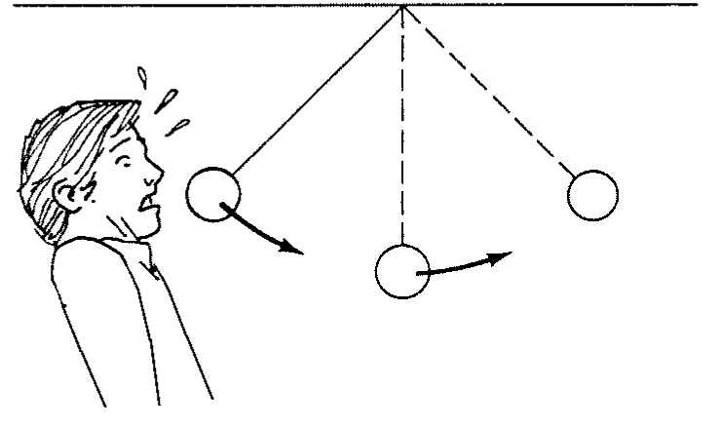

a .A b. B c. C

Answer: b
14. For a fossil fueled electrical generating plant, 10,000 Btu of chemical energy into the plant will result in about how many Btu’s of waste heat dumped into the environment:
a. 0 b. 1000 c. 4000 d. 6000 e. 10,000 Btu’s

Answer: d

15. If a net force of 30 newtons is applied to a cart of mass 3 kg at rest, the velocity of the cart at the end of 5 meters will be ____ m/s.
a. 5 b. 10 c. 12 d. 25 e. 30

Answer: b

16. The cost of running a set of eight 100 watt light bulbs for 6 hours, with the cost of electricity at 9¢ per kWh, is approximately:
a. 5¢ b. 24¢ c. 43¢ d. 54¢ e. 72¢

Answer: c

17. A 100 lb sack of potatoes falls from an airplane. As the velocity of fall increases, the air resistance also increases. When air resistance equals 100 lb, the acceleration of the sack will be ____ m/sec/sec.
a. 0 b. 16 c. 32 d. 9.8 e. 24

Answer: a

