***Elementary Differential Equations, 12e* (Boyce)**

**Chapter 1 Introduction**

1) A portion of the direction field for the differential equation (dy/dt) = *f*(*y*) is shown below:

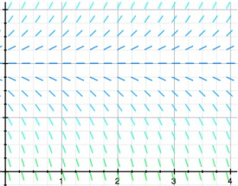

The dotted horizontal line has equation *y* = 18. Fill in the following chart to indicate the behavior as *t* → ∞ of the solution *y*(*t*) of the differential equation corresponding to each initial condition (y) with subscript (0).

|  |  |  |  |  |
| --- | --- | --- | --- | --- |
| Initial Condition (y) with subscript (0) | Approaches the line *y = 18* | Approaches the *x*-axis | Tends towards ∞ | Tends towards ∞ |
| 36 |  |  |  |  |
| 9 |  |  |  |  |
| 0 |  |  |  |  |
| 18 |  |  |  |  |

Answer:

|  |  |  |  |  |
| --- | --- | --- | --- | --- |
| Initial Condition (y) with subscript (0) | Approaches the line *y = 18* | Approaches the *x*-axis | Tends towards ∞ | Tends towards ∞ |
| 36 |  |  | X |  |
| 9 |  |  |  | X |
| 0 |  |  |  | X |
| 18 | X |  |  |  |

Type: ES Var: 1

2) A portion of the direction field for the differential equation (dy/dt) = *f*(*y*) is shown below:

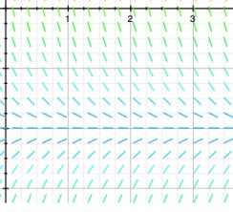

The dotted horizontal line has equation y = -7. Which of the following statements are true? Select all that apply.

A) *y*(*t*) = 0 is the solution to the initial-value problem (dy/dt) = *f*(*y*), *y*(0) = 0.

B) *y*(*t*) = -7 is the only equilibrium solution.

C) There is no solution of the initial-value problem (dy/dt) = *f*(*y*), *y*(0) = (y) with subscript (0) when (y) with subscript (0) = -7.

D) Every solution curve *y*(*t*) is increasing toward a negative limit as *t* → ∞.

E) Every solution curve *y*(*t*) tends towards -7 as *t* → ∞.

F) *F*(*y*) cannot be a linear function of *y*.

Answer: B, E, F

Type: MC Var: 1

3) Which of the following pairs of values of *A* and *B* are such that *all* solutions of the differential equation (dy/dt) = *Ay* + *B* are such that 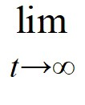*y*(*t*) = 7? Select all that apply.

A) *A* = -2, *B* = 14

B) *A* = -7, *B* = 1

C) *A* = -1, *B* = 7

D) *A* = 1, *B* = -7

E) *A* = -3, *B* = 21

F) *A* = -2, *B* = -14

G) *A* = 2, *B* = -14

Answer: A, C, E

Type: MC Var: 1

4) Which of the following pairs of values of *A* and *B* are such that *all* solutions of the differential equation (dy/dt) = *Ay* + *B* diverge away from the line *y* = 10 as *t* → ∞? Select all that apply.

A) *A* = -2, *B* = 20

B) *A* = 3, *B* = -30

C) *A* = 1, *B* = -10

D) *A* = -1, *B* = 10

E) *A* = -2, *B* = -20

F) *A* = 10, *B* = -1

G) *A* = 2, *B* = -20

Answer: B, C, G

Type: MC Var: 1

5) Eight differential equations and four slope fields are given below.

(A) y' = 1 - (y) with superscript (2) (B) y' = *t* - 1 (C) y' = 1 - *y*

(D) y' = 1 - *t* (E) y' = (y) with superscript (2) - (t) with superscript (2) (F) y' = (t) with superscript (2) - (y) with superscript (2)

(G) y' = 1 + *y* (H) y' = (y) with superscript (2) - 1

**(i)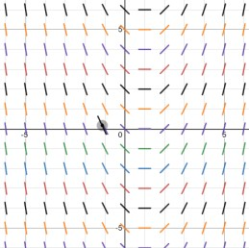 (ii)**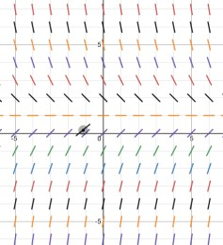

**(iii)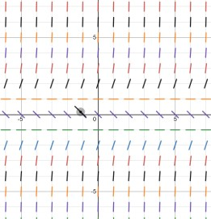(iv)**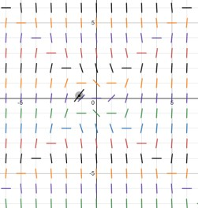

Which of the following are the zero isoclines for the differential equation in (A)? Select all that apply.

A) *y* = 0

B) *y* = 1

C) *y* = -1

D) *y* = *t*

E) *y* = -*t*

Answer: B, C

Type: MC Var: 1

6) Eight differential equations and four slope fields are given below.

(A) y' = 1 - (y) with superscript (2) (B) y' = *t* - 1 (C) y' = 1 - *y*

(D) y' = 1 - *t* (E) y' = (y) with superscript (2) - (t) with superscript (2) (F) y' = (t) with superscript (2) - (y) with superscript (2)

(G) y' = 1 + *y* (H) y' = (y) with superscript (2) - 1

**(i)** **(ii)**

**(iii)****(iv)**

Determine the differential equation that corresponds to each slope field. Fill in the correct letter next to each number below:

|  |  |
| --- | --- |
| Slope Field | Differential Equation |
| (i) |  |
| (ii) |  |
| (iii) |  |
| (iv) |  |

Answer:

|  |  |
| --- | --- |
| Slope Field | Differential Equation |
| (i) | B |
| (ii) | C |
| (iii) | H |
| (iv) | F |

Type: ES Var: 1

7) A pond initially contains 70,000 gallons of water and an unknown amount of pesticide. Water containing 0.07 grams of pesticide per gallon flows into the pond at a rate of 360 gallons per hour. The mixture flows out of the pond at the same rate, so the amount of water in the pond remains constant. Assume the pesticide is uniformly mixed throughout the pond.

Which of these is the differential equation for the amount of pesticide, *P*(*t*), in the pond at any time *t*?

A) 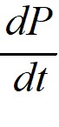 = 0.07 - 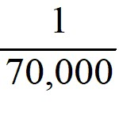*P*(*t*)

B)  = 25.2 - 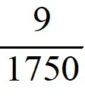*P*(*t*)

C)  = *P*(*t*) - 360

D)  = 360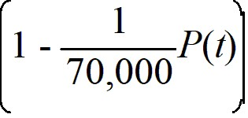

Answer: B

Type: MC Var: 1

8) A pond initially contains 150,000 gallons of water and an unknown amount of pesticide. Water containing 0.08 grams of pesticide per gallon flows into the pond at a rate of 400 gallons per hour. The mixture flows out of the pond at the same rate, so the amount of water in the pond remains constant. Assume the pesticide is uniformly mixed throughout the pond.

How much pesticide will be in the pond after a very long time? ________ grams.

Answer: 12,000 grams

Type: SA Var: 1

9) A pond initially contains 70,000 gallons of water and an unknown amount of pesticide. Water containing 0.05 grams of pesticide per gallon flows into the pond at a rate of 300 gallons per hour. The mixture flows out of the pond at the same rate, so the amount of water in the pond remains constant. Assume the pesticide is uniformly mixed throughout the pond.

Which of these is the general solution of the differential equation for the amount of pesticide, *P*(*t*), in the pond at any time *t*?

A) *P*(*t*) = 3500 + C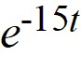

B) *P*(*t*) = 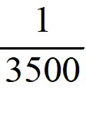 + C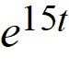

C) *P*(*t*) = 3500 + C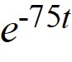

D) *P*(*t*) =  + C

Answer: C

Type: MC Var: 1

10) A pond initially contains 100,000 gallons of water and an unknown amount of pesticide. Water containing 0.07 grams of pesticide per gallon flows into the pond at a rate of 320 gallons per hour. The mixture flows out of the pond at the same rate, so the amount of water in the pond remains constant. Assume the pesticide is uniformly mixed throughout the pond.

Which of these is the solution of the initial-value problem comprised of the differential equation for the amount of pesticide, *P*(*t*), in the pond at any time *t* and the initial condition *P*(0) = (P) with subscript (0)?

A) *P*(*t*) = 7000 + ((P) with subscript (0) + 7000)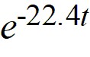

B) *P*(*t*) = 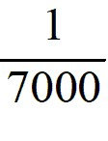 + 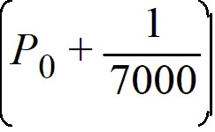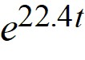

C) *P*(*t*) =  + ((P) with subscript (0) - )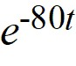

D) *P*(*t*) = 7000 + 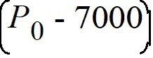

Answer: D

Type: MC Var: 1

11) A pond initially contains 120,000 gallons of water and an unknown amount of pesticide. Water containing 0.08 grams of pesticide per gallon flows into the pond at a rate of 260 gallons per hour. The mixture flows out of the pond at the same rate, so the amount of water in the pond remains constant. Assume the pesticide is uniformly mixed throughout the pond.

Which of these equations would you need to solve to find the time *T* (in hours) after which *P*(*t*) is within 2% of its limiting behavior?

A) *P*(*t*) = 2∙120,000∙0.08

B) *P*(*t*) = 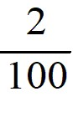120,000∙0.08

C) *P*(*t*) = 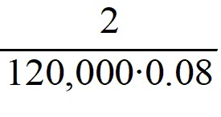

D) *P*(*t*) = 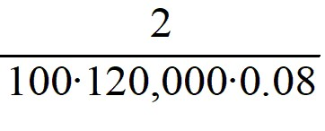

Answer: B

Type: MC Var: 1

12) Newton's Law of Cooling states that the temperature of an object changes at a rate proportional to the difference between the temperature of the object itself and the temperature of its surroundings (typically the ambient temperature). Suppose the ambient temperature is 77°F and the rate constant is 0.09 per minute.

Which of these is a differential equation for the temperature of the object, *T*(*t*), at any time *t*?

A) 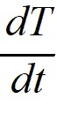 = -0.09(*T* - 77)

B)  = 0.09(*T* - 77)

C)  = -0.09*T* - 77

D)  = -77(*T* - 0.09)

E)  = 0.09 - 77*T*

Answer: A

Type: MC Var: 1

13) Newton's Law of Cooling states that the temperature of an object changes at a rate proportional to the difference between the temperature of the object itself and the temperature of its surroundings (typically the ambient temperature). Suppose the ambient temperature is 72°F and the rate constant is 0.11 per minute.

What is the general solution of the differential equation for the temperature of the object, *T*(*t*), at any time *t*?

A) *T*(*t*) = 72 + *C*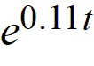

B) *T*(*t*) = 7.92 + *C*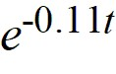

C) *T*(*t*) = 7.92 + *C*

D) *T*(*t*) = 72 + *C*

E) *T*(*t*) = 0.11 + *C*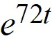

Answer: D

Type: MC Var: 1

14) Newton's Law of Cooling states that the temperature of an object changes at a rate proportional to the difference between the temperature of the object itself and the temperature of its surroundings (typically the ambient temperature). Suppose the ambient temperature is 72°F and the rate constant is 0.1 per minute.

Suppose the temperature of the object is initially 107°F. What is the solution to the initial-value problem comprised of the differential equation for the temperature of the object, *T*(*t*), at any time *t* and the initial condition T(0) = 107?

A) *T*(*t*) = 72 + 35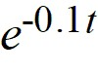

B) *T*(*t*) = 72 + 107

C) *T*(*t*) = 7.2 + 99.8

D) *T*(*t*) = 72 + 35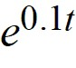

E) *T*(*t*) = 7.2 + 107

Answer: A

Type: MC Var: 1

15) Newton's Law of Cooling states that the temperature of an object changes at a rate proportional to the difference between the temperature of the object itself and the temperature of its surroundings (typically the ambient temperature). Suppose the ambient temperature is 72°F and the rate constant is 0.12 per minute.

Suppose the temperature of the object is initially 97°F. Given the initial condition T(0) = 97, how many minutes does it take the object to reach a temperature of 80.3°F? Round your answer to the nearest tenth of a minute.

Answer: 9.2

Type: SA Var: 1

16) An antibiotic is being administered intravenously to a patient. Fluid containing 6.5 mg/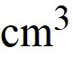 of the antibiotic enters the patient's bloodstream at a rate of 100 /hour. The antibiotic is absorbed by the body or otherwise leaves the bloodstream at a rate proportional to the amount present, with a rate constant of 0.4 per hour. Assume the antibiotic is always uniformly distributed throughout the bloodstream.

Which of these is a differential equation for the amount of antibiotic, *A*(*t*), in the bloodstream at any time *t*?

A) 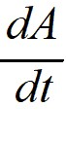 = -0.4*A*(*t*)

B)  = 650 - *A*(*t*)

C)  = 650*A*(*t*) - 0.4

D)  = 650 - 0.4*A*(*t*)

Answer: D

Type: MC Var: 1

17) An antibiotic is being administered intravenously to a patient. Fluid containing 8.0 mg/ of the antibiotic enters the patient's bloodstream at a rate of 100 /hour. The antibiotic is absorbed by the body or otherwise leaves the bloodstream at a rate proportional to the amount present, with a rate constant of 0.6 per hour. Assume the antibiotic is always uniformly distributed throughout the bloodstream.

How much of the antibiotic is present in the bloodstream after a very long time? Round your answer to the nearest hundredth of a milligram.

Answer: 1333.33

Type: SA Var: 1

18) An antibiotic is being administered intravenously to a patient. Fluid containing 4.5 mg/ of the antibiotic enters the patient's bloodstream at a rate of 100 /hour. The antibiotic is absorbed by the body or otherwise leaves the bloodstream at a rate proportional to the amount present, with a rate constant of 0.5 per hour. Assume the antibiotic is always uniformly distributed throughout the bloodstream.

What is the general solution to the differential equation for the amount of antibiotic, *A*(*t*), in the bloodstream at any time *t*?

A) *A*(*t*) = 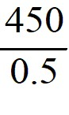 + *K*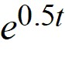

B) *A*(*t*) = 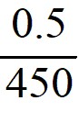 + *K*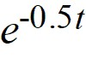

C) *A*(*t*) =  + *K*

D) *A*(*t*) = 450 + *K*

E) *A*(*t*) = -450 + *K*

Answer: C

Type: MC Var: 1

19) Consider the differential equation *x*y' = (x) with superscript (2) + *y*.

What is the general solution of this equation?

A) *y* = *C*(x) with superscript (2) + *x*

B) *y* = (x) with superscript (2) + *Cx*

C) *y* = *C*((x) with superscript (2) + *x*)

D) *y* = (x) with superscript (2) + *x* + *C*

Answer: B

Type: MC Var: 1

20) Consider the differential equation *x*y' = (x) with superscript (2) + *y*.

What is the value of the constant C in the general solution corresponding to the initial condition *y*(2) = 0?

Answer: -2

Type: SA Var: 1

21) For each of the following ordinary differential equations, identify the order and indicate whether it is linear or nonlinear.

|  |  |  |
| --- | --- | --- |
| Ordinary Differential Equation | Order | Linear or Nonlinear? |
| (dy/dt) = (y) with superscript (5) |  |  |
| ((d) with superscript (5)y/d(t) with superscript (5)) + (t) with superscript (6)((d) with superscript (4)y/d(t) with superscript (4)) = sin(3*t*) |  |  |
| (y) with superscript (2)((d) with superscript (2)y/d(t) with superscript (2)) + *y*(dy/dt) + 1 = 0 |  |  |
| (t) with superscript (2)((d) with superscript (2)y/d(t) with superscript (2)) + *t*(dy/dt) + *y* = 0 |  |  |
| (e) with superscript (-5t)((d) with superscript (5)y/d(t) with superscript (5)) + (t) to the (5) root(dy/dt) = cos(3*t*) |  |  |
| ((dy/dt) + t) with superscript (3) |  |  |

Answer:

|  |  |  |
| --- | --- | --- |
| Ordinary Differential Equation | Order | Linear or Nonlinear? |
| (dy/dt) = (y) with superscript (5) | 1 | Nonlinear |
| ((d) with superscript (5)y/d(t) with superscript (5)) + (t) with superscript (6)((d) with superscript (4)y/d(t) with superscript (4)) = sin(3*t*) | 5 | Linear |
| (y) with superscript (2)((d) with superscript (2)y/d(t) with superscript (2)) + *y*(dy/dt) + 1 = 0 | 2 | Nonlinear |
| (t) with superscript (2)((d) with superscript (2)y/d(t) with superscript (2)) + *t*(dy/dt) + *y* = 0 | 2 | Linear |
| (e) with superscript (-5t)((d) with superscript (5)y/d(t) with superscript (5)) + (t) to the (5) root(dy/dt) = cos(3*t*) | 5 | Linear |
| ((dy/dt) + t) with superscript (3) | 1 | Nonlinear |

Type: ES Var: 1

22) A model for the vertical flight of a projectile launched from the ground with velocity *V* in the absence of air resistance is

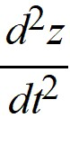 = - 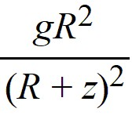

From what single term in this equation can you infer the order of the equation?

Answer: 

Type: SA Var: 1

23) A model for the vertical flight of a projectile launched from the ground with velocity *V* in the absence of air resistance is

 = - 

Is this differential equation linear or nonlinear?

Answer: Nonlinear

Type: SA Var: 1

24) A model for the vertical flight of a projectile launched from the ground with velocity *V* in the absence of air resistance is

 = - 

Which of these initial conditions complete the description of the situation? Select all that apply.

A) *z*(0) = 0

B) *z*(0) = *R*

C) *(dz/dt)(0) = -g*

D) *(dz/dt)(0) = V*

E) *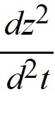(0) = -g*

Answer: A, D

Type: MC Var: 1

25) Which of the following are solutions to the differential equation y'' - 16*y* = 0? Select all that apply.

A) (y) with subscript (1)(*t*) = *C*(t) with superscript ( 4), for any real constant *C*

B) *(y) with subscript (2)(t*) = 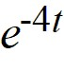

C) (y) with subscript (3)(*t*) = (t) with superscript ( -4)

D) (y) with subscript (4)(*t*) = *C*(e) with superscript (4t), for any real constant *C*

E) *(y) with subscript (5)(t*) = cos(4*t*)

F) (y) with subscript (6)(*t*) = 4 + 2(e) with superscript (4t)

G) (y) with subscript (7)(*t*) = 4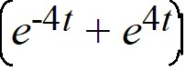

H) (y) with subscript (8)(*t*) = (e) with superscript (Ct), for any real constant *C*

Answer: B, D, F, G

Type: MC Var: 1

26) Which of the following are solutions to the differential equation x''' - 2x'' = 0? Select all that apply

A) (x) with subscript (1)(*t*) = *C*, for any real constant *C*

B) *(x) with subscript (2)(t*) = 5(e) with superscript (2t)

C) (x) with subscript (3)(*t*) = *t* + 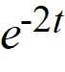

D) (x) with subscript (4)(*t*) = *t*(e) with superscript (2t)

E) (x) with subscript (5)(*t*) = (C) with subscript (1)(e) with superscript (2t) + (C) with subscript (2)

F) (x) with subscript (6)(*t*) = -12 + 7*t* + 7(e) with superscript (2t)

G) (x) with subscript (7)(*t*) = *C*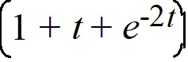

Answer: A, B, F

Type: MC Var: 1

27) For what values of *r* is *y*(*t*) = (e) with superscript (rt) a solution of the differential equation y'' + 4y' - 12*y* = 0?

A) 2 and -6

B) 0 and 2

C) -2 and 6

D) 0 and -6

E) 0, 2, and -6

Answer: A

Type: MC Var: 1

28) For each of the following partial differential equations, identify the order and indicate whether it is linear or nonlinear.

|  |  |  |
| --- | --- | --- |
| Partial Differential Equation | Order | Linear or Nonlinear? |
| 4*u*(u) with subscript (x) + (u) with subscript (y) = 0 |  |  |
| 6(u) with subscript (xx) + 2(u) with subscript (yy) = 0 |  |  |
| ((u) with subscript (x)) with superscript (4) + ((u) with subscript (x)) with superscript (4) = *x* + *y* |  |  |

Answer:

|  |  |  |
| --- | --- | --- |
| Partial Differential Equation | Order | Linear or Nonlinear? |
| 4*u*(u) with subscript (x) + (u) with subscript (y) = 0 | 1 | Nonlinear |
| 6(u) with subscript (xx) + 2(u) with subscript (yy) = 0 | 2 | Linear |
| ((u) with subscript (x)) with superscript (4) + ((u) with subscript (x)) with superscript (4) = *x* + *y* | 1 | Nonlinear |

Type: ES Var: 1

© (2022) John Wiley & Sons, Inc. All rights reserved. Instructors who are authorized users of this course are permitted to download these materials and use them in connection with the course. Except as permitted herein or by law, no part of these materials should be reproduced, stored in a retrieval system, or transmitted, in any form or by any means, electronic, mechanical, photocopying, recording or otherwise.