Chapter 1: The Decimal Number System

1. In the circuit below, Vin = 15 V and R = 5 Kê. What are VO and XC at fCO?
a. XC = 7.07 Kê, VO = 21.2 V
b. XC = 7.07 Kê, VO = 15 V
c. XC = 5.05 Kê, VO = 15 V
d. XC = 5.00 Kê, VO = 10.6 V
e. XC = 3.5 Kê, VO = 10.6 V
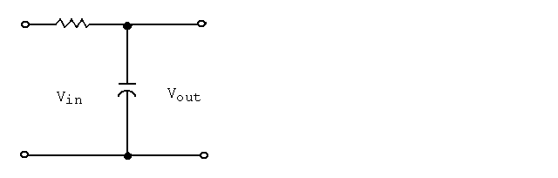

2. In the circuit below, Vin = 20 V, R = 12 Kê, and C = 0.003 æF. Find fCO.
a. 2.8 KHz
b. 4.4 KHz
c. 8.3 KHz
d. 14 KHz
e. 84 KHz

Chapter 1: The Decimal Number System

3. In the circuit below, Vin = 35 V, R = 20 Kê, and fCO = 23 KHz. Find VO and C at fCO.
a. VO = 17.5 V, C = 346 pF
b. VO = 17.5 V, C = 230 pF
c. VO = 24.8 V, C = 346 pF
d. VO = 24.8 V, C = 200 pF
e. VO = 35.0 V, C = 530 pF

4. In the circuit below, Vin = 35 V, R = 20 Kê, and fCO = 23 Khz. What is the circuit impedance and Imax for the circuit?
a. Z = 28.3 Kê, I = 1.24 mA
b. Z = 40.0 Kê, I = 1.75 mA
c. Z = 39.2 Kê, I = 3.50 mA
d. Z = 28.3 Kê, I = 1.75 mA
e. Z = 14.2 Kê, I = 1.24 mA

5. In a low pass filter, Vin = 18.5V and R = 4.5 Kê. Find XC, I P and Vo at fco.

6. In a low pass filter, Vin = 7V, R = 3.3 Kê, C = 180 nF. Find Fco, and Vout at fco.

Chapter 1: The Decimal Number System

7. Referring to the circuit below, the low pass filter has the following characteristic(s):
a. The output voltage is equal to Vin at fCO
b. The power output is 50% of max. at fCO
c. The output decreases as frequency increases
d. The power output is 50% of max. at fCO and the output decreases as frequency increases

8. Below is a circuit for a high pass filter. As the frequency increases, what happens to VR and VC?
a. VR decreases, VC increases.
b. VR remains the same, VC decreases.
c. VR increases, VC remains the same.
d. VR increases, VC decreases.
e. VR increases, VC increases.
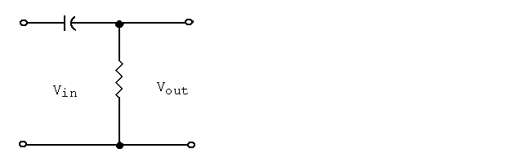

Chapter 1: The Decimal Number System

9. In the circuit below, the frequency is increased from 100 Hz to a maximum value. At what frequency does VO reach the cutoff frequency if R = 100 ê and C = 0.01 æF?
a. 2.53 KHz
b. 159.2 KHz
c. 8.11 KHz
d. 14.33 KHz
e. 11.93 KHz

10. If R = 100 ê and C = 0.01 æF, what is the power dissipated in the circuit below at fCO if Vin = 20 V?
a. 4.00 w
b. 2.82 w
c. 2.00 w
d. 1.41 w
e. 1.00 w

Chapter 1: The Decimal Number System

11. In the circuit below, find fCO and VO if Vin = 42 V, R = 22 K, and C = 0.00015 æF.
a. VO = 29.7 V, fCO = 48.2 KHz
b. VO = 21.0 V, fCO = 48.2 KHz
c. VO = 21.0 V, fCO = 31.7 KHz
d. VO = 29.7 V, fCO = 31.7 KHz
e. VO = 21.0 V, fCO = 34.1 KHz
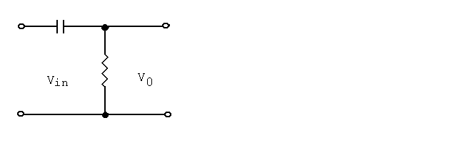

12. What is the value of C required to cause a low pass filter to cutoff at 18 KHz if R = 13.7 Kê?
a. 0.00015 æF
b. 645 pF
c. 0.004 æF
d. 345 pF
e. 0.0006 æF

13. In the circuit below, Vin = 18 V and R = 18 Kê and C = 0.001 æF. What is fCO?

14. Given a series RC circuit, what is the relationship of R and XC at the frequency cutoff?

Chapter 1: The Decimal Number System

15. Using Thevenin's Theorem, find the equivalent circuit for a low pass filter when R1 = 5.6 Kê, R2 = 6.8 Kê, R3 = 10 Kê, and C = 1200 pF.
a. RTH = 13.1 Kê, C = 1200 pF, output across R
b. RTH = 2.3 Kê, C = 1200 pF, output across C
c. RTH = 11.2 Kê, C = 1200 pF, output across C
d. RTH = 12.4 Kê, C = 848 pF, output across R
e. RTH = 13.2 Kê, C = 1200 pF, output across R
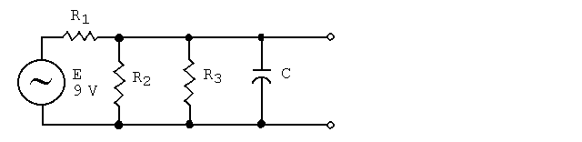

16. Using Thevenin's Theorem, what is fCO of an equivalent circuit for a lowpass filter when R1 = 5.6 Kê, R2 = 6.8 Kê, R3 = 10 Kê, and C = 1200 pF.
a. 15.1 KHz
b. 11.7 KHz
c. 56.4 KHz
d. 8.7 KHz
e. 6.2 KHz

17. In the circuit below, R1 = 3.3 Kê, R2 = 5.6 Kê, R3 = 4.7 Kê, and C = 846 pF. Find VO and RN of an equivalent Norton circuit.
a. VO = 15.0 V, RN = 4.7 Kê
b. VO = 8.5 V, RN = 5.86 Kê
c. VO = 7.5 V, RN = 2.56 Kê
d. VO = 6.5 V, RN = 3.3 Kê
e. VO = 3.9 V, RN = 1.4 Kê
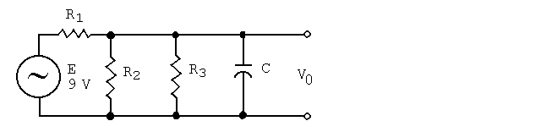

Chapter 1: The Decimal Number System

18. In the circuit below, R1 = 3.3 Kê, R2 = 5.6 Kê, R3 = 4.7 Kê, and C = 846 pF. What is fCO of an equivalent Norton circuit?
a. 843 KHz
b. 521 KHz
c. 470 KHz
d. 213 KHz
e. 131 KHz

19. In the circuit below, R1 = 3.3 Kê, R2 = 5.6 Kê, R3 = 4.7 Kê, and C = 846 pF. What is IC of an equivalent Norton circuit when f = fCO?
a. 4.5 mA
b. 10.7 mA
c. 1.9 mA
d. 2.7 mA
e. 1.8 mA

20. In the series resonant circuit below, Vin = 8.0 V and R = 10 Kê. Find VO.
a. 3.3 V
b. 4.0 V
c. 5.6 V
d. 6.6 V
e. 8.0 V
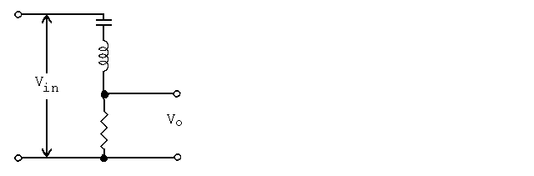

Chapter 1: The Decimal Number System

21. In the circuit below, Vin = 7 V, R = 250 ê, xC = 1000 ê at fr, and C = 90 pF. Find fr and Q.
a. fr = 3.1 MHz, Q = 10
b. fr = 1.8 MHz, Q = 4
c. fr = 1.8 MHz, Q = 1.8
d. fr = 1.2 MHz, Q = 6
e. fr = 1.0 MHz, Q = 4
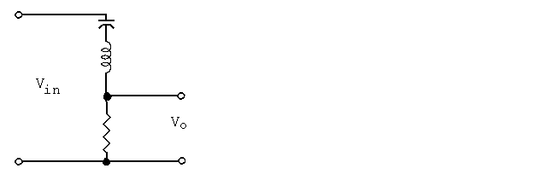

22. In the circuit below, Vin = 7 V, R = 250 ê, xC = 1000 ê, and C = 90 pF. Find the bandwidth.
a. 310 KHz
b. 1000 KHz
c. 450 KHz
d. 200 KHz
e. 250 KHz

Chapter 1: The Decimal Number System

23. In the circuit below, Vin = 7 V, R = 250 ê, xC = 1000 ê, and C = 90 pF. What are the values of VO and I at f1?
a. VO = 4.95 V, I = 19.8 mA
b. VO = 6.21 V, I = 19.8 mA
c. VO = 7.00 V, I = 19.8 mA
d. VO = 5.55 V, I = 22.2 mA
e. VO = 7.00 V, I = 28.0 mA

24. A series resonant circuit is used as a bandpass filter. What is Q if BW = 3 KHz and f1 = 10 KHz?
a. 3.8
b. 3.3
c. 4.3
d. 6.3
e. 7.6

25. A series resonant circuit has Vin = 9.0 V, Q = 6, and fr = 150 KHz. Find BW and VO at f1.
a. BW = 25.0 KHz, VO = 6.4 V
b. BW = 20.8 KHz, VO = 9.0 V
c. BW = 29.2 KHz, VO = 9.0 V
d. BW = 230 KHz, VO = 6.4 V
e. BW = 277 KHz, VO = 4.5 V

26. A series resonant circuit has Vin = 6.2 V, R = 500 ê, fr = 1.4 kHz and
Q = 15. Find BW, f1, and f2.

27. For a low pass filter, fCO = 15 KHz and Vin = 22 V. What is VO when the input frequency is 6.1 KHz?
a. 20.4 V
b. 11.0 V
c. 15.6 V
d. 31.1 V
e. 22.0 V

Chapter 1: The Decimal Number System

28. Find the power dissipated at fCO in a high pass RC filter circuit when R = 4.7 Kê, C = 500 pF, and Vin = 30 V.
a. 58.3 mw
b. 47.0 mw
c. 95.6 mw
d. 116.5 mw
e. 191.5 mw

29. A low pass filter has R = 18 Kê, C = 0.01 F, and Vin = 10 V. Find VO and IC at fCO.
a. IC = 0.39 mA, VO = 10.0 V
b. IC = 1.82 mA, VO = 5.0 V
c. IC = 1.82 mA, VO = 7.1 V
d. IC = 0.39 mA, VO = 7.1 V
e. IC = 0.56 mA, VO = 10.0 V

30. The circuit shown below:
a. Has maximum output at fr
b. Has minimum output at fr
c. Is a band reject filter
d. Has a maximum output at fr and is a band reject filter
e. Has a minimum output at fr and is a band reject filter
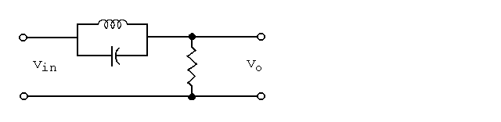

31. Find f1 in the circuit below when R1 = 1 Kê, R2 = 4 Kê, C1 = 0.1 æF, C2 = 700 pF, and E = 20 V.
a. 1 KHz
b. 318 H3
c. 4 KHz
d. 8 KHz
e. 16 KHz
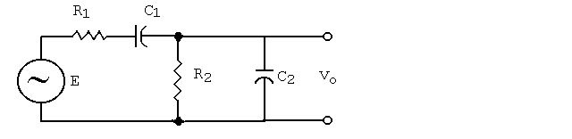

Chapter 1: The Decimal Number System

32. What is f2 in the circuit below when R1 = 1 Kê, R2 = 4 Kê, C1 = 0.1 æF, C2 = 700 pF, and E = 20 V?
a. 390 KHz
b. 284 KHz
c. 169 KHz
d. 71 KHz
e. 57 KHz

33. Find the mid-frequency output voltage in the circuit below when R1 = 1 Kê, R2 = 4 Kê, C1 = 0.1 æF, C2 = 700 pF, and E = 20 V.
a. 4 V
b. 5 V
c. 10 V
d. 16 V
e. 20 V

34. In a bandpass filter, f1 = 45 KHz and f2 = 60 KHz. Find fm.
a. 51.0 KHz
b. 52.0 KHz
c. 52.5 KHz
d. 54.2 KHz
e. 55.7 KHz

35. What is fm for a bandbass filter when f1 = 20.0 MHz and f2 = 28.9 MHz?

Chapter 1: The Decimal Number System

36. In a bandpass filter, the lower cut-off frequency, fr, is best described by:
a. CN
ÄÄÄÄ
2ãC2
b. ÚÄÄÄÄÄÄÄ
ûf1 ú f2
c. 1
ÄÄÄÄÄÄÄ
2ãRTHC1

37. In a bandpass filter, Q is best described by:
a. ÚÄÄ
2ãûLC
b. BW
ÄÄ
2
c. fr
ÄÄ
BW
d. 2ãfL

1. d
2. b
3. c
4. a
5. XC = 4.5 Kê
I = 2.91 mA
P = 38.03 mW
Vo = 13.08 V
6. fco = 267.9 Hz
Vout = 4.95 V
7. d
8. d
9. b
10. c
11. a
12. b
13. fCO = 8.84 KHz
14. XC = R
15. b
16. c
17. e
18. e
19. c
20. e
21. b
22. c
23. a
24. a
25. a
26. BW = 93.3 Hz
f1 = 1.35 kHz
f2 = 1.45 kHz
27. a
28. c
29. d
30. e
31. b
32. b
33. d
34. b
35. fm = 24.04 MHz.
36. c
37. c

