Test Bank

to accompany

Ecology, Fifth Edition

Bowman • Hacker

Chapter 2: The Physical Environment

TEST BANK QUESTIONS

Multiple Choice

1. Fish such as salmon, which are born in freshwater streams but spend most of their adult lives in the ocean, are termed

a. catadromous.

b. anadromous.

c. androgynous.

d. oscillatory.

Answer: b

Textbook Reference: Climate Variation and Salmon Abundance: A Case Study

Learning Objective: Not aligned

Bloom’s Category: 1. Remembering

2. Climatic variation occurs over which time scales?

a. Daily time scales only

b. Daily and yearly time scales only

c. Yearly and decade time scales only

d. Across daily, seasonal, and yearly time scales

Answer: d

Textbook Reference: 2.1 Climate is the most fundamental component of the physical environment.

Learning Objective: 2.1.1 Outline the difference between weather and climate, with specific reference to their temporal scales.

Bloom’s Level: 1. Remembering

3. Which statement about climate is false?

a. Climate usually has little effect on the rate of periodic disturbances in an area.

b. The timing of a change to the physical environment is often ecologically important.

c. Climate influences the rates of abiotic processes that affect organisms.

d. The distribution of organisms tends to reflect extremes, rather than averages, in the climates of particular locales.

Answer: a

Textbook Reference: 2.1 Climate is the most fundamental component of the physical environment.

Learning Objective: 2.1.2 Explain the importance of weather variability for ecological processes.

Bloom’s Level: 1. Remembering

4. Heat loss due to the exchange of kinetic energy by molecules in direct contact with one another is referred to as

a. latent heat flux.

b. convection.

c. conduction.

d. the greenhouse effect.

Answer: c

Textbook Reference: 2.1 Climate is the most fundamental component of the physical environment.

Learning Objective: 2.1.3 Summarize how temperature is determined by the gains and losses of energy at Earth’s surface.

Bloom’s Level: 1. Remembering

5. Earth’s surface releases _______ it receives by solar radiation. Additional energy inputs to Earth’s surface occur in part from back radiation due to _______.

a. more energy than; evapotranspiration

b. more energy than; greenhouse gases

c. about the same energy as; evapotranspiration

d. less energy than; greenhouse gases

Answer: b

Textbook Reference: 2.1 Climate is the most fundamental component of the physical environment.

Learning Objective: 2.1.3 Summarize how temperature is determined by the gains and losses of energy at Earth’s surface.

Bloom’s Level: 2. Understanding

6. Which of the following is not a greenhouse gas?

a. Carbon dioxide

b. Methane

c. Oxygen

d. Water vapor

Answer: c

Textbook Reference: 2.1 Climate is the most fundamental component of the physical environment.

Learning Objective: 2.1.3 Summarize how temperature is determined by the gains and losses of energy at Earth’s surface.

Bloom’s Level: 1. Remembering

7. In the absence of greenhouse gases, Earth would be about _______ than it is now.

a. 2°C warmer

b. 3°C cooler

c. 13°C cooler

d. 33°C cooler

Answer: d

Textbook Reference: 2.1 Climate is the most fundamental component of the physical environment.

Learning Objective: 2.1.3 Summarize how temperature is determined by the gains and losses of energy at Earth’s surface.

Bloom’s Level: 1. Remembering

8. In equatorial regions, the sun’s rays strike Earth’s surface at a more _______ angle than they do toward the poles. This means that the same amount of energy is spread over a(n) _______ area in equatorial regions than in polar regions.

a. perpendicular; smaller

b. perpendicular; larger

c. acute (less than 90° angle); larger

d. acute (less than 90° angle); smaller

Answer: a

Textbook Reference: 2.2 Winds and ocean currents result from differences in solar radiation across Earth’s surface.

Learning Objective: 2.2.1 Draw connections between differential heat gain across Earth’s surface and the development of atmospheric circulation cells.

Bloom’s Level: 2. Understanding

9. Which statement about atmospheric circulation patterns is false?

a. The condensation of water vapor into clouds is a warming process.

b. Cool air can hold more water vapor than warm air can.

c. Thunderclouds potentially reach only to the boundary between the upper region of the troposphere and the bottom of the stratosphere.

d. Air cools due to expansion as it rises in the troposphere.

Answer: b

Textbook Reference: 2.2 Winds and ocean currents result from differences in solar radiation across Earth’s surface.

Learning Objective: 2.2.1 Draw connections between differential heat gain across Earth’s surface and the development of atmospheric circulation cells.

Bloom’s Level: 1. Remembering

10. Which statement best explains why atmospheric pressure declines with altitude?

a. As altitude increases, there are fewer air molecules pressing down on a given molecule of air.

b. At higher altitudes, air is cooler and thus does not move around as much as the warmer air at lower altitudes.

c. As altitude increases, air holds less moisture and thus feels lighter.

d. There is more subsidence as altitude increases.

Answer: a

Textbook Reference: 2.2 Winds and ocean currents result from differences in solar radiation across Earth’s surface.

Learning Objective: 2.2.1 Draw connections between differential heat gain across Earth’s surface and the development of atmospheric circulation cells.

Bloom’s Level: 2. Understanding

11. Which areas of Earth receive the most precipitation on average?

a. Tropics

b. Temperate zones

c. Regions near 30°N and S latitudes

d. Polar zones

Answer: a

Textbook Reference: 2.2 Winds and ocean currents result from differences in solar radiation across Earth’s surface.

Learning Objective: 2.2.1 Draw connections between differential heat gain across Earth’s surface and the development of atmospheric circulation cells.

Bloom’s Level: 1. Remembering

12. Refer to the figure.

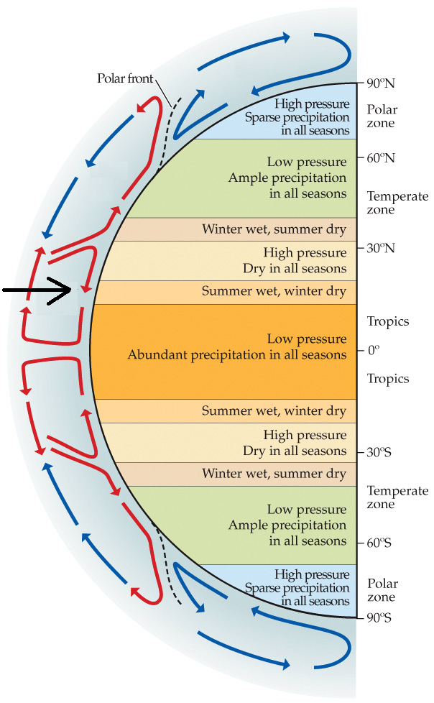

What is the name of the circulation pattern indicated by the black arrow?

a. Polar cell

b. Ferrell cell

c. Dobson cell

d. Hadley cell

Answer: d

Textbook Reference: 2.2 Winds and ocean currents result from differences in solar radiation across Earth’s surface.

Learning Objective: 2.2.1 Draw connections between differential heat gain across Earth’s surface and the development of atmospheric circulation cells.

Bloom’s Level: 1. Remembering

13. Named for their importance to shipping, the trade winds blow to the _______ in the Northern Hemisphere, to the _______ in the Southern Hemisphere, and _______ the equator.

a. west; east; away from

b. east; west; toward

c. west; west; toward

d. east; west; away from

Answer: c

Textbook Reference: 2.2 Wind and ocean currents result from differences in solar radiation across Earth’s surface.

Learning Objective: 2.2.1 Draw connections between differential heat gain across Earth’s surface and the development of atmospheric circulation cells.

Bloom’s Level: 2. Understanding

14. If Earth were heated slightly more at the equator, Hadley cells should be become slightly _______ pronounced, and there would likely be slightly _______ rain at around 30°N.

a. more; more

b. less; more

c. more; less

d. less; less

Answer: c

Textbook Reference: 2.2 Winds and ocean currents result from differences in solar radiation across Earth’s surface.

Learning Objective: 2.2.1 Draw connections between differential heat gain across Earth’s surface and the development of atmospheric circulation cells.

Bloom’s Level: 3. Applying

15. Refer to the figure.

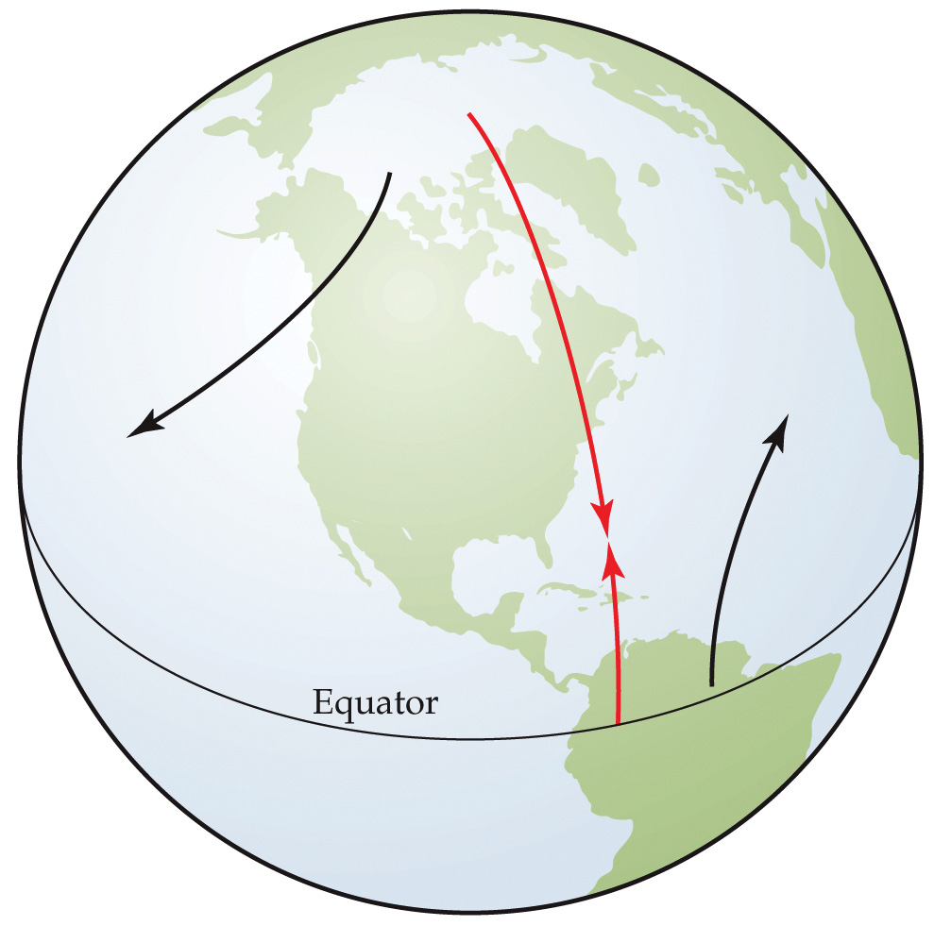

The figure illustrates the Coriolis effect for Earth. Which of the following statements about the Coriolis effect is false?

a. The Coriolis effect has a major impact on determining global patterns of ocean currents as well as winds.

b. The Coriolis effect occurs because points on Earth close to the equator are rotating around Earth’s axis more slowly than points farther from the equator.

c. If the Earth’s direction of rotation was from east to west rather than west to east, the deflection would still occur, but its direction would be reversed.

d. If the Earth was a cylinder (with its length oriented north-south and rotating around a north-south axis) rather than a sphere, no east-west deflection of a north-south trajectory would occur.

Answer: b

Textbook Reference: 2.2 Wind and ocean currents result from differences in solar radiation across Earth’s surface.

Learning Objective: 2.2.2 Explain how surface winds and ocean currents move heat between the tropics and the poles.

Bloom’s Level: 4. Analyzing

16. The Coriolis effect causes moving air at Earth’s surface to appear to be deflected _______ in the Northern Hemisphere and _______ in the Southern Hemisphere.

a. clockwise; clockwise

b. clockwise; counterclockwise

c. counterclockwise; clockwise

d. counterclockwise; counterclockwise

Answer: b

Textbook Reference: 2.2 Winds and ocean currents result from differences in solar radiation across Earth’s surface.

Learning Objective: 2.2.2 Explain how surface winds and ocean currents move heat between the tropics and the poles.

Bloom’s Level: 1. Remembering

17. Suppose Earth’s rotation were somewhat faster than it is now. From the standpoint of a fixed viewer on Earth’s surface, wind moving south in the Northern Hemisphere would appear to be deflected to the _______ and it would be deflected to a _______ extent than it is now.

a. east; greater

b. east; lesser

c. west; greater

d. west; lesser

Answer: c

Textbook Reference: 2.2 Winds and ocean currents result from differences in solar radiation across Earth’s surface.

Learning Objective: 2.2.2 Explain how surface winds and ocean currents move heat between the tropics and the poles.

Bloom’s Level: 3. Applying

18. Compared with land at the same latitude, ocean waters tend to be _______ in the winter and _______ in the summer because water has a _______ heat capacity than land has.

a. warmer; colder; higher

b. colder; warmer; lower

c. warmer; warmer; higher

d. colder; colder; lower

Answer: a

Textbook Reference: 2.2 Winds and ocean currents result from differences in solar radiation across Earth’s surface.

Learning Objective: 2.2.2 Explain how surface winds and ocean currents move heat between the tropics and the poles.

Bloom’s Level: 2. Understanding

19. Refer to the figure.

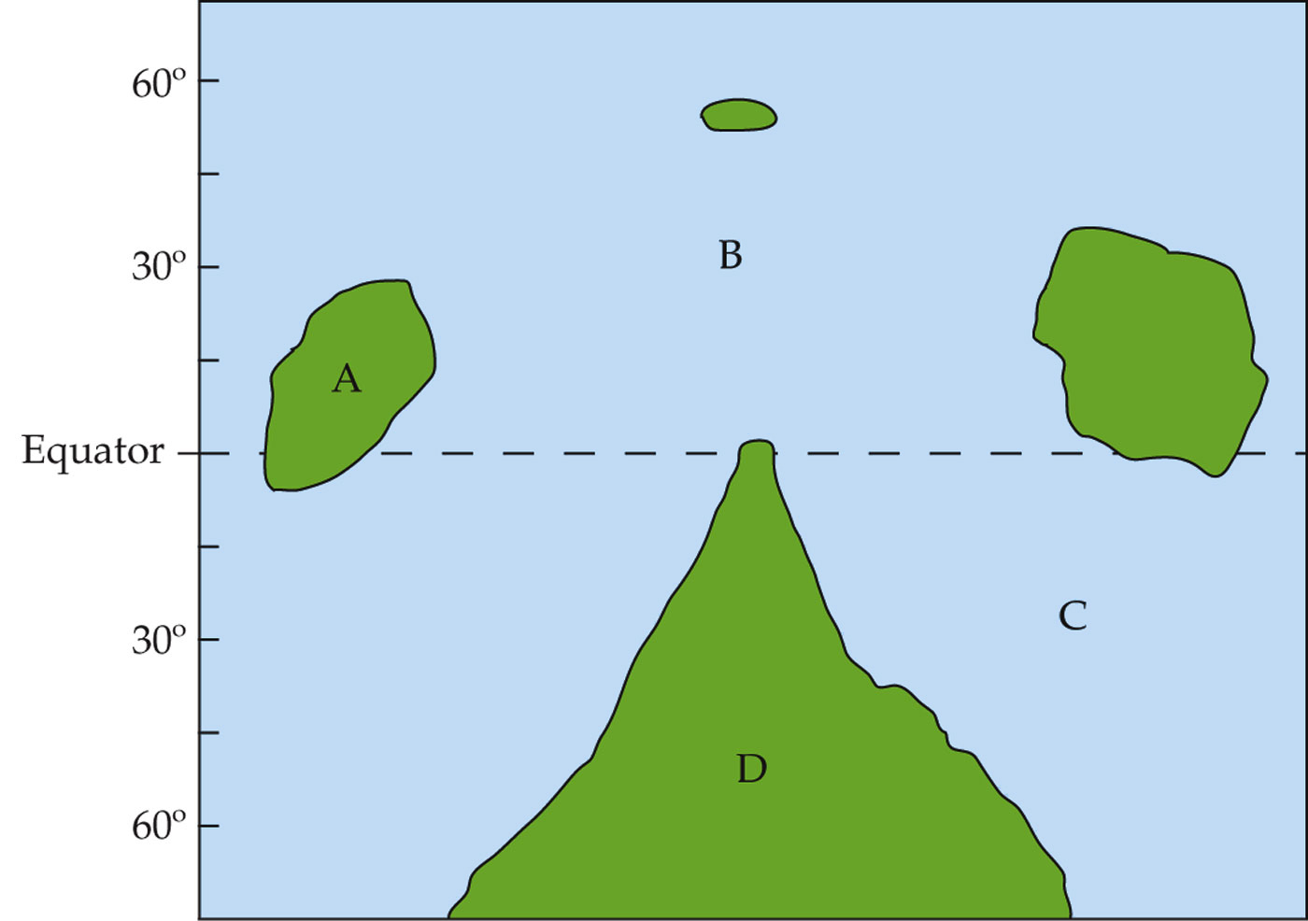

The map is of an imaginary planet that is roughly the same as Earth. Like Earth, it is tilted on its axis by about 23°, and it rotates around a sun-like star in approximately one year. At which site would a high-pressure system be most likely to develop during the summer?

a. Site A

b. Site B

c. Site C

d. Site D

Answer: c

Textbook Reference: 2.2 Winds and ocean currents result from differences in solar radiation across Earth’s surface.

Learning Objective: 2.2.2 Explain how surface winds and ocean currents move heat between the tropics and the poles.

Bloom’s Level: 4. Analyzing

20. Refer to the figure.

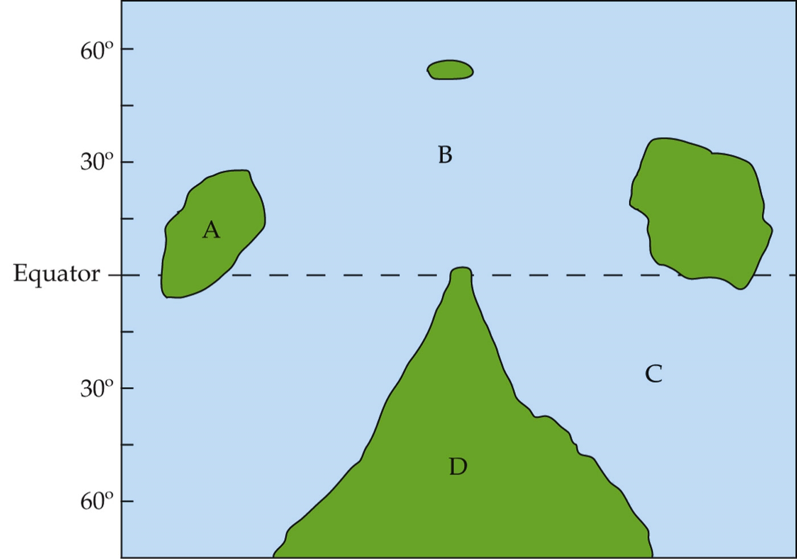

The map is of an imaginary planet that is roughly the same as Earth. Like Earth, it is tilted on its axis by about 23°, and it rotates around a sun-like star in approximately one year. At which site would a high-pressure system be most likely to develop during the winter?

a. Site A

b. Site B

c. Site C

d. Site D

Answer: d

Textbook Reference: 2.2 Winds and ocean currents result from differences in solar radiation across Earth’s surface.

Learning Objective: 2.2.2 Explain how surface winds and ocean currents move heat between the tropics and the poles.

Bloom’s Level: 4. Analyzing

21. Refer to the figure.

The map is of an imaginary planet that is roughly the same as Earth. Like Earth, it is tilted on its axis by about 23°, and it rotates around a sun-like star in approximately one year. Which site would mostly likely have the greatest variation in temperature during the year?

a. Site A

b. Site B

c. Site C

d. Site D

Answer: d

Textbook Reference: 2.2 Winds and ocean currents result from differences in solar radiation across Earth’s surface.

Learning Objective: 2.2.2 Explain how surface winds and ocean currents move heat between the tropics and the poles.

Bloom’s Level: 3. Applying

22. In comparison to deeper waters, surface oceanic waters are

a. colder.

b. saltier.

c. less dense.

d. Both a and b

Answer: c

Textbook Reference: 2.2 Winds and ocean currents result from differences in solar radiation across Earth’s surface.

Learning Objective: 2.2.2 Explain how surface winds and ocean currents move heat between the tropics and the poles.

Bloom’s Level: 1. Remembering

23. High productivity in the open ocean would most likely be found in

a. polar cells.

b. the South Pacific.

c. the Labrador current.

d. upwelling zones.

Answer: d

Textbook Reference: 2.2 Winds and ocean currents result from differences in solar radiation across Earth’s surface.

Learning Objective: 2.2.2 Explain how surface winds and ocean currents move heat between the tropics and the poles.

Bloom’s Level: 1. Remembering

24. Some models of climate change suggest that the Gulf Stream may become weaker as global temperature increases. Such a weakening in the Gulf Stream would most likely result in

a. warming in Seattle.

b. warming in London.

c. cooling in Seattle.

d. cooling in London.

Answer: d

Textbook Reference: 2.2 Winds and ocean currents result from differences in solar radiation across Earth’s surface.

Learning Objective: 2.2.2 Explain how surface winds and ocean currents move heat between the tropics and the poles.

Bloom’s Level: 3. Applying

25. Which statement about oceanic currents is false?

a. Deep oceanic currents meet surface currents at zones of upwelling.

b. Because they move so slowly, oceanic currents contribute little to the exchange of heat between the tropics and the polar regions.

c. Oceanic currents can have profound effects on the climates of regions where they flow.

d. Dense downwelling currents move to the equator.

Answer: b

Textbook Reference: 2.2 Winds and ocean currents result from differences in solar radiation across Earth’s surface.

Learning Objective: 2.2.2 Explain how surface winds and ocean currents move heat between the tropics and the poles.

Bloom’s Level: 1. Remembering

26. Refer to the map.

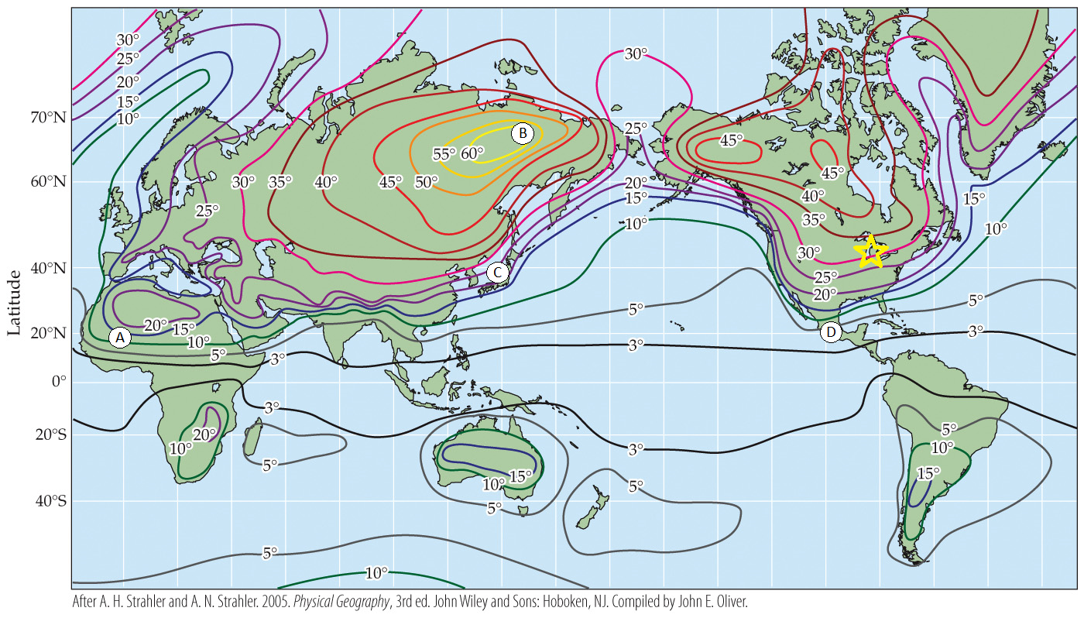

The map shows annual seasonal temperature variation (in °C). Which region shows the greatest temperature variation?

a. Region A, in the Sahara Desert

b. Region B, in Siberia

c. Region C, in Japan

d. Region D, in Mexico

Answer: b

Textbook Reference: 2.3 Large-scale atmospheric and oceanic circulation patterns establish global patterns of temperature and precipitation.

Learning Objective: 2.3.2 Explain how a region’s seasonal changes in temperature are affected by its location, whether it is near a large body of water or at the center of

a large continent.

Bloom’s Level: 2. Understanding

27. Refer to the map.

The map shows annual seasonal temperature variation (in °C). Consider the temperature in Chicago (marked with the yellow star on the map). Suppose the average temperature in Chicago in January, the coldest month of the year, is –5°C. Based on the map, what should the average temperature be in July, the warmest month?

a. 10°C

b. 25°C

c. 40°C

d. 45°C

Answer: b

Textbook Reference: 2.3 Large-scale atmospheric and oceanic circulation patterns establish global patterns of temperature and precipitation.

Learning Objective: 2.3.2 Explain how a region’s seasonal changes in temperature are affected by its location, whether it is near a large body of water or at the center of

a large continent.

Bloom’s Level: 3. Applying

28. Boston, Massachusetts, and Albany, New York, are at about the same latitude, but Albany is farther inland. Based on this, you would expect Albany to have _______ humidity and _______ variation in temperature than Boston.

a. less; more

b. less; about the same

c. more; less

d. more; more

Answer: a

Textbook Reference: 2.3 Large-scale atmospheric and oceanic circulation patterns establish global patterns of temperature and precipitation.

Learning Objective: 2.3.2 Explain how a region’s seasonal changes in temperature are affected by its location, whether it is near a large body of water or at the center of a large continent.

Bloom’s Level: 3. Applying

29. What is measured by the lapse rate?

a. The decline in temperature as one moves away from the equator

b. The decline in temperature as one moves up in altitude

c. The decline in atmospheric pressure as one moves up in altitude

d. The amount of water that air can hold as temperature changes

Answer: b

Textbook Reference: 2.3 Large-scale atmospheric and oceanic circulation patterns establish global patterns of temperature and precipitation.

Learning Objective: 2.3.3 Summarize how air density and air exchange cause a decrease in air temperature with increases in elevation on a mountain.

Bloom’s Level: 1. Remembering

30. Which continent shows precipitation patterns closest to what would be predicted based on the positions of the Hadley, Ferrell, and polar circulation cells?

a. Africa

b. Asia

c. Europe

d. North America

Answer: a

Textbook Reference: 2.3 Large-scale atmospheric and oceanic circulation patterns establish global patterns of temperature and precipitation.

Learning Objective: Not aligned

Bloom’s Level: 1. Remembering

31. Refer to the figure.

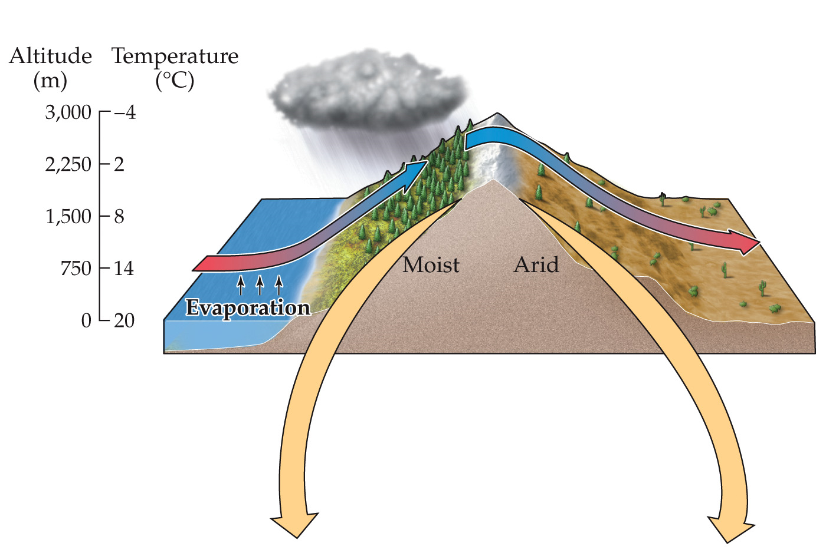

The figure illustrates the rain-shadow effect. Which of the following descriptions of what is being illustrated here is correct?

a. The prevailing winds are blowing from the right side of the figure, accumulating moisture as they move up the slope, leaving the air on the right side of the mountain very dry, and then depositing the moisture as precipitation on the left side of the mountain.

b. The prevailing winds are blowing from the left side of the figure, accumulating moisture as they move up the slope, depositing the moisture at the crest of the mountain, and then leaving the air descending the slope on the right side very dry.

c. The prevailing winds are blowing from the left side of the figure, depositing moisture as the air moves up the slope and cools, leaving the air descending the slope on the right side of the figure very dry.

d. The prevailing winds are blowing from the left side of the figure, depositing moisture as the air moves up the slope and warms, leaving the air descending the slope on the right side of the figure very dry.

Answer: c

Textbook Reference: 2.4 Regional climates reflect the influence of oceans and continents, mountains, and vegetation.

Learning Objective: 2.4.1 Describe the changes in an air mass that moves from a maritime zone across mountains on both the leeward and windward slopes.

Bloom’s Level: 3. Applying

32. Vegetation patterns affect the reflectance of solar radiation. The capacity of a land surface to reflect solar radiation is known as its

a. albedo.

b. evapotranspiration rate.

c. Hadley index.

d. lapse rate.

Answer: a

Textbook Reference: 2.4 Regional climates reflect the influence of oceans and continents, mountains, and vegetation.

Learning Objective: 2.4.2 Illustrate how energy exchange components are influenced by vegetation and subsequently affect climate.

Bloom’s Level: 1. Remembering

33. Deforestation in the tropics should result in a(n) _______ in the land’s ability to reflect solar energy and _______ latent heat transfer.

a. increase; increased

b. increase; decreased

c. decrease; increased

d. decrease; more variable

Answer: b

Textbook Reference: 2.4 Regional climates reflect the influence of oceans and continents, mountains, and vegetation.

Learning Objective: 2.4.2 Illustrate how energy exchange components are influenced by vegetation and subsequently affect climate.

Bloom’s Level: 2. Understanding

34. Re-foresting tropical areas that have been deforested would result in a(n) _______ in the area’s albedo and a(n) _______ in the area’s evapotranspiration rates that should cause the area to recover from the slightly _______ regional climate that is a result of tropical deforestation.

a. decrease; increase; drier

b. decrease; increase; wetter

c. increase; decrease; drier

d. increase; decrease; wetter

Answer: a

Textbook Reference: 2.4 Regional climates reflect the influence of oceans and continents, mountains, and vegetation.

Learning Objective: 2.4.2 Illustrate how energy exchange components are influenced by vegetation and subsequently affect climate.

Bloom’s Level: 4. Analyzing

35. The Connecticut River valley in western New England is an area of lowlands in between hills on both its west and east sides. During the fall and winter, the river valley will most likely be cooler than the surrounding hill towns

a. when it is raining.

b. during late afternoon.

c. on windy days.

d. on clear, calm nights.

Answer: d

Textbook Reference: 2.4 Regional climates reflect the influence of oceans and continents, mountains, and vegetation.

Learning Objective: Not aligned

Bloom’s Level: 2. Understanding

36. During _______, Earth is closest to the sun. This occurs during the month of _______.

a. aphelion; January

b. aphelion; July

c. perihelion; January

d. perihelion; April

Answer: c

Textbook Reference: 2.5 Seasonal and decadal climate variation are associated with changes in Earth’s position relative to the sun and the strength of atmospheric pressure cells.

Learning Objective: 2.5.1 Explain how the tilt of Earth’s axis influences (1) seasonal changes in air temperature in temperate and polar zones and (2) seasonal changes in precipitation in the tropics.

Bloom’s Level: 1. Remembering

37. If the tilt of Earth’s axis were to decrease,

a. seasonality at the poles would increase.

b. seasonality at the poles would decrease.

c. the Intertropical Convergence Zone would move more.

d. Both a and c

Answer: b

Textbook Reference: 2.5 Seasonal and decadal climate variation are associated with changes in Earth’s position relative to the sun and the strength of atmospheric pressure cells.

Learning Objective: 2.5.1 Explain how the tilt of Earth’s axis influences (1) seasonal changes in air temperature in temperate and polar zones and (2) seasonal changes in precipitation in the tropics.

Bloom’s Level: 3. Applying

38. Refer to the figure.

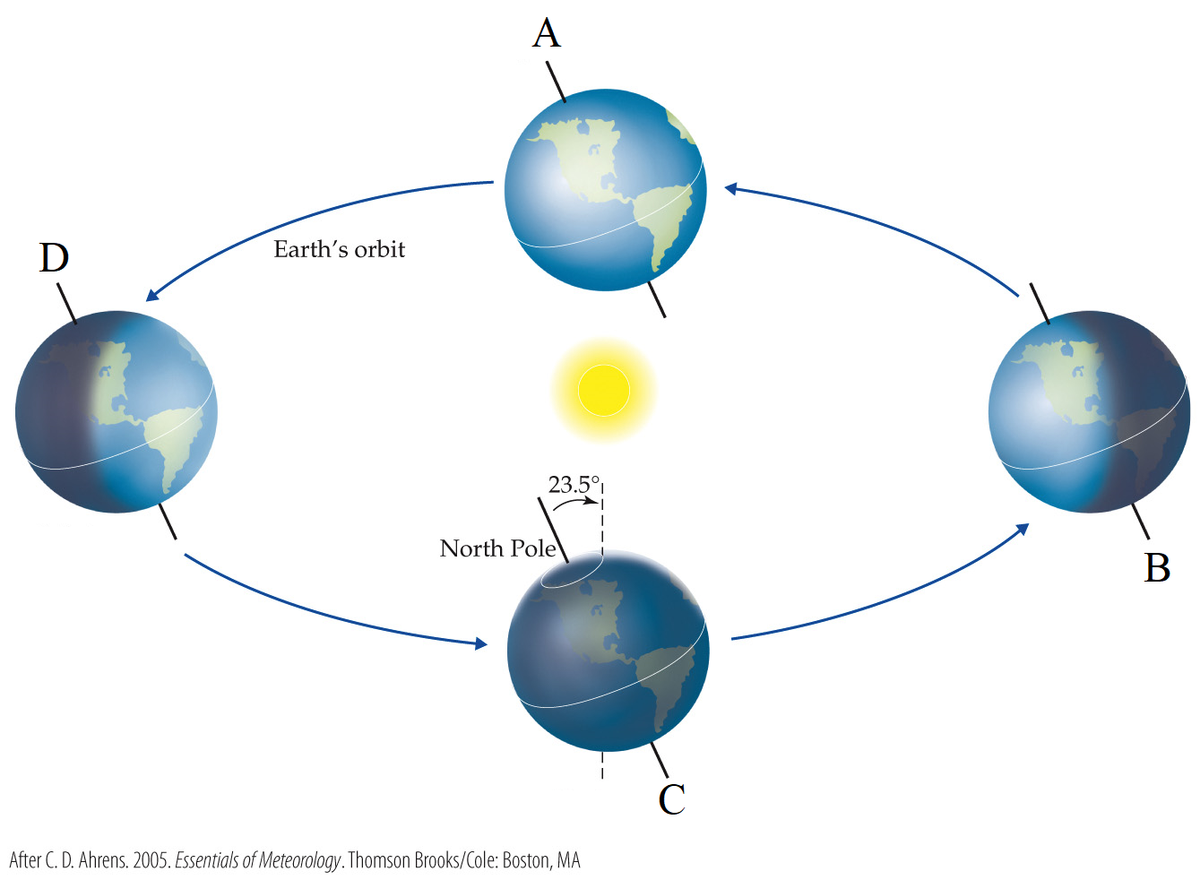

Which statement is true?

a. Position “A” represents the June solstice, when locations in the southern hemisphere are in darkness for more hours than any other day of the year.

b. Position “B” represents the June solstice, when locations in the southern hemisphere are in darkness for more hours than any other day of the year.

c. Position “C” represents the December solstice, when locations in the southern hemisphere are in darkness for more hours than any other day of the year.

d. Position “D” represents the December solstice, when locations in the southern hemisphere are in darkness for more hours than any other day of the year.

Answer: b

Textbook Reference: 2.5 Seasonal and decadal climate variation are associated with changes in Earth’s position relative to the sun and the strength of atmospheric pressure cells.

Learning Objective: 2.5.1 Explain how the tilt of Earth’s axis influences (1) seasonal changes in air temperature in temperate and polar zones and (2) seasonal changes in precipitation in the tropics.

Bloom’s Level: 3. Applying

39. Refer to the figure.

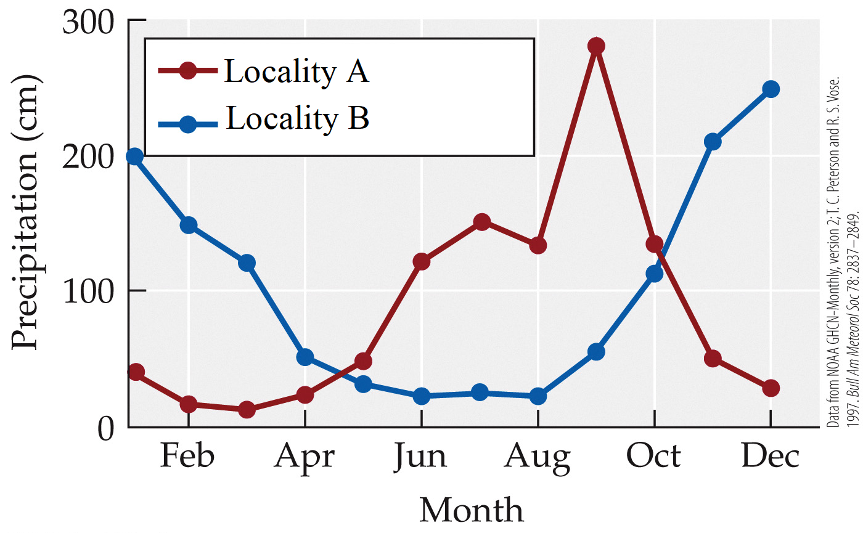

Although tropical regions do not experience strong seasonality as far as temperature, they do commonly experience seasonality as far as rainfall due to a shift across the year of the Intertropical Convergence Zone (ITCZ). According to the figure, which of the following locations is in the southern hemisphere and why?

a. Locality A because precipitation is highest during the time of the year when it is tilted away from the sun.

b. Locality B because precipitation is highest during the time of the year when it is tilted away from the sun.

c. Locality A because precipitation is highest during the time of the year when it is tilted toward the sun.

d. Locality B because precipitation is highest during the time of the year when it is tilted toward from the sun.

Answer: d

Textbook Reference: 2.5 Seasonal and decadal climate variation are associated with changes in Earth’s position relative to the sun and the strength of atmospheric pressure cells.

Learning Objective: 2.5.1 Explain how the tilt of Earth’s axis influences (1) seasonal changes in air temperature in temperate and polar zones and (2) seasonal changes in precipitation in the tropics.

Bloom’s Level: 4. Analyzing

40. Which statement about ice is true?

a. It is less dense than liquid water.

b. It has a higher albedo than open water has.

c. Ice formation at the surface of ponds prevents warming of the waters below.

d. All of the above

Answer: d

Textbook Reference: 2.5 Seasonal and decadal climate variation are associated with changes in Earth’s position relative to the sun and the strength of atmospheric pressure cells.

Learning Objective: 2.5.2 Outline how seasonal changes in surface heating in temperate and polar lakes influence water density and result in the stratification of water.

Bloom’s Level: 1. Remembering

41. During the summer, temperatures and plankton activity in temperate lakes are highest in the _______. This is also the period of _______ lake stratification.

a. epilimnion; highest

b. epilimnion; lowest

c. thermocline; highest

d. thermocline; lowest

Answer: a

Textbook Reference: 2.5 Seasonal and decadal climate variation are associated with changes in Earth’s position relative to the sun and the strength of atmospheric pressure cells.

Learning Objective: 2.5.2 Outline how seasonal changes in surface heating in temperate and polar lakes influence water density and result in the stratification of water.

Bloom’s Level: 2. Understanding

42. Refer to the figure.

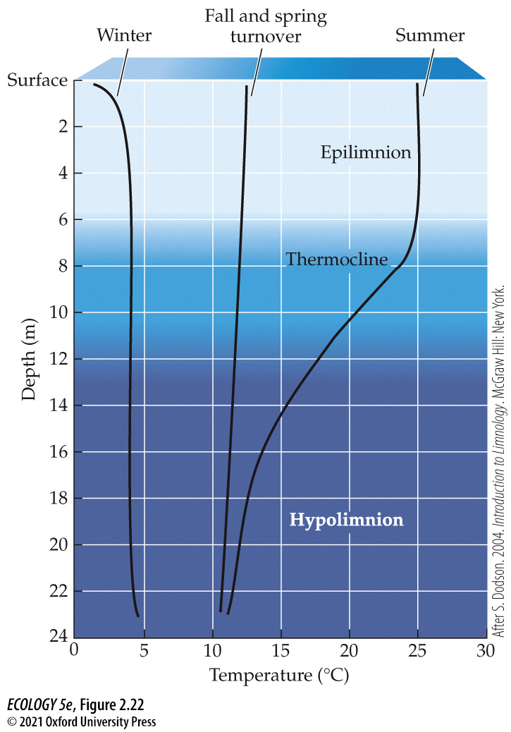

The figure shows the temperature of water at different depths in a typical temperate-zone lake. Which of the following statements is true?

a. In winter, but not in summer, the coldest water is also the densest.

b. In summer, but not in winter, the coldest water is also the densest.

c. Throughout the year, the coldest water is also the densest.

d. The coldest water is in the hypolimnion, so the deepest portion of the lake freezes first.

Answer: b

Textbook Reference: 2.5 Seasonal and decadal climate variation are associated with changes in Earth’s position relative to the sun and the strength of atmospheric pressure cells.

Learning Objective: 2.5.2 Outline how seasonal changes in surface heating in temperate and polar lakes influence water density and result in the stratification of water.

Bloom’s Level: 4. Analyzing

43. The mixing that occurs at fall and spring turnover replenishes _______ in the epilimnion and increases the level of _______ in the hypolimnion.

a. nutrients; sediments

b. nutrients; oxygen

c. oxygen; nutrients

d. oxygen; biological activity

Answer: b

Textbook Reference: 2.5 Seasonal and decadal climate variation are associated with changes in Earth’s position relative to the sun and the strength of atmospheric pressure cells.

Learning Objective: 2.5.2 Outline how seasonal changes in surface heating in temperate and polar lakes influence water density and result in the stratification of water.

Bloom’s Level: 2. Understanding

44. On what time scale does the El Niño Southern Oscillation (ENSO) occur?

a. Daily

b. Monthly

c. Seasonal

d. Between 2 and 10 years

Answer: d

Textbook Reference: 2.5 Seasonal and decadal climate variation are associated with changes in Earth’s position relative to the sun and the strength of atmospheric pressure cells.

Learning Objective: 2.5.3 Describe how cyclic change in the position and strength of high- and low-pressure cells, which occurs during the ENSO for example, influences weather and climate variability.

Bloom’s Level: 1. Remembering

45. El Niño events are associated with

a. greatly increased upwelling in the eastern Pacific Ocean.

b. much reduced or absent upwelling in the eastern Pacific Ocean.

c. flooding in Indonesia and parts of Australia.

d. droughts in the southeastern United States.

Answer: b

Textbook Reference: 2.5 Seasonal and decadal climate variation are associated with changes in Earth’s position relative to the sun and the strength of atmospheric pressure cells.

Learning Objective: 2.5.3 Describe how cyclic change in the position and strength of high- and low-pressure cells, which occurs during the ENSO for example, influences weather and climate variability.

Bloom’s Level: 1. Remembering

46. Which phenomenon is a major cause of the periodic glacial advances and retreats that have occurred over the last two million years?

a. The Pacific Decadal Oscillation (PDO)

b. El Niño Southern Oscillation (ENSO)

c. Periodic changes of Earth’s orbit from more circular to more elliptical

d. Changes in the rate of continental drift

Answer: c

Textbook Reference: 2.5 Seasonal and decadal climate variation are associated with changes in Earth’s position relative to the sun and the strength of atmospheric pressure cells.

Learning Objective: 2.5.3 Describe how cyclic change in the position and strength of high- and low-pressure cells, which occurs during the ENSO for example, influences weather and climate variability.

Bloom’s Level: 1. Remembering

47. When Earth’s orbit becomes more circular (i.e., compared with a more elliptical orbit), the distance between Earth and the sun at aphelion _______. This change leads to a(n) _______ in the intensity of solar radiation at aphelion, and thus _______ seasonality.

a. increases; increase; increases

b. increases; increase; decreases

c. decreases; increase; increases

d. decreases; increase; decreases

Answer: d

Textbook Reference: 2.5 Seasonal and decadal climate variation are associated with changes in Earth’s position relative to the sun and the strength of atmospheric pressure cells.

Learning Objective: 2.5.3 Describe how cyclic change in the position and strength of high- and low-pressure cells, which occurs during the ENSO for example, influences weather and climate variability.

Bloom’s Level: 4. Analyzing

48. Which statement about the Pacific Decadal Oscillation (PDO) is false?

a. It is a major driver of salmon populations in the Pacific.

b. It is an oscillation of sea surface temperature and atmospheric pressure.

c. Its cycles typically do not last as long as those of ENSO and other similar oscillations.

d. Evidence that it has occurred over many centuries has been gathered from tree ring data.

Answer: c

Textbook Reference: 2.5 Seasonal and decadal climate variation are associated with changes in Earth’s position relative to the sun and the strength of atmospheric pressure cells.

Learning Objective: 2.5.3 Describe how cyclic change in the position and strength of high- and low-pressure cells, which occurs during the ENSO for example, influences weather and climate variability.

Bloom’s Level: 1. Remembering

49. The pH of a sample of water that had 10 times the concentration of H⁺ ions as a sample with a pH of 5.8 would be

a. 3.8.

b. 4.8.

c. 6.8.

d. 15.8.

Answer: b

Textbook Reference: 2.6 Salinity, acidity, and oxygen concentrations are major determinants of the chemical environment.

Learning Objective: 2.6.1 Outline what determines the salinity and acidity of soils and waters.

Bloom’s Level: 3. Applying

50. In which aquatic ecosystems are oxygen concentrations in the water usually highest?

a. Rapidly running rivers

b. Deep lakes

c. Slowly running rivers

d. Deep oceans

Answer: a

Textbook Reference: 2.6 Salinity, acidity, and oxygen concentrations are major determinants of the chemical environment.

Learning Objective: 2.6.2 Explain why oxygen concentrations vary depending on elevation, the influence of water on diffusion, and biological consumption.

Bloom’s Level: 1. Remembering

Short Answer/Essay

1. In recent years, major episodes of very cold weather have sometimes been highlighted by non-scientists as evidence that the climate is not really warming. What fundamental misunderstanding does this illustrate and how does this relate to the challenge in detecting the Pacific Decadal Oscillation?

Answer: Weather refers to the current temperature, humidity, precipitation, wind, and cloud cover at a location, while climate describes the typical weather at a given location, based on averages and variation measured over decades. Climate change and the PDO both occur at time scales that are too long to be easily perceived through casual observation.

Textbook Reference: 2.1 Climate is the most fundamental component of the physical environment.

Learning Objective: 2.1.1 Outline the difference between weather and climate with specific reference to their temporal scales.

Bloom’s Level: 2. Understanding

2. If the Earth rotated around its axis from east to west rather than west to east, what major consequences would this have had for the standard routes traversed by sailing ships traveling between Europe or Africa and the Americas prior to the 20th century?

Answer: In this imagined scenario, the prevailing winds between the equator and 30° North or South would have blown eastward rather than westward; similarly, the prevailing winds between 30° and 60° North or South would have blown westward rather than eastward. Therefore, ships traveling from Europe to the Americas would have followed a path within the latitudinal band between 30° and 60° from the equator, whereas ships traveling from the Americas to Europe or Africa would have followed a path within the latitudinal band between the equator and 30° North or South.

Textbook Reference: 2.2 Wind and ocean currents result from differences in solar radiation across Earth’s surface.

Learning Objective: 2.2.1 Draw connections between differential heat gain across Earth’s surface and the development of atmospheric circulation cells.

Bloom’s Level: 3. Applying

3. Refer to the figure.

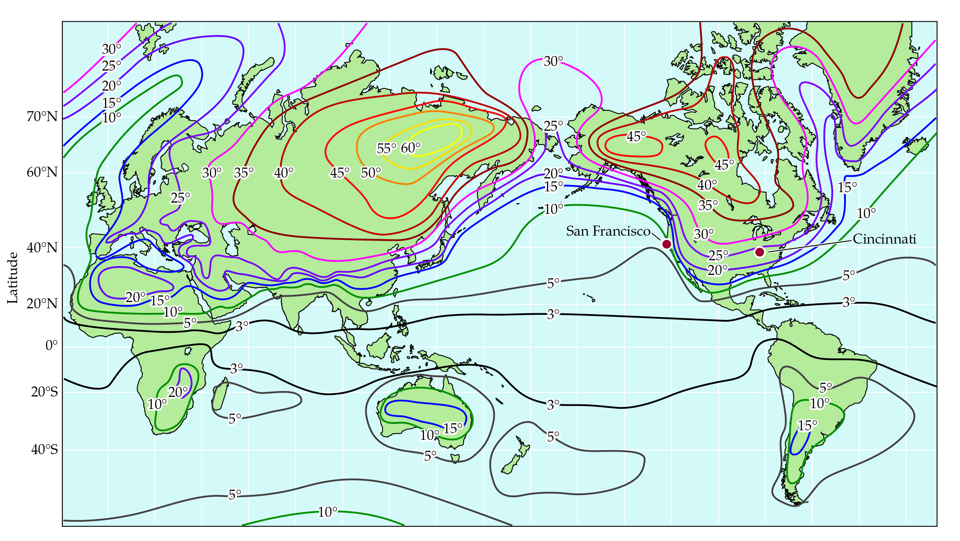

The figure shows seasonal temperature variation expressed as the difference in average monthly temperature between the warmest and coldest months (in ℃). San Francisco and Cincinnati are located at similar latitudes in North America. Based on the figure, which of these two cities experiences less temperature differential between winter and summer? Explain why.

Answer: Temperatures fluctuate much less within a year in San Francisco than in Cincinnati. Because water has a much higher heat capacity than land masses do, the ocean does not get as cold in the winter or as hot in the summer as the land does. At this latitude, prevailing winds travel from the Pacific Ocean eastward across the continent. The temperature of the air masses blowing onto the west coast of North America are relatively warm in the winter and relatively cool in the summer. As the air masses continue across the continent, they cool down in the winter and heat up in the summer. By the time the air masses reach Cincinnati, they are very cold in the winter and very warm in the summer.

Textbook Reference: 2.3 Large-scale atmospheric and oceanic circulation patterns establish global patterns of temperature and precipitation.

Learning Objective: 2.3.2 Explain how a region’s seasonal changes in temperature are affected by its location, whether it is near a large body of water or at the center of a large continent.

Bloom’s Level: 3. Applying

4. Refer to the figure.

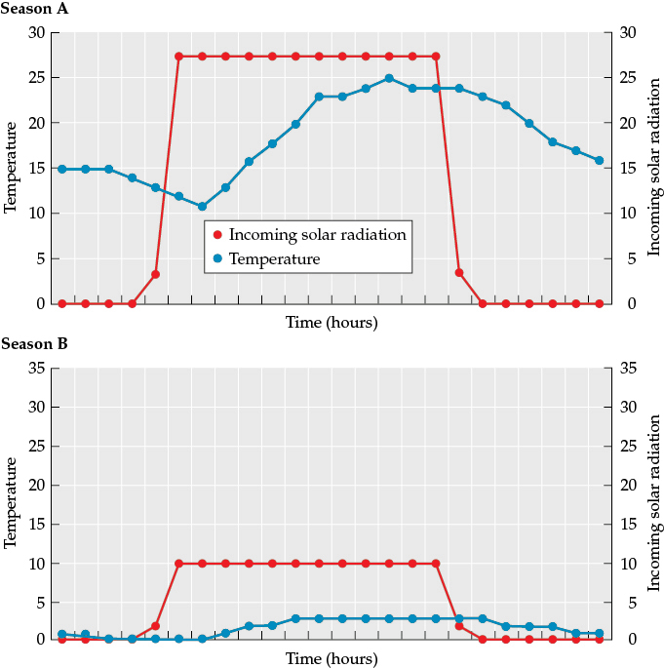

You are one of a team of scientists studying a newly-discovered planet. You are receiving data from a probe that was landed on the planet by an unmanned mission. Your team is working with the little data you have from the probe to learn as much as you can about the planet’s basic characteristics. The figure illustrates data collected by the probe at the same location on the planet during what you suspect are two different seasons (season A and season B). Do you think the planet is tilted on its axis? Describe how the data supports your hypothesis.

Answer: The planet does not appear to be tilted on its axis because although the temperature and amount of incoming solar radiation differ from season A to season B, the length of the daylight period remains the same. If the planet was tilted on its axis, this large difference in temperature and solar radiation could occur, but the number of daylight hours during season B would be much shorter.

Textbook Reference: 2.5 Seasonal and decadal climate variation are associated with changes in Earth’s position relative to the sun and the strength of atmospheric pressure cells.

Learning Objective: 2.5.1 Explain how the tilt of Earth’s axis influences (1) seasonal changes in air temperature in temperate and polar zones and (2) seasonal changes in precipitation in the tropics.

Bloom’s Level: 5. Evaluating

5. Refer to the figure.

You are one of a team of scientists studying a newly-discovered planet. You are receiving data from a probe that was landed on the planet by an unmanned mission. Your team is working with the little data you have from the probe to learn as much as you can about the planet’s basic characteristics. The figure illustrates data collected by the probe at the same location on the planet during what you suspect are two different seasons (season A and season B). Create a hypothesis about the shape of the planet’s orbit, and describe how the data supports your hypothesis.

Answer: The planet most likely has a highly elliptical orbit around its sun. The temperature and amount of solar radiation differs drastically between season A and season B, but based on the number of daylight hours, it does not appear that this is driven by the tilt of the planet’s axis. A likely explanation is that the planet grows warmer as its orbit takes it closer to its sun and becomes colder when its orbit takes it farther from the sun.

Textbook Reference: 2.5 Seasonal and decadal climate variation are associated with changes in Earth’s position relative to the sun and the strength of atmospheric pressure cells.

Learning Objective: 2.5.1 Explain how the tilt of Earth’s axis influences (1) seasonal changes in air temperature in temperate and polar zones and (2) seasonal changes in precipitation in the tropics.

Bloom’s Level: 5. Evaluating

6. Refer to the figure.

You are one of a team of scientists studying a newly-discovered planet. You are receiving data from a probe that was landed on the planet by an unmanned mission. Your team is working with the little data you have from the probe to learn as much as you can about the planet’s basic characteristics. The figure illustrates data collected by the probe at the same location on the planet during what you suspect are two different seasons (season A and season B). Do you think that the planet’s atmosphere contains greenhouse gases? Why or why not?

Answer: It appears that the atmosphere contains greenhouse gases because the atmosphere is insulated from daily heat loss, and while temperatures are cooler at night and warmer during the day, this is a gradual process that doesn’t result in drastic or extreme temperature differences. If the atmosphere did indeed contain greenhouse gases, it would have an effect similar to that recorded by the probe.

Textbook Reference: 2.1 Climate is the most fundamental component of the physical environment.

Learning Objective: 2.1.3 Summarize how temperature is determined by the gains and losses of energy at Earth’s surface.

Bloom’s Level: 4. Analyzing

7. Refer to the figure.

You are one of a team of scientists studying a newly-discovered planet. You are receiving data from a probe that was landed on the planet by an unmanned mission. Your team is working with the little data you have from the probe to learn as much as you can about the planet’s basic characteristics. The figure illustrates data collected by the probe at the same location on the planet during what you suspect are two different seasons (season A and season B). If plants from Earth’s temperate deciduous forests could grow on this new planet, during which season(s) would they most likely show the most active growth? What other information would be required to determine probable growth patterns?

Answer: Plants on Earth are usually most active during periods when temperatures are moderate and water is readily available, and would most likely also be most active on the new planet under similar conditions. It would be important to know if the planet has wet and dry seasons, and how these correspond to the planet’s cold and warm seasons to better determine probable growth patterns.

Textbook Reference: 2.1 Climate is the most fundamental component of the physical environment.

Learning Objective: Not aligned

Bloom’s Level: 3. Applying

8. Refer to the figure.

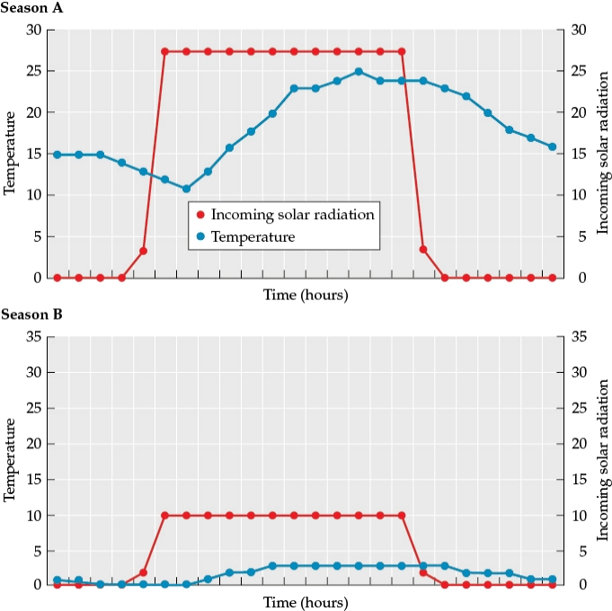

You are one of a team of scientists studying a newly-discovered planet. You are receiving data from a probe that was landed on the planet by an unmanned mission. Your team is working with the little data you have from the probe to learn as much as you can about the planet’s basic characteristics. The figure illustrates data collected by the probe at the same location on the planet during what you suspect are two different seasons (season A and season B). Based on what you have inferred from the data in the figure, sketch a new figure of the hypothetical orbit of this planet around its sun. Sketch the planet at four different positions during its orbit around its sun (at 12:00, 3:00, 6:00, and 9:00, relative to the sun). Label the seasons (A or B) at each of these four locations.

Answer:

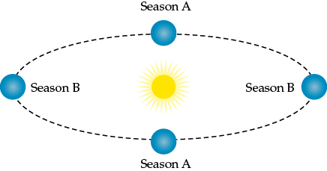

Textbook Reference: 2.5 Seasonal and decadal climate variation are associated with changes in Earth’s position relative to the sun and the strength of atmospheric pressure cells.

Learning Objective: 2.5.1 Explain how the tilt of Earth’s axis influences (1) seasonal changes in air temperature in temperate and polar zones and (2) seasonal changes in precipitation in the tropics.

Bloom’s Level: 5. Evaluating

9. Refer to the figures.

You are one of a team of scientists studying a newly-discovered planet. You are receiving data from a probe that was landed on the planet by an unmanned mission. Your team is working with the little data you have from the probe to learn as much as you can about the planet’s basic characteristics. The figure illustrates data collected by the probe at the same location on the planet during what you suspect are two different seasons (season A and season B). Based on your sketch of the planet at four different positions during its orbit around its sun (the second figure) and the data sent back by the probe, how many growing seasons would the planet have during one complete orbit of its sun?

Answer: It would experience two growing seasons during one complete orbit of its sun.

Textbook Reference: 2.5 Seasonal and decadal climate variation are associated with changes in Earth’s position relative to the sun and the strength of atmospheric pressure cells.

Learning Objective: 2.5.1 Explain how the tilt of Earth’s axis influences (1) seasonal changes in air temperature in temperate and polar zones and (2) seasonal changes in precipitation in the tropics.

Bloom’s Level: 3. Applying

10. Refer to the figure.

You are one of a team of scientists studying a newly-discovered planet. You are receiving data from a probe that was landed on the planet by an unmanned mission. Your team is working with the little data you have from the probe to learn as much as you can about the planet’s basic characteristics. The figure illustrates data collected by the probe at the same location on the planet during what you suspect are two different seasons (season A and season B). The average daily temperature of the probe during season A is about 19°C while the average temperature of the same location in season B is 2°C. Imagine instead that the averages recorded were 40°C in season A and –20°C in season B. List three characteristics of the planet that, if they were different, could cause these more extreme seasonal differences. Justify your answers.

Answer: If the planet had a more pronounced elliptical orbit, it would be much closer to the sun in season A, and much farther away from it in season B. This would change the incoming solar radiation levels, with much more energy coming in during season A and much less energy coming in during season B. If the planet was tilted on its axis, it might have more extreme seasons (similar to those experienced on Earth), because the number of hours of incoming solar radiation (day length) would be different in seasons A and B. If the atmospheric composition changed or fluctuated with the seasons, this could cause changes in temperature. If more greenhouse gases were released into the atmosphere during season A, this stronger greenhouse effect could cause much higher average temperatures on the planet. If atmospheric greenhouse gases left the atmosphere during season B and their concentration decreased, colder temperatures could occur because much more heat would be lost.

Textbook Reference: 2.5 Seasonal and decadal climate variation are associated with changes in Earth’s position relative to the sun and the strength of atmospheric pressure cells.

Learning Objective: 2.5.1 Explain how the tilt of Earth’s axis influences (1) seasonal changes in air temperature in temperate and polar zones and (2) seasonal changes in precipitation in the tropics.

Bloom’s Level: 5. Evaluating

11. A leak from an oil pipeline is flowing into an Alaskan lake that is approximately 1 km wide and 20 m deep. When oil spills into a body of water, much of it floats on top but some can adhere to tiny particles in the water column and be carried into deeper water.

During which season(s) would the oil most likely remain on the surface and be easiest to clean up? Why? During which season would you expect the most oil to move into deeper water? Why?

Answer: The best seasons to clean up the oil would be during the summer or winter because that is when lakes in polar regions are stratified and little mixing occurs (they are less stratified in winter than they are in summer, but even so, there is little turnover in winter). Even if oil did adhere to particles in the lake, these particles are not likely to mix into deeper water during these seasons. This would make it easier to contain the oil. Much higher rates of mixing occur during spring and fall when lakes undergo turnover and the layers become mixed, making it more difficult to contain the oil.

Textbook Reference: 2.5 Seasonal and decadal climate variation are associated with changes in Earth’s position relative to the sun and the strength of atmospheric pressure cells.

Learning Objective: 2.5.2 Outline how seasonal changes in surface heating in temperate and polar lakes influence water density and result in the stratification of water.

Bloom’s Level: 3. Applying

12. A leak from an oil pipeline is flowing into an Alaskan lake that is approximately 1 km wide and 20 m deep. When oil spills into a body of water, much of it floats on top but some can adhere to tiny particles in the water column and be carried into deeper water. Suppose the oil leak occurs during early summer. The oil impacts not only the lake but also the surrounding vegetation, causing trees, bushes, and other plants to die off over the course of the summer. What effect would this have on the local albedo and evapotranspiration around the lake? Would you expect the lake to heat up more or less than it would during normal years? Which layer of the lake would be most affected?

Answer: The loss of vegetation and increase in bare ground would lead to a higher albedo because bare ground reflects more solar radiation than vegetation does. However, this effect would be offset by a decrease in evapotranspiration which would reduce surface cooling and result in a net increase in energy absorption in the affected area. Thus, the lake might heat up more than it normally would. This increase in temperature would be most pronounced in the epilimnion.
Textbook Reference: 2.5 Seasonal and decadal climate variation are associated with changes in Earth’s position relative to the sun and the strength of atmospheric pressure cells.

Learning Objective: 2.5.2 Outline how seasonal changes in surface heating in temperate and polar lakes influence water density and result in the stratification of water.

Bloom’s Level: 3. Applying

COMPANION WEBSITE QUIZ QUESTIONS

1. Which of the following statements about climate is false?
a. Climate controls where organisms live, their geographic distribution, and how they function.
b. Climate is a short-term description of outdoor conditions that we experience daily.
c. Climate can vary over time.
d. There can be seasonal variation in climate.
Answer: b
Textbook Reference: 2.1 Climate is the most fundamental component of the physical environment.

Learning Objective: 2.1.1 Outline the difference between weather and climate, with specific reference to their temporal scales.
Bloom’s Level: 2. Understanding

2. Climate’s control of the geographic distribution of organisms is influenced by _______ more than _______.
a. extreme conditions; average conditions
b. weather; climate
c. average conditions; extreme conditions
d. fire; floods
Answer: a
Textbook Reference: 2.1 Climate is the most fundamental component of the physical environment.

Learning Objective: 2.1.2. Explain the importance of weather variability for ecological processes.
Bloom’s Level: 1. Remembering

3. Sensible heat flux includes convection and

a. conduction.

b. evapotranspiration.

c. upwelling.

d. continental drift.

Answer: a

Textbook Reference: 2.1 Climate is the most fundamental component of the physical environment.

Learning Objective: 2.1.3 Summarize how temperature is determined by the gains and losses of energy at Earth’s surface.

Bloom’s Level: 1. Remembering

4. Cool air is _______ dense than warm air; as air cools, it _______.

a. more; rises

b. more; sinks

c. less; rises

d. less; sinks

Answer: b

Textbook Reference: 2.2 Winds and ocean currents result from differences in solar radiation across Earth’s surface.

Learning Objective: 2.2.1 Draw connections between differential heat gain across Earth’s surface and the development of atmospheric circulation cells.

Bloom’s Level: 2. Understanding

5. During January, in which location would you expect a strong high-pressure system to develop?

a. In the United States, around Colorado

b. In the Atlantic Ocean, near Bermuda

c. In South America, around the equator

d. In South Africa

Answer: a

Textbook Reference: 2.2 Wind and ocean currents result from differences in solar radiation across Earth’s surface.

Learning Objective: 2.2.2 Explain how surface winds and ocean currents move heat between the tropics and the poles.

Bloom’s Level: 3. Applying

6. High-pressure systems typically form over the Atlantic Ocean during the summer. If such systems did not form as often, _______ would become _______.

a. South Carolina; wetter

b. Toronto; wetter

c. South Carolina; drier

d. Paris; wetter

Answer: c

Textbook Reference: 2.3 Large-scale atmospheric and oceanic circulation patterns establish global patterns of temperature and precipitation.

Learning Objective: 2.3.1 Outline the determinants of global temperature and precipitation patterns.

Bloom’s Level: 3. Applying

7. The greatest seasonal variation of temperature is most likely to be seen over

a. oceans at low latitudes.

b. land at low latitudes.

c. land near oceans at low latitudes.

d. land in the middle of a continent at high latitudes.

Answer: d

Textbook Reference: 2.3 Large-scale atmospheric and oceanic circulation patterns establish global patterns of temperature and precipitation.

Learning Objective: 2.3.2 Explain how a region’s seasonal changes in temperature are affected by its location, whether it is near a large body of water or at the center of a large continent.

Bloom’s Level: 2. Understanding

8. It is _______ in mountains and highlands when compared to lowlands because _______.
a. colder; there are more air molecules to absorb the infrared energy from the sun.
b. warmer; mountains are closer to the sun.
c. colder; there are fewer air molecules to absorb the infrared energy radiating from the Earth’s surface.
d. about the same temperature; Earth loses heat to the atmosphere equally across elevations.
Answer: c
Textbook Reference: 2.3 Large-scale atmospheric and oceanic circulation patterns establish global patterns of temperature and precipitation.

Learning Objective: 2.3.3 Summarize how air density and air exchange cause a decrease in air temperature with increases in elevation on a mountain.
Bloom’s Level: 1. Remembering

9. The side of a mountain range that faces into the prevailing winds is called the _______ side. This usually receives _______ precipitation than the other side of the mountain.

a. leeward; more

b. leeward; less

c. starboard; less

d. windward; more

Answer: d

Textbook Reference: 2.4 Regional climates reflect the influence of oceans and continents, mountains, and vegetation.

Learning Objective: 2.4.1 Describe the changes in an air mass that moves from a maritime zone across mountains on both the leeward and windward slopes.

Bloom’s Level: 2. Understanding

10. Snow is white, and thus has a _______ albedo than bare ground. If global warming decreases snow cover, the resulting change in albedo is likely to _______ further warming.

a. higher; enhance

b. higher; mitigate

c. lower; mitigate

d. lower; enhance

Answer: a

Textbook Reference: 2.4 Regional climates reflect the influence of oceans and continents, mountains, and vegetation.

Learning Objective: 2.4.2 Illustrate how energy exchange components are influenced by vegetation and subsequently affect climate.

Bloom’s Level: 3. Applying

11. If perihelion were in July instead of January, seasonality would _______ in the Northern Hemisphere and _______ in the Southern hemisphere.

a. increase; decrease

b. increase; increase

c. decrease; increase

d. decrease; decrease

Answer: a

Textbook Reference: 2.5 Seasonal and decadal climate variation are associated with changes in Earth’s position relative to the sun and the strength of atmospheric pressure cells.

Learning Objective: 2.5.1 Explain how the tilt of Earth’s axis influences (1) seasonal changes in air temperature in temperate and polar zones and (2) seasonal changes in precipitation in the tropics.

Bloom’s Level: 4. Analyzing

12. If liquid water froze at the same temperature at which it is most dense,

a. the surface of temperate-region lakes would tend to freeze before deeper regions.

b. deeper regions of temperate-region lakes would tend to freeze before the surface.

c. no thermocline would form in the summer in temperate-region lakes.

d. the epilimnion would freeze first in temperate-region lakes.

Answer: b

Textbook Reference: 2.5 Seasonal and decadal climate variation are associated with changes in Earth’s position relative to the sun and the strength of atmospheric pressure cells.

Learning Objective: 2.5.2 Outline how seasonal changes in surface heating in temperate and polar lakes influence water density and result in the stratification of water.

Bloom’s Level: 3. Applying

13. Over the last century, which cycle has had the greatest effect on cycles of salmon production in the North Pacific?

a. El Niño Southern Oscillation (ENSO)

b. Pacific Decadal Oscillation (PDO)

c. Sunspot activity cycle

d. Lunar cycle
Answer: b

Textbook Reference: 2.5 Seasonal and decadal climate variation are associated with changes in Earth’s position relative to the sun and the strength of atmospheric pressure cells.

Learning Objective: 2.5.3 Describe how cyclic change in the position and strength of high- and low-pressure cells, which occurs during the ENSO for example, influences weather and climate variability.

Bloom’s Level: 1. Remembering

14. Suppose water sample A has a pH of 4.3. The pH of a sample of water that has 10 times a lower concentration of H⁺ ions as sample A would be

a. 3.3.

b. 3.8.

c. 5.3.

d. 14.3.

Answer: c

Textbook Reference: 2.6 Salinity, acidity, and oxygen concentrations are major determinants of the chemical environment.

Learning Objective: 2.6.1 Outline what determines the salinity and acidity of soils and waters.

Bloom’s Level: 3. Applying

15. In wetland sediments, the physiological functioning of organisms is most likely to be negatively affected by _______ conditions.

a. anoxic

b. anadromous

c. alkaline

d. photic

Answer: a

Textbook Reference: 2.6 Salinity, acidity, and oxygen concentrations are major determinants of the chemical environment.

Learning Objective: 2.6.2 Explain why oxygen concentrations vary depending on elevation, the influence of water on diffusion, and biological consumption.

Bloom’s Level: 1. Remembering

