1. True or false? The tightest barrier that prevents entry of drugs is the skin.

<Answer: False>

1. Which of the following are the main categories of barriers?
2. Static barrier
3. Physiological barrier
4. Dynamic barrier
5. Chemical barrier
6. Biochemical barrier

<Answers: B, D, and E>

1. True or false? The transcellular pathway allows passive transport of all types of molecules through epithelial cells.

<Answer: False>

1. True or false? Hydrophilic and large macromolecules have unfavorable properties to undergo transport through the transcellular pathway.

<Answer: True>

1. Match the following with their function

Terms  
A. Desmosomes

B. Zonula adherens

C. Zonula occludens

Functions

___ Forms free barrier against the free movement of molecules.

___ Responsible for cell-cell adhesion.

___ Responsible for linkage between desmoplakins and intermediate filaments.

<Answer: C, B, A>

1. Label the intercellular complexes in the figure below.

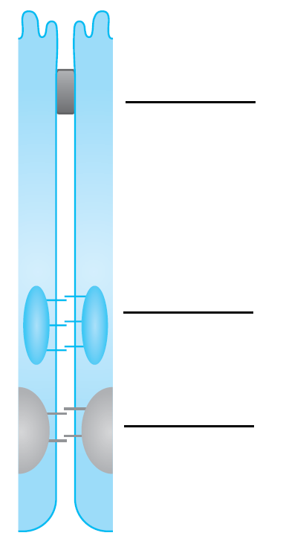

1. Fill in the blanks: Desmosomes form the _____ region of the __________________ and are located toward the ____________ side of epithelial cells

<Answer: end, paracellular pathway, basolateral>

1. True or false? Desmosomes play a mojor role in the barrier function of the paracellular pathway.

<Answer: False>

1. Describe tight junctions.

<Answer: The tight junction is also known as zonula occludens and is located at the most apical portion of the epithelial cell. The name zonula occludens is derived from the Latin word “closing belt,” which describes the functional property of this region. The tight junctions span or circumscribe the cells, forming a barrier against the free movement of molecules across this layer. These junctions impart cell surface its polarity and control drug movement from the apical to the basolateral side. The rate and extent of permeation via paracellular pathway depends on the pore size of the tight junctions.>

1. What are scaffolding proteins?

<Answer: Three scaffolding proteins are associated with tight junctions: ZO-1, ZO-2, and ZO-3. ZO-1 is mainly responsible for interaction with occludin and claudin, thereby stabilizing junctions and cross-linking to the actin cytoskeleton.>

1. True or false? There are nine domains expressed by tight junction proteins.

<Answer: False>

1. True or false? Adherens junction is responsible for cell-cell adhesion.

<Answer: True>

1. List the regions of lipid bilayers.

<Answer: (1) the outermost region, mainly consisting of water molecules, responsible for interactions with other proteins and membranes; (2) polar headgroups, forming the most dense region of the bilayers, which make this region the most difficult for diffusion; (3) the nonpolar tails, responsible for limiting permeation of therapeutic agents having only a specific molecular size and shape; and (4) the innermost region, which is the most hydrophobic in nature and acts as the hydrophobic barrier.>

1. True or false? The blood-brain barrier prevents passage of 98% small molecules but allows 100% of large molecules.

<Answer: False>

1. Which one of these forms the structural framework of neurons?
2. macrophages
3. epithelial cells
4. tight junctions
5. astrocytes
6. desmosomes

<Answer: d>

1. Which is the largest organ of the human body?
2. Brain
3. Stomach
4. Liver
5. Skin
6. Lungs
7. Heart

<Answer: d>

1. Identify the organ and label the parts in this figure.

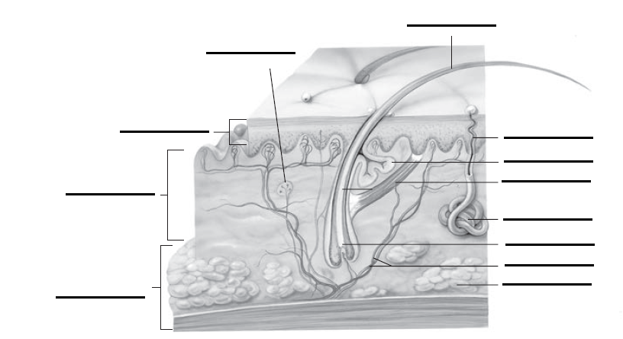

1. Arrange the layers of skin in correct order from innermost to outermost.
2. Dermis
3. Hypodermis
4. Epidermis

<Answer: b) hypodermis, a) dermis and c) epidermis>

1. True or false? Hair follicles and sweat glands constitute about 90% of total skin surface. True or False

<Answer: False>

1. What are the other properties of molecules which determine permeability?

<Answer: Several other properties are also important in determining permeability via the paracellular pathway. Size, charge, and hydrophilicity play vital roles.>

1. True or false? An important factor in permeation of small molecules id hydrogen-binding potential.

<Answer: False>

1. What are the modifications to improve permeability of drugs?
2. Halogenation
3. Sulfonation
4. Conjugation to biopolymers
5. Cationization
6. Hydration
7. Lipidization

<Answer: 1, 3, 4, 6>

23. The human genome encodes different ABC transporters categorized into ________ different classes

* 1. Five
  2. Six
  3. Seven
  4. Eight

<Answer: b>

24. List the various regions of structural homology among ABC transporters and their associated roles.

<Answer: The regions of conserved sequence motifs are the Walker A region (P-loop), Walker B region, signature C motif (LSGGQ motif), glutamine loop (Q-loop), histidine loop (H-loop), and D-loop. Walker A and B regions help in nucleotide binding. Signature C motif aids in communicating transmembrane domains. The Q- and H-loops assist in ATP hydrolysis, whereas the D-loop assists in communicating the catalytic sites.>

25. True or false: __________was the first characterized ABC transporter

<Answer: MDR1/P-gp>

26. Explain the structural classification of Multidrug Resistant proteins (MRPs).

<Answer: The nine functional MRPs (i.e., 1–9) are categorized into two classes based on the number of transmembrane domains (TMDs). MRPs 4, 5, 8, and 9 belong to short MRP transporters, whereas MRPs 1, 2, 3, 6, and 7 belong to the long transporters. Short MRPs exhibit 12 TMDs and 2 nucleotide-binding domains. The long transporters exhibit an additional N-terminal hydrophobic membrane spanning domain, with five TMDs of approximately 220 amino acids.>

27. The localization of MRPs in polarized cells is ________.

1. Apical
2. Basolateral
3. Apical and Basolateral
4. All of the above

<Answer: d>

28. The functional requirement of BCRP is met by ________

1. Monomerization
2. Homodimerization
3. Heterodimerization
4. None of the above

<Answer: b>

29. Match the ABC transporter with the respective number of TMDs.

1. MDR1 1) 6
2. MRP2 2) 12
3. BCRP 3) 17

<Answer: a-2, b-3, c-1>

30. List the CYP families mainly involved for xenobiotic metabolism in humans.

<Answer: Three CYP families, CYP1, CYP2, and CYP3, are responsible for xenobiotic metabolism in humans.>

31. Briefly explain the role of CYP3A in drug delivery.

<Answer: CYP3A is the most predominant drug metabolizing enzymes representing almost 30% of hepatic CYP and 70% of intestinal CYP. Further, this family accounts for 50% to 70% of the total contribution in drug metabolism. CYP3A4 is the major member of this family. A polymorphic isoform, CYP3A5 also plays a dominant role in drug metabolism. Drugs may interact with these enzymes either as substrate or inhibitor. After chronic exposure, most substrates and inhibitors can also cause transcriptional induction.>

32. ____________ play a predominant role in lowering potential damage after exposure to various xenobiotics.

<Answer: Detoxification mechanisms>