**Developmental Biology Exam 1** Name________________

This exam is a “take home exam,” and you may use any materials you wish. You may study with your peers, but you are not allowed to work with any other individual on the specific questions of these exams. **Your submitted response must be your own original work.**

**Solicitation from the Emergency International Science Fund:**

**“The germ cell origin of life to save the rain forest (and us).”**

The recent increase in deforestation of the Amazon rain forest has raised awareness to its impact on global warming as well as to the declining diversification of species on this planet (Figure 1). There is significant concern that even aquatic species of the Amazon River will be severely impacted. In an effort to raise global awareness to these problems, several expeditions to the Amazon rainforest in Brazil have sought to discover new species in the hopes to educate and convince world leaders that this is an essential treasure requiring protection—both to combat global warming and potentially identify new medicinal therapies.

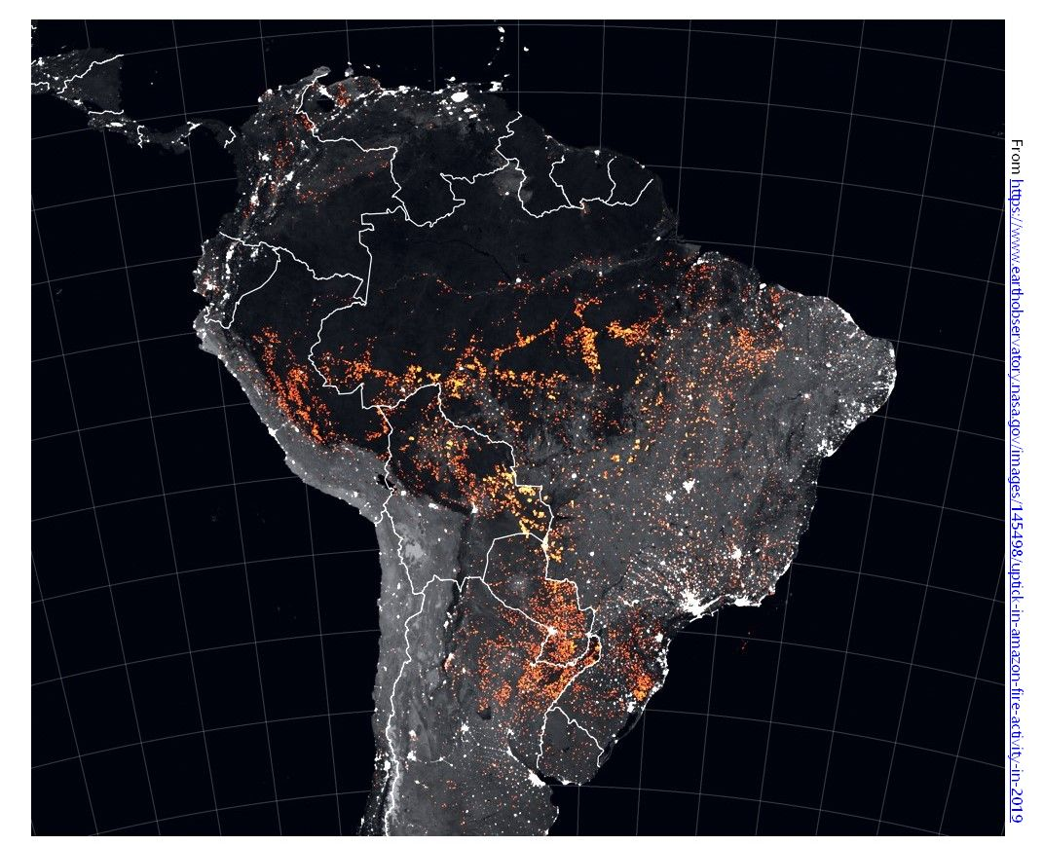

**Figure 1** Locations of fires, marked in orange, detected by MODIS from August 15 to August 22, 2019.

**Consider the Following Scenario:**

A recent exploration by ecologists to the Amazon rainforest and its river basin uncovered a new species of frog that is unlike any other vertebrate species. This easily overlooked, well-camouflaged species is a unique “tailed frog” species. The retention of its tail was what caught the eyes of these scientists. The maintained tails of such frog species have been known to play a role in their reproductive strategies. To investigate this further in the hopes to garner endangered species protections, the Developmental Biology laboratory of Miguel Allende from the University of Chile was enlisted. The Allende lab has long been interested in the processes of regeneration and for a frog species to retain its tail, raised questions about whether it may actually also maintain its regenerative potential post-metamorphosis, which would be a unique finding.

Interestingly, a routine immunocytochemistry for stem cell markers on a preserved frog of this species produced a strange finding: The oct4 primordial germ cell (pgc) marker was expressed in what appeared to be a small subset of stem cells, but in stem cells from every tissue examined! Meaning in addition to the germ cells of this frog’s gonads, each tissue’s stem cell niche housed these same pgc-like stem cells—muscle, gut, brain, bone marrow… all of them!

This finding has spurred the controversial question of whether this frog could provide the evidence that the germ cell is potentially pluripotent and potentially the true immortal cell to the point of being related to the choanoflagellate, from which all metazoan life originates. Now, *that* would be a frog worth saving, a frog that could convince the world’s leaders that this rainforest is worth protecting as it is harboring the missing link to our past and potentially to new cell-based therapies for regenerative medicine.

Excited by the importance of this frog species, now named “choanofrog,” the Allende lab was awarded a grant from the emergency international science fund. **You** are the new postdoctoral fellow just hired by Dr. Allende’s laboratory right in the middle of this discovery. What are you going to do to prove both the evolutionary relatedness of these pgc-like cells to ancestral metazoans and demonstrate the therapeutic potential of these cells?

**Exam Questions**

1. Test the hypothesis that each of the pgc-like stem cells found across all the different tissues possess the same identity.

A. How would you approach testing the relatedness of these stem cells?

B. What would you predict to find from your proposed experimental design?

C. Assuming these pgc-like stem cells prove to be related, then make a proposal for a developmental mechanism by which each stem cell niche became populated with the same resident pgc-like stem cell, yet also capable of generating very different cell type derivatives.

2. Prove the relatedness of these pgc-like stem cells to pluripotent cells across the metazoan tree of life.

A. How would you approach testing the relatedness of these pgc-like stem cells to pluripotent stem cells across species and perhaps even to the ancestral choanoflagellates?

3. Describe how you might leverage the unique (and presumed) pluripotency of these pgc-like stem cells to cure a specific human disease?

**Exam Guidelines**

The more detail you provide, the easier it will be to judge the thoroughness and accuracy of your answer. Superficiality and vagueness will result in loss of points.

Your ideas should be supported with examples from the content covered in class, from the textbook and/or from readings assigned during this unit. It is not necessary to conduct literature research for additional articles to support your claims.

Drawings are welcomed (but not required).

**Extra Credit**

Write a creative and compelling paragraph as to why the choanofrog should be protected and thus support the prevention of any further deforestation of the Amazon rainforest.