**Test Bank**

For

**Counseling Children and Adolescents**

**1st Edition**

Victoria Kress, Youngstown State University

Matthew Paylo, Youngstown State University

Nicole Stargell, University of North Carolina, Pembroke

Prepared by

Amy E. Williams, Youngstown State University

Boston Columbus Indianapolis New York San Francisco Hoboken

Amsterdam Cape Town Dubai London Madrid Milan Munich Paris Montreal Toronto

Delhi Mexico City Sao Paolo Sydney Hong Kong Seoul Singapore Taipei Tokyo

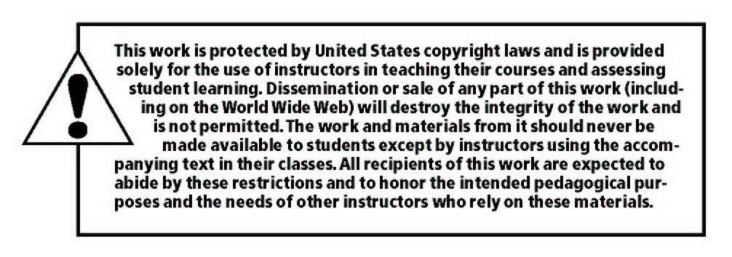

______________________________________________________________________________

Copyright © 2019 by Pearson Education, Inc. or its affiliates.  All Rights Reserved.  Printed in the United States of America. This publication is protected by copyright, and permission should be obtained from the publisher prior to any prohibited reproduction, storage in a retrieval system, or transmission in any form or by any means, electronic, mechanical, photocopying, recording, or otherwise. For information regarding permissions, request forms and the appropriate contacts within the Pearson Education Global Rights & Permissions Department, please visit [www.pearsoned.com/permissions/](http://www.pearsoned.com/permissions/).

Instructors of classes using *Counseling Children and Adolescents****,******by V. Kress, M. Paylo, and N. Stargell*** may reproduce material from the Instructor’s Resource Manual and Test Bank for classroom use.

10 9 8 7 6 5 4 3 2 1 ISBN-10: 0134745159

ISBN-13: 9780134745152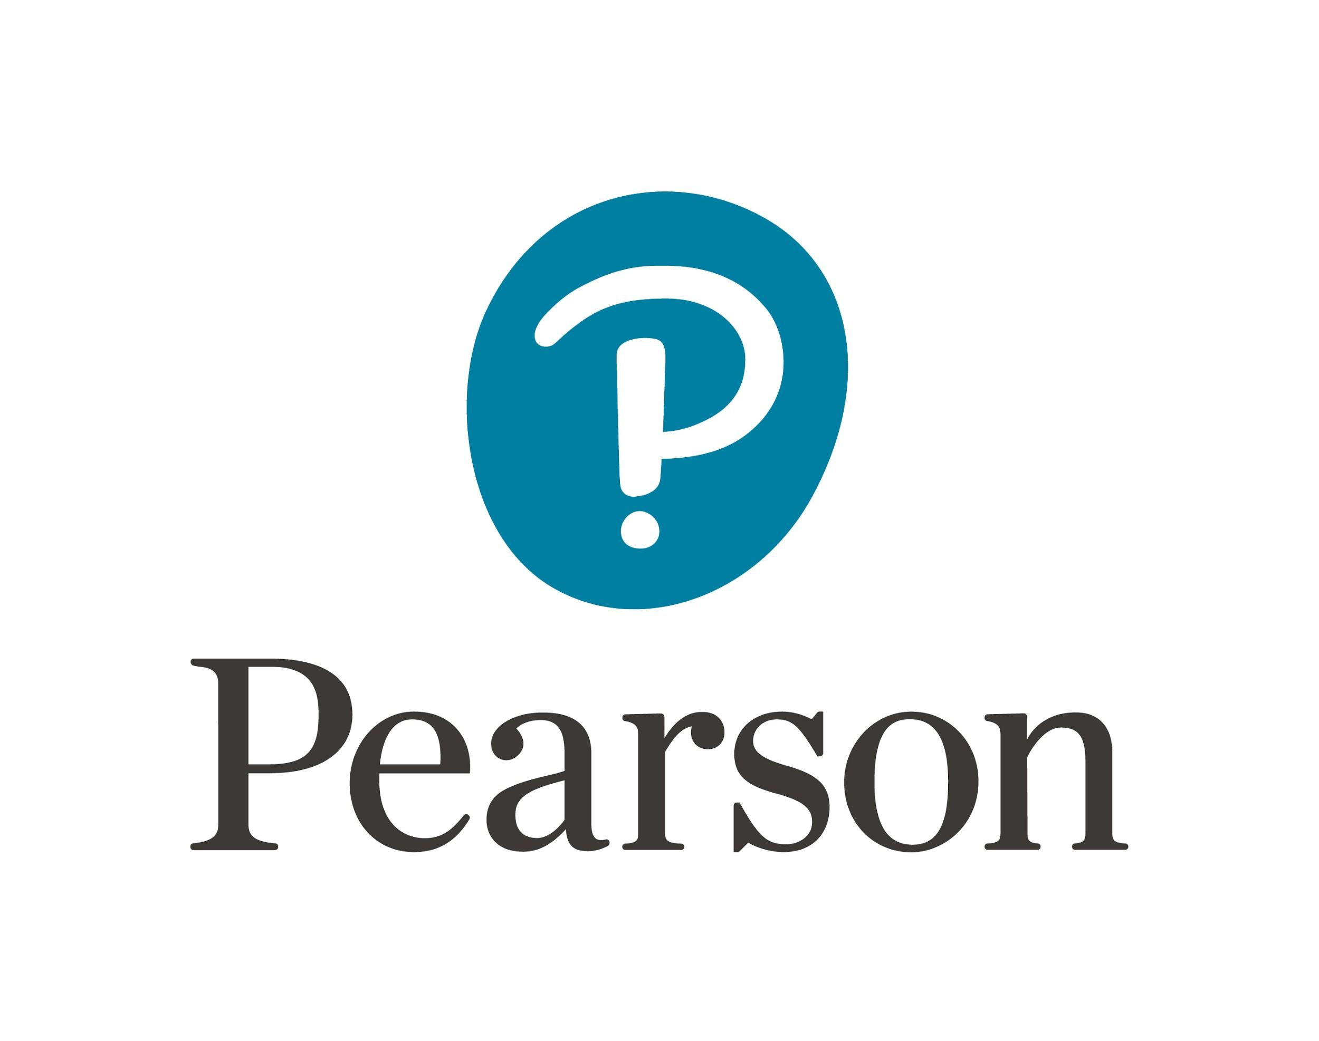

www.pearsonhighered.com

**Introduction**

This test bank contains multiple-choice questions for each chapter in the *Counseling Children and Adolescents, 1st edition* text. These questions may be used to:

* Assess student comprehension of chapter readings
* Measure change in knowledge from the beginning to the end of the course (pre-/post-test)
* Guide students’ focus when reading (as an advance organizer)
* Practice test-preparation strategies for professional examinations

Questions are organized by text chapter and focus on knowledge and application of chapter content. Answer keys are provided at the end of this resource.

**Table of Contents**

Chapter One: Developmentally Informed Youth Counseling 1

Chapter Two: Systemically Informed Youth Counseling 5

Chapter Three: Individual Counseling Foundations 8

Chapter Four: Ethical and Legal Foundations 12

Chapter Five: Counseling Theories That Focus on Thought and Behavior Change and Action 16

Chapter Six: Counseling Theories That Focus on Background Experiences and Relationships 21

Chapter Seven: Counseling Theories That Focus on Family Change Processes 25

Chapter Eight: The Use of Play and Creative Arts in Counseling 27

Chapter Nine: Conceptualizing Young Clients’ Situations and Directing Counseling 30

Chapter Ten: Youth Suicide, Self-Injury, and Homicide 33

Chapter Eleven: Family-Related Transitions and Struggles 36

Chapter Twelve: Academic and Social/Emotional Transitions and Struggles 39

Chapter Thirteen: Neurodevelopmental and Intellectual Impairments 42

Chapter Fourteen: Disruptive Behavior Problems 45

Chapter Fifteen: Abuse and Trauma 47

Chapter Sixteen: Substance Abuse 52

Chapter Seventeen: Anxiety, Obsessive-Compulsive, and Related Disorders 54

Chapter Eighteen: Depressive and Bipolar Disorders 57

Chapter Nineteen: Physical Health-Related Counseling Issues 60

Answer Key 64

Chapter One: Developmentally Informed Youth Counseling

1. Approximately ________ percent of mental health disorders develop prior to age 14.
   1. 10
   2. 20
   3. 50
   4. 70
2. Youth development is:
   1. Consistent and predictable.
   2. Similar for all youth
   3. Slow and predictable
   4. Influenced by context
3. A milestone that differentiates adolescence from childhood is the development of:
   1. Abstract thinking
   2. Problem-solving skills
   3. Awareness of emotions
   4. Awareness of self
4. Insight is a typical developmental milestone of:
   1. Early childhood
   2. Middle childhood
   3. Early adolescence
   4. Later adolescence
5. Trauma is considered a developmental:
   1. Protective factor
   2. Risk factor
   3. Resiliency factor
   4. Both A and C
6. Academic engagement is considered a developmental:
   1. Protective factor
   2. Risk factor
   3. Resiliency factor
   4. Both A and C
7. One example of a cognitive risk factor is:
   1. Low intelligence
   2. Rebelliousness
   3. Poor physical health
   4. Poverty
8. One example of a psychosocial protective factor is:
   1. Humor
   2. High intelligence
   3. Secure attachment
   4. Empathy
9. A 13-year old female client reports increasing mood swings, depression, and irritability. This is *most likely* to be a byproduct of:
   1. Puberty
   2. Social rejection
   3. Family conflict
   4. Poverty
10. A ten-year-old child who apologizes to a peer after an argument but who cannot describe what the peer was feeling during the argument is demonstrating characteristics of the ___________ stage of development.
    1. Sensorimotor
    2. Preoperational
    3. Concrete operational
    4. Formal operational
11. A child who is able to empathize with others and think abstractly is most likely in the __________ stage of development.
    1. Sensorimotor
    2. Preoperational
    3. Concrete operational
    4. Formal operational
12. Attachment in early childhood provides a foundation for:
    1. Physical development
    2. Self-development
    3. Cognitive development
    4. Emotional development
13. A child who demonstrates confidence in relationships with peers and adults demonstrates resilience in the ___________ domain:
    1. Physical
    2. Psychosocial
    3. Cognitive
    4. Emotional
14. A first-grader reacts to frustration in school by pounding her fists on the desk. This is most likely an emotional expression the student learned from a:
    1. Parent
    2. Peer
    3. Teacher
    4. Counselor
15. A baby who is born to a mother over the age of 35 may be at increased risk of:
    1. Down syndrome
    2. Lead exposure
    3. Developmental delay
    4. Cortisol exposure
16. A child who feels positively about his social relationships but negatively about his academic accomplishments is demonstrating differences in ___________ in these two areas.
    1. Self-esteem
    2. Self-concept
    3. Temperament
    4. Affect
17. Temperamental dimensions include each of the following *except:*
    1. Sociability
    2. Positive affect
    3. Fear/inhibition
    4. Euphoria
18. A child who independently engages in drawing, coloring, or other creative activities is likely in Erikson’s stage of:
    1. Trust versus mistrust
    2. Autonomy versus shame and doubt
    3. Initiative versus guilt
    4. Industry versus inferiority
19. In early childhood, mental health issues are most likely to be expressed through:
    1. Verbal expression
    2. Behavioral problems
    3. Poor peer relationships
    4. Poor parent-child relationships
20. A child whose temper tantrums increase during the first week of kindergarten is most likely reacting to:
    1. A traumatic experience
    2. A significant transition
    3. A poor parent-child relationship
    4. A conflict with peers
21. When working with young children, a counselor should do all of the following *except:*
    1. Attend to the child’s basic needs during the session
    2. Integrate the family into counseling whenever possible
    3. Stand over the child to avoid joining the child on his/her level
    4. Allow children to take an active role in the counseling process
22. During middle childhood, children’s growth becomes more:
    1. Predictable
    2. Consistent
    3. Variable
    4. Disorganized
23. The prefrontal lobe of the brain develops dramatically during:
    1. Early childhood
    2. Middle childhood
    3. Early Adolescence
    4. Later Adolescence
24. A young person who describes himself by stating, “I have red hair, blue eyes, and I like karate,” is most likely in the stage of:
    1. Early childhood
    2. Middle childhood
    3. Early Adolescence
    4. Later Adolescence
25. Youth in middle childhood typically formulate a sense of self by:
    1. Taking on parents’ likes and dislikes
    2. Learning from media sources
    3. Comparing themselves to peers
    4. Avoiding activities enjoyed by siblings
26. Friendships in middle childhood:
    1. Involve supportive behaviors
    2. Are defined by self-interest
    3. Provide limited emotional support
    4. Are less important than early childhood friendships
27. Challenges that counselors may encounter with clients in middle childhood include each of the following *except:*
    1. Coping with transitions
    2. Managing independence
    3. Social skills
    4. Substance use
28. The ability to engage in goal-setting and planning in counseling for children in middle childhood is influenced by increasingly complex:
    1. Physical development
    2. Social development
    3. Cognitive development
    4. Emotional development
29. Behavioral concerns can be managed in middle childhood through the use of:
    1. Corporal punishment
    2. Deprivation of privileges
    3. Social isolation
    4. Shame and embarrassment
30. An adolescent you are working with reports that she was punished for skipping class last week. When asked about this behavior, she states, “I really didn’t think I’d get caught.” This is an example of adolescents’ tendency to:
    1. Engage in oppositional behaviors
    2. Fail to foresee consequences
    3. Focus on self-interests
    4. Intentionally test limits
31. A client you are working with states that he is interested in becoming a teacher because both of his parents and all of his grandparents were also teachers. This is an example of:
    1. Identity foreclosure
    2. Identity diffusion
    3. Identity moratorium
    4. Identity achievement
32. Early adolescents are most likely to rely on their __________ when formulating values and beliefs.
    1. Parents
    2. Teachers
    3. Siblings
    4. Peers
33. During adolescence, clients and their families would most benefit from education on:
    1. Rules and consequences
    2. Parental dynamics and sibling relationships
    3. Sexuality and peer relationships
    4. Homework and academic success
34. A desire to be unique typically emerges during:
    1. Early Childhood
    2. Middle childhood
    3. Early Adolescence
    4. Late Adolescence
35. A young person you are counseling describes that his mood swings have become more manageable but that he is worried that he doesn’t stand out and doesn’t stand for anything important. He also reports infrequent marijuana use. This young person is most likely in the stage of:
    1. Early childhood
    2. Middle childhood
    3. Early adolescence
    4. Late adolescence

Chapter Two: Systemically Informed Youth Counseling

1. When working with a young person, context may include all of the following *except:*
   1. Culture
   2. Development
   3. Gender
   4. Diagnoses
2. When considering cultural contexts for working with youth, counselors should:
   1. Assume that all clients from the same culture have similar values
   2. Explore how culture influences the client’s beliefs related to help-seeking
   3. Avoid discussing culture unless the client introduces the topic first
   4. Minimize the influence of culture on a young person to increase resilience
3. Which of the following is an example of a microaggression?
   1. A counselor greets a young Caucasian client with a handshake
   2. A counselor attends a meeting at school with a Caucasian client’s parents after obtaining written consent
   3. A counselor praises a young African American client for being articulate
   4. A counselor consults with an African American client’s pastor after obtaining written consent
4. A strengths-based approach to counseling involves:
   1. Focusing on clients’ strengths, previous successes, and resilience
   2. Relying on outside systems to promote client success and resilience
   3. Highlighting past failures to motivate the client the change
   4. Using reinforcers and punishments to promote client change
5. When working with a young client, a counselor encourages the client to set goals for the session and to select an assignment to complete for between-session homework. This counselor is building resilience by promoting:
   1. Social competence
   2. Problem solving
   3. Autonomy
   4. A sense of purpose
6. A counselor works with a client to explore how the client can develop new friendships at school and in the after-school program she attends. This counselor is building resilience by promoting:
   1. Social competence
   2. Problem solving
   3. Autonomy
   4. A sense of purpose
7. Family risk factors include:
   1. Lack of financial resources
   2. Negative interactions with peers
   3. Community-based violence
   4. Racism/prejudice
8. School risk factors include:
   1. Domestic violence
   2. Bullying
   3. Drug and weapon availability
   4. High residential mobility
9. Community risk factors include:
   1. Limited parental involvement
   2. Delinquent peer influences
   3. School violence
   4. Drug and weapon availability
10. Family protective factors include:
    1. Positive peer influences
    2. Expressions of warmth
    3. Motivation to achieve
    4. Leadership opportunities
11. School protective factors include:
    1. Positive peer influences
    2. Strong cultural identity
    3. Social and sports clubs
    4. Religious values
12. Community protective factors include:
    1. Leadership and volunteer opportunities
    2. Consistent and reasonable discipline
    3. Trusting friendships
    4. Motivation for achievement
13. When defining family as it relates to a client, a counselor should:
    1. Include all family members that are known to the counselor
    2. Focus only on family members living in the child’s household
    3. Include only biological relatives as family members
    4. Use the child’s subjective definition of family
14. A young client has been experiencing stomachaches, avoidance of school, and decreased appetite as a result of the recent birth of a younger sibling in the family. This response is considered:
    1. A sign that the child is at increased risk of mental health disorders
    2. An indication that the child is angry at his parents
    3. A reasonable response to sudden change in the family system
    4. An indication of poor attachment in early childhood
15. According to Olsen, family roles and rules are most effective when they are:
    1. Predictable and flexible
    2. Predictable and inflexible
    3. Unpredictable and flexible
    4. Unpredictable and inflexible
16. To accurately assess communication styles in families, the counselor should:
    1. Ask parents directly about how they communicate
    2. Observe family communication while discussing a range of topics
    3. Have the child draw a picture of how the family communicates
    4. Have the family complete a self-report assessment
17. Family factors that may negatively impact youth include all of the following *except:*
    1. A sibling with a mental or physical health disorder
    2. Overindulgence of the child
    3. Parents’ role as caregivers for their parents
    4. High expectations for academic success
18. Among the 3.5 million reports of child maltreatment, __________ percent involved allegations of neglect.
    1. 20
    2. 40
    3. 60
    4. 80
19. Which of the following is true about child maltreatment?
    1. All children respond in similar ways to abuse or neglect by primary caregivers
    2. A child’s response to abuse or neglect is not influenced by the severity of the maltreatment
    3. Most children will experience secondary traumatic responses including feelings of helplessness and post-traumatic stress disorder
    4. Children who experience maltreatment often adapt and live healthy and productive lives
20. Which of the following is true about intimate partner violence and youth?
    1. Youth who are not physically involved in violence in the home are still likely to experience serious emotional consequences.
    2. Youth who witness intimate partner violence are less likely to bully peers or siblings
    3. Most mental health interventions for addressing the impact of intimate partner violence on youth are ineffective
    4. Only children are at decreased risk of being emotionally impacted by intimate partner violence
21. A counselor is working with an adolescent who states that, “My parents think school is dumb. I’m going to quit school and get a job so I can start helping with bills.” In the long term, this child’s choice may lead to:
    1. Increased self-esteem stemming from work experience
    2. Clear identity stemming from work experience
    3. Decreased career opportunities later in life
    4. Increased educational attainment later in life
22. When considering the relationship between school climate and youth resilience, it is important to note that:
    1. Family conflicts do not influence school performance
    2. Negative experiences in school rarely impact family relationships
    3. Messages from teachers about capabilities often influence youth beliefs and attitudes
    4. Inconsistent rules in school rarely lead to youth behavior problems or concerns
23. Factors that may increase the risk of bullying behaviors include all of the following *except:*
    1. High IQ
    2. Substance use
    3. History of victimization
    4. Learning disorders
24. Factors that may increase the risk of school violence among youth include all of the following *except:*
    1. Substance use
    2. Poor family boundaries
    3. Poverty
    4. Weapons in the home
25. A counselor working with a young person who lives in a high-risk community environment would benefit from:
    1. Avoiding discussing issues of diversity and discrimination to avoid provoking emotions
    2. Encourage the family to relocate to a more stable community
    3. Promote engagement of the youth and family in clubs, sports, or activities that promote resilience
    4. Explain that some factors are uncontrollable and teach acceptance to the young person
26. In communities with neighborhood violence and crime, youth:
    1. Are likely to benefit from mentorship from positive role models
    2. Are unlikely to be protected by family safety and support
    3. Are unlikely to be influenced by peer behaviors
    4. Are likely to be protected by avoiding extracurricular activities
27. When it comes to technology, youth:
    1. Are unlikely to be influenced through social media
    2. Experience isolation if excessive time is spent online
    3. Have limited access to information that informs learning
    4. Derive little benefit from using technology and social media