The Cosmic Perspective, 9e (Bennett et al.)
Chapter 2 Discovering the Universe for Yourself

Section 2.1

1) At midnight, on a clear and moonless night, the number of stars that are distinctly visible to the eye is in the range
A) 2000-5000.
B) 20,000-50,000.
C) 200,000-500,000.
D) 2 million-5 million.
Answer: A

2) Which of the following best describes the modern definition of a constellation?
A) a region of the celestial sphere
B) a pattern of bright stars in the sky
C) a Greek mythological figure
D) a collection of stars that are near one another in space
E) a group of stars that all lie at about the same distance from Earth
Answer: A

3) While the historical definition of a constellation is "a pattern or figure of stars in the sky," the modern definition used by astronomers is
A) a group of stars in the sky that are all very close to each other.
B) a specifically named and bordered region of the celestial sphere.
C) any grouping of very bright stars in our galaxy, often hosting a star cluster.
D) no definition; astronomers no longer use the term constellation.
Answer: B

4) The number of official constellations (as defined by the International Astronomical Union) is
A) 56.
B) 88.
C) 123.
D) 205.
Answer: B

5) The stars stay in "fixed" positions on the celestial sphere because they
A) are all located at precisely the same distance from Earth.
B) are so far away that our eyes don't notice their motions through space.
C) remain stationary relative to our solar system in space.
D) were given their names by ancient civilizations.
Answer: B

6) The celestial sphere is
A) the central spherical region of the Milky Way Galaxy, dense with stars.
B) a spherical galaxy, centered on the Sun.
C) a useful illusion used to map the stars and other objects in the sky.
D) the star-sphere discovered by the Greeks and other ancient civilizations which shows the physical location in space of the nearby stars.
E) another name for our spherical Sun.
Answer: C

7) Which of the following statements about the celestial sphere is not true?
A) When we look in the sky, the stars all appear to be located on the celestial sphere.
B) Earth is placed at the center of the celestial sphere.
C) The celestial sphere does not exist physically.
D) The "celestial sphere" is just another name for our universe.
E) From any location on Earth, we can see only half the celestial sphere at any one time.
Answer: D

8) What is the ecliptic?
A) when the Moon passes in front of the Sun
B) the Moon's apparent path along the celestial sphere
C) the constellations commonly used in astrology to predict the future
D) the Sun's daily path across the sky
E) the Sun's apparent annual path around the celestial sphere
Answer: E

9) What is the celestial equator?
A) another name for the ecliptic
B) the path the Sun appears to trace through the constellations each year
C) a projection of Earth's equator into space
D) the technical name of the Sun's equator
Answer: C

10) On the celestial sphere, the Sun
A) circles once each year along the path called the ecliptic.
B) stays always at the same fixed point among the stars.
C) circles daily around the celestial equator.
D) is the central object.
Answer: A

11) Which of the following statements about the celestial equator is true at all latitudes?
A) It lies along the band of light we call the Milky Way.
B) It represents an extension of Earth's equator onto the celestial sphere.
C) It cuts the dome of your sky exactly in half.
D) It extends from your horizon due east, through your zenith, to your horizon due west.
E) It extends from your horizon due north, through your zenith, to your horizon due south.
Answer: B

12) What is the name of the path on the celestial sphere that goes through the constellations of the zodiac?
A) the celestial equator
B) the ecliptic
C) the Milky Way
D) the meridian
E) the horizon
Answer: A

13) The "Milky Way" in the night sky looks like a blurry circle of light in the sky because
A) we are seeing the stars and gas that lie in disk of our Milky Way Galaxy.
B) our Sun is located at the center of our galaxy.
C) the stars within this band of light are much farther away than other stars.
D) our rotating Earth blurs our view of stars in the Milky Way Galaxy.
Answer: A

14) When we look toward the constellation Sagittarius, we are looking
A) at the galaxy's central bulge.
B) toward Polaris, the "Pole Star."
C) toward the Winter Triangle.
D) out toward the outer Milky Way.
Answer: A

15) When we look into the band of light in our sky that we call the Milky Way, can we see distant galaxies? Why or why not? (Assume we are looking with visible light telescopes.)
A) Yes, distant galaxies appear as small, fuzzy patches of light within the Milky Way band.
B) yes, but only when we look in the direction of the constellation Sagittarius
C) no, because the stars, gas, and dust of the Milky Way block our view of more distant objects
D) no, because galaxies exist only above and below the plane of the Milky Way
E) no, because distant galaxies are too dim to be seen even with powerful telescopes
Answer: C

16) Which of the following correctly describes the meridian in your sky?
A) a half-circle extending from your horizon due east, through your zenith, to your horizon due west
B) a half-circle extending from your horizon due north, through your zenith, to your horizon due south
C) a half-circle extending from your horizon due east, through the north celestial pole, to your horizon due west
D) the point directly over your head
E) the boundary between the portion of the celestial sphere you can see at any moment and the portion that you cannot see
Answer: B

17) You experience night-time when
A) the Moon blocks the Sun's light.
B) Earth is on the opposite side of the celestial sphere from the Sun.
C) you are located on the side of the Earth that faces away from the Sun.
D) you are located on the side of the Earth that faces toward stars.
Answer: C

18) If Earth's rotation slowed down so that it completed exactly one rotation about its axis in 100 hours (instead of 24), what would be the typical time interval between sunrise and sunset?
A) 50 hours
B) 100 hours
C) 12 hours
D) 25 hours
E) 24 hours
Answer: A

19) Why do we experience night and day on Earth?
A) Earth rotates on its axis once every 24 hours.
B) The Sun orbits Earth once every 24 hours.
C) The Moon circles Earth once every 24 hours.
D) The Sun moves around in a circle once every 24 hours, shining like a spotlight on Earth.
Answer: A

20) Do all galaxies out beyond the Milky Way rise in the east and set in the west (if they aren't circumpolar)?
A) Impossible to say for sure, since we haven't yet seen all of the galaxies in the universe.
B) no
C) yes
Answer: C

21) We can describe the position of an object in our local sky by stating its
A) altitude and meridian.
B) altitude and direction.
C) latitude and direction.
D) latitude and longitude.
E) meridian and longitude.
Answer: B

22) How many arcminutes are in 1°?
A) 60
B) 360
C) 3600
D) 100
E) 10,000
Answer: A

23) How many arcseconds are in 1 arcminute?
A) 60
B) 360
C) 3600
D) 100
E) 10,000
Answer: A

24) How many arcseconds are in 1°?
A) 60
B) 360
C) 3600
D) 100
E) 10,000
Answer: C

25) If you hold your fist at arm's length, you will see it spanning an angle of about
A) 1 arcsecond.
B) 1°.
C) 10°.
D) 45°.
E) 90°.
Answer: C

26) The angular sizes of the Sun and Moon are about the same because
A) both objects have the same physical size.
B) both objects are located the same distance away.
C) the Sun is larger in size than the Moon by the same factor (about 400) that it is farther in distance.
D) their angular sizes are an illusion created by the apparent locations on the celestial sphere.
Answer: C

27) Which of the following statements does not use the term angular size or angular distance correctly?
A) The angular size of the Moon is about 1/2 degree.
B) The angular distance between those two houses in the distance is 30°.
C) The angular distance between those two bright stars in the sky is about 2 meters.
D) The angular size of the Sun is about the same as that of the Moon.
E) You can use your outstretched hand to estimate angular sizes and angular distances.
Answer: C

28) We can describe the location of a point on Earth's surface by stating its
A) altitude and meridian.
B) altitude and direction.
C) latitude and direction.
D) latitude and longitude.
E) meridian and longitude.
Answer: D

29) Is there any place on Earth where we can see stars rise in the west and set in the east (rather than rising in the east and setting in the west)? Why or why not?
A) yes, in the Southern Hemisphere, because the sky appears backward there
B) yes, on Earth's equator, because it is halfway between the poles
C) no, because the rising and setting of stars is caused by Earth's west to east rotation
D) no, because the stars that rise in the west and set in the east are too dim to be seen by the naked eye
Answer: C

30) If it is midnight in New York, it is
A) daytime in Sydney, Australia.
B) midnight in Sydney, Australia.
C) midnight in Los Angeles.
D) midday in Rio de Janeiro, Brazil.
E) midnight everywhere.
Answer: A

31) What is a circumpolar star?
A) a star that rises in the east and sets in the west
B) a star that appears to circle from the north celestial pole to the south celestial pole
C) a star that always remains above your horizon
D) a star that appears to make a full circle around us each day
E) a star that is visible from the North or South pole
Answer: C

32) Which of the following statements about circumpolar stars is true at all latitudes?
A) They are the stars close to the north celestial pole.
B) They always remain above your horizon.
C) They make relatively small circles, traveling clockwise around the north celestial pole.
D) Like all other stars, they rise in the east and set in the west.
E) You cannot see them from the Southern Hemisphere.
Answer: B

33) What makes the North Star, Polaris, special?
A) It is the brightest star in the sky.
B) It is the star straight overhead.
C) It appears very near the north celestial pole.
D) It is the star directly on your northern horizon.
E) It can be used to determine your longitude on Earth.
Answer: C

34) You are standing on Earth's equator. Which way is Polaris, the North star?
A) 30 degrees up, due West
B) on the northern horizon
C) directly overhead
D) The answer depends on whether it's winter or summer.
E) The answer depends on what time of day (or night) it is.
Answer: B

35) By locating the north celestial pole (NCP) in the sky, how can you determine your latitude?
A) The altitude of the NCP is the same as your latitude.
B) The altitude of the NCP is your angular distance from the North Pole.
C) The azimuth of the NCP is the same as your latitude.
D) The azimuth of the NCP is the angular distance from the North Pole.
E) The altitude of the NCP is the same as your distance from the North Pole.
Answer: A

36) If you locate the north celestial pole in your local sky and measure its altitude, then you will know
A) your latitude and longitude.
B) your latitude and the direction that is due north for you.
C) your longitude and the direction that is due north for you.
D) your latitude and the local time.
E) your latitude, longitude, and local time.
Answer: B

37) If you see Polaris directly overhead, you must be very close to
A) the equator.
B) the South Pole.
C) the Tropic of Cancer.
D) the North Pole.
Answer: D

38) You are standing at the North Pole. Which way is Polaris, the North star?
A) The answer depends on what time of day (or night) it is.
B) The answer depends on whether it's winter or summer.
C) directly overhead
D) 30 degrees up, due West
E) on the northern horizon
Answer: C

39) The constellation Orion is visible on winter evenings but not on summer evenings because of
A) blockage by the full moon.
B) the tilt of Earth's rotation axis.
C) the location of Earth in its orbit around the Sun.
D) the precession of Earth's rotation axis.
Answer: C

40) Looking through your telescope tonight, you observe a distant galaxy called RXJ1800 and notice that it is very near in the sky to the bright star Vega. What can you conclude from this observation?
A) RXJ1800 and Vega will both set in the west at about the same time.
B) Vega orbits the center of mass of RXJ1800.
C) Vega and RXJ1800 must be no more than a few light-years apart.
D) If you observe them again in a few nights, RXJ1800 and Vega will be farther apart than they appear tonight.
Answer: A

41) We see two stars separated by one degree on the celestial sphere. What can we infer about these stars?
A) They are very close together in space.
B) They have similar luminosities.
C) They rise and set at about the same time.
D) They were born about the same time.
Answer: C

Section 2.2

1) Seasons on Earth are caused by
A) Earth's axis tilt.
B) Earth's varying distance from the Sun.
C) Earth's varying orbital speed around the Sun.
D) the gravitational influence of the Moon.
E) the Sun's gravity.
Answer: A

2) When it is summer in the Northern Hemisphere, it is ________ in the Southern Hemisphere.
A) winter
B) fall
C) spring
D) summer
Answer: A

3) Why is it summer in the Northern Hemisphere when it is winter in the Southern Hemisphere?
A) The Northern Hemisphere is "on top" of Earth and therefore receives more sunlight during the Northern Hemisphere summer.
B) The Northern Hemisphere is tilted away from the Sun and receives more indirect sunlight during the Northern Hemisphere summer.
C) The Northern Hemisphere is tilted toward the Sun and receives more direct sunlight during the Northern Hemisphere summer.
D) It isn't: both hemispheres have the same seasons at the same time.
E) The Northern Hemisphere is closer to the Sun than the Southern Hemisphere during the Northern hemisphere summer.
Answer: C

4) It is summer in the Northern Hemisphere when
A) the Northern Hemisphere is located closer to the Sun than the Southern Hemisphere.
B) the Northern Hemisphere is tilted toward the Sun and the Southern Hemisphere is tilted away.
C) Earth is at its nearest point to the Sun along its orbit.
D) Earth's axis points toward the North Star, Polaris.
Answer: B

5) The Northern and Southern hemispheres have equal illumination from the Sun
A) on the June and December solstices.
B) on the March and September equinoxes.
C) on all four of the equinoxes and solstices.
D) only on the March equinox.
E) at all times.
Answer: B

6) Consider a set of hypothetical planets that are identical in their orbits and properties except they have different axis tilts. Which of the following axis tilts would give its planet the most extreme differences between their seasons? (Axis tilt is measured relative to a line drawn perpendicular to the planet's orbit.)
A) 23.5 degrees
B) 90 degrees
C) 0 degrees
D) 45 degrees
Answer: B

7) Suppose that Earth's rotation axis were tilted by 45 degrees instead of 23.5 degrees. Which of the following would be true, and why?
A) The seasons would be more extreme, because the Sun's rays would be more direct in summer and less direct in winter.
B) The seasons would be more extreme, because the Earth's surface would be closer to the Sun in the summer and farther from the Sun in the winter.
C) The seasons would be less extreme, because the Sun's rays would be less direct in summer and more direct in winter.
D) The seasons would be less extreme, because the Earths' surface would be farther from the Sun in the summer and closer to the Sun in the winter.
Answer: A

8) Suppose Earth's rotation axis were tilted by 45 degrees instead of 23.5 degrees. How would the number of daylight hours be different on December 21 in the United States (or any northern hemisphere country)?
A) There would be more hours of daylight than we have with a 23.5 degree tilt.
B) There would be fewer hours of daylight than we have with a 23.5 degree tilt.
C) The number of daylight hours would be about the same as it is if its tilt were 23.5 degrees.
Answer: B

9) The line representing latitude 45 degrees north runs through the state of Michigan. In Michigan, when is the Sun is directly overhead, at your zenith?
A) every day
B) only on the spring and fall equinoxes
C) only on the summer solstice, noon
D) never
Answer: D

10) Today the Sun appears to be located in the middle of the constellation Virgo. Therefore, tomorrow the Sun will be in the constellation
A) Libra.
B) Virgo.
C) Leo.
D) Sagittarius.
Answer: B

11) Why is January a cold month in the northern United States?
A) Earth is near its farthest point from the sun.
B) There's more snow in January.
C) The northern hemisphere is farther from the sun than the southern hemisphere.
D) The northern hemisphere is tilted away from the sun.
Answer: D

12) Has Polaris always been a good "North Star"? Why or why not?
A) yes, because stars stay fixed on the celestial sphere
B) no, because it is a young star which formed only a few hundred years ago
C) no, because Earth's axis slowly changes the direction it points
D) no, because ancient people did not know how to describe directions on Earth
Answer: C

Section 2.3

1) The time from one new moon to the next is approximately
A) one week.
B) two weeks.
C) three weeks.
D) one month.
E) two months.
Answer: D

2) Which of the following is not the name of one of the phases of the Moon?
A) first-quarter moon
B) third-quarter moon
C) half moon
D) new moon
E) full moon
Answer: C

3) We say that the Moon is gibbous when
A) it appears to be more than half illuminated, but not full.
B) it appears to be less than half illuminated, but not new.
C) it is exactly half illuminated.
D) we see a thin crescent of light.
E) the Moon is visible in the morning.
Answer: A

4) In which general direction should you look to see the Moon rise?
A) north
B) south
C) east
D) west
E) It depends on the phase of the Moon.
Answer: C

5) When we see a crescent moon, the rest of the face that we see is not completely dark because
A) it is partially facing toward the Sun.
B) it is slightly illuminated by sunlight reflected by Earth.
C) it is slightly illuminated by starlight.
D) it is slightly illuminated by the light of Earth's cities.
Answer: B

6) In which general direction should you look to see the Moon set?
A) north
B) south
C) east
D) west
E) It depends on the phase of the Moon.
Answer: D

7) Which of the following statements about the Moon is not true?
A) The Moon goes through its cycle of phases in about a month.
B) The Moon's orbit around Earth is tilted about 5° to the ecliptic plane.
C) The Moon's distance from Earth varies during its orbit.
D) The Moon is visible in our sky only at night.
E) The Moon rotates once in the same amount of time that it takes to orbit around Earth.
Answer: D

8) Why do we see essentially the same face of the Moon at all times?
A) because the other face points toward us only at new moon, when we can't see the Moon
B) because the Moon does not rotate
C) because the Moon's rotational and orbital periods are equal
D) because the Sun illuminates only one half of the Moon at a time
E) because the Moon has a nearly circular orbit around Earth
Answer: C

9) Suppose you live on the Moon. When people on Earth see a first-quarter phase, what phase do you see for Earth?
A) new Earth
B) first-quarter Earth
C) crescent Earth
D) third-quarter Earth
E) full Earth
Answer: D

10) Suppose it is a crescent moon, as seen from Earth. How would Earth appear to someone on the Moon at this time?
A) The side of Earth facing the Moon is completely bright.
B) The illumination of the Earth does not change, as viewed from the Moon.
C) Half of the side of Earth facing the Moon is bright and half is dark.
D) Most of the side of Earth facing the Moon is bright.
Answer: D

11) Suppose you live on the Moon. About how long is a day (i.e., from sunrise to sunrise)?
A) 23 hours 56 minutes
B) 24 hours
C) a month
D) a year
E) about 18 years
Answer: C

12) If the Moon is setting at 6 A.M., the phase of the Moon must be
A) first quarter.
B) third quarter.
C) full.
D) new.
E) waning crescent.
Answer: C

13) If the Moon is setting at noon, then it rose at
A) 6 A.M.
B) 9 A.M.
C) noon.
D) 6 P.M.
E) midnight.
Answer: E

14) If the Moon is setting at noon, the phase of the Moon must be
A) full.
B) first quarter.
C) third quarter.
D) waning crescent.
E) waxing crescent.
Answer: C

15) If the Moon is rising at midnight, the phase of the Moon must be
A) full.
B) first quarter.
C) third quarter.
D) waning crescent.
E) waxing crescent.
Answer: C

16) At approximately what time would a full moon be on your meridian?
A) 6 A.M.
B) 9 A.M.
C) noon
D) 6 P.M.
E) midnight
Answer: E

17) At approximately what time would a first-quarter moon rise?
A) 6 A.M.
B) 9 A.M.
C) noon
D) 6 P.M.
E) midnight
Answer: C

18) Approximately when does a first-quarter moon set?
A) sunset
B) noon
C) midnight
D) sunrise
Answer: C

19) Approximately when does a third-quarter moon rise?
A) sunset
B) noon
C) midnight
D) sunrise
Answer: C

20) Approximately when does a third-quarter moon set?
A) sunset
B) noon
C) midnight
D) sunrise
Answer: B

21) If the Moon rises around 3 A.M., its phase must be
A) full.
B) first quarter.
C) third quarter.
D) waning crescent.
E) waxing crescent.
Answer: D

22) Suppose you live in the United States and you see a crescent moon in your evening sky tonight. What will a friend in South America see tonight?
A) a crescent moon
B) Your friend won't see the Moon tonight, because in South America, it will be visible only in the morning.
C) a gibbous moon
D) a first-quarter moon
Answer: A

23) You observe a full moon rising at sunset. What will you see 6 hours later?
A) a full moon on or near your meridian
B) waning gibbous moon
C) first-quarter moon
D) a third-quarter moon
Answer: A

24) If the Moon is full at midnight, what will its phase be 6 hours later?
A) full moon
B) first-quarter moon
C) new moon
D) third-quarter moon
Answer: A

25) Tonight the Moon is full. Therefore, in one week, the Moon will be
A) full.
B) first quarter.
C) third quarter.
D) new.
Answer: C

26) You see a waxing crescent moon. You email your friend in New Zealand and ask her what moon phase she sees that night. She says
A) waxing crescent.
B) waning crescent.
C) waning gibbous.
D) waxing gibbous.
Answer: A

27) All of the following statements are true. Which one explains the reason why there is not a solar eclipse at every new moon?
A) The nodes of the Moon's orbit precess with an approximately 18-year period.
B) The orbital plane of the Moon is tilted by about 5° to the ecliptic plane.
C) The Moon rotates synchronously with its orbit around Earth.
D) The Moon's orbital period is slightly shorter than the time it takes for a cycle of phases.
E) The Moon's orbital distance varies as it orbits around Earth.
Answer: B

28) Which of the following would be true about solar eclipses if the Moon's orbital plane was exactly aligned with the ecliptic plane?
A) Solar eclipses would be rarer.
B) Solar eclipses would occur more often.
C) Solar eclipses would last much longer.
D) Solar eclipses would be both rarer and would last much longer.
E) Solar eclipses would both occur more often and would last much longer.
Answer: B

29) If the plane of the Moon's orbit around the Earth was perfectly aligned with the ecliptic plane (instead of being tilted by about 5°), a solar eclipse would be visible on some parts of Earth
A) once a day.
B) never.
C) about once a month.
D) about once every six months.
E) about once a year.
Answer: C

30) The conditions required for a solar eclipse are
A) (1) the phase of the Moon must be new; (2) the nodes of the Moon's orbit must be nearly aligned with Earth and the Sun.
B) (1) the phase of the Moon must be full; (2) the nodes of the Moon's orbit must be nearly aligned with Earth and the Sun.
C) (1) the phase of the Moon can be either new or full; (2) the nodes of the Moon's orbit must be nearly aligned with Earth and the Sun.
D) (1) the phase of the Moon must be new; (2) the Moon must be located at the nearest point in its orbit around Earth.
E) (1) the phase of the Moon must be full; (2) the Moon must be located at the nearest point in its orbit around Earth.
Answer: A

31) Why are lunar eclipses more commonly seen than solar eclipses?
A) Lunar eclipses occur at night and are easier to see.
B) The Moon goes around the Earth faster than the Earth goes around the Sun.
C) Earth casts a bigger shadow than the Moon.
D) The tilt of the Moon's axis is smaller than the Earth's.
E) The Moon is much closer to Earth than to the Sun.
Answer: C

32) The conditions required for a lunar eclipse are
A) (1) the phase of the Moon must be new; (2) the nodes of the Moon's orbit must be nearly aligned with Earth and the Sun.
B) (1) the phase of the Moon must be full; (2) the nodes of the Moon's orbit must be nearly aligned with Earth and the Sun.
C) (1) the phase of the Moon can be either new or full; (2) the nodes of the Moon's orbit must be nearly aligned with Earth and the Sun.
D) (1) the phase of the Moon must be new; (2) the Moon must be located at the nearest point in its orbit around Earth.
E) (1) the phase of the Moon must be full; (2) the Moon must be located at the nearest point in its orbit around Earth.
Answer: B

33) In addition to the conditions required for any solar eclipse, what must also be true in order for you to observe a total solar eclipse?
A) Earth must lie completely within the Moon's full shadow (umbra).
B) Earth must lie completely within the Moon's partial shadow (penumbra).
C) Earth must be near aphelion in its orbit of the Sun.
D) The Moon's full shadow (umbra) must touch the area where you are located.
E) The Moon's partial shadow (penumbra) must touch the area where you are located.
Answer: D

34) When only part of the Moon is covered by Earth's full shadow (umbra), we see a(n)
A) total lunar eclipse.
B) penumbral lunar eclipse.
C) partial lunar eclipse.
D) partial solar eclipse.
E) annular eclipse.
Answer: C

35) If a solar eclipse occurs when the Moon is relatively far from Earth, so that its full shadow (umbra) does not reach Earth, then people directly behind the full shadow will experience
A) a penumbral eclipse.
B) a total solar eclipse.
C) a partial solar eclipse.
D) an annular eclipse.
E) no eclipse.
Answer: D

36) During a lunar eclipse, the Moon's phase must be
A) first quarter.
B) third quarter.
C) full.
D) new.
Answer: C

37) During a solar eclipse, the Moon's phase must be
A) first quarter.
B) third quarter.
C) full.
D) new.
Answer: D

38) Imagine that you are on the Moon while your friend experiences a total solar eclipse on Earth. What do you see?
A) You also see a solar eclipse, except with the Sun completely covered by the Earth.
B) You see a relatively small shadow on an otherwise full Earth.
C) You see a full Earth, just as you would if there were no eclipse at this time.
D) You cannot see the Earth because it is blocked by the Sun.
Answer: B

39) When are eclipse seasons?
A) in the spring and fall
B) in the summer and winter
C) when the nodes of the Moon's orbit are nearly aligned with the Sun
D) when Earth and the Sun are aligned with one another
E) during an eclipse
Answer: C

40) What effect does the precession of the Moon's nodes have on eclipses?
A) It causes us to have lunar eclipses exactly every 6 months.
B) It causes eclipses to occur a little less often than they would if the nodes did not precess.
C) It causes eclipses to occur a little more often than they would if the nodes did not precess.
D) Without this precession, eclipses could never occur.
E) Without this precession, eclipses would occur every month.
Answer: C

41) What is the saros cycle?
A) the roughly 6-month period between eclipse seasons
B) the approximately 18-year, 11-day cycle over which the pattern of eclipses repeats
C) the average time between total solar eclipses
D) the average time between a total solar eclipse and a total lunar eclipse
E) the 26,000 year cycle over which Earth's axis sweeps out a cone in space
Answer: B

42) Ancient people who knew the saros cycle could
A) completely predict the details of all eclipses.
B) completely predict the details of solar eclipses, but not lunar eclipses.
C) completely predict the details of lunar eclipses, but not solar eclipses.
D) predict the date and time of the next total solar eclipse that would be visible at their location.
E) predict when lunar and solar eclipses would occur, but not necessarily whether the eclipse would be partial or total, or exactly where it would be visible.
Answer: E

Section 2.4

1) Which of the following objects was not recognized as a planet in ancient times?
A) Mercury
B) Mars
C) Jupiter
D) Saturn
E) Neptune
Answer: E

2) What happens during the apparent retrograde motion of a planet?
A) The planet rises in the west and sets in the east.
B) The planet appears to move westward with respect to the stars over a period of weeks to months.
C) The planet moves backward through the sky over the course of a night.
D) The planet moves backward in its orbit around the Sun.
E) The planet moves through constellations that are not part of the zodiac.
Answer: B

3) What causes the apparent retrograde motion of the planets?
A) It is an illusion created as we pass by a planet in our orbit (or the planet passes by us).
B) It occurs when the planets reverse the direction of their orbits around the Sun.
C) It is caused by the motion of planets around small circles that in turn go around bigger circles.
D) It is an illusion created by our lack of depth perception in space.
E) It is something we see only for planets that orbit the Sun in the opposite direction of Earth.
Answer: A

4) Which of the following objects never appears to exhibit retrograde motion in our sky?
A) The Sun
B) Venus
C) Mars
D) Jupiter
E) Saturn
Answer: A

5) Which of the following statements about parallax is not true?
A) You can demonstrate parallax simply by holding up a finger and looking at it alternately from your left and right eyes.
B) The existence of stellar parallax is direct proof that Earth orbits the Sun.
C) Measurement of stellar parallax allows us to determine distances to nearby stars.
D) Observing stellar parallax requires only a single photograph taken through a powerful telescope.
E) Ancient astronomers were unable to detect stellar parallax and used the absence of observed parallax as an argument in favor of an Earth-centered universe.
Answer: D

6) Which of the following stars would exhibit the largest amount of stellar parallax?
A) the star that is nearest to us
B) the star that is farthest from us
C) the star that is brightest in our sky
D) the star that is dimmest in our sky
E) the star that is moving at the highest speed relative to Earth
Answer: A

7) We can't detect stellar parallax with naked-eye observations. Which of the following would make parallax easier to observe?
A) increasing the size of Earth's orbit
B) speeding up Earth's rotational motion
C) slowing down Earth's rotational motion
D) speeding up the precession of Earth's axis
E) getting away from streetlights
Answer: A

8) Why were ancient peoples unable to detect stellar parallax?
A) They did not look for it.
B) They could not see distant stars.
C) They did not have the ability to measure very small angles.
D) They did not observe for long enough periods of time.
E) They did detect it, but they rejected the observations.
Answer: C

9) The parallax of two stars is reported in a star catalog. Which star is farther?
A) The one with the larger amount of parallax
B) You can't tell, since parallax has nothing to do with distance.
C) The one with the smaller amount of parallax
Answer: C

General Chapter Questions

1) Which of the following explains why Polaris will no longer be the North Star 1,000 years from now?
A) Earth rotates once each day.
B) Earth orbits the Sun once each year.
C) The direction of Earth's axis in space precesses with a period of about 26,000 years.
D) Stars appear to move randomly relative to our Sun in the local solar neighborhood.
E) The universe is expanding.
Answer: C

2) Choose the answer that fills in the three blanks in the correct order: Earth rotates once each ________, Earth orbits the Sun once each ________, and the Moon orbits Earth about once each ________.
A) day, year, month
B) day, year, week
C) year, day, month
D) hour, day, year
E) hour, day, month
Answer: A

3) The reason we don't see stars in the daytime is because
A) the sky is too bright.
B) stars shine only at night.
C) there are no stars in the direction of the Sun.
D) stars disappear in the daytime.
Answer: A

4) Which of the following explains why, about 13,000 years from now, Vega will be a better North Star than Polaris?
A) Earth rotates once each day.
B) Earth orbits the Sun once each year.
C) The direction of Earth's axis in space precesses with a period of about 26,000 years.
D) Stars appear to move randomly relative to our Sun in the local solar neighborhood.
E) The universe is expanding.
Answer: C

5) Which of the following explains why the Big Dipper will look different 100,000 years from now than it does today?
A) Earth rotates once each day.
B) Earth orbits the Sun once each year.
C) The direction of Earth's axis in space precesses with a period of about 26,000 years.
D) Stars appear to move randomly relative to our Sun in the local solar neighborhood.
E) The universe is expanding.
Answer: D

6) Which of the following explains why the Moon rises in the east and sets in the west?
A) Earth rotates once each day.
B) Earth orbits the Sun once each year.
C) The direction of Earth's axis in space precesses with a period of about 26,000 years.
D) Stars appear to move randomly relative to our Sun in the local solar neighborhood.
E) The universe is expanding.
Answer: A

7) Which of the following explains why the stars of Orion's belt rise in the east and set in the west?
A) Earth rotates once each day.
B) Earth orbits the Sun once each year.
C) The direction of Earth's axis in space precesses with a period of about 26,000 years.
D) Stars appear to move randomly relative to our Sun in the local solar neighborhood.
E) The universe is expanding.
Answer: A

8) Which of the following explains why, a million years from now, Alpha Centauri will no longer be the nearest star system to our own?
A) Earth rotates once each day.
B) Earth orbits the Sun once each year.
C) The direction of Earth's axis in space precesses with a period of about 26,000 years.
D) Stars appear to move randomly relative to our Sun in the local solar neighborhood.
E) The universe is expanding.
Answer: D

9) Which of the following explains why the Sun appears to move gradually eastward along the path called the ecliptic on the celestial sphere?
A) Earth rotates once each day.
B) Earth orbits the Sun once each year.
C) The direction of Earth's axis in space precesses with a period of about 26,000 years.
D) Stars appear to move randomly relative to our Sun in the local solar neighborhood.
E) The universe is expanding.
Answer: D

10) Which of the following explains why we see different constellations at different times of year?
A) Earth rotates once each day.
B) Earth orbits the Sun once each year.
C) The direction of Earth's axis in space precesses with a period of about 26,000 years.
D) Stars appear to move randomly relative to our Sun in the local solar neighborhood.
E) The universe is expanding.
Answer: D

11) Which of the following explains why the stars visible in our sky just after sunset are different from those visible just before sunrise?
A) Earth rotates once each day.
B) Earth orbits the Sun once each year.
C) The direction of Earth's axis in space precesses with a period of about 26,000 years.
D) Stars appear to move randomly relative to our Sun in the local solar neighborhood.
E) The universe is expanding.
Answer: A

12) If Earth rotated once every 48 hours (instead of 24 hours), but everything else was the same, which of the following statements would be false?
A) There would still be summer and winter seasons.
B) The length of the year would be longer.
C) The Sun would appear to move across the sky at a slower rate.
D) The length of a day would be longer.
Answer: B

13) Suppose you see a photo showing Jupiter half in sunlight and half in shadow (i.e., a first-quarter Jupiter). This photo might have been taken by
A) the Keck telescope, on Mauna Kea, Hawaii.
B) the Arecibo radio telescope in Puerto Rico.
C) the Hubble Space Telescope (which orbits Earth).
D) the Juno spacecraft that is orbiting Jupiter.
Answer: D

Reading Quiz Questions

1) About how many stars are visible to the naked eye on a clear, dark night away from city lights?
A) a few dozen
B) a couple thousand
C) several million
D) a few hundred billion
Answer: B

2) What do astronomers mean by a constellation?
A) A constellation is a region in the sky as seen from Earth.
B) A constellation is a group of stars related through an ancient story.
C) A constellation is any random grouping of stars in the sky.
D) A constellation is a group of stars that are all located in about the same place in space.
Answer: A

3) What is the ecliptic?
A) the path the Sun appears to trace around the celestial sphere each year
B) the Sun's daily path from east to west in our sky
C) the path traced by the Moon's shadow on Earth during a solar eclipse
D) a half-circle extending from your horizon due north, through your zenith, to your horizon due south
Answer: A

4) What is the celestial sphere?
A) The celestial sphere is a representation of how the entire sky looks as seen from Earth.
B) The celestial sphere is a model that shows the true locations in space of the Sun and a few thousand of the nearest stars.
C) The celestial sphere is a model of how the stars are arranged in the sky relative to our Sun, which is in the middle of the sphere.
D) It represents a belief in an Earth-centered universe, and hence is no longer considered to have any use.
Answer: A

5) What do we mean when we talk about the Milky Way in our sky?
A) The patchy band of light that outlines the plane of the Milky Way Galaxy as seen from Earth.
B) The whitish patch of light we see when we look toward the center of the Milky Way Galaxy.
C) The spiral-shaped galaxy in which we live.
D) The bright stars of the constellations that lie along the ecliptic in our sky.
Answer: A

6) Which of the following correctly describes the meridian in your local sky?
A) a half-circle extending from your horizon due east, through your zenith, to your horizon due west
B) a half-circle extending from your horizon due east, through the north celestial pole, to your horizon due west
C) a half-circle extending from your horizon due north, through your zenith, to your horizon due south
D) the point directly over your head
Answer: C

7) The point directly over your head is called
A) the meridian.
B) the zenith.
C) the north celestial pole.
D) the North Star.
Answer: B

8) Which of the following celestial objects do not rise in the east and set in the west? (Assume that all of these objects are visible from your location on Earth, and that none of them are circumpolar.)
A) stars
B) the Sun
C) the Moon
D) galaxies
E) All of these objects rise in the east and set in the west.
Answer: E

9) Which of the following statements does not use the term angular size or angular distance correctly?
A) The angular distance between those two houses in the distance is 30 degrees.
B) The angular distance between those two bright stars in the sky is about 2 meters.
C) The angular size of the Sun is about the same as that of the Moon.
D) You can use your outstretched hand against the sky to estimate angular sizes and angular distances.
Answer: B

10) Stars that are visible in the local sky on any clear night of the year, at any time of the night, are called
A) bright.
B) seasonal.
C) circumpolar.
D) celestial.
Answer: C

11) We describe a location on Earth's surface by stating its
A) altitude and direction (or azimuth).
B) meridian and longitude.
C) latitude and direction.
D) latitude and longitude.
Answer: D

12) If you are located in the Northern Hemisphere, which of the following correctly describes a relationship between the sky and your location?
A) The altitude of the north celestial pole equals your latitude.
B) The altitude of the celestial equator equals your latitude.
C) The altitude of the north celestial pole equals your longitude.
D) The longitude of the north celestial pole is circumpolar, and therefore crosses your zenith at the meridian.
Answer: A

13) Which of the following best describes why we have seasons on Earth?
A) The tilt of Earth's axis causes different portions of the Earth to receive more or less direct sunlight at different times of year.
B) Earth's elliptical orbit means we are closer to the Sun and therefore receive more intense sunlight at some times of year than at others.
C) The tilt of Earth's axis causes the Northern Hemisphere to be closer to the Sun than the Southern Hemisphere in summer, and vice versa in winter.
D) The varying speed of Earth in its orbit around the Sun gives us summer when we are moving fastest and winter when we are moving slowest.
Answer: A

14) Each choice describes how a few astronomical phenomena are related to time periods. Which list is entirely correct? (Careful: some lists are partially correct.)
A) Earth's rotation defines a day.
The cycle of the Moon's phases takes about a month.
Earth's orbit defines a year.
Earth's cycle of axis precession takes 26,000 years.
B) Earth's rotation defines a day.
The cycle of the Moon's phases takes about a week.
Earth's orbit defines a year.
Earth's cycle of axis precession defines a month.
C) Earth's rotation defines a day.
The Sun's rotation defines a week.
The Moon's rotation defines a month.
Earth's orbit defines a year.
D) Earth's rotation defines a day.
The Saros cycle of eclipses defines a month.
Earth's orbit defines a year.
Earth's cycle of axis precession takes 26,000 years.
Answer: A

15) If we have a new moon today, when we will have the next full moon?
A) in about two weeks
B) in about one week
C) in about a month
D) in about six months
Answer: A

16) We cannot see a new moon in our sky because
A) it is obscured by Earth's shadow.
B) no sunlight is illuminating the Moon.
C) a new moon is quite near the Sun in the sky.
D) it is above the horizon during the daytime.
Answer: C

17) The Moon always shows nearly the same face to Earth because
A) the Moon does not rotate.
B) sunlight always hits the same face of the Moon.
C) the Moon rotates once in the same amount of time that it takes Earth to orbit the Sun once.
D) the Moon rotates once in the same amount of time that it takes the Moon to orbit Earth once.
Answer: D

18) Lunar eclipses can occur only when the phase of the Moon is
A) new.
B) first quarter.
C) full.
D) third quarter.
Answer: C

19) What is the Saros cycle?
A) the 26,000-year cycle of the Earth's precession
B) the roughly 18-year cycle over which the pattern of eclipses repeats
C) the roughly one-month cycle of lunar phases in the sky
D) the annual cycle of the seasons
Answer: B

20) During the time that a planet is in its period of apparent retrograde motion
A) The planet moves backwards (clockwise as viewed from above Earth's north pole) in its orbit of the Sun.
B) The planet appears to rise in the west and set in the east, rather than the usual rising in the east and setting in the west.
C) Over many days or weeks, the planet moves westward relative to the stars, rather than the usual eastward relative to the stars.
D) The planet is getting closer to the Sun in its orbit.
Answer: C

21) What is stellar parallax?
A) It is the daily rise and set of the stars.
B) It describes the fact that stars are actually moving relative to one another, even though to our eyes the stars appear fixed in the constellations.
C) It is the slight back-and-forth shifting of star positions that occurs as we view the stars from different positions in Earth's orbit of the Sun.
D) It is the change in the set of constellations that we see at different times of year in the evening sky.
Answer: C

22) If a star's distance from Earth increased, its parallax shift would
A) decrease.
B) increase.
C) not change.
Answer: A

Concept Quiz Questions

1) Which of the following statements about the celestial sphere is not true?
A) The Earth is placed at the center of the celestial sphere.
B) When we look in the sky, the stars all appear to be located on the celestial sphere.
C) The celestial sphere is another name for our universe.
D) The celestial sphere does not exist physically.
Answer: C

2) The Andromeda Galaxy is faintly visible to the naked eye in the constellation Andromeda. Suppose instead it were located in the same direction in space as the center of the Milky Way Galaxy (but still at its current distance). How would it appear to the eye in that case?
A) We could not see it at all.
B) It would look about the same but would be in the constellation Sagittarius instead of Andromeda.
C) It would be much brighter because it would be illuminated by the many stars in the center of our galaxy.
D) It would look about the same, but it would be harder to pick out because its cloud-like appearance would make it blend in with the cloud-like appearance of the Milky Way in our sky.
Answer: A

3) An angle of 1 arcsecond is
A) about the width of your fist held at arm's length.
B) about the width of a finger held at arm's length.
C) less than the thickness of a human hair held at arm's length.
D) slightly more than the width of a basketball held at arm's length.
Answer: C

4) When traveling north from the United States into Canada, you'll see the North Star (Polaris) getting
A) brighter.
B) dimmer.
C) higher in the sky.
D) lower in the sky.
Answer: C

5) Suppose you use the Southern Cross to determine that the south celestial pole appears 40 degrees above your horizon. Then you must be located at
A) latitude 40 degrees north.
B) latitude 50 degrees south.
C) latitude 40 degrees south.
D) longitude 40 degrees.
Answer: C

6) Suppose you are facing north and you see the Big Dipper close to your northern horizon, with Polaris (and the Little Dipper) above it. Where will you see the Big Dipper in six hours?
A) to the right of Polaris; that is, 90 degrees counterclockwise from its current position
B) to the left of Polaris; that is, 90 degrees clockwise from its current position
C) directly above Polaris
D) still in the same place, below Polaris
Answer: A

7) In any particular place on Earth, certain constellations are visible in the evening only at certain times of the year because
A) our evening view of space depends on where Earth is located in its orbit around the Sun.
B) during some times of year, some constellations drop below the southern horizon.
C) some constellations are circumpolar.
D) on any particular night, we can only see stars that are directly opposite (180 degrees away from) the Sun in the sky.
Answer: A

8) The Sun's path, as viewed from the equator, is highest in the sky on
A) the December solstice.
B) the March and September equinoxes.
C) the June solstice.
D) the day when Earth is closest to the Sun.
Answer: B

9) Suppose Earth's axis tilt was significantly greater than its current 23.5 degrees, but Earth's rotation period and orbital period were unchanged. Which statement below would not be true?
A) Summers and winters would be more severe (for example, hotter and colder, respectively) than they are now.
B) The region of Earth where the Sun does not rise on the winter solstice would be larger (extending farther south) than it is now.
C) The length of each season (for example, the number of days from the summer solstice to the fall equinox) would be significantly longer than it is now.
D) Polaris would not be our North star.
Answer: C

10) If our year were twice as long (that is, if Earth took twice as many days to complete each orbit around the Sun), but Earth's rotation period and axis tilt were unchanged, then
A) stars would take twice as long to rise and set.
B) the cycle of precession would take 13,000 years instead of 26,000 years.
C) the four seasons would each be twice as long as they are now.
D) the Earth would not have seasons.
Answer: C

11) How does Earth's varying distance from the Sun affect our seasons?
A) It doesn't; Earth's orbital distance plays no significant role in the seasons.
B) It makes summer warmer in the Northern Hemisphere than in the Southern Hemisphere.
C) It is responsible for the fact that the seasons are opposite in the Northern and Southern hemispheres.
D) It causes the seasons to be more extreme than they would be if the Earth's distance from the Sun were always the same.
Answer: A

12) Suppose you live in the United States and you see a crescent moon in your evening sky tonight. What will a friend in South America see tonight?
A) Your friend will see a gibbous moon.
B) Your friend will also see a crescent moon.
C) Your friend will see a first-quarter moon.
D) Your friend won't see the Moon tonight because it is up only in the morning.
Answer: B

13) Suppose it is full moon. What phase of Earth would someone on the Moon see at this time?
A) full Earth
B) new Earth
C) first-quarter Earth
D) Earth does not go through phases as seen from the Moon.
Answer: B

14) It's 6 a.m. and the Moon is at its highest point in your sky (crossing the meridian). What is the Moon's phase?
A) new
B) first quarter
C) full
D) third quarter
Answer: D

15) You observe a full Moon rising at sunset. What will you see at midnight?
A) a full moon high in the sky
B) a first-quarter moon
C) a waning gibbous moon
D) a third-quarter moon
Answer: A

16) All the following statements are true. Which one explains the reason that there is not a solar eclipse at every new moon?
A) The nodes of the moon's orbit precess with an 18-year period.
B) The orbital plane of the Moon is tilted slightly (by about 5 degrees) to the ecliptic plane.
C) The Moon is only about one-fourth as large as Earth in diameter.
D) The Moon goes through a complete cycle of phases about every 29-1/2 days.
Answer: B

17) For most of history, the lack of observable stellar parallax was interpreted to mean that
A) stars must all lie at the same distance from Earth, on the celestial sphere.
B) stars were too far away for parallax to be measured with available technology.
C) Earth is stationary at the center of the universe.
D) Galileo's theories of the universe were essentially correct.
Answer: C

18) During the period each year when we see Mars undergoing apparent retrograde motion in our sky, what is really going on in space?
A) Mars is moving around the Sun in the opposite direction from which Earth is moving around the Sun.
B) Earth and Mars are getting closer together.
C) Earth is catching up with and passing by Mars in their respective orbits.
D) Earth and Mars are on opposite sides of the Sun.
Answer: C

19) Suppose you see a photo showing Jupiter half in sunlight and half in shadow (that is, a first quarter Jupiter). This photo might have been taken by
A) a spacecraft orbiting Jupiter.
B) the Hubble Space Telescope (which orbits Earth).
C) the Keck telescope on Mauna Kea, Hawaii.
D) the Arecibo radio telescope in Puerto Rico.
Answer: A

Visual Quiz Questions

1) This diagram represents a simplified model of the celestial sphere. The unlabeled circle that is highlighted in purple represents

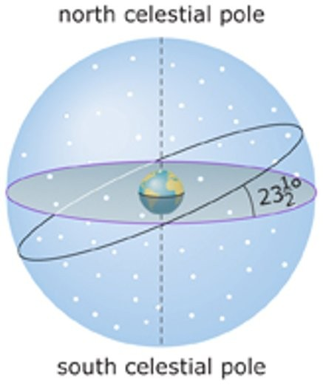
A) the celestial equator.
B) the meridian.
C) the ecliptic.
D) the spring equinox.
Answer: A

2) This diagram represents a person's local sky. What does the red semicircle represent?

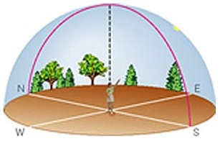
A) the horizon
B) the meridian
C) the zenith
D) the celestial equator
Answer: B

3) What is the approximate latitude and longitude of the South American location marked by the black dot on this diagram?

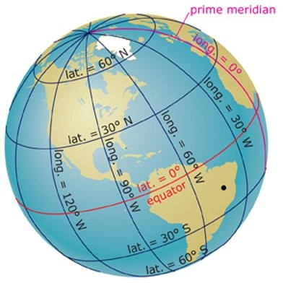
A) latitude = 15ºS, longitude = 45ºW
B) latitude = 30ºW, longitude = 60ºN
C) latitude = 15ºN, longitude = 45ºW
D) latitude = 15ºS, longitude = 75ºW
Answer: A

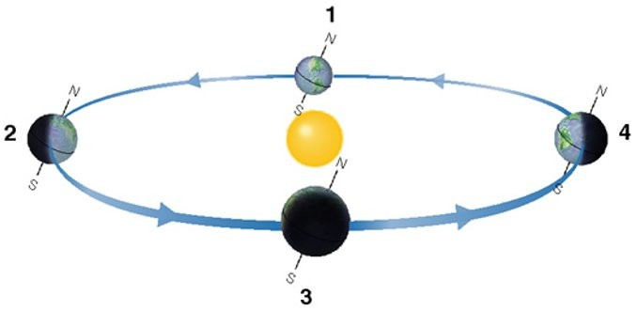

4) Diagrams like this one are commonly used in discussions of seasons and they can be quite useful. However, this diagram greatly exaggerates
A) the size of Earth relative to the size of Earth's orbit around the Sun.
B) the size of the Sun relative to the size of Earth's orbit around the Sun.
C) the amount by which Earth's orbit differs from a perfect circle.
D) all of the answers listed.
E) only the first and third choices.
Answer: D

5) Which position in this diagram represents Earth on the day that we have the longest amount of daylight in the continental United States?
A) 1
B) 2
C) 3
D) 4
Answer: B

6) Which position in this diagram represents Earth at the beginning of spring for the Southern Hemisphere?
A) 1
B) 2
C) 3
D) 4
Answer: C

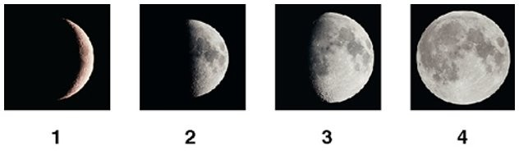

7) Which photo shows what we call a first-quarter moon? (Note: Assume these photos were taken in the Northern Hemisphere.)
A) 1
B) 2
C) 3
D) 4
Answer: B

8) Which photo shows what we call a gibbous moon? (Note: Assume these photos were taken in the Northern Hemisphere.)
A) 1
B) 2
C) 3
D) 4
Answer: C

9) This multiple exposure photograph shows the apparent retrograde motion of Mars. To make this picture, the photographer needed to combine individual photos of Mars taken over a period of

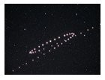
A) one full night.
B) about one hour.
C) about 3 nights.
D) several months.
Answer: D

10) What is this a picture of?

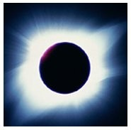
A) a total solar eclipse
B) a total lunar eclipse
C) the saros cycle
D) a full moon
Answer: A

End-of-Chapter Questions

Visual Skills Check
Use the following questions to check your understanding of some of the many types of visual information used in astronomy.

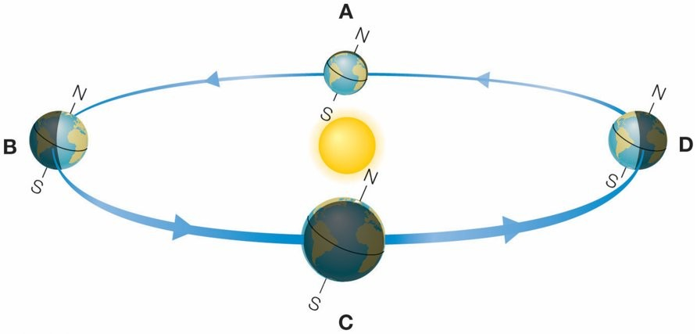

The figure above is a typical diagram used to describe Earth's seasons.

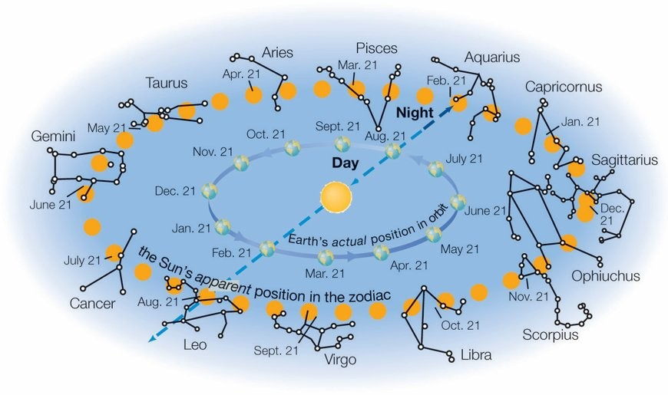

The figure above (based on Figure 2.14) shows the Sun's path through the constellations of the zodiac.

1) Which of the four labeled points (A through D) represents the day with the most hours of daylight for the Northern Hemisphere?
Answer: B

2) Which of the four labeled points represents the day with the most hours of daylight for the Southern Hemisphere?
Answer: D

3) Which of the four labeled points represents the beginning of spring for the Southern Hemisphere?
Answer: C

4) The diagram exaggerates the sizes of Earth and the Sun relative to the orbit. If Earth were correctly scaled relative to the orbit in the figure, how big would it be?
A) about half the size shown
B) about 2 millimeters across
C) about 0.1 millimeter across
D) microscopic
Answer: D

5) Given that Earth's actual distance from the Sun varies by less than 3% over the course of a year, why does the diagram look so elliptical?
A) It correctly shows that Earth is closest to the Sun at points A and C and farthest at points B and D.
B) The elliptical shape is an effect of perspective, since the diagram shows an almost edge-on view of a nearly circular orbit.
C) The shape of the diagram is meaningless and is done only for artistic effect.
Answer: B

6) As viewed from Earth, in which zodiac constellation does the Sun appear to be located on April 21?
A) Leo
B) Aquarius
C) Libra
D) Aries
Answer: D

7) If the date is April 21, what zodiac constellation will be visible on your meridian at midnight?
A) Leo
B) Aquarius
C) Libra
D) Aries
Answer: C

8) If the date is April 21, what zodiac constellation will you see setting in the west shortly after sunset?
A) Scorpius
B) Pisces
C) Taurus
D) Virgo
Answer: C

Chapter Review Questions

1) What are constellations? How did they get their names?

2) Suppose you were making a model of the celestial sphere with a ball. Briefly describe all the things you would need to mark on your celestial sphere.

3) On a clear, dark night, the sky may appear to be "full" of stars. Does this appearance accurately reflect the way stars are distributed in space? Explain.

4) Why does the local sky look like a dome? Define horizon, zenith, and meridian. How do we describe the location of an object in the local sky?

5) Explain why we can measure only angular sizes and angular distances for objects in the sky. What are arcminutes and arcseconds?

6) What are circumpolar stars? Are more stars circumpolar at the North Pole or in the United States? Explain.

7) What are latitude and longitude? Does the sky vary with latitude? Does it vary with longitude? Explain.

8) What is the zodiac, and why do we see different parts of it at different times of year?

9) Suppose Earth's axis had no tilt. Would we still have seasons? Why or why not?

10) Briefly describe key facts about the solstices and equinoxes.

11) What is precession? How does it affect what we see in our sky?

12) Briefly describe the Moon's cycle of phases. Can you ever see a full moon at noon? Explain.

13) Why do we always see the same face of the Moon?

14) Why don't we see an eclipse at every new and full moon? Describe the conditions needed for a solar or lunar eclipse.

15) What do we mean by the apparent retrograde motion of the planets? Why was this motion difficult for ancient astronomers to explain? How do we explain it today?

16) What is stellar parallax? How did an inability to detect it support the ancient belief in an Earth-centered universe?

Does It Make Sense?
Decide whether or not each of the following statements makes sense (or is clearly true or false). Explain clearly; not all of these have definitive answers, so your explanation is more important than your chosen answer.
Example: I walked east from our base camp at the North Pole.
Solution: The statement does not make sense because east has no meaning at the North Pole–all directions are south from the North Pole.

17) The constellation Orion didn't exist when my grandfather was a child.

18) When I looked into the dark lanes of the Milky Way with my binoculars, I saw a cluster of distant galaxies.

19) Last night the Moon was so big that it stretched for a mile across the sky.

20) I live in the United States, and during a trip to Argentina I saw many constellations that I'd never seen before.

21) Last night I saw Jupiter in the middle of the Big Dipper. (Hint: Is the Big Dipper part of the zodiac?)

22) Last night I saw Mars move westward through the sky in its apparent retrograde motion.

23) Although all the known stars rise in the east and set in the west, we might someday discover a star that will rise in the west and set in the east.

24) If Earth's orbit were a perfect circle, we would not have seasons.

25) Because of precession, someday it will be summer everywhere on Earth at the same time.

26) This morning I saw the full moon setting at about the same time the Sun was rising.

Quick Quiz

27) Two stars that are in the same constellation
A) must both be part of the same cluster of stars in space.
B) must both have been discovered at about the same time.
C) may actually be very far away from each other.
Answer: No Correct Answer Was Provided.

28) The north celestial pole is 35° above your northern horizon. This tells you that you are at
A) latitude 35°N.
B) longitude 35°E.
C) latitude 35°S.
Answer: No Correct Answer Was Provided.

29) Beijing and Philadelphia have about the same latitude but different longitudes. Therefore, tonight's night sky in these two places will
A) look about the same.
B) have completely different sets of constellations.
C) have partially different sets of constellations.
Answer: No Correct Answer Was Provided.

30) In winter, Earth's axis points toward the star Polaris. In spring, the axis points toward
A) Polaris.
B) Vega.
C) the Sun.
Answer: No Correct Answer Was Provided.

31) When it is summer in Australia, the season in the United States is
A) winter.
B) summer.
C) spring.
Answer: No Correct Answer Was Provided.

32) If the Sun rises precisely due east
A) you must be located at Earth's equator.
B) it must be the day of either the March or the September equinox.
C) it must be the day of the June solstice.
Answer: No Correct Answer Was Provided.

33) A week after full moon, the Moon's phase is
A) first quarter.
B) third quarter.
C) new.
Answer: No Correct Answer Was Provided.

34) The fact that we always see the same face of the Moon tells us that the Moon
A) does not rotate.
B) rotates with the same period that it orbits Earth.
C) looks the same on both sides.
Answer: No Correct Answer Was Provided.

35) If there is going to be a total lunar eclipse tonight, then you know that
A) the Moon's phase is full.
B) the Moon's phase is new.
C) the Moon is unusually close to Earth.
Answer: No Correct Answer Was Provided.

36) When we see Saturn going through a period of apparent retrograde motion, it means
A) Saturn is temporarily moving backward in its orbit of the Sun.
B) Earth is passing Saturn in its orbit, with both planets on the same side of the Sun.
C) Saturn and Earth must be on opposite sides of the Sun.
Answer: No Correct Answer Was Provided.

Inclusive Astronomy
Use these questions to reflect on participation in science.

37) Cultural Constellations. Many cultures have created their own sets of constellations that differ from those used officially in astronomical research. Learn about the constellations of a particular culture of interest to you. How do the patterns of your chosen constellation(s) relate to the patterns of the official constellations listed in Appendix H? Which set of patterns makes more sense to you personally?

38) Group Discussion: Sharing the Sky. Astronomers around the world are fond of saying "we all share the same sky." Gather in groups of two to four students to discuss the meaning of this statement.
a) Give each group member a chance to describe the similarities and differences you would expect between the sky you see during a 24-hour period and the sky seen by someone on the opposite side of the world or on the other side of the equator.
b) Discuss whether you think that people making independent studies of the sky in different locations would come to similar conclusions about how the universe works. Would their conclusions be more accurate if they shared perspectives with people from other places? Why or why not?
c) Discuss whether the skies that people saw 2000 years ago differ in any significant ways from the skies we see today.
d) Do you think that people living 2000 years from now will have experiences of the sky that are similar to your own?

The Process of Science
These questions may be answered individually in short-essay form or discussed in groups, except where identified as group-only.

39) Earth-Centered or Sun-Centered? Decide whether each of the following phenomena is consistent or inconsistent with a belief in an Earth-centered system. If consistent, describe how. If inconsistent, explain why, and also explain why the inconsistency did not immediately lead people to abandon the Earth-centered model.
a) The daily paths of stars through the sky
b) Seasons
c) Phases of the Moon
d) Eclipses
e) Apparent retrograde motion of the planets

40) Shadow Phases. Many people incorrectly guess that the phases of the Moon are caused by Earth's shadow falling on the Moon. How would you convince a friend that the phases of the Moon have nothing to do with Earth's shadow? Describe the observations you would use to show that Earth's shadow can't be the cause of phases.

41) Earth-Centered Language. Many common phrases reflect the ancient Earth-centered view of our universe. For example, although we now know that day and night arise from Earth's rotation, we speak of "sunrise" or "sunset" as though the Sun were moving around us daily. Identify other common phrases that imply an Earth-centered viewpoint. Do you think this language creates any difficulties in teaching science? Why or why not?

42) A Flat Earth? A few relatively famous people have recently made the claim that the Earth is flat. Working in small groups, first find out the basis on which they make these claims, then make a list of key observations that refute the flat Earth claims. Based on what you learn, how can you tell which websites discussing flat Earth claims are scientifically valid and which are not, and what lessons the flat Earth claims may contribute to the more general issue of "fake news" in our modern society?

43) Group Activity: Lunar Phases and Time of Day. Make a copy of the diagram below representing the Moon's orbit as seen from above Earth's North Pole.Note: You may wish to do this activity using the four roles described in Chapter 1, Exercise 39; you may also find it useful to watch the video "Moon Phases, Part 2."

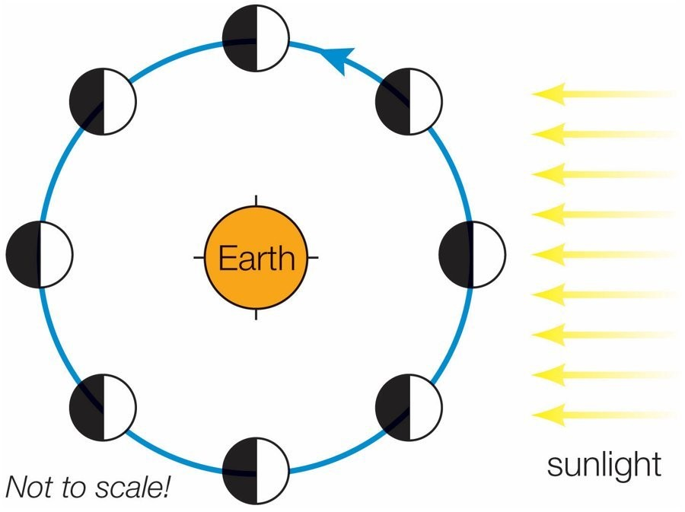

a) Label each of the eight Moon positions with the phase that it represents.
b) What time of day corresponds to each of the four tick marks on Earth? Label each tick mark accordingly.
c) Why doesn't the Moon's phase change during the course of one night? Explain your reasoning.
d) At what times of day would a full moon be visible to someone on Earth? Write down when a full moon rises and explain why it appears to rise at that time.
e) At what times of day would a third-quarter moon be visible to someone on Earth? Write down when a third-quarter moon sets and explain why it appears to set at that time.
f) At what times of day would a waxing crescent moon be visible to someone on Earth? Write down when a waxing crescent moon rises and explain why it appears to rise at that time.

Investigate Further

44) New Planet. A planet in another solar system has a circular orbit and an axis tilt of 35°. Would you expect this planet to have seasons? If so, would you expect them to be more extreme than the seasons on Earth? If not, why not?

45) Your View of the Sky.
a) What are your latitude and longitude?
b) Where does the north (or south) celestial pole appear in your sky?
c) Is Polaris a circumpolar star in your sky? Explain.

46) View from the Moon. Assume you live on the Moon, near the center of the face that looks toward Earth.
a) Suppose you see a full earth in your sky. What phase of the Moon would people on Earth see? Explain.
b) Suppose people on Earth see a full moon. What phase would you see for Earth? Explain.
c) Suppose people on Earth see a waxing gibbous moon. What phase would you see for Earth? Explain.
d) Suppose people on Earth are viewing a total lunar eclipse. What would you see from your home on the Moon? Explain.

47) View from the Sun. Suppose you lived on the Sun (and could ignore the heat). Would you still see the Moon go through phases as it orbits Earth? Why or why not?

48) A Farther Moon. Suppose the distance to the Moon were twice its actual value. Would it still be possible to have a total solar eclipse? Why or why not?

49) A Smaller Earth. Suppose Earth were smaller. Would solar eclipses be any different? If so, how? What about lunar eclipses?

50) Project: Observing Planetary Motion. Find out which planets are currently visible in your evening sky. At least once a week, observe the planets and draw a diagram showing the position of each visible planet relative to stars in a zodiac constellation. From week to week, note how the planets are moving relative to the stars. Can you see any of the apparently wandering features of planetary motion? Explain.

51) Project: Eclipse Trip. Find details about a future total solar eclipse that you may be able to observe. Create a plan for a trip to see the eclipse, including details of where you will view it, how you will get there, and what you should expect to see.

52) Project: A Connecticut Yankee. Read A Connecticut Yankee in King Arthur's Court by Mark Twain. What role does an eclipse play in the story? Discuss its significance.

Quantitative Problems
Be sure to show all calculations clearly and state your final answers in complete sentences.

53) Arcminutes and Arcseconds. There are 360° in a full circle.
a) How many arcminutes are in a full circle?
b) How many arcseconds are in a full circle?
c) The Moon's angular size is about 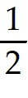°. What is this in arcminutes? In arcseconds?

54) Latitude Distance. Earth's radius is approximately 6370 km.
a) What is Earth's circumference?
b) What distance is represented by each degree of latitude?
c) What distance is represented by each arcminute of latitude?
d) Can you give similar answers for the distances represented by a degree or arcminute of longitude? Why or why not?

55) Angular Conversions I. The following angles are given in degrees and fractions of degrees. Rewrite them in degrees, arcminutes, and arcseconds.
a) 24.3°
b) 1.59°
c) 0.1°
d) 0.01°
e) 0.001°

56) Angular Conversions II. The following angles are given in degrees, arcminutes, and arcseconds. Rewrite them in degrees and fractions of degrees.
a) 7° 38' 42"
b) 12' 54"
c) 1° 59' 59"
d) 1'
e) 1"

57) Sun Diameter. Use the Sun's approximate distance of 150 million km and angular diameter of about 0.5° to calculate the Sun's physical diameter. Compare your answer to the actual value of 1,390,000 km.

58) Betelgeuse Diameter. Estimate the diameter of the supergiant star Betelgeuse from its angular diameter of 0.05 arcsecond and distance of about 600 light-years. Compare your answer to the size of our Sun and the Earth-Sun distance.

59) Eclipse Conditions. The Moon's precise equatorial diameter is 3476 km, and its orbital distance from Earth varies between 356,400 and 406,700 km. The Sun's diameter is 1,390,000 km, and its distance from Earth ranges between 147.5 and 152.6 million km.
a) Find the Moon's angular size at its minimum and maximum distances from Earth.
b) Find the Sun's angular size at its minimum and maximum distances from Earth.
c) Based on your answers to parts a and b, is it possible to have a total solar eclipse when the Moon and Sun are both at their maximum distance? Explain.

