Name______________

1. Identify the following pitches including octave identification. Be sure to watch for clef changes.



1. Notate the following pitches on the staff. Use ledger lines for pitches as needed.



1. Determine if the following two pitches are half steps of whole steps.



1. Identify both the major and minor key signatures.



1. Notate the following key signatures on the staff.

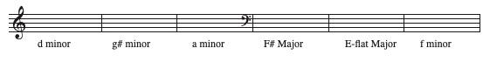

1. Notate the following scales on the staff.

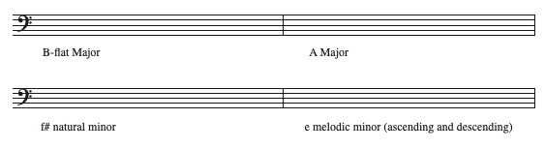

1. Add barlines to the following rhythmic passages. Insert a counting method under each system.

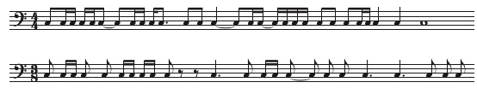

1. Identify the following intervals.



1. Notate a pitch above the given note to form the given interval.



1. Notate a pitch below the given note to form the given interval.



1. Label the keys of the keyboard (one octave only)

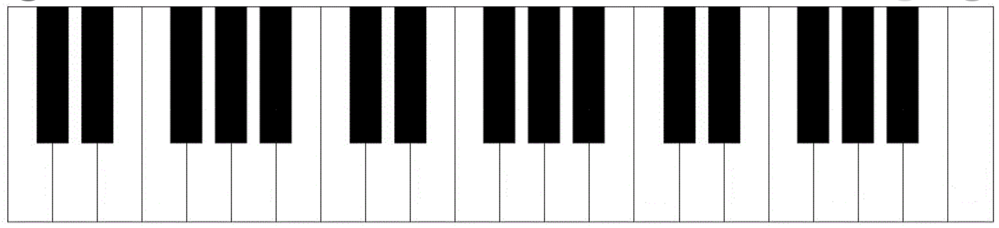

1. Aural Skills
2. Rhythmic
3. Scale Degrees

___ ___

___ ___

___ ___

___ ___

