1. How is difference used as a tool to understand cultures?
 | a. | Cultures are defined by how they relate to each other.
 | b. | Cultures can only exist independently of each other.
 | c. | Cultures define themselves in opposition to dominant power structures.
 | d. | Cultures are only distinct in how they vary geographically.

ANSWER: | a

2. Which region in the United States has the highest concentration of NCAA men's ice hockey teams?
 | a. | Northeast
 | b. | Alaska
 | c. | the Midwest
 | d. | the South

ANSWER: | a

3. Which of the following helps explain the folk culture roots of ice hockey in the United States?
 | a. | winter traditions by Native Americans near the settlement of Jamestown
 | b. | the formal rules of lacrosse were eventually developed by European Canadians
 | c. | stick and ball games of people indigenous to eastern Canada
 | d. | an early peace-building activity between indigenous peoples and Europeans

ANSWER: | c

4. Why did ice hockey remain regionalized in the Northeast, even after the invention of indoor ice rinks?
 | a. | Many people in the United States preferred to watch football.
 | b. | Canadians would not allow Americans to play on their teams.
 | c. | A regional cultural preference had already been established.
 | d. | Only Ivy League schools could afford ice hockey rinks.

ANSWER: | c

5. The perspective of possibilism suggests that:
 | a. | ice hockey spread quickly to the South as the rules of the game popularized
 | b. | ice hockey was created in two places about the same time
 | c. | ice hockey was originally restricted to areas with a cold enough climate
 | d. | ice hockey was unpopular with Americans, and it flourished in Canada

ANSWER: | c

6. Of the three sports, ice hockey, lacrosse, and volleyball, which gained widespread popularity outside of the region it was invented?
 | a. | both ice hockey and volleyball
 | b. | volleyball
 | c. | ice hockey
 | d. | lacrosse

ANSWER: | b

7. Lacrosse and ice hockey are examples of:
 | a. | a blending of indigenous and colonial cultures
 | b. | games imported from European culture during colonization
 | c. | games stolen from Native American culture
 | d. | games independently created for universities

ANSWER: | a

8. Which of the following explains the geographic distribution of NCAA men's volleyball teams?
 | a. | In the 1960s, volleyball became associated with California beach culture.
 | b. | Winters on the East Coast are milder, making volleyball more popular there.
 | c. | It was adapted from a game played by indigenous people in Florida.
 | d. | Only states bordering the Gulf of Mexico have large enough beaches.

ANSWER: | a

9. Which state's university teams dominate in NCAA men's volleyball?
 | a. | Hawaii
 | b. | Florida
 | c. | Massachusetts
 | d. | California

ANSWER: | d

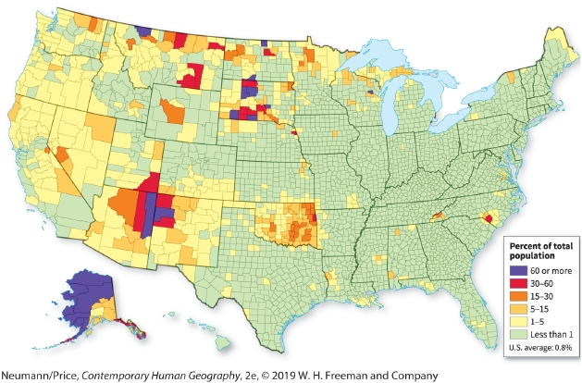

10. Which characteristic of indigenous cultural regions is reflected in this map?
 | a. | their location in large forested regions
 | b. | poor access to roads and infrastructure
 | c. | their strong political voice
 | d. | a strong political presence in the national capital

ANSWER: | b

11. Which state has the most land area that also has the highest percentage of indigenous people?
 | a. | Arizona
 | b. | Texas
 | c. | South Dakota
 | d. | Alaska

ANSWER: | d

12. Which of the following geographic factors might strengthen the relationship between the federal government and indigenous nations?
 | a. | forcing indigenous people to migrate to new reservations
 | b. | locating them farther away from capital cities
 | c. | the rough topography
 | d. | better infrastructure such as roads

ANSWER: | d

13. The current locations of indigenous populations in the United States reflect:
 | a. | eastward movement over time
 | b. | geographic marginalization
 | c. | integration in the national culture
 | d. | an increasingly urbanized population

ANSWER: | b

14. What was the purpose of the forced removal of Native Americans during the 1800s?
 | a. | to integrate Native Americans in the national culture
 | b. | to provide land for European settlers
 | c. | to move Native Americans to better hunting grounds
 | d. | to force them to move to cities

ANSWER: | b

15. Maps that indicate cultural region demonstrate:
 | a. | concentrations of indigenous people live potentially with other groups
 | b. | areas of indigenous people who all belong to the same group
 | c. | areas of strong government authority over indigenous peoples
 | d. | internationally recognized borders that protect indigenous peoples

ANSWER: | a

16. The Andean culture region is an example of:
 | a. | the full extent of the Incan empire
 | b. | a cultural region that crosses international borders
 | c. | a unique mix of Mayan and Incan settlements
 | d. | an area given special status by the Mexican and Guatemalan governments

ANSWER: | b

17. The mountainous regions in South Asia have what have become known as Hill Tribes, which are often characterized by:
 | a. | intensive agriculture in fertile valleys
 | b. | their fervent Islamic beliefs
 | c. | their symbols of national culture and pride
 | d. | distinct language and religion from lowland cultures

ANSWER: | d

18. Why is it useful to map the "hidden" spaces of LGBT residents in a city?
 | a. | It provides a history of how LGBT have been fully integrated into the city.
 | b. | It shows the way the LGBT population is spreading to new neighborhoods.
 | c. | It segregates or demarcates space based on sexual preferences.
 | d. | It allows understanding of the places LGBTs feel safe and contribute to civic life.

ANSWER: | d

19. The decision by the city of Chicago to highlight the neighborhood of Boystown reflects:
 | a. | an attempt to keep out businesses opposed to LGBT groups
 | b. | an attempt to attract diverse people and to show city's openness
 | c. | the history of racial segregation in the city
 | d. | a steep reduction in shootings throughout the city

ANSWER: | b

20. Within North America, many studies of the LGBT geography have taken place in:
 | a. | Cities
 | b. | rural areas
 | c. | continental interior
 | d. | Suburbs

ANSWER: | a

21. The first officially recognized LGBT district in the United States was:
 | a. | Greenwich Village, New York
 | b. | Rehoboth, Delaware
 | c. | Boystown, Chicago
 | d. | Key West, Florida

ANSWER: | c

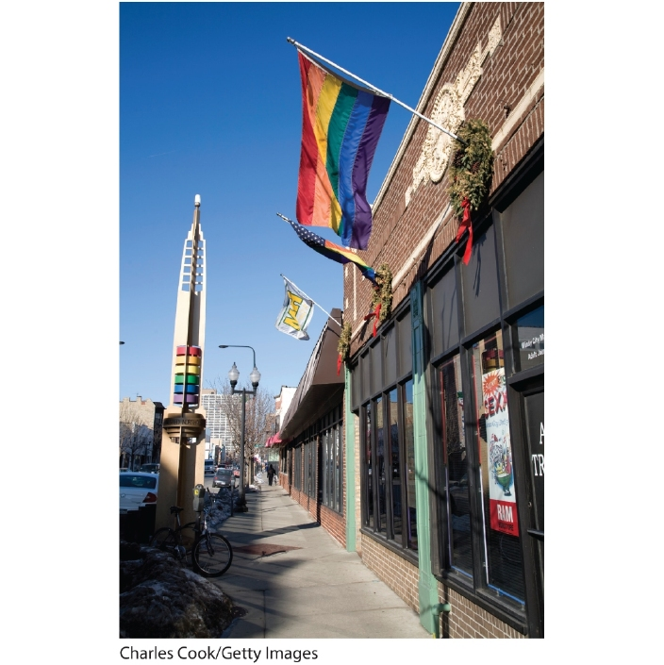

22. The presence of the rainbow flag in this photo signifies that this neighborhood is likely a(n):
 | a. | gentrified neighborhood
 | b. | LGBT neighborhood
 | c. | convergent community
 | d. | elitist landscape

ANSWER: | b

23. Suppose fans of a particular soap opera set in Santa Barbara, California, flock to the city to visit the locations that are featured in each episode. This is an example of:
 | a. | media tourism
 | b. | literary tourism
 | c. | Migration
 | d. | cultural homogeneity

ANSWER: | a

24. Which city does NOT have a robust vampire-tourism economy?
 | a. | Forks, Washington
 | b. | Volterra, Italy
 | c. | Chicago, Illinois
 | d. | New Orleans, Louisiana

ANSWER: | c

25. The town of _____, Washington, has seen its somewhat depressed economy improve as a result of tourism based on the Twilight series of books and movies.
 | a. | Forks
 | b. | Seattle
 | c. | Tacoma
 | d. | Olympia

ANSWER: | a

26. Which country is considered the "mecca" of vampire tourism?
 | a. | Russia
 | b. | Romania
 | c. | Bulgaria
 | d. | Lithuania

ANSWER: | b

27. The Transylvania region is located in:
 | a. | Germany
 | b. | Romania
 | c. | Bulgaria
 | d. | Belarus

ANSWER: | b

28. Which statement is NOT true regarding vampire tourism in Romania?
 | a. | Since the fall of communism, tourist attractions based on the historically inaccurate version of Dracula have been banned.
 | b. | The Dracula story presents Romania as a backward, superstitious region.
 | c. | The fictional character of Dracula links a Romanian hero to an evil beast, thereby disrespecting a key figure in Romanian history.
 | d. | The folk culture of Transylvania has no tradition of vampirism.

ANSWER: | a

29. Which is NOT a major diaspora culture?
 | a. | the Hmong diaspora (following the Vietnam War)
 | b. | the Italian diaspora (following World War II)
 | c. | the Sudanese diaspora (a result of ongoing civil wars in the region)
 | d. | the Cuban diaspora (following the communist revolution)

ANSWER: | b

30. Approximately how many people have the ongoing Sudanese civil wars displaced?
 | a. | 50,000
 | b. | 500,000
 | c. | 2 million
 | d. | 4 million

ANSWER: | d

31. Civil wars in Sudan have been fought primarily between the _____ northern region and the _____ southern region.
 | a. | Arabic; Christian
 | b. | French-ruled; Italian-ruled
 | c. | undeveloped; developed
 | d. | barren; urban

ANSWER: | a

32. The world's newest nation-state is:
 | a. | Belarus
 | b. | Ukraine
 | c. | Transylvania
 | d. | South Sudan

ANSWER: | d

33. An analysis of the Miss South Sudan beauty pageant revealed that the ideal South Sudanese woman was all of the following EXCEPT:
 | a. | Christian
 | b. | light-skinned
 | c. | career-oriented
 | d. | maternal and devoted to reproducing the new nation

ANSWER: | b

34. The term _____ has been coined to describe the pattern of unequal access to the Internet.
 | a. | Disconnectivity
 | b. | Invisible Internet
 | c. | digital divide
 | d. | zero PC

ANSWER: | c

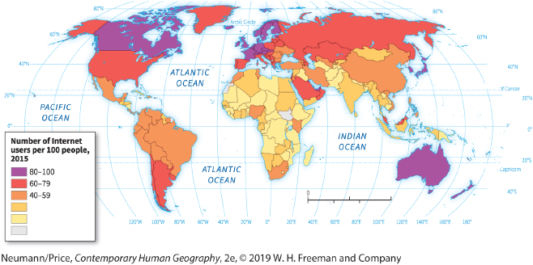

35. According to the map, the digital divide is greatest between _____ and _____.
 | a. | Europe; Asia
 | b. | Asia; Australia
 | c. | South America; Russia
 | d. | North America; Africa

ANSWER: | d

36. According to the map, which African country has the greatest number of Internet users?
 | a. | South Africa
 | b. | Namibia
 | c. | Algeria
 | d. | Democratic Republic of the Congo

ANSWER: | a

37. Which country banned cell phones until 2008?
 | a. | Dominican Republic
 | b. | Haiti
 | c. | Cuba
 | d. | Egypt

ANSWER: | c

38. Which country banned Google Street View in 2010, but later lifted the ban after negotiating strict terms with Google?
 | a. | United Arab Emirates
 | b. | Qatar
 | c. | Canada
 | d. | Czech Republic

ANSWER: | d

39. Which technological device did the United Arab Emirates briefly ban in 2010?
 | a. | the BlackBerry
 | b. | the iPhone
 | c. | the PC
 | d. | the pager

ANSWER: | a

40. The theory that cultures are becoming more alike as a result of globalization trends is the:
 | a. | cultural adaptation theory
 | b. | placelessness theory
 | c. | convergence hypothesis
 | d. | time-space convergence

ANSWER: | c

41. According to the assumption of the convergence hypothesis, the ultimate effect would be:
 | a. | a politically unified world
 | b. | placelessness
 | c. | genocide
 | d. | class warfare

ANSWER: | b

42. Two hundred years ago it might have taken weeks to travel from the East Coast of the United States to the West Coast. Today it takes a few hours. This phenomenon is called:
 | a. | placelessness
 | b. | cultural homogenization
 | c. | convergence hypothesis
 | d. | time-space convergence

ANSWER: | d

43. According to the convergence hypothesis, people and places are:
 | a. | becoming more regionalized
 | b. | achieving a sense of place
 | c. | becoming more differentiated
 | d. | becoming more alike

ANSWER: | d

44. According to Peter Jackson, cultural practices rooted in place shape the effects of globalization through all of the following EXCEPT:
 | a. | hybridization
 | b. | transformation
 | c. | resistance
 | d. | placelessness

ANSWER: | d

45. The idea of local consumption cultures implies that:
 | a. | people in remote locations have no interest in foreign-produced products
 | b. | people in cities are more likely to use foreign-produced products
 | c. | local circumstances can make a difference to the outcomes of globalization
 | d. | all cultures are converging into one global culture

ANSWER: | c

46. Some Americans have begun avoiding products produced in China, because they consider them cheaply made and sometimes even dangerous. Instead, they purchase items made in the United States to support domestic companies. This is a case of:
 | a. | the convergence hypothesis
 | b. | consumer nationalism
 | c. | local consumption culture
 | d. | folk culture renaissance

ANSWER: | b

47. Which is NOT an example of a historic or contemporary diaspora culture?
 | a. | Native Americans in Oklahoma
 | b. | the movement of Southeast Asians into U.S. cities in the late twentieth century
 | c. | the large populations of South Asians in England
 | d. | the contemporary movement of North Africans into southern Spain

ANSWER: | a

48. Which country in 2010 banned full-face veils (burqas) in public?
 | a. | Great Britain
 | b. | Germany
 | c. | France
 | d. | Switzerland

ANSWER: | c

49. Which has NOT been an effect of globalization on indigenous cultures?
 | a. | Local indigenous peoples are now linked to global networks that allow them to rally international support.
 | b. | Globalization introduces new values and organizations, such as the World Trade Organization, not all of which are welcome.
 | c. | Globalization erects barriers that prevent almost all innovations from reaching indigenous cultures.
 | d. | Multinational corporations' quest for profits can threaten the homelands and habitats of indigenous peoples.

ANSWER: | c

50. Which statement is NOT true regarding indigenous ecology?
 | a. | Many believe that indigenous peoples possess a great deal of knowledge about their physical environment.
 | b. | Today indigenous peoples are often seen as conservators of their habitat, but in colonial times they were perceived as destroyers of the habitat for political reasons.
 | c. | The majority of national parks in Central and South America are home to indigenous populations.
 | d. | In most cases, indigenous farming practices provide higher crop yields than "modern" farming practices.

ANSWER: | d

51. Tropical rain forests contain about _____ percent of the Earth's surface and contain approximately _____ percent of the world's biodiversity.
 | a. | 6; 60
 | b. | 10; 50
 | c. | 15; 75
 | d. | 30; 40

ANSWER: | a

52. Europeans historically claimed that indigenous peoples practices destroyed the environment, yet this claim was part of an effort to dispossess indigenous peoples from their land during:
 | a. | colonialism
 | b. | globalization
 | c. | space-time compression
 | d. | independence movements

ANSWER: | a

53. Indigenous people live in some of the most biologically rich areas of the world. Some people suggest this means that:
 | a. | indigenous people need to be removed from these lands in order to protect them
 | b. | cultural preservation and biological preservation should both be goals
 | c. | cultural preservation should be prioritized for the sake of human rights
 | d. | priority needs to be on biological preservation for the sake of the global environment

ANSWER: | b

54. Indigenous rights organizations assert that they have cultivated local biodiversity for generations and that they should have control over the resulting:
 | a. | agricultural harvests
 | b. | tourism industry
 | c. | manufactured goods
 | d. | genetic resources

ANSWER: | d

55. The term used to describe the highly localized knowledge about environmental conditions and sustainable land-use practices is:
 | a. | green revolution
 | b. | indigenous technical knowledge
 | c. | folk-farming
 | d. | in situ agricultural planning

ANSWER: | b

56. An indigenous group that has detailed understanding of local climate systems, water cycles, and species biodiversity can adapt that environment to their needs in sophisticated ways. They might not be able to do the same in a different environment because indigenous technical knowledge is:
 | a. | weaker in the face of globalization
 | b. | inferior to scientific methods
 | c. | inherently place-based
 | d. | adapted to many environments

ANSWER: | c

57. An economy in which people seek to consume only what they produce and to produce only for local consumption rather than for exchange or export is called a _____ economy.
 | a. | diasporic
 | b. | developing
 | c. | swidden
 | d. | subsistence

ANSWER: | d

58. An indigenous group who grows and hunts most of their own food and trades food surpluses and handmade goods to supplement their diets with foods unavailable locally is an example of a:
 | a. | developing economy
 | b. | subsistence economy
 | c. | placeless economy
 | d. | globalized economy

ANSWER: | b

59. The marine life traditionally harvested by the Miskito community of Nicaragua, which became overharvested as a result of globalization, is the:
 | a. | Chilean sea bass
 | b. | sea anemone
 | c. | green turtle
 | d. | harp seal

ANSWER: | c

60. How did globalization impact the way the Miskito community of Nicaragua harvested green sea turtles, which decimated the turtle population?
 | a. | Turtle eggs were harvested as well as the adults.
 | b. | Outsiders were hired and outcompeted the Miskito hunters.
 | c. | Large ships came in to help the Miskito hunt turtles.
 | d. | Harvesting sea turtles was no longer seasonal and instead occurred all year.

ANSWER: | d

61. Why did the Miskito turtle hunters, once a purely subsistence economy, need to work to pay off debts to outsiders, which eventually caused the collapse of the subsistence economy?
 | a. | The community started seeing an increase of drug use.
 | b. | Stores moved in that undercut the local prices of food.
 | c. | The turtle hunters had been given loans to buy equipment for hunting.
 | d. | Local taxes were imposed on the Miskito community.

ANSWER: | c

62. The home of the Miskito community is:
 | a. | Nicaragua
 | b. | Panama
 | c. | Belize
 | d. | Guatemala

ANSWER: | a

63. What is an example of the ability of the Miskito community to maintain their way of life through biological preservation?
 | a. | the opening of a museum dedicated to the extinct green sea turtle
 | b. | the creation of a UN World Heritage Site
 | c. | the creation of a marine biological reserve
 | d. | the opening of an indigenous university

ANSWER: | c

64. The home of the Quechua people can be found in:
 | a. | the Ecuadorian Andes
 | b. | Patagonia
 | c. | the Amazon forest of Brazil
 | d. | Central America

ANSWER: | a

65. When an indigenous community combines local knowledge with globalized technologies, this community is:
 | a. | overcoming the problems associated with globalization
 | b. | negotiating their interactions with the global economy and sustaining their culture
 | c. | giving in to the pressures of globalization
 | d. | allowing the state to mandate their integration into the global economy

ANSWER: | b

66. Appalachians moved to all of the following areas of the continental United States EXCEPT:
 | a. | the Ramapo Mountains of New Jersey
 | b. | the Ozark-Ouachita Mountains
 | c. | the Cascade and Coast Mountains
 | d. | the Texas Hill Country

ANSWER: | a

67. Why did Upland Southerners migrate from the Appalachians to places like the Ozark-Ouachita Mountains and the Cascades of the Pacific Northwest instead of places like the Great Plains?
 | a. | People in the Great Plains were prejudiced against Appalachian people.
 | b. | Their ecological knowledge was better adapted to mountainous areas.
 | c. | Government grants provided land in mountains but not in the Great Plains.
 | d. | The Great Plains was farther away than these mountain ranges.

ANSWER: | b

68. Which of the following is a folk culture adaptation to the local wetland environment in Florida?
 | a. | a dune buggy
 | b. | a speed boat
 | c. | a swamp buggy
 | d. | a fanboat

ANSWER: | c

69. Which doctrine holds that women are inherently better environmental preservationists than men are?
 | a. | Ecofeminism
 | b. | manifest destiny
 | c. | the Monroe Doctrine
 | d. | the grandmother hypothesis

ANSWER: | a

70. Within an ecofeminism framework, why might someone argue that women are better stewards of nature?
 | a. | Women are gentler.
 | b. | Men are too power hungry.
 | c. | Women are more socialist.
 | d. | Women bear children.

ANSWER: | d

71. A farming system that combines the growing of trees with the cultivation of agricultural crops is:
 | a. | swidden cultivation
 | b. | slash-and-burn cultivation
 | c. | agroforestry
 | d. | ecotourism

ANSWER: | c

72. Which was NOT a conclusion reached by Diane Rocheleau in her studies of agroforestry in East Africa and the Dominican Republic?
 | a. | Because men are the primary landowners and workers, women are expected to work more within the province of the home, and to gather water from local sources.
 | b. | Within indigenous cultures that practice agroforestry, women often take the lead in political movements concerned with environmental issues.
 | c. | In general, men and women tend to have different rights with respect to the ownership and control of land and resources.
 | d. | Because men and women have different responsibilities, they have different sets of knowledge about the environment.

ANSWER: | a

73. Diane Rocheleau's work in East Africa and the Dominican Republic identified all of the following themes EXCEPT:
 | a. | gendered environmental rights
 | b. | gendered knowledge
 | c. | gendered sexuality
 | d. | gendered environmental politics

ANSWER: | c

74. A man working for a logging company and who earns a cash income for his household might see a forest for the timber, but a woman might see the forest for the firewood and food she can gather. This is an example of:
 | a. | gendered environmental politics
 | b. | gendered sexuality
 | c. | gendered knowledge
 | d. | gendered environmental rights

ANSWER: | c

75. The adaptive strategies pursued by people living in popular cultures have enormous potential for producing:
 | a. | environmental perceptions
 | b. | intimate relationships with the physical environment
 | c. | advantageous ecological relationships
 | d. | unsustainable and disastrous conditions

ANSWER: | d

76. One benefit for city dwellers of having a less intimate connection with the landscape is:
 | a. | increased vulnerability to natural disasters
 | b. | knowledge of farming in small spaces
 | c. | less vulnerability to environmental forces
 | d. | increased air and water pollution

ANSWER: | c

77. Which of the following is an example of nature in popular culture?
 | a. | an intensively farmed wheat field
 | b. | a small park in a strip mall
 | c. | urban farming
 | d. | a coal mine

ANSWER: | c

78. Understanding why cats began living around humans and eventually became their pets would be a question for someone in the subfield of:
 | a. | cultural geography
 | b. | animal geography
 | c. | political ecology
 | d. | geomorphology

ANSWER: | b

79. The purpose of animal geography is to understand:
 | a. | how nonhuman species participate in interactions with humans
 | b. | how animals are introduced by humans into new environments
 | c. | how animals are distributed around the planet
 | d. | how animals have modified their environments through diet

ANSWER: | a

80. The source of most folk architecture is:
 | a. | collective memory
 | b. | computer-based reproductions
 | c. | professional architectural firms
 | d. | indigenous culture

ANSWER: | a

81. Folk architecture can be described accurately by all of the following EXCEPT:
 | a. | Traditional
 | b. | Functional
 | c. | conservative
 | d. | complicated

ANSWER: | d

82. Why are traditional/folk Yankee houses so large?
 | a. | A large home was a sign of prestige and social class.
 | b. | Cold winters forced much work to be done indoors.
 | c. | Animals were kept and fed inside.
 | d. | Large houses were easier to defend from attack.

ANSWER: | b

83. Folk houses in the Upland South were made of:
 | a. | logs
 | b. | adobe
 | c. | cement
 | d. | canvas

ANSWER: | a

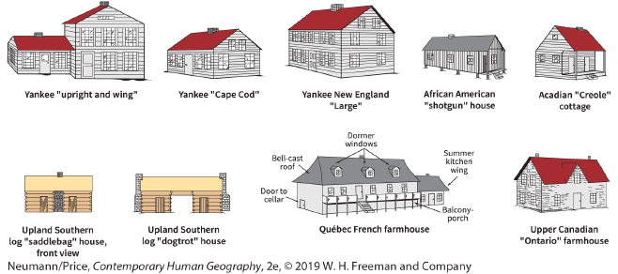

84. According to the figure, which was NOT a style of folk house commonly built in New England?
 | a. | Yankee "upright and wing"
 | b. | "Cape Cod"
 | c. | Upland Southern "dogtrot"
 | d. | New England "large"

ANSWER: | c

85. The "upright and wing" and "Cape Cod" houses pictured here are MOST likely to be found in which region of the United States?
 | a. | the Middle Atlantic region
 | b. | New England
 | c. | the South
 | d. | the Midwest

ANSWER: | b

86. The Acadian "Creole" cottage pictured here is MOST likely to be found in which U.S. state?
 | a. | Florida
 | b. | Mississippi
 | c. | Texas
 | d. | Louisiana

ANSWER: | d

87. The two houses pictured here MOST likely to be found north of the U.S. border are the:
 | a. | upright and wing and Acadian Creole cottage
 | b. | dogtrot house and saddlebag house
 | c. | French farmhouse and Ontario farmhouse
 | d. | New England large and shotgun house

ANSWER: | c

88. A log home consisting of two rooms with a fireplace in between is a:
 | a. | Dogtrot
 | b. | Shotgun
 | c. | saddlebag
 | d. | Cape Cod

ANSWER: | c

89. A log home consisting of two rooms connected by an open-air passageway is a:
 | a. | Dogtrot
 | b. | Shotgun
 | c. | saddlebag
 | d. | Cape Cod

ANSWER: | a

90. A shotgun house is BEST described as:
 | a. | high and wide
 | b. | long and narrow
 | c. | small and tall
 | d. | large and spacious

ANSWER: | b

91. Which type of house is an example of an African American folk dwelling?
 | a. | saddlebag
 | b. | Dogtrot
 | c. | Ontario
 | d. | Shotgun

ANSWER: | d

92. A folk house that is of half-timbered construction and has a central chimney and built-in porch is the Acadian:
 | a. | saddlebag house
 | b. | dogtrot house
 | c. | shotgun house
 | d. | Creole cottage

ANSWER: | d

93. Which association(s) is/are correct?
1) dogtrot/Upland South
2) bell-cast/Acadian
3) shotgun/African American
4) notched log/Upland South
5) Creole/Québec
 | a. | 1 only
 | b. | 1, 3, and 4
 | c. | 2 and 5
 | d. | 2, 3, and 5

ANSWER: | b

94. What process makes it possible to see many of the folk architecture buildings in large cities today?
 | a. | globalization
 | b. | historic preservation
 | c. | urban development
 | d. | gentrification

ANSWER: | b

95. Which is NOT a characteristic of the Ontario farmhouse?
 | a. | one-and-a-half stories high
 | b. | rectangular shape
 | c. | gabled front dormer window
 | d. | kitchen housed in a separate outbuilding

ANSWER: | d

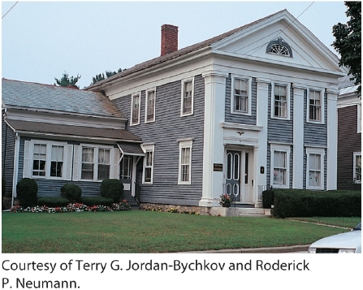

96. The type of house pictured here is a(n):
 | a. | saddlebag house
 | b. | dogtrot house
 | c. | upright and wing house
 | d. | shotgun house

ANSWER: | c

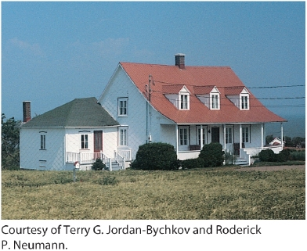

97. The type of house pictured here is a(n):
 | a. | Québec French farmhouse
 | b. | Yankee New England large house
 | c. | Yankee upright and wing house
 | d. | African American shotgun house

ANSWER: | a

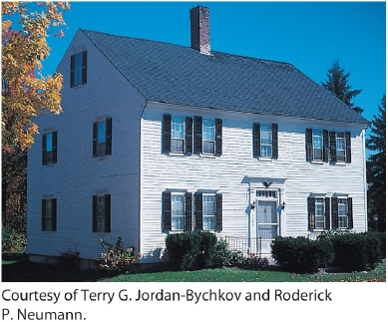

98. The type of house pictured here is a(n):
 | a. | Québec French farmhouse
 | b. | Yankee New England large house
 | c. | Yankee upright and wing house
 | d. | African American shotgun house

ANSWER: | b

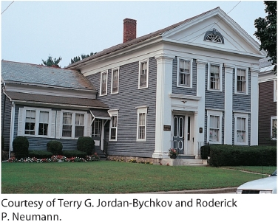

99. The type of house pictured here is a(n):
 | a. | Québec French farmhouse
 | b. | Yankee New England large house
 | c. | Yankee upright and wing house
 | d. | African American shotgun house

ANSWER: | c

100. The architecture of the decorated farmhouses of Hälsingland is rooted in:
 | a. | the Americas
 | b. | the Middle Ages
 | c. | aboriginal culture
 | d. | Christian belief systems

ANSWER: | b

101. The decorated farmhouses of Hälsingland are made of:
 | a. | Brick
 | b. | Stone
 | c. | Timber
 | d. | Mud

ANSWER: | c

102. Which statement is NOT true of the decorated farmhouses of Hälsingland?
 | a. | They are located in Sweden.
 | b. | They represent the final flowering of a centuries-old tradition of folk architecture.
 | c. | The room or building used for social activities was sparsely decorated.
 | d. | Most of the artists who worked on the decorated farmhouses remain unknown.

ANSWER: | c

103. The form of folk architecture considered the "Philippine national dwelling" is the:
 | a. | Ndebele painted house
 | b. | farmhouse
 | c. | nipa hut
 | d. | bamboo hut

ANSWER: | c

104. Which is NOT a characteristic of the nipa hut?
 | a. | It has no windows.
 | b. | It is often raised on stilts.
 | c. | It allows the free flow of cool breezes even during rainy weather.
 | d. | It is constructed primarily of bamboo framing.

ANSWER: | a

105. In which country is the nipa hut MOST common?
 | a. | Korea
 | b. | Vietnam
 | c. | Laos
 | d. | Philippines

ANSWER: | d

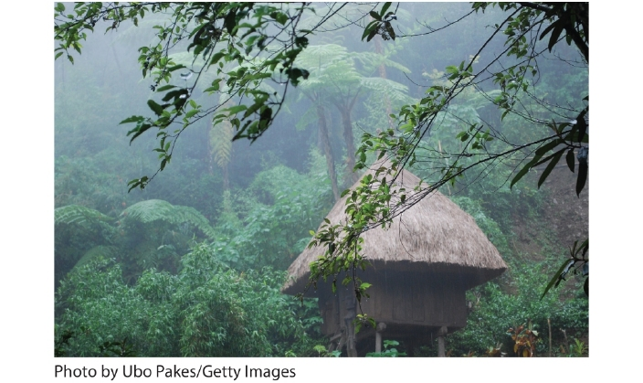

106. Where was this photo likely taken?
 | a. | the Philippines
 | b. | Ontario, Canada
 | c. | Hawaii
 | d. | New Zealand

ANSWER: | a

107. Houses of the Ndebele region in Africa are noted for their:
 | a. | indoor plumbing
 | b. | multiple stories
 | c. | brightly colored walls
 | d. | huge size

ANSWER: | c

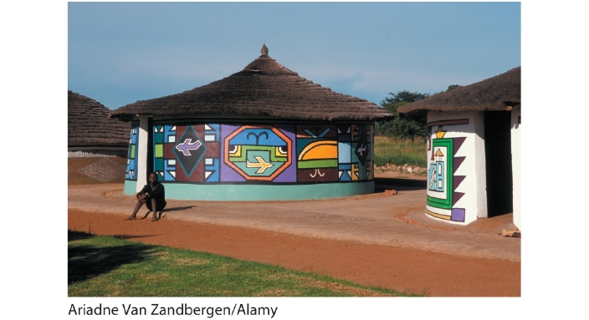

108. The type of dwelling shown in this photo is MOST likely to be found in:
 | a. | East Asia
 | b. | Southern Africa
 | c. | the United States
 | d. | India

ANSWER: | b

109. A shopping mall might be classified as a(n):
 | a. | landscape of consumption
 | b. | elitist landscape
 | c. | sustainable environment
 | d. | amenity landscape

ANSWER: | a

110. North America's largest shopping mall is located in:
 | a. | Minneapolis, Minnesota
 | b. | Paramus, New Jersey
 | c. | Edmonton, Alberta
 | d. | London, Canada

ANSWER: | c

111. The primary goal of a leisure landscape is:
 | a. | employment
 | b. | entertainment
 | c. | conservation
 | d. | ecotourism

ANSWER: | b

112. All of the following are commonly found in amenity landscapes EXCEPT:
 | a. | bodies of water
 | b. | trees
 | c. | mountains
 | d. | informal settlements

ANSWER: | d

113. Which is NOT a leisure landscape?
 | a. | Yellowstone National Park
 | b. | West Edmonton Mall
 | c. | Colonial Williamsburg
 | d. | Disney World

ANSWER: | a

114. An upscale resort overlooking Lake Tahoe would BEST be described as a(n):
 | a. | leisure landscape
 | b. | landscape of production
 | c. | elitist landscape
 | d. | amenity landscape

ANSWER: | d

115. A good example of working landscape is:
 | a. | a vineyard
 | b. | a shopping mall
 | c. | an apartment complex
 | d. | an urban industrial core

ANSWER: | a

116. Pressure from _____ compelled residents of the Malpai region to develop a consortium to maintain the local landscape and ranching as a way of life.
 | a. | amenity migrants
 | b. | the government
 | c. | real estate developers
 | d. | immigrants

ANSWER: | c

117. Which of the following is both an amenity landscape AND a working landscape?
 | a. | a vineyard
 | b. | a shopping mall
 | c. | a national park
 | d. | an urban industrial core

ANSWER: | a

118. Which of the following is an example of an economy in the "New West"?
 | a. | strip mining for coal
 | b. | cattle ranching
 | c. | luxury second homes
 | d. | logging

ANSWER: | c

119. Where is the least likely place that a person with a second home in Durango, Colorado, earned the bulk of their income?
 | a. | New York City, New York
 | b. | San Francisco, California
 | c. | Seattle, Washington
 | d. | Durango, Colorado

ANSWER: | d

120. Within the United States, the "New West" is characterized by all of the following EXCEPT:
 | a. | an amenity-based economy
 | b. | a regional economy based on cattle ranging, mining, and logging
 | c. | outdoor recreational resorts
 | d. | international art and film festivals

ANSWER: | b

121. Which is NOT a feature or characteristic of the ranchette?
 | a. | It is typically a 35- to 70-acre parcel of private land.
 | b. | It is a working ranch, often raising cattle or sheep.
 | c. | It grew in popularity as a result of an influx of affluent migrants from cities.
 | d. | The earliest ranchettes were constructed near desirable natural settings, such as streams, rivers, or lakes.

ANSWER: | b

122. Conflicts in the West over landscape changes are often rooted in:
 | a. | changing economies
 | b. | political disunion
 | c. | cultural values expressed in landscapes
 | d. | environmental change

ANSWER: | c

123. A person who sees the landscape as one of consumption might see a beautiful forest they want to live near for the view. A person who sees the landscape through the lens of production might see:
 | a. | timber that can be harvested
 | b. | factories that can be built
 | c. | the houses that will fit in the area
 | d. | a potential wildfire site

ANSWER: | a

124. Many of the sports sponsored by the National Collegiate Athletic Association (NCAA) can be traced back to folk traditions in specific places.
 | a. | True
 | b. | False

ANSWER: | True

125. Modern hockey emerged in the nineteenth century in the Upper Peninsula of Michigan.
 | a. | True
 | b. | False

ANSWER: | False

126. Lacrosse is quite common west of the Rocky Mountains.
 | a. | True
 | b. | False

ANSWER: | False

127. Volleyball was invented on the West Coast of the United States.
 | a. | True
 | b. | False

ANSWER: | False

128. Concentrations of indigenous peoples are usually found in areas with few roads or modern communication systems.
 | a. | True
 | b. | False

ANSWER: | True

129. There is an NCAA men's ice hockey team in Mississippi.
 | a. | True
 | b. | False

ANSWER: | False

130. The distribution of indigenous peoples within the United States reflects the country's traditional west-to-east movement of European settlers.
 | a. | True
 | b. | False

ANSWER: | False

131. The purpose of the Indian Removal Act of 1830 was to make way for European settlers.
 | a. | True
 | b. | False

ANSWER: | True

132. The Shan and Karen indigenous cultures are found in northern Australia.
 | a. | True
 | b. | False

ANSWER: | False

133. Knopp and Brown's research into LGBT neighborhoods in Seattle found that LGBT influence was concentrated in a small area within the city.
 | a. | True
 | b. | False

ANSWER: | False

134. New York City's Greenwich Village is the first officially recognized LGBT district in the United States.
 | a. | True
 | b. | False

ANSWER: | False

135. Culture regions in Latin America are commonly found in mountainous areas.
 | a. | True
 | b. | False

ANSWER: | True

136. Ancient Hindu and Islamic civilizations were located in the fertile mountains in South Asia.
 | a. | True
 | b. | False

ANSWER: | False

137. LGBT residents in cities tend to cluster in specific neighborhoods where they feel safe expressing their gender and sexual identity.
 | a. | True
 | b. | False

ANSWER: | True

138. The interactions of geography and mobility are fairly predictable and based mostly on patterns of race and gender.
 | a. | True
 | b. | False

ANSWER: | False

139. Ironically, no folk tradition of vampirism exists in Transylvania's regional culture.
 | a. | True
 | b. | False

ANSWER: | True

140. Media tourism is when people travel to places that were part of the life of pop stars.
 | a. | True
 | b. | False

ANSWER: | False

141. The fictional character of Bram Stoker's Dracula is based on a real-life Transylvanian ruler whom Romanians revere as a nationalist hero.
 | a. | True
 | b. | False

ANSWER: | True

142. Tourism based on fictional characters can have a significant impact on local economies.
 | a. | True
 | b. | False

ANSWER: | True

143. Framing Count Dracula, who is based on a Romanian national hero, as a villain challenges the national identity of Romanians.
 | a. | True
 | b. | False

ANSWER: | True

144. Diaspora cultures are born of mobility.
 | a. | True
 | b. | False

ANSWER: | True

145. The United States has been a major receiver of the Sudanese diaspora.
 | a. | True
 | b. | False

ANSWER: | True

146. In general, the United States has refused to give refuge to the Sudanese diaspora.
 | a. | True
 | b. | False

ANSWER: | False

147. The winners of beauty pageants are often thought to embody a nation's essential qualities.
 | a. | True
 | b. | False

ANSWER: | True

148. Diaspora groups that have undergone forced migration rarely struggle with maintaining a coherent identity in their new home.
 | a. | True
 | b. | False

ANSWER: | False

149. The Czech Republic once banned Google's Street View technology.
 | a. | True
 | b. | False

ANSWER: | True

150. The biggest contributor to the digital divide is political censorship.
 | a. | True
 | b. | False

ANSWER: | False

151. The convergence hypothesis refers to the global impact of popular culture on local cultures and places (making places more similar).
 | a. | True
 | b. | False

ANSWER: | True

152. Globalization is most directly and visibly at work in popular culture.
 | a. | True
 | b. | False

ANSWER: | True

153. Suppose a country with a large vegetarian population starts a vegetarian fast-food chain to combat the popularity of a local McDonald's, Burger King, or Wendy's. We might say that this is an example of cultural convergence in action.
 | a. | True
 | b. | False

ANSWER: | True

154. Globalization is capable of revitalizing local difference and local culture.
 | a. | True
 | b. | False

ANSWER: | True

155. Local people have no power against the agents of change and globalization.
 | a. | True
 | b. | False

ANSWER: | False

156. Protesting the impact of McDonald's on the local economy is an example of globalization as a site of struggle.
 | a. | True
 | b. | False

ANSWER: | True

157. When McDonald's alters its menu to suit local tastes, this is an example of homogenization of culture.
 | a. | True
 | b. | False

ANSWER: | False

158. Refusing to purchase goods from large chains such as Walmart and instead purchasing locally made goods is an example of consumer nationalism.
 | a. | True
 | b. | False

ANSWER: | True

159. For indigenous cultures, globalization has had both strong benefits and serious disadvantages.
 | a. | True
 | b. | False

ANSWER: | True

160. The International Cancún Declaration of Indigenous Peoples was mostly supportive of globalization and its effects on indigenous peoples.
 | a. | True
 | b. | False

ANSWER: | False

161. People who depend on the land for their livelihood tend to have a different view of nature than those who work in urban commerce and manufacturing.
 | a. | True
 | b. | False

ANSWER: | True

162. Indigenous technical knowledge evolves through a process of trial and error over generations.
 | a. | True
 | b. | False

ANSWER: | True

163. Miskito communities have been ravaged by international corporations and have been powerless to prevent continued environmental degradation by profit-seeking companies.
 | a. | True
 | b. | False

ANSWER: | False

164. Traditional indigenous technical knowledge is often enough to allow indigenous people to thrive in a globalized world.
 | a. | True
 | b. | False

ANSWER: | False

165. Both mountain bikes and swamp buggies are now mass-produced vehicles that started as handmade regional products intended to help people adapt to the local environment.
 | a. | True
 | b. | False

ANSWER: | True

166. In general, agroforestry practices are considered ecologically sustainable.
 | a. | True
 | b. | False

ANSWER: | True

167. In agroforestry systems, women are generally responsible for planting and weeding, while men are responsible for clearing and cultivation.
 | a. | True
 | b. | False

ANSWER: | True

168. Popular culture is more tied to the physical environment than folk and indigenous culture.
 | a. | True
 | b. | False

ANSWER: | False

169. City dwellers generally make their living from the land.
 | a. | True
 | b. | False

ANSWER: | False

170. Two examples of the effects of off-road recreational vehicles are soil loss and long-term soil deterioration.
 | a. | True
 | b. | False

ANSWER: | True

171. Folk cultures are more closely tied to the environment than are popular cultures.
 | a. | True
 | b. | False

ANSWER: | True

172. Popular culture has a limited impact on the environment.
 | a. | True
 | b. | False

ANSWER: | False

173. In the contemporary era, much of wild nature has been transformed into a spectacle for amusement and entertainment in popular culture.
 | a. | True
 | b. | False

ANSWER: | True

174. "Architecture without architects" refers to folk buildings.
 | a. | True
 | b. | False

ANSWER: | True

175. Folk architecture is a relic form of the cultural landscape of North America.
 | a. | True
 | b. | False

ANSWER: | True

176. Some of the features of the decorated farmhouses of Hälsingland were intended to display the owner's prosperity and social status.
 | a. | True
 | b. | False

ANSWER: | True

177. A common landscape of consumption is the indoor shopping mall.
 | a. | True
 | b. | False

ANSWER: | True

178. Many leisure landscapes are related to tourism.
 | a. | True
 | b. | False

ANSWER: | True

179. There are no historical buildings in Jamestown, Virginia.
 | a. | True
 | b. | False

ANSWER: | True

180. Reconstructed places, such as Jamestown, Virginia, and Louisbourg, Nova Scotia, can play an important role in developing and maintaining connections to the historic roots in contemporary cultural identities.
 | a. | True
 | b. | False

ANSWER: | True

181. In the "New West" of the United States, elitist landscapes now sit on spaces formerly dedicated to resource extraction.
 | a. | True
 | b. | False

ANSWER: | True

182. A ranchette is a parcel of land and a house that can be self-sustaining throughout difficult economic times.
 | a. | True
 | b. | False

ANSWER: | False

183. The most vigorous debates over the use of land in the Sierra Nevada range are over economic issues, not cultural values expressed in the landscape.
 | a. | True
 | b. | False

ANSWER: | False

