1. Which of the following is NOT an example of one dimensional, linear motion?
 | a. | An airliner accelerating down the runway.
 | b. | A rocket climbing upward from a launch pad.
 | c. | A rock dropped toward the ground.
 | d. | An electron orbiting around an atom.
 | e. | A swimmer swimming two lengths of a pool (there and back).

ANSWER: | d

2. A particle moves from x₁ = 30 cm to x₂ = – 40 cm. The displacement of this particle is
 | a. | 30 cm.
 | b. | 40 cm.
 | c. | 70 cm.
 | d. | –70 cm.
 | e. | –40 cm.

ANSWER: | d

3. A particle moves from x₁ = –50 cm to x₂ = 30 cm. The displacement of this particle is
 | a. | 50 cm.
 | b. | 30 cm.
 | c. | 80 cm.
 | d. | 30 cm.
 | e. | 80 cm.

ANSWER: | c

4. Four successive displacements of 3 km, 4 km, 5 km, and 4 km are at right angles to each other as shown in the diagram.
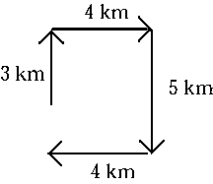
The magnitude of the resultant displacement is
 | a. | 2 km.
 | b. | 16 km.
 | c. | –16 km.
 | d. | –2 km.
 | e. | 0 km.

ANSWER: | a

5. Four successive displacements of 4 km, 5 km, 4 km, and 2 km are at right angles to each other as shown in the diagram.
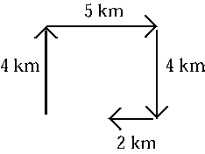
The magnitude of the resultant displacement is
 | a. | 4 km.
 | b. | 15 km.
 | c. | 3 km.
 | d. | –5 km.
 | e. | –15 km.

ANSWER: | c

6. A particle moves from x₀ = 30 cm to x = –40 cm in 5 s. The average velocity of the particle during this time interval is
 | a. | 2 cm/s.
 | b. | –2 cm/s.
 | c. | 14 cm/s.
 | d. | –14 cm/s.
 | e. | 300 cm/s.

ANSWER: | d

7. You drive for 30 min at 100 km/h and then stop for 15 min. You then drive for 45 min at 80 km/h. Your average speed for the entire trip is
 | a. | 73 km/h.
 | b. | 83 km/h.
 | c. | 88 km/h.
 | d. | 90 km/h.
 | e. | 97 km/h.

ANSWER: | a

8. You drive for 30 min for 30 km east and then another 30 min for 40 km north. Your average speed for the entire trip is
 | a. | 40 km/h.
 | b. | 50 km/h.
 | c. | 60 km/h.
 | d. | 70 km/h.
 | e. | 80 km/h.

ANSWER: | d

9. You drive for 30 min for 30 km east and then another 30 min for 40 km north. The magnitude of your average velocity for the entire trip is
 | a. | 40 km/h.
 | b. | 50 km/h.
 | c. | 60 km/h.
 | d. | 70 km/h.
 | e. | 80 km/h.

ANSWER: | b

10. The displacement of an object for a round trip between two locations
 | a. | is always greater than zero.
 | b. | is always less than zero.
 | c. | is zero.
 | d. | can be greater than or less than but not equal to zero.
 | e. | can have any value.

ANSWER: | c

11. The displacement of an object during any time interval is ________ the distance it travels during that same time interval.
 | a. | great than or equal to
 | b. | less than or equal to
 | c. | equal to
 | d. | greater than
 | e. | much greater than

ANSWER: | b

12. An object, located at the origin when t = 0, moves along the x axis as shown in the diagram.
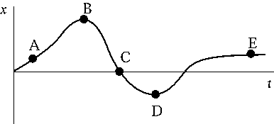
At which point is the object farthest from its starting point?
 | a. | A
 | b. | B
 | c. | C
 | d. | D
 | e. | E

ANSWER: | b

13. The graph shows how the position of a particle depends on time.
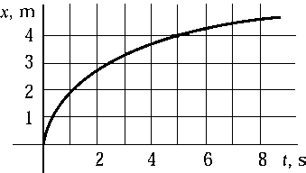
Which choice is closest to the average speed of the particle in the time interval between 0 and 6 s?
 | a. | 0.40 m/s
 | b. | 0.67 m/s
 | c. | 0.75 m/s
 | d. | 1.50 m/s
 | e. | 2.22 m/s

ANSWER: | b

14. Which graph of v versus t best describes the motion of a particle whose velocity is constant and negative?
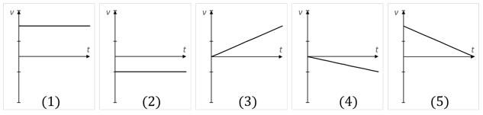
 | a. | 1
 | b. | 2
 | c. | 3
 | d. | 4
 | e. | 5

ANSWER: | b

15. In which graph of v versus t does the particle end up closest to its starting point?
 | a. | 1
 | b. | 2
 | c. | 3
 | d. | 4
 | e. | 5

ANSWER: | d

16. In which graph of v versus t does the particle end up farthest from its starting point?
 | a. | 1
 | b. | 2
 | c. | 3
 | d. | 4
 | e. | 5

ANSWER: | a

17. If the speed of particle A is twice that of particle B, the distance particle B travels in a given interval of time as compared with particle A is
 | a. | twice as great.
 | b. | half as great.
 | c. | the same.
 | d. | four times as great.
 | e. | one-fourth as great.

ANSWER: | b

18. The motion diagram plots the motion of an ant moving to the right along a straight line as it is recorded every 1.0 s, starting at point at x = 0.0 cm. Assuming the ant starts from rest, which graph shows ant's position as a function of time?
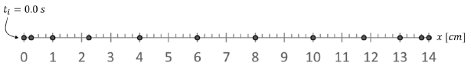
​
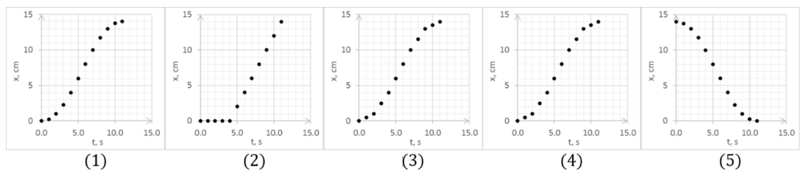
 | a. | (1)
 | b. | (2)
 | c. | (3)
 | d. | (4)
 | e. | (5)

ANSWER: | a

19. The motion diagram plots the motion of an ant moving to the right along a straight line as it is recorded every 1.0 s, starting at point at x = 0.0 cm. Assuming the ant starts from rest, which graph shows ant's velocity as a function of time?
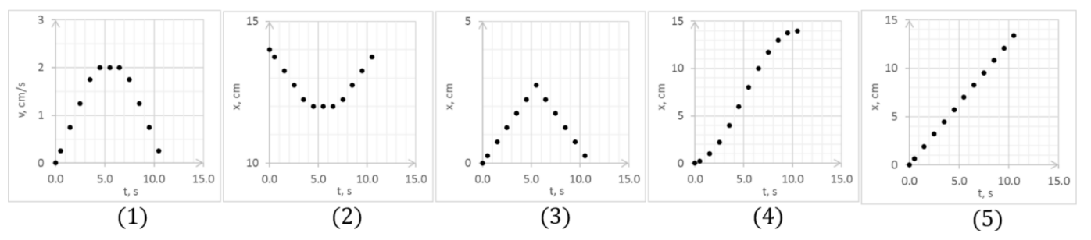
 | a. | (1)
 | b. | (2)
 | c. | (3)
 | d. | (4)
 | e. | (5)

ANSWER: | a

20. The graph represents the position of a particle as a function of time.
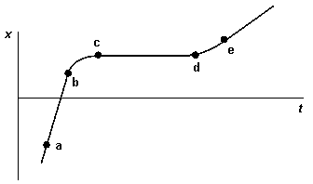
The interval in which the velocity of this particle is zero is
 | a. | a–b
 | b. | b–c
 | c. | d–e
 | d. | c–d

ANSWER: | d

21. The graph represents the position of a particle along the x axis as a function of time.
Which point has the highest instantaneous velocity?
 | a. | a
 | b. | b
 | c. | c
 | d. | d
 | e. | e

ANSWER: | a

22. The graph represents the position of a particle along the x axis as a function of time.
Which interval has the highest magnitude of acceleration?
 | a. | a-b
 | b. | b-c
 | c. | c-d
 | d. | d-e
 | e. | They have equal acceleration

ANSWER: | b

23. In which graph is the particle the farthest from its starting point at time t₀?
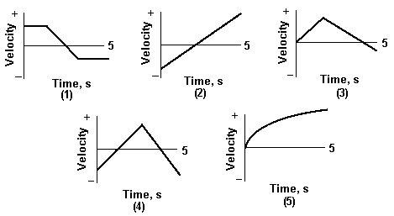
 | a. | (1)
 | b. | (2)
 | c. | (3)
 | d. | (4)
 | e. | (5)

ANSWER: | e

24. In which graph is the particle the closest to the origin at t = 5 s?
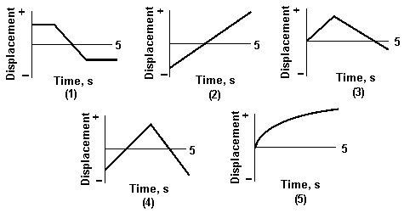
 | a. | (1)
 | b. | (2)
 | c. | (3)
 | d. | (4)
 | e. | (5)

ANSWER: | c

25. An object moves along the x axis as shown in the diagram.
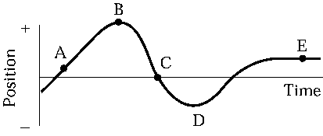
At which point or points is the magnitude of its velocity the smallest?
 | a. | A and E
 | b. | B, D, and E
 | c. | C only
 | d. | E only
 | e. | None of these are correct.

ANSWER: | b

26. An object moves along the x-axis as shown in the diagram.
At which point or points is the object's instantaneous velocity zero?
 | a. | A and E
 | b. | B, D, and E
 | c. | C only
 | d. | E only
 | e. | None of these are correct.

ANSWER: | b

27. Which graph of v versus t best describes the motion of a particle with positive velocity and negative acceleration?
 | a. | (1)
 | b. | (2)
 | c. | (3)
 | d. | (4)
 | e. | (5)

ANSWER: | e

28. Which graph of v versus t best describes the motion of a particle with negative velocity and negative acceleration?
 | a. | (1)
 | b. | (2)
 | c. | (3)
 | d. | (4)
 | e. | (5)

ANSWER: | d

29. Which of the v versus t graphs shows a motion of a particle with the highest acceleration?
 | a. | (1)
 | b. | (2)
 | c. | (3)
 | d. | (4)
 | e. | (5)

ANSWER: | c

30. Which of the graphs shows motion of a particle that has zero acceleration at t = 5 s?
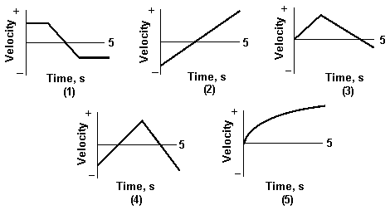
 | a. | (1)
 | b. | (2)
 | c. | (3)
 | d. | (4)
 | e. | (5)

ANSWER: | a

31. Which of the graphs shows motion of a particle with constant acceleration for the entire 5 s?
 | a. | (1)
 | b. | (2)
 | c. | (3)
 | d. | (4)
 | e. | (5)

ANSWER: | b

32. Which of the graphs shows motion of a particle that never has a constant acceleration?
 | a. | (1)
 | b. | (2)
 | c. | (3)
 | d. | (4)
 | e. | (5)

ANSWER: | e

33. An object is at x = –3 m and has a velocity of 4 m/s. It is observed to be slowing down. Its acceleration is
 | a. | positive.
 | b. | negative.
 | c. | zero.
 | d. | negative until the object stops and then positive.

ANSWER: | b

34. An object is at x = –3 m and has a velocity of – 4 m/s. It is observed to be slowing down. Its acceleration is
 | a. | positive.
 | b. | negative.
 | c. | zero.
 | d. | negative until the object stops and then positive.

ANSWER: | a

35. Imagine a velocity versus time graph showing the motion of an object. The graph is a straight line. Which of these quantities CANNOT be determined from this graph?
 | a. | The displacement from time t = 0.
 | b. | The initial velocity at t = 0.
 | c. | The acceleration of the object.
 | d. | The average velocity of the object.
 | e. | The initial position of the object.

ANSWER: | e

36. The graph is a plot of velocity versus time for a moving object during a particular time interval.
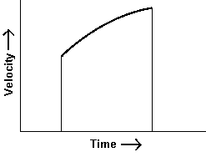
Which of the following statements is correct?
 | a. | The acceleration of the object is zero.
 | b. | The acceleration of the object is constant.
 | c. | The acceleration of the object is positive and increasing in magnitude.
 | d. | The acceleration of the object is negative and decreasing in magnitude.
 | e. | The acceleration of the object is positive and decreasing in magnitude.

ANSWER: | e

37. Two of the graphs shown are INCORRECT for a particle undergoing one-dimensional motion with constant acceleration.
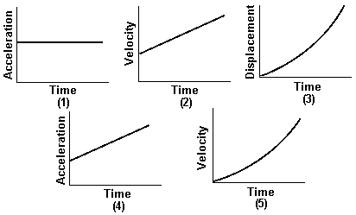
They are
 | a. | (1) and (2).
 | b. | (2) and (3).
 | c. | (3) and (4).
 | d. | (4) and (5).
 | e. | (10 and (5).

ANSWER: | d

38. Figure below shows velocity as a function of time for a particle.
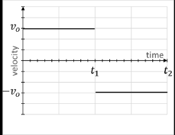
Based on the information in the graph, fill in the table using "positive", "negative" or "zero".
TOTAL DISTANCE | TOTAL DISPLACEMENT | AVERAGE SPEED | AVERAGE VELOCITY | AVERAGE ACCELERATION
​ | ​ | ​ | ​ | ​
​
​
ANSWER: | positive, zero, positive, zero, negative.

39. A car accelerates uniformly from rest to a speed of 20 m/s at the end of 1 min; it then accelerates uniformly to a speed of 40 m/s at the end of the next minute. During this 2-min period, the average speed of the car is
 | a. | 7.5 m/s.
 | b. | 30 m/s.
 | c. | 15 m/s.
 | d. | 20 m/s.
 | e. | 40 m/s.

ANSWER: | d

40. An object is moving in a straight line. At t = 0, its speed is 5.0 m/s. From t = 0 to t = 4.0 s, its acceleration is 2.5 m/s². From t = 4.0 s to t = 11.0 s, its speed is constant. The average speed over the entire time interval is
 | a. | 9.5 m/s.
 | b. | 15 m/s.
 | c. | 13 m/s.
 | d. | 21 m/s.
 | e. | 8.2 m/s.

ANSWER: | c

41. A particle that is moving along a straight line accelerates uniformly from 40 cm/s to 20 cm/s in 5.0 s and then has a constant acceleration of 20 cm/s² during the next 4.0 s. The average speed over the whole time interval is
 | a. | 57 cm/s.
 | b. | 140 cm/s.
 | c. | 86 cm/s.
 | d. | 43 cm/s.
 | e. | 97 cm/s.

ANSWER: | d

42. A particle accelerates uniformly from a speed of 30 cm/s to 40 cm/s in 5 s and thereafter moves at a constant speed of 40 cm/s for an additional 3 s. The average speed over this total time interval is
 | a. | 35 cm/s.
 | b. | 27 cm/s.
 | c. | 0.45 cm/s.
 | d. | 37 cm/s.
 | e. | 73 cm/s.

ANSWER: | d

43. For uniformly accelerated motion, which of the following quantities must be zero?
 | a. | the initial velocity
 | b. | the initial displacement
 | c. | the rate of change of the acceleration
 | d. | the rate of change of the velocity
 | e. | the rate of change of the displacement

ANSWER: | c

44. A particle accelerates uniformly from a speed of 30 cm/s to rest in a time interval of 5.0 s. It then has a uniform acceleration of 10 cm/s² for another 5.0 s. The particle moves in the same direction along a straight line. The average speed over the whole time interval is
 | a. | 20 cm/s.
 | b. | 35 cm/s.
 | c. | 38 cm/s.
 | d. | 100 cm/s.
 | e. | 12 cm/s.

ANSWER: | a

45. A Triumph sports car starts at rest and accelerates uniformly to a speed of 27.0 m/s in 11.8 s. Calculate the distance the car travels during this time interval.
 | a. | 159 m
 | b. | 320 m
 | c. | 1.90 km
 | d. | 640 m
 | e. | 350 m

ANSWER: | a

46. The distance traveled by a car in the x-direction is shown. When the car changes speed for t = 10 s to 15 s, it does so uniformly.
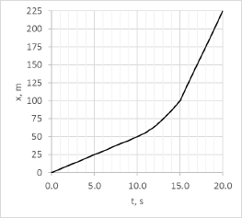
The acceleration of the car between 10 s and 15 s is
 | a. | 1 m/s².
 | b. | 2 m/s².
 | c. | 3 m/s².
 | d. | 4 m/s².
 | e. | 5 m/s².

ANSWER: | d

47. The distance traveled by a car in the x-direction is shown. When the car changes speed for t = 10 s to 15 s, it does so uniformly.
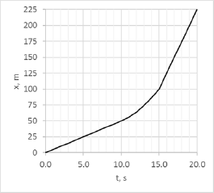
The acceleration of the car at 5 s ____ acceleration at 20 s.
 | a. | is less than the
 | b. | is equal to the
 | c. | is greater than the
 | d. | cannot be determined for
 | e. | depends on what happens when it is accelerating between 10 and 15 s

ANSWER: | b

48. On a graph that shows position on the vertical axis and time on the horizontal axis, a parabolic curve that opens upward represents
 | a. | a motion with constant positive acceleration.
 | b. | a motion with constant negative acceleration.
 | c. | a motion with no acceleration.
 | d. | a motion with positive acceleration followed by a motion with negative acceleration.
 | e. | a motion with negative acceleration followed by a motion with positive acceleration.

ANSWER: | a

49. On a graph that shows position on the vertical axis and time on the horizontal axis, a parabolic curve that opens downward represents
 | a. | a motion with constant positive acceleration.
 | b. | a motion with constant negative acceleration.
 | c. | a motion with no acceleration.
 | d. | a motion with a positive acceleration followed by a motion with negative acceleration.
 | e. | a motion with negative acceleration followed by a motion with positive acceleration.

ANSWER: | b

50. A vehicle is traveling in the x-direction to x = 100 m. It then reverses direction. At the instant when it changes direction, the acceleration of the vehicle is
 | a. | positive.
 | b. | negative.
 | c. | zero.
 | d. | positive then negative.
 | e. | negative then positive.

ANSWER: | b

51. A vehicle is traveling in the x-direction to x = 100 m. It then reverses direction. At the instant when it changes direction, the velocity of the vehicle is
 | a. | positive.
 | b. | negative.
 | c. | zero.
 | d. | positive then negative.
 | e. | negative then positive.

ANSWER: | c

52. A vehicle is traveling in the –x-direction to x = 100 m. It then reverses direction. At the instant when it changes direction, the acceleration of the vehicle is
 | a. | positive.
 | b. | negative.
 | c. | zero.
 | d. | positive then negative.
 | e. | negative then positive.

ANSWER: | a

53. A vehicle is traveling in the –x-direction to x = 100 m. It then reverses direction. At the instant when it changes direction, the velocity n of the vehicle is
 | a. | positive.
 | b. | negative.
 | c. | zero.
 | d. | positive then negative.
 | e. | negative then positive.

ANSWER: | c

54. On a graph that shows velocity on the vertical axis and time on the horizontal axis, zero acceleration is represented by
 | a. | a straight line with a positive slope.
 | b. | a straight line with a negative slope.
 | c. | a straight line with zero slope.
 | d. | either a positive, negative, or zero slope.
 | e. | a curved line.

ANSWER: | c

55. On a graph that shows velocity on the vertical axis and time on the horizontal axis, constant acceleration is represented by
 | a. | a straight line with a positive slope.
 | b. | a straight line with a negative slope.
 | c. | a straight line with zero slope.
 | d. | either a positive, negative, or zero slope.

ANSWER: | a

56. On a graph that shows velocity on the vertical axis and time on the horizontal axis, the area under the curve represents
 | a. | average acceleration.
 | b. | average velocity.
 | c. | displacement.
 | d. | average speed.

ANSWER: | c

57. On a graph that shows acceleration on the vertical axis and time on the horizontal axis, the area under the curve represents
 | a. | average acceleration.
 | b. | average velocity.
 | c. | change in velocity.
 | d. | displacement.
 | e. | total distance.

ANSWER: | c

58. A car and a truck, starting from rest, have the same acceleration, but the truck accelerates for twice the length of time. Compared with the car, the truck will travel
 | a. | twice as far.
 | b. | three times as far.
 | c. | 1.4 times as far.
 | d. | four times as far.
 | e. | one-half as far.

ANSWER: | d

59. An object moves along the horizontal axis as shown on the diagram.
At which point or points is its acceleration zero?
 | a. | A and E
 | b. | B, D, and E
 | c. | C only
 | d. | E only
 | e. | B and D

ANSWER: | a

60. A Lamborghini sports car can accelerate from zero to 60 mph in 4 seconds. It can also accelerate from 60 mph to rest in 36.6 m. What is the ratio of the magnitudes of average positive acceleration over average negative acceleration?
 | a. | 1.74 × 10^{–5}
 | b. | 1.47
 | c. | 0.682
 | d. | 0.0114
 | e. | 0.688

ANSWER: | c

61. Assume the speed of light = 3.0 × 10⁸ m/s. If we assume that a spaceship could accelerate from rest at a constant rate of 9.81 m/s², then how long would it take to reach 1% of the speed of light?
 | a. | 1.8 days
 | b. | 3.5 days
 | c. | 8.6 h
 | d. | 1.5 days
 | e. | 7.1 days

ANSWER: | b

62. If we assume that a spaceship could accelerate from rest up to 1% of the speed of light at a constant rate of 9.81 m/s², how many times would the spaceship travel the distance of 149.6 × 10⁶km between Earth and the sun?
 | a. | 3000 times
 | b. | 3 times
 | c. | 3 million times
 | d. | 30 times
 | e. | 300 times

ANSWER: | b

63. A common statistic in car tests is the standing (starting from rest) quarter-mile performance. A modern sports car can achieve a terminal speed (speed at the end of the quarter-mile) of 120 mph (193 km/h). How does the average acceleration compare to g?
 | a. | 0.36 g
 | b. | 2.8 g
 | c. | 0.067 g
 | d. | 3.57 g
 | e. | 0.73 g

ANSWER: | a

64. A racecar starts from rest and accelerates at a constant rate and reaches a speed of 160 km/h (100 mph) in 6.0 seconds. It continues at this speed for another 5 seconds. What is the car's average speed during the first 11 seconds?
 | a. | 34.3 m/s
 | b. | 29.3 m/s
 | c. | 22.2 m/s
 | d. | 32.3 m/s
 | e. | 44.4 m/s

ANSWER: | d

65. A car is traveling at 120 km/h (75 mph). When applied the braking system can stop the car at a rate of 9.0 m/s². The typical reaction time for an alert driver is 0.5 s versus 2 s for a sleepy driver. Assuming a typical car length of 5 m, calculate the number of additional car lengths it takes the sleepy driver to stop compared to the alert driver.
 | a. | 13
 | b. | 3.0
 | c. | 10
 | d. | 16
 | e. | 26

ANSWER: | c

66. A car accelerates uniformly from a velocity of 10 km/h to 30 km/h in one minute.
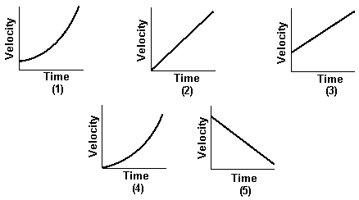
Which graph best describes the motion of the car?
 | a. | (1)
 | b. | (2)
 | c. | (3)
 | d. | (4)
 | e. | (5)

ANSWER: | c

67. A distracted driver going along a parkway at constant speed of 14 m/s passes a police car parked at the sidelines. If the police car takes 4.0 s to take off and chases the distracted driver accelerating at a rate of 2.0 m/s², how long until it catches with the distracted driver's car?
 | a. | 28 s
 | b. | 21 s
 | c. | 7.0 s
 | d. | 110 s
 | e. | 56 s

ANSWER: | b

68. The graph below shows position as a function of time for a swimmer competing in a 100-m race (swimming twice the length of a 50.0 m pool). Which of the following statements regarding the motion is incorrect?
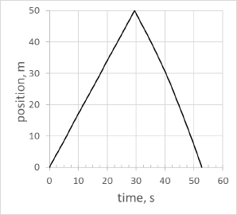
 | a. | The average speed of the swimmer is 1.90 m/s.
 | b. | The average velocity of the swimmer is 1.90 m/s.
 | c. | The average velocity of the swimmer is 0.0 m/s.
 | d. | When swimming the second part of the 100-m race, the swimmer is moving with negative velocity.
 | e. | Swimmer's average acceleration during the second part of the 100-m race is negative.

ANSWER: | b

69. An object is dropped from rest near the surface of Earth. If the time interval during which it falls is cut in half, the distance it falls will
 | a. | double.
 | b. | decrease by one-half.
 | c. | increase by a factor of four.
 | d. | decrease by a factor of four.
 | e. | not change.

ANSWER: | d

70. An object is dropped from rest near the surface of Earth. If the time interval during which it falls is doubled, the distance it falls will
 | a. | double.
 | b. | decrease by one-half.
 | c. | increase by a factor of four.
 | d. | decrease by a factor of four.
 | e. | not change.

ANSWER: | c

71. A projectile is fired vertically upward with a speed of 62 m/s. In the absence of air resistance, the maximum height the projectile attains is
 | a. | 25 km.
 | b. | 98 m.
 | c. | 200 m.
 | d. | 19 km.
 | e. | 3.0 m.

ANSWER: | c

72. A ball is dropped from the top of a building. In the absence of air resistance, the ball will hit the ground with a speed of 49 m/s. The height of the building is
 | a. | 25 m.
 | b. | 5.0 m.
 | c. | 240 m.
 | d. | 120 m.
 | e. | 10 m.

ANSWER: | d

73. An object falling near the surface of Earth has a constant acceleration of 9.8 m/s². This means that the
 | a. | object falls 9.8 m during the first second of its motion.
 | b. | object falls 9.8 m during each second of its motion.
 | c. | speed of the object increases by 9.8 m/s during each second of its motion.
 | d. | acceleration of the object increases by 9.8 m/s² during each second of its motion.

ANSWER: | c

74. A ball is thrown upward from an 80-ft tower with an initial vertical speed of 40 ft/s. If air resistance is ignored, the ball's speed when it reaches the ground will be
 | a. | 67 ft/s.
 | b. | 130 ft/s.
 | c. | 120 ft/s.
 | d. | 49 ft/s.
 | e. | 82 ft/s.

ANSWER: | e

75. A balloon is ascending at a rate of 16 ft/s to a height of 32 ft above the ground when a package is dropped. The time taken, in the absence of air resistance, for the package to reach the ground is
 | a. | 1.0 s.
 | b. | 1.5 s.
 | c. | 2.0 s.
 | d. | 2.5 s.
 | e. | 3.0 s.

ANSWER: | c

76. A balloon is ascending at a rate of 4.00 m/s to a height of 11.0 m above the ground when a package is dropped. The time taken, in absence of air resistance, for the package to reach the ground is
 | a. | 1.96 s.
 | b. | 1.14 s.
 | c. | 2.75 s.
 | d. | 1.50 s.
 | e. | 0.364 s.

ANSWER: | a

77. A balloon is ascending at a rate of 4.00 m/s to a height of 11.0 m above the ground when a package is dropped. In the absence of air resistance, the velocity of the ball when it hits the ground is
 | a. | 15.2 m/s,
 | b. | –15.2 m/s.
 | c. | 14.7 m/s.
 | d. | –14.7 m/s.
 | e. | 0 m/s.

ANSWER: | b

78. An object is thrown upward with a velocity of 32 ft/s from a stationary balloon that is 48 ft above the ground. If air resistance is ignored, the total time until the object impacts the ground is
 | a. | 1.0 s.
 | b. | 2.0 s.
 | c. | 3.0 s.
 | d. | 4.0 s.
 | e. | 6.0 s.

ANSWER: | c

79. An object is thrown upward with a velocity of 9.8 m/s from a stationary balloon that is 14.6 m above the ground. If air resistance is ignored, the total time until the object impacts the ground is
 | a. | 1.0 s.
 | b. | 2.0 s.
 | c. | 3.0 s.
 | d. | 4.0 s.
 | e. | 6.0 s.

ANSWER: | c

80. A particle initially at rest undergoes linear motion with an acceleration that is constant in magnitude and direction. The velocity of the particle
 | a. | is constant in magnitude and direction.
 | b. | is constant in direction only.
 | c. | is constant in magnitude only.
 | d. | can change in magnitude and direction.

ANSWER: | b

81. Which of the following statements is correct?
 | a. | Average velocity is not a vector quantity.
 | b. | The average velocity can always be expressed as a half of the sum of initial and final velocities.
 | c. | An accelerating body always changes its direction of motion.
 | d. | The instantaneous velocity is equal to the time rate of change of the displacement.
 | e. | A body undergoing constant acceleration changes its velocity by increasing increments in succeeding equal time intervals.

ANSWER: | d

82. A ball has been thrown vertically upward. The graph shows the ball's position as a function of time.
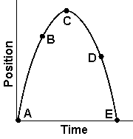
Which one of the following statements best describes the motion of the ball?
 | a. | The velocity of the ball is the same at points A, B, C, D, and E.
 | b. | The acceleration of the ball is 9.8 m/s² at points A, B, D, and E and zero at point C.
 | c. | The acceleration of the ball is –9.8 m/s² at points A, B, D, and E and zero at point C.
 | d. | The ball is the same distance above the ground at points B and D.
 | e. | The velocity of the ball changes continuously at the same rate during its flight.

ANSWER: | e

83. A hammer and feather are dropped from the same height above the lunar surface. Which object hits the ground first?
 | a. | the hammer
 | b. | neither, because they both float in space
 | c. | the feather
 | d. | both at the same time

ANSWER: | d

84. A baseball is thrown vertically up to a height of 30 m on Earth. Assume the acceleration due to gravity on the moon is one-sixth the acceleration of gravity on Earth. If the same ball is thrown up on the moon with the same initial speed, how much further will it travel up?
 | a. | 5.0 m
 | b. | 25 m
 | c. | 12 m
 | d. | 180 m
 | e. | 150 m

ANSWER: | e

85. Two baseballs are thrown vertically up from the ground at the same speed, one on Earth, and one on Mars. The baseball on Earth reaches a maximum height of 25 m. Assume the acceleration due to gravity on Mars is 0.38 times the acceleration due to gravity on Earth. Which ball hits the ground first and by what time difference?
 | a. | Mars by 7.4 s
 | b. | Earth by 7.4 s
 | c. | Earth by 3.7 s
 | d. | Mars by 3.7 s
 | e. | Earth by 2.7 s

ANSWER: | b

86. A sandbag is released from a rising air balloon and hits the ground 7.00 seconds later. From what height was the sandbag dropped from if at the moment of release the balloon was traveling upward at 3.00 m/s?
 | a. | 219 m
 | b. | 240 m
 | c. | 459 m
 | d. | 261 m
 | e. | 55 m

ANSWER: | a

