Indicate the answer choice that best completes the statement or answers the question.

1. Suppose that and . Find the following limit.
​
​
 | a.
 | b.
 | c.
 | d.
 | e. | does not exist

2. A sphere has a volume of 4.12 cubic inches. What is the radius of the sphere? Round your answer to four decimal places.
​
 | a. | 0.9945 inch
 | b. | 1.5787 inches
 | c. | 0.9918 inch
 | d. | 1.9835 inches
 | e. | 1.7988 inches

3. Find the x-values (if any) at which the function is not continuous. Which of the discontinuities are removable?
​
 | a. | 10 and -10, removable
 | b. | discontinuous everywhere 0 00
 | c. | continuous everywhere 0 00
 | d. | 10 and -10, not removable
 | e. | 0, removable

4. Find the constant a and b such that the function
​
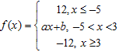
​
is continuous on the entire real line.
​
 | a. | a = 3, b = 0
 | b. | a = 3, b = –3
 | c. | a = –3, b = –3
 | d. | a = –3, b = 3
 | e. | a = 3, b = 3

5. Find the following limit (if it exists). Write a simpler function that agrees with the given function at all but one point.
​
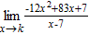 7
​
 | a.
 | b.
 | c.
 | d.
 | e. | does not exist

6. Find the limit (if it exists).
​
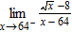
​
 | a. | 0
 | b.
 | c.
 | d.
 | e. | Limit does not exist.

7. Find the limit.
​
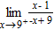
​
 | a. | 1
 | b.
 | c. | 0
 | d.
 | e. | -1

8. Consider the function and the point on the graph of f. Graph f and the secant line passing through and for .
​
 | a. |  | b.
 | c. |  | d.
 | e.

9. Consider the function and the point on the graph of f. Find the slope of the secant line passing through and for . Round your answer to four decimal places.
​
 | a. | m = 0.0932
 | b. | m = 0.0121
 | c. | m = 0.0119
 | d. | m = 0.3065
 | e. | m = 0.0833

10. Suppose that . Find the following limit.
​
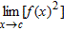
​
 | a. | –1
 | b. | 1
 | c. | 3
 | d. | 0
 | e. | 2

11. Use the graph to find the limit.
​
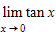
​
 | a. |  | b.
 | c. |  | d.
 | e. | The limit does not exist.

12. Use a graphing utility to graph the function and determine the following one-sided limit.
​
​
 | a.
 | b. | 6
 | c. | –6
 | d.
 | e. | 0

13. A long distance phone service charges $0.35 for the first 8 minutes and $0.05 for each additional minute or fraction thereof. Use the greatest integer function to write the cost C of a call in terms of time t (in minutes).
​
a.
b.
c.
d.
e.

14. Suppose that . Find the following limit.
​
​
 | a. | –5
 | b. | –55
 | c. | 55
 | d. | –11c
 | e. | –11

15. A ring has a inner circumference of 9 centimeters. If the ring's inner circumference can vary between 8.5 centimeters and 9.5 centimeters how can the radius vary? Round your answer to five decimal places.
​
 | a. | Radius can vary between 7.32046 centimeters and 9.14424 centimeters.
 | b. | Radius can vary between 1.64488 centimeters and 1.73895 centimeters.
 | c. | Radius can vary between 1.35282 centimeters and 1.51197 centimeters.
 | d. | Radius can vary between 2.70563 centimeters and 3.02394 centimeters.
 | e. | Radius can vary between 0.93239 centimeter and 1.93239 centimeters.

16. Find 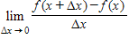 where .
​
 | a. | 1
 | b. | 4
 | c. | –5
 | d. | 1
 | e. | Limit does not exist.

17. Let 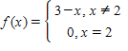
​
Determine the following limit. (Hint: Use the graph to calculate the limit.)
​
​
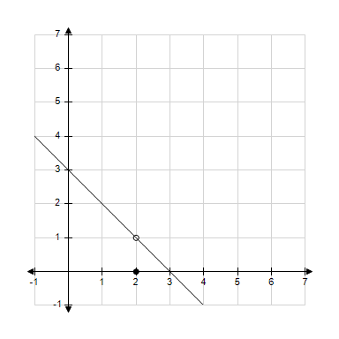
 | a. | 5
 | b. | 3
 | c. | 1
 | d. | 0
 | e. | does not exist

18. Complete the table and use the result to estimate the limit.
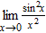
 | –0.1 | –0.01 | –0.001 | 0.001 | 0.01 | 0.1
​
 | a.
 | b. | 0
 | c. | 1
 | d. | 0.5
 | e.

19. A 25-foot ladder is leaning against a house (see figure). If the base of the ladder is pulled away from the house at a rate of 2 feet per second, the top will move down the wall at a rate of 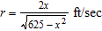 where x is the distance between the base of the ladder and the house. Find the limit of r as .
​
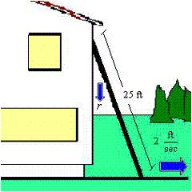
​
 | a.
 | b. | 50
 | c. | 0
 | d.
 | e. | 25

20. Determine the limit (if it exists).
​
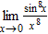
​
 | a. | 0
 | b. | 1
 | c. | 2
 | d. | ∞
 | e. | does not exist

21. Find the vertical asymptotes (if any) of the function .
​
 | a.
 | b.
 | c.
 | d.
 | e. | no vertical asymptotes

22. Find all the vertical asymptotes (if any) of the graph of the function 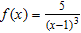.
​
 | a. | x = -1
 | b. | x = 5
 | c. | x = 1, -1
 | d. | x = 1
 | e. | no vertical asymptotes

23. Let 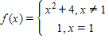
​
Determine the following limit. (Hint: Use the graph to calculate the limit.)
​
​
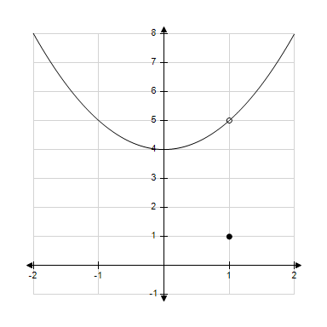
 | a. | 5
 | b. | 16
 | c. | 1
 | d. | 4
 | e. | does not exist.

24. A 30-foot ladder is leaning against a house (see figure). If the base of the ladder is pulled away from the house at a rate of 2 feet per second, the top will move down the wall at a rate of 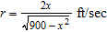, where x is the distance between the base of the ladder and the house. Find the rate r when x is 18 feet.
​
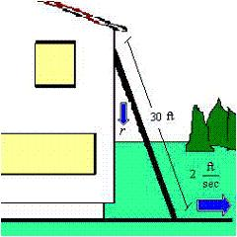
​
 | a. | r = ft/sec
 | b. | r = ft/sec
 | c. | ft/sec
 | d. | r = ft/sec
 | e. | r = ft/sec

25. Decide whether the following problem can be solved using precalculus, or whether calculus is required. If the problem can be solved using precalculus, solve it. If the problem seems to require calculus, use a graphical or numerical approach to estimate the solution.
​
A cyclist is riding on a path whose elevation is modeled by the function wherexand are measured in miles. Find the rate of change of elevation when x= 3.
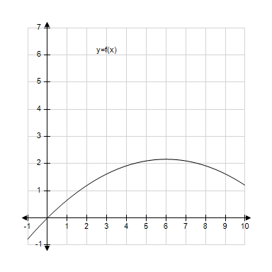
 | a. | precalculus, 0.06
 | b. | calculus, 0.18
 | c. | calculus, 0.36
 | d. | calculus, 0.06
 | e. | precalculus, 0.18

26. Find the following limit if it exists: . Use when appropriate.
​
 | a.
 | b. | –4
 | c. | 1
 | d.
 | e. | does not exist

27. Find the limit.
​
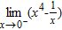
​
 | a. | 1
 | b. | 0
 | c. | -1
 | d.
 | e.

28. Determine whether 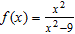 approaches or as xapproaches -3 from the left and from the right by completing the tables below.
x | –3.5 | –3.1 | –3.01 | –3.001
f(x)
​
x | –2.999 | –2.99 | –2.9 | –2.5
f(x)
​
 | a. | ,
 | b. | ,
 | c. | ,
 | d. | ,

29. Determine the limit (if it exists).
​
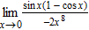
​
 | a. | 8
 | b. | 1
 | c. | 0
 | d. | –2
 | e. | does not exist

30. Find the x-values (if any) at which the function is not continuous. Which of the discontinuities are removable?
​
 | a. | no points of discontinuity
 | b. | x = –9 (not removable), x = –5 (removable)
 | c. | x = –9 (removable), x = –5 (not removable)
 | d. | no points of continuity
 | e. | x = –9 (not removable), x = –5 (not removable)

31. Complete the table and use the result to estimate the limit.
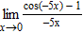
x | –0.1 | –0.01 | –0.001 | 0.001 | 0.01 | 0.1

a.
b.
c.
d.
e.

32. Determine the following limit. (Hint: Use the graph to calculate the limit.)
​
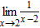
​
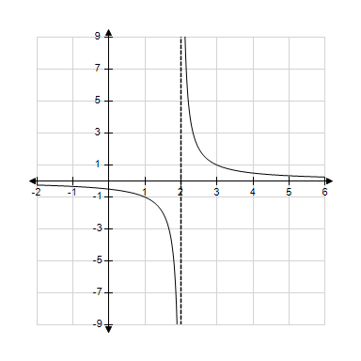
 | a. | –2
 | b. | 0
 | c. | –4
 | d. | 2
 | e. | does not exist

33. A petrol car is parked 65 feet from a long warehouse (see figure). The revolving light on top of the car turns at a rate of revolution per second. The rate at which the light beam moves along the wall is ft/sec. Find the limit of r as .
​
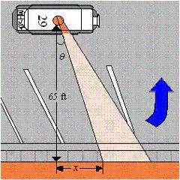
​
 | a.
 | b.
 | c. | 0
 | d. | 65
 | e.

34. Find the limit (if it exists). Note that represents the greatest integer function.
​
​
 | a. | –109
 | b. | 119
 | c. | –119
 | d. | 109
 | e. | does not exist

35. A petrol car is parked 35 feet from a long warehouse (see figure). The revolving light on top of the car turns at a rate of revolution per second. The rate at which the light beam moves along the wall is ft/sec. Find the rate r when is .
​
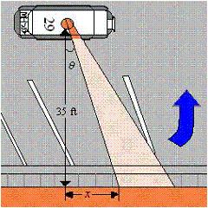
​
 | a. | ft/sec
 | b. | ft/sec
 | c. | ft/sec
 | d. | ft/sec
 | e. | ft/sec

36. Find the limit.
​
​
a.
b.
c.
d.
e.

37. Find the limit (if it exists).
​
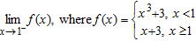
​
 | a. | Limit does not exist.
 | b. | 0
 | c. | 3
 | d. | 4
 | e. | 9

38. Find the value of c guaranteed by the Intermediate Value Theorem.
​
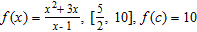
​
 | a. | 7
 | b. | 2
 | c. | 1
 | d. | 5
 | e. | 6

39. Find the x-values (if any) at which is not continuous.
​
 | a. | f(x) is not continuous at x = 0 and f(x) has a removable discontinuity at x = 0.
 | b. | f(x) is not continuous at x = 0, –2 and both the discontinuities are nonremovable.
 | c. | f(x) is not continuous at x = –2 and f(x) has a removable discontinuity at x = –2.
 | d. | f(x) is not continuous at x = 0, –2 and f(x) has a removable discontinuity at x = 0.
 | e. | f(x) is continuous for all real x.

40. Suppose that and . Find the following limit.
​
​
 | a. | 0
 | b. | –4
 | c. | –9
 | d. | –17
 | e. | 52

41. Complete the table and use the result to estimate the limit.
​
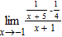
​
​
a.
b.
c.
d.
e.

42. Let and . Find the limit.
​
​
a.
b.
c.
d.
e.

43. Decide whether the following problem can be solved using precalculus, or whether calculus is required. If the problem can be solved using precalculus, solve it. If the problem seems to require calculus, use a graphical or numerical approach to estimate the solution.
​
Find the area of the shaded region bounded by the triangle with vertices (0,0), (7,8), (15,0).
​
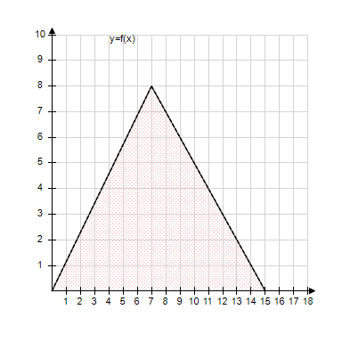
​
 | a. | precalculus , 120
 | b. | calculus , 180
 | c. | precalculus , 60
 | d. | precalculus , 180
 | e. | calculus , 120

44. Find the lmit.
​
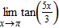
​
 | a.
 | b.
 | c.
 | d.
 | e. | does not exist

45. Use the rectangles in the following graph to approximate the area of the region bounded by .
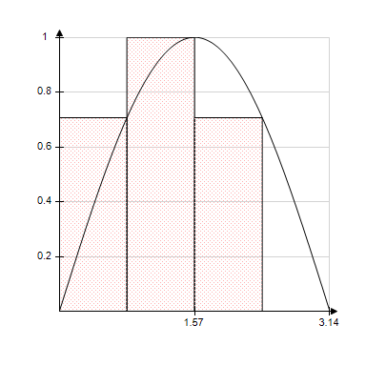
​
 | a. | 0.9481
 | b. | 1.8961
 | c. | 3.7922
 | d. | 1.4221
 | e. | 1.2704

46. Use a graphing utility to graph the function 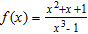 and determine the one-sided limit .
​
 | a.
 | b.
 | c. | 0
 | d. | 3
 | e. | 2

47. Use the graph as shown to determine the following limits, and discuss the continuity of the function at x= -4.
​
(i) (ii) (iii)
​
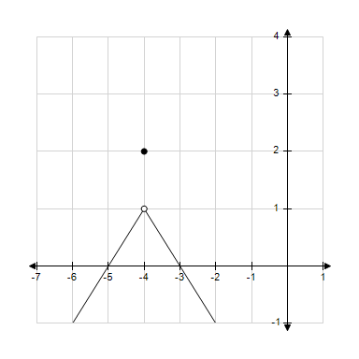
 | a. | 2, 2, 2, continuous
 | b. | 1, 1, 1, not continuous
 | c. | 2, 2, 2, not continuous
 | d. | -4, -4, -4, continuous
 | e. | 1, 1, 1, continuous

48. Decide whether the following problem can be solved using precalculus, or whether calculus is required. If the problem can be solved using precalculus, solve it. If the problem seems to require calculus, use a graphical or numerical approach to estimate the solution.
​
A cyclist is riding on a path whose elevation is modeled by the function where x and are measured in miles. Find the rate of change of elevation when x = 3.
​
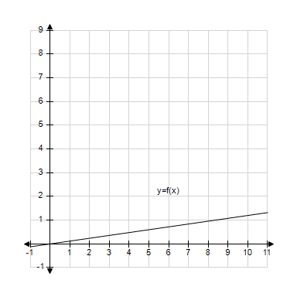
 | a. | calculus, 0.72
 | b. | precalculus, 0.12
 | c. | calculus, 0.12
 | d. | precalculus, 0.72
 | e. | precalculus, 0.37

49. Find the limit (if it exists).
​
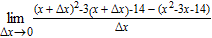
​
 | a.
 | b.
 | c.
 | d.
 | e. | does not exist

50. Consider the function and the point on the graph of f. Find the slope of the secant line passing through and for . Round your answer to one decimal place.
​
 | a. | 2.5
 | b. | 1.0
 | c. | 4.0
 | d. | 5.5
 | e. | 7.0

51. Find the limit.
​
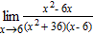
​
 | a.
 | b.
 | c. | –12
 | d. | 6
 | e. | 12

52. Complete the table and use the result to estimate the limit.
​
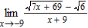
​
​
a.
b.
c.
d.
e.

53. Find the x-values (if any) at which the function f(x) = 11x² - 5x - 5 is not continuous. Which of the discontinuities are removable?
​
 | a. | x = 2, removable
 | b. | x = 0, removable
 | c.
 | d. | continuous everywhere
 | e.

54. Determine the following limit. (Hint: Use the graph to calculate the limit.)
​
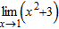
​
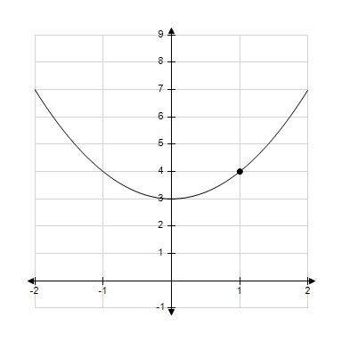
 | a. | 4
 | b. | 1
 | c. | 0
 | d. | 3
 | e. | does not exist

55. Suppose that and . Find the following limit.
​
​
 | a. | –3
 | b. | 5
 | c. | 24
 | d. | –11
 | e. | 0

56. Determine the following limit. (Hint: Use the graph to calculate the limit.)
​
​
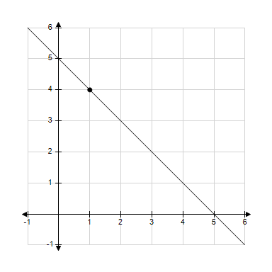
 | a. | 6
 | b. | 1
 | c. | 5
 | d. | 4
 | e. | does not exist

57. Use the graph as shown to determine the following limits, and discuss the continuity of the function at x= 4.
​
(i) (ii) (iii)
​
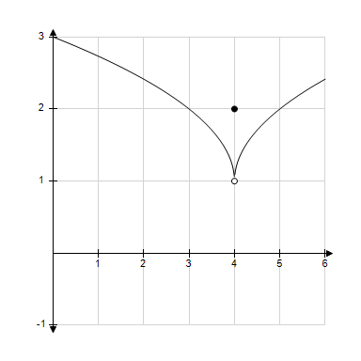
​
 | a. | 1, 1, 1, not continuous
 | b. | 2, 2, 2, continuous
 | c. | 1, 1, 1, continuous
 | d. | 2, 2, 2, not continuous
 | e. | 0, 0, 0, not continuous

58. Find the vertical asymptotes (if any) of the function 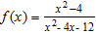.
​
 | a. | x = 2
 | b. | x = 6
 | c. | x = –6
 | d. | x = 12
 | e. | x = –2

59. Find the x-values (if any) at which is not continuous.
​
 | a. | f(x) is not continuous at x = –2 and the discontinuity is nonremovable.
 | b. | f(x) is not continuous at x = 0 and the discontinuity is removable.
 | c. | f(x) is continuous for all real x.
 | d. | f(x) is not continuous at x = –2 and the discontinuity is removable.
 | e. | f(x) is not continuous at x = 0, 2 and x = 0 is a removable discontinuity.

60. Find the limit.
​
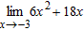
​
 | a.
 | b. | ​
 | c.
 | d.
 | e.

61. Find the limit (if it exists).
​
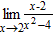
​
a.
b.
c.
d.
e.

62. Find the limit (if it exists).
​
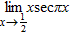
​
 | a.
 | b.
 | c. | 0
 | d.
 | e. | Limit does not exist

63. Use the rectangles in the graph given below to approximate the area of the region bounded by 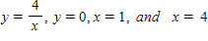. Round your answer to three decimal places.
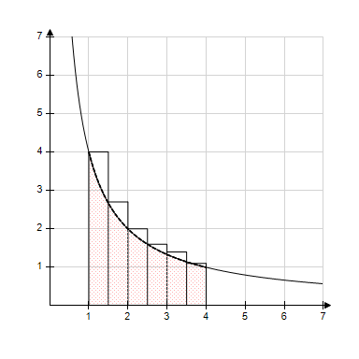
​
 | a. | 2.481 units²
 | b. | 6.371units²
 | c. | 3.585units²
 | d. | 6.872units²
 | e. | 6.903units²

64. Find the value of c guaranteed by the Intermediate Value Theorem.
​
​
 | a. | 1
 | b. | 4
 | c. | 6
 | d. | 2
 | e. | 5

65. Suppose that and . Find the following limit.
​
​
 | a. | 9
 | b. | –3
 | c. | –21
 | d. | –12
 | e. | 108

66. Find the limit.
​
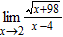
​
a.
b.
c.
d.
e.

67. Consider the length of the graph of 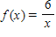 from to . Approximate the length of the curve by finding the sum of the lengths of fiveline segments, as shown in following figure. Round your answer to two decimal places.
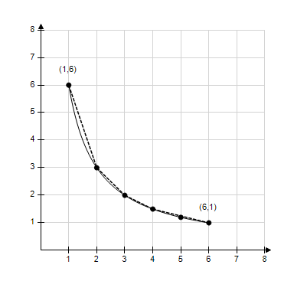
​
 | a. | 7.76
 | b. | 9.77
 | c. | 7.07
 | d. | 9.9
 | e. | 8.76

68. Find the limit (if it exists).
​
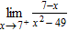
​
 | a.
 | b. | 0
 | c. | Limit does not exist.
 | d.
 | e.

69. Decide whether the following problem can be solved using precalculus, or whether calculus is required. If the problem can be solved using precalculus, solve it. If the problem seems to require calculus, use a graphical or numerical approach to estimate the solution.
​
Find the area of the shaded region.
​
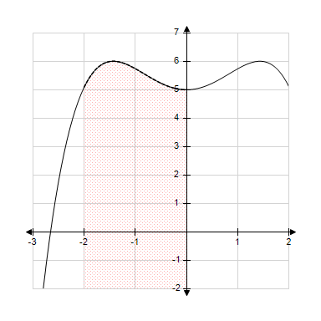
​
 | a. | calculus , 15
 | b. | precalculus , 15
 | c. | precalculus , 18
 | d. | calculus , 22
 | e. | precalculus , 22  ​

70. Decide whether the following problem can be solved using precalculus, or whether calculus is required. If the problem can be solved using precalculus, solve it. If the problem seems to require calculus, use a graphical or numerical approach to estimate the solution.
​
Find the distance traveled in 13 seconds by an object moving with a velocity of feet per second.
​
 | a. | calculus, 162.3521 ft
 | b. | precalculus, 163.7021 ft
 | c. | calculus, 158.9412 ft
 | d. | precalculus, 158.9412 ft
 | e. | precalculus, 162.3521 ft

71. A ring has a inner circumference of 2 centimeters. What is the radius of the ring? Round your answer to four decimal places.
​
 | a. | 0.1592 centimeter
 | b. | 0.6366 centimeter
 | c. | 0.3183 centimeter
 | d. | 0.7979 centimeter
 | e. | 0.4053 centimeter

72. Let and . Find the limit.
​
​
a.
b.
c.
d.
e.

73. Let and . Find the limit.
​
​
a.
b.
c.
d.
e.

74. Find all values of c such that f is continuous on (-∞,∞).
​
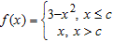
​
 | a. | c = 2
 | b. | c = 0
 | c.
 | d.
 | e.

75. A sphere has a volume of 4.0 cubic inches. If the sphere's volume can vary between 3.2 cubic inches and 5.5 cubic inches , how can the radius vary? Round your answer to five decimal places.
​
 | a. | Radius can vary between 0.91416 inch and 1.09503 inches.
 | b. | Radius can vary between 1.45113 inches and 1.73825 inches.
 | c. | Radius can vary between 0.18475 inch and 2.48475 inches.
 | d. | Radius can vary between 1.58533 inches and 2.07839 inches.
 | e. | Radius can vary between 0.87404 inch and 1.14587 inches.

76. Find all the vertical asymptotes (if any) of the graph of the function .
​
 | a. | x = –2
 | b. | x = 4
 | c. | x = 0
 | d. | x = 4, x = 0
 | e. | no vertical asymptotes

77. Use the graph to determine the following limits, and discuss the continuity of the function at x = -4.
(i) (ii) (iii)
​
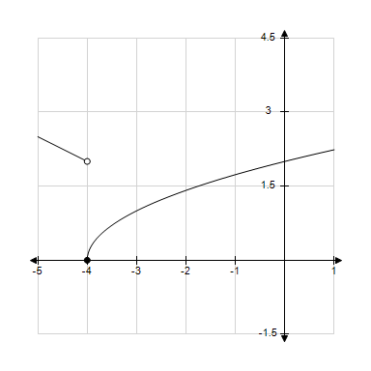
 | a. | 2, -2, does not exist, not continuous
 | b. | 2, 0, does not exist, not continuous
 | c. | 0, 2, does not exist, not continuous
 | d. | -4, 0, does not exist, not continuous
 | e. | 0, 2, 0, continuous

78. Find the limit (if it exists). Note that represents the greatest integer function.
​
​
 | a. | 13
 | b. | Limit does not exist.
 | c. | 12
 | d. | 0
 | e. | 11

79. Consider the function and the point on the graph of f. Estimate the slope m of the tangent line of f at . Round your answer to four decimal places.
​
 | a. | m = 0.2500
 | b. | m = 0.1663
 | c. | m = 0.4633
 | d. | m = 0.1250
 | e. | m = 0.1667

80. Complete the table and use the result to estimate the limit.
​
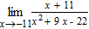
​
​
a.
b.
c.
d.
e.

81. Find the limit.
​
​
a.
b.
c.
d.
e.

82. Find the constant a such that the function
​
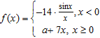
​
is continuous on the entire real line.
​
 | a. | 1
 | b. | –7
 | c. | 7
 | d. | 14
 | e. | –14

83. Determine the limit (if it exists).
​
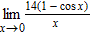
​
 | a. | 0
 | b. | 56
 | c. | 11
 | d. | 28
 | e. | does not exist

84. Find the limit.
​
​
a.
b.
c.
d.
e.

85. Find the limit (if it exists).
​
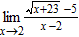
​
 | a. | 10
 | b.
 | c.
 | d.
 | e. | .

86. Consider the function and the point on the graph of f. Estimate the slope of the tangent line of f at .
​
 | a. | 11
 | b. | 8
 | c. | 9
 | d. | 7
 | e. | 10

87. Find all vertical asymptotes (if any) of the function 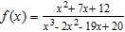
​
 | a. | x = 1, 5
 | b. | x = 1, 5, -4
 | c. | x = -1, -5
 | d. | x = 5
 | e. | x = -5

88. Consider the function and the point on the graph of f. Graph f and the secant line passing through and for .
​
 | a. |  | b.
 | c. |  | d.
 | e.

89. Use the rectangles in the following graph to approximate the area of the region bounded by .
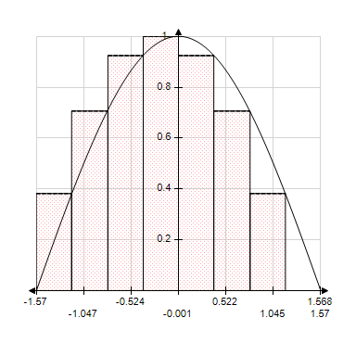
​
​
 | a. | 3.9485
 | b. | 2.6323
 | c. | 1.9742
 | d. | 1.4807
 | e. | 0.9871

90. Let and . Find the limit.
​
​
a.
b.
c.
d.
e.

91. Find all the vertical asymptotes (if any) of the graph of the function 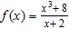.
​
 | a. | x = –2
 | b. | x= 8
 | c. | x= 2
 | d. | x= 2, –2
 | e. | no vertical asymptotes

92. Find the limit.
​
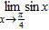
​
a.
b.
c.
d.
e.

93. Discuss the continuity of the function 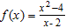.
​
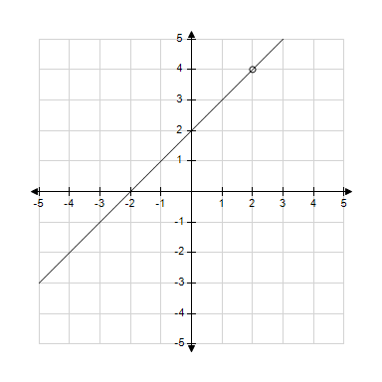
 | a. | f(x) is discontinuous at x= –2.
 | b. | f(x) is discontinuous at x= –2, 2.
 | c. | f(x) is discontinuous at x= 2.
 | d. | f(x) is continuous for all real x.
 | e. | f(x) is continuous at x= 4.

94. Decide whether the following problem can be solved using precalculus, or whether calculus is required. If the problem can be solved using precalculus, solve it. If the problem seems to require calculus, use a graphical or numerical approach to estimate the solution.
​
Find the distance traveled in 12 seconds by an object traveling at a constant velocity of 20 feet per second.
​
 | a. | calculus, 240 ft
 | b. | calculus, 260 ft
 | c. | precalculus, 240 ft
 | d. | calculus, 480 ft
 | e. | precalculus, 480 ft

Answer Key
1. d

2. a

3. d

4. c

5. b

6. d

7. d

8. d

9. a

10. b

11. b

12. d

13. e

14. c

15. c

16. b

17. c

18. c

19. d

20. b

21. b

22. d

23. a

24. a

25. c

26. d

27. e

28. b

29. e

30. c

31. c

32. e

33. a

34. c

35. d

36. d

37. d

38. d

39. d

40. d

41. a

42. d

43. c

44. b

45. b

46. b

47. b

48. b

49. b

50. b

51. b

52. c

53. d

54. a

55. b

56. d

57. a

58. b

59. a

60. e

61. a

62. e

63. b

64. b

65. e

66. d

67. a

68. d

69. a

70. c

71. c

72. c

73. d

74. e

75. a

76. d

77. c

78. c

79. a

80. c

81. b

82. e

83. a

84. c

85. d

86. d

87. a

88. d

89. c

90. b

91. e

92. d

93. c

94. c

