1. Suppose that represents the height, in feet, of a person years old. In real world terms, what does represent? What is its unit? What does represents and what is its unit?
ANSWER: | represents the height of a 10-year old person. Its unit is feet. represents the rate of change of the height when a person is t years old. Its unit is feet per year.

2. The function is both continuous and differentiable at Write these facts as limit statements.
ANSWER: | Since f is continuous at x = 0,  Since f is differentiable at x = 0, exists.  Note that there are alternate ways of writing the answer

3. Suppose and 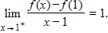 Is continuous and/or differentiable at
 | a. | f is not continuous but differentiable at x = 1
 | b. | f is neither continuous nor differentiable at x = 1
 | c. | f is continuous at but not differentiable at x = 1
 | d. | f is both continuous and differentiable at x = 1

ANSWER: | c

4. Suppose and 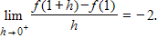 Is continuous and/or differentiable at
 | a. | f is not continuous but differentiable at x = 1
 | b. | f is neither continuous nor differentiable at x = 1
 | c. | f is continuous but not differentiable at x = 1
 | d. | f is both continuous and differentiable at x = 1

ANSWER: | d

5. Use the definition of derivative: 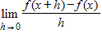 to find
ANSWER: | - 2

6. Use the definition of derivative: to find 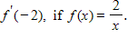
ANSWER: | -

7. Use the definition of derivative: to find 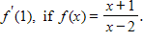
ANSWER: | - 3

8. Use the definition of derivative: 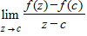 to find
ANSWER: | - 2

9. Use the definition of derivative: to find
ANSWER: | -

10. Use the definition of derivative: to find
ANSWER: | - 3

11. Use the definition of derivative: to find 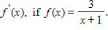
ANSWER:

12. Use the definition of derivative: to find
ANSWER:

13. Use the definition of derivative: to find 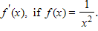
ANSWER:

14. Use the definition of derivative: to find
ANSWER:

15. Given 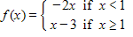, is continuous and/or differentiable at Explain.
 | a. | f is not continuous but differentiable at x = 1
 | b. | f is neither continuous nor differentiable at x = 1
 | c. | f is continuous but not differentiable at x = 1
 | d. | f is both continuous and differentiable at x = 1

ANSWER: | c

16. Given 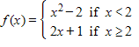, is continuous and/or differentiable at Explain.
 | a. | f is continuous but not differentiable at x = 2
 | b. | f is differentiable but not continuous at x = 2
 | c. | f is neither continuous nor differentiable at x = 2
 | d. | f is both continuous and differentiable at x = 2

ANSWER: | c

17. Use the Intermediate Value Theorem to show that has at least one zero on [0, 2].
ANSWER: | f is continuous on [0, 2], and

18. Use the Intermediate Value Theorem to show that has at least one zero on [- 2, 1].
ANSWER: | f is continuous on [ - 2, 1], and

19. Suppose is a piecewise-defined function, equal to where are continuous and differentiable everywhere. If is the function differentiable at Explain why or why not.
ANSWER: | Yes.

20. Suppose are functions with values Find
 | a. | 7
 | b. | 9
 | c. | – 9
 | d. | – 7

ANSWER: | c

21. Suppose are functions with values Find
 | a. | 15
 | b. | – 12
 | c. | 12
 | d. | – 15

ANSWER: | d

22. Suppose are functions with values Find 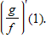
 | a. | 3
 | b.
 | c. | – 1
 | d. | 1

ANSWER: | c

23. Find constants so that 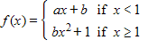, is continuous and differentiable everywhere?
a.
b.
c.
d.

ANSWER: | d

x | g(x) | h(x) | g'(x) | h'(x)
-3 | 0 | 3 | 1 | 0
-2 | 1 | 2 | 2 | -3
-1 | 3 | 0 | -1 | -2
0 | 2 | 3 | -2 | 3
1 | 0 | -1 | -2 | -2
2 | -2 | -2 | -1 | 0
3 | -3 | 0 | 0 | 1

24. Use the table above to find if .
 | a. | 4
 | b. | – 1
 | c. | 1
 | d. | – 4

ANSWER: | d

25. Use the table above to find if 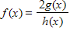.
 | a. | 4
 | b. | – 1
 | c. | 1
 | d. | – 4

ANSWER: | c

26. Use the table above to find if 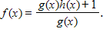
 | a. | 19/9
 | b. | – 19/9
 | c. | 17/9
 | d. | – 17/9

ANSWER: | d

27. Use the table above to find if .
 | a. | – 3
 | b. | 3
 | c. | – 1
 | d. | 1

ANSWER: | b

28. Use the table above to find if .
 | a. | 4
 | b. | – 1
 | c. | 1
 | d. | – 4

ANSWER: | d

29. Use the table above to find if .
 | a. | 3
 | b. | – 3
 | c. | 6
 | d. | – 6

ANSWER: | d

30. Use the table above to find if .
a.
b.
c.
d.

ANSWER: | d

31. Use the table above to find if .
 | a. | 1
 | b. | – 1
 | c. | 7
 | d. | – 7

ANSWER: | d

32. Use the table above to find if .
 | a. | 2
 | b. | – 2
 | c. | 8
 | d. | – 8

ANSWER: | c

33. Find the derivative of 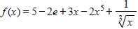.
a.
b.
c.
d.

ANSWER: | c

34. Find the derivative of .
a.
b.
c.
d.

ANSWER: | d

35. Find the derivative of 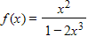.
a.
b.
c.
d.

ANSWER: | d

36. Find the derivative of 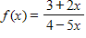.
a.
b.
c.
d.

ANSWER: | b

37. Find the derivative of 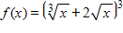.
ANSWER:

38. Find the derivative of 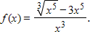
a.
b.
c.
d.

ANSWER: | c

39. Find the derivative of 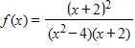.
a.
b.
c.
d.

ANSWER: | d

40. Find the derivative of .
ANSWER:

41. Find the derivative of .
ANSWER:

42. Find the derivative of 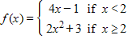.
ANSWER:

43. Find the derivative of 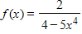.
a.
b.
c.
d.

ANSWER: | b

44. Differentiate 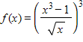 in three ways: (a) with the chain rule, (b) with the quotient rule but not chain rule, (c) without the chain or quotient rules.
ANSWER:

45. Differentiate 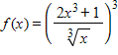 in three ways: (a) with the chain rule, (b) with the quotient rule but not chain rule, (c) without the chain or quotient rules.
ANSWER:

46. Find the derivative of 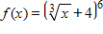.
a.
b.
c.
d.

ANSWER: | b

47. Find the derivative of 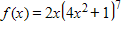.
a.
b.
c.
d.

ANSWER: | c

48. Find the derivative of 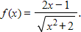
a.
b.
c.
d.

ANSWER: | b

49. Find the derivative of 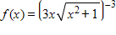.
ANSWER:

50. Find the derivative of 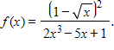
ANSWER:

51. Find the derivative of 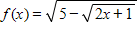.
ANSWER:

52. Find the derivative of 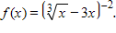
a.
b.
c.
d.

ANSWER: | c

53. Find the derivative of 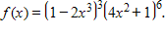
a.
b.
c.
d.

ANSWER: | d

54. Find the derivative of 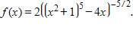
a.
b.
c.
d.

ANSWER: | b

55. If 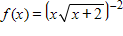, find
ANSWER:

56. Use implicit differentiation to find if
a.
b.
c.
d.

ANSWER: | d

57. Use implicit differentiation to find if
a.
b.
c.
d.

ANSWER: | d

58. Use implicit differentiation to find if .
a.
b.
c.
d.

ANSWER: | c

59. Find the equation of the tangent lines to the circle at the points with x-coordinate
ANSWER:

60. Find the equation of the tangent lines to the graph of at the points with x-coordinate
ANSWER: | and

61. Find the derivative of 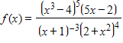.
ANSWER:

62. Find the derivative of 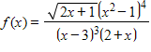.
ANSWER:

63. Find the derivative of 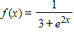.
a.
b.
c.
d.

ANSWER: | d

64. Find the derivative of
a.
b.
c.
d.

ANSWER: | d

65. Find the derivative of 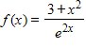.
a.
b.
c.
d.

ANSWER: | c

66. Find the derivative of 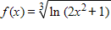.
a.
b.
c.
d.

ANSWER: | b

67. Find the derivative of .
ANSWER:

68. Find the derivative of
a.
b.
c.
d.

ANSWER: | c

69. Find the derivative of
a.
b.
c.
d.

ANSWER: | b

70. Find the derivative of 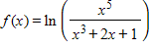.
a.
b.
c.
d.

ANSWER: | c

71. Find the derivative of .
a.
b.
c.
d.

ANSWER: | d

72. Find the derivative of 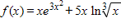.
a.
b.
c.
d.

ANSWER: | d

73. Find the derivative of 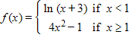.
a.
b.
c.
d.

ANSWER: | d

74. Find the derivative of 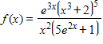.
a.
b.
c.
d.

ANSWER: | d

75. Find the derivative of 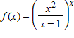.
a.
b.
c.
d.

ANSWER: | b

76. Find the derivative of
a.
b.
c.
d.

ANSWER: | d

77. Find the derivative of .
a.
b.
c.
d.

ANSWER: | c

78. Find the derivative of 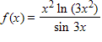.
ANSWER:

79. Find the derivative of
a.
b.
c.
d.

ANSWER: | d

80. Find the derivative of .
ANSWER:

81. Find the derivative of .
a.
b.
c.
d.

ANSWER: | c

82. Find the derivative of
a.
b.
c.
d.

ANSWER: | b

83. Find the derivative of
a.
b.
c.
d.

ANSWER: | d

84. Find the derivative of
a.
b.
c.
d.

ANSWER: | c

85. Find the derivative of
a.
b.
c.
d.

ANSWER: | c

86. Find the derivative of
a.
b.
c.
d.

ANSWER: | d

87. Find the derivative of .
a.
b.
c.
d.

ANSWER: | d

88. Find the derivative of
a.
b.
c.
d.

ANSWER: | b

89. Find the derivative of 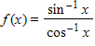.
ANSWER:

90. Find the derivative of .
a.
b.
c.
d.

ANSWER: | c

91. Find the derivative of .
a.
b.
c.
d.

ANSWER: | b

92. Find the derivative of 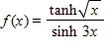.
ANSWER:

93. Find the derivative of .
ANSWER:

94. Use implicit differentiation to find if .
ANSWER:

