1. Copy the points (–5, 5), (3, –3), (–1, –2), (3, 0), (1, –6) in the Cartesian plane.
​
 | a. | ​ | b. | ​
 | c. | ​ | d. | ​
 | e. | ​

ANSWER: | c

2. Find the distance between the points (3, 9) and (7, 1). Round your answer to the nearest hundredth if necessary.
​
 | a. | ​14.14
 | b. | ​6.93
 | c. | ​8.94
 | d. | ​2
 | e. | ​80

ANSWER: | c

3. Find the midpoint of the line segment joining between the points (8, –5) and (5, –6). Round your answer to the nearest hundredth if necessary.
​
 | a. | ​(6.5, 0.5)
 | b. | ​(6.5, –5.5)
 | c. | ​(40, 30)
 | d. | ​(1.5, –0.5)
 | e. | none of these choices

ANSWER: | b

4. Find the length of each side of the right triangle from the following figure.

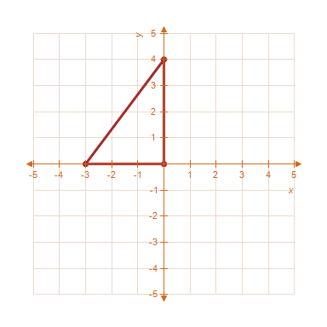
​
 | a. | ​, ,
 | b. | ​​, ,
 | c. | ​​, ,
 | d. | ​​, ,
 | e. | ​​, ,

ANSWER: | a

5. ​Find x such that the distance between the points and is 10.
​
 | a. | ​​
 | b. | ​​
 | c. | ​
 | d. | ​​
 | e. | ​​

ANSWER: | c

6. ​Assume that the number (in millions) of cellular telephone subscribers in the United States from 1996 through 2005 is given in the following table. Use a graphing utility to graph a line plot of the given data. Describe any trends that appear within the last four years.
​​
Year | 1996 | 1997 | 1998 | 1999 | 2000 | 2001 | 2002 | 2003 | 2004 | 2005
Subscribers | 200.5 | 195.1 | 192.9 | 185.3 | 146.6 | 125.6 | 102.5 | 76.7 | 65.9 | 57.3
​
 | a. | ​  ​The number of subscribers appears to be decreasing. | b. | ​  The number of subscribers appears to be increasing.
 | c. | ​  ​  The number of subscribers appears to be constant. | d. | ​  The number of subscribers appears to be decreasing
 | e. | ​  ​  The number of subscribers appears to be increasing linearly.

ANSWER: | a

7. Assume that the number (in millions) of basic cable television subscribers in the United States from 1996 through 2005 is given in the following table. Use a graphing utility to graph a scatter plot of the given data. Describe any trends that appear within the last four years.
​
Year | 1996 | 1997 | 1998 | 1999 | 2000 | 2001 | 2002 | 2003 | 2004 | 2005
Subscribers | 53.5 | 54.1 | 54.9 | 55.3 | 55.6 | 56.1 | 56.5 | 56.7 | 56.9 | 57
​
 | a. | ​  ​The number of subscribers appears to be decreasing. | b. | ​  The number of subscribers appears to be increasing.
 | c. | ​  The number of subscribers appears to be linearly decreasing. | d. | ​  The number of subscribers appears to be constant
 | e. | ​  ​  The number of subscribers appears to be linearly increasing.

ANSWER: | b

8. ​Assume that the median sales prices of existing one family homes sold (in thousands of dollars) in the United States from 1990 through 2005 are as given in the following figure. Use the following figure to estimate the percent increase in the value of existing one-family homes from1999 to 2000. Round your answer to the nearest hundredth if necessary.
​
​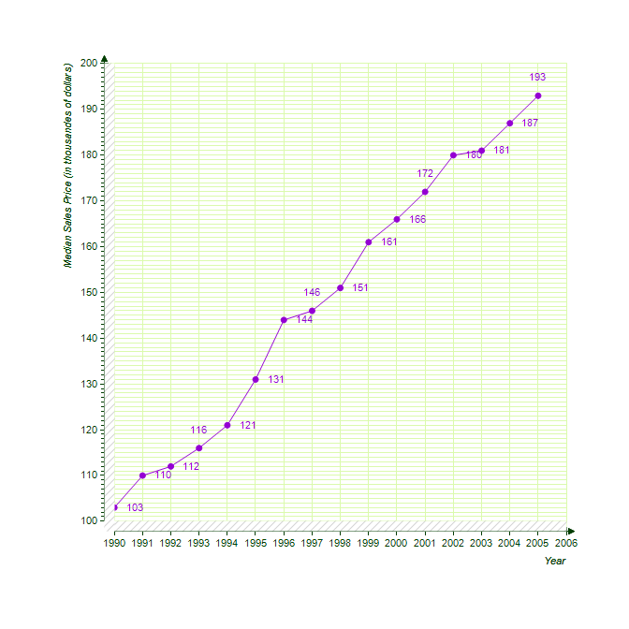 ​

 | a. | ​3.01%
 | b. | ​203.11%
 | c. | ​103.11%
 | d. | ​96.99%
 | e. | ​3.11%

ANSWER: | e

9. ​Use the Midpoint Formula repeatedly to find the three points that divide the segment joining and into four equal parts.
​
 | a. | ​, ,
 | b. | ​​, ,
 | c. | ​​, ,
 | d. | ​​, ,
 | e. | ​​, ,

ANSWER: | b

10. ​The red figure is translated to a new position in the plane to form the blue figure. Find the vertices of the transformed figure from the following graph. (In case your exam is printed in black and white - the red figure has one vertex at (0,0)).
​
​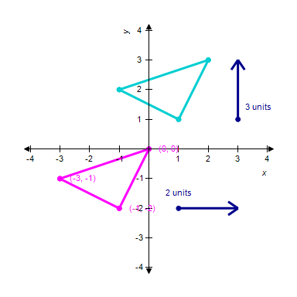
​
 | a. | ​, ,
 | b. | ​, ,
 | c. | ​, ,
 | d. | ​, ,
 | e. | ​, ,

ANSWER: | b

11. ​Which of the following is the correct graph of ?
​
 | a. | ​ | b. | ​
 | c. | ​ | d. | ​
 | e. | ​

ANSWER: | c

12. ​Which of the following is the correct graph of ?
​
 | a. | ​ | b. | ​
 | c. | ​ | d. | ​
 | e. | ​

ANSWER: | a

13. ​Which of the following is the correct graph of 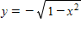?
​
 | a. | ​ | b. | ​
 | c. | ​ | d. | ​
 | e. | ​

ANSWER: | d

14. Sketch the graph of the equation. ?
​
 | a. | ​ | b. | ​
 | c. | ​ | d. | ​
 | e. | ​

ANSWER: | d

15. ​Which of the following is the correct graph of ?
​
 | a. | ​ | b. | ​
 | c. | ​ | d. | ​
 | e. | ​

ANSWER: | b

16. ​Find the x- and y- intercepts of the graph of the equation 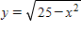?
​
 | a. | ​x- intercepts: , ; ​y- intercepts:
 | b. | ​​x- intercepts: , ; ​y- intercepts:
 | c. | ​​x- intercepts: , ; ​y- intercepts: ,
 | d. | ​​​x- intercepts: , ; ​y- intercepts: ,
 | e. | ​​​x- intercepts: ; ​y- intercepts:

ANSWER: | a

17. ​Find the x- and y- intercepts of the graph of the equation 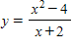?
​
 | a. | ​x- intercepts: ; ​y- intercepts:
 | b. | ​​x- intercepts: , ; ​y- intercepts: ,
 | c. | ​​​x- intercepts: ; ​y- intercepts:
 | d. | ​​​x- intercepts: , ; ​y- intercepts: ,
 | e. | ​​​x- intercepts: ; ​y- intercepts:

ANSWER: | c

18. Sketch the graph of the function ?
​
 | a. | ​ | b. | ​
 | c. | ​ | d. | ​
 | e. | ​

ANSWER: | a

19. Sketch the graph of the equation: .
​
 | a. | ​ | b. | ​
 | c. | ​ | d. | ​
 | e. | ​

ANSWER: | c

20. ​Write the general form of the equation of the circle with center and solution point .
​
 | a. | ​
 | b. | ​
 | c. | ​
 | d. | ​
 | e. | ​

ANSWER: | a

21. Write the general form of the equation of the circle with endpoints of a diameter at .​
​
 | a. | ​
 | b. | ​
 | c. | ​
 | d. | ​
 | e. | ​

ANSWER: | e

22. Find the points of intersection (if any) of the graphs of the equations .
​
 | a. | ​
 | b. | ​
 | c. | ​
 | d. | ​
 | e. | ​

ANSWER: | a

23. ​A manufacturer of DVD players has monthly fixed costs of $7600 and variable costs of $45 per unit for one particular model. For this model DVD player, find the function for monthly total costs where ​x denotes the number of units produced and sold.
​
 | a. | ​
 | b. | ​
 | c. | ​
 | d. | ​
 | e. | ​

ANSWER: | b

24. ​A small business recaps and sells tires. The business has a revenue function and a cost function , where x represents the number of sets of four tires recapped and sold. Find the number of sets of recaps that must be sold to break even.
​
 | a. | ​100
 | b. | ​200
 | c. | ​14
 | d. | ​700
 | e. | ​65

ANSWER: | a

25. ​Find the market equilibrium point for the following demand and supply functions below, where p is price per unit and q is the number of units produced and sold.
Demand:
Supply:

 | a. | ​,
 | b. | ​​,
 | c. | ​,
 | d. | ​,
 | e. | ​,

ANSWER: | a

26. ​Find the market equilibrium point for the following demand and supply functions below, where p is price per unit and q is the number of units produced and sold.
Demand:
Supply:

 | a. | ​,
 | b. | ​​,
 | c. | ​,
 | d. | ​,
 | e. | ​,

ANSWER: | d

27. ​Estimate the slope of the line from the graph.
​
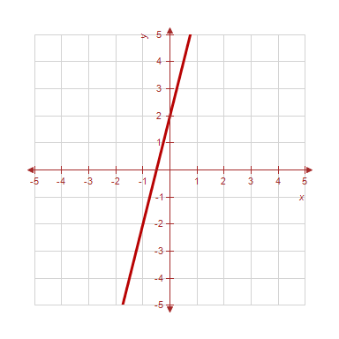​
​
 | a. | ​
 | b. | ​
 | c. | ​
 | d. | ​
 | e. | ​

ANSWER: | c

28. ​Estimate the slope of the line from the graph.
​
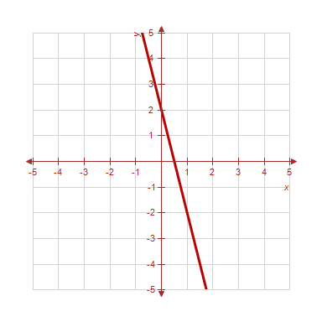​
​
 | a. | ​
 | b. | ​
 | c. | ​
 | d. | ​
 | e. | ​

ANSWER: | d

29. ​Find the slope of the line passing through the pair of points.
​
​ and
​
 | a. | ​
 | b. | ​
 | c. | ​
 | d. | ​
 | e. | ​None of the above

ANSWER: | b

30. ​Find the slope of the line passing through the given pair of points.
​
​
​
 | a. | ​12
 | b. | ​
 | c. | ​–4
 | d. | ​0
 | e. | ​The slope is undefined.

ANSWER: | e

31. ​Find the slope of the line passing through the given pair of points.
​
​
​
 | a. | ​–24
 | b. | ​
 | c. | ​4
 | d. | ​
 | e. | ​The slope is undefined.

ANSWER: | c

32. ​Find the slope of the line passing through the given pair of points.
​
​
​
 | a. | ​
 | b. | ​1
 | c. | ​–9
 | d. | ​–15
 | e. | ​The slope is undefined.

ANSWER: | b

33. ​Use the point on a line having slope to find two additional points through which the line passes.
​
 | a. | ​,
 | b. | ​​,
 | c. | ​​,
 | d. | ​​,
 | e. | ​​,

ANSWER: | a

34. ​Find the slope m and y-intercept b of the line whose equation is given below.
​
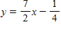
​
 | a. | ​,
 | b. | ​​,
 | c. | ​​​,
 | d. | ​,
 | e. | ​,

ANSWER: | c

35. ​Find the slope m and y-intercept b of the line whose equation is given below.
​
​
 | a. | ​,
 | b. | ​​,
 | c. | ,
 | d. | ​,
 | e. | ,

ANSWER: | b

36. ​Find the slope m and y-intercept b of the line whose equation is given below.
​
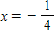
​
 | a. | ​,
 | b. | ​​,
 | c. | ,
 | d. | ​,
 | e. | Both m and b are undefined.

ANSWER: | e

37. ​Find the slope m and y-intercept b of the line whose equation is given below.
​
​
 | a. | ​,
 | b. | ​​,
 | c. | ,
 | d. | ​,
 | e. | Both m and b are undefined.

ANSWER: | e

38. ​Write the equation of the line passing through the given pair of points.
​
 | a. | ​
 | b. | ​
 | c. | ​
 | d. | ​
 | e. | ​

ANSWER: | b

39. ​Write the equation of the line passing through the given pair of points.
​
 | a. | ​
 | b. | ​
 | c. | ​
 | d. | ​
 | e. | ​

ANSWER: | a

40. ​Find an equation of the line that passes through the points 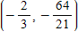 and 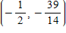.
​
 | a. | ​
 | b. | ​
 | c. | ​
 | d. | ​
 | e. | ​

ANSWER: | b

41. ​Find an equation of the line that passes through the point and has the slope m that is undefined.
​
 | a. | ​
 | b. | ​
 | c. | ​
 | d. | ​
 | e. | ​

ANSWER: | b

42. ​Write the equation and graph the line that passes through the given point and has the slope indicated.
with 0 slope
​
 | a. | ​
 | b. | ​
 | c. | ​
 | d. | ​
 | e. | ​

ANSWER: | b

43. ​Write the equation of the line that passes through the given point and has the slope indicated.
with slope
​
 | a. | ​
 | b. | ​
 | c. | ​
 | d. | ​
 | e. | ​

ANSWER: | b

44. ​True or False: These three points are collinear.
​
, ,
​
 | a. | ​true
 | b. | ​false

ANSWER: | b

45. ​Write the equation of the line through that is parallel to .
​
 | a. | ​
 | b. | ​
 | c. | ​
 | d. | ​
 | e. | ​

ANSWER: | b

46. ​Write the equation of the line through that is perpendicular to .
​
 | a. | ​
 | b. | ​
 | c. | ​
 | d.
 | e. | ​

ANSWER: | e

47. Write an equation of the line that passes through the point (i) parallel to the given line, and (ii) perpendicular to the given line.
​
Point: ​.
Line:
​
 | a. | ​(i) parallel:  (ii) perpendicular:
 | b. | ​(i) parallel:  (ii) perpendicular:
 | c. | ​​(i) parallel:  (ii) perpendicular:
 | d. | ​​(i) parallel:  (ii) perpendicular:
 | e. | ​​(i) parallel:  (ii) perpendicular:

ANSWER: | b

48. ​Write an equation of the line that passes through the point (i) parallel to the given line, and (ii) perpendicular to the given line.
​
Point: .
Lne: .
​​

 | a. | ​(i) parallel:  (ii) perpendicular:
 | b. | ​​(i) parallel:  (ii) perpendicular:
 | c. | ​​(i) parallel:  (ii) perpendicular:
 | d. | ​​(i) parallel:  (ii) perpendicular:
 | e. | ​​(i) parallel:  (ii) perpendicular:

ANSWER: | a

49. ​Find a linear equation that expresses the relationship between the temperature in degrees Celsius and degrees Fahrenheit. Use the fact that water freezes at 0° C (32° F) and boils at 100° C (212° F ). Use the equation to convert 92° F to Celsius. Round to the nearest degree.
​
 | a. | ​33°C
 | b. | ​19°C
 | c. | 69​°C
 | d. | ​108°C
 | e. | ​134°C

ANSWER: | a

50. ​Suppose the resident population of South Carolina (in thousands) was 4,024 in 2000 and 4,257 in 2005. Assume that the relationship between the population y and the year t is linear. Let represent 2000. Estimate the population in 2002 by using linear model for the given data. Round your answer to the nearest thousand residents.
​
 | a. | ​4,179 thousand residents
 | b. | ​3,931 thousand residents
 | c. | ​4,164 thousand residents
 | d. | ​4,117 thousand residents
 | e. | ​4,350 thousand residents

ANSWER: | d

51. ​In 2004, a product has a value of $2,725. Over the next five years, its value will increase by $150 per year. Write a linear equation that gives the dollar value V in terms of the year t. (Let t = 0 represent 2000.)
​
 | a. | ​
 | b. | ​
 | c. | ​
 | d. | ​
 | e. | ​

ANSWER: | c

52. A small business purchases a piece of equipment for $1,010. After 5 years, the equipment will be outdated, having no value. Write a linear equation giving the value V of the equipment in terms of time t in years, .
​
 | a. | ​
 | b. | ​
 | c. | ​
 | d. | ​
 | e. | ​

ANSWER: | d

53. ​If , is y a function of x?
​
 | a. | ​Yes
 | b. | ​No

ANSWER: | b

54. ​If , is y a function of x?
​
 | a. | ​Yes
 | b. | ​No

ANSWER: | b

55. Determine whether y is a function of x.
​
​
​
 | a. | ​Yes
 | b. | ​No

ANSWER: | a

56. Determine whether y is a function of x.
​
​
​
 | a. | ​Yes
 | b. | ​No

ANSWER: | a

57. ​Determine the range of the function .
​
 | a. | ​
 | b. | ​
 | c. | ​
 | d. | ​
 | e. | ​

ANSWER: | a

58. ​Determine the range of the function 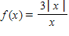.
​
​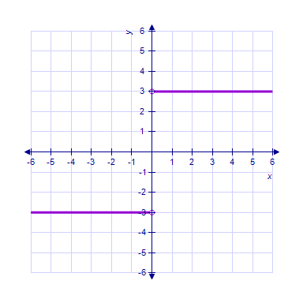
​
 | a. | ​
 | b. | ​
 | c. | ​
 | d. | ​
 | e. | ​

ANSWER: | a

59. ​Evaluate (if possible) the function at the given value of the independent variable. Simplify the results.
​
​,
​
 | a. | ​26
 | b. | ​16
 | c. | ​8
 | d. | ​–2
 | e. | ​undefined

ANSWER: | a

60. ​If 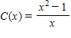 find 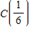.
​
 | a. | ​
 | b. | ​
 | c. | ​
 | d. | ​
 | e. | ​

ANSWER: | d

61. ​Simplify the expression using the given function definition.
​
​, 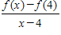
​
 | a. | ​–4
 | b. | ​–8
 | c. | ​–9
 | d. | ​–12
 | e. | ​undefined

ANSWER: | c

62. ​Use the Vertical Line Test to determine which of the following graphs shows y as a function of x.
​
 | a. | ​ | b. | ​
 | c. | ​ | d. | ​
 | e. | ​

ANSWER: | e

63. ​Given and , find .
​
 | a. | ​
 | b. | ​
 | c. | ​
 | d. | ​
 | e. | ​

ANSWER: | b

64. ​Given and , find .
​
 | a. | ​12
 | b. | ​2
 | c. | ​16
 | d. | ​–17
 | e. | ​18

ANSWER: | b

65. Use the Horizontal Line Test to determine whether the functions are one-to-one.
​
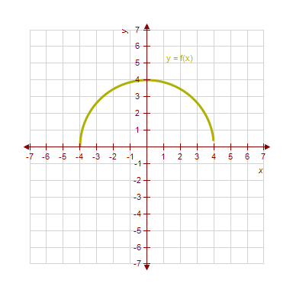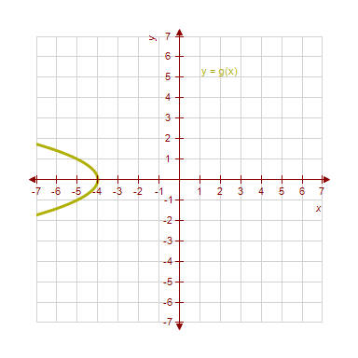
​ ​
 | a. | ​f(x) and g(x) both are one-to-one.
 | b. | ​f(x) is not one-to-one and g(x) is one-to-one.
 | c. | ​f(x) and g(x) both are not one-to-one.
 | d. | ​f(x) is one-to-one and g(x) is not one-to-one.

ANSWER: | b

66. Use the graph of to sketch .
​ ​
 | a. | ​ | b. | ​
 | c. | ​ | d. | ​
 | e. | ​

ANSWER: | b

67. Use the graph of below to sketch .
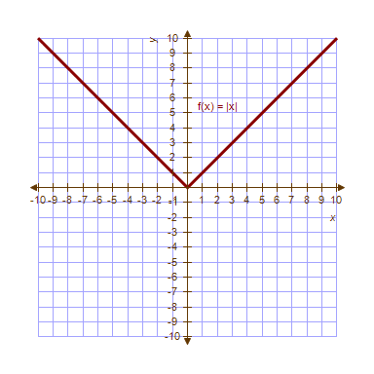
​ ​
 | a. | ​ | b. | ​
 | c. | ​ | d. | ​
 | e. | ​

ANSWER: | b

68. ​The inventor of a new game believes that the variable cost for producing the game is $0.85 per unit. The fixed cost is $9000.
Find a formula for the average cost per unit 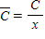.
​
 | a. | ​
 | b. | ​
 | c. | ​
 | d. | ​
 | e. | ​

ANSWER: | c

69. A manufacturer charges $70 per unit for units that cost $40 to produce. To encourage large orders from distributors, the manufacturer will reduce the price by $0.04 per unit for each unit in excess of 100 units. (For example, an order of 101 units would have a price of $69.96 per unit, and an order of 102 units would have a price of $69.92 per unit.) This price reduction is discontinued when the price per unit drops to $62. Express the price per unit as a function of the order size.
​​
 | a. | ​
 | b. | ​
 | c. | ​
 | d. | ​
 | e. | ​

ANSWER: | c

70. ​Complete the table and use the result to estimate the limit. Round your answer to six decimal places.
​
​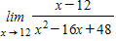
​
x | 11.9 | 11.99 | 11.999 | 12.001 | 12.01 | 12.1
f(x)

​
​
​
​
 | a. | ​0.125000
 | b. | ​0.625000
 | c. | ​0.500000
 | d. | ​0.750000
 | e. | ​–0.250000

ANSWER: | a

71. ​Complete the table and use the result to estimate the limit. Round your answer to six decimal places.
​
​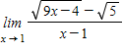
​
x | 0.9 | 0.99 | 0.999 | 1.001 | 1.01 | 1.1
f(x)

​
​
​
​
 | a. | ​–2.012461
 | b. | ​2.137461
 | c. | ​2.012461
 | d. | ​–2.179128
 | e. | ​–2.262461

ANSWER: | c

72. ​Complete the table and use the result to estimate the limit. Round your answer to six decimal places.
​
​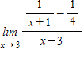
​
x | 2.9 | 2.99 | 2.999 | 3.001 | 3.01 | 3.1
f(x)

​
​
​
​
 | a. | ​0.047500
 | b. | ​0.067500
 | c. | ​–0.192500
 | d. | ​–0.062500
 | e. | ​–0.172500

ANSWER: | d

73. ​Suppose that 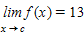 and 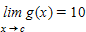. Find the following limit:
​
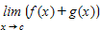
​
 | a. | ​130
 | b. | ​3
 | c. | ​0
 | d. | ​23
 | e. | ​10

ANSWER: | d

74. ​Suppose that 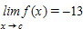 and 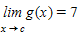. Find the following limit:
​
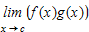
​
 | a. | ​–13
 | b. | ​–20
 | c. | ​–6
 | d. | ​–91
 | e. | ​–7

ANSWER: | d

75. Let 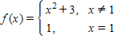.
Determine the following limit. (Hint: Use the graph of the function.)
​
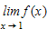
​
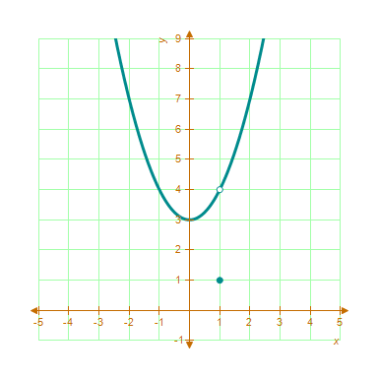.
​ ​
 | a. | ​4
 | b. | ​1
 | c. | ​3
 | d. | ​9
 | e. | ​does not exist.

ANSWER: | a

76. A graph of is shown and a c-value is given. For this problem, use the graph to find 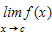.
​
​ 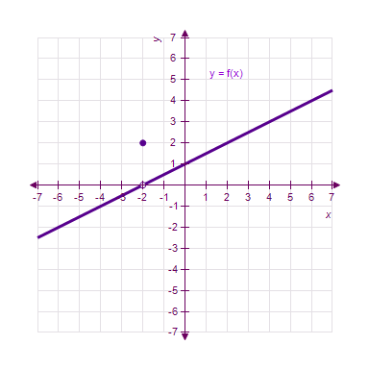.
​ ​
 | a. | ​0
 | b. | ​2
 | c. | ​–2
 | d. | ​1
 | e. | ​does not exist.

ANSWER: | a

77. A graph of is shown and a c-value is given. For this problem, use the graph to find .
​
​ 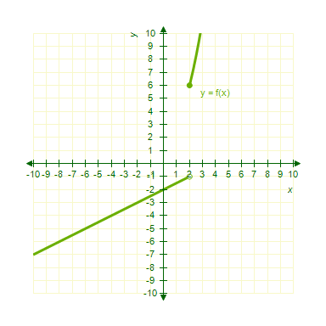.
​ ​
 | a. | ​6
 | b. | ​–4
 | c. | ​4
 | d. | ​12
 | e. | ​does not exist.

ANSWER: | a

78. ​Find the limit (if it exists):
​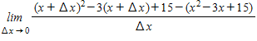
 | a. | ​
 | b. | ​
 | c. | ​0
 | d. | ​
 | e. | ​

ANSWER: | d

79. ​Find 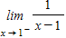.
​
 | a. | ​–1
 | b. | ​0
 | c. | ​-∞
 | d. | ​1
 | e. | ​0∞

ANSWER: | c

80. ​Find the limit: 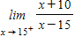.
​
 | a. | ​-∞
 | b. | ​0∞
 | c. | ​0
 | d. | ​-1
 | e. | ​1

ANSWER: | b

81. ​Find 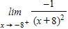.
​
 | a. | ​8
 | b. | ​0∞
 | c. | ​0
 | d. | ​–8
 | e. | ​-∞

ANSWER: | e

82. Determine the following limit. (Hint: Use the graph of the function.)
​
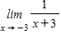.
​
​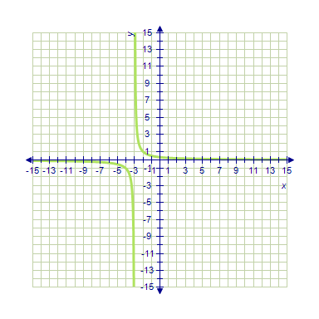
​
 | a. | ​3
 | b. | ​does not exist
 | c. | ​0
 | d. | ​–3
 | e. | ​6

ANSWER: | b

83. Graph the function with a graphing utility and use it to predict the limit. Check your work either by using the table feature of the graphing utility or by finding the limit algebraically.
​
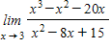.
​
 | a. | ​
 | b. | ​21
 | c. | ​
 | d. | ​0
 | e. | ​does not exist

ANSWER: | e

84. The cost (in dollars) of removing p% of the pollutants from the water in a small lake is given by 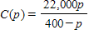, . Evaluate 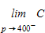.
​
 | a. | ​∞
 | b. | ​22,000
 | c. | ​0
 | d. | ​–22000
 | e. | ​-∞

ANSWER: | a

85. Consider a certificate of deposit that pays 18% (annual percentage rate) on an initial deposit of $5,000. The balance after 18 years is 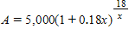. Estimate 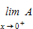, where x is the length of the compounding period (in years). Round your answer to the nearest hundredth.
​​
 | a. | ​127,668.61
 | b. | ​1,839.4
 | c. | ​90,000
 | d. | ​5,900
 | e. | ​5,000

ANSWER: | a

86. ​Determine whether the given function is continuous. If it is not, identify where it is discontinuous.
​
​​

 | a. | ​discontinuous at
 | b. | ​​discontinuous at
 | c. | ​​discontinuous at
 | d. | ​​discontinuous at
 | e. | ​continuous everywhere

ANSWER: | e

87. Find the x-values (if any) at which the function is not continuous. Which of the discontinuities are removable?
​
 | a. | ​continuous everywhere
 | b. | ​, removable
 | c. | ​, removable
 | d. | ​​, removable
 | e. | both B and C

ANSWER: | a

88. ​Describe the interval(s) on which the function 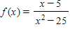 is continuous.
​
 | a. | ​, &
 | b. | ​, &
 | c. | ​, &
 | d. | ​, &
 | e. | ​, &

ANSWER: | c

89. Determine whether the given function is continuous. If it is not, identify where it is discontinuous and which condition fails to hold. You can verify your conclusions by graphing the function with a graphing utility, if one is available.
​
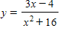
​​

 | a. | ​discontinuous at
 | b. | ​​discontinuous at
 | c. | ​​discontinuous at
 | d. | ​​discontinuous at
 | e. | ​continuous everywhere

ANSWER: | e

90. Find the x-values (if any) at which f(x) is not continuous and identify whether they are removable or nonremovable.
​
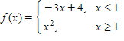
​​

 | a. | is a removable discontinuity
 | b. | is a nonremovable discontinuity
 | c. | is a removable discontinuity
 | d. | is a nonremovable discontinuity
 | e. | f(x) has no discontinuities

ANSWER: | e

91. ​Find the x-values (if any) at which the function 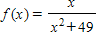 is not continuous. Which of the discontinuities are removable?
​
 | a. | ​not removable
 | b. | ​continuous everywhere
 | c. | ​removable
 | d. | ​discontinuous everywhere
 | e. | ​none of the above

ANSWER: | b

92. ​Find the x-values (if any) at which the function 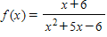 is not continuous. Which of the discontinuities are removable?
​
 | a. | ​no points of discontinuity
 | b. | ​ (not removable), (removable)
 | c. | ​ (removable), (not removable)
 | d. | no points of continuity
 | e. | ​​ (not removable), (not removable)

ANSWER: | c

93. ​Sketch the graph of the function 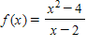 and describe the interval(s) on which the function is continuous.
​
 | a. | ​​ and | b. | ​ and
 | c. | ​ and | d. | ​ and  ​
 | e. | ​none of these choices

ANSWER: | d

94. Describe the interval(s) on which the function 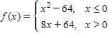 is continuous.
​

 | a. | and
 | b. | and
 | c. | and
 | d.
 | e. | none of these choices

ANSWER: | c

95. Find constants a and b such that the function 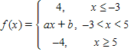 is continuous on the entire real line.
​

 | a. | ,
 | b. | ,
 | c. | ,
 | d. | , ​
 | e. | ,

ANSWER: | e

96. ​A deposit of $8,500 is made in an account that pays 6% compounded every 5 months. The amount A in the account after t years is 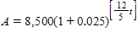, . What are the points of discontinuity of graph of ? (Here, the brackets indicate the greatest integer function.)
​
 | a. | ​1 , , , ,...
 | b. | ​0 , 1 , 2 ,...
 | c. | ​5 , 10 , 15 ,....
 | d. | ​1 , 2 , 3 ,...
 | e. | ​ , , ,...

ANSWER: | e

