1. The potential energy of a pendulum of length 1 and mass 2, relative to its rest position is . Compute the average rate of change of the potential energy over the angle interval 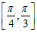.
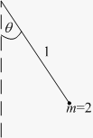
ANSWER:

2. Let denote the slope of the line segment connecting the origin to the point on the graph of the equation . Calculate the average rate of change of for
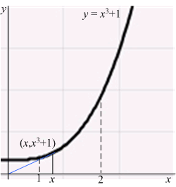
ANSWER:

3. The flight time of a shell shot at an angle and initial velocity is 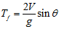. Compute the average rate of change of the flight time for in the interval 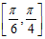.
ANSWER:

4. Let denote the slope of the line segment connecting the origin to the point on the graph of the equation . Calculate the average rate of change of for
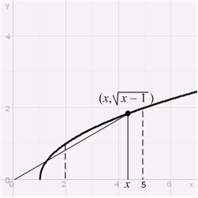
ANSWER:

5. The volume of a cone of radius and height is 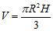.
What is the average rate of change of if the radius increases from 1 to 3 and the height remains unchanged?
ANSWER:

6. The electrical field due to an infinite rod at a point at distance from the rod is perpendicular to the rod and has a magnitude of 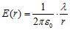( is a constant and is the longitudinal charge density).
Find the average rate of change of the field along the interval .
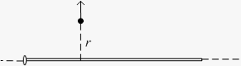
ANSWER:

7. Let denote the slope of the line segment connecting the origin to the point on the graph of the semi-ellipse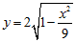. Calculate the average rate of change of for
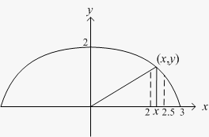
ANSWER: | -0.206 per unit length

8. The electrical field caused by an electrical charge at a point at distance is 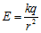( is a constant).
Find the average rate of change of the field along the interval .
ANSWER:

9. The volume of a sphere of radius is 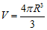. What is the average rate of change of the volume when the radius increases from to ?
ANSWER:

10. Let denote the slope of the line segment connecting the origin to the point on the graph of the equation . Calculate the average rate of change of for
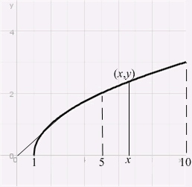
ANSWER:

11. The position of a particle is given by. Compute the average velocity over the time interval . Estimate the instantaneous velocity at .
ANSWER: | Average velocity over : 20  Instantaneous velocity at : 16

12. A balloon is blown up and takes the shape of a sphere. What is the average rate of change of the surface area of the balloon as the radius increases from 3 to 4 cm?
ANSWER:

13. Determine and for the function shown in the figure.
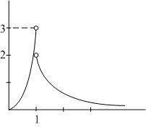
ANSWER:

14. The greatest integer function is defined by , where is the unique integer such that .
The graph of is shown in the figure.
A) For which values of does exist?
B) For which values of does exist?
C) For which values of does exist?
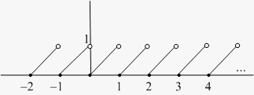
ANSWER: | A) All  B) All  C) Every real number that is not an integer

15. The graph of a function is shown in the figure.
Determine the following limits or state that the limit does not exist (if the limit is infinite, write or ):
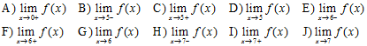
​
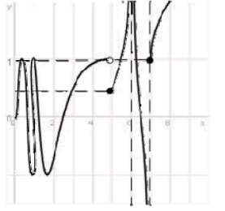
ANSWER:

16. Determine the one-sided limits at of the function shown in the figure and state whether the limit exists at these points.
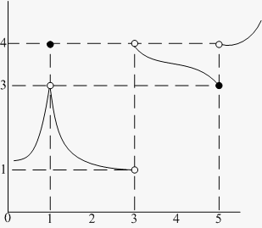
ANSWER: | ; limit exists  ; limit does not exist  ; limit does not exist

17. Consider the function 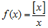for . (Here, [x] denotes the greatest integer function.)
A) Write in piecewise form.
What is for positive integers ?
B) Determine and .
C) For which values of does exist?
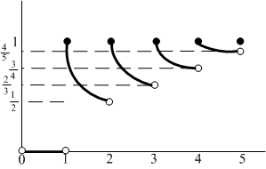
ANSWER: | A)  B)  C) The limit exists for all positive real numbers that are not integers.

18. Determine the one-sided limits at of the function shown in the figure and state whether the limit exists at these points.
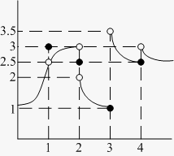
ANSWER: | :Left-sided:Right-sided:Limit  1:2.5:2.5:Exists (2.5)  2:3:2:Does not exist  3:1:3.5:Does not exist  4:2.5:3:Does not exist

19. Consider the function for . (Here, [x] denotes the greatest integer function.)
A) Write in piecewise form. What is for positive integers ?
B) Find and .
C) For which values of does the limit fail to exist?
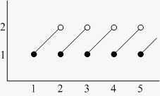
ANSWER: | A) for ,  B)  C) The limit fails to exist for all positive integers.

20. Determine the one-sided limits at of the function shown in the figure and state whether the limit exists at these points.
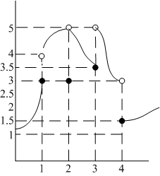
ANSWER: | c:Left-sided:Right-sided:Limit  1:3:4:Does not exist  2:5:5:Exists (5)  3:3.5:5:Does not exist  4:3:1.5:Does not exist

21. Let be the following function defined for :
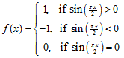
Write as a piecewise-defined function where the intervals are in terms of x instead of , sketch its graph, and determine the points where the limit of does not exist. Find the one-sided limits at these points.
ANSWER:

22. Find a real number such that exists and compute the limit.
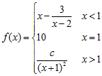
ANSWER:

23. Let . Determine whether each of the following statements is always true, never true, or sometimes true.
A)
B)
C)
D) 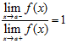
ANSWER: | A) Always  B) Sometimes  C) Never  D) Sometimes (note the case when )

24. Compute the following one-sided limits:
A) 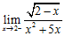
B) 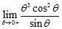
C) 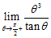
ANSWER: | A) 0  B) 0  C) 0

25. Evaluate the limits using the Limit Laws:
A)
B) 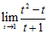
C) 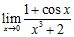
D) 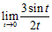
ANSWER: | A)  B)  C)  D)

26. Which of the following functions are examples of the existence of the limit 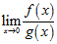, although the limits of and as do not exist?
a.
b.
c.
d.
e.

ANSWER: | c

27. Let , be functions and let . Consider the following statement: If and exist, then also exists. To prove this statement, we should use which of the following?
 | a. | The statement is not true.
 | b. | The Product Rule applied to and .
 | c. | The Quotient Rule applied to and .
 | d. | The Sum Rule applied to and .

ANSWER: | d

28. Evaluate the limits using the Limit Laws:
A)
B) 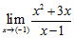
C) 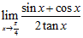
D) 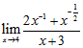
ANSWER: | A)  B)  C)  D)

29. Determine whether the following statement is correct: If , then exists. If yes, prove it; otherwise, give a counterexample
ANSWER: | False;

30. Evaluate the limits using the Limit Laws:
A) 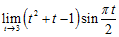
B) 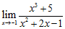
C) 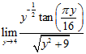
ANSWER: | A)  B)  C)

31. A) Can the Product Rule be used to compute the limit ? (Here, [x] denotes the greatest integer function.) Explain.
B) Show that exists and find it. Hint: Compute the one-sided limits.
ANSWER: | A) No. The limit does not exist.  B) 0

32. Let , , and . To prove that if and exist then also exists, we should use which of the following?
 | a. | The Product Rule applied to and .
 | b. | The Quotient Rule applied to and .
 | c. | The Sum Rule applied to and .
 | d. | The statement is not true.
 | e. | Both A and C

ANSWER: | c

33. Evaluate the limits using the Limit Laws:
A) 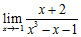
B)
C) 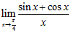
ANSWER: | A)  B)  C)

34. Consider this statement: If and , then 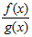does not converge to a finite limit as .
To prove this statement, we assume that 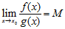exists and is finite. Then, by the Quotient Rule, 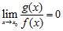and by the Product Rule, 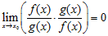.
Which of the following statements completes the proof?
 | a. | From , it follows that 1 = 0, which is a contradiction.
 | b. | From , we can conclude that , which contradicts our assumption.
 | c. | From , we can conclude that , which contradicts our assumption.
 | d. | From , we can conclude that , which contradicts our assumption.

ANSWER: | a

35. Which of the following functions are examples of the existence of the limit 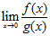, although the limits and do not exist?
 | a.
 | b.
 | c. | (Here, [x] denotes the greatest integer function.)
 | d.
 | e.

ANSWER: | b

36. Assume and are nonzero real numbers. If and 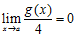, calculate the following limits, if possible. If not, state that it is not possible.
A)
B) 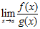
C) 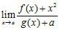
ANSWER: | A) 0  B) Not possible  C)

37. Determine the points at which the following functions are not continuous and state the type of discontinuity: removable, jump, infinite, or none of these.
A) f(x) =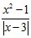
B) g(x) = 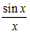
C) h(x) = (Here, [x] denotes the greatest integer function.)
D) j(x) = 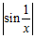
E) k(x) = 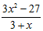
ANSWER: | A) ; infinite  B) ; removable  C) Integers; jump  D) ; none of these  E) x = –3; removable

38. At each point of discontinuity, state whether the function is left or right continuous:
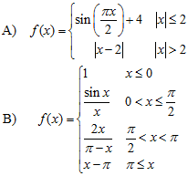
ANSWER: | A) ; left continuous  B) ; left continuous  ; right continuous

39. Determine real numbers a, b, and c that make the function continuous:
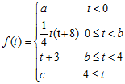
ANSWER:

40. Find the points of discontinuity for each of these functions and state the type of discontinuity: removable, jump, infinite, or none of these.
A) f(x) = 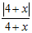
B) g(x) = 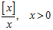(Here, [x] denotes the greatest integer function.)
C) h(x) = 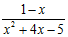
ANSWER: | A) x = –4; jump  B) x = positive integer; jump  C) removable; infinite

41. Determine whether the function is left or right continuous at each of its points of discontinuity:
A) 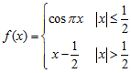
B) (Here, [x] denotes the greatest integer function.)
ANSWER: | A) right continuous  B) Right continuous at the positive integers

42. Determine real numbers and that make the following function continuous:
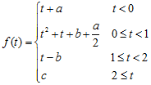
ANSWER:

43. Determine the points where the function is not continuous and state the type of the discontinuity: removable, jump, infinite, or none of these.
A) f(x) = 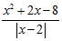
B) g(x) = 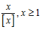(Here, [x] denotes the greatest integer function.)
C) h(x) = 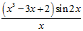
D) j(x) = 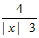
ANSWER: | A) , jump  B) ; jump  C) ; removable  D) x = 3, x = –3; infinite

44. At each point of discontinuity, state whether the function is left or right continuous.
A) 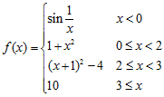
B) 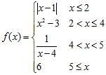
ANSWER: | A) ; right continuous  ; right continuous  B) ; left continuous  ; right continuous

45. Determine real numbers and that make the following function continuous:
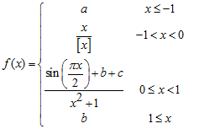
(Here, [x] denotes the greatest integer function.)
ANSWER:

46. Determine the points where the function is not continuous and state the type of discontinuity: removable, jump, infinite, or none of these:
A) f(x) = 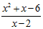
B) g(x) = 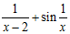
C) h(x) = (Here, [x] denotes the greatest integer function.)
D) j(x) = 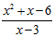
ANSWER: | A) ; removable  B) ; infinite  ; none of these  C) Nonzero integers; jump  D) ; infinite

47. At each point of discontinuity state whether the function is left continuous, right continuous, or neither
A) 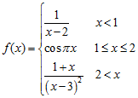
B) 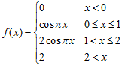
ANSWER: | A) ; left continuous  ; none of these  B) ; right continuous  ; left continuous

48. Determine real numbers and that make the function continuous:
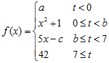
ANSWER:

49. Consider the function
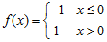
The function is continuous for which of the following functions g?
 | a. | if
 | b. | if
 | c. | if if
 | d. | if if
 | e. | A and C both correct

ANSWER: | c

50. Let be a discontinuous function. Is it possible to find a continuous function such that is continuous? Explain.
ANSWER: | No. If F(x) = f(x) + g(x) is continuous, then f(x) = F(x) – g(x) is continuous by the continuity laws.

51. Sketch the graph of a function that satisfies all of the following conditions:
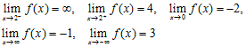
ANSWER:

52. Evaluate each limit or state that it does not exist:
A) 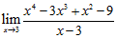
B) 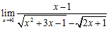
C) 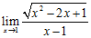
ANSWER: | A) 33  B)  C) Does not exist

53. Evaluate each limit or state that it does not exist:
A) 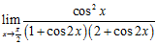
B) 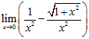
C) 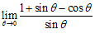
ANSWER: | A)  B)  C)

54. Evaluate the limits in terms of the constants involved:
A) 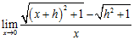
B) 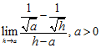
ANSWER: | A)  B)

55. Evaluate each limit or state that it does not exist:
A) 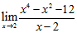
B) 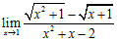
C) 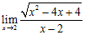
ANSWER: | A) 28  B)  C) Does not exist

56. Evaluate the limit:
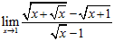
ANSWER:

57. Evaluate each limit or state that it does not exist:
A) 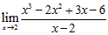
B) 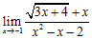
C) 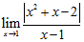
ANSWER: | A) 7  B)  C) Does not exist

58. Determine a real number for which the limit exists and then compute the limit:
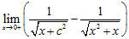
ANSWER: | , the limit is 0

59. Evaluate each limit or state that it does not exist:
A) 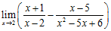
B) 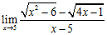
C) 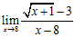
ANSWER: | A)  B)  C)

60. Determine a real number for which the limit exists and then compute the limit:
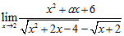
ANSWER: | ; limit is

61. Let f(x) = 2x + 3. Compute 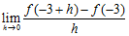.
ANSWER: | 2

62. Compute .
ANSWER:

63. Compute 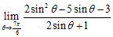.
ANSWER:

64. Evaluate the limits:
A) 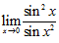
B) 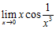
C) 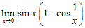
ANSWER: | A) 1  B) 0  C) 0

65. Show that for all . (Here, [x] denotes the greatest integer function.) Then use the above inequality and the Squeeze Theorem to evaluate .
ANSWER: | 0

66. Evaluate the limits in terms of the constants involved:
A) 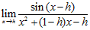
B) 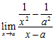
ANSWER: | A)  B)

67. Evaluate the limits using the Squeeze Theorem, trigonometric identities, and trigonometric limits, as necessary:
A) 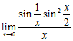
B) 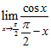
C) 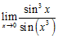
ANSWER: | A) 0  B) 1  C) 1

68. Show that for all . (Here, [x] denotes the greatest integer function.) Then use this inequality with the Squeeze Theorem to evaluate .
ANSWER: | 0

69. Determine a real number such that the following limit exists, and then evaluate the limit for this value:
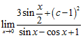
ANSWER: | ; limit is

70. Evaluate each limit or state that it does not exist:
A) 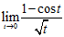
B) 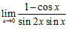
C) 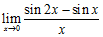
ANSWER: | A)  B)  C)

71. Evaluate the limits:
A) 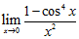
B) 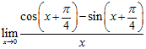
ANSWER: | A)  B)

72. Evaluate the limits:
A) 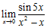
Hint: Factor the denominator.
B) 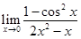
Hint: Factor the two expressions.
C) 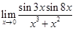
ANSWER: | A)  B)  C)

73. Use the Squeeze Theorem to evaluate the limit
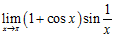
ANSWER: | 0

74. If on the interval [0,4], then must exist.
 | a. | True
 | b. | False

ANSWER: | b

75. Calculate the limits:
A) 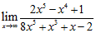
B) 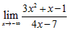
C) 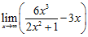
ANSWER: | A)  B)  C)

76. Calculate the limits:
A) 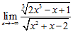
B) 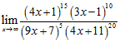
C) 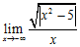
ANSWER: | A)  B)  C)

77. Calculate the following limits:
A) 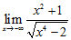
B) 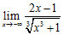
C) 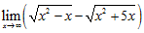
ANSWER: | A)  B)  C)

78. Compute the following limits:
A) 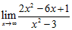
B)
C) 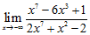
ANSWER: | A)  B)  C)

79. Compute the following limits:
A) 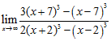
B) 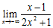
C) 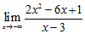
ANSWER: | A)  B)  C)

80. Compute the following limits:
A) 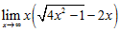
Hint: Multiply and divide by the conjugate expression.
B) 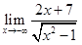
Hint: For .
C) 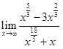
ANSWER: | A)  B)  C)

81. Compute the following limits:
A) 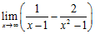
B) 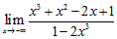
C) 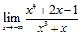
ANSWER: | A)  B)  C)

82. Compute the following limits:
A) 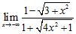
B) 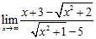
C) 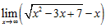
ANSWER: | A)  B)  C)

83. The Intermediate Value Theorem guarantees that the equation has a solution in which of the following intervals?
a.
b.
c.
d.
e.

ANSWER: | a

84. The polynomial must have a root in which of the following intervals?
a.
b.
c.
d.
e.

ANSWER: | b

85. Which of the following functions is a counterexample for the converse of the Intermediate Value Theorem, which states: If assumes all the values between and in the interval , then is continuous on .
 | a. | on
 | b. | on
 | c. | on _{on [0,2]}
 | d. | on (Here, [x] denotes the greatest integer function.)
 | e. | on

ANSWER: | e

86. Which of the following functions has a zero in the interval ?
 | a.
 | b.
 | c.
 | d.
 | e. | Both A and C

ANSWER: | e

87. The Intermediate Value Theorem guarantees that the equation has a solution in which of the following intervals?
 | a.
 | b.
 | c.
 | d.
 | e. | Both A and C

ANSWER: | e

88. Which of the following functions is a counterexample for the converse of the Intermediate Value Theorem, which states: If assumes all the values between and in the interval , then is continuous on .
 | a. | for , , on [1,3]
 | b. | on
 | c. | on on
 | d. | on (Here, [x] denotes the greatest integer function.)
 | e. | Both A and C

ANSWER: | a

89. Which of the following functions is a counterexample for the converse of the Intermediate Value Theorem: If assumes all the values between and in the interval , then is continuous on .
 | a. | if on [1,3]
 | b. | on (Here, [x] denotes the greatest integer function.)
 | c. | on
 | d. | for and
 | e. | Both A and D

ANSWER: | a

90. Assume is continuous on , , and . Determine whether each of the following statements is always true, never true, or sometimes true.
A) : no solution with
B) : no solution with
C) : no solution with
D) : exactly one solution with
E) : a solution with
ANSWER: | A) Sometimes true  B) Sometimes true  C) Never true  D) Sometimes true  E) Always true

91. Draw the graph of a function on such that the graph does not satisfy the conclusion of the Intermediate Value Theorem.
ANSWER: | Answers may vary. A sample answer is:  ​

92. Which of the following properties can be used to prove that is continuous for all ?
 | a. | for all
 | b. | for all and
 | c. | for all and
 | d. | The limit exists
 | e. | for all and

ANSWER: | b

93. Which of the following statements imply that is not continuous at ?
 | a. | has opposite signs on the two sides of
 | b. | implies that
 | c. | For any , implies that
 | d. | If , then .
 | e. | A and C are correct.

ANSWER: | c

94. To show that is not the limit of as , we should show that:
 | a. | For any , there exists such that if then .
 | b. | For any , there exists such that if then .
 | c. | There exists , such that for any the inequalities and have a solution .
 | d. | There exist and such that if , then .
 | e. | A and C are both correct.

ANSWER: | c

95. Suppose there exists a value of so that for any value of , we can find a value of satisfying and . We may conclude that:
 | a. | is the limit of as .
 | b. | is not the limit of as .
 | c. | The limit of as does not exist.
 | d. | The limit of as exists but is not equal to L.
 | e. | None of the above.

ANSWER: | b

96. To show that is not the limit of as , we should show that:
 | a. | There exists such that for any there exists a solution to the inequalities and .
 | b. | There exists such that for any there exists a solution to the inequalities and .
 | c. | There exists such that for any , if , then .
 | d. | For any and , if , then .
 | e. | A and D are both correct.

ANSWER: | a

