#### CHAPTER 2

# CHARTS AND GRAPHS

## CHAPTER LEARNING OBJECTIVES

1. ***Explain the difference between grouped and ungrouped data and construct a frequency distribution from a set of data and explain what the distribution represents.*** The two types of data are grouped and ungrouped. Grouped data are data organized into a frequency distribution. Differentiating between grouped and ungrouped data is important, because statistical operations on the two types are computed differently. Constructing a frequency distribution involves several steps. The first step is to determine the range of the data, which is the difference between the largest value and the smallest value. Next, the number of classes is determined, which is an arbitrary choice of the researcher. However, too few classes overaggregate the data into meaningless categories, and too many classes do not summarize the data enough to be useful. The third step in constructing the frequency distribution is to determine the width of the class interval. Dividing the range of values by the number of classes yields the approximate width of the class interval.

The class midpoint is the midpoint of a class interval. It is the average of the class endpoints and represents the halfway point of the class interval. Relative frequency is computed by dividing an individual frequency by the sum of the frequencies. Relative frequency represents the proportion of total values that is in a given class interval. The cumulative frequency is a running total frequency tally that starts with the first frequency value and adds each ensuing frequency to the total.

2. ***Describe and construct different types of quantitative data graphs, including histograms, frequency polygons, ogives, and stem and leaf plots. Explain when these graphs should be used.*** Two types of graphical depictions are quantitative data graphs and qualitative data graphs. Quantitative data graphs presented in this chapter are histogram, frequency polygon, ogive, and stem and leaf plot. Qualitative data graphs presented are pie chart, bar chart, and Pareto chart. In addition, two-dimensional scatter plots are presented. A histogram is a vertical bar chart in which a line segment connects class endpoints at the value of the frequency. Two vertical lines connect this line segment down to the *x*-axis, forming a rectangle. A frequency polygon is constructed by plotting a dot at the midpoint of each class interval for the value of each frequency and then connecting the dots. Ogives are cumulative frequency polygons. Points on an ogive are plotted at the class endpoints. Stem and leaf plots are another way to organize data. The numbers are divided into two parts, a stem and a leaf. The stems are the left-most digits of the numbers and the leaves are the right-most digits. The stems are listed individually, with all leaf values corresponding to each stem displayed beside that stem.

3. ***Describe and construct different types of qualitative data graphs, including pie charts, bar charts, and Pareto charts. Explain when these graphs should be used.*** A pie chart is a circular depiction of data. The amount of each category is represented as a slice of the pie proportionate to the total. The researcher is cautioned in using pie charts because it is sometimes difficult to differentiate the relative sizes of the slices. The bar chart or bar graph uses bars to represent the frequencies of various qualitative categories. The bar chart can be displayed horizontally or vertically. A Pareto chart is a vertical bar chart that is used in total quality management to graphically display the causes of problems. The Pareto chart presents problem causes in descending order to assist the decision maker in prioritizing problem causes.

4. ***Display and analyze two variables simultaneously using cross tabulation and scatter plots.*** Cross tabulation is a process for producing a two-dimensional table that displays the frequency counts for two variables simultaneously. The scatter plot is a two-dimensional plot of pairs of points from two numerical variables. It is used to graphically determine whether any apparent relationship exists between the two variables.

5***. Describe and construct a time-series graph and be able to visually identify any trends in the data***. Time-series data is defined as data gathered on a particular characteristic over a period of time at regular intervals. Time-series data plots can give the business analyst insights into various trends over time.

## TRUE-FALSE STATEMENTS

1. A summary of data in which raw data are grouped into different intervals and the number of items in each group is listed is called a frequency distribution.

Answer: True

Difficulty: Easy

Learning Objective: Explain the difference between grouped and ungrouped data and construct a frequency distribution from a set of data and explain what the distribution represents.

Section Reference: 2.1 Frequency Distributions

Blooms: Knowledge

AACSB: Reflective Thinking

2. If the individual class frequency is divided by the total frequency, the result is the median frequency.

Answer: False

Difficulty: Medium

Learning Objective: Explain the difference between grouped and ungrouped data and construct a frequency distribution from a set of data and explain what the distribution represents.

Section Reference: 2.1 Frequency Distributions

Blooms: Knowledge

AACSB: Reflective Thinking

3. For any given data set, a frequency distribution with a larger number of classes will always be better than the one with a smaller number of classes.

Answer: False

Difficulty: Medium

Learning Objective: Explain the difference between grouped and ungrouped data and construct a frequency distribution from a set of data and explain what the distribution represents.

Section Reference: 2.1 Frequency Distributions

Blooms: Knowledge

AACSB: Reflective Thinking

4. One rule that must always be followed in constructing frequency distributions is that the adjacent classes must overlap.

Answer: False

Difficulty: Medium

Learning Objective: Explain the difference between grouped and ungrouped data and construct a frequency distribution from a set of data and explain what the distribution represents.

Section Reference: 2.1 Frequency Distributions

Blooms: Knowledge

AACSB: Reflective Thinking

5. A cumulative frequency distribution provides a running total of the frequencies in the classes.

Answer: True

Difficulty: Medium

Learning Objective: Explain the difference between grouped and ungrouped data and construct a frequency distribution from a set of data and explain what the distribution represents.

Section Reference: 2.1 Frequency Distributions

Blooms: Knowledge

AACSB: Reflective Thinking

6. The difference between the highest number and the lowest number in a set of data is called the differential frequency.

Answer: False

Difficulty: Medium

Learning Objective: Explain the difference between grouped and ungrouped data and construct a frequency distribution from a set of data and explain what the distribution represents.

Section Reference: 2.1 Frequency Distributions

Blooms: Knowledge

AACSB: Reflective Thinking

7. A graphical representation of a frequency distribution is called a pie chart.

Answer: False

Difficulty: Easy

Learning Objective: Describe and construct different types of quantitative data graphs, including histograms, frequency polygons, ogives, and stem and leaf plots. Explain when these graphs should be used.

Section Reference: 2.2 Quantitative Data Graphs

Blooms: Knowledge

AACSB: Reflective Thinking

8. A cumulative frequency polygon is also called an ogive.

Answer: True

Difficulty: Medium

Learning Objective: Describe and construct different types of quantitative data graphs, including histograms, frequency polygons, ogives, and stem and leaf plots. Explain when these graphs should be used.

Section Reference: 2.2 Quantitative Data Graphs

Blooms: Knowledge

AACSB: Reflective Thinking

9. A histogram can be described as a type of vertical bar chart.

Answer: True

Difficulty: Medium

Learning Objective: Describe and construct different types of quantitative data graphs, including histograms, frequency polygons, ogives, and stem and leaf plots. Explain when these graphs should be used.

Section Reference: 2.2 Quantitative Data Graphs

Blooms: Knowledge

AACSB: Reflective Thinking

10. One advantage of a stem and leaf plot over a frequency distribution is that the values of the original data are retained.

Answer: True

Difficulty: Medium

Learning Objective: Describe and construct different types of quantitative data graphs, including histograms, frequency polygons, ogives, and stem and leaf plots. Explain when these graphs should be used.

Section Reference: 2.2 Quantitative Data Graphs

Blooms: Knowledge

AACSB: Reflective Thinking

11. For a company in gardening supplies business, the best graphical way to show the percentage of a total budget that is spent on each of a number of different expense categories is the stem and leaf plot.

Answer: False

Difficulty: Hard

Learning Objective: Describe and construct different types of quantitative data graphs, including histograms, frequency polygons, ogives, and stem and leaf plots. Explain when these graphs should be used.

Section Reference: 2.2 Quantitative Data Graphs

Blooms: Knowledge

AACSB: Reflective Thinking

12. In a histogram, the tallest bar represents the class with the highest cumulative frequency.

Answer: False

Difficulty: Medium

Learning Objective: Describe and construct different types of quantitative data graphs, including histograms, frequency polygons, ogives, and stem and leaf plots. Explain when these graphs should be used.

Section Reference: 2.2 Quantitative Data Graphs

Blooms: Knowledge

AACSB: Reflective Thinking

13. A graphical representation of a frequency distribution is called a pie chart.

Answer: False

Difficulty: Easy

Learning Objective: Describe and construct different types of qualitative data graphs, including pie charts, bar charts, and Pareto charts. Explain when these graphs should be used.

Section Reference: 2.3 Qualitative Data Graphs

Blooms: Knowledge

AACSB: Reflective Thinking

14. In contrast to quantitative data graphs that are plotted along a numerical scale, qualitative graphs are plotted using non-numerical categories.

Answer: True

Difficulty: Easy

Learning Objective: Describe and construct different types of qualitative data graphs, including pie charts, bar charts, and Pareto charts. Explain when these graphs should be used.

Section Reference: 2.3 Qualitative Data Graphs

Blooms: Knowledge

AACSB: Reflective Thinking

15. A Pareto chart and a pie chart are both types of qualitative graphs.

Answer: True

Difficulty: Easy

Learning Objective: Describe and construct different types of qualitative data graphs, including pie charts, bar charts, and Pareto charts. Explain when these graphs should be used.

Section Reference: 2.3 Qualitative Data Graphs

Blooms: Knowledge

AACSB: Reflective Thinking

16 A scatter plot shows how the numbers in a data set are scattered around their average.

Answer: False

Difficulty: Medium

Learning Objective: Display and analyze two variables simultaneously using cross tabulation and scatter plots.

Section Reference: 2.4 Charts and Graphs for Two Variables

Blooms: Knowledge

AACSB: Reflective Thinking

17. A scatter plot is a two-dimensional graph plot of data containing pairs of observations on two numerical variables.

Answer: True

Difficulty: Medium

Learning Objective: Display and analyze two variables simultaneously using cross tabulation and scatter plots.

Section Reference: 2.4 Charts and Graphs for Two Variables

Blooms: Knowledge

AACSB: Reflective Thinking

18. A scatter plot is useful for examining the relationship between two numerical variables.

Answer: True

Difficulty: Medium

Learning Objective: Display and analyze two variables simultaneously using cross tabulation and scatter plots.

Section Reference: 2.4 Charts and Graphs for Two Variables

Blooms: Knowledge

AACSB: Reflective Thinking

19. A cross tabulation is a graph that separately displays the frequency counts for two variables.

Answer: False

Difficulty: Medium

Learning Objective: Display and analyze two variables simultaneously using cross tabulation and scatter plots.

Section Reference: 2.4 Charts and Graphs for Two Variables

Blooms: Knowledge

AACSB: Reflective Thinking

20. When looking at a scatter plot, if a trend can be discerned between changes in one variable that appear to be related to changes in the other variable, there is likely a relationship between the two variables.

Answer: False

Difficulty: Medium

Learning Objective: Display and analyze two variables simultaneously using cross tabulation and scatter plots.

Section Reference: 2.4 Charts and Graphs for Two Variables

Blooms: Knowledge

AACSB: Reflective Thinking

21. To consider historical data as part of their decisions, management often uses time-series data.

Answer: True

Difficulty: Easy

Learning objective: Describe and construct a time-series graph. Visually identify any trends in the data.

Section Reference: 2.5 Visualizing Time-Series Data

Blooms: Knowledge

AACSB: Reflective Thinking

22. The point of “cleaning” time-series data is to be sure all the data are accurate.

Answer: False

Difficulty: Medium

Learning objective: Describe and construct a time-series graph. Visually identify any trends in the data.

Section Reference: 2.5 Visualizing Time-Series Data

Blooms: Knowledge

AACSB: Reflective Thinking

23. Time-series data should be shown from oldest time period to the most recent.

Answer: True

Difficulty: Medium

Learning objective: Describe and construct a time-series graph. Visually identify any trends in the data.

Section Reference: 2.5 Visualizing Time-Series Data

Blooms: Knowledge

AACSB: Reflective Thinking

24. To compare two series of data during the same time period, the graph should show the first and then show the second after that, all in one line.

Answer: False

Difficulty: Medium

Learning objective: Describe and construct a time-series graph. Visually identify any trends in the data.

Section Reference: 2.5 Visualizing Time-Series Data

Blooms: Knowledge

AACSB: Reflective Thinking

25. To show differences between different series during the same time periods, different trend lines, each in a different color, and all using the same x axis for graphing.

Answer: True

Difficulty: Medium

Learning objective: Describe and construct a time-series graph. Visually identify any trends in the data.

Section Reference: 2.5 Visualizing Time-Series Data

Blooms: Knowledge

AACSB: Reflective Thinking

26. Visualization of time-series data is considered descriptive business analytics.

Answer: True

Difficulty: Medium

Learning objective: Describe and construct a time-series graph. Visually identify any trends in the data.

Section Reference: 2.5 Visualizing Time-Series Data

Blooms: Knowledge

AACSB: Reflective Thinking

**MULTIPLE CHOICE QUESTIONS**

27. Consider the following frequency distribution:

Class Interval Frequency

10–under 20 15

20–under 30 25

30–under 40 10

What is the midpoint of the first class?

a) 10

b) 20

c) 15

d) 30

e) 40

Answer: c

Difficulty: Easy

Learning Objective: Explain the difference between grouped and ungrouped data and construct a frequency distribution from a set of data and explain what the distribution represents.

Section Reference: 2.1 Frequency Distributions

Blooms: Application

AACSB: Analytic

28. Consider the following frequency distribution:

Class Interval Frequency

10–under 20 15

20–under 30 25

30–under 40 10

What is the relative frequency of the first class?

a) 0.15

b) 0.30

c) 0.10

d) 0.20

e) 0.40

Answer: b

Difficulty: Medium

Learning Objective: Explain the difference between grouped and ungrouped data and construct a frequency distribution from a set of data and explain what the distribution represents.

Section Reference: 2.1 Frequency Distributions

Blooms: Application

AACSB: Analytic

29. Consider the following frequency distribution:

Class Interval Frequency

10–under 20 15

20–under 30 25

30–under 40 10

What is the cumulative frequency of the second class interval?

a) 25

b) 40

c) 15

d) 50

Answer: b

Difficulty: Medium

Learning Objective: Explain the difference between grouped and ungrouped data and construct a frequency distribution from a set of data and explain what the distribution represents.

Section Reference: 2.1 Frequency Distributions

Blooms: Application

AACSB: Analytic

30. The number of phone calls arriving at a switchboard each hour has been recorded, and the following frequency distribution has been developed:

Class Interval Frequency

20–under 40 30

40–under 60 45

60–under 80 80

80–under 100 45

What is the midpoint of the last class?

a) 80

b) 100

c) 95

d) 90

e) 85

Answer: d

Difficulty: Easy

Learning Objective: Explain the difference between grouped and ungrouped data and construct a frequency distribution from a set of data and explain what the distribution represents.

Section Reference: 2.1 Frequency Distributions

Blooms: Knowledge

AACSB: Analytic

31. The number of phone calls arriving at a switchboard each hour has been recorded, and the following frequency distribution has been developed:

Class Interval Frequency

20–under 40 30

40–under 60 45

60–under 80 80

80–under 100 45

What is the relative frequency of the second class?

a) 0.455

b) 0.900

c) 0.225

d) 0.750

e) 0.725

Answer: c

Difficulty: Medium

Learning Objective: Explain the difference between grouped and ungrouped data and construct a frequency distribution from a set of data and explain what the distribution represents.

Section Reference: 2.1 Frequency Distributions

Blooms: Application

AACSB: Analytic

32. The number of phone calls arriving at a switchboard each hour has been recorded, and the following frequency distribution has been developed:

Class Interval Frequency

20–under 40 30

40–under 60 45

60–under 80 80

80–under 100 45

What is the cumulative frequency of the third class?

a) 80

b) 0.40

c) 155

d) 75

e) 105

Answer: c

Difficulty: Medium

Learning Objective: Explain the difference between grouped and ungrouped data and construct a frequency distribution from a set of data and explain what the distribution represents.

Section Reference: 2.1 Frequency Distributions

Blooms: Application

AACSB: Analytic

33. A person has decided to construct a frequency distribution for a set of data containing 60 numbers. The lowest number is 23 and the highest number is 68. If 5 classes are used, the class width should be approximately ___.

a) 4

b) 12

c) 8

d) 5

e) 9

Answer: e

Difficulty: Easy

Learning Objective: Explain the difference between grouped and ungrouped data and construct a frequency distribution from a set of data and explain what the distribution represents.

Section Reference: 2.1 Frequency Distributions

Blooms: Application

AACSB: Analytic

34. A person has decided to construct a frequency distribution for a set of data containing 60 numbers. The lowest number is 23 and the highest number is 68. If 7 classes are used, the class width should be approximately ___.

a) 5

b) 7

c) 9

d) 11

e) 12

Answer: b

Difficulty: Medium

Learning Objective: Explain the difference between grouped and ungrouped data and construct a frequency distribution from a set of data and explain what the distribution represents.

Section Reference: 2.1 Frequency Distributions

Blooms: Application

AACSB: Analytic

35. A frequency distribution was developed. The lower endpoint of the first class is 9.30, and the midpoint is 9.35. What is the upper endpoint of this class?

a) 9.50

b) 9.60

c) 9.70

d) 9.40

e) 9.80

Answer: d

Difficulty: Medium

Learning Objective: Explain the difference between grouped and ungrouped data and construct a frequency distribution from a set of data and explain what the distribution represents.

Section Reference: 2.1 Frequency Distributions

Blooms: Application

AACSB: Analytic

36. The cumulative frequency for a class is 27. The cumulative frequency for the next (non-empty) class will be ___.

a) less than 27

b) equal to 27

c) next class frequency minus 27

d) 27 minus the next class frequency

e) 27 plus the next class frequency

Answer: e

Difficulty: Hard

Learning Objective: Explain the difference between grouped and ungrouped data and construct a frequency distribution from a set of data and explain what the distribution represents.

Section Reference: 2.1 Frequency Distributions

Blooms: Comprehension

AACSB: Analytic

37. The following class intervals for a frequency distribution were developed to provide information regarding the starting salaries for students graduating from a particular school:

Salary Number of Graduates

($1,000s)

18–under 21 -

21–under 25 -

24–under 27 -

29–under 30 -

Before data was collected, someone questioned the validity of this arrangement. Which of the following represents a problem with this set of intervals?

a) There are too many intervals.

b) The class widths are too small.

c) Some numbers between 18,000 and 30,000 would fall into two different intervals.

d) The first and the second interval overlap.

e) There are too few intervals.

Answer: c

Difficulty: Medium

Learning Objective: Explain the difference between grouped and ungrouped data and construct a frequency distribution from a set of data and explain what the distribution represents.

Section Reference: 2.1 Frequency Distributions

Blooms: Comprehension

AACSB: Analytic

38. The following class intervals for a frequency distribution were developed to provide information regarding the starting salaries for students graduating from a particular school:

Salary Number of Graduates

($1,000s)

18–under 21 -

21–under 25 -

24–under 27 -

29–under 30 -

Before data was collected, someone questioned the validity of this arrangement. Which of the following represents a problem with this set of intervals?

a) There are too many intervals.

b) The class widths are too small.

c) The class widths are too large.

d) The second and the third interval overlap.

e) There are too few intervals.

Answer: d

Difficulty: Hard

Learning Objective: Explain the difference between grouped and ungrouped data and construct a frequency distribution from a set of data and explain what the distribution represents.

Section Reference: 2.1 Frequency Distributions

Blooms: Comprehension

AACSB: Analytic

39. Abel Alonzo, Director of Human Resources, is exploring employee absenteeism at the Harrison Haulers Plant during the last operating year. A review of all personnel records indicated that absences ranged from zero to twenty-nine days per employee. The following class intervals were proposed for a frequency distribution of absences:

Absences Number of Employees

(Days)

0–under 5 -

5–under 10 -

10–under 15 -

20–under 25 -

25–under 30 -

Which of the following represents a problem with this set of intervals?

a) There are too few intervals.

b) Some numbers between 0 and 29, inclusively, would not fall into any interval.

c) The first and second interval overlaps.

d) There are too many intervals.

e) The second and the third interval overlap.

Answer: b

Difficulty: Medium

Learning Objective: Explain the difference between grouped and ungrouped data and construct a frequency distribution from a set of data and explain what the distribution represents.

Section Reference: 2.1 Frequency Distributions

Blooms: Comprehension

AACSB: Analytic

40. Abel Alonzo, Director of Human Resources, is exploring employee absenteeism at the Harrison Haulers Plant during the last operating year. A review of all personnel records indicated that absences ranged from zero to twenty-nine days per employee. The following class intervals were proposed for a frequency distribution of absences:

Absences Number of Employees

(Days)

0–under 10 -

10–under 20 -

20–under 30 -

Which of the following might represent a problem with this set of intervals?

a) There are too few intervals.

b) Some numbers between 0 and 29 would not fall into any interval.

c) The first and second interval overlaps.

d) There are too many intervals.

e) The second and the third interval overlap.

Answer: a

Difficulty: Medium

Learning Objective: Explain the difference between grouped and ungrouped data and construct a frequency distribution from a set of data and explain what the distribution represents.

Section Reference: 2.1 Frequency Distributions

Blooms: Comprehension

AACSB: Analytic

41. Consider the relative frequency distribution given below:

Class Interval Relative Frequency

20–under 40 0.2

40–under 60 0.3

60–under 80 0.4

80–under 100 0.1

There were 60 numbers in the data set. How many numbers were in the interval 20–under 40?

a) 12

b) 20

c) 40

d) 10

e) 15

Answer: a

Difficulty: Medium

Learning Objective: Explain the difference between grouped and ungrouped data and construct a frequency distribution from a set of data and explain what the distribution represents.

Section Reference: 2.1 Frequency Distributions

Blooms: Application

AACSB: Analytic

42. Consider the relative frequency distribution given below:

Class Interval Relative Frequency

20–under 40 0.2

40–under 60 0.3

60–under 80 0.4

80–under 100 0.1

There were 60 numbers in the data set. How many numbers were in the interval 40–under 60?

a) 30

b) 50

c) 18

d) 12

e) 15

Answer: c

Difficulty: Medium

Learning Objective: Explain the difference between grouped and ungrouped data and construct a frequency distribution from a set of data and explain what the distribution represents.

Section Reference: 2.1 Frequency Distributions

Blooms: Application

AACSB: Analytic

43. Consider the relative frequency distribution given below:

Class Interval Relative Frequency

20–under 40 0.2

40–under 60 0.3

60–under 80 0.4

80–under 100 0.1

There were 60 numbers in the data set. How many of the number were less than 80?

a) 90

b) 80

c) 0.9

d) 54

e) 100

Answer: d

Difficulty: Medium

Learning Objective: Explain the difference between grouped and ungrouped data and construct a frequency distribution from a set of data and explain what the distribution represents.

Section Reference: 2.1 Frequency Distributions

Blooms: Application

AACSB: Analytic

44. Consider the following frequency distribution:

Class Interval Frequency

100–under 200 25

200–under 300 45

300–under 400 30

What is the midpoint of the first class?

a) 100

b) 150

c) 25

d) 250

e) 200

Answer: b

Difficulty: Medium

Learning Objective: Explain the difference between grouped and ungrouped data and construct a frequency distribution from a set of data and explain what the distribution represents.

Section Reference: 2.1 Frequency Distributions

Blooms: Comprehension

AACSB: Analytic

45. Consider the following frequency distribution:

Class Interval Frequency

100–under 200 25

200–under 300 45

300–under 400 30

What is the relative frequency of the second class interval?

a) 0.45

b) 0.70

c) 0.30

d) 0.33

e) 0.50

Answer: a

Difficulty: Medium

Learning Objective: Explain the difference between grouped and ungrouped data and construct a frequency distribution from a set of data and explain what the distribution represents.

Section Reference: 2.1 Frequency Distributions

Blooms: Application

AACSB: Analytic

46. Consider the following frequency distribution:

Class Interval Frequency

100–under 200 25

200–under 300 45

300–under 400 30

What is the cumulative frequency of the second class interval?

a) 25

b) 45

c) 70

d) 100

e) 250

Answer: c

Difficulty: Medium

Learning Objective: Explain the difference between grouped and ungrouped data and construct a frequency distribution from a set of data and explain what the distribution represents.

Section Reference: 2.1 Frequency Distributions

Blooms: Application

AACSB: Analytic

47. Consider the following frequency distribution:

Class Interval Frequency

100–under 200 25

200–under 300 45

300–under 400 30

What is the midpoint of the last class interval?

a) 15

b) 350

c) 300

d) 200

e) 400

Answer: b

Difficulty: Medium

Learning Objective: Explain the difference between grouped and ungrouped data and construct a frequency distribution from a set of data and explain what the distribution represents.

Section Reference: 2.1 Frequency Distributions

Blooms: Comprehension

AACSB: Analytic

48. Pinky Bauer, Chief Financial Officer of Harrison Haulers, Inc., suspects irregularities in the payroll system, and orders an inspection of "each and every payroll voucher issued since January 1, 2000." Each payroll voucher was inspected and the following frequency distribution was compiled.

Errors per Voucher Number of Vouchers

0–under 2 500

2–under 4 400

4–under 6 300

6–under 8 200

8–under 10 100

The relative frequency of the first class interval is ___.

a) 0.50

b) 0.33

c) 0.40

d) 0.27

e) 0.67

Answer: b

Difficulty: Hard

Learning Objective: Explain the difference between grouped and ungrouped data and construct a frequency distribution from a set of data and explain what the distribution represents.

Section Reference: 2.1 Frequency Distributions

Blooms: Application

AACSB: Analytic

49. Pinky Bauer, Chief Financial Officer of Harrison Haulers, Inc., suspects irregularities in the payroll system, and orders an inspection of "each and every payroll voucher issued since January 1, 2000." Each payroll voucher was inspected and the following frequency distribution was compiled.

Errors per Voucher Number of Vouchers

0–under 2 500

2–under 4 400

4–under 6 300

6–under 8 200

8–under 10 100

The cumulative frequency of the second class interval is ___.

a) 1,500

b) 500

c) 900

d) 1,000

e) 1,200

Answer: c

Difficulty: Hard

Learning Objective: Explain the difference between grouped and ungrouped data and construct a frequency distribution from a set of data and explain what the distribution represents.

Section Reference: 2.1 Frequency Distributions

Blooms: Application

AACSB: Analytic

50. Pinky Bauer, Chief Financial Officer of Harrison Haulers, Inc., suspects irregularities in the payroll system, and orders an inspection of "each and every payroll voucher issued since January 1, 2000." Each payroll voucher was inspected and the following frequency distribution was compiled.

Errors per Voucher Number of Vouchers

0–under 2 500

2–under 4 400

4–under 6 300

6–under 8 200

8–under 10 100

The midpoint of the first class interval is ___.

a) 500

b) 2

c) 1.5

d) 1

e) 250

Answer: d

Difficulty: Hard

Learning Objective: Explain the difference between grouped and ungrouped data and construct a frequency distribution from a set of data and explain what the distribution represents.

Section Reference: 2.1 Frequency Distributions

Blooms: Comprehension

AACSB: Analytic

51. Consider the following stem and leaf plot:

Stem Leaf

1 0, 2, 5, 7

2 2, 3, 4, 4

3 0, 4, 6, 6, 9

4 5, 8, 8, 9

5 2, 7, 8

Suppose that a frequency distribution was developed from this, and there were 5 classes (10–under 20, 20–under 30, etc.). What would the frequency be for class 30–under 40?

a) 3

b) 4

c) 6

d) 7

e) 5

Answer: e

Difficulty: Medium

Learning Objective: Describe and construct different types of quantitative data graphs, including histograms, frequency polygons, ogives, and stem and leaf plots. Explain when these graphs should be used.

Section Reference: 2.2 Quantitative Data Graphs

Blooms: Comprehension

AACSB: Analytic

52. Consider the following stem and leaf plot:

Stem Leaf

1 0, 2, 5, 7

2 2, 3, 4, 8

3 0, 4, 6, 6, 9

4 5, 8, 8, 9

5 2, 7, 8

Suppose that a frequency distribution was developed from this, and there were 5 classes (10–under 20, 20–under 30, etc.). What would be the relative frequency of the class 20–under 30?

a) 0.4

b) 0.25

c) 0.20

d) 4

e) 0.50

Answer: c

Difficulty: Medium

Learning Objective: Describe and construct different types of quantitative data graphs, including histograms, frequency polygons, ogives, and stem and leaf plots. Explain when these graphs should be used.

Section Reference: 2.2 Quantitative Data Graphs

Blooms: Comprehension

AACSB: Analytic

53. Consider the following stem and leaf plot:

Stem Leaf

1 0, 2, 5, 7

2 2, 3, 4, 8

3 0, 4, 6, 6, 9

4 5, 8, 8, 9

5 2, 7, 8

Suppose that a frequency distribution was developed from this, and there were 5 classes (10–under 20, 20–under 30, etc.). What was the highest number in the data set?

a) 50

b) 58

c) 59

d) 78

e) 98

Answer: b

Difficulty: Medium

Learning Objective: Describe and construct different types of quantitative data graphs, including histograms, frequency polygons, ogives, and stem and leaf plots. Explain when these graphs should be used.

Section Reference: 2.2 Quantitative Data Graphs

Blooms: Comprehension

AACSB: Analytic

54. Consider the following stem and leaf plot:

Stem Leaf

1 0, 2, 5, 7

2 2, 3, 4, 8

3 0, 4, 6, 6, 9

4 5, 8, 8, 9

5 2, 7, 8

Suppose that a frequency distribution was developed from this, and there were 5 classes (10–under 20, 20–under 30, etc.). What was the lowest number in the data set?

a) 0

b) 10

c) 7

d) 2

e) 1

Answer: b

Difficulty: Medium

Learning Objective: Describe and construct different types of quantitative data graphs, including histograms, frequency polygons, ogives, and stem and leaf plots. Explain when these graphs should be used.

Section Reference: 2.2 Quantitative Data Graphs

Blooms: Comprehension

AACSB: Analytic

55. Consider the following stem and leaf plot:

Stem Leaf

1 0, 2, 5, 7

2 2, 3, 4, 8

3 0, 4, 6, 6, 9

4 5, 8, 8, 9

5 2, 7, 8

Suppose that a frequency distribution was developed from this, and there were 5 classes (10–under 20, 20–under 30, etc.). What is the cumulative frequency for the 30–under 40 class interval?

a) 5

b) 9

c) 13

d) 14

e) 18

Answer: c

Difficulty: Medium

Learning Objective: Describe and construct different types of quantitative data graphs, including histograms, frequency polygons, ogives, and stem and leaf plots. Explain when these graphs should be used.

Section Reference: 2.2 Quantitative Data Graphs

Blooms: Comprehension

AACSB: Analytic

56. An instructor has decided to graphically represent the grades on a test. The instructor uses a plus/minus grading system (i.e., she gives grades of A-, B+, etc.). Which of the following would provide the most information for the students?

a) a histogram

b) a stem and leaf plot

c) a cumulative frequency distribution

d) a frequency distribution

e) a scatter plot

Answer: b

Difficulty: Medium

Learning Objective: Describe and construct different types of quantitative data graphs, including histograms, frequency polygons, ogives, and stem and leaf plots. Explain when these graphs should be used.

Section Reference: 2.2 Quantitative Data Graphs

Blooms: Knowledge

AACSB: Reflective Thinking

57. The following represent the ages of students in a class:

19, 23, 21, 19, 19, 20, 22, 31, 21, 20

If a stem and leaf plot were to be developed from this, how many stems would there be?

a) 2

b) 3

c) 4

d) 5

e) 10

Answer: b

Difficulty: Medium

Learning Objective: Describe and construct different types of quantitative data graphs, including histograms, frequency polygons, ogives, and stem and leaf plots. Explain when these graphs should be used.

Section Reference: 2.2 Quantitative Data Graphs

Blooms: Knowledge

AACSB: Analytic

58. Each day, the office staff at Oasis Quick Shop prepares a frequency distribution and an ogive of sales transactions by dollar value of the transactions. Saturday's cumulative frequency ogive follows:

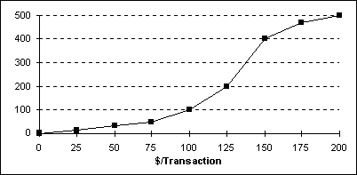

The total number of sales transactions on Saturday was ___.

a) 200

b) 500

c) 300

d) 100

e) 400

Answer: b

Difficulty: Medium

Learning Objective: Describe and construct different types of quantitative data graphs, including histograms, frequency polygons, ogives, and stem and leaf plots. Explain when these graphs should be used.

Section Reference: 2.2 Quantitative Data Graphs

Blooms: Comprehension

AACSB: Analytic

59. Each day, the office staff at Oasis Quick Shop prepares a frequency distribution and an ogive of sales transactions by dollar value of the transactions. Saturday's cumulative frequency ogive follows:



The percentage of sales transactions on Saturday that were under $100 each was ___.

a) 100

b) 10

c) 80

d) 20

e) 15

Answer: d

Difficulty: Medium

Learning Objective: Describe and construct different types of quantitative data graphs, including histograms, frequency polygons, ogives, and stem and leaf plots. Explain when these graphs should be used.

Section Reference: 2.2 Quantitative Data Graphs

Blooms: Application

AACSB: Analytic

60. Each day, the office staff at Oasis Quick Shop prepares a frequency distribution and an ogive of sales transactions by dollar value of the transactions. Saturday's cumulative frequency ogive follows:



The percentage of sales transactions on Saturday that were at least $100 each was ___.

a) 100%

b) 10%

c) 80%

d) 20%

e) 15%

Answer: c

Difficulty: Medium

Learning Objective: Describe and construct different types of quantitative data graphs, including histograms, frequency polygons, ogives, and stem and leaf plots. Explain when these graphs should be used.

Section Reference: 2.2 Quantitative Data Graphs

Blooms: Application

AACSB: Analytic

61. Each day, the office staff at Oasis Quick Shop prepares a frequency distribution and an ogive of sales transactions by dollar value of the transactions. Saturday's cumulative frequency ogive follows:



The percentage of sales transactions on Saturday that were between $100 and $150 was ___.

a) 20%

b) 40%

c) 60%

d) 80%

e) 10%

Answer: c

Difficulty: Hard

Learning Objective: Describe and construct different types of quantitative data graphs, including histograms, frequency polygons, ogives, and stem and leaf plots. Explain when these graphs should be used.

Section Reference: 2.2 Quantitative Data Graphs

Blooms: Application

AACSB: Analytic

62. Each day, the office staff at Oasis Quick Shop prepares a frequency distribution and a histogram of sales transactions by dollar value of the transactions. Friday's histogram follows:

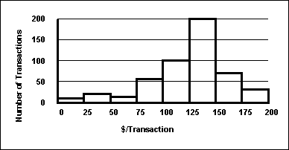

On Friday, the approximate number of sales transactions in the 125–under 150 category was ___.

a) 50

b) 100

c) 150

d) 200

e) 85

Answer: d

Difficulty: Medium

Learning Objective: Describe and construct different types of quantitative data graphs, including histograms, frequency polygons, ogives, and stem and leaf plots. Explain when these graphs should be used.

Section Reference: 2.2 Quantitative Data Graphs

Blooms: Comprehension

AACSB: Analytic

63. Each day, the office staff at Oasis Quick Shop prepares a frequency distribution and a histogram of sales transactions by dollar value of the transactions. Friday's histogram follows:



On Friday, the approximate number of sales transactions between $100 and $150 was ___.

a) 100

b) 200

c) 300

d) 400

e) 500

Answer: c

Difficulty: Medium

Learning Objective: Describe and construct different types of quantitative data graphs, including histograms, frequency polygons, ogives, and stem and leaf plots. Explain when these graphs should be used.

Section Reference: 2.2 Quantitative Data Graphs

Blooms: Comprehension

AACSB: Analytic

64. The staff of Mr. Wayne Wertz, VP of Operations at Portland Peoples Bank, prepared a cumulative frequency ogive of waiting time for walk-in customers.

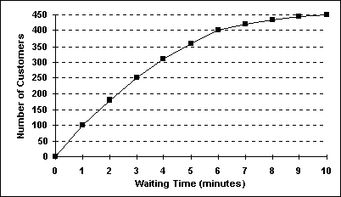

The total number of walk-in customers included in the study was ___.

a) 100

b) 250

c) 300

d) 450

e) 500

Answer: d

Difficulty: Medium

Learning Objective: Describe and construct different types of quantitative data graphs, including histograms, frequency polygons, ogives, and stem and leaf plots. Explain when these graphs should be used.

Section Reference: 2.2 Quantitative Data Graphs

Blooms: Comprehension

AACSB: Analytic

65. The staff of Mr. Wayne Wertz, VP of Operations at Portland Peoples Bank, prepared a cumulative frequency ogive of waiting time for walk-in customers.



The percentage of walk-in customers waiting one minute or less was ___.

a) 22%

b) 11%

c) 67%

d) 10%

e) 5%

Answer: a

Difficulty: Medium

Learning Objective: Describe and construct different types of quantitative data graphs, including histograms, frequency polygons, ogives, and stem and leaf plots. Explain when these graphs should be used.

Section Reference: 2.2 Quantitative Data Graphs

Blooms: Application

AACSB: Analytic

66. The staff of Mr. Wayne Wertz, VP of Operations at Portland Peoples Bank, prepared a cumulative frequency ogive of waiting time for walk-in customers.



The percentage of walk-in customers waiting more than 6 minutes was ___.

a) 22%

b) 11%

c) 67%

d) 10%

e) 75%

Answer: b

Difficulty: Medium

Learning Objective: Describe and construct different types of quantitative data graphs, including histograms, frequency polygons, ogives, and stem and leaf plots. Explain when these graphs should be used.

Section Reference: 2.2 Quantitative Data Graphs

Blooms: Application

AACSB: Analytic

67. The staff of Mr. Wayne Wertz, VP of Operations at Portland Peoples Bank, prepared a cumulative frequency ogive of waiting time for walk-in customers.



The percentage of walk-in customers waiting between 1 and 6 minutes was ___.

a) 22%

b) 11%

c) 37%

d) 10%

e) 67%

Answer: e

Difficulty: Medium

Learning Objective: Describe and construct different types of quantitative data graphs, including histograms, frequency polygons, ogives, and stem and leaf plots. Explain when these graphs should be used.

Section Reference: 2.2 Quantitative Data Graphs

Blooms: Application

AACSB: Analytic

68. The staff of Mr. Wayne Wertz, VP of Operations at Portland Peoples Bank, prepared a frequency histogram of waiting time for walk-in customers.

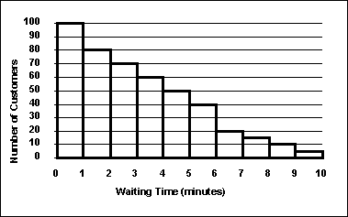

Approximately ___ walk-in customers waited less than 2 minutes.

a) 20

b) 30

c) 100

d) 180

e) 200

Answer: d

Difficulty: Medium

Learning Objective: Describe and construct different types of quantitative data graphs, including histograms, frequency polygons, ogives, and stem and leaf plots. Explain when these graphs should be used.

Section Reference: 2.2 Quantitative Data Graphs

Blooms: Application

AACSB: Analytic

69. The staff of Mr. Wayne Wertz, VP of Operations at Portland Peoples Bank, prepared a frequency histogram of waiting time for walk-in customers.



Approximately ___ walk-in customers waited at least 7 minutes.

a) 20

b) 30

c) 100

d) 180

e) 200

Answer: b

Difficulty: Medium

Learning Objective: Describe and construct different types of quantitative data graphs, including histograms, frequency polygons, ogives, and stem and leaf plots. Explain when these graphs should be used.

Section Reference: 2.2 Quantitative Data Graphs

Blooms: Application

AACSB: Analytic

70. The staffs of the accounting and the quality control departments rated their respective supervisor's leadership style as either (1) authoritarian or (2) participatory. Sixty-eight percent of the accounting staff rated their supervisor "authoritarian," and thirty-two percent rated him "participatory." Forty percent of the quality control staff rated their supervisor "authoritarian," and sixty percent rated her "participatory." The best graphic depiction of these data would be two ___.

a) histograms

b) frequency polygons

c) ogives

d) pie charts

e) scatter plots

Answer: d

Difficulty: Hard

Learning Objective: Describe and construct different types of quantitative data graphs, including histograms, frequency polygons, ogives, and stem and leaf plots. Explain when these graphs should be used.

Section Reference: 2.2 Quantitative Data Graphs

Blooms: Comprehension

AACSB: Reflective Thinking

71. The staff of Ms. Tamara Hill, VP of Technical Analysis at Blue Sky Brokerage, prepared a frequency histogram of market capitalization of the 937 corporations listed on the American Stock Exchange in January 2003.



Approximately ___ corporations had capitalization exceeding $200,000,000.

a) 50

b) 100

c) 700

d) 800

e) 890

Answer: b

Difficulty: Medium

Learning Objective: Describe and construct different types of quantitative data graphs, including histograms, frequency polygons, ogives, and stem and leaf plots. Explain when these graphs should be used.

Section Reference: 2.2 Quantitative Data Graphs

Blooms: Application

AACSB: Analytic

72. The staff of Ms. Tamara Hill, VP of Technical Analysis at Blue Sky Brokerage, prepared a frequency histogram of market capitalization of the 937 corporations listed on the American Stock Exchange in January 2003.



Approximately ___ corporations had capitalizations of $200,000,000 or less.

a) 50

b) 100

c) 700

d) 800

e) 900

Answer: d

Difficulty: Medium

Learning Objective: Describe and construct different types of quantitative data graphs, including histograms, frequency polygons, ogives, and stem and leaf plots. Explain when these graphs should be used.

Section Reference: 2.2 Quantitative Data Graphs

Blooms: Application

AACSB: Analytic

73. The following graphic of PCB Failures is a ___.



a) scatter Plot

b) Pareto Chart

c) pie chart

d) cumulative histogram chart

e) line diagram

Answer: b

Difficulty: Medium

Learning Objective: Describe and construct different types of qualitative data graphs, including pie charts, bar charts, and Pareto charts. Explain when these graphs should be used.

Section Reference: 2.3 Qualitative Data Graphs

Blooms: Knowledge

AACSB: Analytic

74. According to the following graphic the most common cause of PCB Failures is a ___.



a) cracked trace

b) bent pin

c) missing part

d) solder bridge

e) wrong part

Answer: a

Difficulty: Medium

Learning Objective: Describe and construct different types of qualitative data graphs, including pie charts, bar charts, and Pareto charts. Explain when these graphs should be used.

Section Reference: 2.3 Qualitative Data Graphs

Blooms: Comprehension

AACSB: Analytic

75. According to the following graphic, “Bent Pins” account for ___% of PCB Failures.



a) 10

b) 20

c) 30

d) 40

e) 50

Answer: d

Difficulty: Hard

Learning Objective: Describe and construct different types of qualitative data graphs, including pie charts, bar charts, and Pareto charts. Explain when these graphs should be used.

Section Reference: 2.3 Qualitative Data Graphs

Blooms: Comprehension

AACSB: Analytic

76. An instructor has decided to graphically represent the grades on a test. The instructor uses a plus/minus grading system (i.e. she gives grades of A-, B+, etc.). Which of the following would provide the most information for the students?

a) A histogram

b) A bar chart

c) A cumulative frequency distribution

d) A frequency distribution

e) A scatter plot

Answer: b

Difficulty: Medium

Learning Objective: Describe and construct different types of qualitative data graphs, including pie charts, bar charts, and Pareto charts. Explain when these graphs should be used.

Section Reference: 2.3 Qualitative Data Graphs

Blooms: Comprehension

AACSB: Reflective Thinking

77. The 2019 and 2020 market share data of the three competitors (A, B, and C) in an oligopolistic industry are presented in the following pie charts:

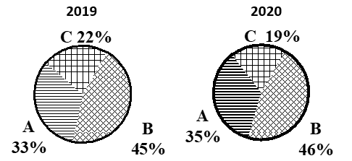

Which of the following is true?

a) Only company B gained market share.

b) Only company C lost market share.

c) Company A lost market share.

d) Company B lost market share.

e) All companies lost market share.

Answer: b

Difficulty: Hard

Learning Objective: Describe and construct different types of qualitative data graphs, including pie charts, bar charts, and Pareto charts. Explain when these graphs should be used.

Section Reference: 2.3 Qualitative Data Graphs

Blooms: Comprehension

AACSB: Analytic

78.The 2019 and 2020 market share data of the three competitors (A, B, and C) in an oligopolistic industry are presented in the following pie charts. Total sales for this industry were $1.5 billion in 2019 and $1.8 billion in 2020. Company C’s sales in 2020 were ___.



a) $342 million

b) $630 million

c) $675 million

d) $828 million

e) $928 million

Answer: a

Difficulty: Hard

Learning Objective: Describe and construct different types of qualitative data graphs, including pie charts, bar charts, and Pareto charts. Explain when these graphs should be used.

Section Reference: 2.3 Qualitative Data Graphs

Blooms: Application

AACSB: Analytic

79. The following graphic of residential housing data (selling price and size in square feet) is a ___.



a) scatter plot

b) Pareto chart

c) pie chart

d) cumulative histogram

e) cumulative frequency distribution

Answer: a

Difficulty: Medium

Learning Objective: Display and analyze two variables simultaneously using cross tabulation and scatter plots.

Section Reference: 2.4 Charts and Graphs for Two Variables

Blooms: Knowledge

AACSB: Reflective Thinking

80. The following graphic of residential housing data (selling price and size in square feet) indicates ___.



a) an inverse relation between the two variables

b) no relation between the two variables

c) a direct relation between the two variables

d) a negative exponential relation between the two variables

e) a sinusoidal relationship between the two variables

Answer: c

Difficulty: Medium

Learning Objective: Display and analyze two variables simultaneously using cross tabulation and scatter plots.

Section Reference: 2.4 Charts and Graphs for Two Variables

Blooms: Comprehension

AACSB: Analytic

81. Suppose a market survey of 200 consumers was conducted to determine the likelihood of each consumer purchasing a new computer next year. Data were collected based on the age of the consumer and are shown below:

|  |  |
| --- | --- |
| **Age Bracket** | **Intent to Purchase** |
|  | **Computer within 1 year** |
| <25 | 54 |
| 25-34 | 57 |
| 35-44 | 49 |
| 45-54 | 29 |
| >55 | 11 |
| **Total Surveyed** | **200** |

Using the table above, which of the following statements is true about the surveyed consumers?

1. More of the surveyed consumers likely to purchase a computer next year are younger.
2. More of the surveyed consumers likely to purchase a computer next year are older.
3. The surveyed consumers likely to purchase a computer are evenly distributed among the age brackets.
4. The largest group of surveyed consumers likely to purchase a new computer next year are between 25 and 34 years old.
5. None of the above statements are true.

Answer: d

Difficulty: Easy

Learning Objective: Display and analyze two variables simultaneously using cross tabulation and scatter plots.

Section Reference: 2.4 Charts and Graphs for Two Variables

Blooms: Comprehension

AACSB: Analytic

82. The following graphic of cigarettes smoked (sold) per capita (CIG) and deaths per 100K population from lung cancer (LUNG) indicates _________



a) a weak negative relationship between the two variables

b) a somewhat positive relationship between the two variables

c) when the number of cigarettes smoked (sold) per capita (CIG) increases the deaths per 100K population from lung cancer (LUNG) decreases

d) a negative relationship between the two variables

e) no relationship between the two variables

Answer: b

Difficulty: Medium

Learning Objective: Display and analyze two variables simultaneously using cross tabulation and scatter plots.

Section Reference: 2.4 Charts and Graphs for Two Variables

Blooms: Comprehension

AACSB: Analytic

83. A retail shoe company would like to consider key elements that might impact the sales related a specific store’s location in the town. If placed on a scatter plot, which two variables would be helpful in helping management with this information?

a) Sales and weather

b) Sales and square footage

c) Sales and nearest grocery store

d) Sales and average age of customers

e) Sales and nearest shopping mall

Answer: e

Difficulty: Medium

Learning Objective: Display and analyze two variables simultaneously using cross tabulation and scatter plots.

Section Reference: 2.4 Charts and Graphs for Two Variables

Blooms: Comprehension

AACSB: Reflective Thinking

84. If both variables being analyzed are nominal data, the best method to reveal any potential connections between them would be with a __________.

a) bar chart

b) scatter plot

c) cross tabulation

d) two pie charts

e) line graphs

Answer: c

Difficulty: Medium

Learning Objective: Display and analyze two variables simultaneously using cross tabulation and scatter plots.

Section Reference: 2.4 Charts and Graphs for Two Variables

Blooms: Knowledge

AACSB: Reflective Thinking

85. Two other names for cross tabulations are ____________ and ____________.

a) frequencies, contingency tables

b) contingency tables, pivot tables

c) scatter tables, pivot tables

d) cross plots, frequencies

e) Pareto charts, cross plots

Answer: b

Difficulty: Medium

Learning Objective: Display and analyze two variables simultaneously using cross tabulation and scatter plots.

Section Reference: 2.4 Charts and Graphs for Two Variables

Blooms: Knowledge

AACSB: Reflective Thinking

86. The following time-series data shows the average number of vacation days taken each year by employees.

2010 22

2011 25

2012 26

2013 29

2014 24

2015 21

2016 22

2017 20

2018 19

Which of the following would be indicated if these data were shown through a visualization of these data?

a) The average increased with each year shown.

b) The average increased and then generally decreased during these years.

c) The average decreased with each year shown.

d) The average was highest in 2012 then declined since then.

e) The average was lowest in 2015 and increased since then.

Answer: b

Difficulty: Medium

Learning objective: Describe and construct a time-series graph. Visually identify any trends in the data.

Section Reference: 2.5 Visualizing Time-Series Data

Blooms: Comprehension

AACSB: Analytic

87. The following time-series data shows the average number of vacation days taken each year by employees.

2010 22

2011 25

2012 26

2013 29

2014 24

2015 21

2016 22

2017 20

2018 19

The most effective visualization of these data would be:

a) a pie chart going chronologically clockwise.

b) a bar chart with most recent year to the left.

c) a line chart with most recent year to the right.

d) a bar chart with the highest average to the left

e) a line chart with the highest average to the right.

Answer: c

Difficulty: Medium

Learning objective: Describe and construct a time-series graph. Visually identify any trends in the data.

Section Reference: 2.5 Visualizing Time-Series Data

Blooms: Knowledge

AACSB: Reflective Thinking

88. A shirt production company has tracked their production since the company started in 1999. The graph of their annual production is shown.

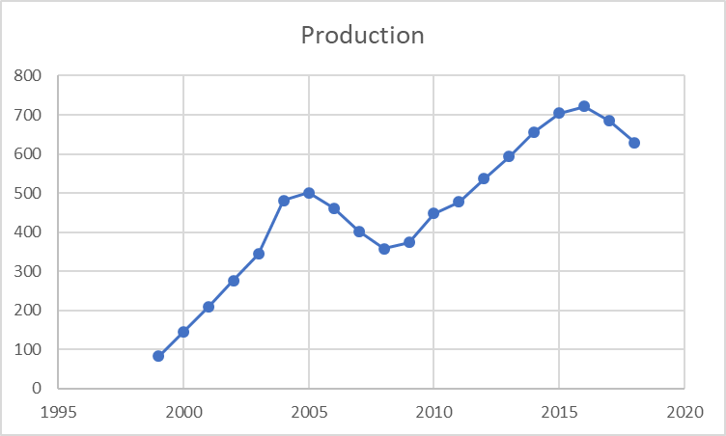

During these years, production has generally _______________.

a) increased in these years.

b) declined in most of the years shown.

c) increased in every year since 1999.

d) decreased in most of those years.

e) increased and declined without a discernable trend.

Answer: a

Difficulty: Medium

Learning objective: Describe and construct a time-series graph. Visually identify any trends in the data.

Section Reference: 2.5 Visualizing Time-Series Data

Blooms: Comprehension

AACSB: Analytic

89. A shirt production company has tracked their production since the company started in 1999. The graph of their annual production is shown.



After 2005, in what year did production recover and surpass the production level of 2005?

a) 2006

b) 2009

c) 2010

d) 2012

e) 2013

Answer: d

Difficulty: Medium

Learning objective: Describe and construct a time-series graph. Visually identify any trends in the data.

Section Reference: 2.5 Visualizing Time-Series Data

Blooms: Comprehension

AACSB: Analytic

90. To show hourly sales throughout a day, a ________ chart would be most effective, and a _________ chart would be more effective at showing what products were sold during that day.

a) pie, line

b) line, line

c) pie, bar

d) line, pie

e) bar, pie

Answer: d

Difficulty: Medium

Learning objective: Describe and construct a time-series graph. Visually identify any trends in the data.

Section Reference: 2.5 Visualizing Time-Series Data

Blooms: Knowledge

AACSB: Reflective Thinking

91. A shirt production company has tracked their production and expenses since the company started in 1999. The graph of both is shown.

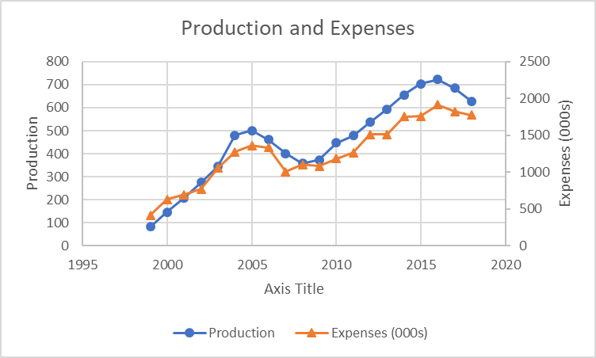

When comparing production and expenses during these years, what conclusion is not true?

a) Both series are generally decreasing.

b) Both series are generally increasing.

c) The time from 2005 to 2008 indicates a downward trend for both

d) The time from 2008 to 2018 indicates an upward trend for both

e) Expenses and production appear to follow similar trends

Answer: a

Difficulty: Medium

Learning objective: Describe and construct a time-series graph. Visually identify any trends in the data.

Section Reference: 2.5 Visualizing Time-Series Data

Blooms: Comprehension

AACSB: Analytic

92. A shirt production company has tracked their sales of red and blue shirts over the past few years. The graph of both is shown below.

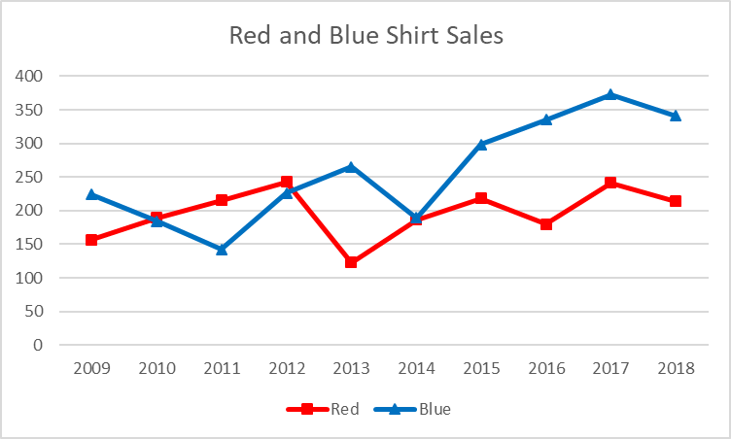

Which of the following is a true statement about the trends in sales?

a) Sales of red shirts are less than those of blue shirts in all the years before 2012.

b) Sales of blue shirts are trending upward from 2014 to 2017.

c) Sales of blue shirts are always higher than those of red shirts.

d) Red shirt sales show an increasing trend.

e) Sales of red shirts are always higher than those of blue shirts.

Answer: b

Difficulty: Medium

Learning objective: Describe and construct a time-series graph. Visually identify any trends in the data.

Section Reference: 2.5 Visualizing Time-Series Data

Blooms: Comprehension

AACSB: Analytic

93. Sales are tracked during the past year in the graph below.

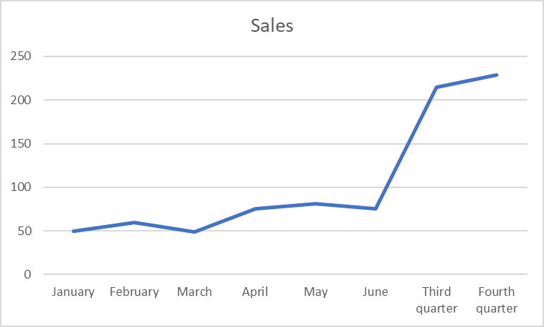

Management is pleased to see the growth in sales at the end of the year. Why would this be an incorrect conclusion?

a) The highest growth was in the month of June

b) Cannot compare sales for different time periods

c) The graph is not showing growth rates

d) A bar graph would be more effective in determining that conclusion

e) A second year of data would be needed to make that conclusion

Answer: b

Difficulty: Medium

Learning objective: Describe and construct a time-series graph. Visually identify any trends in the data.

Section Reference: 2.5 Visualizing Time-Series Data

Blooms: Comprehension

AACSB: Analytic

94. Sales are tracked during the past year in the graph below.

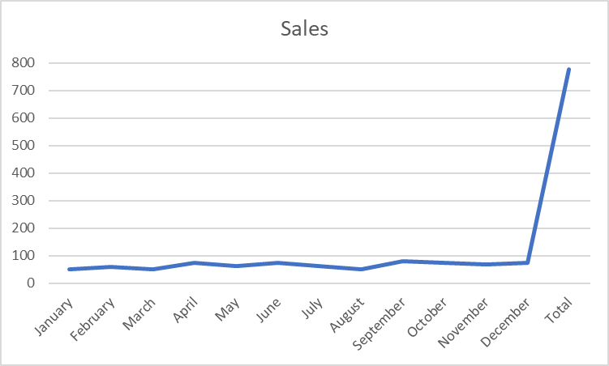

What would be the most effective strategy to allow management to more clearly discern monthly trends in sales?

a) Remove the total value from being included in the graph.

b) Have the axis on the left show more detailed grid lines between 0 and 100

c) Show the trend line in a more vivid color.

d) Add labels to each of the graphed data points.

e) Add minor grid lines throughout the graph making values more clear.

Answer: a

Difficulty: Medium

Learning objective: Describe and construct a time-series graph. Visually identify any trends in the data.

Section Reference: 2.5 Visualizing Time-Series Data

Blooms: Comprehension

AACSB: Analytic

95. Monthly sales were tracked and shown on the graph below.

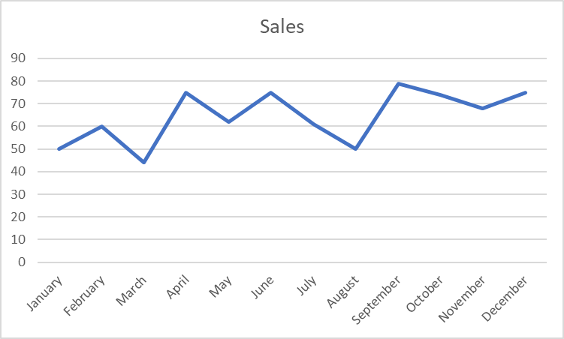

Which of the following would be an incorrect conclusion based on this graph?

a) Sales were lowest in the month of March.

b) Sales increased between August and September.

c) The last month had higher sales than the first month.

d) Sales declined from June through August.

e) The last month had higher sales than September.

Answer: e

Difficulty: Medium

Learning objective: Describe and construct a time-series graph. Visually identify any trends in the data.

Section Reference: 2.5 Visualizing Time-Series Data

Blooms: Comprehension

AACSB: Analytic

**LEGAL NOTICE**

Copyright © 2020 by John Wiley & Sons Canada, Ltd. or related companies. All rights reserved.

Description: cid:image003.jpg@01CD4AF3.E17BD5B0

The data contained in these files are protected by copyright. This manual is furnished under licence and may be used only in accordance with the terms of such licence.

The material provided herein may not be downloaded, reproduced, stored in a retrieval system, modified, made available on a network, used to create derivative works, or transmitted in any form or by any means, electronic, mechanical, photocopying, recording, scanning, or otherwise without the prior written permission of John Wiley & Sons Canada, Ltd.