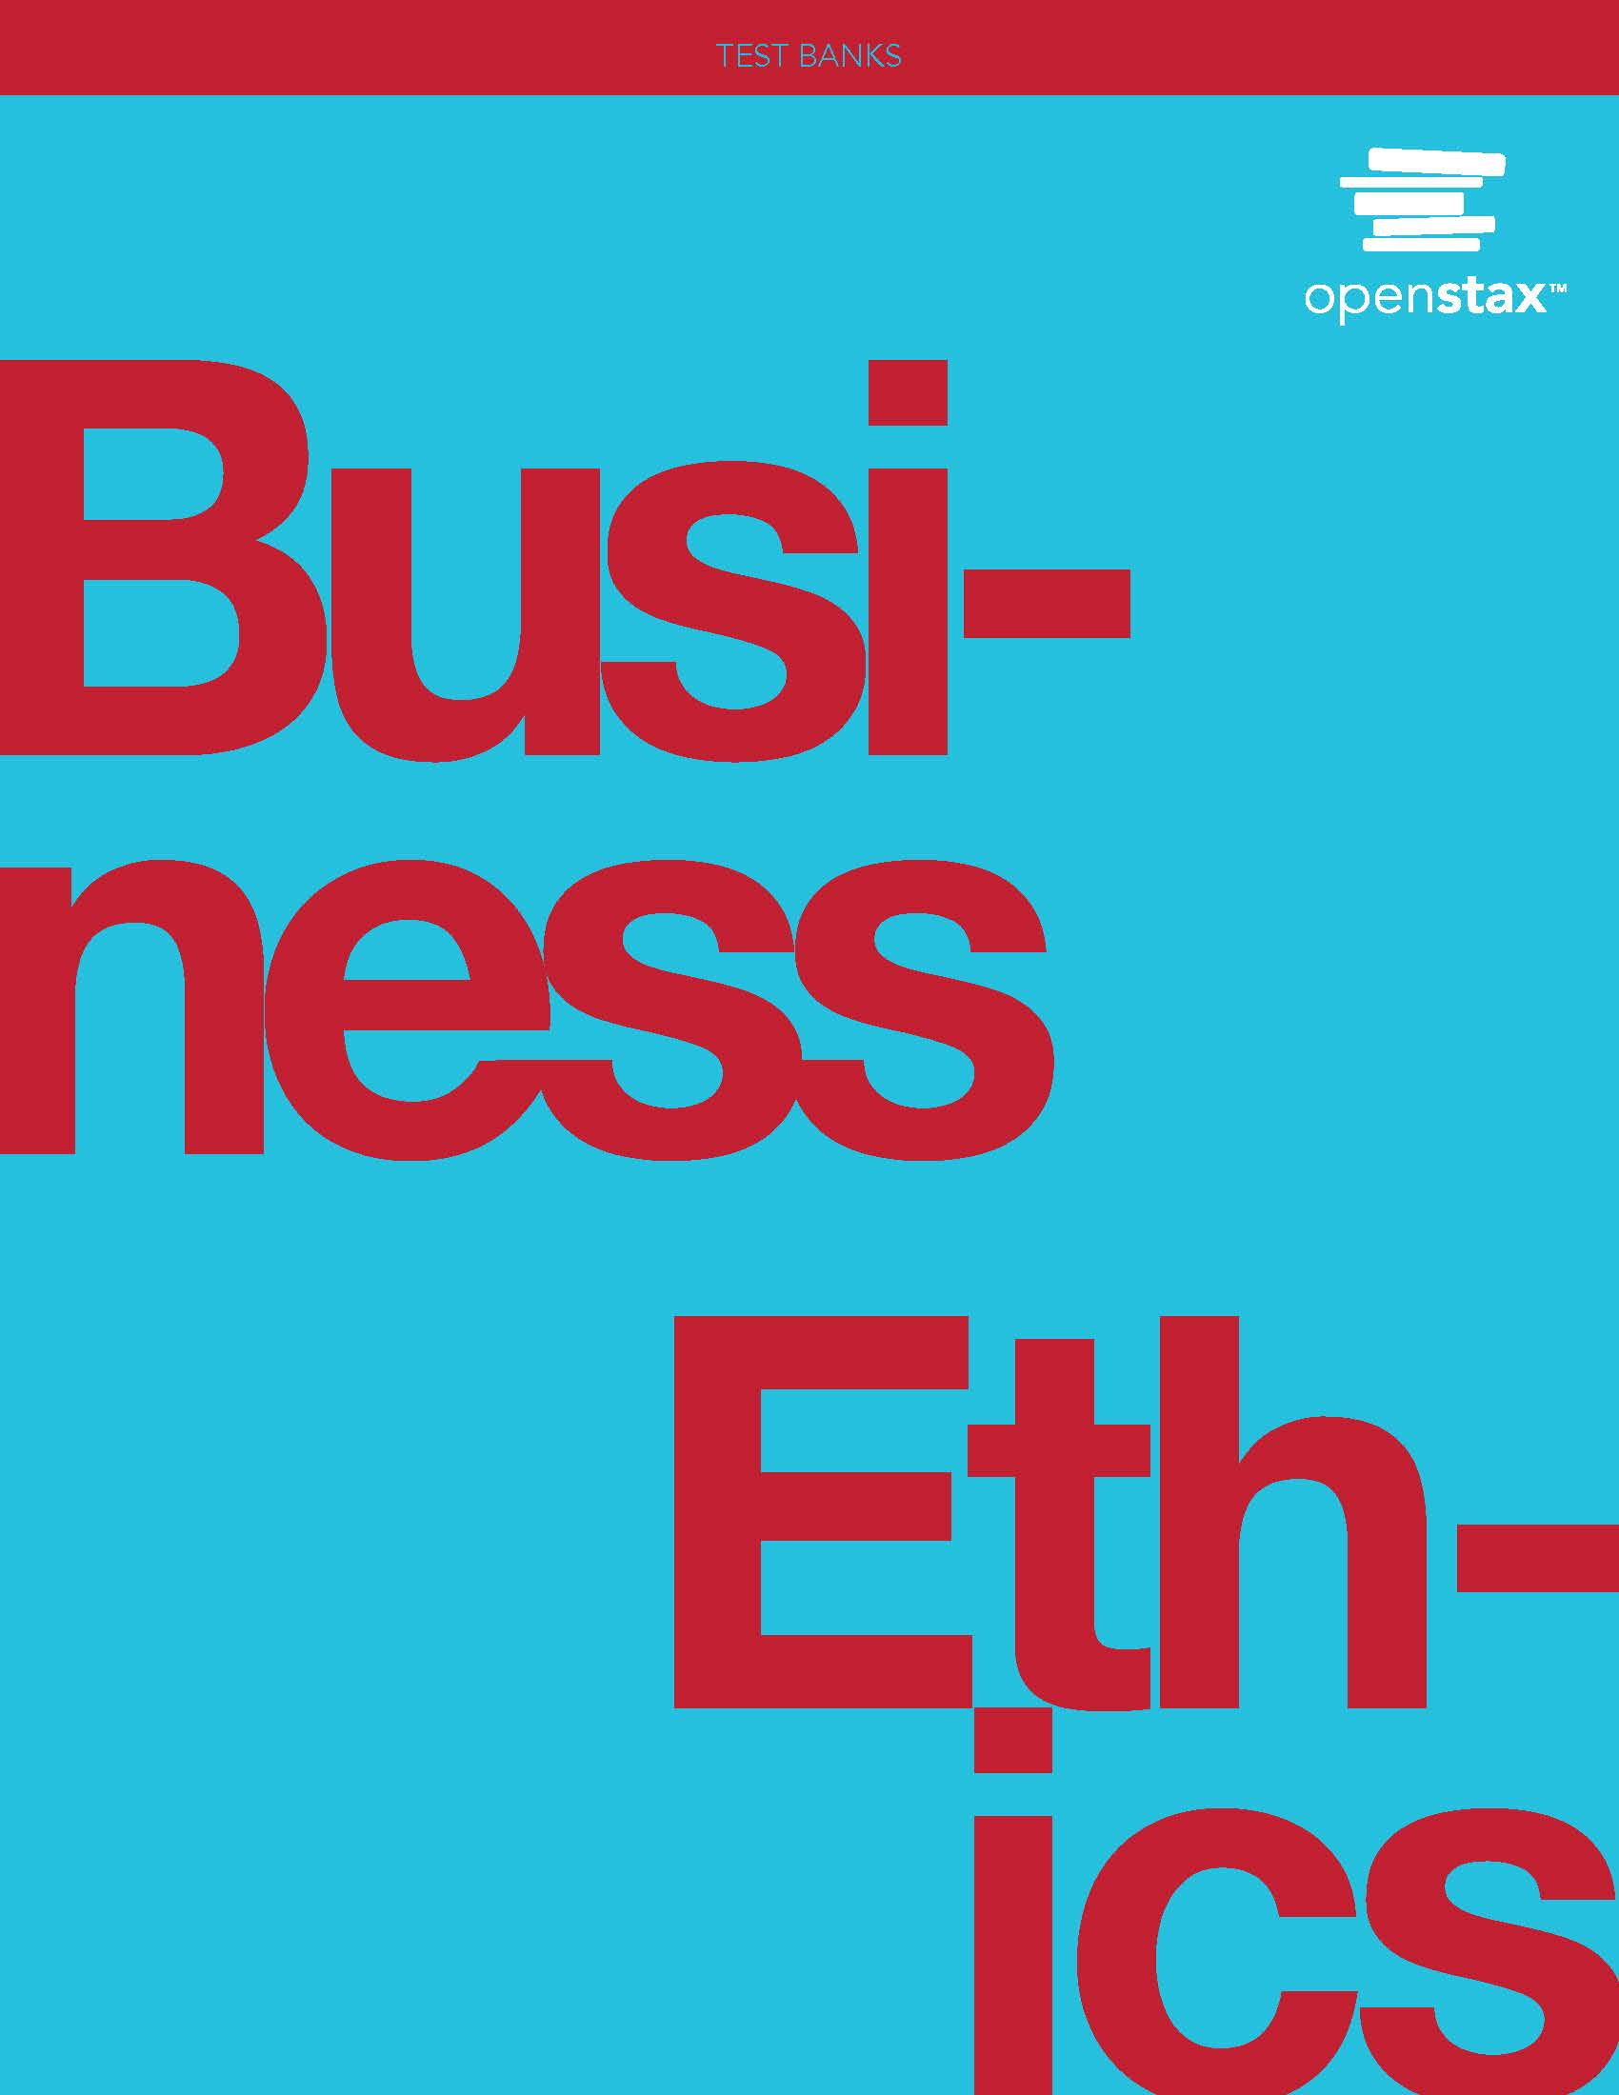

**Chapter 1: Why Ethics Matters**

**\* = Correct answer**

**Multiple Choice/Fill in the Blank**

1. Which of the following is the *best* description for what it means to be a professional of integrity?

A. following the investment style of Warren Buffet

B. thinking long term when investing

C. having an ethical mindset in business*

D. ensuring employee happiness

Difficulty: Easy

Blooms: Understand

AACSB: Ethics, Reflection, Diversity

1. Which of the following companies is considered ethical, according to the chapter?

A. Samsung

B. Kia

C. Au Bon Pain

D. Marriott*

Difficulty: Moderate

Blooms: Application

AACSB: Ethics, Diversity, Real-world

1. What is the *golden mean*?

A. treating every person the same

B. the aim of ethical behavior

C. a middle ground value between deficiency and excess*

D. justice as fairness

Difficulty: Moderate

Blooms: Analyze

AACSB: Ethics, Analytical, Application

1. Which of the following is an example of demonstrating ethical standards?

A. eudaimonia

B. consequentialism*

C. junzi

D. categorical imperative

Difficulty: Moderate

Blooms: Remember, Understand

AACSB: Application

1. What is ethics?

A. standards of behavior for professional and personal lives*

B. standards of behavior for business only

C. someone who is acting empathetic

D. setting norms for ways one interacts only with coworkers

Difficulty: Moderate

Blooms: Understand

AACSB: Ethics

1. Why do businesses care about ethics?

A. to gain greater wealth and power

B. to follow fiduciary duty

C. to uphold honorable standards of behavior*

D. to receive status and recognition

Difficulty: Moderate

Blooms: Analyze

AACSB: Ethics, Analytical

1. Which of the following *best* describes the role of ethics in a business environment?

A. guiding the conduct by which companies abide by the law

B. respecting the right of shareholders

C. guiding the conduct by which companies and their agents abide by the law*

D. respecting the community

Difficulty: Moderate

Blooms: Evaluate

AACSB: Reflection, Real-world

1. Are ethical and legal responsibilities the same?

A. Yes, they are the same standards of behavior and must be followed.

B. No, legal standards are necessary for a properly functioning society, and ethics deals with voluntary business conduct in accordance with laws, statutes, regulations, and policies.*

C. No, because law is always superior to ethics.

D. Yes, because companies have duties of legal and ethical responsibility to assert right or wrong.

Difficulty: Difficult

Blooms: Apply

AACSB: Ethics, Analytical, Application

1. How does Patagonia exemplify ethics?

A. being a market leader in outdoor gear

B. caring about its employees by giving them a large discount for friends and family

C. supporting sustainability with a recycling initiative in all retail stores and warehouses

D. instituting a “1% for the Planet” program that promotes environmentalism*

Difficulty: Moderate

Blooms: Evaluate

AACSB: Diversity, Reflection, Application, Real-world

1. Normative ethics means ________.

A. discovering right and not focusing on wrong

B. discovering right and delineating it from wrong*

C. developing rules and norms for corporate decision-making only

D. developing rules or norms for the greatest good for the greatest number

Difficulty: Moderate

Blooms: Evaluate

AACSB: Ethics, Analytical, Application

1. What does deontology mean?

A. Conduct is determined by a philosophical process focused on Kantian religious teaching.

B. Ethics is a duty we owe to others.*

C. Means justify the ends.

D. The means are the process driver for ancient Roman analytical thinking.

Difficulty: Moderate

Blooms: Apply

AACSB: Ethics, Analytical, Application

1. Adopting a consistent ethical standard is ________.

A. not in a manager’s best interests

B. selfless*

C. in a government’s best interest

D. selfish

Difficulty: Moderate

Blooms: Evaluate

AACSB: Ethics, Analytical, Application

1. What characteristics contribute to the bottom line? (Select all that apply.)

A. funding philanthropy and charitable endeavors*

B. sustainability, also known as “going green”*

C. always giving a dividend to your shareholders

D. taking an interest in employees’ personal lives*

Difficulty: Moderate

Blooms: Evaluate

AACSB: Ethics, Analytical, Application

1. Which personal philosophical approach does Warren Buffet believe in?

A. You can lose money for your firm.

B. Think short term.

C. Invest in yourself.*

D. What matters is how much money you make.

Difficulty: Easy

Blooms: Analyze

AACSB: Ethics, Reflection

1. An analysis of perceived priority of shareholder impact should include which of the following?

A. stakeholders in reverse order of perceived priority

B. largest stakeholders by affiliation

C. interests and goals of shareholders*

D. impact of action or decision of management

Difficulty: Easy

Blooms: Apply

AACSB: Analytical, Application, Real-world

1. Which company attributes increase in value as stakeholders view that company in a positive light? (Select allthat apply.)

A. stock price

B. company name or logo*

C. competition

D. trademark*

Difficulty: Moderate

Blooms: Apply

AACSB: Real-world, Application

1. Which elements constitute corporate culture?

A. shared focus on the environment

B. shared profit of stakeholders

C. how the CEO interacts with his or her employees and managers*

D. how the CEO compensates his or her employees and managers

Difficulty: Moderate

Blooms: Analyze

AACSB: Application, Real-world, Interpersonal

1. Positive goodwill ________. (Select all that apply.)

A. is generated by ethical business practices*

B. is separate from profitability

C. yields better public relations

D. generates long-term business success*

Difficulty: Easy

Blooms: Remember

AACSB: Analytical

1. An ethical financial advisor must ________.

A. donate to charitable causes

B. be truthful about all fees*

C. focus only on potential profit to clients

D. have the same fees as other financial advisors

Difficulty: Moderate

Blooms: Apply

AACSB: Application, Real-world

1. How was management in the Equifax data breach case held accountable?

A. The chief information officer resigned.

B. Hackers accessed information because of insider trading.

C. Customers were offered free Equifax services.

D. The chief executive officer left the firm after he testified before Congress.*

Difficulty: Moderate

Blooms: Understand

AACSB: Application, Real-world

1. Which of the following *most likely* contributes to a corporation’s positive work atmosphere over the long term?

A. having remote working policies for employees

B. treating suppliers fairly

C. engaging in cross-border business

D. being committed to ethical business practices*

Difficulty: Difficult

Blooms: Evaluate

AACSB: Ethics, Diversity, Application, Real-world

1. What is the *best* reason for a universal ethical standard?

A. It is good business practice.

B. It is easier to apply for business leaders.

C. It provides transparency in application.*

D. Having different rules is confusing to employees.

Difficulty: Moderate

Blooms: Analyze

AACSB: Reflection, Ethics

1. Which are the universal principles of behavior?

A. honesty and integrity*

B. virtue ethics and utilitarianism

C. loyalty to management

D. respect for business diversity

Difficulty: Moderate

Blooms: Apply

AACSB: Ethics

1. What did Milton Friedman believe?

A. A business should promote social consciousness.

B. The responsibility of a business is to decrease profits.

C. The only responsibility of a business is to increase profits.*

D. One of the drivers of a business is to increase publicity.

Difficulty: Easy

Blooms: Understand

AACSB: Analytical

1. Which is a characteristic of successful corporate leaders?

A. They will not take pride in their company unless it is profitable.

B. They are focused on short-term results.

C. They treat customers fairly.*

D. They take a competitive, though not always fair, approach to business.

Difficulty: Easy

Blooms: Apply

AACSB: Reflection, Application

1. Why is ethical relativism a good concept to adopt? (Select all that apply.)

A. We should use different standards for different contexts.*

B. Friends and family should be treated differently than coworkers.

C. One does not want an inconsistent outcome.*

D. Our reputation could increase.

Difficulty: Moderate

Blooms: Apply

AACSB: Interpersonal, Analytical, Application

**True/False**

1. True or false? Employees consider whether a company is ethical when selecting potential employers.

Answer: True

Difficulty: Easy

Blooms: Understand

AACSB: Reflection, Ethics

1. True or false? The environment is not considered a stakeholder.

Answer: False

Difficulty: Easy

Blooms: Remember

AACSB: Ethics, Application, Real-world

1. True or false? Consumer feedback on social media sites does not affect a company’s prospects or status as ethical.

Answer: False

Difficulty: Moderate

Blooms: Apply

AACSB: Application, Real-world

1. True or false? The Forbes list of ethical companies is based on the publication’s own research rather than a governmental standard.

Answer: True

Difficulty: Easy

Blooms: Remember

AACSB: Application, Real-world

1. True or false? Phronesis is a practical wisdom that enables us to act virtuously.

Answer: True

Difficulty: Moderate

Blooms: Remember

AACSB: Ethics

1. True or false? Goodwill only applies to shareholders, and it is the amount of money a shareholder could make after selling a holding in a company.

Answer: False

Difficulty: Moderate

Blooms: Apply

AACSB: Application

1. True or false? The business practice of Toyota was deemed ethical when it started to sell cars in the United States in the 1950s.

Answer: True

Difficulty: Moderate

Blooms: Understand

AACSB: Ethics, Application, Real-world

1. True or false? Most admired companies are typically the least profitable.

Answer: False

Difficulty: Easy

Blooms: Remember

AACSB: Application, Real-world

1. True or false? The prevailing current business philosophy is that the sole purpose of business is to make money for shareholders.

Answer: False

Difficulty: Moderate

Blooms: Understand

AACSB: Application, Real-world

**Short Answer**

1. Provide five examples of stakeholders.

Sample Answer: customers, media, suppliers, community, government, and shareholders

Difficulty: Easy

Blooms: Apply

AACSB: Application, Diversity

1. What motivated Mark Faris to be a white-collar criminal? How does he think such crimes could be addressed?

Sample Answer: Mr. Faris admitted that greed, arrogance, and ambition compelled him to become a white-collar criminal. He committed mail and wire fraud, as well as money laundering, and spent almost a year in a federal prison. In his speaking engagements, he proposes solutions such as ethical leadership, personal accountability, and corporate employee training.

Difficulty: Moderate

Blooms: Remember

AACSB: Ethics, Application, Real-world

1. How are stockholders also stakeholders? Explain your answer.

Sample Answer: Stockholders (who own equity shares of a company) are one of the categories of stakeholders, which also include employees, management, customers, suppliers, the environment, and the community, to name a few.

Difficulty: Easy

Blooms: Analyze

AACSB: Application, Ethics

1. What is compliance, and how is does it operate?

Sample Answer: Compliance in terms of business ethics refers to the extent to which a company conducts its business operations in accordance with applicable laws, regulations, standards, and policies. Many companies have a compliance department that is responsible for establishing policies and procedures that are reasonably designed to prevent violations of law, regulations, and corporate policy. Some of these companies have compliance officers and codes of conduct, and implement compliance training and oversight.

Difficulty: Moderate

Blooms: Evaluate

AACSB: Ethics, Application, Real-world

1. Explain the concept of corporate social responsibility. Provide at least threeexamples of companies that follow CSR.

Sample Answer: The nation’s most admired (ethical) companies are among those with the highest profit margins. Consumers want to use companies that care for others and the environment. Many unethical companies went bankrupt in 2008 and 2009. Examples of companies that follow CSR and are mentioned in the chapter include Berkshire Hathaway, Marriott, Nokia, illycaffè, and Toyota.

Difficulty: Moderate

Blooms: Evaluate

AACSB: Application, Real-world

1. Explain how a company enters into a social contract with its stakeholders. Be sure to address the reciprocity of society and companies.

Sample Answer: A company enters into a social contract with society as a whole. It is an implicit agreement among all members to cooperate for social benefits. A company must acknowledge that all society will be affected to some extent by its operations. In return for society’s permission to incorporate and engage in business, a company owes a reciprocal obligation to do what is best for as many of society’s members as possible, regardless of whether they are shareholders. Therefore, when applied specifically to a business, the social contract implies that a company gives back to the society that permits it to exist, benefiting the community at the same time it enriches itself.

Difficulty: Difficult

Blooms: Apply

AACSB: Ethics, Application

1. What happened in the Bradley Birkenfeld case, and how does that relate to whistleblowing? Comment on the irony of the award.

Sample Answer: Former UBS (Switzerland’s largest bank) employee Bradley Birkenfeld received a $104 million whistleblowing reward from the US Internal Revenue Service. While employed at UBS, Birkenfeld assisted in the company’s illegal offshore tax business and he later served over three years in prison for conspiracy. He was, however, also the original source of incriminating information that included the account information of more than four thousand US private clients. That disclosure led to a Federal Bureau of Investigation examination of UBS and the subsequent decision of the US government to impose a $780 million fine on UBS in 2009.

Difficulty: Moderate

Blooms: Remember

AACSB: Reflection, Real-world, Application

1. Who is Warren Buffet, and what is he known for in the business world?

Sample Answer: Warren Buffet, founder of Berkshire Hathaway, is considered one of the most successful investors of all time and an ethical leader. He is an exemplar of business excellence and professional integrity. He has articulated the importance of investing in oneself. Buffet is a philanthropist who has pledged most of his wealth to social causes and he is also an advisor to presidents. He instructed managers to protect their company’s reputation.

Difficulty: Moderate

Blooms: Apply

AACSB: Ethics, Application, Real-world

1. How does TOMS Shoes exemplify corporate social responsibility?

Sample Answer: TOMS Shoes donates one shoe for every pair of shoes (and other goods and money) it sells, in order to “improve lives.” The company also provides shoe-integrated health screenings and uses shoe distribution to positively affect children, job creation, and maternal health. Shoe distribution is accomplished through partner organizations in various countries.

Difficulty: Moderate

Blooms: Evaluate

AACSB: Ethics, Application, Real-world

1. What is ethical relativism? Provide three examples.

Sample Answer: Ethical relativism is the concept that morality relates to one’s culture. What is right or wrong is based on one’s societal practices. This also means an action can be ethical in one culture or country but unethical in another. Examples include favoring the employment of relatives, which may otherwise be considered nepotism; dumping discarded waste instead of recycling; requiring overtime work for certain classes of employees as part of their job description; and stock trading based on the sharing of confidential information, which may constitute insider trading in another jurisdiction.

Difficulty: Difficult

Blooms: Evaluate

AACSB: Reflection, Ethics, Application

1. How does Immanuel Kant’s theory of being duty bound (categorical imperative) apply in a corporate setting today?

Sample Answer: Kant was an eighteenth-century philosopher who believed human beings are creatures of reason, which depends on the respect for rules, and as such, humans are duty bound to avoid contradiction and follow logical ethical principles. Kant believed one must be a moral agent acting with others’ interests in mind. He would judge a corporate act to be ethical if it benefited stockholders and company leadership at the same time as other stakeholders, without any conflicts. This is a limited view that may not be easily applicable in a business situation.

Difficulty: Moderate

Blooms: Analyze

AACSB: Application, Ethics

1. It is less ethical to take a job with a large company that is focused on sustainability and donates a significant amount of money to environmental causes than to work for a nonprofit organization that researches climate change and pays you only if you bring in a certain amount of donations. Do you agree or disagree with this statement?

Sample Answer: Ethics are part of personal decision-making in one’s personal life and business conduct. In this case, you have to determine which job will lead to a more ethical path. Working for an established company with an ethical mindset can have a more positive influence on society and stakeholders, and may be deemed more ethical than working for a company that promotes environmentalism but does not compensate you for the value of your work. Being an ethical person also means valuing your commitment to your work; being an ethical company means treating employees fairly, in line with the competitive marketplace for employment.

Difficulty: Moderate

Blooms: Evaluate

AACSB: Communication, Interpersonal, Reflection, Real-world

1. Do the concepts of deontology, virtue ethics, and utilitarianism come under a single code under normative theory or are they different?

Sample Answer: All three are normative theories of ethics. Deontology is the theory that an ethical decision requires us to observe only the rights and duties we owe to others; from a business context, it requires us to act on the basis of a primary motive to do what is right for all stakeholders. Virtue ethics focuses on proper conduct guided by the training we received growing up. Utilitarianism suggests that an ethical act is one whose consequences create the greatest good for the greatest number of people. Proponents of all the normative theories, although they have different philosophies, actually believe that there should be a single ethical standard.

Difficulty: Difficult

Blooms: Apply

AACSB: Analytical

1. What is the importance of Johnson & Johnson’s corporate code of conduct (or credo) and what does it mean?

Sample Answer: The company’s credo codifies the values that guide Johnson & Johnson’s decision-making. It is available on the company’s website, with links to the various countries where it does business. This corporate mission statement addresses accountability to various stakeholders and the importance of providing high quality products and services. It represents also a modern view of caring for employees.

Difficulty: Difficult

Blooms: Evaluate

AACSB: Ethics, Communication, Real-world

1. Is it ethical to allow a friend or relative to take advantage of an employee discount?

Sample Answer: No, it is not ethical. Employee discounts are meant for the benefit of the employee. They are part of remuneration and provided to give employees additional perquisites. Although some discounts may be labeled “for friends and family,” those are typically part of a specific promotion for marketing purposes. It would be dishonest for an employee to use a discount that is only meant for them, to benefit a friend or family member. This does not mean that employees cannot buy gifts. However, an employee would likely be acting unethically if they gave, without authorization, an employer-provided discount card or coupon to a friend or family member, because such a benefit is typically not transferrable.

Difficulty: Moderate

Blooms: Evaluate

AACSB: Interpersonal, Ethics, Reflection, Application

This file is copyright 2019, Rice University. All Rights Reserved.