Biology: A Guide to the Natural World, 5e (Krogh)
Chapter 1 Science as a Way of Learning: A Guide to the Natural World

1) What invention by Bell Labs in 1947 brought about modern electronics?
A) the invention of software
B) the invention of the transistor
C) the invention of the CD
D) the invention of the computer
Answer: B
Topic: Section 1.1
Skill: Knowledge/Comprehension

2) Science presents society with ________, about which society then makes decisions.
A) values
B) theories
C) options
D) worst-case scenarios
Answer: C
Topic: Section 1.1
Skill: Knowledge/Comprehension

3) Because scientists are in the business of investigating nature, scientists function as:
A) society's eyes and ears on the natural world.
B) political advisors.
C) authorities on the natural world.
D) protectors of the natural world.
Answer: A
Topic: Section 1.1
Skill: Knowledge/Comprehension

4) Which of the following is at the root cause for all cancers?
A) antibiotic resistance
B) obesity
C) the normal cell division process
D) a breakdown of the cell division process
Answer: D
Topic: Section 1.1
Skill: Knowledge/Comprehension

5) Which of the following is true?
A) A scientific theory is a hunch about a natural event.
B) A scientific fact and a scientific theory carry the same weight in the scientific community.
C) A scientific theory explains what we know to this date about a natural event.
D) A scientific theory is the final answer to a question about a natural event.
Answer: C
Topic: Section 1.2
Skill: Application/Analysis
6) Choose the answer that best describes the sequence of the scientific method.
A) experiment, observation, hypothesis, conclusion
B) hypothesis, experiment, observation, conclusion
C) guess, hypothesis, experiment, conclusion
D) observation, hypothesis, experiment, absolute fact
E) observation, hypothesis, experiment, conclusion
Answer: E
Topic: Section 1.2
Skill: Application/Analysis

7) The role of a control in an experiment is to:
A) prove a hypothesis is correct.
B) ensure the experiment can be repeated.
C) prove that a hypothesis is correct and ensure repeatability.
D) provide a basis of comparison to an experimental group.
Answer: D
Topic: Section 1.2
Skill: Application/Analysis

8) We use the scientific method every day. Imagine your car doesn't start one morning before school. Which of these is a reasonable hypothesis regarding the problem?
A) I'm going to be late.
B) I'm out of gas.
C) Check to see whether your lights were left on all night.
D) Add a quart of oil.
Answer: B
Topic: Section 1.2
Skill: Application/Analysis

9) A scientific explanation that is tentative and testable is termed a/an:
A) hypothesis.
B) theory.
C) fact.
D) control.
E) observation.
Answer: A
Topic: Section 1.2
Skill: Knowledge/Comprehension

10) Which of the following is a theory?
A) There is molecular and biochemical evidence that all organisms are related.
B) Many people believe echinacea cures their colds.
C) A boy finds a chipped rock he believes is an arrowhead.
D) Many people claim that the Earth is only 6,000 years old.
Answer: A
Topic: Section 1.2
Skill: Application/Analysis
11) The difference between a theory and a hypothesis is that a:
A) theory must be proven beyond a shadow of a doubt.
B) hypothesis must be proven beyond a shadow of a doubt.
C) hypothesis must be supported by evidence.
D) theory must be supported by evidence.
Answer: D
Topic: Section 1.2
Skill: Application/Analysis

12) Which scientist disproved the theory of spontaneous generation?
A) Einstein
B) Watson
C) Pauling
D) Crick
E) Pasteur
Answer: E
Topic: Section 1.2
Skill: Knowledge/Comprehension

13) A scientific finding is believed to be true until new evidence arises. This view is referred to as:
A) provisional assent.
B) immutable laws.
C) a theory.
D) a supernatural explanation.
Answer: A
Topic: Section 1.2
Skill: Knowledge/Comprehension

14) A good hypothesis must:
A) be falsifiable.
B) be false.
C) be theoretical.
D) lead to a question.
E) be true.
Answer: A
Topic: Section 1.2
Skill: Application/Analysis

15) If you flip the light switch in your living room and nothing happens, what might be a good hypothesis to explain the absence of light?
A) Electricity sometimes flows backward in a wire, preventing the light from shining.
B) The circuit breaker for the living room might be the "off" position.
C) You might have made too many telephone calls this month, thereby reducing the amount of electricity in your lines.
D) The air conditioner is also running upstairs, and it might be using all of the electricity available in your house at the moment.
Answer: B
Topic: Section 1.2
Skill: Application/Analysis
16) Which one of the following is true about scientific knowledge?
A) Scientific knowledge is derived from careful thinking about the way things must work based on application of a few fundamental principles.
B) When based on many experiments, scientific knowledge is absolutely true.
C) Scientific knowledge is acquired though teachings passed on by great scientists.
D) Scientific knowledge is not absolute, because the possibility is always held open that new experiments may one day prove it wrong.
E) Scientific knowledge is derived from the strongest arguments made by the brightest scientists.
Answer: D
Topic: Section 1.2
Skill: Application/Analysis

17) When Pasteur tested the hypothesis of spontaneous generation, he compared the ability of a sterilized growth medium (meat broth) to produce a population of bacteria in two different types of flasks. One had a simple neck open to the outside, and the other had a "goose neck" bend that also was open to the environment. Pasteur expected that bacteria would appear in the flask with the standard neck. In this experiment, the standard neck flask served as a/an:
A) observation.
B) variable.
C) control.
D) statistic.
E) hypothesis.
Answer: C
Topic: Section 1.2
Skill: Application/Analysis

18) The questions that can be answered by science are:
A) limited by religious doctrine.
B) without limit.
C) limited by what can be investigated using the scientific method.
D) limited by what is found in the living world.
E) limited only by imagination.
Answer: C
Topic: Section 1.2
Skill: Application/Analysis

19) Which of the following is the most complex level of organization?
A) a heart
B) a water molecule
C) a rainforest
D) the circulatory system
Answer: C
Topic: Section 1.3
Skill: Application/Analysis
20) A tree in your backyard is home to robins, squirrels, beetles, and lichens. Together all these organisms compose a/an:
A) biosphere.
B) organism.
C) population.
D) community.
E) niche.
Answer: D
Topic: Section 1.3
Skill: Application/Analysis

21) Living things inherit information from their parents encoded in:
A) fats.
B) atoms.
C) proteins.
D) DNA.
Answer: D
Topic: Section 1.3
Skill: Knowledge/Comprehension

22) The liver releases glucose into the bloodstream if you don't eat for a long time. This represents an example of a characteristic possessed by all living things. Which is it?
A) being composed of cells
B) being able to reproduce
C) possessing an inherited information base
D) maintaining a relatively constant internal environment
Answer: D
Topic: Section 1.3
Skill: Application/Analysis

23) Which of the following is the correct order of complexity, going from least to most complex?
A) atom, molecule, organelle, cell, tissue, organ
B) organ, tissue, cell, organelle, atom, molecule
C) organ, tissue, cell, organelle, molecule, atom
D) molecule, atom, organ, tissue, cell, organelle
E) atom, molecule, organelle, cell, organ, tissue
Answer: A
Topic: Section 1.3
Skill: Application/Analysis

24) Organelles are:
A) cells.
B) organisms.
C) a group of cells that serve a common function.
D) like tiny organs within cells.
E) proteins.
Answer: D
Topic: Section 1.3
Skill: Knowledge/Comprehension
25) Tissues are grouped together in functional units called:
A) organelles.
B) cells.
C) organisms.
D) organs.
Answer: D
Topic: Section 1.3
Skill: Knowledge/Comprehension

26) What is the difference between a tissue and an organ system?
A) Tissues are composed of organ systems.
B) Tissues are not composed of cells, but organ systems are composed of cells.
C) A tissue cannot exist unless it is part of an organ system, but an organ system can exist independently of tissues.
D) An organ system includes tissues.
Answer: D
Topic: Section 1.3
Skill: Application/Analysis

27) Which of the following is an example of how living things assimilate energy?
A) blinking at a bright light
B) producing a new generation of offspring
C) eating a meal
D) solving a mathematics problem
Answer: C
Topic: Section 1.3
Skill: Application/Analysis

28) Biology developed as a science later than physics because:
A) biology is less complex than physics.
B) it is more difficult to come up with ways of describing nature.
C) biologists had to invent rules of the living world before they could describe the forms.
D) the living world is tremendously diverse compared to the non-living world.
Answer: D
Topic: Section 1.4
Skill: Application/Analysis
29) Imagine you're a biology instructor lecturing to a group of students interested in ecology, the branch of biology that studies interactions between organisms and their environments. The students complain bitterly that they're not interested in atoms and molecules because these are irrelevant to their interests. As a responsible instructor aiming to provide a complete and meaningful education, you would state:
A) "You need to study atoms and molecules because the organization of life is hierarchical; this implies that, to understand the complex (ecology), you first need to understand the simpler underlying levels."
B) "You need to study atoms and molecules because life exists at the level of the atom."
C) "You need to study atoms and molecules because they're important for many things."
D) "You need to study atoms and molecules because all biologists, regardless of their specific interests, should know about them."
E) "You need to study atoms and molecules because it's in the book."
Answer: A
Topic: Section 1.4
Skill: Application/Analysis

30) Evolution allows us to explain:
A) only the origin of life.
B) only the unity of life.
C) only the diversity of life.
D) both the diversity of life and how all living things are related.
Answer: D
Topic: Section 1.4
Skill: Application/Analysis

31) Most U.S.-grown corn is genetically modified.
Answer: TRUE
Topic: Section 1.1
Skill: Knowledge/Comprehension

32) Goats can be cloned to provide us with human medicines.
Answer: TRUE
Topic: Section 1.1
Skill: Knowledge/Comprehension

33) It doesn't matter whether a hypothesis is correct when it is first stated.
Answer: TRUE
Topic: Section 1.2
Skill: Application/Analysis

34) Observation of a natural event by more than one human or scientific instrument is the basis of the scientific method.
Answer: FALSE
Topic: Section 1.2
Skill: Application/Analysis

35) The experiments of Louis Pasteur to disprove spontaneous generation illustrate the process of the scientific method.
Answer: TRUE
Topic: Section 1.2
Skill: Knowledge/Comprehension
36) A theory must be supported by evidence.
Answer: TRUE
Topic: Section 1.2
Skill: Application/Analysis

37) A hypothesis must be supported by evidence.
Answer: FALSE
Topic: Section 1.2
Skill: Application/Analysis

38) All of the kinds of living things in a given area are called a ________.
Answer: community
Topic: Section 1.3
Skill: Knowledge/Comprehension

39) In terms of the hierarchical organization of life, a bacterium is at the ________ level of organization, and a human is at the ________ level of organization.
Answer: cell; organism
Topic: Section 1.3
Skill: Application/Analysis

40) The scientist who demonstrated that the Earth moves around the sun was ________.
Answer: Copernicus
Topic: Section 1.4
Skill: Knowledge/Comprehension

41) A set of disciplines that focuses on varying aspects of the living world falls under the category of ________.
Answer: life sciences
Topic: Section 1.4
Skill: Knowledge/Comprehension

42) A unifying principle of biology states that there is a gradual modification of populations of living things over time that sometimes results in new species. This principle is called ________.
Answer: evolution
Topic: Section 1.4
Skill: Knowledge/Comprehension
Match the following.

A) population
B) cell
C) biosphere
D) molecule
E) ecosystem

43) All of the ecosystems of the Earth
Topic: Section 1.3
Skill: Knowledge/Comprehension

44) Communities interacting with non-living elements
Topic: Section 1.3
Skill: Knowledge/Comprehension

45) The building blocks of organelles
Topic: Section 1.3
Skill: Knowledge/Comprehension

46) The first level of organization that we can say is alive
Topic: Section 1.3
Skill: Application/Analysis

47) Members of the same species living in the same area
Topic: Section 1.3
Skill: Knowledge/Comprehension

Answers: 43) C 44) E 45) D 46) B 47) A

48) Name three ways that science and technology enrich your life today.
Answer: After reading the chapter, students should be familiar with some of the benefits of science and technology and should be able to give many different examples. Examples could include the availability of modern medicines; electricity and electronics, such as television and telephones; modern transportation; refrigeration.
Topic: Section 1.1
Skill: Knowledge/Comprehension

49) Discuss why it is important that the public be knowledgeable about science.
Answer: After reading the chapter, students should be familiar with the reasons why it is important for the public to understand science and how lack of science education can harm society. Being scientifically literate enables people to better understand how the world around them works. Science allows people to understand the potential influence of new discoveries and technologies on their lives. A scientifically literate public affects policy decisions by the government regarding a whole host of issues, such as environmental protection, food and drug regulation, and research funding.
Topic: Section 1.2
Skill: Application/Analysis
50) What is meant by the statement "science is measurement"?
Answer: The tools of science typically require some sort of measurement or calculation. As our tools become improved, our science becomes improved.
Topic: Section 1.2
Skill: Application/Analysis

51) Using what you have learned in this chapter, explain how you would decide whether multivitamins are beneficial to dogs.
Answer: Use the scientific method to devise controlled experiments to subject two groups of dogs to multivitamins.
Topic: Section 1.2
Skill: Application/Analysis

52) The European corn borer is an insect whose larvae eat corn crops, thus reducing the yield of the crops. Scientists have genetically modified corn in the hopes of making it more resistant to infestation by the European corn borer. Design an experiment to test whether the genetically modified variety is more resistant to infestation than an unmodified variety. State your hypothesis, and identify your experimental group and your control.
Answer: A hypothesis could be that the genetically modified corn is more resistant to infestation than unmodified corn. The experimental group would be a field of genetically modified corn that is infested with the corn borer. The control group would be a field of unmodified corn infested with the same number of corn borers. The amount of corn produced by the experimental group would be compared to the amount produced by the control group.
Topic: Section 1.2
Skill: Synthesis/Evaluation

53) What is the purpose of the "control" in a controlled experiment?
Answer: The control will have only one variable compared to the treatment group. The control group provides a basis for comparison.
Topic: Section 1.3
Skill: Knowledge/Comprehension

54) You are a part of the first scientific team to land on Mars. What steps would you take to determine whether there is any life there? If you found something, how would you know whether it is a living thing?
Answer: First, you would explore the landscape to discover anything that appeared to be alive. Then, using the scientific method to devise controlled experiments, as well as calling on your knowledge and definition of life on Earth, you would determine whether the things you have discovered are alive.
Topic: Section 1.3
Skill: Application/Analysis

55) Explain the difference between a theory and a hypothesis, and give an example of each.
Answer: A hypothesis is a statement of fact yet to be proven, whereas a theory is based on much work and compelling evidence. Student examples will vary. Theories could include the Big Bang, evolution, atomic theory, relativity, etc.
Topic: Section 1.3
Skill: Application/Analysis
56) Evaluate the statement "Nothing in biology makes sense unless it is studied in the light of evolution."
Answer: Evolution is the chief unifying principle of biology that explains both the unity and diversity of life. Evolution shows how all life is connected and, at the same time, explains why there are so many different kinds of living things.
Topic: Section 1.4
Skill: Synthesis/Evaluation
Refer to the figure below, and then answer the question that follows.
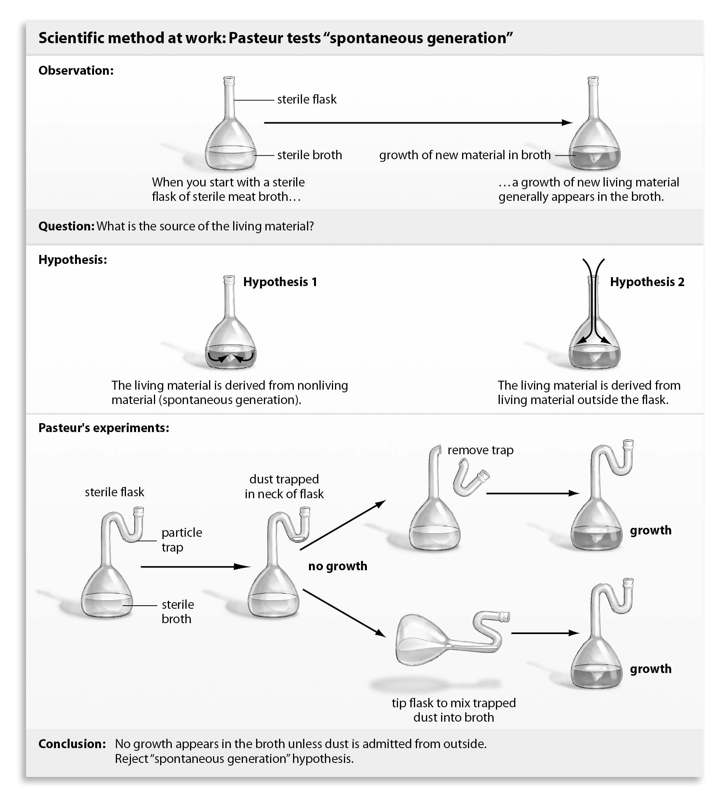
57) What was the purpose in breaking off the dust trap or tilting the flask in Pasteur's experiment?
Answer: To provide a control to show that microbes need to enter the flask from the outside for there to be growth.
Topic: Section 1.2
Skill: Application/Analysis
Refer to the figure below, and then answer the question that follows.

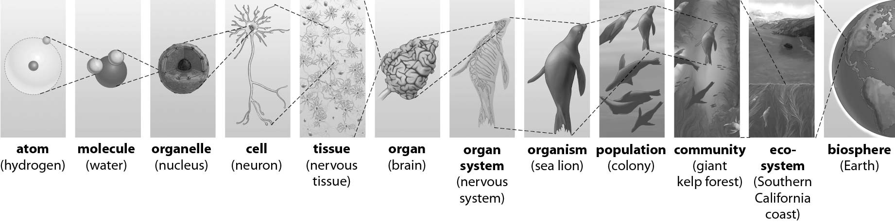
58) Which level of organization is the most inclusive? Which is the least inclusive?
Answer: The biosphere is the most inclusive because it includes all the other levels. The level of the atom is the least inclusive.
Topic: Section 1.3
Skill: Application/Analysis

