# Instructor’s Manual and Test Bank

## *For*

# Behavior Management: Principles and Practices of Positive Behavior Supports

# Fourth Edition

## John J. Wheeler, *East Tennessee State University*

## David D. Richey, *Tennessee Tech University*

***Prepared by***

## Stephanie Tweed, *East Tennessee State University*

Boston Columbus Indianapolis New York San Francisco Hoboken Amsterdam Cape Town Dubai London Madrid Milan Munich Paris Montreal Toronto Delhi Mexico City Sao Paolo Sydney Hong Kong Seoul Singapore Taipei Tokyo

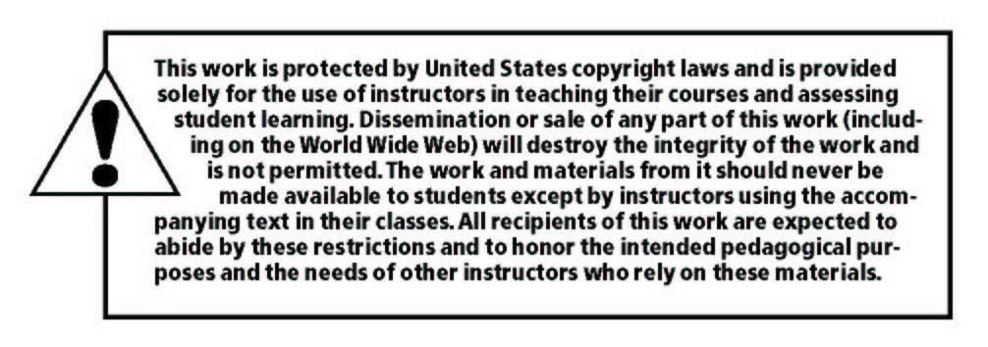

_____________________________________________________________________________________

Copyright © 2019, 2014, 2010 by Pearson Education, Inc. or its affiliates.  All Rights Reserved.  Printed in the United States of America. This publication is protected by copyright, and permission should be obtained from the publisher prior to any prohibited reproduction, storage in a retrieval system, or transmission in any form or by any means, electronic, mechanical, photocopying, recording, or otherwise. For information regarding permissions, request forms and the appropriate contacts within the Pearson Education Global Rights & Permissions Department, please visit [www.pearsoned.com/permissions/](http://www.pearsoned.com/permissions/).

Instructors of classes using *Behavior Management: Principles and Practices of Positive Behavior Supports, 4th Edition by John J. Wheeler and David D. Richey****,*** may reproduce material from the Instructor’s Resource Manual and Test Bank for classroom use.

10 9 8 7 6 5 4 3 2 1 ISBN-10: 0134792068

ISBN-13: 9780134792064 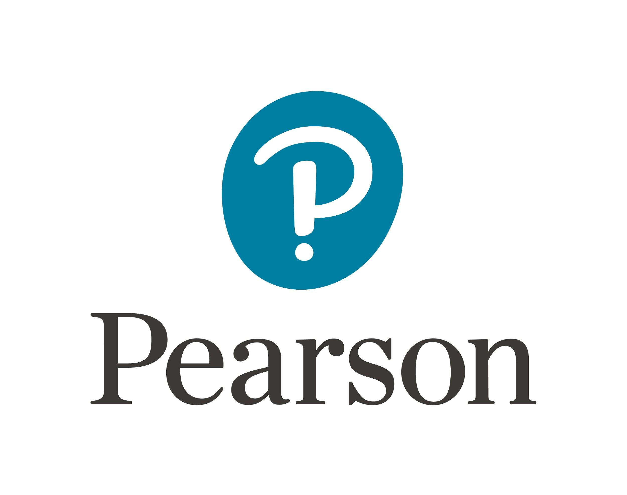

www.pearsonhighered.com

**Contents                                            Page**

Chapter 1: Understanding Behavior in Children and Youth                    01

Chapter 2: Partnering with Families                                07

Chapter 3: Ensuring Ethical Practices in the Delivery of Positive Behavior Supports 13

Chapter 4: Prevention Through Effective Instruction                        19

Chapter 5: Understanding Functional Behavior Assessment                    25

Chapter 6: Single-Case Design                               31

Chapter 7: Planning Positive Behavioral Interventions and Supports            37

Chapter 8: Evaluating Positive Behavior Supports                         43

Chapter 9: Using Reinforcement to Increase Appropriate Behavior                49

Chapter 10: Teaching Positive Replacement Behaviors                    55

Chapter 11: Minimizing Challenging Behavior                            61

Chapter 12: PBIS and Self-Determination                         67

**Answer Key                            73**

**Chapter 1**

**Understanding Behavior in Children and Youth**

**Overview**

    The purpose of this chapter is to provide the student with an overview of how human behavior and learning is conceptualized across multiple theoretical perspectives.  These differing theoretical viewpoints include the: Biomedical Model, Developmental Model, Psychodynamic/Psychosocial Model, Ecological Model, Behavioral Model, Social Learning Model, Applied Behavior Analysis, and Positive Behavior Supports. This chapter is intended to provide a comparative analysis of these varying perspectives and also to provide a historical overview of how positive behavior supports has emerged as a pro-active method for addressing and preventing challenging behavior.

**Objectives:**

The objectives for this chapter will be to

1. List and describe the common theories used to understand the human behavior, including the biomedical, developmental, psychodynamic/psychosocial, ecological, behavioral, and social learning models.
2. Describe the foundations and applications of applied-behavior analysis.
3. Describe the components of positive behavioral interventions and supports (PBIS) and the application of PBIS across the three tiers of prevention (primary, secondary, and tertiary).

**Chapter Outline:**

Theoretical Models for Understanding Behavior

Biomedical Model

Developmental Model

Psychodynamic Model

Ecological Model

Behavioral Model

Social Learning Model

Applied Behavior Analysis

Positive Behavioral Interventions and Supports

Reauthorization of IDEA

The Application of PBS Across Learners and Learning Environments

School-wide Applications of PBS

Factors Influencing the Development of PBS

Chapter Summary

Activities to Extend Learning

Further Reading and Exploration

References

**Test Bank for Chapter 1 Understanding Behavior in Children and Youth**

**Multiple Choice:**

1.    The biomedical model examines the presence of atypical development and behavior as stemming from:

    a.    imbalances in the person’s psyche

    b.    environmental toxins

c.    organic causes

    d.    all of the above

2.    The biomedical model in treating challenging behavior relies largely on:

a.    pharmacological treatment

    b.    meditation and alternative healing methods

    c.    behavior modification

    d.    both b and c are correct

3.    The functional utility of the biological model in the treatment of severe and challenging behavior is

             constrained by:

    a.    the use of diagnostic labels that pose limitations

    b.    the model does not rely on behavioral treatments that directly address the behaviors

    c.    treatments generally utilize medication exclusively to treat the condition

    d.    all of the above are correct

4.    Jean Piaget is synonymous with the:

    a.    Behavioral Model

    b.    Ecological Model

    c.    Developmental Model

    d.    Psychodynamic Model

5.    The developmental model is limited in its ability to explain

    a.    atypical development

    b.    the role of the environment in promoting learning and behavior

    c.    individual differences in children

    d.    all of the above are correct

6.    The psychodynamic model believes that

    a.    unconscious processes are the determinants of abnormal behavior

    b.    environmental factors are the sole determinants for challenging forms of behavior

    c.    one’s superego influences erratic behaviors in individuals

    d.    none of the above are correct

7.    Vygotsky believed that children’s learning and behavioral development was largely influenced by engaging

    and participating in activities with other children, he termed his theory

    a.    the theory of successive approximations

    b.    zone of proximal development

    c.    the theory of temporal development

    d.    social learning theory

8.    B.F. Skinner is best known for his work in the area of

    a.    classical conditioning

    b.    positive behavior supports

    c.    social learning

    d.    operant conditioning

9.    Applied behavior analysis expanded the work of behavior modification in that

    a.    it focused on the development of socially valid behaviors

    b.    it used social reinforcement more than tangibles

    c.    punishers were no longer used

    d.    all of the above are correct

10.    Positive behavior supports views challenging behavior as

    a.    serving a function for the learner

    b.    often a result of a skill deficit

    c.    often linked to specific setting events and antecedents

    d.    all of the above are correct

11.    PBS places emphasis on which of the following:

    a.    quality of life for the individual

    b.    teaching replacement behaviors

    c.    determining the factors that trigger the behavior

    d.    all of the above are correct

12.    Applied behavior analysis operationalizes behaviors in terms that:

    a.    are measureable and observable

    b.    are narrative and non-descript

    c.    are open to individual interpretation

    d.    both b and c are correct

13.    Erik Erikson was a:

    a.    Behavioral theorist

    b.    Psychodynamic theorist

    c.    Ecological theorist

    d.    Developmental Theorist

14.    Albert Bandura is best known for

    a.    Applied behavior analysis

    b.    Theory of personality

    c.    Social learning

    d.    Zone of proximal development

15.    Horner and colleagues in their 1990 paper advanced the cause of

    a.    applied behavior analysis

b.    the developmental model

    c.    positive behavior supports

    d.    none of the above

**Essay Questions:**

1.    Consider the controversy of applied behavior analysis and positive behavior supports. Many argue that

              PBS represents another fad rather than evidence-based practices in the delivery of behavioral interventions

              and supports within schools.  Provide a research-based argument that addresses this controversy and speak

              of the development of PBS, the impetus behind this movement and its relative merits and pitfalls in terms

              of evidence-based practices in addressing challenging behavior in children and youth.

2.    Select one of the theoretical models that have been presented in this chapter and     provide a brief summary

             of the model in your words and offer a supporting rationale as to why you believe this model to be most

             effective in understanding human behavior and learning.

3.    Describe the historical development of the behavioral model stemming from the early work of Pavlov and

              Thorndike to the advent of applied behavior analysis and subsequently positive behavior supports.

4.    Compare and contrast developmental and psychodynamic theories as “stage

    theories” and offer your perspective on their degree of functional utility relative to understanding

             challenging behavior in learners with disabilities.

5.    Provide a contrasting view of the behavioral model and the similarities and differences that surround

              applied behavior analysis and positive behavior supports.

6.    Identify and discuss what you perceive as the merits of PBS and the limitations of this three-tiered model as

    a method for promoting positive behavior.

**Chapter 2**

**Partnering with Families**

**Overview:**

    The central role of parents and families as partners in education is introduced and described in Chapter 2. Specifically addressed is the evolution of how we as educators, both in general education and special education, have viewed and acted upon our relationships with the parents and families of our students. The rationale and evidence for teaming and partnering with families in all aspects of the positive behavior support process, including assessment, planning, intervention, and evaluation of effectiveness, are presented and ideas for successful home/school collaboration are included.

**Objectives:**

The objectives for this Chapter will be to

1.    Describe how education reform and special education reform has affected the partnerships.

between families and professionals, and how education reforms are relevant to positive behavior interventions and supports.

2.    List and describe the six types of involvement from Epstein’s model of family- professional partnerships.

3.    Discuss the historical and current roles of families served through special education.

4.    Delineate the legislative mandate for partnerships and parent involvement.

5.    Define and differentiate among the terms *partnership, empowerment, collaboration, parent involvement,*

and *family-centered supports and services*.

6.    Describe and provide examples of the desired roles of families in the development, implementation and

              evaluation of PBIS.

7.           Summarize research literature which supports the roles of parents and families related to positive behavior support.

**Chapter Outline:**

The Nature of Families and Partnerships in Education

Education Reform and Families

General Education Reform

Special Education Reform

The Parent Participation Principle Underlying Special Education Programs

Unified Systems Reform

* Response to Intervention

Summary of Educational Reforms

Building Reliable Alliances: A Framework for the Family-Professional Partnership

Parents and Special Education-The Paradigm Shift

Positive Behavioral Interventions and Supports and the Family-Professional Partnership

The Behavior Support Team

Applications of PBS and Family-Professional Partnerships

Summary

Activities to Extend Your Learning

Further Reading and Exploration

References

**Test Bank for Chapter 2 Partnering with Families**

**Multiple Choice:**

1.    For us as educators to develop and maintain a strong and positive partnership with families we must:

    a.    understand family diversity and be willing to attain knowledge/skills

    b.    establish our leadership with families and require their respect

    c.    complete a formal assessment of family potential for collaboration

    d.     all of the above

2.    Cancino (2016) points out that the number of grandparents raising grandchildren in the U.S.:

    a.    has decreased this decade but will increase substantially in the future

    b.    is approximately 2.7 million

    c.    makes it necessary to recruit more grandparents as educators

    d.     none of the above

3.    If you as the teacher desired to establish a parent class focusing on child development and teaching parents

            about environments conducive to learning, and to establish a program in which parents/families could share

            their time, talents, occupations, and interests, you would be addressing two of the Epstein six types of

            involvement, including:

    a.    type 1 basic obligations for parenting and type 3 volunteering

    b.    type 4 involvement in home learning and type 5 decision-making

    c.    type 2 communicating and type 6 exchanges with the community

    d.    type 2 communicating and type 5 decision-making

4.    Richey and Wheeler (2000) suggest that we add a dimension of “family-first” to     the notion of “person-

             first” because:

    a.    we must always be more family-centered than child-centered

    b.    family members must not be thought of as individuals, but as a unit

    c.    families are just families, rather than “special needs” families

    d.    political correctness and the current professional practice requires it

5.    *Mills v. Board of Education* was:

    a.    a class action filed by parents and guardians in the District of Columbia

    b.    litigation that outlined procedural safeguards and due process procedures

    c.    highlighted the role of parents/guardians in advocating right to education

    d.    all of the above

6.    Related to the six principles underlying special education programs, the most accurate statement(s) regarding the principle of parent participation is/are:

    a.    parents have access to records of their children

    b.    it supports the involvement of parents/families

    c.    both a and b are correct

    d.    neither a nor b is correct

7.    Unified systems reform:  
    a.    has taken attention away from children with disabilities

    b.    is associated with a focus on preparing educators to be inclusive

    c.    was eliminated as a result of No Child Left Behind

    d.    is the same thing as special education reform

8.    The following statement accurately describes RtI:

    a.    the initials stand for Reasoned training and Inclusion

    b.    like PBS it is three-tiered process and a school-wide model

    c.    like PBS it is primarily focused on challenging behavior

    d.    while a useful educational reform, it does not address parent involvement

9.    A successful _____ is one in which a sense of rights and responsibilities between two parties exists. (Fill in

             the blank)

    a.    entitlement

    b.    professional team collaboration

    c.    empowerment program

    d.    partnership

10.    In order to be successful in family-professional relationships, one must:

    a.     be engaged in his or her own professional growth

    b.    be dedicated to the personal growth in relationships with others

    c.    Be focused on the beliefs, attitudes, and behaviors of one’s self

    d.    all of the above

11.    Specifically with regard to positive behavior supports and the family-professional partnership:

    a.    university pre service programs should prepare teachers to use PBS in partnerships with families

    b.    the focus on “quality of life,” “rich lifestyle” and self-determination is of central importance

    c.    federal special education law supports the importance of a team approach in which parents are

           partners with education

    d.    both b and c are correct

12.    When considering the role of parents/families on the behavior support team, we as educators should:

    a.    be sure that we are consistent in requiring all families to have the same     type of participation

    b.    recognize that cultural differences may play an important role in how families view and participate

           in the team

    c.    treat families respectfully, but maintain a “professional distance”

    d.    all of the above

13.    The main goal of Chapter 2 Partnering with Families is to:

    a.    set the stage for how a partnership with families is integral to successful use of PBS for children

           who have challenging behavior

    b.    establish that the research in this area suggest the need for caution in giving too much

            responsibility to parents

    c.    advocate a shift toward a “family-centered” approach exclusively across all areas of education

    d.    make clear that parent involvement in special education and general education are very different

           and require different teacher skills

14.    Family-centered supports and services are:

    a.    associated more with high school aged youth than with young children

    b.    emphasize mainly the need to refer families for counseling services

    c.    both a and b are correct

    d.    neither a nor b is correct

15.    With regard to the vignette describing Brianna and her experiences in middle school:

    a.    Brianna’s behavioral issues have to do with hitting other children

    b.    Brianna needs a Level 1 positive behavior support plan

    c.    self-monitoring and a daily journal are applied as intervention methods

    d.    a stricter limit on how much time Brianna can spend with her friends will be used

**Essay/Discussion:**

1.          Describe how general education and special education reform have impacted the partnerships between

           families and education professionals.

2.     Provide a brief definition for each of these terms: a) family-centered, b) parent involvement, c) partnership,

             d) collaboration, e) empowerment, and f) reliable alliance. Discuss how you see these having relevance for

             the family-professional relationship specific to positive behavior supports.

3.     What do you see as some of the roles that parents might play in the development, implementation, and

             evaluation of positive behavior supports for their children? Be specific with regard to what they might do

             and how they might participate. What are some of the factors that influence how parents might participate?

4.     Summarize what the Chapter (2) refers to with regard to a “paradigm shift”.

5.     What special considerations might be made to include the grandmother as a volunteer at the nursery school

             (Vignette 2.1 Aaron and His Mom, Dad, and Big Sister), and how might her wish to be a resource to others

              and to share her experiences be accommodated?

6.    Reflecting on content presented in this Chapter, make an argument for the inclusion of parents and families on the behavior support team.

**Chapter 3**

**Ensuring Ethical Practices in the Delivery of Positive Behavior Supports**

**Overview:**

Chapter 3 defines and describes ethics and what it means to engage in ethical behavior. The guidelines that we as professional educators have and apply, allowing us to be accountable and consistent with ethical practices in our collaboration with other professionals and in our service to children and their families, as we plan, implement and evaluate positive behavior supports, are presented. Nine organizing themes for understanding ethical practices are introduced and used to unify ethical standards across different organizations and constituencies related to positive behavior supports.

**Objectives:**

The objectives for this Chapter will be to

1.    Define ethics and ethical conduct.

2.    List and describe the nine organizing themes for understanding ethical practices.

3.    Understand accepted standards of ethical conduct.

4.    Understand the unique position of positive behavior supports within an ethical framework.

5.    Evaluate the extent to which behavior interventions are consistent with ethical standards of conduct.

6.    Compare and contrast different professional organizations’ standards for ethical conduct.

**Chapter Outline:**

Introduction

Nine Organizing Themes for Understanding Ethical Practices

Codes, Standards and Principles of Professional Groups

* National Education Association
* Learning First Alliance
* The Council for Exceptional Children

Prevention and Early Intervention

* National Association for the Education of Young Children
* The Division of Early Childhood of the Council for Exceptional Children

Summary of Ethical Codes, Standards, and Principles from Associations/Organizations

PBS and Ethical Standards

PBS, Ethical Standards, and Practice: Nine Organizing Themes

* Individual Worth and Dignity
* Behavior Reflects a Need
* Prevention and Early Intervention
* Family Partnerships
* Family Diversity
* Natural Environments and Inclusive Settings
* Natural and Logically Occurring Consequences
* Being Positive Rather Than Punitive
* Functionality and Quality of Life

PBS Standards of Practice

Chapter Summary

Activities to Extend Your Learning

Further Reading and Exploration

References