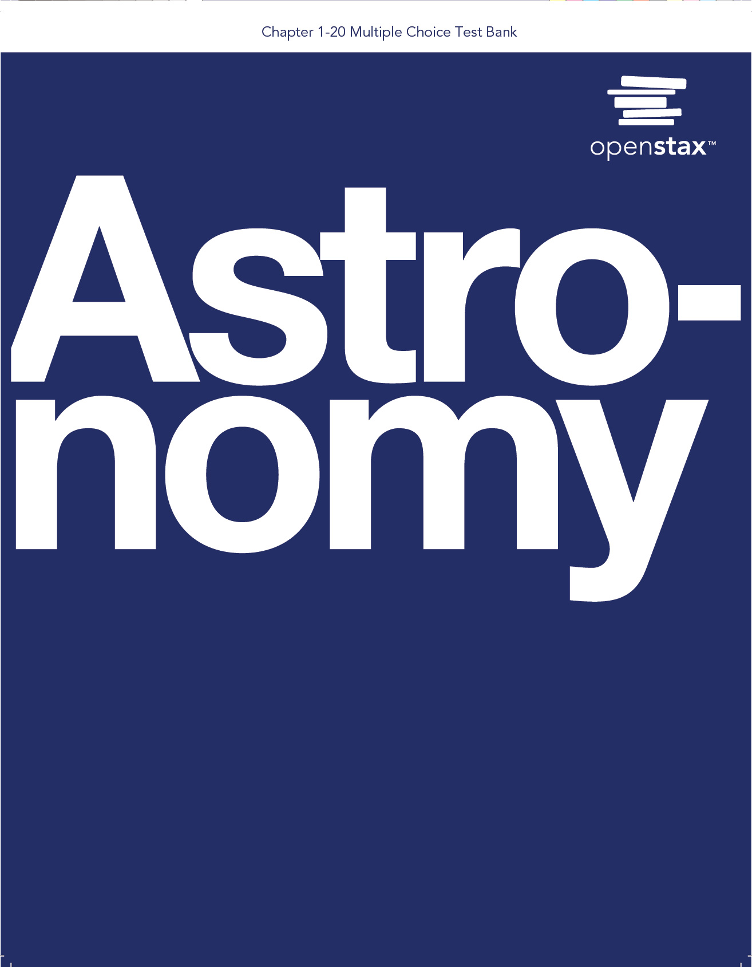

***Astronomy by Fraknoi, Morrison, and Wolff***

Multiple Choice Questions for Chapter 1:

Science and the Universe: A Brief Tour

by Andrew Fraknoi

*NOTE: Because this chapter is just a prologue, and its sections are very short, the questions here are not organized by section, and there are fewer of them than for the other, full chapters.*

1. The way scientists know that a hypothesis in astronomy is a reasonable description of nature is to

a. take a vote of astronomers around the world

b. consult with the oldest experts in the field

c. do experiments and observations about the predictions of the hypothesis

d. count how many scientific papers have been written about it

e. look it up in Wikipedia

2. A light year is

a. the time it takes light travel between the Sun and the furthest planet

b. the time it takes a beam of light to go completely around the Earth’s orbit

c. the distance between the Sun and the next star

d. the distance that light travels in one year

e. how long it takes a Friday afternoon class in college to get finished

3. A star is 230 light years away. The light we see tonight from that star left it

a. one year ago

b. 2.3 years ago

c. 23 years ago

d. 230 years ago

e. the time depends on which part of the sky the star is in

4. The star that provides energy for life on Earth is

a. the Moon

b. the Sun

c. Alpha Centauri

d. the Milky Way star

e. Beyonce

5. The location of the Earth in the Milky Way Galaxy is

a. in the center of the Galaxy

b. on the edge of the Galaxy as far from the center as you can measure

c. a little less than 30,000 LY from the center

d. something astronomers have not yet measured

e. this is a trick question: the Earth is not located in the Milky Way Galaxy

6. Even with the best and largest telescopes, we can’t see all the stars in the Milky Way Galaxy, even though these same telescopes can show us other galaxies. Why is that?

a. starlight isn’t able to travel through black space

b. the Milky Way Galaxy turns too quickly

c. dust in the space between stars builds up over large distances and blocks the light of stars behind the dustier parts of the Milky Way

d. this is still an unsolved problem in astronomy

e. the lights of Bayonne, New Jersey are too bright and interfere with our observations

7. The smallest piece of an element (like gold or lead) that still has all the properties of that element is called

a. a quasar b. an atom c. an electron d. a neutron e. ytterbium

8. By the term universe, astronomers mean

a. the system of the Sun, its planets and moons, and small pieces of debris that surround it

b. the system of 200 to 400 billion stars, of which the Sun is one

c. the collection of several dozen galaxies, of which the Milky Way is one

d. everything that we can observe

e. the realm inside the atom

9. Which of the following is the Earth NOT located in?

a. the solar system

b. the Milky Way Galaxy

c. the Local Group of galaxies

d. The Virgo supercluster

e. you can’t fool me, we are located in all of the above

10. When the authors of our textbook say that astronomers are like police detectives trying to solve crimes, they are explaining that:

a. Both astronomers and detectives work for the government

b. Both astronomers and detectives turn out to be wrong much of the time

c. Both astronomers and detectives must test their hypotheses against any evidence that they gather

d. Both astronomers and detectives mostly work at night

e. Both astronomers and detectives use expensive equipment

11. The laws of nature (as determined by scientists)

a. are constructed from many observations, hypotheses, and experiments

b. apply both on Earth and among the stars

c. can never, ever change once they are written down in textbooks

d. are often written in the language of mathematics

e. more than one of the above

12. Light travels 3 x 105 meters every second. That number in words is

a. 30 meters

b. 3,105 meters

c. 310 meters

d. 300,000 meters

e. none of the above

13. The natural object (not one that humans built) in space that’s closest to Earth is

a. The Moon

b. The Sun

c. Mars

d. Alpha Centauri

e. Jupiter

14. The Astronomical Unit (AU) as defined by astronomers is

a. a distance of one light year

b. the average distance between the Earth and the Sun

c. the time it takes for the Earth to orbit the Sun once

d. the distance the Earth travels in orbit in one day

e. the distance between Congress and the White House

15. A large body in space that consistently makes its own light (instead of merely reflecting another body’s light) is called

a. a star

b. a planet

c. a moon

d. a light year

e. a satellite

16. You are on a camping trip, far away from city lights. You look up into the dark night sky, and see lots of stars, some brighter, some dimmer. All the stars you see with your unaided eye are

a. in our solar system

b. equally close to the Sun

c. in the Milky Way Galaxy

d. outside the universe

e. just reflections of the Sun from a shiny surface beyond Pluto

17. All molecules (like molecules of water or carbon dioxide) are made up of

a. hydrogen

b. groups of stars

c. two or more atoms

d. very small pieces of dust, from the material that lies between the stars

e. baby animals that burrow underground

18. For scientists, an element (like gold) is defined by

a. the number of protons in its nucleus

b. the number of molecules it can form

c. how many neutrons are orbiting its nucleus

d. the value of one pound on the commodities market

e. none of the above

19. Of these, which is the largest?

a. Earth

b. The Solar System

c. Jupiter

d. The Milky Way Galaxy

e. The Universe

20. Of these which is the closest to us?

a. Mars

b. The Moon

c. The Sun

d. The center of the Milky Way

e. The closest spiral galaxy

**Answers to Chapter 1 Multiple Choice Questions**

1. c

2. d

3. d

4. b

5. c

6. c

7. b

8. d

9. e

10. c

11. e

12. d

13. a

14. b

15. a

16. c

17. c

18. a

19. e

20. b