**Multiple Choice**

**1)** A sculpture made from chocolate gnawed by the artist would challenge definitions of art because:

**a.** It is a physical object, but it is not made from artistic materials

**b.** It is made from artistic materials, but it is not a physical object

**c.** It is a physical object, but it is not made from permanent materials

**d.** It is not made from artistic materials, and it is not able to be put in a museum

**2)** When we define art aesthetically, we:

**a.** Imagine all art to be like sunsets at a beach when we close our eyes

**b.** Idealize beauty, so that art from all cultures is seen as uplifting

**c.** Focus on what we see and how colors, shapes, etc. make us feel differently

**d.** Focus on both a work’s beautiful appearance and its important meaning

**3)** One of the ways we evaluate works of art is through their value. What ways can art have value?

**a.** Financial, functional, or emotional

**b.** Financial, functional, or aesthetic

**c.** Functional, emotional, or canonical

**d.** Emotional, financial, or aesthetic

**4)** The works of art accepted by the art world as part of the story of art refers to the:

**a.** Canon

**b.** Patronage

**c.** Diversity

**d.** Contrapposto

**5)** How might an artist demonstrate his or her skill, according to established ideas about art?

**a.** Making art for art’s sake and creating a physical object

**b.** Manipulating materials and techniques and depicting the natural world

**c.** Depicting the natural world and making art for art’s sake

**d.** Making art for art’s sake and using standard art materials

**6)** If someone makes a work of art, but no one ever views it, why might we say it doesn’t have as much meaning?

**a.** Because we will not be talking about it

**b.** Because it would not have to be made with skill

**c.** Because we each play a role in the artistic process

**d.** Because it would not be a part of the canon

**7)** 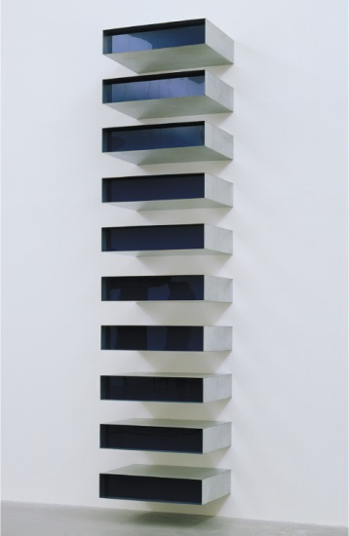

Even though a work of art like Donald Judd’s *Untitled* (figure 2.29) was intended to have no meaning, function, or illusion, why might we still consider it to have meaning?

**a.** The context might change

**b.** We may see it as original

**c.** We perceive things in our own way because of who we are

**d.** Both the artist and viewer need to communicate

**8)** 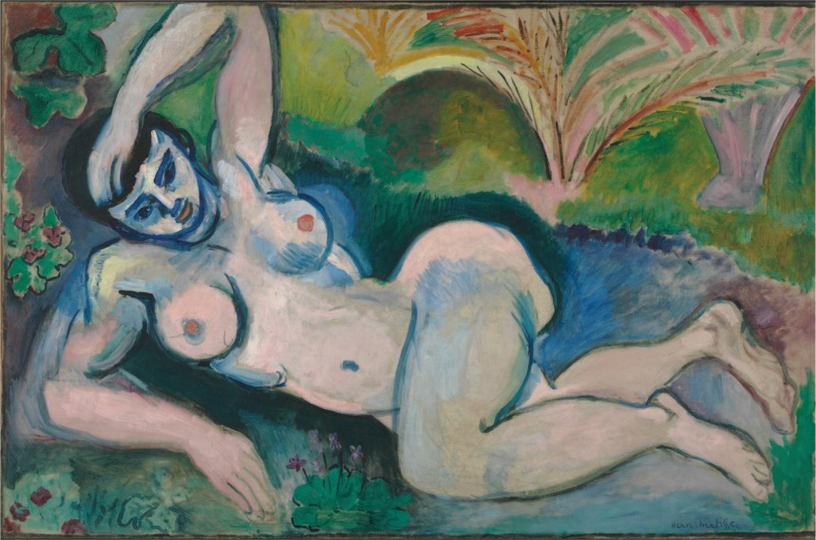

Henri Matisse’s *Blue Nude* (figure 2.31) was controversial because:

**a.** It used unnatural colors

**b.** It depicted a nude

**c.** It was burned in Chicago

**d.** It looked like *Aphrodite*

**9)** What is a good way to approach works of art you find difficult?

**a.** Protest the status quo

**b.** Protest the exhibition of the work of art

**c.** See difficulty as a sign the artist wants to make political statements

**d.** See difficulty as part of your relationship with the artwork

**10)** 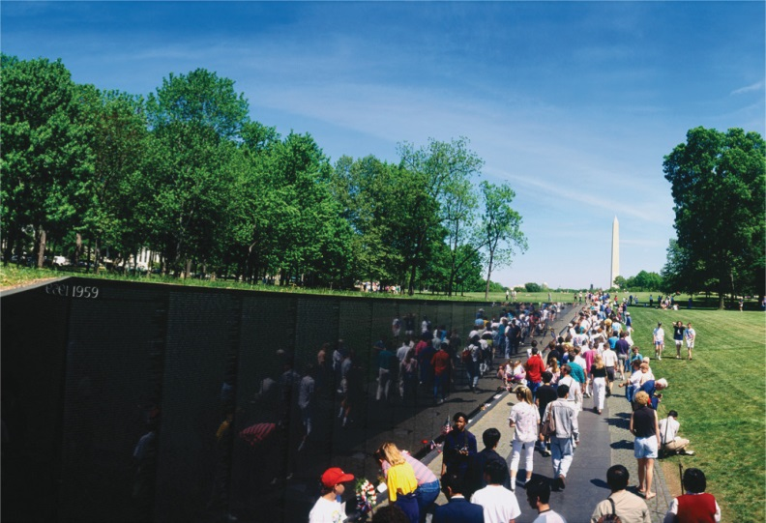

A work of art like Maya Lin’s Vietnam Veterans Memorial (figure 1.3) expresses a theme of war, death, and remembrance. Can we say that this is the only theme it could possibly express?

**a.** No, because works of art can be used to protest the social order

**b.** Yes, because that is the category that fits it best

**c.** No, because works of art can be associated with more than one theme

**d.** Yes, because good works of art should have only one theme

**11)** How might someone change our description of a work of art from representational to *trompe l’oeil?*

**a.** Add bright colors

**b.** Make the objects appear almost photograph-like

**c.** Idealize the forms

**d.** Make a frame that looks like it is a drawing

**12)** If you view a work of art composed of different colored rectangles, circles, and triangles titled *Trees in Winter*, which category would best fit this work of art?

**a.** Representational

**b.** Abstract

**c.** *Trompe l’oeil*

**d.** Nonobjective

**13)** A painting in soft, pastel colors that depicts the horrors of war might be confusing because:

**a.** Subject matter should dictate content

**b.** Subject matter and form influence content

**c.** Content shouldn’t be contradicted by subject matter

**d.** Form is the most important part of content

**14)** If an artist paints a shark’s tooth in a picture of flowers and means for the tooth to symbolize ideas about hateful speech, the tooth would be an example of:

**a.** Iconography

**b.** Pictograph

**c.** Form

**d.** Content

**15)** If we are considering the work of the Renaissance painters Leonardo da Vinci, Michelangelo, and Raphael, what kind of style are we considering?

**a.** Individual style

**b.** Artistic style

**c.** Cultural style

**d.** Time period style

**True/False**

**16)** Art should be defined solely by its beauty.

**a.** True

**b.** False

**17)** Some fine art can have a utilitarian purpose.

**a.** True

**b.** False

**18)** Only the artist determines the meaning of a work of art.

**a.** True

**b.** False

**19)** A work of art can address several themes at once.

**a.** True

**b.** False

**20)** Nonobjective art shows objects from the real world that have been distorted or exaggerated.

**a.** True

**b.** False

**Fill-In-the-Blank**

**21)** Defining art by its beauty is based in the branch of philosophy called ________ (blank).

**22)** Works of art that the art world deems as important make up the ______ (blank).

**23)** The association that a work has with the world around it (culturally, historically, socially, economically, politically, and religiously) is its _______ (blank).

**24)** A work of representational art that tries to make us think it is real rather than painted is a ______ (blank) work.

**25)** The meaning, message, mood, or feeling conveyed in a work is its _________ (blank).

**Essay**

**26)** Why are the definitions used to create the traditional canon of art history problematic?

**27)** A single candle burns in the chandelier, possibly indicating the presence of God. Arnolfini lifts his hand as if swearing a legal oath at the betrothal. The couple has taken off their shoes, which may suggest they are on holy ground. The dog may be a sign of loyalty. The bed and the woman’s raising her dress appearing pregnant could be symbols of fertility.


Explain how the viewer plays an essential role in Jan van Eyck’s *Portrait of Giovanni Arnolfini and His Wife* (figure 2.45A).

**28)** Explain why it can be ok for a viewer to find a different meaning in a work of art than the one the artist intended. When would it NOT be OK?

**29)** Explain why it can be rewarding to find a way to approach a difficult work of art.

**30)** At almost eighteen feet, the painting towers above viewers, just as the voice towered above the Israelites. A strong, densely painted, fiery red core boldly stands in a field of blue. The single red band takes no distinct shape, evoking the one voice from God. The blue is thinly applied, so we can see through it to the white surface underneath.
A repeating floral motif covers the surface. Writing, considered holy because of its connection with sacred texts, is used as decoration. 


Compare and contrast Barnett Newman’s *Voice of Fire* (Figure 2.4) with the *Mihrab* from Isfahan (Figure 2.18A) in terms of type of art, materials used, colors, shapes, lines, purpose, and theme. How do these works show how content can be affected by subject matter and form?

**Answers:**

1. A
2. C
3. A
4. A
5. B
6. C
7. C
8. A
9. D
10. C
11. B
12. D
13. B
14. A
15. D
16. B (False)
17. A (True)
18. B (False)
19. A (True)
20. B (False)
21. Aesthetics
22. Canon
23. Context
24. Trompe l’oeil
25. content