***Applied Calculus, 7e* (Hughes-Hallett)**

**Chapter 1 Functions and Change**

1.1 What Is a Function?

1) *f* (*x*) is the age of Antarctic ice (in hundreds of years) at a depth of *x* meters below the surface. Is f increasing or decreasing?

Answer: increasing

Diff: 1 Var: 1

Section: 1.1

Learning Objectives: Understand the properties and terminology of functions: input/output, function notation, intercepts, increasing/decreasing.

2) A graph of *y* = *f* (*x*) is given in the following figure.

A. What is *f* (5) (to the nearest whole number)?

B. What is the domain of the function?

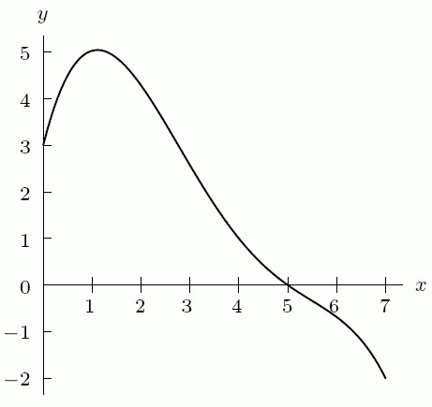

Answer:

A. 0

B. 0 ≤ *x* ≤ 7

Diff: 1 Var: 1

Section: 1.1

Learning Objectives: Understand the properties and terminology of functions: input/output, function notation, intercepts, increasing/decreasing.

3) From the following table,

A. Find *f* (5)

B. Find the value(s) of *x* for which *f* (*x*) = 1. If there is more than one, list them in increasing order, separated by commas.

|  |  |  |  |  |  |  |
| --- | --- | --- | --- | --- | --- | --- |
| *x* | 1 | 2 | 3 | 4 | 5 | 6 |
| *f (x)* | 1 | 3 | 7 | 6 | 4 | 1 |

Answer:

A. 4

B. 1, 6

Diff: 2 Var: 1

Section: 1.1

Learning Objectives: Understand the properties and terminology of functions: input/output, function notation, intercepts, increasing/decreasing.

4) Let *y* = *f* (*x*) = 2(x) with superscript (2) - 5.

A. Find the value of *y* when *x* is zero.

B. Find *f* (3).

Answer:

A. -5

B. 13

Diff: 2 Var: 1

Section: 1.1

Learning Objectives: Understand the properties and terminology of functions: input/output, function notation, intercepts, increasing/decreasing.

5) The empirical function *P* = *g*(*t*) graphed below represents the population *P* of a city (in thousands of people) at time *t*. The ________ of the function is from 1980 to 2020, and the ________ of the function is from approximately 35,000 to 70,000 people.

A line is graphed on a coordinate plane. The horizontal axis labeled t ranges from 19 80 to 20 20, in increments of 10 years. The vertical axis labeled P ranges from 30 to 70, in increments of 20. The line increases and decreases through the following points: (19 80, 50), (19 85, 52), (19 88, 65), (19 90, 70), (19 92, 64.5), (19 95, 42), (2003, 42), (2004, 55), (20 10, 50), (20 12, 58), (20 15, 60), and (20 20, 48). All values are estimated.


Answer: domain; range

Diff: 2 Var: 1

Section: 1.1

Learning Objectives: Understand the properties and terminology of functions: input/output, function notation, intercepts, increasing/decreasing.

6) The graph of *y* = *f* (*x*) is shown in the following figure. The ________ of *f* (*x*) is 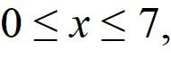 and the ________ of *f* (*x*) is 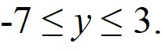

A curve is graphed on an x y coordinate plane. The x axis ranges from 0 to 7, in increments of 1, and the y axis ranges from negative 6 to 4, in increments of 2. The curve decreases concave up from the origin to (2.2, negative 7), increases concave up to (5, 0), then it increases concave down to (6.2, 3), and it decreases concave down to (7, 2). All values are estimated.


Answer: domain; range

Diff: 2 Var: 1

Section: 1.1

Learning Objectives: Understand the properties and terminology of functions: input/output, function notation, intercepts, increasing/decreasing.

7) The graph of *y* = *f* (*x*) is shown in the following figure. Estimate *f* (1) (to the nearest integer).

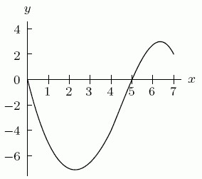

Answer: -5

Diff: 1 Var: 1

Section: 1.1

Learning Objectives: Understand the properties and terminology of functions: input/output, function notation, intercepts, increasing/decreasing.

8) The graph of *y* = *f* (*x*) is shown in the following figure. Is the graph increasing or decreasing around *x* = 3?



Answer: increasing

Diff: 1 Var: 1

Section: 1.1

Learning Objectives: Understand the properties and terminology of functions: input/output, function notation, intercepts, increasing/decreasing.

9) Suppose the graph of *f* is in the figure below. Is  *f* (*B*) positive, negative, or zero?

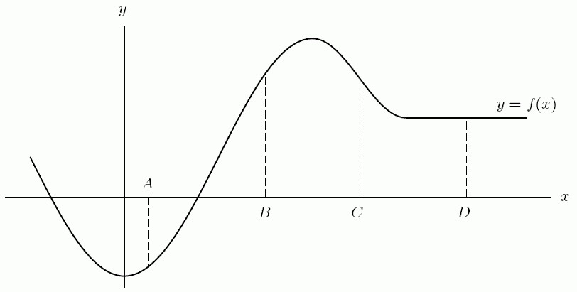

Answer: positive

Diff: 1 Var: 1

Section: 1.1

Learning Objectives: Interpret information about a function given by a graph, table, or words.

1.2 Linear Functions

1) Could the following table represent a linear function? Answer yes or no.

|  |  |  |  |  |
| --- | --- | --- | --- | --- |
| *t* | 1 | 2 | 3 | 4 |
| *p* | 3 | 4 | 6 | 9 |

Answer: no

Diff: 1 Var: 1

Section: 1.2

Learning Objectives: Build linear functions from data, words, or graphs.

2) A. Which two lines in the following figure have the same slope? Enter your answer as "I and II," etc.

B. Which two lines have the same *y*-intercept?

C. Which line has the largest slope?

D. Which line has the largest *y*-intercept?

Four lines are graphed on an x y coordinate plane. The first line labeled 1 passes from a point on the negative x axis to the first quadrant through the positive y axis. The second line labeled 2 is horizontal, runs above the x axis, and intersects the first line in the second quadrant. The third line labeled 3 passes from the second quadrant to the fourth quadrant through the origin, intersects the first line in the second quadrant above the second line, and intersects the second line at a point on the positive y axis. The fourth line labeled 4 passes from a point on the second line to the fourth quadrant through the negative y axis and intersects the first line in the second quadrant below the second line.


Answer:

A. III and IV

B. II and III

C. I

D. I

Diff: 1 Var: 1

Section: 1.2

Learning Objectives: Interpret properties of linear functions: slope, intercepts.

3) The average weight in pounds of American men in their sixties (in 2018) as a function of their heights in inches is given in the following table. The formula that expresses the weight *w* in terms of the height *h* is given by *w* = ________ + ________*h*.

|  |  |  |  |  |  |  |
| --- | --- | --- | --- | --- | --- | --- |
| height (*h*) | 68 | 69 | 70 | 71 | 72 | 73 |
| weight (*w*) | 166 | 171 | 176 | 181 | 186 | 191 |

Answer:

Part A: -174

Part B: 5

Diff: 2 Var: 1

Section: 1.2

Learning Objectives: Build linear functions from data, words, or graphs.

4) Suppose that y = *f* (*t*) is the distance in miles traveled in *t* hours by a car moving at 65 miles per hour. Give a formula for the function *f* (*t*).

Answer: *f* (*t*) = 65*t*

Diff: 1 Var: 1

Section: 1.2

Learning Objectives: Build linear functions from data, words, or graphs.

5) Find the value for *b* in the following table of values for the linear function *f*.

|  |  |  |  |  |  |
| --- | --- | --- | --- | --- | --- |
| *x* | 0 | 5 | 10 | 15 | 20 |
| *f* (*x*) | 10 | 20 | *a* | *b* | *c* |

Answer: 40

Diff: 1 Var: 1

Section: 1.2

Learning Objectives: Build linear functions from data, words, or graphs.

6) Find a formula for the linear function *f*.

|  |  |  |  |  |  |
| --- | --- | --- | --- | --- | --- |
| *x* | 0 | 100 | 200 | 300 | 400 |
| *f* (*x*) | 10 | 15 | ? | ? | ? |

A) *f* (*x*) = 0.05*x* + 10 B) *f* (*x*) = 100*x* + 10

C) *f* (*x*) = 15*x* + 10 D) *f* (*x*) = 0.15*x* + 10

Answer: A

Diff: 1 Var: 1

Section: 1.2

Learning Objectives: Build linear functions from data, words, or graphs.

7) A car is worth $13,000 when it is 1 year old, and it is worth $10,000 when it is three years old.

A. Write the value of the car, *V* (in dollars), as a function of the age of the car, *a* (in years). Assume this is a linear function.

B. How much does the car depreciate in value each year?

C. How much was the car worth when it was first purchased?

Answer:

A. *V* = 14,500 - 1500*a*

B. $1500

C. $14,500

Diff: 2 Var: 1

Section: 1.2

Learning Objectives: Interpret properties of linear functions: slope, intercepts.

8) The equation of the line through the points (1, 3) and (-1, -5) is:

Answer: *y* = -1 + 4*x*

Diff: 2 Var: 1

Section: 1.2

Learning Objectives: Build linear functions from data, words, or graphs.

9) The bill for electricity is $150 when 40 kilowatt hours are used and $250 when 80 kilowatt hours are used.

A. The base cost (without using any electricity) is $________.

B. Each additional kilowatt hour used costs $________.

Answer:

A. 50

B. 2.5

Diff: 2 Var: 1

Section: 1.2

Learning Objectives: Interpret properties of linear functions: slope, intercepts.

10) A school library opened in 1980. In January of 2000, they had 44,000 books. One year later, they had 44,660 books. Assume they acquire the same number of books at the start of each month.

A. How many books did they have in January of 2003?

B. How many books did they have in July of 1980?

Answer:

A. 45,980

B. 31,130

Diff: 1 Var: 1

Section: 1.2

Learning Objectives: Build linear functions from data, words, or graphs.

11) A school library opened in 1980. In January of 2000, they had 16,000 books. One year later, they had 16,960 books. Assuming they acquire the same number of books at the start of each month, give a linear formula for the number of books, *N*, in the library as a function of the number of years, *t*, the library has been open.

Answer: *N* = -3200 + 960*t*

Diff: 1 Var: 1

Section: 1.2

Learning Objectives: Build linear functions from data, words, or graphs.

12) A furniture moving company charges a fixed amount plus a charge for each pound that they move. A person who shipped 60 pounds of furniture was charged $590, while someone else was charged $1110 to ship 190 pounds.

A. Write a function that represents the moving cost, C, in terms of pounds, *x*, and fixed cost.

B. Suppose the company changes their rates. They increase the per pound charge by $1 but cut the fixed amount they charge by half. What is the new function that represents the new moving cost, D?

C. Will someone who ships 190 pounds pay more or less with the new rates than they would have with the original rates?

Answer:

A. *C* = 350 + 4*x*

B. *D* = 175 + 5*x*

C. more

Diff: 2 Var: 1

Section: 1.2

Learning Objectives: Build linear functions from data, words, or graphs.

13) Harley-Davidson (ticker symbol HOG) stock prices dropped sharply in late 2008. Series 1 in the graph below shows the actual prices at the end of each week. The trend over time is approximately linear; and the graph of a possible linear model is given by Series 2. Based on the data given, find the linear model and use it to approximate the stock's price on November 30, 2008, assuming the current trend continued.

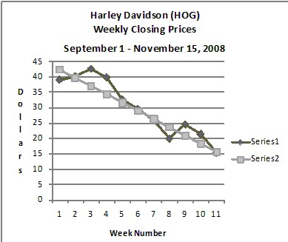

Answer: *y* = -2.5x + 45 and $12.00, but answers will vary slightly.

Diff: 1 Var: 1

Section: 1.2

Learning Objectives: Build linear functions from data, words, or graphs.

14) The height (in inches) and weight (in pounds) of 8 students is given in the following table. Find a regression line for this data and use it to estimate the weight of a person who is 5 feet 3 inches tall. Round to the nearest pound.

|  |  |  |  |  |  |  |  |  |
| --- | --- | --- | --- | --- | --- | --- | --- | --- |
| Height (inches) | 64 | 68 | 62 | 70 | 69 | 65 | 73 | 71 |
| Weight (pounds) | 110 | 150 | 115 | 185 | 160 | 125 | 200 | 170 |

Answer: 112.09

Diff: 2 Var: 1

Section: 1.2

Learning Objectives: Build linear functions from data, words, or graphs.

15) Using the table, find the value of *a* if *f*  is linear.

|  |  |  |  |
| --- | --- | --- | --- |
| *x* | 0 | 10 | 20 |
| *f* (*x*) | 50 | 100 | *a* |

Answer: 150

Diff: 1 Var: 1

Section: 1.2

Learning Objectives: Build linear functions from data, words, or graphs.

16) A bar of soap starts out weighing 125 grams. Write a formula for the quantity *S* grams of soap remaining after *t* days if the decrease is 10 grams per day.

Answer: *S* = 125 - 10*t*

Diff: 2 Var: 1

Section: 1.2

Learning Objectives: Build linear functions from data, words, or graphs.

17) The following table gives values for three different functions. Find a formula for the linear one.

|  |  |  |  |
| --- | --- | --- | --- |
| *t* | *f* (*t*) | *g*(*t*) | *h*(*t*) |
| *-1* | *15* | *21.5* | *1000* |
| *0* | *9* | *24.1* | *600* |
| *1* | *5* | *26.7* | *360* |
| *2* | *4* | *29.3* | *216* |

Answer: *g*(*t*) = 24.1 + 2.6*t*

Diff: 1 Var: 1

Section: 1.2

Learning Objectives: Build linear functions from data, words, or graphs.

18) Give a possible formula for the function shown in the following table.

|  |  |  |  |  |  |  |
| --- | --- | --- | --- | --- | --- | --- |
| *x* | 0 | 1 | 2 | 3 | 4 | 5 |
| *f* (*x*) | -5 | -2 | 1 | 4 | 7 | 10 |

Answer: *f* (*x*) = 3*x* - 5

Diff: 1 Var: 1

Section: 1.2

Learning Objectives: Build linear functions from data, words, or graphs.

19) One of the following tables of data is linear and the other one is exponential. The formula for the linear one is *y* = *ax* + *b*. Find the values of *a* and *b* to two decimal places.

|  |  |  |  |  |  |
| --- | --- | --- | --- | --- | --- |
| *x* | 0 | 0.50 | 1.00 | 1.50 | 2.00 |
| *y* | 3.12 | 2.63 | 2.22 | 1.87 | 1.57 |

|  |  |  |  |  |  |
| --- | --- | --- | --- | --- | --- |
| *x* | 0 | 0.50 | 1.00 | 1.50 | 2.00 |
| *y* | 2.71 | 3.44 | 4.17 | 4.90 | 5.63 |

A. *a* = ________

B. *b* = ________

Answer:

A. 1.46

B. 2.71

Diff: 2 Var: 1

Section: 1.2

Learning Objectives: Build linear functions from data, words, or graphs.

20) Find the equation of the line passing through the points (-2, 1) and (10, -3). Then determine if the line is increasing or decreasing.

Answer:  *y* = -0.33*x* + 0.34, decreasing

Diff: 2 Var: 1

Section: 1.2

Learning Objectives: Build linear functions from data, words, or graphs.

1.3 Average Rate of Change and Relative Change

1) Do you expect the average rate of change in the life expectancy of a U.S. male since 1900 to be positive or negative?

Answer: positive

Diff: 1 Var: 1

Section: 1.3

Learning Objectives: Understand interpretations of average rate of change on an interval: increasing/decreasing, concavity, slope of secant line, average velocity.

2) The population of Los Angeles, California was 3,792,620 in 2010 and was 3,983,540 in 2020. The change in the population of Los Angeles between 2010 and 2020 was ________ people.

Answer: 190,920

Diff: 1 Var: 1

Section: 1.3

Learning Objectives: Find and give units for average rate of change of a function on an interval.

3) The following table gives the number of students taking an applied calculus course at a community college. Find the change in the number of students taking the course

between 2014 and 2020.

|  |  |  |  |  |  |  |  |
| --- | --- | --- | --- | --- | --- | --- | --- |
| Year | 2014 | 2015 | 2016 | 2017 | 2018 | 2019 | 2020 |
| students | 319 | 365 | 390 | 430 | 497 | 568 | 630 |

Answer: 319

Diff: 1 Var: 1

Section: 1.3

Learning Objectives: Find and give units for average rate of change of a function on an interval.

4) The following table gives the number of students taking an applied calculus course at a community college.

A. Find the average rate of change in the number of students taking the course between 2016 and 2020 (in students per year).

B. If the average rate of change continues at the same rate as between 2016 and 2020, in which year will the number of students taking the course first exceed 800?

|  |  |  |  |  |  |  |  |
| --- | --- | --- | --- | --- | --- | --- | --- |
| Year | 2014 | 2015 | 2016 | 2017 | 2018 | 2019 | 2020 |
| students | 309 | 360 | 385 | 440 | 492 | 575 | 633 |

Answer:

A. 62

B. 2023

Diff: 2 Var: 1

Section: 1.3

Learning Objectives: Find and give units for average rate of change of a function on an interval.

5) The number of reported violent crimes in the U.S. between 2006 and 2019 is given in the following table.

A. Find the average rate of change between 2006 and 2013 (to the nearest integer).

B. Find the average rate of change between 2013 and 2019 (to the nearest integer).

|  |  |
| --- | --- |
| Year | Violent crime |
| 2006 | 1,435,123 |
| 2007 | 1,422,970 |
| 2008 | 1,394,461 |
| 2009 | 1,325,896 |
| 2010 | 1,251,248 |
| 2011 | 1,206,005 |
| 2012 | 1,217,057 |
| 2013 | 1,168,298 |
| 2014 | 1,153,022 |
| 2015 | 1,199,310 |
| 2016 | 1,250,162 |
| 2017 | 1,247,917 |
| 2018 | 1,209,997 |
| 2019 | 1,203,808 |

Answer:

A. -38,118

B. 5918

Diff: 2 Var: 1

Section: 1.3

Learning Objectives: Find and give units for average rate of change of a function on an interval.

6) The total sales of household computers in the U.S., as measured by sales to retail consumer dealers, in millions of units, was 60.55 in 2013 and 61.81 in 2020.

A. Find the average rate of change in sales between 2013 and 2020 (in millions of units, to the nearest hundredth).

B. Use your answer to estimate total sales in 2024 (in millions of units, to the nearest hundredth).

Answer:

A. 0.18

B. 62.53

Diff: 2 Var: 1

Section: 1.3

Learning Objectives: Find and give units for average rate of change of a function on an interval.

7) The distance d = *f* (*t*) in feet that a golf ball will fall in *t* seconds if dropped from a very high tower is given by the formula 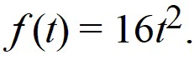 Make and label a table or a graph of values of 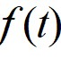 giving distances fallen for the time period 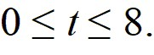 Using your table or graph, the change in the height of the golf ball between times *t* = 3and *t* = 5 is ________ feet, and the average rate of change in the height of the golf ball between times *t* = 3 and *t* = 5 is ________ feet per second.

Answer:

Part A: 256

Part B: 128

Diff: 2 Var: 1

Section: 1.3

Learning Objectives: Find and give units for average rate of change of a function on an interval.

8) Values for *g(x)* are given in the following table. Does it appear that *g(x)* is concave up or concave down?

|  |  |  |  |  |  |  |
| --- | --- | --- | --- | --- | --- | --- |
| *x* | 1 | 2 | 3 | 4 | 5 | 6 |
| *g(x)* | 100 | 90 | 81 | 73 | 66 | 60 |

Answer: concave up

Diff: 1 Var: 1

Section: 1.3

Learning Objectives: Understand interpretations of average rate of change on an interval: increasing/decreasing, concavity, slope of secant line, average velocity.

9) Consider the following graph. Between point A and point B, the graph is: (select all that apply)

A curve is graphed on a coordinate plane. The curve decreases concave up from a point labeled A in the second quadrant through the negative horizontal axis to a point labeled B in the third quadrant. The curve then increases concave up to a point labeled C in the second quadrant, and then it increases concave down to a point labeled D in the first quadrant, close to the vertical axis. The curve then decreases concave down to a point labeled E in the first quadrant, and then it decreases concave up to a point labeled F in the first quadrant.


A) decreasing B) increasing

C) concave up D) concave down

Answer: A, C

Diff: 1 Var: 1

Section: 1.3

Learning Objectives: Understand interpretations of average rate of change on an interval: increasing/decreasing, concavity, slope of secant line, average velocity.

10) Find the average rate of change of *s*(*t*) = -16(t) with superscript (2) + 60*t* - 12 between *t* = 1 and *t* = 3. Round to two decimal places.

A) -4.00 B) -8.00 C) 56.00 D) -0.88

Answer: A

Diff: 2 Var: 1

Section: 1.3

Learning Objectives: Find and give units for average rate of change of a function on an interval.

11) The table gives information about the number of cases of pancreatic cancer diagnosed in the United States.

|  |  |  |  |
| --- | --- | --- | --- |
| Year | 1997 | 2002 | 2004 |
| Number of cases | 27,000 | 30,300 | 31,860 |
|  |  |  |  |

a) Find the average rate of change in number of cases from 1997 to 2002.

b) Find the average rate of change in number of cases from 2002 to 2004.

c) Is the average rate of change increasing or decreasing?

Answer:

a) 660 cases per year

b) 780 cases per year

c) increasing

Diff: 2 Var: 1

Section: 1.3

Learning Objectives: Find and give units for average rate of change of a function on an interval.

12) The graph of *y* = *f* (*x*) is shown in the following figure. Is the graph concave down or concave up around *x* = 6?



Answer: concave down

Diff: 1 Var: 1

Section: 1.3

Learning Objectives: Understand the properties and terminology of functions: input/output, function notation, intercepts, increasing/decreasing.

13) Delia runs 3.1 miles from home to the park at 6 mph, jumps on her bike and returns home in 12 minutes.

a) Sketch a well-labeled graph of Delia's distance from home as a function of time.

b) Find the slope of each segment of the graph and interpret their meaning.

c) What does it mean to say that Delia's velocity on the way home is inversely proportional to the time she takes to ride home?

Answer:

a)

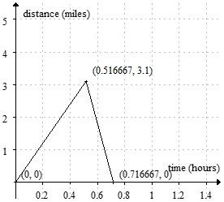

b) The slope of the first segment is 6 miles per hour; her velocity on the way to the park.

The slope of the second segment is -15.5 miles per hour; her velocity on the way home.

c) The faster Delia goes, the less time it takes for her to get back home. In formula form, rate = *d*/*t*.

Diff: 3 Var: 1

Section: 1.3

Learning Objectives: Understand interpretations of average rate of change on an interval: increasing/decreasing, concavity, slope of secant line, average velocity.

1.4 Applications of Functions to Economics

1) Values of a linear cost function are given in the following table. Find a formula for the cost function.

|  |  |  |  |  |
| --- | --- | --- | --- | --- |
| *q* | 0 | 100 | 200 | 300 |
| *C*(*q*) | 100 | 175 | 250 | 325 |

Answer: *C*(*q*) = 0.75q + 100

Diff: 3 Var: 1

Section: 1.4

Learning Objectives: Understand cost, revenue, and profit functions and break even points.

2) A textbook company had fixed costs of $30,000 and variable costs of $10 for a certain book. The company sells the books for $55 each. Find a formula for the profit function, π(*q*).

Answer: π(*q*) = 45*q* - 30,000

Diff: 2 Var: 1

Section: 1.4

Learning Objectives: Understand cost, revenue, and profit functions and break even points.

3) A textbook company had fixed costs of $35,000 and variable costs of $25 for a certain book. The company sells the books for $55 each. What is the break-even point for the company (to the nearest book)?

Answer: 1167

Diff: 3 Var: 1

Section: 1.4

Learning Objectives: Understand cost, revenue, and profit functions and break even points.

4) A $5000 pump depreciates linearly. It is worth $4500 in 2 years. Find a formula for the value of the pump, *V*, as a function of time, *t* (in years) since it was purchased.

Answer: *V*(*t*) = 5000 - 250*t*

Diff: 2 Var: 1

Section: 1.4

Learning Objectives: Understand cost, revenue, and profit functions and break even points.

5) A $3000 pump depreciates linearly. It is worth $500 in 5 years. How many years will it be before the pump is worth nothing?

Answer: 6

Diff: 2 Var: 1

Section: 1.4

Learning Objectives: Understand cost, revenue, and profit functions and break even points.

6) A premium ice cream company finds that at a price of $5.00, demand for their ice cream cones is 4000. For each $0.25 increase in price, the demand decreases by 50. Graph the revenue function and find the price that will maximize revenue.

Answer: $12.50

Diff: 2 Var: 1

Section: 1.4

Learning Objectives: Understand economic applications to supply and demand, taxation, budget constraints.

7) The following graph shows the quantity of goods purchased by consumers at various prices. If the price is $15 per item, how many items do consumers purchase?

A curve is graphed on a coordinate plane. The horizontal axis labeled q or quality purchased, ranges from 0 to 30, in increments of 10. The vertical axis labeled p or price per item in dollars, ranges from 0 to 20, in increments of 5. The curve decreases concave up from (1, 25) through (15, 10) to (32, 4). All values are estimated.


A) 5 B) 8 C) 12 D) 15

Answer: B

Diff: 1 Var: 1

Section: 1.4

Learning Objectives: Understand economic applications to supply and demand, taxation, budget constraints.

8) The following figure gives both supply and demand curves for a certain product. If the price is $50 per item, how many items will the consumers buy?

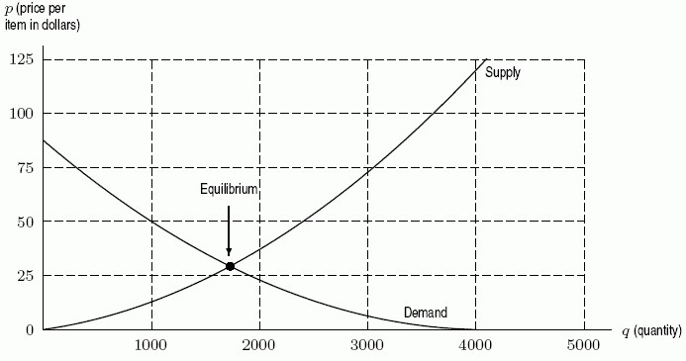

A) 1000 B) 2400 C) 1700 D) 4000

Answer: A

Diff: 1 Var: 1

Section: 1.4

Learning Objectives: Understand economic applications to supply and demand, taxation, budget constraints.

9) The following figure gives both supply and demand curves for a certain product. If the price is $50 per item, would you expect the market pressures to push the price higher or lower?



A) higher B) lower

Answer: B

Diff: 1 Var: 1

Section: 1.4

Learning Objectives: Understand economic applications to supply and demand, taxation, budget constraints.

10) Suppose that *S*(*q*) is the price per unit (in dollars) of widgets which will induce producers to supply *q* thousand widgets to the market, and suppose that *D*(*q*) is the price per unit at which consumers will buy *q* thousand units. Which is larger, D(100) or D(150)?

A) D(150) B) D(100)

Answer: B

Diff: 1 Var: 1

Section: 1.4

Learning Objectives: Understand cost, revenue, and profit functions and break even points.

11) Suppose that *S*(*q*) is the price per unit (in dollars) of widgets which will induce producers to supply *q* thousand widgets to the market, and suppose that *D*(*q*) is the price per unit at which consumers will buy *q* thousand units. If *D*(150) = 10 and S(100) = 10, what do you predict about the future selling price of widgets (currently at $10)?

A) It will rise. B) It will fall.

Answer: A

Diff: 2 Var: 1

Section: 1.4

Learning Objectives: Understand cost, revenue, and profit functions and break even points.

12) A teenager has $24 to spend at a carnival on both food and rides. Food costs (on average) $2 per item, and rides cost (on average) $3 each. Let *f* be the number of food items purchased and *r* be the number of rides purchased. What is the equation of the teenager's budget constraint?

A) 24 = 2*f* - 3*r* B) 24 = 3*f* + 2*r*

C) 24 = 2*f* + 3*r* D) 24(*f* + *r*) = 2 + 3

Answer: C

Diff: 2 Var: 1

Section: 1.4

Learning Objectives: Understand economic applications to supply and demand, taxation, budget constraints.

13) Production costs for manufacturing T-shirts consist of a fixed cost of $18,000 plus variable costs of $3 per shirt. Each T-shirt sells for $12 dollars. Find the total profit, π(*q*), as a function of the number of shirts produced, *q*.

A) π(*q*) = 3*q* - 18,000 B) π(*q*) = 12*q* - 18,000

C) π(*q*) = 15*q* - 18,000 D) π(*q*) = 9*q* - 18,000

Answer: D

Diff: 2 Var: 1

Section: 1.4

Learning Objectives: Understand cost, revenue, and profit functions and break even points.

14) Production costs for manufacturing T-shirts consist of a fixed cost of $20,000 plus variable costs of $3 per shirt. Each T-shirt sells for $7 dollars. What is the marginal cost?

A) $3 B) $7 C) $4 D) $20,000

Answer: A

Diff: 2 Var: 1

Section: 1.4

Learning Objectives: Understand cost, revenue, and profit functions and break even points.

15) Production costs for manufacturing T-shirts consist of a fixed cost of $12,000 plus variable costs of $2 per shirt. Each T-shirt sells for $12 dollars. How many T-shirts must be sold for the company to break even?

A) 1000 B) 1200 C) 6000 D) 3500

Answer: B

Diff: 2 Var: 1

Section: 1.4

Learning Objectives: Understand cost, revenue, and profit functions and break even points.

16) The demand and supply curves for a certain product are given in terms of price, *p*, by

*D*(*p*) = 360 - 10*p* and *S*(*p*) = 6*p* - 120.

What is the equilibrium price?

A) $4 B) $60 C) $30 D) $240

Answer: C

Diff: 3 Var: 1

Section: 1.4

Learning Objectives: Understand cost, revenue, and profit functions and break even points.

17) The demand and supply curves for a certain product are given in terms of price, *p*, by

*D*(*p*) = 340 - 10*p* and *S*(*p*) = 6*p* - 140.

What is the equilibrium quantity?

A) 30 B) 40 C) 4 D) 200

Answer: B

Diff: 3 Var: 1

Section: 1.4

Learning Objectives: Understand economic applications to supply and demand, taxation, budget constraints.

18) The cost of producing *q* items in a tortilla factory is given by *C*(*q*) = 3000 + 0.71*q* dollars. The revenue from sales of *q* items is *R*(*q*) = 0.89*q* dollars.

A. For what values of *q* does the tortilla factory make a profit?

B. Write a formula for profit as a function of *q*.

Answer:

A. *q* > 16,667 items

B. π(*q*) = 0.18q - 3000 dollars

Diff: 2 Var: 1

Section: 1.4

Learning Objectives: Understand cost, revenue, and profit functions and break even points.

19) A company has cost and revenue functions given in dollars by 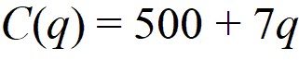 and 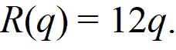 What is the effect on the break even point of decreasing the variable cost?

A) The break-even point is increased. B) The break-even point is decreased.

Answer: B

Diff: 2 Var: 1

Section: 1.4

Learning Objectives: Understand cost, revenue, and profit functions and break even points.

1.5 Exponential Functions

1) A population is growing according to the formula *P* = 225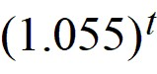, where *P* is the population at year *t*. What is the initial population?

A) 331 B) 237 C) 106 D) 225

Answer: D

Diff: 1 Var: 1

Section: 1.5

Learning Objectives: Understand and interpret the components of exponential functions: percent growth/decay rate, base, initial quantity.

2) A population is growing according to the formula *P* = 250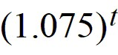, where *P* is the population at year *t*. What is the annual growth rate?

A) 2.5% B) 2.69% C) 7.5% D) 15.56%

Answer: C

Diff: 2 Var: 1

Section: 1.5

Learning Objectives: Understand and interpret the components of exponential functions: percent growth/decay rate, base, initial quantity.

3) A population is growing according to the formula *P* = 200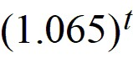. What is the population in year 11?

A) 400 B) 2343 C) 4094 D) 202

Answer: A

Diff: 1 Var: 1

Section: 1.5

Learning Objectives: Understand and interpret the components of exponential functions: percent growth/decay rate, base, initial quantity.

4) A population is growing according to the formula *P* = 275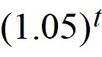, where *P* is the population in year *t*. How many years will it take for the population to exceed 1000?

A) 146 B) 26 C) 27 D) 145

Answer: C

Diff: 3 Var: 1

Section: 1.5

Learning Objectives: Understand and interpret the components of exponential functions: percent growth/decay rate, base, initial quantity.

5) A town has 2000 people initially. Find the formula for the population of the town, *P*, in terms of the number of years, *t*, if the town grows by 45 people a year.

A) *P* = 2000 + 45*t* B) *P* = 2000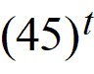

C) *P* = 2000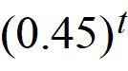 D) *P* = 2000 + 

Answer: A

Diff: 2 Var: 1

Section: 1.5

Learning Objectives: Determine a formula for an exponential function from data, graphs, or words.

6) A town has 1000 people initially. Find the formula for the population of the town, *P*, in terms of the number of years, *t*, if the town grows at an annual rate of 4% a year.

A) *P* = 1000 + 4*t* B) *P* = 1000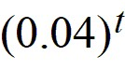

C) *P* = 1000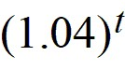 D) *P* = 1000 + 

Answer: C

Diff: 2 Var: 1

Section: 1.5

Learning Objectives: Determine a formula for an exponential function from data, graphs, or words.

7) A town has 2400 people initially. Find the formula for the population of the town, *P*, in terms of the number of years, *t*, if the town shrinks by 90 people a year.

A) *P* = 2400 - 90*t* B) *P* = 2400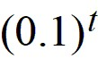

C) *P* = 2400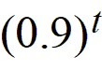 D) *P* = 2400 - 

Answer: A

Diff: 2 Var: 1

Section: 1.5

Learning Objectives: Determine a formula for an exponential function from data, graphs, or words.

8) A town has 800 people initially. Find the formula for the population of the town, *P*, in terms of the number of years, *t*, if the town shrinks at an annual rate of 5% a year.

A) *P* = 800 - 5*t* B) P = 800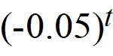

C) P = 800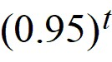 D) *P* = 800 - 

Answer: C

Diff: 2 Var: 1

Section: 1.5

Learning Objectives: Determine a formula for an exponential function from data, graphs, or words.

9) The following table gives values of three functions. Which one(s) could possibly be linear? Select all that apply.

|  |  |  |  |  |  |
| --- | --- | --- | --- | --- | --- |
| *x* | -2 | -1 | 0 | 1 | 2 |
| *f* (*x*) | 12 | 15 | 20 | 21 | 26 |
| *g*(*x*) | 16 | 24 | 36 | 54 | 81 |
| *h*(*x*) | 37 | 34 | 31 | 46 | 49 |

A) *f* (*x*) B) *g*(*x*) C) *h*(*x*)

Answer: C

Diff: 2 Var: 1

Section: 1.2; 1.5

Learning Objectives: Build linear functions from data, words, or graphs.; Determine a formula for an exponential function from data, graphs, or words.

10) The following table gives values of three functions. Which one(s) could possibly be exponential? Select all that apply.

|  |  |  |  |  |  |
| --- | --- | --- | --- | --- | --- |
| *x* | -2 | -1 | 0 | 1 | 2 |
| *f* (*x*) | 12 | 15 | 20 | 21 | 26 |
| *g*(*x*) | 16 | 24 | 36 | 54 | 81 |
| *h*(*x*) | 37 | 34 | 31 | 28 | 25 |

A) *f* (*x*) B) *g*(*x*) C) *h*(*x*)

Answer: B

Diff: 1 Var: 1

Section: 1.2; 1.5

Learning Objectives: Build linear functions from data, words, or graphs.; Determine a formula for an exponential function from data, graphs, or words.

11) A population of rabbits is growing. In 2012, there were 10,000,000 rabbits, and the population was increasing at a rate of 25% per decade. What is the predicted rabbit population in 2016? Round to the nearest rabbit.

Answer: 10,933,621

Diff: 2 Var: 1

Section: 1.5

Learning Objectives: Determine a formula for an exponential function from data, graphs, or words.

12) A population of rabbits is growing. In 2012, there were 10,000,000 rabbits, and the rate of increase was 10% per decade. Find *P*(*t*), the formula to predict the population *t* years after 2012.

A) *P*(*t*) = 10,000,000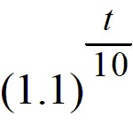 B) *P*(*t*) = 10,000,000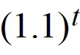

C) *P*(*t*) = 10,000,000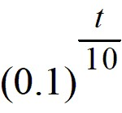 D) *P*(*t*) = 10,000,000

Answer: A

Diff: 2 Var: 1

Section: 1.5

Learning Objectives: Determine a formula for an exponential function from data, graphs, or words.

13) Identify the function defined in the following table as potentially linear, exponential, or neither.

|  |  |  |  |  |  |
| --- | --- | --- | --- | --- | --- |
| *x* | 0 | 2 | 4 | 6 | 8 |
| *f* (*x*) | 4.25 | 3.39 | 2.53 | 1.67 | 0.81 |

A) linear B) exponential C) neither

Answer: A

Diff: 1 Var: 1

Section: 1.5

Learning Objectives: Determine a formula for an exponential function from data, graphs, or words.

14) You were the housing minister in the year 2010 for a country with 30 million people. You were asked to predict the population 15 years from 2010 as part of a 15 year master plan for housing. Census records show that the population was 22.684 million in 2000 and 26.087 million in 2005. What was your best prediction of the population 15 years from 2010?

A) 45.626 million B) 40.974 million

C) 41.739 million D) 52.470 million

Answer: A

Diff: 2 Var: 1

Section: 1.5

Learning Objectives: Determine a formula for an exponential function from data, graphs, or words.

15) Find a formula for the exponential function partially defined in the following table. Round any constants to 3 decimal places.

|  |  |  |  |  |  |
| --- | --- | --- | --- | --- | --- |
| *x* | 0 | 100 | 200 | 300 | 400 |
| *f* (*x*) | 10 | 20 | ? | ? | ? |

Answer: *f* (*x*) = 10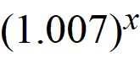

Diff: 3 Var: 1

Section: 1.5

Learning Objectives: Determine a formula for an exponential function from data, graphs, or words.

16) Using the table, find the value of *a* if *f* is exponential.

|  |  |  |  |
| --- | --- | --- | --- |
| *x* | 0 | 10 | 20 |
| *f* (*x*) | 50 | 200 | *a* |

Answer: 800

Diff: 2 Var: 1

Section: 1.5

Learning Objectives: Determine a formula for an exponential function from data, graphs, or words.

17) The following tables shows values for two functions. Which one could be exponential?

|  |  |  |  |  |
| --- | --- | --- | --- | --- |
| *t* | -2 | -1 | 0 | 1 |
| *f* (*t*) | 250 | 300 | 360 | 432 |

|  |  |  |  |  |
| --- | --- | --- | --- | --- |
| *t* | 2 | 3 | 4 | 5 |
| *g*(*t*) | 500 | 750 | 1500 | 4500 |

A) *f* (*t*) B) *g*(*x*)

Answer: A

Diff: 1 Var: 1

Section: 1.5

Learning Objectives: Determine a formula for an exponential function from data, graphs, or words.

18) The following table shows values for an exponential function, *f* (*t*). Find a formula for *f* (*t*). Table entries are rounded to two decimal places.

|  |  |  |  |  |
| --- | --- | --- | --- | --- |
| *t* | -2 | -1 | 0 | 1 |
| *f* (*t*) | 173.47 | 242.86 | 340.00 | 476.00 |

Answer: *f* (*t*) = 340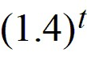

Diff: 2 Var: 1

Section: 1.5

Learning Objectives: Determine a formula for an exponential function from data, graphs, or words.

19) A bar of soap starts out at 100 grams. Write a formula for the quantity *S* grams of soap remaining after *t* days if the decrease is 10% per day.

Answer: S = 100

Diff: 2 Var: 1

Section: 1.5

Learning Objectives: Determine a formula for an exponential function from data, graphs, or words.

20) A photocopy machine can reduce copies to 90% or 70% of their original size. By copying an already reduced copy, further reductions can be made. Write a formula for the size of the image, *N*, after the original image of size *a* has been reduced *n* times with the copy machine set on 90% reduction.

Answer: *N* = *a*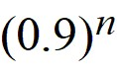

Diff: 2 Var: 1

Section: 1.5

Learning Objectives: Determine a formula for an exponential function from data, graphs, or words.

21) A photocopy machine can reduce copies to 90% or 70% of their original size. By copying an already reduced copy, further reductions can be made. Which will be larger, an image that has been reduced on the 90% setting 8 times, or the same image after being reduced 2 times on the 70% setting?

A) The image reduced on the 70% setting

B) The image reduced on the 90% setting

Answer: A

Diff: 3 Var: 1

Section: 1.5

Learning Objectives: Understand and interpret the components of exponential functions: percent growth/decay rate, base, initial quantity.

22) Which could be a possible formula for the following figure? Assume *a* and *b* are positive constants.

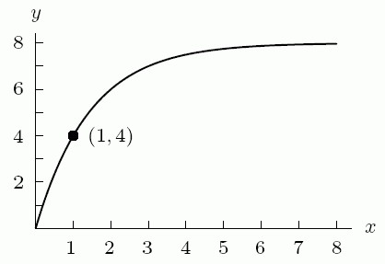

A) *a*(1 - (b) with superscript (-x)) B) *a*(1 - (b) with superscript (x)) C) *a*((b) with superscript (-x)) D) *a*((b) with superscript (x))

Answer: A

Diff: 3 Var: 1

Section: 1.5

Learning Objectives: Determine a formula for an exponential function from data, graphs, or words.

23) Which could be a possible formula for the following figure? Assume *a* and *b* are positive constants.

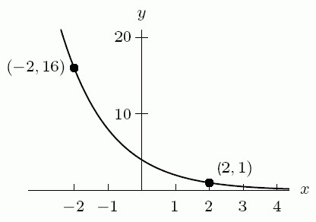

A) *a*(1 - (b) with superscript (-x)) B) *a*(1 - (b) with superscript (x)) C) *a*((b) with superscript (-x)) D) *a*((b) with superscript (x))

Answer: C

Diff: 2 Var: 1

Section: 1.5

Learning Objectives: Determine a formula for an exponential function from data, graphs, or words.

24) Which could be a possible formula for the following figure? Assume *a* and *b* are positive constants.

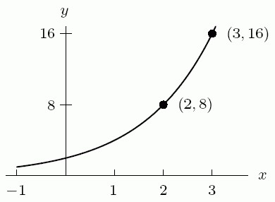

A) *a*(1 - (b) with superscript (-x)) B) *a*(1 - (b) with superscript (x)) C) *a*((b) with superscript (-x)) D) *a*((b) with superscript (x))

Answer: D

Diff: 3 Var: 1

Section: 1.5

Learning Objectives: Determine a formula for an exponential function from data, graphs, or words.

25) Does P = 9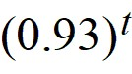 represent exponential growth or decay?

Answer: decay

Diff: 1 Var: 1

Section: 1.5

Learning Objectives: Understand and interpret the components of exponential functions: percent growth/decay rate, base, initial quantity.

26) Does P = 3.9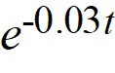 represent exponential growth or decay?

Answer: decay

Diff: 1 Var: 1

Section: 1.5

Learning Objectives: Understand and interpret the components of exponential functions: percent growth/decay rate, base, initial quantity.

27) Joe invested $30,000 in the stock market, while Sam invested $40,000. Joe's investment increased by 6% per year for 10 years. Sam's investment decreased in value by 12% per year for 5 years and then increased by 12% per year for the next 5 years. What was Sam's investment worth after 10 years? Round to the nearest dollar.

Answer: $37,202

Diff: 3 Var: 1

Section: 1.5

Learning Objectives: Determine a formula for an exponential function from data, graphs, or words.

28) A bakery has 600 pounds of flour. If they use 5% of the available flour each day, how many pounds do they have left after 14 days? Round to the nearest pound.

Answer: 293

Diff: 2 Var: 1

Section: 1.5

Learning Objectives: Determine a formula for an exponential function from data, graphs, or words.

29) The following table gives values for three different functions. Find a formula for the exponential one.

|  |  |  |  |
| --- | --- | --- | --- |
| *t* | *f* (*t*) | *g*(*t*) | *h*(*t*) |
| -1 | 15 | 21.9 | 2000 |
| 0 | 9 | 24.1 | 600 |
| 1 | 5 | 26.3 | 180 |
| 2 | 4 | 28.5 | 54 |

Answer: *h*(*t*) = 600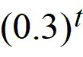

Diff: 2 Var: 1

Section: 1.5

Learning Objectives: Determine a formula for an exponential function from data, graphs, or words.

30) The following table gives values for three different functions. One of the functions is neither linear nor exponential. Is that function increasing or decreasing?

|  |  |  |  |
| --- | --- | --- | --- |
| *t* | *f* (*t*) | *g*(*t*) | *h*(*t*) |
| -1 | 15 | 21.6 | 1000 |
| 0 | 9 | 24.1 | 600 |
| 1 | 5 | 26.6 | 360 |
| 2 | 4 | 29.1 | 216 |

Answer: decreasing

Diff: 2 Var: 1

Section: 1.5

Learning Objectives: Build linear functions from data, words, or graphs.; Determine a formula for an exponential function from data, graphs, or words.

1.6 The Natural Logarithm

1) Solve 7 ∙ (3) with superscript (t) = 5 ∙ (2) with superscript (t) for *t*. Round to 3 decimal places.

Answer: -0.830

Diff: 2 Var: 1

Section: 1.6

Learning Objectives: Use the natural logarithm to solve equations.

2) Solve 6 ∙ 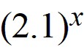 = *a* ∙ (e) with superscript (kx) for both *a* and *k*. Round to 3 decimal places.

*a* = ________ *k* = ________

Answer: Part A: 6

Part B: 0.742

Diff: 3 Var: 1

Section: 1.6

Learning Objectives: Use the natural logarithm to solve equations.

3) Find an equation for the line *L* shown. Your answer will contain the positive constant *b*.

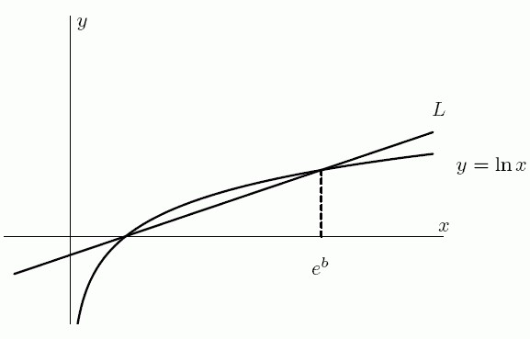

Answer:  *y* = 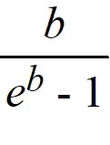 (*x* - 1)

Diff: 3 Var: 1

Section: 1.6

Learning Objectives: Use the natural logarithm to solve equations.

4) Find the equation of the line in the following figure.

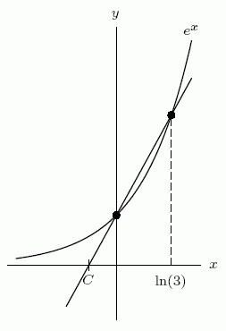

Answer: *y* = 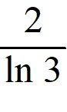 *x* + 1

Diff: 2 Var: 1

Section: 1.6

Learning Objectives: Use the natural logarithm to solve equations.

5) Solve 70 ∙ (14) with superscript (t) = 50 ∙ (12) with superscript (t) for *t*. Round to two decimal places.

Answer: -2.18

Diff: 2 Var: 1

Section: 1.6

Learning Objectives: Use the natural logarithm to solve equations.

6) Use logarithms to solve the equation 20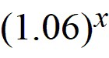 = 100. Round to two decimal places.

Answer: 27.62

Diff: 2 Var: 1

Section: 1.6

Learning Objectives: Use the natural logarithm to solve equations.

7) What interest rate, compounded annually, is equivalent to a 3% rate compounded continuously? Round to two decimal places.

Answer: 3.05%

Diff: 3 Var: 1

Section: 1.6

Learning Objectives: Understand and interpret the forms of exponential functions and convert from base 'a' to base 'e' and vice versa.

8) The following functions represent exponential growth or decay. Which ones represent continuous growth or decay? Select all that apply.

A) *P* = 3.2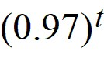 B) *P* = 7.1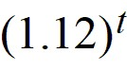

C) *P* = 26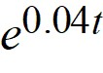 D) *P* = 6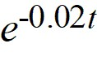

Answer: C, D

Diff: 1 Var: 1

Section: 1.6

Learning Objectives: Understand and interpret the forms of exponential functions and convert from base 'a' to base 'e' and vice versa.

9) Solve (6) with superscript (x) = 15 for *x* using logs. Round to 3 decimal places.

Answer: 1.511

Diff: 1 Var: 1

Section: 1.6

Learning Objectives: Use the natural logarithm to solve equations.

10) Solve 4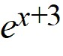 = 8(e) with superscript (6x) using logs. Round your answer to 3 decimal places.

Answer: 0.461

Diff: 2 Var: 1

Section: 1.6

Learning Objectives: Use the natural logarithm to solve equations.

11) If the size of a bacteria colony doubles in 10 hours, how many hours will it take for the number of bacteria to be 5 times the original amount? Round to 3 decimal places.

Answer: 23.219

Diff: 2 Var: 1

Section: 1.6

Learning Objectives: Understand and interpret the forms of exponential functions and convert from base 'a' to base 'e' and vice versa.

12) Tornados are classified in several ways. A tornado's classification on the Fujita Scale as F1 through F5 is most commonly cited. Another classification of tornados is by path length, given by the formula P*l* = 2log(*L*) + 1 where *L* is the length of the tornado's path length, in miles. The Binger, Oklahoma tornado of 1981 was an F4 whose path was 16 miles in length. What was its P*l* classification?

A) P1 B) P2 C) P3 D) P4 E) P5

Answer: C

Diff: 1 Var: 1

Section: 1.6

Learning Objectives: Use the natural logarithm to solve equations.

13) Use your calculator to find all of the solutions to the equation (2) with superscript (x) = (x) with superscript (2). Round your answers to 2 decimal places.

Answer: *x* = -.77, *x* = 4

Diff: 2 Var: 1

Section: 1.6

Learning Objectives: Use the natural logarithm to solve equations.

14) As *x* → -∞, *f* (*x*) = (e) with superscript (x) → ________.

A) ∞ B) 0 C) -∞

Answer: B

Diff: 2 Var: 1

Section: 1.6

Learning Objectives: Understand and interpret the components of exponential functions: percent growth/decay rate, base, initial quantity.

15) One of the following tables of data is linear and the other one is exponential. The formula for the exponential one is *y* = *c*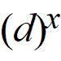. Find the values of *c* and *d* to two decimal places.

|  |  |  |  |  |  |
| --- | --- | --- | --- | --- | --- |
| *x* | 0 | 0.50 | 1.00 | 1.50 | 2.00 |
| *y* | 3.12 | 2.63 | 2.22 | 1.87 | 1.57 |

|  |  |  |  |  |  |
| --- | --- | --- | --- | --- | --- |
| *x* | 0 | 0.50 | 1.00 | 1.50 | 2.00 |
| *y* | 2.71 | 3.44 | 4.17 | 4.90 | 5.63 |

A. *c* = ________

B. *d* = ________

Answer:

A. 3.12

B. 0.71

Diff: 2 Var: 1

Section: 1.6

Learning Objectives: Determine a formula for an exponential function from data, graphs, or words.

16) Write the Roman numeral of the graph that corresponds to each function.

A. ln((e) with superscript (x)) + 1

B. -2ln *x*

C. (e) with superscript (-x)

D. (x) with superscript (5) + 2(x) with superscript (4) - (x) with superscript (3) - 2(x) with superscript (2) + 5

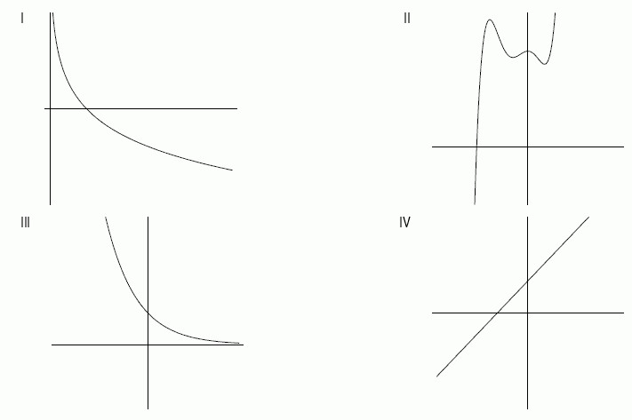

Answer:

A. IV

B. I

C. III

D. II

Diff: 1 Var: 1

Section: 1.6

Learning Objectives: Use the natural logarithm to solve equations.

17) The solid curve below is a portion of the graph of *f* (*x*) = 8(x) with superscript (3) and the dashed curve is a portion of the graph of g(x) = 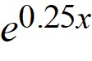. The domain of both functions is all real numbers. Which of the following statements are true? Select all that apply.

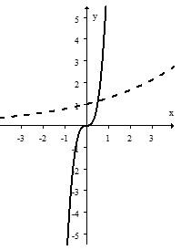

A) At *x* = 1, *f* (*x*) > *g*(*x*).

B) For all *x* > 1, *f* (*x*) > *g*(*x*).

C) As *x* → -∞, *g*(*x*) → 0.

D) There is only one value of *x* for which *f* (*x*) = *g*(*x*).

Answer: A, C, D

Diff: 2 Var: 1

Section: 1.6

Learning Objectives: Build, solve, and interpret exponential functions given data, graphs or words.

18) Using base *e* and transformations, find a formula for the exponential function shown in the graph below.

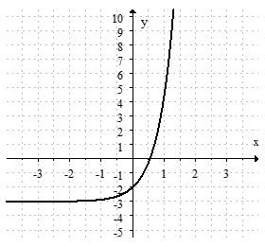

Answer: The answer should be close to *f* (*x*) = (e) with superscript (2x) - 3.

Diff: 2 Var: 1

Section: 1.6

Learning Objectives: Build, solve, and interpret exponential functions given data, graphs or words.

1.7 Exponential Growth and Decay

1) A substance has a half-life of 40 years. What percent of the original amount of the substance will remain after 20 years? Round to the nearest percent.

Answer: 71%

Diff: 2 Var: 1

Section: 1.7

Learning Objectives: Understand and interpret properties of exponential models: doubling time, half-life.

2) The function *P* = 3.2(0.97)*t* represents exponential growth or decay.

A. What is the initial quantity?

B. What is the initial growth or decay rate?

Answer:

A. 3.2

B. 3%

Diff: 2 Var: 1

Section: 1.7

Learning Objectives: Build, solve, and interpret exponential functions given data, graphs or words.

3) The number of bacteria in milk grows at a rate of 9% per day once the milk has been bottled. When milk is put in the bottles, it has an average bacteria count of 500 million per bottle.

A. Write an equation for *f* (*t*), the number of bacteria *t* days after the milk was bottled.

B. Graph *f* (*t*). Label the axes and intercepts.

Answer:

A. *f* (*t*) = 500,000,000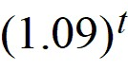

B.

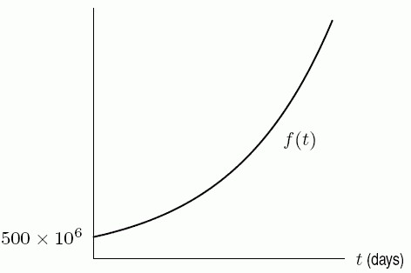

Diff: 2 Var: 1

Section: 1.7

Learning Objectives: Build, solve, and interpret exponential functions given data, graphs or words.

4) The number of bacteria in milk grows at a rate of 11% per day once the milk has been bottled. When milk is put in the bottles, it has an average bacteria count of 500 million per bottle. Suppose milk cannot be safely consumed if the bacteria count is greater than 3 billion per bottle. Under this model, how many days would the milk be safe to drink once it has been bottled?

Answer: 17

Diff: 3 Var: 1

Section: 1.7

Learning Objectives: Understand and use the concepts of present value and future value.

5) Write the function *a*(*t*) = 20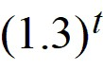 in the form *A*(e) with superscript (kt). Round *k* to 3 decimal places.

Answer: 20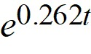

Diff: 2 Var: 1

Section: 1.7

Learning Objectives: Build, solve, and interpret exponential functions given data, graphs or words.

6) Write the function *b*(*t*) = 90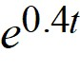 in the form (P) with subscript (0)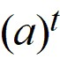. Round *a* to 3 decimal places.

Answer: 90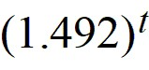

Diff: 2 Var: 1

Section: 1.7

Learning Objectives: Build, solve, and interpret exponential functions given data, graphs or words.

7) Simplify the expression 9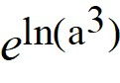 as much as possible.

Answer: 9(a) with superscript (3)

Diff: 2 Var: 1

Section: 1.7

Learning Objectives: Build, solve, and interpret exponential functions given data, graphs or words.

8) What is the doubling time of prices which are increased by 14% per year? Round to the nearest hundredth of a year.

Answer: 5.29 years

Diff: 2 Var: 1

Section: 1.7

Learning Objectives: Understand and interpret properties of exponential models: doubling time, half-life.

9) Each of the curves in the following figure represents the balance in a bank account at time *t* after a single deposit at time *t* = 0. Assuming continuously compounded interest, which curve represents the smallest interest rate?

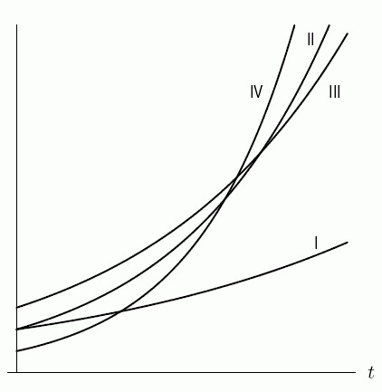

Answer: I

Diff: 2 Var: 1

Section: 1.7

Learning Objectives: Build, solve, and interpret exponential functions given data, graphs or words.

10) You win the lottery and are offered a choice of $90,000 now or $20,000 at the end of each year for five years. Assuming a 4% annual interest rate and ignoring taxes, which is the better option?

A) The first B) The second

Answer: A

Diff: 2 Var: 1

Section: 1.7

Learning Objectives: Build, solve, and interpret exponential functions given data, graphs or words.

11) The population *P* = *f* (*t*) of the United States in millions *t* years after 1790 during the period from 1790 to 1860 was given approximately by the exponential formula 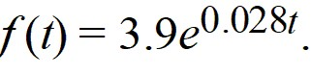 What was the annual percent growth rate of the US during this time period?

Answer: 3%

Diff: 2 Var: 1

Section: 1.7

Learning Objectives: Build, solve, and interpret exponential functions given data, graphs or words.

12) The population *P* = *f* (*t*) of the United States in millions *t* years after 1790 during the years from 1790 to 1860 was given approximately by the exponential formula ** What was the approximate doubling time for the population? Round to the nearest year.

Answer: 23 years

Diff: 2 Var: 1

Section: 1.7

Learning Objectives: Understand and interpret properties of exponential models: doubling time, half-life.

13) A standard cup of coffee contains about 100 mg of caffeine, and caffeine leaves the body at a rate of about 17% an hour. How many mg of caffeine are left in the body after 5 hours if this rate is hourly? Round to 2 decimal places.

Answer: 39.39

Diff: 2 Var: 1

Section: 1.7

Learning Objectives: Understand and use the concepts of present value and future value.

14) A standard cup of coffee contains about 100 mg of caffeine, and caffeine leaves the body at a rate of about 17% an hour. How many mg of caffeine are left in the body after 2 hours if this rate is continuous? Round to 2 decimal places.

Answer: 71.18

Diff: 1 Var: 1

Section: 1.7

Learning Objectives: Understand and use the concepts of present value and future value.

15) A clean up of a polluted lake will remove 6% of the remaining contaminants every year. How many years will it take to reduce the quantity of contaminants to 1/10 of its present level? Round to the nearest tenth.

Answer: 37.2

Diff: 2 Var: 1

Section: 1.7

Learning Objectives: Understand and use the concepts of present value and future value.

16) A new species, introduced into an environment in which it has no natural predators, grows exponentially with continuous growth rate 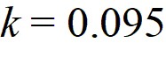 per year. There are initially 45 individuals introduced. Write the formula for *N*(*t*), the number of individuals after *t* years and use it to find how many years will it take for the population to reach 300 individuals. Round to 2 decimal places.

Answer: 19.97

Diff: 2 Var: 1

Section: 1.7

Learning Objectives: Build, solve, and interpret exponential functions given data, graphs or words.

17) The population of Nicaragua was 6.5 million in 2019 and growing at 1.2% per year. Let *P* be the population in millions, and let *t* be the time in years since 2019. Express *P* as a function of *t*. Select all that apply.

A) *P* = 6.5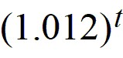 B) *P* = 6.5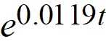

C) *P* = 6.5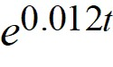 D) *P* = 6.5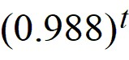

Answer: A, B

Diff: 2 Var: 1

Section: 1.7

Learning Objectives: Build, solve, and interpret exponential functions given data, graphs or words.

18) The population of Nicaragua was 6.5 million in 2019 and growing at 1.2% per year. How many years does it take for the population of Nicaragua to increase by 60%? Round to 2 decimal places.

Answer: 14.06

Diff: 2 Var: 1

Section: 1.7

Learning Objectives: Understand and use the concepts of present value and future value.

19) An exponentially decaying substance was weighed every hour and the results are given below. If the formula 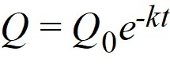 gives the weight of the substance, *Q*, at time *t* in hours since 9 a.m., then (Q) with subscript (0) = ________ and *k* = ________. Round *k* to 2 decimal points.

|  |  |
| --- | --- |
| Time | Weight (in grams) |
| 9 a.m. | 16 |
| 10 a.m. | 14.333 |
| 11 a.m. | 12.840 |
| 12 noon | 11.503 |
| 1 p.m. | 10.305 |

Answer:

Part A: 16

Part B: 0.11

Diff: 2 Var: 1

Section: 1.7

Learning Objectives: Build, solve, and interpret exponential functions given data, graphs or words.

20) An exponentially decaying substance was weighed every hour and the results are given below. What is the half-life of the substance? Round to the nearest tenth.

|  |  |
| --- | --- |
| Time | Weight (in grams) |
| 9 a.m. | 16 |
| 10 a.m. | 14.333 |
| 11 a.m. | 12.840 |
| 12 noon | 11.503 |
| 1 p.m. | 10.305 |

Answer: 6.3 hours

Diff: 1 Var: 1

Section: 1.7

Learning Objectives: Build, solve, and interpret exponential functions given data, graphs or words.

21) In 1992, the Population Crisis Committee wrote:

"Large cities in developing countries are growing much faster than cities in the industrialized world ever have. London, which in 1810 became the first industrialized city to top 1 million, now has a population of 11 million. By contrast, Mexico City's population stood at only a million just 50 years ago and now it is 20 million."

Assume that the percentage growth rates of London and Mexico City were constant over the last two centuries. How many times greater is Mexico City's percentage growth rate than London's? Round to the nearest tenth.

Answer: 5.7

Diff: 2 Var: 1

Section: 1.7

Learning Objectives: Build, solve, and interpret exponential functions given data, graphs or words.

22) Is the function described by the following table of values exponential?

|  |  |  |  |  |  |
| --- | --- | --- | --- | --- | --- |
| *x* | 5.2 | 5.3 | 5.4 | 5.5 | 5.6 |
| *f* (*x*) | 27.8 | 33.36 | 40.032 | 48.0384 | 57.64608 |

Answer: yes

Diff: 1 Var: 1

Section: 1.7

Learning Objectives: Build, solve, and interpret exponential functions given data, graphs or words.

23) A quantity growing exponentially according to the formula 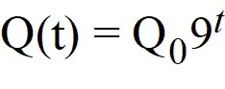 has a doubling time of 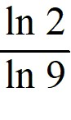.

Answer: TRUE

Diff: 2 Var: 1

Section: 1.7

Learning Objectives: Understand and interpret properties of exponential models: doubling time, half-life.

24) Which is worth more after 15 years: $1200 invested at 10% annual interest or $1500 invested at 8% annual interest?

A) The 10% investment B) The 8% investment

Answer: A

Diff: 2 Var: 1

Section: 1.7

Learning Objectives: Build, solve, and interpret exponential functions given data, graphs or words.

25) Suppose $1200 is invested at 10% annual interest and $1500 is invested at 8% annual interest. After how many years will the investments be equal? Round to the nearest whole number.

Answer: 12

Diff: 3 Var: 1

Section: 1.7

Learning Objectives: Understand and use the concepts of present value and future value.

26) A cigarette contains about 0.4 mg of nicotine. The half-life of nicotine in the body is about 2 hours. How many hours does it take, after smoking a cigarette, for the level of nicotine in a smoker's body to be reduced to 0.12 mg? Round to 2 decimal places.

Answer: 3.47

Diff: 1 Var: 1

Section: 1.7

Learning Objectives: Understand and interpret properties of exponential models: doubling time, half-life.

27) If *f* (*x*) = 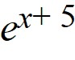, find and simplify the average rate of change 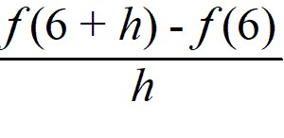.

A) 1 B) (e) with superscript (11) - (e) with superscript (6) C) 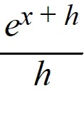 D) 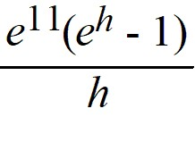

Answer: D

Diff: 2 Var: 1

Section: 1.7

Learning Objectives: Understand and interpret properties of exponential models: doubling time, half-life.

28) In the book *One Grain of Rice*, a girl receives a reward that starts with one grain of rice on day one, two grains on day two, four on day three and eight on day four. Each day, she receives double the number of grains of rice. How many grains of rice does she receive on the 30th day?

A) 900 B) 1,073,741,824

C) 4,640,650,289 D) 60

Answer: B

Diff: 1 Var: 1

Section: 1.7

Learning Objectives: Understand and use the concepts of present value and future value.

29) Lisinopril is an ACE inhibitor derived from the venom of a Brazilian pit viper frequently used in the treatment of hypertension. Because of Lisinopril's relatively long half-life of 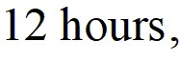 patients need to take a dose just once per day. A patient takes his first dose, 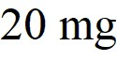, at 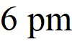 on Saturday.

a) How many hours does it take for the amount of Lisinopril in the patient's body to decrease to 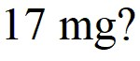 Round to two decimal places.

b) How many milligrams remain in the patient's body right before he takes his next  at  on Sunday? Round to two decimal places

Answer:

a) 2.81 hours

b) 5.00 milligrams

Diff: 2 Var: 1

Section: 1.7

Learning Objectives: Understand and interpret properties of exponential models: doubling time, half-life.

30) If the size of a bacteria colony doubles in 8 hours, how many hours will it take for the number of bacteria to be 5 times the original amount? Round to 2 decimal places.

Answer: 18.58

Diff: 2 Var: 1

Section: 1.7

Learning Objectives: Understand and interpret properties of exponential models: doubling time, half-life.

31) Bank *A* offers 12% interest, compounded yearly, and Bank *B* offers 11.4% interest, compounded continuously. Which bank should you choose if you have $1000 to invest for 10 years?

Answer: Bank B

Diff: 2 Var: 1

Section: 1.7

Learning Objectives: Understand and interpret properties of exponential models: doubling time, half-life.

32) You have $500 invested in an account earning 8.8% interest compounded annually. How many years will it take to triple your money? Round to the nearest tenth of a year.

Answer: 13.0

Diff: 2 Var: 1

Section: 1.7

Learning Objectives: Understand and use the concepts of present value and future value.

33) You have $500 invested in an account earning 8.4% interest compounded annually. Suppose the interest rate were compounded monthly instead, that is you earned 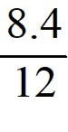% interest each month. How much interest would you then earn for a year?

Answer: $43.66

Diff: 1 Var: 1

Section: 1.7

Learning Objectives: Understand and interpret properties of exponential models: doubling time, half-life.

34) A bank pays 6% annual interest. If $1000 is deposited in this bank account, find the amount in the account after 5 years if the interest is compounded continuously.

Answer: $1349.86

Diff: 1 Var: 1

Section: 1.7

Learning Objectives: Understand and use the concepts of present value and future value.

35) Write a formula for the population, *P*, as a function of time, *t*, if the population starts at 5000 and grows by 125 people each year.

Answer: *P* = 5000 + 125*t*

Diff: 1 Var: 1

Section: 1.7

Learning Objectives: Understand and interpret properties of exponential models: doubling time, half-life.

36) Write a formula for the population, *P*, as a function of time, *t*, if the population starts at 8000 and grows by 5% each year.

Answer: *P* = 8000

Diff: 1 Var: 1

Section: 1.7

Learning Objectives: Understand and interpret properties of exponential models: doubling time, half-life.

37) The elimination half-life of aspirin in plasma is estimated to be between 15 and 20 minutes. Assuming the lower estimate of 15 minutes, how long will it take a dose of 81 mg to decrease to (2/3) the original amount (54 mg) in the plasma?

A) 1.4 minutes B) 9.7 minutes C) 12 minutes D) 8.8 minutes

Answer: D

Diff: 3 Var: 1

Section: 1.7

Learning Objectives: Understand and interpret properties of exponential models: doubling time, half-life.

1.8 New Functions from Old

1) Use the following table to find *f* (*g*(3)).

|  |  |  |  |  |  |
| --- | --- | --- | --- | --- | --- |
| *x* | 0 | 1 | 2 | 3 | 4 |
| *f* (*x*) | 2 | 4 | 6 | 3 | 5 |
| *g*(*x*) | 5 | 3 | 2 | 1 | 0 |

Answer: 4

Diff: 2 Var: 1

Section: 1.8

Learning Objectives: Find and/or evaluate composite functions given by formulas, graphs or tables.

2) One of the graphs below shows the rate of flow, *R*, of blood from the heart in a man who bicycles for 20 minutes, starting at *t* = 0 minutes. The other graph shows the pressure, *p*, in the artery leading to a man's lungs as a function of the rate of flow of blood from the heart. Estimate *p*(*R*(20)).

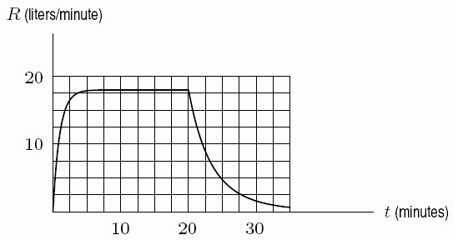

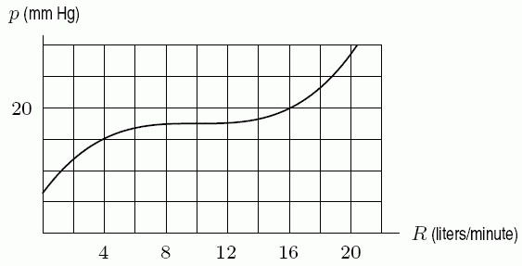

A) 23 mm Hg B) 19 mm Hg C) 27 mm Hg D) 15 mm Hg

Answer: A

Diff: 1 Var: 1

Section: 1.8

Learning Objectives: Find and/or evaluate composite functions given by formulas, graphs or tables.

3) Given the function *m*(*z*) = (z) with superscript (2), find and simplify *m*(*z* + *h*) - *m*(*z*).

Answer: 2*zh* + (h) with superscript (2)

Diff: 2 Var: 1

Section: 1.8

Learning Objectives: Find and/or evaluate composite functions given by formulas, graphs or tables.

4) Let *f* (*x*) = 8*x* + 1 and *g*(*x*) = (x) with superscript (2) + 5. What is *f* (*g*(*x*))?

A) 8(x) with superscript (2) + 41

B) 64(x) with superscript (2) + 16*x* + 6

C) (x) with superscript (2) + 8*x* + 6

D) 8(x) with superscript (3) + (x) with superscript (2) + 40*x* + 5

E) 8(x) with superscript (3) + 40*x* + 1

Answer: A

Diff: 1 Var: 1

Section: 1.8

Learning Objectives: Find and/or evaluate composite functions given by formulas, graphs or tables.

5) The graphs of *y* = *f* (*x*) and *y* = *g*(*x*) are given in the following figure. Estimate *g*(*f* (0)).

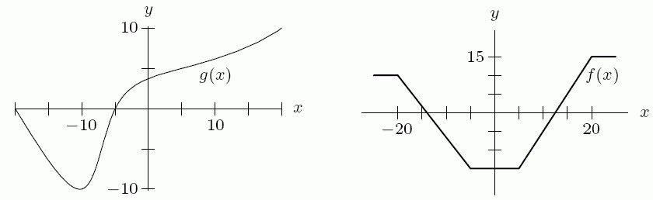

A) -7 B) -15 C) -10 D) 15

Answer: A

Diff: 1 Var: 1

Section: 1.8

Learning Objectives: Find and/or evaluate composite functions given by formulas, graphs or tables.

6) What is the equation for the graph obtained by shifting the graph of = (x) with superscript (3) vertically upward by 5 units, followed by vertically stretching the graph by a factor of 4?

A) 4(x) with superscript (3) + 20 B) 4(x) with superscript (3) + 5

C) 20(x) with superscript (2) + 5 D) 4(x) with superscript (3) + 60(x) with superscript (2) + 300*x* + 500

Answer: A

Diff: 1 Var: 1

Section: 1.8

Learning Objectives: Understand stretches and shifts of graphs both analytically and graphically.

7) What is the equation for the graph obtained by shifting the graph of *y* = (x) with superscript (3) vertically upward by 5 units, followed by vertically stretching the graph by a factor of 3, followed by reflecting the graph across the *x*-axis?

A) -3(x) with superscript (3) - 15 B) -3(x) with superscript (3) - 5

C) 15(x) with superscript (2) + 5 D) -3(x) with superscript (3) - 45(x) with superscript (2) - 225*x* - 375

Answer: B

Diff: 2 Var: 1

Section: 1.8

Learning Objectives: Understand stretches and shifts of graphs both analytically and graphically.

8) If the graph of y = *f* (*x*) shrinks vertically by a factor of 1/2, then shifts vertically by 10 units, then stretches vertically by a factor of 5, the resulting graph is the same as the original graph.

Answer: FALSE

Diff: 2 Var: 1

Section: 1.8

Learning Objectives: Understand stretches and shifts of graphs both analytically and graphically.

9) Given the equation *q*(*x*) = (x) with superscript (3), find and simplify *q*(2*x* + *a*) + *q*(*x*).

Answer: 9(x) with superscript (3) + 12*a*(x) with superscript (2) + 6(a) with superscript (2)*x* + (a) with superscript (3)

Diff: 1 Var: 1

Section: 1.8

Learning Objectives: Find and/or evaluate composite functions given by formulas, graphs or tables.

10) Given the equation *q*(*x*) = (x) with superscript (3), find and simplify *q*((x) with superscript (2)) + *q*(*x* + *a*).

Answer: (x) with superscript (6) + (x) with superscript (3) + 3*a*(x) with superscript (2) + 3(a) with superscript (2)*x* + (a) with superscript (3)

Diff: 1 Var: 1

Section: 1.8

Learning Objectives: Find and/or evaluate composite functions given by formulas, graphs or tables.

11) The cost of shipping *r* grams of material is given by the function *C* = *f* (*r*) = 150 + 4*r*. Find a formula for the inverse function, *r*(*C*).

A) *r* = (*C* - 150)/4 B) *r* = 150 + 4*C*

C) *r* = -150 - 4*C* D) *r* = 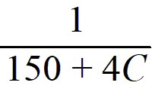

Answer: A

Diff: 2 Var: 1

Section: 1.8

Learning Objectives: Find and/or evaluate composite functions given by formulas, graphs or tables.

12) For *g*(*x*) = 3(x) with superscript (2) + 3*x* and *h*(*x*) = 4*x* - 1, find and simplify *h*(*g*(*x*)).

Answer: 12(x) with superscript (2) + 12*x* - 1

Diff: 1 Var: 1

Section: 1.8

Learning Objectives: Find and/or evaluate composite functions given by formulas, graphs or tables.

13) For *g*(*x*) = 4(x) with superscript (2) + 3*x* and *h*(*x*) = 5*x* - 1, find and simplify *g*(*h*(*x*)).

Answer: 100(x) with superscript (2) - 25*x* + 1

Diff: 1 Var: 1

Section: 1.8

Learning Objectives: Find and/or evaluate composite functions given by formulas, graphs or tables.

14) Use the function in the graph to complete the table of values.

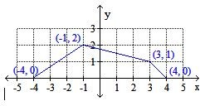

|  |  |  |  |  |
| --- | --- | --- | --- | --- |
|  | -4 | -1 | 3 | 4 |
| *f (x)* | 0 | 2 | 1 | 0 |
| *f (x)* + 4 |  |  |  |  |
| *-f (x)* |  |  |  |  |
| *-f (x)* + 6 |  |  |  |  |

Answer:

|  |  |  |  |  |
| --- | --- | --- | --- | --- |
|  | -4 | -1 | 3 | 4 |
| *f (x)* | 0 | 2 | 1 | 0 |
| *f (x)* + 4 | 4 | 6 | 6 | 4 |
| *-f (x)* | 0 | -2 | -1 | 0 |
| *-f (x)* + 6 | 6 | 4 | 5 | 6 |

Diff: 1 Var: 1

Section: 1.8

Learning Objectives: Understand stretches and shifts of graphs both analytically and graphically.

1.9 Proportionality and Power Functions

1) Which of the following are power functions? Select all that apply.

A)  *y* = (4/5x) B)  *y* = 5 ∙ (2) with superscript (x) C)  *y* = 4 + square root of (x) D)  *y* = 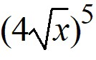

Answer: A, D

Diff: 1 Var: 1

Section: 1.9

Learning Objectives: Write and interpret power functions given by tables, graphs, or words.

2) Use shifts of power functions to find a possible formula for the following graph.

A curve is graphed on an x y coordinate plane. The curve increases concave down from a point on the negative x axis to a marked point (negative 2, 4) and it increases concave up through positive y axis to the first quadrant.


A) *y* = 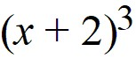 + 4 B) *y* = 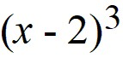 + 4

C) *y* = 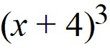 + 2 D) *y* =  - 2

Answer: A

Diff: 1 Var: 1

Section: 1.9

Learning Objectives: Write and interpret power functions given by tables, graphs, or words.

3) Simplify 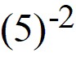, leaving your answer as a fraction where appropriate.

Answer: 1/25

Diff: 1 Var: 1

Section: 1.9

Learning Objectives: Write and interpret power functions given by tables, graphs, or words.

4) The following table gives the values for *y* = *f* (*x*). It is possible that *y* could be inversely proportional to *x.*

|  |  |  |  |  |
| --- | --- | --- | --- | --- |
| *x* | 1 | 2 | 3 | 4 |
| *y* | 3 | 1.5 | 1 | 0.75 |

Answer: TRUE

Diff: 1 Var: 1

Section: 1.9

Learning Objectives: Write and interpret a function describing a proportional relationship.

5) Write a function that represents the following situation. The gravitational force, *F,* between two bodies is inversely proportional to the square of the distance, *d*, between them.

A) *F* = *k*(d) with superscript (2) B) *F* = 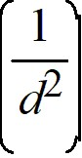 C) (F) with superscript (2) = ((1/d)) D) (F) with superscript (2) = *kd*

Answer: B

Diff: 3 Var: 1

Section: 1.9

Learning Objectives: Write and interpret a function describing a proportional relationship.

6) The number of species, *S*, on an island is proportional to the square root of the area, *A*, of the island. An island which has an area of 9 square miles contains 30 species. How many species would be expected on an island of 4 square miles?

Answer: 20

Diff: 2 Var: 1

Section: 1.9

Learning Objectives: Write and interpret a function describing a proportional relationship.

7) Poiseuille's law says that the rate of flow, *F*, of a gas through a cylindrical pipe is proportional to the fourth power of the radius of the pipe, *r*. If the rate of flow is 500 cm3/sec in a pipe of radius 4 cm for a certain gas, how many cm3/sec flow through a pipe with a 6 cm radius? Round to 2 decimal places.

Answer: 2531.25

Diff: 2 Var: 1

Section: 1.9

Learning Objectives: Write and interpret power functions given by tables, graphs, or words.

8) A new music company wants to start selling collections of digital downloads. The profit π (in thousands of dollars) is π(*p*) = 220*p* - 11(p) with superscript (2), where *p* is the price of a collection (in dollars). Use a graphing calculator to graph π(*p*), and use the graph to answer the following.

A. What is the maximum profit that can be obtained?

B. What is the price of a collection of downloads when the maximum profit is obtained?

Answer:

A. $1100

B. $10

Diff: 2 Var: 1

Section: 1.9

Learning Objectives: Write and interpret power functions given by tables, graphs, or words.

9) A ball is thrown at time *t* = 0 and its height above ground *t* seconds after it is thrown is given by 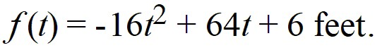 Use a graphing calculator to graph *f* (*t*), and use the graph to answer the following.

A. How high does the ball go?

B. How long is it in the air?

Answer:

A. 70 feet

B. 4 seconds

Diff: 2 Var: 1

Section: 1.9

Learning Objectives: Write and interpret power functions given by tables, graphs, or words.

10) In the following graph, the leading coefficient is ________ (positive/negative)

A curve is graphed on an x y coordinate plane. The curve decreases concave up from the second quadrant through the negative x axis to the third quadrant, then it increases concave up to the positive x axis through the negative y axis. The curve then increases concave down to a point in the first quadrant and decreases concave down to the fourth quadrant through the positive x axis.


Answer: negative

Diff: 1 Var: 1

Section: 1.9

Learning Objectives: Write and interpret power functions given by tables, graphs, or words.

11) In the following graph, the minimum degree is ________.

A curve is graphed on an x y coordinate plane. The curve decreases concave up from the second quadrant through the negative x axis to the third quadrant, then it increases concave up to the positive x axis through the negative y axis. The curve then increases concave down to a point in the first quadrant and decreases concave down to the fourth quadrant through the positive x axis.


Answer: 3

Diff: 1 Var: 1

Section: 1.9

Learning Objectives: Write and interpret power functions given by tables, graphs, or words.

12) Write a formula representing the function that says: The area of a circle is proportional to the square of its radius.

Answer: *A* = π*r*2

Diff: 1 Var: 1

Section: 1.9

Learning Objectives: Write and interpret a function describing a proportional relationship.

13) The illumination, *I*, of a candle is inversely proportional to the square of its distance, *d*, from the object it illuminates. Write a formula that expresses this relationship.

Answer: *I* = (k/(d) with superscript (2))

Diff: 1 Var: 1

Section: 1.9

Learning Objectives: Write and interpret a function describing a proportional relationship.

14) Coulomb's law says that the electrical force between two charged objects is directly proportional to the product of the quantity of charge on the objects and inversely proportional to the square of the distance between the objects. Let (q) with subscript (1) and (q) with subscript (2) be the charge on the two objects. Let *d* be the distance between the objects and *F* be the electrical force between them. Translate Coulomb's Law into mathematical symbols.

A) *F* = 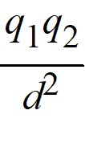 B) *F* = 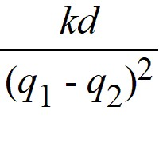

C) *F* = 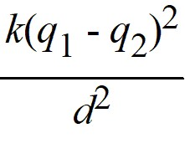 D) *F* = 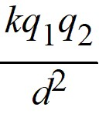

Answer: D

Diff: 1 Var: 1

Section: 1.9

Learning Objectives: Write and interpret a function describing a proportional relationship.

15) As *x* → -∞, the function *f* (*x*) = -17(x) with superscript (4) → ________.

A) -∞ B) ∞ C) neither of these

Answer: A

Diff: 2 Var: 1

Section: 1.9

Learning Objectives: Write and interpret power functions given by tables, graphs, or words.

16) As *x* → -∞, the function *f* (*x*) = 5(x) with superscript (7) → ________.

A) -∞ B) ∞ C) neither of these

Answer: A

Diff: 2 Var: 1

Section: 1.9

Learning Objectives: Write and interpret power functions given by tables, graphs, or words.

17) Sketch global pictures of the functions *f* (*x*) = -100(x) with superscript (3), *g*(*x*) = 28(x) with superscript (4), and *h*(*x*) = 2(x) with superscript (5) on the same set of axes. Label each function on both ends so it is obvious which is which.

Answer:

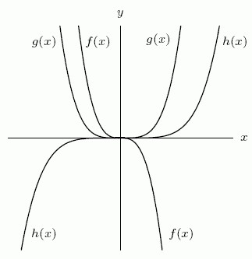

Diff: 2 Var: 1

Section: 1.9

Learning Objectives: Write and interpret power functions given by tables, graphs, or words.

18) Of the functions *f* (*x*) = -100(x) with superscript (3), *g*(*x*) = 28(x) with superscript (4), and *h*(*x*) = 2(x) with superscript (5), which has the largest value as 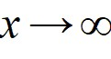?

A) *f* (*x*) = -100(x) with superscript (3) B) *g*(*x*) = 28(x) with superscript (4) C) *h*(*x*) = 2(x) with superscript (5)

Answer: C

Diff: 1 Var: 1

Section: 1.9

Learning Objectives: Write and interpret power functions given by tables, graphs, or words.

19) As *x* → ∞, the function *f* (*x*) = 4 + 24*x* + 78(x) with superscript (3) - 17(x) with superscript (4) → ________.

A) -∞ B) ∞ C) neither of these

Answer: A

Diff: 2 Var: 1

Section: 1.9

Learning Objectives: Write and interpret power functions given by tables, graphs, or words.

20) As *x* → ∞, the function *f* (*x*) = 5(x) with superscript (5) - 30(x) with superscript (4) + 2(x) with superscript (2) - 8*x* + 100 → ________.

A) ∞ B) -∞ C) neither of these

Answer: A

Diff: 1 Var: 1

Section: 1.9

Learning Objectives: Write and interpret power functions given by tables, graphs, or words.

21) As *x* → -∞, *f* (*x*) = (-x) with superscript (3) → ________.

A) ∞ B) -∞ C) 0

Answer: A

Diff: 2 Var: 1

Section: 1.9

Learning Objectives: Write and interpret power functions given by tables, graphs, or words.

22) As *x* → -∞, *f* (*x*) = (x) with superscript (-4) → ________.

A) ∞ B) -∞ C) 0

Answer: C

Diff: 2 Var: 1

Section: 1.9

Learning Objectives: Write and interpret power functions given by tables, graphs, or words.

23) As *x* → -∞, *f* (*x*) = 370 - 5(x) with superscript (2) - 80(x) with superscript (3) + 10(x) with superscript (4) → ________.

A) ∞ B) -∞ C) 0

Answer: A

Diff: 2 Var: 1

Section: 1.9

Learning Objectives: Write and interpret power functions given by tables, graphs, or words.

24) Give a possible formula for the function shown in the following table.

|  |  |  |  |  |  |  |
| --- | --- | --- | --- | --- | --- | --- |
| *x* | 0 | 1 | 2 | 3 | 4 | 5 |
| *g*(*x*) | 0 | 2 | 8 | 18 | 32 | 50 |

Answer: *g*(*x*) = 2(x) with superscript (2)

Diff: 1 Var: 1

Section: 1.9

Learning Objectives: Write and interpret power functions given by tables, graphs, or words.

25) Give a possible formula for the function shown in the following table.

|  |  |  |  |  |  |  |
| --- | --- | --- | --- | --- | --- | --- |
| *x* | 0 | 1 | 2 | 3 | 4 | 5 |
| *h*(*x*) | ------ | 5 | 2.5 | 1.66666667 | 1.25 | 1 |

Answer: *h*(*x*) = (5/x)

Diff: 1 Var: 1

Section: 1.9

Learning Objectives: Write and interpret power functions given by tables, graphs, or words.

26) Write in factored form the equation of the polynomial graphed below. All key features are shown.

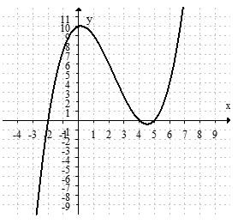

Answer: *p*(*x*) = (1/4)(*x* + 2)(*x* - 4)(*x* - 5)

Diff: 2 Var: 1

Section: 1.9

Learning Objectives: Write and interpret power functions given by tables, graphs, or words.

1.10 Periodic Functions

1) Assume that the function shown in the following table is periodic. What is the amplitude of the function?

|  |  |  |  |  |  |  |  |  |  |
| --- | --- | --- | --- | --- | --- | --- | --- | --- | --- |
| *x* | 1 | 2 | 3 | 4 | 5 | 6 | 7 | 8 | 9 |
| *f* (*x*) | -2 | 0 | -2 | -4 | -2 | 0 | -2 | -4 | -2 |

Answer: 2

Diff: 1 Var: 1

Section: 1.10

Learning Objectives: Interpret periodic functions: amplitude, period, vertical shift, value at a point.

2) Assume that the function shown in the following table is periodic. What is *f* (14)?

|  |  |  |  |  |  |  |  |  |  |
| --- | --- | --- | --- | --- | --- | --- | --- | --- | --- |
| *x* | 1 | 2 | 3 | 4 | 5 | 6 | 7 | 8 | 9 |
| *f* (*x*) | -2 | 0 | -2 | -4 | -2 | 0 | -2 | -4 | -2 |

Answer: 0

Diff: 1 Var: 1

Section: 1.10

Learning Objectives: Interpret periodic functions: amplitude, period, vertical shift, value at a point.

3) At high tide, the water level is 7 feet below a certain pier. At low tide, the water level is 23 feet below the pier. Assuming sinusoidal behavior, let *f* (*t*) = the water level relative to the pier, at time *t* (in hours). At 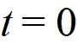 the water is -15 feet and falling until it reaches the first low tide at 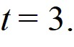 Give a formula for *f* (*t*).

Answer: -8sin((π/6))*t* - 15

Diff: 2 Var: 1

Section: 1.10

Learning Objectives: Find a formula for a periodic function given by graphs, tables, or words.

4) In nature, the populations of two animals, one of which preys upon the other (such as foxes and rabbits) are observed to oscillate with time, and are found to be well approximated by trigonometric functions. The population of foxes is shown in the graph below. Find the amplitude.

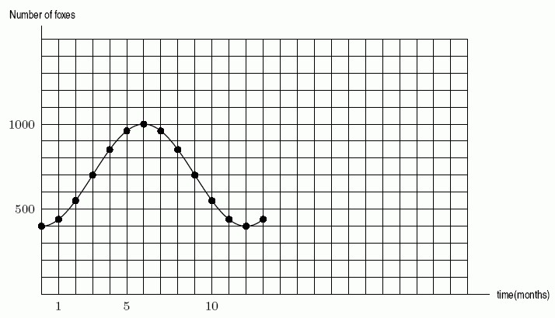

Answer: 300

Diff: 1 Var: 1

Section: 1.10

Learning Objectives: Interpret periodic functions: amplitude, period, vertical shift, value at a point.

5) In nature, the populations of two animals, one of which preys upon the other (such as foxes and rabbits) are observed to oscillate with time, and are found to be well approximated by trigonometric functions. The population of foxes is shown in the graph below. How many foxes will there be in 15 months?



Answer: 700

Diff: 2 Var: 1

Section: 1.10

Learning Objectives: Interpret periodic functions: amplitude, period, vertical shift, value at a point.

6) If *y* = *A* sin *Bx* + *C* defines the function graphed in the following figure, then 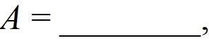 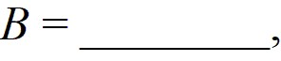 and 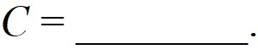

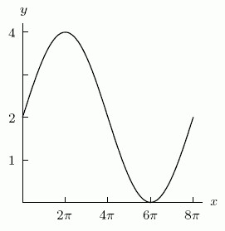

Answer:

A: 2

B: 1/4

C: 2

Diff: 2 Var: 1

Section: 1.10

Learning Objectives: Find a formula for a periodic function given by graphs, tables, or words.

7) If *k*(*t*) = *A* sin *Bπt* + *C* defines the function graphed in the following figure, then ** ** and **

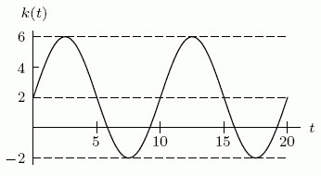

Answer:

A: 4

B: 1/5

C: 2

Diff: 2 Var: 1

Section: 1.10

Learning Objectives: Find a formula for a periodic function given by graphs, tables, or words.

8) The size of a bird population on an island can be described by a sinusoidal graph. The number of birds on the island decreased from a maximum of 20,000 in 1963 to a minimum of 12,000 in 2009, and then began increasing again. In what year will the population begin decreasing again?

Answer: 2055

Diff: 1 Var: 1

Section: 1.10

Learning Objectives: Interpret periodic functions: amplitude, period, vertical shift, value at a point.

9) The size of a bird population on an island can be described by a sinusoidal graph. The number of birds on the island decreased from a maximum of 20,000 in 1963 to a minimum of 12,000 in 2009, and then began increasing again. Find a function that describes this behavior and use it to estimate the number of birds on the island in 2031. Round to the nearest whole number.

Answer: 15,727

Diff: 2 Var: 1

Section: 1.10

Learning Objectives: Interpret periodic functions: amplitude, period, vertical shift, value at a point.

10) What value of *B* would you use if sin *Bt* was to model a periodic function with period 1 year where *t* is measured in months? Round to 4 decimal places.

Answer: 0.5236

Diff: 1 Var: 1

Section: 1.10

Learning Objectives: Interpret periodic functions: amplitude, period, vertical shift, value at a point.

11) What value of *B* would you use if sin *Bt* was to model a periodic function, where *t* is measured in hours and the period is 1/2 day? Round to 4 decimal places.

Answer: 0.5236

Diff: 1 Var: 1

Section: 1.10

Learning Objectives: Interpret periodic functions: amplitude, period, vertical shift, value at a point.

12) Give a formula for the following sinusoidal function as a transformation of 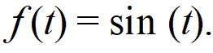

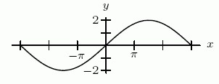

A) *f* (*t*) = -2sin (3*t*) B) *f* (*t*) = -2sin ((t/3))

C) *f* (*t*) = 2sin (3*t*) D) *f* (*t*) = 2sin ((t/3))

Answer: D

Diff: 1 Var: 1

Section: 1.10

Learning Objectives: Find a formula for a periodic function given by graphs, tables, or words.

13) Give a formula for the following sinusoidal function as a transformation of 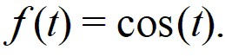



A) *f* (*t*) = 2cos 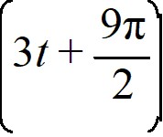 B) *f* (*t*) = 2cos 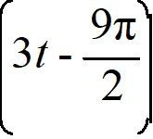

C)  *f* (*t*) = 2cos 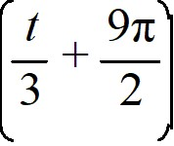 D)  *f* (*t*) = 2cos 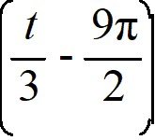

Answer: D

Diff: 2 Var: 1

Section: 1.10

Learning Objectives: Find a formula for a periodic function given by graphs, tables, or words.

14) Temperature in Town A oscillates daily between 30°F at 4 a.m. and 60°F at 4 p.m. If 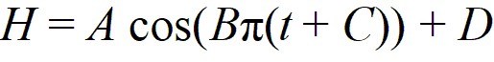 is a formula for the temperature in Town A in terms of time, where time is measured in hours from 4 a.m., then **  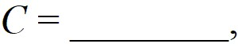 and 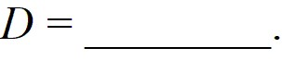

Answer:

A: -15

B: 1/12

C: 0

D: 45

Diff: 2 Var: 1

Section: 1.10

Learning Objectives: Find a formula for a periodic function given by graphs, tables, or words.

15) Temperatures in a room oscillate between the low of -10°F (at 5 a.m.) and the high of 50°F (reached at 5 p.m.). If 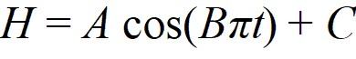 is a formula for the temperature in the room in terms of time from 5 a.m., then ** ** and **

Answer:

A: -30

B: 1/12

C: 20

Diff: 2 Var: 1

Section: 1.10

Learning Objectives: Find a formula for a periodic function given by graphs, tables, or words.

16) Consider the function *g*(*t*) = -10 + cos 3*t* . If its period is *k*π*,* what is *k*?

Answer: (2/3)

Diff: 1 Var: 1

Section: 1.10

Learning Objectives: Interpret periodic functions: amplitude, period, vertical shift, value at a point.

17) Consider the functions *f* (*x*) = 5 + sin 3*x* and *g*(*x*) = 3 sin *x*. Which has a larger amplitude?

A)  *g*(*x*) B)  *f* (*x*)

Answer: A

Diff: 1 Var: 1

Section: 1.10

Learning Objectives: Interpret periodic functions: amplitude, period, vertical shift, value at a point.

18) Sketch a well-labeled graph of a periodic function such that:

-- *f (*0) = 1000

-- the period is 12

-- the amplitude is 600.

Then write a few sentences illustrating how such a function might apply to a dragonfly population.

Answer: Answers will vary. The graph of *f* (*t*) = 1000 + 600sin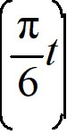 is one such periodic function. One story: At the start of a 12-month experiment about dragonfly populations, there are 1000 dragonflys. Over the first three months, the dragonfly population increases to a maximum of 1600, then returns to its initial population at mid-year. The low point of the population is after 9 months and is 400.

Diff: 2 Var: 1

Section: 1.10

Learning Objectives: Find a formula for a periodic function given by graphs, tables, or words.

19) Consider the function *f* (*θ*) = 30 + 65cos(9.425*θ*). Select all true statements about this function from the list below. Answers are rounded to two decimal places.

A) The period of the function is 0.67.

B) The amplitude of the function is 65.

C) The vertical shift of the function is 30.

D) The period of the function is 0.15.

E) The amplitude of the function is 30.

F) The vertical shift of the function is 65.

Answer: A, B, C

Diff: 1 Var: 1

Section: 1.10

Learning Objectives: Interpret periodic functions: amplitude, period, vertical shift, value at a point.

20) Write an equation of a periodic function with amplitude 35, vertical shift 15, period 2π, and horizontal translation (phase shift) 6 units to the right.

A) *f* (*t*) = 15 + 35cos(*t* - 6)

B) *f* (*t*) = 35 + 15cos(*t* + 6)

C) *f* (*t*) = 35cos(15*t* - 6)

D) *f* (*t*) = 15cos(6*t* - 35)

E) None of the above.

Answer: A

Diff: 1 Var: 1

Section: 1.10

Learning Objectives: Find a formula for a periodic function given by graphs, tables, or words.

21) Of the three functions below, one is a quadratic, one is a cubic, and one is a periodic function. Which one is *f* (*x*)?

|  |  |  |  |  |  |
| --- | --- | --- | --- | --- | --- |
| *x* | 0.2 | 0.4 | 0.6 | 0.8 | 1.2 |
| *f* (*x*) | -0.42 | -0.65 | 0.96 | -0.15 | 0.84 |

|  |  |  |  |  |  |
| --- | --- | --- | --- | --- | --- |
| *x* | 1.3 | 1.7 | 2.5 | 3.0 | 3.5 |
| *g*(*x*) | 0.41 | 0.81 | 0.65 | -0.10 | -1.35 |

|  |  |  |  |  |  |
| --- | --- | --- | --- | --- | --- |
| *x* | 0.5 | 1.2 | 1.8 | 2.0 | 2.2 |
| *h*(*x*) | -1.13 | 0.13 | 0.03 | 0.00 | 0.05 |

A) periodic B) quadratic C) cubic

Answer: A

Diff: 2 Var: 1

Section: 1.10

Learning Objectives: Interpret periodic functions: amplitude, period, vertical shift, value at a point.

© (2022) John Wiley & Sons, Inc. All rights reserved. Instructors who are authorized users of this course are permitted to download these materials and use them in connection with the course. Except as permitted herein or by law, no part of these materials should be reproduced, stored in a retrieval system, or transmitted, in any form or by any means, electronic, mechanical, photocopying, recording or otherwise.