Test Bank
to accompany
Animal Physiology, Fourth Edition
Hill • Wyse • Anderson

Chapter 2: Molecules and Cells in Animal Physiology

TEST BANK QUESTIONS

Multiple Choice

1. Which molecule is part of a cell membrane?
a. Cholesterol
b. Ubiquitin
c. Cyclic AMP
d. Calmodulin
Answer: a
Textbook Reference: Cell Membranes and Intracellular Membranes
Bloom’s Category: 4. Analyzing

2. A molecule that consists of a polar portion and a nonpolar portion is said to be
a. hydrophilic.
b. hydrophobic.
c. an integral protein.
d. amphipathic.
Answer: d
Textbook Reference: Cell Membranes and Intracellular Membranes
Bloom’s Category: 1. Remembering

3. A saturated hydrocarbon tends to
a. be more liquid at colder temperatures compared to an unsaturated hydrocarbon.
b. be more solid at colder temperatures compared to an unsaturated hydrocarbon.
c. contain many double bonds.
d. contain fewer carbon–carbon bonds compared to an unsaturated hydrocarbon.
Answer: b
Textbook Reference: Cell Membranes and Intracellular Membranes
Bloom’s Category: 2. Understanding

4. Compared to fish found in lower temperature habitats, fish that inhabit higher temperatures tend to have more
a. saturated phospholipids in their brain synaptic membranes.
b. saturated phospholipids in their brain proteins.
c. unsaturated phospholipids in their brain synaptic membranes.
d. unsaturated phospholipids in their brain proteins.
Answer: a
Textbook Reference: Cell Membranes and Intracellular Membranes
Bloom’s Category: 3. Applying

5. Which membrane protein is responsible for the passive movement of K⁺ across the typical animal cell membrane?
a. Channel
b. Enzyme
c. Transporter
d. Receptor
Answer: a
Textbook Reference: Cell Membranes and Intracellular Membranes
Bloom’s Category: 2. Understanding

6. When a protein is denatured, which of the following structures is disrupted first?
a. Primary
b. Secondary
c. Tertiary
d. Quarternary
Answer: c
Textbook Reference: Cell Membranes and Intracellular Membranes
Bloom’s Category: 1. Remembering

7. Which molecule is a functional membrane protein?
a. Acetylcholine
b. Cholesterol
c. The Na⁺‒K⁺ pump
d. Calmodulin
Answer: c
Textbook Reference: Cell Membranes and Intracellular Membranes
Bloom’s Category: 5. Evaluating

8. A ring of _______ demarcates the apical surface of the cell from its lateral and basal surfaces.
a. tight junctions
b. septate junctions
c. gap junctions
e. microvilli
Answer: a
Textbook Reference: Epithelia
Bloom’s Category: 2. Understanding

9. Which of the following is considered a communicating junction?
a. Gap junction
b. Tight junction
c. Septate junction
d. Desmosome
Answer: a
Textbook Reference: Epithelia
Bloom’s Category: 1. Remembering

10. _______ is(are) the specific set of processes by which complex chemical compounds are broken down to release energy, create smaller chemical building blocks, or prepare chemical constituents for elimination.
a. Metabolism
b. Catabolism
c. Anabolism
d. Biochemical reactions
Answer: b
Textbook Reference: Elements of Metabolism
Bloom’s Category: 1. Remembering

11. Per gram, the leopard frog can jump farther per jump compared to the western toad because the leopard frog
a. is insensitive to lactic acid.
b. tends to live in warmer climates.
c. has a higher aerobic capacity.
d. creates more lactic acid per unit time.
Answer: d
Textbook Reference: Enzyme Fundamentals
Bloom’s Category: 2. Understanding

12. Which statement regarding enzymes is false?
a. All enzymes are catalysts.
b. Enzymes have substrates and products.
c. Enzymes speed chemical reactions.
d. All catalysts are enzymes.
Answer: d
Textbook Reference: Enzyme Fundamentals
Bloom’s Category: 5. Evaluating

13. Which reaction is catalyzed by LDH?
a. Pyruvic acid + NADH₂ → lactic acid + NAD
b. Pyruvic acid + NAD → pyruvic acid + NADH₂
c. Pyruvic acid + NAD → lactic acid + NADH₂
d. Lactic acid + NADH₂ → pyruvic acid + NAD
Answer: a
Textbook Reference: Enzyme Fundamentals
Bloom’s Category: 3. Applying

14. The amount of substrate converted to product per unit of time is called the
a. turnover number.
b. saturated speed.
c. V_{max}.
d. reaction velocity.
Answer: d
Textbook Reference: Enzyme Fundamentals
Bloom’s Category: 1. Remembering

15. Turnover number (k_{cat}) describes what property of an enzymatic reaction?
a. Activation energy
b. Catalytic effectiveness
c. Enzyme‒substrate affinity
d. The transition state
Answer: b
Textbook Reference: Enzyme Fundamentals
Bloom’s Category: 1. Remembering

16. The likelihood that an enzyme will form a complex with the substrate during a collision is called the
a. catalytic effectiveness.
b. activation energy.
c. enzyme‒substrate affinity.
d. transition state.
Answer: c
Textbook Reference: Enzyme Fundamentals
Bloom’s Category: 1. Remembering

17. An enzymatic reaction is proceeding at subsaturation. Which of the following is not a means by which the enzymatic reaction can be increased?
a. Adding more substrate
b. Adding more enzyme
c. Increasing the catalytic effectiveness
d. Increasing the temperature
Answer: b
Textbook Reference: Enzyme Fundamentals
Bloom’s Category: 3. Applying

18.–22. Refer to the figure below.

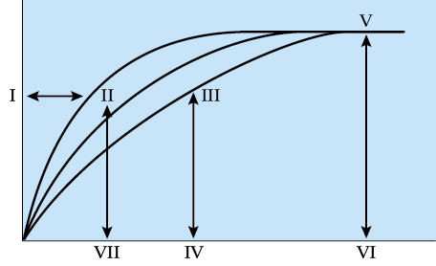

18. Which of the following represent the best labels for the x axis and the y axis in the figure?
a. x = Substrate concentration; y = Reaction velocity
b. x = Enzyme concentration; y = Reaction velocity
c. x = Time; y = Substrate concentration
d. x = Time; y = Enzyme‒substrate conversion rate
Answer: a
Textbook Reference: Enzyme Fundamentals
Bloom’s Category: 3. Applying

19. Which letter in the figure represents high affinity?
a. I
b. II
c. III
d. V
Answer: b
Textbook Reference: Enzyme Fundamentals
Bloom’s Category: 3. Applying

20. Which letter in the figure best represents the V_{max}?
a. VI
b. I
c. III
d. V
Answer: d
Textbook Reference: Enzyme Fundamentals
Bloom’s Category: 3. Applying

21. In the figure, which region best represents the K_{m} of the highest affinity enzyme?
a. I
b. II
c. VII
d. IV
Answer: c
Textbook Reference: Enzyme Fundamentals
Bloom’s Category: 3. Applying

22. If more substrate is added to the reaction system of line C in the diagram, what would be the most likely outcome?
a. The curve of line C would shift toward line B.
b. The V_{max} will increase.
c. K_{m} will decrease.
d. The curve will remain the same.
Answer: d
Textbook Reference: Enzyme Fundamentals
Bloom’s Category: 3. Applying

23. Citrate binding to phosphofructokinase is an example of
a. heterotropic cooperativity.
b. negative cooperativity.
c. allosteric inhibition.
d. competitive inhibition.
Answer: c
Textbook Reference: Enzyme Fundamentals
Bloom’s Category: 3. Applying

24. Human LDH-B₄ and rat LDH-B₄ are examples of
a. isozymes.
b. analogous enzymes.
c. isoenzymes.
d. interspecific enzyme homologs.
Answer: d
Textbook Reference: Enzyme Fundamentals
Bloom’s Category: 2. Understanding

25. An enzyme-encoding gene is considered to be_______ within a cell if the gene results in the synthesis of the encoded enzyme within that same cell.
a. promoted
b. induced
c. expressed
d. enhanced
Answer: c
Textbook Reference: Regulation of Cell Function by Enzymes
Bloom’s Category: 2. Understanding

26. _______ enzymes are present in a tissue in relatively high and steady amounts regardless of conditions, whereas _______ enzymes are present at low levels (or not at all) in a tissue unless their synthesis is activated.
a. Inducible; constitutive
b. Promotable; constitutive
c. Constitutive; inducible
d. Expressed; promotable
Answer: c
Textbook Reference: Regulation of Cell Function by Enzymes
Bloom’s Category: 2. Understanding

27. Which statement regarding allosteric modulation is true?
a. The binding of an allosteric modulator follows the law of mass action.
b. The binding of an allosteric modulator is irreversible.
c. An allosteric modulator, when present, will always bind to the enzyme it modulates.
d. The binding of an allosteric modulator always increases the catalytic activity of the enzyme.
Answer: a
Textbook Reference: Regulation of Cell Function by Enzymes
Bloom’s Category: 5. Evaluating

28. Citrate combines with phosphofructokinase at the _______ site, ultimately _______ catalytic activity and thus regulating glycolysis.
a. allosteric; increasing
b. allosteric; decreasing
c. active; increasing
d. active; decreasing
Answer: b
Textbook Reference: Regulation of Cell Function by Enzymes
Bloom’s Category: 3. Applying

29. Which of the following is directly involved in covalent modulation?
a. The Na⁺‒K⁺ pump
b. Protein kinases
c. van der Waals interactions
d. Calcium
Answer: b
Textbook Reference: Regulation of Cell Function by Enzymes
Bloom’s Category: 5. Evaluating

30.–31. Refer to the figure below.

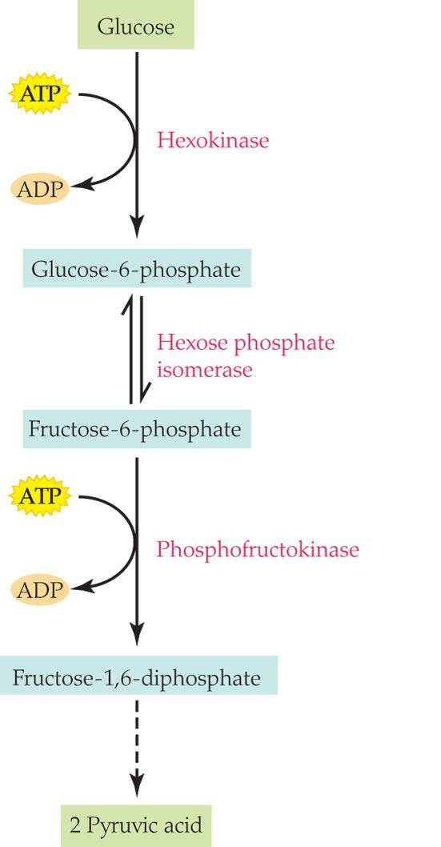

30. How many different enzymes are catalyzing reactions?
a. Two
b. Three
c. Four
d. Five
Answer: b
Textbook Reference: Regulation of Cell Function by Enzymes
Bloom’s Category: 3. Applying

31. According to the figure, a high amount of products from the Kreb’s cycle could act as _______ and result in _______ of the overall reaction.
a. covalent modulators; inhibition
b. covalent modulators; acceleration
c. allosteric modulators; inhibition
d. allosteric modulators; acceleration
Answer: c
Textbook Reference: Regulation of Cell Function by Enzymes
Bloom’s Category: 3. Applying

32. A protein kinase catalyzes the phosphorylation of another protein kinase, which in turn catalyzes the phosphorylation of a third protein kinase. This series of multiple enzyme sequences is an excellent example of
a. amplification.
b. a rate-limiting reaction.
c. inducing enzymes.
d. allosteric regulation.
Answer: a
Textbook Reference: Regulation of Cell Function by Enzymes
Bloom’s Category: 2. Understanding

33. The _______ is(are) directly responsible for the amplifying effects during a second messenger cascade.
a. receptors
b. substrates
c. enzymes
d. cell membrane
Answer: c
Textbook Reference: Regulation of Cell Function by Enzymes
Bloom’s Category: 2. Understanding

34.–35. Refer to the figure below.

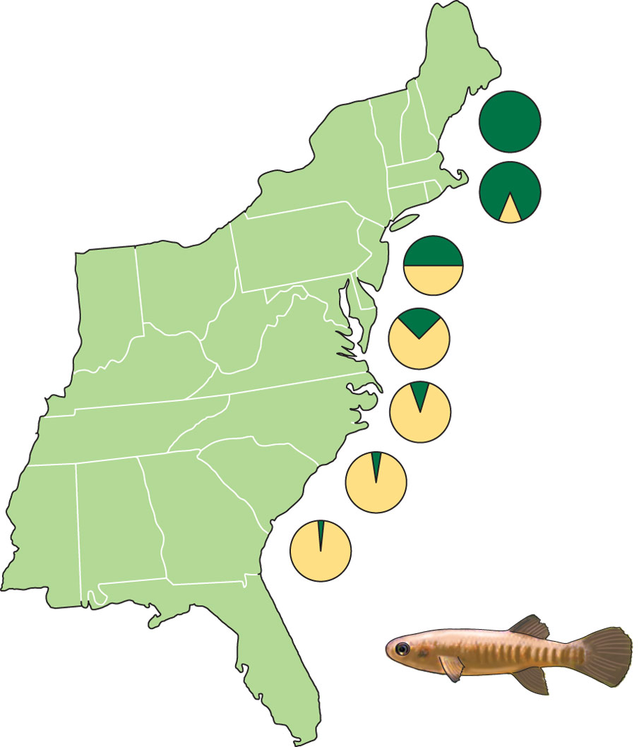

34. Which abiotic factor most likely explains the data in the figure?
a. LDH expression
b. Allele frequencies
c. Temperature
d. Predation
Answer: c
Textbook Reference: Evolution of Enzymes
Bloom’s Category: 3. Applying

35. The figure shows the
a. frequency distribution of two predators on killifish.
b. frequency distribution of two different alleles of the gene for LDH.
c. frequency distribution of two main diets of killifish.
d. temperature tolerance of two subtypes of killifish.
Answer: b
Textbook Reference: Evolution of Enzymes
Bloom’s Category: 1. Remembering

36.–37. Refer to the figure below.

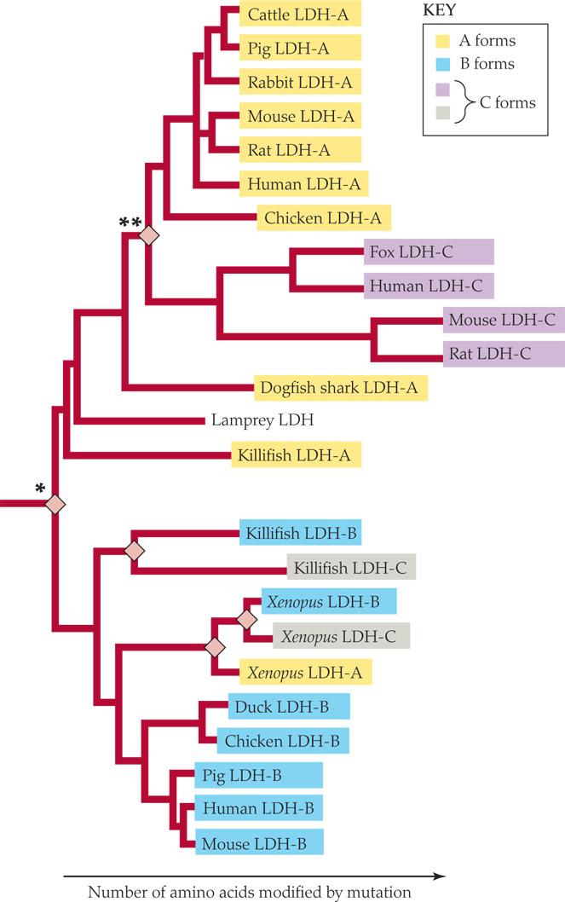

36. What is the best explanation for why mammalian and fish LDH-C enzymes are shown to be so distantly related?
a. Many separate gene duplication events created the C version of LDH.
b. The tree is based on LDH-A relationships, so it does not accurately show how closely related the LHD-C versions are to one another.
c. The enzymes were named before the actual evolutionary relationships were known.
d. The tree is separated based on animal phyla, not LDH.
Answer: c
Textbook Reference: Evolution of Enzymes
Bloom’s Category: 4. Analyzing

37. The diamonds refer to
a. genetic divergence.
b. gene duplication.
c. mutations.
d. speciation.
Answer: b
Textbook Reference: Evolution of Enzymes
Bloom’s Category: 3. Applying

38. In rats, phosphoenolpyruvate carboxykinase activity per gram of liver significantly increases at birth and remains at this higher level for the life of the animal. This is an example of enzymatic change that takes place over a(n) _______ time frame.
a. acute
b. chronic
c. evolutionary
d. developmental
Answer: d
Textbook Reference: Enzymes Are Instruments of Change in All Time Frames
Bloom’s Category: 3. Applying

39. If a protein in situ becomes partially denatured because of high temperature, the denaturation can be reversed by a
a. molecular chaperone.
b. proteasome.
c. ubiquitin.
d. peptidase.
Answer: a
Textbook Reference: The Life and Death of Proteins
Bloom’s Category: 2. Understanding

40. Which of the following tags proteins for destruction?
a. Proteasome
b. Ubiquitin
c. Molecular chaperone
d. Heat-shock protein
Answer: b
Textbook Reference: The Life and Death of Proteins
Bloom’s Category: 1. Remembering

41. The process of absorbing preexisting light and re-emitting it at longer wavelengths is called
a. bioluminescence.
b. reflection.
c. chromatophoration.
d. fluorescence.
Answer: d
Textbook Reference: Light and Color
Bloom’s Category: 2. Understanding

42. The ability of animals to change color in seconds or minutes depends on the function of
a. photocytes.
b. chromatophores.
c. photoproteins.
d. luciferin.
Answer: b
Textbook Reference: Light and Color
Bloom’s Category: 2. Understanding

43. Intracellular modification of activity in response to an external signal is an example of
a. transduction.
b. transformation.
c. conversion.
d. covalent modulation.
Answer: a
Textbook Reference: Reception and Use of Signals by Cells
Bloom’s Category: 2. Understanding

44. Extracellular signaling molecules initiate their actions on a cell by binding with certain protein molecules of the cell called
a. ligands.
b. peripheral proteins.
c. integral proteins.
d. receptors.
Answer: d
Textbook Reference: Reception and Use of Signals by Cells
Bloom’s Category: 1. Remembering

45. Which of the following statements regarding the ligand-gated receptor is false?
a. The naturally occurring ligand can cause the associated protein channel to open.
b. The naturally occurring ligand should bind irreversibly to the receptor until it breaks down.
c. A similarly shaped foreign ligand can attach to the receptor and block the naturally occurring ligand from binding.
d. A ligand can attach to the receptor and activate an intracellular catalytic site on the same molecule.
Answer: b
Textbook Reference: Reception and Use of Signals by Cells
Bloom’s Category: 5. Evaluating

46. Receptor proteins can bring about all of the following cellular actions except
a. reinforcing the structure of the membrane.
b. opening a protein channel on the membrane.
c. activating an enzyme on the intracellular surface.
d. combining with a ligand to initiate transcription.
Answer: a
Textbook Reference: Reception and Use of Signals by Cells
Bloom’s Category: 5. Evaluating

47. The α-conotoxin injected into fish by the cone snail binds to and therefore blocks receptor sites on the muscle membrane. This prevents a(n)
a. enzyme from being activated.
b. G protein from being activated.
c. channel from opening into the nucleus.
d. channel from opening.
Answer: d
Textbook Reference: Reception and Use of Signals by Cells
Bloom’s Category: 3. Applying

48. Which reaction does not directly produce an amplification?
a. Activation of a G protein by an activated receptor
b. Formation of cyclic AMP by catalyzing action of adenylyl cyclase
c. Activation of glycogen phosphorylase kinase by active cAMP-dependent protein kinase
d. Opening of a ligand-gated channel on the membrane
Answer: d
Textbook Reference: Reception and Use of Signals by Cells
Bloom’s Category: 5. Evaluating

49. Which substance is considered a second messenger?
a. IP₃-gated calcium channel
b. Calcium
c. Epinephrine
d. Adenylyl cyclase
Answer: b
Textbook Reference: Reception and Use of Signals by Cells
Bloom’s Category: 5. Evaluating

50. As a second messenger, calcium typically binds to
a. calmodulin, and the complex activates protein kinases.
b. a G protein to activate general second messengers.
c. cyclic AMP to activate cAMP-dependent protein kinases.
d. inositol triphosphate to activate the endoplasmic reticulum.
Answer: a
Textbook Reference: Reception and Use of Signals by Cells
Bloom’s Category: 2. Understanding

Short Answer Questions

1. Describe what it means for a phospholipid to be amphipathic and how this feature is paramount in the formation of the membrane.
Answer: The cell membrane is composed of bilayer phospholipids, which are amphipathic. This means that the molecule consists of a polar part (regional differences in charge) and a nonpolar part (lacking regional differences in charge). Because water is by nature a polar molecule, the polar ends of the phospholipids contact the aqueous solutions, whereas the hydrophobic nonpolar ends of the phospholipids face each other, forming the inner region of the membrane.
Textbook Reference: Cell Membranes and Intracellular Membranes
Bloom’s Category: 2. Understanding

2. Provide a specific example of how a membrane protein can be categorized as more than one functional type.
Answer: There are five functional types of membrane proteins, but a receptor protein, as a prominent example, can be classified into more than one category. Receptor proteins can also function as channels, transporters, and enzymes.
Textbook Reference: Cell Membranes and Intracellular Membranes
Bloom’s Category: 3. Applying

3. Describe how epithelial cells control the transport of substances between the apical and basal sides and thus between different body regions.
Answer: Epithelial cells are able to control and even mediate the transport of substances between the apical and basal areas via occluding junctions between epithelial cells. Substances must pass through the cell to cross the epithelia, and this transcellular path can be highly controlled. Only very small molecules may be able to pass through the occluding junctions and thus take the paracellular path.
Textbook Reference: Epithelia
Bloom’s Category: 2. Understanding

4. Define the law of mass action and apply it to a real biochemical reaction.
Answer: For a given reaction of A + B ↔ C + D, the law of mass action states that if the compounds are out of equilibrium, the reaction will proceed in the direction of equilibrium as dictated by the ratios of concentrations. For example, within glycolysis, pyruvate typically forms lactic acid. However, in the event that lactic acid concentrations rise significantly, the reaction can be reversed, forming pyruvate from lactic acid.
Textbook Reference: Enzyme Fundamentals
Bloom’s Category: 3. Applying

5. Compare and contrast the factors affecting the rate of an enzymatic reaction in a substrate that is subsaturated and one that is saturated or at V_{max}.
Answer: Both reaction velocities at V_{max} and in reactions that are subsaturated will be affected by the number of active enzyme molecules present and the catalytic effectiveness of each enzyme molecule. However, reaction velocities in subsaturated reactions will also depend on the affinity of enzyme molecules for the substrate.
Textbook Reference: Enzyme Fundamentals
Bloom’s Category: 5. Evaluating

6. Describe how amplification works in the cell and why it is important.
Answer: In the cell, if any agent that is activated is itself an enzyme, it is able to catalyze a reaction, forming many products. If these products are also enzymes for other reactions, the amplification process will be exponential. This is important in cell function because one receptor binding one ligand (such as epinephrine) can amplify and bring about a significant result (i.e., the creation of millions of glucose molecules from glycogen).
Textbook Reference: Regulation of Cell Function by Enzymes
Bloom’s Category: 2. Understanding

7. How does the killifish demonstrate the present-day operation of evolutionary forces?
Answer: The killifish that live along the entire east coast of the United States show two different alleles of the gene for the B form of lactate dehydrogenase. Since these fish travel extensively along the coast, one would expect the alleles to be evenly distributed. The fact that different allele frequencies persist from place to place indicates that fish with different alleles undergo differential survival and reproduction—an example of the working of present-day evolutionary forces.
Textbook Reference: Evolution of Enzymes
Bloom’s Category: 3. Applying

8. Compare and contrast bioluminescence and fluorescence and describe the light production of the hydromedusan jellyfish (Aequorea victoria).
Answer: Both bioluminescence and fluorescence can occur within a photocyte, but in bioluminescence, the light is produced de novo. In fluorescence, preexisting light is absorbed and re-emitted at longer wavelengths. In the hydromedusan jellyfish, clusters of photocytes produce blue light. However, the light emitted is green because a green fluorescent protein converts the emission wavelengths.
Textbook Reference: Light and Color
Bloom’s Category: 5. Evaluating

9. List and briefly describe the four types of receptor proteins involved in cell signaling.
Answer: (1) Ligand-gated channels bind ligands so that channels can open for ions to pass through the cell membrane. (2) G protein receptors bind ligands and activate a G protein system, which is a complex secondary messenger system that typically amplifies effects in the cell. (3) The enzyme/enzyme-linked receptor binds a ligand on the extracellular surface that activates the receptor protein. The activated receptor protein is itself an enzyme that catalyzes a reaction, typically on the intracellular side. (4) The intracellular receptor is typically housed inside the nucleus, and the ligand usually passes through the cell membrane and the nuclear membrane via diffusion. Once the ligand attaches to the intracellular receptor, the complex initiates transcription by interacting with the DNA.
Textbook Reference: Reception and Use of Signals by Cells
Bloom’s Category: 2. Understanding

10. Describe how a simple ion such as calcium is used as a second messenger.
Answer: Calcium ions sometimes act as second messengers. Inositol triphosphate activates a gated channel on the endoplasmic reticulum, which releases calcium into the cytoplasm. Calcium then binds to the protein calmodulin, which can then activate protein kinases or other enzymes.
Textbook Reference: Reception and Use of Signals by Cells
Bloom’s Category: 2. Understanding

ONLINE QUIZ QUESTIONS

1. Which statement regarding brain phospholipids in fish is most accurate?
a. Tropical fish tend to have very unsaturated phospholipids in their brain synaptic membranes.
b. Fish in very cold habitats tend to have very saturated phospholipids in their brain synaptic membranes.
c. The colder the habitat, the greater the degree of phospholipid unsaturation in the brain synaptic membranes.
d. The degree of phospholipid saturation in brain synaptic membranes is independent of habitat temperature.
Answer: c
Textbook Reference: Cell Membranes and Intracellular Membranes
Bloom’s Category: 5. Evaluating

2. Which of the following is not a functional type of membrane protein?
a. Enzyme
b. Receptor
c. Structural
d. Resistance
Answer: d
Textbook Reference: Cell Membranes and Intracellular Membranes
Bloom’s Category: 5. Evaluating

3. Which cell‒cell junctions allow cytoplasmic flow between the connected cells?
a. Tight junction
b. Septate junction
c. Gap junction
d. Desmosome
Answer: c
Textbook Reference: Epithelia
Bloom’s Category: 1. Remembering

4. When there are more substrate molecules than the enzyme molecules can accommodate, the reaction is
a. saturated.
b. subsaturated.
c. showing the highest enzyme–substrate affinity.
d. at its K_{m}.
Answer: a
Textbook Reference: Enzyme Fundamentals
Bloom’s Category: 2. Understanding

5. The catalytic effectiveness of an enzyme molecule is expressed as the
a. half-saturation constant, K_{m}.
b. activation energy during a saturated reaction.
c. number of substrate molecules converted to product per second by each enzyme molecule when saturated.
d. maximum velocity, V_{max}.
Answer: c
Textbook Reference: Enzyme Fundamentals
Bloom’s Category: 3. Applying

6. The allosteric site is located
a. on the enzyme.
b. on the substrate.
c. on the cell surface.
d. on the modulator.
Answer: a
Textbook Reference: Enzyme Fundamentals
Bloom’s Category: 1. Remembering

7. Human LDH-A₄ and rat LDH-A₄ together are a good example of
a. isozymes.
b. interspecific enzyme homologs.
c. allosteric modulators.
d. ligands.
Answer: b
Textbook Reference: Enzyme Fundamentals
Bloom’s Category: 3. Applying

8. An animal is exposed to halogenated aromatic hydrocarbons, and as a result, its levels of P450 enzymes rise. This is an example of the action of
a. transcription factors.
b. enhancers.
c. constitutive enzymes.
d. inducible enzymes.
Answer: d
Textbook Reference: Regulation of Cell Function by Enzymes
Bloom’s Category: 3. Applying

9. When an allosterically modulated enzyme is the rate-limiting enzyme in a metabolic pathway, the entire pathway may be upregulated or downregulated by allosteric modulation. The result of downregulation of the entire pathway is called
a. feedback inhibition.
b. positive feedback.
c. covalent modulation.
d. phosphorylation.
Answer: a
Textbook Reference: Regulation of Cell Function by Enzymes
Bloom’s Category: 2. Understanding

10. Multiple-enzyme sequences in which each enzyme in the sequence activates another enzyme is an example of
a. covalent modulation.
b. allosteric modulation.
c. amplification.
d. feedback inhibition.
Answer: c
Textbook Reference: Regulation of Cell Function by Enzymes
Bloom’s Category: 2. Understanding

11. The example of killifish allele frequency distribution along the Atlantic coast describes enzyme changes over a(n) _______ time frame.
a. acute
b. chronic
c. evolutionary
d. developmental
Answer: c
Textbook Reference: Evolution of Enzymes
Bloom’s Category: 3. Applying

12. In the most common protein-degradation mechanism, tagging occurs by the attachment of _______ to the protein targeted to be degraded.
a. a heat-shock protein
b. a molecular chaperone
c. a proteasome
d. ubiquitin
Answer: d
Textbook Reference: The Life and Death of Proteins
Bloom’s Category: 3. Applying

13. In a bioluminescent animal such as the hydromedusa jellyfish Aequorea victoria, the _______ consist(s) of luciferin, O₂, and a protein.
a. chromatophores
b. pigment granules
c. photocyte
d. photoprotein
Answer: d
Textbook Reference: Light and Color
Bloom’s Category: 2. Understanding

14. Color change in fish depends on flattened pigment-containing cells called
a. photoproteins.
b. chromatophores.
c. photocytes.
d. chromocytes.
Answer: b
Textbook Reference: Light and Color
Bloom’s Category: 1. Remembering

15. Which receptor protein brings about cascades of membrane proteins involving significant amplification?
a. Ligand-gated channel
b. G protein–coupled receptor
c. Enzyme/enzyme-linked receptor
d. Intracellular receptor
Answer: b
Textbook Reference: Reception and Use of Signals by Cells
Bloom’s Category: 5. Evaluating

16. Which receptor protein changes membrane voltage immediately when activated?
a. Ligand-gated channel
b. G protein–coupled receptor
c. Enzyme/enzyme-linked receptor
d. Intracellular receptor
Answer: a
Textbook Reference: Reception and Use of Signals by Cells
Bloom’s Category: 5. Evaluating

17. Which receptor proteins activate enzymes on the cell membrane?
a. Ligand-gated channel and G protein–coupled receptor
b. G protein–coupled receptor and enzyme/enzyme-linked receptor
c. Enzyme/enzyme-linked receptor and intracellular receptors
d. Ligand-gated channel, G protein–coupled receptor, and enzyme/enzyme-linked receptor
Answer: b
Textbook Reference: Reception and Use of Signals by Cells
Bloom’s Category: 5. Evaluating

18. Which receptor protein interacts with DNA?
a. Ligand-gated channel
b. G protein–coupled receptor
c. Enzyme/enzyme-linked receptor
d. Intracellular receptors
Answer: d
Textbook Reference: Reception and Use of Signals by Cells
Bloom’s Category: 5. Evaluating

19. When epinephrine attaches to a(n) _______, the process of _______ results in the formation of a large amount of intracellular _______.
a. G protein‒coupled receptor; amplification; glucose
b. ligand-gated receptor; amplification; glucose
c. G protein‒coupled receptor; metabolic pathways; glycogen
d. enzyme-enzyme‒linked receptor; amplification; glycogen
Answer: a
Textbook Reference: Reception and Use of Signals by Cells
Bloom’s Category: 5. Evaluating

20. Which of the following is not involved at the cell membrane in a second messenger cascade?
a. Adenylyl cyclase
b. G protein‒coupled receptor
c. Protein kinase
d. Phospholipase C
Answer: c
Textbook Reference: Reception and Use of Signals by Cells
Bloom’s Category: 5. Evaluating

