***Test Bank***

to accompany

*Animal Behavior*, Eleventh Edition

John Alcock, Linda Green, Paul Nolan, and Dustin Rubenstein

**Chapter 2: The Integrative Study of Behavior**

**Multiple Choice**

1. I say that a white-crowned sparrow sings a distinctive dialect because its genes influenced how its song system was assembled, which in turn made dialect learning possible. You say that it sings the song because of the operation of the robust nucleus of the arcopallium, which sends signals to the bird’s vocal control apparatus, the syrinx. Who is correct?

1. I am wrong because learning is environmentally determined, not determined by the bird’s genes.
2. You are wrong because the bird’s vocal apparatus is called the larynx, not the syrinx.
3. We both may be right because our two hypotheses offer two different proximate levels of analysis of dialect singing.
4. We both may be right because our two hypotheses offer two complementary levels of analysis, one proximate and the other ultimate.

*Answer*: c

2. Research results showed that in zebra finches, the sonograms of the songs of a father and his sons reveal a close match unless a son has been deafened early in life. Someone says that the causal question underlying this research was “Do zebra finches acquire their song by learning?” This statement is _______ because _______.

1. incorrect; the work was really done to establish that the songs were instinctive
2. incorrect; the question is actually a hypothesis, not a causal question
3. correct; zebra finches do learn their songs, as clearly shown by the sonograms
4. correct; by learning their songs from their fathers, males are likely to sing a song attractive to females

*Answer*: b

3. White-crowned sparrows evolved from an ancestral species that possessed the capacity for song learning. This is an example of

1. a developmental explanation.
2. a physiological explanation.
3. an adaptive value explanation.
4. an explanation relating to evolutionary history.

*Answer:* d

4. It is difficult for a sparrow to learn a dialect, which enables females to mate with only those males with good dialects so as to increase the song competence of their offspring.

This is an example of

1. a developmental explanation.
2. a physiological explanation.
3. an adaptive value explanation.
4. an explanation relating to evolutionary history.

*Answer:* c

5. Males in different populations have different forms of certain genes that influence the development of the song system. This is an example of

1. a developmental explanation.
2. a physiological explanation.
3. an adaptive value explanation.
4. an explanation relating to evolutionary history.

*Answer:* a

6. The ability to sing the local dialect enables a bird to communicate more effectively with neighboring males. This is an example of

1. a developmental explanation.
2. a physiological explanation.
3. an adaptive value explanation.
4. an explanation relating to evolutionary history.

*Answer:* c

7. Males in different populations are exposed to different songs, an experience that influences the kind of song that the birds learn. This is an example of

1. a developmental explanation.
2. a physiological explanation.
3. an adaptive value explanation.
4. an explanation relating to evolutionary history.

*Answer:* a

8. The differences among dialects are environmentally determined, not genetically controlled. This is an example of

1. a developmental explanation.
2. a physiological explanation.
3. an adaptive value explanation.
4. an explanation relating to evolutionary history.

*Answer:* a

9. Males in different populations have song systems in their brains that operate slightly differently. This is an example of

1. a developmental explanation.
2. a physiological explanation.
3. an adaptive value explanation.
4. an explanation relating to evolutionary history.

*Answer:* b

10. Young adult white-crowned sparrows are motivated to match their song as closely as possible to that of their neighbors. This is an example of

1. a developmental explanation.
2. a physiological explanation.
3. an adaptive value explanation.
4. an explanation relating to evolutionary history.

*Answer:* b

**Short Answer**

Questions 11−15.

Young white-crowned sparrows are remarkably good at remembering the sounds produced by adult white-crowned males singing around them. If the learning abilities of these birds evolved by Darwinian natural selection, specific conditions must have applied to the species in the past.

Determine whether each of the following statements about those conditions is correct or incorrect.

11. There must have been variation in the memory skills of individuals.

*Answer*: correct

12. The sparrow species must have been threatened by extinction at some point.

*Answer*: incorrect

13. Better than average song “rememberers” must have been able to pass on their abilities to their offspring.

*Answer*: correct

14. Better than average song “rememberers” must have had more surviving offspring on average than the typical sparrow at that time.

*Answer*: correct

15. Any changes that took place in the past must have promoted greater population stability in this bird.

*Answer*: incorrect

16. Refer to the figure below.

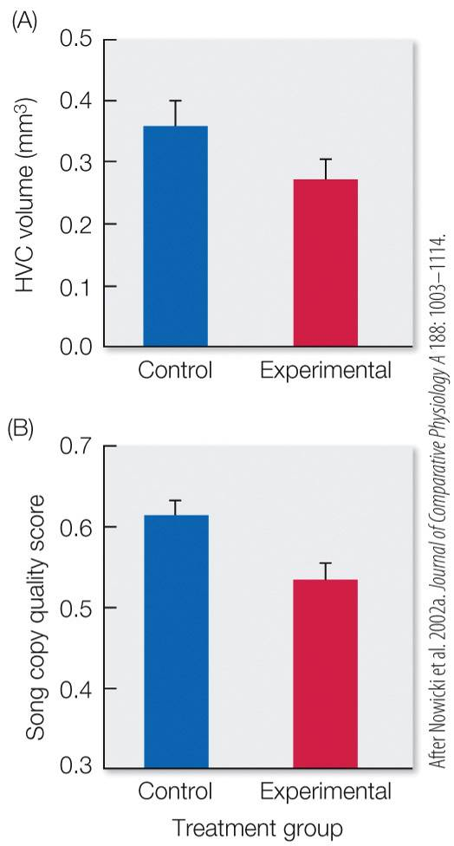

What is the proposed reasoning in Nowicki et al. 2002 for why the experimental group displayed lower values for each of the data sets? (Note: The birds in the experimental group were given 30 percent less food than the birds in the control group.)

*Answer*: The experimental birds suffered from lower nutritional quality and higher developmental stress, which resulted in reduced song complexity and reduced brain development of the HVC.

Questions 17–18.

Researchers produced three sonograms from male zebra finches: a father and two sons. One of the sons had been deafened early in life. The intact young male’s song exactly matched that of his father; the deafened male produced a rudimentary sub-song.

17. Why were these sonograms made? What aspect of the scientific process are they related to?

*Answer:* The sonograms constituted test evidence, data, from an experiment designed to determine the effects of early deafening on male song learning; the results enabled the researchers to conclude that the learning process involved the male bird’s ability to hear himself and his father sing.

18. Outline the complete scientific process for which the sonograms are only one part.

*Answer:* The experiment must have been initially imagined as part of a prediction: “If we do an experiment in which we deafen a young male, it will not be able to hear itself sing and thus should not be able acquire a good copy of its father’s song.” This prediction must have been derived from a hypothesis: “Zebra finch males must be able to hear themselves sing (or hear their fathers sing) if they are to eventually come to sing their father’s song.” This hypothesis must have been developed in response to a causal question: “In the zebra finch, why do sons tend to sing like their fathers?”

19. There are several hypothesized benefits to a bird that can sing the local dialect. Describe two hypotheses that explain the adaptive benefit of learning to sing from one’s neighbor.

*Answer*: The adaptive hypotheses explain the acoustic, social, and/or ecological benefit to learning one’s song from the local environment. The hypotheses are the following: environmental adaptation hypothesis, recognition hypothesis, information-sharing hypothesis, sexual selection hypothesis, and geographic matching hypothesis.

20. In cooperatively breeding birds, songs provide information about the group as well as individual identity, whereas birds with smaller breeding groups (most often composed of only kin) have songs that provide group identity without individual distinction. Why?

*Answer*: According to the information-sharing hypothesis, species with larger breeding groups have expanded repertoires of calls to interpret information about kin and social groupings. If a species has small breeding groups that are almost always kin, all individuals learn the “family” call and utilize it to recognize the group. In larger groups of kin and non-kin, individual birds learn both their natal songs and additional calls as they join with other birds.